
No. 42/2026 29 October 2026

Summary of key issues
- In the week ending 28 October 2026, low-pressure systems brought rainfall and storms to large areas of eastern and central Australia.
  - Cropping regions in Queensland and northern New South Wales saw between 15﻿200 millimetres of rainfall over the period.
  - These falls are expected to support summer crop development and pasture growth but are likely to delay winter crop harvest activities.
- Over the eight days from 29 October to 5 November 2026, rainfall is forecast across much of the eastern two- thirds of Australia.
  - Across eastern cropping regions, falls are expected to be higher in the north, with falls of 15- 50 millimetres in Queensland and northern New South Wales.
  - If realised, these falls are likely to continues to support pasture growth and winter crop grain filling in the southeast, and summer cropping activities in the northeast. However, following rainfall across many north-eastern regions in the past two week, these expected falls are likely to further delay winter crop harvest activities in these areas and increase the risk of grain quality downgrades due to excess moisture at harvest
- The northern rainfall onset has arrived early for some parts of Western Australia, the Northern Territory, and northern and central Queensland, where the onset is usually in November or December during an El Niño year. Wauter storage levels in the Murray-Darling Basin (MDB) increased by 65 gigalitres (GL) between 22 October 2026 and 29 October 2026. The current volume of water held in storages is 14,996 ﻿GL, equivalent to 67% of total storage capacity. This is 1% or 137 GL more than the same time last year. Water storage data is sourced from the Bureau of Meteorology.
- Allocation prices in the Victorian Murray below the Barmah Choke decreased from $324/ML on 22 October 2026 to $295/ML on 29 October 2026. Trade from the Goulburn to the Murray is closed. Trade downstream through the Barmah Choke is closed. Trade from the Murrumbidgee to the Murray is closed.

Climate

Rainfall this week
In the week ending 28 October 2026, low-pressure systems brought rainfall and storms to large areas of eastern and central Australia. Much of Western Australia remained comparatively dry.
- Falls of between 100-300 millimetres were recorded across scattered areas of eastern Queensland and north-eastern New South Wales.
- Falls of 5-100 millimetres were recorded across much of the remaining eastern two-thirds of Australia, including much of Queensland, Victora and Tasmania and large areas of New South Wales, South Australia and the Northern Territory.
- In contrast, much of Western Australia recorded little to no rainfall, except for the far southwest and northeast.
Across cropping regions, western areas recorded little to no rainfall, with significant falls recorded in north-eastern and south-eastern regions.
- Cropping regions in Queensland and northern New South Wales saw between 15-200 millimetres of rainfall over the period.
  - These falls are expected to support summer crop development and pasture growth but are likely to delay winter crop harvest activities.
- In South Australia and Victoria, falls of between 15-50 millimetres were recorded, while southern New South Wales observed 5-50 millimetres.
  - These falls are likely to provide a timely boost to soil moisture levels to support late spring pasture growth and winter crop grain filling.
- Limited rainfall was recorded across remaining cropping regions

Rainfall for the week ending 28 October 2026
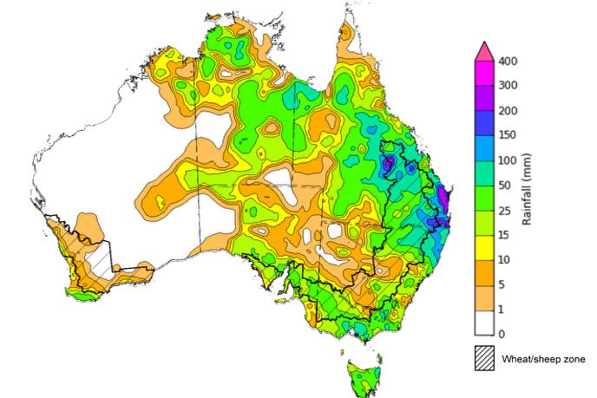
©Commonwealth of Australia 2026, Australian Bureau of Meteorology Issued: 28/10/2026
Note: The rainfall analyses and associated maps utilise data contained in the Bureau of Meteorology climate database, the Australian Data Archive for Meteorology (ADAM). The analyses are initially produced automatically from real-time data with limited quality control. They are intended to provide a general overview of rainfall across Australia as quickly as possible after the observations are received. For further information go to http://www.bom.gov.au/climate/rainfall/

Rainfall forecast for the next eight days
Over the eight days from 29 October to 5 November 2026, rainfall is forecast across much of the eastern two- thirds of Australia. Much of Western Australia, as well as a large area of inland Australia is forecast to receive low rainfall or remain dry.
- Falls of 10-50 millimetres are forecast across much of Queensland, eastern New South Wales, the northeast and far southwest of Western Australia, and Victoria. The Northern Territory and Tasmania are forecast to see 10-100 millimetres.
- More moderate falls of 5-25 millimetres are expected across much of South Australia, as well as central parts of eastern Australia.
- Little to no rainfall is forecast for central Western Australia.
Across cropping regions, rainfall over the eight days to 5 November 2026 is forecast to be high in the east and southeast, with lower totals expected across south-western regions.
- Across eastern cropping regions, falls are expected to be higher in the north, with falls of 15- 50 millimetres in Queensland and northern New South Wales. In contrast, falls of 5- 25 millimetres are forecast across southern New South Wales, Victoria and South Australia.
  - If realised, these falls are likely to continues to support pasture growth and winter crop grain filling in the southeast, and summer cropping activities in the northeast. However, following rainfall across many north-eastern regions in the past two weeks, these expected falls are likely to further delay winter crop harvest activities in these areas and increase the risk of grain quality downgrades due to excess moisture at harvest.
- Western Australia cropping regions are forecast to receive 1-10 millimetres.

Total forecast rainfall for the period 29 October to 5 November 2026
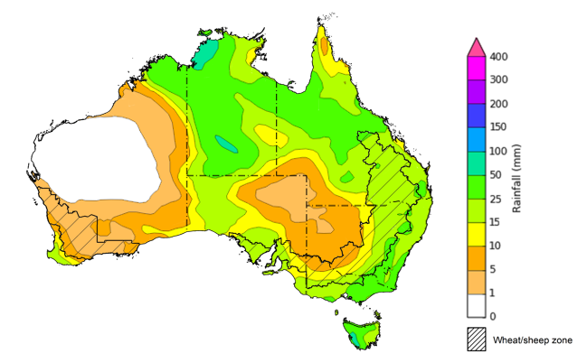
©Commonwealth of Australia 2026, Australian Bureau of Meteorology Issued: 29/10/2026
Note: This rainfall forecast is produced from computer models. As the model outputs are not altered by weather forecasters, it is important to check local forecasts and warnings issued by the Bureau of Meteorology.

Northern Rainfall Onset
The northern rainfall onset outlook provides an indication of whether the first significant rains after the dry season are likely to be earlier or later than normal. The onset occurs when the total rainfall after 1 September reaches 50 millimetres, which is considered approximately the amount of rainfall required to stimulate plant growth. The northern rainfall onset for the 2026–27 season has commenced early across much of the east and in parts central Australia, as well as isolated parts of the northern tropics.
Number of days earlier or later than the long-term average onset date
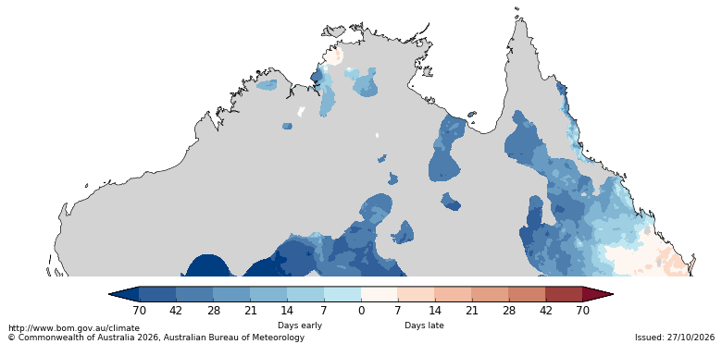
The northern rainfall onset has arrived early for some parts of Western Australia, the Northern Territory, and northern and central Queensland, where the onset is usually in November or December during an El Niño year. In contrast, the date of onset in south-eastern Queensland this season been slightly later than the historical median.
Northern rainfall onset - El Niño years median onset
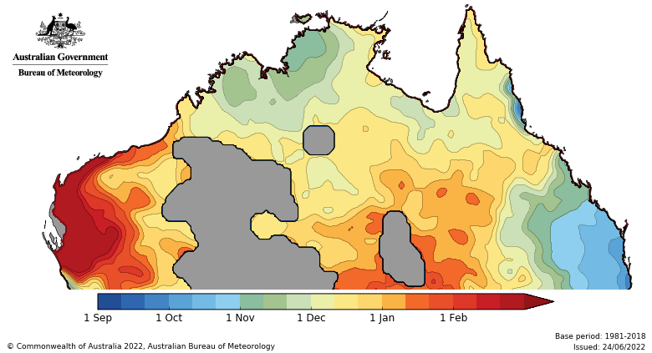

Water

Water markets – current week
Water storage levels in the Murray-Darling Basin (MDB) increased by 65 gigalitres (GL) between 22 October 2026 and 29 October 2026. The current volume of water held in storages is 14,996 GL, equivalent to 67% of total storage capacity. This is 1% or 137 GL more than the same time last year. Water storage data is sourced from the Bureau of Meteorology.

Weekly water storage levels in the Murray-Darling Basin, 2013–2026
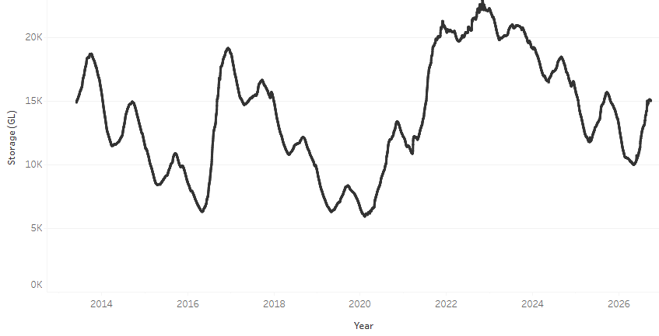
Allocation prices in the Victorian Murray below the Barmah Choke decreased from $324/ML on 22 October 2026 to $295/ML on 29 October 2026. Trade from the Goulburn to the Murray is closed. Trade downstream through the Barmah Choke is closed. Trade from the Murrumbidgee to the Murray is closed.

Monthly surface water trade activity 2022–2026, Victorian Murray below the Barmah Choke

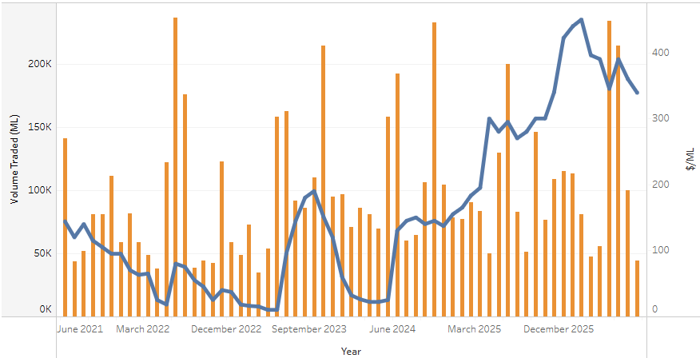

Weekly water market prices, Southern Murray–Darling Basin
Region | $/ML
NSW Murray Above | 195
NSW Murrumbidgee | 230
Vic Greater Goulburn | 268
Vic Murray Below | 295
Note: The water allocation prices shown are volume weighted average prices based on the last 10 trades. Price data is sourced from Waterflow and current as at 29 October 2026.
To access the full, interactive, weekly water dashboard, which contains the latest and historical water storage, water market and water allocation information, please visit https://www.agriculture.gov.au/abares/products/weekly_update/weekly-update-261029

Commodities
Indicator | Week average | Unit | Latest Price | Previous Week | Weekly change |  | Price 12 months ago | Annual change
Selected world indicator prices
AUD/USD Exchange rate | 28-Oct | A$/US$ | 0.70 | 0.70 | 0% | 0.65 |  | 7%
Wheat – US no. 2 hard red winter wheat, FOB Gulf | 28-Oct | US$/t | 299 | 308 | -3% | 231 |  | 30%
Corn – US no. 2 yellow corn, FOB Gulf | 28-Oct | US$/t | 211 | 214 | -1% | 198 |  | 7%
Canola – Rapeseed, Canada, FOB Vancouver | 28-Oct | US$/t | 594 | 595 | 0% | 473 |  | 26%
Cotton – Cotlook A Index | 28-Oct | USc/lb | 90.6 | 91.7 | -1% | 76.1 |  | 19%
Sugar – Intercontinental Exchange, nearby futures, no.11 contract | 28-Oct | USc/lb | 19.2 | 20.4 | -6% | 15.6 |  | 22%
Wool – Eastern Market Indicator | 28-Oct | Ac/kg clean | 1,723 | 1,785 | -3% | 1,476 |  | 17%
Wool – Western Market Indicator | 28-Oct | Ac/kg clean | 1,954 | 1,954 | 0% | 1,622 |  | 20%
Selected Australian grain export prices
Australian Premium White (APW) Wheat, FOB Port Adelaide, SA | 28-Oct | A$/t | 419 | 428 | -2% | 372 |  | 13%
Australian Standard White (ASW) Wheat, FOB Port Adelaide, SA | 28-Oct | A$/t | 408 | 418 | -3% | 368 |  | 11%
Feed Barley – FOB Port Adelaide, SA | 28-Oct | A$/t | 357 | 363 | -2% | 350 |  | 2%
Canola – FOB Kwinana, WA | 28-Oct | A$/t | 794 | 793 | 0% | 794 |  | 0%
Grain Sorghum – FOB Brisbane, QLD | 28-Oct | A$/t | 447 | 453 | -1% | 405 |  | 10%
Selected domestic livestock indicator prices
Beef – Eastern Young Cattle Indicator | 28-Oct | Ac/kg cwt | 1,016 | 984 | 3% | 846 |  | 20%
Mutton – Mutton indicator (18–24 kg fat score 2–3), VIC | 28-Oct | Ac/kg cwt | 836 | 837 | 0% | 739 |  | 13%
Lamb – National Trade Lamb Indicator | 28-Oct | Ac/kg cwt | 1,163 | 1,161 | 0% | 1,108 |  | 5%
Pig – Eastern Seaboard (60.1–75 kg), NSW buyer price | 7-Oct | Ac/kg cwt | 365 | 367 | -1% | 461 |  | -21%
Live cattle – Light steers to Indonesia | 9-Sep | Ac/kg lwt | 450 | 440 | 2% | 440 |  | 2%
Global Dairy Trade (GDT) weighted average prices
Dairy – Whole milk powder | 21-Oct | US$/t | 3,760 | 3,605 | 4% | 3,653 |  | 3%
Dairy – Skim milk powder | 21-Oct | US$/t | 3,975 | 3,847 | 3% | 2,579 |  | 54%
Dairy – Cheddar cheese | 21-Oct | US$/t | 3,645 | 3,925 | -7% | 4,808 |  | -24%
Dairy – Anhydrous milk fat | 21-Oct | US$/t | 5,488 | 5,683 | -3% | 6,977 |  | -21%

Selected world indicator prices
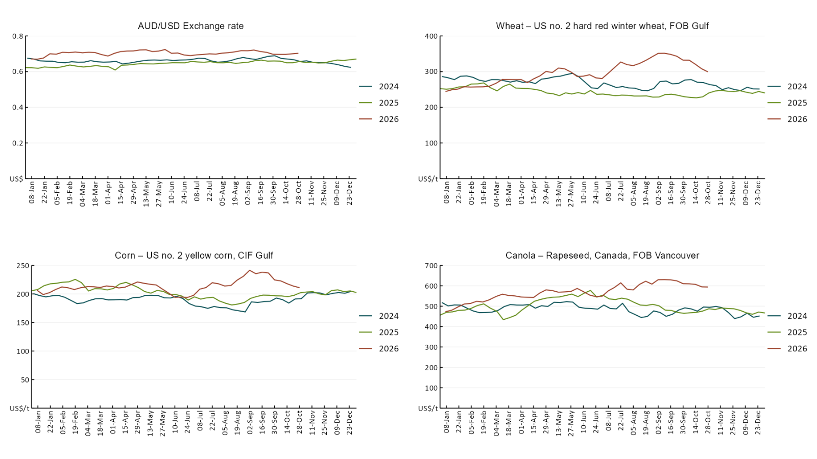

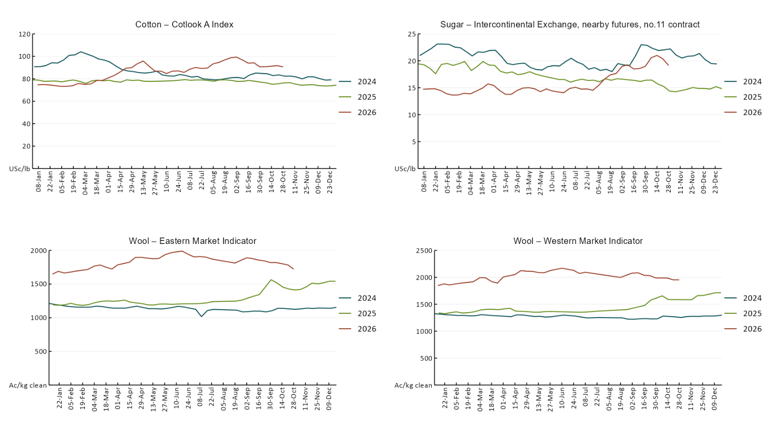

3.2 Selected domestic crop indicator prices
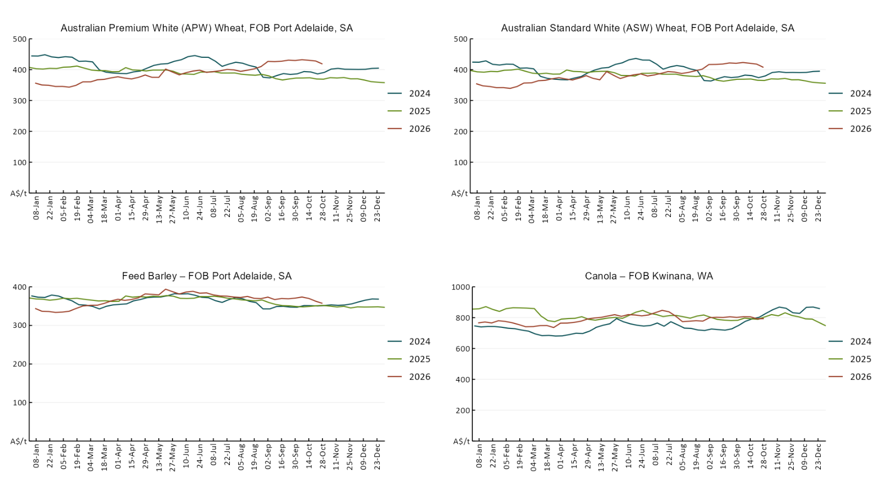

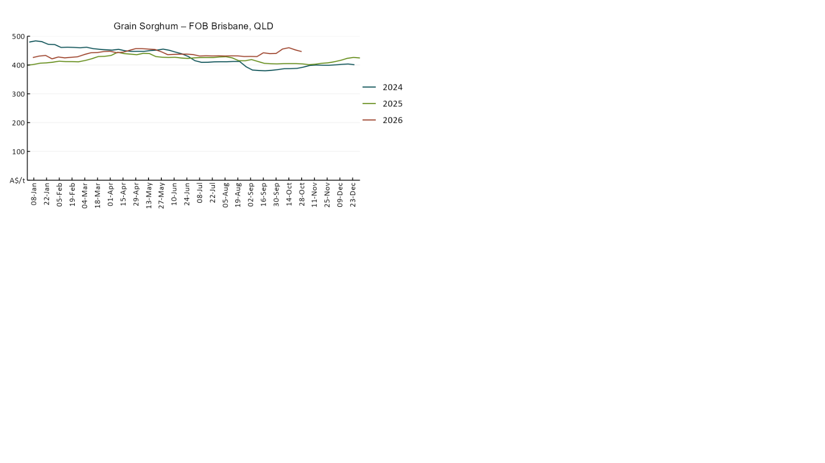

3.3 Selected domestic livestock indicator prices
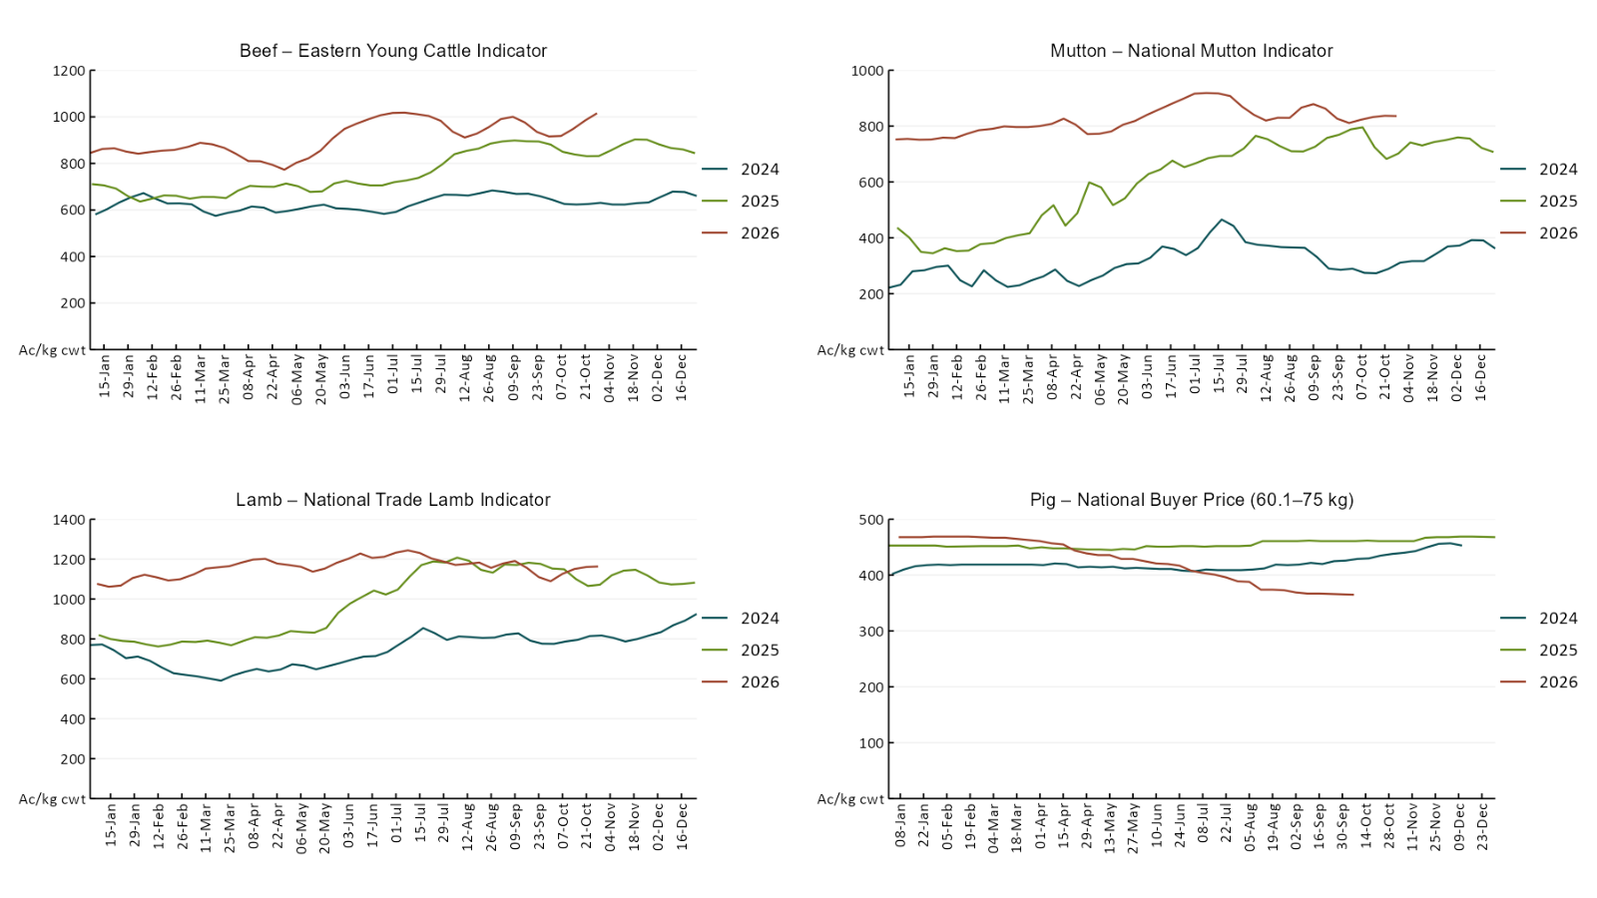

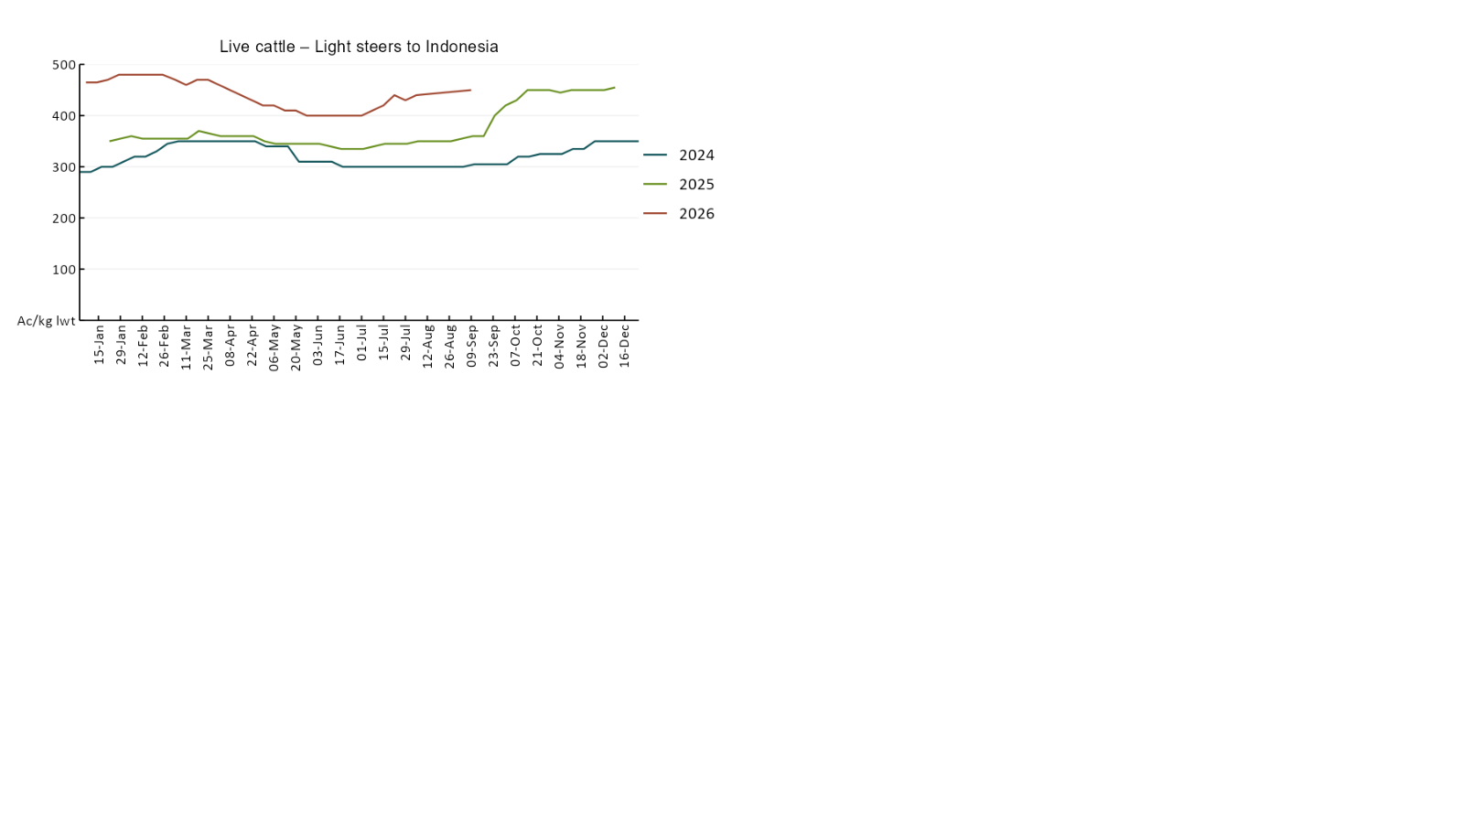

3.4 Global Dairy Trade (GDT) weighted average prices
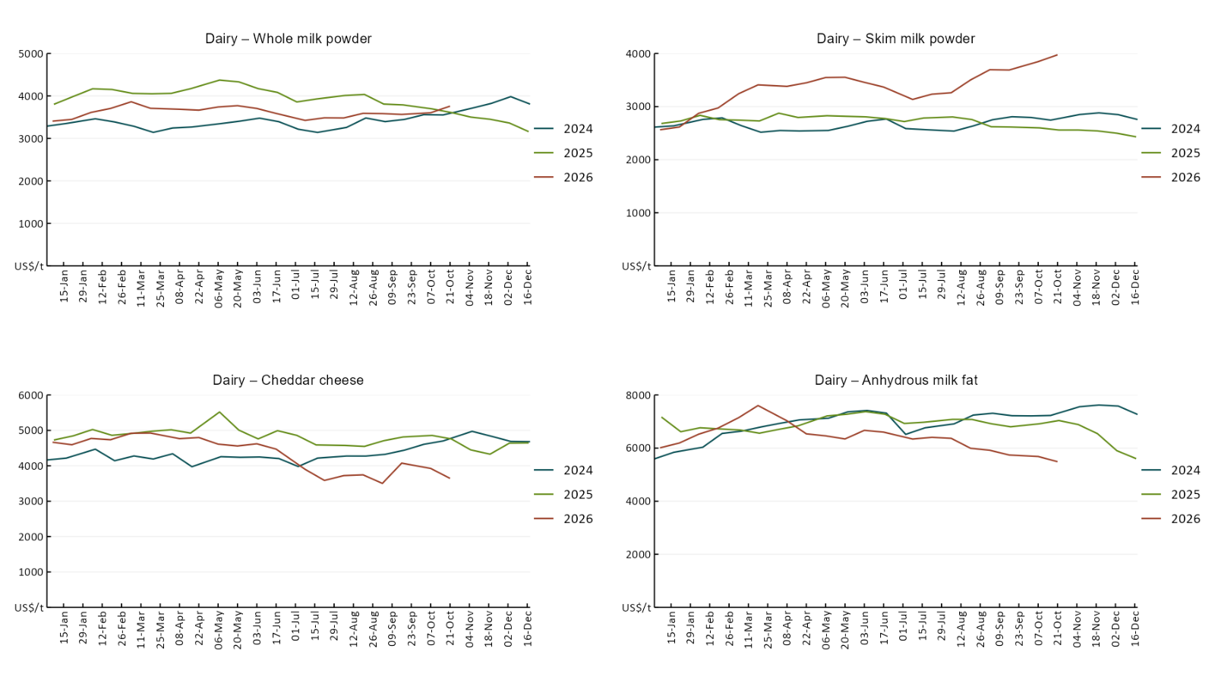

3.5 Selected fruit and vegetable prices
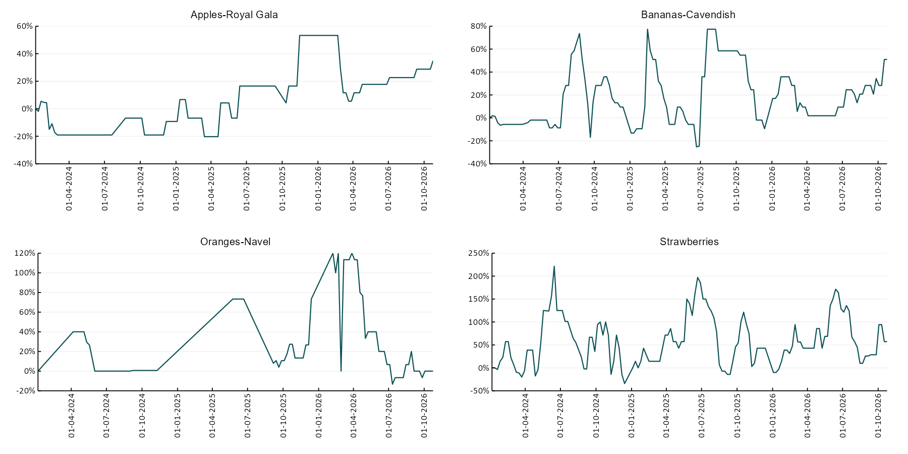

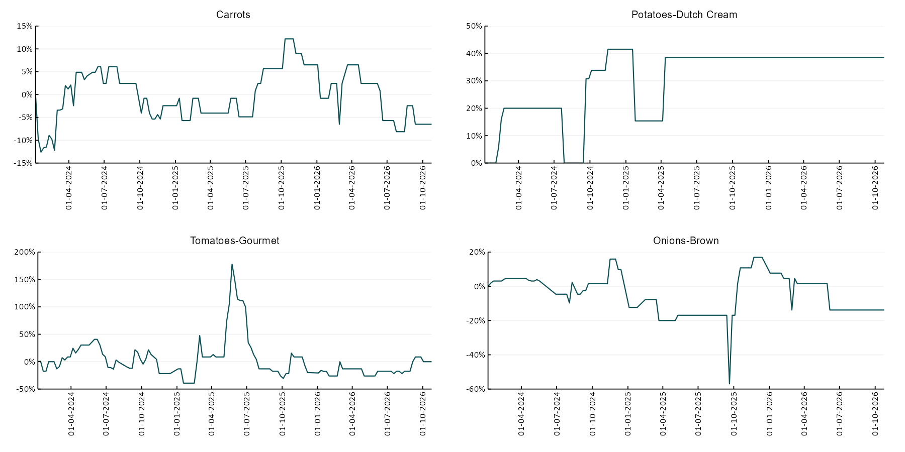

3.6 Selected domestic fodder indicator prices
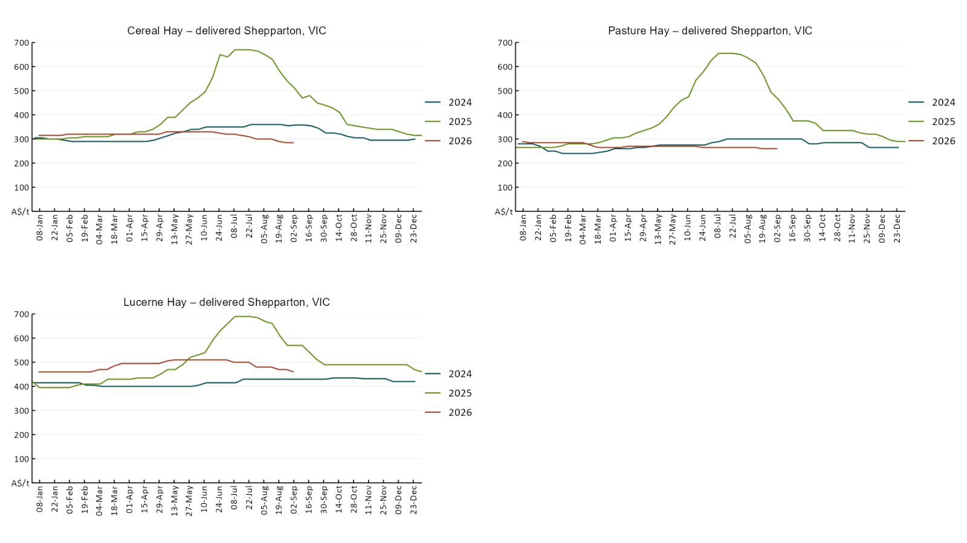

4. Data attribution

Climate
Bureau of Meteorology
- Weekly rainfall totals: www.bom.gov.au/climate/maps/rainfall/
- Monthly and last 3-month rainfall percentiles: https://www.bom.gov.au/climate/ahead/outlooks/#moreMaps
- Rainfall forecast: www.bom.gov.au/jsp/watl/rainfall/pme.jsp
- Seasonal outlook: www.bom.gov.au/climate/outlooks/#/overview/summary/
- Climate drivers: http://www.bom.gov.au/climate/enso/
- Soil moisture: https://awo.bom.gov.au/products/historical/soilMoisture-rootZone/

Other
- Pasture growth: www.longpaddock.qld.gov.au/aussiegrass/
- 3-month global outlooks: Environment and Climate Change Canada, NOAA Climate Prediction Center, EUROBRISA CPTEC/INPE, European Centre for Medium-Range Weather Forecasts, Hydrometcenter of Russia, National Climate Center Climate System Diagnosis and Prediction Room (NCC), International Research Institute for Climate and Society
- Global production: https://ipad.fas.usda.gov/ogamaps/cropmapsandcalendars.aspx
- Autumn break: Pook et al., 2009, https://rmets-onlinelibrary-wiley-com.virtual.anu.edu.au/doi/epdf/10.1002/joc.1833

Water
Prices
- Waterflow: https://www.waterflow.io/
- Ruralco: https://www.ruralcowater.com.au/
- Bureau of Meteorology:
- Allocation trade: http://www.bom.gov.au/water/dashboards/#/water-markets/mdb/at
- Storage volumes: http://www.bom.gov.au/water/dashboards/#/water-storages/summary/drainage

Trade constraints:
- Water NSW: https://www.waternsw.com.au/customer-service/ordering-trading-and-pricing/trading/murrumbidgee
- Victorian Water Register: https://www.waterregister.vic.gov.au/TradingRules2019/

Commodities
Fruit and vegetables
- Datafresh: www.freshstate.com.au

Pigs
- Australian Pork Limited: www.australianpork.com.au

Dairy
- Global Dairy Trade: www.globaldairytrade.info/en/product-results/

World wheat, canola
- International Grains Council: https://www.igc.int/en/default.aspx
- United States Department of Agriculture

World cotton
- Cotlook: www.cotlook.com/

World sugar
- New York Stock Exchange - Intercontinental Exchange

Wool
- Australian Wool Exchange: www.awex.com.au/

Domestic wheat, barley, sorghum, canola and fodder
- Jumbuk Consulting Pty Ltd: Jumbuk AG | Agriculture Consulting

Cattle, beef, mutton, lamb, goat and live export
- Meat and Livestock Australia: https://www.mla.com.au/prices-markets/

Australian Agricultural Drought Indicators
About Australian Agricultural Drought Indicators
- The Australian Agricultural Drought Indicators (AADI) project links weather and agricultural data with a range of scientific and economic models to measure and forecast the effects of climate variability and drought on agricultural outcomes.
On AADI, projected broadacre farm profits are presented as percentile outcomes relative to simulated historical outcomes using the groupings:
Highest | 95-100th percentile
Very much above average | 85-95th percentile
Above average | 65-85th percentile
Average | 35-65th percentile
Below average | 15-35th percentile
Very much below average | 5-15th percentile
Lowest 5% | 0-5th percentile

There are two AADI farm profit indicators:
- The AADI farm profit climate and price indicator shows the effect of climate and prices on broadacre farm business profits of current farms compared to the last 33 years.
- The AADI farm profit climate only indicator isolates the effect of climate on profits by holding prices fixed.

© Commonwealth of Australia 2026

Ownership of intellectual property rights
Unless otherwise noted, copyright (and any other intellectual property rights, if any) in this publication is owned by the Commonwealth of Australia (referred to as the Commonwealth).

Creative Commons licence
All material in this publication is licensed under a Creative Commons Attribution 4.0 International Licence except content supplied by third parties, logos and the Commonwealth Coat of Arms.
Inquiries about the licence and any use of this document should be emailed to copyright@aff.gov.au.


Cataloguing data
This publication (and any material sourced from it) should be attributed as:
ABARES 2026, Weekly Australian Climate, Water and Agricultural Update, Australian Bureau of Agricultural and Resource Economics and Sciences, Canberra, 29 October 2026. CC BY 4.0 DOI: https://doi.org/10.25814/5f3e04e7d2503
ISSN 2652-7561
This publication is available at https://www.agriculture.gov.au/abares/products/weekly_update
Department of Agriculture, Fisheries and Forestry
GPO Box 858 Canberra ACT 2601
Telephone 1800 900 090
Web agriculture.gov.au/abares

Disclaimer
The Australian Government acting through the Department of Agriculture, Fisheries and Forestry, represented by the Australian Bureau of Agricultural and Resource Economics and Sciences, has exercised due care and skill in preparing and compiling the information and data in this publication. Notwithstanding, the Department of Agriculture, Fisheries and Forestry, ABARES, its employees and advisers disclaim all liability, including liability for negligence and for any loss, damage, injury, expense or cost incurred by any person as a result of accessing, using or relying on any of the information or data in this publication to the maximum extent permitted by law.

Statement of Professional Independence
The views and analysis presented in ABARES publications, including this one, reflect ABARES professionally independent findings, based on scientific and economic concepts, principles, information and data. These views, analysis and findings may not reflect or be consistent with the views or positions of the Australian Government, or of organisations or groups who have commissioned ABARES reports or analysis. More information on professional independence is provided on the ABARES website.

Acknowledgements
This report was prepared by Holly Beale and Matthew Miller.

