
No. 43/2026 5 November 2026

Summary of key issues
- In the week ending 4 November 2026, low-pressure systems brought rainfall and storms to large areas of eastern and central Australia.
  - Cropping regions in Queensland and northern New South Wales saw between 5﻿- 100 and 5- 50 millimetres of rainfall respectively over the period. These falls are expected to support summer crop development and pasture growth but are likely to delay winter crop harvest activities and further planting of summer crops.
- Over the eight days from 5 to 12 November 2026, rainfall is forecast across much of the north and east of Australia.
  - Across eastern cropping regions, falls are expected to be higher in the north, with falls of 10- 50 millimetres in Queensland and10-25 millimetres in northern New South Wales.
  - If realised, these falls are likely to continues to support pasture growth and winter crop grain filling in remaining south-eastern cropping regions where winter cropping is concluding, and summer cropping activities in the northeast. However, following rainfall across many north-eastern regions in the past two week, these expected falls are likely to further delay winter crop harvest activities in these areas and increase the risk of grain quality downgrades due to excess moisture at harvest.
- Rainfall during October 2026 was above average across much of Australia, but below average across parts of the southwest and southeast.
  - Across eastern Australia, these conditions have significantly boosted soil moisture levels for summer crops already in the ground but also restricted access for further planting of summer crops and the harvest of remaining winter crops.
  - However, low rainfall across some cropping regions in the south has likely led to a drawdown of stored soil moisture levels to maintain winter crop yields and pasture growth.
- No water storage level update for the Murray-Darling Basin (MDB) is available this week.
- Allocation prices in the Victorian Murray below the Barmah Choke increased from $295/ML on 29 October 2026 to $297/ML on 05 November 2026. Trade from the Goulburn to the Murray is closed. Trade downstream through the Barmah Choke is closed. Trade from the Murrumbidgee to the Murray is open.

Climate

Rainfall this week
In the week ending 4 November 2026, low-pressure systems brought rainfall to large areas of eastern and northern Australia. Much of Western Australia remained comparatively dry.
- Falls of between 5-100 millimetres were recorded across much of Queensland and the Northern Territory, while eastern New South Wales saw 5-50 millimetres.
- Falls of 5-50 millimetres were also recorded across much of south-eastern Australia, including much of Victoria, Tasmania, and parts of South Australia.
- In contrast, much of Western Australia recorded little to no rainfall, except for the far southwest and northeast.
Across cropping regions, rainfall outcomes were mixed, with western and some southern cropping areas seeing little rainfall, while north-eastern areas saw considerable falls.
- Most cropping regions in Queensland saw between 5- 50 millimetres of rainfall over the period, with northern New South Wales seeing up to 25 millimetres in most areas.
  - These falls are expected to support summer crop development and pasture growth but are likely to delay further summer crop planting and winter crop harvest activities.
- In South Australia and Victoria, falls of between 5-25 millimetres were recorded.
  - These falls are likely to provide a timely boost to soil moisture levels to support late spring pasture growth and winter crop grain filling.
- Limited rainfall was recorded in Western Australia and southern New South Wales cropping regions

Rainfall for the week ending 4 November 2026
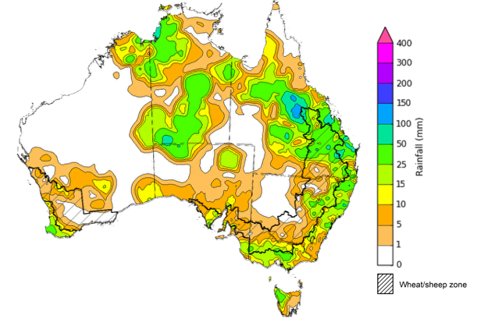
©Commonwealth of Australia 2026, Australian Bureau of Meteorology Issued: 4/11/2026
Note: The rainfall analyses and associated maps utilise data contained in the Bureau of Meteorology climate database, the Australian Data Archive for Meteorology (ADAM). The analyses are initially produced automatically from real-time data with limited quality control. They are intended to provide a general overview of rainfall across Australia as quickly as possible after the observations are received. For further information go to http://www.bom.gov.au/climate/rainfall/

Rainfall forecast for the next eight days
Over the eight days from 5 November to 12 November 2026, rainfall is forecast across much of northern and eastern Australia. Much of southern Western Australia, as well as parts of southern and central Australia are forecast to receive low rainfall or remain largely dry.
- Falls of 5-50 millimetres are forecast across much of Queensland, northern Western Australia, eastern and central New South Wales, Victoria, Tasmania and the Northern Territory.
  - Higher falls of up to 100 millimetres are forecast for parts of the far north.
- Little to no rainfall is forecast for southern Western Australia, western New South Wales or South Australia.
Across cropping regions, rainfall over the eight days to 12 November 2026 is forecast to be high in the east, with lower totals expected across southern and western regions.
- Across eastern cropping regions, falls are expected to be higher in the north, with falls of 10- 50 millimetres in Queensland and 10-25 millimetres in northern New South Wales. In contrast, falls of 5- 25 millimetres are forecast across southern New South Wales and Victoria.
  - If realised, these falls are likely to continues to support pasture growth and winter crop grain filling in the southeast, and summer cropping activities in the northeast. However, following rainfall across many north-eastern regions in the past two weeks, these expected falls are likely to further delay winter crop harvest activities in these areas and increase the risk of grain quality downgrades due to excess moisture at harvest.
- Western Australia and South Australia cropping regions are forecast to receive 1-10 millimetres.

Total forecast rainfall for the period 5 November to 12 November 2026
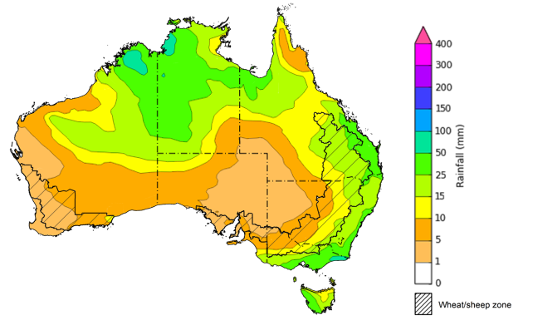
©Commonwealth of Australia 2026, Australian Bureau of Meteorology Issued: 5/11/2026
Note: This rainfall forecast is produced from computer models. As the model outputs are not altered by weather forecasters, it is important to check local forecasts and warnings issued by the Bureau of Meteorology.

Monthly rainfall
Rainfall during October 2026 was above average across much of Australia, including central Australia, Queensland and northern New South Wales, western and central Western Australia, and Victoria. Exceptions were observed in Tasmania, south-western Western Australia, central New South Wales, and parts of the far north.
Across cropping regions, October rainfall was generally very much above average in parts of the north and southeast, with the most pronounced deficiencies across southern Western Australia, as well as parts of central New South Wales.
- Most summer cropping regions including Queensland and northern New South Wales recorded above average to extremely high rainfall.
  - These conditions have significantly boosted soil moisture levels for summer crops already in the ground but also restricted access for further planting of summer crops and the harvest of remaining winter crops.
- Southern New South Wales and Western Australia generally recorded average to below average rainfall.
  - Rainfall deficiencies across some areas have likely resulted in a drawdown of stored soil moisture levels to maintain winter crop yields and pasture growth in these areas.
Rainfall deciles for October 2026
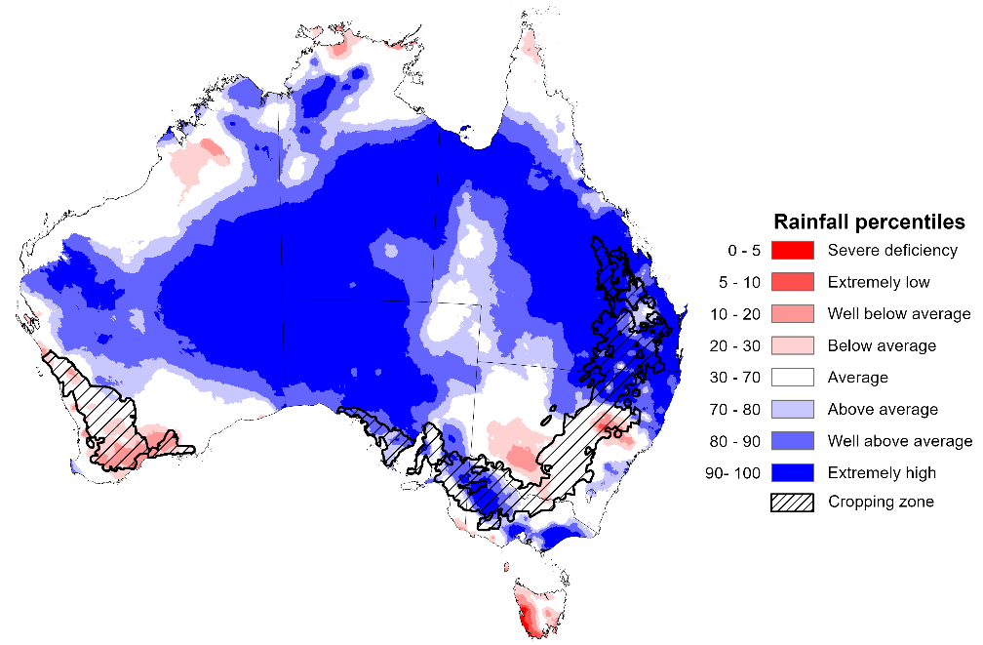
Note: Rainfall for October 2026 is compared with rainfall recorded for that period during the historical record (1900 to present). For further information, go to http://www.bom.gov.au/climate/austmaps/about-rain-maps.shtml
Source: Bureau of Meteorology

Monthly Soil Moisture
In October 2026, modelled upper layer soil moisture was generally average to above average across much of Australia, with parts of south-eastern and western Australia seeing below average modelled soil moisture.
- Much of Western Australia, South Australia, Queensland, the Northern Territory, and parts of northern New South Wales and Victoria saw above average to very much above average upper layer soil moisture.
- In contrast, much of Tasmania, as well as parts of Western Australia, southern New South Wales and western South Australia saw below average to extremely low upper layer soil moisture.
At this time of year, upper layer soil moisture is less critical for well-established winter crops. However, upper layer soil moisture will be critical for supporting the germination and establishment of summer crops in northern and eastern regions.
- Across cropping regions, modelled upper layer soil moisture in October was modelled to be average to very much above average for most cropping regions. Exceptions were modelled in isolated parts of Western Australia, and southern New South Wales with generally below average to very much below average upper layer soil moisture.
This represents a considerable improvement from September 2026 as a result high realised rainfall outcomes across much of the country.
Modelled upper layer soil moisture for October 2026
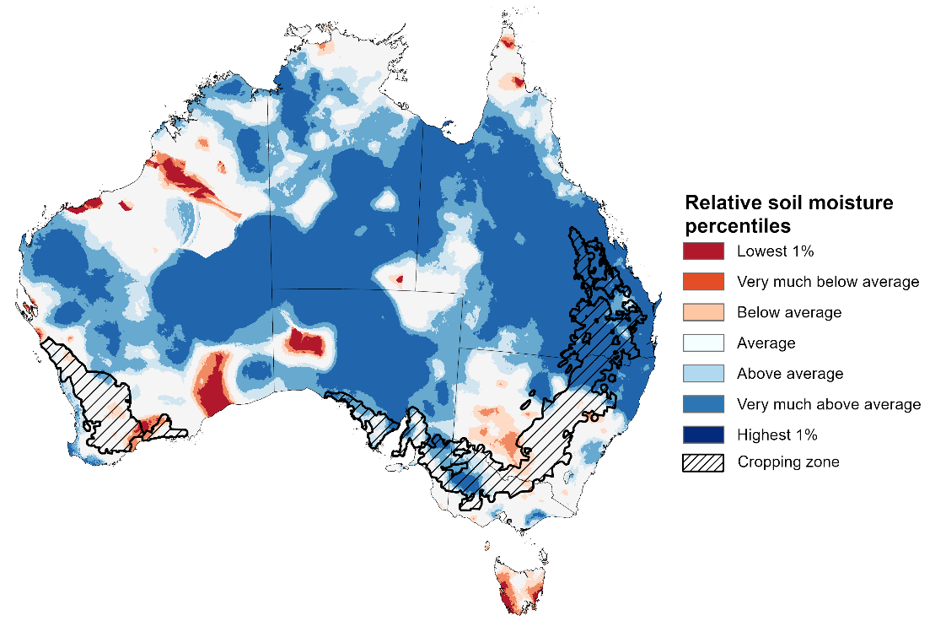
Note: This map shows the levels of modelled upper layer soil moisture (0 to 10 centimetres) during October 2026 This map shows how modelled soil conditions during October 2026 compare with October conditions modelled over the reference period (1911 to 2016). Dark blue areas on the maps were much wetter in October 2026 than during the reference period. The bulk of plant roots occur in the top 20 centimetres of the soil profile. Soil moisture in the upper layer of the soil profile is therefore useful indicator of the availability of water, particularly for germinating seed.
Source: Bureau of Meteorology (https://awo.bom.gov.au/about/overview)
Modelled lower layer soil moisture in October 2026 was average to very much above average across much of central Australia, while extremely low to below average modelled lower layer soil moisture was evident across large areas of south-eastern and western Australia.
- Parts of far northern Queensland, southern Victoria, central and eastern New South Wales, western South Australia, and south-western Western Australia were modelled as having extremely low to below average lower layer soil moisture. By contrast, much of the Northern Territory, the remainder of Queensland, South Australia, northern New South Wales, central Western Australia, and northern Victoria were modelled as having above average to very much above average soil moisture over the period.
Lower layer soil moisture is a larger, deeper store that is slower to respond to seasonal conditions and tends to reflect the accumulated effects of events that have occurred over longer periods. Crop development and pasture growth in areas of above average lower layer soil moisture are typically less reliant on in-season rainfall than in areas with below average lower layer soil moisture.
- Cropping regions in central and southern New South Wales and the west of Western Australia were modelled as having extremely low to below average soil moisture. In contrast, much of Queensland, northern New South Wales, Victoria, and South Australia recorded average to above average soil moisture for this time of year.
In areas with average to above average lower layer soil moisture across the far southeast, this is likely to provide a reserve of plant-available water to support winter crops and pasture growth over the remainder of spring. October 2026 modelling shows an improvement in soil moisture storage for much of the northeast compared to September 2026, which indicates adequate soil moisture reserves to support summer crop yield and positive pasture growth outcome across much of the northeast.
Modelled lower layer soil moisture for October 2026
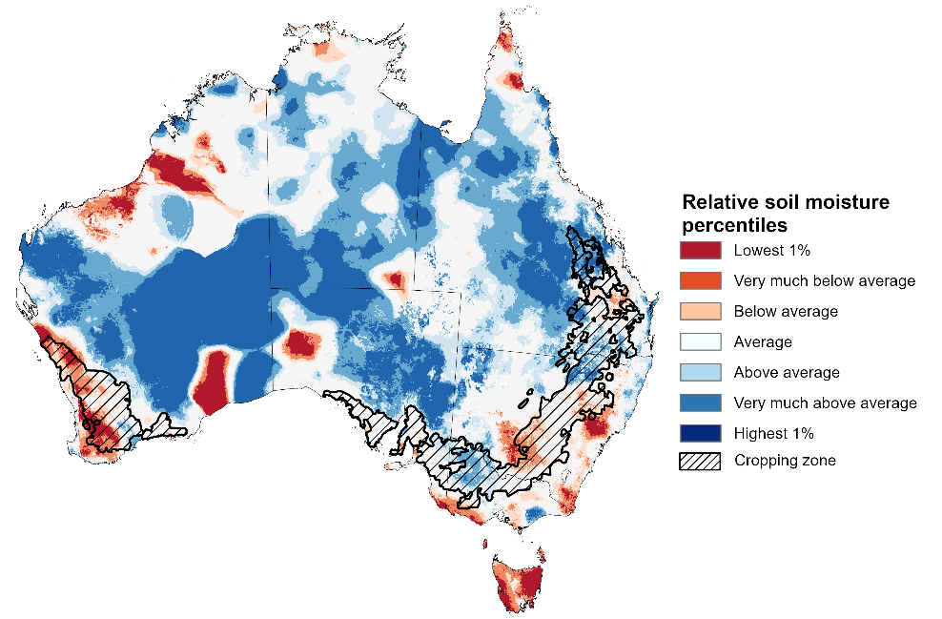
Note: This map shows how modelled soil conditions during October 2026 compare with October conditions modelled over the reference period (1911 to 2016). Dark blue areas on the maps were much wetter in October 2026 than during the reference period. The dark red areas were much drier than during the reference period. The bulk of plant roots occur in the top 20 centimetres of the soil profile. The lower layer soil moisture is a larger, deeper store that is slower to respond to rainfall and tends to reflect accumulated rainfall events over longer time periods.
Source: Bureau of Meteorology (https://awo.bom.gov.au/about/overview)

Pasture Growth
Pasture growth during the August to October period is typically low across large areas of central and northern Australia as it is firmly in the dry season. Across southern Australia, August to October pasture growth provides the spring flush which typically allows producers to cease winter supplementary feeding with grain and hay. It also influences the growth, branding and marking rates of lambs and calves, and the production of meat, milk, and wool over this peak production period.
Pasture growth for the three months to October 2026 was variable across much of country.
- Average to extremely high relative pasture growth was modelled across much of southern and central Australia.
  - This pasture growth is expected to have allowed many farmers to maintain livestock numbers and provided opportunities to build standing dry matter availability.
- In contrast, large areas of north-eastern Australia, and south-western and south-eastern regions, saw relatively low pasture growth for this time of year.
  - This below average pasture growth particularly across eastern Queensland has led to a decline in pasture availability. Graziers in regions where below average pasture growth was recorded will be more reliant on supplemental feed to maintain current stocking rates and production, with others choosing to destock to take advantage of relatively high saleyard prices.
Relative pasture growth for 3-months ending October 2026 (1 August to 31 October 2026)
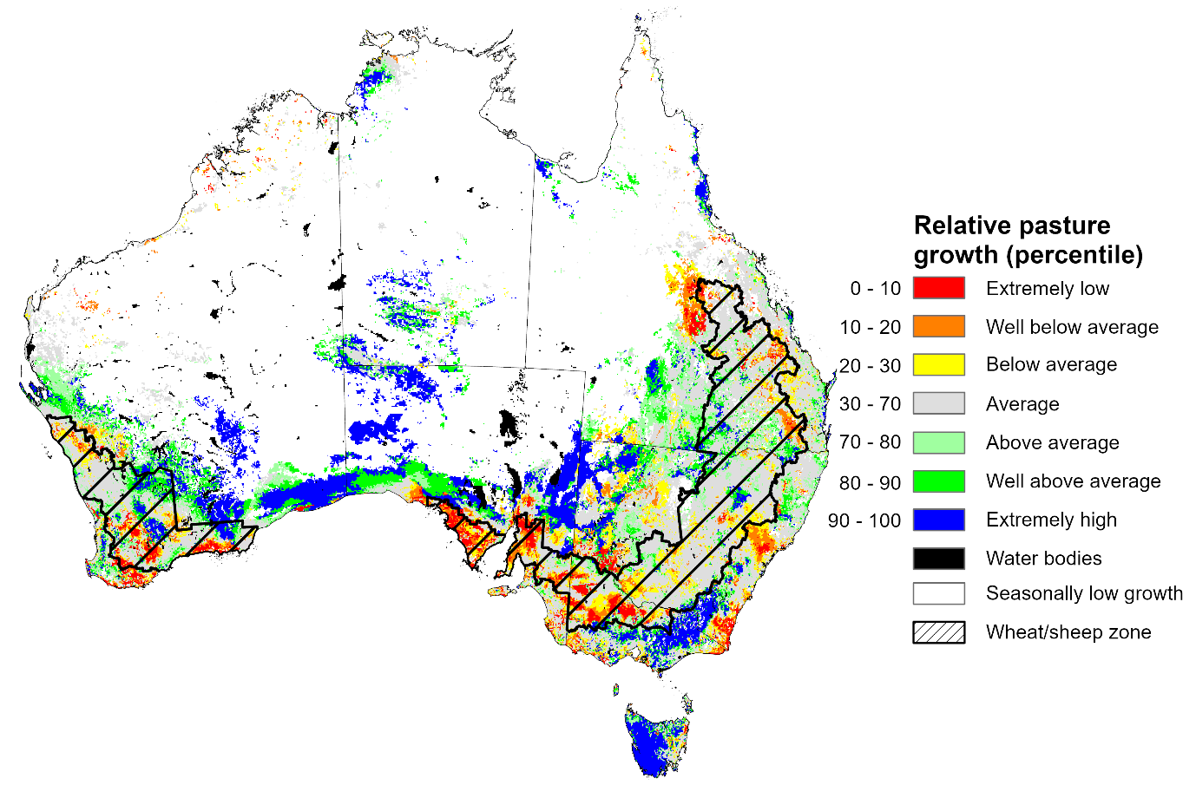

Notes: AussieGRASS pasture growth estimates are relative to the long-term record and shown in percentiles. Percentiles rank data on a scale of zero to 100. This analysis ranks pasture growth for the selected period against average pasture growth for the long-term record (1957 to 2016). Pasture growth is modelled at 5km2 grid cells.
Source: Department of Environment, Science and Innovation

Water

Water markets – current week
Allocation prices in the Victorian Murray below the Barmah Choke increased from $295/ML on 29 October 2026 to $297/ML on 05 November 2026. Trade from the Goulburn to the Murray is closed. Trade downstream through the Barmah Choke is closed. Trade from the Murrumbidgee to the Murray is open.

Weekly water market prices, Southern Murray–Darling Basin
Region | $/ML
NSW Murray Above | 210
NSW Murrumbidgee | 218
Vic Greater Goulburn | 250
Vic Murray Below | 297
Note: The water allocation prices shown are volume weighted average prices based on the last 10 trades. Price data is sourced from Waterflow and current as at 5 November 2026.
To access the full, interactive, weekly water dashboard, which contains the latest and historical water storage, water market and water allocation information, please visit https://www.agriculture.gov.au/abares/products/weekly_update/weekly-update-261105

Commodities
Indicator | Week average | Unit | Latest Price | Previous Week | Weekly change |  | Price 12 months ago | Annual change
Selected world indicator prices
AUD/USD Exchange rate | 4-Nov | A$/US$ | 0.70 | 0.70 | -1% | 0.65 |  | 7%
Wheat – US no. 2 hard red winter wheat, FOB Gulf | 4-Nov | US$/t | 293 | 297 | -2% | 246 |  | 19%
Corn – US no. 2 yellow corn, FOB Gulf | 4-Nov | US$/t | 213 | 211 | 1% | 202 |  | 6%
Canola – Rapeseed, Canada, FOB Vancouver | 4-Nov | US$/t | 605 | 599 | 1% | 488 |  | 24%
Cotton – Cotlook A Index | 4-Nov | USc/lb | 89.5 | 90.4 | -1% | 75.2 |  | 19%
Sugar – Intercontinental Exchange, nearby futures, no.11 contract | 4-Nov | USc/lb | 18.7 | 19.3 | -3% | 14.6 |  | 28%
Wool – Eastern Market Indicator | 28-Oct | Ac/kg clean | 1,723 | 1,785 | -3% | 1,474 |  | 17%
Wool – Western Market Indicator | 28-Oct | Ac/kg clean | 1,954 | 1,954 | 0% | 1,637 |  | 19%
Selected Australian grain export prices
Australian Premium White (APW) Wheat, FOB Port Adelaide, SA | 4-Nov | A$/t | 416 | 417 | 0% | 373 |  | 11%
Australian Standard White (ASW) Wheat, FOB Port Adelaide, SA | 4-Nov | A$/t | 405 | 406 | 0% | 370 |  | 10%
Feed Barley – FOB Port Adelaide, SA | 4-Nov | A$/t | 356 | 357 | 0% | 348 |  | 2%
Canola – FOB Kwinana, WA | 4-Nov | A$/t | 797 | 792 | 1% | 820 |  | -3%
Grain Sorghum – FOB Brisbane, QLD | 4-Nov | A$/t | 448 | 447 | 0% | 405 |  | 11%
Selected domestic livestock indicator prices
Beef – Eastern Young Cattle Indicator | 4-Nov | Ac/kg cwt | 1,037 | 1,022 | 1% | 886 |  | 17%
Mutton – Mutton indicator (18–24 kg fat score 2–3), VIC | 4-Nov | Ac/kg cwt | 863 | 843 | 2% | 741 |  | 16%
Lamb – National Trade Lamb Indicator | 4-Nov | Ac/kg cwt | 1,177 | 1,166 | 1% | 1,132 |  | 4%
Pig – Eastern Seaboard (60.1–75 kg), NSW buyer price | 21-Oct | Ac/kg cwt | 363 | 365 | -1% | 464 |  | -22%
Live cattle – Light steers to Indonesia | 9-Sep | Ac/kg lwt | 450 | 440 | 2% | 449 |  | 0%
Global Dairy Trade (GDT) weighted average prices
Dairy – Whole milk powder | 4-Nov | US$/t | 3,971 | 3,760 | 6% | 3,478 |  | 14%
Dairy – Skim milk powder | 4-Nov | US$/t | 4,109 | 3,975 | 3% | 2,551 |  | 61%
Dairy – Cheddar cheese | 4-Nov | US$/t | 3,970 | 3,645 | 9% | 4,389 |  | -10%
Dairy – Anhydrous milk fat | 4-Nov | US$/t | 5,306 | 5,488 | -3% | 6,715 |  | -21%

Selected world indicator prices
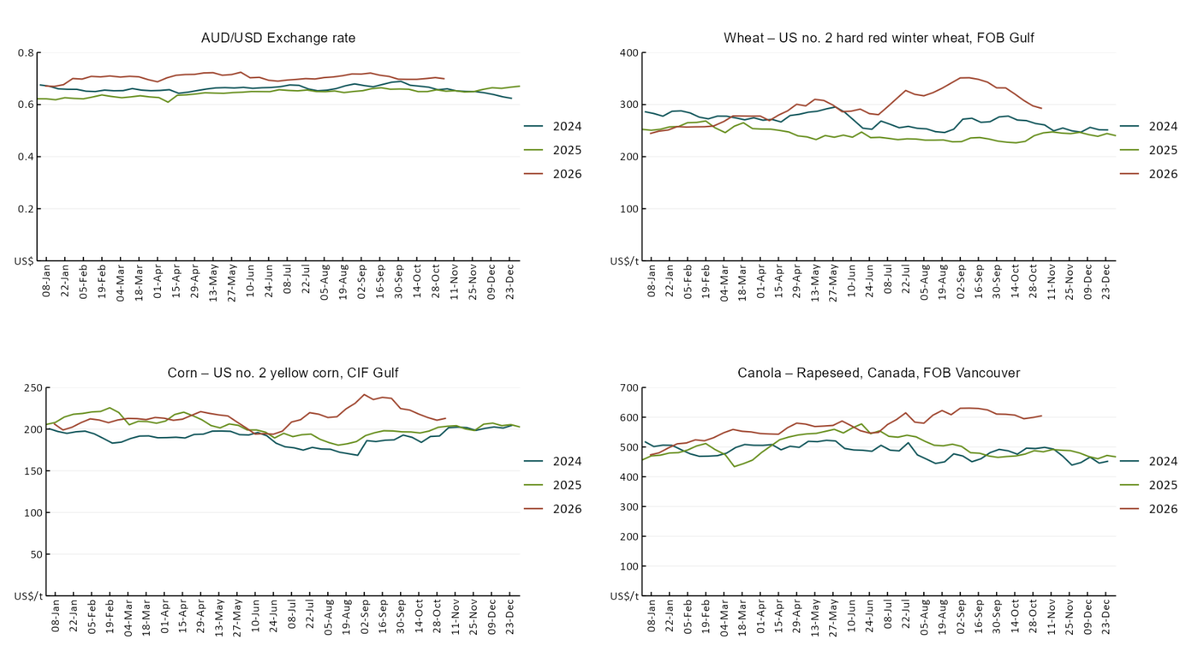

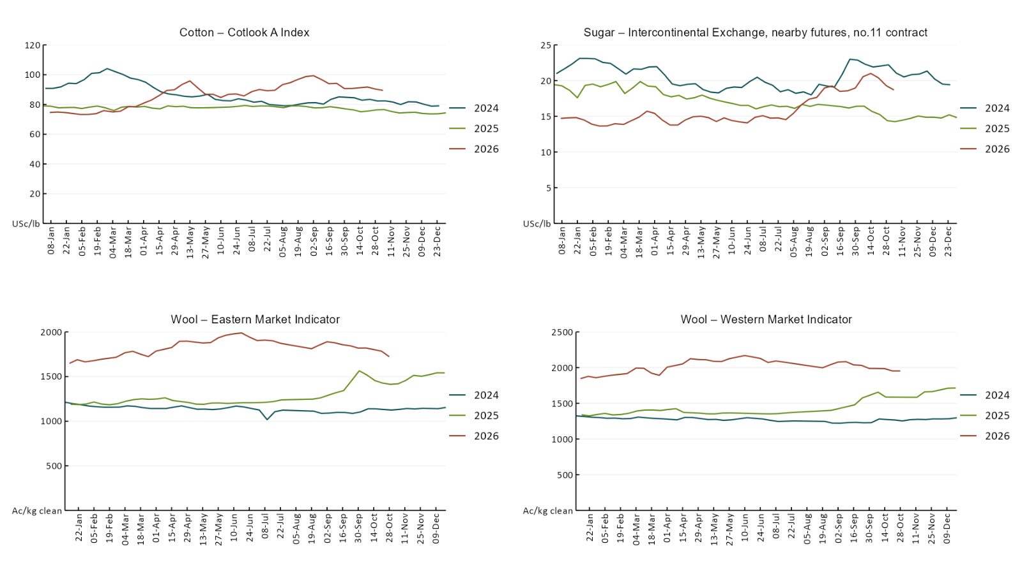

3.2 Selected domestic crop indicator prices
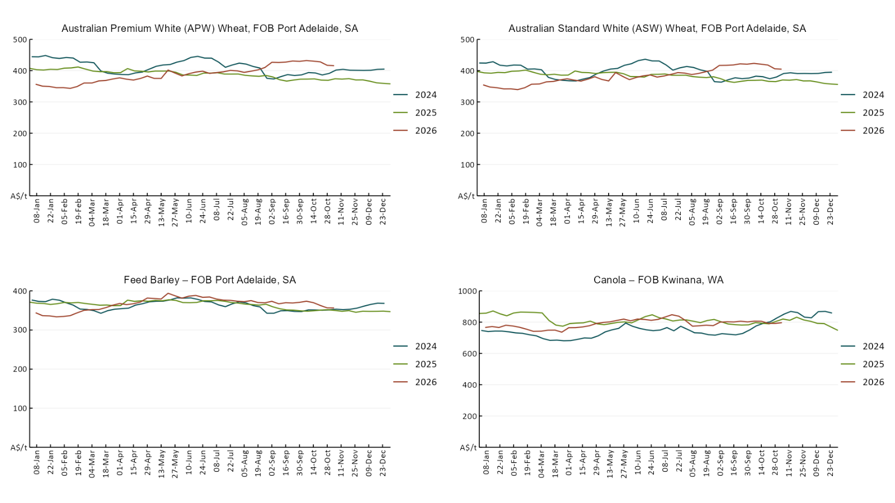

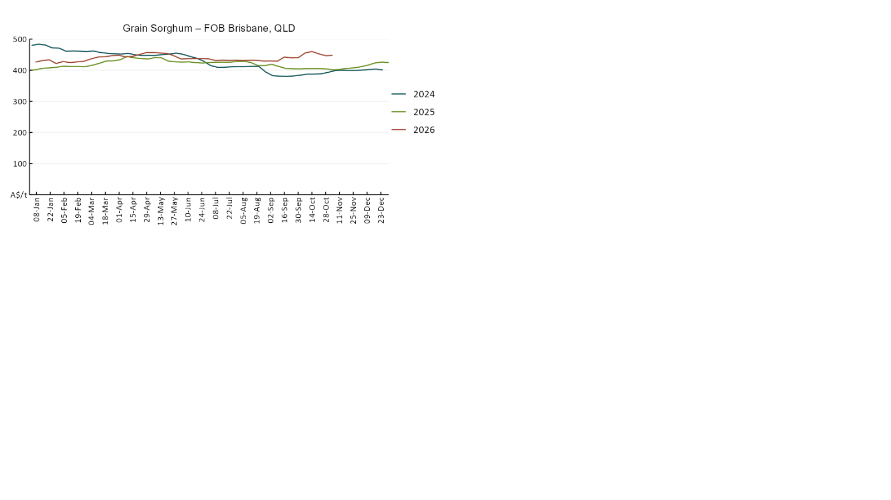

3.3 Selected domestic livestock indicator prices
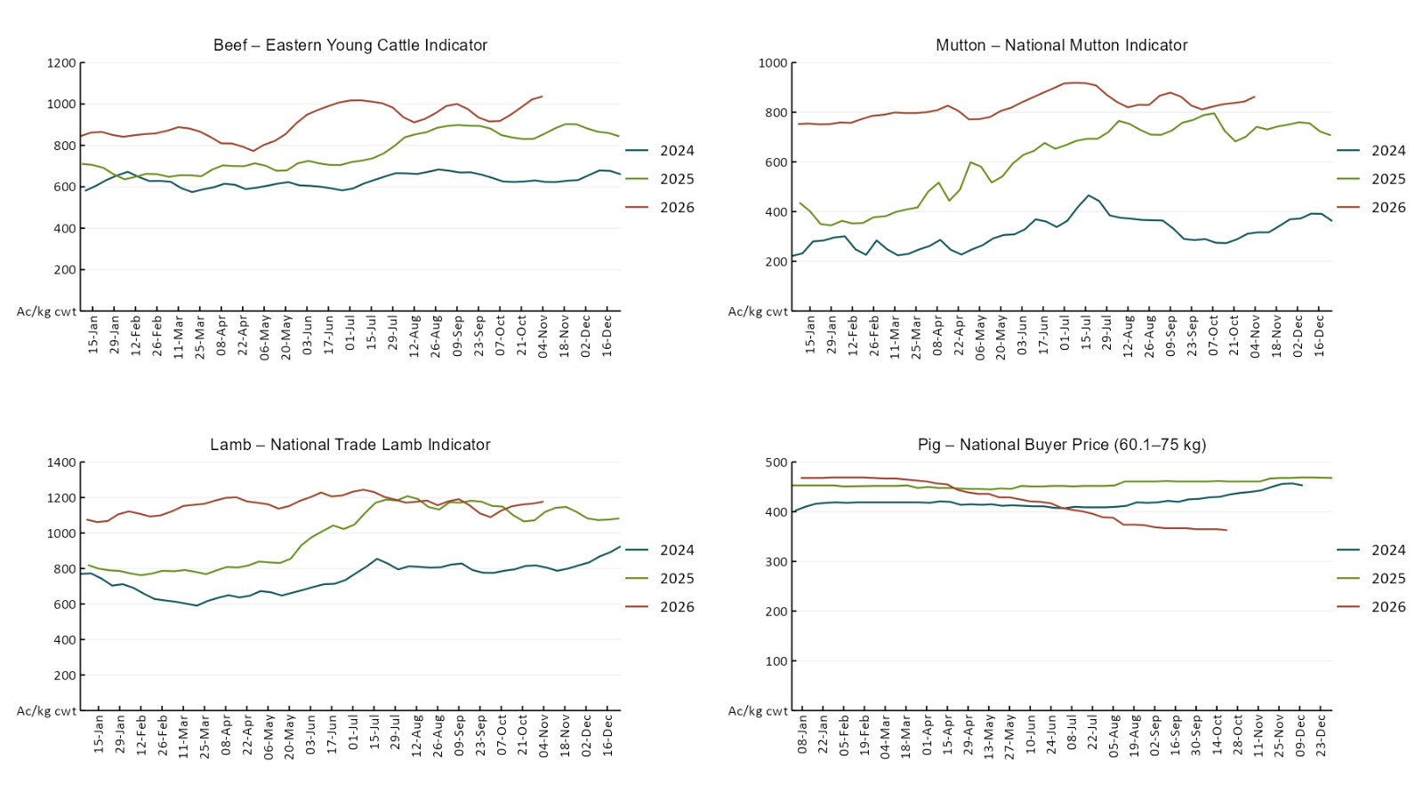

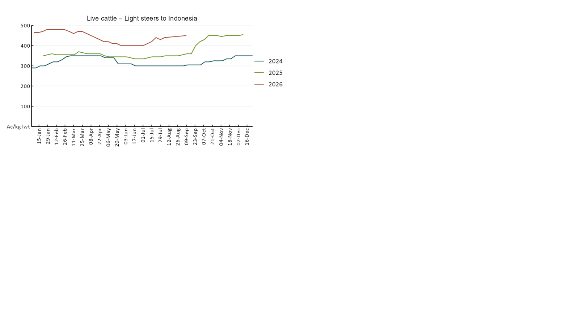

3.4 Global Dairy Trade (GDT) weighted average prices
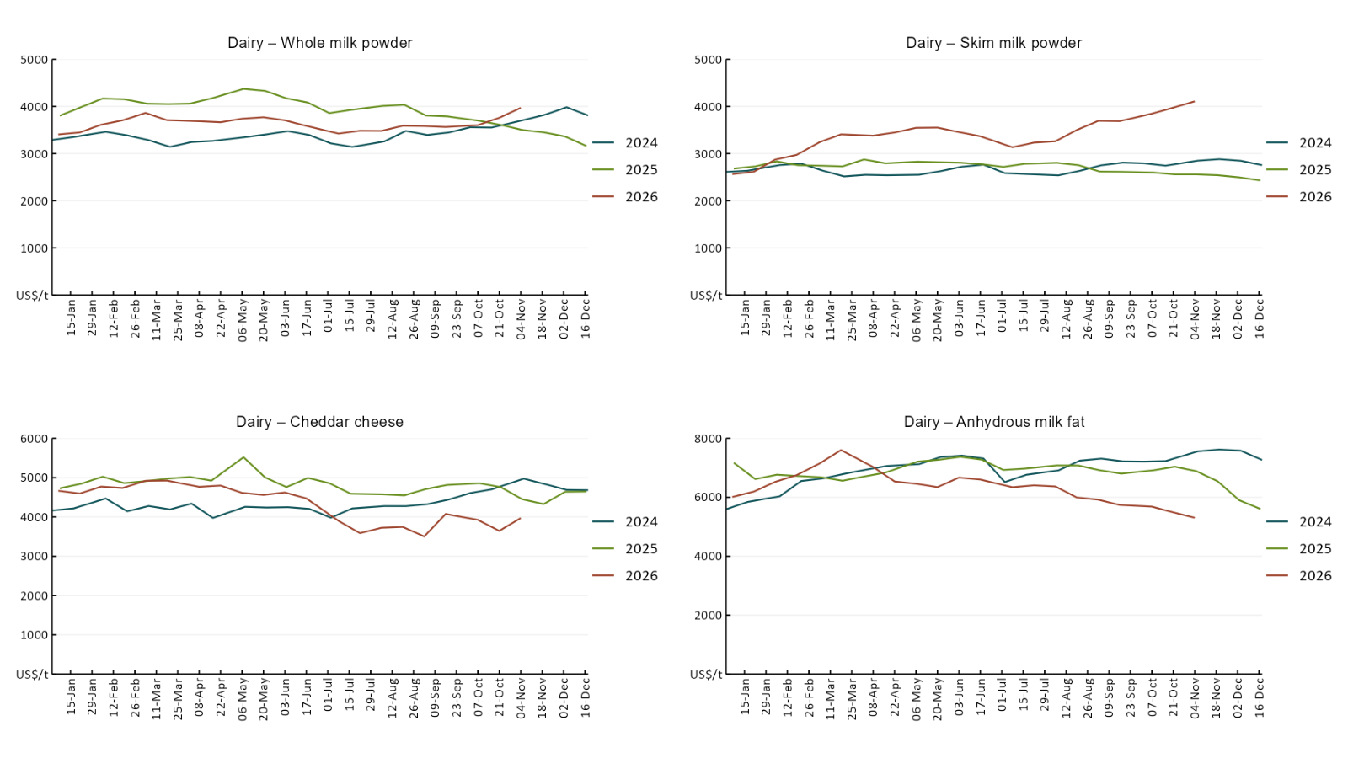

3.5 Selected fruit and vegetable prices
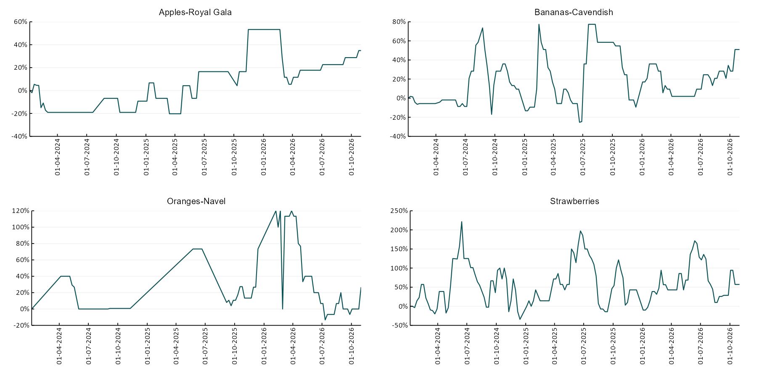

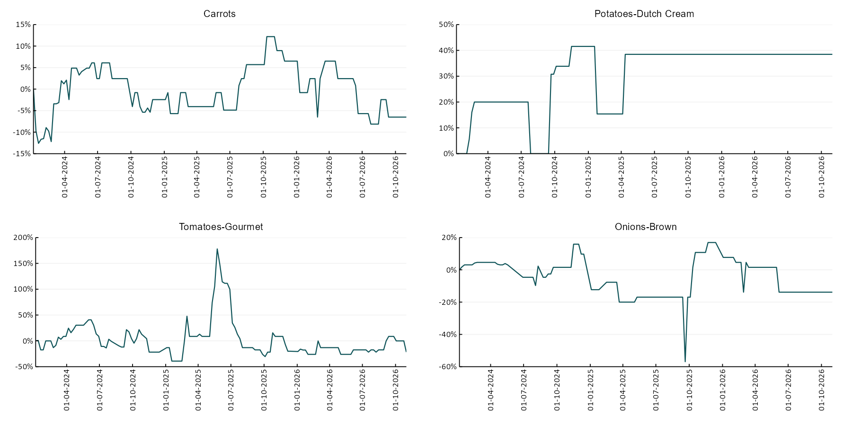

3.6 Selected domestic fodder indicator prices
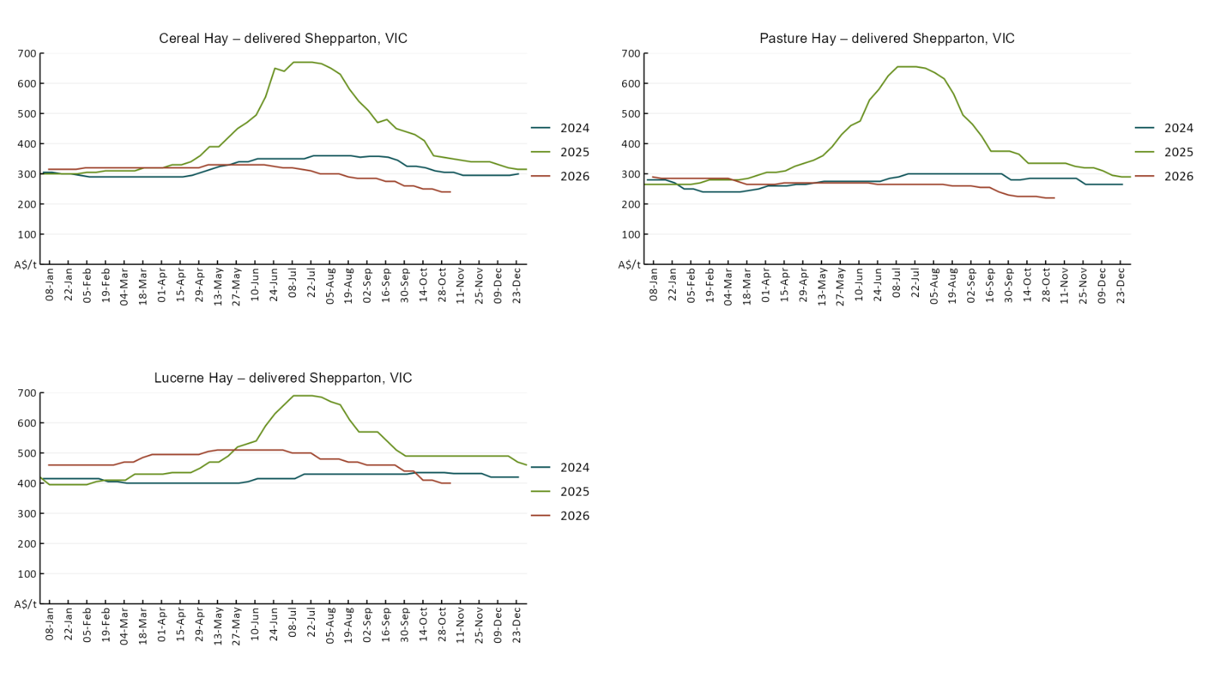

4. Data attribution

Climate
Bureau of Meteorology
- Weekly rainfall totals: www.bom.gov.au/climate/maps/rainfall/
- Monthly and last 3-month rainfall percentiles: https://www.bom.gov.au/climate/ahead/outlooks/#moreMaps
- Rainfall forecast: www.bom.gov.au/jsp/watl/rainfall/pme.jsp
- Seasonal outlook: www.bom.gov.au/climate/outlooks/#/overview/summary/
- Climate drivers: http://www.bom.gov.au/climate/enso/
- Soil moisture: https://awo.bom.gov.au/products/historical/soilMoisture-rootZone/

Other
- Pasture growth: www.longpaddock.qld.gov.au/aussiegrass/
- 3-month global outlooks: Environment and Climate Change Canada, NOAA Climate Prediction Center, EUROBRISA CPTEC/INPE, European Centre for Medium-Range Weather Forecasts, Hydrometcenter of Russia, National Climate Center Climate System Diagnosis and Prediction Room (NCC), International Research Institute for Climate and Society
- Global production: https://ipad.fas.usda.gov/ogamaps/cropmapsandcalendars.aspx
- Autumn break: Pook et al., 2009, https://rmets-onlinelibrary-wiley-com.virtual.anu.edu.au/doi/epdf/10.1002/joc.1833

Water
Prices
- Waterflow: https://www.waterflow.io/
- Ruralco: https://www.ruralcowater.com.au/
- Bureau of Meteorology:
- Allocation trade: http://www.bom.gov.au/water/dashboards/#/water-markets/mdb/at
- Storage volumes: http://www.bom.gov.au/water/dashboards/#/water-storages/summary/drainage

Trade constraints:
- Water NSW: https://www.waternsw.com.au/customer-service/ordering-trading-and-pricing/trading/murrumbidgee
- Victorian Water Register: https://www.waterregister.vic.gov.au/TradingRules2019/

Commodities
Fruit and vegetables
- Datafresh: www.freshstate.com.au

Pigs
- Australian Pork Limited: www.australianpork.com.au

Dairy
- Global Dairy Trade: www.globaldairytrade.info/en/product-results/

World wheat, canola
- International Grains Council: https://www.igc.int/en/default.aspx
- United States Department of Agriculture

World cotton
- Cotlook: www.cotlook.com/

World sugar
- New York Stock Exchange - Intercontinental Exchange

Wool
- Australian Wool Exchange: www.awex.com.au/

Domestic wheat, barley, sorghum, canola and fodder
- Jumbuk Consulting Pty Ltd: Jumbuk AG | Agriculture Consulting

Cattle, beef, mutton, lamb, goat and live export
- Meat and Livestock Australia: https://www.mla.com.au/prices-markets/

Australian Agricultural Drought Indicators
About Australian Agricultural Drought Indicators
- The Australian Agricultural Drought Indicators (AADI) project links weather and agricultural data with a range of scientific and economic models to measure and forecast the effects of climate variability and drought on agricultural outcomes.
On AADI, projected broadacre farm profits are presented as percentile outcomes relative to simulated historical outcomes using the groupings:
Highest | 95-100th percentile
Very much above average | 85-95th percentile
Above average | 65-85th percentile
Average | 35-65th percentile
Below average | 15-35th percentile
Very much below average | 5-15th percentile
Lowest 5% | 0-5th percentile

There are two AADI farm profit indicators:
- The AADI farm profit climate and price indicator shows the effect of climate and prices on broadacre farm business profits of current farms compared to the last 33 years.
- The AADI farm profit climate only indicator isolates the effect of climate on profits by holding prices fixed.

© Commonwealth of Australia 2026

Ownership of intellectual property rights
Unless otherwise noted, copyright (and any other intellectual property rights, if any) in this publication is owned by the Commonwealth of Australia (referred to as the Commonwealth).

Creative Commons licence
All material in this publication is licensed under a Creative Commons Attribution 4.0 International Licence except content supplied by third parties, logos and the Commonwealth Coat of Arms.
Inquiries about the licence and any use of this document should be emailed to copyright@aff.gov.au.


Cataloguing data
This publication (and any material sourced from it) should be attributed as:
ABARES 2026, Weekly Australian Climate, Water and Agricultural Update, Australian Bureau of Agricultural and Resource Economics and Sciences, Canberra, 5 November 2026. CC BY 4.0 DOI: https://doi.org/10.25814/5f3e04e7d2503
ISSN 2652-7561
This publication is available at https://www.agriculture.gov.au/abares/products/weekly_update
Department of Agriculture, Fisheries and Forestry
GPO Box 858 Canberra ACT 2601
Telephone 1800 900 090
Web agriculture.gov.au/abares

Disclaimer
The Australian Government acting through the Department of Agriculture, Fisheries and Forestry, represented by the Australian Bureau of Agricultural and Resource Economics and Sciences, has exercised due care and skill in preparing and compiling the information and data in this publication. Notwithstanding, the Department of Agriculture, Fisheries and Forestry, ABARES, its employees and advisers disclaim all liability, including liability for negligence and for any loss, damage, injury, expense or cost incurred by any person as a result of accessing, using or relying on any of the information or data in this publication to the maximum extent permitted by law.

Statement of Professional Independence
The views and analysis presented in ABARES publications, including this one, reflect ABARES professionally independent findings, based on scientific and economic concepts, principles, information and data. These views, analysis and findings may not reflect or be consistent with the views or positions of the Australian Government, or of organisations or groups who have commissioned ABARES reports or analysis. More information on professional independence is provided on the ABARES website.

Acknowledgements
This report was prepared by Holly Beale and Matthew Miller.

