AAMP Overview

Table of Contents
Before you start 1
What is AAMP? 1
Who can use AAMP? 1
How to access AAMP? 1
AAMP home page 2
My Approved Arrangements page 3
How to navigate within AAMP? 4
Approved Arrangement Details page 5
Contact Details page 6
Classes page 7
Notices page 10
Arrangement Documents page 10
Further information 11

AAMP is accessed through the TradeClear portal and uses multi-factor authentication to enhance user access and security. To access AAMP, you will need a unique email address and mobile phone number.

Before you start
This user guide provides an overview of what the Approved Arrangement Management Product (AAMP) is, who can use it, and how to use it to view and update your Approved Arrangement (AA) details.

What is AAMP?
1. AAMP is a web application biosecurity industry participants (BIPs) can use to view and update their approved arrangement details.
AAMP will minimise the need for you to email us with requests to update your AA details, simplifying and modernising AA administration.

Who can use AAMP?
2. The application is available for use by all BIPs operating under an approved arrangement under Chapter 7 of the Biosecurity Act 2015. Individuals who are listed as the AA Manager (or contact person for an arrangement) can register to use AAMP. This includes accessing the relevant arrangement details.

How to access AAMP?
3. To access AAMP, you will need to:

3.1 Be listed as a contact person (including as a manager) for an AA. Please note changes to class 19 AAs can only be made by the AA manager.
3.2 Complete sign up to TradeClear using the email address recorded by the department in your AA contact details.

3.3 After you sign up and sign in to AAMP the first time using the email address associated with that AA, you will be able to view and update details for each of your AAs using AAMP. Changes to class 19 AAs can only be made by the AA manager.

AAMP home page
4. The AAMP home page is the first page you see when you log in to AAMP.

4.1. You can click the navigation tiles to show the:  - ‘My Approved Arrangements’ page  - ‘Australian Biosecurity Import Conditions’ (BICON) external web site  - ‘Approved Arrangement Search Tool’ web page  - ‘Reportable biosecurity incidents’ web page  - Compose a new email to provide feedback to aa.canberra@aff.gov.au (as shown in figure 1) | 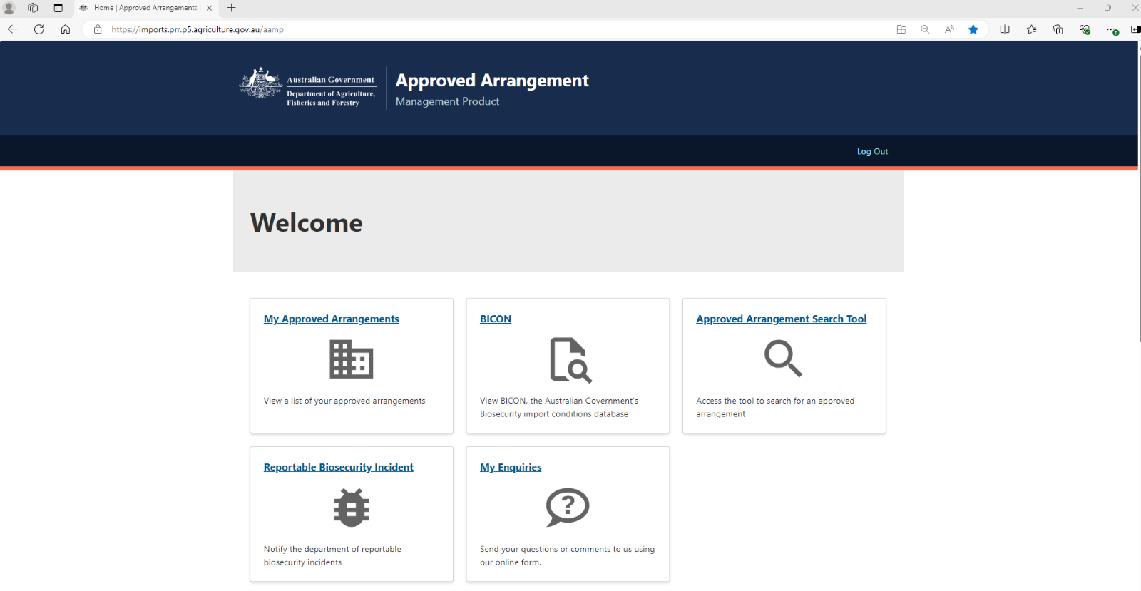  Figure 1: Screenshot of the AAMP home page navigation tiles.
4.2 The ‘Import Industry Advice Notices’ table shows updates and notices that are useful to industry. From the table, you can click on the ‘Title’ link to view the details of the notice (as shown in figure 2). | 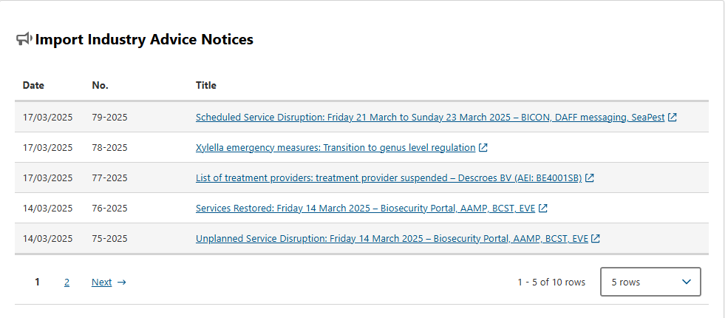  Figure 2: Screenshot of the ‘Import Industry Advice Notices’ section on the lower half of the AAMP home page.

My Approved Arrangements page
5. The ‘My Approved Arrangements’ page shows you a list of the AAs you are associated with and the classes, including class 19 AAs. You can view the information on the page by using the following steps:

5.1 From the ‘Approved Arrangements’ table, you can click on the ‘AA Number’ link to view the details for the selected AA (as shown in figure 3).  5.2 The AA class statuses and their definitions are:  - Applied – the class has been applied for under an application process  - Approved – the class has been approved  - Suspended – the class has been suspended  - Revoked – the class has been revoked  - Not Approved – the class is going to be revoked with a future effective date | 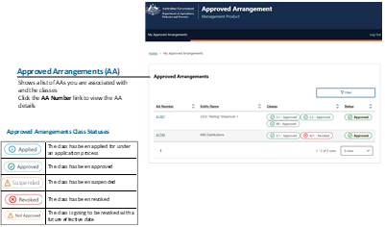  Figure 3: Screenshot of the ‘Approved Arrangements’ table on the ‘My Approved Arrangements’ page in AAMP. Also included is the table of Approved Arrangement class statuses.
5.3 The ‘Class 19 Approved Arrangements’ table will show if you are listed as a contact person for a class 19 AA. From the table, you can click the AA Number link to view the class 19 AA details (as shown in figure 4). | 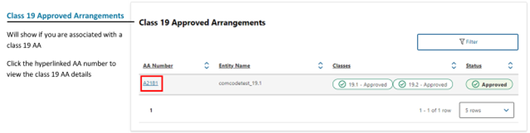  Figure 4: Screenshot of ‘Class 19 Approved Arrangements’ table on the ‘My Approved Arrangements’ page in AAMP.

How to navigate within AAMP?
6. You will be able to navigate within the AAMP web pages by using the following steps:

6.1 Using your mouse, you can click the:  - Header link to take you to the AAMP home page  - Top menu links to take you to the ‘My Approved Arrangements’ page or log out of AAMP  - AAMP Home menu which shows you the current page you are on and clicking on the links will take you to the indicated previous page, or  - Left menu links to navigate to the ‘Approved Arrangement Details’ page, ‘Contact Details’ page, ‘Co-Location Details’ page, ‘Classes’ page, ‘Notices’ page or ‘Arrangement Documents’ page, ‘Accredited Persons’ page, ‘Approved Arrangement Applications’ page for your selected Approved Arrangement (as shown in figure 5) | 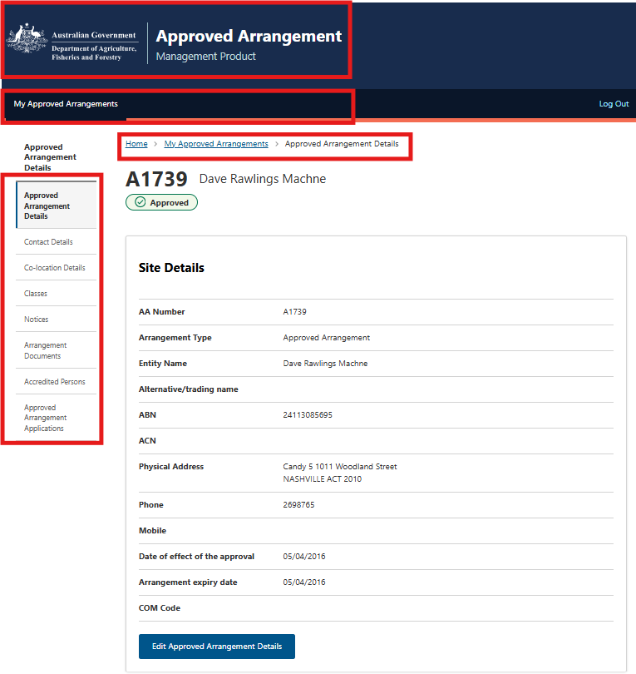  Figure 5: Screenshot of ‘Approved Arrangement Details’ page in AAMP.
6.2 You can click the footer links to show the Departments:  - External web site  - ‘Australian Biosecurity Import Conditions’ (BICON) external web site  - ‘Approved Arrangement Search Tool’ web page  - ‘Reportable Biosecurity Incident’ web page  - ‘Approved Arrangement’ web page  - ‘Accessibility’ web page  - ‘Disclaimer’ web page  - ‘Privacy’ web page  - Compose a new email to provide feedback to aa.canberra@aff.gov.au  - Biosecurity Portal web page (as shown in Figure 6). | 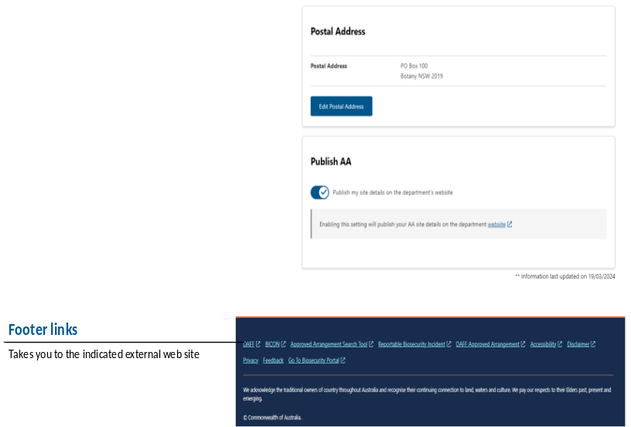  Figure 6: Screenshot of the footer links on the ‘Approved Arrangement Details’ page in AAMP.

Approved Arrangement Details page
7. The ‘Approved Arrangement Details’ page shows you the ‘Approved Arrangement Details’, ‘Contact Details’, ‘Co-location Details’, ‘Classes’, ‘Notices’, ‘Arrangement Documents’, ‘Accredited Persons’ and ‘Approved Arrangement applications’ for your selected AA. You can view the information on the page by using the following steps:

7.1 From the ‘Approved Arrangements Details’ page, you can view the status for your AA (as shown in figure 7).  7.2 The AA statuses and their definitions are:  - Applied – the arrangement has been applied for under an application for a new AA  - Approved – the arrangement has been approved  - Suspended – the arrangement has been suspended  - Revoked – the arrangement has been revoked  7.3 From the ‘Approved Arrangements Details’ table, you can click the ‘Edit Approved Arrangement Details’ button to edit the details for your AA (as shown in figure 7) | 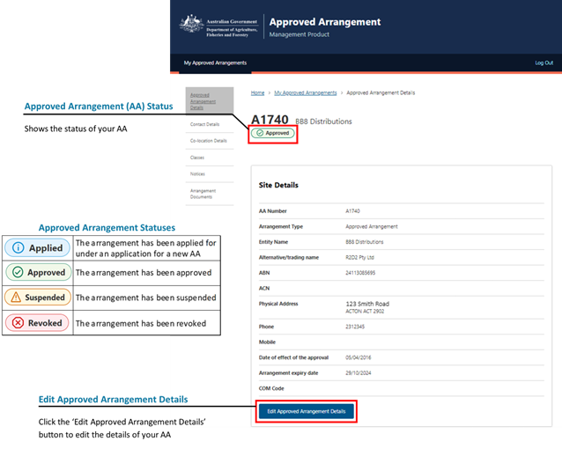  Figure 7: Screenshot of ‘Approved Arrangement Details’ page in AAMP.
7.4 From the ‘Postal Address’ table, you can select the ‘Edit Postal Address’ button to edit the postal address (as shown in figure 8).  7.5 From the ‘Publish AA’ section, you can slide the toggle to the right to publish your AA on the department web site (as shown in figure 8).  Note: The physical address can be updated for AAs with mobile classes 10s and 12s only.  Note: Class 19 AAs will not see the ‘Publish AA’ section on their AAMP.  Note: It will take one business day to update the publishing status on the department’s web site. | 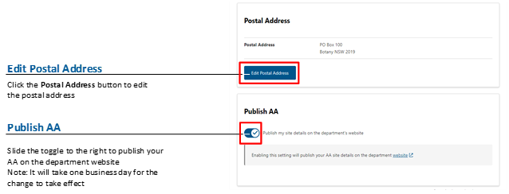  Figure 8: Screenshot of ‘Postal Address’ table and ‘Publish AA’ section from the ‘Approved Arrangement Details’ page for a non-class 19 AA in AAMP.

Contact Details page
8. The ‘Contact Details’ page shows you all the contacts associated with your selected AA, including the preferred contact, the postal address and emails of who you would like biosecurity directions issued through AIMs to be sent to. You can view the information on the page by using the following steps:

8.1 From the ‘Contact Details’ table, you can click the ‘Remove’ button to remove the selected contact (as shown in figure 9).  8.2 You can click the ‘Name’ link to view and edit the details for the selected contact (as shown in figure 9).  8.3 The star next to a contact name indicates this is the preferred contact (as shown in figure 9).  8.4 You can click the ‘Add New Contact’ button to add a new contact (as shown in figure 9).  Note: For further information regarding changing site contacts refer to the ‘Managing contacts in AAMP’ user guide available on the AAMP webpage | 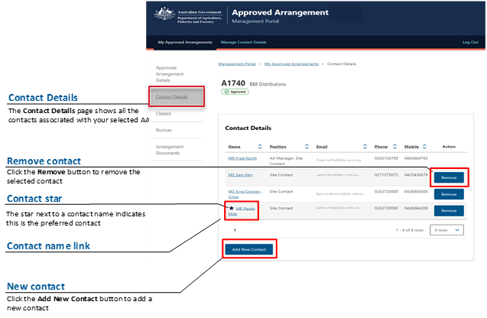  Figure 9: Screenshot of the ‘Contact Details’ page in AAMP.
8.5 From the ‘Postal Address’ table, you can select the ‘Edit Postal Address’ button to edit the postal address for your AA (as shown in figure 10).  Note: This will also update the postal address on the ‘Approved Arrangement Details’ page.  8.6 From the ‘Emails to receive biosecurity directions’ section, you can add and remove email addresses that will be made available in the department’s import management system for the issuing of biosecurity directions (as shown in figure 10).  Note: Class 19 AAs will not see the ‘Emails to receive biosecurity directions’ section on their AAMP. | 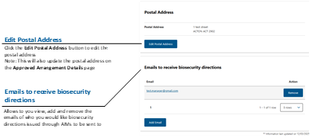  Figure 10: Screenshot of ‘Postal Address’ table and ‘Emails to receive biosecurity directions’ sections on the bottom portion of the ‘Contact Details’ page in a non-class 19 AA in AAMP.

Classes page
9. The ‘Classes’ page shows you all the classes for your selected AA, any non-standard conditions that have been varied as part of your AA and any directions issued (not applicable to class 19 AAs) under sections 421, 426 or 429 of the Biosecurity Act 2015. You can view the information on the page by using the following steps:

9.1 From the ‘Classes’ table, you can click the Class link to view the class conditions on the department ‘Approved Arrangements’ web page (as shown in figure 11).  You can click the class ‘History’ button to view the class status change history (as shown in figure 11).  9.2 From the ‘Non-Standard Conditions’ table, you can click the ‘File Name’ link to view the notice of variation for the selected non-standard condition (as shown in figure 11).  9.3 You can click the ‘Download’ button to download the notice of variation (as shown in figure 11).  Note: The ‘Non-Standard Conditions’ table will only show if your AA has non-standard conditions.  9.4 From the ‘Directions’ table, you can click the direction ‘History’ button to view the direction history (as shown in figure 11). | 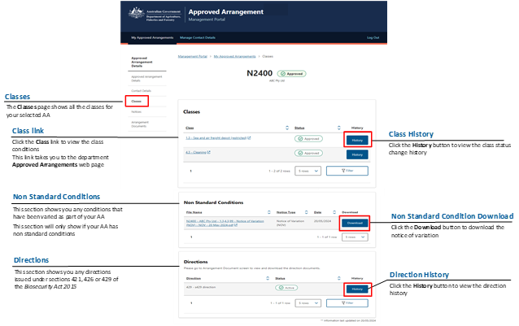  Figure 11: Screenshot of ‘Classes’ page, a left menu link of ‘Approved Arrangement Details’ page in AAMP.
9.5 From the ‘Varied Conditions’ table, you can click the ‘File Name’ link to view or download the notice of variation (as shown in figure 12).  Note: The ‘Varied Conditions’ table will only show if your AA has varied conditions. | 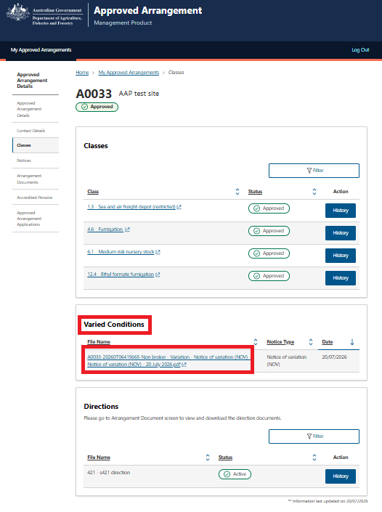  Figure 12: Screenshot of the ‘Varied Conditions’ table on the ‘Classes’ page in AAMP.
9.6 From the ‘Directions’ table, you can click the direction ‘History’ button to view the direction history (as shown in figure 13).  Note: The ‘Directions’ table will only show if your AA has directions under chapter 7 of the Biosecurity Act 2015 in relation to the operation of the arrangement. | 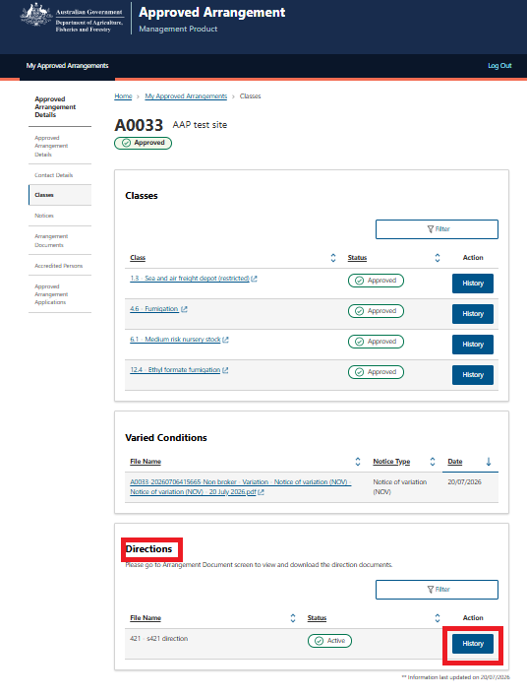  Figure 13: Screenshot of the ‘Directions’ table on the ‘Classes’ page in AAMP.

Notices page
10. The ‘Notices’ page allows you to view and download any notices associated with your AA. You can view the information on the page by using the following steps:

10.1 From the ‘Notices’ table, you can click the ‘File Name’ link to view or download your notice (as shown in figure 14).  10.2 You can click the ‘Filter’ button to filter specific types of notices for your AA (as shown in figure 14). | 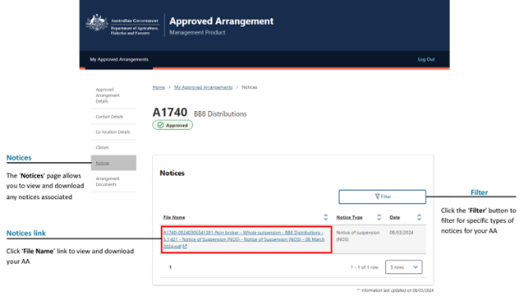  Figure 14: Screenshot of the ‘Notices’ page in AAMP.

Arrangement Documents page
11. The ‘Arrangement Documents’ page shows a list of any documents associated with your AA. You can view the information on the page by using the following steps:
11.1 From the ‘Arrangement Documents’ table, you can click the ‘File Name’ link to view and download your AA document (as shown in figure 15).  Note: A blue dot will show next to ‘Arrangement Documents’ in the left menu and ‘File Name’ link in the table to indicate there are new documents that have been added. | 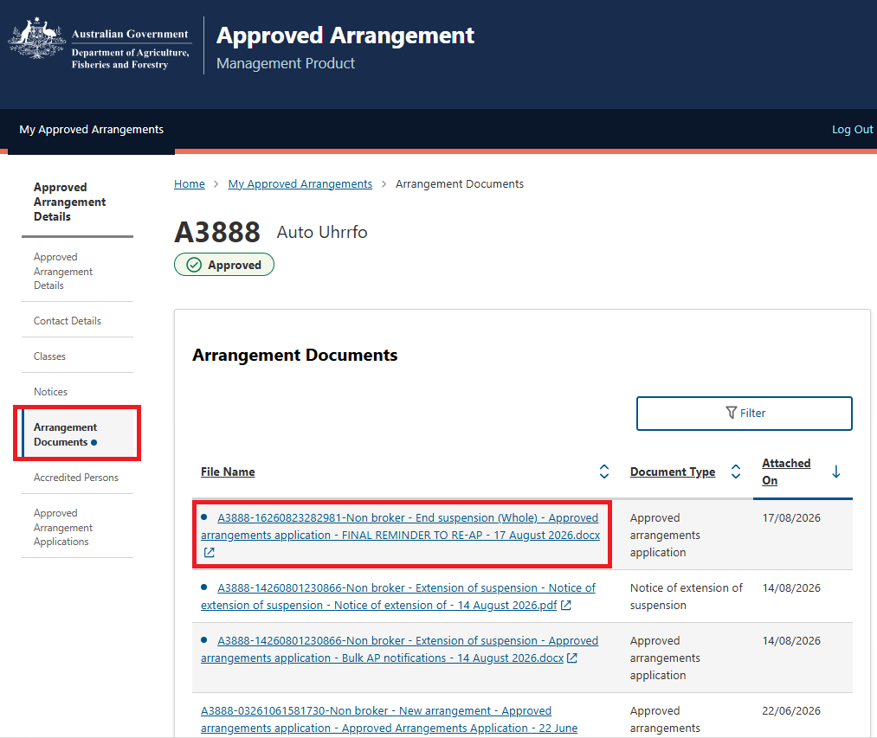  Figure 15: Screenshot of the ‘Arrangement Documents’ page in AAMP.

Further information
If you require further information or support, please email AA Canberra (aa.canberra@aff.gov.au) with your enquiry and approved arrangement details. Please include ‘AAMP’ in the subject field of your email.

Acknowledgement of Country
We acknowledge the Traditional Custodians of Australia and their continuing connection to land and sea, waters, environment, and community. We pay our respects to the Traditional Custodians of the lands we live and work on, their culture, and their Elders past and present.

© Commonwealth of Australia 2024
Unless otherwise noted, copyright (and any other intellectual property rights) in this publication is owned by the Commonwealth of Australia (referred to as the Commonwealth).
All material in this publication is licensed under a Creative Commons Attribution 4.0 International Licence except content supplied by third parties, logos and the Commonwealth Coat of Arms.
The Australian Government acting through the Department of Agriculture, Fisheries and Forestry has exercised due care and skill in preparing and compiling the information and data in this publication. Notwithstanding, the Department of Agriculture, Fisheries and Forestry, its employees and advisers disclaim all liability, including liability for negligence and for any loss, damage, injury, expense or cost incurred by any person as a result of accessing, using or relying on any of the information or data in this publication to the maximum extent permitted by law.

