Managing contacts in AAMP

Table of Contents
Before you start 1
Add a contact person to your AA 1
Edit details of a contact person for your AA 4
Remove a contact person from your AA 5
Further information 6

AAMP is accessed through the TradeClear portal and uses multi-factor authentication to enhance user access and security. To access AAMP, you will need a unique email address and mobile phone number.

Before you start
This user guide will show you how to add, update and remove a contact person for your AA using AAMP.
After you have signed up and signed into TradeClear, you will be able to add, update and remove contact persons (including managers) for each of your AAs using AAMP. Please note changes to class 19 AAs can only be made by the AA manager.

Add a contact person to your AA
1. Once you have accessed AAMP, you will be able to add a contact person to your AA by using the following steps:

- From the AAMP home page, click the ‘My Approved Arrangements’ tile (as shown in figure 1). | 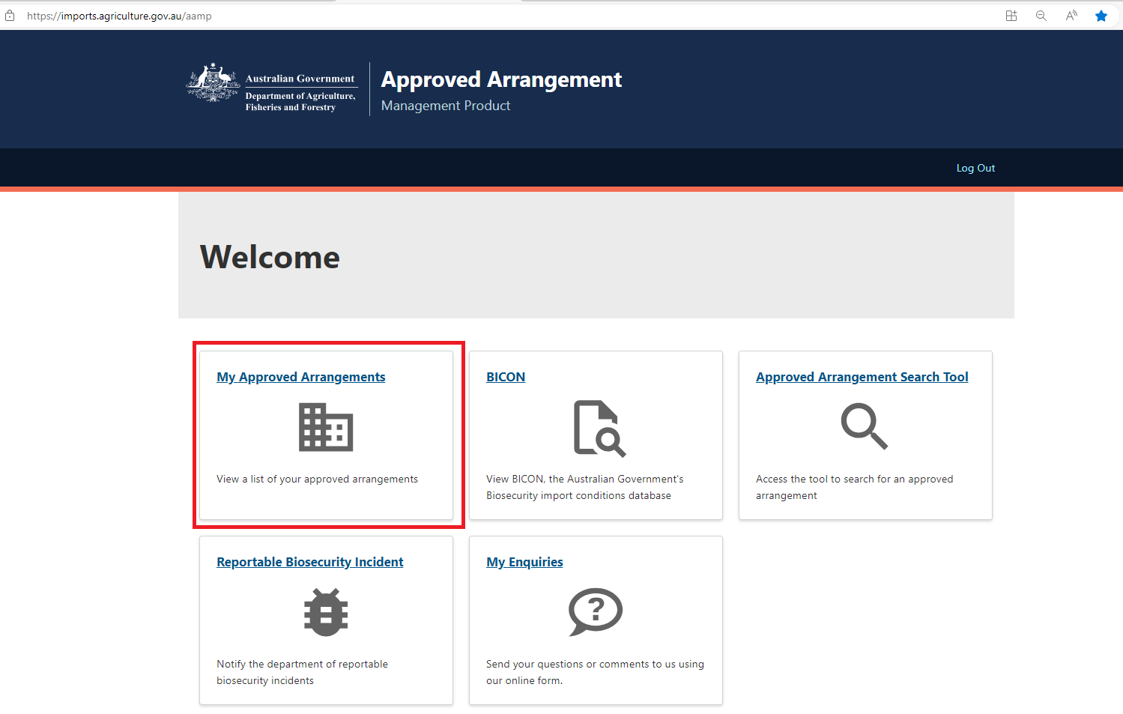  Figure 1: Screenshot of the AAMP home page navigation tiles.
- Click the ‘AA number’ link for the relevant AA (as shown in figure 2). | 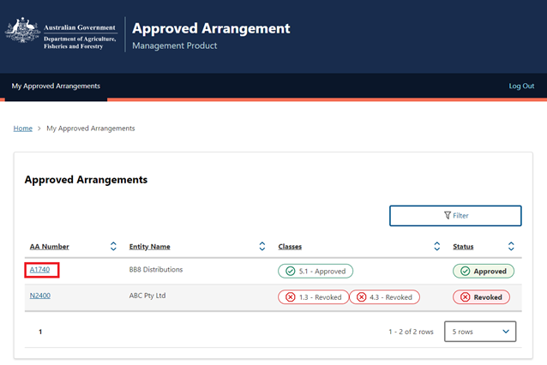  Figure 2: Screenshot of the ‘My Approved Arrangements’ page in AAMP
1.3 In the left menu links, click ‘Contact Details’ to take you to the relevant page (as shown in figure 3).  1.4 Click the ‘Add New Contact’ button (as shown in figure 3).  Note: Changes to the AA manager contact on the parent AA will be updated on all co-located AAs.  Note: Changes to class 19 AAs can only be made by the AA manager.  Note: To nominate a new Approved Arrangement Manager for class 19 AAs, you will need to fill out an application to vary a class 19 approved arrangement form. | 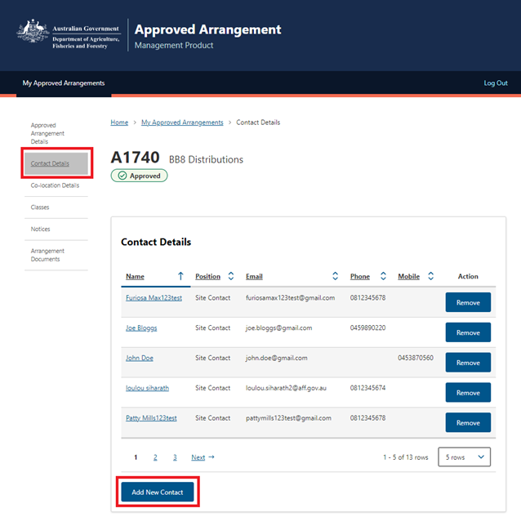  Figure 3: Screenshot of the ‘Contact Details’ page in AAMP.
1.5 Enter the details of the new contact person and click the ‘Save’ button (as shown in figure 4).  Note: Only one contact person can be nominated as the primary contact person and/or the AA manager for each AA. Nominating this site contact as AA Manager will change the existing AA Manager to a site contact.  Note: A change to the approved arrangement manager can only be made if the manager is replaced by another AA manager. | 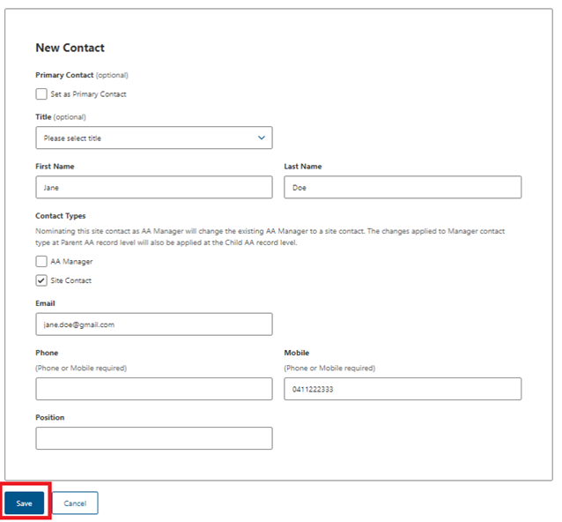  Figure 4: Screenshot of the ‘New Contact’ page in AAMP with new contact details entered.
1.6 The new contact person will show as listed contact for your AA on the ‘Contact Details’. The primary contact person is listed with a blue star in front of their name (as shown in figure 5). | 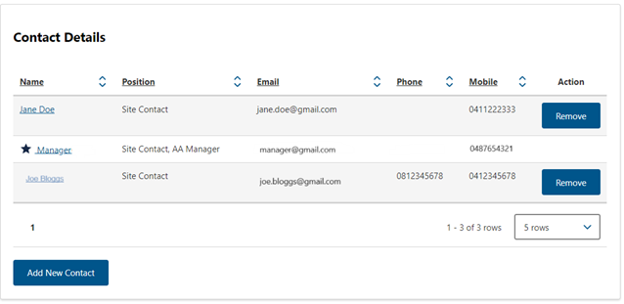  Figure 5: Screenshot of the ‘Contact Details’ page in AAMP with the new contact person showing in the table.

Edit details of a contact person for your AA
2. From the ‘Contact Details’ page, click on the name of the contact person to update their details (as shown in figure 6). | 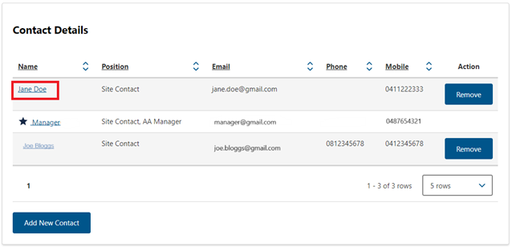  Figure 6: Screenshot of the ‘Contact Details’ table in AAMP.
2.1 Update the details of the contact person and click the ‘Save’ button (as shown in figure 7)  Note: Changes to the AA manager contact on the parent AA will be updated on all co-located AAs.  Note: Changes to class 19 AAs can only be made by the AA manager.  Note: To nominate a new Approved Arrangement Manager for class 19 AAs, you will need to fill out an application to vary a class 19 approved arrangement form. | 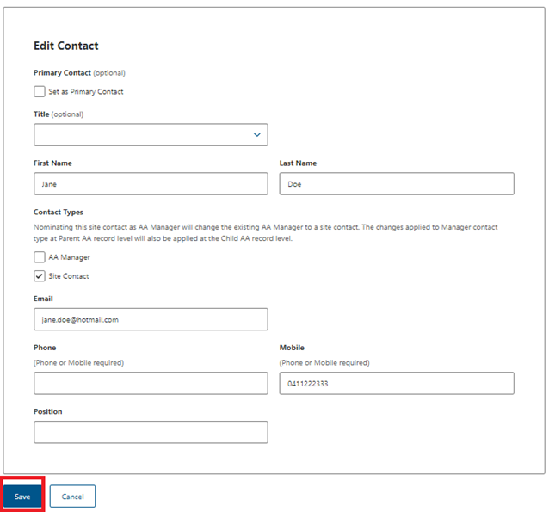  Figure 7: Screenshot of the ‘Edit Contact’ page in AAMP with updated contact details entered.
2.2 The updated details for the contact person for your AA will show on the ‘Contact Details’ page (as shown in figure 8). | 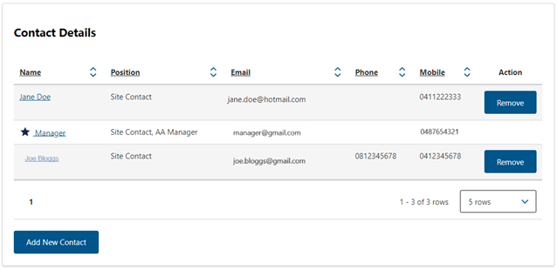  Figure 8: Screenshot of the ‘Contact Details’ table in AAMP with updated contact details showing.

Remove a contact person from your AA

3. From the ‘Contact Details’ page, click the ‘Remove’ button next to the contact you want to remove from your AA (as shown in figure 9).  Note: Changes to class 19 (broker) AAs can only be made by the AA manager. | 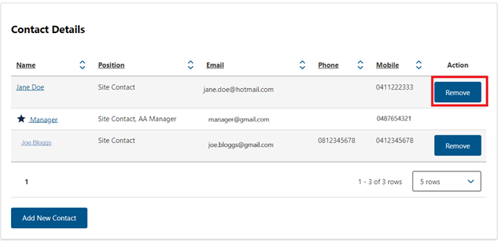  Figure 9: Screenshot of the ‘Contact Details’ page in AAMP.
3.1 Click the ‘Remove’ button to confirm the change (as shown in figure 10)  Note: A change to the approved arrangement manager can only be made if the manager is replaced by another AA manager. | 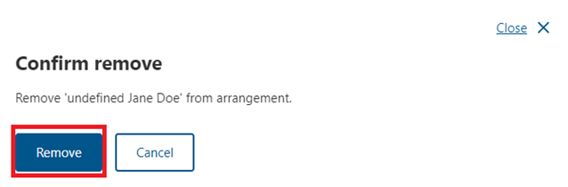  Figure 10: Screenshot of the ‘Confirm change’ page in AAMP asking for confirmation to remove the selected contact.
3.2 The removed contact person will no longer show as a listed contact for your AA on the ‘Contact Details’ page (as shown in figure 11). | 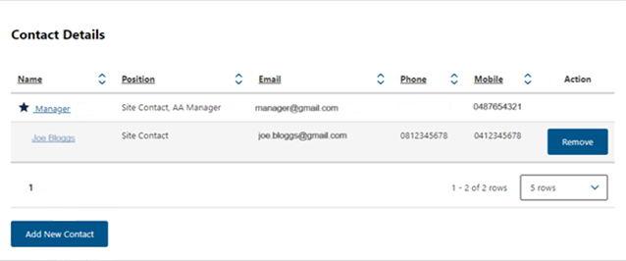  Figure 11: Screenshot of the ‘Contact Details’ page in AAMP with the removed contact no longer showing in the table.

Further information
If you require further information or support, please email AA Canberra (aa.canberra@aff.gov.au) with your enquiry and approved arrangement details. Please include ‘AAMP’ in the subject field of your email.

Acknowledgement of Country
We acknowledge the Traditional Custodians of Australia and their continuing connection to land and sea, waters, environment and community. We pay our respects to the Traditional Custodians of the lands we live and work on, their culture, and their Elders past and present.

© Commonwealth of Australia 2024
Unless otherwise noted, copyright (and any other intellectual property rights) in this publication is owned by the Commonwealth of Australia (referred to as the Commonwealth).
All material in this publication is licensed under a Creative Commons Attribution 4.0 International Licence except content supplied by third parties, logos and the Commonwealth Coat of Arms.
The Australian Government acting through the Department of Agriculture, Fisheries and Forestry has exercised due care and skill in preparing and compiling the information and data in this publication. Notwithstanding, the Department of Agriculture, Fisheries and Forestry, its employees and advisers disclaim all liability, including liability for negligence and for any loss, damage, injury, expense or cost incurred by any person as a result of accessing, using or relying on any of the information or data in this publication to the maximum extent permitted by law.

