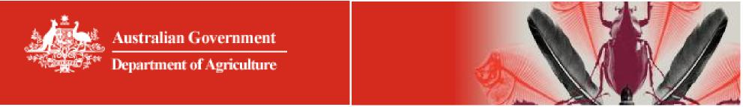

Independent Employer of Australian Government

Authorised Officers Accreditation Scheme

Fact Sheet for Independent AAO Employers
What is the ‘Independent Employer of AAOs Accreditation Scheme’?
It is a scheme developed by the Department of Agriculture to provide for the employment of Australian Government Authorised Officers (AAOs) by independent employment providers. Under the Scheme, agencies will supply AAOs to Australian export slaughter establishments to meet EU standards.
Why is the Department of Agriculture running the Scheme?
Many countries accept product prepared to the Australian Standards, however where there
are additional requirements, the department will develop programs to facilitate trade to those markets.
The European Union requires that post-mortem inspections are performed by inspectors employed by a party other than the food business operation. Therefore to export product to that market, AAOs must be sourced from an Independent Employer.
Who can employ an AAO?
AAOs can be employed by an export registered abattoir or labour hire provider (e.g. independent AAO employer).
For the EU market, AAOs must be employed by an independent AAO employer approved by the department to supply AAOs.
How can you become an Independent employer of AAOs?
Approval is granted when the applicant’s company has been accredited against all the criteria. Companies must also be able to maintain this accreditation.

Can AAOs sourced from an Independent AAO Employer perform other tasks on the establishment?
An abattoir can use relief AAOs hired by the Independent AAO Employer to conduct other activities provided:
- the AAO is not nominated in a position of management and control of the establishment; and
- the primary function of the AAO is to perform meat inspection activities. Where can I find information about the Scheme?
Information on the application process for AAOs, including the application form and the Independent Employer of AAOs Accreditation Scheme is available on the department’s website at https://www.agriculture.gov.au/export/controlled-goods/meat/elmer-3#aemis--australian-export-meat-inspection-system
Participation
To participate in this initiative visit the Independent Employer of AAOs Accreditation Scheme on the department’s website and download the Scheme information.
Departmental Contacts: Assistant Director – Governance and Audits, Export Meat Program.
Email: aao@agriculture.gov.au
Telephone: 02 6272 3933

