**Simulating the effects of climate change on the profitability of Australian farms**

Neal Hughes, Michael Lu, Wei Ying Soh and Kenton Lawson

Research by the Australian Bureau of Agricultural and Resource Economics and Sciences

Working Paper

July 2021



© Commonwealth of Australia 2020

**Ownership of intellectual property rights**

Unless otherwise noted, copyright (and any other intellectual property rights, if any) in this publication is owned by the Commonwealth of Australia (referred to as the Commonwealth).

**Creative Commons licence**

All material in this publication is licensed under a [Creative Commons Attribution 4.0 International Licence](https://creativecommons.org/licenses/by/4.0/legalcode) except content supplied by third parties, logos and the Commonwealth Coat of Arms.

Inquiries about the licence and any use of this document should be emailed to [copyright@awe.gov.au](mailto:copyright@awe.gov.au).



**Cataloguing data**

This publication (and any material sourced from it) should be attributed as: Hughes, N, Lu, Michael, Soh, W, Lawson, K, *Simulating the effects of climate change on the profitability of Australian farms*, ABARES working paper, Canberra, June, DOI: [10.25814/5d9165cf4241d](https://doi.org/10.25814/5d9165cf4241d). CC BY 4.0.

Australian Bureau of Agricultural and Resource Economics and Sciences (ABARES)

GPO Box 858 Canberra ACT 2601

Telephone 1800 900 090

Web [awe.gov.au](http://agriculture.gov.au/)

**Disclaimer**

The Australian Government acting through the Department of Agriculture, Water and the Environment, represented by the Australian Bureau of Agricultural and Resource Economics and Sciences, has exercised due care and skill in preparing and compiling the information and data in this publication. Notwithstanding, the Department of Agriculture, Water and the Environment, ABARES, its employees and advisers disclaim all liability, including liability for negligence and for any loss, damage, injury, expense or cost incurred by any person as a result of accessing, using or relying on any of the information or data in this publication to the maximum extent permitted by law.

**Professional independence**

The views and analysis presented in ABARES publications, including this one, reflect ABARES professionally independent findings, based on scientific and economic concepts, principles, information and data. These views, analysis and findings may not reflect or be consistent with the views or positions of the Australian Government, or of organisations or groups who have commissioned ABARES reports or analysis. More information on [professional independence](https://www.agriculture.gov.au/abares/about/research-and-analysis#professional-independence) is provided on the ABARES website.

**Acknowledgements**

Climate projection data for this project were supplied by the Commonwealth Scientific and Industrial Research Organisation (CSIRO) as part of Climate Change in Australia (CCA). This project was supported by the NSW Department of Primary Industries. Comments on earlier versions of the paper were provided by NSW DPI staff including Rebecca Darbyshire, Jason Crean and Bin Wang. Helpful comments on a recent draft of the paper were also received from Professor Ross Kingwell (University of Western Australia).

Contents

Abstract 1

1 Introduction 2

2 Method 4

Study focus: Australian broadacre farms 4

Farm micro-simulation model: *farmpredict* 6

Commodity prices 8

Climate scenarios 8

3 Results 11

4 Discussion 18

Climate change adaptation 18

Policies to support adaptation 20

Study limitations and future research 21

Appendix A: Additional detail 23

References 25

Figures

Figure 1 Spatial distribution of Australian broadacre farms by industry (AAGIS) 4

Figure 2 Broadacre farm industry / region groups 6

Figure 3 An overview of the *farmpredict* model 7

Figure 4 Percentage change in farm profits under the *Future (RCP4.5 2050)* scenario, relative to *Historical (1950 to 2000)* 12

Figure 5 Percentage change in farm profits under the *Future (RCP8.5 2050)* scenario, relative to *Historical (1950 to 2000)* 13

Figure 6 Percentage change in farm profits under the *Recent (2001 to 2020)* scenario, relative to *Historical (1950 to 2000)* 14

Tables

Table 1 Summary statistics for sample farms by industry group 5

Table 2 Percentage changes in mean winter (April to October) rainfall relative to *Historical (1950 to 2000)* 10

Table 3 Percentage changes in mean summer (November to March) rainfall relative to *Historical (1950 to 2000)* 10

Table 4 Change in summer (November to March) average maximum temperatures (°C) relative to *Historical (1950 to 2000)* 10

Table 5 Percentage change in farm profits relative to *Historical (1950 to 2000)* 11

Table 6 Percentage change in farm revenue relative to *Historical (1950 to 2000)* 16

Table 7 Percentage change in farm cost relative to *Historical (1950 to 2000)* 16

Table 8 Percentage change in profit by farm size group relative to *Historical (1950 to 2000)* 16

Table A1 Percentage of observations where climate projection data are outside the maximum or minimum range of the *farmpredict* training data 23

## Abstract

Recent shifts in the Australian climate including both higher temperatures and lower winter rainfall, have had significant effects on the agriculture sector. Despite these recent trends, there remains uncertainty over the future climate and its potential impacts on Australian farm businesses. In this study, a statistical model of Australian cropping and livestock farms is applied to simulate the potential effects of climate change on farm profits. This farm model is combined with a range of downscaled projections for temperature and rainfall by 2050. The results provide an indication of adaptation pressure: showing which regions, sectors and farm types may be under greater pressure to adapt or adjust to climate change. The future climate scenarios produce a wide range of outcomes, with simulated changes in average farm profits (without adaptation) ranging from -2% to -32% under an ‘intermediate’ global emissions scenario (RCP4.5) and -11% to -50% under a ‘high’ global emissions scenario (RCP8.5), relative to the reference period climate of 1950 to 2000. Generally, larger negative effects are simulated in the more in-land parts of the agricultural zone. While the future capacity of the sector to adapt is uncertain, Australian farmers have adapted effectively to recent shifts in climate, both through improvements in technology and migration of cropping activity. In future, farm-scale modelling could help support adaptation by providing farm businesses with personalised risk analysis, measuring the potential effects of climate change on specific farm businesses given their location, size and other key characteristics

## Introduction

Australian farms are highly exposed to climate variability and to the potential impacts of long-term climate change. Recent droughts across eastern Australia in 2018-19 and 2019-20 had dramatic effects on farm businesses (Martin and Topp 2019; Hughes, Galeano, Hatfield-Dodds 2019) adding to longstanding concerns around the emerging effects of climate change on Australian agriculture (Davis and Doyle 2019; Hambrett 2019).

In addition to higher temperatures, Australia has experienced significant changes in rainfall over the last 20 to 30 years. Average winter rainfall has declined in southern Australia, while summer rainfall has increased in north-western Australia (BOM and CSIRO 2020). These trends are at least partly related to global warming atmospheric changes (see Cai et al. 2014; Cai and Cowan 2013; Cai, Cowan and Thatcher 2012).

These changes have already had large effects on Australian agriculture. Hochman, Gobbett and Horan (2017) estimate that changes in climate have reduced Australian wheat yields by around 27% per cent since 1990. Hughes, Lawson and Valle (2017) found that changes in climate have negatively affected the productivity of Australian cropping farms since 2000 (Kingwell et al. 2014, Islam, Xayavong and Kingwell 2014 found similar effects for farms in south-western Australia). These studies also found evidence of adaptation, including changes in farm practices and migration of cropping activity helping to offset climate effects (Hughes et al. 2017, Kingwell et al. 2014).

Given the difficulty in separating long-term climate change from natural variability, there remains uncertainty over what these trends mean for Australian agriculture over the long-term. Simulating the future effect of climate change on agriculture, therefore remains a large and active area of research (Pearson et al. 2011, Hertel 2018 and Blanc and Reilly 2017).

Much of this research has focused on crop yields, using either statistical models or ‘process-based’ bio-physical simulation models. Recent studies of Australian wheat yields include Ghahramani et al. (2015) and Wang et al. (2019) (who both applied the APSIM model, see Keating et al. 2003). Statistical and process-based models have some obvious relative strengths and weaknesses (see for example Blanc and Reilly 2017). However, recent reviews (Lobell and Burke 2010; Lobell and Asseng 2017; Moore, Baldos and Hertel 2017) show both methods generate similar responses to climate change, at least after accounting for CO2 fertilisation effects (which are generally excluded from statistical models).

Less research has been focused on whole-of-farm outcomes, particularly farm profits. This is important in the context of Australian broadacre farms, which undertake a range of interrelated crop and livestock activities. Most Australian studies on farm-scale outcomes (Ghahramani, Kingwell and Maraseni 2020; Ghahramani and Bowran 2018; Thamo et al. 2017; Ghahramani and Moore 2016; Rodriguez et al. 2014) have applied process-based models to case-study farms (often using the *AusFarm* framework, drawing on the *APSIM* model). These studies generally find negative effects of climate change on Australian farm profits on average (Ghahramani and Bowran 2018; Ghahramani et al. 2020) with a wide range of simulated outcomes, due mostly to uncertainty over rainfall projections.

An alternative way to simulate farm outcomes is to use statistical models which link panel data on farm economic outcomes with observed weather data (in keeping with the growing climate-economy literature, see Dell et al. 2014). Key examples in the United States include Fisher et al. (2012); Deschênes and Greenstone (2012); Segerson and Dixon (1999), while Nelson et al. (2010) applied a similar approach for Australian broadacre farms[1]. Such models capture the responses of farms under real world conditions, dependent on both bio-physical and socio-economic factors (i.e., the behaviour of farm managers). They also tend to provide broader spatial coverage, supporting the simulation of national and industry-wide outcomes of relevance to policy makers.

In this study, a new statistical model of Australian farms *farmpredict* (Hughes et al. 2019) is applied to simulate the potential effects of climate change on the profits of Australian farms. *farmpredict* is a data-driven model of Australian broadacre (extensive cropping / livestock) farms, which simulates the effects of weather conditions and prices on the production and financial outcomes of individual farm businesses. The model offers detailed estimates of output and revenue; input use and costs; changes in farm inventories and in-turn various measures of farm profit. *farmpredict* is based on [Australian Bureau of Agricultural and Resource Economics and Sciences (ABARES)](http://www.agriculture.gov.au/abares/research-topics/surveys/) farm survey data and provides national coverage of the Australian broadacre sector.

Downscaled climate change projections for rainfall and temperature (produced by the CSIRO and BoM 2015) are applied to the *farmpredict* model. Farm outcomes are simulated under projected 2050 climate (for a range of greenhouse gas pathways and general circulation models) and compared to the historical reference period 1949-50 to 1998-1999. For contrast, results are also presented for the recently observed climate (1999-2000 to 2019-20).

Given the statistical approach, the results of this study do not account for the positive effects of long-run adaptation, technological advances and carbon dioxide fertilisation. Further, the scenarios also do not account for potential long-run changes in global supply and demand of agricultural commodities (and any related effects on world commodity prices) or the effects on Australian farms of domestic or international climate change mitigation policy.

In effect, the model results simulate how current day farmers, facing current technology and prices would perform under a sudden shift to 2050 climate conditions. Rather than projecting likely outcomes in 2050, the results provide an indication of ‘adaptation pressure’: identifying which regions, sectors and farm types may be under greater pressure to adapt or adjust to climate change effects.

## Method

### Study focus: Australian broadacre farms

Broadacre farms produce Australia’s main agricultural export commodities including wheat, beef, lamb and wool. Australian broadacre farms occupy around 450 million hectares of agricultural land (around 60% of Australia’s land mass). The industry generates a total annual production of around A$30-35 billion, of which 70-90% is typically exported depending on activity.

Cropping occurs mostly within the Australian ‘Wheat-Sheep zone’ (Figure 1), with livestock tending to dominate in the coastal ‘High-rainfall’ zones and the more in-land ‘Pastoral’ zones, where rainfall is generally too low for cropping. Australian broadacre farms are highly diverse, both in terms of their production systems and sizes. Central Australia is dominated by large grazing farms, some over 1 million hectares in size, while coastal areas are populated with large numbers of smaller properties (of 500 hectares or less).

Figure 1 Spatial distribution of Australian broadacre farms by industry (AAGIS)

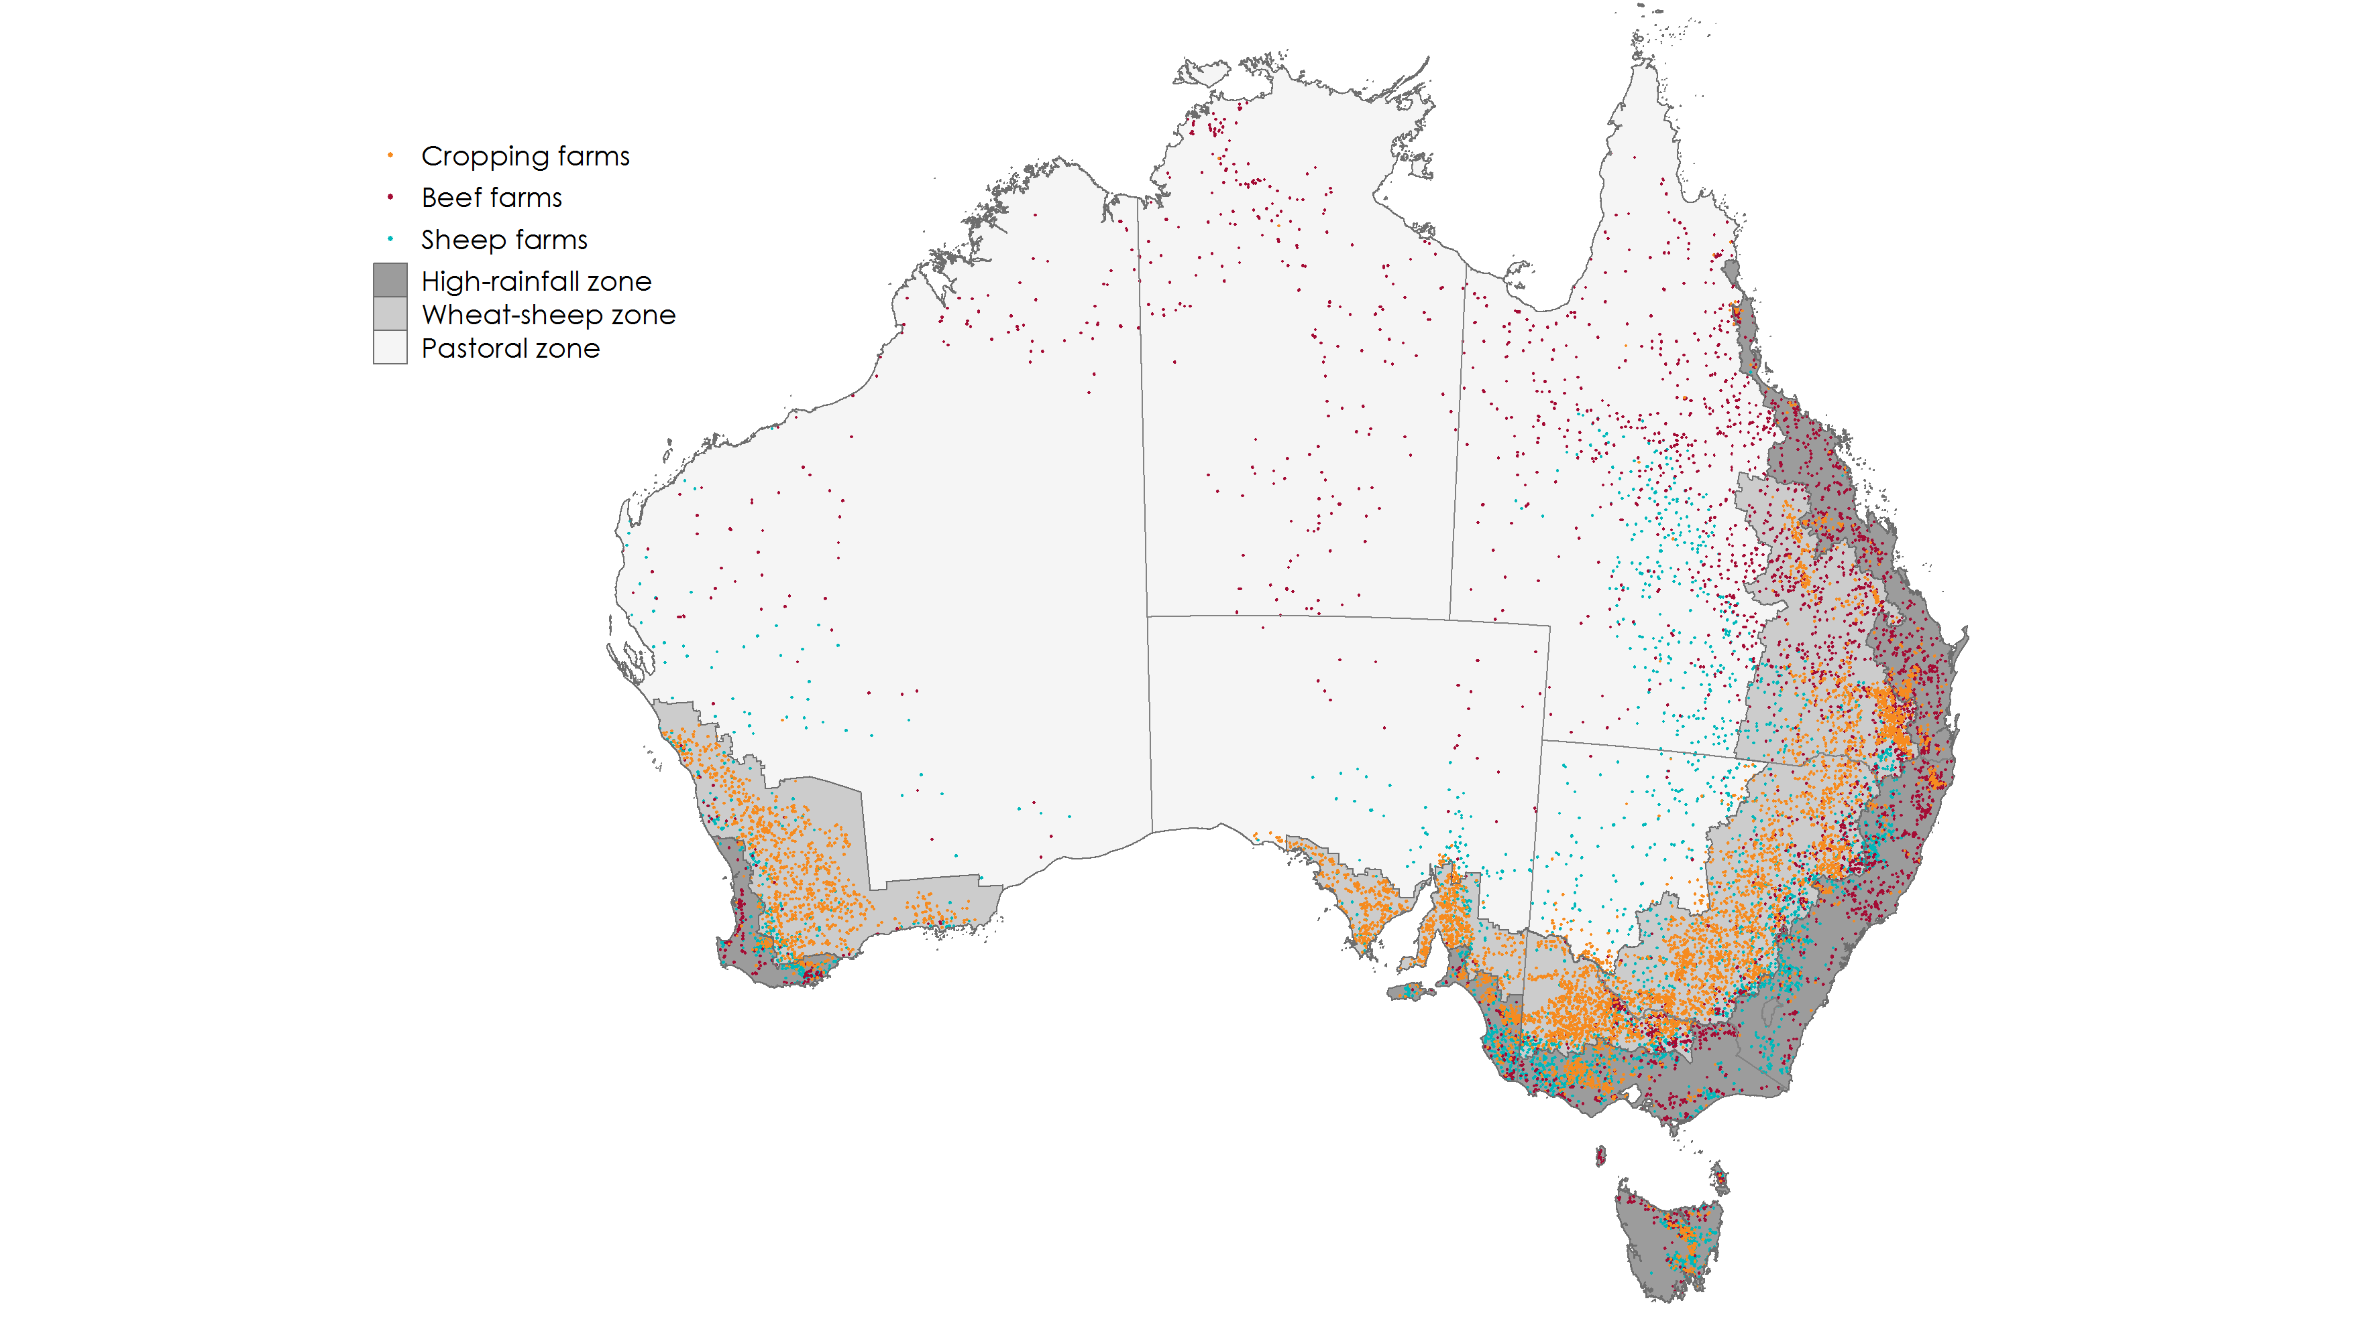

Note: Due to confidentiality issues this map does not show actual farm locations, rather it shows a sample of farm points with the same spatial distribution as the underlying data.

The [Australian Agricultural and Grazing Industry Survey (AAGIS)](http://www.agriculture.gov.au/abares/research-topics/surveys/farm-definitions-method) collects detailed physical and financial information for around 1,600 broadacre farms across Australia each financial year. The survey is designed to provide representative coverage of all Australian broadacre farming regions and industries, including extensive cropping, livestock (beef and sheep) and mixed farming types.

In this study farms sampled in AAGIS between 2015-16 to 2018-19 are taken as the basis for all model simulations. This sample consists of 6,312 observations providing representative coverage of the broadacre farming sector across a wide range of locations and farm sizes (see Table 1). The model simulations take farm characteristics (e.g., land area, capital and opening stock holdings and other factors) as observed in the survey data during these years. Results are reported for the seven major farm industry / region groupings, shown in Figure 2.

Table 1 Summary statistics for sample farms by industry group

|  |  |  |  |  |
| --- | --- | --- | --- | --- |
| **Industry group** | **Sample** | **Area '000 ha** | | |
| **5th percentile** | **mean** | **95th percentile** |
| Beef - Northern | 1,317 | 0.3 | 21.3 | 863.1 |
| Beef - Southern | 738 | 0.1 | 0.8 | 15.3 |
| Sheep - Lamb | 540 | 0.3 | 1.5 | 18.0 |
| Sheep - Mixed | 1,005 | 0.3 | 1.7 | 60.7 |
| Cropping - Northern | 993 | 0.2 | 2.2 | 18.4 |
| Cropping - Southern | 1,216 | 0.4 | 1.8 | 9.1 |
| Cropping - Western | 503 | 1.1 | 5.0 | 18.4 |
| All farms | 6,312 | 0.2 | 2.4 | 212.6 |

Figure 2 Broadacre farm industry / region groups

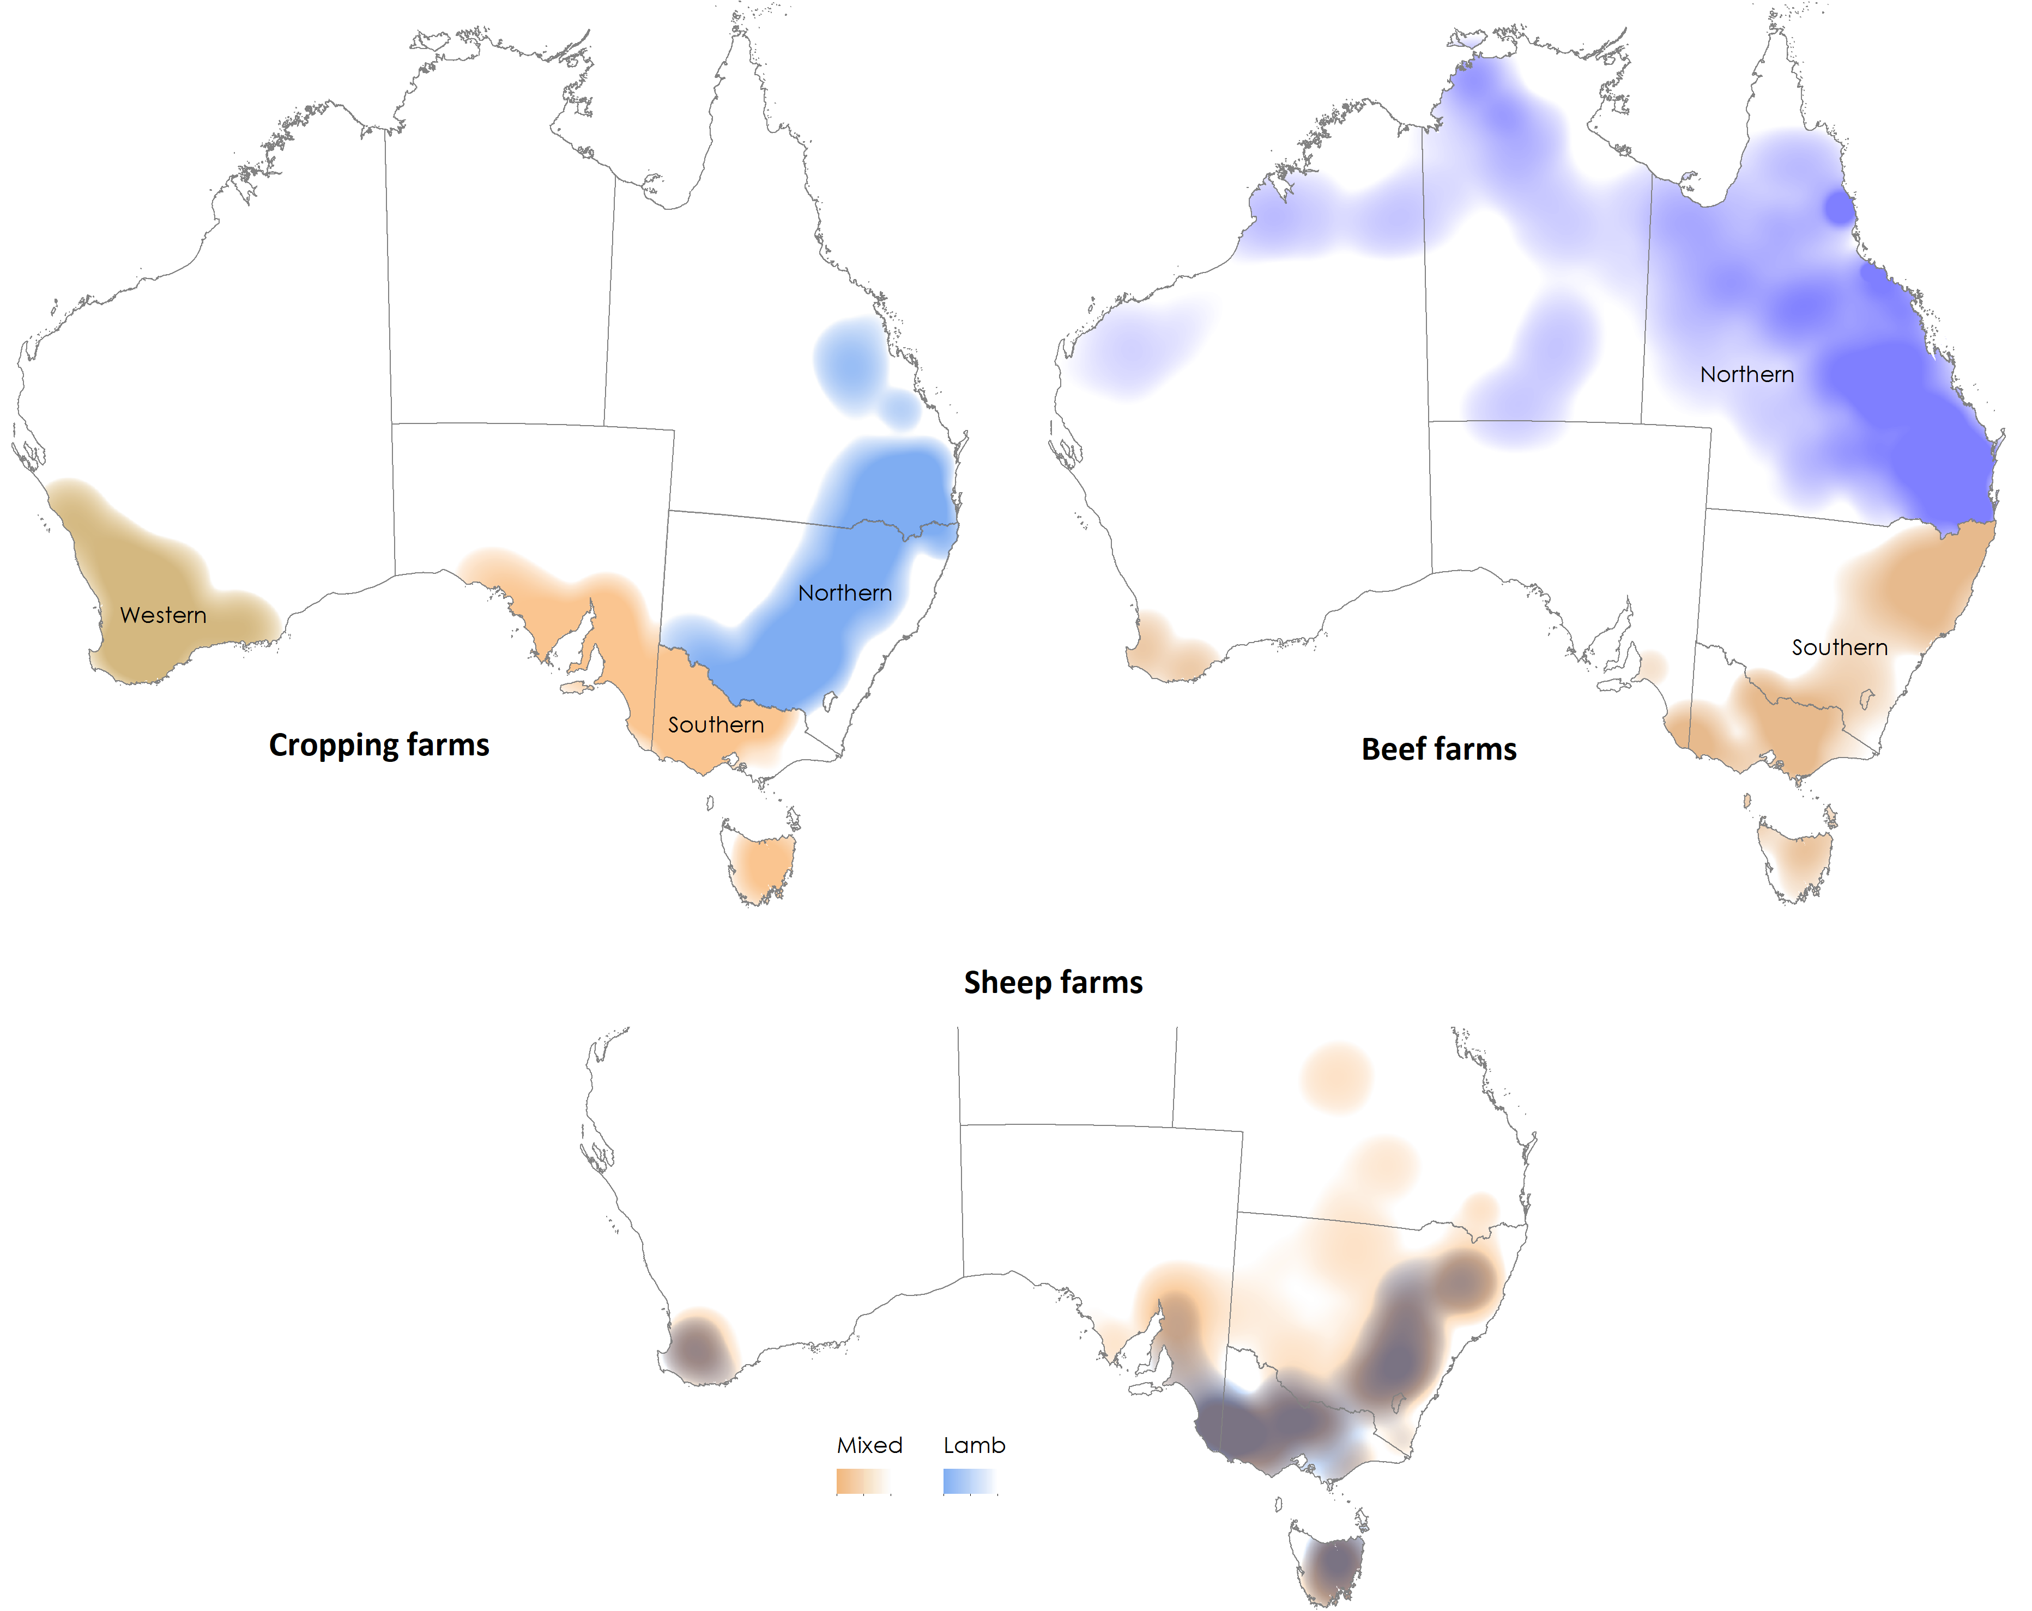

Notes: The farm industry groupings draw on the [Australian and New Zealand Standard Industrial Classification](https://www.abs.gov.au/ausstats/abs@.nsf/0/20C5B5A4F46DF95BCA25711F00146D75?opendocument) (ANSIC) which divides broadacre farming into five sectors: cropping specialists, mixed-cropping livestock, sheep, beef and sheep-beef. *The Beef - Northern* group includes all farms in the beef ANZSIC located in the Meat and Livestock Australia (MLA) Northern region (including the Northern Territory, Queensland and Western Australia north of the Tropic of Capricorn). The *Beef - Southern* region includes all of the remaining beef ANZSIC farms. The *Cropping - Northern,* *Cropping - Southern*, *Cropping - Western* groups include farms in the cropping specialists and mixed-cropping livestock ANZSIC, with the western region defined as Western Australia, the southern as Victoria, Tasmania and South Australia, and the northern region as New South Wales and Queensland. The *Sheep - Lamb* group includes all farms in the sheep ANZSIC, with baseline production of lamb of greater than 200 head, the *Sheep - Mixed* group includes all remaining farms in the sheep ANZSIC.

### Farm micro-simulation model: *farmpredict*

*farmpredict* is a data-driven microsimulation model of Australian broadacre farming businesses (Hughes et al. 2019) based on AAGIS data. *farmpredict* consists of a series of input demand and output supply functions which predict—at a farm level— the production of outputs, the use of inputs and changes in stocks conditional on commodity prices, farm fixed inputs (e.g., land area, opening livestock holdings), climate conditions and other farm characteristics (Figure 3). The model simulates six crop outputs, four livestock outputs and seven stock (inventory) holdings including livestock numbers and on-farm crop and wool storage (Figure 3). These production outcomes are then combined with input and output prices to simulate farm financial results including various measures of profit. In this study we use the [AAGIS](http://www.agriculture.gov.au/abares/research-topics/surveys/farm-definitions-method) [*profit at full equity*](https://www.agriculture.gov.au/abares/research-topics/surveys/farm-definitions-methods#definitions-of-items) measure (farm revenue less costs, adjusted for changes in inventory holdings and financing costs).

Figure 3 An overview of the *farmpredict* model

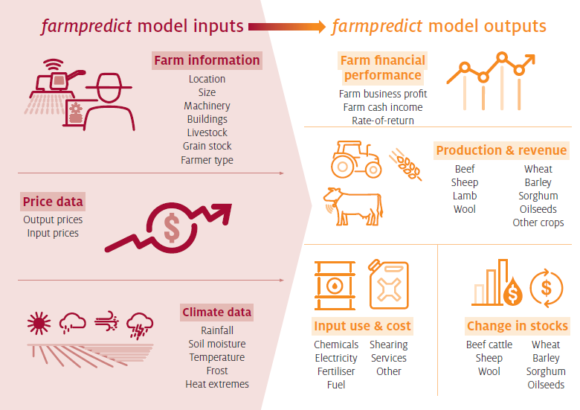

The core of *farmpredict* is a statistical model estimated from historical data. A sample of 40,269 farms (drawn from the AAGIS over the period 1988-89 to 2018-19) is used to estimate the model, with each farm linked via point location geocoding to spatial climate data obtained from the Bureau of Metrology (BoM)[2]. A large number of potential climate variables are included in the model across different time periods / seasons of relevance to broadacre farms (e.g., winter/summer crop growing seasons, see Hughes et al. 2019). For each of these time periods a range of climate measures are considered, including: rainfall volume, average maximum and minimum temperatures and exposure to upper and lower temperature extremes (see Hughes et al. 2019 for more detail).

The statistical model is estimated via a non-parametric machine learning based method, involving the *xgboost* regression algorithm (Chen and Guestrin 2016; Friedman 2002) with multi-target ‘stacking’ (Spyromitros-Xioufis et al. 2012). Hughes et al. (2019) demonstrate the performance of the model with out-of-sample validation tests.

Hughes et al. (2019) also demonstrate the responses of the model to variation in climate. As would be expected, growing season rainfall via its effect on crop yields is one of the key drivers of climate effects in the model. However, the estimated models identify a wide range of relationships with climate influencing: crop planting and storage decisions; input usage (particularly fertiliser and fodder); livestock turn-off, birth and death rates; and farm prices received (via quality effects on livestock and crop outputs). Temperatures play an important role in many of these responses, proving particularly important for livestock birth and death rates (Hughes et al. 2019).

### Commodity prices

Farm input and output commodity prices are assumed to be held fixed at recently observed levels (consistent with related studies, see Ghahramani et al. 2020). While there are ongoing efforts to project long-run global agricultural commodity prices, much uncertainty remains. Based on an ensemble of models, the IPCC (2019) generally project higher real food prices by 2050, with increases of 1% to 29% (median 7%) for cereals and smaller (median 1%) increases for animal sourced foods. The latest medium-term forecasts from the OECD / FAO (2020) and World Bank (2020) suggest limited real change (and some slight decreases) for most agricultural commodity prices to 2030 and 2035. In practice, there remains much uncertainty over global commodity prices to 2050 for reasons beyond climate change including potential technology and consumer preference changes.

While global prices are assumed to be fixed at current levels (in real terms), grain output (wheat, barley and sorghum) and fodder input prices are adjusted in the model simulations to account for the effects of climate on domestic Australian grain and fodder markets. While prices for most broadacre commodities are determined in world markets (and are largely unaffected by Australian climate conditions) price gaps emerge between Australian and world prices of grain in years of widespread drought, as constraints on importing can lead to domestic shortages (Hughes, Soh, et al. 2020). These price spikes tend to soften the financial impacts of drought on cropping farms (as net producers of grain and fodder) and exacerbate them for livestock farms (as net consumers).

Following, Hughes, Soh, et al. (2020) a simple statistical model is applied to simulate the potential impact of future climate scenarios on Australian grain and fodder prices. These results assume fixed world prices for grain (as observed between 2015-16 to 2018-19) but allow for variation in Australian-world price spreads.

### Climate scenarios

Climate projection data are taken from [Climate Change in Australia](http://www.climatechangeinaustralia.gov.au/) (CSIRO and BoM 2015). Specifically, this study makes use of rainfall and temperature projections downscaled, using the delta change method with quantile scaling (CSIRO and BoM 2015). Daily time step data are obtained for a 24 year sequence centred on 2050.

CSIRO and BoM (2015) provide this ‘Application-ready’ data for 8 of the 40 GCMs in CMIP5, selected partly for their skill in representing historical Australian climate data. In this study, 6 of these 8 GCMs are included (*ACCESS1.0*, *CESM1-CAM5*, *CNRM-CM5*, *GFDL-ESM2M*, *HadGEM2-CC*, *CanESM2*) with *NorESM1-M* and *MIROC5* omitted due to their low skill for historical Australian rainfall (see CSIRO and BoM 2015). Two RCPs are available for each GCM: *RCP4.5* (where global emissions peak by 2040, and CO2 concentrations reach around 485 ppm by 2050) and *RCP8.5* (where limited curbing of global emissions, such that CO2 concentrations reach around 540 ppm by 2050).

One concern with statistical models is that projected climate data may fall outside the range of historical data on which the models were trained on. In Appendix A, we show that on average only 0.06% to 0.09% of the observations in these projection scenarios lie outside of the training data ranges. Note that while climate variables (particularly temperatures) often move outside of historically observed values at a given point location, statistical models can still generalise from farms in other locations where such conditions have been observed.

Selecting an appropriate reference period is complicated given the dramatic shifts in Australian rainfall observed in recent decades (and uncertainty over the relative influence of climate change and natural variability). To account for this, we contrast our future climate scenarios against both a long-term historical reference period of 1949-50 to 1999-2000 and to the more recent period 2000-01 to 2019-20. We refer to the four climate scenarios in our study as: *Historical (1950 to 2000)*, *Recent (2001 to 2020)*, *Future (RCP4.5 2050)* and *Future (RCP8.5 2050)*.

Table 2, Table 3 and Table 4 provide comparisons of these four climate scenarios for average winter (April to October) rainfall and average summer (November to March) rainfall and maximum temperatures, for key farm groups (as defined in Figure 2).

For most farm groups, reductions in winter rainfall over the *Recent* period relative to the *Historical* are larger than the mean projections for 2050 (-16.3% on average compared with mean -5.3% under *RCP4.5* and -12.2% under *RCP8.5*). As BOM and CSIRO (2020) note, observed changes in rainfall to date have tended to track the dry end of the projected range (particularly in southern Australia). Under the driest GCM scenarios included in this study declines in winter rainfall on Australian farms of 21.4% (*RCP4.5*) and 30.6% (*RCP8.5*) are projected. For Western Australian cropping farms projections show a higher level of agreement, with large reductions in winter rainfall projected under most GCMs.

Increases in Australian summer rainfall have been observed over the last 20 years in some regions, particularly in parts of western and northern Australia (BOM and CSIRO 2020). However, on average Australian farmers have seen limited change in summer rainfall over the *Recent* period, with some slight increases among western Australian cropping farmers (+9.7%). Climate projections suggest declines in summer rainfall by 2050 for most farming groups (-7.4% and -10.8% under the mean *RCP 4.5* and *RCP8.5* projections on average).

Climate models project increases in average summer maximum temperatures for farmers of +0.5 to +1.2C and +1.3 to +2.0C under the *RCP 4.5* and *RCP8.5* scenarios respectively. Increases in summer maximum temperatures over the *Recent* period have already been large relative to the future projections, particularly for southern Australian cropping farms.

Table 2 Percentage changes in mean winter (April to October) rainfall relative to *Historical (1950 to 2000)*

|  |  |  |  |  |  |  |  |  |
| --- | --- | --- | --- | --- | --- | --- | --- | --- |
| **Industry group** | **Historical (mm/month)** | **Recent** | **Future (RCP4.5 2050)** | | | **Future (RCP8.5 2050)** | | |
| **min** | **mean** | **max** | **min** | **mean** | **max** |
| Beef - Northern | 36.6 | -19.1 | -20.7 | -0.8 | +8.5 | -33.4 | -13.3 | +6.1 |
| Beef - Southern | 71.7 | -13.3 | -18.8 | -7.4 | -3.6 | -26.6 | -12.3 | -8.0 |
| Sheep - Lamb | 58.9 | -15.8 | -18.8 | -5.1 | -2.2 | -29.0 | -11.4 | -4.1 |
| Sheep - Mixed | 53.9 | -17.4 | -18.3 | -3.9 | -1.5 | -28.6 | -10.3 | -4.1 |
| Cropping - Northern | 41.9 | -21.1 | -17.0 | +0.1 | +3.0 | -28.7 | -8.2 | +0.6 |
| Cropping - Southern | 45.3 | -15.3 | -27.5 | -3.3 | +1.3 | -35.0 | -9.4 | -3.1 |
| Cropping - Western | 44.6 | -16.3 | -33.3 | -20.1 | -8.7 | -43.1 | -30.3 | -13.0 |
| All farms | 52.5 | -16.2 | -20.6 | -4.4 | -2.7 | -30.1 | -11.2 | -6.1 |

Table 3 Percentage changes in mean summer (November to March) rainfall relative to *Historical (1950 to 2000)*

|  |  |  |  |  |  |  |  |  |
| --- | --- | --- | --- | --- | --- | --- | --- | --- |
| **Industry group** | **Historical (mm/month)** | **Recent** | **Future (RCP4.5 2050)** | | | **Future (RCP8.5 2050)** | | |
| **min** | **mean** | **max** | **min** | **mean** | **max** |
| Beef - Northern | 98.9 | -2.1 | -20.9 | -15.5 | -4.6 | -34.2 | -21.6 | -12.3 |
| Beef - Southern | 68.0 | -2.1 | -8.0 | -4.9 | -0.3 | -19.5 | -9.3 | +2.0 |
| Sheep - Lamb | 44.6 | +0.3 | -12.3 | -7.9 | -1.7 | -21.7 | -12.6 | -1.5 |
| Sheep - Mixed | 47.6 | -0.6 | -14.5 | -8.8 | -3.1 | -25.7 | -13.4 | -1.7 |
| Cropping - Northern | 55.5 | +0.0 | -20.9 | -12.3 | -5.3 | -33.6 | -18.1 | -6.8 |
| Cropping - Southern | 26.1 | +2.6 | -21.7 | -10.6 | +0.7 | -24.1 | -14.7 | -10.1 |
| Cropping - Western | 17.3 | +16.4 | +11.4 | +21.8 | +29.4 | -15.7 | +11.0 | +44.8 |
| All farms | 55.4 | -0.7 | -13.4 | -9.3 | -2.5 | -25.8 | -14.5 | -5.2 |

Table 4 Change in summer (November to March) average maximum temperatures (°C) relative to *Historical (1950 to 2000)*

|  |  |  |  |  |  |  |  |  |
| --- | --- | --- | --- | --- | --- | --- | --- | --- |
| **Industry group** | **Historical (°C)** | **Recent** | **Future (RCP4.5 2050)** | | | **Future (RCP8.5 2050)** | | |
| **min** | **mean** | **max** | **min** | **mean** | **max** |
| Beef - Northern | 31.7 | +0.7 | +0.4 | +0.9 | +1.5 | +1.3 | +1.7 | +2.2 |
| Beef - Southern | 26.0 | +0.9 | +0.5 | +0.9 | +1.2 | +1.2 | +1.5 | +2.0 |
| Sheep - Lamb | 26.9 | +1.1 | +0.6 | +0.9 | +1.2 | +1.3 | +1.6 | +2.0 |
| Sheep - Mixed | 27.3 | +1.1 | +0.6 | +0.8 | +1.2 | +1.3 | +1.6 | +2.0 |
| Cropping - Northern | 30.4 | +1.1 | +0.3 | +0.7 | +1.1 | +1.3 | +1.6 | +2.0 |
| Cropping - Southern | 27.5 | +1.1 | +0.4 | +0.8 | +1.3 | +0.9 | +1.4 | +2.1 |
| Cropping - Western | 29.8 | +0.6 | +0.3 | +0.9 | +1.3 | +1.0 | +1.5 | +2.1 |
| All farms | 28.2 | +1.0 | +0.5 | +0.8 | +1.2 | +1.3 | +1.6 | +2.0 |

## Results

Simulated changes in farm profits are presented in Table 5 and Figures 4, 5 and 6 (with further results presented in Appendix A). These tables and charts present averages of farm-scale estimates. Note that farm specific results can vary considerably around these averages, even for farms within a given location or industry (particularly with respect to farm size, see Table 8).

Under the *Recent (2001 to 2020)* scenario simulated farm profits are 23% lower on average compared to the *Historical (1950 to 2000)* period (Table 5). As documented in past studies (Hughes, Galeano, Hatfield-Dodds 2019) recent climate effects have been felt most strongly amongst cropping farms particularly in south-western and south-eastern Australia (Table 5, Figure 6).

Table 5 Percentage change in farm profits relative to *Historical (1950 to 2000)*

|  |  |  |  |  |  |  |  |  |
| --- | --- | --- | --- | --- | --- | --- | --- | --- |
| **Industry group** | **Historical ($)** | **Recent** | **Future (RCP4.5 2050)** | | | **Future (RCP8.5 2050)** | | |
| **min** | **mean** | **max** | **min** | **mean** | **max** |
| Beef - Northern | 152,815 | -3.1 | -22.1 | -11.7 | -3.0 | -54.5 | -27.6 | -16.3 |
| Beef - Southern | 20,968 | -22.5 | -26.6 | +0.5 | +10.3 | -63.8 | -18.0 | -2.7 |
| Sheep - Lamb | 108,234 | -14.9 | -16.6 | -5.8 | -0.1 | -31.6 | -12.9 | -5.6 |
| Sheep - Mixed | 58,817 | -26.7 | -37.3 | -13.2 | -6.3 | -66.3 | -28.1 | -15.9 |
| Cropping - Northern | 212,491 | -36.2 | -23.7 | -9.8 | -3.6 | -43.1 | -20.1 | -4.8 |
| Cropping - Southern | 179,423 | -21.7 | -27.7 | -3.3 | +11.5 | -30.8 | -8.5 | +4.1 |
| Cropping - Western | 437,227 | -26.8 | -55.9 | -31.6 | -5.1 | -68.1 | -50.5 | -7.3 |
| All farms | 129,187 | -22.6 | -31.9 | -13.1 | -2.0 | -49.9 | -25.6 | -10.7 |

Figure 4 Percentage change in farm profits under the *Future (RCP4.5 2050)* scenario, relative to *Historical (1950 to 2000)*

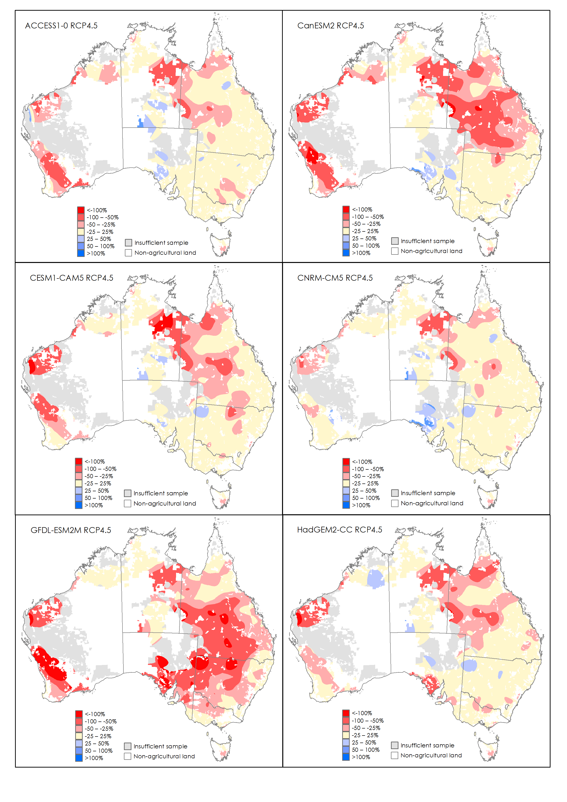

Notes: Maps are generated by interpolating farm-level percentage changes, calculated using a Symmetric Mean Absolute Percentage Error (SMAPE) metric.

Figure 5 Percentage change in farm profits under the *Future (RCP8.5 2050)* scenario, relative to *Historical (1950 to 2000)*

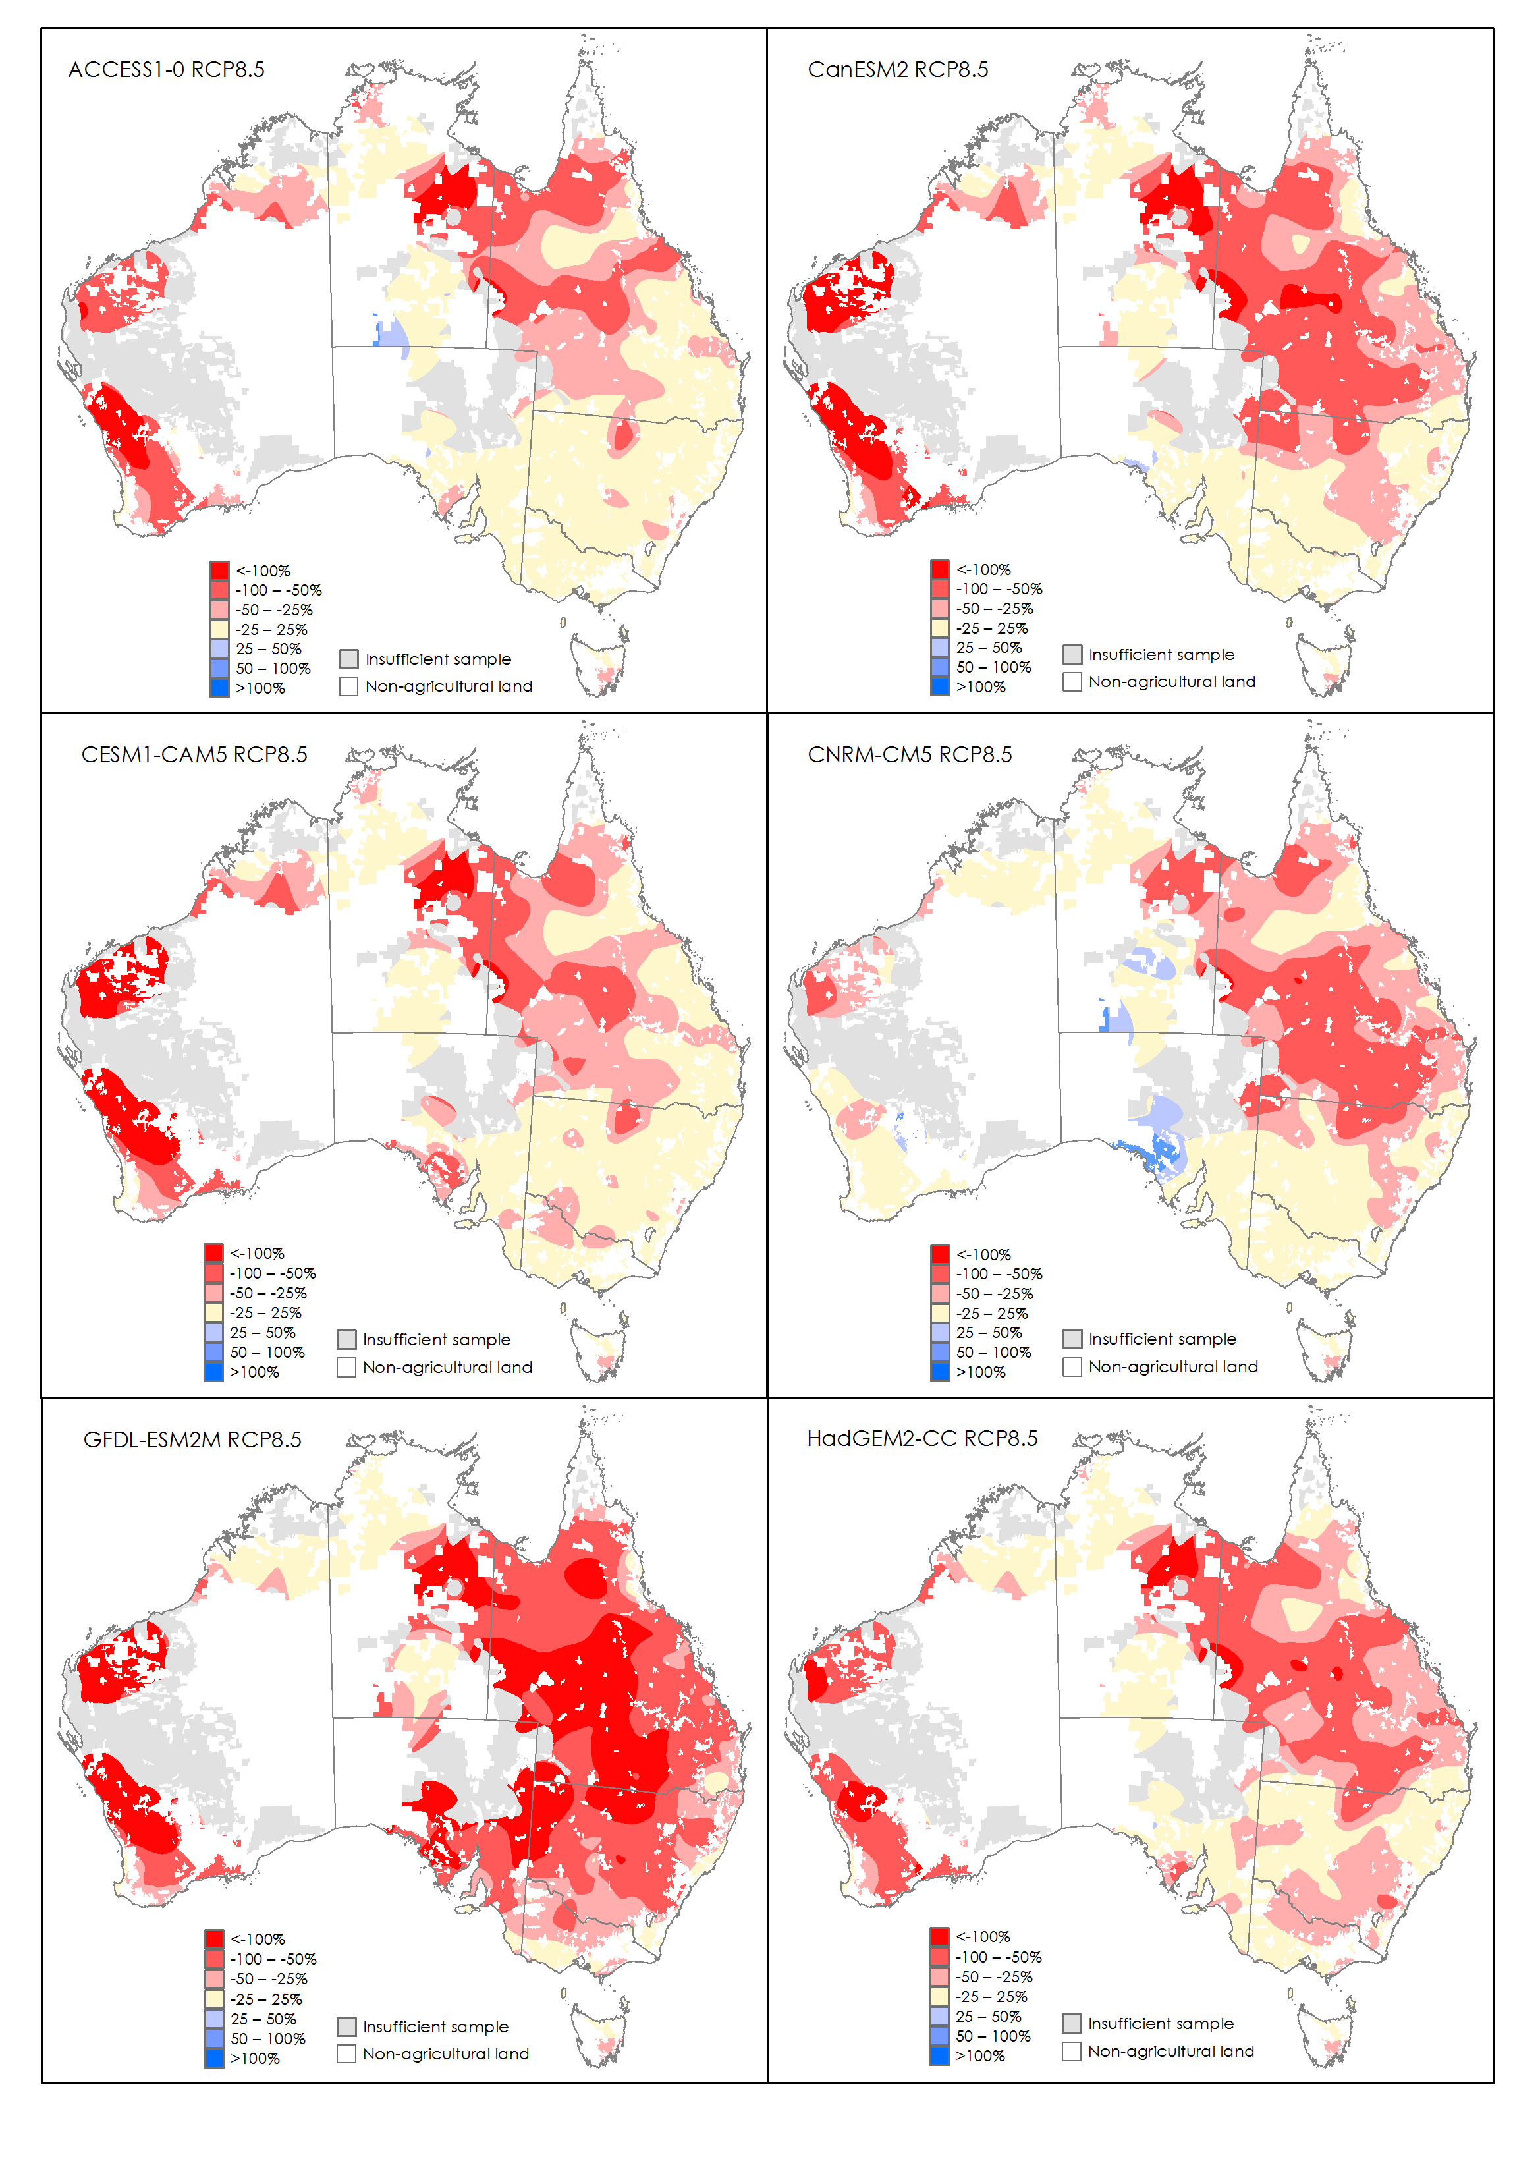

Notes: Maps are generated by interpolating farm-level percentage changes, calculated using a Symmetric Mean Absolute Percentage Error (SMAPE) metric.

Figure 6 Percentage change in farm profits under the *Recent (2001 to 2020)* scenario, relative to *Historical (1950 to 2000)*

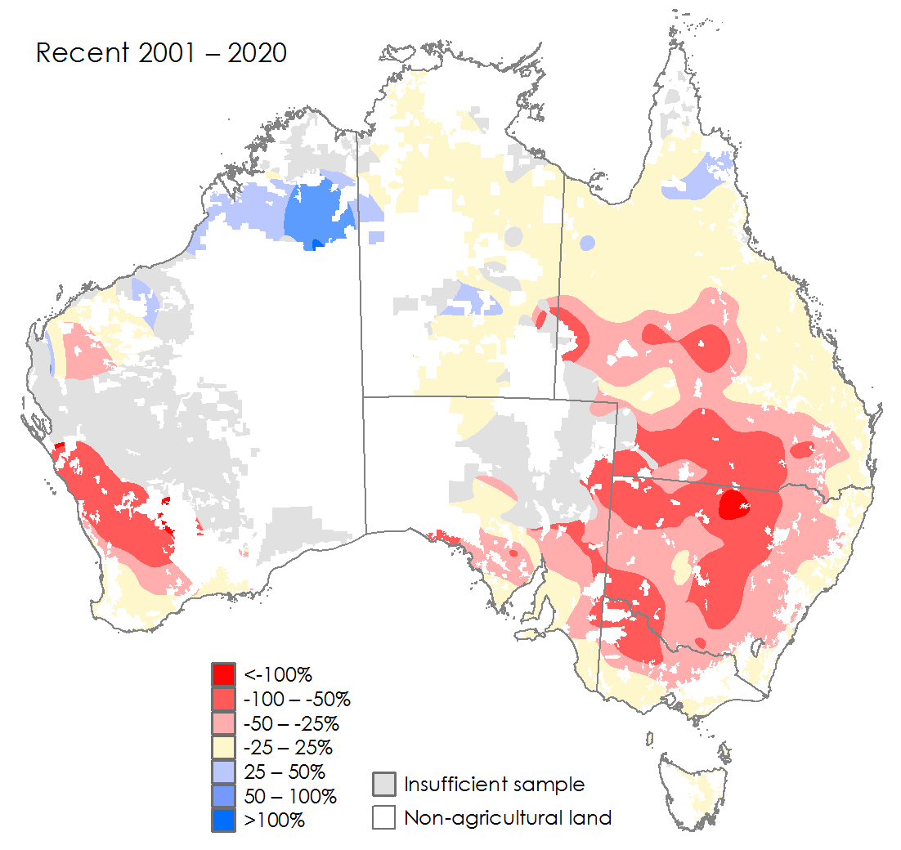

Notes: Map generated by interpolating farm-level percentage changes, calculated using a Symmetric Mean Absolute Percentage Error (SMAPE) metric.

Climate projections for 2050 show a wide range of outcomes across the 6 included GCMs. Simulated changes in average farm profits under the *Future (RCP4.5 2050)* scenario range from -31.9% to -2.0%, while *RCP8.5* ranges from -49.9% to -10.7% (Table 5).

Western cropping farms show the largest mean reductions in average farm profits under the future scenarios (-55.9% to -5.1% under *RCP4.5* and -68.1% to -7.3% under *RCP8.5*). This mainly reflects projected declines in winter growing season rainfall in this region and the resulting effects on crop yields (Table 9) and revenue (Table 6).

Beef farms in northern Australia also show significant reductions in average profit under the *Future 2050* scenarios (-22.1% to -3% under *RCP4.5* and -54.5% to -16.3% under *RCP8.5*). These changes are driven by projected declines in winter and summer rainfall along with increases in maximum temperatures. As discussed in Hughes et al. (2019) the climate response of livestock farms in the *farmpredict* model is relatively more sensitive to temperature than for cropping farms, explaining why simulated livestock farm profits are considerably worse under *RCP8.5* than *RCP4.5*.

In south-eastern Australia *Future 2050* scenarios show a very wide range of potential outcomes, due largely to differences in rainfall across the 6 GCMs. For cropping farms in the southern region (VIC, SA, TAS) changes in average simulated profits under *Future (RCP8.5 2050)* range from -30.8% to +4.1%. Beef farms in southern Australia also show a wide range of outcomes, with simulated change in average farm profits of -63.8% to -2.7% under the *Future (RCP8.5 2050)* scenario.

While the spatial pattern of the effects varies under each GCM, in general the largest changes in farm profits are simulated in the northern parts of the western cropping zone (*WA:North and East Wheat Belt* region, Table A2), along with parts of western NSW (*NSW:Far West*, *NSW:Central West*) and central QLD (*QLD:West and South West*, *QLD:Charleville - Longreach* regions). Similar to recent trends (and previous research), these results generally show larger climate change impacts in more marginal (lower-rainfall) areas. Compared with recent trends (Figure 6) future scenarios show generally smaller effects in south-eastern Australia and larger impacts in Queensland (see Figure 4, Figure 5).

In Tasmania, simulation results are highly consistent across the 6 GCMs with relatively modest declines in profit overall, and negative effects appearing to be concentrated in the south of the state. In contrast, extremely wide variation is observed in parts of South Australia. In the *SA: Eyre Peninsula* region, simulated changes in farm profits range from -76% to +41% under the future scenarios (Table A2).

While not directly comparable (due to differences in climate scenarios, reference periods, farm locations and profit measures) these results are broadly consistent with the recent literature. For example, Ghahramani, Kingwell and Maraseni (2020) simulated percentage changes in farm profits by 2030 of between -74% and +16% (mean -26%) across a range of farm sites in the southern Australian wheat belt (under a ‘Hot and dry’ *RCP8.5* scenario). While Thamo et al. (2017) simulated larger changes in farm net returns by 2050 of -100 to -160% for farms in the Western Australian wheat belt.

Table 6 and Table 7 show simulated changes in average farm revenues and costs. As discussed in Hughes et al. (2019), the effects of hotter and drier conditions on livestock farms tend to be transmitted more through herd (inventory) changes due to lower livestock net birth rates (along with some increase in costs due to higher fodder expenses). Under the *Future (RCP8.5 2050)* scenario (short-run) increases in revenue are actually observed for livestock farms due to increases in turn-off[3]. In contrast, cropping farms show reductions in revenue and costs under most future climate scenarios (due to declines in crop production, see Table 9).

The results in Table 6 and Table 7 also illustrate how small changes in farm revenues and costs can have large effects on profits, particularly for farm groups with low profit margins. This is reinforced by Table 8, which shows changes in profits by farm size. These farm size groupings are based on farm capital holdings relative to farms in the same industry and region group (following Hughes, Galeano, Hatfield-Dodds 2019). In general, smaller farms tend to have lower profit margins than larger farms (Boult and Jackson 2019; Jackson, Hatfield-Dodds and Zammit 2020), as a result they show significantly higher percentage change in profits under future climate scenarios.

Table 6 Percentage change in farm revenue relative to *Historical (1950 to 2000)*

|  |  |  |  |  |  |  |  |  |
| --- | --- | --- | --- | --- | --- | --- | --- | --- |
| **Industry group** | **Historical ($)** | **Recent** | **Future (RCP4.5 2050)** | | | **Future (RCP8.5 2050)** | | |
| **min** | **mean** | **max** | **min** | **mean** | **max** |
| Beef - Northern | 634,004 | +2.38 | +3.13 | +4.65 | +6.39 | +6.05 | +8.23 | +13.94 |
| Beef - Southern | 256,699 | -0.08 | +0.15 | +0.49 | +1.00 | -0.00 | +0.65 | +2.38 |
| Sheep - Lamb | 551,558 | -0.80 | +0.39 | +1.04 | +1.47 | +0.12 | +0.68 | +1.26 |
| Sheep - Mixed | 332,995 | -0.80 | +0.53 | +1.29 | +1.79 | +0.04 | +0.72 | +1.43 |
| Cropping - Northern | 890,090 | -8.89 | -5.60 | -2.13 | -0.27 | -9.35 | -4.22 | -0.51 |
| Cropping - Southern | 735,279 | -6.23 | -9.30 | -1.82 | +2.57 | -10.64 | -3.56 | +0.54 |
| Cropping - Western | 1,636,559 | -8.30 | -19.49 | -11.30 | -2.83 | -24.37 | -17.57 | -3.28 |
| All farms | 590,105 | -4.08 | -4.81 | -1.71 | +0.44 | -5.34 | -3.03 | +0.11 |

Table 7 Percentage change in farm cost relative to *Historical (1950 to 2000)*

|  |  |  |  |  |  |  |  |  |
| --- | --- | --- | --- | --- | --- | --- | --- | --- |
| **Industry group** | **Historical ($)** | **Recent** | **Future (RCP4.5 2050)** | | | **Future (RCP8.5 2050)** | | |
| **min** | **mean** | **max** | **min** | **mean** | **max** |
| Beef - Northern | 399,791 | +1.60 | +0.95 | +2.23 | +4.41 | +2.70 | +4.69 | +9.98 |
| Beef - Southern | 174,313 | +0.74 | -0.49 | +0.01 | +1.42 | -0.52 | +0.31 | +2.75 |
| Sheep - Lamb | 326,247 | +0.84 | +0.08 | +0.54 | +1.83 | +0.11 | +0.98 | +3.36 |
| Sheep - Mixed | 230,312 | +1.28 | +0.10 | +0.67 | +2.45 | +0.21 | +1.50 | +5.03 |
| Cropping - Northern | 588,016 | -3.78 | -2.93 | -0.52 | +0.39 | -5.25 | -1.71 | -0.05 |
| Cropping - Southern | 482,816 | -3.13 | -7.13 | -2.50 | -0.12 | -9.27 | -3.84 | -1.14 |
| Cropping - Western | 1,083,363 | -3.38 | -9.75 | -5.65 | -2.29 | -13.79 | -8.67 | -2.28 |
| All farms | 386,662 | -1.36 | -2.35 | -1.10 | -0.25 | -2.50 | -1.57 | -0.10 |

Table 8 Percentage change in profit by farm size group relative to *Historical (1950 to 2000)*

|  |  |  |  |  |  |  |  |  |
| --- | --- | --- | --- | --- | --- | --- | --- | --- |
| **Farm size** | **Historical ($)** | **Recent** | **Future (RCP4.5 2050)** | | | **Future (RCP8.5 2050)** | | |
| **min** | **mean** | **max** | **min** | **mean** | **max** |
| Small farms | 17,688 | -96.0 | -130.9 | -52.8 | -9.4 | -197.9 | -100.4 | -41.5 |
| Medium farms | 171,877 | -22.6 | -32.2 | -14.6 | -4.1 | -49.6 | -26.8 | -12.2 |
| Large farms | 661,259 | -11.9 | -19.4 | -9.1 | -2.6 | -29.7 | -16.2 | -7.8 |

Finally, Table 9 presents the average simulated domestic grain (and fodder prices) under each climate scenario. Future scenarios show that increases in average Australian prices for major grain crops (wheat, barley and sorghum) are possible (of between 1 and 40%) with increases in prices for livestock fodder (hay) of between 3 and 24%.

**Table 9: Percentage change in average Australian grain and fodder prices by climate scenario**

|  |  |  |  |  |  |  |  |
| --- | --- | --- | --- | --- | --- | --- | --- |
| **Commodity** | **Recent** | **Future (RCP4.5 2050)** | | | **Future (RCP8.5 2050)** | | |
| **min** | **mean** | **max** | **min** | **mean** | **max** |
| Wheat | +6.1 | +1.5 | +4.0 | +13.0 | +3.0 | +8.3 | +26.9 |
| Barley | +7.4 | +0.9 | +5.0 | +19.2 | +3.6 | +11.7 | +40.0 |
| Sorghum | +4.1 | +3.1 | +6.8 | +16.1 | +5.5 | +12.6 | +33.5 |
| Fodder | +7.6 | +3.3 | +6.2 | +14.9 | +6.0 | +10.5 | +24.3 |

## Discussion

### Climate change adaptation

While future projections are subject to much uncertainty, the above results show climate change has the potential to make conditions tougher for many Australian farmers. Under the most severe future scenario (*RCP8.5* with the *GFDL-ESM2M* GCM) average Australian broadacre farm profits are simulated to decline by 50% (relative to the period 1950 to 2000).

Clearly, potential impacts of this magnitude would create strong pressure for adaptation. Already there is evidence of farm adaptation in response to the climate shifts in recent decades (see Hochman et al. 2017; Hughes et al. 2017). While many of the future scenarios are less severe than the *Recent (2001 to 2020)* period, long-term shifts in climate are likely to induce stronger adaptation responses, particularly where they lead farmers to update their expectations over future climate conditions [4]. Recent trends and research provide some indication of the potential incremental and transformational changes that might occur in the sector in response long-term shifts in climate.

To begin, there are a number of structural adjustments possible with existing technology, such as changes in the mix of cropping and livestock activity, changes in the spatial distribution of crop types or livestock breeds across Australia or changes in farm scale. While such adjustments are not included in the above simulations, they have been considered in bio-physical modelling (Ghahramani and Bowran 2018; Ghahramani et al. 2020). Although these studies show potential benefits, adaptations are typically insufficient to fully offset climate change impacts, particularly under the more severe GCM projection scenarios (Ghahramani and Bowran 2018; Ghahramani et al. 2020).

One key response could be a shift away from cropping towards livestock and mixed farming, particularly in more ‘marginal’ lower-rainfall sections of the traditional Australian cropping zone. Farm modelling by Ghahramani et al. (2020) suggests that a shift toward sheep production could partly offset the effects of climate change in low rainfall areas. Analysis of weather data and bio-physical modelling indicates that a southward / coastal shift of the Australian cropping zone has already occurred in recent decades (Fletcher et al. 2020, Nidumolo et al. 2012). In addition, farm survey data (see Hughes et al. 2017, Hughes, Gupta, et al. 2020) show migration in farm cropping activity over the last 20 years, including an increase in cropping in higher-rainfall / coastal zones post 2000, and a recent decline in cropping in some inland / lower-rainfall zones (Figure 6).

**Figure 6: Percentage change in farmland set-up for cropping, 2016-2020 relative to 2006-2010**

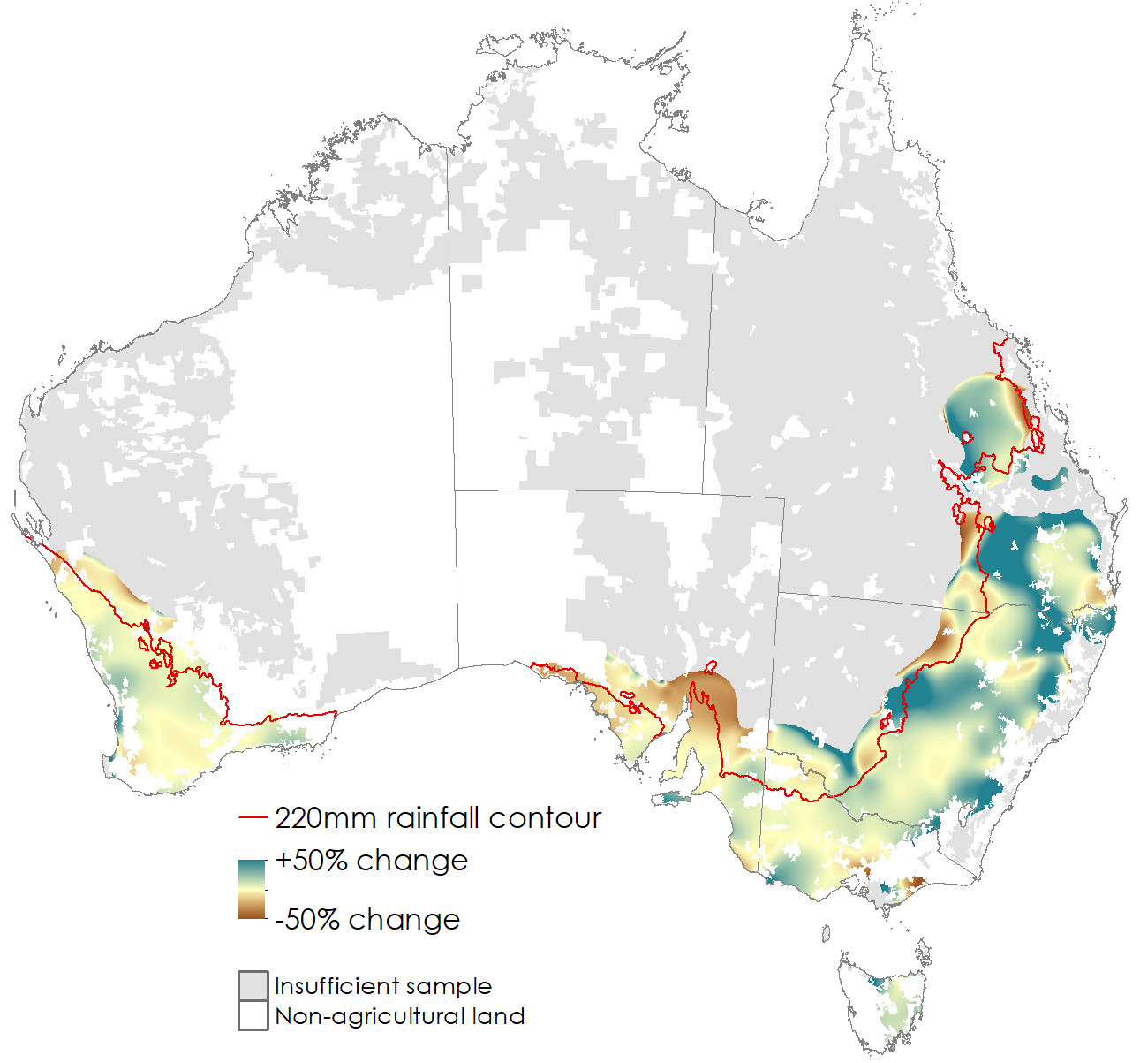

Notes: Excludes beef farms and farms with less than 10% of land area set-up for cropping. Average of 2015-16 to 2019-20 compared to 2005-06 to 2009-10. Areas in-land of the 220mm rainfall isoline received less than 220mm average rainfall per year during the period 1950 to 2020.

Source: ABARES AAGIS data

Another response could be increases in farm size. Farm survey data consistently show higher productivity and profit levels among larger farm businesses, along with steady long-term increases in farm size and reductions in farm numbers (Boult and Jackson 2019; Jackson et al. 2020). Given their lower profit margins, smaller farms are likely to face greater adaptation pressure from climate change (Table 8) which could hasten underlying farm consolidation trends.

Increased investment in on and off-farm grain storage (and grain import supply chains) is also possible. Future scenarios show that increases in average Australian prices for major grain crops (wheat, barley and sorghum) are possible (Table 9) with climate change increasing the severity of drought induced grain shortages. These higher prices could have negative effects on grain consumers including the intensive livestock sector. However, an expansion in grain storage capacity (or grain import supply chains) could help to minimise these effects by limiting grain shortages in drought years.

Over the longer-term, improvements in technology will act to offset the effects of climate change. For example, Hochman et al. (2017) showed that since 1990 improvements in technology have offset the negative effects of declines in rainfall and increases in temperatures, such that average Australian wheat yields have remained relatively constant. Similarly, Chancellor et al. (2021) showed that climate-adjusted Total Factor Productivity (TFP) across the broadacre sector has increased around 28% since 1989, with much larger (68%) gains in the cropping sector. These gains have offset the negative effects of climate over the last 30 years, such that actual industry productivity and profit levels have still increased or at least remained stable (Chancellor et al. 2021).

Evidence also suggests that these recent productivity improvements have had a unique focus on adapting to drier and hotter conditions. For example, cropping farm productivity has increased faster under dry conditions over the last two decades, such that the gap between normal and drought conditions has narrowed over time (Hughes et al. 2017). These gains have been driven by a range of improvements in technology and management practices (including no-till cropping and soil amelioration) which seek to preserve soil moisture from summer fallow rainfall as an adaptation to reduced winter rainfall (see Hunt and Kirkegaard 2012)

A simple continuation of long-run productivity trends (average annual TFP growth of 1.6% since 1960, see Sheng et al. 2013) would be sufficient to prevent any absolute declines in Australian farm productivity or production levels by 2050 even under the most severe climate projections. However, climate change could still reduce Australia’s international competitiveness and farm profits, depending on the climate change impacts and productivity trends in other nations.

A key uncertainty is the extent to which future technologies can further reduce farm sensitivity to dry and hot conditions, both to offset climate change and to improve drought resilience. Here interest lies in genetic improvements in crops, pasture and livestock, new equipment and management practices (such as “precision”, “digital” and /or “regenerative” agriculture, see Leonard et al. 2017; Gosnell, Gill and Voyer 2019), along with advances in weather forecasting (Hayman et al. 2007; Parton, Crean and Hayman 2019). These future technological developments will also have a large bearing on any structural adjustment, including the mix of crop and livestock activity.

In the long-term, there may be pressure for more transformative change, at least where incremental adaptation is insufficient to fully offset climate change impacts. This could include the emergence of new land use activities such as: carbon abatement, biodiversity conservation, plantation forestry, biofuels, renewable energy or farm landscape tourism either as alternatives or complements to traditional farming activities. It remains difficult to predict the extent of such land use change, given uncertainties over climate, technological progress, global commodity prices and incentives associated with these new activities (such as carbon prices and biodiversity payments). Scenario analysis suggests that with strong incentives, large changes in Australian land-use may be possible by 2050 without major impacts on agricultural production (Bryan et al. 2016).

### Policies to support adaptation

Policies to support adaptation include the provision of climate information to farmers, investment in agricultural research and development (R&D), effective drought policy and incentives for carbon abatement and biodiversity. In many cases, these responses involve a continuation of existing government efforts to help farmers manage climate variability and improve agricultural productivity (Stokes and Howden 2010, Asseng and Pannell 2013). For example, Australian governments support investment in new farm technologies to improve climate resilience, through long-standing initiatives such as the agricultural R&D corporations, along with the more recently developed Future Drought Fund (FDF).

Literature on drought policy has long documented the limitations of short-term drought relief, relative to a longer-term focus on preparedness, resilience and self-reliance (Freebairn 1983; Ha et al. 2007; PC 2009; Nelson, Howden and Smith 2008; Botterill and Hayes 2012; Wilhite, Sivakumar and Pulwarty 2014). Climate change increases the importance of effective drought policy, given that poorly designed drought relief programs can limit long-run adaptation, particularly in a changing climate (a key example being Australia’s past Exceptional Circumstances system, see PC 2009).

One alternative to drought relief, is the development of drought insurance markets, particularly for index-based insurance products (see Hertzler 2005; Barnett and Mahul 2007; Hughes, Soh, et al. 2020). Drought insurance has the potential to offer protection from short-run risk, while still providing long-term incentives to invest in drought preparedness, given insurance premiums can be updated in response to new information. Unfortunately, drought insurance markets have struggled to achieve commercial viability to date (both in Australia and internationally), and their long-run feasibility remains an open question (Hertzler 2005; Ha et al. 2007; Nelson et al. 2008; Wright 2014).

Another key role for government is the provision of climate information (Stokes and Howden 2010). Farm adaptation often requires long-term investment decisions to be made in the face of high uncertainty. As a result, farmers have an incentive to delay adaptation until more information becomes available (Stokes and Howden 2010; Ghahramani et al. 2020, Asseng and Pannell 2013). Here there is a role for government to provide up-to-date information on the potential extent and impacts of climate change, and to communicate this information in a meaningful way to farmers. Recently established government programs including Climate Services for Agriculture (CSA) and the Australian Climate Service could play an important role in this regard. Farm-scale modelling, of the type presented in this paper, could also support these communication efforts (as detailed below).

### Study limitations and future research

As with the previous literature these results show a wide range of potential outcomes largely reflecting uncertainty over projected rainfall. Of key importance are projections for Australian winter rainfall where there is a high level of disagreement among GCMs. While rainfall projections in south-eastern Australia are highly uncertain, recent data (particularly the last 20-25 years) show a strong negative trend, such that observed rainfall is now tracking the extreme dry end of the projected range in key parts of southern Australia (see BOM and CSIRO 2020). Any reduction in uncertainty over future rainfall will be valuable, both in refining farm scenario modelling, and in helping farmers to adapt earlier and more decisively.

The statistical approach applied in this study offers both farm-scale analysis and broad regional coverage, helping to identify how impacts could vary across regions, sectors and farm types. The approach also accounts for recent industry trends including adaptation to date, and can be updated on an annual basis as new farm data become available. However, it is unable to account for future adaptation of any kind (or carbon dioxide fertilisation effects) and so may lead to larger estimated impacts than comparable bio-physical model-studies.

This study provides estimates of change in average farm profits but does not consider effects on risk, particularly any change in the frequency of drought years. In practice, changes in farm risk exposure will have a large bearing on adaptation responses. In future, enhancements to the methodology (both to the downscaled temperature and rainfall projections and farm modelling assumptions) could enable a more detailed consideration of climate variability and risk.

Another subject for future work is farm-specific climate change reporting. Here farm-scale simulation results could be used to generate customised reports for farmers, showing the potential impact of climate change on their farm business (given its specific location, size, characteristics etc.). These reports could play a role in supporting adaptation, by translating abstract rainfall and temperature data into meaningful information for farm business owners.

## Appendix A: Additional detail

Table A1 shows the percentage of (farm location / year) observations where the climate projection data are outside of the range of the training data for each of the climate variables in *farmpredict*. For most variables there are very few observations outside the range of the training data. As would be expected measures of upper temperature extremes (particularly *W_winter_gddh*) have the largest percentage of observations above the historical maximum (although these variables have limited influence over model responses see Hughes et al. 2019).

Table A1 Percentage of observations where climate projection data are outside the maximum or minimum range of the *farmpredict* training data

|  |  |  |
| --- | --- | --- |
|  | **Future (RCP4.5 2050)** | **Future (RCP8.5 2050)** |
| *W_aut_fr2_L1* | 0.47 | 0.27 |
| *W_aut_gni_L1* | 0.00 | 0.00 |
| *W_aut_hail_L1* | 0.00 | 0.00 |
| *W_aut_pci_L1* | 0.00 | 0.00 |
| *W_aut_rain* | 0.00 | 0.00 |
| *W_aut_rain_L1* | 0.00 | 0.00 |
| *W_aut_tmax* | 0.24 | 0.17 |
| *W_aut_tmax_L1* | 0.26 | 0.17 |
| *W_aut_tmin* | 0.38 | 0.20 |
| *W_FY_rain* | 0.00 | 0.00 |
| *W_FY_rain_L1* | 0.00 | 0.00 |
| *W_FY_rain_L2* | 0.00 | 0.01 |
| *W_spr_fr2* | 0.00 | 0.00 |
| *W_spr_gni* | 0.00 | 0.00 |
| *W_spr_hail* | 0.00 | 0.00 |
| *W_spr_pci* | 0.00 | 0.00 |
| *W_spr_rain* | 0.06 | 0.04 |
| *W_sum_hail* | 0.00 | 0.00 |
| *W_sum_tmax* | 0.01 | 0.06 |
| *W_sum_tmax_L1* | 0.01 | 0.06 |
| *W_summer_gdd* | 0.00 | 0.00 |
| *W_summer_hgdd* | 0.03 | 0.11 |
| *W_summer_rain* | 0.02 | 0.04 |
| *W_summer_rain_L1* | 0.02 | 0.04 |
| *W_win_fr2* | 0.00 | 0.00 |
| *W_win_gni* | 0.00 | 0.00 |
| *W_win_hail* | 0.00 | 0.00 |
| *W_win_pci* | 0.00 | 0.00 |
| *W_win_rain* | 0.00 | 0.00 |
| *W_win_tmin* | 0.22 | 0.41 |
| *W_winter_gdd* | 0.00 | 0.00 |
| *W_winter_hgdd* | 1.17 | 2.26 |
| *W_winter_rain* | 0.00 | 0.00 |

Table A2 Percentage change in average farm profits relative to the *Historical (1950 to 2000)* scenario, by farm survey region

|  |  |  |  |  |  |  |  |  |
| --- | --- | --- | --- | --- | --- | --- | --- | --- |
| **Region** | **Historical ($/month)** | **Recent** | **Future (RCP4.5 2050)** | | | **Future (RCP8.5 2050)** | | |
| **min** | **mean** | **max** | **min** | **mean** | **max** |
| NSW: Far West | 163,597 | -32.8 | -49.6 | -8.0 | +4.2 | -70.5 | -23.1 | -8.6 |
| NSW: North West Slopes and Plains | 131,163 | -33.7 | -22.5 | -2.3 | +9.1 | -50.9 | -15.8 | +7.1 |
| NSW: Central West | 90,165 | -52.5 | -37.6 | -16.7 | -3.4 | -70.8 | -30.8 | -15.5 |
| NSW: Riverina | 151,912 | -32.3 | -19.0 | -9.4 | +1.9 | -31.5 | -16.2 | -6.1 |
| NSW: Tablelands (Northern Central and Southern) | 58,307 | -20.2 | -19.2 | -5.4 | -0.5 | -45.2 | -17.3 | -2.1 |
| VIC: Mallee | 189,890 | -47.8 | -30.4 | -5.1 | +16.2 | -32.9 | -17.0 | -5.2 |
| VIC: Wimmera | 171,491 | -32.9 | -26.9 | -6.0 | +9.7 | -33.8 | -12.6 | +0.3 |
| VIC: Central North | 44,287 | -55.3 | -42.3 | -18.3 | +3.8 | -54.7 | -28.1 | -12.7 |
| VIC: Southern and Eastern Victoria | 54,353 | -11.5 | -11.9 | -5.1 | +1.7 | -21.7 | -10.4 | -4.1 |
| QLD: Cape York and the Queensland Gulf | 681,507 | +5.6 | -23.7 | -18.3 | -11.8 | -34.2 | -25.5 | -20.5 |
| QLD: West and South West | 259,569 | -8.7 | -38.7 | -21.5 | -6.9 | -85.7 | -44.4 | -27.6 |
| QLD: Central North | 311,333 | -2.3 | -13.3 | -4.6 | +4.7 | -44.9 | -18.5 | -7.3 |
| QLD: Charleville - Longreach | 175,423 | -15.3 | -50.8 | -21.2 | -5.4 | -94.9 | -43.3 | -17.2 |
| QLD: Eastern Darling Downs | 25,963 | -46.9 | -8.3 | +5.4 | +18.7 | -63.0 | -25.2 | +13.9 |
| QLD: Darling Downs and Central Highlands of Queensland | 187,539 | -18.0 | -29.6 | -11.6 | +0.3 | -55.5 | -26.4 | -5.9 |
| QLD: South Queensland Coastal - Curtis to Moreton | 22,855 | -22.4 | -50.0 | -25.1 | -2.8 | -126.5 | -66.0 | -30.3 |
| SA: North Pastoral | 230,793 | -19.0 | -45.8 | -3.1 | +17.4 | -74.0 | -19.0 | +6.3 |
| SA: Eyre Peninsula | 116,794 | -15.9 | -67.9 | -6.8 | +28.5 | -76.3 | -13.7 | +41.4 |
| SA: Murray Lands and Yorke Peninsula | 181,855 | -10.1 | -27.2 | +2.0 | +15.2 | -29.4 | -1.9 | +9.0 |
| SA: South East | 115,651 | -5.5 | -9.5 | -3.2 | +4.1 | -18.0 | -7.6 | -0.4 |
| WA: The Kimberley | 952,013 | +41.5 | -22.6 | -11.4 | +1.9 | -19.4 | -13.1 | -3.6 |
| WA: Pilbara and the Central Pastoral | 312,735 | +6.1 | -30.0 | -13.1 | +4.0 | -64.6 | -33.4 | +1.7 |
| WA: Central and South Wheat Belt | 348,678 | -18.3 | -46.8 | -27.0 | -5.9 | -56.9 | -42.7 | -7.0 |
| WA: North and East Wheat Belt | 302,883 | -48.9 | -77.2 | -40.8 | -2.2 | -97.8 | -67.7 | -7.9 |
| WA: South West Coastal | 62,286 | -5.6 | -15.3 | -6.9 | +0.9 | -29.4 | -21.2 | -2.6 |
| TAS: Tasmania | 96,413 | -7.5 | -11.2 | -9.3 | -7.4 | -12.5 | -9.0 | -6.7 |
| NT: Alice Springs Districts | 650,305 | +1.8 | -15.4 | +9.6 | +26.2 | -21.5 | +0.5 | +18.7 |
| NT: Barkly Tablelands | 3,353,650 | +11.4 | -36.6 | -23.2 | -16.6 | -52.1 | -39.4 | -18.6 |
| NT: Victoria River District - Katherine | 961,234 | +17.5 | -6.1 | -1.1 | +7.0 | -4.1 | -1.1 | +2.0 |
| NT: Top End Darwin and the Gulf of Northern Territory | 306,445 | +12.4 | -7.2 | -1.1 | +10.3 | -6.5 | -1.8 | +8.8 |
| All farms | 129,187 | -22.6 | -31.9 | -13.1 | -2.0 | -49.9 | -25.6 | -10.7 |

## References

Asseng, S., and D. Pannell. 2013. Adapting dryland agriculture to climate change: Farming implications and research and development needs in Western Australia, Climatic Change 118, 167-181.

Barnett, B.J., and O. Mahul. 2007. Weather index insurance for agriculture and rural areas in lower-income countries. American Journal of Agricultural Economics 89, 1241–1247.

Blanc, E., and J. Reilly. 2017. Approaches to assessing climate change impacts on agriculture: An overview of the debate. Review of Environmental Economics and Policy 11, 247–257.

Botterill, L.C., and M.J. Hayes. 2012. Drought triggers and declarations: Science and policy considerations for drought risk management. Natural hazards 64, 139–151.

Boult, C., and T. Jackson. 2019. Disaggregating farm performance statistics by size, 2017-18. Agricultural Commodities. <http://www.agriculture.gov.au/abares/research-topics/productivity/related-research/disaggregating-farm-size>

Bryan, B.A., M. Nolan, L. McKellar, J.D. Connor, D. Newth, T. Harwood, D. King, J. Navarro, Y. Cai, L. Gao, and others. 2016. Land-use and sustainability under intersecting global change and domestic policy scenarios: Trajectories for Australia to 2050. Global Environmental Change 38, 130–152.

Cai, W., and T. Cowan. 2013. Southeast Australia autumn rainfall reduction: A climate-change-induced poleward shift of ocean–atmosphere circulation. Journal of Climate 26, 189–205.

Cai, W., T. Cowan, and M. Thatcher. 2012. Rainfall reductions over Southern Hemisphere semi-arid regions: the role of subtropical dry zone expansion. Scientific reports 2.

Cai, W., A. Purich, T. Cowan, P. van Rensch, and E. Weller. 2014. Did climate change–induced rainfall trends contribute to the Australian millennium drought? Journal of Climate 27, 3145–3168.

Chancellor, W, N. Hughes, S. Zhao, W. Soh, H. Valle, and C. Boult. 2021. Controlling for the effects of climate on total factor productivity: a case study of Australian farms, *Food policy*

Chen, T., and C. Guestrin. 2016. Xgboost: A scalable tree boosting system. Proceedings of the 22nd ACM SIGKDD international conference on knowledge discovery and data mining. ACM, pp. 785–794.

Productivity Commission. 2009. “Government drought support.” *Inquiry Reports*. <https://www.pc.gov.au/inquiries/completed/drought>

Commonwealth Scientific and Industrial Research Organisation, and Bureau of Meteorology. 2020. State of the Climate. [http://www.bom.gov.au/state-of-the-climate](http://www.bom.gov.au/state-of-the-climate/)

Commonwealth Scientific and Industrial Research Organisation, and Bureau of Meteorology. 2015. Climate change in Australia information for Australia’s natural resource management regions: Technical report. <https://www.climatechangeinaustralia.gov.au/en/publications-library/technical-report/>

Davis, J., and K. Doyle. 2019. How climate change is affecting what we grow and eat. ABC News. <https://www.abc.net.au/news/2019-07-17/how-climate-change-is-affecting-what-we-grow-and-eat/11303450?nw=0>

Dell, M., B. Jones and B. Olken. 2014. What do we learn from the weather? The new climate-economy literature. Journal of Economic Literature 52, 740–98.

Deschênes, O., and M. Greenstone. 2012. The economic impacts of climate change: Evidence from agricultural output and random fluctuations in weather: Reply. American Economic Review 102, 3761–73.

Fletcher, L., C. Chen, N. Ota, R. Lawes and Oliver, Y. 2020. Has historic climate change affected the spatial distribution of water-limited wheat yield across Western Australia? Climatic Change 159, 347-364

Fisher, A.C., W.M. Hanemann, M.J. Roberts, and W. Schlenker. 2012. The economic impacts of climate change: Evidence from agricultural output and random fluctuations in weather: Comment. American Economic Review 102, 3749–60.

Freebairn, J.W. 1983. Drought assistance policy. Australian Journal of Agricultural Economics 27, 185–199.

Friedman, J.H. 2002. Stochastic gradient boosting. Computational Statistics & Data Analysis 38, 367–378.

Ghahramani, A., and D. Bowran. 2018. Transformative and systemic climate change adaptations in mixed crop-livestock farming systems. Agricultural Systems 164, 236–251.

Ghahramani, A., R.S. Kingwell, and T.N. Maraseni. 2020. “Land use change in Australian mixed crop-livestock systems as a transformative climate change adaptation. Agricultural Systems 180, 102791.

Ghahramani, A., P.N. Kokic, A.D. Moore, B. Zheng, S.C. Chapman, M.S. Howden, and S.J. Crimp. 2015. The value of adapting to climate change in Australian wheat farm systems: Farm to cross-regional scale. Agriculture, Ecosystems & Environment 211, 112–125.

Ghahramani, A., and A.D. Moore. 2016. Impact of climate changes on existing crop-livestock farming systems. Agricultural Systems 146, 142–155.

Gosnell, H., N. Gill, and M. Voyer. 2019. “Transformational adaptation on the farm: Processes of change and persistence in transitions to climate-smart regenerative agriculture.” Global Environmental Change 59, 101965.

Ha, A., G. Stoneham, J. Harris, B. Fisher, and L. Strappazzon. 2007. Squeaky wheel gets the oil: Incentives, information and drought policy. Australian Economic Review 40, 129–148.

Hambrett, M. 2019. How climate change is affecting what we grow and eat. <https://www.abc.net.au/news/2019-03-02/the-future-of-farming-in-the-era-of-climate-change/10852926>

Hayman, P., J. Crean, J. Mullen, and K. Parton. 2007. How do probabilistic seasonal climate forecasts compare with other innovations that Australian farmers are encouraged to adopt? Australian Journal of Agricultural Research 58, 975–984.

Hertel, T. 2018. Climate change, agricultural trade and global food security. Food; Agriculture Organization of the United Nations. www.fao.org/3/CA1929EN/ca1929en.pdf.

Hertzler, G. 2005. Prospects for insuring against drought in Australia. From disaster response to risk management. Springer, pp. 127–138.

Hochman, Z., D.L. Gobbett, and H. Horan. 2017. Climate trends account for stalled wheat yields in Australia since 1990. Global Change Biology 23, 2071–2081.

Hughes, N., D. Galeano, S., Hatfield-Dodds. 2019. The effects of drought and climate variability on Australian farms. *ABARES report*. <https://www.agriculture.gov.au/abares/publications/insights/effects-of-drought-and-climate-variability-on-Australian-farms>.

Hughes, N., M. Gupta, W.Y. Soh, C. Boult, K. Lawson, M. Lu, and T. Westwood. 2020. The Agricultural Data Integration Project. <https://www.agriculture.gov.au/abares/research-topics/climate/agricultural-data-integration-project>

Hughes, N., K. Lawson, and H. Valle. 2017. Farm performance and climate: climate adjusted productivity on broadacre cropping farms. <https://www.agriculture.gov.au/abares/research-topics/climate/farm-performance-climate>

Hughes, N., W.Y. Soh, C. Boult, and K. Lawson. 2020. Defining drought from the perspective of Australian farms. ABARES working paper. <https://www.agriculture.gov.au/abares/research-topics/working-papers/defining-drought>

Hughes, N., W.Y. Soh, C. Boult, K. Lawson, M. Donoghoe, V. Haydn, and W. Chancellor. 2019. farmpredict: A micro-simulation model of Australian farms. ABARES working paper. <https://www.agriculture.gov.au/sites/default/files/sitecollectiondocuments/abares/farmpredict-micro-simulation-model-of-australian-farms.pdf>

Hunt, J., and J. Kirkegaard. 2012. Re-evaluating the contribution of summer fallow rain to wheat yield in southern Australia. Crop and Pasture Science 62, 915–929.

Intergovernmental Panel on Climate Change (IPCC). 2019. Climate Change and Land: an IPCC special report on climate change, desertification, sustainable land management, food security, and greenhouse gas fluxes in terrestrial ecosystems. <https://www.ipcc.ch/srccl/>

Islam, N., V. Xayavong, and R. Kingwell. 2014. Broadacre farm productivity and profitability in south-western Australia. Australian Journal of Agricultural and Resource Economics 58, 147–170.

Jackson, T., S. Hatfield-Dodds, and K. Zammit. 2020. Snapshot of Australian Agriculture. ABARES report. <https://www.agriculture.gov.au/abares/products/insights/snapshot-of-australian-agriculture-2021>

Jeffrey, S.J., J.O. Carter, K.B. Moodie, and A.R. Beswick. 2001. Using spatial interpolation to construct a comprehensive archive of Australian climate data. Environmental Modelling & Software 16, 309–330.

Keating, B.A., P.S. Carberry, G.L. Hammer, M.E. Probert, M.J. Robertson, D. Holzworth, N.I. Huth, J.N. Hargreaves, H. Meinke, Z. Hochman, and others. 2003. An overview of APSIM, a model designed for farming systems simulation. European journal of agronomy 18, 267–288.

Kingwell, R., L. Anderton, N. Islam, V. Xayavong, A. Wardell-Johnson, D. Feldman, and J. Speijers. 2014. Broadacre farmers adapting to a changing climate. Applied Studies in Climate Adaptation 130.

Leonard, E., R. Rainbow, A. Laurie, D. Lamb, R. Llewellyn, E. Perrett, J. Sanderson, A. Skinner, T. Stollery, L. Wiseman, and others. 2017. Accelerating precision agriculture to decision agriculture: Enabling digital agriculture in Australia. <https://www.crdc.com.au/sites/default/files/CRD18001-001%20CRDC%20P2D%20Report%20low%20res.pdf>

Lobell, D.B., and S. Asseng. 2017. Comparing estimates of climate change impacts from process-based and statistical crop models. Environmental Research Letters 12, 015001.

Lobell, D.B., and M.B. Burke. 2010. On the use of statistical models to predict crop yield responses to climate change. Agricultural and Forest Meteorology 150, 1443–1452.

Martin, P., and V. Topp. 2019. Farm performance: Broadacre and dairy farms, 2017-18 to 2019-20. ABARES report. <https://www.agriculture.gov.au/abares/research-topics/surveys/farm-performance>

Nidumolo, U., P. Hayman, M. Howden and B. Alexander. 2012. Re-evaluating the margin of the South Australian grain belt in a changing climate, Climate Research 51, 249-260.

Mendelsohn, R., W.D. Nordhaus, and D. Shaw. 1994. The impact of global warming on agriculture: A Ricardian analysis. The American economic review, 753–771.

Moore, F.C., U.L.C. Baldos, and T. Hertel. 2017. Economic impacts of climate change on agriculture: A comparison of process-based and statistical yield models. Environmental Research Letters 12, 065008.

Nelson, R., M. Howden, and M.S. Smith. 2008. Using adaptive governance to rethink the way science supports Australian drought policy. *Environmental Science & Policy* 11, 588–601.

Nelson, R., P. Kokic, S. Crimp, P. Martin, H. Meinke, S.M. Howden, P. De Voil, and U. Nidumolu. 2010. The vulnerability of Australian rural communities to climate variability and change: Part II: Integrating impacts with adaptive capacity. *Environmental Science & Policy* 13, 18–27.

Organisation for Economic Co-operation and Development (OECD) – Food and Agriculture Organisation (FAO) 2020. OECD-FAO Agricultural outlook 2020-2029. OECD Publishing. <https://www.oecd-ilibrary.org/agriculture-and-food/oecd-fao-agricultural-outlook_19991142>

Parton, K.A., J. Crean, and P. Hayman. 2019. The value of seasonal climate forecasts for Australian agriculture. Agricultural Systems 174, 1–10.

Pearson, L.J., R. Nelson, S. Crimp, and J. Langridge. 2011. Interpretive review of conceptual frameworks and research models that inform Australia’s agricultural vulnerability to climate change. Environmental Modelling & Software 26, 113–123.

Potgieter, A., H. Meinke, A. Doherty, V. Sadras, G. Hammer, S. Crimp, and D. Rodriguez. 2013. Spatial impact of projected changes in rainfall and temperature on wheat yields in Australia. Climatic Change 117, 163–179.

Raupach, M., P. Briggs, V. Haverd, E. King, M. Paget, and C. Trudinger. 2009. Australian water availability project: CSIRO marine and atmospheric research component: Final report for phase 3. <https://publications.csiro.au/rpr/pub?list=BRO&pid=procite:e8f664e4-e759-4e0f-8ca3-3a8e6e3232d0>

Rodriguez, D., H. Cox, P. deVoil, and B. Power. 2014. A participatory whole farm modelling approach to understand impacts and increase preparedness to climate change in Australia. Agricultural Systems 126, 50–61.

Segerson, K., and B.L. Dixon. 1999. Climate change and agriculture: The role of farmer adaptation. Cambridge University Press, Cambridge, United Kingdom; New York, NY, USA.

Spyromitros-Xioufis, E., G. Tsoumakas, W. Groves, and I. Vlahavas. 2012. “Multi-label classification methods for multi-target regression.” arXiv preprint arXiv 1211.

Sheng, Y., Nossal, K., Ball, E. 2013. Comparing agricultural total factor productivity between Australia, Canada and the United States, AARES Annual Conference

Stokes, C., and M. Howden. 2010. Adapting Agriculture to Climate Change. CSIRO Publishing.

Thamo, T., D. Addai, D.J. Pannell, M.J. Robertson, D.T. Thomas, and J.M. Young. 2017. Climate change impacts and farm-level adaptation: Economic analysis of a mixed cropping–livestock system. *Agricultural systems* 150, 99–108.

Wang, B., D.L. Liu, J.P. Evans, F. Ji, C. Waters, I. Macadam, P. Feng, and K. Beyer. 2019. Modelling and evaluating the impacts of climate change on three major crops in south-eastern Australia using regional climate model simulations. Theoretical and Applied Climatology, 1–18.

Wilhite, D.A., M.V. Sivakumar, and R. Pulwarty. 2014. Managing drought risk in a changing climate: The role of national drought policy. Weather and Climate Extremes 3, 4–13.

World Bank. 2020. World bank commodities price data. World Bank: Washington, DC, USA.

Wright, B.D. 2014. Multiple peril crop insurance. Choices 29.

1. Another related yet distinct method involves the estimation of hedonic models of farm-land prices, often referred to as the ‘Ricardian’ approach, see Mendelsohn, Nordhaus and Shaw (1994).
2. As noted above a smaller sample of farms 6,312 from the period 2015-16 to 2018-19 are used to generate climate simulation results, after the statistical models are estimated from the full sample.
3. This reflects the ‘short-run’ nature of the *farmpredict* model where livestock holdings are held fixed. In practice, changes in livestock herds would be expected under climate change (see the discussion section below). Consideration of livestock dynamics remains a subject for future research.
4. Hughes, Soh, et al. (2020) provide evidence that the recent shifts in climate have already led to some updating in climate expectations by Australian farmers.