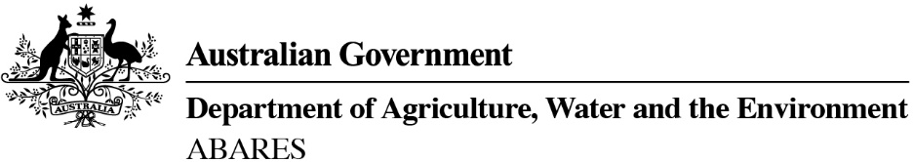

**ABARES Wagga Wagga Regional Outlook conference**

Wednesday, 15 June 2022

Venue - CSU Convention Centre, 286 Pine Gully Road, Charles Sturt University, Wagga Wagga

To register go to www. <https://agriculture.eventsair.com/22waggaroc/delegates/Site/Register>

CONFERENCE PROGRAM

8.30 AM Registration

**SESSION 1: Agriculture’s contribution to Australia’s prosperity**

CHAIR       Olivia Calver, ABC Riverina

9.00 AM Welcome to Country

9.10 AM *Opening address*

Michael Friend

Charles Sturt University

*CSU and DAWE partnership and new biosecurity training services*

9.30 AM Jared Greenville

ABARES

*Big picture issues affecting farmers in New South Wales*

9.50 AM Georgia Twomey

Rabobank

*Market insights adding value to farmers in southern NSW*

10.10 AM Questions and discussion

10.30 AM Morning tea

**SESSION 2:** **Adopting and adapting for sustainable growth panel discussion**

11.00 AM Our experienced panel members will share their stories of innovation and research aimed at driving sustainability and business success. Join in and ask your questions.

MODERATOR John Harvey, AgriFutures Australia

PANELLIST 1: John Stevenson, Warakirri Cropping and Nuffield scholar 2016

PANELLIST 2: Fran McLaughlin, FM Rural and AgriFutures Rural Women’s Acceleration Grant recipient

PANELLIST 3: Marc Greening, Injemira Beef Genetics and The Weekly Times/Coles 2021 Farmer of the Year

PANELLIST 4: Zoe Lamont, My Chef Cuisine

PANELLIST 5: Jason Crean, NSW Department of Primary Industries

12.30 PM      Lunch

**SESSION 3: Capturing value in agriculture**

CHAIR         Bronwen Jaggers, Department of Agriculture, Water and the Environment

1.30 PM      Emily Dahl

ABARES

*Commodity outlook and issues*

1.45 PM      Alister Hawksford

Bureau of Meteorology

*State of the climate*

2.00 PM      Paul Dowler

Regional Investment Corporation

*How the RIC is building a stronger regional Australia for farmers and farm-related*

*small businesses*

2.15 PM      Rob Collier

Riverina Fresh

*Working with your supply chain to capture high value - connecting dairy farmers to award-winning coffee roasters*

2.30 PM      Questions and discussion

3.00 PM      Close and invitation to stay for afternoon tea/networking

About ABARES and the Regional Outlook conferences

The Australian Bureau of Agricultural and Resource Economics and Sciences (ABARES) is the research arm of the Australian Government Department of Agriculture, Water and the Environment. ABARES provides professionally independent research, analysis, forecasts and statistics. ABARES Regional Outlook conferences are an essential part of our delivery of commodity forecasts and research results directly to rural and regional communities, with each conference program tailored to the region.

ENDS