**Exports of Australian waste and recovered materials in 2020-21**

*14 September 2021, Sally Donovan and Joe Pickin*

*©The Department of Agriculture, Water and the Environment*

Blue Environment is commissioned by the Department of Agriculture, Water and the Environment to analyse and report data on monthly and annual exports of waste and recovered materials[1]. The original data is provided by the Australian Bureau of Statistics (ABS), and comprises monthly data and updates to previously reported data[2],[3],[4]. The ABS data is transformed to account for issues such as export codes covering a mixture of wastes and non-wastes, and to make it consistent with national waste data methods[5]. On a tonnage basis nearly all these exports are materials recovered from waste streams for recycling[6] or energy recovery, but a small portion is hazardous waste sent for treatment.

Summary

In 2020-21, Australia exported about 4.25 million tonnes (Mt) of waste and recovered materials with a reported value of $3.2 billion[7]. The tonnage is almost identical to last year, but the reported value is 12% higher. The exports included 3.9 Mt (91%) within the scope of national waste reporting (‘core waste plus ash’). Exports of scrap plastic grew slightly but the proportion of mixed plastics continued to decline. Scrap glass exports dropped from a low level to almost zero as Australia’s ban on unprocessed glass exports came into force in January.

About 1.3 Mt were exported in 2020-21 in codes that could be affected by Australia’s scheduled export bans. This is 30% of the total exports of waste and recovered materials.

Annual trends in exports of waste and recovered materials, in aggregate

Figure 1 shows the tonnage of exports of waste and recovered materials from 2006-07 to 2020-21. Across all waste and recovered materials, 4.25 Mt were exported in 2020-21, almost identical to the previous year and little changed over the past five years.

Scrap metal exports accounted for 48% to 60% of exports in all years. Annual tonnages have been relatively stable since 2016-17, and were 2.45 Mt in 2020-21, representing 58% of the total.

Scrap paper and cardboard tonnages peaked in 2015-16 at 1.53 Mt and have declined in each year since. In 2020-21, 1.05 Mt were exported, or 25% of the total.

The remaining components of exports are relatively small. Exports in the ‘other’ category have grown in recent years. These tend to be dominated by large one-off shipments. Four shipments of sawdust and wood waste pellets to Japan accounted for 25% of ‘other’ wastes in 2020-21.

Figure 2 shows the reported dollar value of exports over 2006-07 to 2020-21, adjusted to dollar values in 2020-21. The total value has varied more than the tonnages, and in 2020-21 increased 12% to $3.2b. Scrap metals represented 70% of the total value, while paper and cardboard accounted for only 7% despite being 25% of the tonnage. Hazardous materials accounted for 12% while only 1% of the tonnage[8].

Figure Exports of waste from Australia by financial year and type, 2006-07 to 2020-21 (Mt)

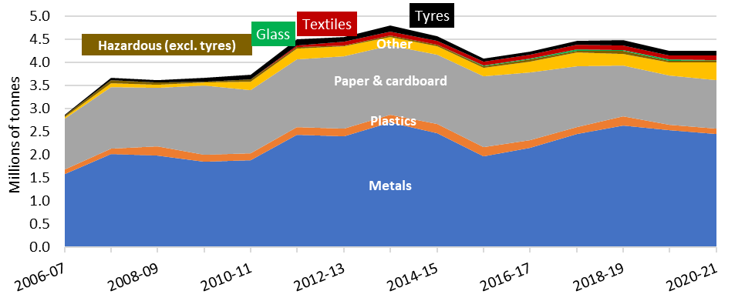

Figure Value of exports of waste from Australia by financial year and type (billions of dollars)

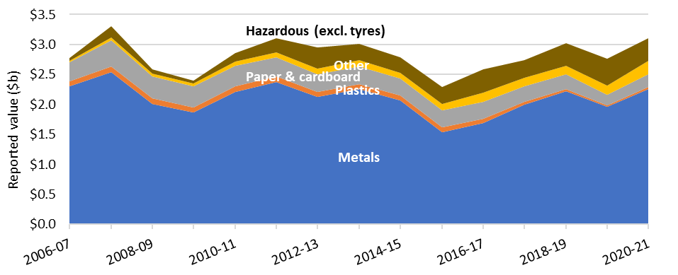

Annual trends in exports of recovered materials to be subject to export bans

Australia has determined to ban the export of waste glass, paper, plastics, and tyres not processed into a value-added material. Figure 3 shows the trend in exports of these materials alone. Scrap plastics fell from a 2015-16 peak of 203 kt (kilotonnes, or thousands of tonnes) and were 124 kt in 2020-21. Exports of scrap glass – the first material to face a ban, from January 2021 – dropped from 26 kt in 2019-20 to just 377 tonnes in 2020-21. Tyre exports were at 101 kt, higher than 2019-20 but lower than 2018-19.

Figure Exports of waste glass, paper, plastics and tyres, 2006-07 to 2020-21 (Mt)

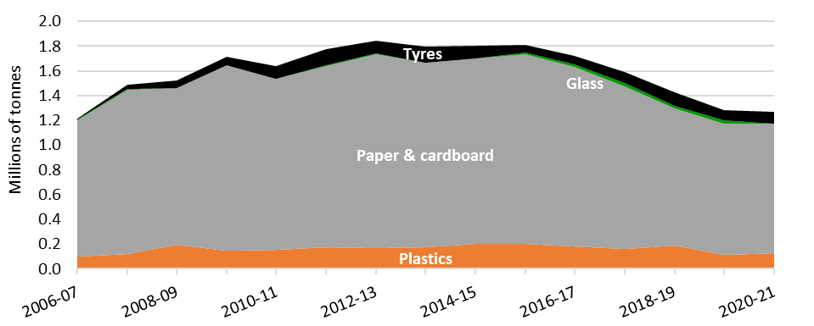

Figures 4 and 5 look more closely at trends since 2014-15 in the export of two of the key material types to be subject to bans: paper and cardboard, and plastics. The figures highlight the changes in quantities and destinations by grade since China began to restrict imports of recovered material in 2017-18. In each case, exports to China are shown on the left, and to other destinations on the right.

Figure 4 shows exports of paper and cardboard by grade. The initial restrictions on waste imports introduced by China in 2017 were expanded in January 2021 but small quantities of better processed materials continue to be received. Exports to other destinations grew, particularly to Indonesia.

Figure Exports of scrap paper and cardboard from Australia to China and other destinations by financial year (kt)

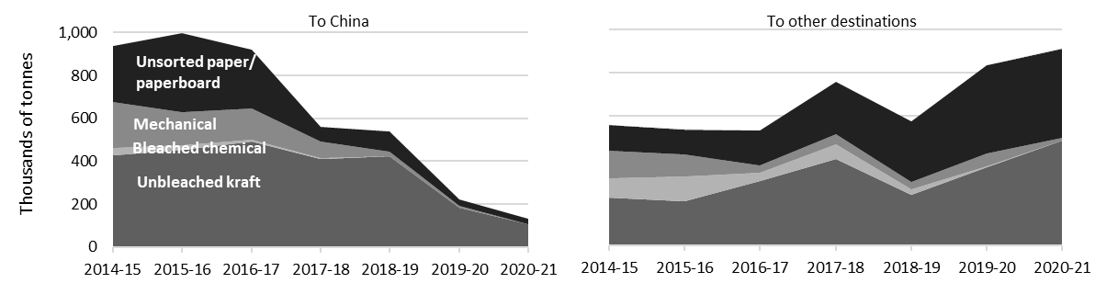

Figure 5 similarly shows exports of plastics since 2014-15. In all years, the largest export grade is mixed plastics (predominantly unsorted materials from domestic recycling collections), followed by sorted HDPE, LDPE and PET (mainly packaging). China was the largest market until 2016-17, after which its restrictions displaced material to other Asian destinations, mainly Indonesia and Malaysia. These destinations also introduced import restrictions, and exports dropped to a low in 2019-20 then rose slightly in 2020-21. Most restrictions relate to contamination rates, and the recent rise may indicate that exporters have improved the quality of their shipments.

Figure Exports of waste plastic from Australia to China and other destinations by financial year (kt)

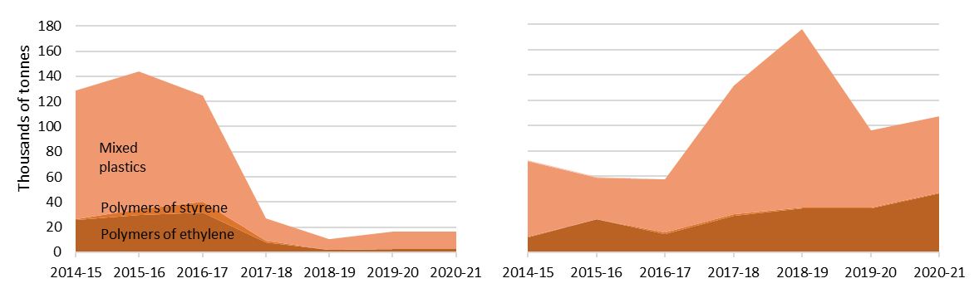

|  |  |
| --- | --- |
| Figure 6 shows exports of waste and recovered materials by destination since 2014-15, ranking the seven destinations that received the most materials in 2020-21. China was the top ranked destination until 2016-17 when it received 1.26 Mt and 30% of Australia’s waste exports, but subsequently dropped dramatically. Exports to Indonesia, India and Vietnam grew from 1.3 Mt in 2015-16 to more than 2.0 Mt in 2020-21 as they provided alternative markets for paper and cardboard waste from China. | Figure Exports of waste from Australia by financial year, showing the top seven destinations (Mt) |
|  |

2020-21 in focus

|  |  |
| --- | --- |
| Figure 7 presents the monthly trend in exports of waste from Australia in tonnes by material between July 2020 and June 2021.  Scrap metal exports dropped in the first half of the year then rose to reach a new high in the last few months as prices boomed. The main recipients were Vietnam, Bangladesh, India and Indonesia, which accounted for 62%.  Scrap paper and cardboard exports gradually increased to February then held steady for the rest of the year. Indonesia received 50% of the total. Of this, 68% was received in the last half of the period, apparently diverted from China after its latest ban came into force (see Table 4). | Figure Monthly exports of waste and recovered materials from Australia by material, July 2020 to June 2021 (kt)    Tyres  Glass  Hazardous  Textiles  Plastics  Other  Paper & cardboard  Metals |

‘Other’ waste exports were consistent except for peaks in October, March and May driven by large one-off shipments of sawdust and wood waste pellets from Bundaberg and Albany to Japan.

Exports of scrap plastic rose slightly despite tightening restrictions on international flows of this waste material. This suggests the quality of the reprocessed materials has increased to comply with the new regulations. Prices for clean bales of HDPE and PET packaging increased strongly during 2020-21. The main recipients were Malaysia (41%), Indonesia (16%) and China (13%).

Scrap tyre exports fluctuated[9]. The main recipients were India (46%) and Malaysia (29%).

Exports of hazardous waste were reasonably consistent. They mainly consisted of lead waste and scrap (74%) and lead-containing slag, ash and residues (20%). The main recipient was South Korea (43%).

Unprocessed glass waste exports were banned in January 2021. It appears that exporters were preparing in advance, as exports were very low throughout the year.

Exports of textiles (nearly all used clothing) increased slightly over the year, with most going to the UAE (60%).

Figure 8 shows monthly exports from Australia during 2020-21, ranking the seven destinations receiving the most materials (from the bottom). Indonesia was the biggest export destination in all but two months, receiving mainly scrap metals and paper and cardboard. Vietnam’s quantities varied significantly because it receives mainly metals, which vary considerably by month. Exports to China diminished as its new January import restrictions approached, and have not recovered.

Figure Exports of waste from Australia by month showing the top seven destinations, 2020-21 (kt)

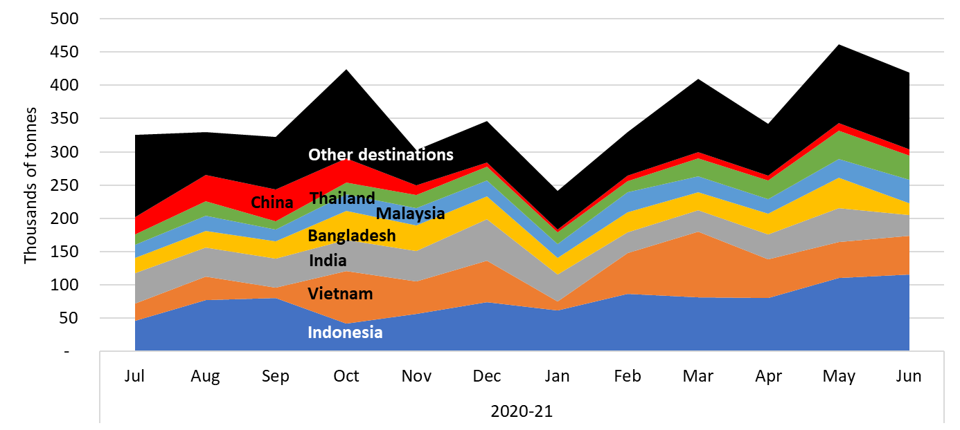

Australia’s 2020-21 exports of waste and recovered materials were from the jurisdictions shown in Figure 9. Victoria (1.06 Mt), NSW (1.04 Mt) and Queensland (1.01 Mt) all exported similar quantities. Victoria exported the most paper and cardboard (340 kt), plastics (59 kt), textiles (50 kt), tyres (34 kt) and ‘other’ wastes (46 kt), while Queensland exported the most metals (723 kt).

Figure Australian 2020-21 waste exports by jurisdiction of origin (kt)

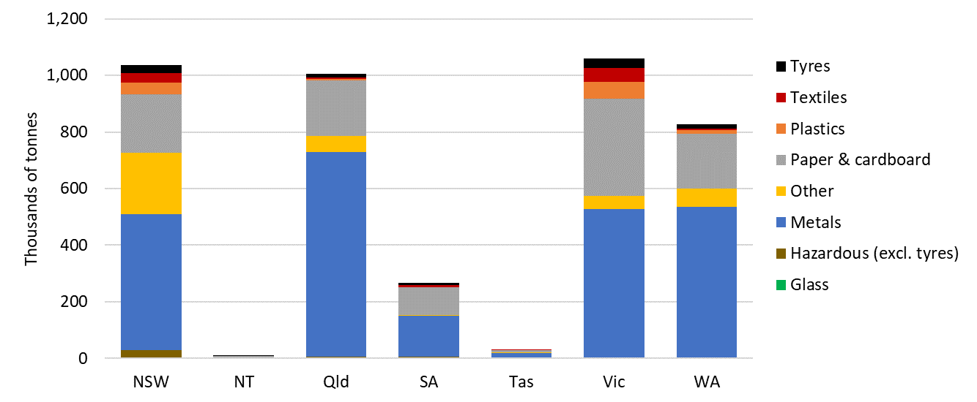

Most waste is exported from a port within its jurisdiction of origin. NSW exported 79% through Sydney, Queensland exported 70% through Brisbane, Victoria exported 87% from Melbourne, NT exported 97% from Darwin, WA exported 74% through Fremantle, and SA exported 93% through Port Adelaide. Tasmania is the exception. Only 42% was exported through Launceston and Burnie and the remainder went through Melbourne (47%) and Sydney (11%). It is understood that exported materials generated in the Australian Capital Territory are typically exported from Sydney.

Figure 10 shows Australia’s 2020-21 waste exports by port of loading. Most exports leave from four main ports: Melbourne (25%); Sydney (20%); Brisbane (19%); and Fremantle (16%). Metals, followed by paper and cardboard, make up the largest share of exports from all ports. Sydney and all other ports also had a large proportion of ‘other’ wastes. This data was only made available from January 2020, so there are no previous years for comparison.

Figure Australian 2020-21 waste exports by port of loading (kt)

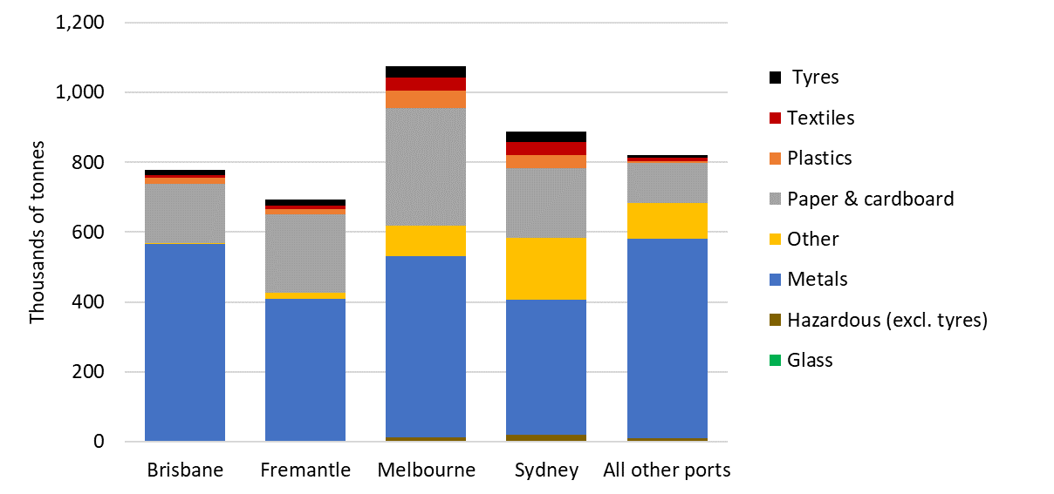

|  |  |
| --- | --- |
| Figure 11 presents monthly trends in the reported unit values of key waste-derived material exports from July 2020 to June 2021. The value of metals, plastics, and paper and cardboard have all increased gradually, while textiles have been consistent throughout the year. The value of tyres was on a decreasing trend but rose again in June. | Figure Comparison of average unit prices by material, July 2020 to June 2021 ($/tonne) |
| Paper & cardboard  Tyres  Plastics  Metals  Textiles |

June 2021 in focus

In June 2021, Australia exported 419,000 tonnes of waste and recovered materials with a reported value of $364 million. This was a decrease of 9% in tonnes and 7% in value compared to May 2021. Indonesia received 27%, the most of all recipients, followed by Vietnam (14%). South Korea received 11% of total exports, attributable to two large shipments of ferrous waste and scrap from ports in WA. Exports of hazardous waste, paper and cardboard and plastics were higher than May, while exports of all other waste types were down.

Context – Australian waste exports compared with overall waste flows

The *National Waste Report 2020* found Australia generated 74 Mt of waste in 2018-19, sending 60% (43 Mt) to recycling, 3% to energy recovery and the remainder to disposal fates, such as landfill or incineration. The 2020-21 exports total of 4.3 Mt of waste and recovered materials therefore represents about 10% of national recycling and 6% of national waste generation.

Table 1 compares quantities of recycling in Australia with exports of waste and recovered materials, noting that nearly all exports are destined for recycling or energy recovery. The hazardous and ‘other’ categories are combined because the proportions of both are low.

The table suggests that 2020-21 exports accounted for 68% of tyres, half of recovered metals and around a third of plastics and paper and cardboard. Nearly all other recovered materials were recycled in Australia. These encompass a wide range of materials, but most of the tonnes were masonry materials, organic wastes and fly ash from coal-fired power stations.

Table Data comparing Australian exports and overall recovery of wastes

|  |  |  |  |  |  |
| --- | --- | --- | --- | --- | --- |
| Waste trade group | Generated in 2018-19 (kt) | Recovered in 2018-19 (kt) | Exported in 2020-21 | | |
| **(kt)** | **($m value)** | **(% of 2018-19 recovery)** |
| Glass | 1,160 | 690 | 0.4 | $0.22 | 0.1% |
| Metals | 5,600 | 5,040 | 2,500 | $2,200 | 49% |
| Other and hazardous[10] | 50,230 | 35,700 | 390 | $230 | 1% |
| Paper and cardboard | 5,920 | 3,500 | 1,000 | $210 | 30% |
| Plastics | 2,540 | 330 | 130 | $40.4 | 38% |
| Tyres | 449 | 160 | 100 | $19.8 | 65% |

Australian waste export ban

A March 2020 meeting of the then Council of Australian Governments agreed to a timetable for implementing bans on exporting waste glass, paper, plastics, and tyres not processed into a value-added material. The relevant materials, dates and main export codes are shown in Table 2.

The ban on unprocessed glass came into effect in January, at which time new codes were introduced for processed glass waste that was suitable for export. Since then, only small amounts of this approved glass have been exported.

Table 2 Material types facing export bans

| Material | Ban date | AHECC[11] code | AHECC description | 2020- 21 exports in this code (rounded tonnes) | | Estimated % of tonnes to be banned[12] |
| --- | --- | --- | --- | --- | --- | --- |
| Glass (unprocessed) | Jan 2021 | 70010000 (pre ban) | Cullet and other waste and scrap of glass; glass in the mass | | 300 | Ban in effect |
| 70010091 | Glass in the mass, cullet and other waste and scrap of glass, not elsewhere specified | |
| Paper and cardboard | Jul 2024 | 47071000 | Recovered (waste and scrap), unbleached, kraft paper or paperboard or corrugated paper or paperboard | | 590,000 | 47% [13] |
| 47072000 | Recovered (waste and scrap) paper or paperboard, made mainly of bleached chemical pulp, not coloured in the mass | | 1,100 |
| 47073000 | Recovered (waste and scrap) paper or paperboard, made mainly of mechanical pulp (e.g. newspapers, journals) | | 11,000 |
| 47079000 | Waste and scrap paper or paperboard (incl. unsorted waste & scrap) | | 444,000 |
| Plastics | Jul 2022 | 39151000 | Waste, parings and scrap, of polymers of ethylene | | 49,000 | 100% [14] |
| 39152000 | Waste, parings and scrap, of polymers of styrene | | 440 |
| 39153000 | Waste, parings and scrap, of polymers of vinyl chloride | | 350 |
| Jul 2021 | 39159092 | Waste, parings and scrap, of plastics (excl. those of polymers of ethylene, styrene or vinyl chloride) | | 74,000 | 83% [15] |
| Whole tyres | Dec 2021 | 40040000 | Waste, parings and scrap of rubber (excl. of hard rubber) and powders and granules obtained therefrom | | 70,000 | 44% 9 |
| 40122000 | Used pneumatic rubber tyres, whether or not subject to recutting or regrooving | | 20,000 | 100% 9 |
| 40129000 | Solid or cushion rubber tyres, rubber tyre treads (incl. interchangeable tyre treads) and rubber tyre flaps | | 10,000 | 6% 9 |

Analysis and comment

Scrap plastics are subject to many restrictions, including import regulations applied by most of our key waste trade partners, as well as the Basel Convention amendment on scrap plastic trade. Nevertheless, exports increased slightly in 2020-21 compared to 2019-20. The share of mixed scrap plastic fell from 80% in 2018-19, to 66% in 2019-20 and then to 60% in 2020-21. This suggests exporters have been able to improve the quality of their sorting to comply with the new restrictions. The EU introduced new restrictions on scrap plastic exports which may also have opened up new markets for Australia. Clean PET and HDPE is currently trading at the highest prices seen for at least a decade, probably driven by packaging manufacturer and brand-owner demand for recycled content packaging.

Until 2016-17, over 60% of Australia’s exports of scrap paper and cardboard went to China. In 2020-21, these exports were only 13%. Overall exports of paper and cardboard have also been declining. Australia was still exporting large quantities of scrap paper and cardboard to China in late 2020, causing concern over what would happen when the new ban came into force in January. However, as China’s paper and cardboard imports dropped, Indonesia’s rose indicating alternative markets were found there. The overall fall in tonnes was only 1%. Although exports to China stopped in January, small quantities have been exported there from February, as high-quality reprocessed materials are exempt from the ban.

End-of-life tyre exports rose in 2020-21. It is understood that the COVID pandemic restrictions in 2019-20 caused a dip in tyre exports to India, Australia’s key trading partner for this material, but they appear to have resumed in 2020-21. It should be noted that export quantities in the ABS data are generally lower than reported through industry sources and calculated via mass balance, indicating significant miscoding.

Exports of unprocessed glass waste were banned from January 2021. Exporters appeared to have been prepared, as less than 400 tonnes were exported over the year, down from 25,000 tonnes in 2019-20.

Although scrap metal export tonnages have been relatively stable on an annual basis for six years, 2020‑21 was variable on a monthly basis. A dip in the middle of the year was followed by a boom, with monthly levels reaching their highest over the four-year monthly timeframe. This is linked to high or even record prices affecting most types of scrap and non-scrap metals[16], variously associated with expanding Chinese production[17] and the pandemic[18]. Ferrous scrap is currently trading at its highest prices for at least two decades, pulling through more marginal material and drawing down stockpiles.

Exports of ‘other’ waste – mostly agricultural organics – reached a new peak in 2020-21 of 387 kt.

Exports of hazardous materials have been relatively consistent since 2015-16.

Over the last two to three months, international trade in goods, including waste materials, has been curtailed due to a confluence of problems, across global shipping availability, container availability, land-side transport availability, and port throughput constraints. This is driven by a multitude of factors, principally ongoing COVID-19 impacts.

Restrictions on waste imports in export destinations – 2020-21 highlights

On 1 January 2021, an amendment to the Basel Convention came into force[19], enhancing control of transboundary movements of plastic waste. The new rules stipulate that mixed plastic waste must be ‘almost free from’ contamination. This has been interpreted to mean anywhere between 0.5% and 5%[20].

On 22 December 2020[21], the EU banned the export of plastic waste to non-OECD countries except when clean and ready for recycling. Further restrictions on global plastic waste trade could be coming as the fifth session of the United Nations Environment Assembly (UNEA), held earlier this year proposed a global

treaty on plastic waste, with 120 countries already indicating support[22]. Due to the COVID pandemic the UNEA was unable to finalise an agreement but has put it on the agenda for next year’s meeting, when in-person sessions are expected to resume. Thailand’s ban on plastic waste imports was also due to come into force in 2020-21, but the government instead decided on a gradual phase out, reducing quotas by 20% per year until 202641. January 2021 was also the start of China’s total ban on solid waste imports. New definitions of certain reprocessed or scrap materials have been settled[23], including ferrous and non-ferrous metals and recycled pulp. Imports of high-quality reprocessed materials are noted as important to China’s zero carbon goals.

Malaysia announced plans to introduce restrictions on scrap metal imports. Negotiations between the metal industry and government are continuing. The metals industry argues that its strong reliance on recycled scrap[24] needs to increase further to comply with emissions reduction commitments, and import restrictions could jeopardise this transition[25]. The draft restrictions cover minimum metal content, contamination limits, as well as pre- and post-shipment inspections. An industry representative claimed these exceed the Basel Convention requirements on hazardous waste. Exporters are concerned that the restrictions could set a precedent leading to global restrictions on the scrap metal trade.

In 2020 Indonesia announced the formation of a task force to look at reducing the country’s dependence on imports of scrap. However, more recently Indonesia’s head of the Centre for Green Industry, Standardization and Industrial Service Policy announced steps to be taken to boost recycling and move towards a circular economy[26]. The announcement noted the significance of the recycling industry to Indonesia’s economy and that imports would remain necessary to provide sufficient feedstocks. Plans to impose increased restrictions on contamination in exports of scraps have settled on a 2% rate, which came as good news to Australian exporters who rely heavily on Indonesia[27].

Restrictions on waste import – overview

The current status of import restrictions for Australia’s top 10 waste and recovered materials destinations is summarised in Table 3, while Table 4 provides details of the import restriction policies, their dates and amount of waste potentially impacted by the bans.

Table 3 Summary of import restrictions by material and top 10 destinations

|  |  |  |  |  |  |  |  |  |  |  |
| --- | --- | --- | --- | --- | --- | --- | --- | --- | --- | --- |
|  | **Glass** | **Haz. waste (excl. tyres)** | **Metals** | **Paper & cardboard** | **Plastics** | **Tyres** | **Textiles** |  |  |  |
| Indonesia | **Restricted** | **Restricted** | **Restricted** | **Restricted** | **Restricted** | **Restricted** |  |  | **Key** |  |
| India |  |  | Considering |  | **Restricted** | Considering |  |  | **Restricted** | Restrictions are in place |
| Bangladesh |  |  |  |  | **Restricted** |  |  |  | Announced | Restrictions announced but not yet implemented |
| Vietnam |  |  | **Restricted** | **Restricted** | **Restricted** |  |  |  | Considering | Restrictions are under consideration |
| China |  |  | **Restricted** | **Restricted** | **Restricted** |  |  |  |  |  |
| Malaysia |  |  | Considering |  | **Restricted** |  |  |  |  |  |
| Thailand |  |  |  |  | **Restricted** |  |  |  |  |  |
| Taiwan |  |  |  | **Restricted** | **Restricted** |  |  |  |  |  |
| South Korea |  |  |  | **Restricted** | **Restricted** | Announced |  |  |  |  |
| Pakistan |  |  |  |  | Considering | **Restricted** |  |  |  |  |

Table 4 Status of waste import restrictions

|  |  |  |  |  |  |  |
| --- | --- | --- | --- | --- | --- | --- |
| Destination | Scope of restrictions | Announced & implemented | Associated exports | | | Impact and uncertainties |
| **Types** | **2019-20 tonnes** | **20-21 tonnes/month** |
| Indonesia | On 27 May 2020 the Indonesian Government published a decree on the implementation of import of non-hazardous and toxic material waste[28]. This limits contamination of imported scrap plastics and paper to 2%. The decree announced the formation of a task force to develop a road map accelerating the availability of domestic raw materials. However, recently the head of the Centre for Green Industry, Standardization and Industrial Service Policy noted the importance of the recycling industry to Indonesia’s economy and the necessity for imports to provide sufficient feedstocks26. | Ann.: Apr-19  Imp.: Nov-19 | Plastics, Paper and cardboard, metals, glass, hazardous waste, tyres, other. | 627,000  (52,000 per  month) | 76,000 | Imports reduced from 61,000 tonnes per month in 2018-19 to 52,000 in 2019-20. However, in 2020-21 the monthly average was back up to over 60,000 tonnes per month in the first half of the year, then climbed as paper and cardboard appeared to be diverted here from China, making the overall monthly average 76,000 tonnes. |
| India | In 2016 India banned the import of scrap plastics with an exemption for special economic zones (SEZ) and export-oriented units (EOU). In August 2019[29] the ban was expanded to cover these zones, but on 27 January 2021 this expansion was revoked meaning waste plastics can again be imported to these areas. The ban excludes electrical/electronic assemblies or components that are defective which can be imported within a year of export. India also has a contamination limit of 1% for recovered paper, which it enforces by randomly inspecting five mixed paper bales per container [30]. India has proposed a new policy seeking to increase local scrap metal processing and reducing reliance on imports[31]. | Ann.: Mar-19  Imp.: Mar-19 to Aug-19  Lifted: Jan-21 | Plastics | 60  (5 per month) | 30 | Plastics imports reduced from 60 to 5 tonnes per month from 2018-19 to 2019-20, then increased to 30 t/month in 2020-21 as restrictions were eased from January. |
| Bangladesh | The Bangladesh Ministry of Commerce Import Policy Order 2015-2018 includes details of waste import regulations[32]. Metals and glass are allowed for bona fide industrial units, paper and cardboard is unrestricted and textiles are allowed with some restrictions. The regulations also mention exemptions for other waste types that would fall under the waste groups hazardous and ‘other’. | Imp: Feb-16 | Plastics |  | 0 | None. |
| Vietnam | On 24 September 2020 Vietnam published[33] ‘*Promulgation of the list of waste permitted for import as production materials*’, overriding previous regulations. Unsorted scrap paper imports and granulated slag from iron and steel manufacture are to be banned by the end of 2021. This builds on a range of 2018 restrictions that allow waste imports only if shipments meet environmental standards and processing capacity is demonstrated. The earlier restrictions covered scrap metals, plastic, paper, glass, and blast furnace slag dust[34]. Under new national standard QCVN 32: 2019/BTNMT, import of e-waste plastics (e.g. TVs and computers) would be forbidden[35]. Scrap metal waste needs to be 99% metal to be allowed in[36]. | Ann. in Sep-20.  Mixed metal waste restricted from Oct-18. | Plastic, paper, metals | 420,000  (35,000 per month) | 45,000 | Imports reduced from 61,000 to 35,000 tonnes per month between 2018-19 and 2019-20, then increased to 45,000 tonnes per month in 2020-21. More waste was received from January, indicating possible diversion here from China after its strengthened ban. |
| Malaysia | Malaysia cracked down on plastic waste imports this year, supported by the Basel Convention amendment on plastics waste, which came into force in January 2021.[37]. The Basel Action Network encouraged the Malaysian Government to similarly inspect all shipments of waste plastics entering the country to ensure continued compliance[38]. Proposed import restrictions on metals are still under negotiation36. | Jul-18. | Plastics, metals | 49,000  (4,100 per month) | 4,200 | Malaysian imports were similar between 2019-20 and 2020-21 (4,100 and 4,200 tonnes per month respectively). There is no apparent impact. |
| China | China banned the import of all solid waste from January 2021[39]. Certain high quality reprocessed materials are not considered waste under the legislation’s definitions including scrap metals and paper-grade recycled pulp. | Ann.: Apr-20  Imp.: Jan-21 | All solid wastes | 328,000  (27,000 per month) | 18,000 | Imports fell from over 100,000 t/mth in 2016-17 to 27,000 in 2019-20 and again to 18,000 t/mth in 2020-21 as restrictions increased. |
| Thailand | Thailand had announced that it would ban the import of all waste plastics by 2022[40]. However, it decided instead to gradually reduce by 20% per year, leading to a total ban in 2026[41]. A ban on 428 types of electronic waste has been announced[42]. | Ann. Aug-18, plastics imp. Aug-18, e-waste <2 yrs. | Plastics | 9,500  (800 per month) | 330 | Plastics imports reduced from 900 to 800 t/mth between 2018-19 and 2019-20 then to 330 t/mth in 2020-21. |
| Taiwan | Import of waste plastics is banned. Exceptions are made to licensed local firms that import waste plastics originating from their own overseas production processes or are a single material, but not from original production processes[43]. Paper imports are restricted to deinked paper, kraft paper, corrugated paper or cardboard that is not bleached. Import of waste newspapers and magazines is banned. | Ann.: Aug-18  Imp.: Oct-18 | Plastics, paper | 14,200  (1,200 per month) | 490 | Imports reduced from 1,500 to 1,200 t/mth between 2018-19 and 2019-20. In 2020-21 they fell further to 490 t/mth. |
| South Korea | On 6 January 2021, the Ministry of Environment announced bans or restrictions on their top 10 waste import materials[44]. Total imports are to reduce by 35% by 2022 and 65% by 2025. Bans on: plastics, mixed waste paper and waste fibre commence in 2022; on coal ash and tyres in 2023; and on corrugated cardboard, dust and sludge in 2023[45]. Imports of PET, PE, PP and PS were banned from the end of June 2020[46]. | Ann.: Feb-20  Imp.: Jun-20 | Paper and cardboard  Plastics | 13,000  (1,100 per month) | 1,200 | No impact is apparent as the restrictions have not yet been implemented. |
| Pakistan | On 25 September 2020 the Pakistan Government Ministry of Commerce banned the import of re-treaded tyres and used pneumatic tyres[47]. On 4 August 2021 the Prime Minister chaired a meeting on waste management where he asked the attending officials to take inspiration from China on scrap plastic imports, indicating restrictions are likely to be announced in the near future[48]. | Sep-20 | Tyres |  | 0 | No impact apparent. |

1. The export codes mapped to waste and recovered materials in 2020-21 differ slightly from those in 2019-20. Details are given in the accompanying workbook (under ‘Ref lists’). The historical data presented here has been updated.
2. Data in these summaries is originally entered by exporters or their agents. It cannot be guaranteed that exporters use the correct codes or values for their exports, so this data should be used with caution.
3. Data may be revised for up to six months after initial publication as customs declarations are amended by individual traders. Due to these revisions, there may be discrepancies between this and preceding reports.
4. The data presented is gross weight, including packaging. This value is used for consistency because the quantities of exported materials are presented in varied units, including numbers of items.
5. Methods and mappings to waste are reviewed regularly and may change in future.
6. Some of these recovered materials contain a proportion of contamination (or ‘off-spec’ content) that needs to be extracted before the material can be used.
7. Dollar values refer to Australian dollars. Historical values are inflated based on the annualised consumer price index.
8. A significant proportion of this value is exports of ‘copper slag and ash’ which were allocated a value of over $450/kg in 2020-21. The value of pure copper is typically around $10/kg. This waste is likely to contain precious metals.
9. Tyre export quantities in the ABS data are generally lower than reported through industry sources. Significant miscoding is likely.
10. Includes large waste streams such as construction and demolition wastes, organics, ash and contaminated soils.
11. Australian Harmonized Export Commodity Classification.
12. Based on the 2018-19 characteristics of these materials.
13. Comprises the proportion of material in AHECC code 47079000, but significant miscoding is apparent in the data.
14. Assumes no material was sorted and processed to the extent that will be required for future export.
15. Excludes fuels.
16. Australian Bureau of Statistics (2021) [International merchandise trade, preliminary, Australia.](https://www.abs.gov.au/statistics/economy/international-trade/international-merchandise-trade-preliminary-australia/latest-release)
17. ABC News (2021) [Record iron ore prices boost Australia’s economy, but will the China trade war end the boom?](https://www.abc.net.au/news/2021-05-27/iron-ore-price-at-record-high-but-australia-china-tensions-loom/100166932)
18. Australian Mining (2021) [Australian copper production declines in 2020](https://www.australianmining.com.au/news/australian-copper-production-declines-in-2020/).
19. Basel Convention, [Plastic waste amendments](http://www.basel.int/Countries/StatusofRatifications/PlasticWasteamendments/tabid/8377/Default.aspx).
20. EScrap News (14 January 2021) [Basel plastic rules cause immediate e-plastics strife](https://resource-recycling.com/e-scrap/2021/01/14/basel-plastic-rules-cause-immediate-e-plastics-strife/).
21. European Commission (2020) [Plastic waste shipments: new EU rules on importing and exporting plastic waste](https://ec.europa.eu/environment/news/plastic-waste-shipments-new-eu-rules-importing-and-exporting-plastic-waste-2020-12-22_en).
22. Langrand M. (March 2021) [A new global treaty to tackle plastic pollution?](https://genevasolutions.news/sustainable-business-finance/a-new-global-treaty-to-tackle-plastic-pollution)
23. Global Recycling (2021) [China: on the road to ‘zero-carbon’](https://global-recycling.info/archives/5425).
24. Recycling International (2021) [Growing fears of global recycling infrastructure ‘collapse’](https://recyclinginternational.com/bir-convention/growing-fears-of-global-recycling-infrastructure-collapse/36136/).
25. Majumder R. (June 2021) [Malaysia’s import restrictions on metal scrap may lose out recycling investments](https://www.alcircle.com/news/malaysias-import-restrictions-on-metal-scrap-may-lose-out-recycling-investments-industry-association-66482).
26. AntaraNews (2021) [Recycling industry processing just one-third of nation’s waste: govt.](https://en.antaranews.com/news/177746/recycling-industry-processing-just-one-third-of-nations-waste-govt)
27. MRW (2021) [Indonesia to allow waste imports with 2% contamination limit](https://www.mrw.co.uk/news/indonesia-to-allow-waste-imports-with-2-contamination-limit-19-07-2021/).
28. Ministers of Trade, Environment and Forestry and Head of State Policy, Indonesia (May 2020), [Implementation of import of non hazardous and toxic material waste as raw material industry](https://images.magnetmail.net/images/clients/ISRIID/attach/ENIndonesiaGovtJointDecreeonRPimportsEN.pdf).
29. Business Today, (24 June 2019) [India bans import of plastic waste from August this year to curb pollution](https://www.businesstoday.in/current/policy/india-bans-import-of-plastic-waste-from-august-this-year-to-curb-pollution/story/358778.html).
30. Waste Dive, (15 January 2020), [India to enforce 1% contamination rate on paper imports, conduct random inspections](https://www.wastedive.com/news/india-enforce-contamination-rate-inspections-paper-imports/570427/).
31. Bone C. (2021) [India mulls over self-sufficient future without imported scrap](https://www.metalbulletin.com/Article/3983295/FOCUS-India-mulls-over-self-sufficient-future-without-imported-scrap.html).
32. Ministry of Commerce, Government of the People’s Republic of Bangladesh (2016) [Import Policy Order 2015-2018](http://extwprlegs1.fao.org/docs/pdf/bgd171057.pdf).
33. Prime Minister of Vietnam (24 September 2020) [Promulgation of the list of waste permitted for import as production materials](https://vanbanphapluat.co/decision-28-2020-qd-ttg-the-list-of-waste-permitted-for-import-as-production-materials). Unofficial translation.
34. Vietnam - National Technical Regulations on Wastes (18 November 2019), <https://www.cciclondon.com/portal/article/index/cat_id/35/id/286.html>.
35. Ministry of Natural Resources and Environment of the Socialist Republic of Vietnam (2018) [Vietnam to ban imports of plastic from used electronics](http://www9.monre.gov.vn/wps/portal/news/!ut/p/c5/dclJDoIwFADQE5n_RYawbJAZFWgh2A0hJJpCw6AVlNPrBcxbPuDwMzSLuDdKjEMjoQJu1o5PAt1KEP2SmEgozS6hFWnoI1yBW38_1oFBhXpNOxxfCZ3ijS5v1uLDrljebZl2VlkgJl54M5tzPeafmzSignihK4-OduoIKrv09mva9lxU0phZvxaHUHVuELqZk-6eooepb8gXeJcnsw!!/).
36. S&P Global Platts (2019) [Vietnam’s Jan scrap imports plunge amid stricter government rules](https://www.spglobal.com/platts/en/market-insights/latest-news/metals/022019-vietnams-jan-scrap-imports-plunge-amid-stricter-government-rules).
37. Reuters (2021) Malaysia permits import of US plastic waste shipment after it passes new UN treaty test <https://www.reuters.com/article/us-malaysia-environment-plastic-idUSKBN2BG0ZL>.
38. The Sun Daily (2 February 2021) [Waste not want not: Malaysia moves to become a leader in tackling plastic waste](https://www.thesundaily.my/opinion/becoming-a-leader-tackling-plastic-waste-DC6466588).
39. Ministry of Ecology and Environment, People’s Republic of China (25 November 2020) [MEE Announcement No. 53 2020](https://images.magnetmail.net/images/clients/ISRIID/attach/20201124ChinaSWimportbanEN.pdf) (unofficial translation by Institute of Scrap Recycling Industries).
40. REB market intelligence (25 January 2021) [Thailand considering plastic import ban from 1st January 2022](https://www.rebnews.com/thailand-considering-plastic-import-ban-from-1-january-2022/).
41. REB (2021) [Thailand’s plastic ban delay took into account balance of need for material and environmental considerations.](https://www.rebnews.com/thailands-plastic-ban-delay-took-into-account-balance-of-need-for-material-and-environmental-considerations/)
42. Saengmanee (2020) [The year nature bounced back](https://www.bangkokpost.com/life/social-and-lifestyle/2042171/the-year-nature-bounced-back).
43. Taipei Times (2018) [New waste plastic, paper import rules to take effect](http://www.taipeitimes.com/News/taiwan/archives/2018/10/02/2003701576).
44. Business Korea (7 January 2021) [Waste import ban roadmaps to come out soon](http://www.businesskorea.co.kr/news/articleView.html?idxno=58078).
45. Inquirer.net (10 January 2021) [S. Korea to phase out industrial waste imports](https://business.inquirer.net/315509/s-korea-to-phase-out-industrial-waste-imports).
46. The Korea Times (2020) [Plastic waste imports banned in Korea amid mounting local trash](https://www.koreatimes.co.kr/www/nation/2020/06/371_292052.html).
47. Pakistan Government Ministry of Commerce (2020) [Import Policy Order 2020](http://www.commerce.gov.pk/wp-content/uploads/2020/09/Import-Policy-Order-25-09-2020.pdf).
48. Pakistan Today (2021) [PM directs to take inspiration from China for waste ban policy.](https://www.pakistantoday.com.pk/2021/08/04/pm-directs-to-take-inspiration-from-china-for-waste-ban-policy/)