National Recovery Plan for the
Hairy-pod Wattle
Acacia glandulicarpa

Oberon Carter

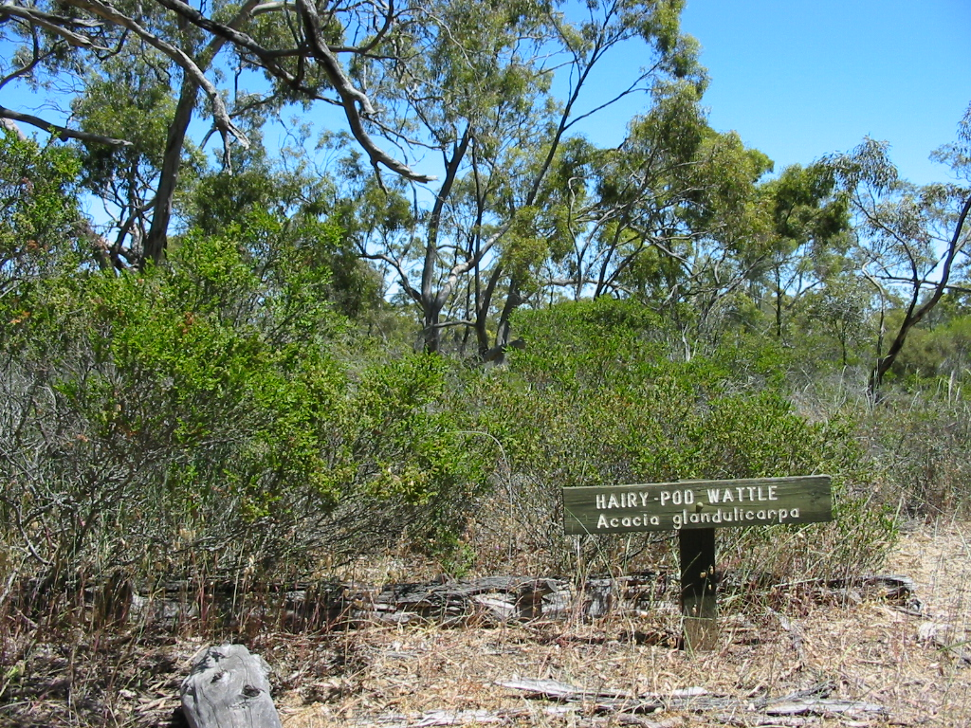

 | 

Prepared by Oberon Carter (Department of Sustainability and Environment, Victoria).

Published by the Victorian Government Department of Sustainability and Environment (DSE) Melbourne, 2011.

© State of Victoria Department of Sustainability and Environment 2011
This publication is copyright. No part may be reproduced by any process except in accordance with the provisions of the Copyright Act 1968.
Authorised by the Victorian Government, 8 Nicholson Street, East Melbourne.

ISBN 978-1-74208-773-3

This is a Recovery Plan prepared under the Commonwealth Environment Protection and Biodiversity Conservation Act 1999, with the assistance of funding provided by the Australian Government.
This Recovery Plan has been developed with the involvement and cooperation of a range of stakeholders, but individual stakeholders have not necessarily committed to undertaking specific actions. The attainment of objectives and the provision of funds may be subject to budgetary and other constraints affecting the parties involved. Proposed actions may be subject to modification over the life of the plan due to changes in knowledge.

Disclaimer
This publication may be of assistance to you but the State of Victoria and its employees do not guarantee that the publication is without flaw of any kind or is wholly appropriate for your particular purposes and therefore disclaims all liability for any error, loss or other consequence that may arise from you relying on any information in this publication.

An electronic version of this document is available on the Australian Government Department of Sustainability, Environment, Water, Population and Communities website www.environment.gov.au

For more information contact the DSE Customer Service Centre 136 186

Citation: Carter, O. 2011. National Recovery Plan for the Hairy-pod Wattle Acacia glandulicarpa. Department of Sustainability and Environment, Melbourne.

Cover photograph: Hairy-pod Wattle Acacia glandulicarpa by Oberon Carter.

Table of Contents

Species Information 3
Description 3
Distribution 4
Population information 5
Habitat 5
Decline and Threats 7
Existing Conservation Measures 8
Recovery Information 8
Recovery objectives 8
Program Implementation 9
Program Evaluation 9
Recovery Objectives, Actions and Performance Criteria 10
Management Practices 12
Affected interests 12
Role and interests of indigenous people 12
Benefits to other species/ecological communities 12
Social and economic impacts 13
Acknowledgments 13
Bibliography 13
Priority, feasibility and estimated costs of recovery actions 14

Summary
The Hairy-pod Wattle Acacia glandulicarpa is a perennial shrub endemic to south-eastern Australia, where it occurs in western Victoria and eastern South Australia. Widespread clearing of habitat has been responsible for the decline in range and abundance of the species. There are estimated to be 6,000–12,000 plants occurring in about 75 locations, almost all of these occurring in the Wimmera region of western Victoria. At least 50% of the total number of plants occur in just seven populations, with one population, in the Little Desert National Park in Victoria, accounting for about 25% of the total number. Most populations are small (<20 plants) and occur in highly vulnerable situations such as roadsides. Remaining populations are threatened by weed invasion, grazing, lack of regeneration, roadworks and altered fire regimes. The Hairy-pod Wattle is listed as Vulnerable under the Australian Government Environment Protection and Biodiversity Conservation Act 1999, Threatened under the Victorian Flora and Fauna Guarantee Act 1988 and Endangered under the South Australian National Parks and Wildlife Act 1972. This national Recovery Plan for the Hairy-pod Wattle details the species’ distribution and biology, conservation status, threats, and recovery objectives and actions necessary to ensure its long-term survival.

Species Information

Description
The Hairy-pod Wattle Acacia glandulicarpa is a dense, rounded, spreading and much-branched shrub 0.5–2 m high, with dull to bright olive-green foliage. Branches are grey-brown, terete and minutely pubescent, marked with small raised leaf bases along the stems. Phyllodes are obliquely oblong-obovate to more or less elliptic, 5–13 mm long and 3–8 mm broad, erect, thick, rigid, glabrous, minutely glandular, and sometimes viscid when young. The lower phyllode margins are usually undulate. Phyllodes are 2-veined, the central vein being more prominent. Lateral veins are few and obscure, and the apex is shortly mucronate. Inflorescences are simple, axillary, solitary or paired, with the bright yellow flower heads carrying 8–20 flowers from July–October. Peduncles are about as long as the phyllode. Seed pods are narrowly oblong, 30 mm long and 2–5 mm wide, straight or curved, sticky, and covered with glandular shining hairs (description from Jessop & Toelken 1986; Maslin 1996). Little is known of the ecology of the Hairy-pod Wattle. Most stands comprise ageing individuals (Venn 1996), although in late 2003 some recruitment was observed at several sites following heavy spring rain.

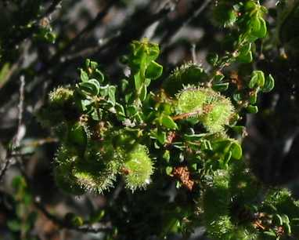 | 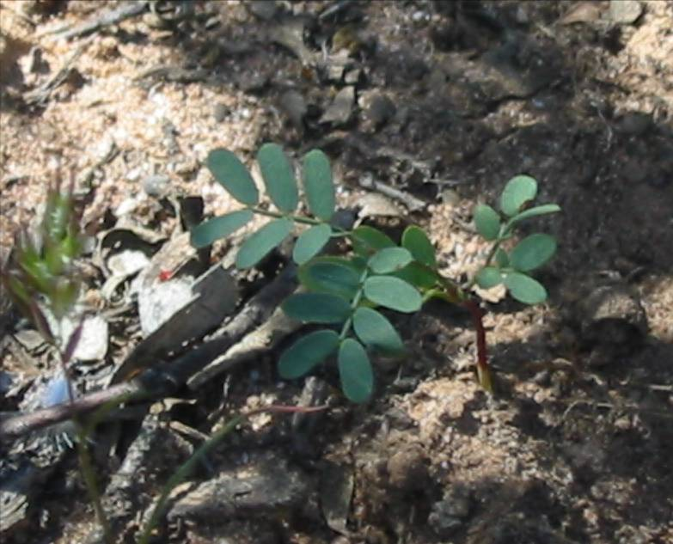
Sticky, unripe seed pods (November 2003, by O. Carter) | seedling at McHabes Hut Track West, Little Desert National Park (November 2003, by O. Carter)

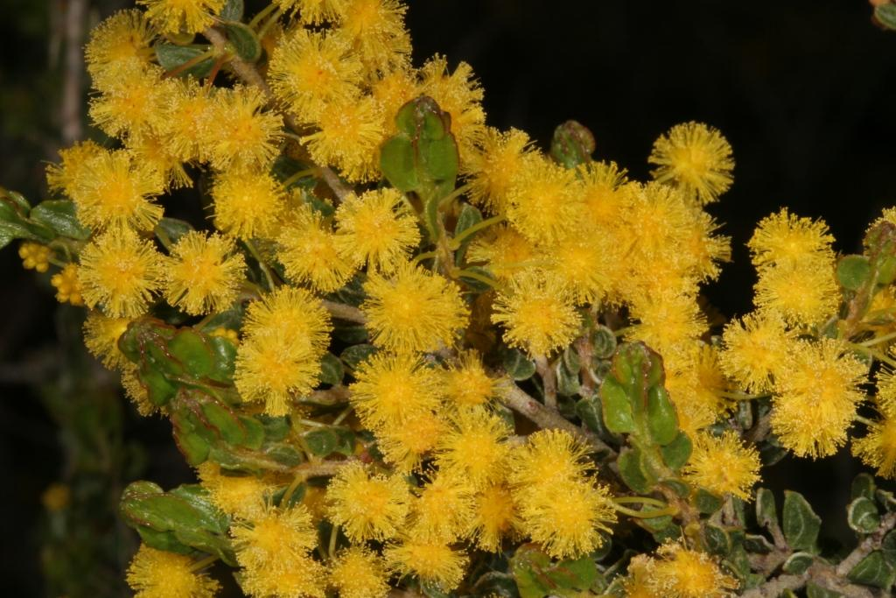
Hairy-pod wattle flowers (September 2007, by Gary Backhouse)

Distribution
The Hairy-pod Wattle is endemic to south-eastern Australia, where it occurs in the Wimmera region of western Victoria and south-east, northern agricultural and north-east pastoral districts of South Australia, in the Murray Darling Depression IBRA bioregion (sensu DEH 2000)
(Figure 1). Although the species has a wide total distribution, plants are apparently restricted to three widely separated broad locations: (1) the Wimmera region of western Victoria; (2) around Burra, and (3) Wertaloona Station in South Australia.
Figure 1. Distribution of the Hairy-pod Wattle
Maps showing the distribution of the Hairy-pod Wattle are available from the Department of Sustainability and Environment (for Victoria) and the Department of Environment and Natural Resources (for South Australia).

Population information
The Hairy-pod Wattle has been recorded from about 75 separate sites (DSE & DENR flora records and additional records from the Horsham Field Naturalists Club), with an estimated total population of 6,000–12,000 plants. Most sites and plants occur in Victoria, with about seven sites currently known from South Australia. At least 50% of the total number of plants occur in just seven populations, with one population (Little Desert National Park-Kiata) accounting for about 25% of the total number (Table 1). At least 60 sites are on roadsides, with most sites comprising very few individuals (1–20 plants). Some of these sites are separated by <100m, hence the total number of breeding populations may be less than 70 and more likely closer to 50. There are likely to be more occurrences of Hairy-pod Wattle along roadsides (and possibly on adjoining private land) that still support remnant native vegetation in the Victorian Wimmera and South Australia (Jessop & Tolken 1986).
Important sites necessary to the long term survival and recovery of the Hairy-pod Wattle have been determined according to their relative chance of long-term ecological viability, including evidence of regeneration, population size, land tenure, patch and landscape condition, and geographic location, with representative sites from across the range of the species requiring protection to maintain the complete range of genetic diversity. Roadside sites have generally not been assessed in sufficient detail to rank according to importance. Given that the bulk of occurrences are along roadsides, and many of these populations will be important in maintaining genetic variability across the full distribution of the species, an action proposed in this Recovery Plan is to more fully assess the importance of these roadside populations.

Habitat
The Hairy-pod Wattle occurs in a range of woodland, shrubland and open mallee vegetation communities, on sandy clay to clay-loam soils, with some stands on ironstone gravel, rarely on heavy clays. Mean annual rainfall across the range of the species is 400–500 mm. Many sites coincide with gentle slopes at the transition zone between heavy clay/gravel soils on the flats and sandy soils on the rises (Venn 1996). Determination and mapping of habitat critical to survival, including environmental data for a large number of sites containing Hairy-pod Wattle an action in this Recovery Plan.
In Victoria, in mallee vegetation on well-drained soils, the species grows with Eucalyptus incrassata, Eucalyptus dumosa, Eucalyptus wimmerensis and/or Eucalyptus behriana. Understorey plants include Glischrocaryon behrii, Dianella revoluta, Acacia acinacea, Astroloma conostephioides, Austrostipa elegantissima, Austrostipa macalpinei, Austrodanthonia species, Babingtonia behrii, Bursaria spinosa subsp. spinosa, Cassytha melantha, Eutaxia microphylla, Goodenia benthamiana, Lasiopetalum behrii, Melaleuca uncinata and Olearia decurrens.
On heavier soils, the Hairy-pod Wattle grows in grassy and shrubby woodland habitats with Eucalyptus leucoxylon, Eucalyptus microcarpa, Allocasuarina luehmannii or Eucalyptus largiflorens. Understorey species include A. acinacea, Acacia euthycarpa, Clematis microphylla, Neurachne alopecuroidea, Schoenus apogon, Dodonaea viscosa subsp. cuneata, Goodenia spp., Chrysocephalum species, Dianella revoluta, Austrostipa species,
A. elegantissima, Austrodanthonia species, Calocephalus citreus, Ptilotus exaltatus, Vittadinia cuneata, Eutaxia microphylla and Arthropodium minus. The Hairy-pod Wattle is generally uncommon where A. luehmannii is the dominant overstorey tree, and is sparse to absent where M. uncinata dominates the understorey.
In South Australia, the species grows in shrubland dominated by Dodonaea viscosa subsp. angustissima, Olearia decurrens and Beyeria lechnaultii on light sandy clay loams (Burra Creek Gorge); shrubby woodland with dominant Acacia carnei and Sida ammophila and subdominant Hakea leucoptera subsp. leucoptera and Acacia tetragonophylla; and tall shrubland with dominant Acacia pycnantha and subdominant Cryptandra amara and Themeda triandra on skeletal soils with outcropping shales.

Table 1. Population information details

Location/site | Pop. size & year | Manager | Threats | Comments
Victoria
Little Desert National Park: Kiata Lowan Sanctuary | 1991: 2,900–3,900 plants  2003: 2,900–3,900 plants | Parks Victoria  (private land) | - grazing by introduced herbivores (L)  - weed invasion esp. Bridal Creeper & Large Quaking-grass (M)  - visitor damage walkers (L)  - track maintenance (L) | largest known pop; comprises two separate groups; a small proportion (<10%) of pop. extends onto adjoining private land that has a conservation covenant
Little Desert National Park: McHabes Hut Track East | 1981: 750 plants  2003: 500–1,000 plants | Parks Victoria | - weed invasion (L)  - inappropriate fire regimes (L)
Little Desert National Park: McHabes Hut Track West | 2003: 300–900 plants | Parks Victoria  (private land) | - weed invasion (L)  - inappropriate fire regimes (L)  - recreational vehicle damage (L) | about 1/3 of pop. extends onto adjoining private land that that has a conservation covenant
Gerang Gerung Flora Reserve & adjoining public land | 1980: 1,500 plants  2003: 1,100–2,400 plants | Parks Victoria & DSE | - weed invasion (M) | one of the largest known pops; includes 50–100 plants in a plantation of non-indigenous Eucalyptus species
Junction Dam Flora Reserve | 1981: 1,000 plants  2003: 700–2,000 plants | Parks Victoria | - weed invasion (M)
Sheepwash Flora Reserve | 1981: 375 plants  2003: 200–500 plants | Parks Victoria | - weed invasion esp. Bridal Creeper & Perennial Veldt-grass (M–H)  - grazing & trampling by domestic stock (M)  - apparent lack of recruitment (M)
South Australia
Hopkins Creek Conservation Park | 2003: <50 plants | DENR | - grazing by domestic stock, feral herbivores (M)  - weed invasion (H)  - erosion (M)  - road works/road maintenance (M) | pop. 'relatively small and localised'
Wertaloona Pastoral Lease, Frome Downs (Eastern Arid Region) | 1993: 330 'clumps' – nos. of plants not known | private | - grazing by domestic stock & feral herbivores (M)  - weed invasion (H)  - erosion (M)
roadside, nth of Farrell Flat/sth west of Hanson | unknown | unknown | - road works/road maintenance (M)  - weed invasion (H)  - agricultural spray drift (H) | range of age classes present (2003)

Decline and Threats
The current distribution of the Hairy-pod Wattle suggests that it may once have been much more abundant, especially in E. microcarpa/A. luehmannii grassy and shrubby woodlands in the Wimmera region of Victoria (Stuwe 1982). Much of this habitat has been cleared for agriculture, and the majority of sites where the Hairy-pod Wattle occurs are on roadsides within an agricultural landscape. In South Australia, remaining populations similarly exist along roadsides or in small reserves of remnant habitat surrounded by farmland. The previous abundance within mallee vegetation communities is not known. Even at sites where overstorey trees remain, a long history of grazing has meant that much of the original understorey diversity has been lost (Venn 1996). Therefore, widespread clearing of habitat since European settlement has most likely been the greatest cause of decline in distribution and abundance of the species in both Victoria and South Australia.
Almost all of the remaining sites where the Hairy-pod Wattle occurs are under great threat. Most of these sites contain small isolated populations within degraded and weedy vegetation, and remaining populations are highly fragmented. Weed invasion, damage from road and utilities installation and maintenance, lack of regeneration and disruption of ecological processes necessary for regeneration are the main threats. These threats are discussed in greater detail below:
Weed invasion
Many sites where the hairy-pod wattle occurs are small and surrounded by agricultural land, from which pasture grasses and other weed species readily invade. Problematic weed species include Bridal Ceeper Asparagus asparagoides, Cape Weed Arctotheca calendula, Patterson’s Curse Echium plantagineum and pasture grasses such as Avena spp., Bromus spp., Ehrharta calycina and Lolium spp. High post-fire cover of introduced grasses at Gerang Gerung may have restricted establishment of new individuals. Weed invasion in degraded sites, notably narrow roadsides, is likely to be inhibiting regeneration of new individuals.
Pathogens
In the late 1990s, extensive galling, thought to be produced by a rust fungus similar to that known to infect Acacia enterocarpa, was observed on plants in the largest population at Kiata (see photo). Some plants apparently died (although whether from galling or other environmental stress was not known), and there was concern that whole populations could be lost (A. Braithwaite pers comm.). However, by 2003, there was no obvious signs of galling on any populations surveyed, and plants in the Kiata population had apparently recovered, perhaps as a result of better rainfall that year. Galling might be initiated by plants suffering environmental stress, especially during extended drought. In larger populations, galling may be just part of natural cycle, but could be especially detrimental to the many roadside populations where just a few plants remain.
Disturbance
Disturbance to or destruction of roadside stands and habitats is a major ongoing threat. Road works, construction and maintenance of fire breaks and installation or maintenance of services along roadsides threaten roadside remnants containing the species and has damaged or destroyed several stands (Venn 1996). Some seedling regeneration has been observed following these activities, possibly through scarifying the hard seed coat and priming the seed for germination following suitable rainfall and/or temperatures. The species disappeared from at least two sites (railway line and cemetery) prior to 1996, as a result of physical disturbance (Venn 1996). The Kiata Lowan Picnic Ground is a popular recreation location, and some trampling of vegetation and habitat may occur.
Grazing
Grazing by introduced livestock may compact soil, increase weed spread and inhibit regeneration via removal of shoots and buds, particularly in drought years. Livestock grazing is formally excluded from important populations on Flora Reserves, however some farmers may run their stock through reserves during dry seasons (eg. Sheepwash Flora Reserve). Browsing by rabbits (and ripping activities to control them) may also damage individuals and stands (Venn 1996).
Herbicide use
Hairy-pod Wattle may be mistaken for Hedge Wattle Acacia paradoxa, and has sometimes been sprayed with herbicide during weed control programs (Venn 1996). Many roadside stands occur adjacent to cropping country and may be damaged by aerial drift from agricultural herbicides.

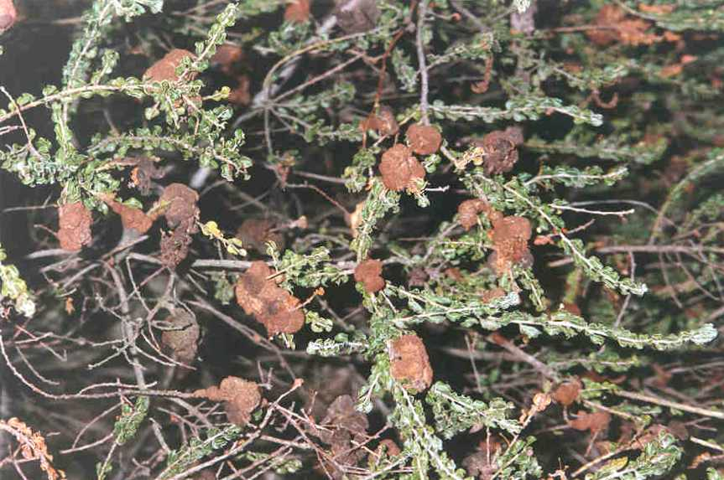
Galling on Hairy-pod Wattle (photo by Horsham Field Naturalists Club)

Disruption of ecological processes
The fragmentation and isolation of most remaining stands would restrict exchange of genetic material between stands. On many degraded roadsides visited in November 2003, few adult plants were fruiting, whereas there was a higher percentage of fruiting in larger sites with intact vegetation, and this may be due to a lack of pollinators.
Changed fire regimes
Optimal fire regimes are not known. Some large, apparently healthy sites have not been burned for more than 100 years (eg. Kiata Picnic Ground) (A. Braithwaite pers. comm.), indicating that long-term absence of fire may not be detrimental. It is probable that frequent burning (eg. at intervals less than the generation time of the species) may be detrimental, preventing seed set at least at some degraded sites where high weed germination and growth may be stimulated. A low intensity autumn fire at Gerang Gerung Flora Reserve killed adult plants and no post-fire regeneration was observed (Venn 1996).

Recovery Information

Existing Conservation Measures
A number of initiatives are underway to protect and enhance populations of Hairy-pod Wattle, including:
- Protection of populations in the Little Desert National Park and flora reserves in Victoria as part of park/reserve management activities, including weed and rabbit control and fire protection. Firebreaks at Little Desert NP are generally placed at the private-land side of the park boundary so as to minimize impacts on Hairy-pod Wattle.
- Protection of Hopkins Creek CP site as part of reserve management activities.
- Conservation covenants on two private land blocks where the species occurs.
- Monitoring and roadside surveys by DSE and the Horsham Field Naturalists Club
- Signage of some populations for public education and to prevent accidental damage.

Recovery objectives
The overall objective of recovery is to minimise the probability of extinction of the Hairy-pod Wattle in the wild and to increase the probability of populations becoming self-sustaining in the long term.
Within the duration of this Recovery Plan, the specific objectives for the recovery of the Hairy-pod Wattle are to:
- Determine distribution, abundance and population structure
- Determine habitat requirements
- Manage threats to populations
- Identify key biological functions
- Determine growth rates and viability of populations
- Establish a population in cultivation
- Build community support for conservation

Program Implementation
The Recovery Plan will run for five years from the time of adoption. Implementation will be managed the Department of Sustainability and Environment (Vic) and the Department of Environment and Natural Resources (SA). In Victoria, a Threatened Flora Recovery Team, consisting of scientists, land managers and field naturalists has been established to oversee threatened flora recovery in Victoria in general. Technical, scientific, habitat management or education components of the Recovery Plan will be referred to specialist sub-committees on research, in situ management, community education and cultivation. Regional Recovery Teams will be responsible for preparing work plans and monitoring progress toward recovery.

Program Evaluation
The Recovery Team will be responsible for annual assessments of progress towards recovery. This Recovery Plan will be reviewed within five years of the date of its adoption under the EPBC Act.

Recovery Objectives, Actions and Performance Criteria

Action | Description | Performance Criteria
Specific Objective 1: Determine distribution, abundance and population structure
1.1 | Undertake surveys to determine the area and extent of populations, the number, size and structure of populations, and inference or estimation of population change.  Responsibility: DSE, PV, DENR | - All known populations accurately counted and mapped.  - Important roadside populations determined.  - Searches are undertaken for new populations.
Specific Objective 2: Determine habitat requirements
2.1 | Accurately survey known habitat and collect floristic and environmental information relevant to community ecology and condition.  Responsibility: PV, DSE, DENR | - Habitat critical to survival mapped for 10 populations.
2.2 | Identify and survey potential habitat, using ecological and bioclimatic information that may indicate habitat preference.  Responsibility: DSE, DENR | - Predictive model for potential habitat developed and tested at five sites.
Specific Objective 3: Manage threats to populations
3.1 | Protect populations on public land.  Responsibility: PV, DSE, DENR | - Incorporation of adjacent public land sites containing species into Gerang Gerung FFR.  - Public Authority Management Agreements negotiated under the FFG Act 1988 with relevant Shires where the species occurs, particularly along roadsides.
3.2 | Protect populations on private land.  Responsibility: DSE | - Discussions initiated and protection measures negotiated with private landholders where substantial populations of the species may be located.
3.3 | Control threats from livestock and feral animals.  Responsibility: PV, DENR | - Maintain rabbit control programs, notably at Little Desert NP sites.  - Control unauthorised grazing at Hopkins Creek CP site.
3.4 | Control threats from pest plants.  Responsibility: PV, DSE, DENR | - Weed control programs maintained, esp. for Bridal Creeper and Paterson’s Curse, at Kiata, Gerang Gerung FFR, Junction Dam FR, Sheepwash FR and at Hopkins Creek CP.
3.5 | Control threats from physical damage, maintenance works and recreational activities.  Responsibility: DSE | - Important roadside populations mapped, signposted where appropriate and land manager informed of location of populations.
3.6 | Investigate cause and impact of galling on populations.  Responsibility: DSE | - Causative agent of and conditions for galling identified and control/mitigation measures identified if required.
Specific Objective 4: Identify key biological functions
4.1 | Evaluate current reproductive status, seed bank status, longevity, fecundity and recruitment levels.  Responsibility: DSE, DENR | - Reproductive ecology and regenerative potential quantified for four representative sites.  - Seed bank potential quantified for 10 representative sites.
4.2 | Identify key stimuli for seed germination requirements.  Responsibility: DSE, DENR | - Stimuli for recruitment identified.  - Management strategies identified to maintain, enhance or restore processes fundamental to reproduction and survival.
4.3 | Identify disturbance regimes to maintain or improve habitat.  Responsibility: DSE, DENR | - Preparation of management prescriptions for ecological burning/grazing at target sites.  - Implementation of management prescriptions at seven sites.
Specific Objective 5: Determine the growth rates and viability of populations
5.1 | Measure population trends and responses against recovery actions by collecting demographic information including recruitment and mortality, timing of life history stages and morphological data.  Responsibility: DSE, DENR | - Techniques for monitoring developed and implemented.  - Population growth rates determined and Population Viability Analysis completed for six important populations.
Specific objective 6: Establish populations in cultivation
6.1 | Establish a seed bank and determine seed longevity and viability.  Responsibility: DSE, DENR | - Seed from 10 important populations across range in storage; longevity and viability determined.
Specific Objective 7: Build community support for conservation
7.1 | Identify opportunities for community involvement in the conservation of Hairy-pod Wattle.  Responsibility: DSE, DENR | - Community nature conservation and Landcare groups aware of the species and support its conservation.
Abbreviations: DEH – Department of Environment and Natural Resources (SA); DSE – Department of Sustainability and Environment (Victoria); PV – Parks Victoria; CP – Conservation Park; FFR – Flora and Fauna Reserve; NP – National Park

Management Practices
On-ground site management will aim to mitigate threatening processes and thereby ensure against extinction. Major threats requiring management include competition from pest plants, inappropriate fire regimes, road works and grazing by pest animals. A range of strategies will be necessary to alleviate these threats including weed control, fire management and control of pest animals. Broadscale protection measures applicable to all populations include legal protection of sites, habitat retention and liaison with land managers including private landholders. In addition, searches of known and potential habitat should continue to better define the distributions and size of populations. To maintain the genetic diversity of Acacia glandulicarpa, representative sites from across the range of the species need to be protected. Larger sites on protected public land should be managed to ensure the long-term survival of these populations and provide the opportunity for these stands to increase. Private land sites should also be offered similar protection, where practicable.
The Recovery Plan also advocates strategies to fill some of the major gaps in our knowledge to date. These include an understanding of the mechanisms underlying recruitment and regeneration. Successful in situ population management will be founded on understanding the relationships between A. glandulicarpa and associated flora, and its response to environmental processes. These are directly linked to biological function and are thus vital to recovery. Demographic censusing will be necessary to gather life history information and to monitor the success of particular management actions. Community participation in recovery actions will be sought, particularly in regard to recovery team membership and implementation of on-ground works. To reduce the likelihood of unforseen development activities negatively impacting upon A. glandulicarpa, information on its distribution, ecology and/or habitat needs to be provided to land managers, especially to local government and transport authorities. This will ensure that adequate searches are made during Environmental Impact Assessments and will increase the chances of new populations being discovered.

Affected interests
Important populations of Hairy-pod Wattle occur on land managed by Parks Victoria, the Department of Sustainability and Environment Victoria, and the Department of Environment and Natural Resources South Australia. These managers have been contacted and have approved the actions outlined in this recovery plan subject to availability of sufficient funding. Portions of some important populations extend into private land (notably Kiata Picnic Ground LDNP site). In some instances that private land is already covenanted for conservation purposes in perpetuity and therefore this recovery plan has no specific recovery actions proposed for the private land areas of those sites. A proposed recovery action for important, yet uncovenanted private land sites is to approach landholders and initiate conservation agreements to protect A. glandulicarpa and associated habitat.

Role and interests of indigenous people
Indigenous communities on whose traditional lands the Hairy-pod Wattle occurs are being been advised, through the relevant regional indigenous facilitator, of this Recovery Plan and invited to provide comments if so desired. Indigenous communities will be invited to be involved in the implementation of the Recovery Plan.

Benefits to other species/ecological communities
The Recovery Plan includes a number of potential biodiversity benefits for other species and vegetation communities in Victoria. Principally, this will be through the protection and management of habitat. The adoption of broad-scale management techniques and collection of baseline data will also benefit a number of other plant species growing in association with Hairy-pod Wattle, particularly those species with similar life forms and/or flowering responses. Notable threatened species occurring within A. glandulicarpa habitat include Eucalyptus froggattii at Nurcoung Flora Reserve, the nationally endangered Acacia enterocarpa and numerous Swainsona spp. (e.g. at Junction Dam Flora Reserve) (Venn 1996). Other Victorian rare or threatened species that occur in known A. glandulicarpa habitat include Austrostipa macalpinei (rare), Austrostipa puberula (rare), Templetonia stenophylla (rare), Goodenia benthamiana (rare), Eucalyptus wimmerensis (rare) and Comesperma polygaloides (vulnerable). The Recovery Plan will also provide an important public education role as threatened flora have the potential to act as ‘flagship species’ for highlighting broader nature conservation and biodiversity issues such as land clearing, grazing, weed invasions and habitat degradation.

Social and economic impacts
The implementation of this Recovery Plan is unlikely to cause significant adverse social and economic impacts. Important populations occur on public land, usually in reserves where present and foreseeable recreational activities are unlikely to be affected by recovery actions for A. glandulicarpa. Two populations on private land are already protected by the landowners through conservation covenants on the properties. Protection of important populations on private land will be achieved through negotiation with landowners, supported by incentives available under NRM programs.

Acknowledgments
The author would like to thank David Brennan, David Cameron, Fiona Coates, Andrew Dawson, Mike Duncan, Jill Fleming, Allyson Lardner and Geoff Suttter (DSE, Vic); Alan Braithwaite (Parks Victoria), Ian Falkenberg (District Ranger, SA), Paul Foreman (private consultant), Randall Johnson and Jean Turner (DENR SA) for their contributions to the production of this Recovery Plan.

Bibliography
DEH 2000. Revision of the Interim Biogeographic Regionalisation of Australia (IBRA) and the Development of Version 5.1. - Summary Report. Department of Environment and Heritage, Canberra.
Jessop, J.P. and Tolken, H.R. 1986. Flora of South Australia 4th Edition: Part 2 – Leguminosae-Rubiaceae. South Australian Government Printer, Adelaide.
Maslin, B.R. 1996. Acacia glandulicarpa. In: Walsh, N.G. & Entwisle, T.J. (eds.) Flora of Victoria. Vol. 3 – Dicotyledons: Winteraceae to Myrtaceae. Royal Botanic Gardens and National Herbarium of Victoria, Melbourne, Inkata Press, Melbourne.
Stuwe, J. 1982. Rare and endangered Victorian plants: 3. Acacia glandulicarpa. Victorian Naturalist 99(2): 62–65.
Venn, D.R. 1996. Hairy-pod wattle Acacia glandulicarpa Action Statement No. 73. Department of Natural Resources and Environment, Melbourne.

Priority, feasibility and estimated costs of recovery actions

Action | Description | Priority | Feasibility | Responsibility | Cost estimate
 |  |  |  |  | Year 1 | Year 2 | Year 3 | Year 4 | Year 5 | Total
1 | Monitoring
1.1 | Pop. surveys | 2 | 100% | DSE, PV, DEH | $20,000 | $15,000 | $5,000 | $0 | $0 | $40,00
2 | Habitat requirements
2.1 | Survey known habitat | 2 | 100% | DSE, DEH | $10,000 | $10,000 | $10,000 | $0 | $0 | $30,000
2.2 | Identify, survey potential habitat | 2 | 75% | DSE | $0 | $10,000 | $10,000 | $10,000 | $0 | $30,000
3 | Manage threats
3.1 | Protect public land habitat | 1 | 75% | PV, DSE, DEH | $5,000 | $5,000 | $5,000 | $0 | $0 | $15,000
3.2 | Protect private land habitat | 1 | 50% | DSE, DEH | $5,000 | $5,000 | $5,000 | $0 | $0 | $15,000
3.3 | Control threats-pest animals | 2 | 75% | PV, DSE, DEH | $27,000 | $10,000 | $10,000 | $10,000 | $10,000 | $67,000
3.4 | Control threats-pest plants | 1 | 75% | PV, DSE, DEH | $20,000 | $20,000 | $20,000 | $10,000 | $10,000 | $80,000
3.5 | Control threats-disturbance | 2 | 75% | DSE, PV, DEH | $10,000 | $10,000 | $5,000 | $5,000 | $5,000 | $35,000
3.6 | Investigate galling | 3 | 50% | DSE, PV | $0 | $0 | $0 | $25,000 | $25,000 | $50,000
4 | Biology, ecology
4.1 | Reproductive status | 2 | 75% | DSE | $0 | $10,000 | $10,000 | $10,000 | $0 | $30,000
4.2 | Seed germination stimuli | 2 | 75% | DSE | $0 | $10,000 | $10,000 | $0 | $0 | $20,000
4.3 | Identify disturbance regimes | 1 | 75% | DSE | $0 | $20,000 | $10,000 | $10,000 | $0 | $40,000
5 | Growth rates, pop. viability
5.1 | Determine population trends | 2 | 75% | DSE | $15,000 | $10,000 | $10,000 | $10,000 | $10,000 | $55,000
6 | Cultivation
6.1 | Establish seedbank | 3 | 100% | DSE, DEH | $4,000 | $2,000 | $2,000 | $2,000 | $2,000 | $12,000
7 | Education, communication
7.1 | Community extension | 3 | 100% | DSE, PV, DEH | $4,000 | $4,000 | $4,000 | $4,000 | $4,000 | $20,000
 |  |  |  | TOTALS | $120,000 | $141,000 | $116,000 | $96,000 | $66,000 | $499,040

