Recovery Plan for Acacia pinguifolia
(Fat-leaved Wattle)

Leanne Pound, Chris Obst and Travis How
Environmental & Biodiversity Services

Doug Bickerton
Department of Environment and Natural Resources, SA

2011

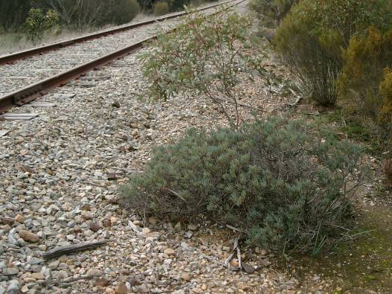



Prepared by Environmental and Biodiversity Services and the Department of Environment and Natural Resources. Published by the Department of Environment and Natural Resources. Adopted under the Commonwealth Environment Protection and Biodiversity Conservation Act 1999 on 20 June 2011.

ISBN: 978-0-9870538-0-0

© Department of Environment and Natural Resources. SA
This publication is copyright. Apart from any use permitted under the copyright Act 1968, no part may be reproduced by any process without prior written permission from the Government of South Australia. Requests and inquiries regarding reproduction should be addressed to:
Department of Environment and Natural Resources
GPO Box 1047
ADELAIDE SA 5001

Note: This recovery plan sets out the actions necessary to stop the decline of, and support the recovery of, the listed threatened species or ecological community. The Australian Government is committed to acting in accordance with the plan and to implementing the plan as it applies to Commonwealth areas.

The plan has been developed with the involvement and cooperation of a broad range of stakeholders, but individual stakeholders have not necessarily committed to undertaking specific actions. The attainment of objectives and the provision of funds may be subject to budgetary and other constraints affecting the parties involved. Proposed actions may be subject to modification over the life of the plan due to changes in knowledge.

Cite as:
Pound L., Obst C., How T. and Bickerton D. (2011). Recovery Plan for Acacia pinguifolia (Fat-leaved Wattle). Report to the Recovery Planning and Implementation Section, Australian Government Department of Sustainability, Environment, Water, Population and Communities, Canberra. Department of Environment and Natural Resources, South Australia.

Copies of this Recovery Plan are available at:
http://www.environment.gov.au/biodiversity/threatened/recovery-list-common.html
and from:
Threatened Species and Ecological Communities Unit
Nature Conservation Branch
Policy Directorate
Department of Environment and Natural Resources
PO Box 1047
Adelaide SA 5001

Cover photograph: Acacia pinguifolia (photo taken by C. Obst)
Contents

Summary …2
Part A: Species information and general requirements 4
Species 4
Conservation Status / Taxonomy / Description 4
Objects of the EPBC Act 4
Role and interests of indigenous people 5
International Obligations 5
Benefits to other species/ecological communities 7
Social and economic impacts 7
Affected interests 7
Distribution 8
Habitat critical to the survival of the species 10
Mapping of habitat critical to the survival of the species 12
Part C: Known and potential threats 16
Biology and ecology relevant to threatening processes 16
Identification of threats 17
Sites and populations under threat 18
Part D: Objectives, Criteria and Actions 19
Recovery Objectives and timelines 19
Specific Objectives 20
Performance Criteria 20
Evaluation of success or failure 20
Recovery Actions 21
Part E: Management Practices 25
Part F: Duration of recovery plan and estimated costs 26
Resource allocation 26
Duration and costs 27
Acknowledgements 29
References 29

Summary

Conservation Status

Acacia pinguifolia is listed as a nationally threatened plant species and the conservation status of this species is outlined in the following table.

Status of Acacia pinguifolia.

Scientific name | Synonym | Common name | EPBC Act 1999 | NPW Act 1972 (SA) | Regional status  (Lang and Kraehenbuehl 2002)
Acacia pinguifolia | none | Fat-leaved Wattle | Endangered | Endangered | Endangered (SL)  Endangered (EP)
SA – South Australia, SL – Southern Lofty, EP – Eyre Peninsula

Recovery Objectives

- Short Term: To improve the age structure of the community by enhancing recruitment within the populations.

- Medium Term: To manage the extinction risk of populations and increase the probability of survival of A. pinguifolia across the species’ entire range.

- Long Term: To improve the national conservation status of A. pinguifolia from Endangered to Vulnerable.

Specific Objectives

The improvement in conservation status of A. pinguifolia is targeted by objectives one to three with the fourth objective vital for the long-term survival of the species.

- To increase the area of occupancy of the species.

- To improve the quality of habitat of the species.

- To increase the abundance of the species.

- To preserve and improve the degree of genetic variability within the species.

Performance Criteria

In order to determine whether the objectives of this recovery plan are being met the following performance criteria have been established.

- Seed from each population in both the Finniss and Eyre Peninsula regions is collected and stored within one year.

- The area of occupancy is defined and then increased over five years.

- The total number of mature plants is increased from its pre-2005 level of approximately 2900, to 4000 in five years, by planting and increasing recruitment.

- Weed control measures reduce by 30% the cover of priority weeds in habitat currently occupied by A. pinguifolia populations within five years.

- Rabbits within the habitat critical to the survival of A. pinguifolia are controlled by baiting and there is a 100% reduction in the number of active warrens present within five years.

- Genetic variability within all A. pinguifolia populations is maintained or increased within five years.

- Soil testing for Phytophthora at populations at potential risk on Eyre Peninsula and Finniss is conducted within the first year, with subsequent monitoring periodically.

Recovery Actions, Duration and costs

Task | Task Description | Priority | Location | Cost Estimate ($)
 |  |  |  | Year 1 | Year 2 | Year 3 | Year 4 | Year 5 | TOTAL
1 | Collection and storage of seed | 1 | F & EP | 3500 | 200 | 200 | 200 | 1000 | 5,100
2 | Field survey & threat assessment | 1 | EP | 5000 | 0 | 0 | 0 | 0 | 5,000
3 | Weed control | 1 | F & EP | 10000 | 10000 | 8000 | 5000 | 5000 | 38,000
4 | Rabbit control | 1 | F | 4000 | 2000 | 1000 | 1000 | 1000 | 9,000
5 | Phytophthora testing | 1 | F & EP | 4000 | 0 | 0 | 0 | 0 | 4,000
6 | Installation of roadside markers | 1 | F & EP | 3000 | 0 | 0 | 0 | 0 | 3,000
7 | Further research & trials | 2 | F | 6000 | 6000 | 3000 | 3000 | 0 | 18,000
8 | Search for new populations | 2 | F & EP | 2000 | 2000 | 2000 | 2000 | 2000 | 10,000
9 | Determine area of occupancy | 2 | F & EP | 2000 | 0 | 0 | 0 | 0 | 2,000
10 | Prevention of damaging recreational activities | 2 | F | 1000 | 10000 | 1000 | 1000 | 1000 | 14,000
11 | Population monitoring | 2 | F & EP | 1500 | 5000 | 5000 | 5000 | 5000 | 21,500
12 | Recovery team | 2 | F & EP | 5000 | 5000 | 5000 | 5000 | 5000 | 25,000
13 | Ongoing educational programmes | 2 | F & EP | 3000 | 3000 | 3000 | 3000 | 3000 | 15,000
14 | Supplementary plantings | 3 | F & EP | 1000 | 1000 | 1000 | 1000 | 1000 | 5,000
15 | Rubbish removal | 3 | F & EP | 2000 | 0 | 1000 | 0 | 1000 | 4,000
16 | Monitor & repair signs | 3 | F | 0 | 0 | 1000 | 0 | 1000 | 2,000
 |  | TOTAL |  | 53000 | 44200 | 31200 | 26200 | 26000 | 180600

F = Finniss Populations, EP = Eyre Peninsula Populations

Part A: Species information and general requirements

Species

This recovery plan is for a single threatened species: Acacia pinguifolia, which is listed as endangered under the Commonwealth Government’s Environment Protection and Biodiversity Conservation Act 1999 (EPBC Act) and under South Australia’s National Parks and Wildlife Act 1972 (NPW Act).

Conservation Status / Taxonomy / Description

Table 1. Status of Acacia pinguifolia

Scientific name | Synonym | Common name | EPBC Act 1999 | NPW Act 1972 (SA) | Regional status  (Lang and Kraehenbuehl 2002)
Acacia pinguifolia | none | Fat-leaved Wattle | Endangered | Endangered | Endangered (SL)  Endangered (EP)

SA – South Australia, SL – Southern Lofty, EP – Eyre Peninsula

Description

A dense, glabrous, spreading light-green shrub, Acacia pinguifolia grows 1-2 m in height and often 2-3 m across. Numerous terete, ascending, arching branches extend from just above or at ground level, with branchlets glabrous, smooth, reddish-brown and with thin bark which is pale grey at the base of the stems. Phyllodes are 1-3.5 cm long, 2-3 mm in diameter and are straight or falcate, terete or somewhat compressed, rigid, thick and fleshy and light green in colour. The surface of phyllodes becomes wrinkled and grooved when dry and the apex ends abruptly with a minute, hard, thick point (Jessop and Toelken 1986).

Inflorescences are simple and axillary, solitary or twin, or sometimes up to four heads. Flower-heads are globular, deep yellow, with 20-30 individual flowers. Peduncles are glabrous, 5-10 mm long and legumes are 5-7 cm long, 5 mm broad, curved and finally twisted, swollen and raised over the seeds, dark brown with light-brown margins and are slightly constricted between the seeds. The seeds are longitudinally arranged within the legume, ellipsoid in shape with a whitish, fleshy aril (Jessop and Toelken 1986).

Objects of the EPBC Act

The EPBC Act has specific objectives regarding roles and interests of indigenous groups, social and economic impacts, other affected community interests, benefits to other species and ecological communities, and international obligations. This recovery plan addresses those objectives, as follows.

Role and interests of indigenous people

- Recognising the role of indigenous people in the conservation and ecologically sustainable use of Australia’s biodiversity

- Promoting the use of indigenous peoples’ knowledge of biodiversity with the involvement of, and in cooperation with, the owners of the knowledge

The Aboriginal Partnerships Section (APS) of the Department of Environment and Natural Resources (DENR) has been contacted regarding the development of this recovery plan. The locations of A. pinguifolia populations have been provided to APS and forwarded to the Department of Aboriginal and Indigenous Services. This consultation was an initial approach to identifying the relevant indigenous people that may have an interest in A. pinguifolia and the area in which it occurs. The Aboriginal heritage organisations that were identified as being potentially interested were then contacted and a fact sheet summary of this plan was made available to them, but to date no comments have been received from these organisations.

The requirements of the Native Title Act 1993 apply to land where Native Title rights and interests may exist. When implementing any recovery actions in this threatened species plan where there has been no Native Title determination, or where there has been no clear extinguishment of Native Title, there needs to be consideration of the possibility that Native Title may continue to exist.

Generally the Native title Act 1993 requires certain procedures to be followed prior to undertaking activities, known as future acts, which may affect Native Title rights and interests These procedures are additional to those required to comply with the Aboriginal Heritage Act 1998. Nothing in this threatened species plan is intended to affect Native Title, and the plan will only be adopted subject to any Native Title rights and interests that may continue in relation to any land on which Acacia pinguifolia is found.

International Obligations

- Assisting in the co-operative implementation of Australia’s international environmental responsibilities

Acacia pinguifolia is not listed under any of the relevant international agreements, specifically:
- Japan Australia Migratory Bird Agreement (JAMBA),
- China Australia Migratory Bird Agreement (CAMBA),
- Convention on Migratory Species (CMS/Bonn Convention), and
- Convention on International Trade in Endangered Species of Wild Fauna and Flora (CITES).

As Acacia pinguifolia is not listed under any international agreement, the implementation of Australia’s international environmental responsibilities is not affected by this recovery plan. However, the plan has been written with a view to meeting Australia’s international environmental responsibilities in a co-operative approach through the involvement of a wide range of stakeholders. Specifically, this plan complies with policy and legislative objectives at the national, state and regional levels.

Table 2. List of current and potential stakeholders in the management of A. pinguifolia

National Stakeholders | Person Contacted
Department of Sustainability, Environment, Water, Population and Communities | Andrew Chalklen
State Stakeholders
Department of Environment and Natural Resources | Anthony Freebairn, Luke Geelen, Paula Peeters, Katrina Pobke, Wendy Stubbs, Kerry Villiers
Conservation Council of South Australia | Vicki-Jo Russell
Department of Transport, Energy and Infrastructure | Tim Reynolds
Threatened Plant Action Group | Tim Jury, Annie Bond
Regional Stakeholders
District Council of Tumby Bay | Laurie Collins
District Council of Lower Eyre Peninsula | Gary Jutzen, Peter Aird
Alexandrina Council | David Cooney
Goolwa to Wellington Local Action Planning Board Inc | Tony Randall
Ngarrindjeri Heritage Committee Inc. | Tom Trevorrow
Barngala Council Inc. | Howard Richards
Australian Plant Society | Hazel O’Connor
Hindmarsh Island Landcare Group | Sue Hogben
Point Sturt Landcare Group
Rodwell Creek/ Wistow Landcare Group | Travis How
Langhorne Creek Landcare Group | Linley Cleggett
Strathalbyn Natural Resource Centre
Signal Point Riverine Environment Group | Greg Lundrom
Asparagus Weeds Working Group | Susan Lawrie
Adelaide and Mount Lofty Ranges Natural Resource Management Board | Andrew West
Murray Darling Basin Natural Resource Management Board | Sarah Lance
Eyre Peninsula Natural Resource Management Board | Peter Sheridan
Friends of Nurragi Association | Tony Hoff
Natural State (Private Consultancy) | Matt Rose
Landholders | Linton Arney, Darrell MacLean

Benefits to other species/ecological communities

Under this recovery plan, which specifically targets A. pinguifolia, other species sharing a common distribution may also benefit from the implementation of the actions recommended. Benefits to numerous species as a response to this plan will have a positive impact upon the vegetation communities in which A. pinguifolia occurs. The following plant communities overlap to some degree with the habitat critical to the survival of A. pinguifolia and should benefit from the implementation of actions recommended under this recovery plan:

On Eyre Peninsula (Pobke 2007):
- Eucalyptus calycogona +/-E. dumosa mid-mallee woodland,
- E. pileata +/- E. socialis +/- E. incrassata +/- E. peninsularis mid-mallee woodland,
- Melaleuca uncinata tall open shrubland,
- E. diversifolia mid-mallee woodland,
- Allocasuarina verticillata low woodland,
- E. cladocalyx mid-woodland,
- E. behriana +/- E. odorata low open woodland,
- E. odorata +/- E. phenax mid-mallee woodland,
- E. leptophylla +/- E. dumosa mid-mallee woodland.

In the Finniss region (Davies 1992):
- Eucalyptus incrassata or E. dumosa +/- E. leptophylla or E. calycogona tall
shrubland (open to sparse),
- E. dumosa +/- E. phenax +/- E. foecunda +/- E. calycogona mid-mallee woodland.

Furthermore, improving the habitat critical for A. pinguifolia will improve the quality of the native vegetation, which may directly benefit any fauna within the area that depend on native ecosystems.

Social and economic impacts

The implementation of this recovery plan is unlikely to cause significant adverse social and/ or economic impacts. On the contrary, through the implementation of actions outlined in the recovery plan, there will be direct positive social impacts to local communities through their involvement with the recovery plan. Community involvement with the recovery plan will foster the building of strong community links and community empowerment.

Affected interests

- Promoting a co-operative approach to the protection and management of the environment involving governments, the community, land-holders and indigenous peoples

The community groups and statutory organisations presented in Table 2 have been identified as current and potential stakeholders in the management of A. pinguifolia. The involvement of a wide range of stakeholders in the implementation of this recovery plan will promote a co-operative approach to the plan, ensuring a successful outcome for environmental protection and management. As Table 2 indicates, most of these stakeholders have already been consulted.

Part B: Distribution and location

Distribution

Acacia pinguifolia is endemic to South Australia and has a widely separated distribution with disjunct populations located on Eyre Peninsula and Fleurieu Peninsula. To determine the location of populations, information was collected from past reports, personal communications with individuals previously involved with the species and personal observations in the field. DENR’s biological databases (BDBSA 2008) were consulted; these comprise the Threatened Plant Population Database, the Opportune Sighting Database, the Reserve Database, the Biological Survey Database and the Adelaide Herbarium Database.

Eyre Peninsula

The majority of A. pinguifolia populations are scattered on Eyre Peninsula and it is estimated that prior to the 2005 Wangary Fire, which burnt a number of A. pinguifolia populations, there were approximately 2770 A. pinguifolia mature individuals within these populations (Pobke 2007). Many mature plants were destroyed by the fire; however many thousands of seedlings have been seen to emerge in the years since (K. Pobke, DENR, pers. comm.). Records show the most northerly population is located within the Kulliparu Conservation Park. The exact location of this population within the park needs to be determined as the spatial information relating to the population is questionable. The remainder of the populations are found in restricted areas of the southern Eyre Peninsula, with the most southerly populations scattered between Cummins and Wanilla, including the Koppio Hills, and another grouping of populations between Cummins and north east to Ungarra.

Fleurieu Peninsula

Acacia pinguifolia has a restricted distribution on Fleurieu Peninsula, occurring only near the settlement of Finniss (Pickett and Mallen 2001; Davies 1992). In 1994 only 116 naturally occurring individuals remained in this area (C. Obst, EBS, pers. obs.), all restricted to roadside or rail reserves. A further 52 planted individuals have also been recorded from the Finniss area (Pickett and Mallen 2001, 2003).

The location of all recorded naturally occurring populations can be seen in Figure 1. Populations recorded before 1980 are considered historic records in the Figure. Locations near Finniss recorded prior to 1980 are considered unlikely to still exist, as they have not been recorded in recent surveys of the area, and were not found in surveys undertaken during 2004 (C. Obst, pers. obs.). The location of planted individuals has not been included on the map as accurate spatial information was not available for all plantings.

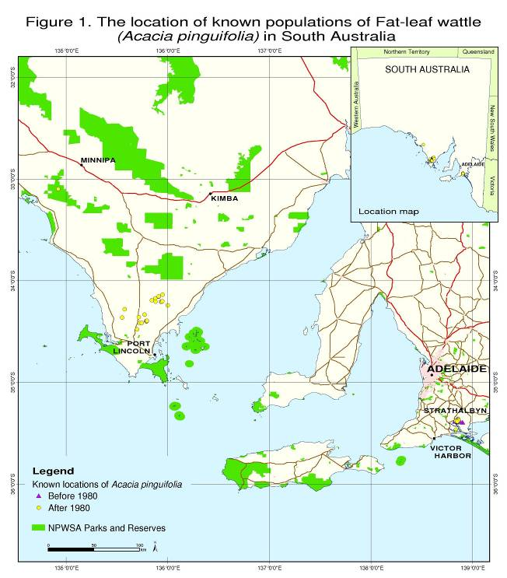

Definitions

Habitat that is critical to the survival of the species

Under Regulation 7.09 of the Environment Protection and Biodiversity Conservation Regulations 2000, habitat critical to survival might comprise:
- sites to meet essential life cycle requirements,
- sites of food sources, water, shelter, fire and flood refuges or those used at other times of environmental stress,
- essential travel routes between the above sites,
- sites necessary for seed dispersal mechanisms to operate or to maintain populations of species essential to the threatened species or ecological community
- the habitat used by important populations
- habitat that is required to maintain genetic diversity
- areas that may not be occupied by the species and/or ecological community but are essential for the maintenance of those areas where they do occur.

Potential habitat

Potential habitat is defined as habitat which may be currently unoccupied by a particular species, but which could present opportunities for reintroduction or re-colonisation, or may maintain only a dormant seed bank. Potential habitat needs to be identified and protected and/or rehabilitated to ensure the long-term future of the species and/or ecological community.

Extent of Occurrence

IUCN (2001) defines the extent of occurrence as the area contained within the shortest continuous imaginary boundary which can be drawn to encompass all the known, inferred or projected sites of present occurrence of a taxon, excluding cases of vagrancy.

Area of Occupancy

The area of occupancy is defined as the area within its ‘extent of occurrence’ which is occupied by a taxon, excluding cases of vagrancy (IUCN 2001).

Population

For the purposes of this recovery plan “populations” are defined as geographically or otherwise distinct groups within a species, between which there is little chance of demographic or genetic exchange (typically one successful migrant individual or gamete per year or less).

Habitat critical to the survival of the species

Given that A. pinguifolia is endangered, it is considered that all known habitat is critical to the survival of the species. An action identified in this recovery plan is survey effort to locate further populations, which could lead to the identification of additional habitat critical to the survival of the species.

Specifically, all known habitat is critical to the survival of A. pinguifolia because:

- The habitat meets essential life cycle requirements including growth and reproduction,
- The habitat provides necessary water and required nutrients for the species,
- All sites are necessary for seed dispersal mechanisms to operate and are likely to maintain populations of pollinating species essential to the threatened species,
- This habitat is required to maintain genetic diversity.

Topography and Soil Type

Whibley (1980) generalises that A. pinguifolia grows mainly on sandy or hard alkaline yellow duplex soils. More specifically, A. pinguifolia in the Finniss area has been found on an undulating plain of sands, sandy clay loams and clay loams of pH 7.5 to 9.5. These soils were a grey or brown colour when dry, and dark grey or dark brown when wet (Davies 1992). Acacia pinguifolia specimens collected from the southern Eyre Peninsula were collected from an undulating terrain with a westerly aspect, either on cream loam with clay subsoil, on red loam (calcareous), brown clay-loam on schist (BDBSA 2004), brown clay loam on broken limestone, and pale grey sand over ironstone gravel (National Herbarium of Victoria, Melbourne, cited in Davies 1992).

Plant Associations

Acacia pinguifolia occurs in the following plant associations in the Finniss region:

- Eucalyptus incrassata or E. dumosa +/- E. leptophylla or E. calycogona tall
shrubland (open to sparse),
- E. dumosa +/- E. phenax +/- E. foecunda +/- E. calycogona mid-mallee woodland (Davies 1992).

On Eyre Peninsula A. pinguifolia grows in the following plant associations:

- Eucalyptus calycogona +/-E. dumosa mid-mallee woodland,
- E. pileata +/- E. socialis +/- E. incrassata +/- E. peninsularis mid-mallee woodland,
- Melaleuca uncinata tall open shrubland,
- E. diversifolia mid-mallee woodland,
- Allocasuarina verticillata low woodland,
- E. cladocalyx mid-woodland,
- E. behriana +/- E. odorata low open woodland,
- E. odorata +/- E. phenax mid-mallee woodland,
- E. leptophylla +/- E. dumosa mid-mallee woodland (Pobke 2007).

Climate

Acacia pinguifolia is found in areas with an average annual rainfall of 400-500 mm (Whibley 1980). Temperature and rainfall data from the closest weather stations to A. pinguifolia populations are presented in Table 3.

Table 3. Average values of maximum temperature (°C), minimum temperature (°C) and rainfall (mm) for the Goolwa (Hindmarsh Island Marina) and Port Lincoln (Tod River) weather stations. Data has been collected from these weather stations since 1989 and 1968 respectively. The average values presented here were calculated in 2004.

Element | Jan | Feb | Mar | Apr | May | Jun | Jul | Aug | Sep | Oct | Nov | Dec | Annual/ Average
Temp max – G | 23.6 | 24.4 | 22.1 | 20.6 | 18.1 | 15.8 | 15.1 | 16 | 18 | 19.9 | 21.2 | 21.9 | 19.7
Temp min – G | 15.4 | 15.5 | 13.9 | 11.7 | 9.7 | 8.4 | 7.6 | 7.7 | 9 | 10.7 | 12.4 | 13.9 | 11.3
Rainfall - G | 13.5 | 15.1 | 18.6 | 26.6 | 42.1 | 58.9 | 59.2 | 54.6 | 50.6 | 40.6 | 27.8 | 30.4 | 437.8
Temp max – PL | 26.2 | 26.3 | 24.5 | 21.9 | 18.8 | 15.9 | 15.3 | 16.2 | 18 | 20.5 | 23.1 | 24.8 | 20.9
Temp min – PL | 13.6 | 14.2 | 13.1 | 10.4 | 8.7 | 6.6 | 5.7 | 6.2 | 6.6 | 8.1 | 10.3 | 12.4 | 9.6
Rainfall - PL | 16.1 | 12.9 | 23.6 | 37.5 | 49.1 | 65.5 | 80.9 | 76.7 | 52 | 30.4 | 17 | 23.4 | 485.3

G – Goolwa, PL – Port Lincoln
Data presented were obtained from the Australian Bureau of Meteorology website (http://www.bom.gov.au/climate/averages/) (April 2004).

Fire and Disturbance

Acacia species are generally early colonisers of a site following a fire, and there is some anecdotal evidence that A. pinguifolia also responds well to fire. In 2000, members of the Threatened Plant Action Group (TPAG) conducted a small burn box trial, setting fire to a 1 m² area adjacent to the remains of a dead A. pinguifolia plant. Some seedlings subsequently emerged, although they failed to survive the following summer. On Eyre Peninsula, mass germination of A. pinguifolia seedlings was observed in the fire scar following the 2005 Wangary fire (Pobke 2007).

The effect of other disturbance measures on recruitment is not known, although observations indicate that disturbance of soil is likely to initiate seed germination and seedling establishment (A. Freebairn, DENR, pers. comm.).

Mapping of habitat critical to the survival of the species

It is considered that all currently occupied habitat of A. pinguifolia is critical to the survival of this species, as discussed above. The locations of all areas of habitat critical to the survival of A. pinguifolia are presented in Figures 2, 3a & 3b. For the purposes of this recovery plan the habitat considered critical to the survival of A. pinguifolia is the currently occupied habitat, including any native vegetation occurring within a buffer of 500 metres around each population.

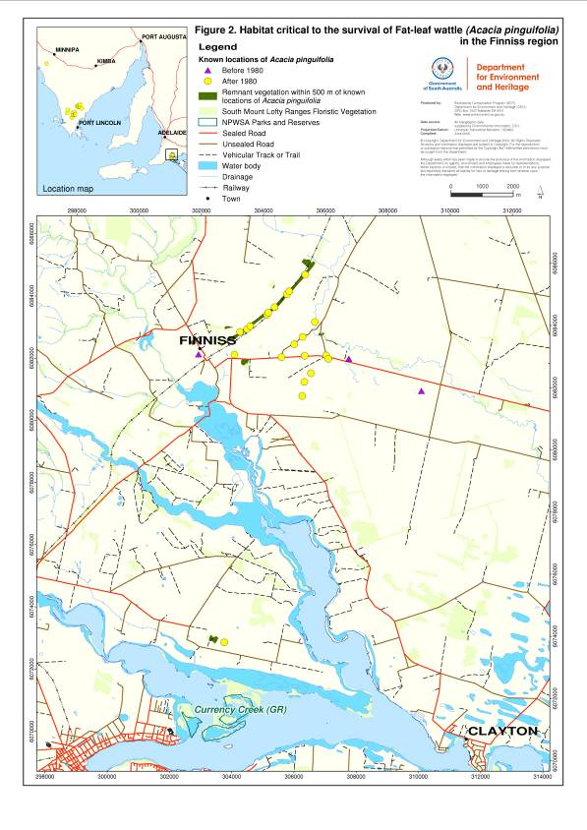

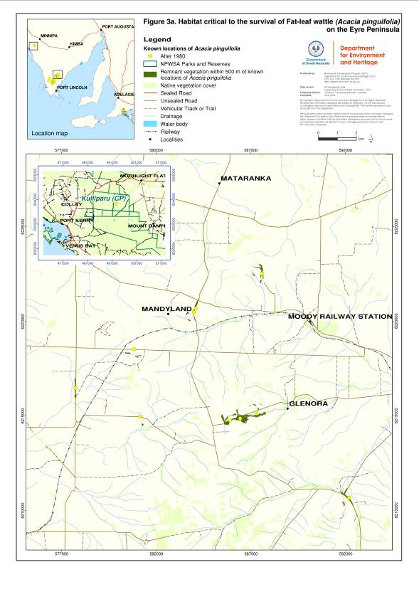

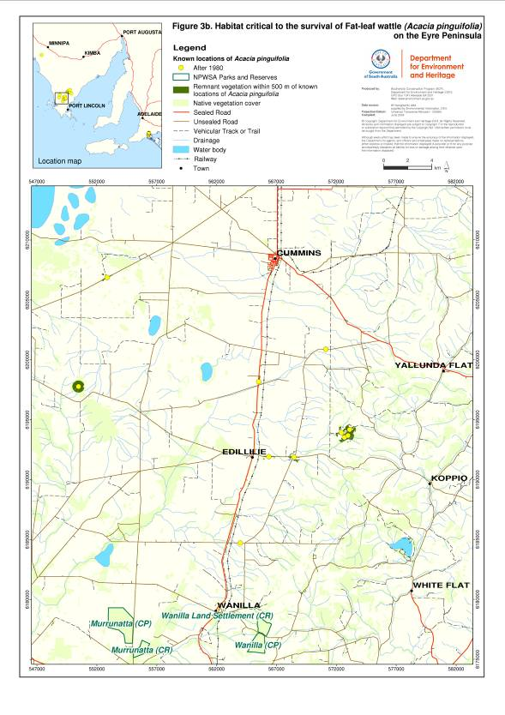
Important populations

All populations of A. pinguifolia are considered important due to the small total numbers of this species; hence all populations should be managed for the protection of this species. The distribution of A. pinguifolia, including all populations of importance, is shown in Figure 1.

Part C: Known and potential threats

Biology and ecology relevant to threatening processes

Flowering of A. pinguifolia occurs from July to October (Jessop and Toelken 1986); however specimens have been collected flowering as early as June and as late as January (Adelaide Herbarium, National Herbarium of Victoria, Melbourne, cited in Davies 1992). Specimens with fruit have been collected from October to February (Davies 1992), and pods ripen and dehisce between November and January (Jusaitis and Sorensen 1994). Growth flushes occur during spring and early summer, with growth rates slowing considerably during autumn and winter (Jusaitis and Sorensen 1994).

Many Acacia species are known to respond to fire with mass germination events. Acacia pinguifolia appears to have a similar response, as noted in Pobke (2007), who observed mass recruitment of Fat-leaved Wattle at some sites on Eyre Peninsula after the 2005 Wangary fire.

Past research

Legume or fruit set in Acacia pinguifolia is considered extremely low in the populations found near Finniss (Obst 2005). An experiment conducted by Jusaitis and Sorensen (1994) found that no tagged flowers developed into pods in one year and only 1.6% of flowers developed into legumes in a second year. Seed set averaged 5-6 seeds per legume. On Eyre Peninsula the majority of populations are thought to produce large amounts of viable seed, and recruitment is common (A. Freebairn, DENR, pers. comm., cited in Pobke 2007).

Small trials have been conducted at Brimarvi Road near Finniss to determine conditions required for natural regeneration of A. pinguifolia. Methods trialled included ripping of ground, raking and a small fire trial (Pickett and Mallen 2003). These met with little or no success.

Research into propagation techniques for A. pinguifolia (Jusaitis and Sorensen 1994) has found that a seed germination rate of >60% could be obtained by rupturing the seed coat, either by boiling seed in water for 30 seconds or by soaking seed in concentrated sulphuric acid (H₂SO₄) for 30 minutes. However, seedlings produced had poor vigour and were unsuitable for introductions in the field (Pickett and Mallen 2003).

In 2007 leaf samples were collected for a study of the genetic vigour between and within Finniss and southern Eyre Peninsula populations of A. pinguifolia (Ottewell et al. 2009). Preliminary results indicate significantly less heterozygosity within Finniss populations compared to southern Eyre Peninsula, and a significant degree of genetic differentiation between the two locations.

In April 2008 a burn trial was conducted at the site known as the Steam Ranger Corridor, near Finniss. Two 500m x 10m strips of A. pinguifolia habitat were burnt, with the aim of stimulating germination. This site will be monitored for a minimum of two years. Additionally, the genetic vigour of the soil seed bank germinants will be measured and compared with that of the extant adults, in order to better understand the biology of the species and assist with translocation planning.

Identification of threats

Small isolated populations

Acacia pinguifolia is located in two disjunct geographic regions: the southern Eyre Peninsula and Fleurieu Peninsula; hence this species has a very fragmented distribution. Populations of A. pinguifolia are geographically and genetically isolated across the two regions and are small in size. Furthermore, the lack of genetic variability within small populations can manifest in inbreeding depression, as appears to be the case at the Finniss sites (Ottewell et al. 2009). These factors may negatively influence the total population size over time.

Grazing

Grazing by both native and introduced herbivores is another threat to Acacia pinguifolia plants. Pickett and Mallen (2000) report that rabbits are causing a severe impact upon A. pinguifolia populations in the Finniss region, with sheep and kangaroos having a lesser effect. Prider (2006) recorded grazing of A. pinguifolia adults and juveniles by sheep.

Grazing may have a negative impact upon population structure and abundance; for example preferential grazing by macropods can alter plant population composition by greatly reducing recruitment through grazing upon seedlings (Hussey 2002). Grazing by sheep may also result in compaction of soil around individuals and an increase in nutrients from manure (Cropper 1993). Soil compaction can reduce the ability of seedlings to penetrate the soil and germinate, whilst an increase in nutrients may facilitate the spread of weed seeds or be detrimental to some vegetation types (Cropper 1993).

Land clearance

Extensive land clearance in the past, predominantly for agricultural use, has been a major factor in reducing the extent of Acacia pinguifolia. Further land clearance is therefore considered to be a threat to A. pinguifolia survival (Jusaitis and Sorensen 1994). Clearance of land has drastically reduced the current habitat of A. pinguifolia and has reduced the amount of land suitable for future habitat. The removal of habitat for agricultural use also increases the negative impacts of edge effects on surviving A. pinguifolia populations.

Road, rail and fence maintenance activities

Minor clearance or accidental damage of vegetation can occur during road or rail maintenance or while repairing or erecting fences. At sites where Acacia pinguifolia populations are located, these activities pose a threat (Pickett and Mallen 2001; Jusaitis and Sorensen 1994). Special care must be taken by local Council or transport authority staff, landholders and contractors, while undertaking these maintenance activities in areas of A. pinguifolia habitat, and roadside markers have been installed at all roadside populations to assist identification of these sites.

Herbicide drift

Herbicide drift from weed control maintenance also poses a threat (Pickett and Mallen 2003). Chemical spray drift can be created by landholders on properties adjacent to Acacia pinguifolia habitat (P. Sheridan pers comm., C. Obst pers. obs.). Also local Council or transport authority staff and contractors can cause off-target damage when undertaking weed control on roadsides and rail corridors.

Weed competition

A major threat to Acacia pinguifolia is competition from weed species, especially Asparagus asparagoides (bridal creeper), which is listed as a Weed of National Significance, Asparagus declinatum (bridal veil), Scabiosa atropurpurea (scabious) and Oxalis pes-caprae (soursob) (Pickett and Mallen 2000). Grassy weed species may also pose a threat (P. Sheridan pers comm.). Competition from weed species can potentially reduce the ability of Acacia pinguifolia to establish from seed, and to capture essential nutrients, light, water and space as would be required for normal growth and development. Competition from the weeds listed above could affect all life stages of individuals of this species.

Phytophthora

Phytophthora cinnamomi, the parasitic root mould found in soil, poses a potential threat to A. pinguifolia populations. Phytophthora can cause severe damage to certain genera of native plants, but it is currently unknown whether it is likely to have an impact on Acacia pinguifolia. Evidence of the potential presence of Phytophthora has been observed at Finniss, but this has not been verified through soil testing. The population located at Finniss, and populations located to the south and west of Cummins on Eyre Peninsula, have been identified as occurring within moderate risk areas for Phytophthora establishment (TSA 2000).

Inappropriate disturbance regimes

The lack of natural recruitment observed for this species may possibly be due to inappropriate disturbance regimes. Pobke (2007) noted a significant increase in recruitment of A. pinguifolia following the 2005 Wangary fires on Eyre Peninsula. A reduction in the frequency of fire disturbance is likely to be an important factor that is now missing from the current habitat of A. pinguifolia. Competition from both weed species and natives may add to the problem. The possibility of inappropriate disturbance regimes should be investigated.

Sites and populations under threat

Acacia pinguifolia in the Finniss area on Fleurieu Peninsula is at risk from the following threats, in order of priority (Obst 2005):

- Weed competition, especially Asparagus asparagoides (bridal creeper), Scabiosa atropurpurea (scabious) and Oxalis pes-caprae (soursob) at all sites in the region; A. declinatum (bridal veil) at Brimarvi Rd. and Ehrharta calycina (perennial veldt grass) on Finniss-Milang Rd. (Pickett and Mallen 2000; Jusaitis and Sorensen 1994)
- Lack of recruitment (resulting from small population sizes), at all sites in this region (Pickett and Mallen 2000; Jusaitis and Sorensen 1994)
- Road and rail maintenance activities along Dry Plains Rd., Finniss-Milang Rd. and the Steam Ranger railway line (Pickett and Mallen 2000; Jusaitis and Sorensen 1994)
- Habitat fragmentation due to land clearance (all sites) (Jusaitis and Sorensen 1994)
- Lack of formal protection of Dry Plains Rd., Finniss-Milang Rd. and the Steam Ranger railway line site
- Inappropriate disturbance regimes (all sites)
- Inadequate knowledge of the ecology (all sites)
- Recreational activities, particularly trail bike riding on Woolshed Rd. and the Steam Ranger railway line site
- Grazing by rabbits and hares at Brimarvi Rd., Woolshed Rd. and the Steam Ranger railway line site (Pickett and Mallen 2000; Jusaitis and Sorensen 1994)
- Potential Phytophthora risk.

Acacia pinguifolia in the southern Eyre Peninsula is at risk from the following threats in order of priority (Pobke 2007):

- Habitat fragmentation (all sites)
- Inappropriate disturbance regimes (all sites)
- Weed competition, in particular Asparagus asparagoides (bridal creeper), Ehrharta calycina (perennial veldt grass), Lolium rigidum (rye grass), Avena fatua (wild oats), Chrysanthemoides monilifera ssp monilifera (boneseed) and/or Pinus halepensis (Aleppo pine), threaten seedling recruitment by fat-leaved wattle at most sites, particularly following the 2005 fires (P. Sheridan, Eyre Peninsula NRM Board, pers. comm.)
- Grazing by rabbits (all sites) (P. Sheridan pers. comm.) and sheep in areas burnt by the 2005 (private property) (Prider 2006)
- Road and railway line maintenance activities (all relevant sites) (Tay 1992 cited in DEH 2002, Prider 2006a)
- Potential Phytophthora risk (populations south and west of Cummins, excluding Kulliparu Conservation Park)
- Farming practices, including herbicide drift (P. Sheridan pers. comm.).

Part D: Objectives, Criteria and Actions

Recovery Objectives and timelines

The overall objectives are:

- Short Term: To improve the age structure of the community by enhancing recruitment within the populations.

- Medium Term: To manage the extinction risk of populations and increase the probability of survival of A. pinguifolia across the species’ entire range.

- Long Term: To improve the national conservation status of A. pinguifolia from Endangered to Vulnerable.

Specific Objectives

The improvement in conservation status of A. pinguifolia is targeted by objectives one to three, with the fourth objective vital for the long-term survival of the species.

  - To increase the area of occupancy of the species.

  - To improve the quality of habitat of the species.

  - To increase the abundance of the species.

  - To preserve and improve the degree of genetic variability within the species.

Performance Criteria

In order to determine whether the objectives of this recovery plan are being met the following performance criteria have been established.

- Seed from each population in both the Finniss and Eyre Peninsula regions is collected and stored within one year.

- The area of occupancy is defined and then increased over five years.

- The total number of mature plants is increased from its pre-2005 level of approximately 2900, to 4000 in five years, by planting and increasing recruitment.

- Weed control measures reduce by 30% the cover of priority weeds in habitat currently occupied by A. pinguifolia populations within five years.

- Rabbits within the habitat critical to the survival of A. pinguifolia are controlled by baiting and there is a 100% reduction in the number of active warrens present within five years.

- Genetic variability within all A. pinguifolia populations is maintained or increased within five years.

- Soil testing for Phytophthora at populations at potential risk on Eyre Peninsula and Finniss is conducted within the first year, with subsequent monitoring periodically.

Evaluation of success or failure
The monitored evaluation of this recovery plan and the planning and implementation of actions will be conducted by a recovery team. In this way, scientific experts and community representatives with relevant qualifications or interests can regularly review the progress of the project. The recovery team will also ensure all on ground works are conducted in an integrated manner with respect to the regional recovery plans that incorporate A. pinguifolia (Obst 2005; Pobke 2007; Willson and Bignall 2009).
The recovery plan is to be reviewed within five years of its implementation.

Recovery Actions

- Collect and store seed from all populations to minimise loss of genetic variability – Priority 1

Due to the small total number of A. pinguifolia individuals, the loss of genetic variability is a serious threat. The collection of seed would aid in maintaining genetic variability for the future as needed. Seed has been collected from Brimarvi Rd. near Finniss and from three sites on Eyre Peninsula, as representative samples for each region; however seed should be collected from all known populations and be stored separately to maintain genetic differences between populations (provenance variation). This work should be conducted in conjunction with the Seed Conservation Centre (DENR) as they conduct similar work with nationally and state threatened species treated as a priority.

- Conduct further surveys for population and life history data – Priority 1

A survey of all known populations should be conducted, to record the current status of population abundance and life history structure, particularly following the 2005 fires on Eyre Peninsula. Furthermore, there are records of A. pinguifolia from Kulliparu CP and Yeldulknie CP, which appear to be significantly outside the species’ range, and require verification (Pobke 2007).

- Weed control – Priority 1

Control of weed species should be continued within areas of habitat currently occupied by A. pinguifolia. Special attention should be directed towards controlling bridal creeper, bridal veil, scabious and soursob within the Finniss area and controlling bridal creeper, perennial veldt grass, rye grass, wild oats, boneseed and/or Aleppo pine on southern Eyre Peninsula.

Current weed control efforts in the Finniss area have been directed towards bridal creeper, with dense infestations targeted with a combination of treatments of Brushoff® and Roundup® and winter/spring weeding days targeting both bridal creeper and bridal veil (Pickett and Mallen 2003). Extreme care must be taken when using herbicides for weed control as A. pinguifolia individuals are susceptible to such sprays resulting in death or dieback (Pickett and Mallen 2003; Jusaitis and Sorensen 1994). Appropriately qualified bush regeneration contractors should be employed to carry out this task.

Biological control methods should be implemented in conjunction with careful herbicide use and should include the use of rust and/or leaf-hoppers. These methods will be most suitable in dense infestations of bridal creeper, whereas traditional minimal impact techniques of bridal creeper control should be targeted towards smaller isolated populations. In the longer term as biological control agents take effect, they can be complemented by the introduction of other minimal impact techniques to have a greater impact.

A reduction of competition from weed species will aid the ability of A. pinguifolia to capture essential nutrients, light, water and space, and may encourage natural regeneration. Frequency of weed control activities will be ascertained from routine monitoring.

- Rabbit control – Priority 1

Control efforts targeting eradication of rabbits in the Finniss area have been conducted during 2001 – 2003 (Pickett and Mallen 2003). A baiting approach, using Pindone carrots, followed by physical closure of warren entrances was used. Monitoring revealed that these efforts were highly successful. Monitoring of habitat of all A. pinguifolia populations should be conducted on an annual basis with monitoring designed to establish if there are any rabbits present or any active warrens. If rabbits or rabbit activity are found then control efforts within A. pinguifolia habitat should be conducted using the above method. Furthermore, seedling survival and recruitment should be monitored to establish the impact of rabbit grazing. If no impact is found, then the potential impact of grazing by other species including sheep and kangaroos must be considered.

- Phytophthora testing – Priority 1

Soil testing should be conducted to determine if Phytophthora is present in soil at populations in areas at moderate risk of Phytophthora establishment. If Phytophthora is found it should be reported to DENR and people visiting or working at these sites should be informed of the appropriate hygiene procedures that need to be applied to these areas. Soil testing should be followed up with monitoring in the field each year to determine whether the timing of any symptoms observed on plants are consistent with an outbreak of Phytophthora or maybe caused by some other stress.

6. Roadside markers - Maintenance and awareness-raising – Priority 1

Populations occurring along the Steam Ranger Rail Corridor are now identifiable to maintenance workers by rail-side markers that have been installed. Another population is located along Brimarvi Road, which has now been closed off to protect the population. Roadside markers have also been installed at roadside populations on Eyre Peninsula. These will improve the recognition of vegetation communities containing A. pinguifolia and of habitat vital for the ongoing survival of this species. It will also alert road maintenance personnel to the presence of significant native vegetation and of the appropriate management practices within these sections of roadside. These markers will need to be checked on a regular basis and replaced where damaged. Induction training and regular refresher courses should also be provided to maintenance workers.

7. Further research and trials – Priority 2

Previous trials have investigated conditions required for natural regeneration of A. pinguifolia, including ripping of ground, raking and response to fire; however for the most part these trials were unsuccessful (Pickett and Mallen 2003). In addition to the current fire and genetics studies, further research into the ecology, general biology and pollination biology in the field should also be undertaken. These will aid in identifying the mechanisms of natural recruitment and methods for successfully facilitating natural regeneration.

Due to a lack of basic biology information relating to this species information is required on the age structure of populations, seed set capacity of different populations, seed germination and seedling survival within populations across both regional locations.

Past research into propagation techniques has derived a method for seed germination which has a germination rate of >60% (Jusaitis and Sorensen 1994); however resultant seedlings have poor vigour (Pickett and Mallen 2003). Research is required to establish conditions including soil mix, moisture balance and fungal tolerance that may optimise seedling vigour following germination.

The scope of all research suggested may be suitable for one or more university Honours projects or for other research institutes.

8. Search for new populations – Priority 2

Whilst the Finniss area has been well surveyed within a small area for A. pinguifolia populations in the past few years, further searches in nearby areas may find new populations thereby increasing the known extent of occurrence of the species. At present, a thorough survey of populations on Eyre Peninsula has not been undertaken.

The survey should be designed to verify all existing populations and identify any additional populations, especially on private land, thereby determining the distribution of A. pinguifolia within each regional area more accurately. When planning the survey search strategy for new populations, consideration must be given to knowledge of the existing distribution and any information relating to the predicted distribution and dispersal mechanisms of the species.

9. Determine area of occupancy – Priority 2

Due to the incomplete survey effort on southern Eyre Peninsula, the current information on area of occupancy of the species is inaccurate; hence it is difficult at this stage to establish targets for improving the area of occupancy. As part of any surveys for the species on Eyre Peninsula, measurements should be made of the area of occupancy.

10. Prevention of damaging recreational activities – Priority 2

Activities that are found through monitoring to be damaging to the populations or habitat of A. pinguifolia should be discouraged or prevented. For example a trail bike track near the Steam Ranger railway line runs directly through A. pinguifolia populations (C. Obst pers. obs.). Efforts to prevent damaging activities may include developing community awareness of A. pinguifolia and its threats (current or potential) or if necessary, fencing to inhibit damaging activities. An allowance for the funding of fencing has been included in Table 5.

11. Continued monitoring of all known sites – Priority 2

Monitoring of all A. pinguifolia populations is considered essential for collecting vital information to aid in the future direction of the management of the species. Such information should include ascertaining population size and trends over time, the rate of recruitment, identifying new threats to populations, establishing whether current actions are being implemented successfully, how often actions are required and any new changes to management that may be necessary.

12. Manage the project through the recovery team – Priority 2

A recovery team will be required to continue the planning and implementation of all actions, and monitor the success of recovery. This will ensure that scientific experts and community representatives regularly review the progress of the project. The team will also be responsible for administrative costs involved in running a recovery team and preparing reports. This could be done by forming a national recovery team or implementing this plan through two regional recovery teams. If a project officer is employed to implement this recovery plan, all planning and implementation of actions will be conducted by the project officer, not the recovery team.

13. Ongoing educational programmes – Priority 2

An ongoing effort is required to educate those landowners with A. pinguifolia populations either on, adjacent to or near their properties. Specifically, landowners should be fully aware of the location of A. pinguifolia populations and should be encouraged to continue to manage their properties in a manner that is not directly or potentially threatening to populations. Protection of these populations is to be encouraged.

Maintenance personnel, in particular road and rail workers, should be reminded to be watchful for A. pinguifolia populations prior to the start of work within the area. An awareness of the presence of populations combined with an emphasis to take extra care with works conducted near or within populations, is required.

14. Supplementary planting – Priority 3

Supplementary plantings from seed stock may be required at some sites if monitoring reveals that the threat of local extinction is imminent. This may be particularly relevant for populations near Finniss, due to the recorded decline of individuals in this area. The need for supplementary plantings within Eyre Peninsula populations will be ascertained through surveying and monitoring.

When conducting plantings, care must be taken to ensure that appropriate stock from the correct provenance is planted to maintain the genetic integrity of each population (as guided by Ottewell et al. (2009)) and that diseases are not introduced into populations from propagated plants and their associated soil.

Plantings, if considered appropriate, should primarily be located adjacent to or within known populations. Additional areas nearby that do not contain A. pinguifolia, but are considered to offer appropriate habitat, should also be considered for plantings.

15. Remove rubbish – Priority 3

Dumping of rubbish is occurring in the Finniss area within the distribution of A. pinguifolia. The rubbish should be removed and dumping discouraged to reduce the threat of damage to plants. If monitoring reveals that the dumping of rubbish is also occurring within the distribution of A. pinguifolia on Eyre Peninsula, this rubbish should also be removed. Community participation in maintaining rubbish-free habitat will lead to the appreciation of native vegetation areas and a sense of ownership of the species and associated vegetation communities.

16. Monitor community signs and repair as necessary – Priority 3

To ensure the continued awareness of the community regarding the presence of A. pinguifolia, all signs erected should be monitored and repaired as needed.
Table 4: Alignment of Specific Objectives, Performance Criteria and Recovery Actions

Specific Objectives | Performance Criteria | Actions
- To increase the area of occupancy of the species. | - The area of occupancy is defined and then increased over five years. | 8. Searches for new populations
- To increase the area of occupancy of the species. |  | 9. Determination of area of occupancy
- To improve the quality of habitat of the species. | - Weed control measures reduce by 30% the cover of priority weeds in habitat currently occupied by A. pinguifolia populations within five years. | 3. Weed control
- To improve the quality of habitat of the species. | - Rabbits within the habitat critical to the survival of A. pinguifolia are controlled by baiting and there is a 100% reduction in the number of active warrens present within five years. | 4. Rabbit control
- To improve the quality of habitat of the species. | - Soil testing for Phytophthora at populations at potential risk on Eyre Peninsula and Finniss is conducted within the first year, with subsequent monitoring periodically. | 5. Phytophthora testing
- To improve the quality of habitat of the species. | 2 - 4 | 6. Installation of roadside markers
- To improve the quality of habitat of the species. | 2 - 4 | 16. Maintenance of signage
- To improve the quality of habitat of the species. | 2 - 4 | 10. Prevention of damaging recreational activities
- To improve the quality of habitat of the species. | 2 - 4 | 13. Ongoing educational programmes
- To improve the quality of habitat of the species. | 2 - 4 | 15. Rubbish removal
- To increase the abundance of the species. | - The number of mature plants is increased to 4000 in five years, by planting and increasing recruitment. | 7. Further research & trials
- To preserve and improve the degree of genetic variability within the species. | - Seed from each population in both the Finniss and Eyre Peninsula regions is collected and stored within one year. | 1. Collection and storage of seed
 | - Genetic variability within all A. pinguifolia populations is maintained or increased within five years | 7. Further research & trials
1, 3 | 1, 5 | 14. Supplementary plantings
1 – 3 | 1 – 5 | 11. Population monitoring
1 - 4 | All | 12. Recovery team
1 – 4 | 1 – 5, 7 | 2. Field survey & threat assessment

Part E: Management Practices

It is important for the overall effectiveness of a recovery plan that any proposed development activities or current management issues that may have a significantly negative impact upon the target species are carefully considered. The emphasis in this plan is on implementing in situ management techniques, using the knowledge gained to better protect populations and promote regeneration and recruitment. To achieve this, recovery actions are designed to acquire baseline data, assess habitat condition, including ecological and biological function and maintain or improve population growth through protection and management.

On-ground site management will aim to mitigate threatening processes by reducing grazing pressure, decreasing the extent of competition from both native and exotic plants and reducing the risk of disturbance by road maintenance activities, whilst maintaining an appropriate disturbance regime.

The recovery actions outlined in the plan are also designed to increase the understanding of the species’ distribution and biology. These include the determination of the actual extent of the species, knowledge of the seed bank dynamics and the factors that are important in the recruitment and establishment of the species.

Management practices undertaken in the vicinity of Acacia pinguifolia should be planned and implemented with careful consideration to ensure that this species and its habitat is not impacted upon. Practices required to avoid a significant impact on the species include:
- implementation of local government roadside management plans, and rail corridor management plans;
- maintenance of Herbarium seed storage facilities; and
- maintenance of State and national species databases.

To avoid significant impacts on the species, any management practices or other activities should avoid all of the following within habitat critical to the survival of A. pinguifolia:
- inappropriate prescribed burning;
- increase in abundance or range of weeds or introduction of new weeds;
- rubbish dumping;
- increase in grazing or browsing;
- spread of Phytophthora;
- compaction or erosion of soil or disturbing soil surface;
- removal of vegetation;
- removal or destruction of A. pinguifolia plants; and
- damage to A. pinguifolia plants.

To reduce the likelihood of development activities with a negative impact upon Acacia pinguifolia it is recommended that relevant information be provided to Local and State Governments, including information on distribution, ecology and habitat. Local and State Governments have a key role in the approval of new developments and in preventing developments that may have the potential to impact on this species. Increased awareness of all relevant parties should allow for better decisions to be made to prevent negative impacts.

Part F: Duration of recovery plan and estimated costs

Resource allocation

Recovery of the A. pinguifolia population within the Finniss area will be funded by the SAMDB NRM Board, and recovery of the populations located on Eyre Peninsula will be covered by the Eyre Peninsula NRM Board, South Australia. Cost estimates are therefore potentially an overestimate for those actions which are to be undertaken as part of the two regional plans. It will be the responsibility of the recovery team(s) to ensure there is no overlap or doubling up of efforts with regard to specific actions.

Duration and costs

The estimated costs and duration of undertaking the actions that are outlined in this plan are presented in Table 5.

Qualifications for Table 5

- The cost estimates given in the above table are estimates only and are intended to act as a guide as to the approximate cost of implementing the actions in this recovery plan. The necessity and full cost of all actions will only be determined in the fullness of time.

- Not all of the above actions may be necessary (e.g. fencing); however an allowance has been made for these actions.

- It is intended that the recovery team(s) will be responsible for all actions.

Table 5. Estimated duration and costs required to undertake recovery actions for A. pinguifolia.
Task | Task Description | Priority | Location | Cost Estimate ($)
 |  |  |  | Year 1 | Year 2 | Year 3 | Year 4 | Year 5 | TOTAL
1 | Collection and storage of seed | 1 | F & EP | 3500 | 200 | 200 | 200 | 1000 | 5,100
2 | Field survey & threat assessment | 1 | EP | 5000 | 0 | 0 | 0 | 0 | 5,000
3 | Weed control | 1 | F & EP | 10000 | 10000 | 8000 | 5000 | 5000 | 38,000
4 | Rabbit control | 1 | F | 4000 | 2000 | 1000 | 1000 | 1000 | 9,000
5 | Phytophthora testing | 1 | F & EP | 4000 | 0 | 0 | 0 | 0 | 4,000
6 | Installation of roadside markers | 1 | F & EP | 3000 | 0 | 0 | 0 | 0 | 3,000
7 | Further research & trials | 2 | F | 6000 | 6000 | 3000 | 3000 | 0 | 18,000
8 | Searches for new populations | 2 | F & EP | 2000 | 2000 | 2000 | 2000 | 2000 | 10,000
9 | Determination of area of occupancy | 2 | F & EP | 2000 | 0 | 0 | 0 | 0 | 2,000
10 | Prevention of damaging recreational activities | 2 | F | 1000 | 10000 | 1000 | 1000 | 1000 | 14,000
11 | Population monitoring | 2 | F & EP | 1500 | 5000 | 5000 | 5000 | 5000 | 21,500
12 | Recovery team | 2 | F & EP | 5000 | 5000 | 5000 | 5000 | 5000 | 25,000
13 | Ongoing educational programmes | 2 | F & EP | 3000 | 3000 | 3000 | 3000 | 3000 | 15,000
14 | Supplementary plantings | 3 | F & EP | 1000 | 1000 | 1000 | 1000 | 1000 | 5,000
15 | Rubbish removal | 3 | F & EP | 2000 | 0 | 1000 | 0 | 1000 | 4,000
16 | Maintenance of signage | 3 | F | 0 | 0 | 1000 | 0 | 1000 | 2,000
 |  | TOTAL |  | 53000 | 44200 | 31200 | 26200 | 26000 | 180600

F = Finniss Populations, EP = Eyre Peninsula Populations

Acknowledgements

The authors would like to thank the following people for the assistance, comments and information they have provided during the preparation of this recovery plan: DENR staff - Phil Ainsley (Adelaide Botanic Gardens), Anthony Freebairn (Pt Augusta), Randall Johnson (Mt Gambier), Manfred Jusaitis (Adelaide Botanic Gardens), Leanne Liddle (Aboriginal Partnerships Section), Katrina Pobke (Pt Lincoln), Wendy Stubbs (Adelaide), Roman Urban (previously Adelaide), previously DENR - Annie Bond, Deborah Davis, Andrew West; EP NRM Board - Peter Sheridan (Pt Lincoln).

The preparation of this plan was funded by the Australian Government and the South Australian Department of Environment and Natural Resources.

References

Biological Data Bases of South Australia (2004 and 2008). Threatened Plant Populations Database, Opportune Sighting Database, Reserve Database and Biological Survey Database. Department for Environment and Heritage, South Australia.

Cropper, S.C. (1993). Management of endangered plants. CSIRO Publications, Victoria.

Davies, R.J.-P. (1992). Threatened plant species of the Murray Mallee, Mount Lofty Ranges and Kangaroo Island Regions of South Australia. Conservation Council of South Australia Inc., Adelaide.

Department for Environment and Heritage (2002). Biodiversity Plan for Eyre Peninsula. Department for Environment and Heritage, South Australia.

Hussey, B.M.J. (2002). Wattle I plant for wildlife? Conservation Science W. Aust. 4 (3): 62-71.

International Union for Conservation of Nature and Natural Resources (2001). IUCN Red List Categories and Criteria: Version 3.1. IUCN Species Survival Commission. IUCN, Gland, Switzerland and Cambridge, UK. ii + 30 pp.

Jessop, J.P. and Toelken H.R. (1986). Flora of South Australia. South Australian Government Printing Division, Adelaide.

Jusaitis, M. and Sorensen, B. (1994). Conservation Studies on Endangered Plant Species from South Australia’s Agricultural Regions. Black Hill Flora Centre.

Lang, P.J. and Kraehenbuehl, D.N. (2002). Plants of Particular Conservation Significance in South Australia’s Agricultural Regions. January 2002 update of unpublished database. Department for Environment and Heritage.

Obst, C. (2005). South Australian Murray Darling Basin Threatened Flora Recovery Plan. Report to the Threatened Species and Communities Section, Australian Government Department of the Environment and Heritage, Canberra.

Ottewell, K., Bickerton, D. and Lowe, A. (2009). Report to project partners, January 2009 - Genetic delimitation and health assessment of threatened flora. Report to Department for Environment and Heritage. University of Adelaide.

Pickett, M. and Mallen, N. (2000). Brimarvi Road Closure and Habitat Protection (Acacia pinguifolia). Unpublished report on a Natural Heritage Trust project, prepared for the Alexandrina Council, Goolwa, South Australia.

Pickett, M. and Mallen, N. (2001). Alexandrina Council Threatened Species Protection Project. Unpublished report on a Threatened Species Network Community Grant Project Report, prepared for the Alexandrina Council, Goolwa, South Australia.

Pickett, M. and Mallen, N. (2003). Brimarvi Road and Environs - Threatened Species Protection Project. Unpublished report on a Natural Heritage Trust project, prepared for Alexandrina Council, Goolwa, South Australia.

Pobke, K. (2007). Draft Recovery Plan for 23 Plant Taxa on Eyre Peninsula, South Australia 2007-2012. Department for Environment and Heritage, Port Lincoln.

Prider, J. (2006). Study design: Fire response and monitoring. Report prepared by Ecological Associates for the Department for Environment and Heritage, Port Lincoln.

Prider, J. (2006a). Threatened Flora Assessment. Report prepared by Ecological Associates for the Department for Environment and Heritage, Port Lincoln.

Tay, S.P. (1992). Threatened Species and Habitats in South Australia. Conservation Council of South Australia. Adelaide.

Transport South Australia, (2000). Phytophthora (Dieback) Control Operational Instruction. Environmental Operations Unit, Transport SA (now Department for Transport, Energy and Infrastructure), South Australia.

Whibley, D.J. (1980). Acacias of South Australia. State Herbarium of South Australia, Adelaide.

Willson, A. and Bignall, J. (2009). Regional Recovery Plan for Threatened Species and Ecological Communities of Adelaide and the Mount Lofty Ranges, South Australia. Department for Environment and Heritage, South Australia.

