Dr Bertie Hennecke

Presentation description

Introduction
This is the accessible text copy of a presentation delivered by Dr Bertie Hennecke for International Day of Plant Health.

Presentation
[Slide 1]
Australia’s Plant Health System and Environmental Biosecurity
Dr Bertie Hennecke
Australia’s Chief Environmental Biosecurity Officer
[Slide 2]
ACEBO Background
2017 Independent Biosecurity Review identified a need to further develop Australia’s environmental biosecurity capabilities:
- Increased national level focus on environmental biosecurity
- Establishment of a senior Commonwealth position of the Australian Chief Environmental Biosecurity Officer
- Formation of the Environment and Invasives Committee
- Drafting an exotic environmental pest, weeds, and diseases list.
[Slide 3]
Environmental Biosecurity: Environmental biosecurity is the management of risks to the natural environment, Indigenous cultural heritage, and to social amenity, from pests, weeds, and diseases entering, emerging, establishing or spreading.
[Slide 4]
[Description: no written text, decorative images only]
[Slide 5]
Recent studies show Australia’s biosecurity is worth $314 billion over 50 years (in present value).
Protecting some of our most valuable assets and industries:
- $5.7 trillion in environmental assets (modelled over 50 years in present value)
- $51 billion in agricultural, forestry and fisheries exports (2020-21 forecast)
- 1.6 million jobs across the agricultural supply chain
- $50 billion direct tourism contribution to Australia’s GDP (2019-20)
- $71 billion in gross value agricultural, forestry and fisheries production (2020-21 forecast)
[Slide 6]
Australia’s biosecurity context
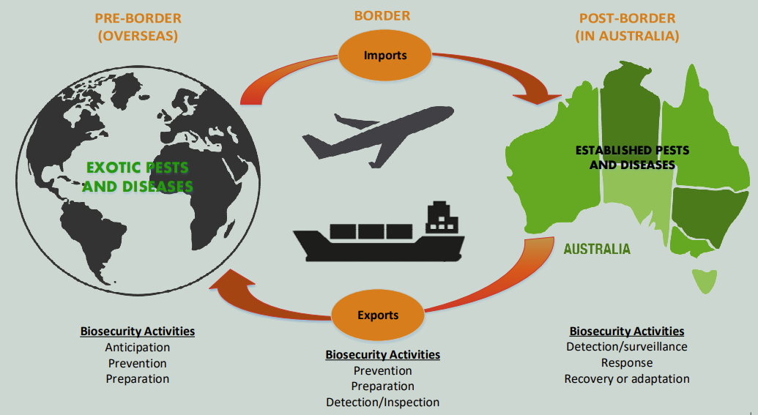
[Image description: A picture of the world on the left includes the text: “exotic pests and diseases” on the picture, “Pre-border (overseas)” above the picture and “biosecurity activities: anticipation, prevention and preparation” underneath the picture. A picture of Australia on the right includes the text: “established pests and diseases” on the picture, “post border (in Australia)” above the picture and “biosecurity activities: detection/surveillance, response and recovery or adaption” underneath the picture. In the middle of the image, arrows point between the picture of the world and Australia in both directions. Above the arrows is the text “border”. The arrow pointing towards the world contains the text “exports” and the arrow pointing towards Australia says the word “imports”. Below the arrows is the text “biosecurity activities: prevention, preparation and detection/inspection”.]
[Slide 7]
Busier world = more risk:
- Shipping and cargo
- Global travel
- Complexity of supply chains
- Changes to environment.
Significant increase by 2025:
- Passengers +72%
- Containerised Cargo +100%
- Shipping +28%
- Containers +75%.
[Slide 8]
Global changes are creating more complexity, greater uncertainty and risk:
- Climate change – expanding geographical range of invasive species
- Shift in trade and travel patterns
- Extreme weather events
- Loss of biodiversity
- Weakening resilience of our ecosystems.
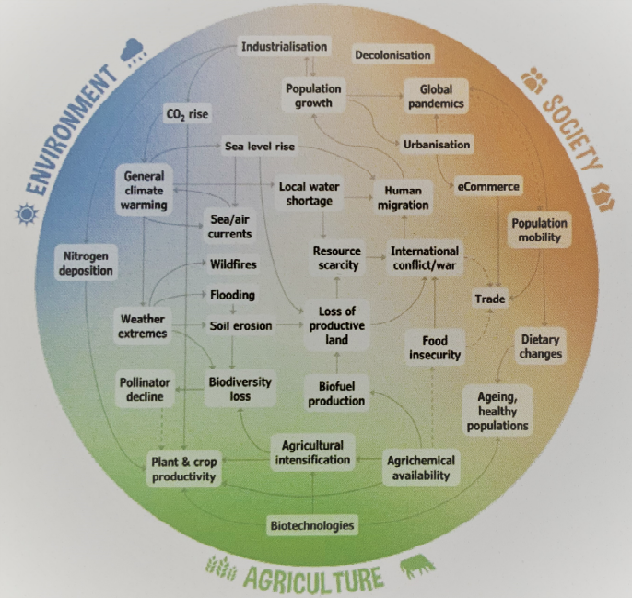
[Image description: A diagram of global changes and their connectedness. A circle surrounded by the text: “Environment”, “Society” and “Agriculture”. Text within the circle lists global changes with arrows showing connectedness between them. For example, the text “extreme weather events” has arrows pointing to text such as: “wildfires”, “flooding” and “soil erosion”. Image credit: New Zealand B3 Team]
[Slide 9]
Broad set of exotic pest species using diverse entry pathways.
[Images descriptions: Dirty hiking boots, a wooden pallet, timber, shipping containers, garlic and a ship hull]
[Slide 10]
The exotic environmental pest list (EEPL):
- List of pests, weeds and diseases assessed as highest biosecurity risk to environment
- 168 entries and 42 identified as higher-risk species
- Comprised of 8 biological groupings - very broad range of taxa
  - Viruses, bacteria, fungi
  - Molluscs, insects, arachnids
  - Weeds, algae
  - Fish, birds, reptiles, mammals.
[Slide 11]
Stopping pests at every opportunity:
- Offshore: where possible, we push the risk off-shore
- Pre-border: strong neighbours = strong biosecurity for Australia
- On the way: increased offshore intelligence, research and data analytics
- At-border: an agile and smart system to cope with the (un)expected
- Immediately post-border: strong government, community and business engagement
- Post-border: rapid detection, response and recovery capability.
[Slide 12]
Biosecurity issues in Australia since 2000:
- Red imported fire ant
- Smooth newt
- Asian black spined toad
- Argentine ant (Norfolk Island)
- Asian honey bee
- Jack Dempsey cichlid
- Emerald furrow bee
- Mexican feathergrass
- Myrtle rust
- Pigeon paramyxovirus
- Read-eared slider turtle
- Yellow crazy ant
[Slide 13]
Established pest animals:
- Wild dogs (Canis familiaris)
- European foxes (Vulpes vulpes)
- European carp (Cyprinus carpio)
- Feral pigs (Sus scrofa)
- Feral cats (Felis catus)
- Feral deer (Cervidae spp.)
[Slide 14]
Who are we working with?:
- States and Territories
- DCCEEW – Threatened Species
- Indigenous groups
- NGOs
- Research organisations
- Industry
- Community sectors.
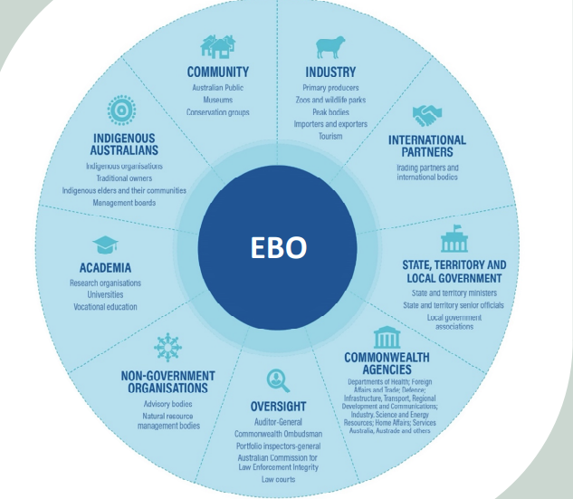
[Image description: A visual and descriptive list of the groups EBO works with.]
[Slide 15]
Thank you!
Dr Bertie Hennecke
Australia’s Chief Environmental Biosecurity Officer
[End of presentation]
Acknowledgement of Country
We acknowledge the Traditional Custodians of Australia and their continuing connection to land and sea, waters, environment and community. We pay our respects to the Traditional Custodians of the lands we live and work on, their culture, and their Elders past and present.
© Commonwealth of Australia 2023
Unless otherwise noted, copyright (and any other intellectual property rights) in this publication is owned by the Commonwealth of Australia (referred to as the Commonwealth).
All material in this publication is licensed under a Creative Commons Attribution 4.0 International Licence except content supplied by third parties, logos and the Commonwealth Coat of Arms.
The Australian Government acting through the Department of Agriculture, Fisheries and Forestry has exercised due care and skill in preparing and compiling the information and data in this publication. Notwithstanding, the Department of Agriculture, Fisheries and Forestry, its employees and advisers disclaim all liability, including liability for negligence and for any loss, damage, injury, expense or cost incurred by any person as a result of accessing, using or relying on any of the information or data in this publication to the maximum extent permitted by law.

