Joel Willis

Presentation description

Introduction
This is the accessible text copy of a presentation delivered by Joel Willis for International Day of Plant Health.

Presentation
[Slide 1]
Biosecurity Operations – Detection tools and technology
Joel Willis
Principal Director, Detection Capability, Biosecurity Operations Division
[Slide 2]
[Images descriptions: ‘Spot’ the robotic dog, a biosecurity detector dog at work with appropriate PPE, Joel Willis with a puppy]
[Slide 3]
Detection Capability:
- Dogs: biosecurity detector dog capability
- X-ray: detection technologies
- New technologies: emerging technology program.
[Slide 4]
National detector dog program overview
Bolstering Australia’s Biosecurity System - Detector Dog Capability Increase:
- Announced in the 2023 October budget
- Provides $11.7 million to increase and sustain the workforce by 20 additional detector dogs and 20 additional handlers
- To date 8 additional detector dogs have graduated under the budget measure.
Quick stats:
- 53 operational dogs
  - 1 in Cairns
  - 9 in Brisbane
  - 23 in Sydney
  - 17 in Melbourne
  - 1 in Adelaide
  - 2 in Perth
- Mail 2022 calendar year (approx.)
  - About 6.2 million mail articles K9 screened
  - About 10,700 mail article K9 interceptions
- Travellers 2022 calendar year (approx.)
  - About 920,000 travellers K9 screened
  - About 10,100 traveller K9 interceptions
- 20,800 total K9 interceptions (2022 calendar year – approx.).
[Slide 5]
The first BMSB found by a detector dog:
- In 2018 we began an innovative project with the University of New England to train our detector dog fleet to sniff out Brown Marmorated Stink Bug (BMSB)
- In November 2021, Velvet was the first detector dog to find a live BMSB
- During a cargo inspection of over 800 vehicles and over 150 bulk break items, Velvet sniffed out a single live BMSB on an off highway Caterpillar Truck
- This live sample was confirmed a BMSB and subsequently used to train and test the entire Brisbane detector dog fleet.
[Slide 6]
Port Botany BMSB deployment
- Deployed to Port Botany in response to a positive detection of BMSB at an approved arrangement
- After finding several bugs in relation to an incoming container, no further detections have been made since January.
[Video description: Video shows two biosecurity detector dogs conducting a Brown Marmorated Stink Bug (BMSB) search in Port Botany during a training exercise. The dogs are shown searching through shrubs and long grass, until one dog gives an indication to a BMSB training swab that had been placed there and receives a dummy reward. The dogs continue to search, and both indicate on the same group of trees.]
[Slide 7]
BMSB in the traveller pathway:
- Whilst screening passengers off a flight from Taipei, detector dog Petal responded to a duffle bag (cabin luggage)
- A single live BMSB was found upon inspection
- The passenger had started their journey in Serbia, connecting through Istanbul and Taiwan.
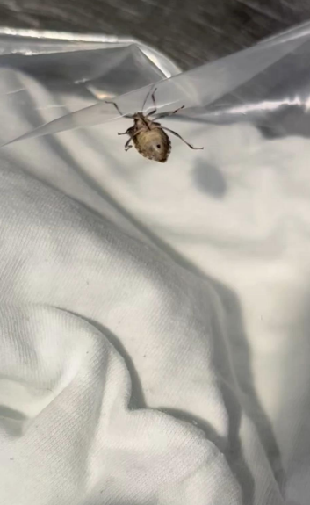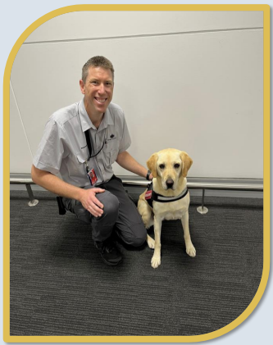
[Image description: Photo of a BMSB on a piece of plastic and a photo of a biosecurity dog and their handler]
[Slide 8]
Re-introducing bees as a target odour:
- Re-introduced queen bees as a target odour across the entire biosecurity detector dog fleet
- Quick process to imprint a detector dog:
  - All dogs provided a conditioned response within 3-5 exercises
  - The entire process for all eight dogs based in Brisbane completed in two days.
[Video description: Video shows a biosecurity detector dog conducting training for a bee target odour search. The dog is shown to be sniffing seven individual black boxes. The dog indicates on a box.]
[Slide 9]
X-ray technology
[Slide 10]
Our investment in new 3D X-ray technology:
- Technology investment: 3D Real Time Tomography (RTT) X-ray Unit
- Decrease in threats entering Australia: detection of biosecurity risk items with 3D X-ray screening
- Unlocking the potential: automated detection algorithms for fruit, meat, seafood, plants and vegetables.
[Slide 11]
2D X-ray vs 3D X-ray.
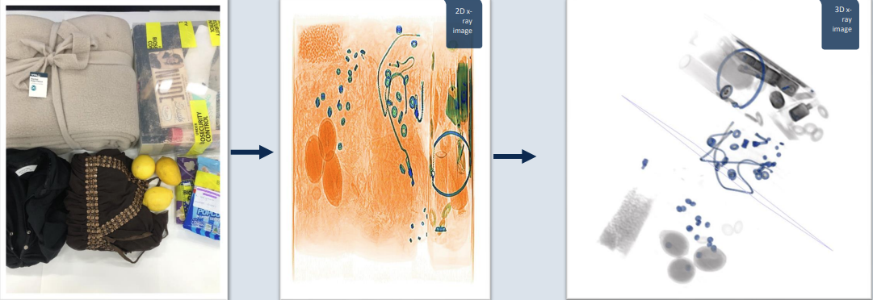
[Images descriptions: A photo of luggage items, a 2D X-ray image of the luggage items and a 3D X-ray image of the luggage items.]
[Slide 12]
[Video description: Video shows a 3D X-ray displaying a piece of fruit in a traveller’s baggage. The 3D image of the luggage is rotated and examined.]
[Slide 13]
Algorithm Development
[Slide 14]
3D X-ray Algorithm Development:
- In partnership with NZMPI and Rapiscan we have developed algorithms to automatically detect biosecurity risks for:
  - Meat
  - Fruit
  - Vegetables
  - Seafood
- Preliminary algorithms have also been developed to allow automated detection of wildlife and trafficable animal parts such as:
  - Lizards
  - Snakes
  - Ivory
  - Rhino horn
  - Turtle shell
  - Tortoise shell.
[Slide 15]
[Video description: Video shows a 3D X-ray displaying a piece of fruit in a traveller’s baggage detected using a fruit algorithm.]
[Slide 16]
Concealed succulents
Power of 3D X-ray:
- 3D X-ray screened a parcel arriving from China labelled as ‘Clothes’
- Following the initial 3D X-ray scan the parcel was inspected and found to have 83 succulents concealed within decorative cushions.
[Video description: Video shows a 3D X-ray displaying concealed succulents in a parcel. The 3D image of the parcel is rotated and examined]
[Slide 17]
2D X-ray Algorithm Development
As well as our successful work on 3D X-ray, we continue to trial our 2D X-ray automated detection algorithms at our dog facility in Brisbane. The department is partnering with both Rapiscan and Smiths to inform our future 2D hardware and software strategy.
Rapiscan 927 DX 2D X-ray unit:
- Trial commenced in 2021
- Building meat image library to provide data to inform algorithm development
- Meat detection algorithm is soon to be deployed on to the Rapiscan 2D X-ray unit.
Smiths 100 100 V-2IS 2D X-ray unit:
- The trial for the Smith’s unit is in early stages of data gathering and validation
- Focus is on validating algorithms and building the image library
- First live trial of meat algorithm expected in mid-2023.
[Slide 18]
Seed Algorithm Development:
- In peak periods seeds comprised up to 70% of all seizures in the mail pathway.
- Current 2D or 3D X-rays are too high energy resulting in them not detecting small seeds.
- Low energy, high resolution X-ray technology was used to develop a seed detection algorithm.
[Video description: Video shows mail being processed through a low energy, high resolution X-ray.]
[Slide 19]
Pre-Screening of Passenger Baggage Trial
[Slide 20]
Pre-Screening of Passenger Baggage Trial:
- Test operations in 2 international airport locations
- The trial will screen hold baggage after arrival but prior to the passenger collecting their baggage
- As bags are unloaded onto the baggage handling system they will be scanned by the 3D X-ray unit
- 3D X-ray images will be sent to a control room where biosecurity officers will assess the contents for biosecurity risk material.
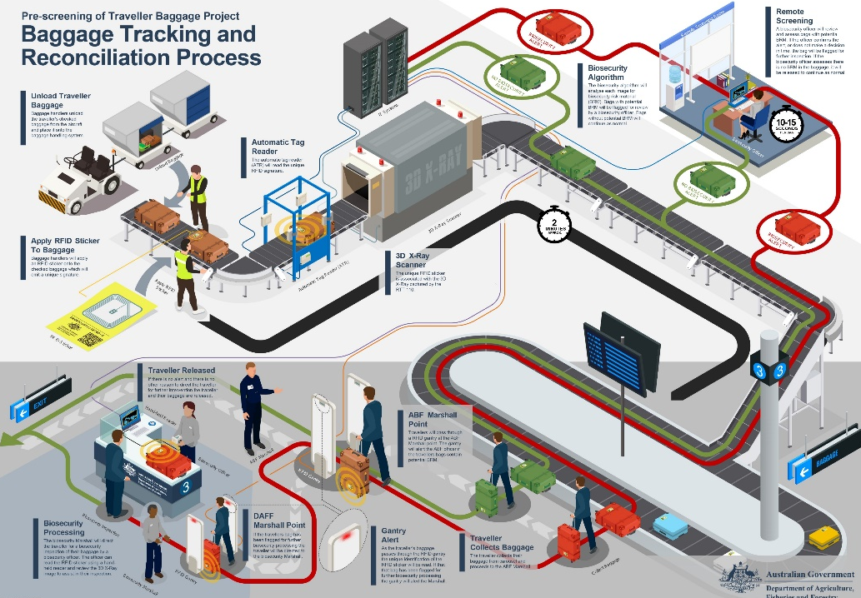
[Image description: A diagram of the pre-screening of traveller baggage project: baggage tracking and reconciliation process.]
[Slide 21]
Our Investment in New 3D X-ray Technology:
- Brisbane Airport: pre-screening of passenger baggage
- Air-Cargo Facility (Sydney): installation planned mid-2023
- Melbourne Airport: pre-screening of passenger baggage
- Melbourne Gateway Facility: Installation planned mid-23.
[Slide 22]
Questions?
[End of presentation]
Acknowledgement of Country
We acknowledge the Traditional Custodians of Australia and their continuing connection to land and sea, waters, environment and community. We pay our respects to the Traditional Custodians of the lands we live and work on, their culture, and their Elders past and present.
© Commonwealth of Australia 2023
Unless otherwise noted, copyright (and any other intellectual property rights) in this publication is owned by the Commonwealth of Australia (referred to as the Commonwealth).
All material in this publication is licensed under a Creative Commons Attribution 4.0 International Licence except content supplied by third parties, logos and the Commonwealth Coat of Arms.
The Australian Government acting through the Department of Agriculture, Fisheries and Forestry has exercised due care and skill in preparing and compiling the information and data in this publication. Notwithstanding, the Department of Agriculture, Fisheries and Forestry, its employees and advisers disclaim all liability, including liability for negligence and for any loss, damage, injury, expense or cost incurred by any person as a result of accessing, using or relying on any of the information or data in this publication to the maximum extent permitted by law.

