**Quick Reference Guide**

Accessing MARS as a Port Authority user

**What must you do?**

In order to use MARS a one-off registration process is required. Accessing MARS is a simple **two-step process,** as detailed below. MARS is tailored so users only see the information they require.

Registering as a port authority allows users to view the following vessel information:

* Vessel and voyage details.
* Applications received including pre-arrival reporting.

# Step 1. How to register for a Department Security Account

a Access the department’s online web services at **[online.agriculture.gov.au/selfservice/](https://online.agriculture.gov.au/selfservice/)**

b This welcome screen will be displayed.

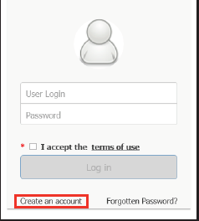

1. Click on the **Create an account** link.
2. The **User Registration** window will be displayed. Complete all the mandatory fields in this window.
3. Once all the mandatory fields have been completed, tick the box in this window to

## Accept the Terms of Use.

1. Click on the **Register** button to register the User ID and password with the department.
2. When the registration details have been submitted a message will be displayed stating that the user account has been created successfully. Account activation will take a few minutes.
3. Click on the **Close** button to return to the **Log In** screen. Enter your User ID and password and click **Log In** to access the online portal.

# Step 2. How to register for MARS access

* 1. From the **Request Access** section of the main MARS landing page select the port authority role.

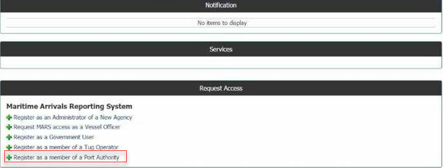

* 1. **Complete** the user details.
  2. Click on **Submit**. The access request will now be sent to the department’s National Maritime Centre (NMC) for assessment.

# What next?

1. You will receive an email with a link to MARS once your access has been granted by the NMC.
2. The MARS icon will now be available when you log in.

 MARS

Each time you log into MARS, you will be agreeing to the terms and conditions based on your role. It is important that you understand your obligations and the privacy arrangements of your access.

# Biosecurity Act 2015 and confidentiality of information

The department provides the authorisation to access information (in MARS) for permissible purposes to manage potential biosecurity risk under section 580 of the Biosecurity Act. MARS users have obligations to manage protected information in accordance with the Act and to only access MARS as part of permissible purposes to manage:

* biosecurity risks
* the risk of contagion of a listed human disease
* the risk of listed human diseases entering Australian territory or a part of Australian territory, or emerging, establishing themselves or spreading in Australian territory or a part of Australian territory
* risks relating to ballast water
* biosecurity emergencies and human biosecurity emergencies
* to give effect to Australia’s international rights and obligations, including under the International Health Regulations, the SPS Agreement and the Biodiversity Convention.

# Need help?

For urgent access or issues, follow up on the access request by contacting the [NMC](https://www.agriculture.gov.au/biosecurity/avm/vessels#need-help).

The department’s service Client Service Charter sets out our service responsibilities and our standard of service at [awe.gov.au/about/commitment](http://www.awe.gov.au/about/commitment)

**NOTE:** Screenshots may look slightly different in MARS.

BIO2589_0716