**Aquatic ecosystems toolkit**

**CASE STUDY 3:**Tasmania

Based on work undertaken by the Tasmanian Department of   
Primary Industries, Parks, Water and Environment and   
John Gooderham for the Aquatic Ecosystems Task Group

2012

**Published by**

Department of Sustainability, Environment, Water, Population and Communities

**Authors/endorsement**

This case study is based on trials of the draft Guidelines for Identifying High Ecological Value Aquatic Ecosystems, and the draft Aquatic Ecosystem Delineation and Description Guidelines. The final reports from these trials are as follows:

DPIPWE (2011). A draft method for identifying High Ecological Value Aquatic Ecosystems for Tasmania using CFEV data. Report prepared for the Aquatic Ecosystems Task Group and the Department of Sustainability, Environment, Water, Population and Communities. Department of Primary Industries, Parks, Water and Environment, Hobart.

Gooderham, J. (2012). Tasmanian HEVAE delineation and description trial: North-eastern Flinders Island. Report prepared for the Department of Primary Industries, Parks, Water and Environment, the Aquatic Ecosystems Task Group and the Department of Sustainability, Environment, Water, Population and Communities. The Waterbug Company, Hobart.

These reports are available on request from the Australian Government Department of Sustainability, Environment, Water, Population and Communities.

Endorsed by the Standing Council on Environment and Water, 2012.

© Commonwealth of Australia 2012

This work is copyright. You may download, display, print and reproduce this material in unaltered form only (retaining this notice) for your personal, non-commercial use or use within your organisation. Apart from any use as permitted under the Copyright Act 1968 (Cwlth), all other rights are reserved. Requests and enquiries concerning reproduction and rights should be addressed to Department of Sustainability, Environment,   
Water, Population and Communities, Public Affairs, GPO Box 787 Canberra ACT 2601 or email   
<[public.affairs@environment.gov.au](mailto:public.affairs@environment.gov.au)>.

**Disclaimer**

The views and opinions expressed in this publication are those of the authors and do not necessarily reflect those of the Australian Government or the Minister for Sustainability, Environment, Water, Population and Communities.

While reasonable efforts have been made to ensure that the contents of this publication are factually correct, the Commonwealth does not accept responsibility for the accuracy or completeness of the contents, and   
shall not be liable for any loss or damage that may be occasioned directly or indirectly through the use of,   
or reliance on, the contents of this publication.

**Citation**

Aquatic Ecosystems Task Group (2012). Aquatic Ecosystems Toolkit. Case Study 3: Tasmania. Department of Sustainability, Environment, Water Population and Communities, Canberra.

For citation purposes, the PDF version of this document is considered the official version. The PDF is available from:

<[www.environment.gov.au/water/publications/environmental/ecosystems/ae-toolkit-cs-3.html](http://www.environment.gov.au/water/publications/environmental/ecosystems/ae-toolkit-cs-3.html)>

**Front cover**: Site HEVF08, a broad lagoon on Flinders Island, Tasmania. Photo by Janet Smith.

# Table of contents

List of figures iii

List of tables iv

Abbreviations v

Introduction 1

Part 1: Identifying High Ecological Value Aquatic Ecosystems (HEVAE) 2

1.1 Groundwork before identifying HEVAE 2

1.2 Identifying HEVAE 3

Part 2: Aquatic ecosystem delineation and description 16

2.1 Assessment unit—north-eastern corner of Flinders Island 16

References 32

## List of figures

Figure 1 CFEV River Section Catchments 3

Figure 2 River Section Catchments (RSCs) (orange) from the HEVAE layer inherit values   
from the wetland immediately upstream of Big Waterhouse Lake including all   
of the immediately connected catchment 7

Figure 3 The ‘distinctiveness’ at this Icena Creek site is associated with wetlands along   
the creek, while ‘representativeness’ and ‘distinctiveness’ are associated with   
the river itself. Some RSCs in the middle of the figure inherit all three criteria as   
a result of being intersected with both ecosystems 8

Figure 4a Locations in Tasmania that are known to support outstanding diversity.   
This data includes nominated sites contained in the CFEV database, and a number   
of diverse fish sites 9

Figure 4b Locations in Tasmania that are known to support features that match against   
the HEVAE criterion of ‘distinctiveness’ 9

Figure 4c Locations in Tasmania that are known to support features that match against   
the HEVAE criterion of ‘vital habitat’ 10

Figure 4d Locations in Tasmania that are known to support features that match against   
the HEVAE criterion of ‘evolutionary history’ 10

Figure 4e Locations in Tasmania that are known to support features that match against   
the HEVAE criterion of ‘naturalness’ 11

Figure 4f Locations in Tasmania that are known to support features that match against   
the HEVAE criterion of ‘representativeness’ 11

Figure 5 Freshwater ecosystems colour coded by the number of HEVAE criteria they meet 12

Figure 6 Freshwater ecosystems that meet four, five or six criteria 13

Figure 7 Freshwater ecosystems colour coded by the number of HEVAE criteria they meet,   
but with an additional four points from splitting up the different input data sets for ‘distinctiveness’. A score of 9 is possible, but the highest score in the state is 8 14

Figure 8 Freshwater ecosystems colour coded by the number of HEVAE criteria they meet,   
but with an additional five points from splitting up the different input data sets for ‘distinctiveness’. A score of 10 is possible, but the highest score in the state is 9 14

Figure 9 Flinders Island, showing the location of the original HEVAE polygon (blue) 16

Figure 10 Location of field sites sampled 21

Figure 11 Principal Components Analysis of environmental variables 23

Figure 12 A dendrogram demonstrating differences between sites based on their   
environmental variables. Difference is displayed in using Euclidean distance 24

Figure 13 MDS plot showing sites separated based on their floral assemblages 24

Figure 14 MDS plot showing sites separated based on their invertebrate assemblages 25

Figure 15 Ecological Focal Zones for the Wetland Complex and for the combined beach   
and estuary Important Bird Sites. Base data by CFEV and the LIST,   
© State of Tasmania 27

Figure 16 A groundwater connected wetland. The upper catchment lies to the left,   
and drains away to the coast on the right 29

Figure 17 A perched wetland, distinguished by the sealing layer of organics (hatched).   
Water can only reach the wetland from overland flow or precipitation 29

Figure 18 A wetland with some organics in its bed, but still with connections to percolated local groundwater. Note this might not exist as a discrete water table 29

Figure 19 A visual comparison of drainage line patterns in north-eastern Flinders Island,   
and areas further south where wetlands have been historically drained.   
Base data by CFEV and the LIST, © State of Tasmania 31

Figure 20 Possible Zone of Influence for the wetland complex. This is basically the greater   
catchment polygon extended south until it reaches Foochow Inlet or private lands.   
Base data by CFEV and the LIST, © State of Tasmania 32

## List of tables

Table 1 Attributes and related data sets selected for each criteria, with an explanation   
of their relevance and use 4

Table 2 Details of the different classifications available for each of the main ecosystems   
used in the CFEV Program 6

Table 3 Values associated with River Section Catchment polygon 469130 17

Table 4 Values investigated for the original HEVAE polygon (469130) and for the entire   
North East River and Arthurs Creek catchment 18

Table 5 Sites visited in the field assessment 20

# Abbreviations

|  |  |
| --- | --- |
| **AETG** | Aquatic Ecosystems Task Group |
| **ANAE** | (Interim) Australian National Aquatic Ecosystems (Classification Framework) |
| **CFEV** | Conservation of Freshwater Ecosystem Values Framework |
| **EFZ** | Ecological Focal Zone |
| **EPBC** | Environment Protection and Biodiversity Conservation Act 1999 (Cwlth) |
| **HEVAE** | High Ecological Value Aquatic Ecosystems |
| **ICV** | Integrated Conservation Value |
| **LIST** | Land Information Systems Tasmania |
| **NVA** | Natural Values Atlas Land Information Systems Tasmania |
| **RSC** | River Section Catchments |
| **TASVEG** | Tasmanian Vegetation Monitoring and Mapping Program |

# Introduction

Trials of draft components of the national Aquatic Ecosystems Toolkit, developed by the Aquatic Ecosystems Task Group (AETG), were undertaken in Tasmania using existing datasets from the Conservation of Freshwater Ecosystem Values (CFEV) program. The projects were trial applications of Modules 3 and 4 of the Aquatic Ecosystems Toolkit.

Note that at the time the trial was undertaken:

* The Guidelines for Identifying High Ecological Value Aquatic Ecosystems (HEVAE) were known as the HEVAE Framework.
* There were six HEVAE criteria; evolutionary history has since been incorporated into distinctiveness.

# Part 1: Identifying High Ecological Value Aquatic Ecosystems (HEVAE)

## 1.1 Groundwork before identifying HEVAE

### Step 1 Identify purpose

The purpose of the assessment was to trial the draft HEVAE identification guidelines in a relatively data-rich area, while also making a comparison of the HEVAE process with the existing CFEV program.

### Step 2 Map and classify aquatic ecosystems

The CFEV program applies to all mapped aquatic ecosystems (at the 1:25 000 scale), including rivers, lakes and waterbodies, wetlands, estuaries, saltmarshes, karst and groundwater-dependent ecosystems. These ecosystems were considered sufficiently equal to the systems and habitats of the ANAE Classification Scheme, precluding the need to apply the ANAE classification. A state-wide audit had been undertaken for the CFEV program to classify all mapped aquatic ecosystems with the exception of groundwater-dependent ecosystems, for which only known locations were mapped.

Physical and biological data were used to provide essentially natural (i.e. pre-European settlement) classifications. All ecosystem spatial units were assigned a biophysical class for each ecosystem component, along with a ‘naturalness’ score. The classification process was also used for applying the CFEV representativeness criterion, by ensuring that the representativeness of all biophysical classes was considered. For further detail refer to the CFEV Project Technical Report (DPIW 2008a).

The CFEV biophysical classifications were used to apply the ‘representativeness’ criterion in this trial of the HEVAE identification guidelines.

### Step 3 Determine scale, regionalisation, and spatial units

**a. Determine scale and regionalisation**

HEVAE were assessed and identified across the whole of the state of Tasmania, including King and Flinders islands, but not Macquarie Island.

**b. Select spatial units**

The CFEV data is attributed to seven different ecosystems in its standard format: rivers, wetlands, waterbodies, karst, estuaries, saltmarshes, and groundwater-dependent ecosystems. The first step to undertake a HEVAE assessment was to combine these different ecosystems into a single spatial layer and associated data file using the CFEV River Section Catchments (RSC) layer. The RSC consists of a series of polygons; each associated with a section of river between confluences, and delineates the area of surrounding land that will drain into a specific river section (Figure 1).

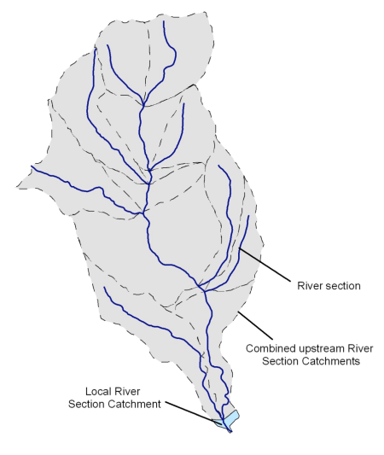

**Figure 1 CFEV River Section Catchments.**

**Each polygon (dotted lines) is associated with a river section (blue). River sections are the lengths of continuous river between river junctions. (DPIW 2008a. CFEV Technical Report: Appendices)**

One of the benefits of the RSC polygons is that their size varies with topography, and therefore hydrological connectivity. For example, in a broad, flat landscape such as a lowland floodplain, the polygons are larger, which works well because the landscape is also likely to be more hydrologically connected.

**Expert knowledge input**

The HEVAE/CFEV comparison trial commenced with an expert workshop to determine which components of the CFEV data would be useful for the HEVAE process, and whether additional data sets could be readily sourced. Experts were selected for the workshop that were familiar with the data sets involved, and the disciplines that would be relevant to the HEVAE assessment.

During the HEVAE assessment process, it was apparent that existing state-wide data sets often require heavy interpretation to allow them to fit with the HEVAE criteria and in some cases new data needs to be sought. For less well known features, this is difficult, and expert opinion may be the only source of information. Thus the trial highlighted the importance of input from expert knowledge and less well known data sets, which includes involving the specialists responsible for existing data.

## 1.2 Identifying HEVAE

### Step 4 Assign attributes to chosen spatial unit

**a. Selection of criteria**

At the time the trial was undertaken, there were six HEVAE criteria: diversity, distinctiveness, vital habitat, evolutionary history, naturalness and representativeness. Because the purpose of the assessment was to trial the draft Guidelines for Identifying HEVAE, this trial applied all six core criteria.

**b. Selection of attributes**

The attributes selected and the reasoning for the selection of those attributes is provided in Table 1.

**Table 1 Attributes and related data sets selected for each criteria, with an explanation of their relevance and use**

| Criterion | Attributes | Explanation |
| --- | --- | --- |
| **Diversity** | Fauna species richness | ‘Sites of fauna species richness’ contributes one of the subcomponents of Integrated Conservation Value (ICV) in the CFEV data. In this study it directly furnishes the diversity criteria by flagging known sites with an unusual diversity of invertebrates as defined by experts from a number of fields—see CFEV Technical Report (DPIW 2008a). A re-analysis of state electro-fishing records showed that a number of locations around the state stand out by possessing six or more taxa consistently. These additional sites were added to the CFEV data as diverse fish sites.  This criterion was sparsely populated and as a result contributes quite a lot to the overall maps. In its defence it draws on a broad set of resources, although it would benefit from some botanical additions. |
| **Distinctiveness** | Priority freshwater taxa/communities  Threatened native vegetation communities  Threatened species  Nationally important features | Data for priority freshwater taxa/communities were obtained from the CFEV database.  Threatened native vegetation communities were applied as they are mapped in TASVEG 2.0.  Threatened species were taken from the Natural Values Atlas, while nationally important features were obtained from the Tasmanian Geo-Conservation Database (v7.0).  In several instances there are nationally listed features that aren’t listed by the state. These were included as this is considered a national data set. The biggest example is lowland grasslands, which are EPBC listed but not covered in state listings. |
| **Vital habitat** | Important bird sites | Despite several options being investigated (such as rivers without barriers for diadromous fish species, and groundwater connectivity sites), no data was established to the extent where it could be easily incorporated. The ‘Important Bird Site’ data from the ‘Special Values’ dataset in CFEV was used, and updated with a number of records from the ‘Inventory of Nationally Important Shorebird Sites in Tasmania’ (Woehler & Park 2006).  Great Lake and Arthurs Lake provide vital habitat for an ecosystem that was peculiar enough to be listed alongside individual threatened species in the ‘Threatened Species Handbook’ (Bryant & Jackson, 1999). So this ecosystem has been included as ‘vital habitat’. |
| **Evolutionary history** | Phylogenetically distinct fauna/flora  Distinctive (‘primitive’) taxa | Data for phylogenetically distinct fauna/flora were obtained from the CFEV data as ‘special values’ (CFEV Technical Report 2008a, 2008b). This data set was used after being updated with new observation records (since 2005). It includes animals such as Syncarids and Phreatoicids (primitive crustaceans).  The CFEV database also records platypus as being present ubiquitously across most of Tasmania. This distribution data was not included as it swamped the analysis).  In the original workshop, huon pine was recommended as an example of a primitive species that exemplified the evolutionary history criterion, while also being associated with freshwater ecosystems (it is riparian). Huon pine distribution records from the Natural Values Atlas were included in this layer. |
| **Naturalness** | Unimpacted  ecosystems = 1  Impacted sites = <1  Ozestuary ‘pristine’ estuaries | Naturalness has been assessed for all freshwater ecosystems in Tasmania as part of the CFEV project. The CFEV rule scores (an Nscore) all unimpacted ecosystems with a 1, and impacted sites score less than 1, with particularly degraded sites scoring closer to zero. Unimpacted (Nscore = 1) was chosen as the cut-off for ecosystems ‘not adversely affected by modern human activity’ (AETG 2009).  The Ozestuary project identified a list of ‘pristine’ estuaries (Murray et al. 2005), and while most of these overlap with the CFEV assessments, there are several different recommended sites. These have also been added to the ‘naturalness’ attributes. |
| **Representativeness** | Representative Conservation Value (RCV) | This criterion was furnished entirely by the Representative Conservation Value (RCV) data from the CFEV program. ‘Representativeness’ uses a series of biophysical classifications (details in Table 2) for each of the six main ecosystems in the CFEV data, and this is a ‘flattened’ representation of the most representative or ‘A’ band from RCV. ‘A’ band is defined to select the best examples of each of the classes based on size and condition, and ensures that a minimum number or area of these is included (specific rules can be found in the CFEV technical report, DPIW 2008a).  This data is considered finer scale than would be available through a single bio-physical classification or a regionalisation based on physical and chemical characteristics. In most instances the CFEV classifications use biological data, so their assessment of representativeness is pertinent for real ecological communities that exist in Tasmania, rather than just the physical components that are assumed to influence them. |

**Table 2 Details of the different classifications available for each of the main ecosystems used in the CFEV Program**

The right hand column displays the number of classes resulting from each classification. It should be noted that these classes can overlap spatially as the same ecosystem feature can be (and often is) highly representative of multiple classes. (Refer to DPIW 2008a for more information).

| Ecosystem | Variable | Classification type | Units |
| --- | --- | --- | --- |
| **Rivers** | Fluvial geomorphic river types | Physical | 43 classes |
| Hydrological region | Physical | 4 classes |
| Macroinvertebrate assemblage | Biological | 44 classes |
| Native fish assemblage | Biological | 54 classes |
| Macrophyte assemblage | Biological | 8 classes |
| Crayfish region | Biological | 5 classes |
| Tree assemblage | Biological | 50 classes |
| **Waterbodies** | Physical class (area, depth, shoreline complexity, geomorphic mosaic group) | Physical | 71 classes |
| Frog assemblage | Biological | 15 classes |
| Native fish assemblage | Biological | 54 classes |
| Crayfish region | Biological | 5 classes |
| Tree assemblage | Biological | 50 classes |
| Tyler class | Biochemical | 7 classes |
| **Estuaries** | Biophysical class (as per Edgar, Barrett & Graddon 1999). | Biophysical | 19 classes |
| Biological class | Biological | 4 classes |
| Physical class | Biological | 9 classes |
| **Wetlands** | Physical class (Tyler corridor, area, geomorphic responsiveness, elevation) | Physical | 71 classes |
| Frog assemblage | Biological | 15 classes |
| Burrowing crayfish region | Biological | 2 classes |
| Tree assemblage | Biological | 50 classes |
| Dominant wetland vegetation type | Biological | 26 classes |
| Tyler class | Biochemical | 7 classes |
| **Saltmarshes** | Biophysical class (location, area, tidal zone/wave energy dominant vegetation) | Biophysical | 23 classes |
| **Karst** | Physical class (region, lithology) | Physical | 110 classes |

**c. Development of metrics**

The rationale and data requirements for the selected metrics are detailed in Table 1.

**d. Compile and assign data**

In many instances, CFEV readily provides data that can be matched against the HEVAE criteria. In some cases the data was out of date and needed to be revised (for example, threatened species and communities). In some instances additional data sets were also sourced. However, within the restricted timelines of the trial, this was only undertaken when data could be readily incorporated without excessive modification.

By intersecting the seven different ecosystems with the underlying CFEV River Section Catchments layer, the RSC polygons were attributed with data from the parent data sets. This method has the benefit of allowing values from different types of ecosystems to be combined if they co-occur spatially. It also places a spatial boundary around values within which they are, in most cases, quite likely to exist. For example, a waterbody containing a threatened species will pass the threatened species value to all the RSCs with which it intersects. Figure 2 shows the RSCs that were attributed with the values from a wetland immediately upstream of Big Waterhouse Lake in north-eastern Tasmania.

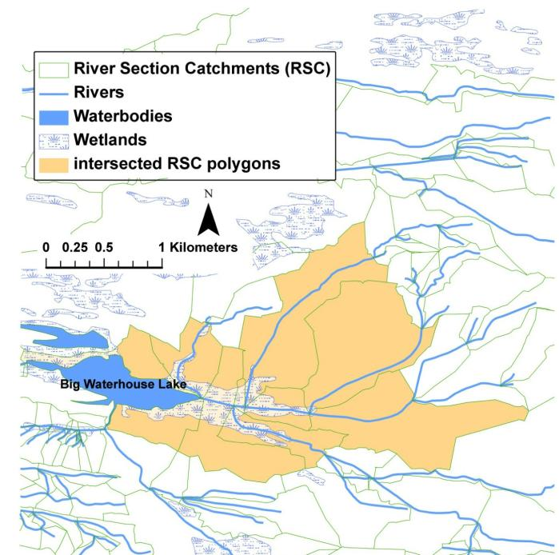

**Figure 2 River Section Catchments (RSCs) (orange) from the HEVAE layer inherit values from the wetland immediately upstream of Big Waterhouse Lake including all of the immediately connected catchment**

### Step 5 Apply the assessment process and identify units of high ecological value

**a. Apply the criteria**

The final HEVAE layer and associated data file is essentially the CFEV RSC layer with a series of new attributes that are calculated from the various values that fall within each polygon. Figure 3 provides an example where RSC polygons have been given the values of naturalness, distinctiveness and representativeness by the parent features, in this case a river system and a series of wetlands. The final HEVAE score is a combination of river and wetlands and therefore combines values from both.

This method of combining values results in a HEVAE score that ranges between zero and six, and handles the HEVAE criteria in a binary fashion (i.e. the polygon either has or lacks each HEVAE criteria).

To address this issue, sites were then able to score more than one for a given criterion; ‘distinctiveness’ has four input datasets that are possibly worthy of separate consideration. Therefore, a site that had a threatened native vegetation community, a number of threatened species, a geo-conservation site, and a set of characteristics that are listed as a priority in CFEV, could score four for ‘distinctiveness’. This meant the maximum score achievable was nine, a modification referred to as ‘D4’.

A further modification was made by adding scores based on whether or not sites host one or more threatened species. This adds an extra point to the scoring system for multiple threatened species, giving a maximum score of 10.

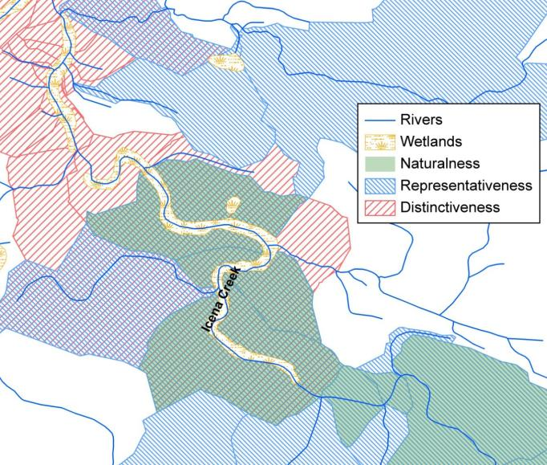

**Figure 3 The ‘distinctiveness’ at this Icena Creek site is associated with wetlands along the creek, while ‘representativeness’ and ‘distinctiveness’ are associated with the river itself. Some RSCs in the middle of the figure inherit all three criteria as a result of being intersected with both ecosystems.**

**b. Identify HEVAE**

The datasets were intersected with the RSC polygons to produce the following maps   
(Figure 4a to 4f), which demonstrate that each of the criteria has a distinctive distribution across the Tasmanian landscape.

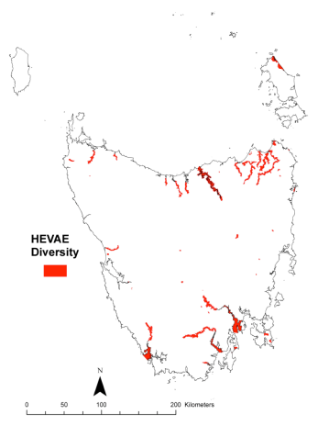

**Figure 4a Locations in Tasmania that are known to support outstanding diversity**

**This data includes nominated sites contained in the CFEV database,   
and a number of diverse fish sites.**

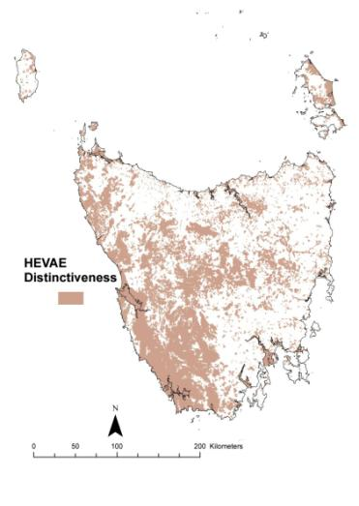

**Figure 4b Locations in Tasmania that are known to support features that match against the HEVAE criterion of ‘distinctiveness’**

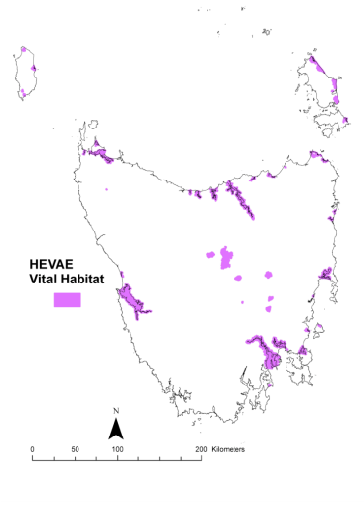

**Figure 4c Locations in Tasmania that are known to support features that match against the HEVAE criterion of ‘vital habitat’**

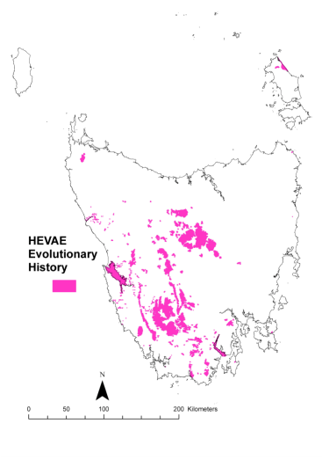

**Figure 4d Locations in Tasmania that are known to support features that match against the HEVAE criterion of ‘evolutionary history’**

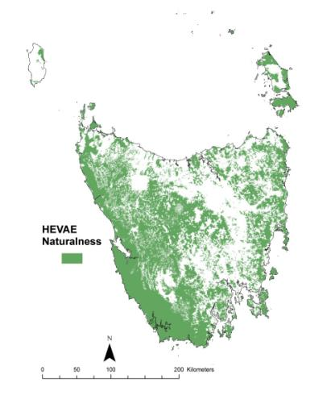

**Figure 4e Locations in Tasmania that are known to support features that match against the HEVAE criterion of ‘naturalness’**

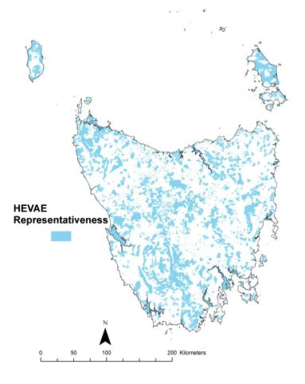

**Figure 4f Locations in Tasmania that are known to support features that match against the HEVAE criterion of ‘representativeness’**

The maps produced for each criterion were combined to produce a single map that coded each River Section Catchment by the number of HEVAE criterion met in the assessment (Figure 5). One site in the north east of Flinders Island (a lagoon complex including Hogans and Fergusons lagoons) met all six criteria, while seven other ecosystems met five criteria. However, the Flinders Island site is not considered an outstanding example of any of the sites, highlighting the need to subjectively assess values rather than simply matching them to a broadly defined criterion.

If a shortlist was to be extracted from this information it would probably list all River Section Catchments complexes that meet five or six criteria, because the number of locations that meet four of the criteria is substantially larger (Figure 6).

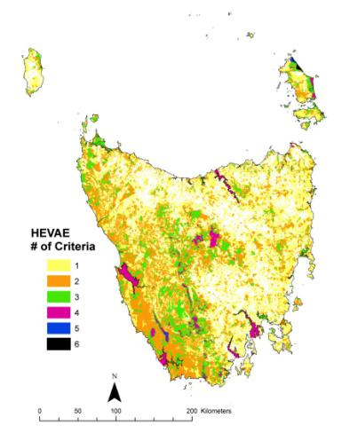

**Figure 5 Freshwater ecosystems colour coded by the number of HEVAE criteria they meet**

For those sites that meet five or six criteria, the threatened native vegetation communities are quite regularly responsible for the ‘distinctiveness’ criterion, and that it is common for these to occur alongside threatened species. ‘Evolutionary history’ and ‘vital habitat’ are the two criteria whose absence prevents the majority of the locations shown in Figure 6 from scoring against all six criteria.

One of the earlier concerns about this method was that estuary and large lake polygons would do better than other ecosystems simply because of their size. From these eight locations (only one of which is a large estuary), it seems that this isn’t as big a problem as first thought.

This method is heavily influenced by criteria that have limited data inputs (such as ‘diversity’ and ‘vital habitat’), as the presence of these criteria allows them to potentially have more than four criteria. The random co-occurrence of broadly distributed values (such as naturalness, representativeness and distinctiveness) results in at least two criteria being attributed to much of the state. This tails off exponentially, with a single ecosystem possessing all six criteria.

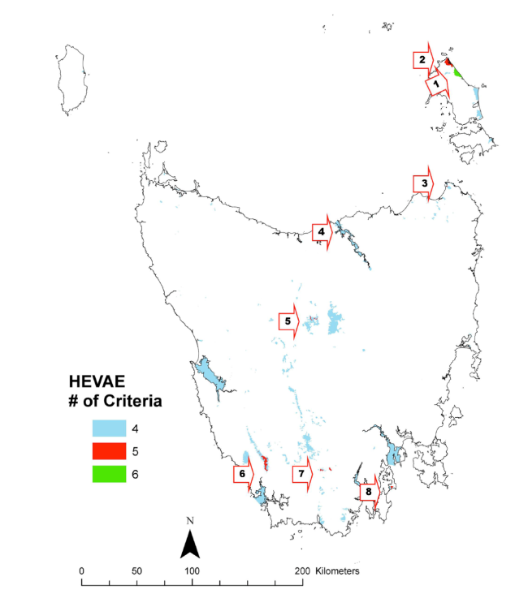

**Figure 6 Freshwater ecosystems that meet four, five or six criteria**

Only one ecosystem meets all six criteria—the lagoon complex in the north-east of Flinders Island that includes Hogans and Fergusons lagoons (1). Seven other ecosystems each have five criteria: North East Inlet (2), Tregaron Lagoon No.3 (3), The Tamar Estuary/Wetland complex (4), Lake Augusta and surrounding wetlands (5), parts of the upper Hardwood River (6), sections of the upper Huon associated with Karst and wetlands (7) and Big Lagoon (8). Numerous ecosystems furnish four criteria (light blue).

Using the ‘D4’ method to score more than 1 for the ‘distinctiveness’ criterion, one site scored an eight (north-east of Flinders Island), and four sites scored a seven (a wetland on the Tamar, Boulanger Bay, Port Macquarie and Big Lagoon) (Figure 7). This modification to the scoring system promotes a number of sites in the top categories, raising questions about the stability of these rankings.

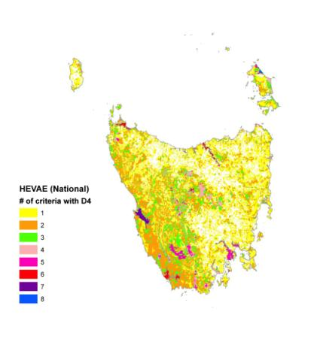

**Figure 7 Freshwater ecosystems colour coded by the number of HEVAE criteria they meet, but with an additional four points from splitting up the different input data sets for ‘distinctiveness’. A score of 9 is possible, but the highest score in the state is 8.**

A further modification based on whether a site hosted one or many threatened species provides the most benefit to the larger ecosystems such as lakes and estuaries (Figure 8). This isn’t surprising given their larger size alone makes them more likely to include more threatened species.

Both modifications to the scoring process add resolution to the higher scoring sites. This would be desirable if a list of high-value sites that could be ranked was required, demonstrating that some sites have more values than others, while working with a manageable set of high value sites. However, if a discrete set of obviously distinct sites was required, then the original HEVAE provides this with a distinct break between sites that score four and sites that score against five criteria.

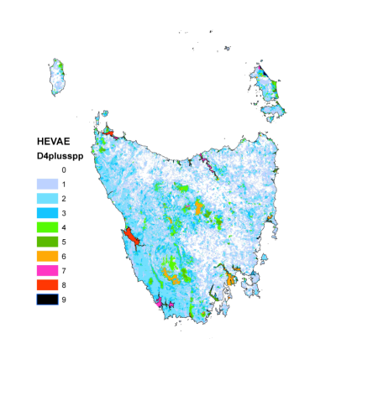

**Figure 8 Freshwater ecosystems colour coded by the number of HEVAE criteria they meet, but with an additional five points from splitting up the different input data sets for ‘distinctiveness’. A score of 10 is possible, but the highest score in the state is 9.**

While the CFEV database holds a wide range of aquatic values data, it is not housed in a way that is instantly compatible with the HEVAE criteria. Translating the broader dataset across in some instances simplifies the original content; some of it is incorporated under the ‘distinctiveness’ criterion, thus reducing the weight of those features, while more poorly populated data sets (e.g. ‘vital habitat’) tend to contribute more to the accumulated criteria scores than would seem reasonable.

The potential to align single features with multiple criteria was a constant temptation, and efforts were made to avoid ‘double dipping’. For example, species listed because they occur in greatly reduced habitat could be justifiably considered under ‘distinctiveness’ for their threatened status, while the habitat supporting them can be included under ‘vital habitat’. However there were a number of instances where a single ecosystem contained multiple values.

During an early iteration of the HEVAE assessment, it was noted that Great and Arthurs lakes were not scoring particularly high, despite being well-documented and known to contain threatened species, living fossils, and ‘vital habitat’ for a complex, endemic ecological community (Bryant & Jackson 1999). The data was re-examined, which revealed many of the values known to exist in the lakes were either being missed, or combined into the ‘distinctiveness’ criterion. For example, the lakes contain ‘living fossils’, the Paranasipides lacustris (a small species of mountain shrimp), and the phreatoicid isopods (a diverse set of endemic crustaceans), which provide an obvious match for the ‘evolutionary history’ criterion. Re-assessment of the lakes (using a mixture of expert opinion, literature, and site-specific survey data) takes them from scoring against two criteria to four.

An iterative process where existing data is re-assigned and important unincorporated data sets are included is essential for the HEVAE assessment process.

# Part 2: Aquatic ecosystem delineation and description

## 2.1 Assessment unit—north-eastern corner of Flinders Island

In trialling the draft Guidelines for Identifying High Ecological Value Aquatic Ecosystems (HEVAE) in Tasmania, the single highest scoring area in the state was an elongate polygon in the north-east of Flinders Island (Figure 9).

The north-eastern corner of Flinders Island hosts a number of different freshwater habitats containing values that can be matched against all of the HEVAE criteria. As such it offers a good test case for delineation and description, the main tasks dealt with in Module 4: Aquatic Ecosystem Delineation and Description Guidelines of the Aquatic Ecosystems Toolkit.

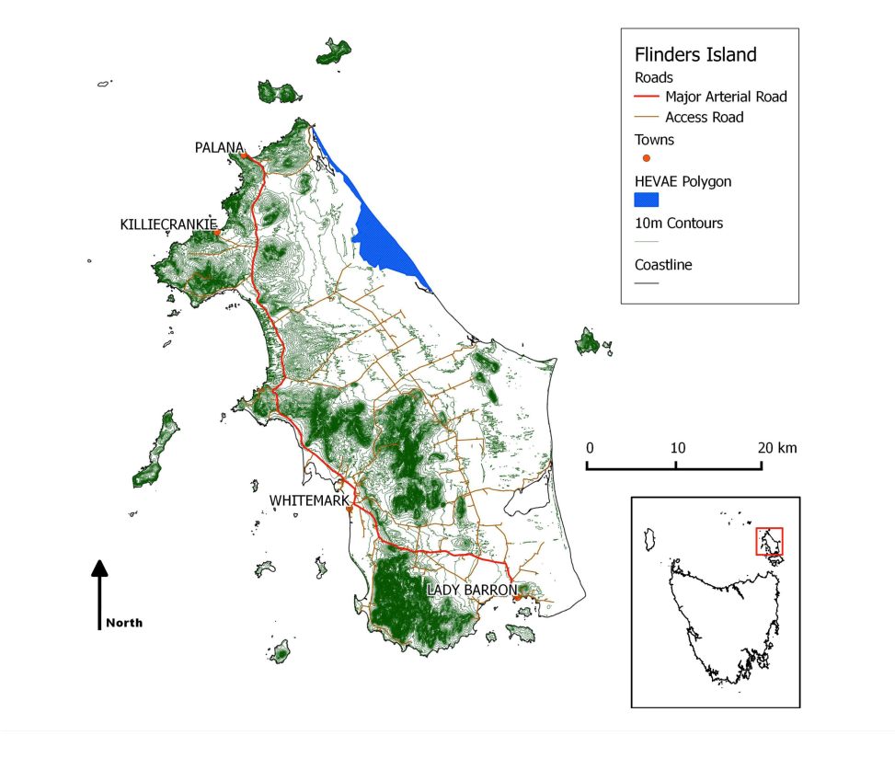

**Figure 9 Flinders Island, showing the location of the original HEVAE polygon (blue)   
Inset (lower right) shows the location of Flinders Island relative to the rest of Tasmania.   
The 10m contours (green) highlight areas with steeper topography. Base data by CFEV   
and the LIST, © State of Tasmania.**

### Step 1 Identify/review values, aquatic ecosystem classification, and components and processes for the high ecological value aquatic ecosystems or assessment units

**Review of aquatic ecosystem types**

The aquatic ecosystem types within the HEVAE polygon were identified using the CFEV mapping and classification process as described in section 1.1 (Step 2). Subsequent field assessment identified errors in the available CFEV data layer and the resultant reliance on alternative mapping such as aerial photographs.

**Validation of ecological values**

Validation of the identified HEVAE polygon was based on an initial desktop assessment, and was verified by a field assessment. This process resulted in the identification of two potential HEVAE polygons with separate values.

**Desktop assessment**

The polygon of interest (with River Section Catchment ID 469130) was unique in that it intersected values that could be argued to match quite well with each of the HEVAE criteria (see Table 3).

**Table 3 Values associated with River Section Catchment polygon 469130**

|  |  |
| --- | --- |
| HEVAE criterion | Value (source—authority) |
| **Evolutionary History  (now subsumed within Distinctiveness)** | Hemiphlebia mirabilis, ancient greenling damselfly  (records from the CFEV Special Values data) |
| **Distinctiveness** | Galaxiella pusilla (records from CFEV Special Values data and the Natural Values Atlas)  Wetland plant communities (Threatened Native Vegetation Communities) |
| **Diversity** | North East River Mouth—Estuarine fish community  (Graham Edgar nominated—included in CFEV) |
| **Vital Habitat** | Important bird sites |
| **Naturalness** | As defined in CFEV by Naturalness score |
| **Representativeness** | Wetland classes as defined in CFEV as ‘A’ band, or highly representative exist within the area. |

Following the trial of the draft Guidelines for Identifying HEVAE, a number of interviews were conducted with relevant specialists to ascertain the relative importance and extent of these values, and the critical components and processes that underpin them, and to start the process of encapsulating that information within conceptual models.

From examining NVA reports (DPIPWE 2011b) of the area, there was the possibility that the entire catchment of the North East River and Arthurs Creek might contain sufficient values in areas adjacent to North East River and Arthurs Creek to be included in a slightly larger HEVAE. As an initial scoping of this possibility, the values presented in Table 4 were investigated for both the original polygon (469130) and the entire catchment.

**Table 4 Values investigated for the original HEVAE polygon (469130) and for the entire North East River and Arthurs Creek catchment**

|  |  |
| --- | --- |
| HEVAE criterion | Values |
| **Diversity** | Discussions with estuarine expert Graham Edgar (Tasmanian Aquaculture and Fisheries Institute and the University of Tasmania) have made it clear that while the North East River Estuary is definitely connected to the North East River and intersects the HEVAE polygon being investigated, it was nominated for a marine fish assemblage and is unlikely to be strongly affected/connected with any of the freshwater aquatic ecosystems nearby  (G. Edgar 2011, pers. comm. 28 November). This information casts into doubt the option of adding the entire estuary to the final HEVAE delineation based on this value alone. This effectively loses the ‘diversity’ criterion from the site. Field surveys suggest that the diverse range of invertebrate communities supported by the wetland complex of the area may itself warrant being considered as an example of diversity. |
| **Distinctiveness** | The records used in the CFEV/HEVAE trial remain relevant. Several more records of Galaxiella pusilla from the area have now been updated to the Natural Values Atlas (DPIPWE 2011b).  If the entire catchment is used as an HEVAE, 11 different threatened plant species that have associations with aquatic ecosystems are contained, while the original polygon from the HEVAE trial contains only one. This number includes species listed either under the federal Environment Protection and Biodiversity Conservation Act (Commonwealth of Australia 2007), or the Tasmanian Threatened Species Protection Act 1995 (SAC 2001, DPIW 2006).  Additionally, several threatened native vegetation communities (DPIW 2007) exist in the area, including most freshwater wetland communities as recognised by TASVEG mapping (DPIW 2009). If the entire catchment is used as an HEVAE, 10 different communities are contained, while the original polygon from the HEVAE trial contains only seven. The threatened vegetation communities listed in this report are only those associated with aquatic ecosystems. This includes strongly ephemeral systems on Flinders Island, so some of the communities include terrestrial members. |
| **Vital Habitat** | Both Foochow Inlet to the south and the estuary of the North East River are recognised as important bird sites by the CFEV program in consultation with Birds Tasmania (DPIW 2008a and 2008b). These sites, and the length of coast between them, are the subject of surveys for shorebirds and terns (Woehler 2008) and are considered, together with the length of coastline south to Pot Boil Point to be of high conservation value for their high densities of hooded and red capped plovers. North East River provides important breeding sites for both fairy and Caspian terns, and is likely to also be important for small terns. These values exist quite specifically on the sea shore/foredunes, and in the estuary of the North East River, which may make it difficult to justify simply adding them to the more obviously freshwater values that exist in the inland wetlands. They also lack obvious connectivity with the other freshwater values as the rivers in the area (which would usually provide a link) are possibly less important in their contribution to catchment flow than groundwater. |
| **Evolutionary History** | Revision of the draft HEVAE criteria by the AETG led to a number of changes that affect the values that can be listed for the north-eastern corner of Flinders Island (and RSC469130). The criterion ‘evolutionary history’ was re-assigned as a sub-category within ‘distinctiveness’, and this reduces the number of HEVAE criteria possible, from six to five (as calculated in the CFEV HEVAE report (DPIPWE 2011a). Despite this, Hemiphlebia mirabilis is definitely a contributor to the ‘distinctiveness’ criterion, so possible sites were identified for verification by field visits. |
| **Naturalness and Representativeness** | These criteria are both still well served by data from the CFEV program. The entire north-eastern corner is in natural condition according to the CFEV database, and the area contains wetland, saltmarsh, river and estuary ecosystems that are considered highly representative as assessed during the CFEV project (DPIW 2008a). |

**Field assessment**

Sites in north-eastern Flinders Island were visited over four days (8–11 November 2011) (Table 5; Figure 10). The purpose of the field visits was to collect observations that would enable the development of conceptual models, and to determine whether the values identified in the detailed desktop assessment existed on the ground, and if they had obvious distributions or factors on the ground that would limit them.

To help assemble conceptual models of the area a suite of physico-chemical parameters were sampled (including elevation, average water level, alkalinity, pH, conductivity, surrounding land use). Of the values identified in the desktop assessment, threatened flora, threatened vegetation communities and the ancient greenling damselfly (Hemiphlebia mirabilis) were considered items that could possibly be field verified.

Field surveys were conducted to assess the area for threatened species and to accrue suitable observations to inform conceptual models of the area. Time was limited, so the survey methods used were qualitative with an emphasis on obtaining as broad a measure of the diversity available at each of the sites as possible.

Floral surveys involved partitioning wetlands into vegetation zones determined by their dominant species. All plant species within each zone were recorded together with an estimate of their percentage ground cover and Braun-Blanquet cover-abundance class. GPS position, estimate of population size and area were recorded for each threatened species observed. These data were averaged across the zones to provide values for the whole wetland. Nomenclature of plant species is based upon Buchanan (2008).

Invertebrates were surveyed using standard live-pick methods (as per Davis et al. 1999) which allow good assessments of diversity and assemblage to be obtained with limited field time. Invertebrates were preserved and later identified to the lowest taxonomic level possible.

**Table 5 Sites visited in the field assessment**

| Site code | Site name | Date | Easting | Northing | Elevation (ASL) |
| --- | --- | --- | --- | --- | --- |
| HEVF01 | Rutland | 8/11/2011 | 589510.9 | 5587106 | 17.78 |
| HEVF02 | Mini Rutland | 8/11/2011 | 588776.8 | 5586859 | 8.47 |
| HEVF03 | ESE Mt Boyes | 9/11/2011 | 582669.9 | 5585048 | 25.00 |
| HEVF04 | Nice Lagoon | 9/11/2011 | 585003.3 | 5586275 | 15.55 |
| HEVF07 | Half Burnt Swamp | 10/11/2011 | 585084.3 | 5583302 | 28.52 |
| HEVF08 | Headwater Lagoon | 10/11/2011 | 586369.9 | 5583830 | 15.15 |
| HEVF09 | Swan Lagoon | 10/11/2011 | 586172.4 | 5583670 | 16.23 |
| HEVF11 | The Splodge | 11/11/2011 | 589888.9 | 5587831 | 7.27 |
| HEVF12 | Fergusons Lagoon | 11/11/2011 | 592038.1 | 5587432 | 5.02 |
| HEVF13 | Hogans Lagoon | 11/11/2011 | 591001.6 | 5588301 | 7.00 |

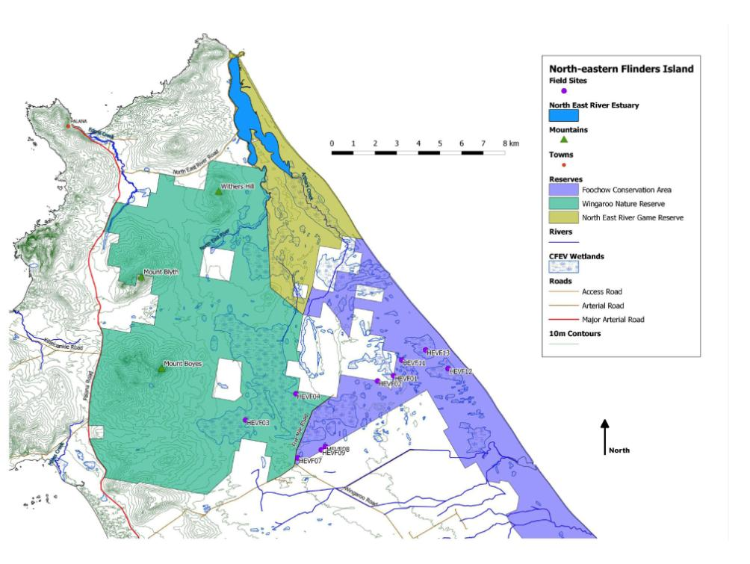

**Figure 10 Location of field sites sampled**

**Coloured areas represent the various reserves, pale squares within these are private land.   
Base data by CFEV and the LIST, © State of Tasmania.**

North East River and Arthurs River were difficult to access because of extensive mud flats, and a lack of vehicle access tracks. This difficulty of access bodes well for the ‘naturalness’ of the area as it is protected from many impacts simply because it is inaccessible. This was true for much of the northern part of the area investigated, the only access being from the south along Five Mile Road. The main field result from the attempt to get into Arthurs Creek is that the CFEV saltmarsh layer seems to underestimate the extent of saltmarsh in the area, and may need updating, either from the new TASVEG v2.0 (DPIW 2009), or possibly from aerial photos. Much of the area covered by CFEV wetland polygons in the estuaries of the North East River and Arthurs Creek are actually extensive saltmarshes, a mix of beaded samphire (Sarcocornia quinqueflora) and shrubby glasswort (Tecticornia arbuscula). As such, these areas have considerable ecological value as saltmarshes, which are nationally diminished in distribution and extent (Richardson, Swain & Wong 1998).

The Important Bird Sites (‘vital habitat’) were not ground-truthed on this trip. The work of Eric Woehler, and his recent reports are considered sufficient to verify the presence and extent of these values.

The remainder of the field assessment was executed through access in the south of the area via Five Mile Road. The sites form a transect perpendicular with the coast, allowing a reasonable range of diversity to be covered in a small distance and providing examples from a range of wetland morphologies. There is no guarantee that these sites are totally representative of the greater catchment, but the diversity of wetland types is of note even if it is restricted to the forms sampled in this field survey.

In regard to the ancient greenling damselfly (Hemiphlebia mirabilis), it was important to establish whether suitable habitat still existed for the species as described in papers on its ecology and management (DSE 2003, New 2007, Trueman et al. 1992), even if the species was not sighted.

Site HEVF11 was previously the location of records of both the ancient greenling damselfly (Hemiphlebia mirabilis), and the dwarf galaxias (Galaxiella pusilla), so it was unfortunate to find the location had been burnt, probably in a fire in 2007. This fire appeared to have been intense enough to burn the organic layer that would normally help the wetland retain water; it was dried to a fraction of its original extent despite nearby wetlands being full. The 2007 fire seems to have affected quite a large amount of the north-eastern Flinders area. The damselfly, which is easily discernable from the commoner damselflies using the original description of the species which contained a detailed description of the larva (Tillyard 1928), wasn’t evident in any of the samples from this expedition. The only other site where ancient greenling damselfly have been observed on Flinders Island (east of Mount Boyes) was inaccessible this trip. Dwarf galaxias were observed in large numbers in HEVF08, and a single individual in HEVF01.

Surveys yielded new records for three plant species listed in the Tasmanian Threatened Species Protection Act 1995 (SAC 2001, DPIW 2006). Utricularia australis (yellow bladderwort) was found in HEVF07, while Stylidium despectum was found alongside HEVF01 and HEVF02. Isopogon ceratophyllus was found near HEVF03, in the heathland outside the survey area and so is not included as an aquatic value, but is mentioned here for completeness.

**Analysis of field data**

In Figure 11, the groupings from the conceptual model fit well with the physico-chemical data, with PC1 (the X-axis of the plot) splitting out three groups. The purpose of this analysis was not to find significant differences, rather to highlight potential differences along the continuum of aquatic ecosystems within the inland wetlands complex i.e. it was descriptive rather than analytical. Data was analysed using the multivariate statistical package Primer (Primer-E Ltd 2009), using a selection of routines developed ‘to link biotic patterns to environmental variables‘ (Clarke & Warwick 2001).

Analysing the environmental variables was done first using a Principle Components Analysis (PCA) (Primer-E Ltd 2009). This provides an ordination with a series of vectors that can be used to interpret which variables are most different between the various sites.

The groupings from the conceptual model fit well with the physico-chemical data, in Figure 11, PC1 (the X axis of the plot) splits out three groups. HEVF12 and HEVF13 are the large groundwater connected lagoons nearest the coast with higher conductivities/salinities (Fergusons Lagoon and Hogans Lagoon). In the middle of PC1, a line of five sites is a mix of partially connected and shallow wetlands. HEVF08 is a moderate depth, partially connected wetland with a drainage line that runs into it from the west. This makes it a little different from the other wetlands as it probably has a slightly larger catchment, and this could make it slightly less ephemeral. HEVF02 and HEVF03 are all shallow wetlands, and HEVF11 was probably once an organic-lined, perched wetland (like HEVF04, HEVF07 and HEVF09), but has been altered, and now groups with the shallow wetlands. The main environmental variables splitting this group vertically are the inversely-correlated variables of temperature and shading. HEVF08 is the cooler, more shaded of the wetlands, and HEVF11 the warmest, thanks to its darkly coloured water and the lack of shade offered by the herbfield/marsupial lawn that surrounded it. Furthest to the right of PC1, are the perched wetlands, which are all so similar as to obscure one another’s labels. These wetlands share relatively low pH.

The environmental variables provide a useful grouping of the 10 sites that is robustly visible from clustering (Figure 12). The two coarsest splits (at Euclidean distances 6.4 and 4.6) yield three groups as described in the previous section detailing the Principle Components Analysis. These groupings provide an underlying pattern that can be readily compared with the plant and invertebrate assemblages.

Two groups are the most dissimilar (splitting at a distance of 6.4) at the blue dotted line and the green line shows sites grouped at 4.6. The split of three groups is similar to that shown in the PCA  
 (Figure 11).

Non-metric Multi-Dimensional Scaling (MDS) allows the differences between sites to be displayed approximately in two-dimensional space. Sites that have more similar floral assemblages will be closer than those that share fewer species. In Figure 13, the blue dotted and green lines from the environmental variable figures previously show that the larger groundwater connected wetlands are separating out HEVF12 and HEVF13. The other two groups are still discernable, but HEVF03 has been separated from its counterparts by the three perched wetlands (HEVF04, HEVF07 and HEVF09). HEVF03 is peculiar in terms of its flora as it had a dominant layer of terrestrial taxa such as Sprengelia, Hakea and Leucopogon, genera absent from other sites. This suggests it spends considerable time dry. Otherwise, this MDS matches well with the established groupings.



**Figure 11 Principal Components Analysis of environmental variables   
PC1 explains 62% of the variation between sites, PC2 13%. The tight cluster to the right obscures labels for HEVF04, HEVF07 and HEVF09, which were very similar in terms of the environmental variables measured. Data have been normalised but not transformed.**



**Figure 12 A dendrogram demonstrating differences between sites based on their environmental variables. Difference is displayed in using Euclidean distance.**



**Figure 13 MDS plot showing sites separated based on their floral assemblages.   
The blue and green lines show groups as defined by the environmental variables in Figure 12.**

Overall, the communities observed in this study match partly with the Lepidosperma longitudinale or scrub wetlands of Kirkpatrick and Harwood (1983a), and partly with their description of sedgelands (ibid.).

A number of wetlands along the east coast of Flinders Island (including the north-eastern corner assessed herein) were previously suggested as being of high conservation significance (Kirkpatrick & Tyler 1988) due to the species and communities they contained (Kirkpatrick & Harwood 1983b).

The MDS of the invertebrates also separates out the larger groundwater-connected wetlands HEVF12 and HEVF13 (see Figure 14). Similarly to the floral assemblage data HEVF03 is not quite the same as the other partially connected or shallow wetlands. Its fauna is dominated by ephemeral wetland species such as clam shrimp (Conchostraca), and it differs from the other shallow wetlands by simply containing less diversity (15 taxa, while most others support more than 20). This lack of diversity is typical of temporary wetlands shortly after rewetting, as most of the taxa that disperse aerially haven’t located the site yet, so the fauna is dominated by locals and creatures that colonise early from eggs in the sediment. The other wetlands with a relatively depauperate fauna were HEVF11 and HEVF13. HEVF11 had a strange community dominated by large predatory beetles that were absent from the other wetlands, and a handful of mosquito larvae (Culicidae). It shared only half of its taxa with other sites. This oddball assemblage earns HEVF11 a spot in the lower left corner of the MDS. Despite having only 13 taxa HEVF13 shared most of these with nearby wetland HEVF12, and so stayed in its original grouping.

Overall, the groupings established by the environmental data and the conceptual models hold true for the 10 wetlands surveyed. The wetlands are far from identical however, and even the perched wetlands, which overlapped totally in the PCA (Figure 11) support quite different floral and invertebrate assemblages. This emphasises the diversity of the area. From the perspective of geomorphology, invertebrate ecology and botany, there are grounds to suggest that this complex of wetlands has sufficient heterogeneity within it to fulfil the HEVAE criterion of ‘diversity’.



**Figure 14 MDS plot showing sites separated based on their invertebrate assemblages.   
The blue and green lines show groups as defined by the environmental variables in Figure 12.**

### Step 2 Identify the core elements

The core elements of a north-eastern Flinders Island HEVAE are:

|  |  |  |
| --- | --- | --- |
| Criteria | Core elements | Values |
| Distinctiveness, Naturalness, Representativeness,  (and possibly diversity) | The wetted areas of each individual wetland | Hemiphlebia mirabilis (unconfirmed)  Galaxiella pusilla (confirmed)  Threatened vegetation communities (confirmed)  Threatened species (from NVA—unconfirmed) |
| Vital Habitat | Foochow Inlet, North East River Estuary and beach/foredunes between | Important Bird Sites |

Comprehensive surveys have not been conducted throughout the area considered, but the breadth of existing threatened species observations and the diversity in the small sample of sites included in the field assessment make it reasonable to include all the wetlands in north-eastern Flinders Island in a HEVAE.

The CFEV mapping of the area is not at a scale useful for demarcating most of the wetland core elements in this area as they exist as a constellation of smaller habitats within swathes of drier vegetation types. The method used to delineate CFEV wetland polygons involves intersecting wet areas from LIST maps with TASVEG mapped vegetation types that are known to be associated with freshwaters. In this landscape this results in larger polygons that define the surrounding vegetation types quite well but do not consistently map the wetlands themselves. In some instances the CFEV wetland polygons work quite well as the vegetation type will effectively act as a shallow ephemeral wetland that simply spends most of its time as a terrestrial vegetation type with the odd deep spot where water persists slightly longer. The area surrounding wetland HEVF03 is a good example of this. Here granite and wet heathlands (TASVEG codes SHG and SHW) contain large numbers of deeper aquatic areas which change in extent depending on various coarse morphological drivers such as, water regime, fire history, and the accrual of organic matter.

Ideally, polygons could be created for each of the smaller wetlands using aerial imagery, but as this does not yet exist, the method followed here involves using the 1:25 000 LIST-mapped wet areas as a guide for where the core elements extend to, as these proved a reliable indicator in the field, accurately mapping wetlands as small as five metres in diameter. This can then be used to delineate an Ecological Focal Zone (EFZ), and ultimately the boundaries of an HEVAE.

The core elements of the important bird sites are the entire foredune/beach and estuary polygons as mapped. These comparatively large areas reflect the birds’ use of the areas for foraging (beaches and estuary) and nesting (estuary and foredunes), together with the fact that there are multiple species of birds involved.

### Step 3 Identify and summarise the critical components and processes

The Aquatic Ecosystems Delineation and Description Guidelines state that steps three to six of the guidelines can be iterative. As such, the critical components and processes identified relate to the two separate ecological focal zones identified at Step 4 (a wetland complex and an estuary/foreshore).

The critical processes that drive the two areas are slightly different, the wetland complex relying strongly upon groundwater processes, while the estuary/foreshore is controlled by a mix of coastal and estuarine processes. The critical components of the wetland complex could be considered the wetlands themselves, and the recurring extent of their expression when inundated. In contrast, the critical components in the estuary and foreshore are the broad areas within which the various bird species forage and potentially reproduce.

### Step 4 Identify the ecological focal zones (EFZ) and delineate the overall EFZ

**Mapping considerations**

Five-metre contours are not available for this part of Tasmania, and the range across the entire study area is just over 20 metres. This makes defining boundaries using catchments problematic in the flatter areas as there are only a couple of contour lines and a scattering of point heights available from which to infer topography. The best example of this is probably the southern margin of the catchment which could possibly be anywhere between the CFEV defined edge and the Patriarch River as all the waterways south of Foochow Inlet are artificial drains. The southern boundary can be demarcated by the existing Foochow Conservation Area, as this is arguably the current extent of the remaining belt of undrained wetlands. This gives the polygon a harsh southern boundary that is ultimately the result of land tenure, but still reflects the extent of natural and representative examples of wetlands (Figure 15). The final polygon will need to acknowledge the small number of private properties that it contains. In most cases these will contain modified wetlands like HEVF01 and HEVF02, that are not necessarily the most natural or representative examples of their wetland types.

Delineating a separate coastal zone is similarly problematic, as the crest of the foredune (which would make a sensible boundary) is barely distinguished by a series of point heights and a change in vegetation type. This distinction becomes less obvious north of Hogans Lagoon. In this instance (as in the case of the southern boundary of the wetland complex), a documented boundary needs to be attempted, and then confirmed should more detailed mapping become available (i.e. five-metre contours).

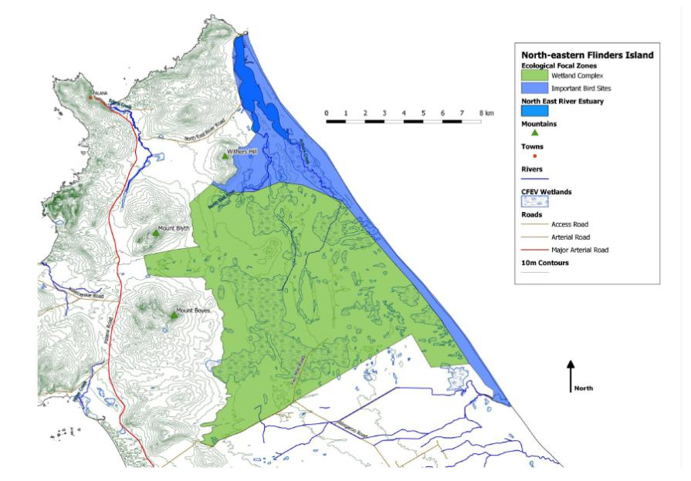

**Figure 15 Ecological Focal Zones for the Wetland Complex and for the combined beach and estuary Important Bird Sites. Base data by CFEV and the LIST, © State of Tasmania.**

**Geographic boundaries**

The greater catchment of North East River is bound to the west by the set of three small mountains: Withers Hill, Mount Blyth and Mount Boyes. Given that the wetlands don’t continue up the scrub-covered slope, gradient and vegetation effectively demarcate the western boundary of the Ecological Focal Zone for the wetland complex. While the slopes obviously provide a catchment from which surface and groundwater flows are derived, they are not necessarily linked in any other way. To this end, the 40 metre contour might serve as a fitting boundary as it marks the beginning of the steeper terrain with the only notable exception being the saddle between Mount Boyes and Mount Blyth. This area could be included despite its altitude as it shares the same lazy gradient and from the mapping and aerial photos contains a number of small wetlands. This boundary is determined by applying the precautionary principle, whereby it is expected that all relevant wetlands should be included within in this arbitrary 40 metre contour.

### Step 5 Identify/develop conceptual models

The values of ‘diversity’ and ‘vital habitat’ were contributed to the original HEVAE polygon by coastal and estuarine values, which, while they are ultimately linked through a shared catchment, do not fit easily within the conceptual models developed for the inland wetlands. Interestingly, the two areas described by the following conceptual models are unlikely to have been as well scored if they had originally been assessed individually. The inland wetland complex would have scored four (of six possible criteria), and the estuary/foreshore would have only scored two.

**Inland wetlands**

The field surveys and desk-based assessment revealed the north-eastern area of Flinders Island to contain a range of values that are associated with the extensive swathe of wetlands in the flatter areas of the catchment of the North East River. This flat area is covered with permeable Quaternary sands. Much of the overland flow is likely to end up as shallow groundwater, and this fact alone has quite a significant set of implications for the ecology of the area.

**Geomorphology**

The higher ground to the west of the catchment is dominated by granitic, impermeable geologies, and limestone. Surface and groundwater both drain to the east from here, the groundwater moving through surficial Quaternary sediments, but being partially restrained by the more consolidated, older Tertiary (or Neogene) layers beneath (Currie, Harrington & Pritchard 2008). This phenomenon manifests in accessible groundwater in the area and features in the groundwater maps produced by Mineral Resources Tasmania (2006). This mapping is limited so the groundwater resource is presumed to extend from the recharge zone on the eastern slopes of the island’s central range to the east coast. Much of the Quaternary surface deposits in this area are calcareous. This has a marked effect upon water chemistry, with percolated groundwater generally becoming more alkaline as it spends more time in contact with these sediments, and also increasing slightly in electrical conductivity (I Houshold 2011, pers. comm., 25 November). Before either surface or groundwater flow reaches the east coast, it passes through a newer dune system. These Quaternary dunes form a longitudinal ridge proximal to the east coast and are the higher ground east of where Fergusons (HEVF12) and Hogans (HEVF13) lagoons are situated.

A broad literature on wetland classification exists, but the morphologies observed on Flinders Island seem best catered for by the systems of Gilvear et al. (1989). These hydrogeomorphic classifications concentrate on the importance of the source of the water in the wetland. In the north-eastern Flinders Island wetland complex, these differences in connectivity are reflected well in water chemistry and other aspects of the ecology, and so the following description includes physical, chemical, and biological aspects of the ecosystems, all of which separate strongly based on the origin of the wetland water (i.e. surface versus groundwater). The wetland types separate out broadly as a range of groundwater-dependent ecosystems with connected, perched, and intermediate forms.

It should be noted that the assumptions about geomorphology are based mainly upon water chemistry, but the variables recorded were those considered important based on previous work (Bowling & Tyler 1984) and do seem to correspond with the observed trends in biota.

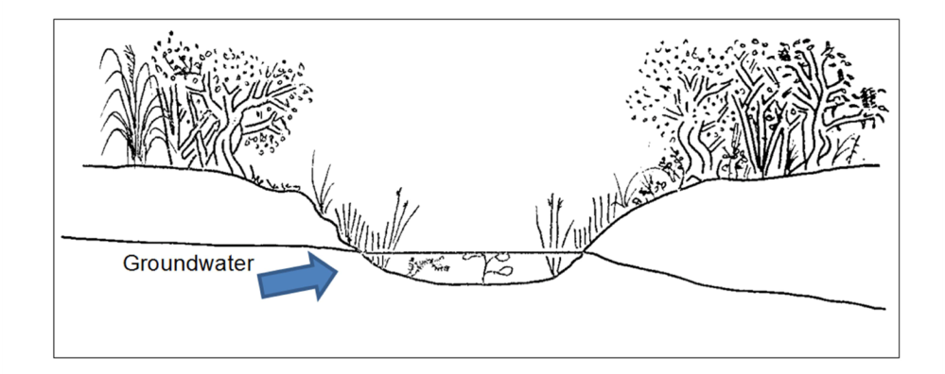

**Figure 16 A groundwater connected wetland. The upper catchment lies to the left, and drains away to the coast on the right.**

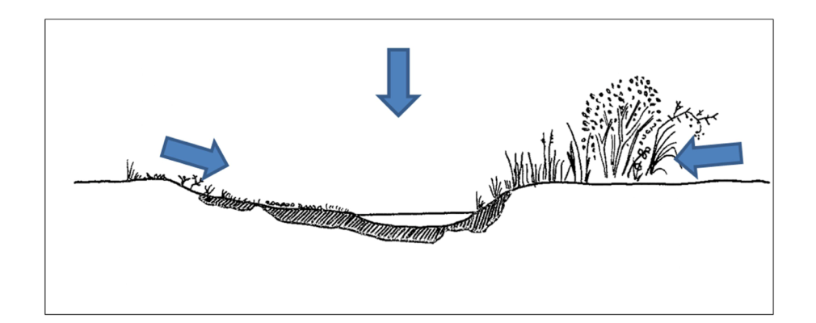

**Figure 17 A perched wetland, distinguished by the sealing layer of organics (hatched). Water can only reach the wetland from overland flow or precipitation.**

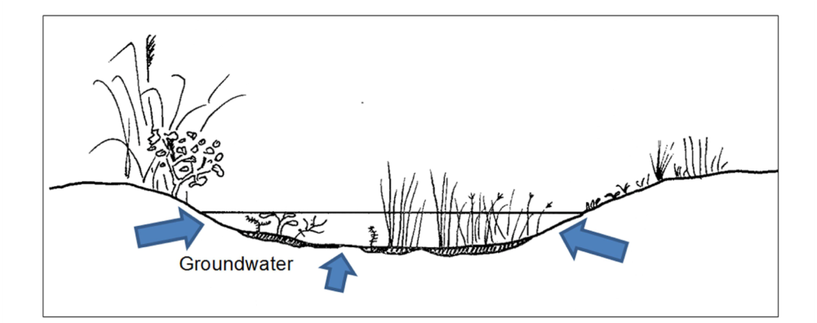

**Figure 18 A wetland with some organics in its bed, but still with connections to percolated local groundwater. Note this might not exist as a discrete water table.**

HEVF12 (Fergusons Lagoon) and HEVF13 (Hogans Lagoon) appear to be of the groundwater connected wetland type (see Figure 16), based on their slightly sunken position in the landscape, and their high alkalinities (greater than 50 milligrams per litre of calcium carbonate).

Characteristics of groundwater connected wetlands:

* high alkalinity, possibly high conductivity
* high pH
* benthic layer of mineral sands/shell.

In contrast, a number of the smaller wetlands (HEVF04, HEVF07, HEVF09, and possibly HEVF11) appear to have a perched morphology (see Figure 17).

Characteristics of perched wetlands:

* low alkalinity, low conductivity
* darker colour
* warmer temperature
* low pH
* benthic layer of deposited organics.

Commonly, wetlands are a mix of these two forms, with a partial organic layer, but also with some connectivity to the high EC, high-alkalinity waters (see Figure 18). This intermediate form seems to fit with HEVF08. HEVF11 could also possibly fit with this group as its organic layer has been damaged by fire, and it has a moderately high alkalinity suggesting that it has at least some groundwater connectivity.

Alternatively, they can be ephemeral wetlands that exist briefly in hollows around terrestrial or inundation-tolerant vegetation communities. This form fits well with observations of the shallow wetlands HEVF01, HEVF02 and HEVF03. Of all the wetlands, these are likely to be the most ephemeral due to their depth, and the persistence of an over storey of either amphibious or terrestrial vegetation.

Overall, the conceptual model describes the flow of groundwater from west to east through a belt of small wetlands which interact with it to differing extents. Surface flows also play an important part in the conceptual model, as they provide linkages during wetter times of the year and this is important for dispersal of many of the values contained within the wetlands. A good example of this would be the dwarf galaxias, which seems to disperse readily through ephemeral and shallow wetlands.

**Estuary/foreshore**

The Important Bird Sites described in the desktop assessment are restricted to the foredunes and their eastern sides. However, the birds listed include a number of mobile species such as terns that are likely to feed in the North East River Estuary at times. It is likely that the provision of food for these species relies to at least some extent upon river flows from the North East River and Arthurs Creek. To this end it is worth including the associated saltmarshes, mudflats and shallow water as potential feeding grounds that service the species for which the Important Bird Sites are identified.

The two conceptual models described above are best served with two separate polygons as described in the Delineation section.

### Step 6 Identify threats

In the north-east of Flinders Island, the existence of a mix of crown land, Wingaroo Nature Reserve, Foochow Conservation Area and the North East River Game Reserve has minimised the draining of the wetlands in the area. The draining of wetlands is ubiquitous in temperate eastern Australia, making wetland complexes of this size quite rare.   
It is likely that the wetland complex in north-eastern Flinders Island would have originally extended further south down the island, but it has now been replaced for the most part with a series of drains (Figure 19).

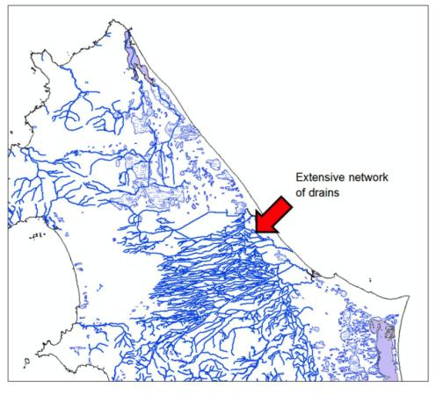

**Figure 19 A visual comparison of drainage line patterns in north-eastern Flinders Island, and areas further south where wetlands have been historically drained. Base data by CFEV and the LIST, © State of Tasmania.**

Another threat particular to wetlands in the area is fire. This is particularly true of perched wetlands, which alter drastically once fire has removed the lining organic layer (Corbett K. 2010, Corbett S. 2010). As most of these wetlands are ephemeral, they are susceptible to burning during the end of summer when many of them have dried out. While periodic burning is tolerated by some vegetation types such as the adjacent Banksia dry scrubland (SDU in TASVEG), fires and particularly frequent or intense burns can be detrimental to communities associated with deeper organic layers (such as Melaleuca ericifolia swamp forest—TASVEG code NME).

Damage from the 2007 fire was evident throughout the southern part of the catchment, and along much of the road to Palana suggesting that possibly up to two-thirds of the area being considered as an HEVAE was burnt. In HEVF11, one of the original sites where ancient greenling damselfly and dwarf galaxias were both recorded in the past, there were a number of organic pedestals that may give some indication of the depth of the organic layer that lined the wetland before the fire.

Whilst this delineation and description of the north-east Flinders Island is relevant for this assessment, there is potential for both processes to be altered should further disturbance occur in the future.

**Zone of Influence**

While it is beyond the scope of the Aquatic Ecosystem Delineation and Description Guidelines to identify the Zone of Influence (ZOI), a possible ZOI for the wetland complex on Flinders Island was established in this trial.

One of the defining characteristics of the water chemistry in the wetlands of north-eastern Flinders Island is the alkalinity it derives from contact with calcareous sands from the porous Quaternary layer, but also (possibly) from contact with limestone outcrops in the upper catchment. Much of the upper catchment is within the Wingaroo Nature Reserve (see Figure 10). The greater catchment would therefore make a suitable Zone of Influence for the wetland complex (Figure 20).

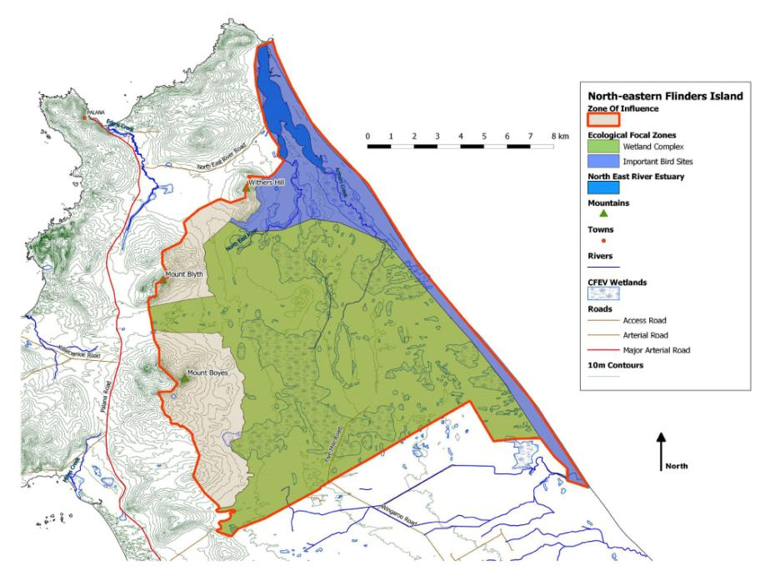

**Figure 20 Possible Zone of Influence for the wetland complex. This is basically the greater catchment polygon extended south until it reaches Foochow Inlet or private lands. Base data by CFEV and the LIST, © State of Tasmania.**

**Output—Asset Delineation Record Sheet**

|  |  |
| --- | --- |
| Aquatic Ecosystem Delineation and Description Record Sheet | |
| **Name of aquatic ecosystem** | North-eastern Flinders Island |
| **Date of delineation** | November 2011 |
| **Purpose for delineation** | Trialling of the HEVAE delineation tools. |
| **Scale** | Most mapped inputs to the process are 1:25 000. |
| **Experts involved** | Graham Edgar, marine ecologist, Sandy Bay Campus, Marine Research Laboratories, Taroona  John Gooderham, freshwater ecologist, The Waterbug Company  Janet Smith, botanist, DPIPWE  Eric Woehler, bird specialist, Birds Tasmania |
| **Datasets used** | Natural Values Atlas © State of Tasmania  • Data current, and maintained. The data used in this report was accessed in  November 2011.  TASVEG v2.0 © State of Tasmania  • This data has a number of undifferentiated categories within the saltmarsh and wetland group of vegetation.  CFEV © State of Tasmania  • Data is from an assessment of the Conservation Freshwater Ecosystem Values conducted in 2004. Associated data on the distribution of values, and their condition is generally more than 8 years out of date, so this data needs to be confirmed against current sources such as the NVA (above).  Field surveys (freshwater invertebrates, flora)  • Conducted in November 2011, this includes information on freshwater invertebrates, a floral survey, and some fish observations.  LIST geology and Topography 1:2500 © State of Tasmania  • Used to derive various boundaries, and locate features in the report. |
| **Gaps/limitations** | The central and northern parts of this HEVAE are not easily accessed. It is recommended that future work establish how widespread the observed values are with further field surveys. |
| **Ecosystem description** | The greater catchment of the North East River and Arthurs Creek containing both an inland wetland complex and coastal and estuarine areas which together form an Important Bird Site. |
| **Ecosystem types** | The HEVAE includes saltmarshes, lacustrine and palustrine wetlands, estuaries, rivers and shallow coastal waters.  Classification used for the conceptual model is the hydrogeomorphic classes of Gilvear et al. (1989). See attached report for reference.  Classification system used for ‘representativeness’ borrowed directly from the CFEV project. See attached report for reference. |
| **Land use** | Reserve, Private property (cattle grazing) |
| **Land tenure** | Three reserves: Wingaroo Nature Reserve, North East River Game Reserve, and Foochow Conservation Area interspersed by private properties. |
| **HEVAE  criteria met** | Criteria 1 Diversity  Criteria 2 Distinctiveness  Criteria 3 Vital Habitat  Criteria 4 Naturalness  Criteria 5 Representativeness |
| **Summary  of values** | Criteria related:  **Distinctiveness Threatened fauna species**  • Hemiphlebia mirabilis (unconfirmed)  • Galaxiella pusilla (confirmed)  **Threatened flora species**  • Utricularia australis yellow bladderwort (confirmed)  • Stylidium despectum (confirmed)  • Isopogon ceratophyllus (confirmed)  **Threatened vegetation communities** (confirmed)  • see Appendix F of attached report  **Threatened species** (from NVA—unconfirmed)  • see Appendix E of attached report  **Naturalness** High (from CFEV data)  **Representativeness** as per CFEV program outputs  **Vital Habitat** Important Bird Sites: Foochow Inlet, North East River Estuary and beach/foredunes between.  Identified by experts: diversity of wetland types in a constrained area based on Invertebrate assemblage, floral communities and geomorphology. |
| **Description/ justification** | The EFZ for this HEVAE was delineated using the extent of the wetlands in question (as mapped), or the extent of the Important Bird Sites and related foraging areas (from Woehler 2008), see reference lists in the attached report. The data sets used and experts consulted are listed above, including information on data quality and confidence. |
| **Presence  in other listing** | EPBC threatened species  Other: Threatened Vegetation Communities, Tasmanian Threatened Species Protection Act. |
| **References** | Conceptual models and references are all contained in attached document.  Gooderham, J. (2012). Tasmanian HEVAE delineation and description trial: North-eastern Flinders Island. Report prepared for the Department of Primary Industries, Parks, Water and Environment, the Aquatic Ecosystems Task Group and the Department of Sustainability, Environment, Water, Population and Communities. The Waterbug Company, Hobart. |

# References

AETG (2009). Draft guidelines for applying the criteria for the HCVAE assessment process.   
Aquatic Ecosystems Task Group and the Department of Environment, Water, Heritage   
and the Arts, Canberra.

Bryant, S.L., and Jackson, J. (1999). Tasmania’s Threatened Fauna Handbook: What, where and how to protect Tasmania’s threatened animals. Threatened Species Unit, Parks and Wildlife Service, Hobart.

Bowling, L.C., and Tyler, P.A. (1984). Physicochemical differences between lagoons of King and Flinders Island, Bass Strait. Australian Journal of Marine and Freshwater Research,   
35: 655–662.

Buchanan, A. (2008). Census of the Vascular Plants of Tasmania: web edition for 2008. Tasmanian Herbarium, Tasmanian Museum and Art Gallery, Hobart.

Clarke, K.R., and Warwick, R.M. (2001). Change in marine communities: an approach to statistical analysis and interpretation. Primer-E Ltd, Plymouth.

Corbett, K. (2010). Lavinia State Reserve, King Island: Post-fire geomorphology and vegetation assessment. Report 1, Assessment of peat deposits, fire damage and drainage features. Report for Cradle Coast NRM, Burnie.

Corbett, S. (2010). Lavinia State Reserve, King Island: Post-fire geomorphology and vegetation assessment. Report 2, vegetation. Report for Cradle Coast NRM, Burnie.

Currie, D., Harrington, G., and Pritchard, J. (2008). Development of Models for Tasmanian Groundwater Resources: Conceptual Model Report for Flinders Island. Prepared by Resource & Environmental Management Pty Ltd and Aquaterra for The Department of Primary Industries and Water, Hobart.

Davis, J.D., Horwitz, P., Norris, R., Chessman, B., McGuire, M., Sommer, B., and Trayler, K. (1999). Wetland Bioassessment Manual (Macroinvertebrates). National Wetlands Research and Development Program. Environment Australia, Canberra.

DPIPWE (2011a). A draft method for identifying High Ecological Value Aquatic Ecosystems for Tasmania using CFEV data. Report to the Department of Sustainability, Environment, Water, Population and Communities.

DPIPWE (2011b). The Natural Values Atlas. (Access through managed accounts and a data license agreement.) Department of Primary Industries, Parks, Water and Environment. [Verified June 2012] <[http://www.naturalvaluesatlas.tas.gov.au/](http://www.dpiw.tas.gov.au/inter.nsf/WebPages/RLIG-5433LB?open)>

DPIW (2006). Threatened species status—what these terms mean. Department of Primary Industries and Water, Hobart. [Verified June 2012]  
<<http://www.dpiw.tas.gov.au/inter.nsf/WebPages/RLIG-5433LB?open>>

DPIW (2007). List of Threatened Native Vegetation Communities. Department of Primary Industries   
and Water, Hobart. [Verified June 2012]  
<<http://www.dpiw.tas.gov.au/inter.nsf/webpages/awah-6547zl?open>>

DPIW (2008a). Conservation of Freshwater Ecosystem Values (CFEV) Project Technical Report. Conservation of Freshwater Ecosystem Values Program, Department of Primary Industries and Water, Hobart.

DPIW (2008b). Conservation of Freshwater Ecosystem Values (CFEV) Project Technical Report: Appendices. Conservation of Freshwater Ecosystem Values Project. Department of Primary Industries and Water, Hobart.

DPIW (2009). TASVEG Version 2.0 Metadata, Tasmanian Vegetation Monitoring and Mapping Program. Department of Primary Industries and Water, Hobart. [Verified June 2012]   
<<http://www.thelist.tas.gov.au/>>

DSE (2003). Flora and Fauna Guarantee Action Statement #46: Hemiphlebia Damselfly (Hemiphlebia mirabilis). Department of Sustainability and Environment, East Melbourne.

Edgar, G.J., and Barrett, N.S., and Graddon, D.J. (1999). A Classification of Tasmanian estuaries and assessment of their conservation significance using ecological and physical attributes, population and land use. Technical Report. Marine Research Laboratories, TAFI, Hobart. [Verified June 2012] <<http://eprints.utas.edu.au/1718/>>

Gilvear, D.J., Tellam, J. H., Lloyd, J.W., and Lerner, D.N. (1989). ‘The hydrodynamics of East Anglian fen systems’. M.M. Brinson (ed) A Hydrogeomorphic Classification for Wetlands (1993). Technical Report WRP-DE-4, prepared for U.S. Army Corps of Engineers. [Verified June 2012] <[http://el.erdc.usace.army.mil/wetlands/pdfs/wrpde4.pdf](http://www.dpiw.tas.gov.au/inter.nsf/webpages/awah-6547zl?open)>

Kirkpatrick, J.B., and Harwood, C.E. (1983a). Plant Communities of Tasmanian Wetlands. Australian Journal of Botany, 31: 437–451.

Kirkpatrick, J.B., and Harwood, C.E. (1983b). Conservation of Tasmanian macrophytic wetland vegetation. Papers and Proceedings of the Royal Society of Tasmania, 117: 5–20.

Kirkpatrick, J.B., and Tyler, P.A. (1988). ‘Tasmanian Wetlands and their Conservation’. A.J. McComb and P.S. Lake (eds) The Conservation of Australian Wetlands. Surrey Beatty and Sons and the World Wildlife Fund, Baulkham Hills.

Mineral Resources Tasmania (2006). Northeast Tasmania Groundwater Map. Department of Primary Industries, Parks, Water and Environment (Tasmania). [Verified June 2012] <<http://www.dpiw.tas.gov.au/inter.nsf/Attachments/JMUY-8LAV68/$FILE/NE%20groundwater%20map.pdf>>

Murray, E., Radke, L., Creasey, J., Dyall, A., Heap, A., Brooke, B., Beard, D., and Ryan , D. (2005). ‘Pristine Estuaries: Providing Basic Biophysical Information for Future Management’. Geoscience Australia. [Verified June 2012] <<http://www.agso.gov.au/pdf/GA6426.pdf>>

New, T.R. (2007). The Hemiphlebia damselfly Hemiphlebia mirabilis Sélys (Odonata, Zygoptera) as a flagship species for aquatic insect conservation in south-eastern Australia. The Victorian Naturalist, 124: 269–272.

Primer-E Ltd. (2009). PRIMER V6. Primer-E Ltd, Plymouth.

Richardson, A.M.M., Swain, R., and Wong, V. (1998). Relationship between the crustacean and molluscan assemblages of Tasmanian saltmarshes and the vegetation and soil conditions. Marine and Freshwater Research, 49: 785–799.

Scientific Advisory Committee (2001). Guidelines for the Listing of Species under the Tasmanian Threatened Species Protection Act 1995. Department of Primary Industries, Water and Environment, Hobart.

Tillyard, R.J. (1928). The larva of Hemiphlebia mirabilis Selys (Odonata). The Proceedings of the Linnean Society of New South Wales, 53: 192–206.

Trueman, J.W.H., Hoye, G.A., Hawking, J.H., Watson, J.A.L., and New, T.R. (1992). Hemiphlebia mirabilis Selys: New localities in Australia and perspectives on conservation (Zygoptera: Hemiphlebiidae). Odonatologica, 21: 367–374.

Woehler, E. (2008). Report on Coastal Shorebird and Tern Survey, Flinders Island, 3–9 November 2008. Birds Tasmania report to Parks & Wildlife Service, Hobart.

Woehler, E., and Park, P. (2006). Inventory of nationally important shorebird sites in Tasmania. Birds Tasmania report to Birds Australia and the Department of Environment and Heritage.

## Legislation

Commonwealth of Australia (2007). Environment Protection and Biodiversity Conservation Act 1999. Department of Environment and Heritage. [Verified June 2012] <<http://www.comlaw.gov.au/Details/C2012C00248>>