NOVEMBER 2017

Integrated Ecosystem Condition Assessment Framework: Guidance Manual

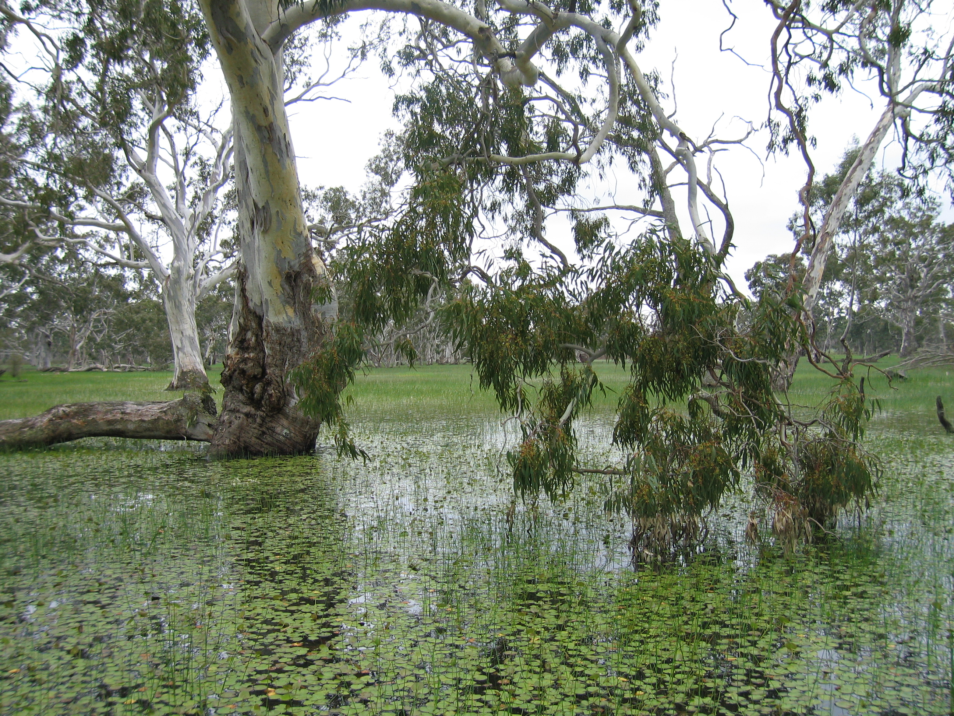
Published by
Department of the Environment and Energy
Authors/endorsement
Endorsed in consultation with Wetlands and Aquatic Ecosystems Sub Committee (WAESC).
© Commonwealth of Australia 2017
This work is copyright. You may download, display, print and reproduce this material in unaltered form only (retaining this notice) for your personal, non-commercial use or use within your organisation. Apart from any use as permitted under the Copyright Act 1968 (Cwlth), all other rights are reserved. Requests and enquiries concerning reproduction and rights should be addressed to Department of the Environment and Energy, GPO Box 787 Canberra ACT 2601 or email public.affairs@environment.gov.au.
Disclaimer
The views and opinions expressed in this publication are those of the authors and do not necessarily reflect those of the Australian Government or the Minister for the Environment and Energy.
While reasonable efforts have been made to ensure that the contents of this publication are factually correct, the Commonwealth does not accept responsibility for the accuracy or completeness of the contents, and shall not be liable for any loss or damage that may be occasioned directly or indirectly through the use of, or reliance on, the contents of this publication.
Citation
The Aquatic Ecosystems Toolkit is a series of documents to guide classifying and assessing the condition of aquatic ecosystems, and provide guidance on how to identify high ecological value aquatic ecosystems. The Modules in the series are:
Module 1: Aquatic Ecosystems Toolkit Guidance Paper
Module 2: Interim Australian National Aquatic Ecosystem (ANAE) Classification Framework
Module 3: Guidelines for Identifying High Ecological Value Aquatic Ecosystems (HEVAE)
Module 4: Aquatic Ecosystem Delineation and Description Guidelines
Module 5: Integrated Ecosystem Condition Assessment (IECA) Framework
This document is Module 5 and should be cited as:
Department of the Environment and Energy (2017). Aquatic Ecosystems Toolkit. Module 5: Integrated Ecosystem Condition Assessment. Australian Government Department of the Environment and Energy, Canberra.
The publication can be accessed at https://www.environment.gov.au/water/cewo/monitoring/aquatic-ecosystems-toolkit .
Acknowledgements:
The preparation of this manual has been guided by the knowledge and experience of the Wetlands and Aquatic Ecosystem Sub Committee (WAESC) and before the establishment of WAESC, the Aquatic Ecosystems Task Group. It also builds on an initial draft manual developed by the Murray Darling Freshwater Research Centre under the leadership of Dr Ben Gawne. These inputs have been crucial to the scope and detail of the manual. This manual was completed by Water’s Edge Consulting.
In addition, the following people participated in technical steering committee meetings and stakeholder meetings and their time and contributions are very gratefully acknowledged.
Aaron Schonberg (WA Fisheries)
Adam Watt (SA DEWNR)
Adrian Pinder (WA DPaW)
Allan Raine (NSW DPI)
Andrew Lowes (CEWO)
Anthony Moore (CEWO)
Anthony Swirepik (OWS)
Bonnie Learmonth (CEWO)
Chris Pulkkinen (MDBA)
David Baxter (NSW OEH)
Frances D’Souza (WA DoW)
Frederick Bouckaert (MDBA)
Gayle Partridge (CEWO)
Glen Scholz (SA DEWNR)
Greg Green (QLD DEHP)
Jason Higham (SA DEWNR)
Joanne Blessing (QLD DSITI)
Karen Stuart-Williams (CEWO)
Kate Ryan (MDBA)
Kim Wilson (PHCC)
Linda Reid (CEWO)
Lisa Evans (ACT EPSDD)
Lisa Thurtell (NSW OEH)
Mark Kelton (QLD DEHP)
Michael Coote (WA DPaW)
Michelle Bald (SA DEWNR)
Mike Hammond (WA DoW)
Mike Ronan (QLD DEHP)
Moya Tomlinson (OWS)
Nadia Kingham (CEWO)
Paul Marsh (CEWO)
Paul Reich (VIC DELWP)
Paul Wilson (VIC DELWP)
Rebecca Quinn (SA DEWNR)
Rob Donohue (WA DoW)
Romeny Lynch (WA DoW)
Shaun Meredith (WA DOF)
Sonia Colville (DAWR)
Tamarind Mera (PIRSA)
Tim Storer (WA DoW)

The Finalisation of the Integrated Ecosystems Condition Assessment Framework and Manual was supported through funding from the Australian Government's Water Resources Assessment and Research Grants Program.

Photo credit:
Freshwater meadow, West Wimmera, R. Butcher

Contents
Abbreviations 6
1 Introduction 8
1.1 The Australian Aquatic Ecosystems Toolkit 8
1.2 Target audience 9
1.3 Definitions 9
1.4 Overview of the IECA Framework 10
1.5 How to use this manual 14
2 Part A: Context and Current understanding 16
2.1 Framing the question 16
2.1.1 Clarify objectives 16
2.1.2 Identify Triggers, Targets and Thresholds 17
2.1.3 Stakeholder engagement 18
2.1.4 Establish the spatial boundaries of the assessment unit 19
2.2 Purpose of IECA 20
2.3 Groundwork 21
2.3.1 Accessing expertise: Establish a TAG or other appropriate oversight body (optional) 21
2.3.2 Collating existing information 21
2.3.3 Define the scale of assessment 21
2.3.4 Identify existing conceptual models 23
2.3.5 Identify externalities likely to affect the assessment 24
2.4 Part A: Outputs 25
3 Part B: Workflow 26
3.1 Step 1: Identify and prioritise values 26
3.2 Step 2: Identify and prioritise threats 33
3.3 Step 3: Develop Key Evaluation Questions (KEQs) 40
3.4 Step 4: Identify and prioritise indicators 44
3.5 Step 5: Design assessment and implementation 48
3.6 Step 6: Analyse and Aggregate 52
3.7 Step 7: Harmonise and Integrate 59
3.8 Step 8: Develop Report Card 68
4 References cited 72
5 Glossary 76
Appendix A: Comparison of existing Australian condition assessment methods with the IECA Framework 81
Appendix B: Peel-Yalgorup Case Study 86
Introduction 86
Part A: Context and Current Understanding 86
Defining the management context 86
Framing the question and purpose 86
Stakeholder engagement 86
Identify Triggers, targets and Thresholds 87
Establish the spatial boundaries of the assessment unit 88
Purpose 90
Groundwork 90
Accessing expertise: Establish a TAG or other appropriate oversight body (optional) 90
Collating existing information 91
Define the spatial and temporal scale of the assessment 91
Identify existing conceptual models 92
Identify externalities likely to affect the assessment 93
Assumptions 93
Part A: Outputs 93
Part B: Workflow 94
Step 1: Identify and prioritise values 94
Step 2: Identify and prioritise threats 96
Step 3: Develop Key Evaluation Questions (KEQs) 98
Step 4: Identify and prioritise indicators 100
Step 5: Design assessment and implementation 101
Step 6: Analyse and Aggregate 102
Step 7: Harmonise and Integrate 105
Step 8: Report Card 108
References cited 108
Appendix C: CICES – a standard approach to classifying services 110
Appendix D: Example set of Components, Processes, Functions and Services 111
Appendix E: IUCN-CMP Threat Classification V2.0 113
Appendix F: Potential indicators 114
Appendix G: Advantages and disadvantages of different taxa as indicators for assessing condition 117

Abbreviations
ANAE | (Interim) Australian National Aquatic Ecosystems (Classification Framework)
AquaBAMM | Aquatic Biodiversity Assessment Mapping Methodology
CEWO | Commonwealth Environmental Water Office
CPS | Components, processes and ecosystem services
DEHP | Department of Environment and Heritage Protection, Queensland
DELWP | Department of Environment, Land, Water and Planning
DEWNR | Department of Environment, Water and Natural Resources, South Australia
DoEE | Department of the Environment and Energy, Commonwealth
DOF | Department of Fisheries, Western Australia
DoW | Department of Water, Western Australia
DPI | Department of Primary Industry, New South Wales
DPSIR | Driver-Pressure-State-Impact-Response
DSEWPaC | Department of Sustainability, Environment, Water, Population and Communities (now DoEE)
DSITI | Department of Science, Information Technology and Innovation, Queensland
EPBC | Environment Protection and Biodiversity Conservation Act 1999
EPSDD | Environment, Planning and Sustainable Development Directorate, Australian Capital Territory
FARWH | Framework for the Assessment of River and Wetland Health
HEVAE | High Ecological Value Aquatic Ecosystems
IECA | Integrated Ecosystem Condition Assessment
IMCRA | Integrated Marine and Coastal Regionalisation of Australia
MCA | Multi-Criteria Analysis
NRM | Natural Resource Management
NWI | National Water Initiative
OEH | Office of Environment and Heritage, New South Wales
OWS | Office of Water Science, Commonwealth
SRA | Sustainable Rivers Audit
TAG | Technical Advisory Group
WAESC | Wetlands and Aquatic Ecosystem Sub Committee

Introduction

The Australian Aquatic Ecosystems Toolkit
The Aquatic Ecosystems Toolkit was developed in response to requirements of the National Water Initiative (NWI). The Toolkit contains practical tools and guidance for identifying high ecological value aquatic ecosystems (HEVAE), and classifying, delineating, describing and determining the condition of aquatic ecosystems in a nationally consistent manner. The Toolkit is presented in five Modules that are based on or compatible with, existing jurisdictional tools and approaches to identifying, classifying and assessing the condition of aquatic ecosystems. These include:
Module 1 Aquatic Ecosystems Toolkit Guidance Paper: Information on the Toolkit including the drivers, its potential use, and history of the Toolkit development (AETG 2012a).
Module 2 Interim Australian National Aquatic Ecosystem (ANAE) Classification Framework: broad-scale, semi-hierarchical, attribute-based scheme, which provides a nationally consistent, flexible framework for classifying different aquatic ecosystems and habitats including rivers, floodplains, lakes, palustrine wetlands, estuaries and subterranean ecosystems (AETG 2012b).
Module 3 Guidelines for Identifying High Ecological Value Aquatic Ecosystems (HEVAE): guidance to identify HEVAE across a range of scales and ecosystem types including descriptions of the five HEVAE criteria and guidance on applying those criteria to identify ecosystems of high ecological value (AETG 2012c).
Module 4 Aquatic Ecosystem Delineation and Description Guidelines: steps to guide users through the process of delineating and describing aquatic ecosystems which have been identified as having high ecological values (AETG 2012d).
This document is Module 5, the Integrated Ecosystem Condition Assessment (IECA) Framework. It provides a flexible method for undertaking an integrated ecosystem condition assessment for aquatic ecosystems. The relationship between this module and the others in the Toolkit, and the potential use of the IECA Framework as part of an adaptive management process is illustrated in Figure 1.
The IECA Framework development has been guided and overseen by the IECA Technical Steering Committee (IECA TSC), under the multi-jurisdictional Wetlands and Aquatic Ecosystems Sub Committee (WAESC) and the former Aquatic Ecosystems Task Group (AETG). The WAESC reports to the National Water Reform Committee. The IECA Framework is intended to be of use to Commonwealth, state and regional agencies tasked with assessing and reporting on the condition of aquatic ecosystems, or setting standards/guidelines for such assessments, and contribute to the assessment of management intervention outcomes.

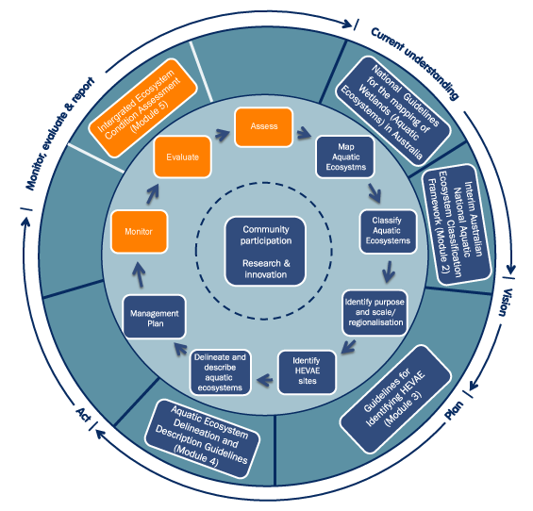
Figure 1: Potential process for implementing the Aquatic Ecosystems Toolkit within an adaptive management framework (outer and inner circles), highlighting Module 5.

Target audience
A target audience for the document is catchment management authorities and natural resource management agencies operating at a regional level, which are most responsible for designing and implementing monitoring and condition assessments. The IECA Framework is also of use for Commonwealth, state and territory government agencies, who set standards for monitoring, evaluation and reporting of aquatic ecosystems.
The IECA Framework is flexible and can be applied beyond condition reporting, for example as part of Environmental Impact Assessments and other planning processes.

Definitions
A common language relevant to the identification, assessment and management of aquatic ecosystems has been developed and utilised in the Aquatic Ecosystem Toolkit (AETG 2012a). While a glossary of terms is provided in Chapter 5, some of the terms of most relevance to the IECA Framework and that will assist readers as they progress through this manual include:
Aggregation – the process of combining scores from the same index, sub-index, or indicator in different locations to provide a single score at a larger spatial scale (modified from Alluvium 2011).
Aquatic ecosystem – ecosystems dependent on flows, or periodic or sustained inundation/waterlogging for their ecological integrity (e.g. wetlands, rivers, karst and other groundwater-dependent ecosystems, saltmarshes, estuaries and areas of marine water the depth of which at low tide does not exceed six metres).
Ecological value – the perceived importance of an ecosystem, which is underpinned by the biotic and/or abiotic components, processes, functions and services that characterise that ecosystem.
Ecosystem services – the contributions that ecosystems make to human well-being.
Assessment unit – the part of an aquatic ecosystem, entire aquatic ecosystem, group of ecosystems, sub-catchment, catchment/valley, region, or basin that is being assessed.
Baseline condition – a quantitative level or value, at a stated point of time that must be defined by the user (e.g. current condition, Ramsar “at the time of listing”, pre-European, a predetermined time), to which other data and observations of a comparable nature are compared.
Condition assessment – a means to assess the state of an ecosystem, generally using several ecological measures/indicators, often used to assess long-term changes resulting from widespread anthropogenic activity.
Threat(s) – a generic term that includes the combination of a pressure and all its associated stressors.
Integrated ecosystem assessment – a formal synthesis and quantitative analysis of information on relevant natural and socioeconomic factors, in relation to specified ecosystem management objectives (Levin et al. 2014).
Integration – the process of combining scores from several indices, sub-indices or indicators to provide a single score at the same spatial scale (Alluvium 2011).
Surveillance monitoring – a program to monitor trends in ecological condition, often over large spatial scales (e.g. regions/catchments) and over long time periods (years to decades), generally without detailed assessments of management interventions.
Intervention monitoring – a program to monitor one or more indicators of interest in response to one or more specific interventions, usually for a single asset/ecosystem. It aims to report on the influence of an intervention, and often operates under an experimental framework that focusses on the response to the intervention, which may or may not be accompanied by reporting on condition.

Overview of the IECA Framework
The IECA Framework can be used to:
- Assess and report on status and trends in condition and threats, relating to predetermined baseline or reference point for priority ecological values of aquatic ecosystems (condition assessment, surveillance monitoring); and
- Assess and report on effectiveness of management activities on condition and threats affecting aquatic ecosystems (intervention monitoring).
It is important to note that the IECA Framework primarily focuses on condition assessment and surveillance monitoring of aquatic ecosystems. Condition assessment and surveillance monitoring can be undertaken for a variety of purposes, but only become useful if they accurately reflect ecological condition and support or inform management needs (Kuehne et al. 2017). This should not be confused with intervention monitoring (see above), although assessment of aquatic ecosystem condition can be useful as part of a program that assesses management interventions (see Section 2.2).
The IECA Framework can be applied to all inland and estuarine aquatic ecosystem types and can operate at multiple spatial scales (e.g. individual wetland or an entire catchment). Central to the IECA Framework (as with all modules in the Toolkit) is the principle of building on existing methods and programs, particularly those developed and adopted by Australian jurisdictions. For new condition assessments or surveillance monitoring programs the IECA Framework provides a consistent logic and approach able to be adapted to many situations, particularly in cross boundary or jurisdictional assessments/programs.
The nested or hierarchical nature of the IECA Framework is a key feature. When undertaking integrative ecosystem level condition assessments, it is critical to include both biotic and abiotic elements of the ecosystem and, where appropriate to the purpose of the assessment, a range of ecosystem services and benefits. Ideally data should be included in the assessment from different organisational levels (e.g., species, communities, biotopes) even though the assessments of the different levels may serve different purposes (Borja et al. 2016).
The IECA Framework is comprised of an eight-step process, which is preceded by a planning phase which establishes the context and current understanding regarding the assessment unit (Figure 2). Many of the preliminary steps are common to all modules in the Toolkit; these modules should be consulted for relevant details. At every stage, assumptions and knowledge gaps should be documented to ensure transparency.
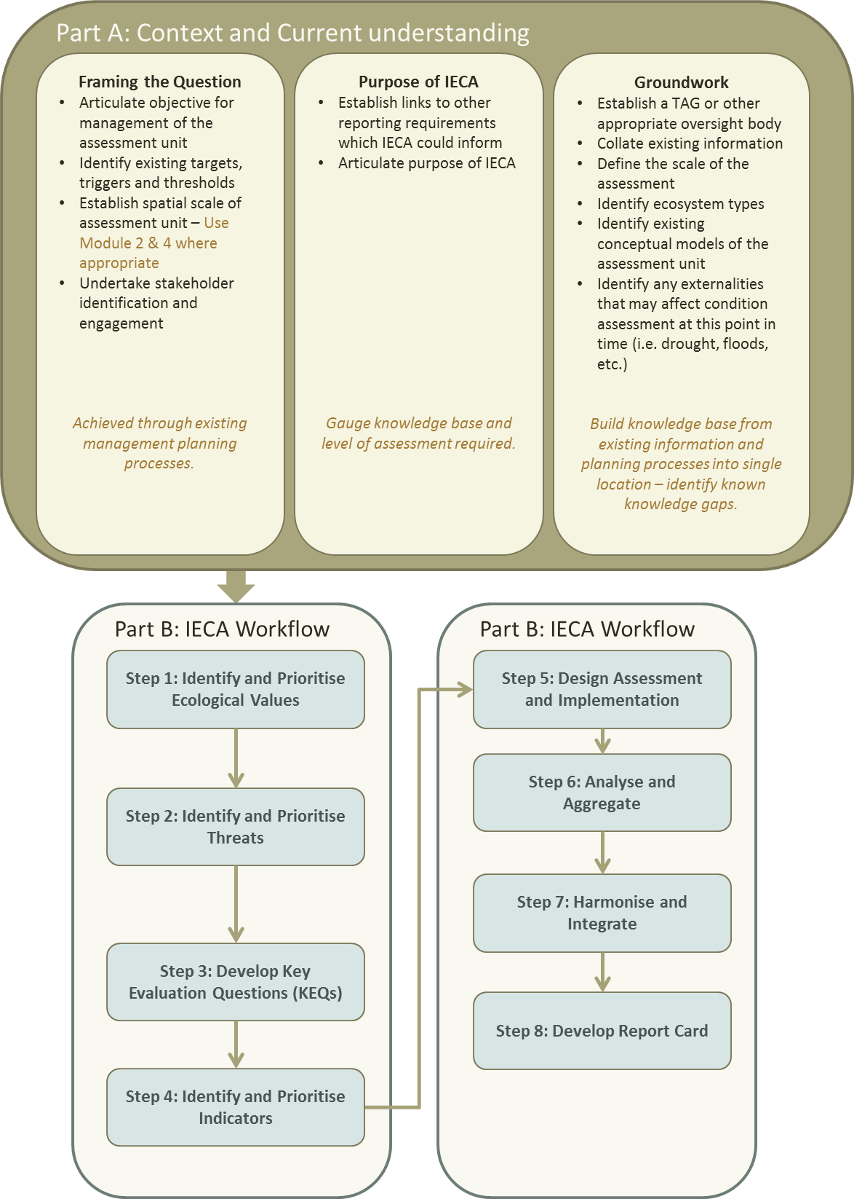
Figure 2: IECA Framework.
One of the aims of the IECA Framework is to assist multi-jurisdictional collaboration, by providing a consistent means by which to define, assess and report on the condition of aquatic ecosystems at varying scales (i.e. from regional to multi-jurisdictional and national scales). A benefit of this approach is that it can allow jurisdictions to assess and manage aquatic ecosystems that exist across state boundaries from a common understanding and in a coordinated manner.
One mechanism for facilitating consistent assessment and reporting is the adoption of a common set of themes that summarise the nature of aquatic ecosystems, along with associated indicators. The IECA Framework has six themes (hydrology, water quality, structural integrity, aquatic ecosystem connectivity, biodiversity and ecosystem services), each with associated indicator groups (Table 1). Including several of the indicator groups in an assessment is recommended, with some being highly desirable and others optional (Table 1). Having consistent themes assessed is particularly important when assessment units span several jurisdictions or comparisons across jurisdictions is an intended outcome. The structure of the IECA Framework is flexible and will allow it to be tailored to the needs of different programs (see Section 3.4 for further information on themes and indicators).

Table 1: IECA Framework Themes and Indicator groups.
Theme | Indicator group | Include in assessment | Brief description
Hydrology | Surface water | Desirable | The hydrological regime of the ecosystem(s) in the assessment unit. The timing, movement and distribution of water through the assessment unit.
Hydrology | Groundwater | Optional
Water quality | Physical | Desirable | Physico-chemical characteristics of water within each ecosystem type within the assessment unit.
Water quality | Chemical | Desirable
Structural integrity | Physical form | Optional | The state of local habitat and its likely ability to support aquatic life.
Structural integrity | Ecosystem extent | Desirable | Spatial extent of the ecosystem(s) within each assessment unit.
Structural integrity | Fringing zone | Desirable | Structural and condition features of the streamside zone, or the zone surrounding the assessment unit, or ecosystem type.
Structural integrity | Soil quality | Optional | Physico-chemical characteristics of soils within each ecosystem type within the assessment unit.
Aquatic ecosystem connectivity | Ecological connectivity | Desirable | Structural or functional connectivity that allow materials or organisms to move between or influence habitats, populations or assemblages that are intermittently isolated in space or time (Kindlmann and Burel 2008, Sheaves 2009).
Aquatic ecosystem connectivity | Hydrological connectivity | Desirable | Water-mediated transfer of matter, energy, and/or organisms within or between elements of the hydrologic cycle (Pringle 2003).
Biodiversity | Aquatic biota | Desirable | Species richness, abundance, composition, critical life stages of aquatic biota.
Biodiversity | Ecosystem diversity | Optional | Diversity of the ecosystems within each assessment unit.
Ecosystem Services | Regulating | Optional | Contributions that ecosystems make to human well-being. They are seen as arising from the interaction of biotic and abiotic processes, and refer specifically to the ‘final’ outputs or products from ecological systems. That is, the things directly consumed or used by people (Haines-Young and Potschin 2011).
Ecosystem Services | Provisioning | Optional
Ecosystem Services | Cultural | Optional

How to use this manual
This manual is structured in two parts (Figure 2), designed to be flexible in order to take advantage of existing methods and information relevant to the aquatic ecosystems being considered. The intent is that users can use the IECA Framework at any point in the adaptive management process identified in Figure 1.
Many existing state and regional condition assessment methods and frameworks are compatible with the IECA Framework; these may require only minor additions/modifications to meet the requirements of IECA (see Appendix A). In some instances existing information will fulfil the requirements of a particular step in the Framework. For each step, existing information should be sourced and evaluated if “fit for purpose” and the outcomes documented prior to moving on to the next step in the Framework. It is highly recommended that even if there are large amounts of data already in hand, that the steps in the Framework are followed, as a checklist of sorts.
For example, some of the preliminary steps (Part A) of the IECA Framework may not be relevant in all circumstances (e.g. development of a technical advisory group (TAG), identification of triggers and targets). A number of factors can affect the scale and scope of a condition assessment, including such things as the need for a TAG and/or particular targets and triggers. These include:
- The objectives of the management and assessment program;
- The spatial and temporal scale of an assessment;
- The availability of existing data and condition assessment methods;
- Available resources;
- Stakeholder engagement and interest; and
- Legislative and reporting requirements.
A common-sense approach is advocated, whereby the objectives of a condition assessment program are considered in the context of available resources and external circumstances, so that program can be designed in the most cost-effective manner.
There are eight steps in Part B of the IECA Framework, each presented in the format shown in Table 2. These steps will constitute the bulk of the workflow in applying the IECA Framework. Application of the steps of the IECA Framework is illustrated in Appendix B in an example based on the Peel-Yalgorup Ramsar site in Western Australia. Other examples of individual tasks within the steps are also used throughout the document to illustrate key points, including a hypothetical estuary assessment unit with the characteristics listed in Table 3.
Table 2: Content for each workflow step.
Aim | Clear statement of the intent of each step in the workflow.
Inputs | Inputs needed to complete all tasks.
Tasks | Detailed description of what is required to achieve the stated aim.
Assumptions and Knowledge gaps | Identification and documentation of assumptions and knowledge gaps.
Other resources | Links to key resource documents which provide additional guidance for elements of the tasks.
Outputs | Checklist of the minimum requirements/standard output.

Table 3: Characteristics of the hypothetical estuary example.
Fictitious River Estuary Assessment Unit characteristics
Location: South-eastern Australia
ANAE types: Freshwater permanent river (Fictitious River), intermittent saltmarsh, seasonally open estuary (Fictitious River Estuary), beach, dune system, permanent marsh (Lake Fictitious)
Basic list of values: Native fish, waterbirds, indigenous cultural values, recreational use, diversity of wetland types, vegetation diversity.
Threats:
- Natural system modification: Water resource management
- Climate change: Change precipitation and hydrological regime
- Climate change: sea level rise
- Invasive species: foxes and cats
- Invasive species: exotic weeds
- Biological resource use: recreational fishing
- Human intrusion and disturbance: recreational activities
Baseline: Status at 2015
Management goal: Maintain biodiversity and cultural values of the site, specifically native fish and waterbird communities at 2015 levels.

Part A: Context and Current understanding
There are several preliminary steps that must occur prior to the design and implementation of a condition assessment. This section describes the initial planning and groundwork phase (Part A) of the IECA Framework. The steps need not be undertaken in the sequence presented, as it is highly likely that many steps will involve an iterative process. For example, the spatial boundaries of the assessment unit may be initially set by natural resource managers, and then refined through stakeholder input or upon advice from technical experts.
It is recommended that this planning and context setting stage be undertaken even if there is considerable information already in hand for the assessment unit. It will help consolidate information and aid in the early identification of knowledge gaps. In some situations the steps in Part A of the Framework could help formulate business cases for future project work.

Framing the question

Clarify objectives
Management of even the simplest of aquatic ecosystems rarely occurs in isolation of broader planning and management policies and initiatives. The first step in the IECA Framework involves documenting the relevant management and planning instruments, as well as objectives to be assessed. This may simply be the management objective(s) for the aquatic ecosystem(s) in question. For example, in the case of Ramsar wetlands this may be “to maintain ecological character”, while in other instances consideration of regional water resource plans, catchment management plans or reporting requirements such as State of the Environment Reporting may be relevant.
Should there be no clear management objectives or goals, then these will need to be derived and clearly stated prior to commencing condition assessments, mostly likely with the input of relevant stakeholders (see Section 2.1.3 below). This situation is likely if a ‘new’ program is commencing in which condition assessment will play a role in managing the assessment unit.
To be effective, objectives should be SMART:
- Specific - clear and unambiguous. Where ever possible general statements as objectives should be avoided. For example there should be no objectives such as “improved water quality”;
- Measurable - quantified, contain a measurable element that can be readily monitored to determine success or failure;
- Achievable - realistic and attainable;
- Relevant - considerate of temporal scale of response, resources available. Temporal objectives should be worded to match the sampling and reporting scale of the assessment. That is, a single snapshot assessment cannot have temporal objectives; and
- Time bound - specify a time scale in which the outcome is met/assessed.
More often than not, objectives are likely not written as SMART objectives and will require refinement for use in IECA. Examples of non-SMART and SMART objectives for the hypothetical estuary example (introduced in Section 1.5) are provided in Table 4.

Table 4: Example of converting simple ‘objectives’ to SMART objectives for the hypothetical estuary example.
Non-SMART | IECA SMART
Improve native fish breeding | Improve native fish breeding at Fictitious River Estuary via increased recruitment of common galaxias by 2025, compared to baseline set in 2015.
Maintain cultural values | Maintain cultural values through improved condition of country (reduced weediness), measurable improvement in well-being of Traditional owners (increased access to country) and maintenance of eel populations at 2015 levels in Lake Fictitious by 2020.

Identify Triggers, Targets and Thresholds
While jurisdictions may use existing methods and their own terminology, within the IECA Framework the following definitions apply:
Trigger – The value of an indicator that, if it were to be exceeded, would signal to managers that intervention is required to avoid further degradation or a major change in state. An ‘early warning’ indicator can be monitored through time and is known to herald predictable changes in advance of an event (i.e., threshold/tipping point) or provide a cue to an increased probability of it occurring.
Target – The value an indicator is expected to achieve if management objectives have been met.
Threshold - A tipping point where a relatively rapid change from one ecological condition to another occurs. When a system is close to an ecological threshold, a large ecological response results from a relatively small change in a driver (Selkoe et al. 2015).
Condition assessment using the IECA Framework may contribute to assessment against established targets and triggers (e.g. assessment against Limits of Acceptable Change at Ramsar sites, or restoration targets specified in watering plans). Newly established triggers, targets and thresholds set specifically for an assessment using the IECA Framework should ideally be for individual indicators, not the composite indicators derived from aggregation, as this will allow transparency. Composite indices can be developed via aggregation. The setting of new triggers, targets and thresholds occurs in Step 5 of the IECA workflow (see Section 3.5).
Assessments require standards from which change can be measured (Kopf et al. 2015), and in IECA these are specified as baseline or reference point. There is a substantial literature on setting baselines, with common practices including use of:
- Reference condition – often specified as a time such as pre European or natural conditions with the assumed absence of human activity;
- Least disturbed reference sites – typically a specified location which in theory are the best representative real-world examples of conditions in the absence of humans, however, most are subject to some level of anthropogenic pressure. Also this approach has the problem that in different locations and assessment ‘ least disturbed’ can vary significantly;
- Best available data – often a contemporary period of time in which there are available data to describe range of variability in the attribute of interest. It is rare that all attributes of interest will have data across a uniform period of time, and this needs to be considered.
Baselines will need to be identified, or set, for each element of the assessment. See recommended reading below for further guidance on setting a baseline. The TAG should be engaged in this process.
Tip: When setting baselines (and targets, triggers and thresholds), be aware that some pressures will be ongoing and / or increase in intensity potentially negating gains achieved by intervention. Baselines set without recognition that they need to be adaptively managed (i.e. checked for relevancy, achievability, and updated) may ultimately indicate a failure to achieve management objectives, as any gains could be masked (See Figure 3). In some cases shifting baselines will require retrospective calculation / analyses of data to align datasets using different baselines, with caveats included in the reporting. Measures of success may of interventions may need to be reconsidered when drivers that lie outside the scope of intervention make achieving outcomes difficult (Gillon et al. 2016).
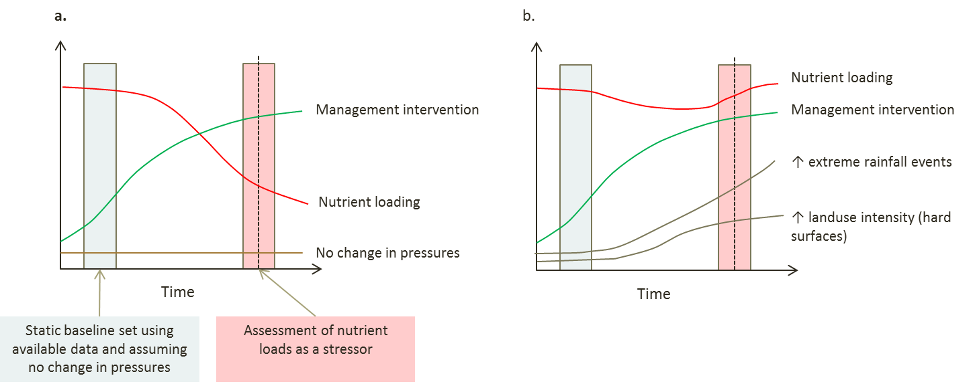
Figure 3: Static baselines can affect management–outcome relationships if not adaptively managed. a). Expected trajectories of management intervention and nutrient loading outcomes, given assumption of stationary pressures. b). trajectory of management intervention and nutrient loading outcomes, given increasing pressures that counteract management effort (modified from Gillon et al. 2016).
Further recommended reading
- Gillon, S., Booth, E.G., and Rissman, A.R. (2016). Shifting drivers and static baselines in environmental governance: challenges for improving and proving water quality outcomes. Regional Environmental Change 16(3): 759–775.
- Kopf, R.K., Finlayson, C.M., Humphries, P., Sims, N.C., and Hladyz, S. 2015. Anthropocene Baselines: Assessing Change and Managing Biodiversity in Human-Dominated Aquatic Ecosystems. BioScience 65(8): 798–811.

Stakeholder engagement
The scope and purpose of stakeholder engagement will depend largely on the management objectives for the assessment unit and the level of stakeholder interest. The International Association for Public Participation’s Public Participation Spectrum (IAP2 International Federation 2014) provides a good guide for developing an engagement plan for different levels of stakeholder interest and goals for stakeholder engagement. The approach outlined in Table 5 can be used to complement the stakeholder engagement approaches likely to already exist in relation to assessment units.
Traditional Owners, as the people who have rights and responsibilities for lands and waters on their country, should be explicitly involved in engagement processes to be conducted for the assessment unit being assessed in accordance with established Indigenous engagement guidelines and processes.
Table 5: Public participation spectrum (Reproduced With permission - (IAP2 International Federation 2014) (https://www.iap2.org.au/About-Us/About-IAP2-Australasia-/Spectrum).
Increasing level of public impact

INFORM | CONSULT | INVOLVE | COLLABORATE | EMPOWER
Public Participation Goal:
To provide the public with balanced and objective information to assist them in understanding the problems, alternatives and/or solutions. | To obtain public feedback on analysis, alternatives and/or decisions. | To work directly with the public throughout the process to ensure that public concerns and aspirations are consistently understood and considered. | To partner with the public in each aspect of the decision, including the development of alternatives and the identification of the preferred solution. | To place final decision-making in the hands of the public.
Promise to the Public:
We will keep you informed. | We will keep you informed, listen to and acknowledge concerns and provide feedback on how public input influenced the decision. | We will work with you to ensure that your concerns and aspirations are directly reflected in the alternatives developed and provide feedback on how public input influenced the decision. | We will look to you for direct advice and innovation in formulating solutions and incorporate your advice and recommendations into the decisions to the maximum extent possible. | We will implement what you decide.
Example Tools:
Fact sheets  Web sites  Open houses. | Public comment  Focus groups  Surveys  Public meetings. | Workshops  Deliberate polling. | Citizen advisory committees  Consensus-building  Participatory decision-making. | Citizen juries  ballots  Delegated decisions.

Establish the spatial boundaries of the assessment unit
As defined in Section 1.1 an assessment unit is the spatial extent of the IECA assessment. This may be a single aquatic ecosystem (e.g. a wetland or a river reach) or a larger spatial unit, such as a wetland complex. It can also be a sub-catchment or an entire basin/drainage division, such as the Murray-Darling Basin or the Lake Eyre Basin. The boundary of the IECA assessment must be spatially defined, together with a brief justification for the extent. The aquatic ecosystems within the assessment unit can be delineated and classified according to the methods provided in the Toolkit Modules 2, the Interim Australian National Aquatic Ecosystems Classification Framework, and 4, the Aquatic Ecosystem Delineation and Description Guidelines (AETG 2012b, AETG 2012d), and as described in Section 2.3.3.

Purpose of IECA
While the primary purpose of the IECA Framework is to assess the condition of aquatic ecosystems within the defined assessment unit, it may also serve other purposes, such as:
- A part of a broader project assessing HEVAE (for which the other Toolkit modules will be important);
- To establish a benchmark of condition against which change can be assessed;
- To determine changes in condition over time (through repeated condition assessments, for example assessing condition and change in condition at Australian Ramsar sites);
- To fulfil and/or set specific planning or reporting requirements (e.g. reporting against Basin Plan objectives); or
- To inform a management intervention program (see Text Box 1).
It is important to identify if status, trend, or both are the intent of the assessment. Status tends to characterise the size or magnitude of change of interest at a particular point in time in relation to a baseline or point of reference. Trend characterises an increase or decrease in a response of interest measured over years (typically). Both status and trend can be assessed in relation to triggers, targets and thresholds.
Any relevant reporting requirements or management planning activities identified when considering the management context (see Section 2.1.1 above) and relevant targets, triggers or thresholds (see Section 2.1.2 and 3.5) should be explicitly considered here and incorporated into the objectives for IECA.
Specific objectives must be articulated and agreed with stakeholders. Objectives need also to be ‘SMART’ (modified from Doran 1981):
- Specific – clear and unambiguous;
- Measurable –quantified, contain a measurable element that can be readily monitored to determine success or failure;
- Achievable – realistic and attainable;
- Relevant - considerate of program objectives, temporal scales of response, resources available and local context; and
- Time bound - specify a time scale in which the outcome is met/assessed.
Text Box 1: Potential usefulness of the IECA Framework in intervention management in aquatic ecosystems
Although IECA is a condition assessment framework designed primarily for surveillance monitoring and not for intervention monitoring, there are several ways in which the IECA Framework could contribute to an intervention management program for aquatic ecosystems:
- Identification of potential management intervention sites (e.g. selecting sites for management that require some form of restoration, but are not in such poor condition that they are unlikely to respond to the intervention);
- Providing information on factors that may contribute to ecological responses to management interventions (covariates, counterfactual);
- Providing a context of aquatic ecosystem condition at the assessment unit and its local region/catchment; and
- Long term trends in condition of aquatic ecosystems over time.

Groundwork

Accessing expertise: Establish a TAG or other appropriate oversight body (optional)
If the scale of the assessment is large and/or there is little existing information available on the assessment unit, appropriate indicators and assessment methods, then a technical advisory group (TAG) or other oversight body would be of benefit and should be established. The TAG/oversight body should include individuals with both local knowledge of the assessment unit or aquatic ecosystems in question, as well as relevant scientific or policy disciplines. Ideally, expertise would include:
- Aquatic ecosystem management;
- Local expertise;
- Policy expertise;
- Researcher/s with relevant local knowledge; and
- Traditional owner representation.
The primary role of the TAG/oversight body is to provide expert input to each of the steps involved in an application of the IECA Framework, from defining the spatial scale, through the identification and prioritisation of values and threats, indicator selection, setting the baseline and sample design.
Early engagement of group members is desirable, as it provides for continuity of decision making throughout the process and increases efficiency in information collation and assessment. The terms of reference for the TAG/oversight body should be clearly stated and specify the expectations and requirements of the group, as well as the decision-making process.

Collating existing information
The IECA Framework seeks to build on existing knowledge. Existing information on the assessment unit and ecosystem(s) in question should be collated and reviewed, including their components, processes, functions and services. Any externalities that may affect condition at the time of the assessment should be recorded. These include, for example, antecedent conditions such as drought and floods as well as other factors that may influence condition assessment or interpretation.
While seemingly common sense, it is good to be reminded that there will be an array of existing information available for even the most data poor systems. This may be in the form of previous surveys, condition assessments and studies of the assessment unit (including information from applying other Toolkit modules), or at broader spatial scales such as meteorological or remotely sensed landscape scale data. In addition, knowledge of similar systems may be used to increase understanding and develop some assumptions (that may need to be tested with collected data) (see also Section 2.3.4 on conceptualisation).

Define the scale of assessment
Although the spatial boundary of the assessment unit needs to be defined at the beginning of the process (see Section 2.1.4), a decision is also needed on the scale of the assessment within the assessment unit. If the assessment unit is small (e.g. a single wetland or river reach) then the scale of the condition assessment is likely to be the whole of the assessment unit. If the scale is very large, consideration needs to be given to defining which aquatic ecosystems within the assessment unit are to be included in the assessment. For example, is the assessment unit comprised of:
- Wetlands only?
- Major river systems?
- Aquatic ecosystems considered representative of the assessment unit?
- High ecological value aquatic ecosystems (HEVAE)?
- Aquatic ecosystems considered being most at risk or in poor condition?
- Ecosystems that are the subject of regional/local management initiatives?
The assessment unit and relevant aquatic ecosystems can be mapped and classified once the spatial scale of the assessment has been determined and documented (see Toolkit Modules 2 and 4, AETG 2012b and 2012d). The classification system used for the IECA Framework is the Interim Australian National Aquatic Ecosystem (ANAE) Classification (Toolkit Module 2). A typology for describing ANAE wetlands in the Murray Darling Basin is available as an example of classification (see Brooks et al. 2013). The typology presented in Brooks et al. (2013) may need refinement to be relevant to the ecosystem types within the assessment unit of interest.
The temporal scale of the assessment is also important and should match the objectives of the program. Useful questions to help determine an appropriate temporal scale are:
- Over what time can change(s) in condition be expected?
- What are the relevant management/planning time scales that need to be considered?
- Is the assessment based on existing information and if so, for what time periods is that information available?
The TAG/oversight body can be used to provide advice on appropriate spatial and temporal scales, as can scientific expertise from within research institutes. It is important to consider the scale of assessment and the scale of indicators selected, that these should match (see Step 4 for criteria relating to selecting indicators).

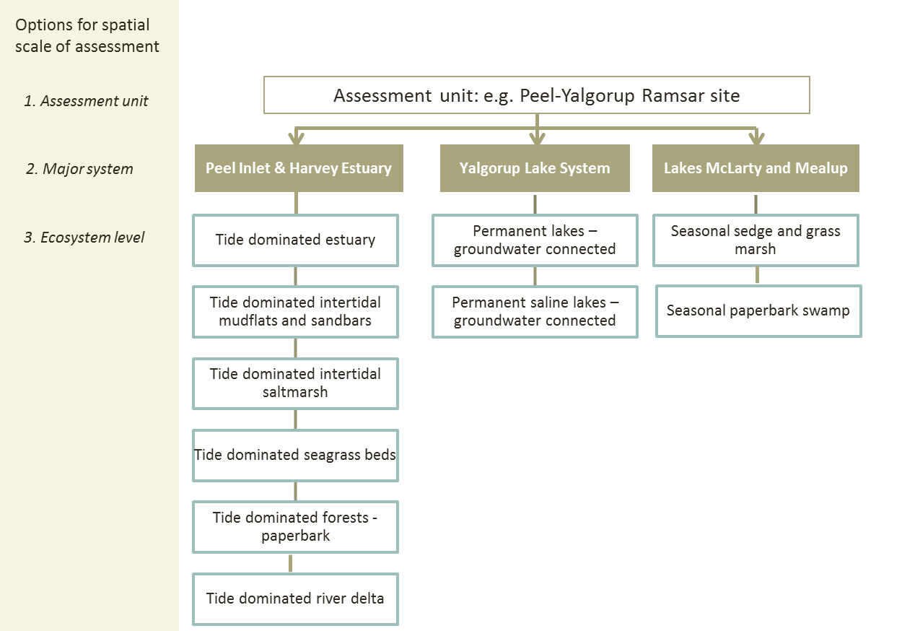
Figure 4: Example of options for spatial assessment scales. Data is reported at the assessment unit but may be collected at the ecosystem type scale. Not all ecosystem types shown – example only; doesn’t represent entire Peel-Yalgorup Ramsar Site.

Identify existing conceptual models
Conceptual models have become widely accepted as useful tools in natural resource management. They can be used to integrate and illustrate our current understanding of aquatic ecosystems and the relationships between components, processes and services. Aquatic ecosystems are highly complex, and the key to a good conceptual model is to focus on the aspect(s) or issue(s) of interest and to represent systems as simply as possible. Conceptual models are best developed in an iterative manner and from a broad understanding of the ecological drivers, components and processes that operate within the aquatic ecosystem.
In terms of condition assessment, conceptual models can (Gross 2003):
- Articulate important processes and variables;
- Contribute to understanding interactions between ecosystem processes and dynamics;
- Identify key links between drivers, stressors, and ecosystem responses;
- Facilitate selection and justification of indicators;
- Facilitate evaluation of data from a condition assessment; and
- Clearly communicate dynamic processes to technical and non-technical audiences.
There are a wide variety of conceptual model types and a good guide to the development of conceptual models is provided in ‘Pictures worth a thousand words: A guide to pictorial conceptual modelling’ (Department of Environment and Heritage Protection 2012a).
See https://wetlandinfo.ehp.qld.gov.au/wetlands/resources/pictorial-conceptual-models.html.
Begin developing a conceptual understanding of the assessment unit by identifying any existing conceptual models. It should be noted that conceptual models identified early in the IECA Framework are most likely going to be broad and will require refinement once later steps have been completed, particularly during the identification of priority values and threats, and selection of indicators for assessment.

Identify externalities likely to affect the assessment
Identify any known externalities, such as upstream management or land use activities, prevailing climatic conditions, previous flood or drought periods, antecedent conditions and or stochastic events (e.g. bushfire) that have the potential to affect the outcome of the assessment.

Part A: Outputs
The required outputs of Part A of the IECA Framework are:
- Statement of management context;
- Refined existing, or newly developed, SMART management objectives;
- Existing, or newly developed, triggers and targets (if required);
- Statement of purpose for IECA (how it relates to management context);
- Spatial boundary description in plain English and GIS spatial layer;
- Classification and map of aquatic ecosystems within the assessment unit using ANAE Classification and typology;
- Existing conceptual models relating to the assessment unit;
- Statement of spatial and temporal scale of assessment (may be included in objectives);
- A stakeholder engagement process, including establishment of a TAG/oversight body;
- Engagement of expert input, as needed;
- Identified externalities likely to affect assessment; and
- Clearly documented assumptions that have been made in the above processes to ensure transparency in the assessment.

Part B: Workflow

Step 1: Identify and prioritise values
Ecological value is the perceived importance of an ecosystem or ecosystem component, which is underpinned by the biotic and/or abiotic components, processes, functions and services that characterise that ecosystem. In the IECA Framework, ecological values are those identified as important following the application of relevant criteria (e.g. HEVAE, Ramsar or other) and identification of critical components, processes, functions, and services (see Glossary for definitions) in describing the ecological character of the ecosystem (or another comparable process). They can also include socially derived values through other processes such as the National Water Quality Monitoring Strategy Protected Environmental Values, or local policies and/or community concerns. Ecological values are often grouped or categorised, in the IECA Framework a number of themes and indicator groups have been adopted (Figure 5), as described in Section 1.4.
When considering ecosystem services the IECA Framework focuses predominantly on the ecological aspects of those services. Ecosystem service benefits and economic values can be noted, but are not quantified in monetary terms. It is imperative that people can see benefits in order for ecosystem services to have relevance and gain broad based support. Some jurisdictions may have existing definitions and lists of values associated with aquatic ecosystems (e.g. Queensland – see link in ‘Other resources’ later in this section) which may be suitable for use in the IECA Framework. For identification of cultural services relating to Ramsar wetlands, specific guidance is provided in Module 2 of the National Guidelines for Ramsar wetlands: Implementing the Ramsar Convention in Australia (DEWHA 2008).

Figure 5: Themes and indicator groups for Ecological Values as defined for the IECA Framework.
Aim
To identify, and prioritise, the ecological values of the assessment unit, at each scale of assessment.
Inputs
- Lists of values derived from published information such as management plans and policies, watering plans, monitoring reports and searches of threatened species databases, etc. and/or from the result of community engagement and consultation.
- If including risk to values as a criterion for prioritisation then the output of Step 2 is required.
Tasks
- Identify ecological values for each scale of assessment (e.g. ecosystem type, assessment unit, etc.) from relevant sources of information.
If the assessment unit has been identified via a HEVAE assessment or other management planning process, much of the information on ecological values will have been documented. Information on cultural or socio-economic values may be required (depending on the objective of the condition assessment) and these will need to be collated, as the HEVAE is focussed on ecological values only. The TAG or oversight group members can provide input in terms of expert and local knowledge, augmenting published information. Consultation with Traditional Owners, other stakeholders and or community consultation may also identify additional values.
Relevant values should be tabulated and listed by theme (see Table 1) and scale of assessment. This may require distilling different descriptions of values from different sources of information into logical groupings (see Text Box 2 for an example). It is recommended that this be captured in an Appendix, or in the assumptions documented for this step, to allow transparency. Some values may align with more than one of the themes, in which case that value should be included under each of the relevant themes. The values should then be reviewed by the TAG/oversight body to confirm their inclusion in the subsequent steps.
- List values as components, processes, functions and services.
Describe the values as critical components, processes, functions, and services:
- Components – The physical, chemical and biological parts of an aquatic ecosystem (e.g. habitat, species, genes, soils).
- Processes – Any change or reaction which occurs within ecosystems, whether physical, chemical or biological. Ecosystem processes include decomposition, production, nutrient cycling, and fluxes of nutrients and energy.
- Functions – Activities or actions which occur naturally in ecosystems as a product of the interactions between the ecosystem structure and processes (e.g. floodwater control; nutrient, sediment and contaminant retention; food web support; shoreline stabilisation and erosion controls; storm protection, stabilisation of local climatic conditions, particularly rainfall and temperature).
- Ecosystem services – The contribution(s) that ecosystems make to human well-being (see Appendix D for classification of ecosystem services).
Describing values as components, processes, functions and services will facilitate the identification of indicators. A list of potential components, processes, functions and services typically encountered in aquatic ecosystem is presented in Appendix D.

Text Box 2. Step 1 Identification of values example for the Lake Eyre Basin (LEB)
The LEB is an example where values have been identified in consultation with the Lake Eyre Basin Community Advisory Committee. The draft Lake Eyre Basin State of the Basin Condition Assessment 2016 Report (public consultation document) (LEBMF 2017) lists the ’key’ values, such as the relatively natural hydrological regime that supports ecosystem components (e.g. waterbirds, native fish), processes (e.g. waterbird breeding, fish breeding) and services (e.g. provision of water for livestock consumption). Aligning the LEB values with the IECA Framework at this step is relatively straight forward, requiring distilling the values into a shorthand description and alignment with the IECA themes.
An example of this process is provided in Table 6. Note: that Table 6 does not include the exact list of key values identified in the draft Lake Eyre Basin State of the Basin Condition Assessment 2016 Report; the abbreviated list is provided for purely demonstration purposes.
Table 6: Example OF KEY Values associated with Lake Eyre basin (source document LBMF 2017).
Value | Distilled/ short hand description | IECA Theme
Rivers of the Basin are amongst the most hydrologically variable in the world, and unpredictable river flows are the key feature determining the health of communities and the environment. | - Natural hydrological regime  - Variable hydrological regime | Hydrology - surface water
The Basin stands out among the great flooded systems of the world because the Channel Country is maintained in relatively unaltered character. |  | Hydrology - surface water
Surface water flow is considered to be near natural condition^ |  | Hydrology - surface water
Underneath most of the Basin … lies the Great Artesian Basin … which is essential for the Great Artesian Basin springs, permanent wetlands that provide habitat for unique aquatic life forms in otherwise dry landscapes. | - Significant subsurface aquatic ecosystems | Hydrology - groundwater
Hydrology has an overriding influence on the riverine ecosystems and the plants and animals inhabiting those systems in the Basin. | - *Provides refuges for aquatic biota  - Supports migratory species | Aquatic ecosystem connectivity
Many plants and fish in these diverse aquatic ecosystems only occur in the Basin. | - **Supports rare and threatened species  - Supports endemic species  - Vegetation diversity  - Waterbird abundance  - Waterbird diversity  - High native fish diversity  - Low proportion of invasive species | Biodiversity
Wetlands of the Basin are amongst the most significant in Australia for abundance and diversity of waterbirds and several, including Coongie Lakes, have been recognized for their high natural values. |  | Biodiversity
Grazing occupies the greatest area as a land use, although oil and gas extraction are the most economically significant. | - Supports livestock grazing  - Supplies water for stock | Services - provisioning
There is a long and continuous Aboriginal history in the Basin, and a rich and complex culture that reflects thousands of years of living with and surviving highly variable conditions. The dreaming paths of Aboriginal nations across the Basin form ceremonial routes along which goods and knowledge originally flowed, and which are alive and relevant today | - Spiritual identity  - Aboriginal heritage  - Cultural economy  - Important for intergenerational knowledge transfer | Services - cultural
Conservation and heritage areas represent a further significant land use and provide a major focus for a growing tourism industry. | - Indigenous and European heritage areas  - Supports tourism | Services - cultural
^ Not listed under ‘Key values’ but is one of the key messages

- Prioritise the values.
Undertake a simple multi-criteria analysis (MCA) to identify the highest priority values which will become the focus of the condition assessment. An MCA uses a series of defined criteria to provide a relative ranking of values in order of priority. Criteria for prioritising values should be:
- Consistent and logical;
- Transparent;
- Easy to use; and
- Able to be evaluated using available documentation and data.
The management objectives for the assessment unit will guide the development of criteria. Criteria for prioritising values may be related to (for example):
- Policy or legislative importance (e.g. maintaining listed threatened species or communities; meeting priorities under the Murray Darling Basin Plan; relate to meeting regional waterway restoration targets);
- Retaining or improving condition of the assessment unit in relation to components and processes that contribute to the high ecological value of the assessment unit (e.g. maintaining ecological character at Ramsar sites, meeting the listing criteria for HEVAE);
- Significance to the ecosystem(s) in question (e.g. fundamental or unique components or processes of the wetland or river reach);
- Community significance (e.g. species or communities important to the local community or stakeholder groups); and
- Relationship to current management actions (e.g. focus of on-ground management actions or of interest to site managers).
In some instances different criteria will need to be applied to values within different themes. Once the criteria are developed, review them for redundancy and logic.
Tip: Don’t have too many criteria, as this will likely result in redundancy and over complicate the process, significantly increasing the time required to complete this task. Three to six criteria for the MCA should be enough.
Next, develop a simple scoring and weighting system. Scoring can be based on relative preference, importance or contribution to the objective for prioritisation. More preferred options should score higher on the scale, and less preferred options score lower. A simple scoring system would be 1-3, where 1 is low and 3 is high.
Weighting assigns a numerical factor to each criterion based on the relative importance of the criterion. For example, if Criterion 1 is considered to be of greater relevance to the objectives of the assessment than other criteria, it may be weighted with a higher numerical score, to reflect this. Undertaking a sensitivity analysis is recommended to determine how to weight the criteria, and whether weighting actually makes a difference in the outcome. It is important to justify and document why different weights were given to different criteria.
The TAG can be engaged in this process either directly or in a review capacity.
An example set of criteria and a simple scoring system are illustrated for a Ramsar site in Table 7. These may or may not be suitable to the assessment being undertaken. Keep in mind that the prioritisation is about focusing the assessment on the main values (and threats in Step 2), and getting an appreciation of the scope – it doesn’t need to be overly complicated.
Table 7: Example of a set of Criteria and scores for prioritisation of values (and descriptions of low (1), medium (2) and high (3) rankings) for a Ramsar site.
Criteria | Description | Score
1. Critical to the ecological character of a Ramsar site | Low priority: Not identified as a critical or supporting Components, Processes, or Services (CPS), but occurs within the site. | 1
1. Critical to the ecological character of a Ramsar site | Medium priority: Value relates to a supporting CPS identified for the site (typically in the Ramsar Information Sheet or Ecological Character Description). | 2
1. Critical to the ecological character of a Ramsar site | High priority: Value is a critical component, process or service/benefit and present in the management unit. | 3
2. Management priority | Low priority: Value not currently identified as a management priority. | 1
2. Management priority | Medium priority: Value relates to one or more state listed and/or one or more items listed under international agreements; regional management priority included in regional planning frameworks, management plans etc. Management may be only partially implemented. | 2
2. Management priority | High priority: Value relates to one or more matters of National Environmental Significance under the Environment Protection and Biodiversity Conservation Act (EPBC), or other national planning instrument, may or may not include state listed or internationally listed taxa. | 3
3. Community priority | Low priority: Value identified as a low priority by general community. | 1
3. Community priority | Medium priority: Value identified as of moderate priority for the community. | 2
3. Community priority | High priority: Value identified as a high priority by the community | 3
4. Risk (from risk assessment- Step 2 in IECA) | Low priority: No high or extreme risks identified for the value. | 1
4. Risk (from risk assessment- Step 2 in IECA) | Medium priority: One high risk identified for the value. | 2
4. Risk (from risk assessment- Step 2 in IECA) | High priority: An “extreme” risk and / or two or more “high” risks identified for the value. | 3

Tip: If including a risk assessment output as part of the MCA for prioritising values, then this will require Step 2 to be undertaken in parallel with Step 1. For this reason it can be beneficial to engage the TAG to address prioritising values and risk at the same time.

- Create a performance matrix for values under each theme (applying the scoring system).
A performance matrix is the table of scores for each value, grouped by theme. This is the main output of the prioritisation. It provides a visual summary of the ranking of each option against each criterion. The performance matrix has the following characteristics:
• Each row represents a value (component, process or service);
• Each column corresponds to a criterion, considered in the comparison of the different options; and
• The entries in the body of the matrix reflect the combined scores by the TAG.
Once the scores have been applied, weighted and summed, it is necessary to determine a threshold for those that will be considered a high priority and continue through the condition assessment process. Several methods of scoring and integration are available including categorical scales (e.g. Jenks natural breaks, k-means algorithm), averaging (e.g. all values above the average are considered a priority), and percentiles (e.g. values that score in the top 25th percentile are considered a priority). Module 3, Guidelines for Identifying HEVAE provides a summary of the advantages and disadvantages of several methods.
It is also useful to update the conceptual model following the identification and prioritisation of values.
Tip: The method of determining the high priority value threshold must be set a priori, that is before the criteria are scored. This will allow for an independent and transparent decision on high priority values.

Text Box 3. Example ecological value prioritisation matrix for a subset of values from the IECA proof of concept trial at Hattah Lakes (Gawne et al. 2013).
Note that Criterion 1 has been weighted as twice as important as Criteria 2 and 3.
Priority thresholds were determined based on percentages as follows:
- High = 67–100%,
- Medium = 34–66% and
- Low = 0–33%.
 | Criteria*
Values | Criterion 1 Weighted x2 | Criterion 2 | Criterion 3 | Ranking score | Final rating % | Priority
Connectivity | 6 | 3 | 3 | 12 | 100 | High
Waterbird recruitment | 6 | 2 | 3 | 11 | 92 | High
Dispersal waterbird (migration) | 6 | 2 | 3 | 11 | 92 | High
Nutrient cycling | 2 | 2 | 2 | 6 | 50 | Medium
Sediment trapping | 2 | 1 | 1 | 4 | 33 | Low
Natural hazard reduction (flood mitigation) | 2 | 1 | 1 | 4 | 33 | Low
* see Gawne et al. (2013) for details of each criterion

Other resources
- HEVAE criteria – see Australian Aquatic Ecosystem Toolkit, Module 3 (AETG 2012c) http://www.environment.gov.au/resource/aquatic-ecosystems-toolkit-module-3-guidelines-identifying-high-ecological-value-aquatic;
- National Guidance for Describing Ecological Character at Ramsar Sites (DEWHA 2008) http://www.environment.gov.au/water/wetlands/publications/national-framework-and-guidance-describing-ecological-character-australian-ramsar-wetlands ;
- Queensland conceptual model guide http://wetlandinfo.ehp.qld.gov.au/resources/static/pdf/resources/pictorial-conceptual-models/30150-wetlands-conceptual-model-guidelines-25-01-13.zip ; and
- Queensland list of values https://wetlandinfo.ehp.qld.gov.au/wetlands/management/wetland-values/values-services.html
- Prioritisation references (there is a large volume of literature on multi-criteria analysis and decision making):
  - Dodgson , J., Spackman, M., Pearman, A.D., and Phillips, L.D. 2009. Multi-criteria analysis: a manual. Department of the Environment, Transport and Regions, London. Available from http://www.communities.gov.uk/documents/corporate/pdf/1132618.pdf
  - Langemeyer, J., Gomez-Baggethun, E., Haase, D., Scheuer, S., and Elmqvist, T. 2016. Bridging the gap between ecosystem service assessments and land-use planning through Multi-Criteria Decision Analysis (MCDA). Environmental Science & Policy 62: 45–56.
Assumptions and Knowledge gaps
Clearly articulate and document any assumptions made in relation to assigning scores, confidence ratings and weightings as part of the values prioritisation process. Any knowledge gaps associated with this step in the workflow should also be documented.
For example, the identified values of an assessment unit may be constrained by available data and local knowledge. There may be uncertainty around whether the assessment unit supports particular values. An assessment unit may contain suitable habitat and the relevant range for particular threatened species or ecological communities, but limited or historical survey data creates doubt as to whether the species is present and supported by the aquatic ecosystems in question. These uncertainties should be documented clearly as knowledge gaps. Decisions as to whether to include uncertain values in the assessment are made with advice from the TAG, and should consider:
- How likely it is that the system supports the value.
- The likelihood that the value would be considered a high priority value. This judgement would be based on the conceptual models of the system and experts’ understanding of the values of similar systems.
- The consequences of not including the value in the assessment. This judgement would be based on the conceptual models of the system, whether there are likely to be trade-offs between this value and other system values and/or the extent to which other values are reliant on this value.
Outputs
The required outputs of Step 1 are:
- A distilled set of values for the assessment unit and scale of assessment;
- A prioritised list of ecological values by theme and scale of assessment;
- An updated conceptual model; and
- Documentation of assumptions and knowledge gaps.

Step 2: Identify and prioritise threats
Identifying the influence of threats on assessment units is an important constituent of the IECA Framework as it underpins the assessment’s capacity to inform management responses to condition assessments that suggest management objectives are not being met.
The risk assessment process recommended is consistent with the Australian/New Zealand Standard: Risk Management (AS/NZS 4360:2004; Standards Australia and Standards New Zealand 2004) and the Standards Australia Handbook: Environmental risk management - principles and process (HB 203-2000; Standards Australia and Standards New Zealand 2006). The risk assessment approach follows a structured and iterative process, with the following steps:
- Establish the context – existing values and environmental conditions;
- Identify risks – threats and associated potential impacts; and
- Analyse risks – assign likelihoods and consequences to determine level of risk.

In most cases, it will not be feasible to undertake a comprehensive assessment of all threats to an assessment unit, so a risk assessment approach is used to identify the high priority threats to each of the values. In order to prioritise threats, members of the TAG/oversight body need to evaluate the likelihood of occurrence and consequences of each of the threats occurring at each assessment level. The confidence of each response should also be recorded using a scale of 1 to 3 with 3 being high confidence and 1 being low confidence. The likelihood and consequence scores are then multiplied together and the average of all responses calculated to provide an overall risk matrix.
Aim
To identify and prioritise the threats to the ecological values identified in Step 1, at each scale of assessment.
Inputs
- IUCN-CMP threat classification v2.0 (see Appendix E);
- Conceptual models from Part A; and
- List of pressures and stressors derived from published information such as relevant management plans, watering plans, and monitoring reports.
Tasks
- List pressures and stressors for the values identified in Step 1
‘Threat’ is a generic term that includes the combination of a pressure and all its associated stressors. Within the context of the IECA Framework:
- Pressures are defined as human activities and natural processes (i.e. drivers) that have the potential to impact the natural environment; and
- Stressors are the altered physical, chemical, or biological agents or processes arising from a pressure or pressures, which can induce an adverse environmental response. For example it is the reduced inflows, or the increased salinity that are the stressors associated with water resource management, which is the pressure.
From the information collated in previous tasks, construct a list of pressures and stressors to the ecological values of the assessment unit. The IECA Framework has adopted the IUCN-CMP threat classification scheme for threats (Appendix E). This scheme is being adopted as a common basis to describe threats at the National level. An indicative list of indicators of stressors is provided in Appendix F.
- Develop a stressor model to illustrate impact pathways
Develop a stressor model for the ecological values from Step 1 and threats identified in the previous task. A stressor model clearly shows the relationship between the pressure, associated stressor and impact on the high priority values. The stressor model should evolve from any existing model identified or developed in the previous steps. It informs the identification of impact pathways for the risk assessment and prioritisation of threats. A hypothetical stressor model for an estuary is provided in Figure 6, showing the linkages between the threat categories, the stressors and values impacted.

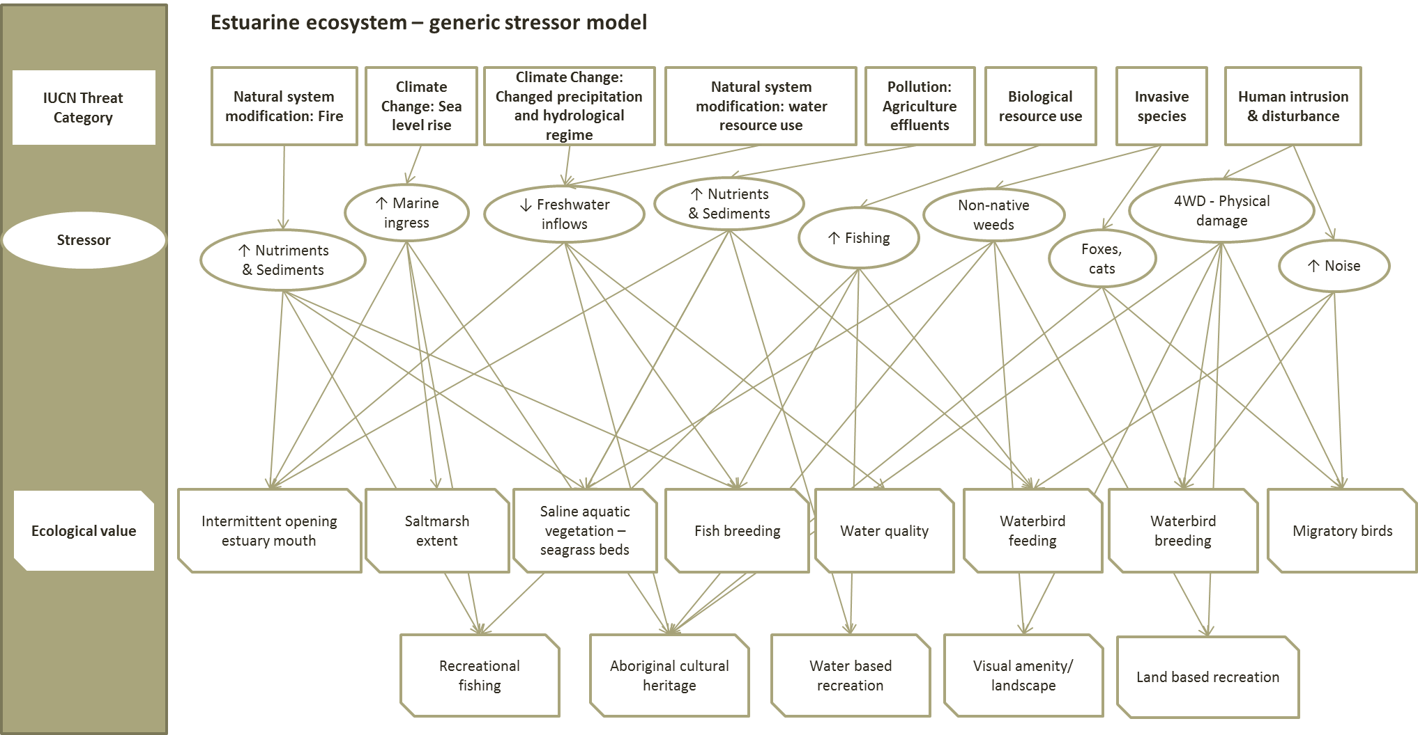
Figure 6: Hypothetical stressor model for an estuarine assessment unit. In this model all identified ecological VALUES AND threats are included.
- Assign risk to each threat-value combination and rank threats
Use the stressor conceptual model to help identify impact pathways linking threats to values. For example, impact pathways associated with changed precipitation and hydrological regimes, as illustrated in Figure 6, are described in Table 8.
Table 8: Hypothetical impact pathways for climate change: Changed precipitation and hydrological regime threat for the estuary example presented in Figure 5.
Pathway
1 | Threat: Climate: Changed precipitation and hydrological regime » Stressor: Decreased freshwater inflows » Impact: Altered hydrology leading to more frequent closure of estuary opening (value)
2 | Threat: Climate: Changed precipitation and hydrological regime » Stressor: Decreased freshwater inflows » Impact: Altered hydrology indicative of decline in health of Country and Aboriginal cultural heritage values
3 | Threat: Climate: Changed precipitation and hydrological regime » Stressor: Decreased freshwater inflows » Impact: Altered hydrology changes spawning and migration cues affecting fish breeding (value)
4 | Threat: Climate: Changed precipitation and hydrological regime » Stressor: Decreased freshwater inflows » Impact: Altered salinity levels affecting water quality (value).

Undertake a simple risk assessment (see Table 9 as an example) using the TAG/oversight body to assign likelihood (Table 10) and consequence (Table 11) to each threat/value impact pathway identified. Use the likelihood and consequence scoring matrix (Table 12) to assign risk scores to each pathway and then rank into high, medium and low threats for each level of assessment. Next decide what level of risk will be included in the assessment (i.e. only high risks, or a subset of moderate and high risks based on a score cut off).
Table 9: Hypothetical assessment of risk for each impact pathway for the Climate change threat to the estuary example presented in Figure 5 and Table 8.
Pathway | Likelihood | Consequence | Risk
1 | Likely | Major - Widespread measureable changes to the ecosystem components with a major change in process or function. Recovery (i.e. within historic natural variability) in 3 to 10 years. | 16 – High
2 | Unlikely | Moderate - Detectable negative impact on social benefits, cultural heritage, or wellbeing but without long lasting effects. Access to country more limited in some areas and/or resources for cultural heritage purposes also limited. Limitations lasting 1-2 years. Traditional owner rights acknowledged and but not engaged in management of country. | 6 – Low
3 | Possible | Major - Widespread measureable changes to the ecosystem components with a major change in process or function. Recovery (i.e. within historic natural variability) in 3 to 10 years. | 12 - Moderate
4 | Almost certain | Minor - Localised measurable changes to the ecosystem components without a major change in process or function. Recovery (if relevant) in less than 1 year. | 10 – Low

Table 10: Likelihood categories.
Almost certain | Likely | Possible | Unlikely | Rare
Is expected to occur in most circumstances | Will probably occur in most circumstances | Could occur | Could occur but not expected | Occurs only in exceptional circumstances

Table 11: Example of Consequence categories. Modify according to assessment objective and values included in assessment. For example time of recovery might be assessed DIFFERENTLY; social consequence categories might be described differently dependent on the values of the assessment unit (modified from Cottingham and Butcher 2015).
Category | Negligible | Minor | Moderate | Major | Extreme
Ecosystem process and function | Alteration or disturbance to ecosystem within natural variability. Ecosystem interactions may have changed but it is unlikely that there would be any detectable change outside natural variation / occurrence. | Localised measurable changes to the ecosystem components without a major change in process or function. Recovery (if relevant) in less than 1 year. | Widespread measurable changes to the ecosystem components without a major change in function (no loss of components or introduction of new species that affects ecosystem function). Recovery (if relevant) in 1 to 2 years. | Widespread measureable changes to the ecosystem components with a major change in process or function. Recovery (i.e. within historic natural variability) in 3 to 10 years. | Long term and possibly irreversible damage to one or more ecosystem function. Recovery, if at all, greater than 10 years.
Habitat and communities | Alteration or disturbance to habitat within natural variability. Less than 1% of the area of habitat affected or removed. | 1 to 5% of the area of habitat affected in a major way or removed. | 5 to 30% of the area of habitat affected in a major way or removed. | 30 to 90% of the area of habitat affected in a major way or removed. | Greater than 90% of the area of habitat affected in a major way or removed.
Species | Population size or behaviour may have changed but it is unlikely that there would be any detectable change outside natural variation / occurrence. | Detectable change to population size and / or behaviour, with no detectable impact on population viability (recruitment, breeding, recovery) or dynamics. | Detectable change to population size and / or behaviour, with no impact on population viability (recruitment, breeding, recovery) or dynamics. | Detectable change to population size and / or behaviour, with an impact on population viability and or dynamics. | Local extinctions are imminent / immediate or population no longer viable.
Social | Short-term interruptions in cultural services/ benefits (days), perceived benefits unaltered. | Cultural services/benefits restricted and perceptions of benefits altered in a localised area for short-term (< 1 year) | Cultural services/benefits restricted and perceptions of benefits altered in a localised area for > 1 year. | Long-term disruption to Cultural services/benefits and perceptions of benefits altered at a regional scale for 1 to 5 years. | Long-term disruption to cultural services/ benefits and perceptions of benefits altered at a regional scale for > 5 years.
Economic | No measurable reduction in provisioning services beyond historical variability. No effect on local and regional businesses. | Measureable reduction (<5 percent) in local provisioning services and or local economy. Effects lasting < 1 year | Significant reduction (5 - 30 percent) in provisioning services or local economy, effects lasting < 1 year. | Significant reduction (5 - 30 percent) in provisioning services or local economy, effects lasting 1 - 5 years. | Significant reduction > 30 percent) in provisioning services or regional economy, with effects lasting > 5 years.
Cultural | No measurable negative impact on social benefits, cultural heritage, or wellbeing. No limitations on access to country and or resources for cultural heritage purposes. Traditional owner rights acknowledged and taken into consideration in management of country. | Barely discernible and or/temporary negative impact on social benefits, cultural heritage, or wellbeing. Some limitations on access to country in some areas and/or resources for cultural heritage purposes. Limitations only short term (< 6 months). Traditional owner rights acknowledged and taken into consideration in management of country. | Detectable negative impact on social benefits, cultural heritage, or wellbeing but without long lasting effects. Access to country more limited in some areas and/or resources for cultural heritage purposes also limited. Limitations lasting 1-2 years. Traditional owner rights acknowledged and but not engaged in management of country. | Significant negative impact on social benefits, cultural heritage, or wellbeing lasting for 6 to 10 years. Considerable limitations on access to country in majority of areas and/or access to resources for cultural heritage purposes. Traditional owner rights only partly acknowledged and not taken into consideration in management of country. | Sustained, long term negative impact on social benefits, cultural values, or wellbeing. Complete loss of access to country or resources for cultural heritage purposes. Loss of ability to conduct intergenerational knowledge transfer, destruction of spiritually significant locations. Traditional owner rights ignored and actively excluded from consideration of management of country.

Table 12: Likelihood and Consequence scoring matrix. Light green = Low risk, Yellow = Moderate risk, Red = High risk.
 |  | CONSEQUENCE
LIKELIHOOD |  | Insignificant | Minor | Moderate | Major | Catastrophic
 |  | 1 | 2 | 3 | 4 | 5
Almost certain | 5 | 5 | 10 | 15 | 20 | 25
Likely | 4 | 4 | 8 | 12 | 16 | 20
Possible | 3 | 3 | 6 | 8 | 12 | 15
Unlikely | 2 | 2 | 4 | 6 | 8 | 10
Rare | 1 | 1 | 2 | 3 | 4 | 5

- Adapting outputs from existing risk assessments
In many cases risk assessments will have been undertaken as part of the management of the assessment unit and it may be possible to extract the risk categories assigned to value threat combinations. It will be necessary to document any assumptions made in using existing risk assessment outcomes – including that all the values and threats identified via the IECA Framework are captured.
A critical consideration will be to check if the scale of the existing risk assessment matches that of the IECA assessment. For example if an existing assessment is done at a regional or large spatial unit and the IECA is assessing condition of values at a habitat or ecosystem level, then the existing risk levels are unlikely to be fit for purpose.
Other resources
- Salafsky, N., Salzer, D., Stattersfield, A.J., Hilton-Taylor, C., Neugarten, R., Butchart, S.H.M., Collen, B., Cox, N., Master, L.L., O’Connor, S., and Wilkie, D. 2008. A Standard Lexicon for Biodiversity Conservation: Unified Classifications of Threats and Actions. Conservation Biology 22(4): 897–911;
- IUCN-CMP threat classification (see Appendix E); and
- Pressure models – WetlandInfo https://wetlandinfo.ehp.qld.gov.au/wetlands/.
Assumptions and Knowledge gaps
There are often knowledge gaps around the effects of threats on ecological values. Where knowledge gaps exist, it is important to consider if the threat is included in the assessment or not.
The decision to include a threat that is a considered a knowledge gap should be based on:
- The likelihood that the system experiences the pressure.
- How likely the pressure or stressor would be considered a high priority. This judgement can be based on the conceptual models of the system and experts’ understanding of the pressure or stressor of similar systems.
- The consequences of not including the pressure or stressor in the assessment. This judgement can be based on the conceptual models of expert judgements.
In data poor systems, the assessment can default to large scale pressures for which there is often information available (e.g. water resource development, land use).
Any assumptions made in relation to assigning risk should be clearly articulated and documents. Any knowledge gaps associated with this step in the workflow should also be documented.
Outputs
The required outputs of Step 2 are:
- Stressor model illustrating relationship between threat–stressor–ecological values;
- Ranking of threats for each scale of assessment and for the assessment unit; and
- List of priority threats at each scale of assessment.

Step 3: Develop Key Evaluation Questions (KEQs)
Condition assessments using the IECA Framework are focussed by Key Evaluation Questions (KEQs) that are developed by aligning the management objective and purpose of the IECA for each scale of assessment. Identifying KEQs helps frame the assessment design, selection of indicators, and the evaluation of responses. It is important to ensure management questions closely inform the assessment from the beginning, as reviews of past assessments have shown that this can significantly improve the utility of the data collected (e.g. Kuehne et al. 2017).
Aim
To develop KEQs for the priority ecological values and priority threats at each scale of assessment.
Inputs
- Objectives and assessment targets, triggers and thresholds (where developed; see Step 5 as well);
- Outputs from previous steps; and
- Existing conceptual models.
Tasks
- Refine conceptual model(s) focusing on KEQs
Refine the conceptual models to help identify and clarify the KEQs for the assessment unit. Conceptual models can be used to show the different ecological responses to stressors and management interventions relative to the assessment unit or appropriate scale of assessment. This can be done for each theme, high priority value and/or high priority threats. The number of models developed will be determined by the management objectives and the relative complexity of the assessment. The models should clarify the temporal and spatial scale of expected responses, and additional factors that modify those responses among different aquatic ecosystem types within the assessment unit. Where possible it is helpful to show causal pathways specific to particular responses and or implementation modifiers.
Factors that influence the effectiveness of management interventions in achieving outcomes are referred to as modifiers in the IECA Framework (after Brooks and Reich 2012, Morris and Reich 2013, Brooks et al. 2013, Morris et al. 2015). Modifiers should be included in conceptual models to illustrate how they influence the condition of values and threatening processes.
Using the hypothetical estuary example: let’s say there were six priority values identified from Steps 1 (see bottom row of Figure 7a and b) and two priority threats (climate change: change precipitation and hydrological regime and invasive species). It is possible to refine the conceptual model shown in Figure 6 above to focus on the relationships between the priority threats and values. This in turn will help focus the development of the KEQs.

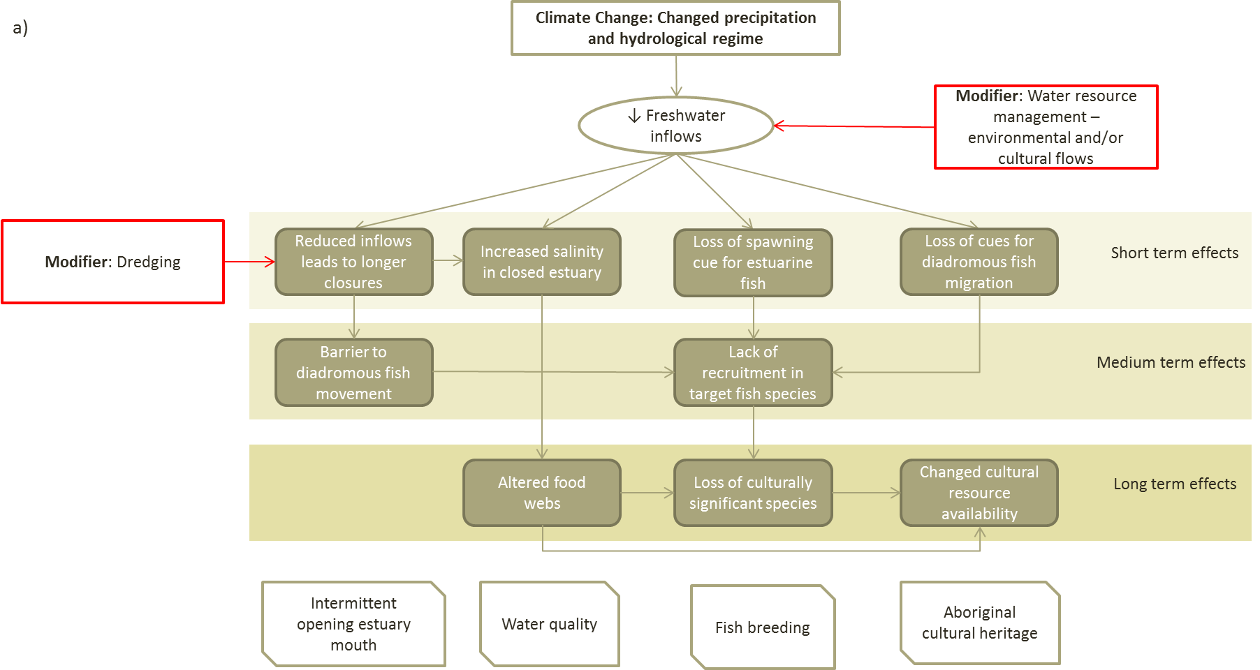
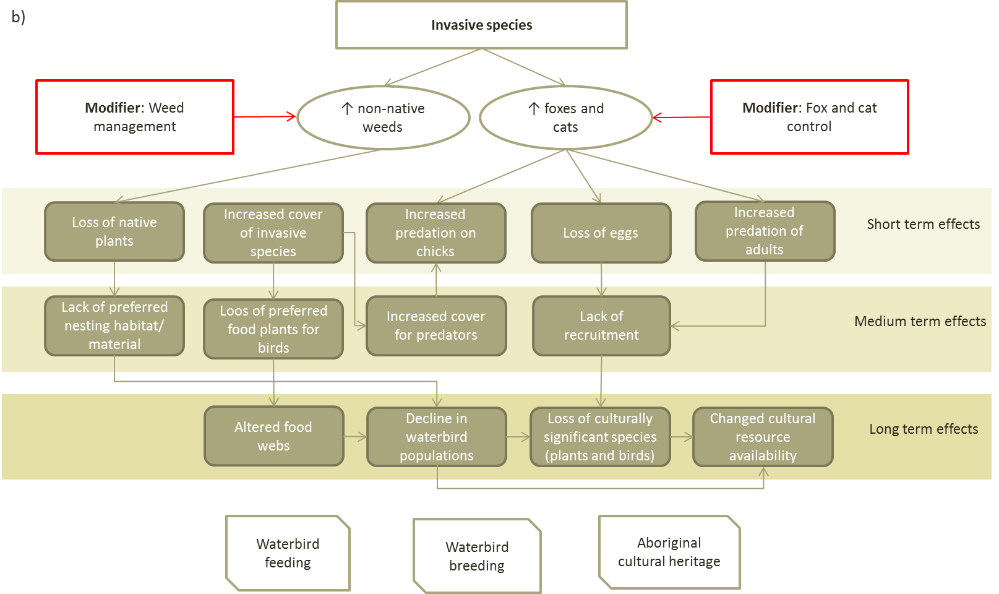
Figure 7: Conceptual models showing potential modifiers and temporal scale of ecological effects associated with: A) climate change pressures, and B). Invasive species, for the estuary example from step 2. Short term effects occur on an annual basis, Medium term effects on a 1-5 year basis, Long term effects occur over five or more years.

- Draft KEQs relating to assessment of priority values and priority threats
Next, list the KEQs relevant to the purpose of the assessment for the priority values and threats identified in the previous steps. KEQs are simple statements that help frame the assessment, and aiding in identifying indicators to be assessed. Include the assumptions, such as the temporal and spatial scale of effect for each KEQ. These may require some refinement in relation to triggers, targets and thresholds where they are available and or developed in Step 5. As stated in Part A of the Framework, setting a baseline, or reference point is essential to assess changed status and trends over the longer term.
Some hypothetical KEQs for the estuary example are presented in Table 13.
Table 13: hypothetical KEQs for the Fictitious River Estuary Example presented in Step 2.
Hypothetical management objective SMART elements in italics) | Hypothetical KEQ | Assumption | Temporal scale of effect | Spatial scale of effect
Improve native fish breeding at Fictitious River Estuary via increased recruitment of common galaxias by 2025, compared to baseline set in 2015. | To what extent did environmental water management affect the status of native fish breeding? | Timing and volume of freshwater inflows are main cue for breeding in target species. | Long term 3-5 years | Assessment unit
 | To what extent did environmental water management affect the condition of fish breeding habitat? | Poor spawning success linked to reduced seagrass habitat, reduced extent of nursery habitat leads to reduced recruitment. | Long term 3-5 years | Assessment unit
Maintain cultural values through improved condition of country (reduced weediness), measurable improvement in well-being of Traditional owners (increased access to country) and maintenance of eel populations at 2015 levels in Lake Fictitious by 2020. | To what extent did cultural water management affect condition of Country? | Hydrology is key driver of ecological integrity, which in turn supports cultural economy and wellbeing. | Long term greater than 5 years | Assessment unit
 | To what extent did cultural water management affect well-being of Traditional owners? |  | Medium term 2-3 years | Assessment unit - regional
 | To what extent did dredging affect status of eel migration? | Eels are culturally significant species reliant on free passage between resident wetlands and the ocean for sustaining local populations. | Long term greater than 5 years | Estuary opening - local
Maintain aquatic connectivity of the seasonally open Fictitious River Estuary via dredging in low flow years (<x gigalitres/day) to allow for annual diadromous fish migration. | To what extent did dredging operations affect the status of diadromous fish migration? | Diadromous fish populations are reliant on passage between freshwater and marine environments. | Short term | Estuary opening
 | To what extent did dredging result in improved status of water quality in estuary during periods of low river flow? | Estuarine salinity levels dependent on balance of marine inflows and flushing by freshwater flows. | Short term | Estuary opening - local
Increase successful waterbird breeding by:  - Improving breeding habitat by reducing invasive weeds in key breeding locations (saltmarsh) by 2020 to 2015 baseline (% cover).  - Reducing predation on beach breeding waterbirds by invasive species to 2015 levels. | To what extent did weed control activities lead to improved status of waterbird breeding? | Reduced weediness could lead to greater availability of preferred nesting sites and nesting material. | Medium term | Assessment unit
 | To what extent did fox and cat control programs lead to improved status of waterbird breeding? | Reduced direct predation of nesting birds will lead to increased recruitment/success of waterbird breeding events. | Short term | Assessment unit

Other resources
- DELWP (2016). Victorian Wetland Monitoring and Assessment Program (WetMAP), Department of Environment, Land, Water and Populations.
- Brooks, S.S. & Reich, P. (2012). The DSE Works Monitoring Method Trial: Review and Recommendations.
- Brooks, S., Reich, P. and Morris, K. (2013). Conceptual models to support riparian monitoring, evaluation and reporting. Arthur Rylah Institute for Environmental Research. Unpublished Client Report for the Department of Sustainability and Environment, Victoria.
- Morris, K. and Reich, P. (2013). Understanding the relationship between livestock grazing and wetland condition. Arthur Rylah Institute for Environmental Research Technical Report Series No. 252, Department of Environment and Primary Industries, Heidelberg, Victoria.
- Morris, K., Brooks, S., Reich, P. and Hale, R. (2015). Riparian Intervention Monitoring program – version 1. Arthur Rylah Institute for Environmental Research. Unpublished Client Report for the Water and Catchments Group, Department of Environment, Land, Water and Planning, Heidelberg, Victoria.
Assumptions and Knowledge gaps
Clearly articulate and document any assumptions made in relation to developing the KEQ and updating of conceptual models. Also document any knowledge gaps associated with this step in the workflow.
Outputs
The required outputs of Step 3 are:
- Re-statement of the management objectives;
- Update conceptual models to include modifiers and temporal and spatial scale of outcomes; and
- List KEQ in relation to management objectives.

Step 4: Identify and prioritise indicators
This step will guide the selection of indicators (with associated targets/reference points) for assessing the condition of high priority values and magnitude of threats (pressure, stressor, response). Indictors are used to enable an assessment against management objectives (track progress relating to objectives and communicate trends), KEQs, and the magnitude of pressures and stressors acting on the assessment unit and priority values. Four types of indicators have been defined for the IECA Framework:
- Condition indicators, which seek to enable an assessment of system condition against management objectives (equates to State Change indicators in the DPSIR framework);
- Pressure indicators, which assess the magnitude of pressures within and acting on the assessment unit and priority values;
- Stressor indicators, which assess the magnitude of stressors and acting on the assessment unit and priority values; and
- Response indicators, which assess either the impact of pressures and stressors or the effect of management modifiers on the assessment unit and priority values.
Aim
To identify priority indicators to assess condition (status and trend) of, and threats to, the ecological values and effectiveness of management interventions.
Inputs
- KEQs and conceptual models developed in previous steps;
- Lists of potential indicators (see Appendix F); and
- Examples of prior data collected (identified in Part A).
Tasks
- Identify potential indicators
Using the conceptual models and the KEQs developed in the previous steps identify potential indicators for assessing condition of values and threats and stressors (see hypothetical estuary example in Figure 8). The selection of indicators is ultimately dictated by the management objectives and the objective of the assessment using the IECA Framework. Indicators should have at least several of the following basic characteristics (Dale and Beyeler 2001):
- Are easily measured: easy to understand, simple to apply, and provide information to managers and policymakers that is relevant, scientifically sound, easily documented, and cost-effective;
- Are sensitive to stresses on the system of concern, whilst ideally having little natural variation;
- Respond to stress in a predictable manner and be unambiguous;
- Are anticipatory: signify an impending change in the ecological system;
- Are integrative: the full suite of indicators provides a measure of coverage of the key gradients across the ecological systems (e.g. soils, vegetation types, temperature, etc.); and
- Have a known response to natural disturbances, anthropogenic stresses, and changes over time, and have low variability in response.
Not all indicators will have all these characteristics, but it is a good checklist to use when creating the first list of potential indicators. A critical consideration in the selection of indicators is making sure the scale of response is related to the scale of the assessment. No single indicator is applicable across all spatial scales of concern (Dale and Beyeler 2001).
Appendix F has lists of potential indicators for the themes, services and stressors. Additional links to information on indicators for assessing condition of aquatic ecosystems are provided under ‘Other resources’, below.
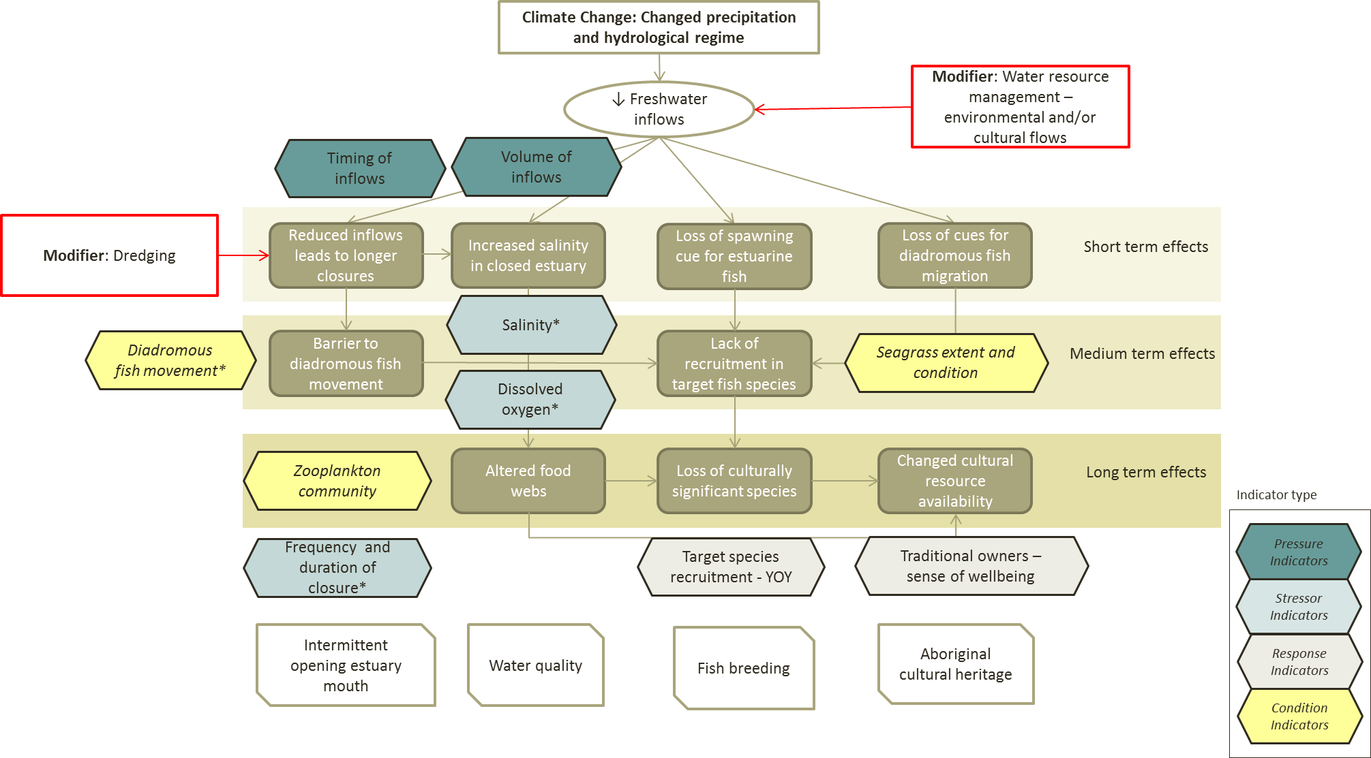
Figure 8: Updated conceptual model showing indicators relating to climate change, for the hypothetical estuary example from step 2.

- Prioritise indicators
It is likely that the previous task will identify more indicators than is feasible to include in the assessment (e.g. due to budget or resource constraints). In such circumstances, the list of potential indicators has to be reduced to those which will provide the best outcome in terms of addressing the objectives and addressing the KEQs.
One way to achieve this is to adopt a prioritisation process similar to that described for prioritising values in Step 1, with a suite of criteria being used to evaluate each indicator. There are a large number of criteria that can be used (Niemeijer and de Groot 2008), and an indicative set of criteria may include:
- Relation to high priority value. This criterion scores the degree to which the indicator provides a direct measurement of the condition of the value.
- Integrative. The extent to which an indicator is correlated with other indicators, or contributes to an integrated assessment of condition and threats.
- Scale alignment. The alignment between the scale of indicator response and the assessment. This requires consideration of the area over which the indicator provides useful information and also the time frame over which the indicator would respond.
- Management utility. A rating of an indicator’s suitability for informing management intervention decisions. This would include its capacity to provide information on both condition and the effects of stressors and could incorporate the level of certainty required by managers.
- Feasibility. A rating of the feasibility of measuring an indicator.
- Cost. An estimate of the relative cost of measuring an indicator
The process of developing descriptors for “high” “medium” and “low” categories for each criterion and developing a scoring and weighting systems is the same as that used for the prioritisation of values (see Step 1).
- Data considerations for indicators
Data requirements for each indicator cannot be prescribed, but should be considered as part of the SMART objective setting process. Two important considerations are:
- The setting of a target or baseline condition, which is essential to convert raw data into a condition assessment (i.e. provide a basis for comparison and assessment); and
- When the assessment unit is large, there will be numerous data issues that arise, including how to score an assessment unit that has, for example a large number of different channels and gauging stations and thus large numbers of different flow curves, and potential values for seasonality.
Point 1 is part of the indicator selection process for each individual IECA program. Point 2 relates to data aggregation and is covered in more detail in Step 6.
- Indicator sensitivity analysis
Before finally settling on an indicator it should be assessed for its utility in the role proposed. Sensitivity analysis is a combination of assessing the sensitivity of the indicator to change in conditions as well as the ability of using the indicator to assess change. That is, sensitivity analysis incorporates the response of the indicator to the stressor with the variability of the indicator and its ability to detect significant differences in condition, between assessment units or through time. Variability may occur in the response of the indicator (inherently, through space or time), or in the measurement of the indicator. Sensitivity analysis is essential when evaluating indicators before implementation and reporting (i.e. before Steps 5 and 6 in the IECA workflow).
Sensitivity analysis can be applied to individual indicators, but also to integrated condition scores (based on composite indicators – i.e. multiple sub-indicators in one indicator group) as well. The process detailed above to select indicators involves the use of judgement in regards to the selection of sub-indicators (within a theme), the need for weighting, and the treatment of missing data (see Step 6 and 7). This process needs to be transparent and based on sound statistical principles – it may be advisable to engage a statistician. The sensitivity of existing individual indicators from current programs should already be known. The sensitivity of new indicators and of integrated condition scores will need to be considered here and in Steps 5, 6, and 7 of the IECA workflow.
Tip: Basically a sensitivity analysis is about ‘will the indicator answer my question?’, ‘have I chosen the right indicator?’ – these are the basic questions that need to be answered to have some confidence in the final set of indicators selected for use in the IECA.
Other resources
- A list of advantages and disadvantages relating to different taxa as indicators of condition is provided in Appendix G.
- Oz Coasts website has information on the identification of indicators for estuarine and coastal systems (http://www.ozcoasts.gov.au/indicators/index.jsp) which may help in identifying potential indicators.
- QLD DEHP web page on Ecosystem Health Indicators, https://www.ehp.qld.gov.au/water/monitoring/assessment/water_quality_indicators.html#biological_indicators
- WetlandInfo – https://wetlandinfo.ehp.qld.gov.au/wetlands/
- Jackson, L.E., Kurtz, J.C., and Fisher, W.S., eds. (2000). Evaluation Guidelines for Ecological Indicators. EPA/620/R-99/005. U.S. Environmental Protection Agency, Office of Research and Development, Research Triangle Park, NC. 107 p.
Assumptions and Knowledge gaps
Identification of potential indicators is often completed using information and knowledge gained from other systems and in the published literature. As such, this step is less constrained by knowledge of the aquatic ecosystems within the assessment unit than Steps 1 and 2. However, the suitability of some indicators, in terms of their ability to detect responses to changed conditions at the assessment unit in question may be uncertain. In addition, it may be difficult to identify suitable indicators for some values or threats. In these situations, clearly document the knowledge gaps and any decisions or assumptions made.
Cost benefit considerations can also play a role in choosing indicators, including the need to engage specialist expertise or undertake specific types of data collection/analysis. These considerations should be noted if they are not overtly covered in the criteria used to select indicators.
Outputs
The required outputs of Step 4 are:
- List of indicators for use in the assessment; and
- Updated conceptual models showing linkages between values, threats and indicators.

Step 5: Design assessment and implementation
In some cases data may be lacking for high priority values and threats at the assessment unit, and additional data collection will be required. This step documents the process for identifying the need for additional data and how to design and implement an assessment program. Expert advice will often be required at this point and engaging with the TAG and or statisticians is highly recommended for this step. Note the purpose of the IECA (i.e. surveillance monitoring, condition assessment or intervention monitoring) will influence the design considerations as different elements and levels of detail are required.
Aim
To design a condition assessment program to collect additional data in order to undertake a complete IECA that address the objectives and KEQ for the assessment unit.
It is vital to know how analyses will be undertaken before data collection begins. The design phase often requires several iterations, as a design is refined to ensure it is effective and efficient. If data has been collected prior to considering its analysis/reporting it may only be possible to undertake limited analyses. This will, therefore, compromise the ability to detect trends and draw conclusions.
Inputs
- Lists of KEQs and identification of data required to answer KEQs;
- Lists of existing data collected (identified in Part A) including meta-data;
- Assessment of adequacy of existing data for use in IECA (see Appendix A); and
- Scale of assessment and reporting.
Tasks
- Review existing programs and information with respect to indicators and KEQs and undertake a fit for purpose assessment and identify gaps.
Most of the existing programs will have been reviewed as Part A of the IECA; however, it may become evident after indicator selection that additional data is required. First double check that this is the case by checking the following:
Does the existing data include meta-data? Check if there is information regarding when and where samples were taken and how sampling sites were selected. This is essential information that must be documented, to illustrate how the data are representative of the assessment unit and the objectives.
Can the data be reported at the scale of the assessment being assessed by IECA? If the data are not selected using a probabilistic sampling design, then you will need to determine if bias can be accounted for. For example, if the coverage of the data is less than the full assessment unit is there complementary data to fill the gaps or, can the IECA be made at a smaller scale than desired scale?
Can data be combined from different programs? When combining data from different programs it is important to adapt the data to the same management scale. When there is incomplete coverage within the assessment unit between the programs some complications will arise. The principles that should be used are the same as for any stratified sampling program, however calculations can get very complex depending on how many programs are involved, how well they cover the area and if there is any overlap in coverage. A very simple example is presented in Text Box 4 (see also Step 7, Task 1).

Text Box 4. Combining data from different programs
In this scenario, data are available from two programs, with different spatial coverage of the assessment unit. There are 12 sites in Program A and they cover 66% of the area of the assessment unit. There are two sites in Program B and they cover 34% of the unit. Thus, when calculating the overall assessment unit score simply averaging of all of the sites is not acceptable, as the Program B sites obviously need to carry more weight than the Program A sites. For a simple measure such as an average, it would be simplest to calculate the average in B×0.34 + the average in A × 0.66 as the overall average, provided the site locations are deemed adequately spatially representative.
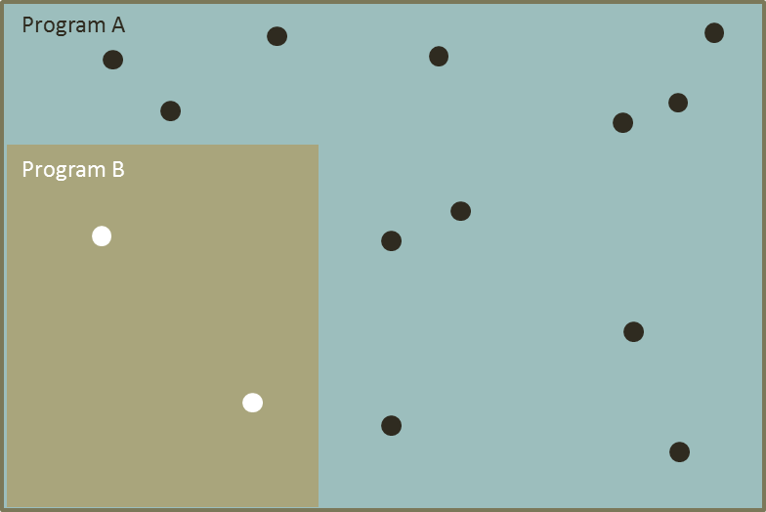
Figure 9: Illustration of combining data from two programs.
- Identify data deficiencies and priorities
Once the review of data from existing programs is done, eliminate existing data sets that cannot report at the correct scale (i.e. scale of assessment). These may include data that are not representative, do not address a KEQ, or do not have site selection information. List what additional data required that are essential to address the KEQs.
- Design an assessment program to address KEQs (this includes identifying frequency and locations for each indicator, sampling protocols)
Use the described scale of the assessment to guide a sampling design that allows reporting at the appropriate scale for each and every theme as required. There are a number of excellent reference books on designing assessment and monitoring programs for aquatic ecosystems and these should be referred to (see ‘Other resources’ later in this section). Where possible it is recommended to get a statistician to advise and/or review the proposed approach for collection and analysis of additional data. Sampling design considerations will vary according to the objectives and purpose of the IECA. For example surveillance monitoring may require a probabilistic design or stratified random design, whereas KEQ intervention analysis may require biased or spatially selective sampling to assess intervention effects on specific components and location, depending on the priority values.
When the design requires additional data from several themes or indicator groups, then it may be possible to look at sampling logistical efficiencies before starting data collection. However, it is important to start by looking at the requirements for each theme independently and determine the statistical requirements associated with a complementary sampling design (see response analysis section in Step 7). Considerations relating to cost, expertise and methods employed will also influence the selection of indicators.
In some cases it may be desirable to undertake a pilot study to confirm the usefulness of the selected indicators. Other approaches which may help in selecting indicators for new data collection include Multiple Lines and Levels of Evidence (MLLE) may also be of use in designing the assessment program.
- Develop triggers, targets and thresholds
For additional data collected specifically for the assessment, it may be necessary to establish baseline condition (reference points) against which to assess change in condition, and/or targets or thresholds of potential concern (e.g. see Cook et al. 2016, Arciszewski et al. 2017). These should be correlated or linked to the management objectives for the assessment unit. It doesn’t matter how well indicators are selected if they are not related to targets, or baseline conditions, that relate to the successful achievement of management objectives (Samhouri et al. 2014). Assessment of indicators in relation to targets can be used to instigate, cease, or adapt management intervention (Samhouri et al. 2014), and to be effective they need to SMART (see Section 2.1.1).

For existing programs and data the triggers, targets and thresholds are usually already set. In some cases they may require refinement to be explicit within the context of the IECA. This may have been done in Part A (e.g. see Section 2.1.2).
- Develop an evaluation and reporting plan
Develop a clear evaluation and reporting plan, the purpose of which is to (modified from CEWO 2013):
- Illustrate the relationship between the scale of assessment, design, analysis and reporting outcomes;
- Provide transparency in the implementation of the IECA in relation to management objectives for the assessment unit;
- Aid in determining whether the desired outcomes for IECA and management objectives at the assessment unit are being achieved;
- The relationship to, and use of, existing information;
- Impact appropriateness, effectiveness, efficiency and legacy assessed at different stages of the assessment to determine immediate, intermediate and longer-term outcomes;
- Detail requirements (timing, frequency etc.) for output and outcome reports; and
- Communications and reports on evaluation results as required to internal stakeholders and key external stakeholders.
Reporting should illustrate the hierarchical nature and integration of information being collected in the IECA, including the combination, interrelatedness and dependencies between the factors that affect the priority values of the assessment unit over time. The reporting framework should be concise, capable of being consistently applied over time, and allow comparison with other assessments. The reporting framework will also link to Step 8 and the considerations of developing a report card which summarises the results of an assessment.
- Implement the assessment
This task involves the collection of the specified data and refinement of the design, if required. This may include updating conceptual models or reassessing the effectiveness of some indicators (part of Steps 6 and 7). As stated above, development of an assessment program is an adaptive process, not a static one.

Other resources
- Arciszewski, T.J., Munkittrick, K.R., Scrimgeour, G.J., Dubé, M.G., Wrona, F.J., and Hazewinkel, R.R. (2017). Using adaptive processes and adverse outcome pathways to develop meaningful, robust, and actionable environmental monitoring programs: Strengthening Environmental Monitoring. Integrated Environmental Assessment and Management. doi:10.1002/ieam.1938.
- Downes B.J., Barmuta L.A., Fairweather P.G., Faith D.P., Keough M.J., Lake P.S., Mapstone B.D. and Quinn G.P. (2002). Monitoring Ecological Impacts: Concepts and Practice in Flowing Waters. xii + 434 pp. Cambridge University Press, Cambridge, UK.
- CEWO. 2013. Commonwealth Environmental Water - Monitoring, Evaluation, Reporting and Improvement Framework, Commonwealth Environmental Water, June 2013 V2.0. http://environment.gov.au/water/cewo/publications/cew-monitoring-evaluation-reporting-and-improvement-framework
- Cook, C.N., de Bie, K., Keith, D.A., and Addison, P.F.E. (2016). Decision triggers are a critical part of evidence-based conservation. Biological Conservation 195: 46–51.
Assumptions and Knowledge gaps
Document the knowledge gaps and any assumptions made in relation to existing data that were identified. For new assessments, include details of any new data and updating of conceptual models. Also document any knowledge gaps associated with this step in the workflow.
Outputs
The required outputs of Step 5 are:
- List of existing data that will be used and data that is required to be collected to address objectives and KEQs (i.e. additional data);
- Documented conceptual model(s);
- Documented sample design for additional data;
- Documented set of targets or thresholds for additional data; and
- Data analysis required for existing and additional data.

Step 6: Analyse and Aggregate
Aggregation is the scaling of the assessment data to the spatial and temporal scale desired for reporting. When the data are collected at a smaller scale, this is often called ‘upscaling’, although downscaling is also a form of aggregation. Ecological values can be measured at any scale from a single sampling site all the way up to the national scale, and thus aggregation plays an important role in ecological condition assessments. This is further reinforced when we consider that IECA aims to align existing programs that will often have different scales of data collection, as they are designed for different purposes. If all data points within each theme are collected at the same scale with a known selection probability, then aggregation is simple, and typically an averaging approach can be used. How data are collected/sourced and then aggregated is an important consideration in the design phase, and should relate to the objectives and KEQs of the program.
Some existing programs (e.g. Index of Stream Condition and Sustainable Rivers Audit) attempt to perform site scale integration before aggregation (Figure 10a) as this allows better engagement of local managers and communities. However the site scale assessments can be inefficient for some themes that are relevant at larger scales, and sometimes coarse, depending on the integration method. This lower-scale integration approach also either requires all data to be available at the smaller spatial scale, or may be susceptible to missing data. It also assumes that a single sampling frame applies to all themes and this is probably not true (e.g. sampling vegetation and water quality at the same point is not possible if there is no water). Also in this approach errors in integration are aggregated. Overall this approach is not recommended.
Aggregation before integration (Figure 10b) is desirable for multi-site/ecosystem assessments because it is more efficient (some themes are not ‘over-sampled’), simpler, and can create narrower confidence intervals. It also has the substantial advantage of allowing independent sampling frames for each indicator. Themes are sampled independently of each other (this will mean less unnecessary data collection) and each theme can be sampled to a desired level of confidence in assessment. If missing data is an issue it is able to be handled within each theme. The negatives of this approach are that sampling of different themes at different scales can require more logistical effort for field work. Also will requires alignment of individual themes scores to the same spatial scale before integration (themes with missing data may need to be dropped).
Aggregation before integration is recommended for use in IECA assessments.

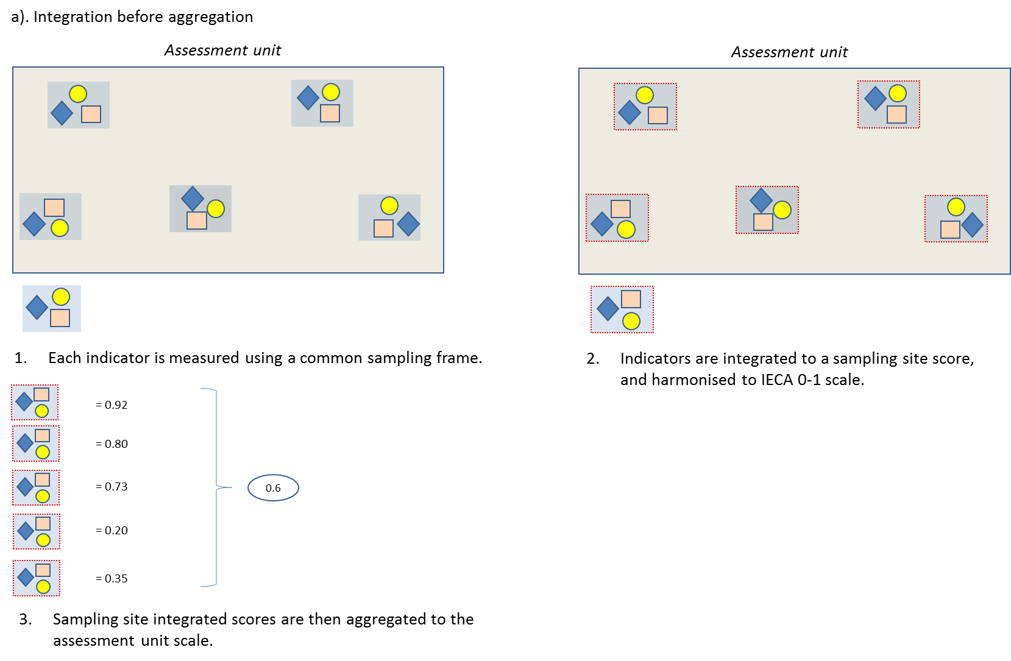
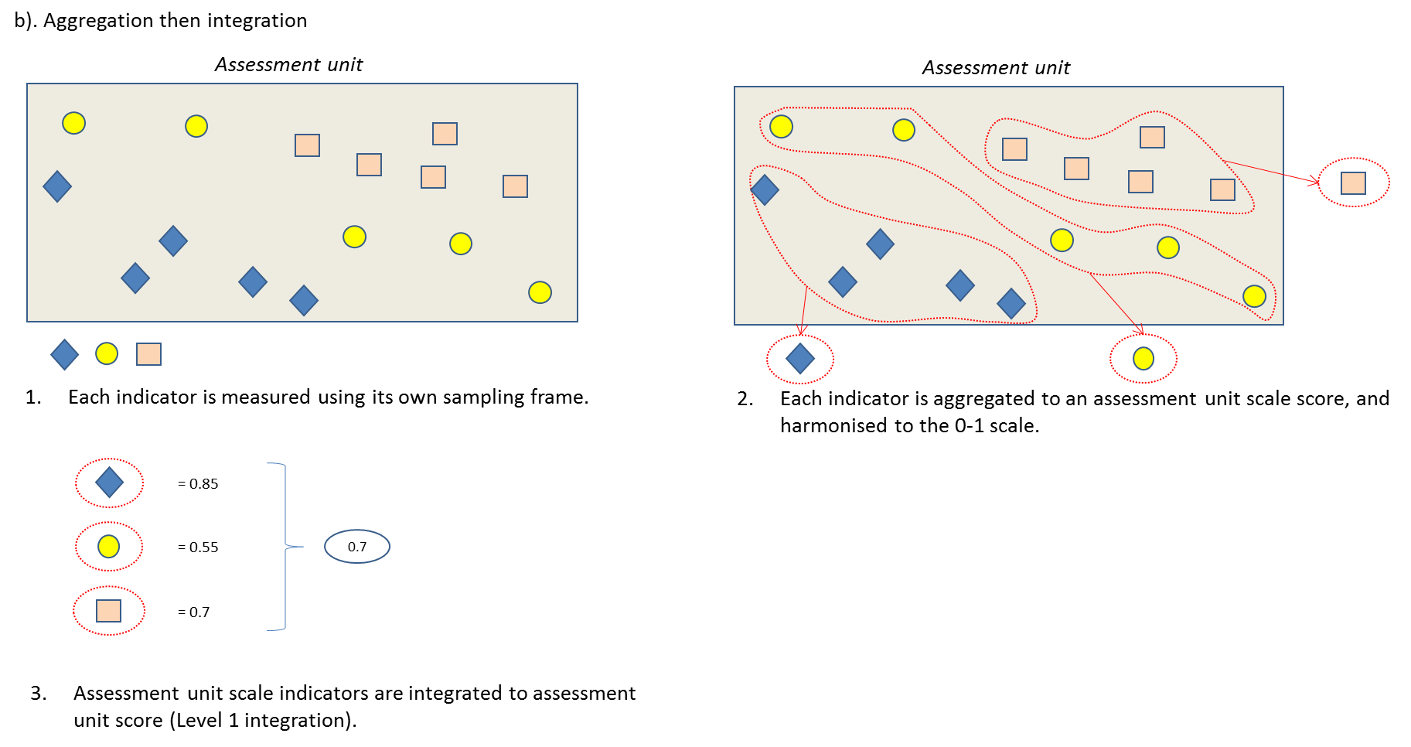
Figure 10: Two different methods for getting from indicators to an integrated condition score. The outer box represents the assessment unit. a) each indicator or theme is assessed within each of a number of sites and each site receives an integrated assessment that is subsequently aggregated to the assessment unit scale for reporting. b) each indicator or theme is assessed at the assessment unit scale then scores are integrated. The approach illustrated in b) is recommended.

Aim
To convert collected information (data) into assessment scores for each theme that can be reported individually or for comparison between assessment units in space or time.
Inputs
- Raw data;
- List of contributing assessment programs;
- Knowledge of sampling frame used when collecting raw data to allow aggregation;
- Targets, triggers, points of reference for each indicator group;
- Agreed weights or levels of importance of indicator groups within each theme;
- Method for integrating indicator groups within each theme; and
- Standardised reporting framework.
Tasks
- Documentation of data collection methodology, including sampling strategy and sampling frame used for a) existing, and b) additional data collection (Step 5)
The IECA Framework allows for the use of existing programs, which in turn can facilitate assessment continuity and effectiveness, as data are sometimes comprehensive and already available. When attempting to use existing rather than additional data having multiple data sets at multiple scales, a mixture of sampling frames and selection probabilities and strata for sites and indicators can obviously increase the complexity of the analysis. For this reason it is recommended that once all existing programs are identified that the information relating to aggregation and integration of data is tabulated to extract information regarding attributes, assessment endpoints, scoring procedures and aggregation techniques (Table 14) (e.g. Langhans et al. 2013).
To combine data within or between themes from two programs requires:
- A combined target population definition;
- A combined sample frame; and
- A re-calculation of weights (inclusion probabilities) using original survey design information (Larsen et al. 2007).
When the reporting scale and spatial domain is different to the combined sampling frame (this will nearly always be the case if the data were collected for a different purpose to IECA), then caveats will need to be placed on the results. For example, data from a high country riparian vegetation survey may be combined with several lowland riparian vegetation surveys, but if the IECA assessment aims for a state-wide assessment, then there is a substantial part of the state that may not have been included in the sampling frame. This potential bias must be identified when reporting.
- Calculate condition scores for priority values, ecosystems and assessment units.
The KEQ and the scale at which the baseline condition are set influence how the data are collected and how they can be reported. The analysis may be at the sampling site scale, or it may be at a larger scale. For example, an objective related to the diversity of native riparian plants in an assessment unit may be interested in average species richness within a sampling site, and/or the total diversity of plants in the entire assessment unit. The former requires a number of point assessments, one for each sampling site which is then typically averaged to return a score for the assessment unit. The latter measure of diversity only requires a single assessment calculated for the entire assessment unit.
A site-based method of scoring can either compare individual site data to the baseline condition, or it can compare the assessment unit average score to a baseline condition, depending on how the objectives were conceived. Using the average of site based scores is preferred where available as it gives more flexibility in reporting and allows for simple measures of confidence of assessment to be included.
- Apply selection weights to indicator groups as necessary.
All scores that are to be scaled up to the assessment unit level must use site selection probabilities when aggregating (see example in Text Box 4). When sites selected to be sampled are not selected using equal probabilities, then assessment unit scale baseline conditions must reflect these probabilities when setting the points of reference or thresholds. For example, if an assessment addresses a total waterbird count objective, and 10 out of 20 permanent wetlands (inclusion probability of 0.5) are sampled compared with ephemeral 5 out of 50 (inclusion probability = 0.1) ephemeral wetlands, then the baseline or reference population value must reflect this.
- Guidance on appropriate method(s) for aggregation ( e.g. for up scaling data)
There are typically three main methods for aggregating scores to a larger scale for reporting (Table 14). These are either some form of average, extrapolation using a model, or summing of the data. The actual method chosen will depend on the sampling strategy that was used when existing data was collected, or the design of sampling when collecting additional data. The sampling strategy is influenced by the distribution of the attribute being reported, and the point of reference or target for the indicator being measured.
The aggregation method will be determined by the design, which should relate to the program type and KEQs. The likelihood that data will be collected at different scales, along with the possibility that different themes can require different aggregation methods, reinforces the recommendation that aggregation occurs before integration.
For the majority of cases, averaging will be most appropriate for use in the IECA Framework.

Table 14: Summary of common methods of Aggregation. all examples require that data are collected using a probabilistic sampling method.
Method | Description | Example | Advantages | Disadvantages | When to use
Averaging | Creates an average score for the assessment unit. | Mean AUSRIVAS OE50 score. | Well suited to upscaling indicators that have a site scale reference value. Can use sites selected with unequal probability simply.  Simple to obtain simple confidence intervals for the assessment unit | Few if any. Scores can tend to a central value, hence the range or variability in the individual scores is lost by averaging. | Default method when scores are calculated at a series of sampling points (in space or time)
Modelling | Predicting a large scale value. | Species accumulation curve to predict assessment unit total species richness. | Suited to indicators that have an assessment unit scale reference value. | Only as good as the data that are collected.  Adds modelling error to sampling error in all predictions.  Complex if site selection probabilities are not equal. | To determine cumulative (larger spatial scale) values, or to calculate scores for unmeasured points (in space or time).
Summing | Creates a total score for the assessment unit. | a) Total species richness collected in the assessment unit  b) Proportion of the assessment unit with feature x. | Suited to indicators that have an assessment unit scale reference value.  Can upscale simple indicators like presence absence of a feature from site data. | Can be complex if site selection probabilities or site sizes are not equal. Typically does not have confidence intervals that are as tight as averaging. | When the baseline is set at the larger scale.

- Dealing with missing data
Missing data is frequently encountered in ecological assessments, for example due to insufficient sampling, loss of samples, limitations in access to sites, or failure of measuring instruments. Thus it is possible that missing data will occur at some point in an IECA. The relative impact of missing data can vary. For example, missing data can have large weight on some types of indicators compared with others (e.g. presence absence, weediness). Large amounts of missing data will result in less confidence in assessments. Also the level at which data are missing is important. Data missing for indicators groups within a theme may have less influence than those missing at theme scale. Themes with large numbers of sub-indicators, and or indicator groups, are more likely to have missing data, but are less likely to be affected by missing data.
Missing data can be handled in a several ways:
- Collect more data (see below).
- Imputation/Infilling: filling in the missing data using a range of approaches (see ‘Other resources’, below, for literature on imputation approaches).
- Deleting: If the missing data are totally random, then it could be deleted as the remaining data will be representative of the sample. However, this is rarely the case and if data do not occur randomly, deletion can lead to bias as the remaining values do not represent the whole sample.
- Default scores: Set a default score for missing data (usually a mid-range score to have low influence on assessment, OR a conservative value if following the precautionary principle to assessment).
- Surrogates: Use surrogate data (from a different sub-indicator that is somehow aligned with the desired indicator if it exists) – or realign conceptual model to match other available data.
Missing data become problematic if it is the same indicator data that are consistently missing. For example, if ‘weediness’ is missing more often than vegetation ‘species diversity’ then inevitably, their respective influence or weight on the IECA are not what they are intended to be.
It is strongly recommended that a statistician is consulted to provide advice on the implications of missing data on the IECA.
Table 15: Example of missing data Effects. For the biodiversity themes, as there are multiple indicators a few missing data records are acceptable. For the water quality theme, one missing data record is enough to invalidate the use of the theme for that assessment unit.
Assessment unit | Indicators (sub-indicator level) |  |  |  |  |  | Theme | Indicators (sub-indicator level) |  | Theme | IECA
 | B1 | B2 | B3 | B4 | B5 | B6 | Biodiversity | N1 | N2 | Water quality
A | 67 |  | 66 | 65 | 44 | 56 |  | 31 | 42
B |  | 55 | 66 | 67 |  | 59 |  | 33
C | 67 |  |  |  | 43
D |  |  |  |  |  |  |  | 33 | 42

Other resources
- Robinson, W., and Butcher, R. (2017). Briefing Paper 3 IECA Framework: Approaches to aggregation, harmonisation and integration. Integrated Ecosystem Condition Assessment (IECA) Framework Phase 3 Report to the Department of the Environment and Energy.
- Norris, R.H. Dyer, F., Hairsine, P., Kennard, M., Linke, S., Merrin, L., Read, A., Robinson, W., Ryan, C., Wilkinson, S., and Williams, D. (2007). A baseline assessment of water resources for the National Water Initiative, Level 2 assessment. Assessment of River and Wetland Health: A Framework for Comparative Assessment of the Ecological Condition of Australian Rivers and Wetlands. The WRON Alliance, 36pp.
- Enders, C.K. (2010). Applied Missing Data Analysis. Guilford Press: New York.
- Gibert, K et al. (2008) Review of method for handling missing data in longitudinal analysis. In Data Mining for Environmental Systems, Developments in Integrated Environmental Assessment Volume 3, Environmental Modelling, Software and Decision Support. Edited by A.J. Jakeman, A.A. Voinov, A.E. Rizzoli and S.H. Chen. http://bmcmedresmethodol.biomedcentral.com/articles/10.1186/1471-2288-12-96
- Schafer, Joseph L., John W. Graham. 2002. “Missing Data: Our View of the State of the Art.” Psychological Methods. 2002, Vol. 7, No. 2, 147–177.
Assumptions and Knowledge gaps
Document assumptions and caveats when analysing and aggregating the data. Document how missing data are dealt with and what bias or changes to confidence this might entail.
Outputs
The required outputs of Step 6 are:
- Theme assessment scores;
- Levels of confidence associated with the assessments;
- Statement of limitations/bounds/extent to which the assessment can be applied; and
- Approach adopted for aggregation and dealing with missing data.

Step 7: Harmonise and Integrate
Harmonisation is the processing of data prior to integration and should be considered within the integration process. It is the alignment of different indicators with different properties so that integration can produce meaningful outcomes. The TAG should be consulted to confirm the conceptual relevance of harmonising various indicators. This section is written as a generic overview because the IECA Framework is flexible allowing locally relevant indicators; thus there are no standard methods proposed for data collection. It is likely that many assessments using the IECA Framework will be made up of unique sets of indicators. Even the same set of indicators may have different levels of importance across different assessment units.
This section is written assuming that all indicators are measured on a numerical scale, as this is the common manner used in ecological assessments. However, there are occasions where an indicator may be assessed using a categorical scale (e.g. low, medium or high for conservation value, or presence/absence of a species). In those cases, the integration requires use of a non-numerical method, such as expert rules (e.g. Carter 2011, Davies et al. 2012) or conversion of the categories to a numerical value first.
Aim
To produce an integrated assessment score from the indicator categories assessed for each assessment level.
Inputs
- Aggregated data for the assessment unit (output of Step 6);
- If not already standardised, then reference points for each category for harmonisation; and
- Integration framework guidelines
  - Integration strategy (e.g. additive integration, expert rules);
  - Integration weights.
Tasks
- Using different data sources – i.e. data from existing methods or additional data
Data collected using different sampling frames and/or different methods will need to be adjusted for spatial sampling probabilities/strata and standardised measurement units (although this is not essential for expert rules approaches). In a simple example, conversion of fish data to catch per unit effort rather than just raw abundance may allow data collected in sites of different sizes or with different selection methods to be comparable. Note: some of this may have been done in Step 6.
- Method options for harmonisation of indicator values
Harmonisation merely means conversion to a common scale. Prior to integration, the raw data are converted to a standard and normalised scale to allow ease of integration and weighting. After the TAG has been consulted to confirm the conceptual relevance of harmonising indicators, the relative equivalence of the scale intervals used in the harmonisation process should also be confirmed. For example harmonising SIGNAL scores and EPT scores derived from AusRivAS is simple mathematically but converting them both to a 0 to 1 scale may mask different and non-linear relationships between the indicator value and the ecological response it represents.
An illustration of harmonisation is presented in Figure 11. This approach can be used when raw data are available, when existing condition scores are used a different approach is needed (see Task 6 below – converting condition scores to IECA bands). It is important to document how harmonisation was done, so that reverse ‘unpacking’ of the IECA scores becomes possible.
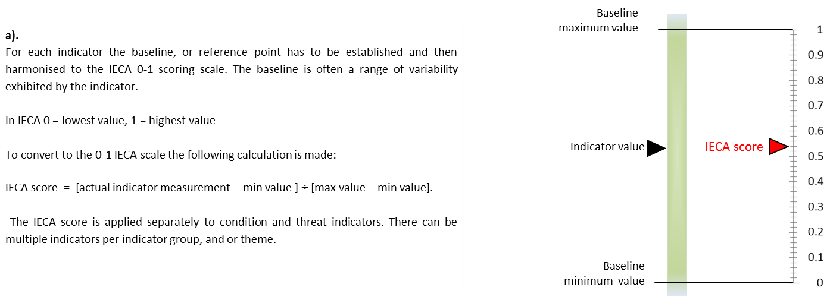
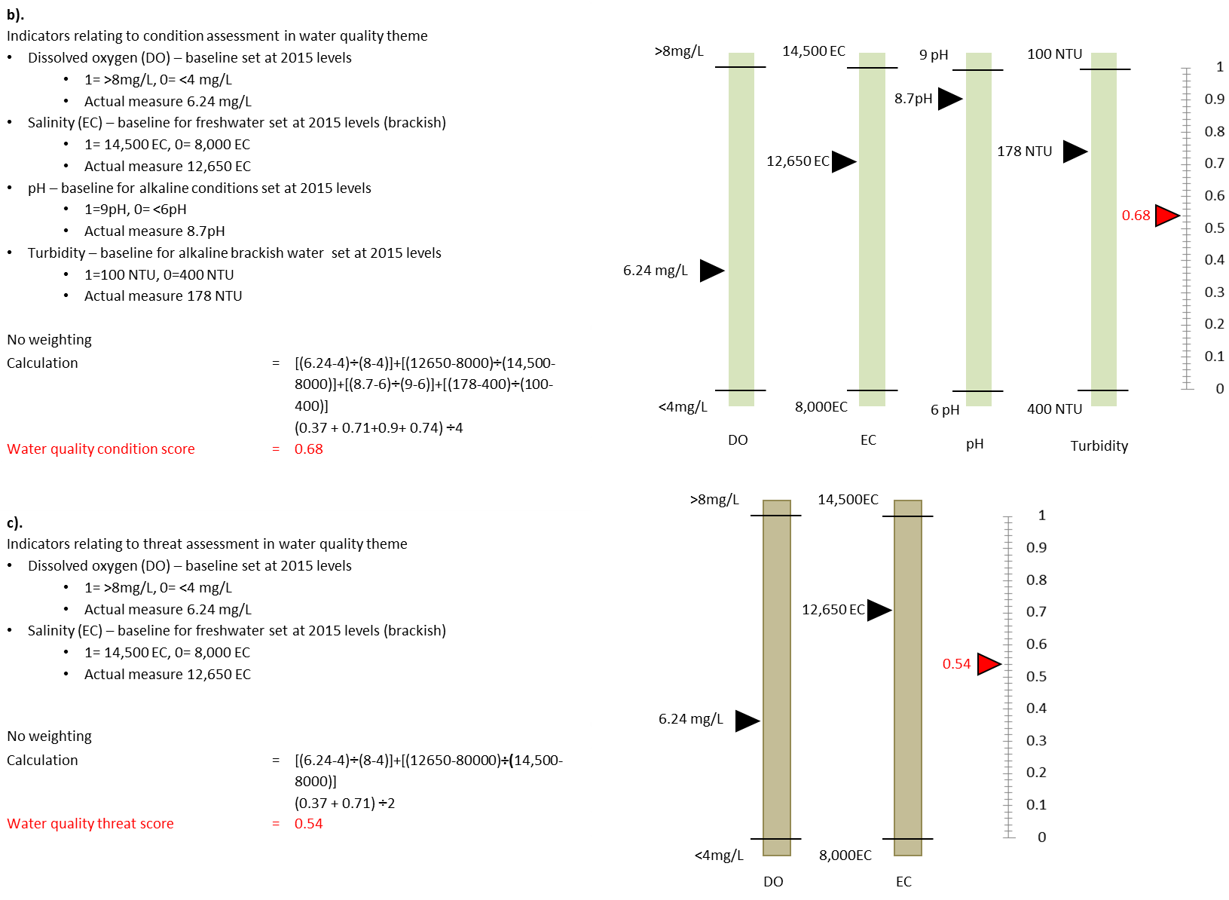
Figure 11: Example of indicator conversion to IECA score. a) General calculation, b) Example of four water quality condition indicators for the hypothetical estuary example. c). Example of two stressor indicators relating to water quality for the for hypothetical estuary example (after United Nations Development Programme 2007).

- Levels and options for integration
Integration of data used in the IECA Framework can occur at different levels depending on if the data is from an existing method (i.e. output at ecological value theme level) or is newly collected data specific to the assessment. In most assessments it is likely that there will be a need or desire to combine information from a number of indicators (or sub-indicators) to provide a single assessment score at the indicator group level: this is referred to as Level 1 integration (Figure 12 and Figure 13). For each assessment unit and/or ecosystem type within the assessment unit, the scores for each indicator group can be further integrated to provide an assessment score for each of the relevant ecological value themes: called Level 2 integration. The final option is to undertake integration across the themes to a single score for the appropriate spatial unit being assessed; typically, the assessment unit and/or the ecosystem type level (Figure 12). This is Level 3 integration and is only recommended in limited circumstances. Ultimately the level of integration will be at the level that produces a meaningful outcome, addresses the objectives and/or answers the key evaluation questions.
Tip: Condition and threat scores should be kept separate in assessments and reported at the scale most relevant to informing management options. It may also be advisable to keep the data separated for condition, stressor, pressure and response type indicators.

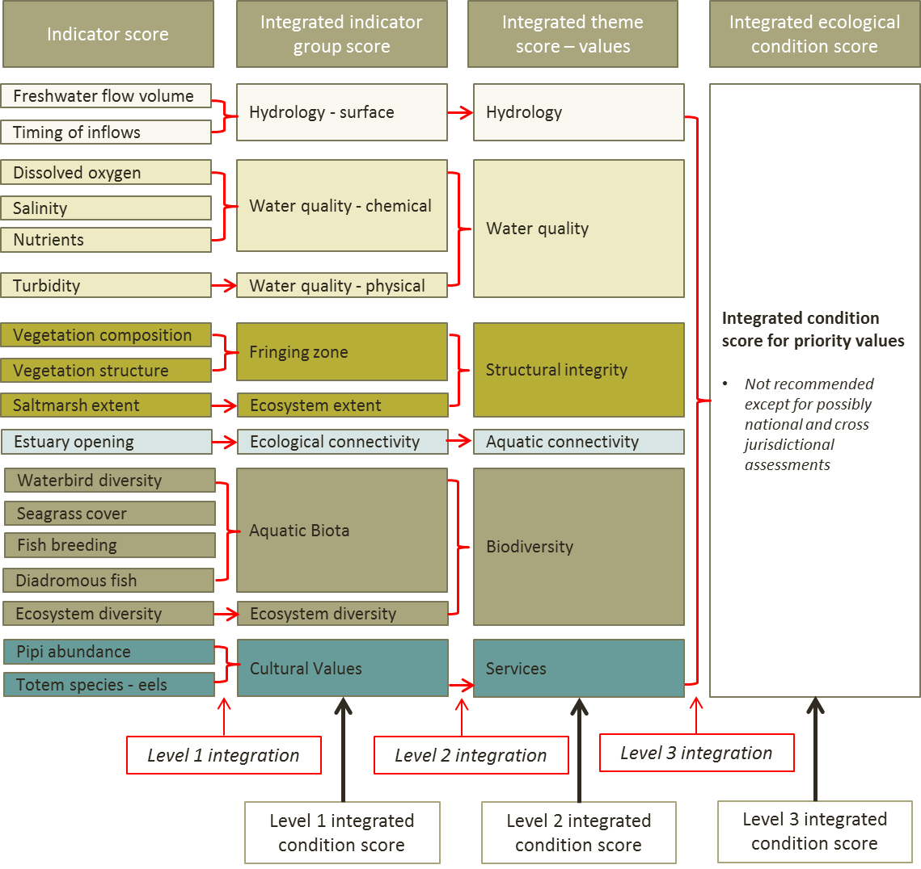
Figure 12: Illustration of Levels of integration for priority values using hypothetical estuary example.

Tip: Level 3 integration, to produce a single score, for condition of values and threats should only be used rarely; such as at the national level or possibly in cross jurisdictional assessments. In the majority of assessments integration should only proceed to Level 2. This will ensure transparency and also minimise the weighting considerations that potentially arise from having an uneven number of indicators in each indicator group and or theme.

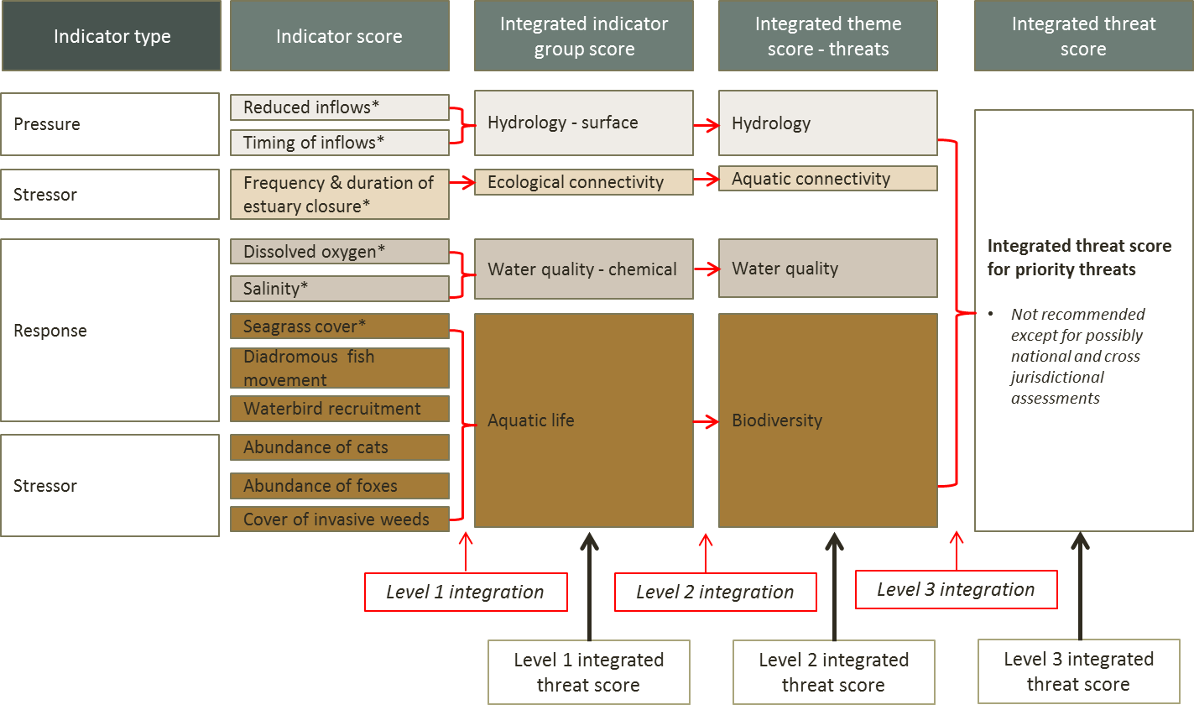
Figure 13: Illustration of Levels of integration for priority threats (Climate change and Invasive species) using hypothetical estuary example. * indicators which can be assessed as either condition or threat indicators. Note may wish to keep indicator types separate at level 1 integration (i.e. don’t integrate response and stressor indicators for aquatic life).
The integration methods do not need to be the same at each level. The most common forms of integration are some kind of additive or averaging process that requires the assumption that the (sub-) indicator scores are correlated; which is more likely for Level 1 or 2, for within theme, assessments. When using an additive method for Level 1 and 2 integration it may be necessary to compensate for missing data statistically, for example by using Geometric means, Standardised Euclidean distances, or simple averaging (note this works best for randomly distributed, spatially representative site designs, not selective/spatially biased or stratified designs) (see Step 6 Task 7).
Other alternatives to additive integration include:
- The precautionary principle:
  - which is limited because it returns conservative assessments;
  - cannot easily include unequal weights for sub-components; and
  - performs poorly when there is missing data.
- Expert rules:
  - Which may be considered costly in some situations, can deal with conceptual/value based differences in components/indicators, and be set up to be optimised for a specific assessment.
- Undertake a redundancy and sensitivity analysis
While the earlier sensitivity analysis focused on confirming whether an indicator responds to a stressor, here such an analysis seeks to confirm the degree to which the condition index responds to the indicators. It requires analysing the influence of each sub-indicator; indicator and theme score to the overall assessment (see Step 4, Task 4). For example, redundancy and sensitivity analysis could consider the consequence for the Hydrology theme and IECA scores in the example presented in Figure 12, if tidal regime data were unavailable.
The sensitivity analysis should also identify redundant or ineffective sub-indicators. In other words, the IECA has been set up using conceptual models, but what is the reality of the proposed conceptual links in light of data collection and analysis? For example, one or more of the variables measured may be invariant and thus do not influence IECA scores. Perhaps a key indicator species occurs in every site, or another species can’t be detected using the sampling frame. Indicators based on these results can potentially have no effect or a disproportionate effect on the IECA.
A typical sensitivity analysis involves scenario modelling where individual indicators are manipulated whilst the higher level composite indicators are monitored (e.g. running computer generated data scenarios where the input data are simulated in a way that allows the responses of the higher level scores to be monitored).
In summary, a sensitivity analysis should include:
- Verification of response to condition (indicators and integrated scores).
  - That the score responds to changes in ecosystem condition.
- Verification of the range of the response (indicators and integrated scores).
  - That the indicator can achieve the theoretical minimum and maximum scores.
- Verification of the type of response (linear or not, multiplicative or not, etc.) for indicators and integrated scores.
  - Is a value of 0.8 twice 0.4? Is an increase from 0.8 to 0.9 the same as an increase from 0.1 to 0.2?
- Contribution of indicators to indicator groups, ecological themes and IECA scores.
  - Do some indicators barely- or over-influence the integrated assessment score?
See ‘Other resources’ (below) for recommended reading on how to undertake sensitivity analysis.
- IECA banding
A scaled grade system that has been recommended for national reporting has been adopted. The approach has been utilised by Davies et al. (2008) and Roberts et al. (2009) and is consistent with the recommendations of the FARWH (Norris et al. 2007), with scores scaled from 0 to 1 across five bands as shown in Table 16.
This is consistent with many other condition assessments (Table 17), with a score of 1 (or close to 1) equating to no change from or equivalence to baseline condition, while a score of 0 indicates an extreme change or total loss. An example of applying the IECA banding to a system of existing condition assessment is presented in Text Box 5.

Table 16: IECA score and bands.
IECA Score | ICEA Band description
Condition
1 – 0.8 | Largely unmodified | Excellent
0.79 – 0.6 | Slightly modified | Good
0.59 – 0.4 | Moderately modified | Moderate
0.39 – 0.2 | Substantially modified | Poor
0.19 – 0 | Severely modified | Very Poor
Threat
1 – 0.8 | Largely unmodified | Negligible
0.79 – 0.6 | Slightly modified | Minor
0.59 – 0.4 | Moderately modified | Moderate
0.39 – 0.2 | Substantially modified | Major
0.19 – 0 | Severely modified | Extreme

Table 17: Comparison of grades used by the Sustainable Rivers Audit, AusRivAs, Riverine vegetation indicator and FARWH condition assessment programs. Note, the SRA scores have been divided by 100 to facilitate comparison.
Score | SRA (MDBA 2012) | AusRivAS (Nichols et al. 2014) | Riverine vegetation indicator (Roberts et al. 2009) | FARWH ((Alluvium 2011)
>1 |  | Better than reference*
1 – 0.8 | Good | Reference | Largely unmodified | Largely unmodified
0.79 – 0.6 | Moderate | Significantly impaired | Slightly modified | Slightly modified
0.59 – 0.4 | Poor | Severely impaired | Moderately modified | Moderately modified
0.39 – 0.2 | Very Poor | Impoverished | Substantially modified | Substantially modified
0.19 – 0 | Extremely Poor | Impoverished | Severely modified | Severely modified
*Scores greater than 1 in AusRivAS typically indicates enrichment – therefore a degraded state – an expert judgement will need to be made as how to harmonise such scores to the IECA grades.
- Converting grade scores from existing programs to IECA banding
Integrated scores are generally produced by mathematical averaging or an expert rules approach (including minimum averaging) (Langhans et al. 2014). It should be noted that when there are numerous themes to be integrated, or lots of sub-indicators within a theme, any form or averaging will tend to return middle of the range scores with limited value ranges. Hence simple and less complex assessments will tend to be more sensitive. That is because perturbations in any one indicator group of a theme with many (sub)-indicators, will have relatively less influence on the composite score than for a theme with few (sub)-indicators. This is a feature that can be easily understood by considering that the only possible outcome from taking the average of two non-correlated variables is to obtain a number somewhere in between. Subsequently, the more variables that are used, the more likely they will not be correlated with each other and the more likely the final score will be somewhere near the middle of the range of all possible outcomes.
There are essentially three options when integrating uncorrelated scores.
- Go ahead with the integration using a mathematical averaging approach and either:
  - adjust the range of integrated scores to the original/desired scale statistically; or
  - use the ranks of the integrated scores as indications of the ranks of the condition assessments (that is, scores are not absolute, but higher scores indicate better condition).
- Use a non-mathematical approach such as:
  - precautionary principle/ minimum averaging; or
  - expert rules.
- Use one of the above but also deconstruct individual elements in reporting.

Text Box 5. Example of converting existing condition grades to IECA Bands
In the draft Lake Eyre Basin State of the Basin Condition Assessment 2016 fish populations are used a key condition indicator (LEBMF 2017, Schmarr et al. 2015). Fish population data collected annually since 2010 from sites in five catchments of the Lake Eyre Basin was used to identify ecoregions within each catchment (i.e. regions with similar fish populations and dynamics). Fish communities were described in context of their ecoregion and were delineated in time based on their hydro-climate phase (dispersal phase, wet phase and drying phase). A biological condition gradient approach (Figure 14) was then used to identify the condition of fish populations within each of the ecoregions and hydro-climatic phase, and the condition scores then aggregated (averaged) to provide catchment condition scores.
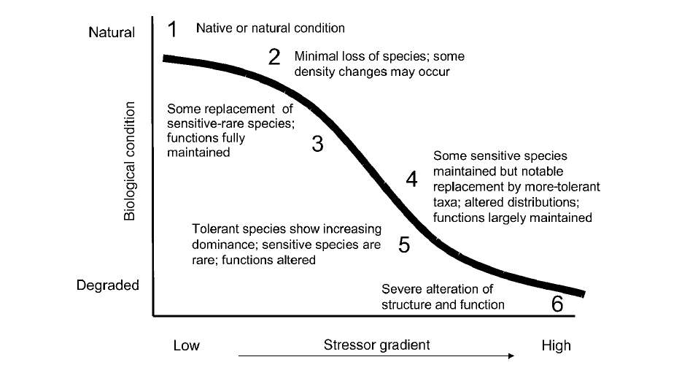
Figure 14: Conceptual diagram of the Biological Condition Gradient framework (from LEBMF 2017).
The condition gradient assessment approach used six ‘tiers’ of condition scores related to increasing levels of stress. The condition scores were aligned to the IECA scoring (0-1) as shown in Table 18 and Figure 15 below, which simply involved standardising the scores from the LEBRA Grades to the IECA 0-1 scores.
Table 18: LEBRA Fish community condition scores (From LEBMF 2017) (0–1 is not included in the lEBRA condition).
LEBRA condition | LEBRA score | IECA score | IECA condition
Good | 1–2 | 0.8–1.0 | Largely unmodified/Excellent
Acceptable | 2–3 | 0.6–0.79 | Slightly modified/Very good
Poor | 3–4 | 0.4–0.59 | Moderately modified/Good
Very poor | 4–5 | 0.2–0.39 | Substantially modified/Fair
Dire | 5–6 | 0.0–0.19 | Severely modified/Poor

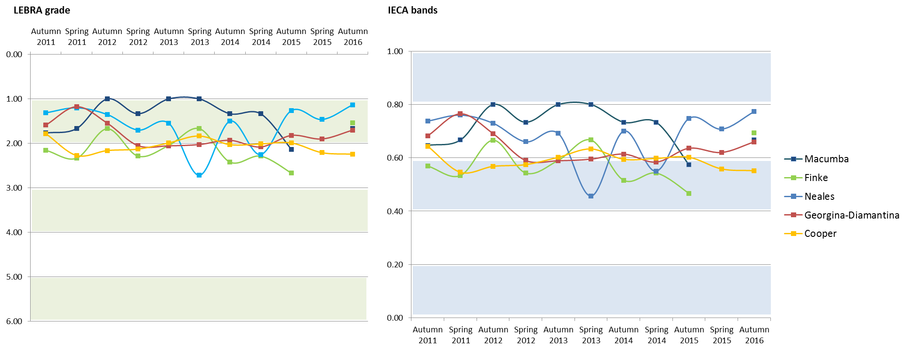
Figure 15: Fish community condition results for five catchments in the Lake Eyre Basin (adapted from DAWR 2017) converted to IECA Bands. Note the direction of the Y axis is inverse and different scales.
Other resources
- Langhans, S.D., Lienert, J., Schuwirth, N., and Reichert, P. (2013). How to make river assessments comparable: A demonstration for hydromorphology. Ecological Indicators 32: 264–275. doi:10.1016/j.ecolind.2013.03.027.
- Langhans, S.D., Reichert, P., and Schuwirth, N. (2014). The method matters: A guide for indicator aggregation in ecological assessments. Ecological Indicators 45: 494–507. doi:10.1016/j.ecolind.2014.05.014.
- Larsen, D.P., Olsen, A.R., Lanigan, S.H., Moyer, C., Jones, K.K., and Kincaid, T.M. (2007). Sound Survey Designs can Facilitate Integrating Stream Monitoring Data Across Multiple Programs. Journal of the American Water Resources Association 43(2): 384–397. doi:10.1111/j.1752-1688.2007.00030.x.
- Jackson, L.E., Kurtz, J.C., and Fisher, W.S., eds. (2000). Evaluation Guidelines for Ecological Indicators. EPA/620/R-99/005. U.S. Environmental Protection Agency, Office of Research and Development, Research Triangle Park, NC. 107 p.
Assumptions and Knowledge gaps
Clear statement defining the integration method used and justification for the ecological categories included and the reasoning for their assigned weights in integration.
Outputs
The required outputs of Step 7 are:
- Individual scores for Level 1 and Level 2 of integration for the assessment unit that are harmonised to a 0 to 1 grade;
- Documentation of how harmonisation was undertaken;
- Separate outputs for condition and threats to ecological values for each scale of assessment; and
- Reporting of the score using the agreed IECA bands.

Step 8: Develop Report Card
Integrated scores are really a starting point for reporting. They are rarely the endpoint and seldom used for setting policy. Rather, they are a tool for comparisons or ranking of assessment units. It is important that assessments include descriptions of how the indicators are related to the integrated score, and allow for individual indicators to be reported when desired. Report cards seek to distil and communicate important information to an audience in a way that is accessible, even when there is a large amount of complex information.
The presentation of integrated assessments can influence how the target audience(s) might visualise, interpret and accept the results. Given the complexity of integrated assessment scores, neither the general public (media, citizens, etc.) nor policy-makers generally read methodological notes and “caveats”. Therefore, their comprehension of the results will be largely based on the “messages” transmitted through summary tables or charts.
It is critical to recognise that integrated ecosystem condition assessments merely provide a starting point for reporting and analysis, which then has to be deepened by going back to the ‘unpacked’ detail (e.g. of individual indicator values). If the way in which an integrated assessment is built or disseminated does not allow users and analysts to go into the details, then overall credibility of the exercise may be impaired.
There are numerous formats and purposes for report cards, so prescriptive guidance is not applicable for IECA. Rather the guidance provided below presents the key considerations for developing a report card and points to key resources and examples developed under other programs.
Aim
To develop a report card for the assessment unit at the appropriate level of integration for the target audience.
Inputs
- Output from previous steps; and
- Data and IECA harmonised scores derived from existing programs.

Tasks
- State the objective for the report card
In developing a report card it is essential to clarify:
- The audience – managers, policy makers, community;
- The message – comparing condition to baseline, target, trends through time, effectiveness of management; and
- What the audience will do with information – design interventions, support management changes, refine policy.

There are five features that should be considered when developing an IECA report card (adapted from Harwell et al. 1999):
- A report card should be understandable to multiple audiences (e.g. general public, stakeholders, water managers or scientists).
- A report card should show the status (condition) of the assessment unit by:
- expressing the assessment on a standard scale (0 to 1 across five condition bands); and
- integrating condition scores from multiple indicators into a single IECA grade, typically only up to Level 2 integration.
- A report card should address differences in responses across time (i.e. not all indicators are expected to vary on the same time scale). For example water quality may be expected to respond over short time scales, but vegetation extent and condition may take many years to respond to management actions.
- A report card should recognise baselines, targets and triggers for the selected assessment unit(s) and clearly report condition against these.
- A report card should provide the scientific basis for assigning particular grades (may be in attached documentation (e.g. a fact sheet or report), but must be easy to find).

- Create the report card
The report card should relate information for each priority value within each theme, as either scores for themes or scores for single indicators. As stated earlier the report card should include the relevant target and trigger (if relevant) for each component of each theme in the assessment and make it clear if targets or triggers have been met. Include an assessment of distance from the trigger/target.
Visual representation of complex information allows the report card to be interpreted more easily by a wider audience. Choose colours, shapes, graphs, diagrams and other aids that suit the style and needs of the audience and based on how they will receive the information (i.e. web based, printed summary report, brochure/flyer).
Text Box 6: REport card for hypothetical estuary example
A simple example report card for the hypothetical estuary example is presented in Figure 16.
- The audience is local site managers;
- The intent or message is to demonstrate current condition and threat status for ecosystems to inform future management.
- This type of status report card could be used to inform further interventions – in this case review of environmental and cultural flows to the estuary.
The report card shows condition and threat status (not trend) outputs for two scales of assessment: whole of assessment unit (white box) and three component ecosystems (blue shaded box). Being a hypothetical example scores are not provided for the ecosystem but the shading illustrates the different condition and threat scores for each ecosystem. This highlights the benefits of providing an ecosystem level assessment, as in this hypothetical the saltmarsh is in good condition and not threatened. The main areas of concern would be maintaining the estuary opening regime and freshwater inflows. If these were a real application and not just hypothetical, report cards would be developed to illustrate the outcomes for the priority values in relation to the management objectives and KEQs.

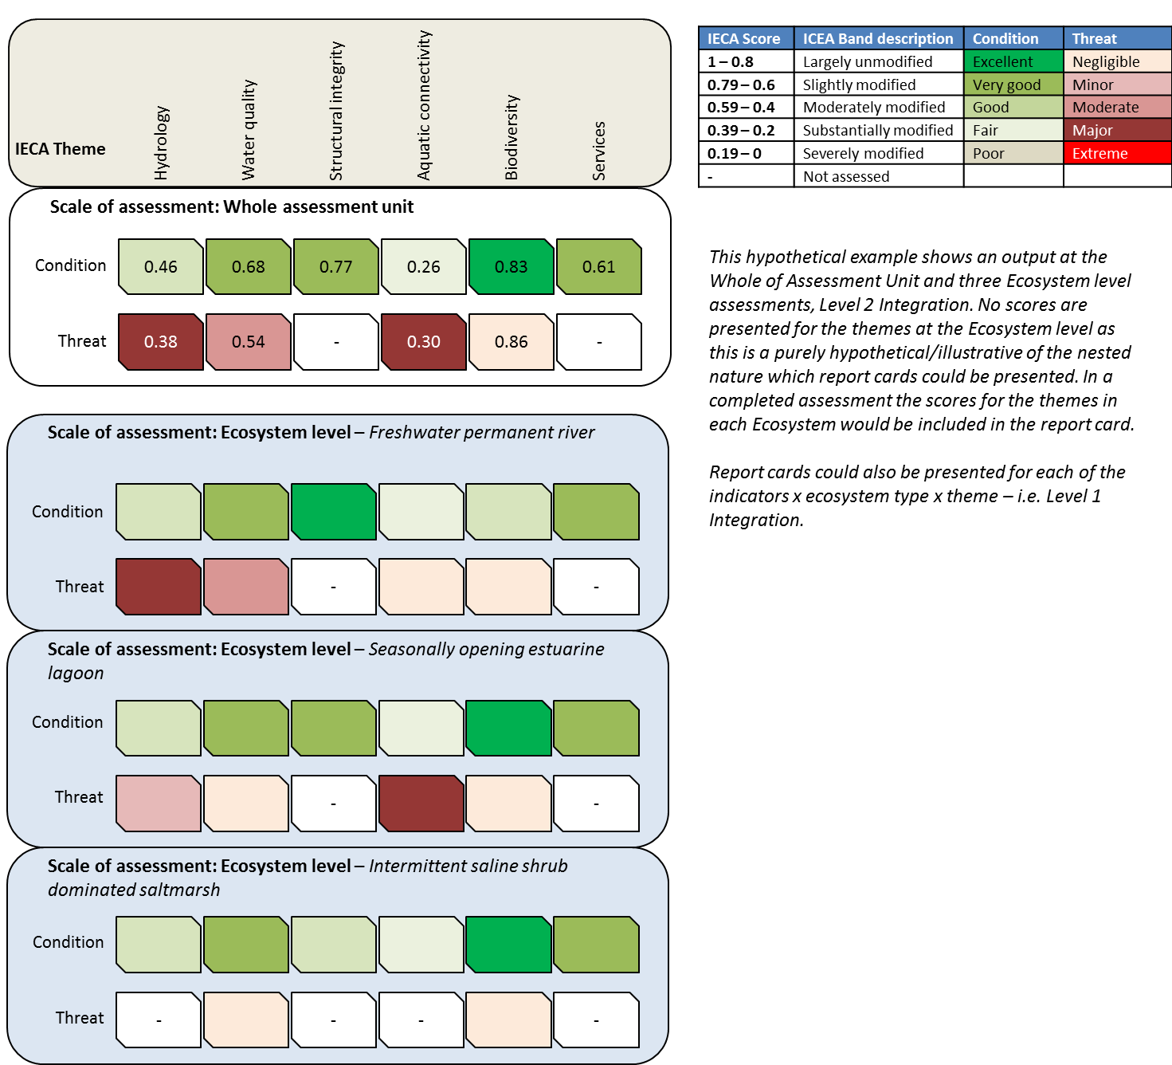
Figure 16: Simple condition and threat status report card for hypothetical estuary example, Level 2 Integration output (i.e. scores at IECA theme level) whole of Assessment Unit and Ecosystems.
Other resources
- Dennison, B. and Kelsy, H. (2017). The continuing evolution of the report card process. IAN https://www.youtube.com/watch?v=QoYyRT-qQtg
- National Report Card Network - http://riverhealth.org.au/national-report-card-network/workshop/
- IAN – Integration and Application Network - http://ian.umces.edu/
- Connolly, R.M., Bunn, S., Campbell, M., Escher, B., Hunter, J., Maxwell, P., Page, T., Richmond, S., Rissik, D., Roiko, A., Smart, J., Teasdale, P. (2013). Review of the use of report cards for monitoring ecosystem and waterway health. Report to: Gladstone Healthy Harbour Partnership. November 2013. Queensland, Australia.
- Kung, A. (2016). Using environmental report cards to encourage constructive stakeholder relationships in natural resource management: developing a participatory report card process. The University of Queensland. PhD Thesis.

Outputs
The required outputs of Step 8 are:
- Stated audience, message/intent, and purpose of the report card;
- Caveats and assumptions made relating to the development of the report card; and
- Separate outputs for condition and threats to ecological values for each scale of assessment in preferred report card format.

References cited
AETG. 2012a. Aquatic Ecosystems Toolkit. Module 1: Aquatic Ecosystems Toolkit Guidance Paper. Australian Government Department of Sustainability, Environment, Water, Population and Communities, Canberra. http://www.environment.gov.au/water/publications/environmental/ecosystems/ae-toolkit-mod-1.html.
AETG. 2012b. Aquatic Ecosystems Toolkit. Module 2. Interim Australian National Aquatic Ecosystem Classification Framework. Australian Government Department of Sustainability, Environment, Water, Population and Communities, Canberra. http://www.environment.gov.au/water/publications/environmental/ecosystems/ae-toolkit-mod-2.html.
AETG. 2012c. Aquatic Ecosystems Toolkit. Module 3: Guidelines for Identifying High Ecological Value Aquatic Ecosystems (HEVAE). Australian Government Department of Sustainability, Environment, Water, Population and Communities, Canberra. http://www.environment.gov.au/water/publications/environmental/ecosystems/ae-toolkit-mod-3.html.
AETG. 2012d. Aquatic Ecosystems Toolkit. Module 4: Aquatic Ecosystem Delineation and Description Guidelines. Australian Government Department of Sustainability, Environment, Water, Population and Communities, Canberra http://www.environment.gov.au/water/publications/environmental/ecosystems/ae-toolkit-mod-4.html.
Albert, C., Bonn, A., Burkhard, B., Daube, S., Dietrich, K., Engels, B., Frommer, J., Götzl, M., Grêt-Regamey, A., Job-Hoben, B., Koellner, T., Marzelli, S., Moning, C., Müller, F., Rabe, S.-E., Ring, I., Schwaiger, E., Schweppe-Kraft, B., and Wüstemann, H. 2016. Towards a national set of ecosystem service indicators: Insights from Germany. Ecological Indicators 61: 38–48. doi:10.1016/j.ecolind.2015.08.050.
Alluvium. 2011. Framework for the assessment of river and wetland health: findings from the trials and options for uptake, Waterlines report, National Water Commission, Canberra.
Arciszewski, T.J., Munkittrick, K.R., Scrimgeour, G.J., Dubé, M.G., Wrona, F.J., and Hazewinkel, R.R. 2017. Using adaptive processes and adverse outcome pathways to develop meaningful, robust, and actionable environmental monitoring programs: Strengthening Environmental Monitoring. Integrated Environmental Assessment and Management. doi:10.1002/ieam.1938.
Bland, L.M., Keith, D.A., MIller, R.M., and Rodriguez, J.P. (Editors). 2016. Guidelines for the application of IUCN Red List of Ecosystems Categories and Criteria, Version 1.0. Gland, Switzerland: IUCN. ix + 94pp.
Borja, A., Elliott, M., Andersen, J.H., Berg, T., Carstensen, J., Halpern, B.S., Heiskanen, A.-S., Korpinen, S., Lowndes, J.S.S., Martin, G., and Rodriguez-Ezpeleta, N. 2016. Overview of Integrative Assessment of Marine Systems: The Ecosystem Approach in Practice. Frontiers in Marine Science 3. doi:10.3389/fmars.2016.00020.
Brooks, S., Cottingham, P., Butcher, R., and Hale, J. 2013. Murray-Darling Basin Aquatic Ecosystem Classification: Stage 2 report. Peter Cottingham & Associates report to the Commonwealth Environmental Water Office and Murray-Darling Basin Authority, Canberra.
Carter, C. 2011. Sustainable River Audit 2: Metric processing system, unpublished report to the Murray-Darling Basin Authroity, Environmental Dynamics Project ED5115, Environmental Dynamics, Hobart.
CEWO. 2013. Commonwealth Environmental Water - Monitoring, Evaluation, Reporting and Improvement Framework, Commonwealth Environmental Water, June 2013 V2.0.
Cook, C.N., de Bie, K., Keith, D.A., and Addison, P.F.E. 2016. Decision triggers are a critical part of evidence-based conservation. Biological Conservation 195: 46–51. doi:10.1016/j.biocon.2015.12.024.
Cottingham, P., and Butcher, R. 2015. Ramsar Managment Plan for the Glenelg River Estuary and Long Swamp Wetland Complex. Prepared for Glenelg Hopkins CMA.
Dale, V.H., and Beyeler, S.C. 2001. Challenges in the development and use of ecological indicators. Ecological Indicators 1(1): 3–10. doi:10.1016/S1470-160X(01)00003-6.
Davies, P., Stewardson, M.J., Hillman, T.J., Roberts, J., and Thoms, M.C. 2012. Sustainable Rivers Audit 2: The ecological health of rivers in the Murray–Darling Basin at the end of the Millennium Drought (2008–2010). Volume 2. MDBA.
Davies, P.E., Harris, J.H., Hillman, T.J., and Walker, K.F. 2008. Sustainable Rivers Audit Report 1: a report on the ecological health of rivers in the Murray–Darling Basin, 2004–2007, Report prepared by the Independent Sustainable Rivers Audit Group for the Murray–Darling Basin Ministerial Council. Murray-Darling Basin Commission, Canberra.
Department of Environment and Heritage Protection. 2012a. Pictures worth a thousand words: A guide to pictorial conceptual modelling, Queensland Wetlands Program, Queensland Government, Brisbane.”.
Department of Environment and Heritage Protection. 2012b. Framework for evaluating aquatic ecosystem connectivity, Queensland Government, Brisbane.
Department of the Environment, Water, Heritage and the Arts. 2008. National framework and guidance for describing the ecological character of Australian Ramsar Wetlands: module 2 of the National Guidelines for Ramsar Wetlands - implementing the Ramsar Convention in Australia. Dept. of the Environment, Water, Heritage and the Arts, Canberra. Available from http://www.environment.gov.au/water/publications/environmental/wetlands/pubs/module-2-framework.pdf [accessed 30 June 2013].
DEWHA. 2008. National framework and guidance for describing the ecological character of Australian Ramsar Wetlands: Module 2 of the National Guidelines for Ramsar Wetlands - implementing the Ramsar Convention in Australia. Dept. of the Environment, Water, Heritage and the Arts, Canberra.
Dodgson, J., Spackman, M., Pearman, A.D., and Phillips, L.D. 2009. Multi-criteria analysis: a manual. Department of the Environment, Transport and Regions, London. Available from http://www.communities.gov.uk/documents/corporate/pdf/1132618.pdf.
Doran, G.T. 1981. There’s a S.M.A.R.T. way to write management’s goals and objectives. Management Review. AMA Forum 70(11): 35–36.
European Union. 2013. Mapping and Assessment of Ecosystems and their Services An analytical framework for ecosystem assessments under Action 5 of the EU Biodiversity Strategy to 2020.
Gawne, B., Butcher, R., Durant, R., Ellis, I., Henderson, M., Ning, N., Campbell, C., and Hawking, J. 2013. IECA Proof of Concept Trial – Technical report. Final Report prepared for the Department of Sustainability, Environment, Water, Population and Communities by The Murray-Darling Freshwater Research Centre, MDFRC Publication 27/2013.
Gillon, S., Booth, E.G., and Rissman, A.R. 2016. Shifting drivers and static baselines in environmental governance: challenges for improving and proving water quality outcomes. Regional Environmental Change 16(3): 759–775. doi:10.1007/s10113-015-0787-0.
Gross, J. 2003. Developing Conceptual Models for Monitoring Programs. NPS Inventory and Monitoring Program, USA.
Haines-Young, R.H., and Potschin, M.B. 2011. Common International Classification of Ecosystem Services (CICES): 2011 Update. Paper prepared for discussion at the expert meeting on ecosystem accounts organised by the UNSD, the EEA and the World Bank, London, December 2011.
Harwell, M.A., Myers, V., Young, T., Bartuska, A., Gassman, N., Gentile, J.H., Harwell, C.C., Appelbaum, S., Barko, J., Causey, B., Johnson, C., McLean, A., Smola, R., Templet, P., and Tosini, S. 1999. A Framework for an Ecosystem Integrity Report Card. BioScience 49(7): 543. doi:10.2307/1313475.
Heink, U., Hauck, J., Jax, K., and Sukopp, U. 2016. Requirements for the selection of ecosystem service indicators – The case of MAES indicators. Ecological Indicators 61: 18–26. doi:10.1016/j.ecolind.2015.09.031.
IAP2 International Federation. 2014. IAP2’s Public Participation Spectrum. Available from https://www.iap2.org.au/Tenant/C0000004/00000001/files/IAP2_Public_Participation_Spectrum.pdf.
Kindlmann, P., and Burel, F. 2008. Connectivity measures: a review. Landscape Ecology 23: 879–890. doi:10.1007/s10980-008-9245-4.
Kopf, R.K., Finlayson, C.M., Humphries, P., Sims, N.C., and Hladyz, S. 2015. Anthropocene Baselines: Assessing Change and Managing Biodiversity in Human-Dominated Aquatic Ecosystems. BioScience 65(8): 798–811. doi:10.1093/biosci/biv092.
Kuehne, L.M., Olden, J.D., Strecker, A.L., Lawler, J.J., and Theobald, D.M. 2017. Past, present, and future of ecological integrity assessment for fresh waters. Frontiers in Ecology and the Environment 15(4): 197–205. doi:10.1002/fee.1483.
La Notte, A., D’Amato, D., Mäkinen, H., Paracchini, M.L., Liquete, C., Egoh, B., Geneletti, D., and Crossman, N.D. 2017. Ecosystem services classification: A systems ecology perspective of the cascade framework. Ecological Indicators 74: 392–402. doi:10.1016/j.ecolind.2016.11.030.
Langemeyer, J., Gomez-Baggethun, E., Haase, D., Scheuer, S., and Elmqvist, T. 2016. Bridging the gap between ecosystem service assessments and land-use planning through Multi-Criteria Decision Analysis (MCDA). Environmental Science & Policy 62: 45–56. doi:10.1016/j.envsci.2016.02.013.
Langhans, S.D., Lienert, J., Schuwirth, N., and Reichert, P. 2013. How to make river assessments comparable: A demonstration for hydromorphology. Ecological Indicators 32: 264–275. doi:10.1016/j.ecolind.2013.03.027.
Langhans, S.D., Reichert, P., and Schuwirth, N. 2014. The method matters: A guide for indicator aggregation in ecological assessments. Ecological Indicators 45: 494–507. doi:10.1016/j.ecolind.2014.05.014.
Larsen, D.P., Olsen, A.R., Lanigan, S.H., Moyer, C., Jones, K.K., and Kincaid, T.M. 2007. Sound Survey Designs can Facilitate Integrating Stream Monitoring Data Across Multiple Programs. Journal of the American Water Resources Association 43(2): 384–397. doi:10.1111/j.1752-1688.2007.00030.x.
LEBMF. 2017. Lake Eyre Basin: State of the basin 2017 draft report (Public Consultation document) Department of Agriculture and Water Resources, Canberra, November. CC BY 3.0.
Levin, P.S., Kelble, C.R., Shuford, R.L., Ainsworth, C., deReynier, Y., Dunsmore, R., Fogarty, M.J., Holsman, K., Howell, E.A., Monaco, M.E., Oakes, S.A., and Werner, F. 2014. Guidance for implementation of integrated ecosystem assessments: a US perspective. ICES Journal of Marine Science 71(5): 1198–1204. doi:10.1093/icesjms/fst112.
MDBA. 2012. Sustainable Rivers Audit 2: The ecological health of rivers in the Murray Darling Basin at the end of the Millennium Drought (2008-2010). Summary.
Mononen, L., Auvinen, A.-P., Ahokumpu, A.-L., Rönkä, M., Aarras, N., Tolvanen, H., Kamppinen, M., Viirret, E., Kumpula, T., and Vihervaara, P. 2016. National ecosystem service indicators: Measures of social–ecological sustainability. Ecological Indicators 61: 27–37. doi:10.1016/j.ecolind.2015.03.041.
Nanson, G.C., and Croke, J.C. 1992. A genetic classification of floodplains. Geomorphology 4(6): 459–486.
Nichols, S.J., Reynoldson, T.B., and Harrison, E.T. 2014. Evaluating AUSRIVAS predictive model performance for detecting simulated eutrophication effects on invertebrate assemblages. Freshwater Science 33(4): 1212–1224. doi:10.1086/678946.
Niemeijer, D., and de Groot, R.S. 2008. A conceptual framework for selecting environmental indicator sets. Ecological Indicators 8(1): 14–25. doi:10.1016/j.ecolind.2006.11.012.
Norris, R., Dyer, F., Hairsine, P., Kennard, M.J., Linke, S., Merrin, L.E., Read, A., Robinson, W., Ryan, C., Wilkinson, S., and Williams, D. 2007. Assessment of River and Wetland Health: A Framework for Comparative Assessment of the Ecological Condition of Australian Rivers and Wetlands. National Water Commission, Canberra, ACT.
Oesterwind, D., Rau, A., and Zaiko, A. 2016. Drivers and pressures – Untangling the terms commonly used in marine science and policy. Journal of Environmental Management 181: 8–15. doi:10.1016/j.jenvman.2016.05.058.
Pringle, C. 2003. What is hydrologic connectivity and why is it ecologically important? Hydrological Processes 17(13): 2685–2689. doi:10.1002/hyp.5145.
Roberts, J., Hale, J., Jansen, A., Dixon, I., and Kobryn, H. 2009. Indicator Protocol: River (riparian) vegetation. Supporting Report. Report prepared for River Health Consulting Group, Department of Water, Environment, Heritage and the Arts.
Salafsky, N., Salzer, D., Stattersfield, A.J., Hilton-Taylor, C., Neugarten, R., Butchart, S.H.M., Collen, B., Cox, N., Master, L.L., O’Connor, S., and Wilkie, D. 2008. A Standard Lexicon for Biodiversity Conservation: Unified Classifications of Threats and Actions. Conservation Biology 22(4): 897–911. doi:10.1111/j.1523-1739.2008.00937.x.
Samhouri, J.F., Haupt, A.J., Levin, P.S., Link, J.S., and Shuford, R. 2014. Lessons learned from developing integrated ecosystem assessments to inform marine ecosystem-based management in the USA. ICES Journal of Marine Science 71(5): 1205–1215. doi:10.1093/icesjms/fst141.
Schmarr, D.W., Cheshire, D.L.M., Mathwin, R., McNeil, D.G., Howson, T., Cockayne, B., and Duguid, A. 2015. Evidence based approaches to condition assessment of fish communities in the Lake Eyre Basin, Central Australia. Goyder Institute for Water Research Technical Report Series No. 15/45, Adelaide, South Australia.
Selkoe, K.A., Blenckner, T., Caldwell, M.R., Crowder, L.B., Erickson, A.L., Essington, T.E., Estes, J.A., Fujita, R.M., Halpern, B.S., Hunsicker, M.E., Kappel, C.V., Kelly, R.P., Kittinger, J.N., Levin, P.S., Lynham, J.M., Mach, M.E., Martone, R.G., Mease, L.A., Salomon, A.K., Samhouri, J.F., Scarborough, C., Stier, A.C., White, C., and Zedler, J. 2015. Principles for managing marine ecosystems prone to tipping points. Ecosystem Health and Sustainability 1(5): art17. doi:10.1890/EHS14-0024.1.
Sheaves, M. 2009. Consequences of ecological connectivity: the coastal ecosystem mosaic. Marine Ecology Progress Series 391: 107–115. doi:10.3354/meps08121.
United Nations Development Programme. 2007. Fighting climate change: Human solidarity in a divided world. Human Development Report 2007/2008. Palgrave Macmillan.

Glossary
Additional terms and definitions relevant to aquatic ecosystems can be found on the QLD WetlandInfo website: see http://wetlandinfo.ehp.qld.gov.au/wetlands/resources/glossary.html.
Term | Definition
Abiotic | Non-living, chemical and physical components in the environment.
Aquatic ecosystem | Ecosystems that depend on flows, or periodic or sustained inundation/waterlogging for their ecological integrity (e.g. wetlands, rivers, karst and other aquatic groundwater-dependent ecosystems, saltmarshes and estuaries) but do not generally include marine waters (defined as areas of marine water the depth of which at low tide exceeds six metres, but to be interpreted by jurisdictions). For the purpose of the Aquatic Ecosystems Toolkit, aquatic ecosystems may also include artificial waterbodies such as sewage treatment ponds, canals and impoundments.
Aquatic ecosystem connectivity | Aquatic ecosystem connectivity is the mechanism that propagates environmental processes spatially and temporally (Department of Environment and Heritage Protection 2012b).
Assessment unit | The ecosystem, group of ecosystems, river valley, sub catchment, catchment or basin that is being assessed.
Attribute | An attribute is a mathematical or statistical indicator, or characteristic of a HEVAE criterion that provides the basis for scoring. An attribute may contain several metrics that are aggregated to provide an attribute score. It is also used in the Interim ANAE Classification Framework to describe characteristics of aquatic ecosystems in order to classify them.
Aggregation | The process of combining scores from the same index sub-index, or indicator in different locations to provide a single score at a larger spatial scale (modified from Alluvium 2011).
Baseline condition | A quantitative level or value, at a stated point of time that must be defined by the user (e.g. current condition, Ramsar “at the time of listing”, pre-European, a predetermined time), to which other data and observations of a comparable nature are compared.
Biodiversity | Biodiversity (or biological diversity) is the variability among living organisms from all sources including inter alia, terrestrial, marine and other aquatic ecosystems and the ecological complexes of which they are a part; this includes diversity within species (genetic diversity), between species (species diversity), of ecosystems (ecosystem diversity), and of ecological processes.
Components | The physical, chemical and biological parts of an aquatic ecosystem e.g. species, habitat, pH, soils, etc.
Condition | The state or health of individual animals or plants, communities or ecosystems as they relate to values and ecosystem services with reference to specific management goals or objectives and assessment against a defined baseline. Condition indicators can be physical-chemical or biological and represent the condition of the ecosystem. They may also be surrogates for pressures and stressors acting within the ecosystem.
Condition assessment | A means to assess the state of an ecosystem, generally using several ecological measures/indicators, often used to assess long-term changes resulting from widespread anthropogenic activity.
Condition indicators | Condition indicators can be physical-chemical or biological and represent the condition of the ecosystem. They may also be surrogates for pressures and stressors acting within the ecosystem.
Driver | Any natural or human-induced factor that directly or indirectly causes a change in an ecosystem (Millennium Ecosystem Assessment 2005 cited in European Union 2013). The ultimate factors that cause change (e.g. population growth, climate) (OECD 2003). Anthropogenic and natural drivers can lead to manageable and unmanageable pressures, respectively (Oesterwind et al. 2016).
Effects | The physical, chemical, and biological responses/impacts caused by stressors.
Ecological | Relating to or concerned with the relation of living organisms to one another and to their physical surroundings
Ecological connectivity | Physical or ecological events that allow materials or organisms to move between or influence habitats, populations or assemblages that are intermittently isolated in space or time (Sheaves 2009).  Includes functional connectivity – organisms behavioural responses to individual landscape elements and the spatial configuration of the entire landscape; and structural connectivity - where connectivity is based entirely on landscape structure with no direct link to any behavioural attributes of organisms (Kindlmann and Burel 2008 and references within) .  Ecological connectivity is a multifaceted process affecting and enabling the lives of organisms over the full range of conceptual scales, with ecosystem components connected by a diversity of factors, including physical and biological translocation of nutrients, ontogenetic, life history, spawning and feeding migrations, food-web dynamics, predator–prey interactions, and many more. All of these play crucial roles in structuring biological populations, communities and assemblages, and in driving the biological processes that support them. (Sheaves 2009).
Ecological value | Ecological value is the perceived importance of an ecosystem, which is underpinned by the biotic and/or abiotic components, processes, functions and services that characterise that ecosystem. In the IECA Framework, ecological values are those identified as important through application of the criteria (HEVAE, Ramsar or other) and identification of critical components, processes, functions, and services in describing the ecological character of the ecosystem (or another comparable process).
Ecosystem approach | The Ecosystem Approach defined in CBD (2000) is a management and resource planning procedure that integrates the management of human activities and their Institutions with the knowledge of the functioning of ecosystems. In the management of aquatic ecosystems and resources, it requires to “identify and take action on influences that are critical to the health of aquatic ecosystems, there by achieving sustainable use of ecosystem goods and services and maintenance of ecosystem integrity.  The Ecosystem Approach can be defined as the ability to fulfil the major aim of protecting and maintaining the natural structure and functioning while at the same time ensuring the creation of ecosystem services from which societal benefits can be obtained (Elliot 2011) (modified from Borja et al. 2016).
Ecosystem function | Activities or actions which occur naturally in ecosystems as a product of the interactions between the ecosystem structure and processes e.g. floodwater control, nutrient, sediment and contaminant retention, food web support, shoreline stabilisation and erosion controls, storm protection, and stabilisation of local climatic conditions, particularly rainfall and temperature.
Ecosystem process | Any change or reaction which occurs within ecosystems, physical, chemical or biological. Ecosystem processes include decomposition, production, nutrient cycling, and fluxes of nutrients and energy (MA 2005 cited in European Union 2013, Ramsar Convention, Resolution V1.1).  Processes are the dynamic forces within an ecosystem. They include all processes that occur between organisms and within and between populations and communities, including interactions with the non-living environment that result in existing ecosystems and that bring about changes in ecosystems over time (from AETG 2012).
Ecosystem services | The contribution(s) that ecosystems make to human well-being. Includes categories of provisioning, regulating, cultural and supporting services.
Ecosystem state | The physical, chemical and biological condition of an ecosystem at a particular point in time (European Union 2013).
Ecosystem status | A classification of ecosystem state among several well-defined categories. It is usually measured against time and compared to an agreed target (modified from European Union 2013).
Environmental | Relating to the natural world and the impact of human activity on its condition.
Groundwater-dependent ecosystem (GDE) | Natural ecosystems that require access to groundwater to meet all or some of their water requirements on a permanent or intermittent basis so as to maintain their communities of plants and animals, ecological processes and ecosystem services.
Habitat | The environment where an organism or ecological community exist and grows for all or part of its life.
Harmonisation | The process of harmonising the scoring procedure of ecological indicators or assessment units to a common scale (modified from Langhans et al. 2013)
High Ecological Value Aquatic Ecosystems (HEVAE) | For the purposes of the Toolkit, HEVAE are assets, comprising one or more aquatic ecosystems, that are considered to be of high ecological value as determined by a consistent and objective process such as that provided by Module 3: Guidelines for Identifying High Ecological Value Aquatic Ecosystems (HEVAE).
Human well-being | Broadly, is the condition of humans and society, defined in terms of the basic material and other natural resource needs for a good life, freedom and choice, health, wealth, social relations, and personal security (Munns et al. 2015).
Hydrological connectivity | Hydrological connectivity is the water-mediated transfer of matter, energy, and/or organisms within or between elements of the hydrologic cycle (Pringle 2003). Hydrological connectivity consists of links between water-dependent ecosystems that allow migration, colonisation and reproduction of species. These connections also enable nutrients and carbon to be transported throughout the system to support the healthy functioning and biodiversity of rivers, floodplains and wetlands. Hydrologic and ecological links are between upstream and downstream sections of river (longitudinal connectivity), between rivers and their floodplains (lateral connectivity) and between surface and groundwater (vertical connectivity).
Impacts | Ecological impact is the effect of human activities and natural events on living organisms and their non-living environment (OECD Glossary of statistical terms https://stats.oecd.org/glossary/detail.asp?ID=718).  Environmental impact refers to the direct effect of socio-economic activities and natural events on the components of the environment (OECD Glossary of statistical terms https://stats.oecd.org/glossary/detail.asp?ID=827).
Indicator | Refers to representative, measurable variable/s which conveys useful information concerning ecosystem condition. These can be physico-chemical and/or biological.  Biological indicator refers to organisms, species or community whose characteristics show the presence of specific environmental conditions. Other terms used are indicator organism, indicator plant and indicator species (OECD Glossary of statistical terms https://stats.oecd.org/glossary/detail.asp?ID=213).  An environmental indicator is a parameter, or a value derived from parameters, that points to, provides information about and/or describes the state of the environment, and has a significance extending beyond that directly associated with any given parametric value. The term may encompass indicators of environmental pressures, conditions and responses (OECD Glossary of statistical terms https://stats.oecd.org/glossary/detail.asp?ID=830).
Integration | The process of combining scores from several indices, sub-indices or indicators to provide a single score at the same spatial scale (modified from Alluvium 2011).
Integrated Ecosystem Assessment(IEA) | A formal synthesis and quantitative analysis of information on relevant natural and socioeconomic factors, in relation to specified ecosystem management objectives (Levin et al. 2014).
Intervention | A management activity that seeks to change an ecosystem’s state or condition and achieve a management objective.
Intervention monitoring | Intervention monitoring is where the primary aim is to monitor one or more indicators of interest in response to one or more specific interventions, usually for a single asset/ecosystem. It aims to report on the influence of an intervention, often operates under an experimental framework that focusses on the response to the intervention, which may or may not be accompanied by reporting on condition.
Intrinsic value | The value of something in and for itself, independent of any use or function it may have in relation to someone or something else; a non-utilitarian value (Freeman 2003 cited in Munns et al. 2015).
Objective(s) | Objectives are the purposes for which information is required, stated within the context of the program, research problem or hypotheses that gave rise to the need for information.
Pressures | Human activities and natural processes (i.e. drivers) that have the potential to impact the natural environment.
Pressure indicators | Indicators which assess the magnitude of pressures within, and acting on, the assessment unit, and priority values.
Response | The changes in state or condition caused by management activities, or interventions.
Response indicators | Indicators which assess the either the impact of pressures and stressors or the effect of management modifiers on the assessment unit and priority values.
Risk | The probability that an adverse ecological effect (impact) will occur as a result of ecosystem exposure to a particular pressure/stressor and is determined by measuring ecological consequence of a Stressor/stressor and the likelihood of it occurring.
Services | Abbreviation for ecosystem services and benefits, see definition of ecosystem services.
Spatial extent | The total area of the geographic distribution of an ecosystem type, asset or assessment unit estimated with a specified metric (modified from Bland et al. 2016).
Stressors | The altered physical, chemical, or biological agents or processes arising from a pressure(s), or activities, which can induce an adverse environmental response.
Surveillance monitoring | A program to monitor trends in ecological condition, often over large spatial scales (e.g. regions/catchments) and over long time periods (years to decades), generally without detailed assessments of management interventions.
Target | The value an indicator is expected to achieve if management objectives have been met.
Theme | The broad grouping of ecological values used to structure the IECA Framework.
Threats/ threatening processes | A generic term that includes the combination of a pressure and all its associated stressors.
Trigger | The value of an indicator that, if it were to be exceeded, would signal to managers that intervention is required to avoid further degradation or a major change in state. An ‘early warning’ indicator can be monitored through time and is known to herald predictable changes in advance of an event (i.e., threshold/tipping point) or provide a cue to an increased probability of it occurring.
Threshold | A tipping point where a relatively rapid change from one ecological condition to another occurs. When a system is close to an ecological threshold, a large ecological response results from a relatively small change in a driver (Huggett 2005, Groffman et al. 2006, Suding and Hobbs 2009, Selkoe et al. 2015).

Appendix A: Comparison of existing Australian condition assessment methods with the IECA Framework
The second objective for IECA requires that the Framework can build on existing condition assessment methods, including both broad-scale and asset-based condition assessments, and introduce new capabilities to meet evolving management needs. To provide guidance on the requirements of an aquatic ecosystem condition assessment, a high level review of existing aquatic ecosystems condition assessment methods, with some indication of if they meet the brief and if not, what modifications / additions would be required was undertaken. There are many tools and programs that are relevant to the management of aquatic ecosystems and may be useful resources in the early stages of an IECA assessment (e.g. GDE Atlas, Atlas of Living Australia, OzCoasts). The review, however, is restricted to methods that are directly related in some way to the assessment of condition of aquatic ecosystems in Australia. The key characteristics of the methods reviewed are presented in Table A1.
Criteria for assessment of integration with IECA
- Objective driven - the assessment method must have a clearly stated objective that forms the basis of all other aspects of design. The objective must be compatible with that for an IECA (i.e. be related to aquatic ecosystem condition)
- Sampling design - Assessment method must currently have, or be conducive to the development of, a clearly justified and documented sampling design that includes:
- Distribution of sampling sites
- Size and location of assessment unit
- Nested hierarchical design that allows for reporting at different scales: site, ecosystem, assessment unit, catchment or State.
- Statistical basis for the design, with implications for analysis, integration and aggregation.
- Choice of indicators - Indicators must be linked to the objective. Indicators and their metrics must be relevant to the condition assessment and either IECA value or threat relevant to the ecosystem/assessment unit.
- Tested - Assessment method has been applied and undergone evaluation and review prior to full-scale implementation.
- Reporting - outputs are or could be reported in condition bands to be consistent across different scales and harmonised with IECA grading system.
- Referential – is there a clear benchmark defined for assessing condition against (e.g. natural, pre-European, control site, modelled counterfactual, etc.).

Table A1: Characteristics of Key condition assessment programs with reference to criteria FOR ASSESSMENT OF INTEGRATION WITH IECA .
Reference/Name of assessment program | C1 | C2 | C3 | C4 | C5 | C6 | Comment
AECRs (SA) | Yes – primary objective is condition | Yes – nested hierarchical design | Yes indicators are for condition but vary between assessments | Yes – method has been implemented | Yes –report cards are produced | Yes – least impacted | Good fit with IECA.
EHMP / Healthy Waterways (QLD) | Yes – primary objective is “health” or condition | Yes – nested hierarchical design | Yes – indicators for values and threats | Yes – tested and formally reviewed | Yes – reporting and report cards | Yes – natural conditions identified by ecosystem type | Very good fit with IECA.
FARWAH (National) | Yes – condition is primary purpose | Yes – nested hierarchical design | Yes – indicators for values and threats | Yes, extensively tested across different states and territories and updated to reflect outcomes | Yes – five condition bands | Yes – referential to natural | In many respects FARWH is very similar to IECA in that it is a flexible framework designed to integrate across scales and different methods for condition of aquatic ecosystems. It doesn’t however, include all ecosystem types, nor does it provide a means of harmonising scores across indices. The main difference is FARWH assesses against pre-European condition whereas IECA is against ecological values at a set point in time, not necessarily pre-European.
ISC (Vic) | Yes – primary purpose is condition | Yes – nested hierarchical design | Yes – indicators for values and threats | Yes – extensively tested throughout Victoria | Yes – five condition bands | Yes – referential to natural / pre-European | Only covers rivers and streams, but data could be used from this method.
IWC (Vic) | Yes – primary purpose is condition | No – applied at individual wetlands only; no guidance for scaling up | Partial – indicators for vegetation and threats, but not for other biota | Yes – extensively tested throughout Victoria | Yes – condition bands are provided | Yes – referential to natural / pre-European | Could be used in an IECA with some additions, including a process for scaling up from individual wetlands and some other biotic indicators.
Lake Eyre Basin Rivers Assessment - LEBRA (Lake Eyre Basin) | Yes – primary purpose is condition | Yes – sites selected to be representative of catchments and the Basin | Partial – indicators for hydrology and water quality, fish the only biota. | Yes - adaptively managed | Partial –condition scores fish communities based on data collected under LEBRA. | Partial against Biological Condition Gradient and thresholds of potential concern | Assessment is primarily based on data collected under the Lake Eyre Basin Rivers Assessment monitoring programme. Data could be used to inform an IECA of river systems if a method was applied for integration and scaling.
LTIM (Murray-Darling Basin) | No – primary purpose is effects of e-water | Yes - Some scaling from site to whole of Basin, but sample design varies across Areas and indicators | No - Indicators linked to responses to water regime, not condition | No – an adaptive management approach is adopted with potential improvements to methods over time. | No – no condition scores of bands | Not consistently – the idealized reference is “in the absence of environmental water”. | This is not a condition assessment and does not provide any condition scores The purpose is intervention monitoring and is probably of limited use to an IECA assessment.
NSW Estuary Ecosystem Health | Yes – health / condition is primary purpose | Partial – currently reports at the whole of asset scale, but mention of future scaling up. | Yes – indicators of values and threats | Unknown – is a new protocol recently implemented. | Yes – condition scores in five bands, with some guide on integration of sub-indices. | Yes – against trigger values from “reference” sites. | This is a new method that could easily be adapted into an IECA assessment.
Q-catchments (QLD) | Yes – primary purpose is condition | Yes – method dictates the selection of representative sites | Partial – indicators are of threat / risk | Yes – implemented as Stream and Estuary Assessment Program (SEAP) and in a number of catchments | Yes - condition bands and scores | Yes - referential | This is a framework that provides excellent guides for monitoring design and risk assessment. Riverine focus.
RARC / TRARC (National) | Yes – primary purpose is condition | Partial – advises to select representative sites; but no mechanisms to scale up from site to larger scale | Partial – indicators for values and threats but vegetation is the only biotic measure. | Yes - extensively tested and refined for different areas of Australia. | Yes- condition bands and scores | Yes - referential | Limited to riparian zones only and no method for scaling up from site scale.
RCI (NSW) | Yes – primary purpose is condition | Yes – reports at reach and sub-catchment scales | Partial – almost exclusively based on existing data and remote sensing | Yes - tested in NSW catchments, but no field validation | Yes - condition bands and scores | Yes - referential | A tool that integrates existing data into a condition score. Riverine focus.
SOC Wetlands (NSW) | Yes – primary purpose is condition | Yes, reporting at site and catchment scales | Partial - exclusively based on existing data | Yes - tested in NSW catchments, but no field validation | Yes - condition bands and scores | Unknown – the basis for each score is not defined | A tool that integrates existing data into a condition score.
SRA (Murray-Darling Basin) | Yes – primary purpose is condition | Yes, reporting at site and catchment scales | Yes – indicators in five themes, related mostly to condition rather than threat. | Yes – extensive validation and audit process | Yes - condition bands and scores | Yes - referential | A good match to IECA, but riverine focus.
SWIRC (WA) | Yes – primary purpose is condition | Yes, reporting at site and catchment scales | Yes – indicators in five themes, covering both values and threats. | Yes – tested and adaptively managed | Yes - condition bands and scores | Yes - referential | Follows FARWH principles, so aligned with IECA, but only for rivers.
TLM (MDBA) | Partial – is a secondary objective | No – reporting is only at six sites and no trend is reported | No – no defined indicators of condition | Yes – methods have been tested | No – no scores or condition grades | No - reference condition is not consistently defined | TLM is not directly aligned with IECA. Perhaps data from some of the indicators could be adapted as it was in the Victorian proof of concept.
TRCI (TAS) | Yes – primary purpose is condition | Yes, reporting at site and catchment scales | Partial – indicators in five themes covering values but not threats. | Yes – tested and adaptively managed | Yes - condition bands and scores | Yes - referential | Follows FARWH principles, so similar to IECA, but only for rivers and no threat indicators.
WFAT-M (QLD) | Yes – pressures and state (condition) | Yes, reporting at site and catchment scales | Yes – indicators of value and threat | Yes – pilot tested and method being written | Yes - condition bands and scores | Unknown – may be clear in the method | The method for WFAT-M is not yet available and this review is based on limited information from a pilot test. Currently only lacustrine and palustrine systems included in the approach.

Appendix B: Peel-Yalgorup Case Study

Introduction
This case study represents an application of the steps in the IECA Framework to the Peel-Yalgorup Ramsar Site. The case study uses real data provided by organisations with a responsibility for and an interest in the management of the Peel-Yalgorup System including: The Department of Water, the Peel-Harvey Catchment Council, BirdLife WA and the Department of Parks and Wildlife. While we have drawn on existing management plans, monitoring and data provided, it should be recognised that this case study is simply an illustration of how the steps of the IECA Framework could be applied with existing data on a wetland system. It does not represent a full assessment of the site and does not necessarily reflect the current condition of the Peel-Yalgorup Ramsar site or its ecological character.
Management of Ramsar sites typically involves assessment of trend in condition of critical components, processes and services (CPS) in relation to a benchmark (usually time of listing) and thresholds which represent a potential change in character (Limits of Acceptable Change) – trends are not presented in this example.
The Peel-Yalgorup Ramsar Site is an example of a site with multiple aquatic ecosystem types within an assessment unit. For illustrative purposes, the steps of the IECA Framework have been applied at different spatial scales (individual ecosystem types, whole of assessment unit) and to different locations within the Ramsar site.

Part A: Context and Current Understanding

Defining the management context
The Peel-Yalgorup System is a Ramsar site and the management plan lists three objectives (Peel-Harvey Catchment Council 2009):
- The Peel-Yalgorup System will be managed in accordance with the principle of wise use, that is, the conservation of the wetlands, and human uses that are compatible with maintenance of the natural properties of the ecosystem,
- Community stakeholders will be engaged and supported in active environmental stewardship; and
- The ecological character of the Peel-Yalgorup System, including services and values, will be maintained or enhanced to achieve long-term positive outcomes.

Framing the question and purpose

Stakeholder engagement
Collaborative management is a key focus for the Peel-Yalgorup Ramsar Site. In 2007 a technical advisory group (TAG) was established to guide development of the ECD (2007) and management plan (2009) and over time their priority became collaborative management. The TAG comprises representatives from 27 stakeholder groups including government agencies, non-government organisations, local community groups and traditional custodians. The primary objectives of the TAG are (Peel-Harvey Catchment Council 2017):
- Collaborative management of the Peel-Yalgorup Ramsar Site;
- Reporting their activities against the Management Plan’s Strategies and Actions; and
- Reporting monitoring results against the Limits of Acceptable Change (Management Triggers) and assessing, as far as data allows, ecological health of the system.
The Peel-Yalgorup Ramsar Site TAG is an established, inclusive, stakeholder group that would be ideal to guide the application of the IECA Framework to the site.

Identify Triggers, targets and Thresholds
There are Limits of Acceptable Change (LAC) established for the Peel Yalgorup Ramsar site. LAC are synonymous with thresholds within the IECA Framework and are defined as (Department of Sustainability, Environment, Water, Population and Communities, 2012):
“the variation that is considered acceptable in a particular component or process of the ecological character of the wetland, without indicating change in ecological character that may lead to a reduction or loss of the criteria for which the site was Ramsar listed.”
The LAC for the Peel-Yalgorup Ramsar site presented in Hale and Butcher (2007) were developed prior to the release of the national guidelines for developing ecological character descriptions (Department of the Environment, Water, Heritage and the Arts 2008), and by and large represent management triggers rather than thresholds relating to a potential change in ecological character (i.e. LAC). Within the context of maintaining ecological character, management triggers are set as early warnings for trends, which if left unabated have potential to exceed LAC, and potentially alter the ecological character of the site.
For the purposes of illustrating the steps of the IECA Framework, the LAC from Hale and Butcher (2007) have are considered as triggers. These are provided in Table B1.
Note: other components were identified as critical in the ECD but had insufficient data at the time of writing to develop and assess LAC and thus are not included in Table B 1. In a full application of the IECA Framework these components would be identified as requiring additional data collection to be included in a complete assessment.
Table B 1: Triggers (LAC) for the Peel Yalgorup Ramsar Site (from Hale and Butcher 2007).
Location | Component, process, service | Triggers (LAC)
Peel-Harvey Estuary | Nutrients | Total phosphorus < 30 μg/L (maximum)  Orthophosphate, Ammonium, nitrate-nitrite - median concentrations < 10 μg/L
Peel-Harvey Estuary | Dissolved oxygen | 70 – 80 % saturation
Peel-Harvey Estuary | pH | pH > 7 at all times
Peel-Harvey Estuary | Salinity | Winter salinity in the centre of the Peel Inlet and Harvey Estuary < 30 ppt for a minimum of 3 months.  Water in the Harvey River mouth over winter < 3 ppt
Peel-Harvey Estuary | Phytoplankton | Chlorophyll a – median concentrations < 10 μg/L
Peel-Harvey Estuary | Invertebrates | Median CPUE for blue swimmer crabs should not drop below 1.0 kg/trap lift per annum (based on commercial fishing).
Peel-Harvey Estuary | Waterbirds | Support > 20,000 total waterbirds in 4 out of 5 years  Support > 1 % of the population of the following birds 3 out of 5 years: Banded Stilt (3000) Red-necked Stint (3200) Red-capped Plover (950) Red-necked Avocet (1100) Fairy Tern (60) Curlew Sandpiper (1800) Sharp-tailed Sandpiper (1600) Musk Duck (250)  Australasian Shoveler (120) Eurasian Coot (10,000) Grey Teal (20,000)  Breeding recorded for waterbird species (Pelicans, Little Pied Cormorants, Little Black Cormorants, Black Swan, Grey Teal, Darter and Black-winged Stilt) a minimum of once every three years.
Yalgorup Lakes | Nutrients | Orthophosphate, ammonium, nitrate-nitrite - median < 10 μg/L
Yalgorup Lakes | Salinity | Lake Clifton salinity < 35 ppt maximum and < 25 ppt during winter and spring.
Yalgorup Lakes | pH | pH > 7 at all times
Yalgorup Lakes | Macroalgae | No sustained epiphytic macroalgal growth on thrombolites at Lake Clifton
Yalgorup Lakes | Waterbirds | Support > 1 % of the population of the following birds 3 out of 5 years: Banded Stilt (3000) Red-necked Stint (3200) Hooded Plover (60) Musk Duck (250) Shelduck (2400)  Successful breeding recorded for waterbird species (Black Swans, Hooded Plover, Red-capped Plover, Banded Lapwing and Great Crested Grebe).
Yalgorup Lakes | Thrombolites | No loss of thrombolites at Lake Clifton.
Lakes McLarty and Mealup | Nutrients | Orthophosphate < 30< μg/L; ammonium < 40 μg/L; nitrate-nitrite < 100 μg/L when water levels > 500 mm
Lakes McLarty and Mealup | Salinity | Salinity under rush and sedge communities < 1 ppt
Lakes McLarty and Mealup | pH | pH > 7 at all times in Lake McLarty
Lakes McLarty and Mealup | Aquatic plants | Greater than 50% of open water not covered in floating aquatic plants.
Lakes McLarty and Mealup | Littoral vegetation | Typha limited to < 20 % of the wetland area  Freshwater sedges covering a minimum of 20% of the wetland area
Lakes McLarty and Mealup | Paperbarks | No decline in health or net loss in extent of paperbark community.
Lakes McLarty and Mealup | Waterbirds | Support > 20,000 total waterbirds in 4 out of 5 years  Support > 1 % of the population of the following birds 3 out of 5 years: Banded Stilt (2100) Red-necked Stint (3200) Red-capped Plover (950) Red-necked Avocet (1100) Curlew Sandpiper (1800) Black-winged Stilt (3000) Sharp-tailed Sandpiper (1600) Australian Shelduck (2400) Eurasian Coot (10,000)

Establish the spatial boundaries of the assessment unit
This application of the IECA Framework is to the Peel-Yalgorup Ramsar site as defined by the boundary description and illustrated in Figure B1. Note that it does not extend to Lakes Goegrup and Black, which are not officially part of the Ramsar site. Lakes Goegrup and Black are proposed extensions for the Site which contribute to meeting several of the Ramsar criteria and are included in the ECD and Management Plan. They are managed as part of the Ramsar site by the TAG, but have not been officially included as part of the formally listed site. In a full application of the Framework a decision by the TAG would be required as to include these lakes in the assessment unit or not.

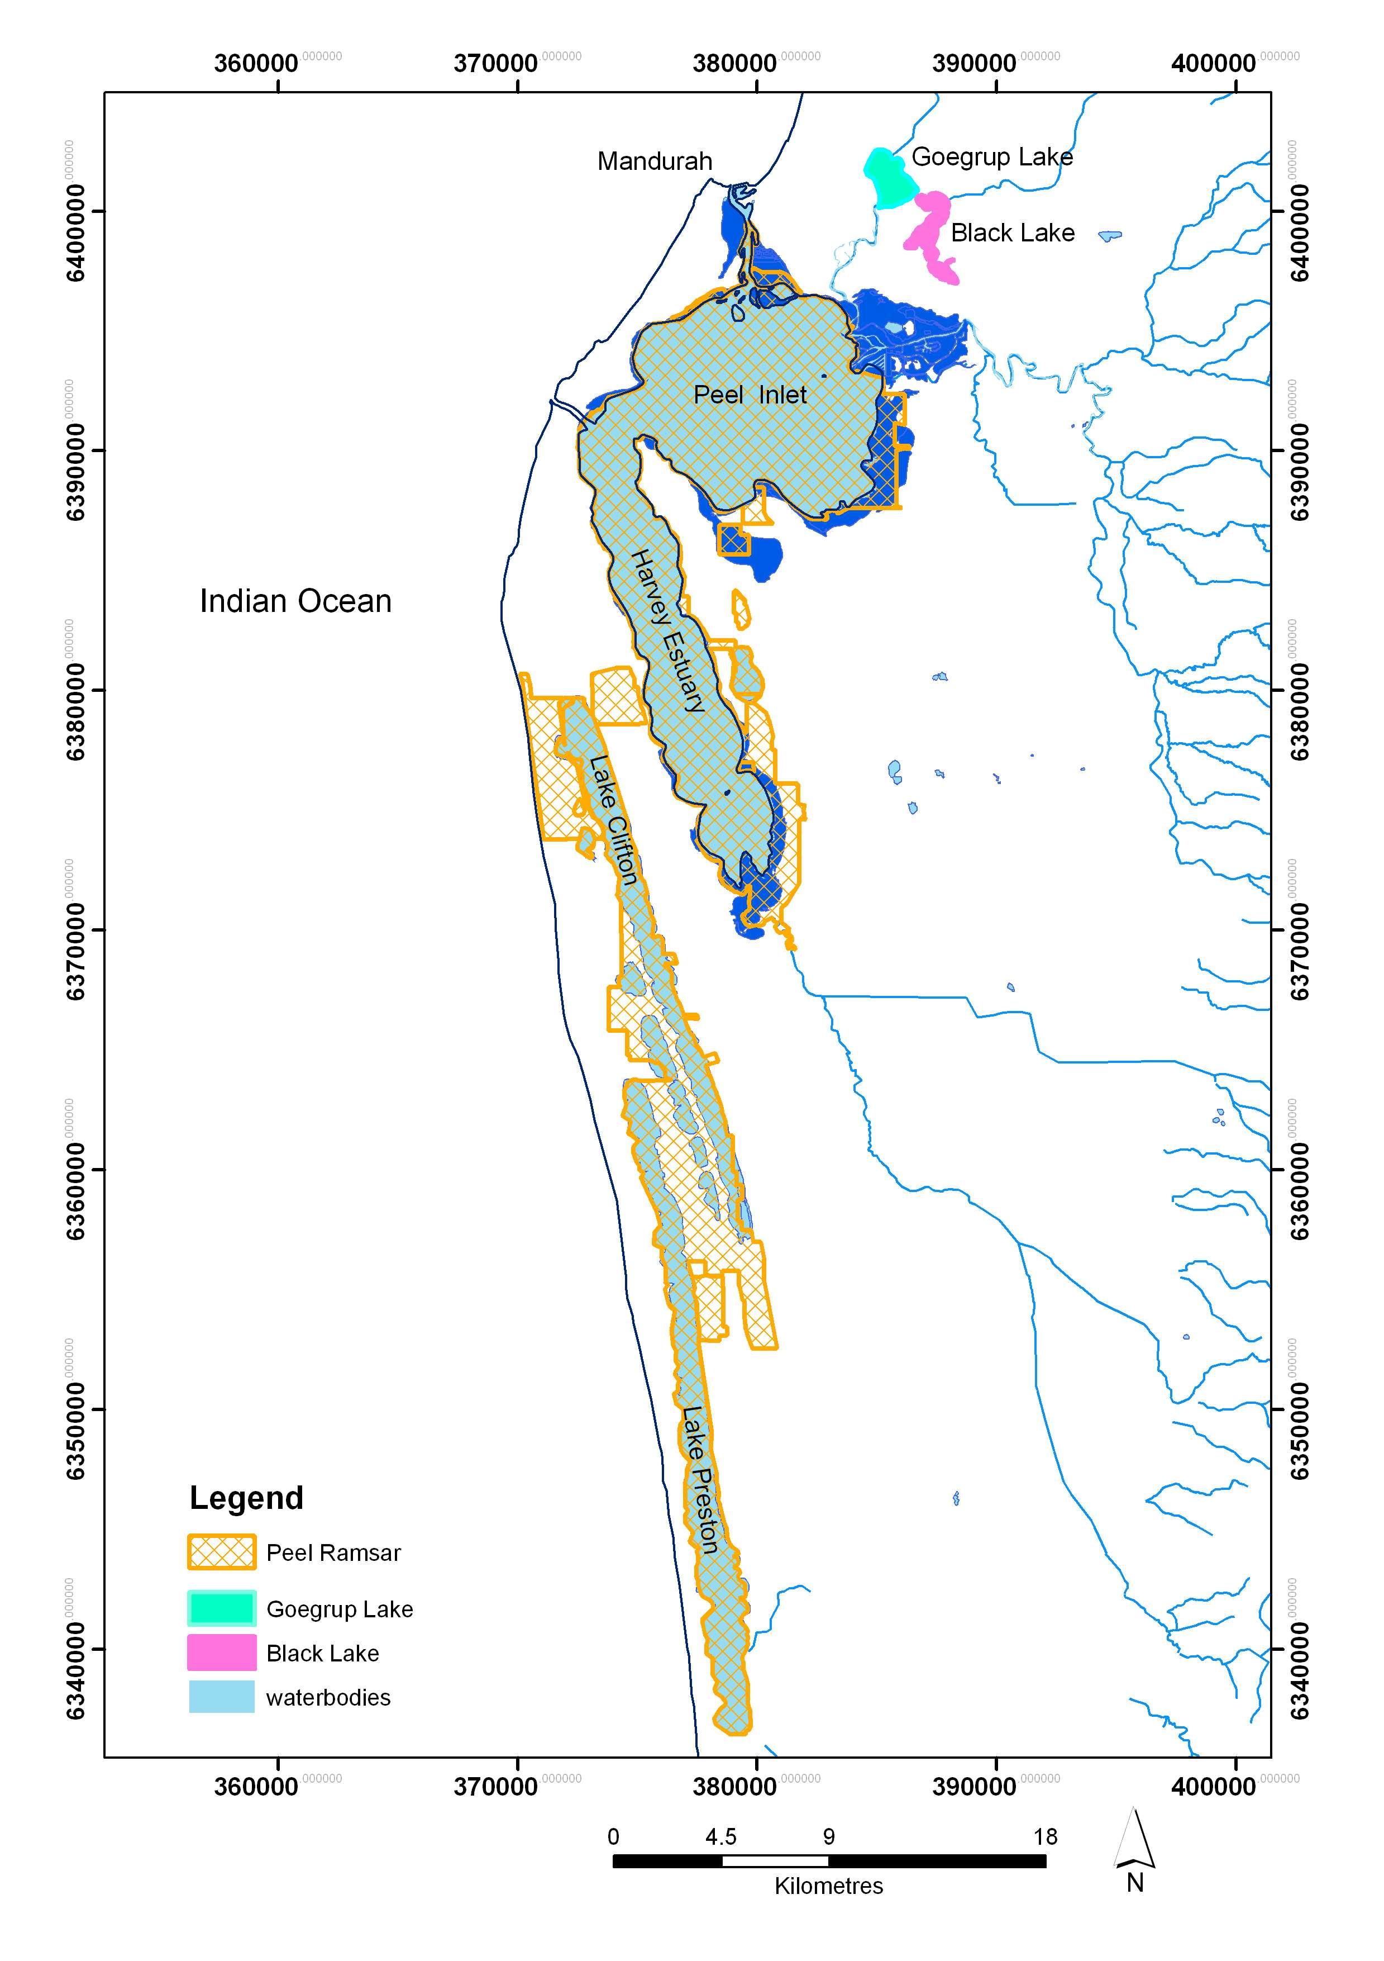
Figure B 1: Peel Yalgorup Ramsar site as indicated by the yellow boundary (Hale and BUTcher 2007).
The wetland types within the site have been assigned Ramsar wetland types as follows (Hale and Butcher 2007):
- Peel Inlet and Harvey Estuary – Marine/Coastal, dominated by “Estuarine Waters” with areas of “Intertidal mud and sand flats” and “Intertidal marshes”
- Yalgorup Lake System – Inland, dominated by “Permanent saline/brackish lake”
- McLarty Lake System – Inland, dominated by “Permanent and seasonal freshwater lakes over 8 ha”
Brooks et al. (2013) developed a typology for the application of the ANAE in the Murray Darling Basin. Possible ANAE types that could be present at the site which would fall under the Ramsar types present at site are presented in Table B 2. Mapping and or ground trothing would be required to confirm the type and extent of the ANAE types if a full application of the Framework was to be applied. It is important to note is that the Ramsar classification is a global system and therefore is more coarse that the ANAE.

Table B 2: Ramsar and possible ANAE wetland types. Ramsar types are presented in order of dominance (extent in hectares) (as per RIS 2003).
Ramsar code | Ramsar type | Possible ANAE type(s)
F | Estuarine waters | Tide dominated estuary
F | Estuarine waters | Tide dominated seagrass beds
F | Estuarine waters | Tide dominated subtidal seaweed beds
Q | Permanent saline/brackish/ alkaline lakes | Permanent saline lakes
Q | Permanent saline/brackish/ alkaline lakes | Permanent saline lakes with aquatic beds
O | Permanent freshwater lakes (over 8 ha) | Permanent lakes
O | Permanent freshwater lakes (over 8 ha) | Permanent lakes with aquatic beds
Ts | Seasonal/intermittent freshwater marshes/ on inorganic soils; seasonally flooded meadows, sedge marshes | Temporary tall emergent marshes
Ts |  | Temporary sedge/grass/forb marshes
Ts |  | Freshwater meadows
G | Intertidal mud, sand or salt flats | Tide dominated intertidal mudflats and sandbars
H | Intertidal marshes; includes salt marshes, salt meadows, raised salt marshes; includes tidal brackish and freshwater marshes | Tide dominated intertidal saltmarsh
W | Shrub-dominated wetlands; shrub swamps, shrub-dominated freshwater marshes, shrub carr, alder thicket on inorganic soils. | Permanent salt marshes
W |  | Temporary lignum swamps (?)
Xf | Freshwater, tree-dominated wetlands; includes freshwater swamp forests, seasonally flooded forests, wooded swamps on inorganic soils | Temporary paperbark swamps
Xf |  | Permanent paperbark swamps
Tp | Permanent freshwater marshes/pools | Permanent tall emergent marshes
Tp | Permanent freshwater marshes/pools | Permanent sedge/grass/forb marshes

Purpose
Consistent with the management objectives for the Peel-Yalgorup Ramsar site, the purpose of this application of the IECA Framework is to assess the 2016 state of the ecological character of the Peel Yalgorup Ramsar site.
For application of IECA at Ramsar sites, it’s important to note that the LAC are developed for the critical components, processes and services of the site and as such assessment is against these established thresholds. Risk assessments of threats are often included in Ramsar management planning and are occasionally included in associated monitoring programs. The IECA Framework may assist in identifying gaps and inform the development of assessment programs; however for Ramsar sites the focus of management will be on assessing trends in the critical CPS and response to management interventions. Aggregation of data will be limited at most Ramsar sites.

Groundwork

Accessing expertise: Establish a TAG or other appropriate oversight body (optional)
As described above, a TAG is already in place for the Peel-Yalgorup System and comprises a broad range of stakeholder groups and expertise.

Collating existing information
This illustration of how the steps of the IECA Framework could be applied to a Ramsar site was undertaken completely with existing publications and data. Key sources of information comprised:
- Peel-Yalgorup Ecological Character Description (Hale and Butcher 2007)
- Peel-Yalgorup Ramsar Site Management Plan (Peel-Harvey Catchment Council 2009)
- Lake Mealup Recovery Program (Peel-Harvey Catchment Council 2010)
- State of the Fisheries Reporting (Fletcher and Santoro 2015)
- Water quality data for the Peel-Harvey Estuary 2012 - 2016 (as supplied by the Department of Water)
- Water quality and hydrological data for Lakes McLarty and Mealup (as supplied for the Department of Parks and Wildlife)
- Waterbird data supplied by BirdLife WA: Shorebird 2020 Project’s annual count (2012 - 2016) with support of the Mandurah Bird Observers and Peel-Harvey Catchment Council
- Waterbird data available on the Atlas of Living Australia (http://www.ala.org.au/)
In addition to sourcing existing management plans and ecological descriptions, an important step in collating existing information would be to check if there have been any changes to species and communities of conservation significance present. For example in 2010 the Thrombolite (microbialite) Community of a Coastal Brackish Lake (Lake Clifton) was listed as critically endangered community under EPBC Act. Curlew sandpiper was listed as critically endangered under the EPBC Act in 2015 and are also found at the site. In a full application of the IECA Framework this would mean that the Thrombolite community and newly listed species such as the curlew sandpiper would be priority values of the site.

Define the spatial and temporal scale of the assessment
The spatial scale of the assessment is defined by the boundary of the Ramsar site. In addition to assessing character at the scale of the entire Ramsar site, a finer spatial scale has also been considered to illustrate reporting of condition at multiple spatial scales. The ECD (Hale and Butcher 2007) and Management Plan (Peel-Harvey Catchment Council 2009) grouped wetlands within the Peel-Yalgorup Ramsar Site according to geographic location and broad type. These groups have been adopted for the application of the IECA Framework:
- Peel Inlet and Harvey Estuary – Marine/Coastal, dominated by “Estuarine Waters” with areas of “Intertidal mud and sand flats” and “Intertidal marshes”
- Yalgorup Lake System – Inland, dominated by “Permanent saline/brackish lake”
- McLarty Lake System – Inland, dominated by “Permanent and seasonal freshwater lakes over 8 ha”

In terms of temporal scale, two questions are considered:
- What is the baseline against which condition will be assessed?
- What is the timeframe of the current assessment?
A benchmark for assessing change in character has been established within the ecological character description for the Ramsar site (Hale and Butcher 2007). The usual benchmark for a Ramsar site is “at the time of listing”. The Peel-Yalgorup Ramsar site was designated as a wetland of international importance in June 1990. In April 1994, the Dawesville Channel, a large artificial connection to the Indian Ocean, designed to decrease the nutrient accumulations and algal problems in the Peel-Harvey Estuary, was opened. The increased connection to the marine environment resulted in fundamental and permanent changes to ecological components of the Peel-Harvey Estuary and the ecological character description established a new benchmark for the Ramsar site against which future changes in character could be assessed. This illustration of the IECA Framework adopts this more recent benchmark as described in Hale and Butcher (2007).
The Limits of Acceptable Change (see Table B1) were used to guide the time period over which data would be assessed to represent current conditions. That is, several LAC include integration over a five year period to account for natural variability (e.g. ‘Support > 20,000 total waterbirds in 4 out of 5 years’). Therefore, a five year period of January 2012 to December 2016 has been selected as the temporal scale of assessment representing current conditions to illustrate the steps of the IECA Framework.

Identify existing conceptual models
There are several existing conceptual models for the Peel-Yalgorup Ramsar site that illustrate the links between components, processes and services (for example Figure B 2). Note that components, processes and services equate to ecosystem values as defined in the IECA Framework. The model in Figure B 2 has been updated to reflect the additional values identified at the site since the model presented below was developed (Figure B 3). For example the Thrombolite community and recently nationally listed waterbirds are present at the site which means the site meets an additional Ramsar listing criteria, criterion 2, which was not captured in the model below. Recreation, cultural heritage and identity, spiritual significance and ecological connectivity have been included in the updated conceptual model as these are likely significant values – but were not identified as critical in the 2007 ECD.
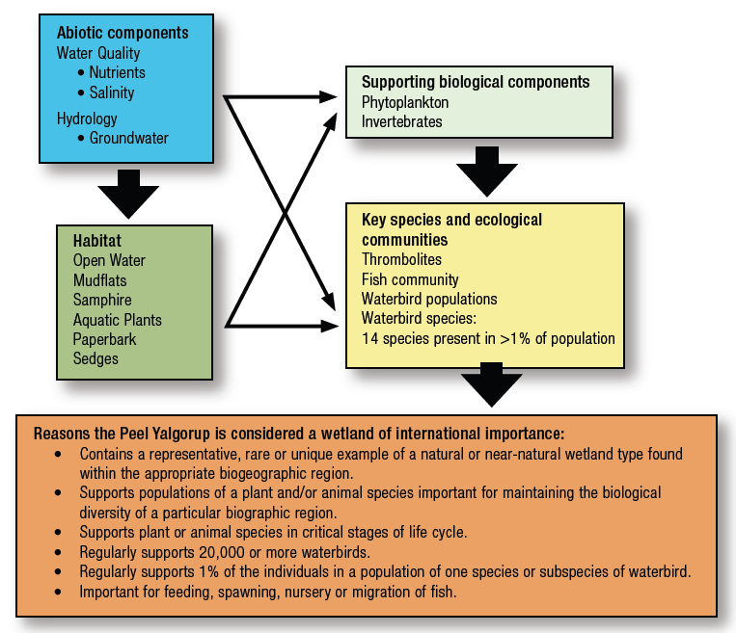
Figure B 2: Critical components and processes of the Peel-Yalgorup Ramsar Site at time of listing (Peel-Harvey Catchment Council 2009).
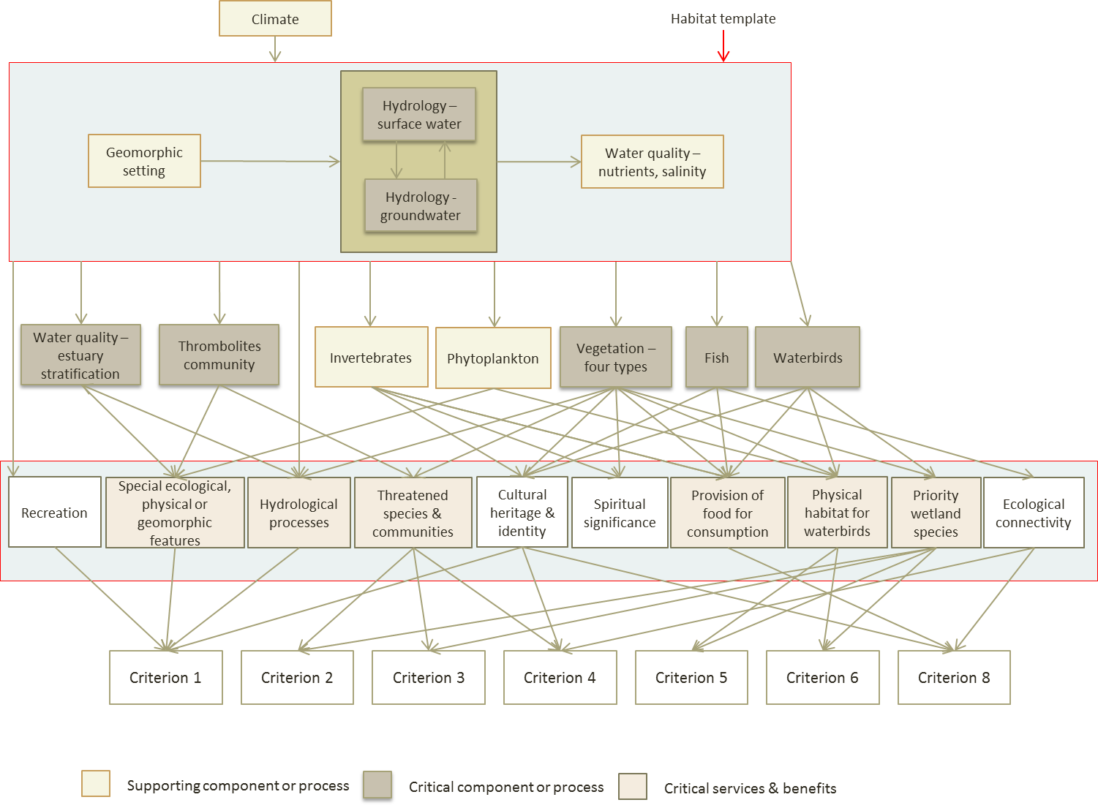
Figure B 3: Updated conceptual model indicating relationship between critical components, processes, services and the Ramsar criteria which are met as of 2016.

Identify externalities likely to affect the assessment
The Peel-Yalgorup Ramsar Site is a large and complex system that is affected by a number of local and regional factors. During the 2012–2016 assessment period, the region was subject to a number of years of below average rainfall and periods of drought (Bureau of Meteorology Climate online). The population of the Mandurah region has increased 15 % in the period 2011 to 2016 and there has been a significant increase in the number of buildings in and around the Ramsar site (Australian Bureau of Statistics).

Assumptions
This illustration of how the steps of the IECA Framework can be applied to a Ramsar site is based on a number of assumptions. The most significant of these is that the 2007 ecological character description adequately establishes a baseline and that the Limits of Acceptable Change reflect reasonable trigger values for the site. Any results of analysis must be considered in this context – that is it is for illustrative purposes only.

Part A: Outputs
Table B 3: Summary of required outputs from example application of Part A of the IECA Framework.
IECA Part A requirements | Application outputs – example only
Statement of management context | To manage the Peel Yalgorup Ramsar site to maintain or enhance its ecological character.
Refined existing, or newly developed, SMART management objectives | Objectives adopted from the Ramsar site management plan (Peel-Harvey Catchment Council 2009).
Existing, or newly developed, triggers and targets | Assess against existing Limits of Acceptable Change as specified in Table B 1.
Statement of purpose for IECA (how it relates to management context) | To assess condition status as of 2016, using data from 2012-2016 where available, for a sub-set of critical components, processes and services.
Spatial boundary description in plain English and GIS spatial layer | Ramsar site boundary as per Figure B 1.
Classification and map of aquatic ecosystems within the assessment unit using ANAE Classification and typology | Knowledge gap – in a full assessment this would need to be addressed. Possible ANAE types are provided in
Existing conceptual models relating to the assessment unit | Updated conceptual model including relationship between ecological values (critical CPS) and Ramsar listing criteria (Figure B 3).
Statement of spatial and temporal scale of assessment (may be included in objectives) | Assessment spatial scale – ecosystem type (mainly the Peel-Harvey Estuary).  Temporal scale: 2012-2016.
A stakeholder engagement process, including establishment of a TAG/oversight body | Utilise existing Peel-Yalgorup System Ramsar TAG.
Engagement of expert input, as needed. | Broad range of expertise is found on the Peel-Yalgorup System Ramsar TAG. Also the TAG regularly engages with Universities, state agencies, and other experts as required.
Identified externalities likely to affect assessment | None identified for this example application.
Clearly documented assumptions that have been made in the above processes to ensure transparency in the assessment | See above – main assumption is that the 2007 ECD adequately describes the ecological character of the site.

Part B: Workflow

Step 1: Identify and prioritise values
The ECD and Management Plan for the Peel-Yalgorup Ramsar site list a large number of values. As an example, the values of the Peel-Harvey Estuary portion of the site are listed, as identified in the ecological character description and management plan according to the IECA themes in Table B 2.
Table B 4: Values associated with the Peel-Harvey Estuary portion of the Ramsar site (Hale and Butcher 2007).
IECA Theme | Peel-Harvey Value | Components, processes, functions and services
Hydrology | Tidal exchange through the Dawesville Channel maintains water quality and habitat within the system | Process: tidal exchange
Hydrology | Seasonal surface water inflows moderate marine water salinities and bring nutrients from the catchment stimulating productivity. | Processes: seasonal freshwater inflows, primary production
Water quality | Water quality: seasonal fluctuations in salinity reflecting the balance between freshwater inflows and marine waters. Nutrients enter through the freshwater rivers and groundwater, and then are partially flushed out of the system. | Component: water quality (salinity, nutrients, dissolved oxygen)
Structural integrity | Geomorphology: Shallow “bar-built” estuary, with an artificial connection to the Indian Ocean. | Component: estuary form and mouth (artificial)
Aquatic ecosystem connectivity | Connectivity between rivers, estuary and the sea is important for migratory fish and marine invertebrates.  Connectivity between the Peel-Harvey Estuary and other locations in the Ramsar site provides a network of sites for feeding and breeding waterbirds. | Process: migration
Biodiversity | Seagrass and macroalgae provide habitat and food for fish and waterbirds and directly contribute to biodiversity. | Components: seagrass, macroalgae
Biodiversity | Fringing vegetation is dominated by coastal saltmarsh.  Areas of paperbark community at the Harvey River delta. | Components: saltmarsh and paperbark communities
Biodiversity | The site supports significant diversity and abundance of fish and estuarine invertebrates.  The estuary is an important breeding habitat for crabs, prawns and numerous fish species. | Components: fish and invertebrate diversity and abundance  Process: fish and invertebrate breeding
Biodiversity | The estuary supports a diversity and abundance of waterbirds, with an average of > 20,000 waterbirds annually and a maximum record of 150,000 waterbirds. This includes several species, listed under international migratory agreements. The estuary regularly supports > 1% of the population of eleven species of waterbird. Breeding has been recorded for 12 species of waterbird. | Component: waterbird diversity and abundance  Process: waterbird breeding  Process: waterbird migration
Services - provisioning | Peel-Harvey Estuary is an important commercial and recreational fishery. | Service: commercial and recreational fishing
Services - regulating | The estuary plays a role in flood mitigation for surrounding residential and agricultural lands. | Function: flood mitigation
Services - cultural | The estuary is a popular for recreation and acts as a tourist hub for the region. | Services: recreation and tourism
Services - cultural | The estuary is an important site for traditional custodians. | Service: indigenous cultural values

A prioritisation process to identify the components, processes and services that are critical to the ecological character of the Ramsar site is provided in the national framework for describing ecological character of Australian Ramsar Wetlands. There are four criteria based on components, processes and services (Department of the Environment, Water, Heritage and the Arts 2008):
- that are important determinants of the sites unique character;
- that are important for supporting the Ramsar criteria under which the site was listed;
- for which change is reasonably likely to occur over short to medium time scales (less than 100 years); and
- that will cause significant negative consequences if change occurs.
These criteria are not applied through a scoring system, but as absolutes, with the “critical” components, processes and services being those that meet all four criteria. An application of these criteria to the values identified for the Peel-Harvey portion of the Ramsar site results in a sub-set of values identified as critical to the ecological character of the Ramsar site (Table B 3). These are considered the priority values for this illustration of the application of the IECA Framework.
Table B 5: Performance matrix for the values of the peel-harvey estuary segment of the Ramsar site. Note that the table Largely reflects the results of the identification of critical components, processes and services provided by the ecological chacarter description (hale and Bucther 2007).
Values | Criterion 1 | Criterion 2* | Criterion 3 | Criterion 4 | Priority
Hydrology - Tidal exchange |  |  | X
Hydrology – Surface and groundwater inflows |  |  |  |  | High: critical component
Geomorphology |  |  | X
Water quality |  |  |  |  | High: critical component
Migration |  |  |  |  | High: process
Benthic plants (seagrass and macroalgae) |  |  |  |  | High: critical component
Fringing vegetation (saltmarsh and paperbark) |  |  |  |  | High: critical component
Fish and invertebrates |  |  |  |  | High: critical component
Waterbirds |  |  |  |  | High: critical component (abundance and diversity); process (breeding)
Commercial and recreational fishing |  | X |  |  | High: critical service (for crabs)*
Flood mitigation | X | X | X | X
Recreation and tourism | X | X |  | X
Indigenous cultural values |  | X
* note that a service cannot be considered critical under the criteria 2 as there are no Ramsar listing criteria specific to provision of services. In the case of commercial crabbing, the absence of this fishery would be viewed as a change in the character of the site and was included as a critical service in the ECD.
Assumptions and Knowledge gaps
The identification of priority values is based entirely on the information provided in the ECD for the site. No new information was sourced, nor was there any new analysis on the application of the criteria for identifying critical components, processes and services.

Step 2: Identify and prioritise threats
List pressures and stressors for the values identified in Step 1
The threats to ecological character identified in the management plan and ECD of the Peel-Yalgorup Ramsar site have been translated into the IUCN threat classification scheme (see Appendix E). Threats to ecological character are (adapted from Peel-Harvey Catchment Council 2009):
- Residential & Commercial Development - 1.1. Housing & urban areas
- Agriculture and Aquaculture - 2.3. Livestock farming
- Biological Resource Use - 5.4. Fishing & harvesting aquatic resources
- Human Intrusion & Disturbance - 6.1. Recreation activities
- Natural System Modifications - 7.2. Dams & water management/use
- Invasive & Other Problematic Species & Genes - 8.1. Invasive non-native/alien species
- Pollution - 9.1. Household sewage & urban wastewater, 9.3. Agricultural & forestry effluents
- Climate Change - 11.4. Changes in precipitation and hydrological regimes
Stressors associated with these threats include (adapted from Hale and Butcher 2007):
- Increased nutrients, toxicants, salinity and acidity
- Decreased extent, duration and frequency of inundation
- Increased sea level
- Invasive species
- Increased noise
Develop a stressor model to illustrate impact pathways
The stressor model developed for the Peel-Yalgorup Ramsar site has been modified to adopt the IUCN threat categories (Figure B 4).

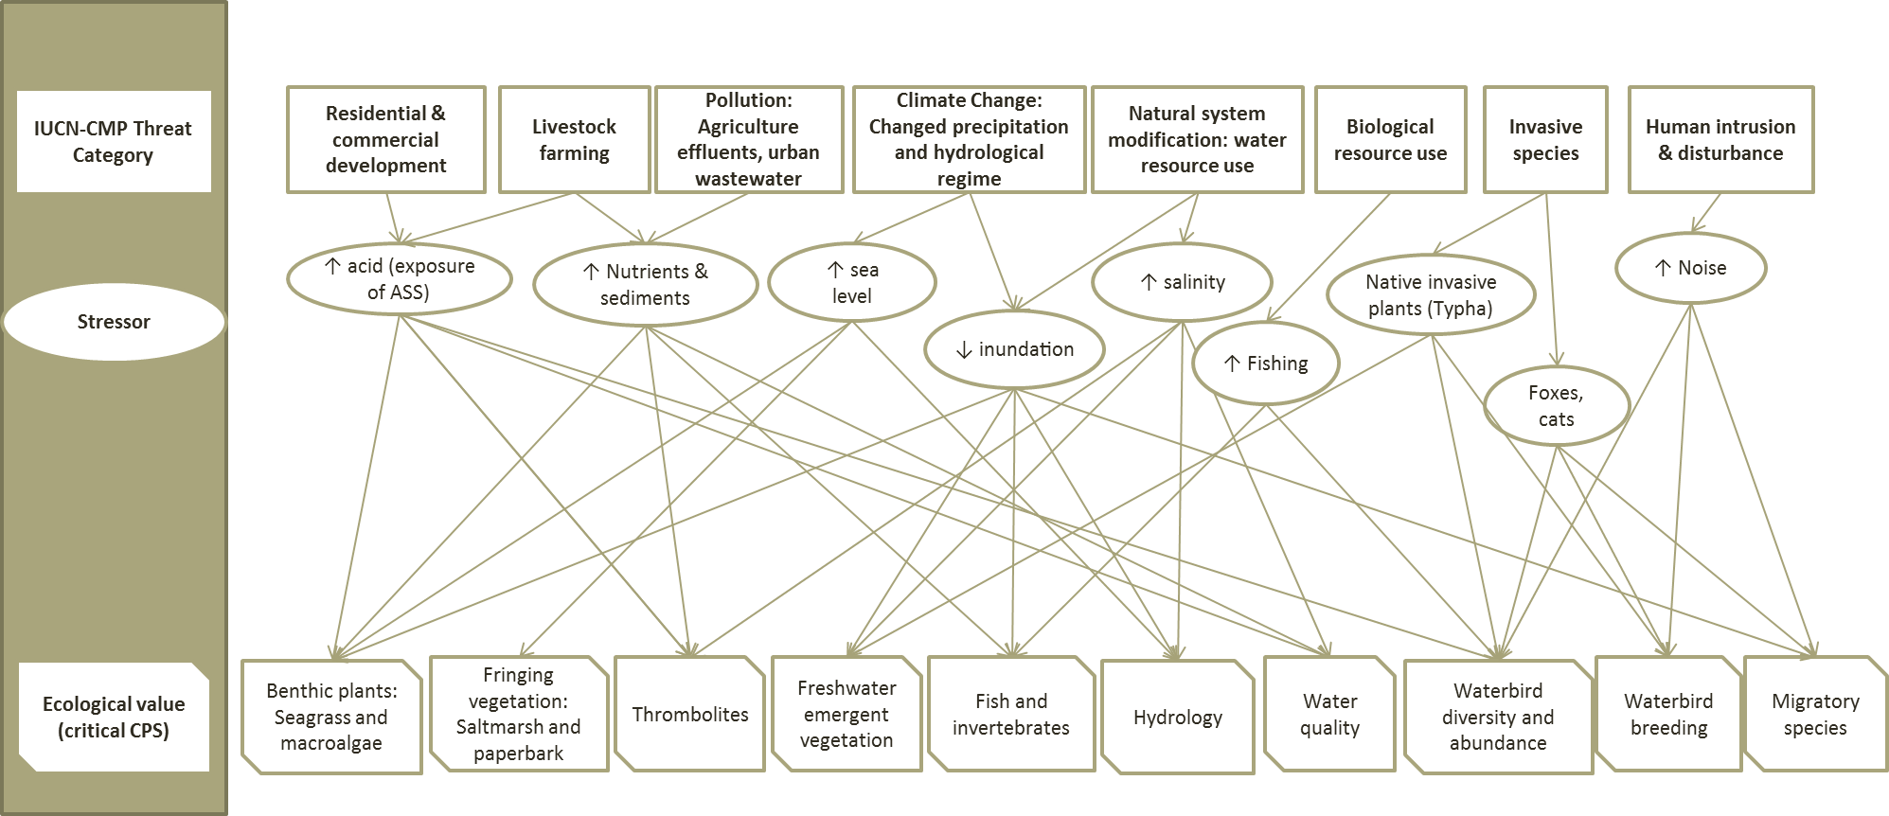

Figure B 4: Stressor model of pressures and stressors affecting the priority values for the Peel-Yalgorup Ramsar site (Modified from hale and butcher 2007).
Assign risk to each threat-value combination and rank threats / Adapting outputs from existing risk assessments
The management plan for the Peel Yalgorup Ramsar Site (Peel-Harvey Catchment Council 2009) completed a comprehensive risk assessment that assessed the effects of threats (which they defined as “sources of stress”) and stresses on the critical components, process and services of the site. This process was similar to the impact pathway approach of IECA and the outputs considered suitable for the identification of priority threats (Table B 6). The outputs of the risk assessment identified the following high priority threats (and associated stressors) (adapted from Peel-Harvey Catchment Council 2009):
- Climate change and water resource use - exposure of ASS
- Pollution from agriculture and urban sources - increased nutrients
- Climate change and water resource use - decreased frequency, extent and duration of inundation
- Climate change and water resource use - increased salinity
- Recreation - increased noise and physical disturbance
- Climate change - sea level rise
- Invasive species – Typha
Table B 6: Outputs of risk assessment (adapted from Peel-Harvey Catchmenet Council 2009).
Threat | Stressor | Peel-Harvey | Yalgorup Lakes | Lakes McLarty & Mealup
Climate change | Sea level rise | High | Low | Low
Climate change and water resource use | Decreased inundation | Low | High | High
Climate change and water resource use | Exposure of ASS | Medium |  | Very High
Climate change and water resource use | Increased salinity |  | High | Medium
Pollution: Agricultural and urban | Increased nutrients | High | High | High
Invasive species | Typha |  |  | High
Recreation | Noise | Medium | High | Medium
Biological resource use | Fishing | Medium

Assumptions and Knowledge gaps
The identification of priority threats is based entirely on the information provided in the ECD and management plan for the site. No new information was sourced, nor was there any new risk assessment. The outputs of the previous risk assessment process have simply been adapted to the IECA terminology. It is possible that there have been significant change in threats to the site in the past 8 years that are not captured.

Step 3: Develop Key Evaluation Questions (KEQs)
Refine conceptual model relating to impact pathways of high risk and high priority values
A hypothetical example of a refined conceptual model for the high priority stressor of increased nutrients in the Peel-Harvey Estuary segment of the Ramsar site is provided in Figure B 5. It uses an example modifier from the Water Quality Improvement Plan (EPA 2008) and illustrates potential short, medium and long term responses.

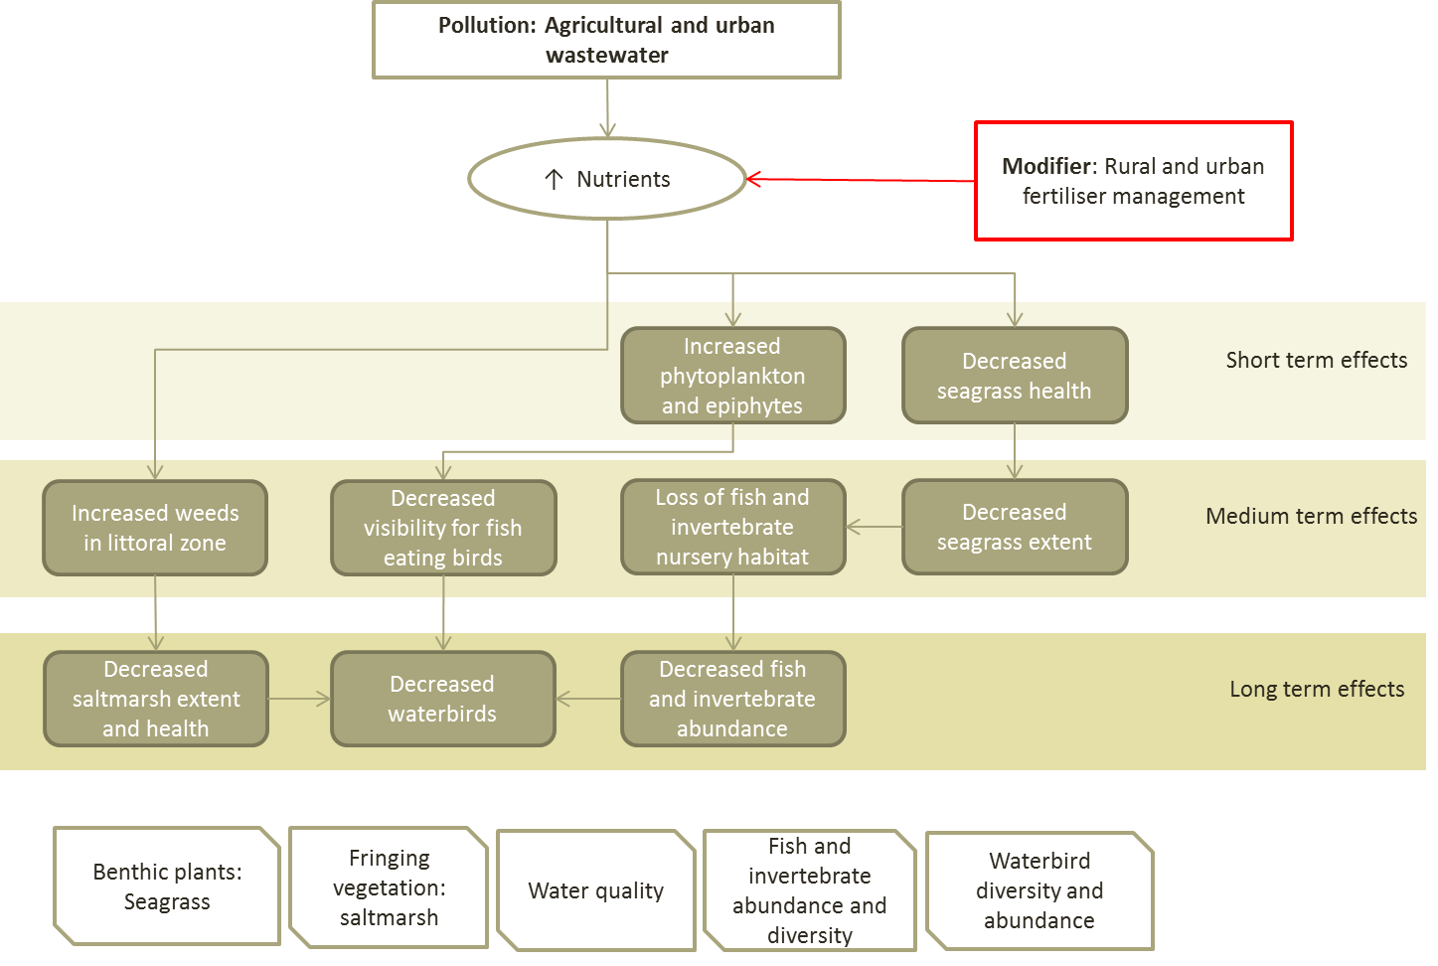
Figure B 5: Pressure Stressor Response conceptual model showing potential modifier and temporal scale of ecological effects of increased nutrients in the peel-harvey estuary segment.
Draft KEQs relating to management objective for each scale of assessment
The management objective for the Peel-Yalgorup Ramsar site is to protect and / or restore ecological character. KEQs for this system will therefore be related to ensuring that indicators for priority values (critical components, process and services) are within the thresholds established by Limits of Acceptable Change. In order to assess the effectiveness of management actions on protecting and restoring ecological character, KEQs can also be derived for priority threats. Some examples of KEQs for both values and threats are provided in Table B 7.
Table B 7: Hypothetical Key Evaluation Questions for the Peel Yalgorup Ramsar site. Note: this is only a very small number of KEQ, used only to illustrate the approach.
Management objective | Key Evaluation Question | Assumption | Temporal scale of effect | Spatial scale of effect
To work towards protecting and/or restoring the ecological character of the Peel-Yalgorup System | Has abundance of waterbirds been maintained as indicated by Limits of Acceptable Change? | Limits of Acceptable Change adequately reflect the benchmark condition | Medium term 5 years | Whole of site
 | Has waterbird breeding been maintained as indicated by Limits of Acceptable Change? | Limits of Acceptable Change adequately reflect the benchmark condition | Medium term 5 years | Whole of site
 | Have commercial crab numbers been maintained within Limits of Acceptable Change? | Limits of Acceptable Change adequately reflect the benchmark condition | Short term Annual | Peel-Harvey Estuary
 | Has saltmarsh extent and condition been maintained? | Baseline of extent and condition has been established. | Long term 10 years | Peel-Harvey Estuary
 | Have nutrient concentrations reduced since the implementation of the Water Quality Improvement Plan (WQIP) in 2008? | Actions in the WQIP have been implemented | Long term 10 years | Peel-Harvey Estuary

Step 4: Identify and prioritise indicators
The process for establishing Limits of Acceptable Change for the Peel-Yalgorup Ramsar site used a prioritisation for selection of indicators. A series of criteria were applied to identify indicators (Hale and Butcher 2007):
- For which there is adequate information to form a baseline against which change can be measured;
- For which there is sufficient information to characterise natural variability;
- That are primary determinants of ecological character;
- That can be managed; and
- That can be monitored.
A subset of indicators resulted from this process, and then a hierarchical approach based on the expected temporal scale of change was applied. This led to short term indicators measured within an annual timeframe for abiotic components and processes such as water quality and hydrology and medium to long-term indicators for biological responses. The output was a prioritised set of indicators for values and threats at defined temporal and spatial scales. These have been translated into the IECA format and terminology (Table B 8).
Table B 8: Potential indicators for high priority values and threats in the Peel Yalgorup Ramsar site showing IECA indicator type, time frame for collection of data and relevant location within the Ramsar site.
IECA Theme | Indicator | IECA Indicator type | Time frame | Relevant location
Hydrology | Water level | Pressure, Condition | Collected monthly, reported annually | Yalgorup Lakes, Lakes McLarty and Mealup
Water quality | Total phosphorus | Pressure | Collected monthly, reported annually | Peel-Harvey Estuary
Water quality | Orthophosphate, ammonium, nitrate-nitrite | Pressure | Collected monthly, reported annually | All segments
Water quality | Salinity | Stressor, Condition | Collected monthly, reported annually | All segments
Water quality | pH | Stressor, Condition | Collected monthly, reported annually | All segments
Water quality | Dissolved oxygen | Response, Condition | Collected monthly, reported annually | Peel-Harvey Estuary
Biodiversity | Chlorophyll a | Stressor | Collected monthly, reported annually | Peel-Harvey Estuary
Biodiversity | Macroalgae density | Stressor | Annual | Yalgorup Lakes
Biodiversity | Thrombolites extent | Condition | Annual | Yalgorup Lakes
Biodiversity | Aquatic plants extent | Condition | Annual | Lakes McLarty & Mealup
Biodiversity | Typha extent | Stressor | Annual | Lakes McLarty & Mealup
Biodiversity | Paperbark extent | Condition | Annual | Lakes McLarty & Mealup
Biodiversity | Waterbirds: abundance | Condition | Measured annually reported in a rolling five year period | All segments
Biodiversity | Waterbirds: evidence of breeding | Condition | Measured annually reported in a rolling three year period | All segments
Services | Commercial crab catch per unit effort | Condition | Annual | Peel-Harvey Estuary

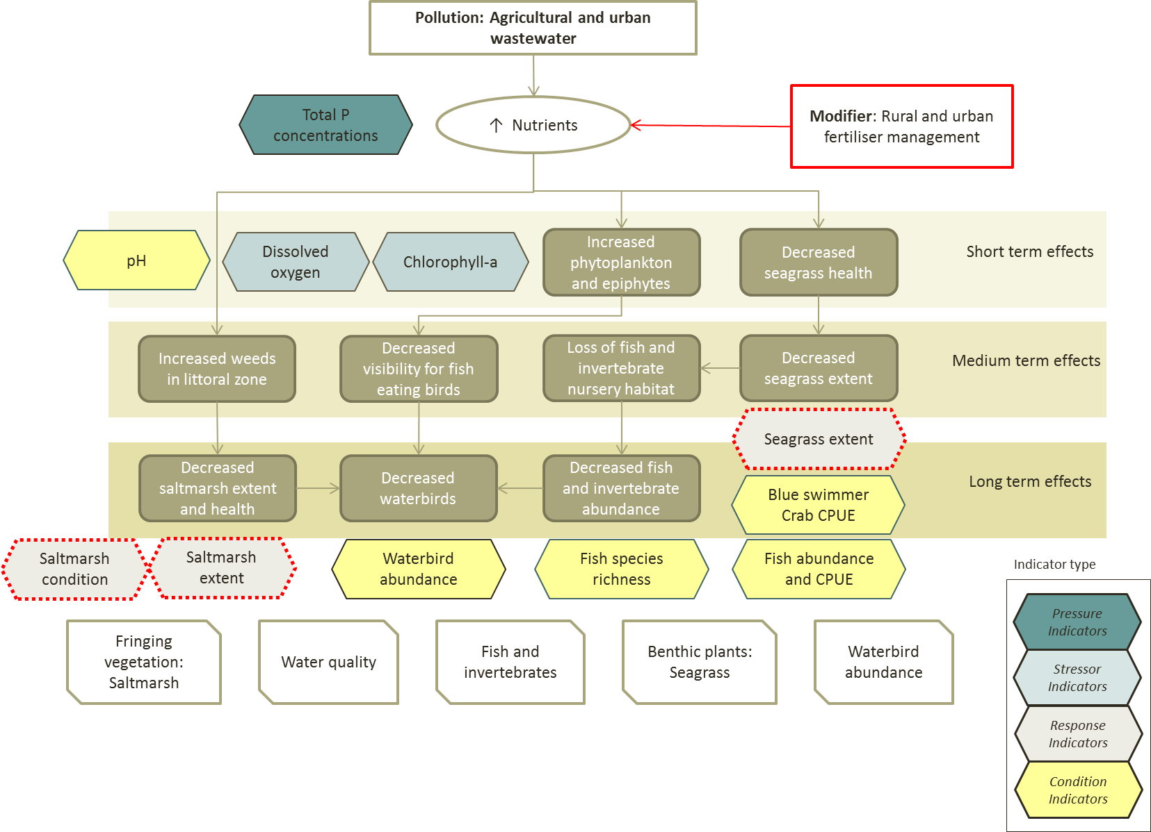
Figure B 6: Pressure Stressor Response conceptual model showing potential modifier and subset of indicators for assessing Pollution: Agricultural and urban wastewater impacts on the peel-harvey estuary segment of the Ramsar site. Indicators with dashed red outline are those for which existing data is lacking – see Step 5. Note that the indicator may also be a different type to that shown, for example pH can be both a condition and stressor indicator.

Step 5: Design assessment and implementation
In a full application further consideration of the existing monitoring programs would be undertaken – for example the waterbird and crab sampling design – whether these were considered adequate or in need of refinement (see comments under Step 7 assumptions and knowledge gaps).
However, for the purposes of illustrating this step in the IECA Framework, a single indicator from the site has been selected: extent of fringing vegetation.
Review existing programs and information with respect to indicators and KEQs and undertake a fit for purpose assessment and identify gaps.
Fringing vegetation (saltmarsh) is identified as a priority value (critical component) of the Peel-Harvey Estuary (Hale and Butcher 2007). A Limit of Acceptable Change was not developed for this component, as there was insufficient information upon which a baseline could be established. The ecological character description and management plan for the site indicated monitoring should be implemented to fill this knowledge gap. The objective of the vegetation monitoring program was to (Peel-Harvey Catchment Council 2009):
“To determine the extent and condition of samphire and paperbark communities fringing the Peel-Harvey Estuary to set a baseline against which change can be assessed”.
In 2009, saltmarsh extent within the Ramsar site was assessed via remote sensing using 1995 and 2007 aerial imagery. This assessment reported a total saltmarsh extent in the Peel-Harvey Estuary (within the Ramsar boundary of 287 hectares in 2007; which represented a 20% loss in extent since 1995 (Hale and Kobryn 2009). The remote sensing method, however, was not able to determine community composition or health.
In 2008 and 2009, monitoring of saltmarsh condition and extent was implemented at several transects around the Peel-Harvey Estuary and elsewhere in the Ramsar site (DEC 2008, Smith 2009). A review of the vegetation monitoring in the Ramsar site indicated that the method used was limited by a lack of replication and incomplete sample design (Hale 2010). Given these limitations, it is unlikely to be fit for purpose for use in the IECA.
Identify data deficiencies and priorities
The KEQ for saltmarsh is: “Has saltmarsh extent and condition been maintained?” In order to answer this question, a more recent assessment of saltmarsh extent is required as well as an assessment of saltmarsh condition. Given that there is no benchmark at the time of listing for saltmarsh condition at the site, but that one for extent has been established, then the indicator saltmarsh extent may be considered a higher priority indicator. It can also be assumed that a change in condition may, over time, be reflected in a change in extent of the community and so extent may act as a surrogate for condition, albeit over longer time scales.
Design assessment program to address KEQs (this includes identifying sampling frequency and locations for each indicator, sampling protocols)
While a complete design of a monitoring program for saltmarsh extent and condition is beyond the scope of this case study example, as a start the mapping completed by Hale and Kobryn in 2009 (based on 2007 aerial imagery) should be repeated to assess current extent.
A method for assessing saltmarsh condition, which includes a sample design, indicators, field methods and a guide on analysis is provided in Hale (2010). This would provide a benchmark against which change in saltmarsh condition could be assessed.

Step 6: Analyse and Aggregate
Three sources of data have been used to illustrate the analysis and aggregation steps of the IECA Framework:
  - Water quality data collected by the Department of Water at six locations within the Peel-Harvey Estuary - aggregated to the wetland scale (i.e. Peel-Harvey Estuary),
  - Waterbird abundance data provided by BirdLife WA from 25 sites across the Ramsar site as part of the Shorebirds 2020 annual count - aggregated to the scale of the assessment unit (i.e. the Peel Yalgorup Ramsar Site), and
  - Commercial crab catch data reported by Fisheries WA - already aggregated to the wetland scale (i.e. Peel-Harvey Estuary).
Several indicators were extracted from these data to assess against three themes using different techniques (Table B 9).
Table B 9: Summary of indicators, themes and aggregation methods used in this case study.
Theme | Indicators | Indicator type | Aggregation method | Temporal scale | Spatial scale
Water quality | pH | Stressor | Proportion of samples within LAC each year | 2012-2016 | Peel-Harvey Estuary
Water quality | Dissolved oxygen | Response | Proportion of samples within LAC each year | 2012-2016 | Peel-Harvey Estuary
Water quality | Total phosphorus | Pressure | Proportion of samples within LAC each year | 2012-2016 | Peel-Harvey Estuary
Biodiversity | Total waterbird abundance | Condition | Sum | 2012-2016 | Peel Yalgorup Ramsar Site
Services: provisioning | Blue-swimmer crab (catch per unit effort) | Condition | Average | 2012-2016 | Peel-Harvey Estuary

The indicators for the water quality theme have LAC that are based on comparisons with individual readings, rather than an average or median value:
- pH > 7 at all times
- dissolved oxygen concentrations of 70–80 % saturation
- Total phosphorus concentrations < 30 mg/L (maximum)
Data from four sites across the Peel-Harvey Estuary, collected monthly (for most parameters) from January 2011 to December 2016, were compared to the LAC and the proportion of samples that were within the LAC calculated (Table B 10).
Table B 10: Proportion (on a scale of 0 to 1, where 1 = 100 %) of samples at each site that were within Limits of Acceptable change for the three indicators of water quality (pH, dssolved oxygen and total phosphorus). * Total Phosporus data is not available, but all available data were within the LAC and the years with missing data are assumed to be the same.
Site | Year | pH | Dissolved oxygen | Total phosphorus
PHE01 | 2012 | 0.85 | 0.23 | 1.00
PHE04 | 2012 | 0.85 | 0.00 | 1.00
PHE07 | 2012 | 0.85 | 0.00 | 1.00
PHE31 | 2012 | 0.85 | 0.38 | 1.00
PHE01 | 2013 | 0.92 | 0.15 | 1.00
PHE04 | 2013 | 0.92 | 0.15 | 1.00
PHE07 | 2013 | 0.92 | 0.15 | 1.00
PHE31 | 2013 | 0.92 | 0.38 | 1.00
PHE01 | 2014 | 1.00 | 0.00 | 1.00*
PHE04 | 2014 | 1.00 | 0.09 | 1.00*
PHE07 | 2014 | 1.00 | 0.00 | 1.00*
PHE31 | 2014 | 1.00 | 0.00 | 1.00*
PHE01 | 2015 | 1.00 | 0.06 | 1.00*
PHE04 | 2015 | 0.93 | 0.00 | 1.00*
PHE07 | 2015 | 0.93 | 0.00 | 1.00*
PHE31 | 2015 | 1.00 | 0.25 | 1.00*
PHE01 | 2016 | 1.00 | 0.09 | 1.00
PHE04 | 2016 | 1.00 | 0.05 | 1.00
PHE07 | 2016 | 1.00 | 0.00 | 1.00
PHE31 | 2016 | 1.00 | 0.09 | 1.00

Waterbird abundance is the indicator selected to provide an example of data analysis and aggregation for the biodiversity theme. Waterbirds are counted in February each year at 25 sites across the Ramsar site and data was provided by BirdLife WA. These counts are part of the national Shorebirds 2020 program and may not capture all species and for primarily temporal reasons may also not capture the highest abundance of birds at the site. For this reason, counts were augmented with data from the Atlas of Living Australia. The highest maximum count for each species was extracted (regardless of source) to calculate total waterbird abundance for each segment of the Ramsar site. The totals from each segment were then summed to provide an overall abundance for the Peel-Yalgorup Ramsar site for each year (Table B 11).
Table B 11: Waterbird abundance in the Peel Yalgorup Ramsar site 2012 - 2016 (data from BirdLife WA and Atlas of living australia).
Year | Peel-Harvey Estuary | Yalgorup Lakes | Lakes McLarty and Mealup | Total for Peel-Yalgorup Ramsar site
2012 | 20395 | 20913 | 281 | 41589
2013 | 16958 | 64811 | 5924 | 87693
2014 | 20295 | 18445 | 19698 | 58438
2015 | 30475 | 18166 | 3182 | 51823
2016 | 15214 | 12398 | 697 | 28309

Commercial crab catch data was used as the indicator for the provisioning services theme. This data was aggregated for the Peel-Harvey Estuary by Fisheries WA and is reported as median catch per unit effort (weight of crabs per trap).
Table B 12: Catch per unit effort (CPUE) for blue swimmer crabs in the Peel-Harvey Estuary (data from Fletcher and Santoro 2015).
Year | CPUE (kg / trap)
2010 | 1.2
2011 | 1.3
2012 | 1.4
2013 | 1.4
2014 | 1.3
2015 | 1.4

Assumptions and Knowledge gaps
There are a large number of assumptions associated with the analysis and aggregation of data for the three example themes:
- The water quality data was analysed with the assumption that the four sites in Peel-Harvey were randomly located and representative of the waterbody as a whole.
- The waterbird data has an assumption that it represents the annual maximum count for the site, which is unlikely to be true as the timing of the survey is selected to be best at a national scale, when an earlier count would better reflect maximum numbers at this location. Although all waterbirds are counted in the survey, the monitoring program is focused on shorebirds and other species may not be well represented by either the location or the timing of surveys. As such there is a low level of confidence the data. In a full application of the IECA this would have been identified as an issue and additional data collected to assess waterbird abundances at appropriate temporal scales.
- The assumption for the commercial crab indicator is that the data is a census and that the numbers given are relevant to and representative of the Peel-Harvey Estuary. Again in a full application this is probably a value for which additional data would be collected, one that considers population character structure (i.e. age class distributions).

Step 7: Harmonise and Integrate
Data from the three themes illustrated in Step 6 have been integrated to provide IECA scores by comparing the aggregated data with the Limits of Acceptable Change, and for waterbird abundance, a comparison with the Ramsar listing criteria of regularly supporting > 20,000 waterbirds across the entire site.
For water quality, the proportion of samples that were within LAC were averaged across the three threat indicators, the four sites and the five sample years to derive an Level 1 Integration IECA score for Water quality of 0.69 (Table B 13).
Table B 13: Water quality Threat Score dervied for pH, Dissolved oxygen and total phosphorus across four sites and five years. In a full application other water quality data may be included.
Site | Year | pH | Dissolved oxygen | Total phosphorus | Water quality  Integration Level 1
PHE01 | 2012 | 0.85 | 0.23 | 1.00 | 0.69
PHE04 | 2012 | 0.85 | 0.00 | 1.00 | 0.62
PHE07 | 2012 | 0.85 | 0.00 | 1.00 | 0.62
PHE31 | 2012 | 0.85 | 0.38 | 1.00 | 0.74
PHE01 | 2013 | 0.92 | 0.15 | 1.00 | 0.69
PHE04 | 2013 | 0.92 | 0.15 | 1.00 | 0.69
PHE07 | 2013 | 0.92 | 0.15 | 1.00 | 0.69
PHE31 | 2013 | 0.92 | 0.38 | 1.00 | 0.77
PHE01 | 2014 | 1.00 | 0.00 | 1.00 | 0.67
PHE04 | 2014 | 1.00 | 0.09 | 1.00 | 0.70
PHE07 | 2014 | 1.00 | 0.00 | 1.00 | 0.67
PHE31 | 2014 | 1.00 | 0.00 | 1.00 | 0.67
PHE01 | 2015 | 1.00 | 0.06 | 1.00 | 0.69
PHE04 | 2015 | 0.93 | 0.00 | 1.00 | 0.64
PHE07 | 2015 | 0.93 | 0.00 | 1.00 | 0.64
PHE31 | 2015 | 1.00 | 0.25 | 1.00 | 0.75
PHE01 | 2016 | 1.00 | 0.09 | 1.00 | 0.70
PHE04 | 2016 | 1.00 | 0.05 | 1.00 | 0.68
PHE07 | 2016 | 1.00 | 0.00 | 1.00 | 0.67
PHE31 | 2016 | 1.00 | 0.09 | 1.00 | 0.70
Aggregated indicator score |  | 0.95 | 0.1 | 1.0
Integrated water quality score for Peel-Harvey Estuary (Level 1 integration) |  |  |  |  | 0.69

The Biodiversity score is calculated by comparing total abundance with the LAC; “> 20,000 waterbirds in four out of five years”, applied to each segment. In order to be recognised as a wetland of international importance under the Ramsar Convention, a wetland must meet at least one of nine listing criteria. The Peel Yalgorup Ramsar site meets (among others) criterion 5 (regularly supports > 20,000 waterbirds). Compliance with this listing criterion has also been applied in deriving an integrated IECA score for biodiversity. In this instance, compliance with the LAC is assigned a score of 1 and non-compliance is assigned a score of 0 (Table B 14).
Change in ecological character is typically assessed at the whole of the Ramsar site, and applications of the criteria are also assessed at the whole of site scale. Therefore, for the purpose of illustrating the application of the Framework, the appropriate scale of assessment for waterbird abundance in relation to meeting criterion 5 is the whole of the assessment unit (Ramsar site).
In a full application at the site, addition for other elements of biodiversity (i.e. vegetation, migratory species, etc.) would be aggregated to the appropriate scale then integrated to provide an output for the theme.
Table B 14: Waterbird abundance in the Peel Yalgorup Ramsar site 2012 - 2016 (data from BirdLife WA and Atlas of living australia).
Year | Peel-Harvey Estuary | Yalgorup Lakes | Lakes McLarty and Mealup | Total for Peel-Yalgorup Ramsar site
2012 | 20395 | 20913 | 281 | 41589
2013 | 16958 | 64811 | 5924 | 87693
2014 | 20295 | 18445 | 19698 | 58438
2015 | 30475 | 18166 | 3182 | 51823
2016 | 15214 | 12398 | 697 | 28309
Ecosystem/segment score | 0 | 0 | 0 | 1
Waterbird abundance aggregated and harmonised – whole of assessment unit |  |  |  | 1

The LAC for commercial crab catches is “median CPUE for blue swimmer crabs should not drop below 1.0 kg/trap lift per annum (based on commercial fishing).” The integrated score is calculated by averaging compliance with the LAC over the five year assessment period. Compliance with the LAC is assigned a score of 1 and non-compliance is assigned a score of 0 (Table B 15).
Table B 15: Level 1 Integrated IECA score for services.
Year | CPUE (kg / trap) | Crab indicator
2011 | 1.3 | 1
2012 | 1.4 | 1
2013 | 1.4 | 1
2014 | 1.3 | 1
2015 | 1.4 | 1
Level 1 Integrated services score |  | 1

As stated above, a full application of IECA would capture additional data, including data on the hydrology of the lakes (groundwater and surface water), salinity, vegetation, phytoplankton, threatened species, invasive species, macroalgae, recreational impacts and other threating processes. Many of these are monitored and contribute to assessing the ecological character of the site; but were not included in this example. In a full application, some new data would be collected, for example to assess saltmarsh in the Peel-Harvey Estuary, and possibly new thresholds set (i.e. update some of the LAC to meet current national guidelines, DEWHA 2008). Figure B 7 and Figure B 8 present a possible set of indicators relating to assessment of condition, and threats to, the priority ecological values of the site.
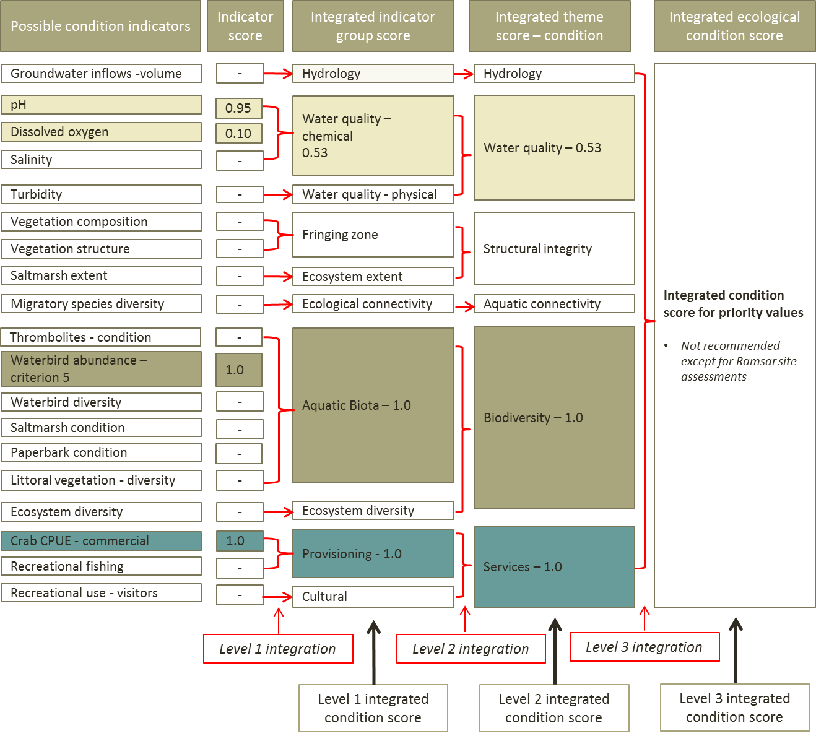
Figure B 7: Illustration of integration for condition indicators for the Peel-Yalgorup Ramsar site. Shaded boxes represent the output for indicators used in the case STUDY; the white boxes are an example of the possible range of condition indicators that could be included in an assessment – which would change the Level 1 and 2 Integrated scores.

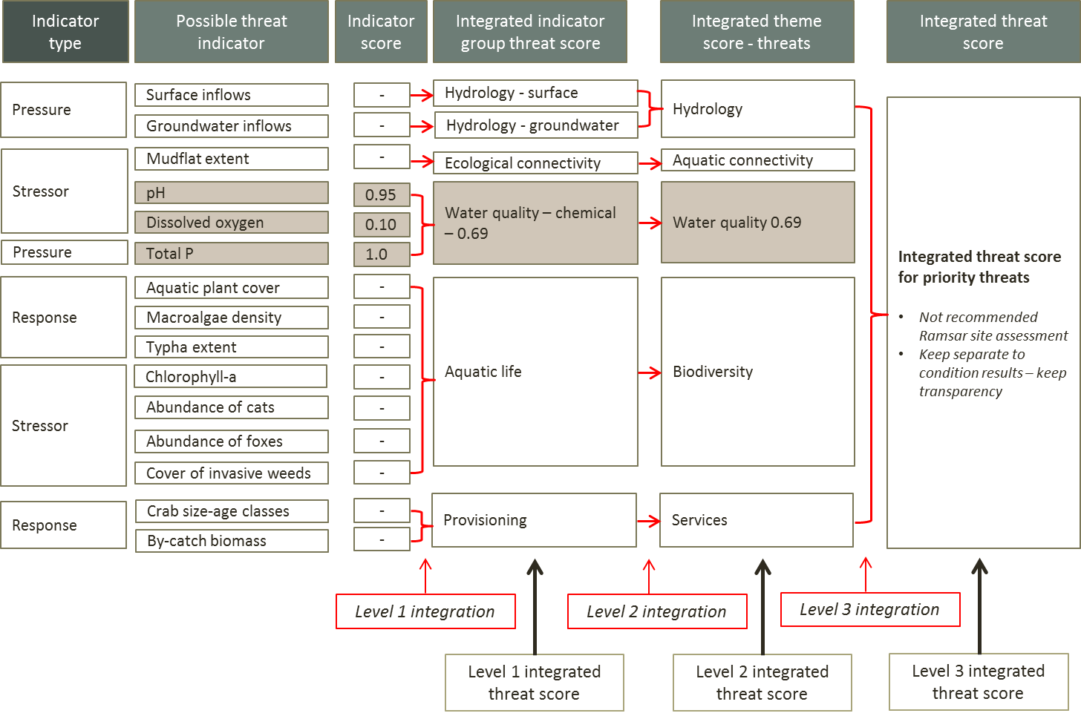
Figure B 8: Illustration of integration for threat indicators for the Peel-Yalgorup Ramsar site. Shaded boxes represent the output for indicators used in the case STUDY; the white boxes are an example of the possible range of threat indicators that could be included in an assessment – which would change the Level 1 and 2 Integrated scores.

Assumptions and Knowledge gaps
All the assumptions listed under Step 6 (Analysis and aggregation) apply equally to this integration step. In addition, there is an assumption that the Limits of Acceptable Change adequately establish a benchmark for this site.
It must be stressed that this case study is simply illustrating how the steps in the IECA Framework can be applied to a Ramsar wetland. The scores calculated do not reflect the actual condition of the site and do not account for a large number of critical components, processes and services.

Step 8: Report Card
The final step in the IECA Framework is to develop a report card. For a Ramsar site, the audience for a report card would vary, but one of the primary audiences is the general public. In developing a report card for the general public the objectives would include promoting awareness of the Ramsar Convention, the values and benefits associated with the site, and the current or trends in condition and threat to the priority values.
An example of a report card was not produced as too few indicators were included in the case study.

References cited
DEC (Department of Environment and Conservation) (2008). Littoral vegetation monitoring of the Peel-Yalgorup Ramsar Site. Unpublished report to the Peel-Harvey Catchment Council.
Department of Sustainability, Environment, Water, Population and Communities, (2012). Limits of acceptable change - Fact sheet, Commonwealth of Australia, Canberra.
Environmental Protection Authority (2008) Water Quality Improvement Plan for the Rivers and Estuary of the Peel-Harvey System - Phosphorus Management, Environmental Protection Authority, Perth, Western Australia.
Fletcher, W.J. and Santoro, K. (eds). (2015). Status Reports of the Fisheries and Aquatic Resources of Western Australia 2014/15: The State of the Fisheries. Department of Fisheries, Western Australia.
Hale, J. (2010). Peel-Yalgorup Ramsar Littoral and Fringing Vegetation Monitoring: Review. A report to the Peel-Harvey Catchment Council.
Hale, J. and Butcher, R. (2007). Ecological Character Description of the Peel-Yalgorup Ramsar Site, Report to the Peel-Harvey Catchment Council and the Department of Environment and Conservation, Perth, Western Australia.
Hale, J. and Kobryn H. (2009). Peel-Yalgorup Ramsar Wetlands Monitoring: Littoral and Fringing Vegetation Mapping.
Peel-Harvey Catchment Council (2017). Peel -Yalgorup System Ramsar TAG, Factsheet, Peel-Harvey Catchment Council, Mandurah.
Peel-Harvey Catchment Council (2009). Peel-Yalgorup Ramsar Site Management Plan, Peel-Harvey Catchment Council, Mandurah.
Peel-Harvey Catchment Council (2010). Lake Mealup Recovery Program: Adaptive Management Plan; a report prepared by Juan Luis Montoya for the Peel-Harvey Catchment Council, Mandurah, Western Australia.
Smith, R. (2009). Report on 2009 littoral and fringing vegetation monitoring within the Peel-Yalgorup System Ramsar site, Ekologica Pty. Ltd.

Appendix C: CICES – a standard approach to classifying services
There are a range of ecosystem service classifications available, however the Common International Classification of Ecosystem Services (CICES) has been chosen for IECA to introduce a level of consistency in the approach to classifying ecosystem services. Consistency in the use of standard terms/classifications is a key feature of IECA. In regard to services, adopting CICES will ultimately aid in environmental accounting, mapping and valuing ecosystem services and ecosystems assessments more generally.
The resources supporting the CICES were a key consideration in adopting this system for IECA. CICES provides an online Bayesian Belief Network which allows a comparison of the categories at the class level in CICES to the ecosystem services listed in the Millennium Ecosystem Assessment (MA), The Economics of Ecosystems and Biodiversity (TEEB), and the United Kingdom National Ecosystem Assessment UK NEA). This will enable users to have a degree of confidence that services are the same between the different classifications. See https://cices.eu/the-equivalences-between-cices-and-the-classifications-used-by-the-ma-and-teeb/ .
Table C 1: Top three levels of CICES. See the CICES website (http://cices.eu/) for Latest full version of the classification with examples.
Section | Division | Group
Provisioning | Nutrition | Biomass
Provisioning | Nutrition | Water
Provisioning | Materials | Biomass, Fibre
Provisioning | Materials | Water
Provisioning | Energy | Biomass-based energy sources
Provisioning | Energy | Mechanical energy
Regulation & Maintenance | Mediation of waste, toxics and other nuisances | Mediation by biota
Regulation & Maintenance | Mediation of waste, toxics and other nuisances | Mediation by ecosystems
Regulation & Maintenance | Mediation of flows | Mass flows
Regulation & Maintenance | Mediation of flows | Liquid flows
Regulation & Maintenance | Mediation of flows | Gaseous / air flows
Regulation & Maintenance | Maintenance of physical, chemical, biological conditions | Lifecycle maintenance, habitat and gene pool protection
Regulation & Maintenance | Maintenance of physical, chemical, biological conditions | Pest and disease control
Regulation & Maintenance | Maintenance of physical, chemical, biological conditions | Soil formation and composition
Regulation & Maintenance | Maintenance of physical, chemical, biological conditions | Water conditions
Regulation & Maintenance | Maintenance of physical, chemical, biological conditions | Atmospheric composition and climate regulation
Cultural | Physical and intellectual interactions with ecosystems and land-/seascapes [environmental settings] | Physical and experiential interactions
Cultural |  | Intellectual and representational interactions
Cultural | Spiritual, symbolic and other interactions with ecosystems and land-/seascapes [environmental settings] | Spiritual and/or emblematic
Cultural |  | Other cultural outputs

Appendix D: Example set of Components, Processes, Functions and Services
Table D 1: Examples of components, processes, functions and services associated with aquatic ecosystems. Modified from National Guidelines for Developing Ecological Character Descriptions for Ramsar Sites (DEWHA 2008) and cited references (not necessarily an exhaustive list).
Component, process, function, service | Example
Component
Climatic components | Precipitation
Climatic components | Temperature
Climatic components | Evaporation (may be considered a process)
Climatic components | Wind
Geomorphic features – physical form | Area
Geomorphic features – physical form | Depth
Geomorphic features – physical form | Aquatic ecosystem shape
Geomorphic features – physical form | Bathymetry
Geomorphic features – physical form | Shoreline characteristics
Geomorphic features – physical form | Channel type – braided, wandering, meandering, etc.
Geomorphic features – physical form | Channel bank characteristics – height, slope, etc.
Geomorphic features – physical form | Topography/morphology
Geomorphic features – physical form | Floodplain fluvial type – ( see Nanson and Croke 1992)
Hydrological components | Timing/season
Hydrological components | Frequency of inundation
Hydrological components | Duration of inundation
Hydrological components | Cease to flow/zero flow attributes in terms of frequency, timing and duration
Hydrological components | Volume
Hydrological components | Tidal regime
Hydrological components | Depth to aquifer
Hydrological components | Aquifer type
Soils and substrate characteristics | Substrate composition - silt, sand, pebbles, cobbles, boulders, etc.
Soils and substrate characteristics | Site and soil profile characterisation
Soils and substrate characteristics | Soil physical properties (e.g. structure, texture, consistency and profile)
Soils and substrate characteristics | Soil chemical properties (e.g. organic content, nutrients, sulfides, acid neutralising capacity, salts and pH)
Soils and substrate characteristics | Soil biological properties (e.g. soil organisms such as bacteria and fungi, invertebrates – shellfish, mites and worms)
Physico-chemical water quality | Nutrients (e.g. nitrogen, phosphorus)
Physico-chemical water quality | Electrical conductivity
Physico-chemical water quality | Cations and anions
Physico-chemical water quality | Turbidity
Physico-chemical water quality | Temperature
Physico-chemical water quality | Dissolved oxygen
Physico-chemical water quality | pH
Physico-chemical water quality | Light attenuation
Biota – abundance, species, composition | Algae and phytoplankton, including diatoms - diversity, abundance, extent, composition
Biota – abundance, species, composition | Aquatic invertebrates (e.g. zooplankton, macroinvertebrates) - diversity, abundance, extent, composition
Biota – abundance, species, composition | Aquatic vegetation – diversity, abundance, extent, composition
Biota – abundance, species, composition | Vertebrate fauna (e.g. fish, amphibians, reptiles, waterbirds, mammals) - diversity, abundance, extent, composition
Ecosystem type – ANAE | Aquatic ecosystem type and extent – see (AETG 2012b, Brooks et al. 2013 for a typology).
Processes
Climatic processes | Temperature gradients
Climatic processes | Stratification and mixing
Geomorphic processes | Erosion
Geomorphic processes | Sedimentation
Geomorphic processes | Fluvial processes - channel progression and cut offs, avulsions, etc.
Geomorphic processes | Scouring
Hydrological processes | Hydrological connectivity
Hydrological processes | Groundwater infiltration and seepage
Hydrological processes | Hydraulic processes
Hydrological processes | Water balances
Hydrological processes | Surface water run off
Hydrological processes | Rainfall interception
Hydrological processes | Evapotranspiration
Hydrological processes | Evaporation
Energy and nutrient  dynamics | Primary production
Energy and nutrient  dynamics | Nutrient cycling (nitrogen, phosphorus)
Energy and nutrient  dynamics | Carbon cycling
Energy and nutrient  dynamics | Decomposition
Energy and nutrient  dynamics | Oxidation–reduction
Biotic processes | Reproduction
Biotic processes | Regeneration
Biotic processes | Dispersal
Biotic processes | Migration
Biotic processes | Pollination
Biotic processes | Bioaccumulation
Biotic processes | Filtration/sequestration/storage/accumulation by micro-organisms, algae, plants, and animals
Biotic processes | Competition  Diseases and pathogens
Biotic processes | Predation
Biotic processes | Succession
Biotic processes | Herbivory
Function/Services
Regulating | Flood mitigation
Regulating | Pollution control - buffering
Provisioning | Provision of natural resources
Supporting (see processes as well) | Recycle nutrients and energy
Supporting (see processes as well) | Food web support
Supporting (see processes as well) | Provides habitat including refugia, nurseries, moulting sites

Appendix E: IUCN-CMP Threat Classification V2.0
The Conservation Measures Partnership's (CMP) Conservation Direct Threats Classification V2.0 (Table E 1), developed in association with the IUCN, and is adopted in the IECA Framework. This classification is designed to provide a simple, hierarchical, comprehensive, consistent, expandable, exclusive and scalable classification of all direct threats to biodiversity. For pollution and invasive species, the distinction between a threat and a stressor is somewhat arbitrary, however to maintain a consistent use of terminology the IUCN-CMP classification should be adopted.
Table E 1: IUCN Threat categories. See the link below for the full classification with examples that help to further elucidate the nature of the threat. For example, Oil & gas drilling can be defined further to consider exploration and production separately.
1. Residential & Commercial Development  1.1. Housing & urban areas  1.2. Commercial & industrial areas  1.3. Tourism & recreation areas | 7. Natural System Modifications  7.1. Fire & fire suppression  7.2. Dams & water management/use  7.3. Other ecosystem modifications  7.4 Removing/reducing human management
2. Agriculture & Aquaculture  2.1. Annual & perennial non-timber crops  2.2. Wood & pulp plantations  2.3. Livestock farming  2.4. Marine & freshwater aquaculture | 8. Invasive & Other Problematic Species & Genes  8.1. Invasive non-native/alien species  8.2. Problematic native species  8.3. Introduced genetic material  8.4 Pathogens and microbes
3. Energy Production & Mining  3.1. Oil & gas drilling  3.2. Mining & quarrying  3.3. Renewable energy | 9. Pollution  9.1. Household sewage & urban waste water  9.2. Industrial & military effluents  9.3. Agricultural & forestry effluents  9.4. Garbage & solid waste  9.5. Air-borne pollutants  9.6. Excess energy
4. Transportation & Service Corridors  4.1. Roads & railroads  4.2. Utility & service lines  4.3. Shipping lanes  4.4. Flight paths | 10. Geological Events  10.1. Volcanoes  10.2. Earthquakes/Tsunamis  10.3. Avalanches/Landslides
5. Biological Resource Use  5.1. Hunting & collecting terrestrial animals  5.2. Gathering terrestrial plants  5.3. Logging & wood harvesting  5.4. Fishing & harvesting aquatic resources | 11. Climate Change  11.1. Ecosystem encroachment  11.2. Changes in geochemical regimes  11.3. Changes in temperature regimes  11.4. Changes in precipitation and hydrological regimes  11.5 Severe/ extreme weather events
6. Human Intrusions & Disturbance
6.1. Recreational activities
6.2. War, civil unrest & military exercises
6.3. Work & other activities

Appendix F: Potential indicators
Indicators are not prescribed by the IECA Framework. Rather, indicators are expected to be locally relevant and are anticipated to differ between different jurisdictional programs and assessment units. A brief, non-exhaustive, list of potential indicators are presented in Table F 1 for each ecological value theme. These are not separated into condition, stressor response or threat indicators, just a general list of suggestions.
A list of potential stressor indicators are presented in Table F 2. These are all indicative lists only.
Table F 1: Example of indicators for each ecological value theme – not exhaustive. Modified from MDFRC (2015).
Theme | Indicator group | Example indicators
Hydrology | Hydrology | Volume, seasonality, low flow period, groundwater regime, naturalness of regime, etc.
Water quality | Water quality | Salinity, dissolved oxygen, turbidity, toxicants, etc.
Structural integrity | Physical form | Undercut banks, sedimentation, woody debris, shoreline complexity, etc.
Structural integrity | Ecosystem extent | Area
Structural integrity | Fringing zone | Quality of riparian vegetation, structural composition, naturalness, etc.
Structural integrity | Soils | Salinity, acid-sulphate, density, etc.
Aquatic ecosystem connectivity | Ecological connectivity | Buffer integrity, catchment disturbance, flow paths for life history stages, etc.
Aquatic ecosystem connectivity | Hydrological connectivity | Annual return intervals, persistence of water, energy transfer, nutrient and carbon cycling, etc.
Biodiversity | Aquatic biota/life | Diversity, abundance, structure, composition, population, etc.
Biodiversity | Ecosystem extent | Area
Services | Regulating | Flood mitigation capacity, distribution and delivery of water
Services | Provisioning | Food provision – fisheries CPUE, extent of crops/food item, volume of water for irrigation
Services | Cultural | Recreation – participation indicators, land use indicators, accessibility indicators, etc.  Heritage – number of registered places, accessibility indicators, wellbeing indicators,  Tourism - numbers of visitors, accessibility indicators, etc.

Additional resources for selecting Potential indicators for services.
See the following references – this is a rapid evolving area that needs further research in Australia.
- Heink et al. (2016). Requirements for the selection of ecosystem service indicators – The case of MAES indicators, Ecological Indicators, 61: 18-26.
- Mononen et al. (2016) National ecosystem service indicators: Measures of social–ecological sustainability. Ecological Indicators, 61: 27-37.
- Albert et al. (2016) Towards a national set of ecosystem service indicators: Insights from Germany. Ecological Indicators, 61: 38-48.
- La Notte et al. (2017) Ecosystem services classification: A systems ecology perspective of the cascade framework, Ecological Indicators, 74: 392-402.

Table F 2: List of potential stressor ndicators (Modified from Butcher et aL. 2011).
Stressor type | Example Indicators
Climatic
Increased temperature | Temperature (water/air)
Decreased rainfall | Rainfall totals (annual, seasonal, monthly) trends over longer timeframes e.g. decades
Decreased snowfall | Snow cover duration, depth
Decreasing stream flows due to decreased run off | Stream flows
Rising sea-levels | Sea-level trends, rate of rise, tidal range (m AHD)
Changed ocean currents | Current pattern
Increased frequency/intensity of storms | Frequency, area damaged, intensity of storm events
Increased frequency/intensity of fires | Frequency, extent, intensity of fires
Physical disturbance | Area and/or number of damaged areas from storm events/flooding
Hydrological
Decreased frequency of inundation | Frequency of inundation
Decreased extent of inundation | Extent of inundation, depth
Decreased duration of inundation | Duration of inundation
Increased duration of inundation | Duration of inundation
Altered seasonality of inundation | Timing of inundation
Decreased frequency of cease to flow events | Frequency of cease to flow events
Increased frequency of cease to flow events | Frequency of cease to flow events
Decreased duration of cease to flow event | Duration of cease to flow event
Increased duration of cease to flow event | Duration of cease to flow event
Altered seasonality of cease to flow event | Timing of cease to flow event
Altered (increased or decreased – specify) magnitude of inundation | Depth and duration of inundation (magnitude)
Decreased high flows | Hydrograph
Increased base flows | Hydrograph
Altered seasonal freshwater flows | Hydrograph
Changed interaction between surface water and groundwater (specify) | Depth to groundwater, timing of groundwater inputs, groundwater quality, as appropriate
Change in soil moisture | Soil moisture
Geomorphological
Increased sediment transport | Total suspended solids
Increased deposition | Changed wetland bed/channel morphology/Channel sinuosity
Increased erosion | Extent of erosion
Altered bathymetry | Depth
Water/sediment quality
Increased nutrients | Nutrient concentrations or loads for Nitrogen (TN, NO_{x}, NH₄), Phosphorous (TP, FRP), dissolved inorganic Nitrogen (DIN) and Phosphorous (DIN), Chlorophyll a
Decreased DO | % saturation of dissolved oxygen, concentration of dissolved oxygen
Increased acidity | pH in water/ soil/sediments
Toxicants (includes heavy metals, pesticides, herbicides, and hydrocarbons) | Specify target toxicant(s) or group of toxicants, concentration in water/sediment/biota
Increased temperature | Temperature in air/water
Increased suspended sediments | Total suspended solids
Decreased light | Turbidity, secchi depth, light attenuation, total suspended solids, colour
Increased salinity | Electrical conductivity, salinity, total dissolved salts in water/ soil
Increased organic carbon | Dissolved or total organic carbon concentration, biological oxygen demand (BOD)
Increased alkalinity | Alkalinity, carbonate concentration
Biotic
lkjkljChangeRemoval of vegetation | Extent of vegetation
Species removal | Loss of species, species abundance, size distribution
Invasive species | Target species, abundance, density, distribution, presence/absence, extent, % cover, impact on non-invasive species, ratio of invasive to non-invasive species
Translocation of species | Vehicle traffic, new occurrences of species, visitation rates
Pathogens | Target organism, counts
Connectivity
Changed hydrological connectivity | Number and/or extent of barriers, loss of cues
Changed ecological connectivity | Extent of barriers
Anthropogenic disturbance
Increased human activity | Number of visitors/vehicles, recreational activities, commercial and recreational harvesting of fish and shellfish
Physical disturbance | Frequency, area of disturbance (trampling, pugging, vehicle damage), stocking rates
Increased noise | Decibels
Increased rubbish/litter | Observational – standing stock, accumulation rates

Appendix G: Advantages and disadvantages of different taxa as indicators for assessing condition
Modified from: Butcher, R. J. (2003). Options for the assessment and monitoring of wetland condition in Victoria.
Microbial Communities
ADVANTAGES
- Tight linkage to fundamental processes (e.g., decomposition, denitrification, respiration)
- Samples easily collected, transported, and analysed
- Some taxa linked to animal welfare (e.g. streptococci)
- Immediate response to contamination
- Measurable in wetlands which lack surface water
- Sensitive to presence of some contaminants (e.g. Ames test, Microtox test)
- "indicator taxa" relatively well-known (especially protozoans)
- Some culture bioassay data are available

DISADVANTAGES
- Response is often not identifiably stressor-specific
- Laborious and slow (plate culture) identification; process measurements difficult to interpret with regard to ecological significance
- General absence of existing regional field databases
- Rapid turnover requires frequent sampling; do not integrate conditions over time very well
- Naturally great micro-spatial variation, especially in tidal wetlands
- Drifting cells in riverine wetlands complicate interpretation
- Low social recognition of their importance
- Bioaccumulation is irrelevant and impractical to detect

Algae
ADVANTAGES
- Tight linkage to fundamental processes (e.g. photosynthesis, respiration)
- Pivotal relationships in food webs
- Simple biomass indicators
- Measurable in some wetlands which lack surface water
- Tolerances and indicator value are relatively well-known, particularly to nutrients, and most are very sensitive to herbicides, respond well to water quality variables such as nutrients, pH, alkalinity, metals and temperature
- Simple collection procedures with minimal wetland impact
- Identification rapid to division and family level
- Response to stressors is usually immediate
- Historic and prehistoric record in sediment diatoms
- Generally immobile and thus reflective of site conditions, useful for in situ exposure assessments and whole-effluent bioassays

DISADVANTAGES
- Response is often not identifiably stressor-specific
- Laborious identification requires taxonomic expertise
- Lack regional field databases
- Rapid turnover requires frequent sampling; strong temporal variability, do not integrate (except sediment diatoms)
- Low social recognition of their importance – not necessarily true in Australia
- Bioaccumulation is unmeasurable
- Quantitative inference of water quality requires large calibration data set
- Drifting cells of unattached species complicate interpretation
- Most relatively insensitive to heavy metals and pesticides

ALTERNATIVES
- Water quality measures for nutrients (N, P)
- Alkalinity, pH measurement
- Metal analysis
- BOD, COD
- ATP

Mosses, Liverworts, Ferns
ADVANTAGES
- A few taxa are reputed indicator species for physicochemical contaminants
- Perhaps the most sensitive indicator of hydric regimes
- The only integrator of the long-term geologic record (i.e. peat core analyses for metals
- Accumulation, land cover change, ground water flow reversals)
- Immobile and thus reflective of site conditions

DISADVANTAGES
- Response is often not identifiably stressor-specific
- Laborious sampling and identification
- Low social recognition of their importance
- Lack regional field databases exist
- Not previously used in Australia

Submerged Aquatic Vascular Plants
ADVANTAGES
- Extremely sensitive to turbidity, eutrophication, hydroperiod, herbicides, metals
- Sensitivities of several indicator species are well known
- Relatively important in food webs (e.g. waterfowl)
- Immobile and thus reflective of site conditions, useful for in situ exposure assessments
- Structural component; littoral habitat for fauna
- Sampling is relatively easy; simple abundance metric
- Integrators of environmental conditions
- Patterns interpretable using remote sensing

DISADVANTAGES
- Some difficult to sample systematically throughout a wetland
- Absent from wetlands that lack standing water (e.g. bogs)
- Tolerant of intermittent pollution
- Laborious identification
- Low social recognition of their importance
- Few if any regional field databases exist

ALTERNATIVES
- TSI
- Secchi
- Nutrient analysis
- Metal analysis
- Herbicide analysis

Non-rooted Aquatic Vascular Plants
ADVANTAGES
- Extremely sensitive to nutrient additions
- Sensitivities of some indicator species (e.g. Lemna) are well known
- Important in food webs (e.g. waterfowl)
- Mostly immobile and thus reflective of site conditions, useful for in situ exposure assessments
- Patterns sometimes interpretable using remote sensing

DISADVANTAGES
- Difficult to sample systematically throughout a wetland
- Limited bioaccumulation due to short lifespan
- Absent from wetlands that lack standing water (e.g. bogs)
- Laborious identification
- Low social recognition of their importance
- Few if any regional field databases exist

Emergent (Herbaceous) Vascular Plants
ADVANTAGES
- Occur in virtually all wetlands
- Sensitivities of some indicator species (e.g. Typha, Phragmites, Phalaris) to nutrients/sediment are well known
- Immobile and thus reflective of site conditions, useful for in situ exposure assessments
- Bioaccumulate to a moderate degree
- Patterns interpretable using remote sensing
- Moderately sensitive to nutrients and hydroperiod alteration
- Some regional field databases may exist

DISADVANTAGES
- Not highly sensitive to contaminants and sedimentation
- Lagged response to stressors (episodic contamination may not be reflected)
- Low social recognition of importance
- Sampling and identification is laborious
- Dispersal, herbivory, soil type and other factors often overshadow contaminant effects

Forested/Shrub (Woody) Vascular Plants
ADVANTAGES
- Occur widely
- Sensitivities of many species to hydroperiod change are relatively well known
- Immobile and thus reflective of site conditions
- Bioaccumulate to a moderate degree
- Patterns interpretable using remote sensing
- Sampling techniques and community metrics well-developed
- Trends can be inferred (with care) using tree ring analyses
- Signs of stress (e.g. die-offs) are socially recognised
- Sampling and identification are fairly easy
- Community can be characterised even in the dormant season

DISADVANTAGES
- not highly reflective of contaminants and sedimentation
- long lagged response to stressors (episodic contamination may not be reflected); in situ experimentation is impractical
- response difficult to interpret where past management (e.g. silviculture) has been practiced

Aquatic Insects (e.g. dragonflies, midges)
ADVANTAGES
- Occur in all wetland types, even those lacking surface water
- Community metrics/indices well-developed (e.g. Index of Biotic Integrity, RBA methods) but need adaptation for wetlands
- Intermediate life spans reflect episodic events without requiring extremely frequent sampling
- Bioaccumulate to a moderate degree
- Can be caged for whole-effluent bioassays or in situ assessments
- Relatively important in food webs
- community can usually be sampled year-round
- Some regional field databases exist, though few for wetlands
- Show characteristic response to all major wetland stressors (hydroperiod, sediment, nutrients, contaminants)
- Some taxa linked to human welfare (eg, mosquitoes)
- Sampling protocols not fully developed for wetlands
- Contaminants may induce identifiable deformities

DISADVANTAGES
- Occurrence in isolated wetlands may be strongly tied to sources of colonisers and their dispersal mechanisms
- Sampling difficult and true densities very difficult to determine in wetlands with herbaceous vegetation
- Laborious identification
- Low social recognition of their importance
- Naturally great micro-spatial variation
- Community composition potentially affected by selective predation (e.g. by fish, waterfowl)

Benthic/Epiphytic Macro-crustaceans (e.g. amphipods, crayfish, oligochaetes, isopods)
ADVANTAGES
- less subject to dispersal than aquatic insects (and thus more reflective of conditions in a particular wetland)
- may be more sensitive than aquatic insects to contaminants
- fairly simple sampling and identification
- social recognition of some species (e.g. crayfish)
- other advantages --- similar to Aquatic Insects, above

DISADVANTAGES
- Naturally great micro-spatial variation
- Community composition potentially affected by selective predation (e.g. by fish, waterfowl)

Mollusca
ADVANTAGES
- Highly immobile and thus most reflective of site conditions, useful for in situ exposure assessments
- Highly bioaccumulative (e.g. clams, mussels)
- Contaminants may induce identifiable deformities
- Can be sampled year-round
- Historic recreation of growth is possible (with care)
- Presumptive indicator of hydroperiod (complete, sustained wetland drawdown)
- High social importance of coastal species (shellfish)

DISADVANTAGES
- Very localised occurrence, related largely to dissolved solids rather than contaminants
- Laborious sampling and (in freshwater) identification

Macroinvertebrates in general
ADVANTAGES
- Respond to : DO, sediment metals, other toxins, organic enrichment, fish
- Integrators of environmental conditions
- Low mobility
- Moderate temporal variability
- Trophic link to fish and birds

DISADVANTAGES
- High spatial variability due to habitat dependence
- Littoral habitat sampling may be difficult
- Metrics are not well developed and tested in lakes and wetlands
- Laboratory identification and count can be time consuming requires expertise.

ALTERNATIVES
- DO
- Sediment TOC
- Toxicity bioassays
- Fish community structure

Zooplankton
ADVANTAGES
- Respond to fish, phytoplankton, thermal loading, acidity, and pesticides
- Field sampling and counting relatively easy but does require taxon expertise
- Trophic link to fish
- Sedimentary record for some groups

DISADVANTAGES
- Response to human stressors and impacts not well documented
- Interpretation difficult: respond to both higher and lover trophic levels
- Do not integrate well – high temporal variability

ALTERNATIVES
- Fish community structure
- Trophic state – secchi depth, chlorophyll, phosphorus
- Algae

Fish
ADVANTAGES
- Community metrics well-developed (Index of Biotic Integrity), though not for wetlands; many reputed indicators (e.g. carp)
- Respond to: DO, pesticides, metals, organic enrichment, eutrophication, acidification, thermal loading
- Most comprehensive set of bioassay data, tolerance to stress known
- Can be caged for whole effluent bioassay and in situ studies, or avoidance measured using radiotelemetry
- Moderately bioaccumulative
- Integrators of environmental conditions
- Fairly simple identification (except larval stages)
- Population characteristics, growth fairly easy to discern
- Contaminants may induce identifiable deformities
- Can be sampled year-round
- Presumptive indicator of hydroperiod (absent from isolated wetlands with complete, sustained drawdown)
- Integrate broad, longer-term, landscape-level impacts because of their mobility, high trophic position, and longer life span
- High social importance of most species; existing water quality standards for aquatic life focus on fish

DISADVANTAGES
- Mobility makes it difficult to locate specific contaminant sources
- Absent (or present for only brief periods) in most wetlands
- Laborious sampling, field sampling is time consuming and expensive, with high spatial variance and gear problems
- Intensively managed; stocking, angling impact
- Early life stages and non-game species may be difficult to identify
- The only index which has been developed and tested regionally

ALTERNATIVES
- DO
- Trophic state
- Toxicity bioassays
- Contaminant analysis
- Alkalinity, pH measurement

Amphibians and Reptiles
ADVANTAGES
- Small home range relative to larger vertebrates
- Highly (e.g. tortoise) to moderately bioaccumulative
- Some social recognition
- Fairly simple identification
- Fairly well-established sampling protocols
- Sensitive to hydroperiod alteration
- Present in most inland wetland types

DISADVANTAGES
- Sampling limited to certain seasons in some regions
- Mostly absent from tidal wetlands
- Sampling can be laborious
- Presence can be strongly influenced by natural dispersal conditions

Birds
ADVANTAGES
- High social recognition, particularly waterfowl
- Have the only relatively extensive databases on trends, habitat needs, distribution
- Moderately extensive bioassay data
- Some species (e.g. wading birds, harrier) are highly bioaccumulative
- Simple sampling and identification
- Present in all wetland types
- Established sampling protocols are available
- Suitable indicator of degradation occurring at the landscape scale

DISADVANTAGES
- in general, community structure is highly controlled by physical habitat, and perhaps hunting mortality, rather than contaminants
- mobility makes it difficult to locate specific causes of mortality sources (could be thousands of miles away)
- essentially absent from some wetlands in winter

Mammals
ADVANTAGES
- Many are highly bioaccumulative
- High social recognition and value (e.g. platypus)
- Fairly simple sampling and identification
- Present in most wetland types
- Established sampling protocols are available

DISADVANTAGES
- Great temporal and spatial variation (many species are cyclic) makes data interpretation difficult
- In general, community structure is highly controlled by physical habitat, and perhaps trapping mortality, rather than contaminants
- Mobility (and frequent use of non-wetland habitat) makes it difficult to locate specific causes of mortality sources

Ecosystem Processes
Definition: Whole-wetland measurement of photosynthesis, primary productivity, respiration, denitrification, nitrogen fixation, decomposition, leaching, and/or similar processes
ADVANTAGES
- Most important indicators of wetland sustainability and life support function

DISADVANTAGES
- Not as sensitive to contamination as is community structure or tissue analysis
- Measurement is laborious, time-consuming (e.g. isotopes)
- Social recognition of importance is weak
- Extreme spatial and temporal variation
- Measured values may reflect natural successional stage rather than human-induced stress

IECA adopts the IUCN-CMP Threat classification in which “threats are synonymous with sources of stress and proximate pressures. Threats can be past (historical), ongoing, and/or likely to occur in the future.” (Salafsky et al. 2008).
Noting that the scale of the remote sensing needs to match the scale of the assessment.
Available at http://www.environment.gov.au/water/cewo/publications/interim-classification-aquatic-ecosystems-mdb
Modifiers are also known as management levers, response modifiers, controlling factors, and sometimes drivers, in other programs.
Includes concept of intrinsic value, see glossary for definition of intrinsic value.
The Assessment Toolbox on WetlandInfo provides a comprehensive list of assessment methods see http://wetlandinfo.ehp.qld.gov.au/wetlands/resources/tools/assessment-search-tool/

