# Agricultural Workforce Tripartite Statement

**This week, through the Australian Government’s Jobs and Skills Summit, agriculture employer groups, unions and government have come together, to agree on a way forward to address the specific workforce challenges impacting the Australian agriculture sector.**

**All involved identified the vital role that agriculture and its processing plays in our country, not only in feeding and clothing the nation, but also in providing valuable jobs in rural, regional and metropolitan areas.**

**All acknowledged the opportunity to resolve longstanding challenges in the sector, including serious skill and labour shortages and the right of workers to good pay and working conditions.**

**As a result of this cooperation, agriculture employers, unions and government have agreed to establish a new, tripartite working group to develop initiatives and measures to address short and long-term workforce issues in the agriculture sector.**

**The Working Group’s objective will be to pursue solutions to better skill, attract, protect and retain workers in the agriculture and processing sectors. In particular, the group will collaborate with government to ensure the agriculture sector benefits from announcements made at the Summit in relation to skills, migration and worker protections.**

**The Working Group also commits to explore opportunities for:**

* **Agriculture specific skills, apprenticeships and training programs, including in the regions, to uplift capability for workers and employers,**
* **Attracting Australians to the sector by promoting well-paid, secure, local employment and careers,**
* **Maximising value and security from visa classes, including the successful PALM scheme, to support the farm and processing sectors,**
* **Further protections for workers to ensure they are treated fairly, including in relation to labour hire and deductions,**
* **Encouraging wider participation in the industry among women, First Nations, youth, people with disability and older Australians,**
* **Improved housing for key workers in regional areas, and**
* **Building capability for data collection on the agricultural workforce.**

**The Working Group will hold its first meeting in early October and will operate for a period of 12 months, to inform the Australian Government’s forthcoming Employment White Paper.**

**This tripartite group commits to working together prioritising this work on agriculture workforce issues, to deliver real outcomes for our sector.**

**It is in all of our interests that the agriculture industry continues to thrive, providing economic opportunity as well as meaningful jobs.**

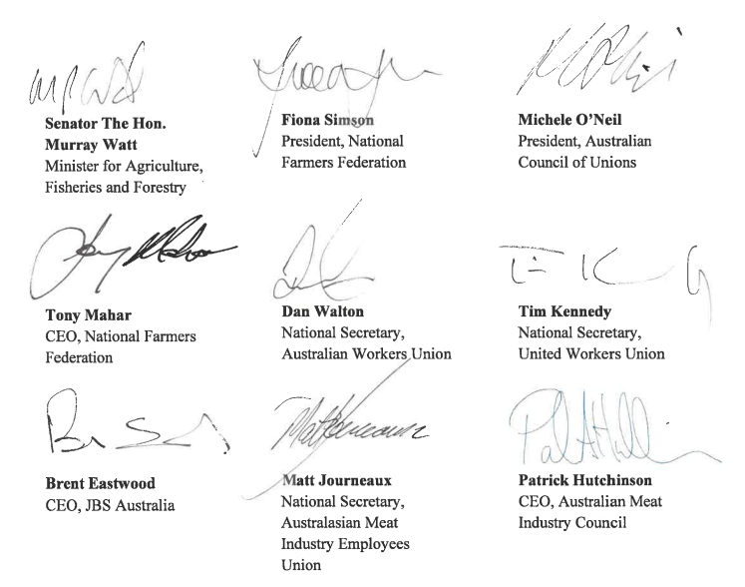

**Acknowledgement of Country**

We acknowledge the Traditional Custodians of Australia and their continuing connection to land and sea, waters, environment and community. We pay our respects to the Traditional Custodians of the lands we live and work on, their culture, and their Elders past and present.

© Commonwealth of Australia 2022

Unless otherwise noted, copyright (and any other intellectual property rights) in this publication is owned by the Commonwealth of Australia (referred to as the Commonwealth).

All material in this publication is licensed under a [Creative Commons Attribution 4.0 International Licence](https://creativecommons.org/licenses/by/4.0/legalcode) except content supplied by third parties, logos and the Commonwealth Coat of Arms.

The Australian Government acting through the Department of Agriculture, Fisheries and Forestry has exercised due care and skill in preparing and compiling the information and data in this publication. Notwithstanding, the Department of Agriculture, Fisheries and Forestry, its employees and advisers disclaim all liability, including liability for negligence and for any loss, damage, injury, expense or cost incurred by any person as a result of accessing, using or relying on any of the information or data in this publication to the maximum extent permitted by law.