# Agriculture Biodiversity Stewardship Policy Statement

**April 2022**

© Commonwealth of Australia 2022

**Ownership of intellectual property rights**

Unless otherwise noted, copyright (and any other intellectual property rights) in this publication is owned by the Commonwealth of Australia (referred to as the Commonwealth).

**Creative Commons licence**

All material in this publication is licensed under a [Creative Commons Attribution 4.0 International Licence](https://creativecommons.org/licenses/by/4.0/legalcode) except content supplied by third parties, logos and the Commonwealth Coat of Arms.

Inquiries about the licence and any use of this document should be emailed to [copyright@awe.gov.au](mailto:copyright@awe.gov.au).



**Cataloguing data**

This publication (and any material sourced from it) should be attributed as: DAWE 2022, Agriculture Biodiversity Stewardship Policy Statement, Department of Agriculture, Water and the Environment, Canberra, March. CC BY 4.0.

ISBN 978-1-76003-537-2

This publication is available at awe.gov.au/agriculture-land/farm-food-drought/natural-resources/landcare/sustaining-future-australian-farming

Department of Agriculture, Water and the Environment

GPO Box 858 Canberra ACT 2601

Telephone 1800 900 090

Web [awe.gov.au](https://www.awe.gov.au/)

**Disclaimer**

The Australian Government acting through the Department of Agriculture, Water and the Environment has exercised due care and skill in preparing and compiling the information and data in this publication. Notwithstanding, the Department of Agriculture, Water and the Environment, its employees and advisers disclaim all liability, including liability for negligence and for any loss, damage, injury, expense or cost incurred by any person as a result of accessing, using or relying on any of the information or data in this publication to the maximum extent permitted by law.

**Acknowledgement of Country**

We acknowledge the Traditional Custodians of Australia and their continuing connection to land and sea, waters, environment and community. We pay our respects to the Traditional Custodians of the lands we live and work on, their culture, and their Elders past and present.

## Minister’s foreword

Australia’s agricultural industry continues to make an important contribution to our economy and nation and is a driving force in many regional and rural communities. In the face of serious challenges including drought, bushfires, floods and COVID-19, Australian agriculture has demonstrated incredible resilience and is thriving.

The Australian Government is committed to providing strong foundations and getting the framework and policy settings right for a competitive, prosperous, and sustainable agriculture sector. To work with industry to support their goal to be a $100bn agriculture sector by 2030 through 7 themes – with Agricultural Stewardship being one of the themes.

We are ensuring Australian farmers are rewarded for the stewardship of their land.

Australian farmers manage nearly 60 per cent of Australia’s landscape and are some of the most important stewards of our land and environment. Their stewardship supports agricultural productivity and delivers environmental outcomes, including biodiversity. Farmers should be rewarded for this stewardship and take advantage of the growing environmental market opportunities from corporate Australia to pay for biodiversity outcomes.

That is why the Australian Government is establishing a voluntary national agriculture biodiversity market which will create new drought-resilient income streams for farmers. A national voluntary agriculture biodiversity stewardship market that recognises and financially rewards them for their efforts to restore, enhance or protect biodiversity.

A voluntary national agriculture biodiversity market will enable farmers to use land not currently used for agricultural production to improve biodiversity – and receive additional income. And we have introduced legislation into the Parliament to create a voluntary market for all of Australia.

We have conducted pilots to demonstrate the science—a world first, rigorous approach for measuring biodiversity outcomes on-farm. The Carbon plus Biodiversity pilot enables new plantings of native vegetation to get biodiversity outcomes and carbon credits. The Enhancing Remnant Vegetation pilot enables existing native vegetation to be valued for biodiversity outcomes.

To better connect farmers with buyers of stewardship outcomes and support farmers in planning projects we have established the National Stewardship Trading Platform. This is driving down costs for farmers to participate in these markets ensuring more income flows to farmers.

The government has also developed a Farm Biodiversity Certification Scheme and Biodiversity Stamp that recognises farmers biodiversity management. This will maintain and open new markets.

There is a significant market shift underway as global investors increasingly focus on biodiversity stewardship. The government has created the foundations for Australian farmers to create new income streams by meeting this growing demand.

The Hon. David Littleproud MP

Minister for Agriculture and Northern Australia

Contents

Minister’s foreword 3

The market opportunities 5

The vision: A voluntary national agriculture biodiversity stewardship market 6

Agriculture Biodiversity Stewardship Pilots − the pathway to a market 8

Connecting farmers with the market 10

A Framework for a voluntary market 11

Supporting participation 11

Showcasing biodiversity outcomes to markets 12

**Figures**

Figure 1: Agriculture Stewardship NRM pilot regions 8

Figure 2: National Stewardship Trading Platform, marketplace 10

Figure 3: Farm Biodiversity stamp 12

## The market opportunities

Australia's farmers are responsible for maintaining healthy ecosystems on more than 50 per cent of Australia's land. Farmers are some of the most important stewards of our land and environment.

Increasingly private sector and philanthropic buyers are looking for biodiversity benefits to meet their environmental, social and governance responsibilities. Globally investors and governments are working to better account for impacts on nature in economic activity. It is widely anticipated that this is going to drive a major increase in nature-driven private investment as well as reporting and standards in agricultural supply chains.

A voluntary agriculture biodiversity stewardship market provides opportunities to address this, and better recognise and reward biodiversity stewardship by farmers. Farmers are uniquely placed to supply biodiversity and carbon services. Participation in a voluntary agriculture biodiversity market gives farmers the chance to diversify farm income, improve productivity through shelter belts and other plantings, and contribute to the resilience of their communities.

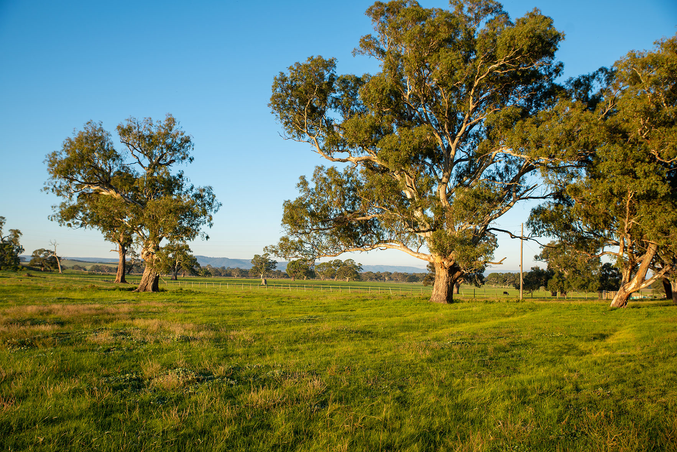

## The vision: A voluntary national agriculture biodiversity stewardship market

A voluntary national agriculture biodiversity stewardship market will enable farmers to use unproductive land to improve biodiversity—creating additional income opportunities, on farm benefits and environmental outcomes.

The market will

* recognise and reward farmers who undertake new plantings of native species, as well as projects where farmers actively manage their land to protect or enhance existing native vegetation.
* capitalise on increasing private sector interest in investing in biodiversity, as companies respond to consumer and shareholder expectations about their environmental credentials.
* be world leading and allow Australian farmers to leverage their biodiversity credentials with trading partners.

It would complement the voluntary carbon market, providing an opportunity for farmers to get paid for the biodiversity benefits by doing carbon plantings according to biodiversity protocols.

To make a real difference to Australian farmers and the environment, the agriculture biodiversity stewardship market will need to achieve national scale and provide farmers with the means to promote their achievements to domestic and international markets.

These markets need to be driven by cost effective, scientifically rigorous system that will be recognised by domestic and international markets.

The government has delivered on this vision through

* Piloting a market-based approach for
  + Carbon + Biodiversity projects - improving on-farm biodiversity by establishing new native vegetation
  + Enhancing Remnant Vegetation projects - improving on-farm biodiversity through active management of existing native vegetation.
* A National Stewardship Trading Platform to support project planning and connect farmers with buyers
* The Agriculture Stewardship Biodiversity Market legislation currently before parliament
* Further investment through the 2022 Budget, with $27.3 million to
  + simplify participation for farmers and buyers
  + providing on-ground support from Natural Resource Management organisations.
  + expanded National Stewardship Trading Platform will make trading easier, and
  + improved baseline data on biodiversity.
* Developing the Australian Farm Biodiversity Certification Scheme so farmers biodiversity management can be recognised by consumers and markets.

## Agriculture Biodiversity Stewardship Pilots − the pathway to a market

The government has developed the building block of the market through scientifically developed pilots under the Agriculture Biodiversity Stewardship Package. The pilots have been testing biodiversity protocols, trialling assessment systems, methods and approaches to inform the design of the market.

To ensure their scientific credibility and integrity, biodiversity protocols were designed by the Australian National University and piloted in a number of trial regions across Australia. The pilots not only demonstrated and refined the technical protocols and systems, they showed that there was a genuine market opportunity. Farmers are keen to sell these services, and there are willing buyers.

Figure 1: Agriculture Stewardship NRM pilot regions

Carbon + Biodiversity

The Carbon + Biodiversity (C+B) Pilot provides incentives for farmers to produce biodiversity benefits by opting to plant local or mixed native species as part of their environmental plantings carbon project. This includes projects like new biodiverse shelter belts or tree planting along water courses. Two rounds have been conducted with $11.6 million offered to 118 projects. Contracted farmers are moving to register their projects with the Emissions Reduction Fund and receive credits.

These projects are providing new streams of income for farmers, deliver biodiversity and other on-farm benefits, and provide carbon sequestration outcomes that can also be traded to earn income under the Emissions Reduction Fund or privately.

Enhancing Remnant Vegetation

The Enhancing Remnant Vegetation Pilot has been trialling how farmers could be paid for activities to protect and enhance existing remnant native vegetation on their properties. Eligible management activities need to improve the condition of remnant vegetation which lead to biodiversity benefits as well as other potential benefits on farm. Examples of the types of activities include:

* installing fencing to protect remnant vegetation
* carrying out weeding to improve the condition of native vegetation
* pest control to minimise impact on native vegetation
* replanting local native vegetation.

The first successful projects were announced in March-April 2022 with $12.7 million offered to 74 projects.

## Connecting farmers with the market

The pilots have shown the potential of a voluntary agriculture biodiversity stewardship market if farmers and private buyers can be brought together. This reinforces the findings of the 2020 [Frontier Economics](https://www.awe.gov.au/sites/default/files/documents/biodiversity-services-platform-scoping-study.pdf) scoping study that found that the current voluntary biodiversity market is complex and hard to navigate for both buyers and sellers. There is a lack of standard, credible, transparent information, and transaction costs are high.

The government’s [National Stewardship Trading Platform](https://agsteward.com.au/) commenced operation in December 2021 is designed to overcome these problems. It provides a simple tool for farmers and buyers to connect, reducing transaction costs and uncertainty.

The platform provides tools to plan projects, including C+B and ERV projects. It has a ‘marketplace’ where a farmer can list a project to sell, and buyers can advertise their interest in purchasing. Currently buyers and sellers connect through the platform then negotiate terms of sale off the platform.

Figure 2: National Stewardship Trading Platform, marketplace

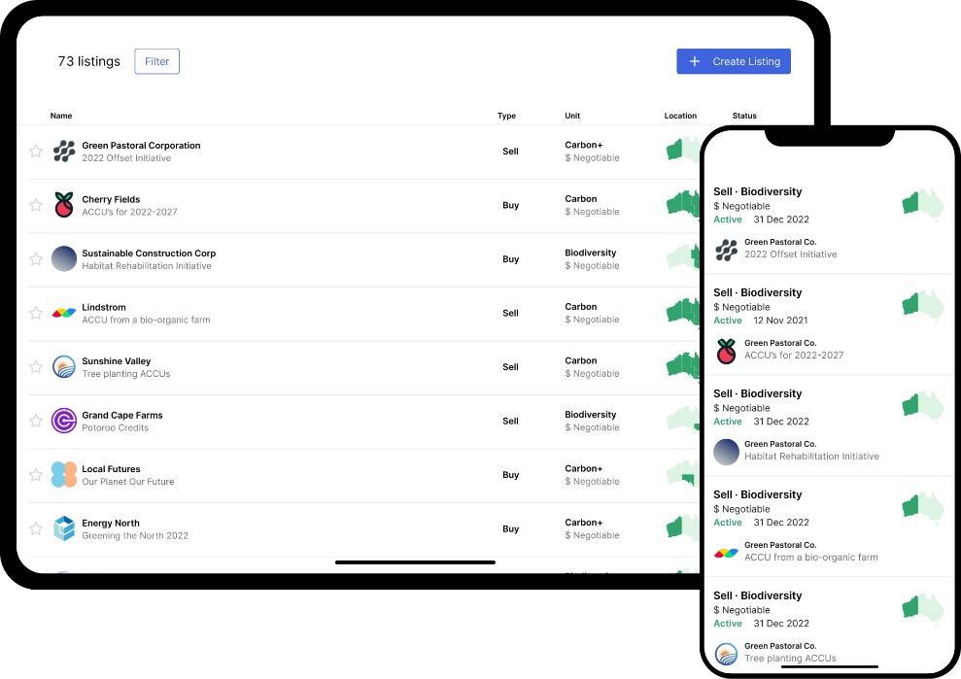

**The 2022-23 Budget included an additional $13.7 million to enable automated trading on the** National Stewardship Trading Platform. It would enable buyers and sellers to make transactions through the platform, use monitoring and accounting functions, and support engagement with the requirements under the voluntary market legislation. These improvements will support market growth and drive down market participation costs to farmers. The expanded platform it expected to be operational around mid-2023.

## A Framework for a voluntary market

A bill to create the legal framework for a national voluntary agriculture biodiversity stewardship market has been introduced in Parliament. The *Agriculture Biodiversity Stewardship Market Bill 2022* provides legislative backing for new opportunities for Australian farmers to create income from biodiversity on their land.

The bill will establish a nationally consistent framework to describe and verify biodiversity outcomes on agricultural land. Biodiversity protocols, informed by science, will define project types that will achieve biodiversity outcomes. These will build on those already developed under the stewardship pilots.

The bill will create an independent expert advisory committee, the Agriculture Biodiversity Stewardship Market Advisory Committee. This will provide independent advice to the Minister for Agriculture on the biodiversity protocols, informed by public consultation and expert engagement.

The bill will create a new form of tradeable property, a biodiversity certificate which is issued by the Australian government and tracked on a register. This certificate will be an asset in its own right, separate from the land, that can be purchased, transferred, claimed or used.

The bill will ensure integrity through government assurance and compliance, with the Clean Energy Regulator to undertake regulatory functions.

## Supporting participation

On-Ground support to farmers

As part of the $27.3 million provided in the 2022-23 Budget, **the Government is** funding Natural Resource Management (NRM) organisations across Australia to provide on-ground support to farmers to participate in carbon and biodiversity markets.

The pilots showed that farmers need expert advice to help them participate in these emerging markets. NRM organisations are well placed to provide trusted and locally relevant support to farmers. They can help farmers identify the best projects suitable to them, and for biodiversity improvements, and provide practical support to develop and apply for these.

Cost efficient market participation and biodiversity measurement

The budget measure also provided funding for innovative ways to use remote sensing, on-ground data and national analysis to enable cost-effective ways to monitor improvements in biodiversity. It also invests in approaches to assessing biodiversity improvements on the ground. These are aimed at driving down the costs for participation while ensuring market confidence.

Taxation Treatment

Concessional tax treatment to primary producers that generate revenue from the sale of Australian Carbon Credit Units (ACCUs) and biodiversity certificates. This provides farmers with an estimated $100 million benefit through the tax system over the forward estimates.

## Showcasing biodiversity outcomes to markets

There is a rapidly growing push from consumer and markets globally to better account for impacts on nature. To provide for these market opportunities the Government has released a voluntary Australian Farm Biodiversity Certification Standard (the standard). A trademarked certification stamp and technical standard have been released, setting out the rules and procedures for farms to be certified as ‘biodiversity friendly’.

Figure 3: Farm Biodiversity stamp

The scheme aims to help farmers and industry supply chains take advantage of growing international and domestic market demand for food and fibre products with sustainability credentials.