Agriculture Biodiversity Stewardship

Carbon + Biodiversity Pilot
Enquiries can be made by email at agstewardship@awe.gov.au.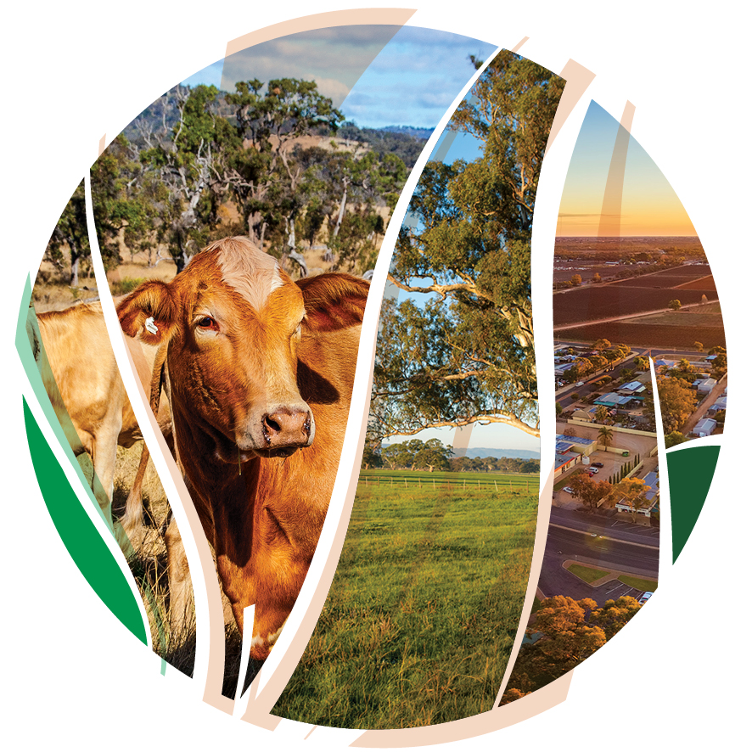
© Commonwealth of Australia 2021
Ownership of intellectual property rights
Unless otherwise noted, copyright (and any other intellectual property rights) in this publication is owned by the Commonwealth of Australia (referred to as the Commonwealth).
Creative Commons licence
All material in this publication is licensed under a Creative Commons Attribution 4.0 International Licence except content supplied by third parties, logos and the Commonwealth Coat of Arms.
Inquiries about the licence and any use of this document should be emailed to copyright@awe.gov.au.

Cataloguing data
This publication (and any material sourced from it) should be attributed as: DAWE 2021, Agriculture Biodiversity Stewardship: Carbon + Biodiversity Pilot, Department of Agriculture, Water and the Environment, Canberra, March. CC BY 4.0.
This publication is available at https://www.agriculture.gov.au/ag-farm-food/natural-resources/landcare/sustaining-future-australian-farming
Inquiries can be made by email at agstewardship@awe.gov.au.
Department of Agriculture, Water and the Environment
GPO Box 858 Canberra ACT 2601
Telephone 1800 900 090
Web awe.gov.au
Disclaimer
The Australian Government acting through the Department of Agriculture, Water and the Environment has exercised due care and skill in preparing and compiling the information and data in this publication. Notwithstanding, the Department of Agriculture, Water and the Environment, its employees and advisers disclaim all liability, including liability for negligence and for any loss, damage, injury, expense or cost incurred by any person as a result of accessing, using or relying on any of the information or data in this publication to the maximum extent permitted by law.
Acknowledgements
We thank Professor Andrew Macintosh, Dr Don Butler, Professor Phillip Gibbons, Professor David Lindenmayer, Dr Peter Burnett and Leslie White from the Australian National University (ANU) in preparing this documentation.

Acknowledgement of Country
We acknowledge the Traditional Owners of Country throughout Australia and their continuing connection to land, sea and community. We pay our respects to them and their cultures and to their elders past, present and emerging.

Participating in the pilot
Carbon+Biodiversity participants
If you participate in this pilot you are offering to provide the Australian Government with long-term biodiversity improvement services in conjunction with an Emissions Reduction Fund (ERF) project.

Look over the program documents and seek advice on participation
The program documents published at www.agriculture.gov.au/agriculturestewardship outline how to participate. We encourage you to develop a project idea and seek independent professional advice (such as from financial, legal, agronomy and carbon project experts) before applying.

When applications open, complete and submit an application
Finalise your project plan and submit it through the Agriculture Stewardship portal.

DAWE will assess your project and determine what biodiversity payment we will offer
We assess applications against the eligibility criteria and exclude (and notify) ineligible applications. We will calculate a biodiversity payment offer based on the estimated cost of your project and the revenues the project could generate from carbon credits. Alternatively, you can submit your own bid price. Projects will be ranked (highest to lowest) based on a benefit-cost ratio against other applications in their region.

We make recommendations for included projects
A project assessment panel will advise the decision maker on which projects are the best value for money, based on the costs and benefits.

Biodiversity payment offers are approved and notified
The decision maker approves the amount we will offer to successful applicants. We notify successful applicants of our payment offer for their biodiversity improvement services.

You consider the offer and the legal terms
We will provide the legal agreement, which will give you the option (but not the obligation) to undertake the biodiversity stewardship project and receive the biodiversity payment. You will be legally obligated to complete the project only when the option is exercised.

You register your ERF project with the Clean Energy Regulator
You must register your project with the Clean Energy Regulator (CER) and have it formally accepted within 4 months of exercising the option to initiate the biodiversity stewardship project. See more information on how to register an ERF project.

Payments
When your project is successfully registered under the ERF, we will provide you with 50% of the biodiversity payment. The remainder of the payment will be made in 2 equal instalments over the subsequent 2-3 years.

Plantings and ongoing obligations
You must establish your plantings in accordance with the requirements of both the ERF (for carbon) and this pilot (for biodiversity). Both programs have rules governing the establishment and management of environmental plantings and ongoing reporting/monitoring requirements.
Contents
Acknowledgement of Country 3
Participating in the pilot 4
1. Introduction 8
2. About the C+B Pilot 9
2.1 Core elements 9
2.2 Funding amount 10
2.3 Case studies 10
2.4 Project period 12
3. Eligibility criteria 14
3.1 Eligible applicants 14
3.4 How project applications are assessed 16
4. How to apply 17
5. Timing of pilot opportunity processes 20
5.1 Questions during the application process 20
6. Project selection process 21
6.1 Assessment of project applications 21
6.2 Who will assess applications 22
6.3 Who will approve projects 22
7. Successful applications 23
7.1 Payment schedule 23
8. Reporting and monitoring requirements 25
8.1 Reporting 25
8.2 Monitoring 25
8.3 Data sharing 26
9. Project variations 27
9.1 Keeping us informed 27
9.2 Audit or declaration 28
9.3 Acknowledgements 28
10. Probity, privacy and freedom of information 29
10.1 Fair process 29
10.2 Conflict of interest 29
10.3 Privacy 29
10.4 Confidential information 30
10.5 Freedom of information 31
10.6 Enquiries and feedback 31

Tables
Table 1 How to apply for the Pilot program 17
Table 2 Application details of the Pilot program 17
Table 3 Costing details of the Pilot program 18
Table 4 Activity timeframes 19

Figures
Figure 1 Map of eligible Carbon + Biodiversity Pilot regions. Round 1 pilot NRM regions are highlighted in green. 15

Introduction
This document explains the Agriculture Biodiversity Stewardship – Carbon + Biodiversity Pilot (the C+B Pilot).
The pilot is a component of the Australian Government’s Agriculture Stewardship Package. The package will create new market-based mechanisms that reward farmers for improving environmental outcomes on agricultural land.
Farmers can and are already taking steps to build farm resilience, by planting and maintaining environmental plantings that protect their soils, farm dams and waterways. This Pilot trials a market-based mechanism for farmers to provide biodiversity and carbon abatement services by establishing biodiverse environmental plantings.
Over time, the aim is to create a credible market mechanism that improves biodiversity and climate outcomes and creates new income opportunities for farmers. The pilot is initially being run in 6 Natural Resource Management regions:
- Burnett-Mary in Queensland;
- Central West in New South Wales;
- North Central in Victoria;
- NRM North in Tasmania;
- Eyre Peninsula in South Australia;
- South West in Western Australia.
This document sets out:
  - the eligibility and assessment criteria
  - how to apply to participate
  - how applications are considered, and how biodiversity payment offers are made
  - how farmers that have applied are notified and receive payments
  - how participating farmers’ projects will be monitored and evaluated
  - responsibilities and expectations.
We have worked in partnership with the ANU to develop the pilot.

About the C+B Pilot
The C+B Pilot will trial a market-based mechanism that supports biodiverse environmental planting projects in agricultural areas. Participants who establish and maintain biodiverse environmental plantings in accordance with the C+B planting protocol will be eligible to receive payments for biodiversity. They will also potentially be able to receive Australian Carbon Credit Units (ACCUs) for the carbon sequestered in the plantings under the Australian Government’s ERF. Participants will be able to sell the ACCUs to the Australian Government or other buyers, which would provide an additional source of revenue for the projects.
The objectives of the pilot are:
  - trial a market-based system whereby farmers can be paid to provide biodiversity improvement services
  - provide the information, knowledge and experience necessary to increase and monetise on-farm biodiversity stewardship.
The intended outcomes of the pilot are:
  - increase the adoption of biodiversity practices by enabling farmers to be rewarded for their stewardship by those willing to pay
  - improve biodiversity and increase carbon sequestration in environmental plantings
  - provide confidence to the market.

2.1 Core elements
The C+B pilot has 5 core elements.
- Participants will be required to undertake new ERF environmental plantings projects involving reforestation through either planting or direct seeding of native tree and shrub species. Participants will also need to ensure they satisfy relevant ERF participant obligations, including in relation to measurement, reporting and auditing.
- Projects participating in the C+B Pilot will also need to comply with the C+B planting protocol and reporting requirements. The planting protocol sets out rules about the location, dimensions, configuration and composition of plantings to ensure projects generate biodiversity benefits.
- Projects contracted under the C+B Pilot will receive biodiversity payments over the course of the project. Payments will be contingent on the satisfaction of relevant C+B Pilot requirements, including the planting protocol.
- Projects that meet ERF requirements, as determined by the CER, will be able to receive ACCUs for the carbon sequestered in the planting project. Participants can sell, keep or cancel any ACCUs they receive for the projects.
- Plantings established under the C+B Pilot will need to be protected and maintained for at least 25 years. Once registered under the ERF, the projects will be subject to the ERF permanence requirements.

2.2 Funding amount
The total budget for the C+B Pilot component of the Agriculture Stewardship Package is up to $23.5 million.
The pilot will trial a dual-track approach to determining the biodiversity payments made to applicants. This is to ensure value for money and demonstrate the potential of a market approach to investors who may have an interest in purchasing biodiversity outcomes.
Under the dual-track approach, the biodiversity payments offered to applicants will be determined using one of two processes.
  - Option A: Applicants can submit cost estimates for their project and, if they are successful in the selection process, they will receive a biodiversity payment offer that considers their estimated costings.
  - Option B: Applicants can submit their own bid price for the biodiversity payment they are willing to accept, along with their project costs. If they are successful in the selection process, they will receive a biodiversity payment offer based on either the bid price or the estimated costs of the project.
All projects will be assessed according to the costs and biodiversity benefits.
For applicants who choose Option A, the price offer will be calculated using a financial model that accounts for the likely revenues from the sale of carbon credits and the project costs. The model will estimate:
  - the carbon revenues projects could receive from the sale of carbon credits
  - the cost of establishing and maintaining the plantings
  - the cost of reporting and auditing associated with the project.
The model will consider the revenue and cost estimates to calculate a biodiversity payment offer, having regard to the aim of providing efficient participants with an appropriate rate of return on their investment.
Option B is similar to Option A, but it gives applicants the opportunity to put in a lower bid price to increase their chances of receiving an offer – for example, if they think the plantings will increase agricultural production. The same financial model will be used to test the competitiveness of the bids made by applicants who choose to submit a bid price. If a bid is deemed to be uncompetitive (too high), the applicant may receive a biodiversity payment offer based on the estimated costs of the project. Where this occurs, the offer will be derived using the same approach as detailed for Option A.

2.3 Case studies
This section includes 2 case studies in different eligible regions to provide examples of how the pilot will work and the size of a payment the project might receive. Use these case studies can act as a guide to help you decide whether to apply but they should not be relied on when making your own financial decisions. The case studies go into some detail to help potential applicants understand the interactions between this pilot and the ERF.

Case study 1: Environmental Planting Project near Grenfell, New South Wales
Patrick and Jane own a 2,700-hectare property outside Grenfell, in the Central West region of New South Wales. They operate a mixed farming operation on the property, mainly producing sheep and wheat. To diversify their income and provide additional shelter for livestock, they apply to participate in the C+B Pilot for a 40 hectare tree planting project.
Patrick and Jane and their advisers estimate that the tree plantings are likely to sequester approximately 225 tonnes of carbon dioxide (tCO₂) per hectare, or 9,000 tCO₂ in total, over 25 years.
Under the ERF, a 5% risk of reverse buffer discount is applied when calculating the number of carbon credits that environmental planting projects receive. Participants must choose between a 25-year or 100-year ‘permanence period’ – the period over which the plantings must be protected and maintained. If participants opt for a 25-year permanence period, a 20% permanence period discount is applied when calculating their carbon credits entitlements, on top of the 5% risk of reverse buffer discount. Projects with 100-year permanence periods are not required to apply a permanence period discount. Patrick and Jane decide the best option for them is a 25-year permanence period.
Accounting for the total number of ACCUs the project could receive and when they are likely to be issued, the possible future price of ACCUs, and a preferred discount rate, Patrick and Jane and their advisers calculate that the present value of the ACCUs from the project is likely to be in the around $2,000 per hectare, or $80,000 for the whole project. The average price paid for contracts from the auction held by the Clean Energy Regulator in September 2020 was $15.74 per ACCU.
To participate in the C+B Pilot, the plantings must be established and managed in accordance with the ERF environmental plantings method and the C+B planting protocol. After consulting their local Natural Resource Management Group, Central West Local Land Services, Patrick and Jane decide the best way to establish the plantings consistent with these requirements is via mechanical tubestock planting. They also decide that 2 km of fencing will be required to protect the plantings from livestock, kangaroos, rabbits and other feral herbivores. Before planting, Patrick and Jane plan to treat the weeds on the site with 2 rounds of boom spraying and one round of spot spraying. Considering these project details, they calculate that the likely establishment costs around $3,500 per hectare, or $140,000 in total.
In planning the project, Patrick and Jane also consider recurrent weed and pest management costs across the 40 hectares of plantings, and the reporting and auditing costs associated with the C+B Pilot and the ERF. Under the ERF, all tree planting projects are required to undergo 3 third-party audits, the first of which is due at the end of the first reporting period. These third-party audits are paid for by the project participant. The C+B Pilot has no equivalent third-party auditing requirements but participants must submit periodic reports on the environmental and financial performance of projects.
Using the planting area and cost data they submit, the department provide Patrick and Jane with a biodiversity payment offer of $2,500 per hectare, or a total of $100,000.
If Patrick and Jane enter a C+B agreement and exercise the option to initiate the project, they could receive $50,000 upfront (after the project is registered under the ERF) to support the plantings. They will then receive the remaining $25,000 in the following 2-3 years, contingent on verification that the plantings have been established in accordance with the C+B planting protocol and the satisfaction of other program requirements.

Case study 2: Environmental Planting Project near Campbell Town, Tasmania
Rowena owns a 1,000 hectare property near Campbell Town, in Tasmania’s Midlands, where she runs sheep. To help reduce lambing mortality and diversify her income, Rowena decides to participate in the pilot and apply for a biodiversity payment. She plans to undertake a 15 hectare environmental planting, comprised of a mix of shelter belts and block plantings.
Under average climate conditions, tree plantings are likely to sequester approximately 280 tCO₂ per hectare over 25 years. After considering the applicable ERF requirements, Rowena decides on a 100-year permanence period, thereby avoiding the need to apply a 20% permanence period discount when calculating the ACCU entitlements associated with the project.
Considering the ERF requirements, including the need to apply a 5% risk of reversal buffer, and other factors, Rowena and her advisers calculate that the present value of the ACCUs from the project is likely to be around $3,400 per hectare, or $51,000 for the whole project.
The area where Rowena wants to put the plantings is reasonably hilly. After consulting with her local Natural Resource Management Group, NRM North, Rowena decides the best way to establish the plantings in this hilly area is through manual tubestock plantings. She also decides to use tree guards in some areas to protect the seedlings from feral grazing impacts. Rowena plans to spot spray the site and source the tubestock from a local nursery. All up, she estimates the plantings will cost $4,200 per hectare to establish, or $63,000 in total.
Rowena estimates she will need to spend around $60 per hectare per year ($900 per year total, in present value terms) on managing the plantings (weeding and pest control) and reporting under the ERF and C+B Pilot. In addition, in making her business plan, she accounts for the need to pay for three third party audits under the ERF.
Using the planting area and cost data that Rowena submits, the department provides her with a biodiversity payment offer of $3,500 per hectare, or $52,500 in total. If Rowena goes ahead with the project, she can receive $26,250 upfront after she registers the project under the ERF and the remaining $26,250 in the following 2-3 years if she satisfies the program requirements.

2.4 Project period
C+B Pilot projects will need to be protected and maintained for a minimum of 25 years. This is consistent with the minimum permanence period for ERF tree planting projects. If plantings die or are otherwise lost over 5% or more of the planting area, participants will be required to re-plant the area in accordance with the C+B planting protocol.
Successful applicants who enter a C+B agreement can withdraw from the program at any time before exercising the option to provide the contracted services. After a participant exercises the option, registers under the ERF and receives the funding, they can only withdraw by repaying the biodiversity payment, plus interest. The same applies after the plantings are established.
Additionally, once a project is registered under the ERF, participants are required to protect and maintain the credited carbon stocks for the duration of the project’s nominated ‘permanence period’. The permanence period is the period over which participants are required to protect and maintain the credited carbon stocks. Participants must choose between a 25-year or 100-year permanence period. The period starts when the first ACCUs are issued to the project. If participants opt for a 25-year permanence period, a 20% permanence period discount is applied when calculating their ACCU entitlements. Projects with 100-year permanence periods are not required to apply a permanence period discount when calculating their ACCU entitlements.
Participants of registered ERF projects can apply to the CER to have their project revoked at any time. However, for the CER to accept a revocation application, the participants must relinquish the same number of ACCUs as have been issued for the project.
See Permanence obligations for further information on ERF project permanence requirements.

Eligibility criteria
Eligibility criteria apply to both the applicant and to the proposed project. You must provide the information we need to assess your eligibility and the eligibility of your proposed project.
If you, or your proposed project, do not meet all the eligibility criteria, your application will not undergo assessment.

3.1 Eligible applicants
To be eligible, you must satisfy these requirements:
- Your property must be in one of the eligible pilot regions (see section 3.2 below).
- Your property must be predominantly used for agricultural purposes.
- You must be willing and able to undertake a new ERF environmental plantings project.
- You must be an individual or body corporate who owns the land on which the project will be undertaken, in the sense of holding the freehold title.
- You must meet the participant obligations under the ERF as outlined on the CER’s website (http://www.cleanenergyregulator.gov.au/ERF/Want-to-participate-in-the-Emissions-Reduction-Fund/Planning-a-project/participant-obligations).
- You must not have begun the project.
- You must provide a commitment to act with the utmost good faith in your engagements with the program.
You cannot submit more than three applications in total. If you submit more than three applications, only the first three will be considered.
3.2 What projects are eligible?
To be eligible, your project must satisfy the following requirements:
- All planting areas associated with a project must be located within the same pilot region.
Projects can be comprised of one or more planting areas. The planting areas associated with a project can be located on different properties and different land titles, provided the properties are owned by the same applicant. However, the planting areas must be located within the same pilot region and each planting area must be located wholly within the boundaries of the region.
- Projects must cover an area of between 5 and 200 hectares.
The project must satisfy the eligible offset project registration requirements under the ERF, including the requirements under the ERF environmental planting method and must not already be registered.
- The environmental plantings must be carried out in accordance with the C+B planting protocol.
The environmental plantings must be carried out in accordance with the C+B planting protocols for the relevant region. The protocols specify the location, dimensions, configuration and composition of plantings and are designed to ensure projects generate the maximum possible biodiversity benefits. The protocols contain rules about the proximity of plantings to houses and other infrastructure. These rules are designed to reduce the bushfire risk associated with plantings.
- Projects must not receive financial or other support for the establishment of the plantings under another federal, state/territory or local government environment program, other than the ERF.
For more information, see the requirements for the ERF environmental planting method, guide to the reforestation by environmental or mallee planting ERF method.
3.3 Eligible locations
To be eligible to participate in the Pilot, your project must be in one of 6 eligible Natural Resource Management (NRM) regions. The eligible NRM regions are:
  - Burnett-Mary in Queensland
  - Central West in New South Wales
  - North Central in Victoria
  - NRM North in Tasmania
  - Eyre Peninsula in South Australia
  - South West in Western Australia
Figure 1 Map of eligible Carbon + Biodiversity Pilot regions.
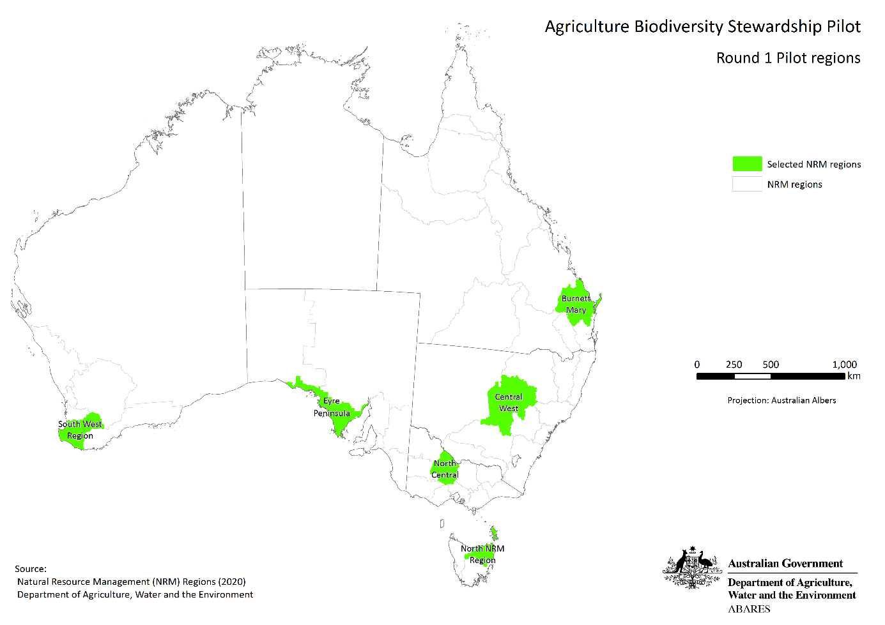

3.4 How project applications are assessed
A competitive, transparent and fair process will be used to assess and select projects to ensure the pilot delivers biodiversity improvements that are value for money and achieve biodiversity outcomes. Details of the assessment, ranking and selection process are provided in section 6.1 below.

How to apply
Before applying, you must read and understand this program document.
We strongly recommend that you seek independent professional advice about your participation in this pilot, potentially including financial, legal, agronomy and carbon project specialists.
Application timelines
Round 1 Applications open 12 April 2021
Round 1 Applications close 11 June 2021
Note: Further rounds may take place if the full amount of funding is not exhausted.
Table 1 How to apply for the Pilot program
To apply you must:
Complete the application through the web portal accessed at agriculture.gov.au/agriculturestewardship
Provide your personal details and the address of the property on which the project will be located
Signify your commitment to act with the utmost good faith in all engagements with the program
Confirm you hold the freehold title to the property and that it is predominantly used for agricultural purposes
Plot where the plantings will be established on your property or properties
Submit cost estimates for your project.
The web portal will also allow you to submit a bid price for the biodiversity payment you would be willing to accept to undertake the project. Applicants do not have to submit a bid price – those that do not will be provided with a payment offer based on their cost estimates. Submitting a bid price may increase your chances of being successful in the application process.
The requirement to act with the utmost good faith in all engagements with the program is intended to ensure participants embrace and support the objectives of the pilot. The C+B Pilot is trying to improve public good environmental outcomes, while providing new market opportunities for the agricultural sector. These objectives can only be realised if participants engage with the program in a collaborative manner.
Applicants should ensure the planting areas are plotted as accurately as possible because the plotted areas will be used to generate your payment offer or test the competitiveness of your bid price.
To assist with your project planning, the web-portal will provide an indicative estimate of the anticipated carbon sequestration in the planting areas (tonnes of carbon dioxide equivalent (tCO₂-e)). This estimate is not a projection of the ACCUs the project is likely to receive – it is an indicative estimate of the carbon sequestration in an environmental planting project on the site under average climate conditions.
Table 2 Application details of the Pilot program
For each planting area, you will be required to provide details on the project, including:
Size and location of the planting
The number of mature native trees that will be retained within the planting area
The current vegetation cover in the planting area
Site preparation (weed control) method (spot spray, boom spray or other)
Soil preparation method (manual digging, deep ripping or discing)
Planting method (manual tubestock planting, mechanical tubestock planting, or direct seeding)
Tree protection method (fencing, guards or no protection)
Annual management regime (grazing, weeding and pest control).

The ERF environmental plantings method has requirements that should be taken into account. An overview of the requirements under the ERF environmental planning method is available here.
Table 3 Costing details of the Pilot program
For each planting area, you will also be required to provide estimates of the costs of key project components including:
Site preparation (weed control)
Soil preparation
Tubestock or seed, and total planting costs
Tree guards and fencing
Recurrent management (such as weeding and pest control).
To help estimate these costs, a price guide will be published for each region that provides an indicative price for each component of your project.
The cost estimates must not include the cost of management actions that are required to be carried out by or under a law of the Commonwealth or a state or territory, or are already funded under another Australian Government, state, territory or local government environment program.
As noted, under the ERF, participants must choose between a 25-year or 100-year permanence period. If participants opt for a 25-year permanence period, a 20% permanence period discount is applied when calculating their ACCU entitlements. Applicants should note that the 20% permanence period discount is not considered when calculating biodiversity payment offers under the C+B Pilot. The financial model we use to generate the payment offers assumes all projects have 100-year permanence periods. This is to ensure the C+B Pilot does not provide higher payment offers to projects with shorter permanence periods.
You are responsible for ensuring that your application addresses the eligibility criteria and is complete and accurate. Applications that contain false or misleading information may be excluded from consideration. Giving false or misleading information is also an offence under the Criminal Code Act 1995 (Cth).
You must notify us if there are any key changes to your organisation or its business activities, particularly if they affect your ability to meet your obligations under the project, carry on business or pay debts due. The legal agreement will contain provisions that apply if you sell the land on which the project is established.
If you find an error in your application after submitting it, you should contact us immediately at agstewardship@awe.gov.au or 1800 900 090.
You cannot change your application after the closing date and time.
If we find an error or information that is missing, we may ask for clarification or additional information from you that will not change the nature of your application. However, we can refuse to accept any additional information from you that would change your submission after the application closing time.
You should keep a copy of the confirmation notice you receive on the Agriculture Stewardship web-portal when you submit your application and any supporting documents.
We will acknowledge that we have received your application within 2 to 3 working days.
If you need further guidance on the application process or if you are unable to submit an application online contact us at agstewardship@awe.gov.au or 1800 900 090.

Timing of pilot opportunity processes
You must submit an application between the published opening and closing dates. Late applications will not be assessed but can be considered for future rounds of the pilot should sufficient funds remain.
Table 4 Activity timeframes
Activity | Timeframe
Release of program specifications for potential applicants to consider | 4 weeks
Applications open | 8 weeks
- Assessment of applications and make biodiversity payment offers to applicants | 4 weeks
Applicant consideration of offer | 4 weeks
- Earliest start | Late 2021
- ERF project registration | Within 4 months of exercising the option to initiate a project
Undertake plantings | Within 9 months of ERF project registration, unless an extension is provided due to drought or other factors that are beyond the control of the applicant
End date of activity or agreement | If the option to initiate a project is not exercised – 6 months after the date of execution of the agreement  If the option to initiate a project is exercised – 25 years after the date on which the project is registered under the ERF
ERF Permanence end date | 25 or 100 years from the date the first ACCUs are issued

5.1 Questions during the application process
If you have any questions during the application period, contact us by email at: agstewardship@awe.gov.au or via phone at 1800 900 090.
We will endeavour to respond to emailed questions within three working days.
Frequently asked questions and their answers will be published on our website as they arise.

Project selection process

6.1 Assessment of project applications
Applications will be subject to an initial screening to determine whether the project and applicant meet the eligibility requirements.
Applications that are eligible will be assessed and ranked in accordance with the process detailed in this section.
The application will be assigned a possible biodiversity payment offer and a biodiversity benefit score.
The biodiversity payment offer will be determined in accordance with one of these processes:
Option A: Applicants can submit cost estimates for their project and, if they are successful in the selection process, they will receive a biodiversity payment offer that takes into account their estimated costings.
Option B: Applicants can submit their own bid price for the biodiversity payment they are willing to accept, along with their project costs. If they are successful in the selection process, they will receive a biodiversity payment offer based on either the bid price or the estimated costs of the project.
The possible biodiversity payment offer will be determined in accordance with a 4-step process.
- A file will be created for each application containing details of the proposed project and the estimated cost of key project components.
- The data on the location of the projects in each application file will be used to generate an indicative estimate of the number of ACCUs the projects could receive over 25 years.
- The cost estimates submitted by applicants will be assessed against cap prices set for each relevant cost component. Cap prices will be set for each component in each region based on prevailing market prices of relevant goods and services. If an estimate submitted by an applicant for a cost component exceeds the relevant cap price, the cap price will replace the applicant’s estimate when generating the payment offer or testing the competitiveness of the bid price. The cap prices will not be published in the price guide.
- For applicants that choose Option A, a financial model will be used to generate the possible biodiversity payment offer. The model will account for:
  - estimated carbon revenues the projects could receive from the sale of ACCUs and
  - the estimated costs associated with the project (establishment costs, recurrent management costs, and reporting and auditing costs).
The model will consider the revenue and cost estimates to calculate a possible biodiversity payment offer, having regard to the aim of providing efficient participants with an appropriate rate of return on their investment.
For applicants that choose Option B, the possible biodiversity payment price offer will be set at the bid price. However, the competitiveness of the bid price will be tested by generating a shadow payment offer using the same pricing model that is used for Option A.
The biodiversity benefit score will reflect the predicted future biodiversity value of the site and its contribution to biodiversity conservation across the region. The score will be calculated based on a number of factors, including the size of the proposed planting areas, the location of the planting areas and their association with threatened species and ecosystems, the presence of mature trees that provide habitat for biodiversity within the planting area, whether the planting area is near watercourses or other water bodies, and the applicant’s choice of permanence period (projects that opt for 100-year permanence periods will be given a higher score).
A benefit–cost score will be calculated for all eligible applications, using their biodiversity benefit scores (benefit) and possible biodiversity payment offers (cost).
All eligible applications will be given a ranking within their region using their benefit-cost score (highest benefit–cost score is ranked first and so on for the region).
The benefit–cost scores assigned to applications will be standardised to facilitate comparisons between regions.
All eligible applications will ranked based on their standardised benefit–cost scores (highest standardised benefit-cost score is ranked first and so on for the program).
Applicants that submit more cost-effective planting projects are more likely to succeed. This can be done through good project design (e.g. using cost-effective planting methods and locating plantings in areas that are good for biodiversity), and by submitting lower bid prices and providing lower project cost estimates.

6.2 Who will assess applications
The Minister for Agriculture will establish an assessment panel, chaired by a senior officer of the department. The panel will include 2 departmental employees, and 2 specialist advisors from the ANU.
An independent probity advisor will support the selection advisory panel, and other experts may be invited by the chair in a non-voting capacity.
The selection advisory panel will recommend which projects should be successful to the decision maker.

6.3 Who will approve projects
The decision-maker will be the Minister for Agriculture. The decision maker decides which projects to approve based on the recommendations of the selection advisory panel.

Successful applications
Successful applicants will be notified and sent a legal agreement, with details of the biodiversity payment offer and contracted project activities.
Upon receiving the offer, applicants will be given the opportunity to propose good faith variations to the details of the project – for example, minor modifications to the size of the planting. Any proposed modifications will be accepted or rejected at our discretion, to ensure that it does not compromise the integrity and fairness of the selection process. Where variations are made to the project, the payment offer may also change.
The agreement will contain a clause requiring the contracted party to act with the utmost good faith in the performance of their obligations and in their dealings concerning the C+B Pilot.
The agreement will give the contracted party the option (but not the obligation) to undertake the project and be paid the biodiversity payment price offer. Once this option is exercised, the contracted party will be legally required to:
- register the project under the ERF within 4 months;
- undertake the plantings within 9 months of registering the ERF project, unless an extension is provided by us on account of drought or other factors that are beyond the control of the applicant that could adversely affect the success of the plantings (plantings must not commence until the project is registered under the ERF).
These obligations will not take effect until and unless the option is exercised. If the option is not exercised within 6 months, it will expire – the successful applicant would lose the opportunity to receive the biodiversity payment if they undertake the plantings.

7.1 Payment schedule
Biodiversity payments under the C+B Pilot will be made over the first 3 years of the project, dependent on when the option to initiate the project is exercised. The project payment schedule for projects will be as follows and recognises that most costs associated with environmental plantings are incurred upfront.
Table 2 Project payment schedule
Payment number | Amount
Payment 1 | Up to 50% of payment upon registration of the ERF project
Payment 2 | Up to 25% of payment following establishment of the plantings
Payment 3 | Remainder of payment within three years of the registration of the project under the ERF
All payments will be contingent on satisfying prescribed project milestones.
Payment 1 will be contingent on the registration of the project under the ERF (with an unconditional project declaration from the CER). The project will be eligible to receive the payment immediately following registration, ensuring participants have program funds to assist with the costs of establishing the plantings.
Payment 2 payment will be contingent on:
  - providing evidence that the plantings have been established in accordance with the project’s contracted specifications and the C+B planting protocol; and
  - providing itemised data to us about the cost of establishing the plantings in the accordance with the terms of the legal agreement.
The Payment 3 will be contingent on:
  - providing evidence that:
    - the contracted recurrent management actions have been undertaken (such as weeding and pest control); and
    - the mortality rate in the plantings are within prescribed parameters and, where significant mortality events have occurred, an appropriate number of replacement plants have been planted.
  - providing information on the financial performance of the project to us in the accordance with the terms of the legal agreement, including the sale price of any ACCUs and the cost of contracted recurrent management actions.
Where applicable, payments will be GST inclusive. If you are registered for the Goods and Services Tax (GST), where applicable, we will add GST to your payment and issue you with a Recipient Created Tax Invoice.

Reporting and monitoring requirements

8.1 Reporting
The C+B Pilot aims to provide information, knowledge and experience on how to support and monetise on-farm biodiversity stewardship. To do this, information needs to be gathered and analysed from participants on the environmental and financial performance of their projects.
Consistent with this, successful applicants that exercise the option to initiate projects will be required to submit annual C+B reports on the financial and environmental performance of projects over their first 3 years. Over the remainder of the 25-year contract period, C+B reports will be required to be submitted when participants’ report under the ERF.
The C+B reporting requirements will be streamlined to reduce transaction costs for participants. The first three C+B reports will be required to contain:
  - evidence that plantings have been established in accordance with the project’s contracted specifications and the C+B planting protocol (for example, prescribed tree and understory species have been planted in the appropriate places, proportions and configurations), and that contracted recurrent management actions have been undertaken
  - information on the mortality rate of the plantings and the steps taken to address any significant mortality events
  - itemised financial data on the project, including the costs of establishing the plantings and undertaking the contracted recurrent management actions, the sale price of ACCUs, the cost of audits, and the cost or time taken to complete reporting requirements
C+B reports submitted in later years will be similar, although they will not have to include information on the establishment of the plantings. The focus of the ongoing reporting will be on the health of the plantings and project costs
Participants will be able to use a range of data sources for reporting purposes, including ground photographs, aerial photographs, satellite imagery and invoices.

8.2 Monitoring
Environmental planting projects initiated under the C+B Pilot will be required to:
  - establish long-term monitoring plots and allow designated parties to access the sites for monitoring purposes
  - allow designated parties to access the broader project areas for monitoring and evaluation purposes.
Monitoring visits will occur in accordance with a rotational scheme-wide monitoring schedule that ensures a proportion of projects are inspected each year and all projects are visited every 2 to 4 years. If there is evidence of non-compliance with C+B Pilot requirements, projects may also be subject to additional spot visits.
The monitoring visits will serve 2 purposes. Firstly, they will allow the us (or our delegate) to check compliance with the program requirements without the need for third-party auditors. Participants will not be responsible for the cost of the visits. Secondly, they will help fill gaps in the scientific understanding of how environmental plantings affect biodiversity and the carbon accumulation rates in different types of environmental plantings.
Participants will receive an indicative schedule of monitoring visits when they exercise the option to initiate a project. They will also be notified of any visits in writing no less than 30 days ahead of such site visits. The written notice will provide information on the nature and purpose of the visit, and the designated personnel who will be involved. They will also be given the opportunity to discuss when the visits will be conducted so they do not inconvenience you or your business.
The obligations to maintain the monitoring plots and to allow designated parties to access the project areas will cease at the end of the project term.
Audits of the ERF eligible component of projects will be conducted in accordance with CER auditing rules.

8.3 Data sharing
If you are successful and exercise the option to initiate a project, you will be required to share (on a confidential basis) data on the financial and environmental performance of your project, including expenses and revenues associated with project activities and potential sale of ACCUs. This is important because it is a pilot and information is needed to build and improve the system.

Project variations
As noted in section 7, upon receiving the offer, applicants can apply to us to vary their project. Contracted parties can also apply to us to vary their project, both before and after the option to initiate a project has been exercised.
Applications for project variations will be accepted or rejected at our discretion. In making decisions on applications for variations, we will consider the nature and extent of the variation, the implications of any changes for the integrity of the application and selection process, and the obligation for program participants to act in good faith.
Where an application is made for a project variation that involves the reduction of a planting area (including a reduction in the area included within the boundaries of an ERF carbon estimation area), the variation will only be accepted if the applicant repays or forgoes an amount of the C+B funding, plus interest, that is proportionate to the reduction in the planting area. That is, if the planting area is reduced by 30%, 30% of the funding plus interest will need to be repaid.
Once a project is registered under the ERF, any variation in the boundaries of a project or planting area that requires a corresponding variation of the project registered under the ERF will only be considered after the variation has been accepted by the CER.
Where variations are made to the project, the biodiversity payment offer may also change. This applies equally to projects where the plantings have already been established. Participants may be required to repay funds (plus interest) if they vary a project and it reduces the applicable payment offer.
In addition to variations in the specifics of projects, under the contract, participants must notify us of any material changes in your organisation or its business activities that are relevant to the project. This includes any changes in your name, postal address, email, phone numbers and bank account details. Participants must also notify us of any material non-compliance with the terms and conditions of your C+B contract or ERF requirements.

9.1 Keeping us informed
You should let us know if anything is likely to affect your project.
You must also inform us of any changes to your:
  - name
  - addresses
  - nominated contact details
  - bank account details.
If you become aware of a breach of terms and conditions under the legal agreement, you must contact us immediately.

9.2 Audit or declaration
If there is evidence of non-compliance with C+B Pilot requirements, we may ask you to provide an independently audited statement about project activities and/or the information contained in C+B reports.

9.3 Acknowledgements
If you make a public statement about your participation in the pilot, we require you to acknowledge your participation as follows:
‘This project participated in the Australian Government Agriculture Biodiversity Stewardship – Carbon + Biodiversity Pilot.’ (or another form of text agreed by us).

Probity, privacy and freedom of information

10.1 Fair process
We will make sure that the assessment and decision-making process is fair; is undertaken according to the published documentation, and incorporates appropriate safeguards against fraud, unlawful activities and other inappropriate conduct.
This program document may be changed occasionally by the Minister for Agriculture, which could affect future applicants. Where this happens, updated documentation will be published on our website.

10.2 Conflict of interest
Any conflicts of interest could affect the performance of the pilot program. There may be a conflict of interest, or perceived conflict of interest, our staff, the ANU’s staff, any member of a committee or advisor and/or you or any of your personnel:
  - has a professional, commercial or personal relationship with a party who is able to influence the application selection process, such as an Australian Government officer (or member of an external panel)
  - has a relationship with or interest in, an organisation, which is likely to interfere with or restrict the applicants from carrying out the proposed activities fairly and independently or
  - has a relationship with, or interest in, an organisation, that which they will receive personal gain because the organisation receives a payment under the program.
You will be asked to declare, as part of your application, any perceived or existing conflicts of interests or that, to the best of your knowledge, there is no conflict of interest.
If you later identify an actual, potential, or perceived conflict of interest, you must inform us in writing immediately.
Conflicts of interest for Australian Government staff will be handled as set out in the Australian Public Service Code of Conduct (Section 13(7)) of the Public Service Act 1999. Panel members and other officials, including the decision-maker, must also declare any conflicts of interest.

10.3 Privacy
We treat your personal information according to the Privacy Act 1988 and the Australian Privacy Principles. This includes letting you know:
  - what personal information we collect
  - why we collect your personal information
  - who we give your personal information to.
Personal information means information or an opinion about an identified individual, or an individual who is reasonably identifiable.
Sensitive information is a subset of personal information and includes any information or opinion about an individual's racial or ethnic origin, political opinion or association, religious beliefs or affiliations, philosophical beliefs, sexual preferences or practices, trade or professional associations.
For further information see our privacy policy.

10.4 Confidential information
Other than information available in the public domain, you agree not to disclose to any person, other than us, any confidential information relating to the application and/or agreement, without our prior written approval. The obligation will not be breached where you are required by law, Parliament or a stock exchange to disclose the relevant information or where the relevant information is publicly available (other than through breach of a confidentiality or non-disclosure obligation).
We may at any time, require you to arrange for you; or your employees, agents or subcontractors to give a written undertaking relating to nondisclosure of our confidential information in a form we consider acceptable.
We will keep any information in connection with the agreement confidential to the extent that it meets all of these conditions:
- you clearly identify the information as confidential and explain why we should treat it as confidential
- the information is commercially sensitive
- revealing the information would cause unreasonable harm to you or someone else.
We will not be in breach of any confidentiality agreement if the information is disclosed to:
  - the selection advisory panel and other Australian Government employees and contractors to help us manage the pilot program effectively
  - employees and contractors of our department so we can research, assess, monitor and analyse our programs and activities
  - employees and contractors of other Australian Government agencies for any purposes, including government administration, research or service delivery
  - other Australian Government, state, territory or local government agencies in program reports and consultations
  - the Auditor-General, Ombudsman or Privacy Commissioner
  - the responsible minister or parliamentary secretary
  - a House or a Committee of the Australian Parliament.
  - The CER to support the administration of the ERF component.
  - The contract may also include any specific requirements about special categories of information collected, created or held under the agreement.

10.5 Freedom of information
All documents in the possession of the Australian Government, including those about this opportunity, are subject to the Freedom of Information Act 1982 (FOI Act).
The purpose of the FOI Act is to give members of the public rights of access to information held by the Australian Government and its entities. Under the FOI Act, members of the public can seek access to documents held by the Australian Government. This right of access is limited only by the exceptions and exemptions necessary to protect essential public interests and private and business affairs of persons in respect of whom the information relates.

10.6 Enquiries and feedback
If you are dissatisfied with the way your application assessment was handled, you may provide your complaint to us. All complaints must be provided in writing.
Any questions about the decisions for this pilot program should be sent to agstewardship@awe.gov.au or 1800 900 090.
Any questions on the ERF can be sent to the Clean Energy Regulator at enquiries@cleanenergyregulator.gov.au or 1300 553 542.
If you do not agree with the way we have handled your complaint, you may complain to the Commonwealth Ombudsman. The Ombudsman will not usually investigate a complaint unless the matter has first been raised directly with us.
The Commonwealth Ombudsman can be contacted on:
Phone (Toll free): 1300 362 072
Email: ombudsman@ombudsman.gov.au
Website: www.ombudsman.gov.au

