Animal Health Committee (AHC) provides veterinary leadership and technical expertise for Australia’s animal health systems. AHC includes the Australian, state and territory chief veterinary officers (CVOs), and the Australian Centre for Disease Preparedness; with Animal Health Australia and Wildlife Health Australia as observers. The committee reports to the National Biosecurity Committee (NBC). This communiqué covers the major topics discussed at the AHC50 face-to-face meeting held 1-3 September 2026 in Perth, Western Australia.

High Pathogenicity Avian Influenza (HPAI)
AHC members and observers participated in a strategic workshop that explored international experiences in managing HPAI and considered potential future scenarios for Australia. AHC committed to working with poultry industries on longer-term management approaches and the capabilities, governance and policy settings that may be required to support them.
In addition, AHC:
- approved a National Response Strategy for the management of H5 HPAI in non-avian livestock, which provides nationally agreed guidance to support decision-making and response activities should H5 HPAI be detected in livestock species,
- discussed progress on a national avian influenza vaccination in poultry policy review including stakeholder consultation plans, and
- considered emerging evidence and implementation considerations relating to the use of nitrogen whole-house gassing as an additional poultry depopulation method during an emergency animal disease response.
Development of a National lumpy skin disease (LSD) Vaccination Strategy
AHC noted progress made in developing the strategy, including consideration of lessons from international LSD outbreaks, vaccination approaches and movement controls for vaccinated animals. Modelling of potential Australian LSD incursion scenarios is underway to help inform the strategy. AHC supported the strategy's planned consultation and development pathway through to 2027.
Foot-and-Mouth Disease (FMD) developments
AHC Members discussed recent global developments with FMD, including geographic distribution, social attitudes towards disease control approaches and changes to the World Organisation for Animal Health international health standards. AHC agreed to continue work that informs future policy considerations.
Biosecurity Outlook
AHC discussed emerging threats and opportunities for animal health in Australia. Discussion focused on lessons learned from transboundary animal disease outbreaks overseas, workforce capability challenges, technological changes and climate variability, including the potential impact of El Niño conditions in the coming months. These insights will be used to inform strategic planning and ongoing stakeholder engagement.
National Animal Health Data and Intelligence Sharing
AHC agreed principles for a future vision for national animal health data and intelligence sharing. Members considered lessons from the current H5 HPAI in wildlife response and discussed key considerations for the future.
AHC stakeholder session
AHC met with a broad range of industry, wildlife and animal health stakeholders who attended both in person and online. Discussions focused on the evolving H5 HPAI situation in Australia, including updates on the current response from the Australian Chief Veterinary Officer and BirdLife Australia. Attendees participated in an open forum discussion which covered a range of topics including on carcass management for the current H5 HPAI in wildlife response and pork industry impacts from Japanese encephalitis virus.
Acknowledgements
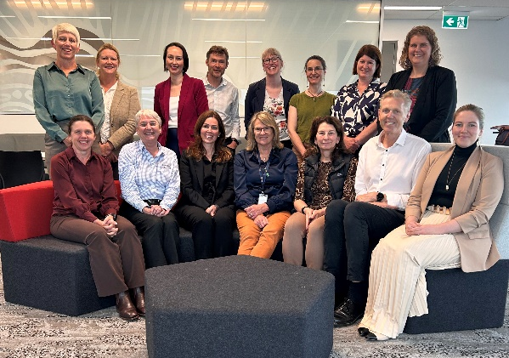
AHC would like to thank the WA Department of Primary Industries and Regional Development for hosting the AHC50 meeting.

