Alpine Sphagnum Bogs and Associated Fens
EPBC Act policy statement 3.16
A nationally threatened ecological community
Australian Government Department of the Environment, Water, Heritage and the Arts

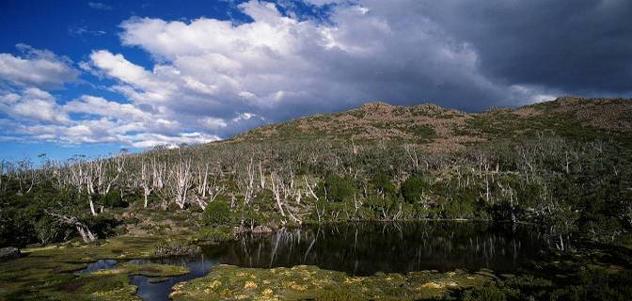
Subalpine lakeside sphagnum with endemic Athrotaxis cupressoides pencil pines surrounded by burnt snowgums. Walls of Jerusalem National Park, Tasmania.

- The Alpine Sphagnum Bogs and Associated Fens ecological community is found in small pockets in the high country of Tasmania, Victoria, New South Wales and the Australia Capital Territory.
- The Alpine Sphagnum Bogs and Associated Fens ecological community can usually be defined by the presence or absence of sphagnum moss.
- Long term conservation and restoration of this ecological community is essential in order to protect vital inland water resources.
- Implementing favourable land use and management practices is encouraged at sites containing this ecological community.

What is an ecological community?
An ecological community is a naturally occurring group of plants, animals and other organisms that constitute a unique habitat. Its structure, composition and distribution are determined by environmental factors such as soil type, position in the landscape (e.g. altitude), climate and water availability. Species within each ecological community interact with and depend on each other – for example, for food or shelter. Listed ecological communities include grasslands, woodlands, shrublands, forests, wetlands, ground springs and cave communities. Examples already listed under the Environment Protection and Biodiversity Conservation Act (EPBC Act) include the Natural Temperate Grasslands of the Victorian Volcanic Plain, Temperate Highland Peat Swamps on Sandstone and the Weeping Myall Woodlands, to name but a few.
Together with threatened species, ecological communities are protected as one of several matters of National Environmental Significance under the EPBC Act. Threatened ecological communities can be listed as vulnerable, endangered or critically endangered, categories which represent their decline and potential for extinction across their national extent. Protection through the EPBC Act complements other conservation measures.
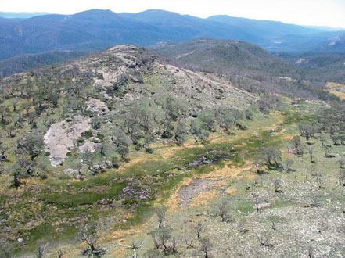
As well as being important because of their unique biodiversity and place within the Australian landscape, ecological communities provide a range of ecosystem services, including the natural management of water, the reduction or control of erosion and salinity, and carbon storage. In addition to providing vital connections as wildlife corridors and habitat refuge for many threatened plant and animal species, ecological communities also contribute to tourism, recreation and the productivity of our farmlands.
Cotter Source Bog, Mount Scabby, ACT.
WHAT IS THE ALPINE SPHAGNUM BOGS AND ASSOCIATED FENS ECOLOGICAL COMMUNITY?

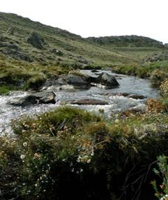
The Alpine Sphagnum Bogs and Associated Fens ecological community is an endangered ecological community listed under the EPBC Act.
The Alpine Sphagnum Bogs and Associated Fens ecological community occurs in small pockets in Tasmania, Victoria, New South Wales (NSW) and the Australian Capital Territory (ACT). The ecological community consists of highly fragmented, isolated remnants, and its present geographic extent is restricted. Most (but not all) examples of the listed community are situated within national parks and other conservation related land tenure.
The Alpine Sphagnum Bogs and Associated Fens ecological community is typically found in alpine, subalpine and montane environments, often (but not always) above the climatic treeline. It is important to note that the limit of tree vegetation is variable depending on topographic features and localised climatic conditions, such as the degree of cold air drainage at individual sites which may prevent the growth of trees. Consequently, the Alpine Sphagnum Bogs and Associated Fens ecological community
also occurs at sites with lower elevations, where local conditions and
vegetation are equivalent to those of true alpine sites. ‘Frost hollows’ and
‘inverted treelines’ are common.
Alpine fen, Happy Jacks Creek, Kosciuszko National Park, NSW.
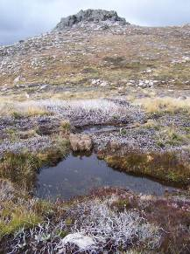
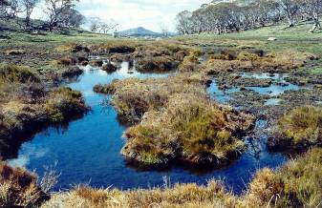

Alpine sphagnum bog pool, Mount Jagungal, Kosciuszko National Park, NSW.
Alpine sphagnum bog, Mount Jagungal, Kosciuszko National Park, NSW.

Bogs and fens each contain their own distinctive vegetation, however, they are considered inseparable in this context given the high degree of interdependence. For this reason, they have been listed together as a single community.
As the name suggests, the Alpine Sphagnum Bogs and Associated Fens ecological community can usually be defined by the presence or absence of sphagnum moss, even though it is not always the dominant genus. However, there are some sites in the listed community where sphagnum moss is only a minor component, and the vegetation is dominated by shrubs or species such as Empodisma minus. There are also sites where sphagnum moss has been depleted or lost due to disturbance. In these cases, the site may still be considered to be part of the listed community if other key species are present, and an underlying layer of peat is evident.
The Alpine Sphagnum Bogs and Associated Fens ecological community contains a number of recognised variants, changing in a predictable progression from the hillsides down to the valley floor. Bogs are found in permanently wet areas, such as along streams, valley edges and valley floors. They are also situated on slopes where soils are waterlogged. The key to bog formation is a good supply of groundwater and an impeded drainage system that keeps the water table at or near the surface.
Permanently wet areas provide suitable habitat for the growth of Epacris and other shrub species. Along with sphagnum moss, these plants form a slightly domed ‘raised’ bog. A ‘raised’ bog is a dynamic community that oscillates through a cycle of herbs and shrubs on the hummocks and hollows that characterise this landscape.
Carex sedges may replace some shrubs at the edges of valleys and on valley floors. In these locations, the vegetation forms a flatter, more concave ‘valley’ bog.
Fens are semi-permanent to permanent pools of water, typically found in the wettest areas along watercourses or on valley floors. These conditions generally do not favour the growth of some sphagnum moss species, so in these locations the listed ecological community tends to be dominated by sedges.
The Alpine Sphagnum Bogs and Associated Fens ecological community contains many endemic plant species, as well as providing significant habitat for a number of endemic and threatened animals. An indicative list of plant species commonly found in the bog and fen components of the listed ecological community on mainland Australia and in Tasmania is presented at Tables 1 and 2 respectively. (Please note that this list is not comprehensive.) The plants identified are not necessarily found in every occurrence of the ecological community, and other species may also be present.

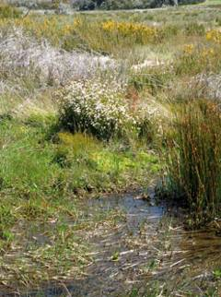
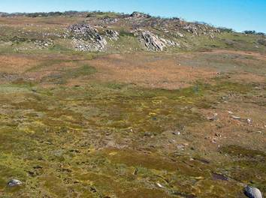

Alpine fen, Ogilvies Plain,
Kosciuszko National Park, NSW.
Alpine sphagnum bog, Mount Jagungal,
Kosciuszko National Park, NSW.
Table 1. Typical native plant species found in bogs in the Alpine Sphagnum Bogs and Associated Fens ecological community (mainland and Tasmanian sites).

MAINLAND SITES |  | TASMANIAN SITES
Scientific Name | Common Name | Scientific Name | Common Name
Shrubs |  | Shrubs
Baeckea gunniana | alpine baeckea | Baeckea gunniana | alpine heathmyrtle
Baeckea utilis | mountain baeckea | Callistemon viridiflorus | green bottlebrush
Callistemon pityoides | alpine bottlebrush | Ozothamnus hookeri | kerosene bush
Epacris gunnii | coral heath | Ozothamnus rodwayi | alpine everlastingbush
Olearia algida | alpine daisybush | Richea scoparia | scoparia
Oxylobium ellipticum | common shaggy pea
Richea continentis | candle heath
Herbs |  | Herbs
Asperula gunnii | mountain woodruff | Acaena novae-zelandiae | bidgee-widgee / biddy biddy
Epilobium gunnianum | willow herb | Asperula gunnii | mountain woodruff
Gonocarpus micranthus | creeping raspwort | Celmisia asteliifolia | snow daisy
Nertera granadensis | matted nertera
Oreomyrrhis ciliate | bog carraway
Psychrophila introloba | marsh marigold
Grasses, Sedges, Rushes |  | Grasses, Sedges, Rushes
Astelia alpine | pineapple grass | Astelia alpina | pineapple grass
Baloskion australe | mountain cordrush | Baloskion australe | southern cordrush
Carex appressa | tall sedge | Empodisma minus | spreading rope rush
Carex gaudichaudiana | fen sedge / tufted sedge | Gahnia grandis | cutting grass
Carpha nivicola | broad-leaf flower-rush | Gymnoschoenus sphaerocephalus | buttongrass
Empodisma minus | spreading rope rush | Oreobolus pumilio | alpine tuft rush
Luzula modesta | bog woodrush | Poa labillardierei | snow grass
Poa costiniana | prickly snow grass
Ferns |  | Ferns
Blechnum penna-marina | alpine water fern | Blechnum penna-marina | alpine water fern
 |  | Gleichenia alpina | alpine coral fern
Mosses |  | Mosses
Sphagnum cristatum | sphagnum moss | Sphagnum australe | sphagnum moss
Sphagnum novozelandicum | sphagnum moss | Sphagnum cristatum | sphagnum moss
 |  | Sphagnum falcatulum | sphagnum moss

Table 2. Typical native plant species found in fens in the Alpine Sphagnum Bogs and Associated
Fens ecological community (mainland and Tasmanian sites).

MAINLAND SITES |  | TASMANIAN SITES
Scientific Name | Common Name | Scientific Name | Common Name
Herbs |  | Herbs
Brachyscome obovata | baw baw daisy | Gunnera cordifolia | Tasmanian mudleaf
Deschampsia caespitosa | tufted hairgrass | Lobelia surrepens | mud pratia
Epilobium gunnianum | willow herb
Lobelia surrepens | mud pratia
Oreomyrrhis cilata | bog carraway
Grasses, Sedges, Rushes |  | Grasses, Sedges, Rushes
Carex echinata | star sedge | Baloskion australe | southern cordrush
Carex gaudichaudiana | fen sedge / tufted sedge | Carex gaudichaudiana | fen sedge
Carpha nivicola | broad-leaf flower-rush | Carpha alpina | alpine straw sedge
Empodisma minus | spreading rope rush | Empodisma minus | spreading rope rush
Isolepis crassiuscula | alpine clubsedge | Gymnoschoenus sphaerocephalus | buttongrass
Juncus falcatus | sickle leaf rush
Mosses |  | Mosses
Sphagnum cristatum | sphagnum moss | Sphagnum cristatum | sphagnum moss
Sphagnum novozelandicum | sphagnum moss
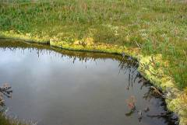
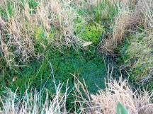

Bog pool surrounded by Sphagnum cristatum and Richea continentis. Northern Bogong High Plains, Victoria.
Inundation-tolerant Sphagnum novozelandicum (dark green) and hummock-forming Sphagnum cristatum (paler, brighter green).

Some Key Species
The following photographs show some of the key indicative species of the Alpine Sphagnum Bog and Associated Fens ecological community from Tables 1 and 2. An expanded list of key indicative species can be found in the listing advice for this ecological community at: www.environment.gov.au/cgi-bin/sprat/public/publiclookupcommunities.pl

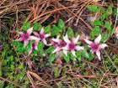  Psychrophila introloba. | 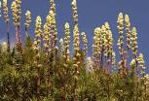  Richea continentis. | 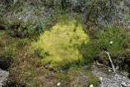  Sphagnum spp.
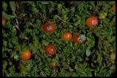  Nertera granadensis. | 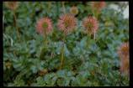  Acaena novae-zelandiae. | 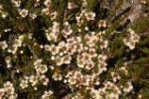  Baeckea gunniana.
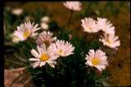  Celmisia asteliifolia. | 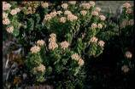  Ozothamnus rodwayi. | 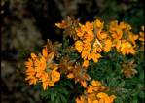  Oxylobium ellipticum.
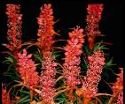  Richea scoparia. | 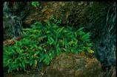  Blechnum penna-marina. | 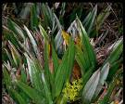  Astelia alpina.
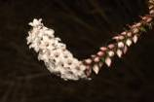  Epacris gunnii. | 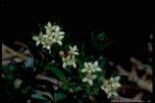  Asperula gunnii. | Brachyscome obovata.
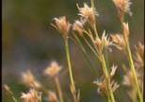  Carpha alpina. | 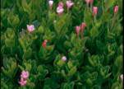  Epilobium gunnianum. | 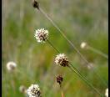  Gymnoschoenus sphaerocephalus.
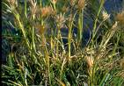  Carpha nivicola. | 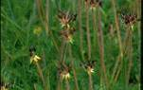  Oreomyrrhis ciliata. | 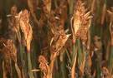  Baloskion australe.
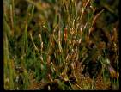  Empodisma minus. | 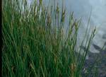  Carex guadichaudiana. | 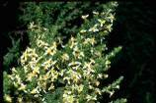  Olearia algida.
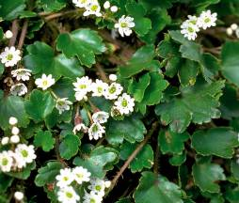
Dichosciadium ranunculaceum var. ranunculaceum (wreath pennywort). This species is endemic to the ecological community.
Why is the Alpine Sphagnum Bogs and Associated Fens ecological community so important?
The Alpine Sphagnum Bogs and Associated Fens ecological community is home to a rich profusion of flora. It also provides significant habitat for several threatened fauna species, including the Southern Corroboree Frog. The Alpine Sphagnum Bogs and Associated Fens ecological community is a critical refuge for a number of endemic flora and fauna species, many of which are at risk of extinction as threats like global warming continue to marginalise their niche habitats. As warmer temperatures and other changing climatic conditions increase the pressure on water availability, the importance of this ecological community’s functional role in regulating water release and flow downstream also increases.
The Alpine Sphagnum Bogs and Associated Fens ecological community provides critical ecosystem services for major inland water resources. On the mainland, it includes the headwaters of important rivers such as the Murray, Murrumbidgee and Snowy Rivers. These rivers support many inland cities and towns, and are vital for agriculture and other significant industries. Inland-flowing alpine streams provide a high proportion of total streamflow in the Murray-Darling Basin, emphasising that these water resources and the environment where they originate are of regional and national importance. In Tasmania, the alpine and subalpine zones are also the main source for many of the island’s river systems.
Peat bogs such as those in the Alpine Sphagnum Bogs and Associated Fens ecological community are also highly significant from a conservation perspective, as they contain pollen and charcoal deposits that provide a botanical and climatic timeline dating back millions of years. This type of geological record is of critical importance in providing a picture of past climatic conditions, which in turn greatly assists understanding of ongoing climate change and its effects.
Finally, the Alpine Sphagnum Bogs and Associated Fens ecological community includes sites like the Ginini Flats Wetland and Blue Lake, which are of international significance through their listing under the Ramsar Convention on Wetlands. Ginini Flats Wetland is also the largest intact bog and fen community in the Australian Alps.
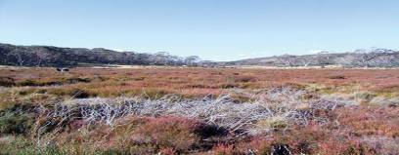

Mount Ginini Wetlands, Brindabella Ranges, ACT.

Where is the ecological community found?
The high-resolution map (which can be found through a link at: http://www.environment.gov.au/cgi-bin/sprat/public/publicshowcommunity.pl?id=29&status=Critically%20Endangered) shows the areas in south eastern Australia where the Alpine Sphagnum Bogs and Associated Fens ecological community is likely to occur. The description of the ecological community provided in the listing advice is always the definitive source of information for identifying a nationally threatened ecological community and any mapped vegetation units should only be used as a guide.
The ecological community is known to occur in the following Interim Biogeographic Regionalisation of Australia (IBRA) bioregions: Australian Alps, Tasmanian Central Highlands and Tasmanian Southern Ranges, as well as the Bondo subregion of the South Eastern Highlands bioregion on mainland Australia. It may also be present within the Ben Lomond and Tasmanian South East bioregions in Tasmania.
In general, alpine and subalpine regions are found above 1600 metres above sea level (asl) on mainland Australia, and above 800m asl in Tasmania. However, as previously stated, the climatic treeline is variable depending on topographical features and localised climatic conditions such as the degree of cold air drainage at individual sites. For example, this ecological community is known to exist at 1200m asl in Victoria, and as low as 1000m asl in parts of NSW and the ACT.
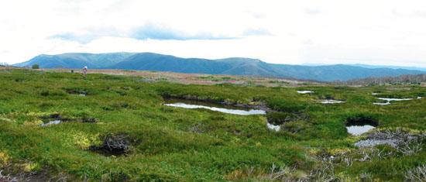
Bog pools on the Northern Bogong High Plains, looking towards Mount Bogong, Victoria.

State equivalents to the listed community
Different jurisdictions classify plant communities in different ways. Vegetation in Victoria has been classified using a system of Ecological Vegetation Classes (EVCs) to describe the floristics of different plant associations. A similar system is used in Tasmania, called TASVEG. Recent studies in NSW have also provided detailed classifications across the mainland alpine and subalpine regions in general. These floristic equivalents are listed below in Table 3.
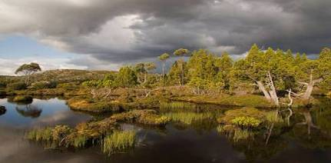
Highland lakeside sphagnum hummocks under an overstorey of Athrotaxis cupressoides pencil pines. Pencil pines only survey in fire-protected areas and often with their roots buried in sphagnum moss. Walls of Jerusalem National Park, Tasmania.

Table 3. Relevant floristic equivalents.
Various components of the Alpine Sphagnum Bogs and Associated Fens ecological community have been described according to a range of floristic associations.
State/Territory | Classification | Community Name
Victoria | EVC 171 | Alpine Fen
Victoria | EVC 210 | Sub-alpine Wet Heathland
Victoria | EVC 221 | Sub-alpine Wet Heathland/Alpine Fen Mosaic
Victoria | EVC 288-61 | Alpine Valley Peatland (Raised Bog)
Victoria | EVC 288-62 | Alpine Valley Peatland (Valley Bog)
Victoria | EVC 917 | Sub-Alpine Wet Sedgeland
Victoria | EVC 1011 | Alpine Peaty Heathland
Tasmania | TASVEG MSP | Sphagnum peatland
NSW (Keith, 2004) | Keith Vegetation Class | Alpine Bogs and Fens
Mainland  (McDougall & Walsh, 2007) | Community 1 | Baw Baw – Lake Mountain Wet Heathland
Mainland  (McDougall & Walsh, 2007) | Community 2 | Richea continentis – Carpha nivicola – Sphagnum cristatum Wet Heathland
Mainland  (McDougall & Walsh, 2007) | Community 3 | Baeckea gunninana – Callistemon pityoides – Sphagnum cristatum Wet Heathland
Mainland  (McDougall & Walsh, 2007) | Community 8 | Fen
(See Further Information section for reference details)

In addition to these classification systems, Tasmania, Victoria and NSW have ecological communities equivalent to the Alpine Sphagnum Bogs and Associated Fens listed as threatened under their own state environment legislation. This information may enable land managers who are familiar with their own state’s vegetation classifications to identify whether the listed community may occur at a particular site.
- In NSW, the ecological community is protected under the Threatened Species Conservation Act 1995 as part of a broader community called “Montane peatlands and swamps of the New England Tableland, NSW North Coast, Sydney Basin, South East Corner, South Eastern Highlands and Australian Alps Bioregions”. http://threatenedspecies.environment.nsw.gov.au/tsprofile/index.aspx
- In Tasmania, ‘Sphagnum peatland’ is listed as ‘Rare’ under the Nature Conservation Act 2002.
- In Victoria, two components of the Alpine Sphagnum Bogs and Associated Fens ecological community have been listed under the Flora and Fauna Guarantee Act 1988. These are the ‘Alpine Bog Community’ and the ‘Fen (Bog Pool) Community’. The ‘Caltha introloba Herbland Community’ may also be found with sphagnum bogs, particularly around areas of late-lying snow.
- The ACT has not (as at August 2009) listed this ecological community under the Nature Conservation Act 1980.
The listing of the Alpine Sphagnum Bogs and Associated Fens ecological community under the EPBC Act protects the ecological community throughout its entire range, including sites which are not already protected by state or territory legislation, or within national park boundaries or other conservation related tenure.
Species of Special Importance
The Alpine Sphagnum Bogs and Associated Fens ecological community is home to many endemic and threatened plant and animal species. Some of these plants and animals are also listed and protected individually under the EPBC Act. These include the Southern Corroboree Frog, Northern Corroboree Frog, Baw Baw Frog,
Booroolong Frog, Verreaux’s Alpine Tree Frog and the summer-flowering Bogong Eyebright plant.

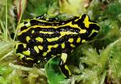  Northern Corroboree Frog. | 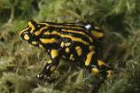  Southern Corroboree Frog.
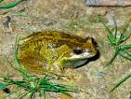  Verreaux's Alpine Tree Frog. | 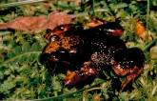  Baw Baw Frog.

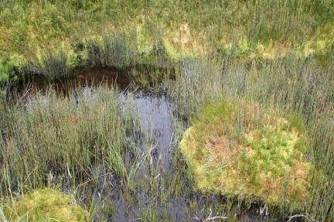

Close up of an alpine sphagnum bog pool.
Why is the ecological community listed as endangered?
The decision to list the Alpine Sphagnum Bogs and Associated Fens ecological community as endangered was made by the Australian Minister for the Environment, Heritage and the Arts after a rigorous process that involved consultation with stakeholders and advice from the Threatened Species Scientific Committee (TSSC). The TSSC is an independent scientific body that advises the Minister on the conservation status of native species and ecological communities.
The TSSC determined that this ecological community is endangered due to its small geographic distribution coupled with demonstrable threats, continued decline of functionally important species and the severe reduction in the community integrity across its range. Most patches containing the ecological community are small.
National listing of an ecological community recognises that its long-term survival is under threat. The listing aims to prevent any further decline and to promote and assist recovery through landholder and community efforts.
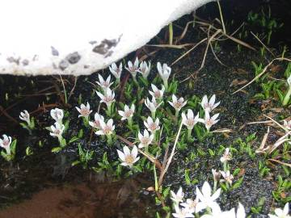

Sphagnum remnants within a burnt and scorched landscape. Lake Mountain, Victoria.
Sphagnum remnants within a burnt and scorched landscape. Lake Mountain, Victoria.
Psychrophila introloba commences flowering under snow.
Pretty Valley, Bogong High Plains, Victoria.
What does the listing of the ecological community mean for land managers or potential developers?
If the listed ecological community is present at a particular site, then adequate protection and appropriate land use practices are vitally important if the ecological community is to persist for the benefit of future generations.
The listing of the Alpine Sphagnum Bogs and Associated Fens ecological community under the EPBC Act does not prevent land managers from continuing to use land in the same way they were before the EPBC Act came into force, providing that they do not significantly change or intensify their activities (and the activity is lawful).
National protection means any new or intensified activities that may have a significant impact on the listed ecological community should be referred to the Australian Minister for the Environment, Heritage and the Arts for assessment.
The EPBC Act allows for some exemptions to the requirement for assessment and approval. This means that some activities may not need to be referred for an assessment or approval under certain circumstances. However, failure by proponents to refer an action that has a significant impact on the listed ecological community may have legal consequences such as financial penalties and/or remediation orders.
Those activities that may require referral under the EPBC Act include, but are not restricted to:
- changes to natural drainage regimes, such as the diversion of water, affecting the community
- clearing of the ecological community, dumping of spoil, construction of structures fragmenting the community or impeding natural water balances (e.g. causeways, raised fencelines, fuel breaks, etc.)
- clearing of native vegetation adjacent to the listed community or in the immediate upstream catchment such that drainage regimes supporting the ecological community are affected
- significant and adverse changes in management regimes affecting the community, including the use of fire
- new weed management regimes that pose significant risk to the listed community, and
- allowing new access for domestic stock and other grazing animals (e.g. where there has previously been no access) or intensification in the numbers of animals with access to the ecological community.
It is also important to note that some plant or animal species occurring within remnants may also be protected individually under the EPBC Act. Therefore, any activity which may significantly impact on these listed species may also require approval. In addition, most occurrences of the ecological community fall within places included on the National Heritage List, such as the Australian Alps National Parks and Reserves. The ecological community and its associated flora and fauna are specifically listed as values of the Australian Alps National Parks and Reserves National Heritage listed place, and are therefore also protected by the heritage provisions of the EPBC Act.
Further information is available on:
Exemptions:
www.environment.gov.au/epbc/about/exemptions.html
Referrals:
www.environment.gov.au/epbc/assessments/referral-form.html
Approvals:
www.environment.gov.au/epbc/approval.html
Enquiries may also be directed to the Department’s Community Information Unit on 1800 803 772.
In addition to EPBC Act requirements, check if any state or local approvals are necessary before undertaking an activity.
Farmers and land managers who have the listed ecological community on their properties are encouraged to seek assistance from the Environmental Liaison Officer at the National Farmers’ Federation. The Environment Liaison Officer can be contacted by phone on 1800 704 520 or via email at: environment@nff.org.au
Threats, Impacts and Conservation Actions
Alpine vegetation is particularly susceptible to change in general, along with a range of more specific adverse impacts. This is due in part to the restricted growing season in the alpine and subalpine regions, but also the very fragile nature of some systems, of which the Alpine Sphagnum Bogs and Associated Fens ecological community is just one example. The biggest threats currently facing this community are fire and the ongoing effects of climate change. Other significant threats to the Alpine Sphagnum Bogs and Associated Fens ecological community include exotic weed invasions, grazing and trampling by non-native animals, tourism and increased human infrastructure. Harvesting of sphagnum moss for use in the horticultural industry is also an issue in some areas, mainly in Tasmania.
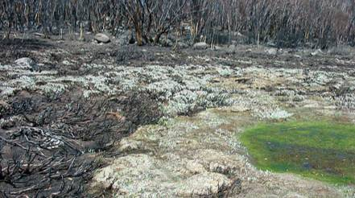

Sphagnum remnants within a burnt and scorched landscape. Lake Mountain, Victoria.

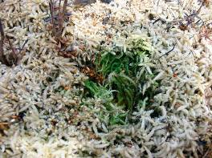
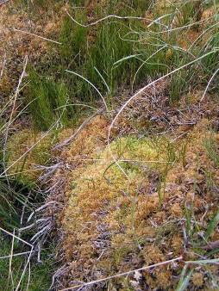

Carpha nivicola.
Close up of an unburnt sphagnum remnant in a burnt alpine bog. Lake Mountain, Victoria.

Sphagnum moss recovery post fire.

Whilst many Australian vegetation types are adapted to or highly tolerant of fire, sphagnum moss and its underlying peats are very fire sensitive. Sphagnum moss depends on the survival of remnant unburnt fragments for regeneration, whilst shrubs such as Epacris gunnii and Richea continentis rely on seedling recruitment in order to re-establish post-fire. Both of these processes take a long time, leaving the bog environment extremely vulnerable to prolonged soil erosion and weed invasion in the interim. The ecological community is particularly vulnerable after fire, as large animals are able to gain access to a larger proportion of a bog. This can then adversely affect post-fire recovery.
Too frequent fire is also an ongoing threat to the listed community, particularly under drought conditions. This was clearly demonstrated by the significant damage to the Alpine Sphagnum Bogs and Associated Fens ecological community in 2003 and 2006, when wildfires swept across the high country of Victoria, NSW and the ACT. The ecological community was also affected by the Victorian wildfires of February 2009.
The impact of a changing climate may directly affect the Alpine Sphagnum Bogs and Associated Fens ecological community through warmer temperatures and reduced precipitation. As pressure on water availability increases, so too does the importance of the listed community’s functional role in regulating water release and flow downstream. This ecological community is particularly vulnerable to climate change because it is already at the limits of its possible range, providing critical refuge habitat for many species. If the community becomes warmer or drier, there is nowhere for these species to go.
One of the better documented threats to alpine vegetation is the impact of animals introduced to Australia since European settlement. All alpine and subalpine regions on the mainland and in Tasmania were used for the summer grazing of cattle from the early 1800s onwards. Although cattle no longer have legal access to national parks, it is important to understand that the impact of non-native animals on alpine vegetation is long-term, with the effects remaining long after the initial problem is removed. Furthermore, the threat of trampling by cattle still remains outside of national parks (for example, in some state forests). Trampling by feral animals such as horses, deer, goats and pigs is also a threat to the ecological community.
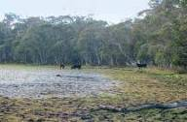
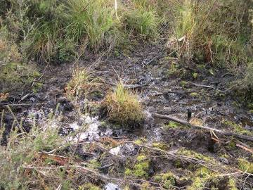

Cattle grazing in a alpine sphagnum bog at Lake Hill, near Low Plain, Nunniong Plateau, Victoria.

An alpine sphagnum bog that has been severely trampled by cattle.
Australian soils and vegetation are very susceptible to the impact of hard-hooved vertebrates. In particular, sphagnum moss is easily crushed and broken up by trampling and wallowing. These activities cause channels to form in the disturbed sphagnum moss, resulting in erosion and changes to natural drainage patterns, which can ultimately lead to the bog drying out.
Infrastructure such as drains and aqueducts also alter natural drainage patterns. Changes in water runoff (both quantity and timing) potentially threaten the listed community as they can significantly alter the surrounding vegetation, leading to bogs and fens drying out.

Cattle grazing in an alpine sphagnum bog at Lake Hill, near Lower Plain, Nunniong Plateau, Victoria.

Another of the greatest threats currently facing the Alpine Sphagnum Bogs and Associated Fens ecological community is exotic weed invasion. Whilst intact sites can be quite resistant to weed establishment, those already compromised by fire or other impacts such as grazing and trampling become very susceptible. Some exotic weeds are now in such abundance that they are permanently altering the floristic composition and structural integrity of some bog and fen sites. Highly invasive weeds of particular concern for the ecological community include willows, hawkweed, soft rush, Yorkshire fog and sweet vernal grass. For information on the management of some of these weeds, visit the Weeds of National Significance website: http://www.weeds.org.au/WoNS
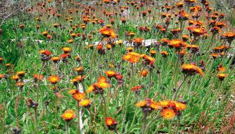

Hawkweed is an invasive exotic weed species which threatens the integrity of the ecological community.

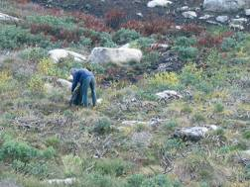
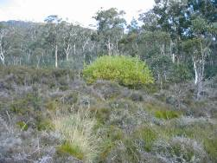

Removal of willow seedlings (yellow plants) from a previously burnt alpine sphagnum bog.
Mature willow embedded in sphagnum hummocks.

To assist in the protection of the ecological community, continued survey work and mapping is encouraged. Monitoring to identify key threats as well as protecting known sites outside national parks through the development of conservation agreements and covenants would also help to protect the Alpine Sphagnum Bogs and Associated Fens ecological community.
Table 4 summarises some of the key threats to the Alpine Sphagnum Bogs and Associated Fens ecological community. It also includes possible actions that land managers may take to conserve the listed ecological community and benefit their land, although this list is not exhaustive. Conservation advice has been prepared for the Alpine Sphagnum Bog and Associated Fens ecological community. This document is designed to provide additional management guidance and is available on SPRAT at the following web address:
www.environment.gov.au/cgi-bin/sprat/public/publiclookupcommunities.pl

Table 4. Key threats faced by the Alpine Sphagnum Bogs and Associated Fens ecological community.
Threat | Impact | Management Actions
Fire | - Permanent change to the structure and species composition of the community  - Removal of functionally important species such as sphagnum moss subsequently impacts on water holding capacity, water quality and erosion rates.  - Loss of habitat for native animals | - Develop and implement suitable fire management strategies to prevent further loss of community integrity and functionally important species
Trampling, browsing and grazing by hard-hooved non-native animals | - Vegetation removal  - Compaction of soil and sphagnum moss  - Increased runoff and other changes to hydrology  - Accelerated erosion and exotic weed invasion | - Maintain fencing to prevent domestic stock from accessing areas known to contain the ecological community  - Implement existing management plans for the control and eradication of feral non-native animals in alpine and subalpine regions  - Manage known sites to exclude non-native animals
Invasive Weeds | - Introduced plants compete with native plants for space, water and nutrients  - Irreversible changes to floristic composition, structure and hydrology | - Identify and undertake weed management at known sites to reduce and/or remove weeds using appropriate methods, especially at sites where new weed threats are becoming established  - Appropriately manage known occurrences of the listed community to prevent the introduction/establishment of new invasive weeds

Is funding available to protect the ecological community?
Regardless of whether the ecological community exists on private property, council land or public land, land managers or community groups may be eligible for funding to help preserve or restore remnants.
Funding through the Australian Government’s Caring for our Country initiative may be available for activities undertaken which have an environmental benefit. For more details, visit: www.nrm.gov.au/funding/index.html
The National Reserve System (NRS) has an important role in protecting biodiversity values. Building the NRS is one of the priorities under Caring for our Country. Funding may be available to landholders in priority areas who seek financial support to either purchase land or establish protected areas on private land for inclusion in the NRS. For more details, visit: www.environment.gov.au/parks/nrs
There may be state government initiatives to help protect alpine bogs, as they are listed under state legislation in Tasmania, Victoria and NSW. Regional offices of the Department of Environment, Climate Change and Water in NSW, the Department of Sustainability and Environment in Victoria and the Department of Primary Industries, Parks, Water and Environment in Tasmania may all be able to assist. A local Catchment Management Authority, Regional Natural Resource Management Group, or your local council can also provide you with information about any current
programs in place to support conservation efforts.
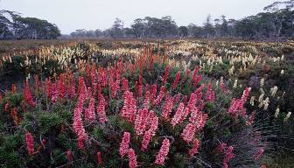

Richea scorparia. Clarence Lagoon, Central Plateau Conservation Area, Tasmania

Where to go for further information
- Listing advice and conservation advice for the Alpine Sphagnum Bogs and Associated Fens ecological community is available online, and a comprehensive reference list is included with these documents. Go to the ecological community and view these documents: www.environment.gov.au/cgi-bin/sprat/public/publiclookupcommunities.pl
- NSW Department of Environment, Climate Change and Water (NSW listed ecological community). ‘Montane peatlands and swamps of the New England Tableland, NSW North Coast, Sydney Basin, South East Corner, South Eastern Highlands and Australian Alps Bioregions’ ecological community profile is also available online at: www.threatenedspecies.environment.nsw.gov.au/tsprofile/index.aspx
- Further information on Victoria’s EVC benchmarks can be found at: www.dpi.vic.gov.au
- Further information on Tasmania’s TASVEG Vegetation Community Benchmarks can be found at: www.dpipwe.tas.gov.au

Harris, S. and Kitchener, A. (Editors) (2005). From Forest to Fjaeldmark: Descriptions of Tasmania’s Vegetation. Department of Primary Industries, Water and Environment, Hobart.
Keith, D. (2004). Ocean Shores to Desert Dunes – The Native Vegetation of New South Wales and the ACT. Department of Environment and Conservation (NSW), Hurstville.
McDougall, K. and Walsh, N. (2007). Treeless vegetation of the Australian Alps. Cunninghamia, 10(1): 1-57.
VDSE (Victorian Department of Sustainability and Environment) (2005). EVC/Bioregion Benchmark for Wetland Vegetation Assessment. (EVCs 44, 171, 210, 221, 288-61, 288-62, 917 and 1011) Victorian Government Department of Sustainability and Environment, Melbourne.
Whinam, J., Barmuta, L.A. and Chilcott, N. (2001). Floristic description and environmental relationships of Tasmanian Sphagnum communities and their conservation management. Australian Journal of Botany 49 (6), 673-685.
Whinam, J. and Chilcott, N. (2003). Floristic description and environmental relationships of Sphagnum communities in NSW and the ACT and their conservation management. Cunninghamia 7, 463-500.
Psychrophila introloba.
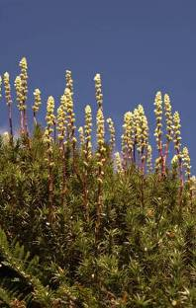
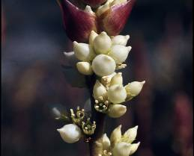

Psychrophila introloba.

Close up of Richea continentis

Richea continentis
Useful websites
- EPBC Act web site:
www.environment.gov.au/epbc
- EPBC Act Administrative Guidelines on Significance: www.environment.gov.au/epbc/assessmentsapprovals/guidelines/index.html
- Information about nationally threatened ecological communities and species:
www.environment.gov.au/cgi-bin/sprat/public/sprat.pl
- Caring for our Country – What can I do?
www.nrm.gov.au/do/landholders/index.html
- National Heritage Places List website
www.environment.gov.au/heritage/places/national/index.html
- Australian Alps National Parks
www.australianalps.environment.gov.au/
- Department of Climate Change
www.climatechange.gov.au/publications/

Additional Copies
If you would like extra copies of this booklet, please contact the Community Information Unit of the Department of the Environment, Water, Heritage and the Arts.
Email: ciu@environment.gov.au
Freecall: 1800 803 772

Carpha nivicola

This brochure is designed to assist land managers, owners and occupiers to identify, assess
and manage the Alpine Sphagnum Bogs and Associated Fens, an ecological community
listed under Australia’s national environment law, the Environment Protection and Biodiversity
Conservation Act 1999 (EPBC Act). The brochure is a companion document to the listing
advice which can be found at the Australian Government’s Species Profi le and Threats
Database (SPRAT). Please go to the Alpine Sphagnum Bogs and Associated Fens ecological
community profile in SPRAT, then click on the ‘Details’ link:
www.environment.gov.au/cgi-bin/sprat/public/publiclookupcommunities.pl

IMAGES
1. Subalpine lakeside sphagnum with endemic Athrotaxis
cupressoides pencil pines surrounded by burnt
snowgums. Walls of Jerusalem National Park, Tasmania.
© Grant Dixon Photography
2. Cotter Source Bog, Mount Scabby, ACT. © ACT Parks,
Conservation and Lands
3. Alpine fen, Happy Jacks Creek, Kosciuszko National Park,
NSW. © Rod Atkins
3. Alpine sphagnum bog pool, Mount Jagungal, Kosciuszko
National Park, NSW. © Roger Good and Genevieve Wright
3. Alpine sphagnum bog, Mount Jagungal, Kosciuszko
National Park, NSW. © Roger Good and Genevieve Wright
4. Alpine fen, Ogilvies Plain, Kosciuszko National Park, NSW.
© Rod Atkins
4. Alpine sphagnum bog, Mount Jagungal, Kosciuszko
National Park, NSW. © Roger Good and Genevieve Wright
6. Bog pool surrounded by Sphagnum cristatum and Richea
continentis. Northern Bogong High Plains, Victoria.
© Arn Tolsma
6. Inundation-tolerant Sphagnum novozelandicum
(dark green) and hummock-forming Sphagnum cristatum
(paler, brighter green). © Arn Tolsma
7. Psychrophila introloba. © Australian Alps Collection
7. Richea continentis. © M. Fagg, ANBG
7. Sphagnum spp. © M. Fagg, ANBG
7. Nertera granadensis. © C. Totterdell, ANBG
7. Acaena novae-zelandiae. © M. Fagg, ANBG
7. Baeckea gunniana. © M. Fagg, ANBG
7. Celmisia asteliifolia. © R. Hill, ANBG
7. Ozothamnus rodwayi. © M. Richardson, ANBG
7. Oxylobium ellpiticum. © M. Fagg, ANBG
7. Richea scoparia. © M. Fagg, ANBG
7. Blechnum penna-marina. © M. Fagg, ANBG
7. Astelia alpina. © M. Fagg, ANBG
8. Epacris gunnii. © M. Fagg, ANBG
8. Asperula gunnii. © C. Totterdell, ANBG
8. Brachyscome obovata. © C. Totterdell, ANBG
8. Carpha alpina. © C. Totterdell, ANBG
8. Epilobium gunnianum. © C. Totterdell, ANBG
8. Gymnoschoenus sphaerocephalus. © M. Fagg, ANBG
8. Carpha nivicola. © C. Totterdell, ANBG
8. Oreomyrrhis ciliata. © C. Totterdell, ANBG
8. Baloskion australe. © M. Fagg, ANBG
8. Empodisma minus. © C. Totterdell, ANBG
8. Carex gaudichaudiana. © C. Totterdell, ANBG

8. Olearia algida. © C. Totterdell, ANBG
8. Dichosciadium ranunculaceum var. ranunculaceum
(wreath pennywort). This species is endemic to the
ecological community. © M. Fagg, ANBG
9. Mount Ginini Wetlands, Brindabella Ranges, ACT.
© Ruth Crabb
10. Bog pools on the northern Bogong High Plains, looking
towards Mount Bogong, Victoria. © Arn Tolsma
11. Highland lakeside sphagnum hummocks under an
overstorey of Athrotaxis cupressoides pencil pines. Pencil
pines only survive in fire-protected areas and often with
their roots buried in sphagnum moss. Walls of Jerusalem
National Park, Tasmania. © Grant Dixon Photography
12. Northern Corroboree Frog. © Murray Evans, ACT Parks,
Conservation and Lands
12. Southern Corroboree Frog. © Steve Wilson
12. Verreaux’s Alpine Tree Frog. © Nathan Litjens
12. Baw Baw Frog. © Gregory Hollis
13. Close up of an alpine sphagnum bog pool.
© Murray Evans, ACT Parks, Conservation and Lands
13. Psychrophila introloba commences flowering under snow.
Pretty Valley, Bogong High Plains, Victoria. © Arn Tolsma
15. Sphagnum remnants within a burnt and scorched
landscape. Lake Mountain, Victoria. © Arn Tolsma
15. Close up of an unburnt sphagnum remnant in a burnt
alpine bog. Lake Mountain, Victoria. © Arn Tolsma
15. Sphagnum moss recovery post-fire. © ACT Parks,
Conservation and Lands
16. An alpine sphagnum bog that has been severely trampled
by cattle. © Keith McDougall
16. Cattle grazing in an alpine sphagnum bog at Lake Hill, near
Low Plain, Nunniong Plateau, Victoria. © Arn Tolsma
17. Hawkweed is an invasive exotic weed species which
threatens the integrity of the ecological community.
© Keith McDougall
17. Removal of willow seedlings (yellow plants) from a
previously burnt alpine sphagnum bog. © Arn Tolsma
17. Mature willow embedded in sphagnum hummocks.
© Arn Tolsma
19. Richea scoparia at Clarence Lagoon, Central Plateau
Conservation Area, Tasmania. © Grant Dixon Photography
20. Close up of Richea continentis. © G. Butler, ANBG
20. Richea continentis. © M. Fagg, ANBG

Disclaimer
The contents of this document have been compiled using a range of source materials. This document is valid as at August 2009.
The Commonwealth Government is not liable for any loss or damage that may be occasioned directly or indirectly through the use
of or reliance on the contents of the document.

© Commonwealth of Australia 2009
This work is copyright. You may download, display, print and reproduce this material in unaltered form only (retaining this notice) for
your personal, non-commercial use or use within your organisation. Apart from any use as permitted under the Copyright Act 1968,
all other rights are reserved. Requests and inquiries concerning reproduction and rights should be addressed to Commonwealth
Copyright Administration, Attorney General’s Department, Robert Garran Offices, National Circuit, Barton ACT 2600 or posted at
http://www.ag.gov.au/cca.

