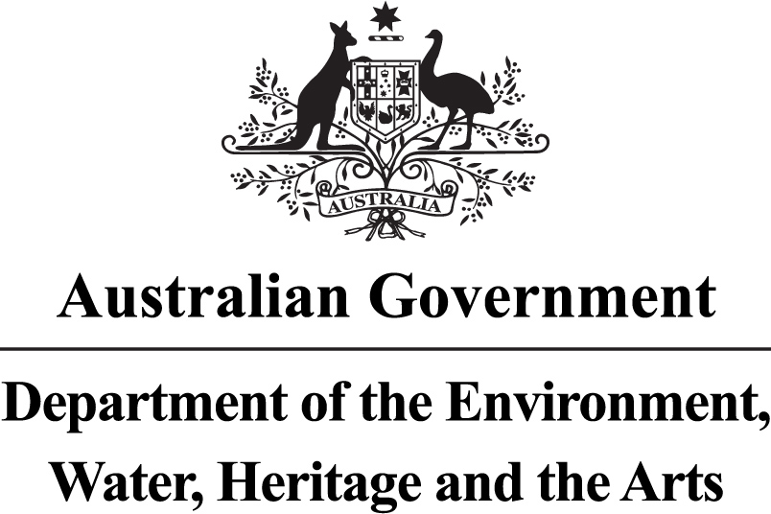

3. Amending/ Replacing a Heritage Strategy
A guide for
Commonwealth agencies

© Commonwealth of Australia 2010. This work is copyright. You may download, display, print and reproduce this material in unaltered form only (retaining this notice) for your personal, non-commercial use or use within your organisation. Apart from any use as permitted under the Copyright Act 1968, all other rights are reserved. Requests and inquiries concerning reproduction and rights should be addressed to Commonwealth Copyright Administration, Attorney General’s Department, Robert Garran Offices, National Circuit, Barton ACT 2600 or posted at http://www.ag.gov.au/cca
While reasonable efforts have been made to ensure that the contents of this publication are factually correct, the Commonwealth does not accept responsibility for the accuracy or completeness of the contents, and shall not be liable for any loss or damage that may be occasioned directly or indirectly through the use of, or reliance on, the contents of this publication. The information contained in this document is provided as a guide only. Agencies should seek their own legal advice on addressing the requirements of the EPBC Act.

1. About this guide
This is a Guideline on amending/ replacing a Heritage Strategy, consistent with the requirements of the Environment Protection and Biodiversity Conservation Act 1999 (EPBC Act), the Australian Government’s pre-eminent environment and heritage legislation.

2. When does a Heritage Strategy need to be amended/ replaced?
There is a statutory requirement that Heritage Strategies are reviewed every three years (see separate Guideline 2: Reviewing a Heritage Strategy). If, when conducting the three-yearly review you find that your Strategy requires updating, it should be amended, or revoked and replaced.

However, updating your Heritage Strategy can be done at any time; you need not wait until the statutory three-year review period. It is important to update an agency Heritage Strategy when circumstances within your agency change and the Heritage Strategy becomes outdated.

3. Do we amend our Heritage Strategy, or
revoke & replace?
The EPBC Act does not define amendment, or revocation and replacement of a Heritage Strategy. DEWHA Heritage Division suggests that a practical approach is taken. Therefore, an agency should amend its existing Heritage Strategy if there are only minor updates or administrative changes, and revoke and replace its Heritage Strategy if there are major or fundamental changes, thus creating an entirely new Strategy. The process is the same in both cases. Please consult the DEWHA Heritage Division if you are unsure.

4. What is the process for amending/ replacing a
Heritage Strategy?
The EPBC Act sets out a process for amending or revoking and replacing a Heritage Strategy.

- An agency may in writing amend, or revoke and replace its Heritage Strategy, provided it notifies the Minister for the Environment.
- You must provide the Minister with a copy of the amended or replacement Strategy within 20 business days (we suggest this is from the time of the amended Strategy being signed-off internally by your agency).
- The Minister will advise you whether the Strategy is consistent with the Commonwealth Heritage management principles.
- If the Minister finds that the Strategy is inconsistent with the Commonwealth Heritage management principles, suggested changes should be made, and a final copy of the Strategy should be provided to the Minister.

Below are the requirements of a Heritage Strategy, and guidance on how to address each requirement when updating your Strategy.
1. (a) A statement of the agency’s objective for management of its heritage places.
Does this objective need updating? (for example, as a result of more specific information you’ve ascertained about your agency’s heritage places?)

- A description of how the Heritage Strategy operates within the agency’s corporate planning framework.
Does this need updating? (has the position or operation of your Heritage Strategy within the corporate planning framework changed?)

- A list of key positions within the agency, the holders of which are responsible for heritage matters.
Have these positions changed? [Remember, the positions should refer to general titles and names of sections etc, rather than naming specific staff members.]

- An outline of a process for consultation and liaison with other government agencies on heritage matters.
Have the agencies you need to liaise with changed? (either different agencies, or changes in agency titles since the change in Government)
Has the process for consultation been working? Are changes needed to make this work better or to ensure it happens?

- An outline of a process for consultation and liaison with the community on heritage matters, including, in particular, a process for consultation and liaison with Indigenous stakeholders on Indigenous heritage matters.
Is this process still appropriate?
Has the process for consultation and liaison been working? Are changes needed to make this work better or to ensure it happens?

- An outline of a process for resolution of conflict arising from the assessment and management of Commonwealth Heritage values.
Is this process still appropriate?
Has the process for conflict resolution been tested? Did it work? Are changes needed to make this work better?

- An outline of processes for monitoring, reviewing and reporting on the implementation of an agency’s heritage strategy.
Was the review process triggered three years from developing the Heritage Strategy? If not, what could be changed to ensure it is formally reviewed in three years from now?
Is there a process for regular monitoring of the Heritage Strategy to ensure it is up to date? Eg. Could this be integrated with the process for other corporate documents that are regularly reviewed?

2. (a) An outline for the process for identifying and assessing the Commonwealth Heritage values of all agency property.
Has the process been followed? Has it been completed? Is your agency now responsible for any additional portfolio Divisions or agencies which have not yet been assessed?
If assessments are complete, this should be updated to say what the agency has done. A commitment to reviewing this if portfolio responsibilities change should be included.
If the process has not been followed or completed, is this because the process is not appropriate? Does this need revision?

(b) A statement of the time-frames for the completion of:
(i) the agency’s heritage identification and assessment program.
If this process has not been finalised, update the time-frames. If it has, include a summary statement.
(ii) the agency’s register of places and their Commonwealth Heritage values.
If this process has not been finalised, update the time-frames. If it has, include a summary statement.

(iii) the agency’s report to the Minister, that includes details of the program and a copy of the register.
If this process has not been finalised, update the time-frames. If it has, include a summary statement.

3. (a) A description of how the agency’s heritage places register will be maintained, updated and made accessible to the public.
If this has been achieved, include a summary statement. If not, does the commitment need revising?

(b) A statement of the time frame for the preparation of management plans for the agency’s Commonwealth Heritage places.
If this process has not been finalised, update the schedule. If it has, include a summary statement.

- An outline of the existing use, by the agency, of places with Commonwealth Heritage values.
Has the use of any of your agency’s places changed?
Outline any expected changes in use in the next three to five years?

- An outline of current or expected development, works, disposal or other proposals that may affect Commonwealth Heritage values.
Update this to reflect any proposals which are expected in the next three to five years.

- An outline of the process to ensure that Commonwealth Heritage values are considered in the agency’s planning for future development, works, divestment or other proposals.
Has this process been working? If not, outline a new process that will ensure Commonwealth Heritage values are considered.

- A plan and budget for the maintenance and long-term conservation of Commonwealth Heritage values.
Update this to reflect any changes in planning and budget over the coming three to five years.

- An outline of the process by which the success of the agency in conserving Commonwealth Heritage values will be monitored and reviewed.
Has this process worked? Has your agency been able to measure the success of conserving Commonwealth Heritage values?
If not, suggest a new process that will be more effective.

4. (a) A program for the training of agency staff about Commonwealth Heritage obligations and best practice heritage management.
Have staff been trained about Commonwealth Heritage obligations?
If not, outline the changes that will occur to ensure staff are trained in the future.

(b) A program for promoting community awareness of Commonwealth Heritage values, as appropriate.
Has your agency undertaken a program to promote community awareness?
Are there new opportunities in the coming three to five years where your agency could do this?

General changes
- Are references to your agency name and/or portfolio responsibilities still correct?
- Is reference to the Minister for Environment, Heritage and the Arts correct? (suggest this be changed to ‘the Environment Minister’)

- Is reference to the Department of Environment, Water, Heritage and the Arts correct? (suggest this be changed to ‘the Commonwealth agency with responsibility for Heritage’)

5. Further information
Heritage Division would be happy to review your updated heritage strategy and provide feedback prior to it being provided to the Minister.

If you would like to discuss a heritage strategy review, please contact us at:

Heritage Division
Department of the Environment, Water, Heritage and the Arts
GPO Box 787
CANBERRA ACT 2601

Tel: (02) 6274 1111
Fax: (02) 6274 2092
Email: heritage@environment.gov.au
Web: www.heritage.gov.au

