Analysis of possible
change in ecological character of the Roebuck Bay and Eighty Mile Beach Ramsar sites

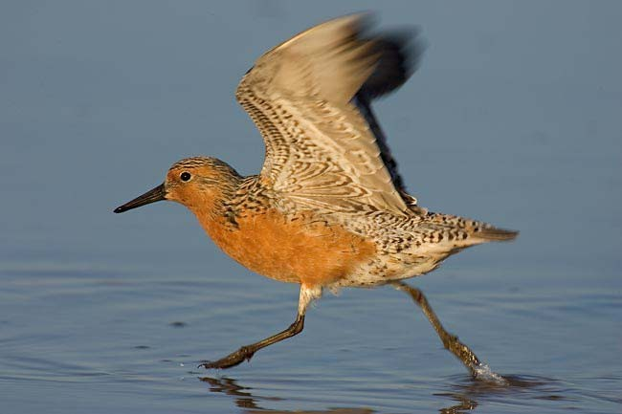

Draft Report

Prepared for the Department of Sustainability, Environment, Water, Population and the Communities
by Bennelongia Pty Ltd

May 2010

Analysis of possible change in ecological
character of the Roebuck Bay and Eighty
Mile Beach Ramsar sites

Bennelongia Pty Ltd
5 Bishop Street Jolimont WA 6913 www.bennelongia.com.au ACN 124 110 167

Report 84/2010
May 2010

Cover picture. Red Knot
From http://www.birdsasart.com/bn136.htm
Arthur Morris, Birds as Art

LIMITATION: This review has been prepared for use by the Client and its agents. Bennelongia accepts no liability or responsibility in respect of any use or reliance on the review by any third party. Bennelongia has not attempted to verify the accuracy and completeness of all information supplied by the Client.

COPYRIGHT: The document has been prepared to the requirements of the Client. Copyright and any other Intellectual Property associated with the document belong to Bennelongia and may not be reproduced without written permission of the Client or Bennelongia.

Client – Department of Environment, Water, Heritage and the Arts
Report Version Prepared by Checked by Submitted to Client
Method Date
Draft report | Vers. 1 | James Richardson & | Gayle Partridge | email | 13.v.10
 |  | Stuart Halse
Final report |  | Stuart Halse & James |  | email | 23.vi.10
 |  | Richardson

EXECUTIVE SUMMARY
North-west Western Australia supports more non-breeding migratory shorebirds than any other area of
Australia and it is one of the more important areas for shorebirds in the East Asia-Australasian Flyway. Eighty Mile Beach and Roebuck Bay contain the major concentrations of migratory shorebirds in north- west Western Australia and were both nominated as Ramsar sites in 1990. It has recently been suggested that shorebirds have declined at Eighty-mile Beach over the last decade. This report examines whether there may have been declines in numbers of migratory shorebird species at the two Ramsar sites in north-west Western Australia, Eighty-mile Beach and Roebuck Bay.

The report had three objectives:
• To investigate whether statistically significant changes have occurred in the numbers of migratory shorebirds counted at Eighty-mile Beach and Roebuck Bay, and in particular whether numbers of Great Knot and Red Knot have changed.
• To determine whether the ecological characters of Roebuck Bay and Eighty Mile Beach have changed since listing as a result of any decline in migratory shorebird numbers.
• To determine possible causes of any declines observed in migratory shorebird numbers, including whether any declines may be the result of habitat change at staging areas in the Yellow Sea.

The available data strongly suggest there has been no decline in use of Roebuck Bay by migratory shorebirds, over the past decade and also over the past 25 years, although this is based principally on data from the northern part of the Bay. Total numbers of shorebirds at Roebuck Bay from 2004 to 2009 remained above the threshold for the shorebird Limits of Acceptable Change at that site.

In contrast, there has been a statistically significant decline in numbers of migratory shorebirds in a regularly monitored sector (5 – 40 km) at the northern end of Eighty-mile Beach. This decline is not reflected in long-term analysis of numbers in the 5 – 15 km sector of the Beach since 1993 and it is unclear whether the decline is representative of the Beach as a whole. Species thresholds, as well as total shorebird thresholds, of Limits of Acceptable Change have been defined for Eighty-mile Beach based on counts in the northern part of the Beach (0 – 60 km) made during the last decade and numbers of Bar-tailed Godwit, Greater Sand Plover and Terek Sandpiper were below threshold values for these species in 2009. These breaches of the Limits of Acceptable Change at Eighty-mile Beach are likely to continue.

It is concluded that a change in the ecological character of Eighty-mile Beach, as defined by the ecological character description, is occurring as a result of declining numbers of shorebirds using the 0 –
60 km sector of the Beach during the last decade. There appears to be no change at Roebuck Bay.
Given that there has been no decline of resident Australian shorebirds and no obvious reduction in prey availability, the decline of migratory shorebirds in the sector 0 – 60 km at Eighty-mile Beach may be an artefact of survey methodology, a consequence of shorebird biology and prey distributions, or the result of reduced Flyway populations. It is considered unlikely that anthropogenic activities on Eighty-mile Beach itself have affected migratory shorebird numbers.

The impact of specific mudflat reclamation activities in the Yellow Sea (such as at Saemangeum) was not directly detectable in shorebird numbers in north-west Western Australia. While there has been a

reduction in shorebird numbers at the northern end of Eighty-mile Beach, the pattern of decline was constant and not obviously related to the timing of major developments in the Yellow Sea. This may be a consequence of the impacts of reclamation being partially buffered by increased use of less productive, alternative staging wetlands.
CONTENTS
EXECUTIVE SUMMARY 3
1. INTRODUCTION 1
2. SITE DESCRIPTIONS 2
3. METHODS 3
3.1 MYSMA Data 4
3.1.1. Summer 4
3.1.2. Winter 5
3.2. Combined MYSMA – BA Data 5
3.2.1. November Counts of Eighty-mile Beach 5
3.2.2. Long-term Counts of Eighty-mile Beach 5
3.2.3. November Counts of Roebuck Bay 6
3.2.4. Long-term Summer Counts of Roebuck Bay 6
3.3. Analyses 6
4. RESULTS 6
4.1. MYSMA Data 6
4.1.1. Summer 6
4.1.2. Winter 7
4.2. Combined MYSMA – BA Data 8
4.2.1. Eighty Mile Beach 8
4.2.2. Roebuck Bay 12
4.3. Long-term Data 14
4.3.1. Eighty-mile Beach 14
4.3.2. Roebuck Bay 14
4.4. Limits of Acceptable Change 14
4.4.1. Eighty-mile Beach 14
4.4.2. Roebuck Bay 14
5. DISCUSSION 14
5.1. Trends in Shorebird Numbers 14
5.1.1. Eighty-mile Beach 14
5.1.2. Roebuck Bay 14
5.1.3. North-west Western Australia and Flyway Populations 14
5.2. Ecological Character of Roebuck Bay and Eighty-mile Beach 14
5.3. Causes of Shorebird Decline 14
5.4. Monitoring 14
6. ACKNOWLEDGMENTS 14
7. REFERENCES 14

1. INTRODUCTION
Apart from the intrinsic interest in how shorebirds navigate and store the necessary energy, the long distance migrations of shorebirds have highlighted that species conservation often depends on inter- government cooperation, with failures to conserve in one country resulting in population loss in another. Consequently, shorebirds are the subject of three bilateral agreements involving Australia that are aimed at achieving habitat protection and species conservation. These are the Japan-Australia Migratory Bird Agreement signed in 1974, the China-Australia Migratory Bird Agreement signed in 1986 and the Republic of Korea-Australia Migratory Bird Agreement signed in 2007. Migratory shorebirds are also the focus of a multilateral agreement, the East Asian-Australasian Flyway Partnership, signed in
2006, which involves 10 countries, including the Russian Federation.

Over the past two decades there has been increasing concern that the population numbers of many migratory shorebird species are declining as a result of reduction in available habitat (Gosbell and Clemens 2006; Nebel et al. 2008). While population decline has been observed in the few species of resident Australian shorebirds and other waterbirds in Australia (Kingsford et al. 1999), the international obligations on countries to maintain habitat for migratory shorebird species has meant that the potential population declines of these species have probably attracted more attention.

This report examines whether there may have been real declines in numbers of migratory shorebird species at two Ramsar sites in north-west Western Australia: Eighty-mile Beach and Roebuck Bay. The Convention on Wetlands of International Importance (more commonly known as the Ramsar Convention) was signed in 1971 and its purpose is to promote conservation of wetlands and their biota. Most countries are signatories. The best known aspect of the Convention is the List of Wetlands of International Importance, which is a list of wetlands nominated by national governments as being of outstanding importance. Nominated wetlands must meet at least one of a series of nomination criteria and signatory countries must report on the ecological character of these wetlands. Substantial change of character may result in a wetland being removed from the List. Both Eight-mile Beach and Roebuck Bay were nominated to the List of Wetlands of International Importance by the Australian Government in 1990.

North-west Western Australia supports more non-breeding migratory shorebirds than any other area of Australia and is one of the more important areas for shorebirds in the East Asia-Australasian Flyway. Eighty Mile Beach and Roebuck Bay contain the major concentrations of migratory shorebirds in north- west Western Australia. It has been suggested that shorebirds have declined at Eighty-mile Beach over the last decade (Rogers et al. 2009). The changes have been attributed to global declines in the numbers of many migratory shorebird species and it has been inferred that a significant amount of decline is associated with a reduction in the area of tidal flats in the Yellow Sea. These mudflats between Korea and China are used as staging areas during annual migrations. The main shorebird counting program at Eighty-mile Beach and Roebuck Bay, the Monitoring Yellow Sea Migrants in Australia program (MYSMA), has included focus on the Great Knot because north-west Western Australia is the stronghold of the species in the non-breeding season and because especially grave decline of this species has been predicted as a result of habitat loss at Saemangeum and other Yellow Sea estuaries (Rogers et al. 2009).

Under Article 3.2 of the Ramsar Convention, the Australian Government is required to keep itself informed of any change in the ecological character of listed Ramsar wetlands and report them to the

Ramsar Bureau (NRMMC 2009). If the Government is advised of a potential change to a site, and an initial investigation suggests the matter warrants further attention, the Department of the Environment, Heritage, Water and the Arts (DEHWA) will undertake a formal assessment to determine:

• The nature of the change (i.e. it has already occurred, is occurring, or will potentially occur).

• Whether the change can be substantiated on the best available science.

• Whether the change is a human-induced adverse alteration.
• Whether the change has occurred in a critical component, process or benefit/service of the site. The analyses presented in this report re-examine whether there has been any decline in shorebird use
of Eighty-mile Beach and Roebuck Bay and seeks to determine whether the decline is likely to be
attributable to land use changes, pollution or other human interference within the two Ramsar sites or whether is more likely attributable to overall declines in Flyway populations of migratory shorebird species. In particular, the analyses used data from the MYSMA project and the Birds Australia database (including Australasian Wader Studies Group counts and Shorebird 2020 Project counts) to:

• Investigate whether statistically significant changes have occurred in the numbers of migratory shorebirds counted at Eighty-mile Beach and Roebuck Bay, and in particular whether numbers of Great Knot and Red Knot have changed.

• Determine whether the ecological characters of Roebuck Bay and Eighty Mile Beach have changed since time of listing.

• Determine possible causes of any declines observed in migratory shorebird numbers, including whether any declines may be a result of habitat change at staging areas in the Yellow Sea.

Results of analyses of population trends were interpreted in the context of the Limits of Acceptable Change recognized for shorebirds in the ecological character descriptions for Eighty-mile Beach and Roebuck Bay. There is a single waterbird Limit of Acceptable Change at Roebuck Bay: “total waterbird abundance in early November >99400 (i.e. > 75per cent of mean of November counts, dependent on counting technique)” (Bennelongia 2008). The waterbird limits of Acceptable Change for Eighty-mile Beach are more comprehensive: “counts in the area 0 - 60 km … shorebird numbers >200,000 during summer and
>20,000 during winter.” Thresholds were also set for five species in the area 0 - 60 km in summer: Bar- tailed Godwit >35,000, Great Knot >55,000, Greater Sand Plover >23,000, Red-necked Stint > 8,000, Terek Sandpiper > 4,800 (Hale & Butcher 2009).

2. SITE DESCRIPTIONS
Despite its name, Eighty Mile Beach actually extends as a linear beach for some 225 km (140 miles) from
Cape Missiessy in the north (19°S) south west to Cape Keraudren (20°S) (Figure 1). For most of its length it comprises an extensive intertidal area and narrow beach, backed by sand dunes that give way inland to narrow coastal plains. In the southern part of the beach there are occasional small rocky outcrops and, in the section 160 - 165 km south of Cape Missiessy, a continuous low rocky cliff abuts the mudflats. There are no mangroves except for a few 1-2 m high bushes in a small creek where the Mandora Marsh drains into the sea. All of Eighty-mile Beach is within the Ramsar site boundary.
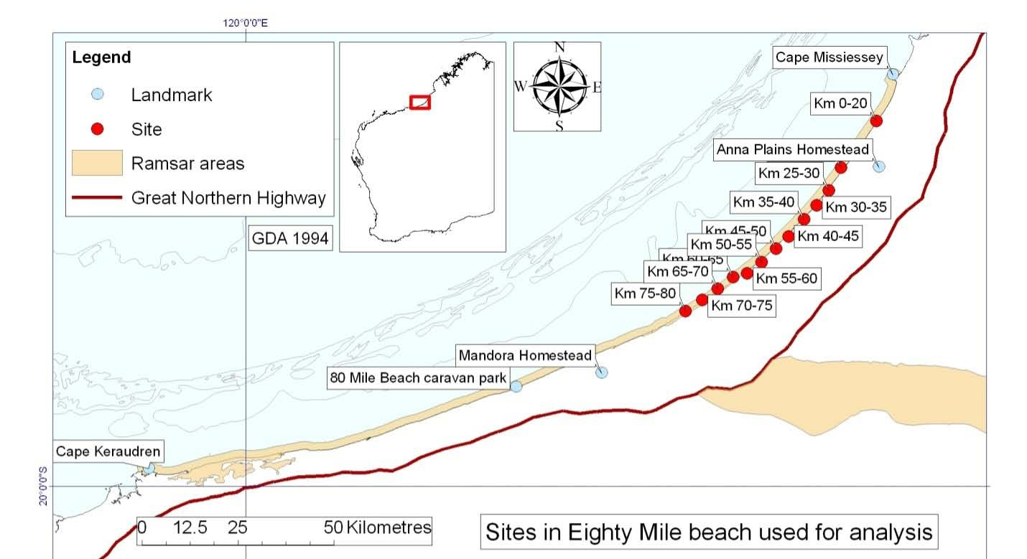
Figure 1. Location of Ramsar site and regularly counted sectors of Eighty-mile Beach.

Counts on Eighty-mile Beach were usually made (and recorded) in 5 km sectors of the Beach. The numbering system for these sectors is based around the access track to the Beach from Anna Plains station homestead, about 20 km south of Cape Missiessy. Thus, the first 5 km sector south of the access track is 0 - 5 km, the second 5 - 10 km, and so on. The area to the north of the access track has rarely been counted and the sectors are recorded with negative notation, i.e. the first 5 km north is 0 – -5 km.

Roebuck Bay is a large marine embayment with very extensive mudflats on the eastern side, especially around Bush Point at the southern extremity (Figure 2). The northern shore consists of a series of small sandy beaches backed by low cliffs of pindan sand, with isolated rocky outcrops and a few mangrove plants on the beach and a broad mudflat. The eastern shore is fringed by mangroves, with saltmarsh on the landward side of the mangroves, behind which is a large area of low-lying grassland subject to flooding after cyclones. While the eastern shore is used extensively by foraging birds, they usually roost (and are counted) on the northern shoreline or at Bush Point. The most western portion of Roebuck Bay (including Quarry Beach) is outside the Ramsar site boundary. However, shorebirds treat Roebuck Bay (or at least the northern shores of the Bay) as a single area and shorebird counting over the years has been aligned with the pattern of shorebird occurrence rather that with the Ramsar site boundary.

3. METHODS
Shorebird counts were compiled from three sources: the MYSMA database compiled by Danny Rogers, the Birds Australia database, and a set of data prepared for this report by Ken and Danny Rogers. Rob Clemens extracted the data used from the Birds Australia database. Background information on counting methods is available in Rogers (2005) and Rogers et al. (2009).

Prior to analyses, all species other than migratory shorebirds were removed from the datasets. Oriental
Plover, Oriental Pratincole and Little Curlew were also removed (except where examining Limits of Acceptable Change) because these species tend to forage inland and typically roost on beaches only in times of hot weather (Rogers et al. 2009).
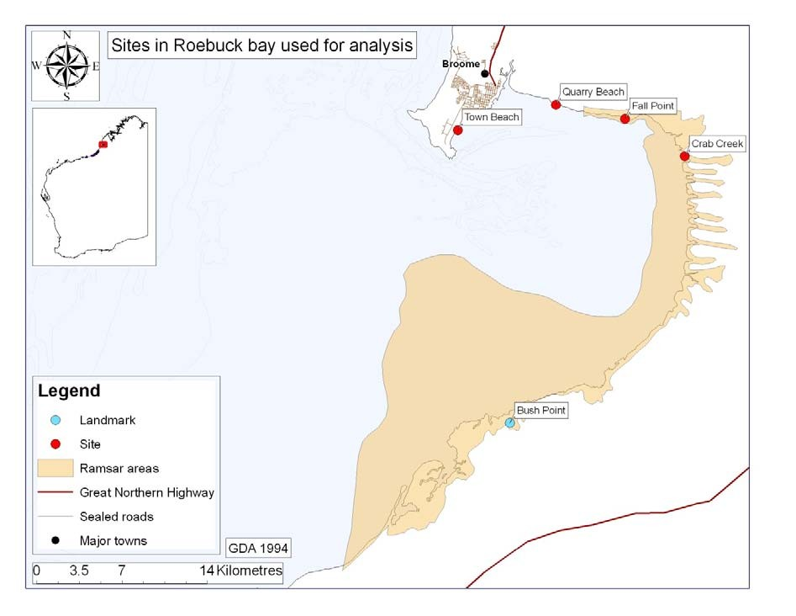
Figure 2. Location of Ramsar site, some of the sectors counted and landmarks at Roebuck Bay.

3.1 MYSMA Data

3.1.1. Summer
The MYSMA dataset for shorebirds counted at Eighty-mile Beach and Roebuck Bay each summer and
winter between 2004 and 2009 is based on a series of ground counts at different sectors of beach. There were two counts each summer, one to four weeks apart, and one or two winter counts. The sectors 5 – 40 km of Eighty-mile Beach were counted consistently in summer, the sectors 40 – 60 km were counted most of the time, and the sectors 60 – 80 km were counted in 2001 and 2009. Other sectors were counted sporadically and are not included in analyses.

The datasets provided to us suggest that the only sector of Roebuck Bay counted consistently during summer surveys was Quarry Beach (lack of consistency was more pronounced when Birds Australia data were included in analyses). However, we were told this reflects the way data were entered, rather than count completeness, and it has been assumed that extracting survey counts for all sectors of the northern shore with data for any survey will provide a count for the whole northern shore in that survey.

Summer counts were mostly made in November or December, after birds that would continue southwards migration had moved through north-west Western Australia, and numbers were representative of population sizes at Eighty-mile Beach and Roebuck Bay through the austral summer. However, the first count in summer 2008 (the A count) was made in late October, when passage migrants were still present, and the number of birds recorded was more than 3 standard deviations above the mean of the 12 MYSMA summer counts (Figure 3). Subsequent validation of the data suggested the principal reason for the high 2008A was that some of the counts were duplicated in the dataset, rather than the number of birds being particularly high. However, the 2008 A count was removed from analyses (rather than trying to correct the data) because it was likely to be unrepresentative of summer conditions and it had high leverage.

3.1.2. Winter
Only in 2006 and 2007 were two counts made during winter, so analyses of winter data were restricted to the first survey date each year. Consistent counting occurred only at Eighty-mile Beach and the winter analysis of MYSMA data is restricted to Eighty-mile Beach.

3.2. Combined MYSMA – BA Data
The Birds Australia dataset contains shorebird counts from north-west Western Australia dating back to 1983 but the database custodians and those involved in previous analyses suggest that counts prior to 1999 had variable methodology and often indeterminate spatial coverage, so that they are difficult to use in analysis of population trends (Rob Clemens, pers. comm.). Furthermore, the counts made between 1993 and 2000 for the Population Monitoring Program (PMP) were undertaken in February. In 2001, the counting date was shifted to November because of perceived problems with February counts after significant rainfall (Danny Rogers pers. comm.). We have restricted analysis, as much as possible, to counts made in November and have excluded summer data from February except for particular analyses where long-term trends were examined to validate trends observed in November counts since 2001.

In order to obtain an estimate of shorebird population sizes prior to 2004 (by which time significant changes were occurring at the Yellow Sea tidal flats), we looked at combining the MYSMA data with Birds Australia data between 2001 and 2004. The Birds Australia dataset contains few counts from winter on Eighty-mile Beach and so we combined only summer data for this Ramsar site, although data from both seasons were combined for Roebuck Bay.

3.2.1. November Counts of Eighty-mile Beach
Additional Birds Australia counts were available for Eighty-mile Beach in 2001 and 2002, the first covering all sectors from 10-200 km (covered 80per cent of Beach but called a total count) and the second covering 5 - 40 km. It has been suggested that some species, especially Red Knot, have shifted southwards on Eighty-mile Beach over the last decade and, to examine whether population trends were consistent in different sectors of the Beach, we divided the 5 – 80 km sectors into three groups: 5 – 40 km, 40 – 60 km and 60 – 80 km. We used the second summer (i.e. B) MYSMA count each year.

3.2.2. Long-term Counts of Eighty-mile Beach
A dataset for analysis of long-term trends in key shorebird species at Eighty-mile Beach was provided by
Danny and Ken Rogers. This dataset of long-term summer and winter counts was based on surveys of the sector 5 – 15 km, which had been counted most years from 1993 as part of the AWSG’s Population Monitoring Program (PMP) counts and, after 2003, as MYSMA counts. Counts of all migratory shorebirds were not available.

3.2.3. November Counts of Roebuck Bay
The trend across years in summer between 2001 and 2009 was examined using the B counts for the
northern shore from the MYSMA dataset from 2004 to 2009 and the northern shore counts from the Birds Australia dataset from 2001 to 2004. The average of the two 2004 counts, which were made a week apart, was used in analyses.

3.2.4. Long-term Summer Counts of Roebuck Bay
A dataset for analysis of long-term trends in shorebirds at Roebuck Bay was provided by Danny and Ken Rogers. For about one-third of species-date combinations, we were unable to reproduce the counts they provided using the dataset we had obtained from Birds Australia. The dataset was based on surveys of the northern shore from 1982 in summer, and 1993 in winter, to 2009 as part of the PMP and MYSMA programs.

3.3. Analyses
For each area and time period, up to three correlations were calculated for shorebird numbers against calendar year. Shorebird groups analysed were:

1. All migratory shorebird species other than Oriental Plover, Oriental Pratincole and Little Curlew. For analyses of the MYSMA data alone, Great Knot and Red Knot were also excluded from the count of all migratory shorebirds.

2. Selected species of migratory shorebird expected to show decline (Rogers et al. 2009). These were Great Knot, Red Knot, Bar-tailed Godwit and Terek Sandpiper. The Greater Sand Plover and Red-necked Stint were included in analyses for Eighty-mile Beach because Limits of Acceptable Change have been nominated for these species.

3. Resident Australian shorebirds. These were Pied Oystercatcher and Red-capped Plover.

In addition to the above analyses, numbers of all shorebirds (including Oriental Plover, Oriental Pratincole and Little Curlew) counted at Roebuck Bay from 2004 to 2009 were compared with the Limits of Acceptable Change outlined in the ecological character description of Roebuck Bay (Bennelongia 2008).

Numbers of all shorebirds, and numbers of Great Knot, Bar-tailed Godwit, Greater Sand Plover, Red- necked Stint and Terek Sandpiper, counted in sectors 5 – 60 km at Eighty-mile Beach in 2001 and 2009 were compared with the Limits of Acceptable Change in the Eighty-mile Beach ecological character description for summer counts (Hale & Butcher 2009). The summer Limits of Acceptable Change apply to sectors 0 - 60 km but no data were available for 0 – 5 km. Insufficient data were available to make comparisons with winter limits.

4. RESULTS

4.1. MYSMA Data

4.1.1. Summer
Based on the average of the two early summer counts in the MYSMA counts, the numbers of migratory shorebirds on the northern part of Eighty-mile Beach and on Quarry Beach at Roebuck Bay appear to have declined about 7per cent per year since 2004 but the decline is not statistically significant (Figure 4). It should be noted that with the exception of 2008, when the first of the two counts was made in late
October (see Methods), the two counts each year were within 17-47per cent of each other, representing similar levels of precision to that usually seen in shorebird counts (Rogers et al. 2007). Similar apparent declines were seen in the numbers of Great Knot (8per cent, Figure 5) and Red Knot (10per cent) but neither decline was significant.

4.1.2. Winter
As was the case with summer counts, there has been no discernable trend in numbers of migratory shorebirds during winter since 2004 (Figure 5). In addition, neither the Great Knot nor Red Knot showed discernable trends.

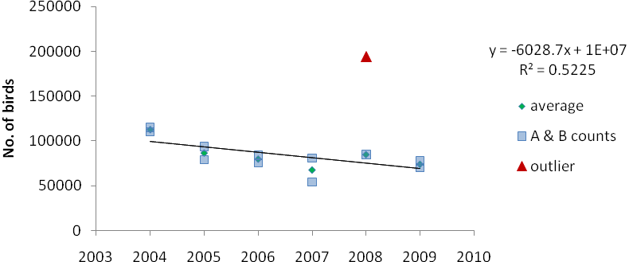

Figure 3. . Numbers of migratory shorebirds at regularly monitored sectors of Eighty-mile Beach and
Roebuck Bay in summer. Averaged counts showed no trend across time (outlier excluded).

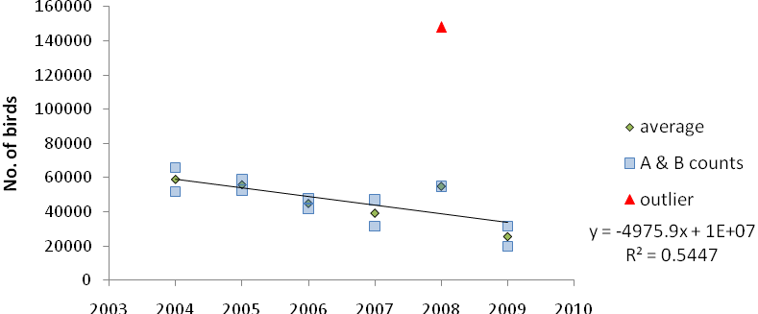

Figure 4. Numbers of Great Knot from 5- 40 km at Eighty-mile Beach and on the northern shore of
Roebuck Bay in summer. Counts showed no trend (outlier excluded).

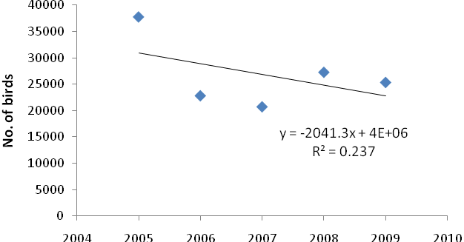

Figure 5. Numbers of migratory shorebirds from 5- 40 km at Eighty-mile Beach and on the northern shore of Roebuck Bay in winter. Counts showed no significant trend.

4.2. Combined MYSMA – BA Data

4.2.1. Eighty Mile Beach
The 11per cent decline in summer counts of migratory shorebirds at the consistently counted 5 – 40 km
sectors of Eighty-mile Beach between 2001 and 2009 was greater than that observed in MYSMA counts as a result of the high 2001 Australasian Wader Study Group (AWSG) count (Figure 6). The trend of decline was not obvious between sectors 40 – 60 km. Nor was it obvious between 60 and 80 km, although these sectors were counted only in 2001 and 2009. Thus, it is unclear whether numbers on all of Eighty-mile Beach are likely to have declined between 2001 and 2009.

Individual migratory shorebird species mostly showed similar patterns, with Great Knot counts declining 10 per cent per year in the sectors 5 - 40 km but showing no change from 40 - 60 km and an apparent smallincrease from 60 – 80 km (Figure 7). Counts of Red Knot showed weak evidence of decline between 2001 and 2009 in sectors 5 - 40 km because of the high 2001 count, highly variable counts from 40 – 60 km, and an apparent increase from 60 – 80 km, suggesting little change overall in numbers from 5 – 80 km (Figure 8).

Counts of Bar-tailed Godwit declined about 10 per cent per year in sectors 5 - 40 km and but showed no change from 40 – 60 km, with a small apparent increase from 60 – 80 km (Figure 9). Terek Sandpiper showed a similar pattern, declining by 11 per cent per year in sectors 5 - 40 km but showing no change from 40 – 80 km (Figure 10). Greater Sand Plover declined by 15 per cent per year in sectors 5 – 40 km (Figure 11). In contrast, Red-necked Stint numbers declined about 8per cent per year in sectors 30-60 km but increased about 30per cent per annum in sectors 40-60 km (P <0.05, Figure 12).

Counts for two species of resident Australian shorebird were examined in an attempt to assess whether patterns in migratory shorebird abundance on Eighty-mile Beach were driven principally by local factors. Both numbers of Pied Oystercatcher and Red-capped Plovers showed non-significant increases across all sectors (Figures 13, 14).
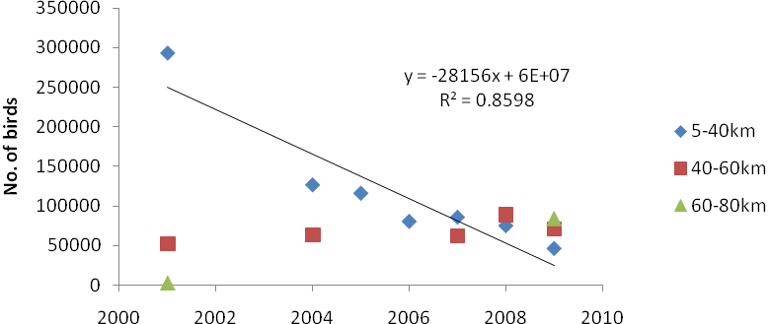

Figure 6. Numbers of migratory shorebirds in summer at Eighty-mile Beach, 2001 – 2009, from 30-60 km, 40-60 km, and 60- 80 km. Numbers declined significantly in sectors 5 - 40 km (P <0.01).

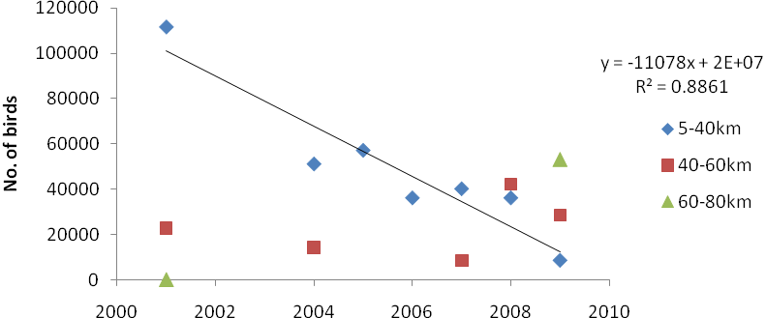

Figure 7. Numbers of Great Knot at Eighty-mile Beach, 2001 – 2009, between 5 - 40 km, 40 – 60 km, and
60 – 80 km. Numbers declined significantly in sectors 5 - 40 km (P <0.01).

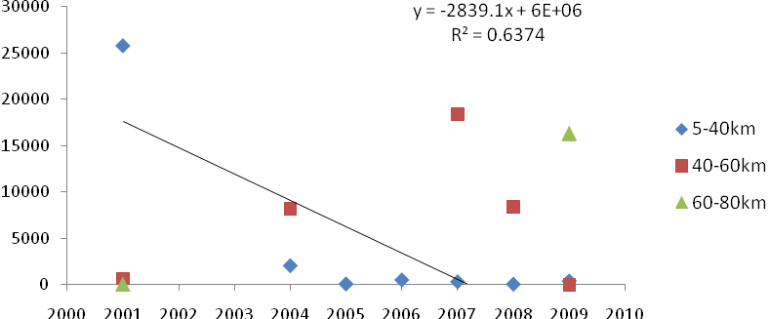

Figure 8. Numbers of Red Knot at Eighty-mile Beach, 2001 – 2009, from 5 - 40 km, 40-60 km and 60 – 80 km. Numbers showed apparent decline after 2001 from 5 - 40 km (P <0.10, NS).
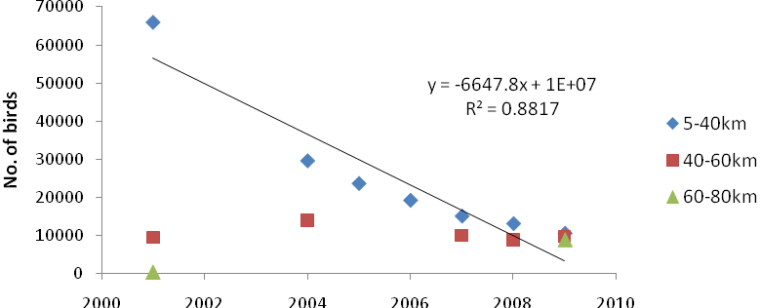

Figure 9. Numbers of Bar-tailed Godwit at Eighty-mile Beach, 2001 – 2009, from 5 - 40 km, 40-60 km and
60 – 80 km. Numbers declined significantly in sectors 5 - 40 km (P <0.01).

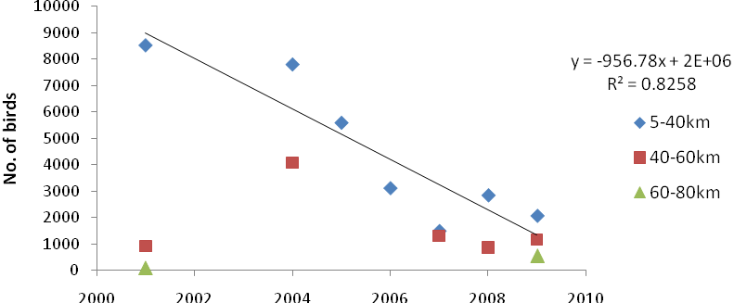

Figure 10. Numbers of Terek Sandpiper at Eighty-mile Beach, 2001 – 2009, from 5 - 40 km, 40-60 km and
60 – 80 km. Numbers declined significantly in sectors 5 - 40 km (P <0.01).

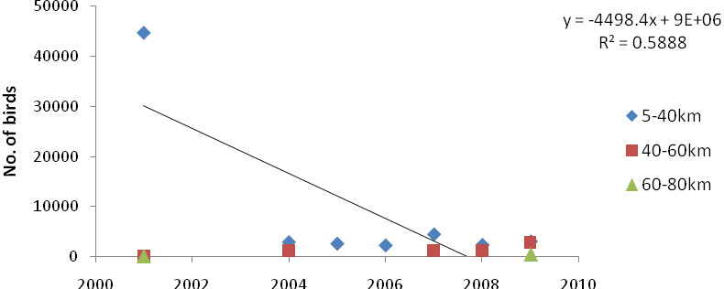

Figure 11. Numbers of Greater Sand Plover at regularly monitored sites at Eighty-mile Beach, 2001 –
2009, from 5 - 40 km, 40-60 km and 60 – 80 km. Numbers declined significantly in sectors 5 - 40 km. (P
<0.05).

Figure 12. Numbers of Red-necked Stint at regularly monitored sites at Eight-mile Beach, 2001 – 2009, from 5 - 40 km, 40-60 km and 60 – 80 km. Numbers declined significantly from 5 – 40 km (P <0.01) and increased from 40 – 60 km (P < 0.05).

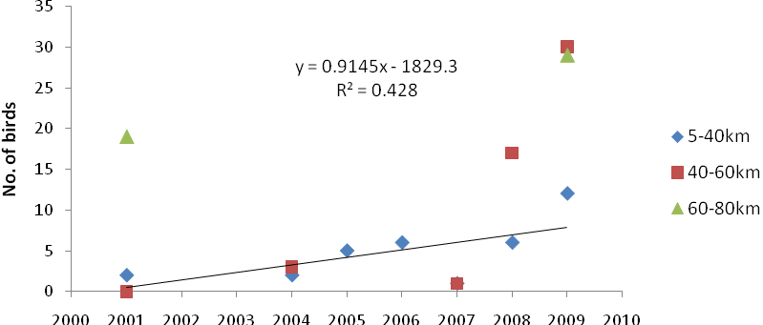

Figure 13. Numbers of Pied Oystercatchers at regularly monitored sites at Eighty-mile Beach, 2001 –
2009, from 5 - 40 km, 40-60 km and 60 – 80 km. Counts showed no trend in sectors 5 - 40 km.

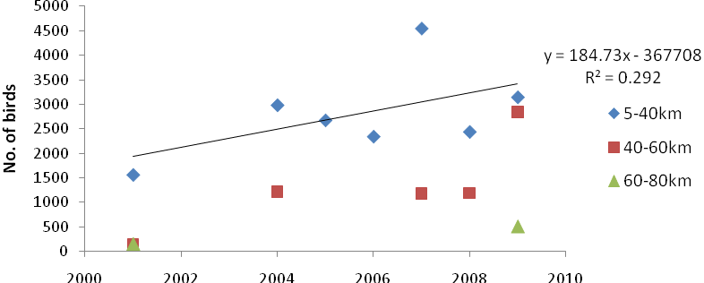

Figure 14. Numbers of Red Capped Plovers at regularly monitored sites at Eighty-mile Beach, 2001-2009, from 5 - 40 km, 40-60 km and 60 – 80 km. Counts showed no trend in sectors 5 - 40 km.

4.2.2. Roebuck Bay
In contrast to the northern sectors of Eighty-mile Beach, the numbers of migratory shorebirds counted during summer on the northern shore of Roebuck Bay from 2001 - 2009 showed no significant trend
(Figure 14). Counts of individual species showed the same pattern as all migratory shorebirds and there were no trends in numbers of any species on the northern shore during summer 2001 - 2009 (Figures 15-20).

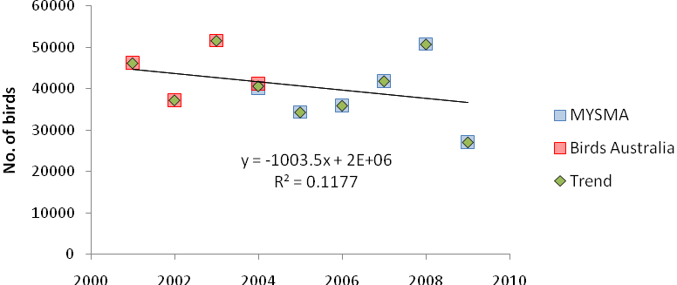

Figure 14. Numbers of migratory shorebirds on the northern shore of Roebuck Bay, 2001 – 2009. The
2004 value is average of Birds Australia and MYSMA counts. Trend is not significant.

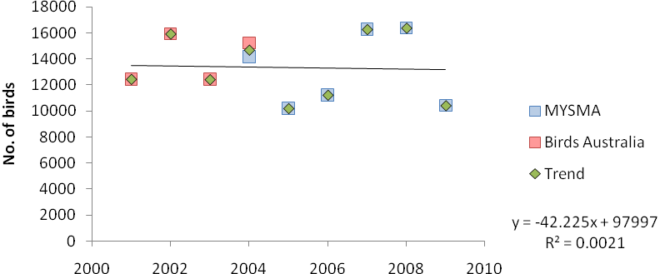

Figure 15. Great Knot counts on the northern shore of Roebuck Bay, 2001 – 2009. 2004 value is average of Birds Australia and MYSMA counts. Trend is not significant.
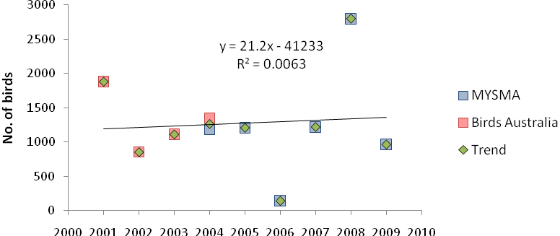

Figure 16. Red Knot counts on the northern shore of Roebuck Bay, 2001 – 2009. 2004 value is average of
Birds Australia and MYSMA counts. Trend is not significant.

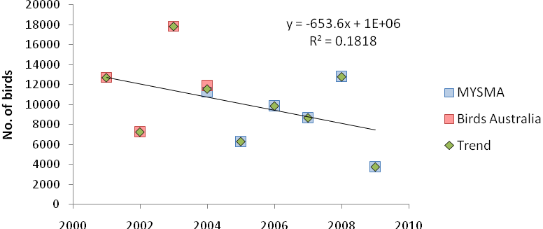

Figure 17. Bar-tailed Godwit counts on the northern shore of Roebuck Bay, 2001 – 2009. 2004 value is average of Birds Australia and MYSMA counts. Trend is not significant.

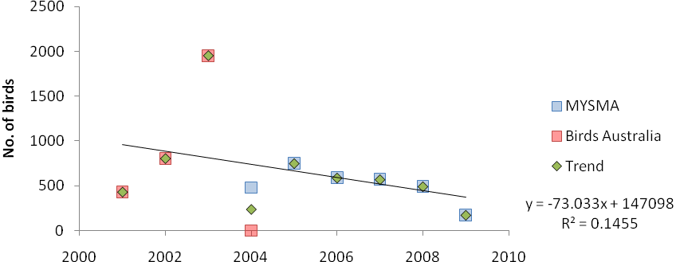

Figure 18. Terek Sandpiper counts on the northern shore of Roebuck Bay, 2001 – 2009. 2004 value is average of Birds Australia and MYSMA counts. Trend is not significant.

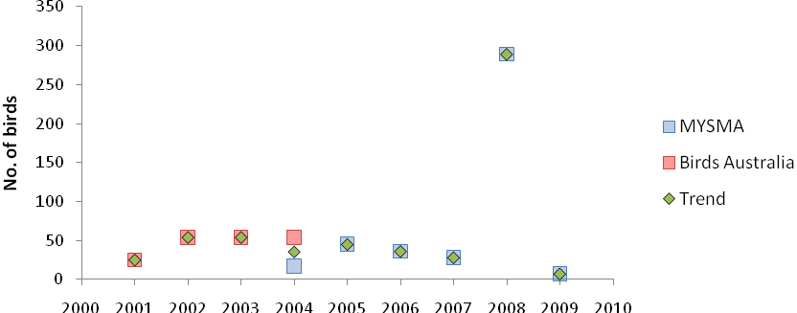

Figure 19. Pied Oystercatcher counts on the northern shore of Roebuck Bay, 2001 – 2009. 2004 value is average of Birds Australia and MYSMA counts. Trend is not significant.

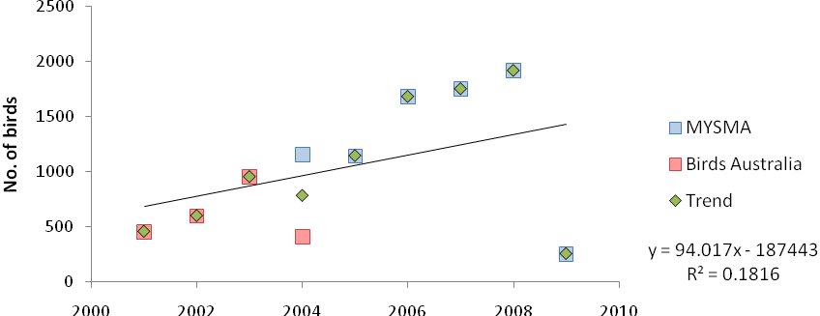

Figure 20. Red capped Plover counts on the northern shore of Roebuck Bay, 2001 – 2009. 2004 value is average of Birds Australia and MYSMA counts. Trend is not significant.

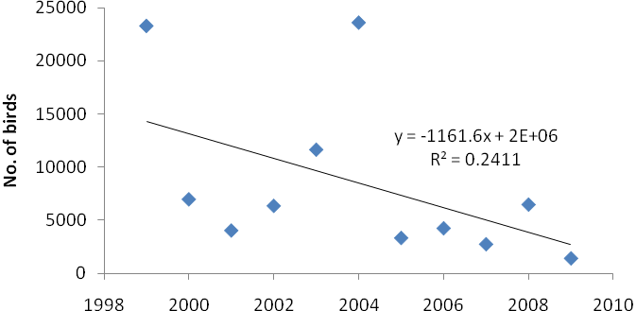

Figure 21. Numbers of migratory shorebirds during winter on the northern shore of Roebuck Bay, 1999 –
2009. Counts showed no significant trend.
The numbers of Red-capped Plover also varied substantially across years (Figure 22). Interestingly, this was the species with the greatest discrepancy between Birds Australia and MYSMA counts in 2004, with the MYSMA count being 280per cent of the Birds Australia count. There was no significant trend across years.

Counts of all migratory shorebirds on the northern shore of Roebuck Bay during winter also showed no trend across years (Figure 21).

4.3. Long-term Data

4.3.1. Eighty-mile Beach
Long-term patterns in counts for individual species at at Eighty-mile Beach are confused. No species appears to have declined in abundance in summer since the early 1990s and counts of some migratory species, including Bar-tailed Godwit, have shown non-significant increases in summer numbers (Figure 22). Winter counts of Bar-tailed Godwit have declined significantly but it is one of the very few species to do so, with high counts in the early and mid-1990s being the likely cause.

The non-significant increase of summer numbers of Bar-tailed Godwit may be an artefact of counts prior to 2001 being made in February (when fewer birds may be present and logistical difficulties are also likely to reduce counts, Rogers et al. 2009). However, the fact that many species show parallel trends in summer and winter counts suggests the February counts usually provide accurate population estimates for most species (e.g. Great Knot and Red-capped Plover, Figures 23, 25). Another cause of possible unreliability in the data is the short length (10 km) of the sectors counted regularly since 1993. The statistical power associated with the long-term summer dataset is likely to be low for most species because of relatively high variability between adjacent years.

Great Knot showed no trends in either summer or winter but summer counts were cyclical, with a return period of about 10 years (Figure 23) that was present, albeit much less clearly, in the counts of most migratory species in summer in the 5 - 15 km sector. Terek Sandpiper counts were extremely variable in both summer and winter. In summer this is probably associated with the short length of Beach surveyed and in winter with the low numbers of birds remaining in Australia (Figure 24).

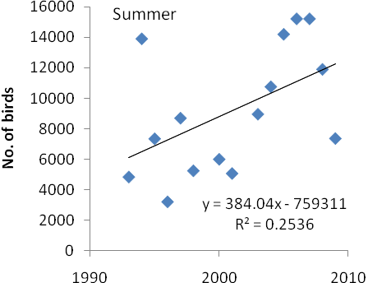
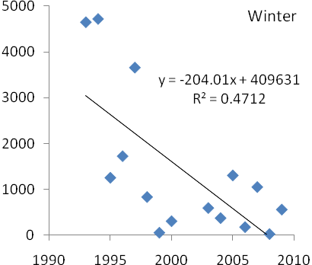

Figure 22. Counts of Bar-tailed Godwit, 1993 – 2003, at Eighty-mile Beach. Summer trend NS, winter trend P <0.01.
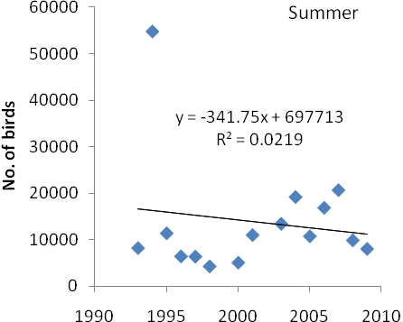

Figure 23. Counts of Great Knot, 1993 – 2003, at Eighty-mile Beach. Summer trend NS, winter trend NS.
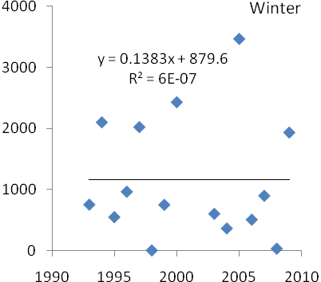

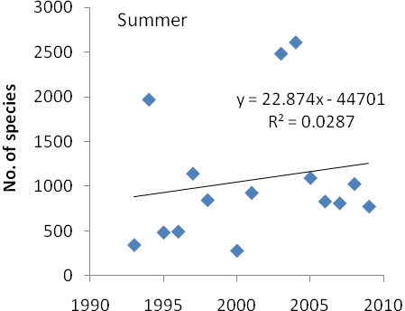
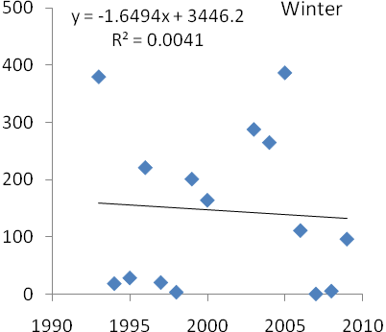

Figure 24. Counts of Terek Sandpiper, 1993 – 2003, at Eighty-mile Beach. Summer trend NS, winter trend NS.

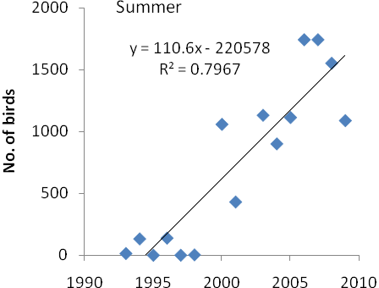
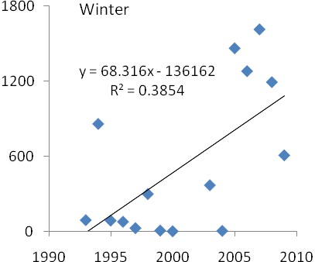

Figure 25. Counts of Red-capped Plover, 1993 – 2003, at Eighty-mile Beach. Summer trend P <0.001, winter trend P <.05
Counts of the Australian resident species, Red-capped Plover, increased significantly in both summer and winter with approximately similar patterns (Figure 25).

4.3.2. Roebuck Bay
The total number of shorebirds counted in summer on the northern shore of Roebuck Bay showed no
significant trend from 1982 to 2009, with counts in 1982 and around 2005 being high relative to the rest of the dataset (Figure 26). Matching the slight, non-significant increase in total numbers of shorebirds counted, some migratory species increased in numbers.

Summer numbers of Bar-tailed Godwit showed no change (Figure 27) but numbers of Great Knot (Figure
28) and Terek Sandpiper (not shown, P <0.05) both increased significantly.

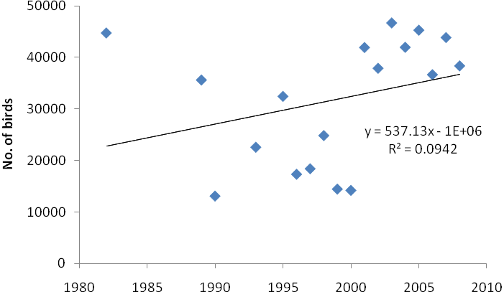

Figure 26. Number of migratory shorebirds on the northern shore of Roebuck Bay in summer, 1982 –
2009. There was no trend.

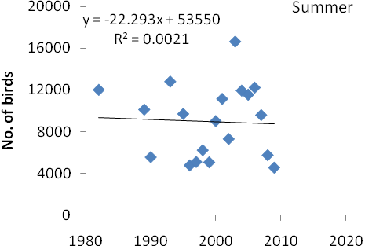

Figure 27. Counts of Bar-tailed Godwit on the northern shore of Roebuck Bay in summer and winter,
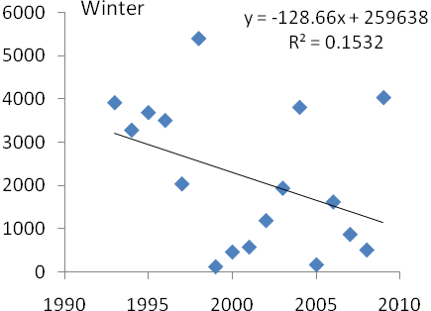

1982 – 2009 and 1993 – 2009. Summer trend NS, winter trend NS.
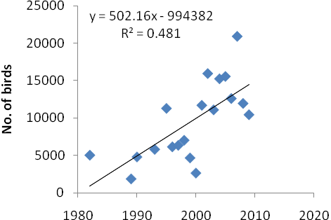

Figure 28. Counts of Great Knot on the northern shore of Roebuck Bay in summer and winter, 1982 –
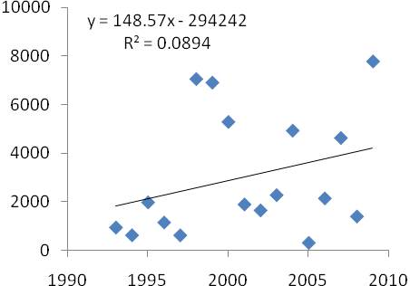

2009 and 1993 – 2009. Summer trend P <0.001, winter trend NS.

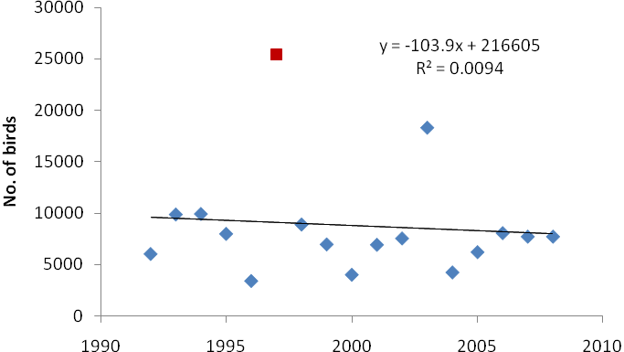

Figure 29. Number of migratory shorebirds on the northern shore of Roebuck Bay in winter, 1993 –
2009. There was no trend. It has been suggested the 1997 count includes Bush Point and, thus, is outlier, although the 2003 count was almost as high.

The overall number of migratory shorebirds on the northern shore of Roebuck Bay showed no change between 1993 and 2009.

Individual species showed few trends, although inter-annual variability was high (see Figure 27, 28). Counts of the Australian resident species increased dramatically in summer after 2000 and were very high in winter 2009, reflecting the pattern at Eighty-mile Beach (Figure 25) in a more pronounced way.

4.4. Limits of Acceptable Change

4.4.1. Eighty-mile Beach
Given that the threshold for Limit of Acceptable Change in shorebird populations at Eighty-mile Beach is
is 1 standard deviation below the mean of counts on which the Limit of Acceptable Change was based,
approximately every sixth count is expected to be below the threshold if populations remain static. Thus counts must be regularly below the thresholds before a breach occurs. Nevertheless, it appears that shorebirds are approaching, or have reached, the Limits of Acceptable Change at Eighty-mile Beach as they are currently defined (Table 1). Whether this represents a true change in shorebird use of Eighty-mile Beach or an artefact of the way the Limits of Acceptable Change have been defined is unclear.

Table 1. Summer counts of shorebirds at Eighty-mile Beach in 2001 and 2009 as percentages of the thresholds for Limit of Acceptable Change. Bar-tailed Godwit, Greater Sand Plover and Terek Sandpiper
were below threshold in 2009.
2001 |  |  |  |  | 2009
Threshold Count Percentage Count Percentage
All shorebirds | 200000 | 373887 | 1.87 | 205359 | 1.03
Great Knot | 55000 | 147364 | 2.68 | 82225 | 1.50
Bar-tailed Godwit | 35000 | 79625 | 2.28 | 27478 | 0.79
Greater Sand Plover | 23000 | 62166 | 2.70 | 18159 | 0.79
Red-necked Stint | 18000 | 19783 | 1.10 | 23709 | 1.32
Terek Sandpiper | 4800 | 9562 | 1.99 | 3517 | 0.73

4.4.2. Roebuck Bay
The threshold for Limit of Acceptable Change at Roebuck Bay includes waterbirds. However, if it is assumed that 75per cent of birds present are shorebirds (see Table 23 of Bennelongia 2008), then the threshold for the Limit of Acceptable Change all shorebirds in October/November at Roebuck Bay is
74,550 birds. This threshold was almost reached in 2006 and, to a lesser extent, in 2007 but there is no indication that the total shorebird population is consistently approaching the threshold (Table 2). Thus, any changes occurring in the waterbird populations at Roebuck Bay are within the Limit of Acceptable Change.

Table 2. Summer counts of shorebirds at Roebuck Bay from 2004 to 2009 as percentages of the thresholds for Limit of Acceptable Change (74,550 birds). The threshold was almost reached in 2006.
Count Percentage
2004 | 92764 | 1.24
2005 | 81343 | 1.09
2006 | 74664 | 1.00
2007 | 77229 | 1.04
2008 | 94440 | 1.27
2009 85007 1.14

5. DISCUSSION
Given the large amount of shorebird observation and research in north-west Western Australia over the past 30 years (e.g. Minton & Martindale 1982; Tulp et al. 1994; Barter & Minton 1998; Battley et al.
2004, 2006; Minton et al. 2006; Rogers et al. 2006a), there is surprisingly little information about the numbers of shorebirds utilising this area and trends in use. It was only with the realisation that global populations of shorebirds are perhaps declining that population monitoring programs have become prominent and reliable population estimates will start to become regularly available (Oldham 2007, Rogers et al. 2009), although periodic shorebird counts have been made at Roebuck Bay and Eighty-mile
Beach since 1981 (Minton 2006) and the AWSG has had a framework for population monitoring in Australia since 1986 or earlier with its Population Monitoring Program (Gosbell & Clemens 2006).

The AWSG’s PMP counts at Roebuck Bay and Eighty Mile Beach in summer and winter since 1993 appear to provide inconsistent coverage of the two Ramsar sites but Danny and Ken Rogers provided subsets of count data from regularly counted sectors for analysis. These counts (prior to 2004 and the establishment of the MYSMA program) were highly variable between years and count dates differed pre- and post-2001. For these reasons, statistical power is low in analyses of this dataset. Nevertheless, the direction of the counts was generally to show apparent increases in population sizes of shorebirds with time. This is an unlikely occurrence, given that shorebird populations are generally regarded as declining world-wide, and it is much more likely that survey techniques have improved since the PMP counts began. The apparent increases in population sizes are probably the result of better organised surveys that detect a higher proportion of the shorebirds present and count them more accurately.

It should be noted with regard to the PMP counts of Eighty-mile Beach that the shorebird count data come from relatively small areas within each Ramsar site, and that any changes in the distributions of shorebird species within the wetlands may affect counts. Changes lasting several years, perhaps because of local declines in prey abundance (e.g. Botton et al. 1994; Gill et al. 2001), may wrongly be interpreted as a trend in shorebird numbers at a Ramsar site. This also applies to the MYSMA counts made since 2004 at Eighty-mile Beach. However, monitoring data for mudflat invertebrates suggests that invertebrate abundance probably increased slightly on the northern shore of Roebuck Bay between 2001 and 2009 (Pearson et al. 2010). Invertebrate abundance showed order of magnitude increases in 2009 at Eighty-mile Beach (mostly because of increased numbers of Oweniidae worms that are not prey items). There is no invertebrate information for southern parts of Roebuck Bay or Eighty-mile Beach.

5.1. Trends in Shorebird Numbers

5.1.1. Eighty-mile Beach
The number of migratory shorebirds counted at the northern end of Eighty-mile Beach during the austral winter, from 5- 40 km, showed no trend between 2004 and 2009 (Figure 6). Most key migratory shorebird species showed no trends in counts during winter over the longer term, since 1993, in the sector 5 – 40 km. While Bar-tailed Godwit showed a significant decline, the high number of tests we carried out meant that some significant relationships could be expected by chance alone.

In contrast, the numbers of migratory shorebirds counted during the austral summer in sectors 5 - 40 km at Eighty-mile Beach declined 11per cent per year between 2001 and 2009 (Figure 6). This decline was mirrored in four species that were previously considered to be declining by Rogers et al. (2009) (Great Knot, Bar-tailed Godwit, Greater Sand Plover, Terek Sandpiper). However, overall migratory shorebird numbers and numbers of Great Knot appeared to increase slightly in the adjacent sectors 40 - 60 km and
60 – 80 km. This pattern was significant in Red-necked Stint (Figure 12). Numbers of Red Knot showed
no trend. Numbers of the two resident Australian species analysed appeared to increase slightly in the sector 5 - 40 km but these trends were not significant and the absolute numbers of Pied Oystercatchers counted were too small to give reliable information. The overall picture of these analyses was that, if trends in shorebird numbers in the sector 5 – 40 km at Eighty-mile Beach are representative of trends on the Beach as a whole, there has been a decline in summer numbers of migratory shorebirds on Eighty- mile Beach, with the declines being pronounced in some individual species. However, it is unclear whether the trend occurs across the whole Beach.
As a result of the declines observed in the northern part of Eighty-mile Beach (0 – 60 km), summer numbers of Bar-tailed Godwit, Greater Sand Plover and Terek Sandpiper in 2009 were below the thresholds for Limits of Acceptable Change. The significant downward trends seen in numbers of these species in the northern part of Eighty-mile Beach suggests these three species must be regarded as likely to be consistently under the threshold in future counts. It is likely total number of shorebirds will soon also be consistently under the threshold.

As already mentioned, it is possible that breaches of the Limits of Acceptable Change are an artefact of thresholds being based on counts in a small section of the Beach, and that populations on the Beach as a whole may not be declining. Six counts of the whole of Eighty-mile Beach made during the last 25 years shed little light on the trends in shorebird numbers at Eighty-mile Beach. The first count of 550,000 birds, in the early 1980s (Minton 2006), was based on extrapolations from a series of counts of part of the Beach and is usually regarded as being an over-estimate. An aerial count around the same time in November 1982 recorded 330,000 shorebirds (Minton 1982). The third count in February 1999 recorded only 53,722 shorebirds (Birds Australia database). The fourth count November 2001 was 471,000 shorebirds (Birds Australia database) and is likely to be a relatively high count in terms of annual variability, given that the 2001 count was above any ‘trend line’ for regularly counted sections of the Beach (Figure 6). The fifth count, made in early October 2008 from the air by Stuart Halse and Adrian Boyle, was 262,562 shorebirds (Richard Kingsford et al. unpubl. data). The sixth count, made on the ground six weeks later in November 2008 as a Shorebirds 2020 count was 321,137 shorebirds (Birds Australia database). The 2008 ground count represents a decline of about 4.5per cent per year since 2001 whereas comparison of the 1982 and 2008 November counts suggests there has been no long-term decline in numbers at all (if that is assumed the aerial count of 330,000 is more accurate than the extrapolated count of 550,000 shorebirds).

In summary, the thresholds for the Limits of Acceptable Change were breached for three species in 2009 and population trends for these species at the northern end of Eighty-mile Beach suggest the breaches occur consistently. Available data suggest total number of shorebirds will soon be in breach as well. It is not clear, however, that there is a declining trend in the use of the Beach by shorebirds because the long-term counts show no decline. Causes for doubting the validity of long-term counts are a change in counting dates and small survey areas. Causes for doubting the validity of the counts are 2001 that much of the trend is generated by 2001 (which may be an unusually high count) and an apparent cyclical pattern of shorebird abundance, which means that trends apparent over five or six years may not represent long-term patterns.

5.1.2. Roebuck Bay
The number of migratory shorebirds counted on the north shore of Roebuck Bay during the austral winter showed no trend between 2001 and 2009 or over the longer term (Figures 21, 29).

The number of migratory shorebirds counted on the north shore of Roebuck Bay during summer also showed no trend (Figures 14, 26). This pattern was repeated for the period 2001 – 2009 in the four species of migratory shorebirds analysed individually and also in the two species of resident Australian shorebirds. Counts of shorebirds in the whole of Roebuck Bay from 2004 to 2009 have shown that the number of shorebirds remains above the threshold for Limit of Acceptable Change.

The available data strongly suggest there has been no decline in use of Roebuck Bay by migratory shorebirds.

5.1.3. North-west Western Australia and Flyway Populations
Given the considerable evidence presented over the past few years of population decline and loss of
shorebird habitat in the East Asian-Australasian Flyway (Gosbell & Clemens 2006; Moores 2006; Rogers et al. 2006b; Nebel et al. 2008), it is surprising that the two Ramsar sites in north-west Western Australia no evidence of shorebird decline at Roebuck Bay and equivocal evidence of decline at Eighty-mile Beach. However, these sites are the first landfalls in Australia for migratory shorebirds on the western flight path of the East Asian-Australasian Flyway and Roebuck Bay is regarded high quality shorebird habitat and is extensively used to accumulate body mass prior to the northwards migration (Battley et al. 2004). Counts at Roebuck Bay and Eighty-mile Beach may be buffered from decline in Flyway populations because they fill each year to carrying capacity, with reductions in shorebird numbers occurring only at other north-western Australian, and southern Australian, shorebird sites that constitute sub-optimal non-breeding habitat (see Evans 1976; Gill et al. 2001; Escudero et al. 2003). The declines observed in the northern part of Eighty-mile Beach in summer over the last decade may indicate that this large site is not as well buffered as Roebuck Bay.

5.2. Ecological Character of Roebuck Bay and Eighty-mile Beach
There is no evidence of any change in ecological character of Roebuck Bay in relation to shorebird numbers during the last decade. Migratory shorebird numbers have remained constant in both summer and winter since 2001.

There is clear evidence that, on the basis of the Limits of Acceptable Change for shorebirds defined in the ecological character description (Hale & Butcher 2009), Eighty-mile Beach is currently changing character because it is being used by reduced numbers of some species of shorebird in summer. The numbers of migratory shorebirds in winter do not appear to be changing and it remains unclear whether the declines detected at the northern end of the Beach, as indicators of declining use of the Beach, are valid. The very limited monitoring of mudflat invertebrates (Pearson et al. 2010) suggests that, if real, the shorebird declines documented at Eighty-mile Beach reflect reduced Flyway populations rather than a deterioration of shorebird habitat at Eighty-mile Beach. The lack of changes in numbers of resident Australian shorebird species (in fact, non-significant increases) provides support for this interpretation.

No significant anthropogenic changes at Eighty-mile Beach have been reported and the area remains very secluded. There is public access only for a small area around the Eighty-mile Beach Caravan Park (Figure 1).

5.3. Causes of Shorebird Decline
Given the lack of evidence of shorebird decline at Roebuck Bay, and even at Eighty-mile Beach, we have not tried to identify the cause of declines in shorebird use of north-west Western Australia and the two Ramsar sites. However, likely causes can be grouped into three categories:
1. Reduced breeding success. Breeding habitats of shorebirds coming to north-west Western Australia are mostly located in remote parts of eastern Siberia (Minton et al. 2006) where there has been little anthropogenic activity. While increasing temperatures may affect breeding success (Harding et al. 2007), it is considered unlikely that reduced breeding success is the main driver of the declines believed to be currently occurring in Flyway populations.
2. Loss of staging habitat. Migration is energetically expensive and most species require staging habitats along the migration path where they can feed and replace energy. The most important staging areas in the East Asian-Australasian Flyway are in the Yellow Sea. Recently completed and planned development that involves mudflat reclamation around the Yellow Sea is

considered likely to cause substantial reductions in shorebird populations (Moores 2006; Rogers et al. 2006b).
3. Loss of non-breeding habitat. Nebel et al. (2008) have shown that there has been substantial loss of inland habitat for shorebirds in Australia and that this has been associated with markedly reduced populations of shorebirds in land Australia. Shorebird habitat in most estuaries in southern Australia is also likely to have declined although this does not appear to have been well documented. The extent of loss of shorebird habitat in north-west Western Australia is less.

Contrary to the predictions of Rogers et al. (2006b), impacts of building the 33 km sea dyke across the tidal flats at Saemangeum in South Korea were not directly evident in the pattern of decline of shorebird numbers, especially of Great Knot, in north-west Western Australia. The dyke was completed in early 2006 and impacts should have been detectable by the austral summer of 2008. The failure to detect impacts of individual developments may be attributable to impacts being partially buffered by increased use of less productive, alternative staging wetlands (Gill et al. 2001). However, it is likely that, over time, Flyway population sizes will decrease because of prey depletion at the alternative staging sites and shorebird population adjustments to the lower carrying capacities of these sites (see Zharikov & Skilleter 2003; Burton et al. 2006). The principal effect of buffering may be to prevent impacts of development being immediately obvious. Decline in the numbers of migratory shorebirds reaching north-west Western Australia appears to be an inevitable consequence of reclamation of tidal flats in the Yellow Sea, with associated reduction in staging habitats. It is expected that declines in the number of shorebirds using Roebuck Bay and Eighty-mile Beach will occur and, in fact, this may already be happening at Eighty-mile Beach.

5.4. Monitoring
Analysis of the shorebird data for Roebuck Bay and Eighty-mile Beach highlighted the importance of regular, long-term monitoring in determining whether the ecological character of the Ramsar sites is being maintained. Such monitoring must have a robust sampling design, consistent counting methodology (including the same spatial coverage and counting intensity on all occasions) and consistent data recording. Monitoring only part of a site, while often statistically defensible, reduces the value of monitoring and the certainty associated with monitoring results. The analyses in this report of long-term data from small areas highlight the difficulties associated with its use. Future shorebird monitoring at Eighty-mile Beach and Roebuck Bay should regularly encompass the whole of each site.

It is also important that shorebird monitoring at Roebuck Bay and Eighty-mile Beach is complemented by information on Flyway population trends and also by monitoring of other aspects of the ecological character of these two Ramsar wetlands, such as the abundance of mudflat invertebrates on which the shorebirds feed.

6. ACKNOWLEDGMENTS
Danny Rogers provided the MYSMA dataset and, together with Ken Rogers, put much unpaid time into preparing datasets for analysis, as well as much providing useful advice on shorebird monitoring in north-west Western Australia. Rob Clemens prepared the Birds Australia dataset and provided advice on these counts. Both Rob and Danny provided detailed comments on a draft of the report.

7. REFERENCES
Battley, P.F., Piersma, T., Rogers, D.I., Dekinga, A., B., S., and van Gils, J.A. (2004) Do body condition and plumage during fuelling predict northwards departure dates of Great Knots Calidris tenuirostris from north-west Australia? Ibis 146, 46-60.
Battley, P.F., Rogers, D.I., and Hassell, C.J. (2006) Prebreeding moult, plumage and evidence for a presupplemental moult in the Great Knot Calidris tenuirostris. Ibis 148, 27-38.
Battley, P.F. and Rogers, D.I. (2007) Migration. In Geering, A., Agnew, L. and Hardy, S. (eds), pp. 35-49, Shorebirds of Australia. CSIRO, Melbourne.
Barter, M. A. and C. Minton. (1998) Can pre-migratory weight gain be used to predict departure weights of individual waders from north-Western Australia? Stilt 32, 5–15.
Bennelongia (2008) Ecological character description for Roebuck Bay. Report to the Department of
Environment and Conservation. Bennelongia Pty Ltd, Jolimont.
Botton, M.L., Loveland, R.E., and Jacobsen, T.R. (1994) Site selection by migratory shorebirds in
Delaware Bay, and its relationship to beach characteristics and abundance of horseshoe crab
(Limulus polyphemius) eggs. Auk 111, 605-616.
Evans, P.R. (1976) Energy balance and optimal foraging strategies in shorebirds: some implications for their distributions and movements in the non-breeding season. Ardea 64, 117-139.
Lane, B.A. (1987) Shorebirds in Australia. Nelson, Melbourne.
Gill, J.A., Norris, K., Potts, P.M., Gunnarsson, T.G., Atkinson, P.W., and Sutherland, W.J. (2001) The buffer effect and large-scale population regulation in migratory birds. Nature 412, 436-438.
Gill, J.A., Sutherland, W.J., and Norris, K. (2001) Depletion models can predict shorebird distributions at different spatial scales. Proceeding of the Royal Society of London B 268, 369-376.
Gill, R.E., Tibbitts, T.L., Douglas, D., C., Handel, C.M., Mulcahy, D.M., Gottschalck, J.C., Warnock, N., McCaffery, B.J., Battley, P.F., and Piersma, T. (2009) Extreme endurance flights by landbirds crossing the Pacific Ocean: ecological corridor rather than barrier? Proceeding of the Royal Society of London B, 276, 447-457.
Gosbell, K., and Clemens, R. (2006) Population monitoring in Australia: some insights after 25 years and
future directions. Stilt 50, 162-175.
Hale, J., and Butcher, R. (2009) Ecological character description of the Eighty-mile Beach Ramsar site, Unpublished report to the Department of Environment and Conservation, Perth.
Harding, S.B., Wilson, J.R., Geering, A.D.W., 2007. Threats to shorebirds and conservation action. In Geering, A., Agnew, L. and Hardy, S. (eds), pp. 197-213, Shorebirds of Australia. CSIRO, Melbourne.
Kingsford, R.T., Wong, P.S., Braithwaite, L.W., and Maher, M.T. (1999) Waterbird abundance in eastern
Australia, 1983-92. Wildlife Research 26, 351-366.
Minton, C. (2006) The history of wader studies in north-west Australia. Stilt 50, 224-234.
Minton, C. D. T., and Martindale, J. (1982). Report on wader expedition to north-west Australia in.
August/September 1981. Stilt 2, 14-26
Minton, C., Wahl, J., Jessop, R., Hassell, C., Collins, P., and Gibbs, H. (2006) Migration routes of waders which spend the non-breeding season in Australia. Stilt 50, 135-157.
Moores, N. (2006). South Korea’s shorebirds: a review of abundance, distribution, threats, and conservation values. Stilt 50, 62-72.
Nebel, S., Porter, J.L., and Kingsford, R.T. (2008) Long-term trends of shorebird populations in eastern
Australia and impacts of freshwater extraction. Biological Conservation 141, 971-980.
NRMMC (2009) National guidance on notifying change in ecological character description of Australian Ramsar wetlands (Article 3.2). Module 3 of the national guidelines for Ramsar wetlands. Department of the Environment, Heritage, Water and the Arts, Canberra.
Oldham, J. (2007) Shorebirds 2020 underway! Stilt 51-52, 20.

Pearson, G., de Goeij, P., Piersma, T. and Halse, S. (2010) Report on benthic invertebrate monitoring at Roebuck Bay and Eighty-Mile Beach in 2009. Unpublished report to Broome Bird Observatory. Bennelongia Pty Ltd, Jolimont.
Piersma, T., de Goeij, P., and Tulp, I. (1993) An evaluation of intertidal feeding habitats from a shorebird
perspective: Towards relevant comparisons between temperate and tropical mudflats.
Netherlands Journal of Sea Research 31, 503-512.
Rogers, D. (2005). Distribution of shorebirds along Eighty-mile Beach. In Piersma, T., Pearson, G.B., Hickey, R. and Lavaleye, M. (eds), pp. 183-205, The long mud: benthos and shorebirds of the foreshore of Eighty-mile Beach, Western Australia. Royal Netherlands Institute for Sea Research, Texel.
Rogers, D.I., Battley, P.F., Piersma, T., Van Gils, J.A., and Rogers, K.G. (2006a) High-tide habitat choice:
insights from modelling roost selection by shorebirds around a tropical bay. Animal Behaviour
72, 563-575.
Rogers, D.I., Moores, N., and Battley, P.F. (2006b) Northwards migration of shorebirds through
Saemangeum, the Geum Estuary and Gosmo Bay, South Korea in 2006. Stilt 50, 73-89.
Rogers, D.I., Rogers, K.G., Gosbell, K.B., and Hassell, C.J. (2007) Causes of variation in population monitoring surveys: insights from non-breeding counts in north-western Australia, 2004-2005. Stilt 50, 176-193.
Rogers, D., Hassell, C., Oldham, J., Clemens, R., Boyle, A., and Rogers, K. (2009) Monitoring Yellow Sea
Migrants in Australia (MYSMA): north-western Australian shorebird surveys and workshops, December 2008. Unpublished report to Department of Environment, Heritage, Water and the Arts, 76 pp.
Wetlands International, 2006. Waterbird population estimates, 4th ed. Wetlands International, Wageningen.

Appendix 1. Shorebird count sectors at Eighty-mile Beach arranged according to coordinates in the Birds Australia dataset. Note that sector names have been changed to match the sector names used in the MYSMA data set.
