Analysis of Farm Management Deposits Scheme key performance indicators

2024–25 findings
Financial Policy and Business Support Branch

Background
As part of ongoing monitoring and evaluation activities, the department developed revised key performance indicators (KPIs) for the Farm Management Deposits (FMD) Scheme following the 2021 scheme evaluation:
- Long term, stable rolling averages or increases in number of FMD accounts and total FMD holdings.
- A ratio that shows a positive relationship, at an industry level, between changes in farm cash income and changes in FMD holdings.
‘Industry level’ refers to industries for which ABARES collects farm cash income data for (beef, sheep, cropping, and dairy).
The first KPI measures stability or growth in scheme uptake over time. Confirmation of stability or growth shows the scheme provides the agriculture sector with an effective financial buffer and an increased ability for primary producers to manage risks. A 10-year rolling average is used in the calculation to account for fluctuations in scheme use between seasons.
The second KPI measures if primary producers are using the scheme to suit their individual circumstances to manage financial risk and enhance their financial capacity. The ratio is calculated by dividing the percentage change in annual net FMD holdings by the percentage change in average farm cash income (FCI). The net change is calculated on the difference between 1 July and 30 June.
Point-in-time observation of this KPI at individual industry level should be considered in the context of prior year FCIs and industry forecasts, as those factors may influence a primary producer’s decision and capacity to increase or reduce their FMD holdings.
The KPIs are calculated and considered annually, supported by ABARES analysis.

KPI 1: FMD accounts and holdings
At 30 June 2025, the 10-year rolling average of accounts remained relatively stable at approximately 49,000 accounts, a 1% decline from 30 June 2024. The 10-year rolling average of FMD account holdings increased in real terms by 1.4% to approximately $7.6 billion. This modest growth in the rolling average is underpinned by strong historical broadacre farm performance, particularly between 2019–20 to 2022–23, across much of Australia (Figure 1).
In comparison to the 10-year rolling average, over the 12 months to 30 June 2025 FMD holdings rose 0.9% (in nominal terms) to ~$7.1 billion, reversing 2023–2024’s year-on-year decline. The increase in holdings in 2025 coincides with a rise in broadacre farm incomes (see ABARES Financial performance of broadacre farms).
Note: The number of accounts does not indicate the number of primary producers participating in the FMD Scheme as a primary producer may hold multiple FMD accounts, including across industries and with different authorised deposit-taking institutions (ADIs).
Figure 1: 10-year rolling average of FMD account holdings (real terms) and number of FMD accounts, at 30 June each year
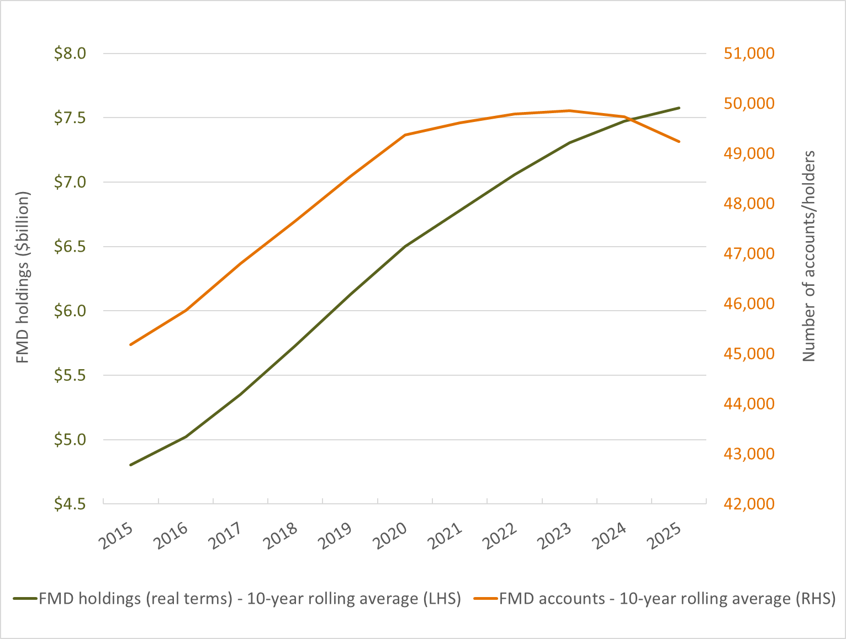
Note: Dollar values are presented in real terms (adjusted to 2024–25 values). Adjusting to real terms removes the effect of inflation and allows financial values across different time periods to be compared in like terms. ABARES adjusts for inflation using the consumer price index produced by the Australian Bureau of Statistics.
Sources: ABARES Farm data portal, and DAFF FMD statistics

KPI 2: Farm cash income and FMD holdings
For 2024–25, a positive relationship between changes in farm cash income (FCI) and FMD holdings was observed for the cropping and dairy industries only. All other industries displayed a negative ratio, where FMD holdings fell despite considerable increases in average FCIs across measured industries (Table 1).
Table 1: Ratio of annual percentage change in FMD holdings to annual percentage change in farm cash income (FCI), 30 June 2025
Industry | Annual % change in FCI | Annual % change in FMD holdings | Ratio of annual % change in FMD holdings to annual % change in FCI
Beef | 141.5% | −2.5% | -0.02
Sheep | 151.1% | -4.4% | -0.03
Cropping ª | 61.6% | 0.8% | 0.01
Sheep-beef | 115.8% | -9.1% | -0.08
Mixed livestock and cropping ^{b} | 175.4% | -4.3% | -0.02
Total broadacre ^{c} | 87.2% | -2.8% | -0.03
Dairy | -19.7% | -1.0% | -0.05
a Cropping is reported as ‘grain’ in monthly FMD statistics b Mixed livestock and cropping is reported as ‘grain-sheep/beef’ in monthly FMD statistics. c Broadacre comprises: beef, sheep, cropping, sheep-beef, and mixed livestock and cropping.
Sources: ABARES Farm data portal, and DAFF FMD statistics
In 2024–25, farm cash incomes (FCIs) across broadacre industries are projected to rise significantly, particularly for sheep, beef, and mixed livestock-cropping enterprises. This follows sharp declines in 2023–24, mainly due to lower farmgate prices for beef cattle and sheep.
Although incomes improved in 2025 for these sectors, they come after recent years of below-average earnings across most livestock industries. For example, sheep farm incomes in 2024 were $51,000 – well below the 10-year average of around $123,000 – and followed an FCI of $84,000 in 2023. Similarly, beef industry FCI was $75,000 in 2024, compared to a 10-year average of $174,000. Despite FCI gains in 2025, income shortfalls in prior years may have constrained some farmers’ capacity to contribute to FMDs, with priority given instead to debt repayment and working capital needs.
In 2025, the negative ratios observed between FMD holdings and FCI for most broadacre industries likely reflect the regional variation in farm incomes, where some regions remained affected by drought whereas others recorded productive seasonal conditions.
The FMD KPIs are underpinned by ABARES historical analysis, which tested the relationship between FCI and FMD holdings over time to confirm it is statistically significant. For the analysis, ABARES conducted a log-log linear regression on data for broadacre, cropping, mixed livestock and cropping, beef, sheep, and sheep-beef from 2002 to 2023. A log-log linear regression is a statistical method that finds the relationships between a dependent variable and one or more independent variables. The inputs to the linear regression model were the dependent variable (value of FMD holdings) and the independent variable (value of FCI), by industry. The FCI data for these industries are sourced from Australian Agricultural and Grazing Industries Survey and Australian Dairy Industry Survey, which are run annually by ABARES. The value of FMD holdings was sourced from monthly data provided to DAFF by ADIs.
The results from the model show evidence that a positive, long-term relationship exists at the industry level, excluding dairy, between FMD holdings and FCI. Previous ABARES analysis highlighted that individuals use FMDs to suit their particular circumstances, with usage varying by industry, location and farm size. Dairy producers typically experience more consistent cashflow than broadacre farmers, which may contribute to the way they use the FMD Scheme.

© Commonwealth of Australia 2025
Unless otherwise noted, copyright (and any other intellectual property rights) in this publication is owned by the Commonwealth of Australia (referred to as the Commonwealth). All material in this publication is licensed under a Creative Commons Attribution 4.0 International Licence except content supplied by third parties, logos and the Commonwealth Coat of Arms.
The Australian Government acting through the Department of Agriculture, Fisheries and Forestry has exercised due care and skill in preparing and compiling the information and data in this publication. Notwithstanding, the Department of Agriculture, Fisheries and Forestry, its employees and advisers disclaim all liability, including liability for negligence and for any loss, damage, injury, expense or cost incurred by any person as a result of accessing, using or relying on any of the information or data in this publication to the maximum extent permitted by law.

