ANZRP ANNUAL REPORT 2012/13

Chairman’s Letter to members
I would like to welcome you to ANZRP’s second Annual Report.
ANZRP is a not for profit, industry-run member body established to:
- provide its members – 68 of Australia’s leading technology importers and manufacturers – with a lean, sustainable arrangement to meet their liability under Product Stewardship legislation
- create a broader community that collects, processes and safely recycles electronic waste (e-waste) covered by the legislation (Televisions and Computers) for responsible environmental outcomes.

OUR MISSION
Through our national TechCollect program, we aim to provide Australia’s leading industry-backed scheme for e-waste collection and recycling, demonstrating leadership to:
- reduce e-waste contribution to landfill by delivering on collection and recycling targets
- scale operations to drive down collection and recycling costs
- encourage maximum resource recovery from end of life e-waste to capture its commercial and environmental value
- provide a free drop off service to households and small businesses
across Australia
- engage, educate and collaborate with stakeholders to drive sustained behavioural change in the community.

HIGHLIGHTS OF 2012/13
2012/13 has been a hectic but very promising year for our young organisation, in which we consolidated and built upon the important work done in 2011/12:
- Our member base is the envy of the industry: we signed over 50% of Australia’s liable parties.
- We built strong partnerships with our five recycling partners.
- We established strong and fruitful relationships with industry associations and other recycling schemes, such as Mobile Muster and ABRI (Australian Battery Recycling Initiative).
- We became a key sponsor of Planet Ark’s RecyclingNearYou.com.au website, an excellent online resource containing information about recycling services for a range of products.
- We joined the Global Product Stewardship Council to provide a strong and vigorous local voice in international e-waste discussion and developments.
- We are delivering over 90% coverage Australia-wide.
- Our TechCollect program was awarded a Guinness World Record – a tremendous achievement – for the most consumer electronics collected for recycling in a single week.
- We carefully managed our costs, to the extent that we are able to credit funds to our members.
- Above all, considering the size of Australia, it’s quite mind-boggling to contemplate that we ran collection events from Darwin in the north, to Burnie in the south, and many places in between.

OUR PEOPLE
Above all, we achieved great success in the caliber of our people. Our strong, united Board of Directors has provided invaluable stability and invested its time and expertise.
Driving our success on a day-to-day basis was our CEO Carmel Dollisson and her talented ANZRP team. On behalf of the Board I would like to thank Carmel for her strong leadership. The progress made by ANZRP in just twelve months is testament to the work she has done.
Finally I must acknowledge the support and encouragement of our members. It is only with their involvement that we are able to fulfil our objective of delivering a lean, sound and responsible e-waste recycling solution that helps to protect and preserve our environment. It is an objective that we can all be proud of.

Mark Mackay
Chairman ANZRP

Chief Executive Officer’s Report
I am delighted to report that ANZRP has made great strides in its vision to create a community that collects, processes and safely recycles electronic waste for responsible environmental outcomes. And all of this activity culminated in us achieving a Guinness World Record. We are, according to Guinness, “officially amazing”!

THE YEAR IN REVIEW
It has been a busy, challenging, but also exhilarating year, with gratifying results and many invaluable learnings to inform our future operations. While we were challenged by the external operating environment in a new and largely unknown market, we have developed the foundations for a sustainable program to drive success into future years.
It is timely to reflect on where we were a year ago, as a newly incorporated entity that had just gained approval from the Federal Government as a Co-regulatory Arrangement (CRA). The model we adopted was that of the European Recycling Platform (ERP), a not for profit industry scheme which has been widely successful.
With a working group made up of Canon, Apple and HP, and an Interim Board from Canon, Toshiba, Lenovo and Panasonic, we set course to deliver on the industry model and establish the best practice benchmark.

CHALLENGES
In a start-up company, new challenges arise almost on a daily basis. I’m happy to say that our ANZRP team tackled each and every new challenge with relish and determination, gaining much insight in the process:
- The competitive environment. By the end of 2012/13 there were five different CRAs under the National Television and Computer Recycling Scheme, each working towards the same objective of securing members, though TechCollect remained the only not for profit, industry-for-industry model.
- A lack of history in local e-waste recycling. There was little reliable information on the number of liable parties, consumer interest in dropping off product for recycling, the volume or mix of available e-waste, or the willingness of local government to work with CRAs. We were pioneers in a new field.
- The potential for over-collection. Coinciding with our formation, Australia was in the midst of the analogue-to-digital switch and a collection event in the Australian Capital Territory had netted well over a thousand tonnes of product – far beyond expectations.
- No mandated recycling standard. Each of the CRAs adopted different strategies for meeting targets, as the Scheme did not yet mandate a recycling standard or set a required level of material to be recovered from collected e-waste. As a result, there was not a level playing field.
- Price wars. A price-competitive member drive resulted in cost becoming a key driver in program selection: in some cases the only driver.
- The waste arising calculation. Our research into how Australia’s top companies deal with end-of-life IT product supported our view that the IT waste calculation in the regulations did not appropriately take into account product that is legitimately shipped off-shore for further use.
- IT vs. TVs – managing the balance. Very early we identified that the e-waste stream was 70%+ TVs – an over-representation against our targets. We found that the public wanted to drop off old TVs in high numbers and that the Scheme’s initial recycling targets did not appear to reflect the e-waste stream in the market, as indicated by the graph (Fig. 1) below. This created an IT volume shortfall.

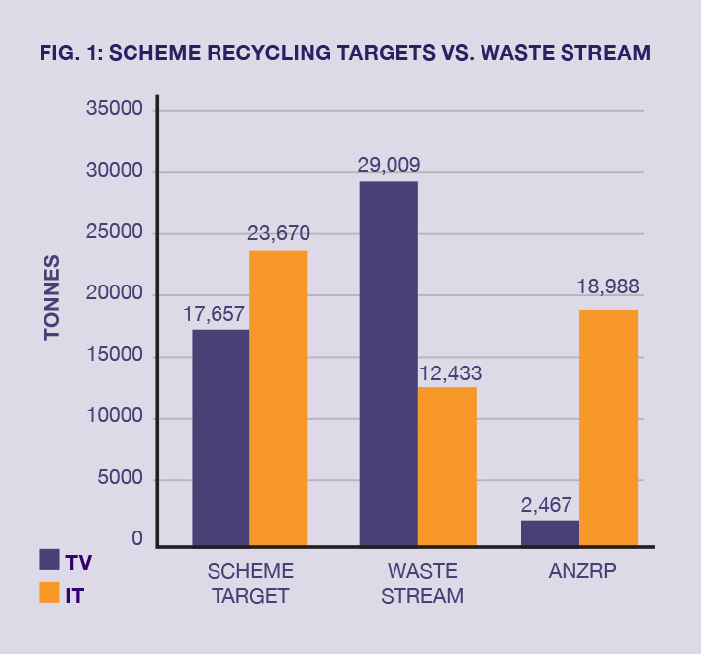

ACHIEVEMENTS
In such a new and largely unknown market, we achieved great success in many areas:
- Members. Our membership drive – based on industry for industry, not for profit, sustainable recycling – surpassed our expectations, securing over 50% of liable parties by volume. The majority of members were in the Computer class: ANZRP held 80% of the computer target and 14% of the
TV target.
- Services to members. We delivered a number of membership initiatives including regular newsletters and forums; and provided guidance and support to members on matters relating to the regulations.
- Leadership in compliance. We placed the highest importance on standards and workplace health and safety. Working with Environmental Resources Management (ERM), we audited our five preferred recyclers – and all passed.
- Leadership in recycling processes. We mandated the objective of a 90% recovery of materials, including fully treating leaded glass, which adds significantly to our costs but is consistent with our objective to achieve a program that delivers safe and responsible environmental outcomes.
- Strong partnerships. We developed deep and sustainable partnerships with environmentally sound local governments and waste management companies that provide easy community access and a steady flow of e-waste volume. We provided our partners with multiple levels of support, from collection units to transport logistics and marketing activity.
- Strong community service, education and awareness. Our network of collection partners provides environmentally sound – and free – drop-off points to the community; and we are spreading awareness of the program and the importance of e-waste recycling.
- Advocacy. We deepened our advocacy initiatives on behalf of members, sharing our expertise and insights with the regulatory team, which has been open to feedback on the Scheme in its formative year.
- Amendments to the regulations. Advocacy extends to action: we demonstrated to the Regulator that the available waste stream would not deliver sufficient computer volume to meet targets, and secured an amendment to the regulations, moving from two separate targets to a single target from 1 July 2013.
- Strong program management. With no initial e-waste collection experience in-house, we appointed Infoactiv as our Program Manager for the first year, while paving the way for in-house management from October 2013.
- Driving volume and meeting reasonable access targets. We have plans to meet the reasonable access target due 31 December 2013. We over-achieved the TV volume target and, carrying the remaining computer volume target over to 2013/14, had achieved it by September 2013.
- A strong financial position. We have begun building a financially sustainable organisation and at the close of 2012/13 were in a strong financial position, having delivered the program under the forecast cost (taking into account the computer volume shortfall and making a provision for the shortfall to be fully recycled in 2013/14).

THE YEAR AHEAD
Though our focus here is on 2012/13, I would be remiss in not mentioning how all of our hard work through the year provided the groundwork for key developments in 2013/14, in both operations and marketing:
- Bringing program management in-house. Our expanding team will manage the enormous, and tremendously exciting, task of building and managing our relationships with permanent collection and event partners, logistics providers and recyclers.
- Building the brand. We will continue to focus on major event strategies, alongside consistent ongoing local area and national activity. The year ahead will also include an ongoing review of our educational offering.
Our ambition, in 2013/14, is to ensure that the TechCollect brand is synonymous with e-waste recycling in Australia, and that we remain the leading sustainable CRA.

THANK YOU
Over the last year we have received enthusiastic encouragement, advice, cooperation and participation from many people. I would particularly like to thank the following:
- The stakeholders who provided guidance and support in the start-up phase – the AIIA, Australian Industry Group and our overseas friends at the ERP, ENE EcologyNet Europe and CESA
- Infoactiv, for providing sound establishment services as our Program Manager, and their own suppliers
- Our service providers, for providing the benefit of their various fields of expertise so that we could achieve best practice in everything we did
- Our advisers at the Department of Sustainability, Environment, Water, People and Communities, for their guidance and support to our mission
- Our collection partners and recyclers who were, quite simply, absolutely critical to our efforts
- The Board, for providing immeasurable support and an extraordinary level of expertise across the business
- Our members – ANZRP exists because of their faith in us to deliver a professional operation to fulfil their obligations and provide a high standard community service
And finally, to my ANZRP team, I thank you for your exceptional efforts in 2012/13. You have capably and patiently managed challenges large and small to assist us in making enormous progress over the
last year.
For me, it is a privilege to be able to lead ANZRP with such worthy objectives, and I’m very proud of what we have all achieved together so far. I look forward to an exciting 2013/14. Thank you.
Carmel Dollisson
CEO ANZRP

TECHCOLLECT PROGRAM AND MARKETING SUMMARY
In its first full year of operations, ANZRP has established the foundations for a strong and sustainable ongoing program, driving effective operational and marketing strategies to support our objectives.
The building blocks underpinning the successful outcomes for the TechCollect program in 2012/13 were:
- Securing key collection and recycling partners that achieved required audited standards
- Driving volume and reasonable access targets
- Establishing brand awareness and community support

SECURING KEY COLLECTION AND RECYCLING PARTNERS

Collection partners
One of our key priorities was establishing services across the country to deliver regular and reliable volume.
- By 30 June 2013 TechCollect had provided 143 services across Australia (81 of which were permanent, with the remainder being primarily one-off event sites – a full list of these services is on page 10).
- This was a significant increase on the14 services established by the end of the previous year, and an extremely tangible reminder of the great progress that has been made.
There was initial difficulty in securing sites for permanent collection services, leading to a reliance on one-off events to achieve reasonable access targets – events that delivered lower volumes at an increased cost. However, out of these early challenges came key learnings that have informed much of our strategic thinking since:
- A greater focus on securing permanent sites
- A strong multi-channel approach that encompasses the B2B channel, particularly for computer product
Our collection services contributed not just to volume targets, but expanding the reach of our brand. Many permanent and event services were supported with marketing activity, including advertising, publicity, social media, direct mail and signage. This activity, complemented by national marketing campaigns, ensured that the TechCollect brand continued to grow at a grassroots level through 2012/13.
The map below (Fig. 2) shows the total weight of TV and Computer (IT) products collected in each state and territory, as well as each individual region.

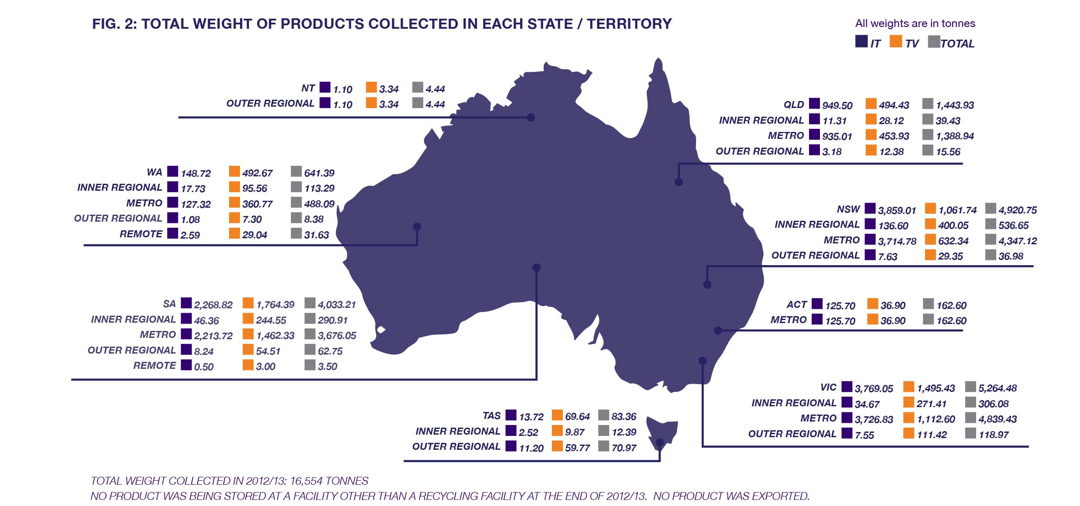

Recyclers
TechCollect’s second vital partnership is with recyclers, who are selected to meet the highest local and international e-waste recycling standards – an important consideration in protecting the reputations of our members and reinforcing our own leadership role in responsible recycling.
TechCollect’s five recyclers in 2012/13 were:
- PGM
- Sims
- TES-AMM
- Total Green Recycling
- E-Cycle
We do not partner with recyclers who cannot demonstrate appropriate standards, and the caliber of our existing partners was confirmed when – in association with the independent environmental auditor ERM – we audited them. All five passed the audit process.
No breaches of environmental or occupational health and safety (OH&S) laws were reported in TechCollect’s collection, transportation, storage and recycling activities in 2012/13.

DRIVING VOLUME AND REASONABLE ACCESS TARGETS

Volume
- In the 2012/13 Operating Year 16,554 tonnes of e-waste were collected through all ANZRP activity, representing 77% of our combined target.
- The remaining 23% carried over to 2013/14 and was processed by September 2013.
The table below (Fig. 3) details the types and weight of materials recovered from products delivered to our recyclers in 2012/13.
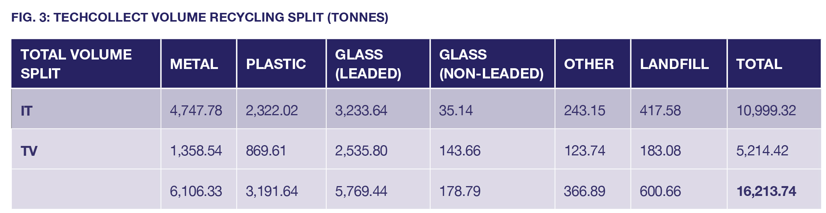

With our focus on permanent services and brand awareness, a stronger multi-channel approach encompassing B2B and retail, and in-house management of all program activities, we will be in an effective position to drive increased volume to meet the 2013/14 target.

Reasonable access
All CRAs under the Product Stewardship Act are required to provide Australians with reasonable access to a free e-waste drop-off service. The number of services required and the regions these are located in are determined by the regulations.
- Of the 143 TechCollect services at 30 June 2013, 97 counted towards reasonable access, and 93% of the population had reasonable access to one of those services.
- TechCollect also covered almost all Metropolitan and Inner Regional areas, and was on track to meet our 31 December 2013 reasonable access target of 124 services.

Product mix: TV vs. IT
While IT products (computers and accessories) are estimated to make up about 60% of all e-waste in Australia (based on import volume), they only represented about 25% of product dropped off at our collection sites in 2012/13, with TVs being over-represented. As ANZRP represents more than 75% of the Computer class, this was a matter of some concern.
In 2013/14, TechCollect will be working to a single product target rather than two separate targets, but we will continue to review the splits between products and drive strategies to increase drop-off volumes of IT products.

ESTABLISHING BRAND AWARENESS AND COMMUNITY SUPPORT

The Guinness campaign: a record-breaking effort
Our most notable volume-related achievement in 2012/13 was also one of the biggest success stories of our marketing activity: setting a Guinness World Record for the most consumer electronics collected for recycling in a seven day period, an exceptional result for a start-up operation.
- In the period 20-28 April 2013, TechCollect and its partners collected 474 tonnes of e-waste, with the public encouraged to “do their bit” to help Australia achieve a world record.
- The event received significant media coverage through a strong national marketing campaign, achieving:
- 24 print mentions
- 32 online mentions
- 14 radio mentions
- 2 TV mentions
- Media coverage amounted to a total circulation of 2,901,824, a phenomenal result that did much to establish the importance of e-waste recycling, and TechCollect’s important role in the process.
The success of the campaign was made possible through the support of our members, collection partners, recyclers, ANZRP staff (particularly Allison Murray in our marketing team), our external publicity agency The Bravery, and independent witnesses who verified the results.

2013: BUILDING ON THE FOUNDATIONS
The scope of operations that ANZRP undertook in 2012/13 to establish the TechCollect service and brand were extensive and far-reaching, taking us across the nation and encompassing a myriad of activities.
In itself, the amount of e-waste collected – where previously no scheme had existed to manage recycling of e-waste in Australia – was a considerable achievement. That it was consistently done to the highest standards, using a sustainable and lean not for profit model, reinforces the importance of our program activities.
All of this work has ensured that we are in a strong position to consolidate our successes and meet our longer-term targets. The next year will be an exciting one for TechCollect, in which we will build upon the strong foundations already established.

ANZRP BOARD AND STAFF

ANZRP BOARD OF DIRECTORS
Mark Mackay Chairman
(appointed 4 July 2012)

Stephen Rust
Panasonic Australia Pty Limited
(appointed 8 March 2012)

Janet Heather Leslie
Canon Australia Pty Limited
(appointed 16 Nov 2011)

Garry Pearce
Epson Australia Pty Limited
(appointed 4 July 2012)

Mark Whittard
Toshiba Australia Pty Limited
(appointed 16 Nov 2011)

Michael Wilson
Fuji Xerox Australia Pty Limited
(appointed 4 July 2012)

Alan Munro
Lenovo (Australia & New Zealand) Pty Limited
(appointed 16 Nov 2011/ resigned 21 March 2013)

Robert Mesaros
Hewlett Packard Australia Pty Limited
(appointed 16 Nov 2011)

Martin Stokie
PricewaterhouseCoopers
(appointed 4 July 2012)

ANZRP STAFF
Carmel Dollisson
Chief Executive Officer
Sonya Blondinau
(General Manager Operations)
Elena Vereskova
Finance & Membership Officer
Yvonne Terry
(Administration & Accounts Officer)

AUDIT, GOVERNANCE & RISK COMMITTEE
Stephen Rust – Chairman
Mark Mackay
Michael Wilson
Martin Stokie

MARKETING & STAKEHOLDER ENGAGEMENT COMMITTEE
Mark Whittard – Chairman
Mark Mackay
Janet Heather Leslie
Alan Munro (resigned 21 March 2013)

TECHCOLLECT SERVICES - as at 30 June 2013

LOCATION STATUS LOCATION STATUS

ACT SERVICES
Ainslie Event
Deakin Event

NSW SERVICES
Auburn Event
Broadmeadows Event
Canley Vale Event
Castle Hill Event
Clarendon Event
Gosford Event
Hornsby Event
Kogarah Event
Liverpool Event
Maitland Event
Meadowbank Event
Minnamurra Event
Miranda Event
Mosman Event
Penrith Event
Queanbeyan Event
Rooty Hill Event
Tamworth Event
Thirroul Event
Villawood Event
Wahroonga Event
Wetherill Park Event
Albury Permanent
Bargo Permanent
Dalmeny Permanent
Dubbo Permanent
Inverell Permanent
Jiliby Permanent
Katoomba Permanent
Kempsey Permanent
Kincumber Permanent
Lismore Permanent
Maclean Permanent
Marsden Park Permanent
Matraville Permanent

NSW SERVICES
Mortdale Permanent
Moruya Permanent
Mossvale Permanent
Mulgoa Permanent
Parkes Permanent
Port Macquarie Permanent
Wetherill Park Permanent
Woy Woy Permanent

NORTHERN TERRITORY SERVICES
Karama Event
Parap Event

QUEENSLAND SERVICES
Cleveland Event
Enoggera Event
Benaraby Permanent
Brendale Permanent
Caboolture Permanent
Crestmead Permanent
Emerald Permanent
Gladstone Permanent
Gympie Permanent
Helensvale Permanent
Moranbah Permanent
Portsmith Permanent
Redcliffe Permanent
Seventeen Seventy Permanent
Tanawha Permanent
Tumbulgum Permanent

SOUTH AUSTRALIAN SERVICES
Burnside Event
Ceduna Event
Prospect Event
Salisbury Event
Somerton Park Event
St Agnes Event
Bordertown Permanent
Clare Permanent
Gladstone Permanent

LOCATION STATUS

SOUTH AUSTRALIAN SERVICES
Goolwa Beach Permanent
Kadina Permanent
Mount Gambier Permanent
North Plymton Permanent
Renmark Permanent
Seaford Heights Permanent
Strathyalbyn Permanent
Tailem Bend Permanent
Two Wells Permanent
Wingfield Permanent
Yankalilla Permanent

TASMANIAN SERVICES
Burnie Event
Glenorchy Event
Prospect Event

VICTORIAN SERVICES
Balwyn North Event
Cranbourne Event
Caulfield North Event
Colac Event
Croydon Event
Dandenong Event
Darebin Event
Doncaster East Event
Epping Event
Flemington Event
Geelong Event
Geelong Event
Hadfield Event
Queenscliffe Event
Springvale Event
Swan Hill Event
Anglesea Permanent
Ballarat Permanent
Camberwell Permanent
Dandenong Permanent
Drysdale Permanent
Eaglehawk Permanent
Forge Creek Permanent
Geelong Permanent

LOCATION STATUS

VICTORIAN SERVICES
Lardner Permanent
Mildura Permanent
Moe Permanent
Moonee Ponds Permanent
Morwell Permanent
Neerim South Permanent
Notting Hill Permanent
Plenty Permanent
Trafalgar Permanent
Traralgon Permanent
Wantirna South Permanent
Wodonga Permanent
Wyndham Permanent

WESTERN AUSTRALIAN SERVICES
Bayswater Event
Carlisle Event
Cottesloe Event
Craigie Event
Crawley Event
Floreat Event
Hazelmere Event
Landsdale Event
Middle Swan Event
Mosman Park Event
Australind Permanent
Bandy Creek Permanent
Bunbury Permanent
Busselton Permanent
Dardanup Permanent
Dunsborough Permanent
Fremantle Permanent
Kalgoorlie Permanent
Mindarie Permanent
Red Hill Permanent
Walliston Permanent

