Australian and New Zealand Standard Diagnostic Procedures (ANZSDP) for Yersiniosis in fish
Version 2019
J Carson  T Wilson  M Douglas | Centre for Aquatic Animal Health and Vaccines Animal Health Laboratory  Department of Primary Industries and Water, Launceston, Tasmania, 7250  jeremy.carson@dpipwe.tas.gov.au  teresa.wilson@dpipwe.tas.gov.au  marianne.douglas@dpipwe.tas.gov.au
A Barnes | The University of Queensland  School of Biological Sciences and Centre for Marine Science, St Lucia Campus, Brisbane, Queensland 4072  a.barnes@uq.edu.au

Summary
Yersiniosis is a contagious bacterial disease of salmonids, eels, goldfish, sole, sturgeon and turbot caused by Yersinia ruckeri, a member of the family Enterobacteriaceae. The bacterium is found in fish populations throughout Europe, North and South America, China, Australia and New Zealand.
Infection with Yersinia ruckeri results in a bacterial septicaemia without disease specific signs but is most commonly detected from exophthalmos and blood spots in the eye. The severity of the disease is dependent upon the biotype of the bacterium involved and host species. Acute infections in trout with the 'Hagerman’ strain are usually florid and the disease is referred to as enteric red mouth. A milder form of the disease occurring in Atlantic salmon (Salmo salar) and Chinook salmon (Oncorhynchus tshawytscha) is termed yersiniosis.
Identification of the agent
A diagnosis of yersiniosis is based on clinical signs and isolation in culture of the bacterial pathogen from systemic sites such as head kidney or spleen. The bacterium is not fastidious and can be grown on simple culture media such as tryptone soya agar. The identification of Y. ruckeri should be made by phenotyping. A polymerase chain reaction method is also available for confirmatory identification or detection of sub-clinical carriers.
Status of Australia and New Zealand
Some strains of Yersinia ruckeri are enzootic to both Australia and New Zealand. In Australia, three forms of Y. ruckeri are known to occur: serotype O1b biotype 1, O1b biotype 2 and serotype O2. In New Zealand only serotype O1b is known to occur. The virulent Hagerman strain, serotype O1a, the cause of enteric red mouth in rainbow trout (Oncorhynchus mykiss), is exotic to both countries.

Contents
Summary ii
Identification of the agent ii
Status of Australia and New Zealand ii
1. Diagnostic overview 1
Introduction 1
Aetiology 2
Clinical signs 3
Diagnostic tests 4
Guidance on safety and biosecurity requirements 5
2. Test Methods 6
Sample collection 6
Culture 7
Identification 8
PCR Identification 13
References 18
Appendix A: Reagents and kits 21
Coomassie Blue-TSA-SDS Agar 21
POST selective enrichment medium 21
Ribose ornithine desoxycholate (ROD) agar 22

Tables
Table 1 Phenotypic characteristics of Yersinia ruckeri and Hafnia alvei 11
Table 2 Yersinia ruckeri primer set for conventional PCR 13
Table 3 Master mix amplification reagents for conventional PCR 14
Table 4 Yersinia ruckeri primer set and probe for TaqMan®RT-PCR for 16S rDNA gene target 16
Table 5 Master mix amplification reagents for 16S rRNA TaqMan®RT-PCR 16
Table 6 Base ingredients for Coomassie Blue-TSA-SDS agar 21
Table 7 Base ingredients for POST selective enrichment medium 21
Table 8 Base ingredients for Ribose ornithine desoxycholate (ROD) agar 22

Figures
Figure 1 Atlantic salmon infected with Yersinia ruckeri serotype O1b 4
Figure 2 Flow diagram for investigating Yersiniosis in fish 5
Figure 3 Faeces collection method for anaesthetised fish 7
Figure 4 Pure culture of Yersinia ruckeri on sheep's blood agar 9
Figure 5 Primary culture (farm submission) from kidney of Atlantic salmon 9
Figure 6 Colonies of Yersinia ruckeri on ribose ornithine desoxycholate (ROD) agar 10
Figure 7 Yersinia ruckeri on XLD medium after 48 hours incubation at 25°C 10
Figure 8 Amplicon sequence, 5'–3' for 16S rRNA gene fragment diagnostic of Yersinia ruckeri 15

Diagnostic overview

Introduction
Yersiniosis in fish is a significant bacterial septicaemia caused by Yersinia ruckeri. The organism appears to have a wide geographical distribution because it is found in many countries that raise salmonids and non salmonids under intensive conditions.
Yersinia ruckeri has been reported to occur in fish from Australia, Bulgaria, Canada, Chile, China, Denmark, Finland, France, Germany, Greece, India, Iran, Italy, New Zealand, Norway, Portugal, South Africa, Spain, Sweden, Switzerland, Turkey, United Kingdom, United States of America and Venezuela. The number of countries in which Y. ruckeri has been isolated is increasing and the list is indicative only.
The severity of the disease is dependent upon the biotype involved and salmonid host. Acute infections in rainbow trout (Oncorhynchus mykiss) with the 'Hagerman' strain are usually florid and the disease is referred to as enteric red mouth or ERM. A form of the disease, which may be less severe, also occurs in Atlantic salmon (Salmo salar) involving a serotype of Y. ruckeri different to the 'Hagerman' type. This condition is referred to as yersiniosis (also salmonid blood spot) (Llewellyn, 1980). The term yersiniosis is used to distinguish the infection in finfish from that in rainbow trout.
Data on epizootiology are based on rainbow trout infected with virulent strains. The disease can affect fish of all age classes but is most acute in small fish up to fingerling size. In larger fish, the disease is chronic. Fish most at risk are those subject to stress arising from poor management or environmental changes such as elevated temperatures or poor water quality (Rodgers, 1991). Losses in juvenile rainbow trout may reach 2% per week with cumulative losses reaching 35%. The disease yersiniosis in Atlantic salmon by comparison is less severe with cumulative mortalities typically reaching 1%.
Sub-clinical carriage of the pathogen is known to occur in rainbow trout (Busch, 1975) and Atlantic salmon. Localisation of bacteria may occur in the kidney and the distal portion of the gastro-intestinal tract, a site from which bacteria may be excreted to the water column.
A wide variety of fish species have been cited as susceptible hosts. Species of commercial importance include: Atlantic salmon (Salmo salar), brook trout (Salvelinus fontinalis), brown trout (Salmo trutta), Chinook salmon (Oncorhynchus tshawytscha), coho salmon (Oncorhynchus kisutch), rainbow trout (Oncorhynchus mykiss), eel (Anguilla anguilla), goldfish (Carassius auratus), perch (Perca fluviatilis), channel catfish (Ictalurus punctatus), sole (Solea solea), sturgeon (Acipenser baeri and A. schrencki) and turbot (Scophthalmus maximus).
In Australia, infection with Y. ruckeri occurs predominantly in Atlantic salmon with rare isolations from rainbow trout, brown trout and brook trout. In New Zealand, rainbow trout and Chinook salmon are known to be susceptible to infection.
While Y. ruckeri is the pre-eminent species of Yersinia that is a cause of disease, Y. enterocolitica, Y. intermedia and Y. frederiksenii have also been isolated from fish. Of the species listed, only Y. intermedia has been associated with disease and is a cause of septicaemia in cold-compromised Atlantic salmon (Carson and Schmidtke, 1993).

Aetiology
Yersinia ruckeri is a member of the family Enterobacteriaceae and possesses general attributes associated with the taxon. The genus Yersinia forms a discrete cluster of species within the gamma subgroup of the Proteobacteria, based on 16S rRNA gene phylogenetic analysis (Ibrahim et al., 1993). Within the genus, five sub-lines can be identified, one of which contains a single species, Y. ruckeri. The 16S rRNA gene sequence homology for the genus is high, ranging from 99.6% for Y. intermedia and Y. mollarettii to 96.6% for Y. ruckeri and Y. enterocolitica. The monophyly of Y. ruckeri is evident however by DNA-DNA hybridisation, which shows that Y. ruckeri has only a 38% sequence homology with other species of the genus tested to date. Based on whole genome sequencing, the closest related species are Y. entomophaga and Y. nurmii (Rueter et al., 2014).
The phenotype of Y. ruckeri is unlike other species of Yersinia, and instead appears to have characteristics of a number of other members of the Enterobacteriaceae. Early descriptions of the pathogen in Australia suggested that the organism had features of Serratia liquefaciens (Llewellyn, 1980), while other studies have reported a similarity to Salmonella arizonae (Austin and Austin, 1999). There is marked similarity in phenotypes between Hafnia alvei and Y. ruckeri but not by serotype or genotype (De Grandis et al., 1988). Current descriptions of the pathogen are more complete, and based on a wide range of isolates from a number of geographic regions. Yersinia ruckeri can be readily differentiated from other members of the Enterobacteriaceae.
The virulence factors of Y. ruckeri have not been fully determined. It has been established that the pathogen produces a siderophore, ruckerbactin, which is involved in sequestering iron under potentially growth limiting conditions and expressed in vivo (Romalde and Toranzo, 1993). Possession of an efficient iron uptake mechanism is an important component of the virulence capacity of Y. ruckeri. Survival of the pathogen within the host is also thought to be assisted by synthesis of a cell envelope lipid, a heat-sensitive factor (HSF+) that masks immuno-reactive surface antigens (Furones et al., 1993). Extracellular factors including proteases and haemolysin (Romalde and Toranzo, 1993) are known to be elaborated by Y. ruckeri, which also possesses a Type III secretion system to transport exotoxins to host cells (Gunasena et al., 2003).
A 62 megadalton (MDa) plasmid has been detected in European and American strains of Y. ruckeri (Guilvout et al., 1988) while a 75 MDa plasmid has been found only in serogroup O1 isolates (Garcia et al., 1998) (see Serotyping). This plasmid appears to be significantly different to the 42–47MDa virulence plasmid associated with other species of the genus Yersinia. The role of Y. ruckeri plasmids as virulence factors remains unclear.
The organism is oxidase negative, facultatively anaerobic, ferments glucose and is usually motile (see ‘Phenotypic profile’ for exceptions) by means of a peritrichous arrangement of flagella; the G+C ratio of DNA has been determined at 48 ± 0.5 mol%. The species has a growth temperature optimum between 20 and 25°C but can grow at 37°C. Like other species of the genus, the response of Y. ruckeri in characterisation tests can be significantly different at 37°C compared with 25°C (Bercovier and Mollaret, 1984); the most consistent phenotypic descriptions of the species have been determined at 25°C.
On the basis of heat stable antigens (lipopolysaccharide), Y. ruckeri can be divided into four major serotypes: O1, O2, O3 and O4 (Romalde et al., 1993). Within serotype O1, two subgroups O1a and O1b can be distinguished while for O2, three subgroups O2a, O2b and O2c can be recognised. Isolates of serotype O2 ferment sorbitol, while those of serotype O1 do not (O’Leary et al., 1982). The serotype predominant in Australia, and the only known serotype in New Zealand, is O1b (see Serotyping). It should be noted that most isolates have been serotyped with the group specific O1 antiserum with fewer isolates tested with monospecific O1b antiserum. In Tasmania, serotype O2 has been isolated during disease outbreaks in hatchery Atlantic salmon and rainbow trout, as well as post-transfer smolt. The emergence of serotype O2 occurred as a point-event at a single location between 2011 and 2012 and has not been detected subsequently.
Strains of Y. ruckeri can be grouped into clonal types on the basis of biotype, serotype and outer membrane protein types (Davies and Frerichs, 1989; Davies, 1990; Davies, 1991a; Davies 1991b). Most strains of Y. ruckeri belong to serogroup O1 (see ‘Serotyping’ below); within this serogroup, 6 clonal types designated 1–6 can be recognised. Australian isolates have been placed in clonal groups 1 and 3; by comparison, most strains from Europe, including the virulent 'Hagerman' strain from the United States, have been placed in clonal group 5. Clonal groups 2 and 5 contain strains associated with major disease outbreaks and also contain virulent strains. The remaining clonal groups are considered to be relatively avirulent. A further form of biotyping is recognised within the O1 serogroup. On the basis of motility and Tween 80 hydrolysis, two distinct phenotypes are recognised (Davies and Frerichs, 1989). Biotype 1 strains are motile and hydrolyse Tween 80 while biotype 2 is negative for both traits. In Australia, biotypes 1 and 2 occur. The predominant form of Y. ruckeri is serotype O1b biotype 1 and is associated with most disease outbreaks. The incidence of serotype O1b biotype 2 appears to be infrequent, occurring as isolated point-events. In Tasmania, the last occurrence was in 2007.
Although Y. ruckeri has a worldwide distribution, Australian and New Zealand strains have a unique and distinct lineage from those in the northern hemisphere, as determined by whole genome sequence analysis (Barnes et al., 2016). Within the Australasian lineage three distinct types are evident: Atlantic salmon serotype O1b (biotypes 1 and 2), rainbow trout and Chinook salmon serotype O1b and thirdly, serotype O2 from Atlantic salmon and rainbow trout. Of note is that serotype O2 in Australia has emerged independently to that which occurred in North America.

Clinical signs
There are no specific early signs of disease to indicate infection with Y. ruckeri other than general indicators of bacterial septicaemia.
The first signs of the disease in juvenile salmonid fish are seen as an increase in mortalities above the normal attrition rate. Changes in fish behaviour may be observed including swimming near the surface, moving sluggishly, and darkening. Inappetence occurs in affected fish. A common feature of yersiniosis in Atlantic salmon is the development of a marked unilateral or bilateral exophthalmos often with frank patches of haemorrhagic congestion on the iris of the eye, a characteristic that gave rise to the epithet salmonid blood spot disease. Blood spots in the eye are also a common feature of yersiniosis in Chinook salmon in New Zealand (Carson and Schmidtke, 1993). In rainbow trout, subcutaneous haemorrhage in the mouth and throat is strongly indicative of the disease and hence the term enteric red mouth. This does not appear to be a characteristic of infection in Atlantic salmon in Australia.
Other external signs of the disease may include haemorrhagic congestion at the base of the pectoral and pelvic fins, a distended vent and in small fish especially, pallor to the gills arising from bacterial induced anaemia. Small areas of muscle liquefaction resulting in skin lesions can occur but is uncommon.
Yersiniosis may occur in Atlantic salmon smolt, usually 3–6 weeks after their introduction to seawater. The number of fish affected is small, with cumulative mortalities ranging from 1% in non-brackish sites to 5% under brackish conditions. Infection is manifest by poor feeding response in recently transferred smolt, rising levels of mortality and appearance of exophthalmos and blood spots in the eye (Figure 1). In flow-through hatcheries fed with river water, mortality levels can reach 0.2% per day with cumulative mortalities reaching 1%.
Figure 1 Atlantic salmon infected with Yersinia ruckeri serotype O1b
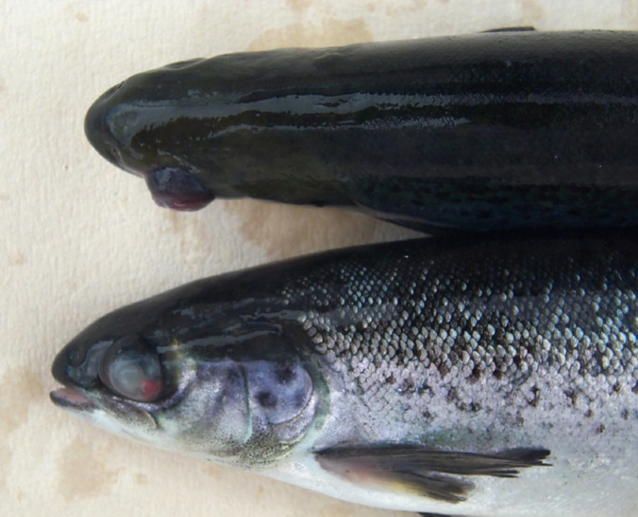
Note: Fish exhibit exophthalmos and characteristic blood spot associated with Yersinia ruckeri serotype O1b.
Image courtesy of Kevin Ellard.
Post-spawning rainbow trout or egg-bound fish may develop a chronic peritonitis. In most instances this is due to Maltaromaticum piscicola, but occasionally Y. ruckeri may also be isolated. Since a number of pathogens may be associated with this condition, bacteriological examination should be undertaken to reach a definitive diagnosis.
Fish infected with Y. ruckeri may have petechiation on the pyloric caecae, hypertrophy of the spleen, peritonitis, and the gastro-intestinal tract may be empty of food but filled with a clear to yellow mucus. In aggressive forms of the disease, erythema around the meninges may also be seen.
Histopathological findings in fish infected with Y. ruckeri are those of a typical septicaemia. Bacteria are readily detected free in the blood and in circulating and sequestered macrophages; tissue localisation of bacteria at sites of haemorrhage may also be evident.
Histologically, salmon fry may contain overwhelming numbers of bacteria with high concentrations detectable in macrophages of kidney and liver sinusoids. Circulatory collapse is evident with oedema and apparent anaemia. These changes are most evident in the gills, which may show blood stasis and bacterial clumps.
Yersinia ruckeri infection in Atlantic salmon smolt during post-transfer acclimatisation stress is characterised by fewer bacteria in blood, with congestion, haemorrhage and tissue localisation more apparent than acute inflammation. Localisation in the choroid and meninges is common, and encephalitis may be seen.

Diagnostic tests
Diagnosis of yersiniosis requires isolation and identification of Y. ruckeri from tissue samples. More commonly, it is based on phenotypic profile and the species can be readily differentiated from other taxa within the Enterobacteriaceae. In addition, a polymerase chain reaction technique is available and best used either to confirm the identity of ambiguous isolates or for prevalence estimates of carriers in at-risk populations (Figure 2).
Figure 2 Flow diagram for investigating Yersiniosis in fish
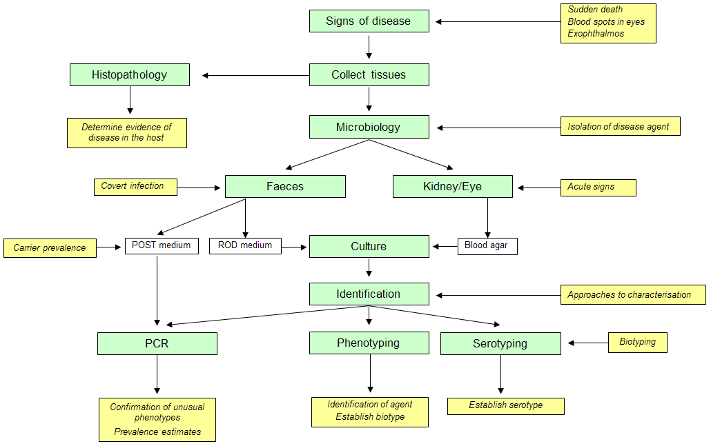

Guidance on safety and biosecurity requirements
Yersinia ruckeri is primarily a pathogen of a diverse range of fish species, many of which are of economic importance, and can be classified as livestock in a broad sense. On the basis of World Health Organisation (WHO) risk classification criteria, Y. ruckeri should be considered as Risk Group 2 on the basis that it can cause human (De Keukeleire et al., 2014) and animal disease but is unlikely to be a serious hazard to laboratory workers, livestock or the environment. Where disease occurs, effective treatment and preventative measures are available. As a Risk Group 2 organism, diagnostic and experimental work with Y. ruckeri are to be undertaken at facilities which are compliant with the requirements of Physical Containment Level 2 (PC2) as given in:
- Australian and New Zealand Standard 2982:2010 Laboratory design and construction
- Australian and New Zealand Standard 2243.3:2010 Safety in laboratories, Part 3 Microbiological safety and containment
- the most recent published edition of the Australian and New Zealand standards

Test methods

Sample collection

Acute infections
It is preferable to select fish on site and culture immediately. Where this is not possible, live fish should be submitted; if fish are too large to transport live, then they should be euthanized, packed in ice and sent to the laboratory. To reduce adverse microbial changes, the time between collection and receipt by the laboratory should not exceed 12 hours.
Moribund fish or fish with apparent lesions such as exophthalmos, blood spots in the eyes or congestion at the base of the fins should be selected for culture. In the early stages of an outbreak, recovery of the pathogen from individual fish can be variable and it is necessary to culture at least 5 but preferably 10 fish to obtain a reliable diagnosis of infection.
The concentration of bacteria in organs of the fish may vary considerably, particularly in the early stages of infection. To increase the likelihood of recovery, several sites must be cultured. It is essential to sample behind the eye and the kidney or spleen (or liver in small fish, if the spleen is too small). All these organs represent sites where bacteria are most likely to be concentrated within the host. Smears for Gram's stain should be prepared for each site sampled.

Eye
Lightly sear the surface of the eye and the surrounding skin. Excise the eye intact using a fine scalpel blade; collect a sample from the remnants of the choroid mass at the back of the orbit using a fine sterile glass pipette or a 10 µL pipette tip fitted to a pipettor if the fish are small. Alternatively, inoculate culture plates by touching the back of the eye on the surface of an agar plate.

Kidney
Observing aseptic precautions, dissect the fish to reveal the kidney. Collect a sample from the anterior region of the kidney using a sterile glass pipette. Use a 10 µL pipette tip fitted to a pipettor if the fish are small or use a drawn glass pipette.

Spleen
Working from the left hand side of the fish, aseptically remove the flank to reveal the spleen. Remove a portion of spleen and inoculate culture plates by touching the cut surface of the tissue on the surface of an agar plate. A liver sample may be collected in similar fashion.

Testing for carriers
Detection of carrier fish for prevalence estimates is accomplished by selective enrichment culture coupled with PCR detection of Y. ruckeri (SEC-PCR) (Wilson and Carson, 2001; Carson and Wilson, 2003). The use of direct culture in the absence of highly selective-indicator media for Y. ruckeri can make testing for carriers by culture of faeces an unrewarding exercise. Where required, the following procedures are recommended for the collection of samples.

Euthanased fish
Culture kidney by the method described above. In addition, remove the distal 1–2 cm of the gut and place in a sterile petri dish. Slit the gut along its length and, with a cotton swab, sample the walls of the gut.

Live fish
Anaesthetise the fish to be tested. Gently massage the ventral surface of the fish from the pectoral fins towards the anus to express a small quantity of faeces (Figure 3). A strand of 5–10 mm in length is sufficient. Using a sterile swab, pick up the faeces and transfer the sample to a bottle of POST enrichment medium (see appendix A).
Figure 3 Faeces collection method for anaesthetised fish
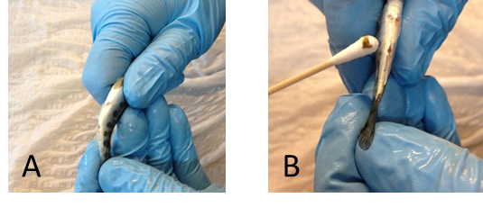
Note: (A) Expression of faeces from gut. Gently massage abdomen from pelvic fins towards anus. (B) Pick up faecal strand with a sterile swab and place in POST selective enrichment medium.

Culture
Yersinia ruckeri is not a fastidious organism and can be grown on simple culture media such as tryptone soya agar. In addition, the species can tolerate bile salts, the selective component in a number of media used for the isolation of enteropathogenic Enterobacteriaceae. Yersinia ruckeri will grow readily on MacConkey agar and XLD agar (xylose lysine desoxycholate).

Culture from haematogenous sites
Inoculate a plate of blood agar base (Oxoid, blood agar base no. 2, CM271) enriched with 7–10% defibrinated sheep's blood. Adequate growth can also be obtained on tryptone soya agar (Oxoid CM131), but colonial morphology on this medium is nondescript.
If secondary infection with other bacteria is suspected, samples should also be cultured on plates of XLD agar (Oxoid CM469) or preferably Ribose Ornithine Desoxycholate (ROD) agar, a moderately selective indicator medium for Y. ruckeri (Rodgers, 1992) (see appendix A).
Where signs of disease are apparent, typically Y. ruckeri is recovered in pure culture from internal sites and, depending on the stage of infection, colony density will range from light to heavy.

Culture from faeces
Recovery of Y. ruckeri from faeces is only of value for the detection of sub-clinical carrier fish. Isolation is problematic for direct culture as highly selective plate media are currently not available.
The Shotts-Waltman medium (Waltman and Shotts, 1984) is a semi-selective indicator medium for Y. ruckeri, with inhibitory properties equivalent to MacConkey agar. The indicator is based on the ability of Y. ruckeri to hydrolyse Tween 80, and inability to produce acid from sucrose. The concentration of bromothymol blue was incorrectly stated in the original formulation and was subsequently amended to 0.03 g/L (Shotts, 1991). The value of this medium has been questioned (Hastings and Bruno, 1985; Rodgers and Hudson, 1985) since biotype 2 strains of Y. ruckeri are unable to hydrolyse Tween 80 (Davies, 1990). Use of the medium is not recommended.
Ribose Ornithine Desoxycholate (ROD) agar can be useful for the detection of Y. ruckeri in faeces of carrier fish (Rodgers, 1992) and can detect biotypes 1 and 2. A key differential feature of the medium is formation of zones of precipitation around colonies of Y. ruckeri. This feature however is seen only with serotypes O1 and O4 (Rodgers, 1992) and the medium is of limited value for the detection of other serotypes of Y. ruckeri. The medium does not suppress the growth of all Enterobacteriaceae, and Citrobacter, Hafnia and Enterobacter may predominate in some faecal samples. If ROD is not available, XLD agar can be used but is less discriminating than ROD.
To inoculate ROD, prepare a 1:10 dilution of the faeces in phosphate buffered saline, pH 7.2, 0.1 M. Homogenise the sample by aspirating with a pipette and inoculate single plates of blood agar and ROD medium with 1 µL of suspension using a calibrated loop. Alternatively, inoculate plates of blood agar and ROD medium directly with a swab and streak for isolated colonies with a loop.
The density of Y. ruckeri in faecal samples tends to be low in carriers and, typically, few colonies of Y. ruckeri will be evident on culture plates. To increase the likelihood of detection, selective enrichment culture should be used for carriers. The medium POST (polymyxin ox-bile sodium deoxycholate thallous acetate), coupled with PCR for detecting Y. ruckeri following enrichment can be used for estimating prevalence in at-risk populations of fish (Carson and Wilson, 2003). Individual samples or pooled samples can be used with POST up to a maximum of five fish per pool.

Incubation
Cultures should be incubated in air at 25°C for up to 72 hours, and examined daily. If isolation is attempted from faecal samples, suspect colonies should be subcultured on appearance to blood agar, to ensure that colonies of Y. ruckeri are not overgrown. Samples cultured on ROD medium should be incubated for at least 96 hours so that the differential properties of the medium are fully expressed (see Colonial morphology). For SEC-PCR, samples should be incubated in POST for three to five days at 25°C.

Identification

Smears
In smears from tissues such as kidney or from the retro-bulbar region of the eye, cells of Y. ruckeri appear as short rods approximately 1.5 µm long and 0.75 µm wide. The cells stain well with dilute carbol-fuchsin as the counter stain, and a marked bipolar staining may be evident. Frequently, the cells of Y. ruckeri in tissue smears appear rectangular with square ends. This unusual appearance is not evident when the bacteria are grown on culture media.
Care must be exercised when examining smears made from the eye and surrounding tissue. If retinal tissue forms part of the smear, casual examination may mistake retinal rods for bacillary bacteria. Retinal rods can be differentiated from bacteria by their regular, too angular appearance and brown pigmentation, features that can be observed when the condenser, field and stage iris of the microscope are set critically.

Colonial morphology
On blood agar, well separated colonies of Y. ruckeri after incubation at 25°C for 48 hours appear off-white, opaque with a marked bull's eye (Figure 4). Colonies are approximately 2–3 mm in diameter, smooth, entire edged with a low convex profile. Older cultures develop a highly characteristic, slightly acrid odour, reminiscent of stale mushrooms.
Figure 4 Pure culture of Yersinia ruckeri on sheep's blood agar
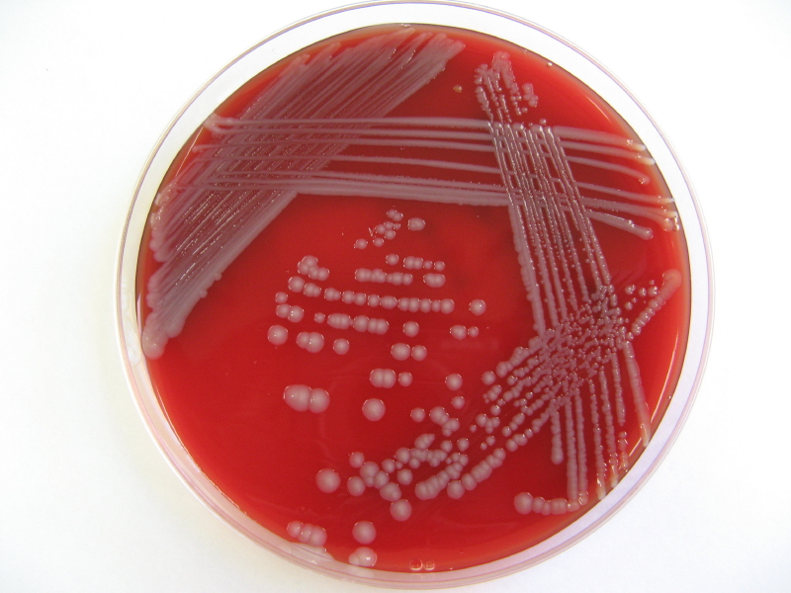
Note: Appearance after incubation at 25°C for 48 hours. Colonies showing characteristic bull's eye appearance.
Occasionally, plaques can be seen on primary plates (Figure 5) arising from bacteriophage activity. The significance of this finding is uncertain, other bacteriophages specific for Y. ruckeri are known to exist (Stevenson and Airdrie, 1984).
Figure 5 Primary culture (farm submission) from kidney of Atlantic salmon
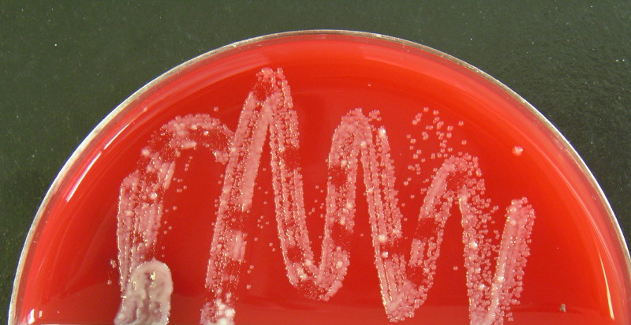
Note:Primary culture showing plaques caused by bacteriophage.
On ROD medium, colonies of Y. ruckeri serotype O1, biotype 1 and 2 and serotype O4 appear as yellow colonies on a red background with zones of precipitation around the colonies after incubation for 96 hours (Figure 6). Yersinia ruckeri other than serotypes O1 or O4 appear as yellow colonies but without the characteristic zone of precipitation.
Figure 6 Colonies of Yersinia ruckeri on ribose ornithine desoxycholate (ROD) agar
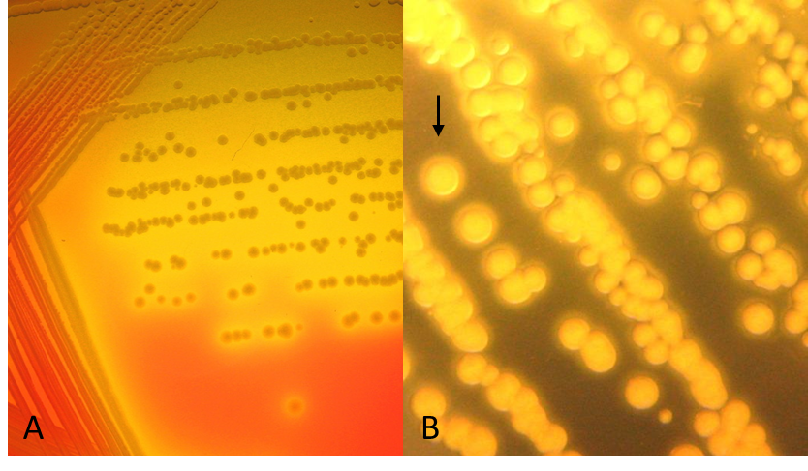
Note: (A) Yellow colonies of Y. ruckeri arising from ribose fermentation. (B) After four days incubation at 25°C, zones of precipitation (arrowed) are evident with serotype O1 isolates.
Yersinia ruckeri on XLD appear as bright pink colonies, 1–2 mm in diameter, often with a zone of diffuse pink colouration (Figure 7).
Differential reactions on the medium rely on the ability to ferment xylose, lactose or sucrose and/or decarboxylate lysine. Most coliforms appear as yellow colonies, the result of acid production. Salmonella, Shigella, Edwardsiella and Providencia species appear as pink colonies, due either to lysine decarboxylation or no fermentation action at all. Yersinia ruckeri is unable to ferment any of the 3 sugars present but is able to decarboxylate lysine. Pseudomonads may also appear as pink or pink/orange colonies and should be differentiated from Y. ruckeri.
Figure 7 Yersinia ruckeri on XLD medium after 48 hours incubation at 25°C
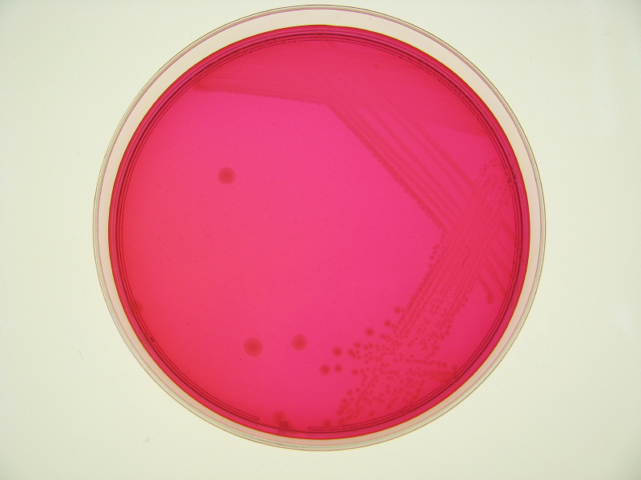
Note: Nondescript pink colonies arising from lysine decarboxylation and failure to ferment either xylose, lactose or sucrose.
With practice, colonies of Y. ruckeri can be readily identified, but care must be exercised, as Hafnia alvei has an almost identical colonial morphology on blood agar. On XLD however, H. alvei forms yellow colonies because of xylose fermentation while on ROD it forms yellow colonies due to ribose fermentation; no halo of precipitation is apparent as is seen with some serotypes of Y. ruckeri. Where suspicious colonies are evident, confirmatory identification based on phenotype or genotype must be undertaken. Where H. alvei is identified in fish with signs of clinical disease, the finding is considered significant, as the species is a recognised pathogen of brown trout and rainbow trout (Gelev et al., 1990; Rodriguez et al., 1998).

Identification tests
Standard tests for the Enterobacteriaceae can be used for the identification of Y. ruckeri. Recommended procedures may be found in Cowan (1974) and MacFaddin (2000). Tests should be incubated at 25°C and results recorded at 48 hours. Tests should be in conventional tube format or in miniaturised form so long as they have direct equivalence to the conventional test. Identification can be achieved by computer-assisted probabilistic methods (see Phenotypic profile).
Use of API 20E for identification is not recommended as it is unreliable (Romalde and Toranzo, 1991; Furones et al., 1993).
Use of MALDI-TOF spectrometry can reliably confirm Y. ruckeri. However, it is not capable of serotyping or biotyping isolates.

Phenotypic profile
The biochemical profile of Y. ruckeri is well described and the species may be differentiated readily from other taxa within the genus Yersinia and the family Enterobacteriaceae (Table 1). Hafnia alvei is similar morphologically and serologically to Y. ruckeri but can be readily differentiated by phenotype. Key differential tests are motility at 37°C, citrate utilisation, gluconate oxidation, fermentation of rhamnose and xylose.
The range of tests given in Table 1 can be used for computer-assisted probabilistic identification using the software package PIBWin (Bryant, 2004), which is freely available for download and use. A probabilistic database for Enterobacteriaceae based on data compiled from Holmes and Costas (1992) and Farmer (1995), is freely available from the authors. MicroSys E24, a panel of miniaturised tests for Enterobacteriaceae, validated for use with Y. ruckeri is available (DPIPWE, Launceston, Tasmania) and is designed for use with probabilistic identification systems.
Table 1 Phenotypic characteristics of Yersinia ruckeri and Hafnia alvei
Test | Y. ruckeri* | H. alvei*
Oxidase | 0 | 0
Motility 25°C | 82 | 70
Motility 37°C | 0 | 85
MacConkey | 100 | 100
Arginine dihydrolaseª | 0 | 10
Lysine decarboxylase^{b} | 100 | 98
Ornithine decarboxylase^{b} | 100 | 100
Urease^{c} | 0 | 0
H₂S | 0 | 0
Citrated | 100 | 16
ONPG^{e} | 100 | 90
Phenylalanine deaminase^{f} | 0 | 0
Gluconate oxidation^{g} | 0 | 93
Acetoin^{h} 25°C | 100 | 88
Indole^{i} | 0 | 0
Acid^{J} Cellobiose | 0 | 45
Acid^{J} Inositol | 0 | 0
Acid^{J} Lactose | 0 | 7
Acid^{J} Maltose | 100 | 100
Acid^{J} Mannitol | 100 | 100
Acid^{J} Raffinose | 0 | 4
Acid^{J} Rhamnose | 0 | 96
Acid^{J} Salicin | 0 | 19
Acid^{J} Sorbitol | 20 | 17
Acid^{J} Sucrose | 0 | 2
Acid^{J} Trehalose | 100 | 98
Acid^{J} Xylose | 0 | 98
* Percentage of positive strains
Test type: a Thornely, b Møller, c Christensen, d Simmons, e Lowe, f Ewing, Davis & Reavis, g Haynes, h Clark & Lubs + Coblentz reagents, i Kovác, j Bromocresol purple broth base.
There is little phenotypic variation within the species other than the two biotypes within serogroup O1 (Davies, 1989). Biotype 1 contains most known strains, which are motile and hydrolyse Tween 80, while biotype 2 consists of non-motile, Tween 80 hydrolysis negative strains, most of which have been found only in the United Kingdom and Norway and as an emerging type in Australia. Strain variation is seen with respect to sorbitol fermentation. Nearly all representatives of serotype O1 are sorbitol negative while isolates of serotype O2 and O4 are sorbitol positive. This characteristic, while not considered a reliable indicator of serotype, is nevertheless a useful marker. Strains that possess the virulence-associated, heat-sensitive factor (HSF) can be identified using Coomassie Blue-TSA-SDS agar (see appendix A). On this medium HSF+ strains appear as blue colonies with pale centres with surrounding zones of precipitation, while HSF+ colonies are dark blue and have no zones of precipitation (Furones et al., 1993). The virulence factor is associated only with strains of serotype O1 and is not found in any of the other serotypes.

PCR Identification
Direct detection of pathogens in overtly and covertly infected fish by means of PCR must be approached with caution. Despite the exquisite sensitivity inherent in PCR, when used for direct detection in fish, the test may not be sufficiently sensitive. Typical lower limits of detection are rarely less than 1 × 10³ cells g⁻¹ of tissue, which limits the usefulness of the test as a means of detecting low levels of infection in fish. Problems also lie in regard to assigning significance to positive PCR reactions. Since the test signifies only presence of amplifiable DNA, in the absence of clinical signs or a previous clinical history, a positive PCR reaction is not sufficient evidence of disease.
Despite the limitation of PCR as a means of direct detection, it can be used reliably as a means of confirming the identity of isolates with ambiguous phenotypes or, with caution, can be used for rapid and specific detection of Y. ruckeri in fish with overt infection or populations with a known history of yersiniosis. Direct detection PCR should not be considered for fish with no previous history of disease unless some form of independent verification is undertaken alongside such as culture.

Identification of cultures by conventional PCR

Primer set
A well-characterised primer set (Table 2) for conventional PCR has been developed for Y. ruckeri based on the 16S rRNA gene of the bacterial genome (Carson et al., 1998) and has a high level of intra- and inter-species specificity.
Table 2 Yersinia ruckeri primer set for conventional PCR
Primer | Direction | Sequence 5’–3’
YrF | Forward | AAC CCA GAT GGG ATT AGC TAG TAA
YrR | Reverse | GTT CAG TGC TAT TAA CAC TTA ACC C

DNA extraction
Rapid DNA extraction from colonies, suitable for confirming bacterial identity, is achieved simply by boiling. To 100 µL of 18 MΏ water in a 1.5 mL microfuge tube, suspend sufficient cells to a density equal to McFarland 0.5 (~5 × 10⁸ cells mL⁻¹). Hold the tube at 100°C in a dry-heat block for 10 minutes and then cool rapidly in ice for 5 minutes. Centrifuge the tube at 15,000 × g for 5 minutes and collect the supernatant containing released DNA. The extracted DNA is suitable for amplification without purification.
Bacterial DNA can be extracted from blood and tissue of fish using QIAmp (Qiagen) or PureGene (Gentra Systems) tissue digestion and extraction kits. DNA prepared using either system is substantially free of PCR inhibitors and can be used for amplification without further purification. For the PCR conditions described (see below), the concentration of purified DNA should be adjusted to a concentration of 10–20 ng µL⁻¹ for PCR; template volume is 2 µL.

Master mix
There are no specific reagent standards required for the test other than the use of a hot-start DNA polymerase. Good amplicon yields have been achieved using Platinum TaqTM (Invitrogen, Life Technologies). The reaction mix based on this polymerase is given in Table 3. The concentrations specified for dNTPs, magnesium and primers are critical for maintaining specificity and should not be altered unless validated.
Table 3 Master mix amplification reagents for conventional PCR
Reagent | Stock concentration | Reaction volume | Reaction concentration
×10 buffer | As supplied | 2 µL | -
dNTPs | 2.5 mM ea | 1.6 µL | 200 µM
MgCl | 50 mM | 0.8 µL | 2.0 mM
Primer YrF | 10 µM | 4 µL | 2.0 µM
Primer YrR | 10 µM | 4 µL | 2.0 µM
Taq | 5U µL⁻¹ | 0.1 µL | 0.5U 20 µL⁻¹
Water | - | 5.5 µL | -
Template | 10–20 ng µL⁻¹ | 2 µL | 10–20 ng DNA
Total | - | 20 µL | -

Cycle
Amplification is achieved using an initial denaturation of 94°C for 3 minutes followed by annealing at 60°C for 30 seconds, extension at 72°C for 30 seconds and denaturation at 94°C for 30 seconds over 35 cycles, with a final extension at 72°C for 4 minutes.

Controls
A positive control of purified DNA from a known isolate of Y. ruckeri must be included with each PCR test. The DNA concentration of the positive control should be in the range of 50–500 fg. A negative control using water only as the template must also be included in each test.

Detection
Amplicon should be visualised by electrophoresis using TAE buffer with 2% agarose gel containing a nucleic acid stain such as GelRed (Jomar Bioscience) or Midori Green (Nippon Genetics) (see appendix A). Use a 100 bp ladder as a comparative index of amplicon size. A single amplicon of 247 bp length is the expected result following amplification with primer pair YrF and YrR.

Sequencing
If PCR is used for a critical diagnosis, the amplicon must be verified by sequence analysis. The expected sequence for the amplicon is given in Figure 8. Sequences in bold represent the forward and reverse primers, YrF and YrR respectively.
Figure 8 Amplicon sequence, 5'–3' for 16S rRNA gene fragment diagnostic of Yersinia ruckeri
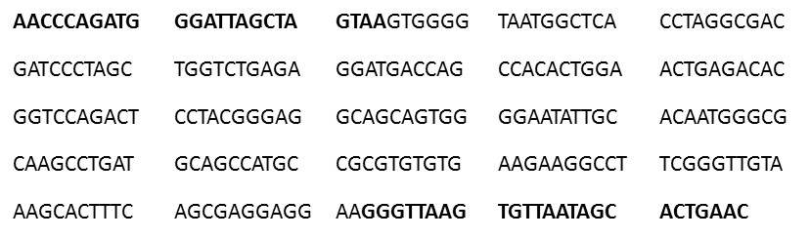
Note: Primer sequences are in bold text

Lower limit
Using purified DNA as the template the limit of detection using 1 µL of template is between 5–10 fg, which approximates to 1–2 bacterial genome equivalents. Amplification should be sufficiently robust to produce clearly visible bands by agarose gel electrophoresis.

Limitations
Despite a lower level of detection approaching a single bacterium, PCR for direct detection in tissue is not sensitive. Lower limits of detection are typically not less than 1 × 10³ cells g⁻¹ and more frequently are closer to 1 × 10⁴ cells g⁻¹. This apparent lack of sensitivity arises from the small tissue samples that can be processed coupled with small template volumes of low concentration.

Selective enrichment culture PCR for prevalence estimates
Depending on the size of the population to be assessed and the likely prevalence, sample sizes could range from 50 to several hundred. Individual cultures could be collected but makes investigations unwieldy and cumbersome. To make it a more manageable process, pooled samples can be used. Design of a survey should be based on sound epizootiological principles to determine the number of samples required for a given situation (Cameron, 2002; Sergeant, 2016)
Faecal samples should be collected on swabs and placed in 10 ml volumes of POST medium. If pooled samples are to be used, up to five swabs can be placed in a 10 ml volume of the selective medium. After incubation at 25°C for 3–5 days, 1 ml of medium is centrifuged at 5,000 x g for 5 minutes to pellet the bacteria. Bacterial DNA from the pellet is then extracted and purified using a suitable commercial DNA extraction spin-column kit or a magnetic particle processor. One aliquot of POST medium seeded with a known isolate of Y. ruckeri, such as TCFB 0715, and an aliquot of un-inoculated medium must be included in the extraction process.

Primer set
Amplification of the extracted DNA can be achieved using the conventional PCR primer set given in Table 2, however real-time PCR with internal probe is a faster, more specific approach, well suited for high-throughput testing required for prevalence surveys. A well-validated PCR primer set and probe has been published with a 16S rRNA target (Carson et al., 1998) and formatted as a TaqMan® assay (Table 4). The probe uses a 5' FAM™ reporter dye and 3' Black Hole Quencher-1™ (BHQ-1).
Table 4 Yersinia ruckeri primer set and probe for TaqMan®RT-PCR for 16S rDNA gene target
Primer | Direction | Sequence 5’–3’
Yer8 | forward | GCG AGG AGG AAG GGT TAA GTG
YerR | reverse | GTT AGC CGG TGC TTC TTC TG
YerProbe | forward | FAM– AAT AGC ACT GAA CAT TGA CGT TAC TCG –BHQ-1

Master mix
Any TaqMan® compatible reagents can be used for the assay. Good amplicon yields can be achieved using 2× TaqMan® Fast Universal Master Mix (FUMM) (Table 5). Primer and probe concentrations should not be altered unless validated.
Table 5 Master mix amplification reagents for 16S rRNA TaqMan®RT-PCR
Reagent | Stock concentration | Reaction volume | Reaction concentration
Primer Yer8 | 10 M | 1.2 µL | 0.6 µM
Primer YerR | 10 M | 1.2 µL | 0.6 µM
Yer Probe | 10 M | 0.55 µL | 0.275 µM
2x FUMM | 2× | 10.0 µL | 1×
Water | - | 5.05 µL | -
Template DNA | - | 2 µL | -
Total | - | 20 µL | -

Cycle
Amplification is achieved using a real-time thermal cycler capable of running a TaqMan® assay. Cycle conditions with the Applied Biosystems 7500 Fast or Applied Biosystems Quantstudio 5 thermal cyclers are an initial denaturation of 95°C for 20 seconds, followed by 45 cycles of denaturation at 95°C for 3 seconds and annealing and extension of 60°C for 30 seconds.

Controls
A positive control of purified DNA from a known isolate of Y. ruckeri, such as TCFB 0715, must be included with each PCR test. The DNA concentration of the positive control should be in the range of 50–500 fg. A negative control using water only as the template must also be included in each test.

Prevalence testing
Results from the SEC-PCR can be interpreted using the suite of methods available from Epi Tools at AusVet Services (Sergeant, 2016) ; estimates of true prevalence from single swabs or pooled prevalence are available.

Serotyping
Davies (1990) established a serotyping scheme based on heat-stable O-antigens. In this scheme 5 serotypes were recognised: designated O1, O2, O5, O6 and O7. On the basis of 6 representative isolates, Australian strains are considered to be rough-type mutants of serogroup O1. This scheme was revised by Romalde et al (1993) who recognised serotypes O1a, O1b, O2a, O2b, O2c, O3 and O4. Using this serotyping scheme Australian isolates of biotypes 1 and 2 belong to serogroup O1b. Sorbitol positive isolates from Australia have been serotyped as poly-O2; sub-typing has not been performed.
Serotyping of Y. ruckeri can be undertaken by the AAHL Fish Diseases Laboratory of the CSIRO Australian Animal Health Laboratory, Geelong.
Enquiries should be directed by email to: GAAFDLSubmissions@csiro.au or by phone to 03 5227 5000.

References
Austin B, Austin D, 1999, Bacterial Fish Pathogens: Disease of Farmed and Wild Fish (3rd ed), Praxis Publishing, Chichester.
Barnes AC, Delamare-Deboutteville J, Gudkovs N, Brosnahan, C, Morrison, RN, Carson, J, 2016, Whole genome analysis of Yersinia ruckeri isolated over 27 years in Australia and New Zealand reveals multiple lineages with slow evolution under host selection, Microbial Genomics, pp. 1–17, doi: 10.1099/mgen.0.000095.
Bercovier H, Mollaret HH, 1984, ‘Genus XIV Yersinia Van Logem 1944’, in NR Krieg (eds), Bergey's Manual of Systematic Bacteriology, Williams & Wilkins, Baltimore, vol. 1, pp. 498–506.
Boustead N & Anderson C, 1990, Enteric Redmouth Disease in New Zealand, New Zealand Freshwater Fisheries Miscellaneous Report no. 71, ISSN 1170–2001.
Bryant, TN, 2004, PIBWin - software for probabilistic identification, Journal Applied Microbiology, vol. 97, pp. 1326-1327, doi: 10.1111/j.1365-2672.2004.02388.x.
Busch RA, Lingg A, 1975, Establishment of an asymptomatic carrier state infection of enteric redmouth disease in rainbow trout (Salmo gairdneri). Journal of the Fisheries Research Board of Cananda, vol. 32, pp. 2429-2432, doi: 10.1139/f75-279.
Cameron A, 2002, Survey Toolbox for Aquatic Animal Diseases – A practical manual and software package, Australian Centre for International Agricultural Research, Canberra.
Carson J, Dobson S, Franzmann P, McCammon S, Miller J, Williams M, 1998, Development of molecular probes for use in bacterial disease diagnosis and health monitoring of farmed and wild finfish in Australia, Fisheries Research & Development Corporation Project 1993/128.
Carson J, Schmidtke LM, 1993, Opportunistic infection by psychrotrophic bacteria of cold compromised Atlantic salmon. Bulletin European Association Fish Pathologists, vol. 13, pp. 49–52.
Carson J, Wilson TK, 2003, Development of selective enrichment culture-polymerase chain reaction (SEC-PCR) for the detection of bacterial pathogens in covertly infected farmed salmonid fish, Fisheries Research & Development Corporation Project 1999/201.
Cowan ST, 1974, Cowan and Steels’ manual for the identification of medical bacteria 2nd edn, Cambridge University Press, Cambridge, United Kingdom.
Davies RL, Frerichs GN, 1989, Morphological and biochemical differences among isolates of Yersinia ruckeri obtained from wide geographical areas, Journal Fish Diseases, vol. 12, pp. 357–365, doi: 10.1111/j.1365-2761.1989.tb00324.x.
Davies RL, 1990, O-serotyping of Yersinia ruckeri with special emphasis on European isolates. Veterinary Microbiology, vol. 22, pp. 299–307, doi: 10.1016/0378-1135(90)90016-O.
Davies RL, 1991, Clonal analysis of Yersinia ruckeri based on biotypes, serotypes and outer membrane protein-types, Journal Fish Diseases, vol. 14, pp. 221–228, doi: 10.1111/j.1365-2761.1991.tb00591.x.
Davies RL, 1991a, Outer membrane protein profiles of Yersinia ruckeri. Veterinary Microbiology, vol. 26, pp. 125–140, doi: 10.1016/0378-1135(91)90049-L.
De Grandis SA, Krell PJ, Flett DE, Stevenson RMW, 1988, Deoxyribonucleic acid relatedness of serovars of Yersinia ruckeri, the enteric redmouth bacterium. International Journal of Systematic and Evolutionary Microbiology, vol. 38, pp. 49–55, doi: 10.1099/00207713-38-1-49.
De Keukeleire S, De Bel A, Jansen Y, Janssens M, Wauters G, Piérard D, 2014, Yersinia ruckeri, an unusual microorganism isolated from a human wound infection. New Microbes New Infect, vol. 2, pp. 134–135, doi: 10.1002/nmi2.56.
Farmer JJ, 1995, ‘Enterobacteriaceae’, in P Murray (eds), Manual of Clinical Microbiology 6th edn, American Society for Microbiology, Washington DC, pp. 438–449.
Furones M, Gilpin M, Munn C, 1993, Culture media for the differentiation of isolates of Yersinia ruckeri, based on detection of a virulence factor, Journal of Applied Bacteriology, vol. 74, pp. 360–366, doi: 10.1111/j.1365-2672.1993.tb05139.x.
Furones M, Rodgers C, Munn C, 1993, Yersinia ruckeri, the causal agent of Enteric Redmouth Disease (ERM) in fish, Annual Review of Fish Diseases, vol. 3, pp. 105–125, doi: 10.1016/0959-8030(93)90031-6.
Garcia JA, Dominguez L, Larsen JL, Pedersen K, 1998, Ribotyping and plasmid profiling of Yersinia ruckeri. Journal of Applied Microbiology, vo. 85, pp. 949–955, doi: 10.1111/j.1365-2672.1998.tb05258.x.
Gelev I, Gelev E, Steigerwalt A, Carter G, Brenner D, 1990, Identification of the bacterium associated with haemorrhagic septicaemia in rainbow trout as Hafnia alvei, Research in Microbiology, vol. 141, pp. 573–576, doi: 10.1016/0923-2508(90)90021-H.
Guilvout I, Quilici ML, Rabot S, Lesel R, Mazigh D, 1988, BamHI restriction endonuclease analysis of Yersinia ruckeri plasmids and their relatedness to the genus Yersinia 42- to 47-megadalton plasmid, Applied and Environmental Microbiology, vol. 54, pp. 2594–2597.
Gunasena DK, Komrower JR, MacIntyre S, 2003, The fish pathogen Yersinia ruckeri possesses a TTS system, Advances in Experimental Medicine and Biology, vol. 529, pp. 105–107.
Hastings TS, Bruno DW, 1985, Enteric redmouth disease: survey in Scotland and evaluation of a new medium, Shotts-Waltman, for differentiating Yersinia ruckeri. Bulletin European Association Fish Pathologists vol. 5, pp. 32–35.
Holmes B, Costas M, 1992, ‘Identification and typing of Enterobacteriaceae by computerized methods’, in RG Board, D Jones, FA Skinner (eds), Identification Methods in Applied and Environmental Microbiology, Blackwell Scientific Publications, Oxford, pp. 127–150.
Ibrahim A, Goebel BM, Liesack W, Griffiths M, Stackebrandt E, 1993, The phylogeny of the genus Yersinia based on 16s rDNA sequences. FEMS Microbiology Letters, vol. 114, pp. 173–178, doi: 10.1111/j.1574-6968.1993.tb06569.x.
Llewellyn LC, 1980, A bacterium with similarities to the redmouth bacterium and Serratia liquefaciens (Grimes and Hennerty) causing mortalities in hatchery reared salmonids in Australia, Journal of Fish Diseases, vol. 3, pp. 29–39, doi: 10.1111/j.1365-2761.1980.tb00181.x.
MacFaddin JF, 2000, Biochemical tests for identification of medical bacteria 3rd edn, Lippincott, Williams & Wilkins, Baltimore, USA.
O'Leary P, Sanders J, Fryer J, 1982, Serotypes of Yersinia ruckeri and their immunogenic properties, Oregon Agricultural Experiment Station Technical Paper 6235, Oregon State University, Corvallis, Oregon, pp. 15
Reuter S, Connor TR, Barquist L, Walker D, Feltwell T, Harris SR, Fookes M, Hall ME, Pretty NK, Fuchs TM, Corander J, Dufour, M, Ringwood T, Savin C, Bouchier C, Martin L, Miettinen, M, Shubin M, Riehm JM, Laukkanen-Ninios, R, Sihvonen LM, Siitonen A, Skurnik M, Prfimer Falcã J, Fukushima H, Scholz HC, Prentice MB, Wren BW, Parkhill J, Carniel E, Actman M, McNally A, Thomson NR, 2014, Parallel independent evolution of pathogenicity within the genus Yersinia, PNAS, vol. 111, pp. 6768–6773, doi: 10.1073/pnas.1317161111.
Rodgers CJ, Hudson EB, 1985, A comparison of two methods for isolation of Yersinia ruckeri from rainbow trout (Salmo gairdneri). Bulletin European Association Fish Pathologists, vol. 5, pp. 92–93.
Rodgers CJ, 1991, The usage of vaccination and antimicrobial agents for control of Yersinia ruckeri. Journal of Fish Disases, vol.14, pp. 291–301, doi: 10.1111/j.1365-2761.1991.tb00826.x.
Rodgers CJ, 1992, Development of a selective-differential medium for the isolation of Yersinia ruckeri and its application in epidemiological studies, Journal of Fish Diseases, vol. 15, pp. 243–254, doi: 10.1111/j.1365-2761.1992.tb00660.x.
Rodríguez L, Gallardo C, Acosta F, Nieto P, Real F, 1998, Hafnia alvei as an opportunistic pathogen causing mortality in brown trout, Salmo trutta L, Journal of Fish Diseases, vol. 21, pp. 365–370, doi: 10.1046/j.1365-2761.1998.00116.x.
Romalde JL, Conchas RF, Toranzo AE, 1991, Evidence that Yersinia ruckeri possesses a high affinity iron uptake system, FEMS Microbiology Letters, vol. 80, pp. 121–126, doi: 10.1111/j.1574-6968.1991.tb04647.x.
Romalde JL, Magirinõs B, Barja JL, Toranzo AE, 1993, Antigenic and molecular characterization of Yersinia ruckeri . Proposal for a new intraspecies classification, Systematic and Applied Microbiology, vol. 16, pp. 411–419, doi: 10.1016/S0723-2020(11)80274-2.
Romalde JL, Toranzo AE, 1991, Evaluation of the API-20E system for the routine diagnosis of the Enteric Redmouth disease, Bulletin European Association Fish Pathologists, vol. 11, pp. 147–149.
Romalde JL, Toranzo AE, 1993, Pathological activities of Yersinia ruckeri, the enteric redmouth (ERM) bacterium, FEMS Microbiology Letters, vol. 112, pp. 291–300.
Sergeant ESG, 2016, Epitools epidemiological calculators, AusVet Animal Health Services and Australian Biosecurity Cooperative Research Centre for Emerging Infectious Disease.
Shotts EB, 1991, Selective isolation methods for fish pathogens, Society for Applied Bacteriology symposium series, vol. 20, pp. 75S–80S.
Stevenson RMW, Airdrie DW, 1984, Isolation of Yersinia ruckeri bacteriophages, Applied and Environmental Microbiology, vol. 47, pp. 1201–1205.
Waltman WD, Shotts EB, 1984, A medium for the isolation and differentiation of Yersinia ruckeri, Canadian Journal of Fisheries and Aquatic Sciences, vol. 41, pp. 804–806, doi: 10.1139/f84-093.
Wilson TK, Carson J, 2001, Rapid, high throughput extraction of bacterial genomic DNA from selective enrichment culture media, Letters in Applied Microbiology, vol. 32, pp. 326–330, doi: 10.1046/j.1472-765X.2001.00906.x.

Appendix A: Reagents and kits

Coomassie Blue-TSA-SDS Agar
- Dissolve the base ingredients listed in Table 6.
- Autoclave at 121°C for 15 minutes.
- Cool to 55°C.
- Dissolve 10 g of sodium dodecyl sulphate in 50 mL of distilled water and sterilise by filtration.
- Add aseptically to the cooled molten base.
- Prepare a 1% solution of Coomassie Brilliant Blue R250 (BioRad) in distilled water and sterilise by filtration.
- To 990 mL of cooled molten TSA+SDS aseptically add 10 mL of the sterile Coomassie Blue solution.
- Pour the medium as plates.
Table 6 Base ingredients for Coomassie Blue-TSA-SDS agar
Ingredient | Details
Tryptone soya agar (Oxoid CM131) | 40 g
Distilled water  pH | 940 mL  7.3 ± 0.2
Source: Furones et al., 1993.

POST selective enrichment medium
Dissolve the ingredients (Table 7), adjust the pH as required and aliquot into 250 ml volumes; autoclave at 121°C for 15 minutes and cool to room temperature.
Prepare a 2% stock of polymyxin B in distilled water and sterilise using a 0.22 µm filter. From the batch potency assay for the polymyxin B, calculate the volume of aqueous stock to be added to a volume of sterile base medium to achieve a final concentration of polymyxin B of 25,000 International Units per 250 ml of medium.
Stock polymyxin B can held frozen as aliquots at –20°C for three months. Once polymyxin B has been added to the base medium, it should be stored between 2 and 8°C and used within 24 hours.
Table 7 Base ingredients for POST selective enrichment medium
Ingredient | Details
Tryptone Soy Broth (Oxoid CM0129)) | 30 g
Ox-gall (Difco 212820) | 60 g
Thallus acetate (CAS no. 563-68-8) | 0.18 g
Crystal violet | 0.0025 g
MgSO₄.7H₂O | 0.1 g
Distilled water  pH | 1000 mL  7.2
Note: The initial formulation of POST included sodium deoxycholate. While this component further increased the selective properties of the medium, the total concentration of bile salts varies with each batch of ox-gall. This resulted in a failure to select for less resistant strains of Y. ruckeri. Omitting sodium deoxycholate reduces specificity of POST but this is compensated for by coupling the detection assay with a TaqMan® PCR incorporating an internal specificity probe.

Ribose ornithine desoxycholate (ROD) agar
Dissolve the ingredients in the distilled water (Table 8) and bring to the boil. Do not overheat and do not autoclave. Cool to 55°C.
Dissolve 10 g of sodium dodecyl sulphate in 50 mL of distilled water and filter sterilise; add aseptically to the cooled molten base. Pour as plates.
Table 8 Base ingredients for Ribose ornithine desoxycholate (ROD) agar
Ingredient | Details
Yeast extract | 3.0 g
Sodium deoxycholate | 1.0 g
NaCl | 5.0 g
Sodium thiosulphate | 6.8 g
Ferric ammonium citrate | 0.8 g
D-Ribose | 3.75 g
D-Maltose | 7.5 g
Ornithine hydrochloride | 5.0 g
Phenol red | 0.08 g
Agar | 12.5 g
Distilled water  pH | 950 mL  7.4
Source: Rodgers 1992

