Plant Exports Management System (PEMS)

## 3 September release

The Plant Exports Management System (PEMS) will be enhanced with the below update for hay and straw inspections.

### **Grain and Plant Product Inspection - Hay**

#### **Outcome Details**

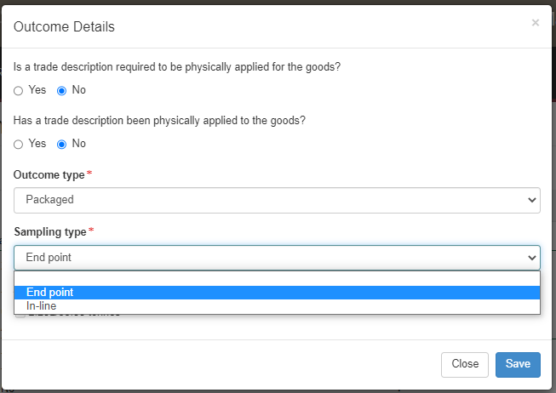

When recording the ‘Outcome Details’ in an inspection record there is a new ‘Sampling Type’ field that must be completed with details of the sampling method used

* ‘End Point’ or
* ‘In-line’

If In-line is selected, the ‘In-line sampling type’ drop down will appear. This field must be completed with further details of the in-line sampling method used, such as:

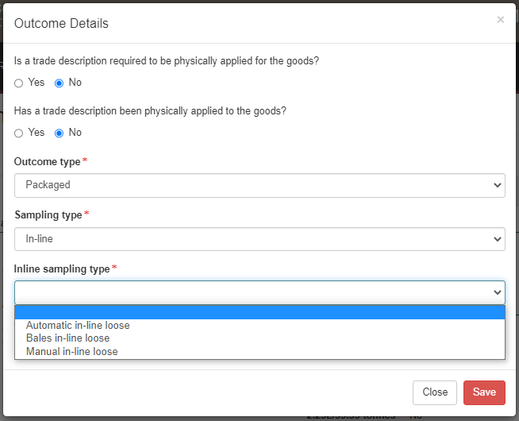

* ‘Automatic in-line loose’,
* ‘Bales in-line loose’ or
* ‘Manual in-line loose’

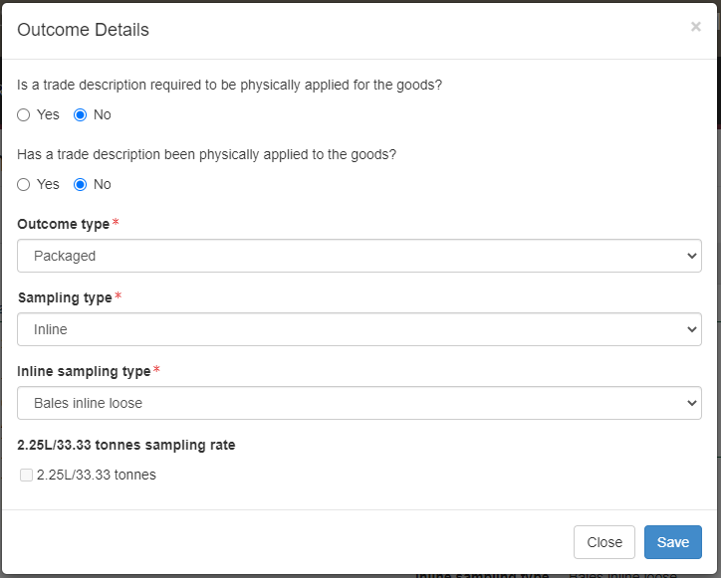

The 2.25L/33.33 tonne sampling rate will not be able to be selected.

© Commonwealth of Australia 2021

Unless otherwise noted, copyright (and any other intellectual property rights) in this publication is owned by the Commonwealth of Australia (referred to as the Commonwealth).

All material in this publication is licensed under a [Creative Commons Attribution 4.0 International Licence](https://creativecommons.org/licenses/by/4.0/legalcode) except content supplied by third parties, logos and the Commonwealth Coat   
of Arms.

The Australian Government acting through the Department of Agriculture, Water and the Environment has exercised due care and skill in preparing and compiling the information and data in this publication. Notwithstanding, the Department of Agriculture, Water and the Environment, its employees and advisers disclaim all liability, including liability for negligence and for any loss, damage, injury, expense or cost incurred by any person as a result of accessing, using or relying on any of the information or data in this publication to the maximum extent permitted by law.