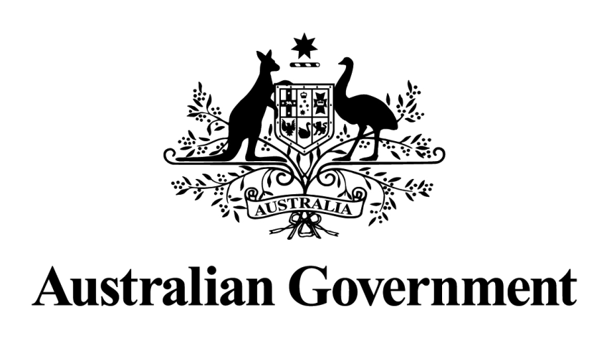

Australian Packaging Covenant

Action Plan

July 2010 to June 2015

Prepared by

Department of Sustainability, Environment, Water,
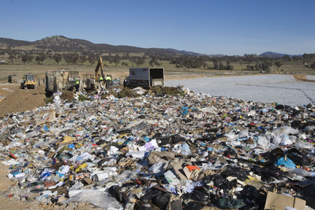
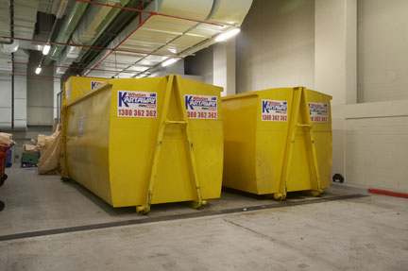
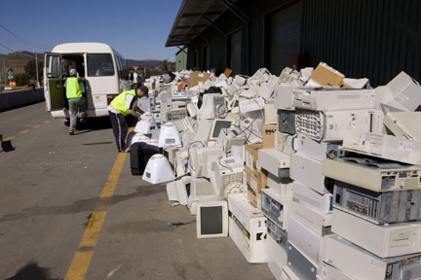
Population and Communities

Commonwealth of Australia © 2011

This work is copyright. Apart from any use as permitted under the Copyright Act 1968, no part may be reproduced by any process without prior written permission from the Commonwealth. Requests and inquiries concerning reproduction and rights should be addressed to the Commonwealth Copyright Administration, Attorney General’s Department, Robert Garran Offices, National Circuit, Barton ACT 2600 or posted at http://www.ag.gov.au/cca

Cover (left to right) Ecologically Sustainable Development Building Management (Erica Lauthier), Mugga Lane Landfill Site (Dragi Markovic), Electronic waste collection (Dragi Markovic).

Acronyms
APCC Australian Packaging Covenant Council
CEI Chief Executive Instruction
COAG Council of Australian Governments
DSEWPaC Department of Sustainability, Environment, Water, Population and Communities
EMS Environmental management system
EPHC Environment Protection and Heritage Council
KPI Key performance indicator
ICT Information and communication technology
SPG Sustainable Packaging Guidelines

Definitions
Action plan Australian Government Australian Packaging Covenant Action Plan 2010–2015.
Agencies Includes Australian Government departments and entities that are not departments; e.g. commissions and statutory authorities.
Covenant Australian Packaging Covenant.
Non-office recycling Recovery systems for recyclables in non-office environments in urban, regional and remote locations (e.g. public places, service delivery sites, office-based cafés, reserves, national parks).
Office-based recycling Recovery systems for recyclables in offices in urban and regional centres (i.e. excluding remote locations).
Table of Contents
Executive Summary 4
Introduction 5
About the Australian Government 7
Role in the packaging supply chain 7
Australian Government owned brands 8
Previous achievements 9
National Packaging Covenant Action Plans 9
National Waste Policy Implementation 9
Australian Government actions 10
Term of the action plan 10
Roles and undertakings 10
Key performance indicators 11
Table 1 - Australian Government specific actions 12

Contact Officer:
Director, Product Stewardship Packaging Section
Environment Standards Branch
Department of Sustainability, Environment, Water, Population and Communities
Telephone: (02) 6275 9000 or (02) 6274 1111
Facsimile: (02) 6274 2849
Email: productstewardship@environment.gov.au

Executive Summary
The National Waste Policy: Less Waste, More Resources, which was agreed by the Environment Protection and Heritage Council in November 2009 and endorsed by the Council of Australian Governments in October 2010, sets the direction for national action on waste and resource recovery for the period to 2020. The Australian Packaging Covenant is a key national mechanism for implementing Strategy 3 of the National Waste Policy – better management of packaging to improve the use of resources, reduce the environmental impact of packaging design, enhance away from home recycling and reduce litter.
The covenant is the voluntary component of a co-regulatory arrangement which dates back to 1999. It is based on the principles of shared responsibility through product stewardship, between key stakeholders in the packaging supply chain and the Australian, state, territory and local governments. Signatories to the covenant are obliged to prepare an action plan outlining how the covenant principles will be implemented in their business operations.
The Australian Government’s Australian Packaging Covenant Action Plan 2010-2015 outlines the activities the government will undertake to assist the Australian Packaging Covenant in achieving its objectives and goals. This action plan builds on activities undertaken under the previous National Packaging Covenant and aims to make government operations more sustainable and drive a culture of sustainability in Australia.
Government agencies are responsible for implementing the commitments in this action plan and reporting qualitative data through a new reporting template. The Department of Sustainability, Environment, Water, Population and Communities will facilitate the implementation of this action plan and prepare an annual report to the Australian Packaging Covenant Council.
The action plan outlines how the Australian Government will incorporate the principles of the covenant in its operations by:
- implementing the covenant’s Sustainable Packaging Guidelines
- implementing recovery systems for used packaging materials and paper
- purchasing products that include recycled materials
- facilitating nationally effective product stewardship policies and programs relating to packaging.
This action plan was endorsed by Senator Don Farrell, Parliamentary Secretary for Sustainability and Urban Water, on 8 June 2011.

Introduction
The National Waste Policy: Less Waste, More Resources was agreed by the Environment Protection and Heritage Council (EPHC) in November 2009 and endorsed by the Council of Australian Governments (COAG) in October 2010. The National Waste Policy sets the direction for national action on waste and resource recovery across six key directions for the period to 2020:
- Taking responsibility—shared responsibility for reducing the environmental, health and safety footprint of products and materials across the manufacture-supply-consumption chain and at end-of-life.
- Improving the market—efficient and effective Australian markets operate for waste and recovered resources, with local technology and innovation being sought after internationally.
- Pursuing sustainability—less waste and improved use of waste to achieve broader environmental, social and economic benefits.
- Reducing hazard and risk—reduction of potentially hazardous content of wastes with consistent, safe and accountable waste recovery, handling and disposal.
- Tailoring solutions—increased capacity in regional, remote and Indigenous communities to manage waste and recover and re-use resources.
- Providing the evidence—access by decision makers to meaningful, accurate and current national waste and resource recovery data and information to measure progress and educate and inform the behaviour and the choices of the community
The Policy’s key directions are supported by sixteen strategies to achieve the outcome of less waste, more resources by 2020. Strategy 1 of the National Waste Policy is to establish national framework legislation to support voluntary, co-regulatory and regulatory product stewardship and extended producer responsibility schemes. In April 2010, Senator Don Farrell, Parliamentary Secretary for Sustainability and Urban Water, introduced this landmark legislation, the Product Stewardship Bill 2010, into the Australian Parliament.
The Australian Packaging Covenant (the covenant) is a key national mechanism under Strategy 3 of National Waste Policy for reducing the environmental impacts of packaging. The covenant is the voluntary arm of a co-regulatory arrangement to reduce the environmental impacts of packaging in Australia. Responsibility for delivering the covenant’s objectives is shared between all sectors of the packaging supply chain – raw material suppliers, packaging manufacturers and suppliers, consumers, recyclers and all levels of government. Regulatory underpinning for the covenant is currently provided by the National Environment Protection (Used Packaging Materials) Measure, which protects brand owners from being disadvantaged by taking action to reduce the environmental impact of their packaging. Before 2015 the covenant will be assessed for transitioning under the new national framework legislation.
The new covenant was endorsed by the EPHC in June 2010 and came into effect from 1 July 2010. It is the third such agreement. The first covenant (1999-2005) focussed on building kerbside recycling services. The second covenant (2005-2010) focussed on developing recycling infrastructure. The new covenant places an increased emphasis on improving packaging design, increasing recycling away from home and reducing litter.
The Australian Government is a founding signatory to the covenant and contributes funds to support the operation of the covenant secretariat. Since 1999 it has actively participated in the covenant’s development and implementation. Most recently, it has been involved in leading the consultation and decision-making process for the new covenant. In early 2010, the Department of Sustainability, Environment, Water, Population and Communities (DSEWPaC) led the preparation of a Regulation Impact Statement, which informed the EPHC decision to endorse the new covenant.
As a signatory to the covenant, the government is obliged to prepare an action plan outlining how the covenant will be implemented in its business operations. This is the government’s third action plan and the first under the new streamlined covenant. The action plan covers the five-year period from 1 July 2010 to 30 June 2015. It builds on the achievements of the first two action plans and introduces new initiatives to improve packaging waste management across government operations. The plan may be amended at any time to reflect emerging priorities and initiatives.

About the Australian Government
The Australian Public Service employs approximately 164,000 people and undertakes a wide range of activities throughout Australia, including:
- government administration;
- management of public buildings;
- management of defence facilities and
- management of specialised sites such as the Antarctic bases.
Within the Australian Public Service there are the following departments:
- Agriculture, Fisheries and Forestry  - Attorney-General’s  - Broadband, Communications and the Digital Economy  - Climate Change and Energy Efficiency  - Defence  - Education, Employment and Workplace Relations  - Families, Housing, Community Services and Indigenous Affairs  - Finance and Deregulation  - Foreign Affairs and Trade  - Health and Ageing | - Human Services  - Immigration and Citizenship  - Infrastructure and Transport  - Innovation, Industry, Science and Research  - Prime Minister and Cabinet  - Regional Australia, Regional Development and Local Government  - Resources, Energy and Tourism  - Sustainability, Environment, Water, Population and Communities  - Treasury  - Veterans’ Affairs
In addition there are around 80 statutory and executive agencies within the above portfolios which employ staff under the Public Service Act 1999.
The Departments of the Parliament are not part of the Australian Public Service but are covered by this action plan.

Role in the packaging supply chain
The primary role of the government in the packaging supply chain is that of a consumer of packaging products. The government also uses packaging in distributing items such as information kits and mail.
The scale of the government’s activities, particularly its expenditure on goods and services, places it in a strong position to foster more sustainable use of resources throughout the economy. Stimulating demand for products with recycled content can increase markets for recovered material and spur business innovation to improve the use of resources and reduce the environmental impact of packaging.

Australian Government owned brands
Australia Post is the only Australian Government brand owner and is responsible for preparing its own action plan under the Covenant.

Previous achievements

National Packaging Covenant Action Plans
Under previous action plans for the National Packaging Covenant the Australian Government implemented numerous initiatives, including:
- The government developed a waste audit methodology and reporting tool, which established baseline data and assisted agencies to collect consistent information and report against covenant’s key performance indicators. The reporting tool was a key factor in the substantial increase in participation rates for agency reporting. In 2006-07, before its introduction, 57 agencies reported on their packaging waste performance. In 2009-10, 98 out of 107 agencies submitted reports, covering 98.7 per cent of full-time equivalent staff.
- The government addressed covenant objectives by:
  - demonstrating improvement in government packaging waste and recycling performance against baseline data
  - continuing its commitment to improve the environmental sustainability of its own operations, achieving a 52.6 per cent recycling rate for packaging waste in 2008-09 and a 55 per cent recycling rate in 2009-10 increasing the percentage of agencies with on-site recovery facilities for recyclable post-consumer packaging. In 2008-09, 70.6 per cent of agencies reported that they have such facilities. In 2009-10, 91per cent of agencies reported having such facilities.
- In addition, DSEWPaC, on behalf of the Australian Government, ensured continued education and communication through:
  - continuing support for the Australian Sustainable Schools Initiative which seeks to support schools and their communities to become sustainable. One area of action is waste minimisation, which includes packaging waste
  - publishing a revised model Environmental Management System (EMS) in the form of a new EMS Tool which assists government agencies and office-based organisations to establish, or improve, their own EMS.

National Waste Policy Implementation
The National Waste Policy was agreed by the EPHC in November 2009 and endorsed by COAG in October 2010.
- Strategy 3 of the National Waste Policy provides for better management of packaging to improve the use of resources, reduce the environmental impact of packaging design, enhance away-from-home recycling and reduce litter. The covenant has been incorporated into the National Waste Policy under Strategy 3.
- Strategy 16 sets out an undertaking that the EPHC will publish a three-yearly current and future trends waste and resource recovery report. Australia’s first National Waste Report was published on 7 May 2010. The report presents a contemporary picture of resource recovery and waste management in Australia.
- The National Waste Policy identifies sustainable procurement as one of its key priorities.

Australian Government actions
The covenant includes three key overarching performance goals, aimed at minimising the overall environmental impacts of packaging:
Design: Packaging optimised to achieve resource efficiency and reduced environmental impact without compromising product quality and safety.
Recycling: The efficient collection and recycling of packaging, from households and away-from-home sources.
Product Stewardship: A demonstrated commitment to product stewardship by organisations in the supply chain and other signatories.
The Australian Government commits to undertaking a number of key actions to support achievement of the covenant’s three overarching goals. Specific actions and key performance measures are outlined in Table 1 below. In summary, the government commits to:
- implementing the covenant’s Sustainable Packaging Guidelines (available at: www.packagingcovenant.org.au)
- implementing recovery systems for used packaging materials and paper
- purchasing products that include recycled materials
- facilitating nationally effective product stewardship policies and programs relating to packaging
Progress against these commitments will be reported in the government’s annual report to the Australian Packaging Covenant Council (APCC), together with data against the relevant key performance measures outlined in Table 1.
DSEWPaC will manage performance against the commitments, including liaising with Australian Government agencies through relevant fora. In addition, DSEWPaC will continue to provide funds to support the administration of the covenant.
Making government operations sustainable is a gradual and incremental process. With appropriate environmental management systems and procurement and waste management policies in place the government can make a contribution to developing a culture of sustainability in Australia.

Term of the action plan
The action plan extends from 1 July 2010 to 30 June 2015. It will be reviewed in June 2015 and may be adjusted where required to reflect emerging opportunities to deliver covenant goals.

Roles and undertakings
As a signatory to the covenant the government is required to:
- submit an action plan by 31 March 2011;
- submit an annual report each year outlining performance against action plan commitments by the due date as advised by the APCC;
- publish the organisation’s action plan and annual reports on its web site in a prominent and readily identifiable way and
- allow independent audits.

Key performance indicators
The Covenant’s Strategic Plan lists the priorities for 2010-15 as improving packaging design and use, increasing recycling of used packaging away from home and reducing packaging litter. The achievement of these goals is to be measured through eight key performance indicators (KPIs) (set out below). The Covenant Council will report annually on continuous improvement against these KPIs.
KPI 1. Percentage of signatories in the supply chain implementing the Sustainable Packaging Guidelines for design or procurement of packaging.
KPI 2 National recycling rate for packaging.
KPI 3. Percentage of signatories with on-site recovery systems for recycling of used packaging.
KPI 4. Percentage of signatories with a policy to buy products made from recycled packaging.
KPI 5 Additional tonnes of material reprocessed in primary and secondary markets as a result of covenant-funded projects.
KPI 6. Percentage of signatories with formal processes in place to work with others to improve design and recycling of packaging.
KPI 7. Percentage of signatories demonstrating other product stewardship outcomes for packaging.
KPI 8. Reduction in the number of packaging items in litter.
Six of the covenant’s eight KPIs (1, 3, 4, 6, 7 & 8) have been identified as relevant to the Australian Government’s operations. Actions the government will undertake to contribute to progress on these KPIs are outlined in Table 1.

Table 1 - Australian Government specific actions
Performance Goal | Outcomes | Key Performance Indicators | Actions | Timeline Against Actions | Key Performance Measures
Reporting | Establishment of mechanism for reporting covenant performance. | KPIs 1, 3, 4, 6, 7 & 8 | To assist agencies in the reporting process, the Department of Sustainability, Environment, Water, Population and Communities (DSEWPaC) will:  - develop an electronic reporting template and an information pack on the Covenant;  - update this template and information pack to align with the requirements of the Covenant;  - publish an annual report which identifies non-reporting agencies and  - circulate the annual report through relevant fora.  Departments will submit completed templates (including for portfolio agencies) to DSEWPaC by the deadline. | 2011  As required  Annually  Annually  Annually | - Reporting template developed.  - Continuous improvement in percentage of agencies submitting reports.  - 100 per cent of agencies reporting using template by 2015.  - Non-reporting agencies identified in the annual report.  Baseline: 92 per cent of all agencies submitted reports in 2009-10.
Design  Optimise packaging to use resources efficiently and reduce environmental impact without compromising product quality and safety | Packaging designed to:  - avoid or minimise the use of materials and other resources  - optimise its recyclability and recycled content  - reduce the impact of litter. | KPI 1 | The Australian Government will abide by the principles embedded in the Sustainable Packaging Guidelines (SPGs) for packaging design and procurement (available at: www.packagingcovenant.org.au).  Relevant government agencies (i.e. agencies that use packaging in their operations) will promote and report on the sustainable packaging design and procurement by:  - implementing the SPGs in their packaging design and procurement practices (from 2011-12);  - reporting annually on implementation of the SPGs and  - providing examples of effective implementation of relevant principles of the SPGs.  DSEWPaC will provide all agencies with guidance on implementing the SPGs.  DSEWPaC will publish an annual report identifying relevant agencies not implementing SPGs from 2014-15. | Ongoing  Ongoing  Annually  Ongoing  2011  Annually | - 100 per cent of relevant agencies reporting implementation of the SPGs by 2015.  - Examples of effective implementation of relevant principles of the SPGs published.  - Relevant agencies not implementing SPGs identified in 2014-15 annual report.  Baseline: to be established in annual report.
Recycling  Efficiently collect and recycle packaging | Improved recovery of packaging from away-from-home sources. | KPI 3 | Office-based recycling  All Australian Government agencies will:  - implement on-site materials recovery systems for recyclable materials (including used packaging) for all office-based staff (excluding remote localities) by 2015 (or provide a reason for non-implementation);  - report annually on implementation of office-based recycling and  - provide examples of best practice and innovation in office-based recycling.  DSEWPaC will publish an annual report which identifies agencies that have not implemented office-based recycling and their reasons for non-implementation (from 2011-12).  Note: Agencies that choose to collect quantitative waste and recycling data and/or use the NABERS Waste tool (www.nabers.gov.au) are encouraged report this data as examples of best practice and innovation. | By 2015  Annually  Annually  Annually | - Continuous improvement in per cent of reporting agencies with on-site recovery systems (including for used packaging).  - Continuous improvement in per cent of office-based staff with access to on-site recovery systems.  - Examples of best practice and innovation published.  - Agencies without office-based recycling and reasons identified in annual report (from 2011-12).  Baseline: 91 per cent of reporting agencies had on-site recovery systems for used packaging in 2009-10.
 |  |  | Non-office recycling  All Australian Government agencies will:  - implement non-office recycling, where practicable, such as in public areas of government premises;  - report annually on implementation of non-office recycling and  - provide examples of best practice and innovation in non-office recycling and or waste minimisation in public areas of government premises or when staging events. | Ongoing  Annually  Annually | - Percentage of agencies reporting implementation and operation of non-office recycling systems and practices.  - Examples of best practice and innovation published.  Baseline: to be established in annual report.
 | Increased secondary markets for recycled materials. | KPIs 4 & 6 | All Australian Government agencies will work to promote the government’s sustainable procurement goals though such actions as:  - creating a Chief Executive Instruction (CEI) on procurement outlining how it will consider environmental impacts when procuring goods and services;  - implementing the Australian Government ICT Sustainability Plan 2010-2015 requirement that general use office copy paper have a minimum of 50 per cent post-consumer recycled content by July 2011, with a progression to 100 per cent post-consumer recycled content by July 2015;  - reporting annually on implementation of the sustainable procurement actions and  - providing examples of best practice and innovation in sustainable procurement. | Ongoing  Ongoing  Annually  Annually | - Percentage of agencies with a CEI on sustainable procurement.  - Percentage of agencies reporting:  - use of at least 50 per cent post-consumer recycled content for general use office copy paper, and  - use of 100 per cent post-consumer recycled content for general use office copy paper.  - Examples of best practice and innovation published.  Baseline: to be established in annual report.
 |  |  | DSEWPaC will:  - ensure that guidance on sustainable procurement, such as standard specifications and model contract clauses, is available to procurement officers by 2014 and  - develop improvement indicators once guidance on sustainable procurement is established. | 2014  2015 | - Guidance on sustainable procurement available to procurement officials by 2014.  - Improvement indicators developed.
Product Stewardship  Demonstrated commitment to product stewardship | Signatories in the supply chain working with others to improve design and recycling of packaging. | KPIs 4, 6 & 7 | All Australian Government agencies will implement the following packaging-related actions under the Australian Government ICT Sustainability Plan 2010-2015:  - Requiring ICT suppliers be signatories to the Australian Packaging Covenant (the Covenant) by July 2011 or comply with the requirements of the National Environment Protection (Used Packaging Materials) Measure  - Requiring relevant ICT equipment to comply with ISO 14024 or ISO 14021 standard at the level of EPEAT silver (eco-label) or equivalent as a minimum environmental performance standard. These standards include criteria for packaging such as material selection and design for end of life  - Providing sample Request for Tender and Green ICT clauses for ICT procurement contracts that promote the outcomes of minimising packaging, optimising recyclability and recycled content, and the take back and re-use or recycling of packaging, where possible.  All Australian Government agencies will report annually on implementation of the above actions under the ICT Sustainability Plan.*  DSEWPaC will publish an annual report which identifies agencies not implementing the above actions of the ICT Sustainability Plan in 2014-15.  *Note. Reporting under this action plan is not a substitute for reporting requirements under s516A of the Environment Protection and Biodiversity Conservation Act 1999. | Ongoing  Annually  Annually | - Percentage of agencies reporting implementation of the packaging-related actions under the ICT Sustainability Plan.  - Agencies not implementing the packaging-related actions under the ICT Sustainability Plan identified in 2014-15 annual report.  Baseline: to be established in annual report.
 |  | KPI 7 | DSEWPaC, on behalf of the Australian Government, will continue to implement the National Waste Policy. This will include supporting product stewardship policies and programs for packaging waste and litter under Strategy 3.  DSEWPaC is also committed to establishing frameworks to facilitate education and communication of Covenant principles. It will continue to undertake some activities with external parties, such as:  - supporting the Publishers National Environment Bureau by developing and publishing advertisements in national publications that promote newsprint recycling to the community. These advertisements also promote recycling in general, highlighting the benefits of kerbside recycling and encouraging the purchasing of products manufactured from recovered materials.  DSEWPaC will continue to explore education, communication and community engagement projects linked to national waste priorities as opportunities arise. | Ongoing  Ongoing  Annually  Ongoing | - Information on relevant actions published in annual report.
 | Reduction in litter | KPI 8 | All Australian Government agencies will:  - implement litter reduction measures in public places, where practicable, such as in public areas of government premises;  - consider ways to minimise waste in public areas of Government premises or when staging events, through improved procurement and waste management;  - report annually on implementation of litter reduction measures and  - provide examples of best practice and innovation in litter reduction. | Ongoing  Ongoing  Annually  Annually | - Percentage of agencies reporting implementation litter reduction measures in public places.  - Examples of best practice and innovation published.  Baseline: to be established in annual report.

Australian Public Service Commission State of the Service Report 2009-10.

