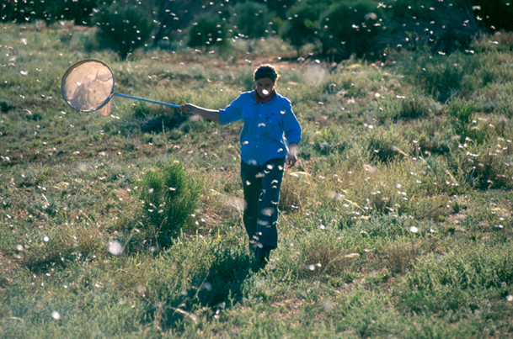

AUSTRALIAN PLAGUE

LOCUST COMMISSION

ANNUAL

REPORT

2019–20

**J:\APLC\APLC-Common\Logos\black\APLC_Logo.tif**

A joint venture of the Australian Government and the Member States of New South Wales, Victoria, South Australia and Queensland.

Contents

[Introduction 1](#_Toc55825200)

[APLC Charter 1](#_Toc55825201)

[Director’s Report: 2019-20 2](#_Toc55825202)

[Focus and Challenges for 2020-21 3](#_Toc55825203)

[Overview of 2019-20 locust situation 4](#_Toc55825204)

[Australian plague locust 4](#_Toc55825205)

[Spur-throated locust 5](#_Toc55825206)

[Migratory locust 5](#_Toc55825207)

[Achievement of Key Performance Indicators 9](#_Toc55825208)

[Operations 11](#_Toc55825209)

[Survey and Monitoring 11](#_Toc55825210)

[Forecasting and information 11](#_Toc55825211)

[Control operations and pesticide use 13](#_Toc55825212)

[Organisational Management 14](#_Toc55825213)

[Staffing 14](#_Toc55825214)

[Workplace Health & Safety (WHS) 14](#_Toc55825215)

[Competency based training and assessment 14](#_Toc55825216)

[Environmental Management System 15](#_Toc55825217)

[International linkages 17](#_Toc55825218)

[Administration 19](#_Toc55825219)

[Governance 19](#_Toc55825220)

[Financial Management 20](#_Toc55825221)

[Research 22](#_Toc55825222)

[Purpose and research areas 22](#_Toc55825223)

[Research and Development Collaborations 22](#_Toc55825224)

[Summaries of research in progress 23](#_Toc55825225)

[1. Control Agents and Application Technology 23](#_Toc55825226)

[2. Environment 24](#_Toc55825227)

[3. Locust Ecology and Forecasting 25](#_Toc55825228)

[Publications 29](#_Toc55825229)

[Appendix 1: APLC Commissioners (as at 30 June 2020) 30](#_Toc55825230)

[Appendix 2: 2019-20 Australian plague locust situation report for each Member State 31](#_Toc55825231)

[New South Wales 31](#_Toc55825232)

[Queensland 31](#_Toc55825233)

[Victoria 32](#_Toc55825234)

[South Australia 32](#_Toc55825235)

**Figures**

[**Figure 1: Australian plague locust distribution September 2019 6**](#_Toc55825367)

[**Figure 2: Australian plague locust distribution February 2020 7**](#_Toc55825368)

[**Figure 3: Australian plague locust distribution March-April 2020 8**](#_Toc55825369)

[**Figure 4: APLC 2019-20 ground survey coverage and intensity 12**](#_Toc55825370)

[**Figure 5: Monthly machine learning forecasting of *C. terminifera* nymph densities across inland eastern Australia 26**](#_Toc55825371)

[**Figure 6: The Area Under the Curve (AUC) of the mean Receiver Operating Characteristics (ROC) curve 27**](#_Toc55825372)

[**Figure 7: Example plot for Riverina region showing relationship between precedent NDVI values in locust outbreak versus non-outbreak years. 28**](#_Toc55825373)

**Tables**

[**Table 1: APLC performance against KPI measures 9**](#_Toc55825448)

[**Table 2: Locust control agent stocks 2019-20 13**](#_Toc55825449)

[**Table 3: APLC Environmental Management System conformance 15**](#_Toc55825450)

[**Table 4: Cost Sharing of Approved 2019-20 Budget 20**](#_Toc55825451)

[**Table 5: Income Received 2019-20 20**](#_Toc55825452)

[**Table 6: APLC 2019-20 financial performance report 21**](#_Toc55825453)

[**Table 7: APLC Reserve Fund Reconciliation 21**](#_Toc55825454)

# Introduction

The Australian Plague Locust Commission was established in 1974 and began operations in late 1976. The Commission is financed by the Member States of New South Wales, Victoria, South Australia and Queensland, with a matching contribution from the Australian Government. Funding allocations from the Member States are in proportion to the agreed benefit delivered to that state by APLC operations, while the Australian Government contribution reflects the broader national benefit derived from APLC activities. These five governments constitute the Member Parties of the Commission.

## APLC Charter

A Memorandum of Understanding (MOU) was signed between the Member Parties in 2002, and incorporates a Charter that replaced the original terms of reference under which the APLC had operated since its establishment.

The purpose of the APLC, as defined in that Charter, is “to control locust populations in those situations where they have the potential to inflict significant damage to agricultural industries in more than one Member State.” In fulfilling its charter the APLC is required to:

* implement a preventive control strategy to minimise economic loss to agricultural industries caused by the Australian plague locust, spur-throated locust and migratory locust, with priority given to Australian plague locust
* minimise risk of locust control to the natural environment, human health and markets for Australian produce
* develop improved locust management practices through a targeted research program
* provide a monitoring and forecasting system for operations conducted by APLC and Member States
* promote and facilitate adoption of best practice in locust control by Member States
* participate in cooperative national and international programs for development of APLC expertise
* continually review APLC operations to ensure they keep pace with the expectations of industry, community and government.

# 

# Director’s Report: 2019-20

The 2019-20 season started with every indication that it would be a repeat of the preceding two or three seasons, with a continuation of both extended drought conditions and low locust populations across eastern Australia. Starting the season with such a low locust population and with little probability of there being a significant change to the rainfall outlook, the Commission planned for limited locust survey activity throughout 2019-20 and for a very low probability of the need to implement any locust control. In the face of that lower activity level, vacant field officer positions in both New South Wales and Queensland remained unfilled.

While the catastrophic bushfires raged throughout spring and early summer, their impact was largely confined to areas east of the Great Dividing Range and the slopes immediately to the west. Consequently, there was limited effect on the majority of the eastern Australian habitat of the Australian plague locust. Conversely, climatic influences in parts of the northern hemisphere were proving very favourable for the development of an extensive Desert Locust population in areas from eastern Africa, the Arabian Gulf and south-west Asia.

The arrival of widespread rainfall in numerous regions of NSW and Qld in late January 2020, and the receipt of heavy rainfall in February across even wider areas saw both the immediate bushfire threat diminish while providing suitable conditions for locusts to bounce back from the many preceding generations of low numbers. Breeding activity and high nymphal survival resulted in a noticeable increase in several NSW and Qld regions to medium density infestation with some areas of higher density identified in March and April 2020.

The same rainfall which provided suitable conditions for an upswing in locust numbers also provided some access challenges for surveys in a number of regions, with localised flooding restricting access to some of the more likely breeding areas in the period immediately following that rainfall. And just when that restriction to survey was starting to recede, the COVID-19 pandemic started to exert its influence. While locust surveys were regarded as essential travel, APLC was extremely careful to not become a risk creator in the face of unmanaged transmission of the disease, and so undertook very limited ground surveys which covered only the highest priority areas. In order to manage the risk to staff, APLC officers were encouraged to camp outside of local centres rather than use commercial accommodation whenever their surveys could not be completed by single day trips.

The Australian Plague Locust Commission has always been held in very high regard internationally, reflecting not only our demonstrated efficiency and effectiveness at locust monitoring and management, but also in recognition of the resources we apply to all areas of relevant research and development. The continuous improvement we apply to our operating systems and the wealth of technical knowledge we generate are the recognised results of an appropriately-resourced, enduring agency dealing with an intermittent issue. It is not surprising, therefore, that numerous requests have been made to APLC during 2019-20 to provide information, input and assistance to various locust population upsurges across several continents.

A combination of monsoonal and cyclonic weather events during April – August 2019 resulted in the improvement of habitat conditions and a subsequent upsurge in the Desert Locust population stretching from India and Pakistan in the east, across Iraq, Iran, Saudi Arabia and Yemen, and as far west as Kenya, Somalia, Ethiopia and Eritrea. Under the auspices of the United Nations – Food and Agriculture Organisation (UN-FAO), APLC participated in a five day planning event in Ethiopia in December 2019 during which a range of scenarios and response options were developed. UN-FAO also made subsequent requests to APLC for the placement of experienced staff into the response in east Africa, which resulted in an experienced APLC officer travelling to Kenya in March 2020 to undertake the role of aerial operations coordinator for eastern Africa.

The multi-generational migration of this extensive Desert Locust population also resulted in large summer breeding areas in the Indo-Pakistan border regions, and area which experienced its last major locust invasion some 40 years ago. In response to this, APLC has been engaged by both the Asian Development Bank (ADB) and the World Bank (WB) as they work with the Pakistan government to develop a loan program which will allow Pakistan to both mount an immediate response to limit the impact of this Desert Locust upsurge and to develop an enduring capacity for the monitoring and management of locust populations into the future. APLC has and will continue to provide information, technical input and operational guidance to the development of this ADB-WB Pakistan program – all through remote engagement and with no need for on-site presence.

At the same time as eastern Australia was receiving welcome late summer and autumn rainfall, the same climatic patterns resulted in an improvement of habitat conditions for the South American locust in areas of Argentina, Bolivia, Paraguay, Brazil and Uruguay. In planning an appropriate response to this population upsurge, requests were received from our counterpart agency SENASA in Argentina, seeking information and guidance in the development of large-scale aerial locust control practices based on the extensive experience in and ongoing development of the practices which APLC employs in Australia.

## Focus and Challenges for 2020-21

A number of challenges have been identified and addressed as APLC plans its approach to the upcoming 2020-21 locust season. The likelihood of a continuing improvement in climatic and habitat conditions will result in a more significant locust population, requiring more extensive survey activity. There is also a higher probability that APLC may have to undertake locust control activities than there has been for the last seven or eight years, although this is most likely to occur with the autumn generation in March-April 2021. Both of these factors will necessitate moves to re-establish a full field staffing contingent later in 2020.

Operational efficiency may also be impacted by the interstate movement restrictions that have been applied by several jurisdictions as part of their ongoing response to the COVID-19 pandemic. Plans for early season cross-border survey activities have been revised as a result, and strategies for access to intra-jurisdictional support are being advanced.

The likelihood of a more extensive locust population in 2020-21 does, however, present some opportunities for the Commission. A number of research and development activities which have been delayed in the absence of a field population, such as the evaluation of alternative locust control agents, can now proceed to undertake the field evaluation phase of this work.



Chris Adriaansen

Director APLC

# Overview of 2019-20 locust situation

## 

## Australian plague locust

Population levels remained low over inland eastern Australia throughout 2018-19. Only sporadic low density breeding occurred, maintaining the overall low population densities. Vegetation in most areas that received rainfall during summer dried out rapidly. Low food availability combined with prolonged high temperatures contributed to increased mortality of nymphs and adults.

Very low locust population numbers continued during spring 2019 and summer 2020 as drought conditions persisted in most regions. The onset of widespread rainfall from late January 2020 in New South Wales and Queensland and further heavy rainfall during February and autumn produced favourable habitat conditions for locust breeding. APLC surveys were limited during this period due to flooding and Covid-19 travel restrictions. Local breeding resulted in an increase in locust numbers during March in the Central West and Northwest Plains regions of New South Wales, and in the Central Highlands and Central West regions of Queensland. At the start of April, localised high density adults were reported in the Nyngan–Cobar area of Central West New South Wales and a widespread medium-density adult population was subsequently identified in the Central West, Northwest Plains and Riverina regions. Locust numbers also increased in North Central Victoria during April after migrations from New South Wales.

In early September 2019, low density adults and occasional late instar nymphs were identified in parts of Southwest Queensland (Fig. 1) These were the residual members of a small increase in population during autumn 2019, after flood rains (>100 mm) produced habitat conditions suitable for locust breeding. Locust numbers declined during spring as habitats became very dry.

The locust population level remained very low in all surveyed states during the remainder of spring and December 2019. Only occasional adults were recorded in most areas of Queensland, New South Wales, South Australia and northern Victoria and no nymphs were observed. Pasture vegetation was severely depleted in many regions and remained very dry.

Heavy rainfall at the start of November in parts of western New South Wales created opportunities for localised breeding, but subsequent surveys did not detect an increase in population level. The first significant summer rainfall commenced in the second half of January, with heavy falls (>40 mm) in several regions of Queensland and moderate rainfall (20-40 mm) in the New South Wales. There were further heavy rains during February, with totals over 100mm in the Northwest Plains and Central West of New South Wales and in South Central Queensland. Surveys during January and February continued to detect only low-density adults in most regions (Fig. 2). A moderate increase in locust numbers was identified in the Queensland Central Highlands and Central West during March, with occasional low density late instar nymphs in the Central Highlands.

While no APLC surveys were conducted in New South Wales during March, there no reports of locust sightings. In early April, New South Wales Central West Local Land Services staff reported swarming adult locusts along roadsides in the Nyngan–Cobar–Hermidale area. Subsequent APLC surveys and landholder reports identified several small swarms in that area and widespread medium densities in other areas of the Central West, Riverina and parts of the Far Southwest region (Fig.3). Increased locust numbers were reported from several locations in North Central Victoria in mid-April. The increase resulted from migrations from Central West New South Wales in early April.

Widespread low and medium-density autumn egg laying occurred in these regions and a further increase in population levels is likely after nymphs develop during spring.

## Spur-throated locust

Surveys during 2018-19 indicated the overwintering adult population of this species was one of the lowest recorded by the APLC. Population levels in surveyed regions remained very low throughout 2019-20.

Surveys during spring and summer 2019 identified only occasional density adults in the Central West, Southwest, South Central and Central Highlands regions of Queensland. No nymphs were detected. No locusts were recorded in New South Wales, Victoria or South Australia.

Breeding opportunities were limited until after heavy rainfall in Northwest, Central West, South Central and the Central Highlands regions of Queensland during the second half of January.

Surveys in the Northwest and Central West and South Central regions of Queensland in March identified only occasional adults. Low-density nymphs were recorded in several areas of the Central Highlands at one location near Muttaburra in the Central West. In the Central Highlands nymphs were recorded at a number of locations north of Clermont and also in the Emerald–Springsure and Buckland Plains districts of. These were the first nymphs detected during 2019–20, although surveys were limited due to heavy rainfall and flooding as well as Covid-19 travel restrictions. No surveys were undertaken of the Queensland Gulf or Cape York regions where monthly rainfall totals were >100 mm in January and February. A report of adults damaging mangroves came from the Normanton area in mid-May.

The low numbers of nymphs recorded during autumn reflects the very low numbers of adults in those regions and the late initiation of breeding due to poor habitat conditions before January. Although this species can lay multiple egg pods, reproduction was largely confined to the February–March period. Fledging of nymphs occurred during April and May, and a moderate increase in adult numbers was likely in the Central Highlands.

## Migratory locust

Population densities of this species remained generally low throughout the 2019–20 season, but a small increase in numbers was detected in Queensland during autumn. This species is persistent in the in the Central Highlands, eastern Central West and South Central regions of Queensland and produces irregular outbreaks.

This species was not recorded during surveys in spring or summer. However, adults were recorded at a number of locations in the Queensland Central Highlands region in late March. Isolated–Scattered density adults were identified in the Clermont area and at several locations in the Emerald–Rolleston, Arcadia Valley and Buckland Plains districts. The adults were associated with dense tall grasses along roadsides. No nymphs were identified, but access to less densely vegetated sites was limited. No locusts were recorded during surveys in the Central West and South Central regions of Queensland. However, low numbers were recorded in the Longreach light trap on 23–24 March, indicating that low density populations may have been more widespread in Central West Queensland.

The frequency with which this species was detected in March indicates sporadic, low-density breeding occurred over a wide area during summer resulting in a moderate population increase in the Central Highlands.

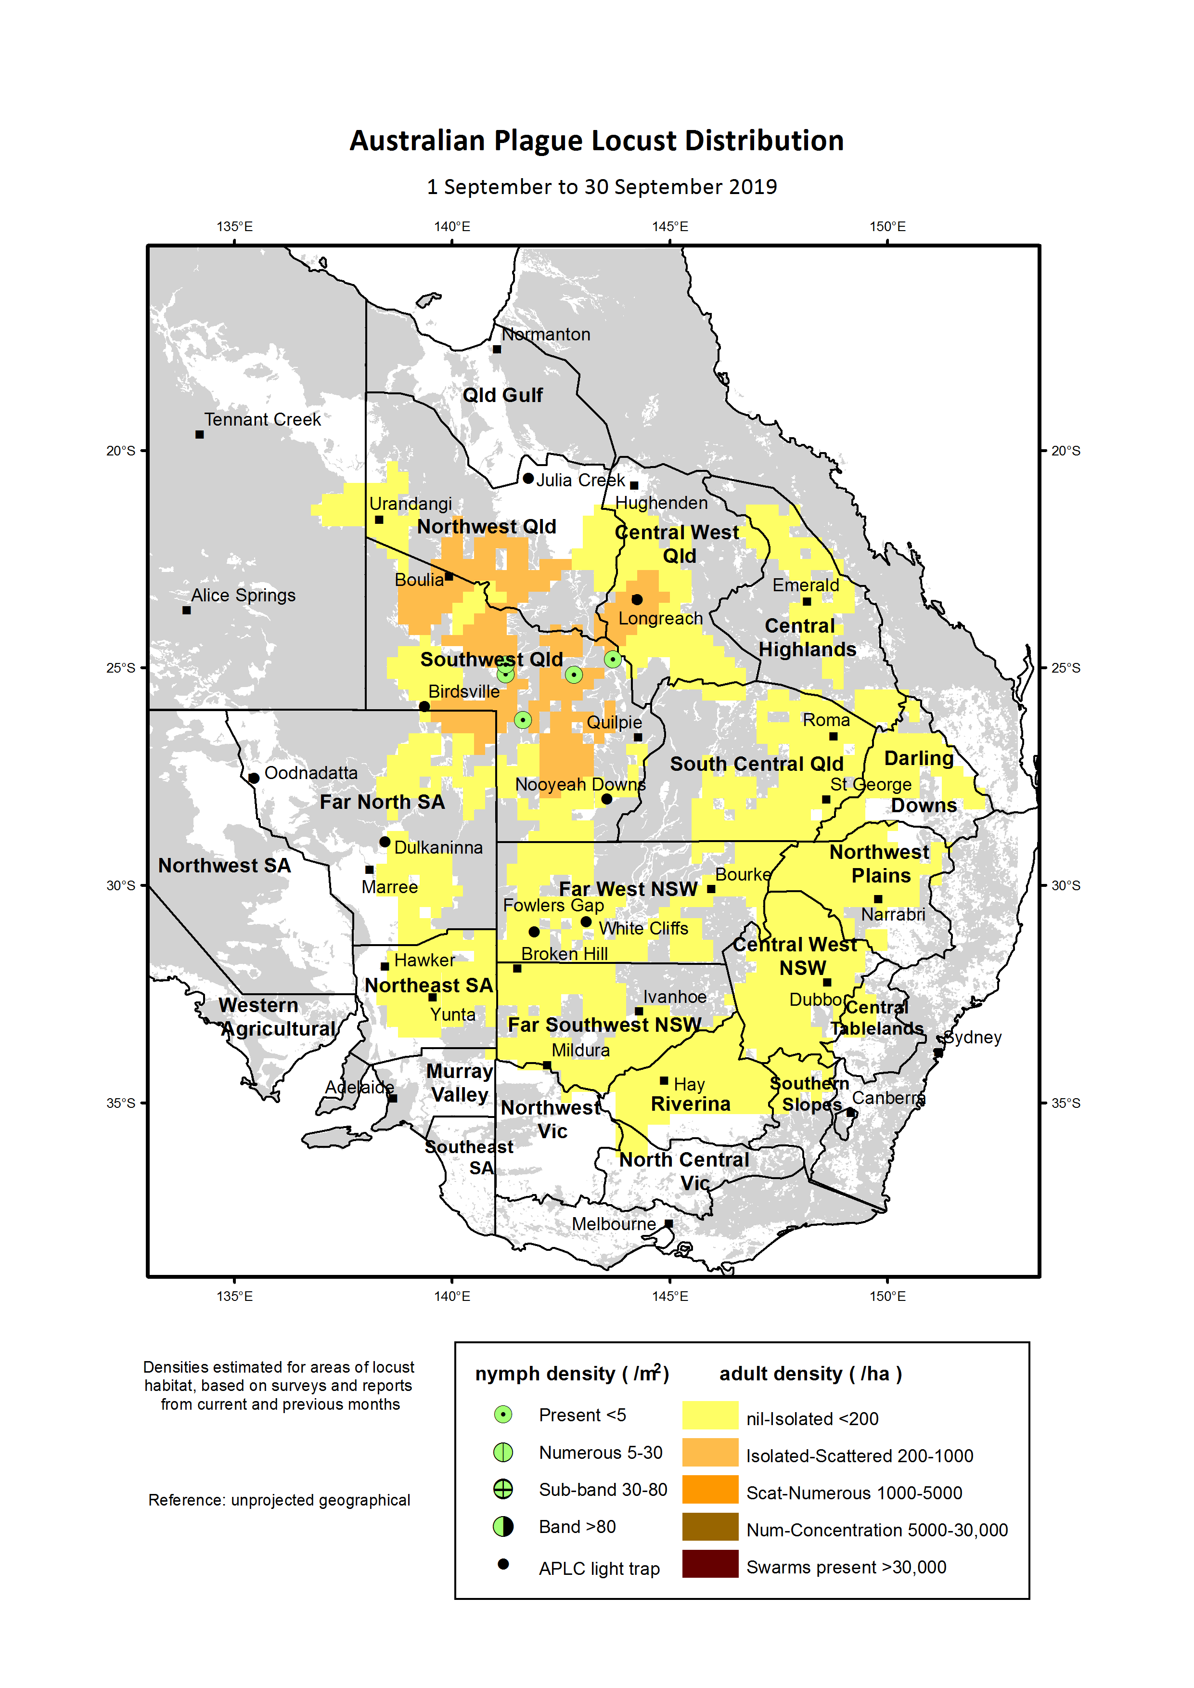

Figure 1: Australian plague locust distribution September 2019

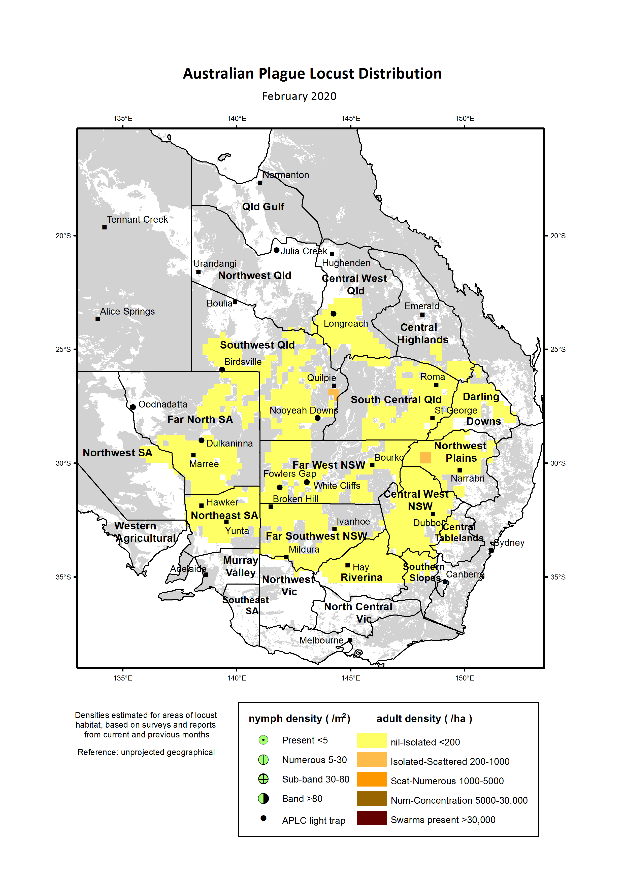

Figure 2: Australian plague locust distribution February 2020

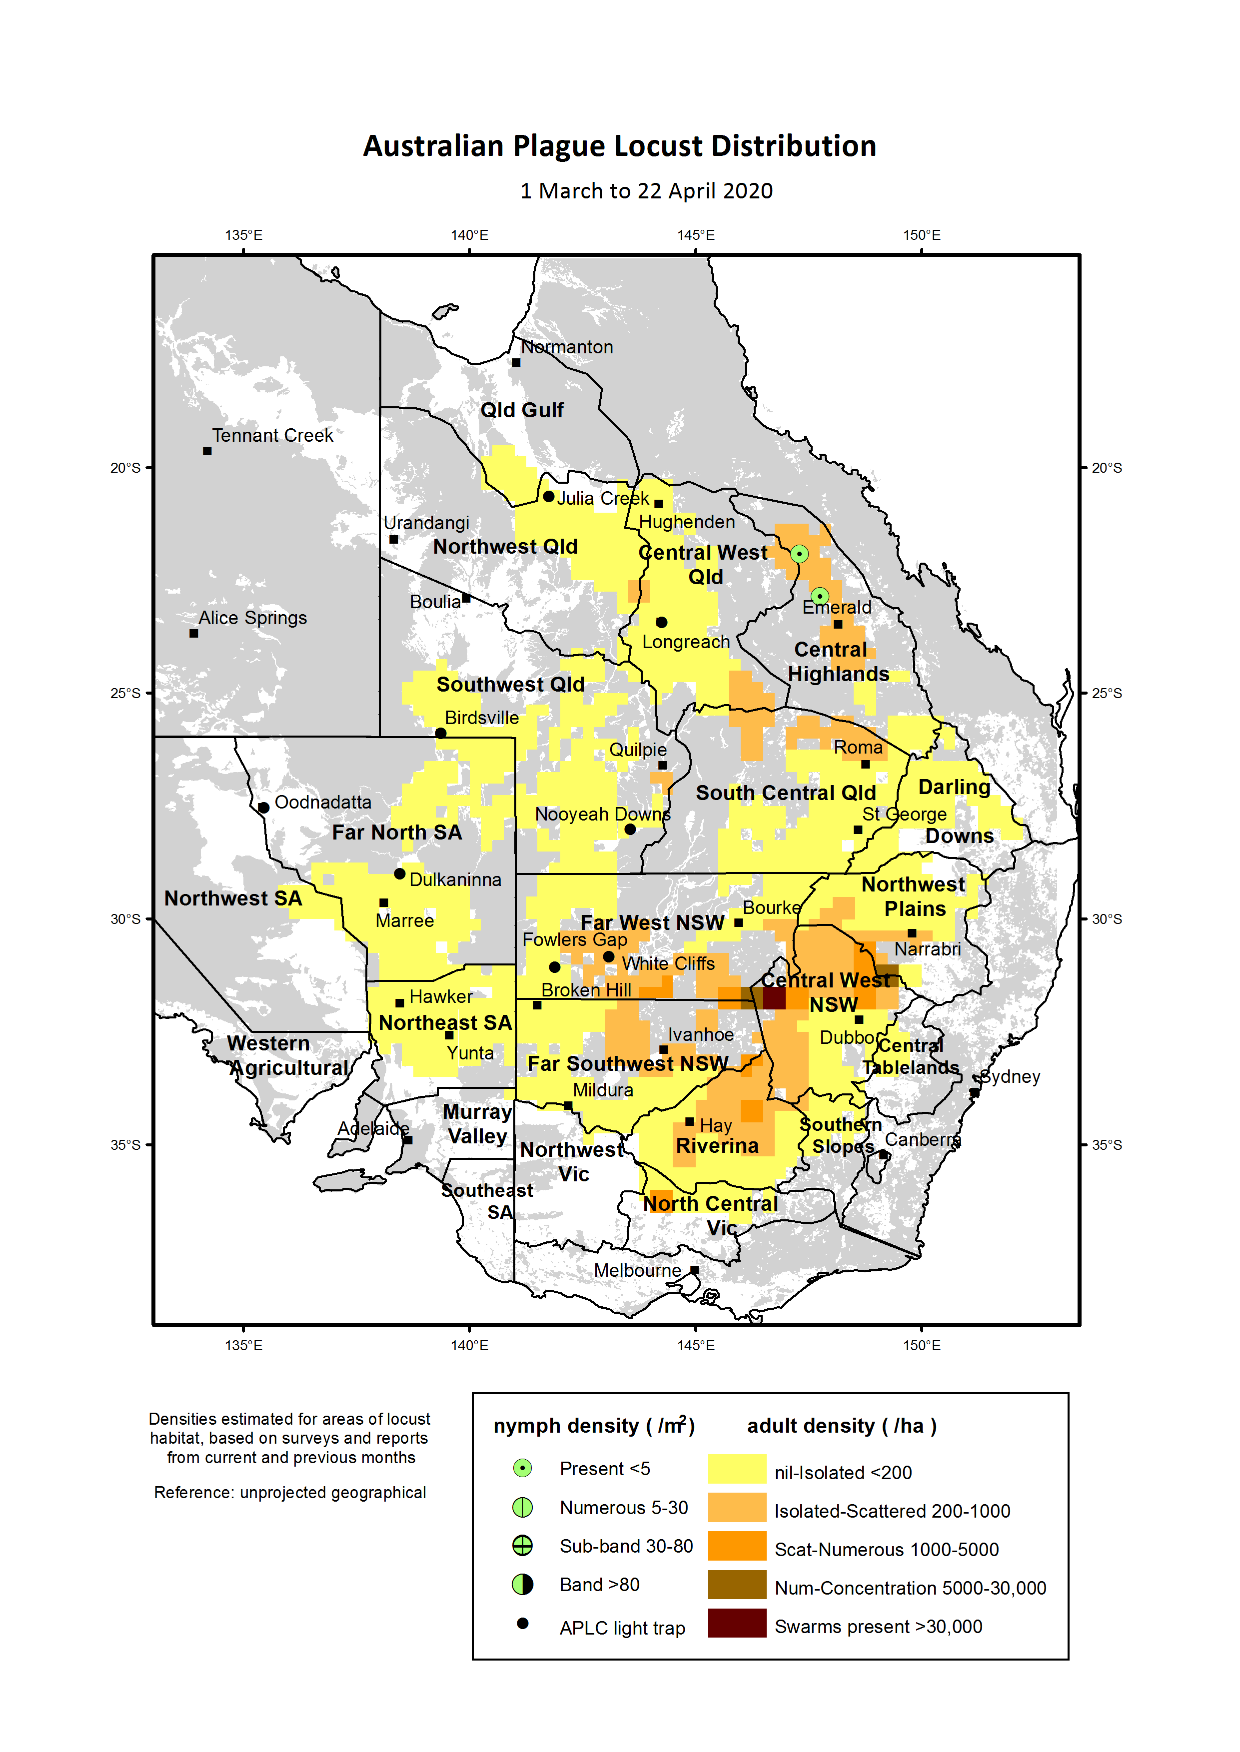

Figure 3: Australian plague locust distribution March-April 2020

# Achievement of Key Performance Indicators

The 2005 external review of the APLC suggested a number of Key Performance Indicators (KPIs) against which the future performance of the APLC could be measured. These KPIs have been adopted with some modifications to provide additional measures for reporting on an annual basis. Details of the KPIs and performance measures, together with an assessment of the APLC’s performance in 2019-20 against each, are summarised in Table 1.

Table 1: APLC performance against KPI measures

| **Key Performance Indicator** | **KPI Measures** | **Performance Assessment**  **2019-20** |
| --- | --- | --- |
| Effectiveness of monitoring, prediction and control of locust populations | Significant populations detected at early-mid instar stage  Accuracy of forecasts of population scale, timing and location  Majority of control measures against nymphal stage  No adverse aerial spraying incidents | No significant populations went undetected, with only limited populations evident in 2019-20.  Forecasts accurately indicated consistent low levels with only short-duration and localised higher density infestations.  No control activity undertaken during 2019-20  Not applicable, as no control activity. |
| Availability and effectiveness of control agents | Availability of existing agents  Replacement agents identified and application rates/techniques verified | No change to availability of current control agents. Significant stocks remain on hand of all control agents, managed in accordance with APLC stock management policy.  Alternative control agent assessment continues, with several suitable additional insecticides successfully evaluated under laboratory conditions. Further refinement of formulation and rate details continues in collaboration with manufacturers. Field evaluation planned as soon as suitable field populations are present. |
| Environmental impact of control | No reported/observed significant adverse impacts | No observed or reported adverse impacts due to an absence of control operations in 2019-20. |
| Trade risks minimised | No adverse trade (residue) impacts | Not applicable, as no control activity undertaken in 2019-20. |
| Cooperation with environmental, WHS and other relevant agencies in developing and implementing plans for control programs | Plans developed and agreed and reviewed on regular basis. | Not applicable, as no control activity undertaken in 2019-20. |
| Ensuring WHS of APLC staff, including aerial safety | No significant WHS incidents | Two minor WHS incidents recorded with no injury resulting. |
| Improved management practices developed through a targeted research program | Research findings incorporated into APLC control strategy and operations | Elements of research outcomes identified for incorporation into future control operations and practices. |
| APLC staff participation in national and international programs/scientific conferences | APLC staff invited to participate in appropriate programs and conferences | High levels of international engagement as detailed in International Linkages and Director’s Report sections. |
| Training of member state staff | APLC training course developed and core of trained member state staff available | APLC provided training to Victorian department staff and Swifts Creek area landholders in response to persistent locust presence in that locality. |

# Operations

## Survey and Monitoring

Field survey for the presence and abundance of pest locust species was limited during the 2019‑20 season. Persistent extreme drought conditions resulting in very low locust abundance during the early part of the season reduced the requirement for field survey activities.

Between January and March 2020, heavy rainfall, flooding and consequent road closures restricted access to many areas. That same rainfall was, however, responsible for a late upsurge in the locust population due to successful breeding of the summer generation and high nymphal survival early in the autumn generation.

In March and April, when the locust population had built up to levels which warranted additional survey activity, Covid-19 travel restrictions made only short single-day surveys from APLC’s three field bases at Narromine, Broken Hill and Longreach possible. Despite this, sufficient information was gathered to identify that the 2020-21 season was likely to start with a more substantial population than had been evident for several years.

Ground survey operations by APLC field staff covered a total distance of 33,479 kilometres over the period 27 Aug 2019 to 28 Apr 2020. Field surveys focussed on the areas where locust presence was known or anticipated from previous surveys and reports, overlaid by rainfall and habitat condition information. A further level of information regarding the timing of hatching and development for the range of geographical areas was also considered in deciding the timing and location of ground surveys. Figure 5 shows the location and intensity of APLC ground surveillance conducted during the 2019–20 season. The total effort (approximately 101 person-days) and the distance surveyed was the lowest among the last three seasons, reflecting the ongoing low levels of locust population across APLC’s area of operations and the generally poor habitat conditions which were present during the season.

No aerial surveillance was undertaken in 2019-20 season due to the absence of any significant locust infestations.

The UNSW insect monitoring radar (IMR) at Bourke airport, NSW, ceased operation in January 2019 after more than two decades. It will be upgraded with latest radar transceiver and digital signal processing equipment. However, the COVID-19 pandemic has a significant impact on the progress of system redesign and construction. The upgraded IMR in Hay, NSW, had been running 24 hours a day, 7 days a week at the time rate of 80% observation and 20% self-check, other than a period in September and October 2019 when the IMR malfunctioned due to its aged DC motor (which was replaced in late November). The new system samples the whole radar detection range (0.2 to 2.5km) instead of the previous segmented range which covered only one third of the total range height (0.2 to 1.3km) interspersed with two thirds of unobserved gaps. Improved signal processing produces fine vertical resolution with the vertical movement of flying insect detectable at 13cm in the 0.2 to 1.0km range, and 20cm in the1.0 to 2.5km range

All field survey information was recorded and stored in a database as part of the APLC Geographic Information System (GIS).

## Forecasting and information

During the 2019-20 season, seven Locust Bulletins reporting on current locust population levels and forecasting population development were prepared and released covering the period from October 2019 to April 2020. Each of these Bulletins was released within the first week of the month to meet the information delivery target proposed by APLC, except the April Bulletin which was delayed until 22 April to allow for report information from state agencies to be updated. As previously agreed with APLC Commissioners, no hard copies of the Locust Bulletin were produced or distributed. All Bulletins were posted on APLC web pages, with automatic release alerts emailed to all APLC Bulletin subscribers.

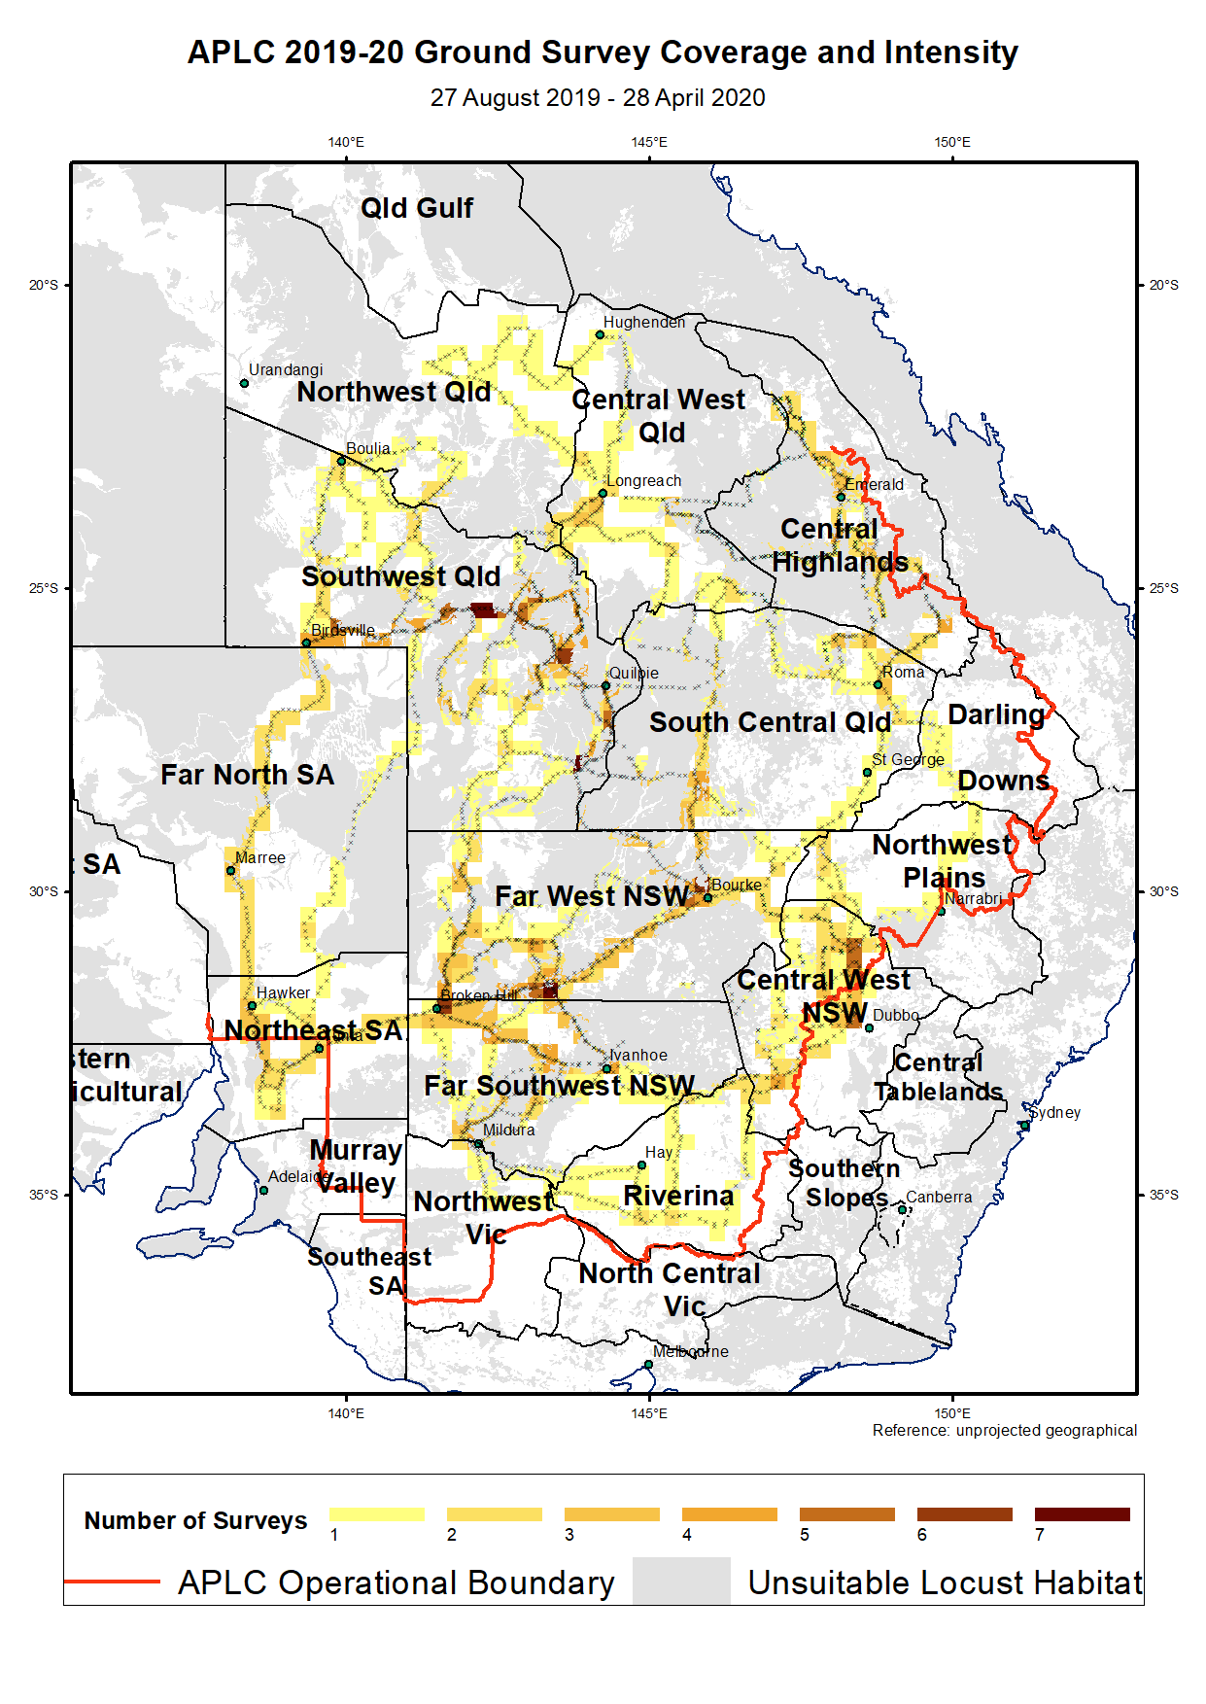

Figure 4: APLC 2019-20 ground survey coverage and intensity

## Control operations and pesticide use

No control activity was undertaken in 2019-20 due to the absence of any significant locust populations.

Significant quantities of all control agents are currently on hand, as detailed in Table 2.

Table 2: Locust control agent stocks 2019-20

|  |  |  |  |
| --- | --- | --- | --- |
| **Product** | **Quantity** | **Area treatable** | **Value** |
| Fenitrothion  (Sumithion® ULV) | 73,800 litres | 351,429 ha | $1,682,640 |
| Fipronil  (Adonis ® 3UL) | 25,000 litres | 227,273 ha | $419,750 |
| Malathion  (Fyfanon® ULV) | 800 litres | 1,143 ha | $6,400 |
| Summer Spray Oil | 15,990 litres | 27,523 ha | $26,383 |
| Metarhizium  (Green Guard ® ULV) | 175 kg dry spores | 5,000 ha | $115,350 |

The total inventory value of the APLC pesticide stocks held on 30 June 2020 was approximately $2.250 million (based on cost at purchase). The above figures do not include the 3,750 litres of fenitrothion still held by APLC on behalf of Queensland or the value of material donated to APLC by the Victorian Government in 2014. The exclusion of the value of this material is to ensure correlation between the inventory value recorded by APLC and that recognised on the asset listing maintained by the Australian Government Department of Agriculture, Water and the Environment.

Small quantities of pesticide can also be held at APLC field bases for immediate use during a control operation. The remainder (with the exception of the Green Guard stocks) is held at commercial storage premises in NSW. Green Guard stocks are held as dry spores at the premises of the manufacturer in NSW as this extends their viability.

Sampling and analysis of APLC’s stocks of chemical pesticides was completed in mid-2019. Results demonstrated that all of the product held by APLC was within the manufacturer’s specifications for both efficacy and purity, and was therefore safe and effective to use. A base-level stock of *Metarhizium* biopesticide has been re-established in 2019-20 following disposal of the previous holdings of *Metarhizium* dry spores which had tested at below minimum viable standard.

# Organisational Management

## Staffing

Staffing at APLC’s three field bases has remained unchanged during 2019-20, with two field officer positions remaining vacant at Longreach and one remaining vacant at Narromine. By agreement with APLC Commissioners, these positions remained unfilled in view of the low level of locust activity and the consequent reduced need for field operations.

Mathew Connelly, who had worked in the role of Safety and Training Officer since 2015 departed in August 2019 due to interstate family commitments. His predecessor in this role, Heath McRae, returned to the role in February 2020 after a number of years working in the WHS field for the Department of Agriculture in north Queensland. As part of negotiating Heath’s return to this role, a revised scope of duties was developed which included broader involvement in strategic development activities.

## Workplace Health & Safety (WHS)

During the 2019-20 period, two WHS incidents were recorded across all of APLC’s activities and operations. One was a minor vehicle incident, while the second related to the entry of a snake to one of the APLC field bases. Neither incident resulted in injury.

All operations personnel satisfactorily completed the annual pre-season fitness for duty medical evaluation.

## Competency based training and assessment

Relevant APLC personnel satisfactorily completed or renewed qualifications in Dangerous Goods Transport, Heavy Vehicle Licencing, First Aid and Driver Safety in addition to completing training required to address any outstanding elements of field operations. Some scheduled renewal of skills in operational areas could not be completed due to the absence of a substantial field locust population.

Additional external training was undertaken by all APLC staff leading towards a Certificate in Public Safety (Biosecurity Response Operations). The core units of this externally-offered course were completed in view of the interest expressed by many APLC staff to become involved in other biosecurity responses, and followed placements completed by several APLC staff during the citrus canker outbreak response in the Northern Territory. In addition to the online components, all APLC staff completed the practical assessments for this course during the 2019 pre-season meeting held in Canberra.

# Environmental Management System

As there were no gregarious populations of locusts within the Commission’s area of operations, no control campaign-related environmental assessment or work was undertaken.

A summary of APLC’s standing in relation to the performance indicators of our Environmental Management System (EMS) is provided in Table 3 below.

Table 3: APLC Environmental Management System conformance

| **Program** | **Sub-project** | **2019-20 Progress** |
| --- | --- | --- |
| 1. Excellence in all operational areas | Staff trained to full field competence | Skills maintenance ensured as far as possible in the absence of various field activities. |
| DGPS used in all aircraft | DGPS remains a standard requirement for all aircraft engaged by APLC for application of locust control agents, and is stipulated for all control aircraft in the current aerial services contract specifications. |
| Improved control efficiency | Absence of control operations has not allowed for improvements in control operations to be identified and/or implemented. |
| 2. All waste managed appropriately | Waste management contract | Expired biopesticide stocks disposed of in accordance with regulatory requirements.  Laboratory waste was disposed of through an accredited contractor. |
|
| 3. Minimise the intensity, extent and duration of disturbance to native flora and fauna | Incidents effectively managed | Not applicable, as no control activity undertaken |
|
| Reduce the proportional use of fenitrothion in control ops | Not applicable, as no control activity undertaken |
|
| Increased successful use of fipronil and larger track spacing | Not applicable, as no control activity undertaken |
|
| 4. Contribute to our understanding of natural and managed ecosystems | Develop risk assessment process for APLC pesticides, based on outcomes of environmental research. | Ongoing environmental research activity continues to focus on the response of arid and semi-arid ecological systems to pesticide exposure. Additionally, laboratory-based research is quantifying the sensitivity and metabolic fate of locust insecticides on key representative marsupial species as well as the development of biomarker assays for use in future research projects. Publication of key research findings is currently underway. |
|
| Develop field protocols based on research | Recent research outcomes has reinforced validity of current locust control practices employed by APLC. Forthcoming research on alternative locust control insecticides will gather additional information that will be addressed in field operations protocols as appropriate. |
|

| **Program** | **Sub-project** | **2019-20 Progress** |
| --- | --- | --- |
| 5. Avoid disturbance to protected sites/areas | Procedures and buffers developed to avoid disturbance | No change necessary – current agreed protocols remain appropriate and have been recognised in the APVMA review of locust control agents. The potential for locust spray operations to overlap with areas sensitive to chemical pesticide application are reviewed continuously as needed in collaboration with the relevant environmental authority. |
| Develop environmental aspect into APLC stakeholder training course. | No external stakeholder training requested or undertaken |
| 6. Ensure stakeholders are aware of all environmental obligations and they assist APLC achieve these. | Landholder consultation prior to and after pesticide application | Not applicable, as no control activity undertaken |

# International linkages

As a foundation member of the Global Locust Initiative (GLI), which had been established through an endowment provided to Arizona State University in USA, APLC participated in several events hosted by GLI. This culminated in the collaborative development of a multinational PhD thesis project for an Arizona State University (ASU) student involving APLC, NSW Department of Primary Industries, SENASA Argentina and the United Stated Department of Agriculture. Douglas Lawton, the ASU PhD student on this project, was jointly hosted in Australia by APLC and NSW DPI during 2019-20 and while the absence of significant local locust populations did hamper completion of some parts of the original project, relevant alternative activities were able to be undertaken. Further details of this project are captured within the “Summaries of Research in Progress” section of this annual report.

In December 2019, APLC Director Chris Adriaansen represented Australia at the International Locust Consultative Committee meeting held in Addis Ababa, Ethiopia. This event, conducted under the auspices of the United Nations – Food and Agriculture Organisation (UN-FAO) Transboundary Pest Program, is usually held every two to three years. In this instance, it had been more than six years since the last meeting of this Committee. A major focus of this five day meeting was planning for the response to the upsurge of the Desert Locust population in eastern Africa, the Arabian Gulf and south-west Asia. At this meeting and subsequently, Australia was able to provide technical advice and guidance to a number of national agencies and regional Commissions based on our accumulated experience and expertise.

Following on from this planning and subsequent contacts, UN-FAO made a request of APLC to provide on-site assistance with the locust control program being implemented in east Africa. After expressing some initial interest, several APLC field staff declined to take up the opportunity to play a role in this response program. However, in March 2020 APLC was able to arrange for its Safety and Training Officer, Heath McRae, to travel to Kenya to take on the role of Aerial Operations Coordinator for the east Africa Desert Locust response.

While negotiating for the possible placement of APLC staff in east Africa, UN-FAO also made a request for the donation of suitable locust control pesticide to use in the east African response. APLC currently holds large stocks of fenitrothion, which have been on hand for some 10 years. Detailed discussions advanced between APLC and UN-FAO regarding supply of 535 x 75 litre drums of fenitrothion, sufficient to treat almost 200,000 hectares of infestation at standard APLC aerial application rates. UN-FAO were willing to arrange and pay for air transport of this product to overcome the logistical difficulties of shipping from Australia to Kenya. As this potential donation would have a financial impact upon APLC (due to requirement to write-off the value of this asset), formal approval was sought from APLC Commissioners as representatives of the investors. While the full economic impact of the COVID-19 pandemic were yet to become evident, Commissioners took into account other accumulated financial pressures at that time in determining that APLC was not well-placed to absorb the financial impact of this donation. UN-FAO subsequently undertook a tender process to secure the insecticide it required for this response.

As a consequence of the contacts made at the December 2019 Consultative Committee meeting and the subsequent advice provided, the Asian Development Bank (ADB) and World Bank requested APLC input into their engagement with Pakistan to develop a loan project aimed at facilitating the development of both an immediate locust control response and a sustainable locust management capacity in Pakistan. APLC Director Chris Adriaansen subsequently made presentations at two webinars arranged by ADB covering immediate response actions and the establishment of an ongoing locust monitoring and management capacity within the Pakistan government. As part of this engagement, it has been made clear to ADB, World Bank and the various Pakistani Government agencies that APLC is willing to provide information, technical advice and other input, but that this would be wholly through remote engagement and that there is no immediate prospect for on-site participation of APLC staff.

Dr Haikou Wang was invited to attend the Second International Radar Aeroecology Conference in Zhengzhou, China during 22-24 September 2019, and its satellite workshops in Nanjing (20/09) and Beijing (25/09). The conference/workshops had frontier scientists from USA, UK, Sweden, Israel, Japan, Australia, and China. APLC has previously collaborated with the UNSW-ADFA on using specifically built radar to observe locust migrations and is the only organisation in the world that uses radars as operational tools other than research equipment in the field of entomology.

# Administration

## Governance

The Commission is governed by six Commissioners: one from each of the four Member States, one from the Australian Government Department representing agriculture issues and one from the Australian Government Department representing environmental matters. Functional and operational management of the Commission is undertaken by a Director assisted by staff based in Canberra HQ and at three field bases in NSW and Qld. The Commission is accountable to the Ministers of Agriculture representing the five governments which finance APLC. Details of the 2019-20 APLC Commissioners and Director are provided in **Appendix 1.**

There were changes to the two Commissioners representing the Australian Government during 2019-20 following changes to executive appointments within the Department of Agriculture, and subsequent to the amalgamation of the Department of Agriculture and the Department of Environment into a single Department of Agriculture, Water and the Environment (DAWE). Despite this amalgamation, there will remain two APLC Commissioners representing the Australian Government even though they now both come from one agency. This reflects the clear intent of the APLC Memorandum of Understanding, which directed that there should be one Australian Government Commissioner representing agricultural issues, while a separate Commissioner is required to represent environmental issues. Consequently, there are now two APLC Commissioners from DAWE with each representing one of these two issue areas.

There was one teleconference meeting of APLC Commissioners in 2019-20. No face-to-face meetings were held by agreement between all parties, as the minimal preceding and current locust situation raised no policy or strategic operations issues requiring discussion or decision. The proposed 2019-20 APLC budget was discussed during a teleconference on 18 November 2019. A full explanation of the 2018-19 financial performance of APLC was provided at that time as background to the consideration of the proposed 2019-20 budget.

All Commissioners subsequently approved the proposed 2019-20 APLC budget in December 2019.

Financial Performance Reports are provided to Commissioners following the end of each quarter of the financial year. These provide Commissioners with regular updates of the overall progression of expenditure against the approved budget, and highlight (where appropriate) any major variances to planned expenditure. A full year Financial Performance Report is also provided to detail any end-of-year surplus (or deficit) as this is taken into account in formulating the budget for the following financial year.

# Financial Management

The 2019-20 APLC Expenditure Budget approved by Commissioners totalled $4.173 million. Of that amount, $0.858 million was to be drawn from accumulated Reserve Funds with the balance contributed by the Australian Government and Member States in agreed proportions (Table 4).

Total revenue received from all Member Parties during 2019-20 was $3,244,890, with other income of $18,749 (principally from profits on vehicle sale) also contributing to the $3,263,639 total actual income received. (Table 5). Revenue received from Member States totalled $1,657,670. Revenue received from the Commonwealth totalled $1,587,220. The Commonwealth also allocated a further amount of $69,058 for the Commonwealth’s share of unfunded depreciation.

Total expenditure for APLC to the end of June 2020 was $3,222,790 (Table 6). When balanced against actual revenue received (not including the nominal $0.858 million Reserve Fund draw-down), actual revenue received exceeded expenditure by $48,849. The net effect of this is evident in the reconciliation of the APLC Reserve Fund (Table 7), which shows a total balance at 30 June 2020 of $3,968,050.

Direct expenses for 2019-20 were below budgeted amounts in all three areas: employee expenses, control operations and supplier expenses.

In accordance with APLC budgeting policy established at the 69th Commissioners Meeting in May 2012, the value of the Reserve Fund will be held at (or close to) $3 million, with accumulated reserve in excess of that amount to be applied as a reduction in funding contributions requested from Member Parties for the following financial year. As a consequence, Member Party contributions requested for the 2020-21 APLC budget will reflect the application of $0.968 million of accumulated reserve funds.

Table 4: Cost Sharing of Approved 2019-20 Budget



Table 5: Income Received 2019-20



Table 6: APLC 2019-20 financial performance report



Table 7: APLC Reserve Fund Reconciliation



# Research

## Purpose and research areas

In carrying out its charter, the APLC identifies and undertakes research to plan for, and be responsive to, issues relating to its activities. These include, but are not limited to, the efficient monitoring and accurate forecasting of locust populations, the potential environmental and trade impacts of its control programs, the cost and efficacy of control agents, and the decision-making associated with locust control. An ongoing research program is essential to addressing these issues now and into the future. The three research areas targeted are:

* Improvement in efficacy and reduction of risks associated with **control agents and application technology** addressing both immediate and future issues
* Identification and measurement of **environmental** and trade (residue) risks potentially resulting from the APLC’s operations and integration of research results into the core business of APLC and Member State agencies
* Improved understanding of the **population ecology** of locusts to improve the effectiveness of existing surveillance and forecasting systems as well as improving planning, preparedness and early intervention strategies.

## Research and Development Collaborations

During the year, APLC has undertaken R&D collaborations with a number of Australian and international institutions and agencies. These have ranged from Australian and overseas universities such as the University of Wollongong and Arizona State University in the USA, through to agencies such as CSIRO.

In all instances, the collaboration between APLC and these institutions and agencies has added significant value to the APLC R&D portfolio. APLC officers are able to gain access to facilities and equipment which are not available to them within the APLC laboratory areas, primarily because their frequency of use does not justify the investment required. More importantly, however, APLC and its researchers build intellectual capital and expertise which not only expands the APLC knowledge base, but also provides a professional point of reference for APLC researchers operating in relatively narrow technical areas.

A major focus of collaborative development during 2019-20 has been work undertaken with the team from CSIRO Health and Biosecurity, led by Professor Darren Kriticos, to redevelop the APLC data gathering, data management and information development system. Once completed in 2021, this collaboration will create a system in the cloud-based computing environment that accesses external datasets (such as rainfall, soil moisture and habitat condition) in the most efficient and timely manner which will then be processed in a consistent manner to produce visual products in a dashboard environment. While initially targeted at assisting all APLC officers in the completion of their work, the dashboard environment will ultimately offer the opportunity to present real-time information to APLC’s stakeholders.

## Summaries of research in progress

*The following research summaries provide an overview of current research activities being undertaken by the Australian Plague Locust Commission. The research summaries are not considered to constitute publication as the investigations are often incomplete and any results presented tentative.*

### 1. Control Agents and Application Technology

* 1. **Maintaining a locust population in the laboratory**

A population of *Chortoicetes terminifera* (CT) are maintained at the APLC laboratory to ensure supply of insects for pesticide evaluation trials in the laboratory. The colony was initiated because of dwindling field population due to drought and usual sources such as University of Sydney and Adelaide have closed their facilities. Initially a CT breeding colony was established at the APLC laboratory from small number of adults which were collected from Lake Cargelligo (33.1657°S, 146.3280°E), NSW in February 2018. Since then, multiple generations have been produced in the laboratory to be used for pesticide evaluation trials. This laboratory population will be rejuvenated with fresh field-sourced insects as they become available.

* 1. **Developing alternative control option for Australian Plague Locust**

Currently, only two chemical insecticides - fenitrothion and fipronil - are used by the APLC for large area aerial control of CT. Both are broad spectrum insecticides and have levels of environmental concern which have been recognised in APLC’s environmental research program. Sensitivity of some native animals to fenitrothion is high. This pesticide is currently under review by the regulatory authority Australian Pesticide and Veterinary Medicine Authority (APVMA) as part of their regular review of aged pesticide chemistry. Honey bees are very sensitive to fipronil and recent egg contamination issues in the EU countries make this chemical very vulnerable to restricted use, if not its complete removal from the market. Therefore, there is a need for APLC to find alternative insecticides that can be used efficiently and effectively against locusts in the situations in which APLC operates, can be applied as a blanket or barrier treatment, and have a reduced environmental or off-target impact as a standard.

To achieve this objective two groups of chemicals were evaluated to identify effective chemicals against CT. In one group, 10 relatively new and selective insecticides were evaluated for blanket or barrier application representing different insecticide classes, including two Insect Growth Regulator (IGR) products and one bio-insecticide,. In a second group, three insecticides in the pyrethroid class were tested which are quick acting with relatively short residual action and may be effective for contact spray on a crop close to harvest. Chemicals were selected through desk top research based on certain criteria of the pesticides such as availability and access to the products, reported efficacy against orthopterans, mode of action, existing registration by APVMA, suitable residual activity, reduced mammalian and avian toxicity, withholding period (WHP) and export slaughter interval (ESI).

Chemicals were evaluated in two stages. In the first stage trials were conducted in the laboratory to identify the most effective products using the highest label rate of all selected pesticides through topical and dipping method bioassay. In the second stage, the most effective pesticides identified in the first stage were further evaluated to determine the effective dose using LD90 value. All trials were conducted at CSIRO Black Mountain laboratory.

Almost all insecticides tested were found to be effective, producing >97% mortalities against CT. The two IGR products and the bio-insecticide produced lower mortality rates. Some of the effective pesticides were from the neonicotinoid group, and were consequently excluded from further evaluation due to significant international concerns over this group of insecticides. Only three pesticides were selected for further evaluation involving determining the effective dose and for subsequent field trial. The effective dose was determined for one of these insecticides prior to the imposition of restrictions to the use of CSIRO facilities as part of that agency’s COVID19 response, which has prevented completion of effective dose trials for rest of the pesticides.

All three pyrethroids tested were found to be equally effective and were quick acting, achieving 100% mortality within 48 hours of application.

All three selected chemicals are scheduled for testing in field trials in 2020-21, subject to the availability of suitable field populations of locusts.

**1.3 Pre-mortem effect of *Metarhizium acridum* on CT**

The efficacy of *M. acridum* against CT is well documented but little is known regarding the pre-mortem effects of *M. acridum*, such as changes to feeding behaviour and the reproductive potential of CT. Therefore investigation is being undertaken to study the impact of *M. acridum* on CT’s feeding, oviposition, fecundity and hatchability. To achieve this objective, 3/5 days old adults are being inoculated with a sub-lethal dose of metarhizium, with the subsequent impact on these factors to be measured. This work is in progress, with results yet to be collated and analysed.

### 2. Environment

**2.1 Impacts of locust control pesticides on arid-zone fauna *[Australian Research Council Linkage Project LP160100686]***

This collaborative research project between the APLC, University of Wollongong and Macquarie University aims to improve our understanding of how different organisms encounter pesticide in the landscape through quantifying residue deposition in arid grasslands and investigating how pesticides used to control locust outbreaks impact on the behaviour and physiology of key target fauna.

Two pesticides studied were the organophosphate pesticide, fenitrothion, and the phenyl pyrazole pesticide, fipronil.

The specifically objectives of the project were;

* develop a spray deposition model of aerial ultra-low volume (ULV) applications of fipronil and fenitrothion, incorporating residue depletion profiles over time within different ecosystem compartments in arid-zone native vegetation communities
* determine the short-term impact of aerially sprayed fipronil and fenitrothion on the behavior and condition of free-ranging non-target fauna that use the environment differently, including a small marsupial mammal, lizards of different sizes, small birds and an ant species
* quantify the relative importance of dietary and non-dietary pesticide exposure routes in vertebrates to gauge the impact on behaviour from pesticide exposure for key animal species.

With the field sampling components of this study complete, pesticide residue analyses are underway in soil, vegetation and animal plasma samples. The results will contribute to more biologically relevant risk assessments for pesticides, improve existing knowledge of spray deposition behaviour for ULV fipronil and fenitrothion applications and contribute data on the impacts of pesticides on arid zone fauna.

**2.2 Sensitivity of *Sminthopsis macroura* (Gould 1845) to the phenyl pyrazole insecticide, fipronil and it’s comparative metabolic fate in dunnarts and mice *[CSIRO collaboration]***

The APLC has continued it’s productive relationship with CSIRO (Black Mountain Laboratories, Canberra) to finalise studies that further our understanding of the sensitivity of an Australian endemic marsupial (*Sminthopsis macroura* Gould 1845) to the locusticide, fipronil, and further research into it’s metabolic fate in this species. Experiments have concluded and tissue residue analysis and processing of histological samples from this research project are progressing.

### 3. Locust Ecology and Forecasting

Over the past 18 months, the APLC has engaged in cutting-edge research involving scientists based at NSW DPI (Dr Bin Wang, Dr Cathy Waters), CSIRO Data 61 (Dr Stephane Mangeon, Dr Ross Darnell and Dr Warren Jin), CSIRO Health & Biosecurity (H&B) (Dr Darren Kriticos), and CSIRO Oceans & Atmosphere (O&A) (Dr Juergen Knurr), to develop an improved model-based and observational-based population forecasting system for the Australian plague locust (C. terminifera). This system is based around two different but interlinked analytical approaches:

1. simulation modelling (DYMEX); and
2. empirical data fitting (machine learning algorithms and statistical modelling).

#### 3.1 DYMEX

Developed by CSIRO, DYMEX is a generic simulation model of pest insect life-history, lifecycle and development with bioclimatic inputs. The latest version of DYMEX for *C. terminifera* is over two decades old. Hence the APLC in collaboration with CSIRO H&B initiated an overhaul of the model. This overhaul reflects:

1. the APLC’s on-going commitment to identify and pursue enhanced quantitative approaches to forecasting locust population dynamics including potential outbreaks;
2. increased knowledge about *C. terminifera* biology and ecology; and
3. the availability of high-resolution and accurate satellites and models capturing environmental and climate variability e.g. remotely sensed vegetation datasets and seasonal weather forecasts.

As part of a series of DYMEX workshops involving CSIRO H&B, Dr Allan Spessa, Dr Ted Deveson and Dr Haikou Wang, APLC has developed a detailed roadmap for improving DYMEX. After consideration of many different elements of the model that could impinge on model accuracy, realism, and utility, and in recognition of available resources and expertise, APLC and CSIRO decided to tackle the improvement of diapause simulation and resource (grass herbage) limitation as the most urgent and achievable elements over the short to medium term.

#### 3.2 Empirical Modelling

The empirical approaches essentially predict locust abundances using historical *C. terminifera* survey data and various suites of bio-physical variables, and comprise two main projects:

1. Advanced non-linear statistical modelling to forecast locust nymph densities at daily intervals (Mangeon *et. al.* (2020)); and
2. Application of modern machine learning (ML) algorithms (principally Random Forests) to predict the probability of nymph outbreak densities at monthly time steps.

The latter project builds on an existing collaboration between Dr Allan Spessa and Dr Bin Wang of NSW DPI, published as part of Wang *et al.* 2019, and was initially carried out as a CSIRO Data61 fellowship awarded to Dr Spessa in mid-2019. Basically, this approach predicts nymph outbreak densities as a function of a) biophysical variables (prior months’ Net Primary Productivity, soil moisture, relative humidity, rainfall and temperature); and b) past months’ population levels at broader scales estimated via standard APLC field surveys. Figs 5 and 6 illustrate the accuracy of the ML approach developed through this collaborative work.

To enhance project synergy, datasets used by these data-driven approaches to modelling *C. terminifera* population dynamics through space and time are also used to improve, constrain and test DYMEX.

|  |  |  |
| --- | --- | --- |
| 2009 | 2010 | 2011 |
|  |  |  |

Figure 5: **Monthly machine learning forecasting** of *C. terminifera* nymph densities across inland eastern Australia

using Random Forest (RF) classification models for years 2009, 2010 and 2011. For each year, the left-hand column represents observed densities (from field surveys), and the right-hand column is model prediction. Features comprise a suite of biophysical variables (including climate and grass Net Primary Productivity (NPP) generated from a land surface/vegetation dynamics model) and observed locust densities in past two months. blue = non-outbreak density class, orange = outbreak density class. (Spessa, Wang, Nikonovas *et al.* 2020).

**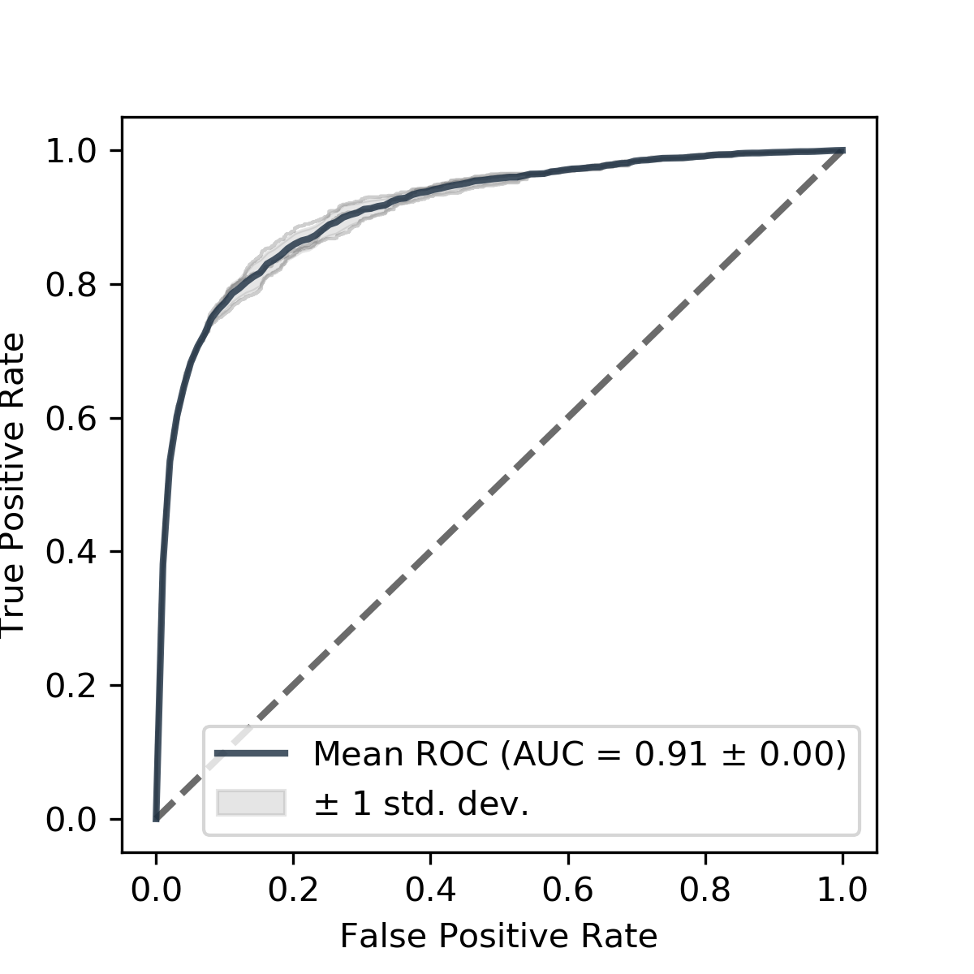**

Figure 6: **The Area Under the Curve (AUC)** of the mean Receiver Operating Characteristics (ROC) curve

associated with the RF classifier model described in Fig. 5. An AUC – ROC curve is a performance measurement for classification problem at various thresholds settings. ROC is the mean probability curve (of several random model runs, in this case 100) and the AUC represent degree or measure of separability. It tells how much model is capable of distinguishing between classes. The higher the AUC, the better the model is at distinguishing different classes. In this case, the RF model exhibits a 91% chance of discriminating between nymph non-outbreak densities (negative class) versus outbreak nymph densities (positive class).

**3.3 Development of GIS-based habitat response maps to support the development of an early warning signal of APL population increase.** (Collaborative project between APLC, NSW DPI and Arizona State University Global Locust Initiative, undertaken by ASU PhD student Douglas Lawton.)

The goal of this project was to identify how Australian plague locust (APL) outbreaks were influenced by environmental variables throughout the APLC’s area of operation. To do this, we used remotely sensed data (MODIS NDVI) and the APLC and state agency survey/control datasets.

The analysis was able to show that preceding vegetation growth is important for APL outbreaks as expected (figure 7). However, there were considerable differences when this relationship was broken into bioregion and season specific responses. This is likely due to large climatic patterns (e.g. major rainfall zones) and biotic and abiotic factors such as vegetation structure and soil characteristics. Therefore, accounting for the spatiotemporal variance in this relationship is important.

Currently, the APLC forecasting models do not take into account the spatiotemporal variation of APL outbreaks which can lead to less accurate predictions. To demonstrate this, various hierarchical generalized additive models were constructed and tested for model fit. Four biologically relevant spatiotemporal levels were chosen in the following order: Species range > Major Rainfall Zones > Bioregions > Seasons. By acknowledging these levels it was possible to dramatically increase model fit.

A comparison of APL outbreaks to those of the northern hemisphere’s Desert Locust was undertaken to show generalizable features of locust outbreaks globally. Similar biologically relevant spatiotemporal levels were used: Species range > Invasion/Recession zone > Ecoregion > Season and constructed the same types of models.

This showed that there are dramatic differences between the relationship of preceding vegetation growth and species which is likely due to the unique features of the drylands each species is found in. Interestingly, even though the relationship between preceding vegetation growth and outbreaks changes, the spatiotemporal hierarchy remained constant. This work suggests that acknowledging this hierarchical structure will likely remain important for most locust species. The results of this project component are broadly applicable and are an important contribution to locust management in Australia as well as globally.

**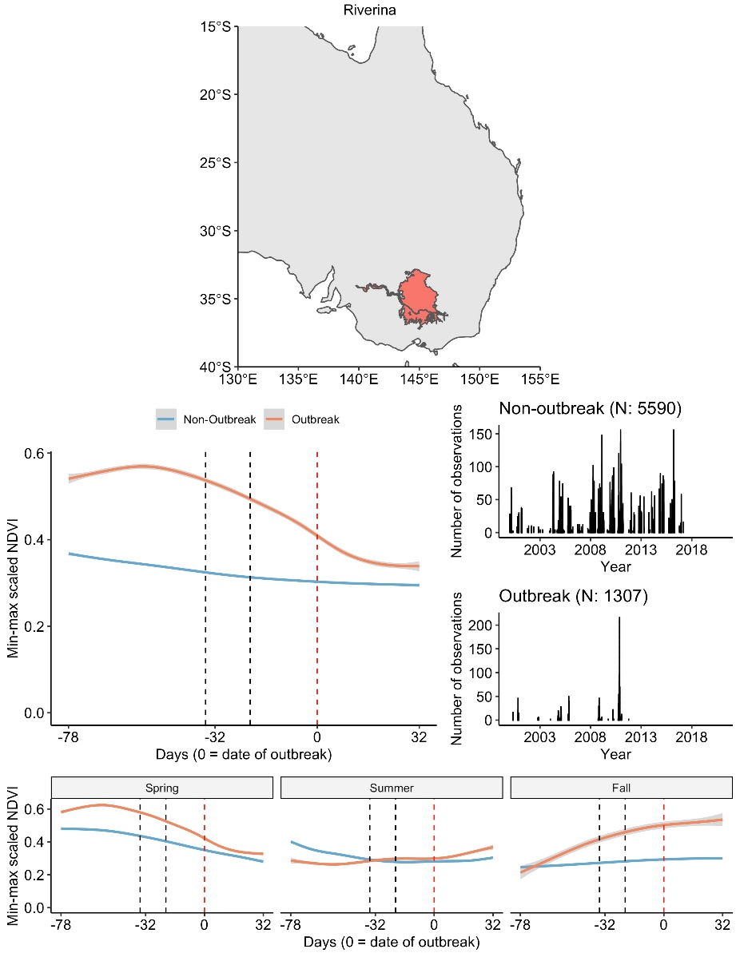**

Figure 7: **Example plot** for Riverina region showing relationship between precedent NDVI values in locust outbreak versus non-outbreak years.

# Publications

Death Clare E, Griffiths Steve and **Story PG.** (2019). Terrestrial vertebrate ecotoxicology in Australia – an overview. *Current Opinion in Environmental Science and Health* 11:43-52.

Lawton D, Waters C, **Deveson E**, **Spessa A**, Wang B, Cease A (2020). Global change and locust swarms: a synthesis of climate change and land degradation effects on insect populations booms. XXVI International Congress of Entomology, in Helsinki, Finland (ICE 2020).

Mangeon S, **Spessa A**, **Deveson E**, Darnell R, Kriticos D (2020). Data-driven models of Australian Plague Locust abundance based on environmental predictors. Accepted Science Reports.

Maute K, Hose GC, **Story PG**, Bull CM, French KO (2019). Surviving drought: Differential benefits of pulse rainfall events to arid zone arthropod populations. *Ecology Online First e02884-1-e02884-9* <https://doi.org/10.1002/ecy.2884>

Maute K, Hose GC, **Story PG**, Bull CM and French KO (2020). Surviving drought: A framework for understanding animal responses to small rain events in the arid zone. *The Bulletin of the Ecological Society of America* 101 (1):e01621

Wang B, **Deveson E**, Waters C, **Spessa A**, Lawton D, Feng P, De Li L (2019). Future climate change likely to reduce the Australian plague locust (Chortoicetes terminifera) seasonal outbreaks. Science of the Total Environment. 668 (2019) 947–957.

# Appendix 1: APLC Commissioners (as at 30 June 2020)

Dr Bertie Hennecke

Assistant Secretary, Plant Health Policy

Plant Biosecurity Division

Department of Agriculture, Water and the Environment

Mr Anthony McGregor

Assistant Secretary - Chemicals Management Branch

Environment Standards Division

Department of Agriculture, Water and the Environment

Mr Andrew Sanger

Director – Invasive Plants and Animals

NSW Department of Primary Industries

Dr Kyla Finlay

Principal Officer Entomology, Chief Plant Health Officer Unit

Agriculture Victoria

Department of Jobs, Precincts and Regions

Mr Michael McManus

Manager, Rural Chemicals Operations

Biosecurity SA

Primary Industries and Regions South Australia

Dr John Robertson

General Manager - Invasive Plants and Animals   
Biosecurity Queensland   
Department of Agriculture and Fisheries

**Director**

Mr Chris Adriaansen

Australian Plague Locust Commission

# Appendix 2: 2019-20 Australian plague locust situation report for each Member State

Specific details regarding locust population densities and locations are provided in the monthly Locust Bulletins, available from the APLC web pages at the following site www.agriculture.gov.au/pests‑diseases‑weeds/locusts/bulletins.

## New South Wales

The locust population level in Surveys in New South Wales remained at very low levels during spring 2019 and summer 2020. Ongoing drought conditions reduced remaining dry pasture cover to very low levels in most regions. Widespread heavy rainfall commenced in the Northwest Plains and Central West in mid-January and continued through February and autumn. Favourable vegetation and soil conditions allowed successful locust breeding during late January and February. Fledging of nymphs in March and early April produced an increase in adult population to medium and locally high densities.

Surveys during spring identified very few locusts in the Riverina and Central West regions. No locusts were recorded in the Far West and Far Southwest regions. The Bourke and Cobar districts of the Far West region received heavy rainfall in early November, with more widespread light–moderate falls in the Riverina and Far Southwest regions. This produced suitable habitat conditions for localised breeding, but subsequent surveys in December and February did not detect a significant increase in population level in the Far West or Central West. Low density adult locusts were identified in the Bourke–Wilcannia area but no nymphs were detected. There was no significant rainfall in inland regions during December and habitats became dry.

There was heavy rainfall (>40 mm) in the Northwest Plains and patchy, moderate rainfall (20-40 mm) in the Central West and Riverina during the second half of January. There was further widespread heavy rainfall across the eastern half of the state during February and March. Only limited surveys were possible in February due to heavy rainfall and flooding, and Covid-19 travel restriction in March and April.

Locust population density increased in the Central West region during March, most likely following undetected local breeding there and in the Northwest Plains during January and February. Locusts were reported from the Nyngan and Coonamble areas in early April, but subsequent heavy rainfall prevented access to those areas until mid-April. Subsequent surveys identified medium density adults and several small swarms in the Nyngan–Hermidale–Nymagee area and medium densities in the Coonamble–Quambone area. In mid-April, Local Land Services received reports of egg laying near Nymagee and on several properties in the Baradine–Bugaldie area. The higher density locusts were recorded in areas adjacent to forest and tree lines. Wind trajectories indicated that redistribution and localised aggregation of young adults occurred within NSW during late March and early April.

Surveys and reports in the second half of April indicated a moderate population increase also occurred in parts of the Far West, Far Southwest and Riverina regions as adults dispersed from the Central West. Egg laying occurred during April and May and low-density hatchings are likely in parts of all regions of New South Wales. Localised higher density nymphs could develop in the Central West and Northwest Plains regions.

## Queensland

There was a moderate increase in locust population levels in western Queensland during autumn 2019 after flood rains (>100 mm) produced habitat conditions suitable for locust breeding. In early September 2019, low density adults and occasional late instar nymphs were identified in parts of Southwest Queensland, most likely a residual population from late autumn breeding (Fig. 1). Most adults were recently fledged from a winter nymph generation. Localised medium density adults and residual low density late-instar nymphs were identified in the Windorah area. Locust numbers declined during spring as habitats became very dry. Few adults and no nymphs were identified during subsequent surveys during summer. Only occasional adults were recorded in the Central West and South Central regions during summer, with more consistent low density counts in the Central Highlands region.

There was widespread heavy storm rainfall (>40 mm) in Northwest, Central West, South Central and parts of the Southwest and Central Highlands regions of Queensland during the second half of January. Rainfall totals >100 mm were received in many locations. Improved habitat conditions initiated sporadic low-density breeding in several regions, producing some nymphs during February and March. However, surveys were severely limited by flooding and Covid-19 restrictions and no nymphs were detected until March, when occasional late-instar nymphs were recorded in the Central Highlands. Adult population numbers remained generally low in surveyed areas of the Central west, South Central and Southwest regions during March. However, adults were reported from the Roma area in mid-March.

A moderate increase in overall population levels is likely to have occurred in all regions of Queensland in late autumn.

## Victoria

Locust population levels remained low in Victoria throughout spring and summer. APLC surveys in Northwest Victoria in October did not detect any locusts. There was a moderate population increase in North Central Victoria in early April as a result of migrations from New South Wales.

A residual population of locusts, along with several grasshopper species, persisted in the Omeo–Swifts Creek area during 2018-19. Surveys by Victorian agriculture officers in the Omeo Valley area in mid-November 2019 recorded no locusts and low numbers of several grasshopper species.

There was widespread light–moderate rainfall (<20-40 mm) in Northwest and North Central Victoria during November. Monthly rainfall totals >50 mm were recorded in many locations during February, March and April.

The first verified reports of increased locust numbers came from near Mitiamo in mid-April, and subsequent reports came from Jarklin and Mysia. Wind trajectories indicate that migrations were possible from Central West New South Wales, through the Riverina, during the first week of April. Habitat and soil conditions were favourable for locust breeding in Victoria during April. Hatchings are likely in North Central Victoria during October and nymphs are likely to develop at low and medium densities in localised areas.

## South Australia

Locust population levels remained very low in South Australia throughout 2019-20. There were no reports of locust activity and light traps did not record any locusts. Vegetation in most regions remained dry throughout the season. Spring surveys in the Northeast region in spring and in the Far North and Northeast regions in February did not detect any locusts.

There was no significant rainfall in South Australia in spring and the first half of summer. There was localised light–moderate rainfall (<20-40 mm) in the Northwest and Northeast regions in the first week of January, followed by moderate–heavy rainfall (20->40 mm) in Northwest, Northeast and parts of the Far North regions at the start of February. Vegetation response was short-lived in most areas, as a consequence of the prior extreme drought conditions.