Management of Phytophthora cinnamomi for Biodiversity Conservation in Australia

Part 2: National Best Practice Guidelines

Appendices
APPENDIX 1
Phytophthora cinnamomi

What is it?
Phytophthora cinnamomi is a microscopic organism and is often referred to as a fungus. While it shares some characteristics of true fungi it is in fact more closely related to algae.
Kingdom: | Chromista
Phylum: | Oomycota
Order: | Personsporales
Family: | Peronosporaceae
Genus: | Phytophthora
Species: | cinnamomi
What does it look like?
In the vegetative state, P. cinnamomi consists of colourless threadlike material called mycelium. Three types of spores are produced asexually by the mycelium: sporangia (pl.), within which zoospores are formed; and chlamydospores. A fourth type of spore, called an oospore, is produced through sexual recombination of A1 and A2 mating strains of the pathogen.
Sporangia are the largest of all the spores and when mature range from 50 to 70 microns (or 0.05 to 0.07mm) in length (Figure A1.1a), which is invisible to the naked eye. Twenty to thirty zoospores, each less than 10 microns in diametre, are produced within each sporangium. Zoospores are roughly kidney-shaped and have no cell wall with only a membrane to protect them. However, they have two flagella which enables them to swim for short distances (25-35mm) through water (Figure A1.1b).
Chlamydospores are round, average 41 microns in diameter and are commonly thin-walled, although thick walled chlamydospores have been observed (Figure A1.2a). The sexually produced oospores are round and thick-walled, with a diameter in the range 19 to 54 microns and are considered highly resistant to degradation (Figure A1.2b).
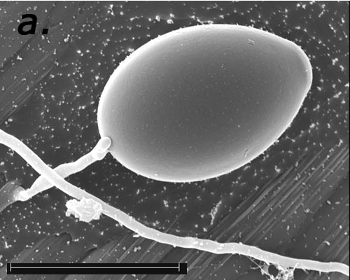 | 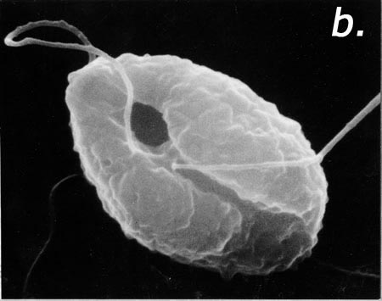  Note: Figure A1.1b published in Hardham (1987) |  | Figure A1.1 A sporangium with mycelium attached, the horizontal bar measures 50 microns (a) and a zoospore showing both flagella (b) of Phytophthora cinnamomi (Scanning electron micrographs: Professor A Hardham, The Australian National University, Canberra, A.C.T.).
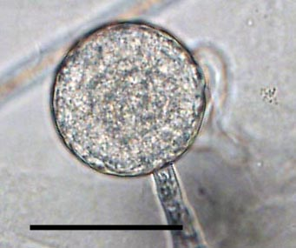 |  | 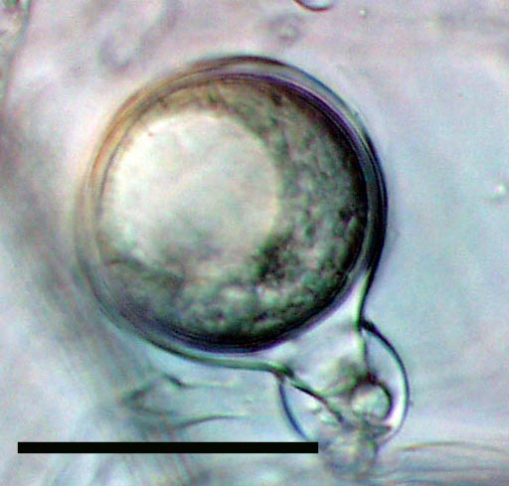 | Figure A1.2 A thin-walled chlamydospore (a) and thick–walled oospore (b) of Phytophthora cinnamomi. The scale bar in both images represents 40 microns (Light microscope images: K McCarren, Murdoch University, Perth, Western Australia.).
What is the life-cycle, and how does it cause disease?
While all spores have the capacity to directly infect plants, zoospores are thought to be the major infection propagule. Figure A1.2 shows the generalised life cycle of P. cinnamomi.
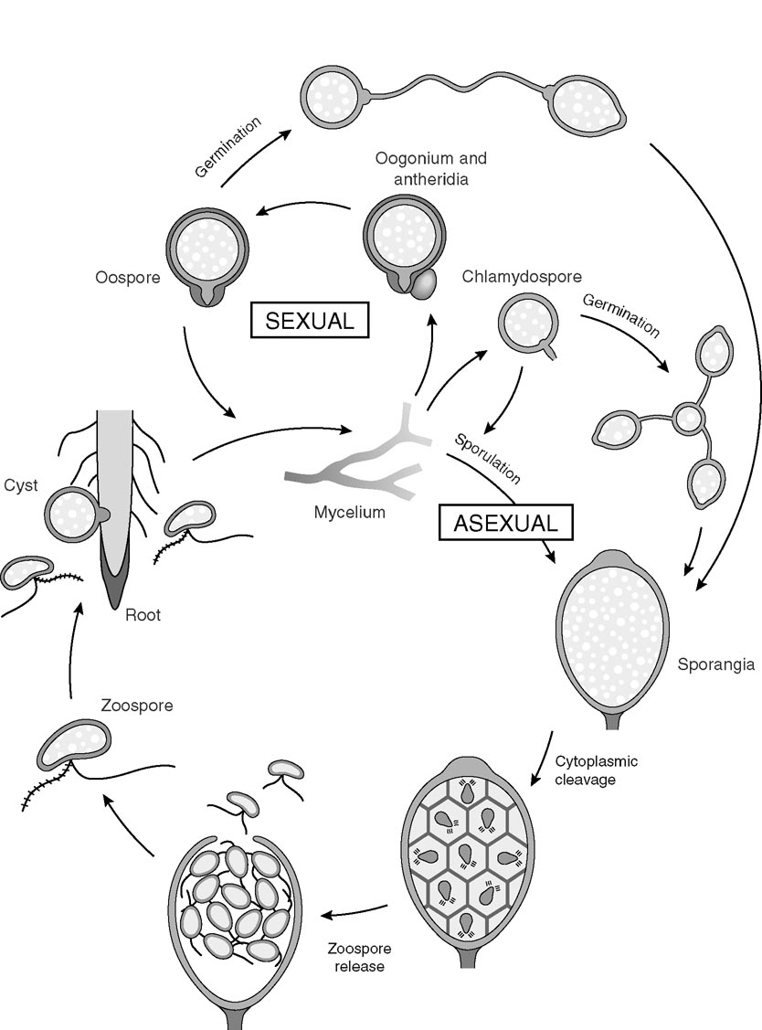 | Figure A1.2 Generalised life cycle of Phytophthora cinnamomi (Diagram Professor A Hardham, The Australian National University, Canberra, A.C.T.).

Under favourable conditions, P. cinnamomi readily produces sporangia. When sporangia reach maturity all the zoospores within it are released. The zoospores can swim short distances in free water and are attracted to the chemical and electrical signals that emanate from actively growing plant root tips.
When a zoospore encounters a root it develops into a cyst which involves: the loss of the flagella; a rounding of the kidney-shape; the release of an adhesive, which firmly fixes the zoospore-cyst to the surface of the root; and the production of a cell wall. The plant becomes infected when the zoospore-cyst produces a germ-tube which chemically and physically breaches the protective surface of the root. Once inside the plant, the germ-tube develops into mycelium and grows between, and into the plant cells gaining nutrients from the contents. The pathogen will travel through the root killing the roots as it goes. The pathogen may exit the infected root at some point starting new infections.
The plant becomes visibly diseased when many infections take place on the one plant (Figure A1.3), resulting in the impairment of the plant’s physiological and biochemical functions. Uptake of water is one of the functions affected, and this is why symptoms of P. cinnamomi infection have similarities, at least initially, with those of water-stress.

Figure A1.3 Zoospore-cysts of Phytophthora cinnamomi amassed on a plant root. (Scanning electron micrograph: Professor A Hardham, The Australian National University, Canberra, A.C.T.). | 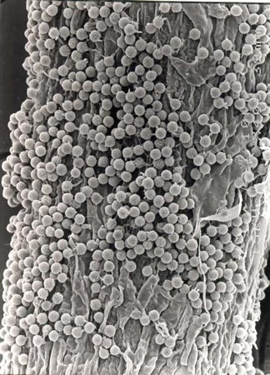
As the A2 mating strain predominates in the Australian environment, it is unlikely that sexual recombination, and thus oospore production, is happening to any large degree in the natural environment. Of the asexual spores, chlamydospores are considered the most resistant to degradation and have, therefore, been implicated in the ability of P. cinnamomi to survive for long periods of time under unfavourable conditions.
Where did it come from?
P. cinnamomi is present in all States and Territories of Australia where it causes disease in an extremely diverse range of native, ornamental, forestry and horticultural plants. Since the mid 1960’s/early 1970’s P. cinnamomi has been recognised as a serious pathogen in native ecosystems of Australia. It is generally accepted that P. cinnamomi was introduced to Australia (probably by European settlers on infested horticultural plants), the major evidence being:
- The A2 strain of P. cinnamomi predominates in the Australian environment. However, if Australia was the centre of origin a greater balance between the A1 and A2 strains would be expected.
- The high level of susceptibility of many Australian native species of plant which suggests that the plants did not evolve with the pathogen.
How does P. cinnamomi spread?
P. cinnamomi can be spread in water, soil or plant material that contains the pathogen and dispersal, whether active or passive, is favoured by moist or wet conditions.
Active Dispersal: Active dispersal occurs as a result of actions by the pathogen and is also referred to as autonomous spread. As mentioned earlier, zoospores can swim short distances in free water. Soil texture determines how easily zoospores can move through the profile, coarse-textured soils with large pores, and water-filled root channels facilitate autonomous spread. As described above, P. cinnamomi grows through roots and can spread to the roots of adjacent plants where root-to-root contact occurs. Root-to-root movement of the pathogen is thought to be one of the major ways in which the pathogen moves upslope.
Passive Dispersal: The movement of P. cinnamomi with no effort on the part of the pathogen is referred to as passive dispersal. P. cinnamomi can be carried in overland and subsurface water flow, which is apparent from the prevalence of infestations in low lying areas. Native and feral animals have been implicated in spreading P. cinnamomi, particularly where there are digging behaviours.
By far, the most significant vector of P. cinnamomi in the natural environment is, however, the human. Humans have the capacity to disturb and transport more soil than any other vector, and all human activities carry some likelihood of spreading P. cinnamomi. Most of the large centres of infestation that exist today in southern temperate Australia occurred as a result of human activity, often as a direct result of the introducing infested soil or road-building materials to vulnerable unifested areas.
Pathogen Survival: There are currently no known methods to completely eradicate P. cinnamomi from an infested site, and there is no evidence to suggest that the pathogen will disappear from a site once it has killed all of the most susceptible plant species. P. cinnamomi is thought to be able to survive long-periods of unfavourable conditions through the production of chlamydospores. However, there are still significant gaps in our knowledge about the exact mechanisms of long-term pathogen survival.
The rationale for current management approaches
Fact 1: P. cinnamomi cannot be eradicated from an infested site.
Fact 2: P. cinnamomi can be readily spread in the landscape through the movement of soil, plant material and water that is infested with the invisible pathogen.
Fact 3: Passive spread of P. cinnamomi is not easily controlled but is relatively slow.
Fact 4: The potential for active spread of P. cinnamomi is variable and so is the ability to control it.
- Active spread by native and feral animals is difficult and prohibitively expensive to control.
- Active spread in subsurface water is difficult to control, however, under certain circumstances and to some degree surface drainage can be controlled.
- Humans have the potential to spread P. cinnamomi faster and further than any other vector. Fortunately however, human activities and behaviours can successfully be modified and are thus the primary focus of current management approaches.
Recommended Reading
The information presented above is an extremely brief treatment of international and national research on P. cinnamomi spanning over 40 years. Many fundamental questions about the biology and epidemiology of P. cinnamomi remain unclear or unanswered. Continued research is essential to unlocking knowledge necessary for improvements in current management approaches. The following books and journal articles provide reviews of the research undertaken to date and are recommended for anyone who would like more information.
Erwin DC, Bartnicki-Garcia S, Tsao PH (Eds.) (1983) Phytophthora, Its Biology, Taxonomy, Ecology and Pathology. St. Paul, American Phytopathology Society.
Shearer BL, Tippett JL (1989) Jarrah Dieback: The Dynamics and Management of Phytophthora cinnamomi in the Jarrah (Eucalyptus marginata) Forest of South-western Australia. Research Bulletin No. 3. The Department of Conservation and Land Management, Western Australia.
Irwin JAG, Cahill DM, Drenth A (1995) Phytophthora in Australia. Australian Journal of Agricultural Research 46, 1311-1137.
Erwin DC, Ribeiro OK (1996) Phytophthora Diseases Worldwide. American Phytopathological Society Press. St Paul, Minnesota.
Hardham AR (2001) The cell biology behind Phytophthora pathogenicity. Australasian Plant Pathology 30, 91-98.
Hardham AR (2005) Pathogen profile: Phytophthora cinnamomi. Molecular Plant Pathology 6(6), 589-604.
McCarren KL, McComb JA, Shearer BL, Hardy GEStJ (2005) The role of chlamydospores of Phytophthora cinnamomi – a review. Australasian Plant Pathology 34, 333-338.

