APPENDIX 2
The Rationale of Current Management Options

There are currently no proven methods to eradicate P. cinnamomi from a site or to prevent autonomous spread, and transmission by animals is usually very difficult and prohibitively expensive to control. As humans have the potential to spread P. cinnamomi further and faster than any other vector, on-ground measures focus on the modification of their activities and behaviours to manage the pathogen and the disease it causes. The management options provided in Table 5.1 to 5.7 (main document) address the two major objectives of P. cinnamomi management: i) minimise the spread of P. cinnamomi by humans to uninfested sites and ii) mitigate the impact of P. cinnamomi at infested sites.
Planning
The efforts and cost of managing P. cinnamomi during site restoration or conservation activities, for example, will be quickly laid to waste if the pathogen is not similarly managed during the construction or repair of road and tracks at the same site. Consequently, management of P. cinnamomi within an organisation or region should be approached strategically, be included in any existing environmental management framework, and the deployment of options from Tables 5.1 to 5.7 (main document) should form part of a coordinated management plan for a site or area.
While it will not be practical or possible to deploy all the management options for a particular activity, the probability of successful management will be higher if appropriate options are deployed in an integrated fashion. Decisions on the most appropriate combination of options will need to be made on a case-by-case basis in the context of the physical and socio/political environment, the resources available, and the ability to manage the risks associated with P. cinnamomi.
Planning will also need to consider management priorities for the implementation of options for which a limited number of species or a limited area will benefit, such as the disease mitigation options of ex-situ conservation and phosphite application.
Prior planning is crucial to reducing the likelihood of spreading P. cinnamomi during wildfire management or emergency rescue operations. However, it is acknowledged that during such events protection of life and property takes priority.
Communication
The management P. cinnamomi on public lands requires cooperation and commitment not only from staff and contractors, but also from the general public. The role of communication in effective deployment of P. cinnamomi management measures should not be underestimated. The form and intent of management prescriptions needs to be communicated clearly to all stakeholders. The appropriate communication tools for a particular circumstance will depend on the target stakeholder group but may include: organisational standard operating procedures, codes of practice, conditions of contract, management and work plans for specific sites, training for on-ground workers, signage (Figure A2.1), extension material and programs, and consultation processes.
The form and dissemination of the appropriate information must be considered during the planning phase for management of the site or area. Many of the management options presented in Table 5.1 to 5.7 will require consultation with other stakeholders. Issues of access to public land, for example, will potentially affect wildfire planning and management, commercial activities in the area, and use of the area by the general public.

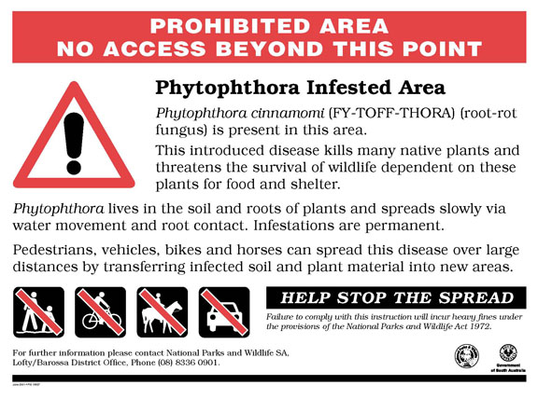 | Figure A2.1 A sign used by the Department for Environment and Heritage in South Australia to inform that all access is restricted to a Phytophthora infested area, and that non-compliance under State laws that can attract a fine (Image: R Velzeboer, Department for Environment & Heritage in South Australia).
Objective 1: Minimise the Spread of P. cinnamomi
Access
Access to a specified area can be managed to minimise the likelihood of human-vectored spread of P. cinnamomi through the:
- prohibition of human access (sometimes referred as ‘quarantine’)
- restriction of access to periods when the likelihood of pathogen transmission is low
- reduction or modification of access points and roads, tracks and trails through an area
Access Prohibition or Restriction
Prohibiting access or quarantining an area is generally used to protect environmental assets of high conservation value from P. cinnamomi. Prohibition of access may be enforceable by law, under legislation such as the WA Conservation and Land Management Act 1984, the SA National Parks and Wildlife Act 1972 (Figure A2.1), and the Tasmanian Plant Quarantine Act 1997.
As P. cinnamomi can be readily spread in infested soil, plant material and water, access to specified areas may be restricted to periods when soils are not likely to adhere to vehicles and pedestrians. Land managers may chose to restrict all access (Figure A2.1) or just vehicular traffic while still permitting activities such as bushwalking, cycling and horse-riding, which are perceived in some areas and under some circumstances to pose a low risk.
Modification to Access Points, Roads, Trails and Tracks
The distribution pattern of P. cinnamomi in many parts of Australia is highly correlated with the occurrence of roads and tracks. Access management should give consideration to the number, position and condition of roads, tracks and trails. The number should be kept to a minimum, where possible they should be positioned down slope of uninfested areas, especially those supporting rare and threatened taxa, and the surface should be hard-packed and free from potholes.
When access to an area is to be permanently prohibited, the methods of road closure must ensure that unauthorised use cannot continue. The methods and standards of permanently closing and rehabilitating roads recommended by CALM in WA include, mechanical ripping of a portion of the road/track surface and/or the use of logs (>400mm diameter) and other debris to block the entrance (Figure A2.2) (CALM, 2003). Other structural barriers such as gates and fencing are used to restrict pedestrian and vehicle access (Figure A2.3).
The following manuals address the construction and maintenance of roads and tracks with specific references to issues of P. cinnamomi management:
- Rainforest Dieback: Risks Associated with Roads and Walking Tracks (Worboys and Gadek, 2004), which was developed for the wet tropics of northern Queensland
- Walking Track Management Manual developed by the Tasmanian Parks and Wildlife Service is available from: http://www.parks.tas.gov.au/manage/tracstrat/walking_track_manual.html

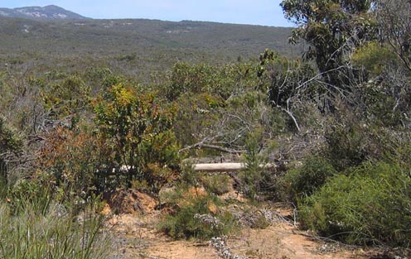 | 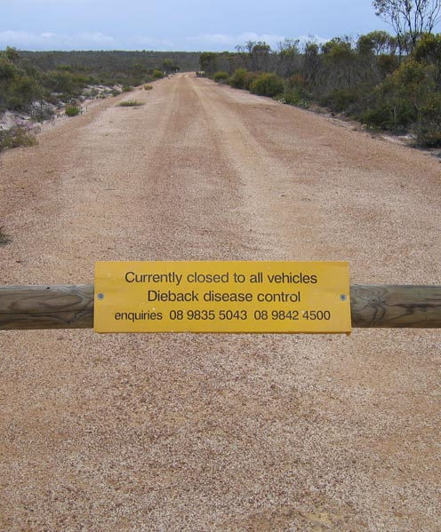
Figure A2.2 Permanent closure of a track in Waychinicup National Park in the south-west of Western Australia, by mechanical ripping of a portion of the track, and blocking of the entrance with a log and debris (Photo: E O’Gara). | Figure A2.3 Temporary closure of a road in Fitzgerald River National Park in the south-west of Western Australia (Photo: E O’Gara).
Hygiene
Where access is permitted, hygiene refers to specific procedures designed to prevent the spread of P. cinnamomi by ensuring that infested soil, water and/or plant material are removed from machinery, vehicles, equipment and footwear before they enter uninfested areas. The term ‘clean on entry’ is often used to describe such hygiene procedures. It is generally accepted that ‘it is easier to keep clean than to get clean’, which leads to the following recommendations: i) postpone activities during wet weather, ii) begin activities with clean vehicles/equipment, and iii) avoid wet or muddy areas during activities.
Machinery and Vehicles
Permanent or semi-permanent wash-down facilities may be constructed where machinery and vehicles require routine cleaning for fixed activities. All vehicles entering the Alcoa Huntly Bauxite Mine in WA, which is situated in an area of jarrah forest that is largely uninfested, must go through an automated wash-down facility (Figure A2.4). The vehicle operator must perform a visual inspection after wash-down, and before proceeding into the mine, to ensure all mud and soil was removed (Alcoa Procedural Control Documents).
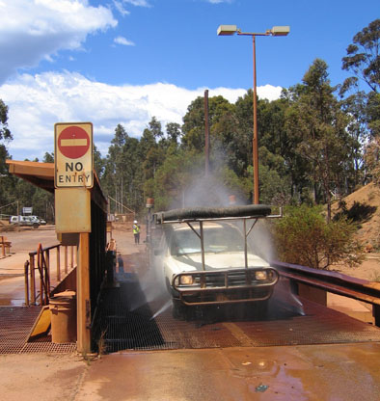 | Figure A2.4 The automatic wash-down facility at the entrance to Alcoa’s Huntly bauxite mine in the south-west of Western Australia, designed to remove soil from trucks and light vehicles entering the mine, thus minimising the probability of introducing Phytophthora cinnamomi to the predominantly disease-free site (Photo: E O’Gara).
A hygiene system was developed in Victoria to mitigate the risk of spreading a declared weed by fire-fighting vehicles and personnel during a large bushfire in 2005. A wash-down facility was created on a dry and compacted disused football oval by digging out a wash-bay (20 m long x 7 m wide) and filling it with blue metal. Dozers, dozer transport trucks, fire trucks and command vehicles were driven onto the blue metal, one at a time, for washing with a high pressure water sprayer. Surface run-off was carried away from the wash-bay by drainage channels, although run-off was minimal a result of drainage through the blue metal and the use of high pressure, low volume sprayer. The system was well accepted by the ground-crews and worked in parallel with fire suppression activities, with over 750 vehicles washed in a 35 h period. The system is currently being reviewed for use in the coming year to address the weed risks but also to mitigate the risks of spreading P. cinnamomi during fire suppression and prescribed fuel reduction burning operations (J Fleming, pers. comm.).
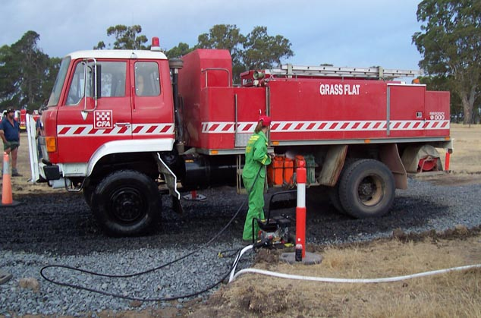 | Figure A2.5 Hygiene system developed initially for weed control during fire suppression activities in Victoria, but which is considered suitable also for P. cinnamomi management (Photo: J Fleming, Department of Sustainability & Environment, Victoria).
Portable wash-down systems enable machinery and vehicles to be cleaned at the point of risk for activities that do not have a fixed location (Figure A2.6). Hygiene measures commonly call for the minimisation of water during cleaning, as wash-down effluent also poses a risk of spreading the pathogen. To reduce the amount of water required for effective wash-down it is recommended that large clods of dirt are firstly removed with a hard brush or other tool (DWG, 2000; PTG, 2003; Worboys and Gadek, 2004), and high pressure, low-volume water sprayers used to remove remaining material. High pressure hot water systems are recommended for cleaning earth moving equipment in Victoria, as the hot water is believed to assist in killing rather than simply removing the pathogen (Smith, 2002).
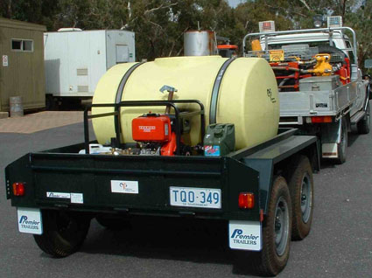 | Figure A2.6 A portable wash-down unit. This type of system is used widely in South Australia and Western Australia to wash vehicles and equipment during general field and fire-fighting operations (Photo: R. Velzeboer, Department for Environment and Heritage in South Australia).
A group of stakeholders in Tasmania concerned about Phytophthora and weed control have developed hygiene procedures for a range of machinery, vehicles and small equipment (Rudman et al., 2004). Dust and grime are not considered a high risk for transmission of the pathogen (DWG, 2000; CALM, 2003; PTG, 2003).
Barrier System for Working Across Infestation Boundaries
A system for working hygienically across infestation boundaries has been developed in WA (CALM, 2003) and Tasmania (Rudman, 2004). In WA, CALM uses a ‘barrier system’ when forestry operations straddle an infestation boundary, to prevent contamination of the uninfested part of the site. A physical barrier, such as logs, marks the infestation boundary. The operation is split so that certain tasks are restricted to the uninfested part of the site with clean machinery, vehicles and equipment and other tasks to the infested area with separate machinery, vehicles and equipment that are not subject to hygiene (Figure A2.7).

Figure A2.7 Diagrams of the two types of ‘barrier system’ employed by the Department of Conservation and Land Management in Western Australia to prevent the spread of Phytophthora cinnamomi to uninfested sites during operations that traverse infestation boundaries disease (Diagram: K Vear, Department of Conservation and Land Management, Western Australia)
Non-Vehicular Activities
Although activities involving the use of heavy machinery and vehicles present a significant risk of spreading soil infested with P. cinnamomi, non-vehicular activities are not without risk. Where high conservation values are at stake, activities such as bushwalking, horse riding and cycling may pose an unacceptable risk of introduction and may also be subject to hygiene. SA DEH developed the idea of a ‘hygiene kit’ for the cleaning of footwear and small equipment (Figure A2.8), which they encourage bushwalkers to assemble and carry (SA DEH, 2003a), and require all departmental vehicles to carry (SA DEH, 2002a).
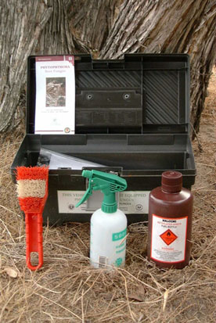 | Figure A2.8 A ‘hygiene kit’ containing equipment and information to facilitate the cleaning and disinfection of footwear, small tools and equipment against Phytophthora. The Department for Environment and Heritage in South Australia actively promotes the assembly and use of such kits amongst stakeholders (Photo: R Velzeboer, Department for Environment and Heritage in South Australia).
In situ apparatus for footwear hygiene ranges in sophistication from a simple tray and brush system (Figure A2.9) to a system developed by Parks Victoria named the ‘Anakie Scrubber’ (Figure A2.10). The Anakie Scrubber consists of a disinfectant footwear bath, designed to minimise evaporation and prevent the entry of rainfall and fauna to the reservoir (D Peters, pers. comm.).
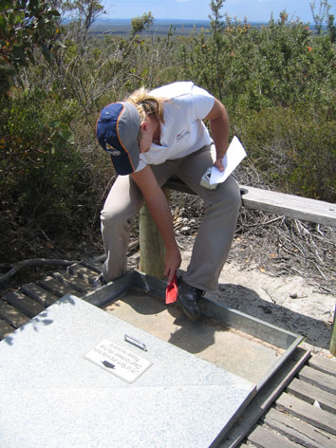 | 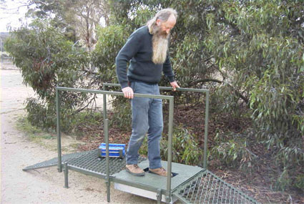
Figure A2.9 A boot cleaning station in Fitzgerald River National Park in the south-west of Western Australia, consisting of a metal pan into which soil is brushed from footwear with brush provided (Photo: E O’Gara). | Figure A2.10 The ‘Anakie Scrubber’ footwear cleaning station consists of a metal ramp and disinfectant bath with an immersion plate for the cleaning of footwear prior entering uninfested areas (Photo: D Peters, Parks Victoria).

Introduced Material
Under the Victorian Flora and Fauna Guarantee Act 1988 the use of gravel infested with P. cinnamomi is listed as a key threatening process (DSE, 2004). Current best practice recommends the use of pathogen-free road-building materials in areas that are uninfested or where the disease status is unknown. The difficulty in sourcing pathogen-free material is a significant problem in all parts of Australia, and as there is currently no national certification system, even materials advertised as pathogen-free may not be. In the event that pathogen-free gravels cannot be obtained, the recommendation is that the introduction of suspect material be avoided. A lower risk alternative is freshly crushed rock that has been crushed, transported and stored hygienically.
CALM in WA have an ‘in-house’ process by which gravel pits on CALM land and for CALM use can be ‘certified’ P. cinnamomi-free by personnel accredited by the Department in the identification and diagnosis of the pathogen (CALM, 2003). There are informal systems in place in Tasmania and Victoria where P. cinnamomi experts assess the disease status of quarries through surveys of disease symptoms of vegetation in the pits and drainage lines into and out of the pits, and/or sampling and analysis for the presence of the pathogen (T Rudman and I Smith, pers. comm.).
The WA extractive industry has a Code of Practice (DWG, 2004b) and best practice guidelines for management of P. cinnamomi (DWG, 2005). A Quarry Code of Practice in Tasmania provides principles, acceptable standards and suggested measures on all aspects of the extractive process to improve environmental outcomes, including the management of P. cinnamomi (DPIWE & DIER, 1999). However, there is currently no national system for the certification of basic raw materials for road building or other bulk soils and sand supplies.
The introduction of planting material to an uninfested site should be avoided wherever possible and revegetation achieved through encouraging natural regrowth or use of seed. However, if the introduction of planting material is necessary, then plants should be obtained from NIASA accredited suppliers (NGIA website – Accreditation, accessed 12/12/05).
Water, Drainage and Effluent
There are currently no accepted methods of controlling the spread of P. cinnamomi in subsurface water flows. Under certain circumstances surface drainage can be re-directed away from uninfested areas, and recommendations for the management of drainage is to direct it to infested areas or to the lowest point in the landscape (Rudman, 2004; CALM, 2003; DWG, 2000). Alcoa prevent surface water from freely draining into jarrah forest surrounding bauxite mines in WA through a series of channels and bunds.
The primary recommendations in relation to water management at infested sites, or where disease status is unknown is to minimise use and seriously consider the source of the water wherever possible. If water must be used at a site, suspect supplies should be disinfected using Phytoclean® (http://www.phytoclean.com.au/). All safety precautions should be taken when using disinfectants, and as the environmental effect of broad-scale use is unknown it is recommended that they be used judiciously.
Objective 2: Mitigate the Impact of P. cinnamomi
Options for the mitigation of impact to biodiversity at infested sites or areas are currently limited to the use of phosphite and ex-situ conservation of susceptible plants. As discussed previously, the cost of these options makes only limited application practical. Consequently, the use of phosphite and/or ex-situ conservation as part of an integrated management plan for a site or area requires a process of prioritisation and forward planning.
Phosphite
The autonomous spread of P. cinnamomi is currently very difficult, if not impossible, to control. However, phosphite (also referred to as phosphonate), the anionic form of phosphonic acid (HPO₃²⁻), has been shown in WA and Victoria to slow the spread and reduce the impact of the P. cinnamomi in susceptible vegetation. Phosphite is currently used in WA to protect areas of high conservation value and critically endangered species from the threat of P. cinnamomi.
Despite the fact that research on the use of phosphite in natural ecosystems has occurred predominantly in WA and Victoria to date, it is presented in Table 5.1 (in main document) as a management option for ecosystems under threat of P. cinnamomi in Australia. Faced with the continued threat that P. cinnamomi poses to a significant proportion of Australia’s native vegetation, and the limited management options, the most responsible recommendation for other States and Territories is that, after reference to the available research, phosphite be used judiciously in the management of P. cinnamomi, results monitored and data collected to increase the national body of knowledge on this important management tool.
The Australian Pesticides and Veterinary Medicines Authority (APVMA) administer the National Registration Scheme for Agricultural and Veterinary Chemicals (NRS) in partnership with the States and Territories. Phosphite is currently not registered for use in native vegetation, and therefore an ‘off-label permit’ may be required from the APVMA before use. However, as legislation can vary between states/territories it is recommended that the APVMA or the relevant APVMA State/Territory Co-ordinator is contacted for advice on permit requirements before use.
The beneficial properties of phosphite include:
- the induction of resistance to P. cinnamomi, in otherwise susceptible plant species (Guest and Bompeix, 1990)
- its mobility in phloem and xylem (Ouimette and Coffey, 1990) enabling application by trunk injection to trees and large shrubs (Hardy et al., 2001)
- the uptake of phosphite through foliage which enables it to be applied as a foliar spray, either manually or by broad scale aerial application (Barrett, 2003)
- it has a simple chemical structure and current data indicates that it has low mammalian toxicity and breaks down rapidly in the soil (Guest and Grant, 1991).
Aerial application (Figure A2.11) is a rapid way to treat entire plant communities especially where rough terrain would make ground application practically impossible or prohibitively expensive (CALM website – Dieback Phosphite, accessed 11/04/05). Foliar application using backpack (Figure A2.12) or trailer-mounted sprayers is usually restricted to small areas such as small reserves, remnant bushland or spot infestations (Hardy et al., 2001). Trunk injection of trees and large shrubs is used in strategic areas where their loss would have a high visible impact, and where foliar application is impractical (Hardy et al., 2001).
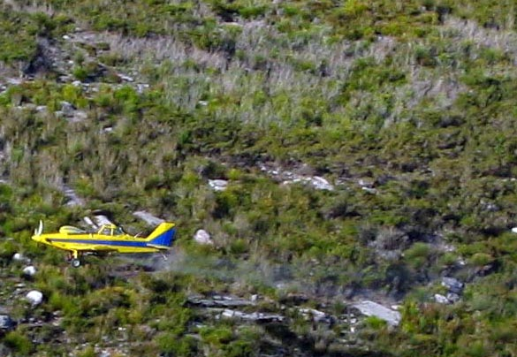 | 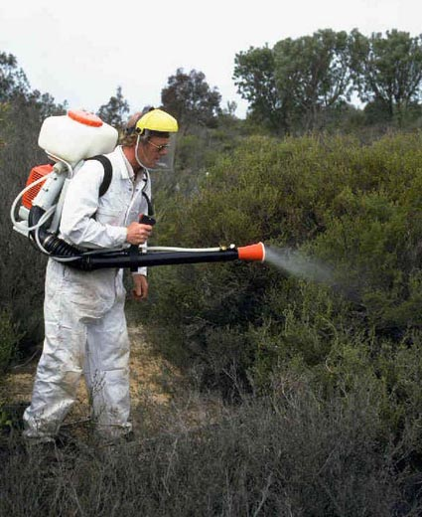
Figure A2.11 Aerial application of phosphite in Stirling Ranges National Park in the south-west of Western Australia (Photo: G Freebury, Department of Conservation and Land Management, Western Australia). | Figure A2.12 Foliar application of phosphite by backpack mister (Photo: B Shearer, Department of Conservation and Land Management, Western Australia).
As the need for phosphite treatment in WA regularly exceeds the available resources, a protocol for setting treatment priorities was developed by CALM, and a scoring system developed to rank assets with highest priority. The following broad priorities apply in WA:
PRIORITY A
- protect threatened and priority flora, fauna and ecological communities
- strategic applications to protect other conservation, landscape and heritage values and local endemic representations of flora or fauna habitat.
PRIORITY B - Rehabilitation projects and commercial values such as timber, recreation and/or wildflowers.
CALM have also produced detailed Phosphite Operation Guidelines which provides background information on the compound, and covers all methods and aspects of application.
Ex-situ Conservation
In WA, ex-situ conservation of germplasm in seed banks is a well established technique and with no definitive solution to the threat of P. cinnamomi, may be the last hope in conserving some of the States susceptible species (Anon, 2004; Cochrane, 2001; Cochrane, 2004). Compared to other types of germplasm, seed conservation has many benefits including: the simplicity of the technology, low cost and space requirements, the potential for long-term storage with little loss of seed viability, the applicability of the technique to a wide range of species, and greater genetic representation in seed than in vegetative material (Cochrane, 2004).
CALM and the WA Botanic Gardens and Parks Authority are partners in the Millennium Seed Bank Project in which collections of seed in WA are duplicated in the Royal Botanic Gardens Kew, United Kingdom in the Millennium Seed Bank (Cochrane, 2001). The conserved seed facilitates the implementation of species recovery plans in WA by providing material for translocation of rare and threatened flora (Cochrane, 2004; Royal Botanic Gardens Kew - Millennium Seedbank Project website, accessed 18/04/05). An additional benefit of the WA seed bank has been the provision of material to the Senior Phytophthora Research Scientist in CALM for trials to extend knowledge on the range of WA plant species that are susceptible to P. cinnamomi (Cochrane, 2004; Shearer et al., 2004).
Translocation as defined by the Australian Network for Plant Conservation is the ‘deliberate transfer of plants or regenerative plant material from one place to another’ (Australian Network for Plant Conservation website, accessed 18/04/05). Translocation includes the following techniques:
- re-stocking - increasing the size of the existing population
- re-introduction – establish a population where it formerly occurred
- introduction – establish a population where it is not known to have occurred, within the known range and habitat
- conservation introduction – establish a population in an area that is outside the known range, which has appropriate habitat.
Experimental translocation of 10 species in WA was funded in 1998 by the Natural Heritage Trust, and the method is now integrated with a range of other recovery actions to conserve State-listed critically endangered species (Cochrane, 2004; Monks and Coates, 2002; L Monks, pers. comm.).
A2 REFERENCES

Alcoa Procedural Control Documents: Environmental/Dieback. Alcoa World Alumina Australia, Booragoon, Western Australia.
Anon (2004) The Millennium Seed Bank Project: in Western Australia. Achievements 2001-2004. Information brochure produced by The Department of Conservation and Land Management and Botanic Parks and Gardens Authority, Western Australia, and Millennium Seed Bank Project Kew and Royal Botanic Gardens Kew (Wakehurst Place), UK.
Australian Network for Plant Conservation website: http://www.anbg.gov.au/anpc/books.html#Translocation
Barrett S (2003) Monitoring of aerial phosphite application for the control of Phytophthora cinnamomi in the Albany District. In: ‘Phytophthora in Forests and Natural Ecosystems’, Eds. J McComb, G Hardy and I Tommerup. From Proceedings of the 2nd International IUFRO Meeting, Western Australia, 30th September – 5th October 2001.
CALM (2003) Phytophthora cinnamomi and disease caused by it. Volume 1-Management Guidelines. Department of Conservation and Land Management, Government of Western Australia. http://www.calm.wa.gov.au/projects/pdf_files/DBmanual2003.pdf
CALM website (WA Government Department of Conservation and Land Management) – Dieback Phosphite: http://www.calm.wa.gov.au/projects/dieback_phosphite.html
Cochrane A (2001) Our Frozen Future. Landscope 16(4), 23-27.
Cochrane A (2004) Western Australia’s Ex Situ Program for Threatened Species: A Model Integrated Strategy for Conservation. In: Ex Situ Plant Conservation. Supporting Species Survival in the Wild. Eds. EO Guerrant Jr, K Havens, M Maunder (2004) pp40-65. Island Press, Washington DC.
DPIWE & DIER (1999) Quarry Code of Practice. Department of Primary Industries, Water and Environment and Department of Infrastructure, Energy and Resources, Government of Tasmania.
DSE (2004) Draft Strategic Plan for management of Phytophthora cinnamomi in Victoria. Department of Sustainability and Environment, Government of Victoria.
DWG (2000) Managing Phytophthora Dieback: Guidelines for Local Government. Dieback Working Group, Western Australia.
DWG (2004) Environmental Code of Practice for the Management of Phytophthora Dieback in Extractive Industries. Dieback Working Group, Western Australia.
DWG (2005) Management of Phytophthora Dieback in Extractive Industries. Dieback Working Group, Western Australia.
Guest DI, Bompeix G (1990) The complex mode of action of phosphonates as antifungal agents. Australasian Plant Pathology 19, 113-115.
Guest DI, Grant B (1991) The complex action of phosphonates as antifungal agents. Biological Reviews 66, 159-187.
Hardy GEStJ, Barrett S, BL Shearer (2001) The future of phosphite as a fungicide to control the soilborne plant pathogen Phytophthora cinnamomi in natural ecosystems. Australasian Plant Pathology 30, 133-139.
Monks L, Coates D (2002) The translocation of two critically endangered Acacia species. Conservation Science Western Australia 4(3), 54-61.
NGIA website (Nursery and Garden Industry Australia) – Accreditation: http://www.ngia.com.au/accreditation/overview.asp
Ouimette DG, Coffey MD (1990) Symplastic entry and phloem translocation of phosphonate. Pesticide Biochemistry and Physiology 38, 18-25.
PTG (2003) Phytophthora Management Guidelines. Phytophthora Technical Group. Funded by The Greater Mount Lofty Parklands (Yurrebilla), Department for Environment and Heritage, Government of South Australia.
Royal Botanic Gardens, Kew website - Millenium Seedbank Project: http://www.rbgkew.org.uk/msbp/internat/australia.html
Rudman T (2004) Interim Phytophthora cinnamomi Management Guidelines. Department of Primary Industries, Water and Environment. Government of Tasmania.
Rudman T, Tucker D, French D (2004) Tasmanian Washdown Guidelines for Weed and Disease Control. Department of Primary Industries, Water and Environment, Government of Tasmania. (http://www.dpiwe.tas.gov.au/inter.nsf/Attachments/LJEM-5ZM43C/$FILE/Washdown%20Guidelines%20Edition%201.pdf
SA DEH (2002a) Phytophthora Threat Management Procedure: Standard Operating Procedures-002. Department for Environment and Heritage. Government of South Australia.
SA DEH (2003a) Phytophthora: Fire Response Team Handbook, Kangaroo Island. Department for Environment and Heritage. Government of South Australia.
Shearer BL, Crane CE, Cochrane A (2004) Quantification of the susceptibility of the native flora of the South West Botanical Province, Western Australia, to Phytophthora cinnamomi. Australian Journal of Botany 52(4), 435-443.
Smith I (2002) Guidelines for reducing the spread of Phytophthora cinnamomi during earth moving operations. Department of Natural Resources and Environment. Government of Victoria.
TPWS website (Tasmanian Parks and Wildlife Service) – Walking Track Management Manual: http://www.parks.tas.gov.au/manage/tracstrat/walking track manual.html
Worboys S, Gadek P (2004) Rainforest Dieback: Risks Associated with Roads and Walking Tracks. Cooperative Research Centre for Tropical Rainforest Ecology and Management, Cairns, Queensland.

