APPENDIX 3
AREAS VULNERABLE TO DISEASE CAUSED BY Phytophthora cinnamomi

This section provides information necessary to navigate the decision flow chart (Figure 5.1) in Guidelines for Best Practice On-Ground Management (Section 5). It provides information on the broad climatic envelope of P. cinnamomi in Australia, based on current knowledge of rainfall and temperature requirements for the establishment and persistence of the pathogen, and in some cases on other criteria such as geology, soil and elevation.
Climatic Envelope of Phytophthora cinnamomi in Australia
Figure A3.1 depicts areas of Australia where, based on current knowledge, some of the conditions (i.e. rainfall and minimum temperatures) are conducive to the proliferation of P. cinnamomi and the establishment of disease. The dark shading around much of the coast shows areas where average annual rainfall exceeds 600 mm, and the lighter shading denotes 400-600 mm rainfall. The unshaded areas of central, southern and western Australia indicate areas where average annual rainfall is less than 400 mm. Small areas of Tasmania and the Southern Highlands of NSW shaded in orange indicate where the maximum average daily temperature is less than 12ºC, which is considered too low for pathogen establishment.
P. cinnamomi has been shown to have the greatest and most widespread impact in areas where the average annual rainfall exceeds 600 mm, but in WA the pathogen can cause disease in stream zones and water-gaining sites in the 400-600 mm zones (CALM, 2003). While rainfall is a key factor influencing the distribution of disease caused by P. cinnamomi, there are many other components of the ‘disease pyramid’ (Figure A3.2) that affect its ability to establish and persist. A disease epidemic will develop over time when the pathogen is present in a conducive environment (i.e. suitable rainfall, temperature, geology and soil) with susceptible plant hosts.
Knowledge of current epidemics caused by P. cinnamomi indicates that the components of the disease pyramid are most likely to converge in the temperate south of the continent, generally south of latitude 30º, which is marked on the map in Figure A3.1. Although rainfall is clearly sufficient for the establishment of P. cinnamomi in the wet/dry, true and sub-tropical north of Australia, there is little data to indicate that P. cinnamomi is a problem in undisturbed native ecosystems of northern WA or the NT, and there is insufficient knowledge of pathogen epidemiology to predict its potential to become a problem in the future. P. cinnamomi is a serious concern in the Wet Tropics World Heritage region of Far North Queensland, where the syndrome is complex, differs considerably from that in the temperate south of the continent and appears to be related to prior significant disturbance of sites (Gadek and Worboys, 2003).

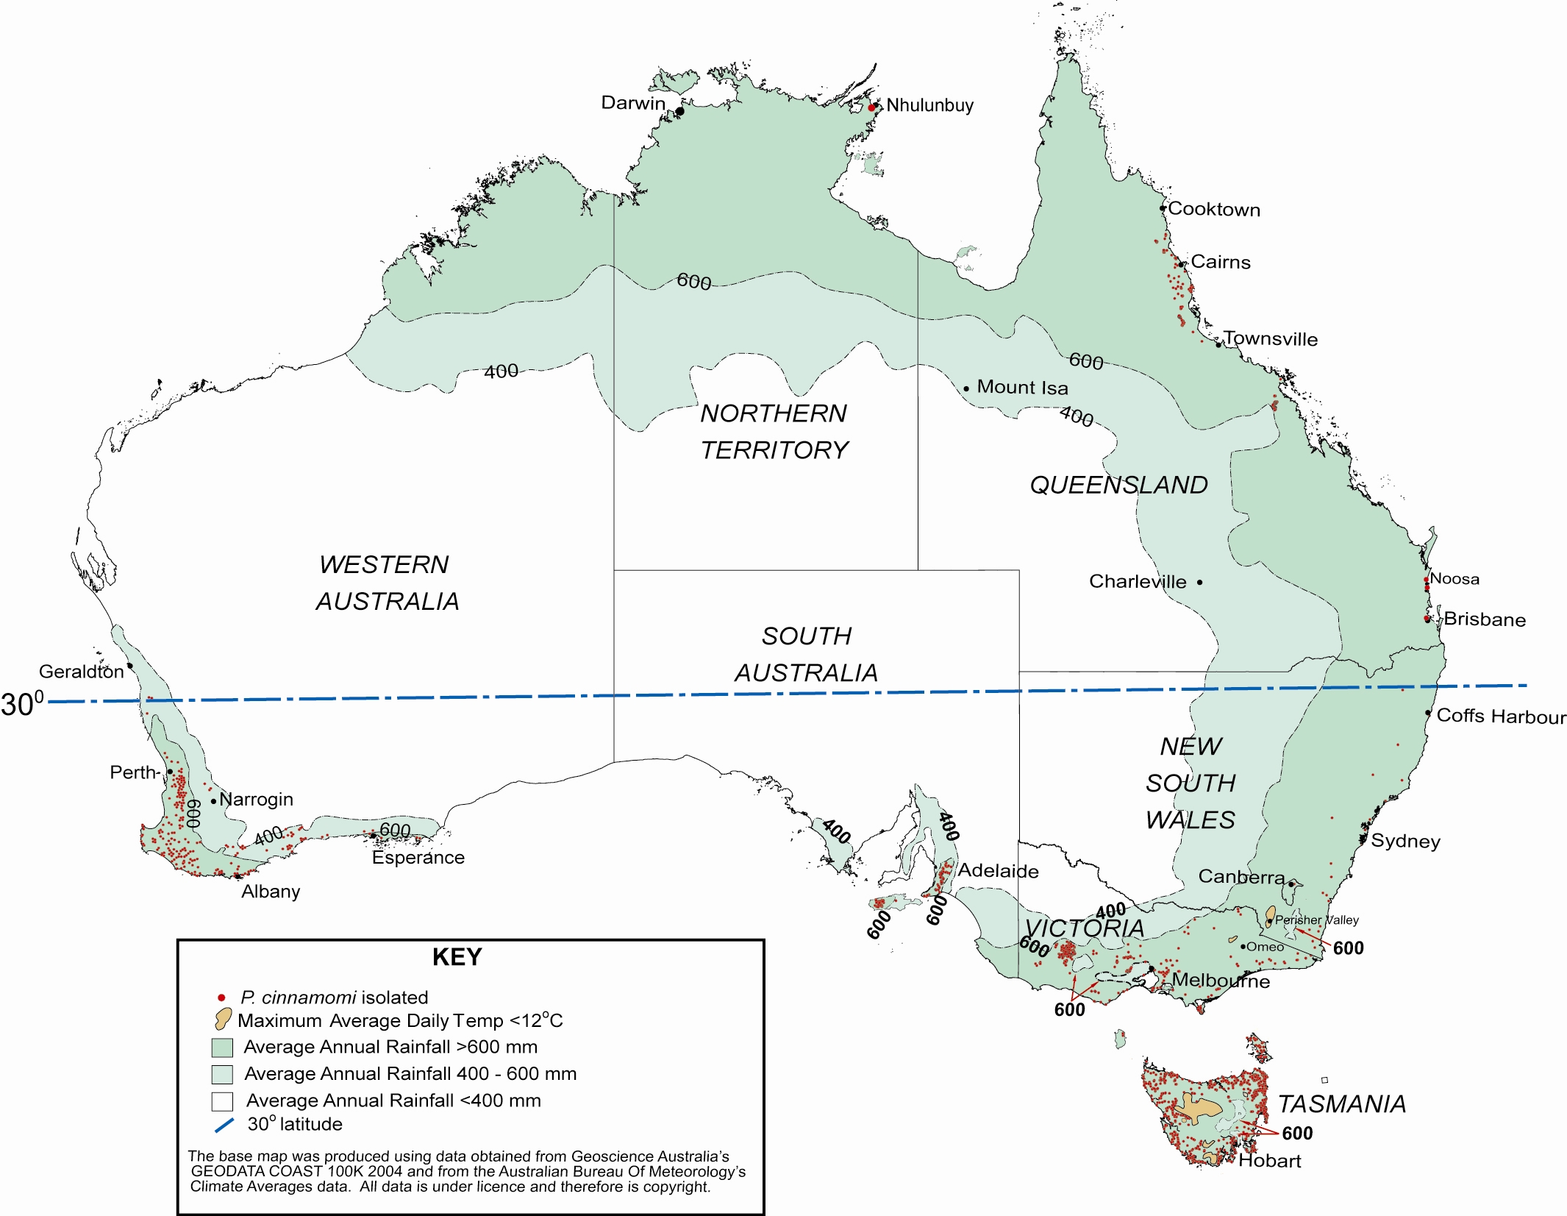 | Figure A3.1 Map of Australia indicating the broad climatic envelope of Phytophthora cinnamomi in Australia, based on current knowledge of rainfall and temperature requirements. Red spots indicate non-agricultural sites from which P. cinnamomi was isolated. Please refer to the main body of text for further explanation of the map.  Source of P. cinnamomi isolation data: WA - Podger (1999), WWF, DCC (2004); SA – BDBSA (2005); Tasmania – Peters et al. (1998); Victoria – Gibson et al. (2002); NSW – McDougall (unpublished data), Summerell (unpublished data), Pratt and Heather (1973), McDougall and Summerell (2003); Queensland (Brisbane) - O’Dwyer et al. (1999); Queensland (Noosa/Coolum region) - Pegg and Alcorn (1972), Pratt et al. (1973); Queensland (Wet Tropics) – Data obtained under licence and copyright from the Cooperative Research Centre for Tropical Rainforest Ecology and Management; NT – Weste (1983).

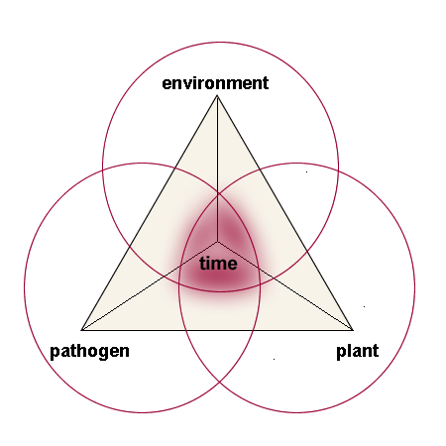 | Figure A3.2 Disease pyramid showing disease epidemic (red shading) resulting from the convergence of virulent pathogen, susceptible host, suitable environment and time.

Phytophthora cinnamomi Isolation Records
P. cinnamomi isolations records at non-agricultural sites are marked on the map in Figure A3.1. Isolation records do not indicate the extent of the infestation or the impact of disease, merely the presence of the pathogen as indicated by the analysis of soil and/or plant material. Although data was not available, it is thought that P. cinnamomi is widespread on the entire coastal strip of NSW.
Criteria for the Vulnerability of an Area to Phytophthora cinnamomi in Australia
In Australia, P. cinnamomi does not usually cause severe damage in undisturbed vegetation at sites that receive a mean annual rainfall of less than 600 mm, and are north of latitude 30º. Therefore the areas of Australia vulnerable to disease caused by P. cinnamomi can be separated into three broad climatic zones:
- all elevations in those areas of Mediterranean climate where annual rainfall exceeds 600 mm – in southern WA and SA, and southern Victoria as far east as Wilson’s Promontory
- the temperate uniform, but erratic rainfall regimes at low elevations of the coastal plain and foothills between Wilson’s Promontory and south of the border area between Victoria and NSW
- winter dominant rainfall areas in maritime climates of coastal and sub-montane Tasmania.
Speculation still exists over the role of P. cinnamomi in damage to undisturbed montane regions above 800 m such as those found in the southern Great Dividing Range, the Central Highlands of Tasmania, and the upland and highland rainforests of central and Far North Queensland.
Some States in Australia have identified broad zones where biodiversity is vulnerable to the threat of P. cinnamomi, due to the coincidence of susceptible vegetation and environmental conditions that are conducive to the establishment and persistence of P. cinnamomi. The environmental criteria used to identify zones of vulnerability vary from State to State and are summarised below. The biomes that appear to be least threatened are the wet-dry tropics and the arid and semi-arid regions of the continent (Environment Australia, 2001).

Western Australia
In Western Australia, the vulnerable zone is defined by CALM (2003) as:
- the parts of the South West Land Division and areas adjoining it to the north-west and south-east that receive an average annual rainfall greater than 400 mm
- those areas receiving rainfall above 400 mm that do not have a calcareous substrate and in which susceptible native plants occur in conjunction with the environmental factors required for P. cinnamomi to establish and persist.
A decision flow chart to assist in determining the vulnerability of a site to disease in WA has been developed by CALM (CALM website – Protectable Areas Flowchart, accessed 17/03/03).

Tasmania
The vulnerable zones of Tasmania include areas where there is a coincidence of:
- susceptible native vegetation in open communities
- non-calcareous soils
- elevation below 700 m
- average annual rainfall greater than 600 mm.

Victoria
Where susceptible native species or communities of plants occur, the following areas in Victoria are considered vulnerable to the threat of P. cinnamomi:
- all elevations in those sites of Mediterranean climate from the west of the State across to Wilson’s Promontory where average annual rainfall exceeds 600 mm
- the temperate rainfall regimes at low elevations of the coastal plain and the foot hills between Wilson’s Promontory
- south of the border between Victoria and NSW.

South Australia
In SA, any site with susceptible vegetation growing on neutral to acid soils and an average annual rainfall greater than 500 mm is considered vulnerable to the threat of P. cinnamomi (PTG, 2003).

Queensland
The average annual rainfall in the wet tropics of Far North Queensland is rarely limiting for the establishment of P. cinnamomi. As with NSW and the ACT, the pathogen tends to have a cryptic nature, and is frequently isolated from soils beneath symptom-free vegetation. However, dieback attributed to P. cinnamomi in natural tropical ecosystems of Far North Queensland is commonly associated with some prior disturbance (particularly roads) on sites that have the following characteristics:
- elevation above 750 m
- notophyll dominant vegetation
- acid-igneous geology (Gadek et al., 2001; Worboys and Gadek, 2004).
Although dieback related to P. cinnamomi is reported in upland subtropical rainforests of the Eungella Plateau, west of Mackay, and from the Wallum Heathlands of the south-east of the State, there has been no assessment of what criteria may be useful in categorising vulnerable vegetation (S Worboys, pers. comm.).

New South Wales & Australian Capital Territory
Clear criteria for what constitutes an area’s vulnerability to the threat of P. cinnamomi in NSW and ACT are not available for two major reasons:
- there is insufficient knowledge of the susceptible species in NSW & ACT
- there is variable susceptibility of plant species depending on climatic conditions, i.e. some species only appear susceptible during sustained periods of unusually high rainfall.
Anecdotal evidence suggests that sites that receive less than 600 mm average annual rainfall are not vulnerable to the threat of P. cinnamomi. Beyond that, and because of the apparently cryptic nature of the disease in NSW & ACT, a precautionary approach should be adopted and the pathogen assumed to be absent unless it can be proven to be present (McDougall and Summerell, 2003).

Northern Territory
To date there is no unequivocal record of P. cinnamomi being associated with disease in undisturbed native vegetation in the NT. It is generally accepted that the environmental conditions are not conducive to the establishment and persistence of P. cinnamomi in susceptible native plant communities.
A3 REFERENCES
BDBSA (2005) SA_PCdbase_March2005. Biological Databases of South Australia, Department for Environment and Heritage, Government of South Australia.
CALM (2003) Phytophthora cinnamomi and disease caused by it. Volume 1-Management Guidelines. Department of Conservation and Land Management, Government of Western Australia. http://www.calm.wa.gov.au/projects/pdf_files/DBmanual2003.pdf
CALM website (WA Government Department of Conservation and Land Management) -Protectable Areas Flowchart: http://www.naturebase.net/science/pdf_files/dcc_pap_flowchart.pdf
CRC TREM website (Cooperative Research Centre Tropical Rainforest Ecology and Management): http://www.rainforest-crc.jcu.edu.au/
Environment Australia (2001) Threat Abatement Plan for Dieback Caused by the Root-rot Fungus Phytophthora cinnamomi. Environment Australia, Commonwealth Government of Australia, Canberra. http://www.deh.gov.au/biodiversity/threatened/publications/tap/phytophthora/.
Gadek PA, Gillieson D, Edwards W, Landsberg J, Pryce J (2001) Rainforest Dieback Mapping and Assessment in the Wet Tropics World Heritage Area. Schools of Tropical Biology, Tropical Environmental Studies, Geography and the Rainforest CRC. James Cook University, Cairns.
Gadek PA, Worboys S (2003) Rainforest Dieback Mapping and Assessment: Phytophthora species diversity and impacts of dieback on rainforest canopies. Cooperative Research Centre for Tropical Rainforest Ecology and Management. Rainforest CRC, Cairns. pp114
Gibson M, Milne R, Cahill D, Wilson B (2002) Preliminary review of the actual and potential distribution of Phytophthora cinnamomi dieback in parks and reserves across Victoria. Report to Parks Victoria. Centre for Environmental Management, University of Ballarat.
McDougall KL, Summerell BA (2003) The impact of Phytophthora cinnamomi on the flora and vegetation of New South Wales – a re-appraisal. In: ‘Phytophthora in Forests and Natural Ecosystems’, Eds. J McComb, G Hardy and I Tommerup. From Proceedings of the 2nd International IUFRO Meeting, Western Australia, 30th September – 5th October 2001. p49-56.
O’Dwyer C, Brown B, Friend R, Drenth A (1999) Survey for the presence of Phytophthora cinnamomi in Brisbane Koala Bushlands. Research Report for Brisbane City Council Open Space Planning Section.
Pegg KG and Alcorn JL (1972) P. cinnamomi in indigenous flora in southern Queensland. Search 3, 257.
Peters D, Thackway R (1998) A new biogeographic regionalisation for Tasmania. Report prepared for the National Reserve System Program Component of the Natural Heritage Trust. Project NR 002: Undertake biophysical regionalisation for Tasmania (http://www.gisparks.tas.gov.au/dp/newibra/home.html)
Podger FD (1999) A National Overview of Phytophthora cinnamomi in Australia: Supplementary information to accompany the draft National Threat Abatement Plan. Environmental Australia, Commonwealth Government of Australia, Canberra.
Pratt BH, Heather WA (1973) The origin and distribution of Phytophthora cinnamomi Rands in Australian native plant communities and the significance of its association with particular plant species. Australian Journal of Biological Science 26, 559-573.
Pratt BH, Heather WA, Shepherd CJ (1973) Recovery of Phytophthora cinnamomi from native vegetation in a remote area of New South Wales. Transactions of the British Mycological Society 60(2), 197-204.
PTG (2003) Phytophthora Management Guidelines. Phytophthora Technical Group. Funded by The Greater Mount Lofty Parklands (Yurrebilla), Department for Environment and Heritage, Government of South Australia.
Weste G (1983) Dieback and death of Eucalyptus tetradonta due to Phytophthora cinnamomi in native forest at Nhulunbuy, N.T. Australasian Plant Pathology 12, 42-44.
Worboys S, Gadek P (2004) Rainforest Dieback: Risks Associated with Roads and Walking Tracks. Cooperative Research Centre for Tropical Rainforest Ecology and Management, Cairns, Queensland.
WWF, DCC (2004) Arresting Phytophthora Dieback: The Biological Bulldozer. A report by the World Wildlife Fund and the WA Dieback Consultative Council. http://www.wwf.org.au/News_and_information/Publications/PDF/Report/diebackreport.pdf

