

Exports work instruction

Applying to become an Authorised Officer using the Plant Exports Management System
Direction to authorised officers
This is official instructional material of the Department of Agriculture, Fisheries and Forestry (the department). Failure to comply with it may result in a breach of relevant legislation and/or the code of conduct under section 13(5) of the Public Service Act 1999.

Purpose of this document
This document details the procedure for applying to become a third party Authorised Officer (AO) using the Plant Exports Management System (PEMS).
__________________________________________________________________________________
Contents
This document contains the following topics:
Purpose of this document 1
Policy statement 1
Roles and responsibilities 2
Register for the department’s online services 3
Log in to online services 6
Complete your application 10
Review and complete personal details 10
Employment 21
Job functions 27
Documents 33
Payment 38
Contact information 49
Related material 49
Document information 49
Version history 50

Policy statement
The policy, definitions and legislation related to this work instruction can be found in the Exports Policy: Management of third party plant exports authorised officers.

Roles and responsibilities
The following table outlines the roles and responsibilities undertaken when applying to become an AO.
Role | Responsibility
Applicant | - Applying to become an AO through PEMS.  - Attaching all the required documentation to their application.  - Paying all applicable fees and charges.

Register for the department’s online services
The following table outlines how to register for the department’s online services.
Step | Action | Graphic
1. | - Go to https://online.agriculture.gov.au/selfservice  Note: The login page will display.  - Select ‘Create an account’. | 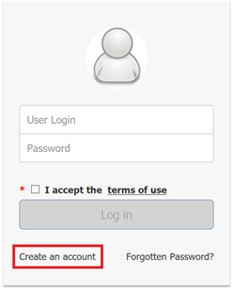
2. | - Enter your details.  - Read the terms of use.  - Check the ‘I accept the terms of use’ box.  - Click ‘Register’. | 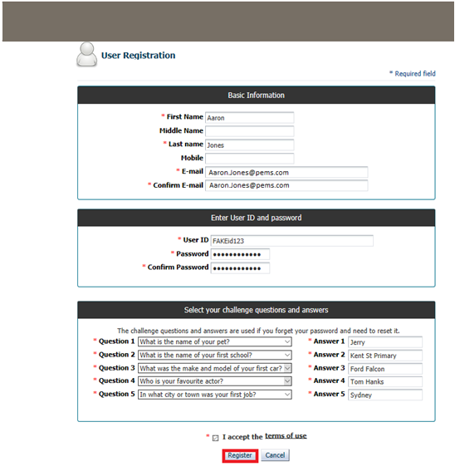
3. | - Note the confirmation of your registration.  - Click the ‘Close’ button.  - Go to ‘Log in to online services’. | 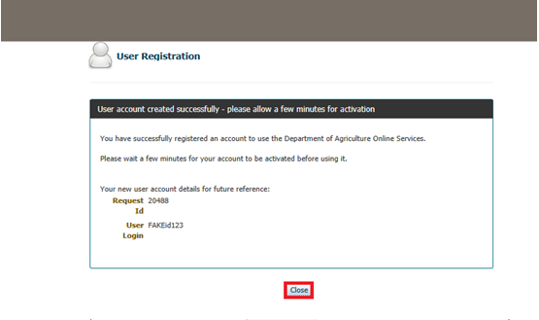

Log in to online services
The following table outlines how to log in to online services and apply for PEMS access.
Step | Action | Graphic
1. | Go to: https://online.agriculture.gov.au/selfservice  Note: The login page will display. | 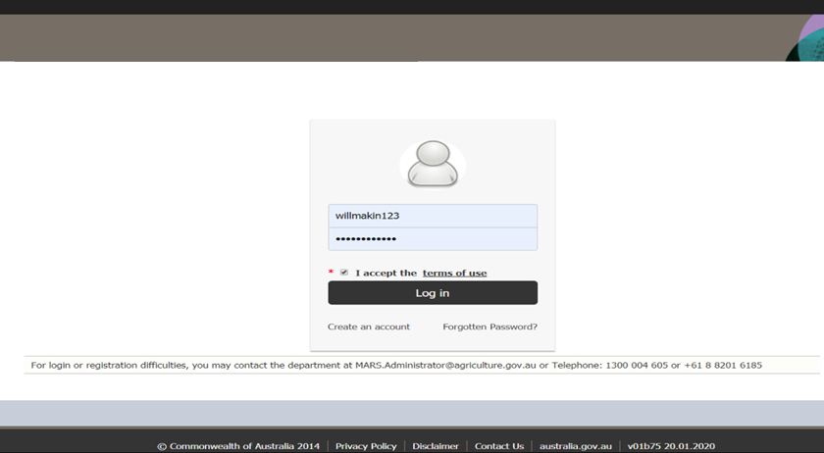
2. | - Enter your User Login and Password.  Note: This information will have been sent to you via email following registration.  - Check the ‘I accept the terms of use’ box.  - Click ‘Log in’. | 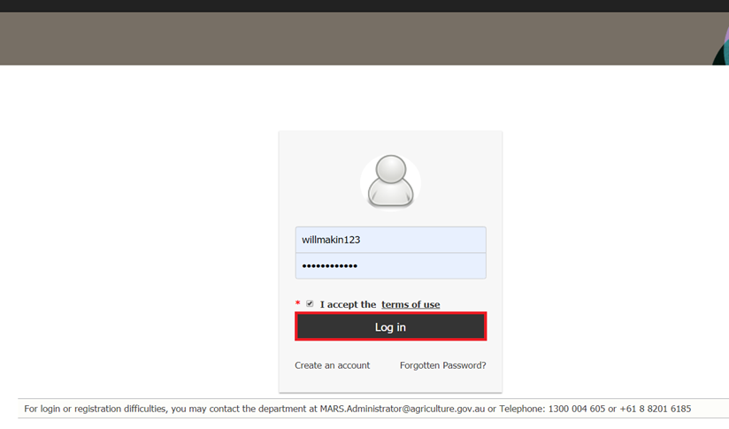
3. | Click ‘Register as a PEMS External User’. | 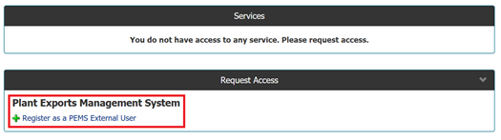
4. | - Enter your details.  - Select the ‘Authorized Officer’ PEMS role.  - Click ‘Submit’. | 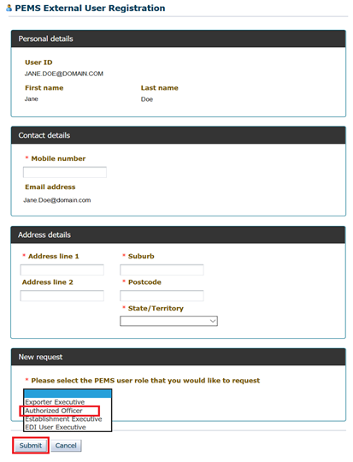
5. | - Note the confirmation of your application.  - Within 10 business days, you will receive an email regarding your registration request. If you do not receive an email within 10 business days, please email the Authorised Officer Program. | 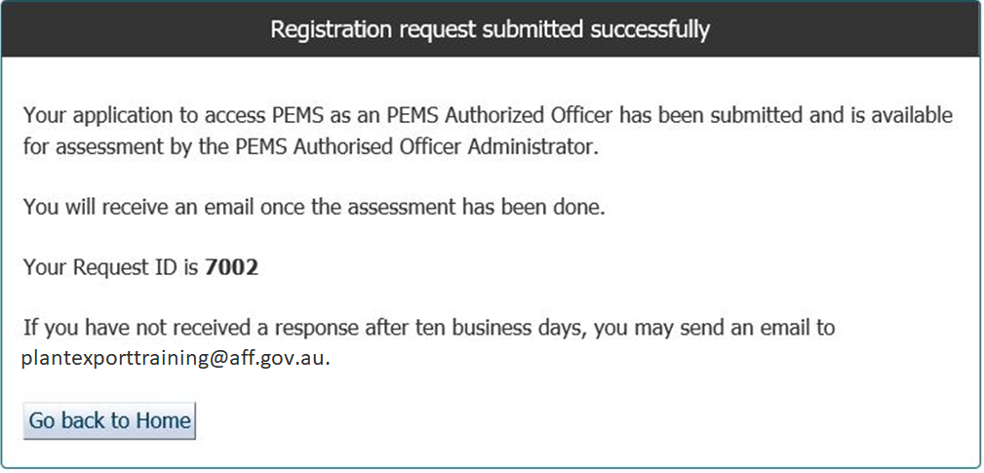

Complete your application

Review and complete personal details
The following table outlines how to review and complete personal details for an AO application.
Step | Action | Graphic
1. | - Once you have received an email saying that your request has been approved go to: https://online.agriculture.gov.au/selfservice  Note: The login page will display.  - Enter your User Login and Password.  - Check the ‘I accept the terms of use’ box.  - Click ‘Log in’.
2. | - Click the ‘PEMS’ icon to enter PEMS.  - Click the ‘Application’ icon to be taken to your application. | 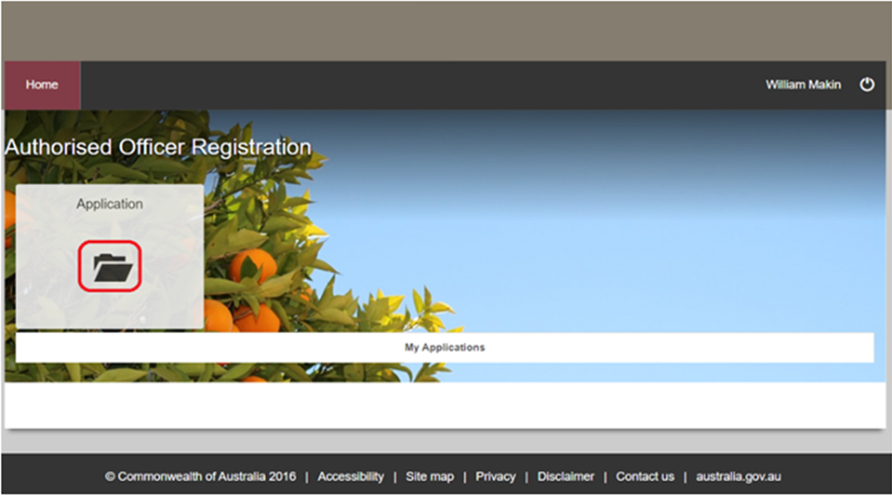
3. | - Read the application requirements and check the mandatory boxes  - Click ‘Create’. | 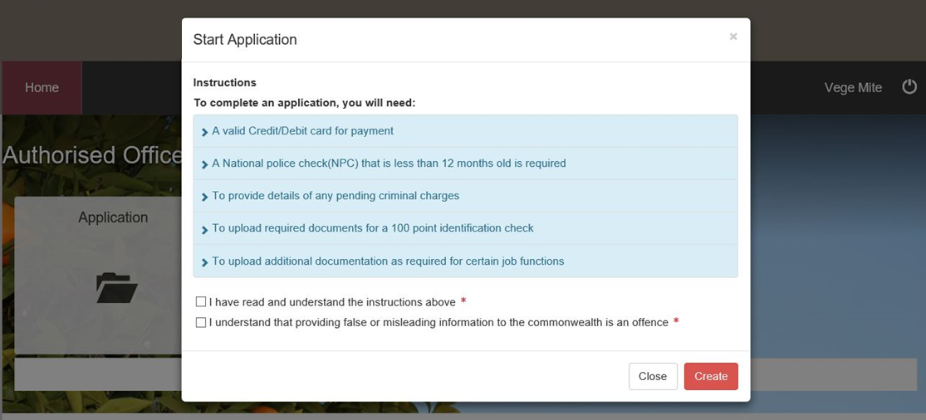
4. | - Review your details  - Click ‘Change’. | 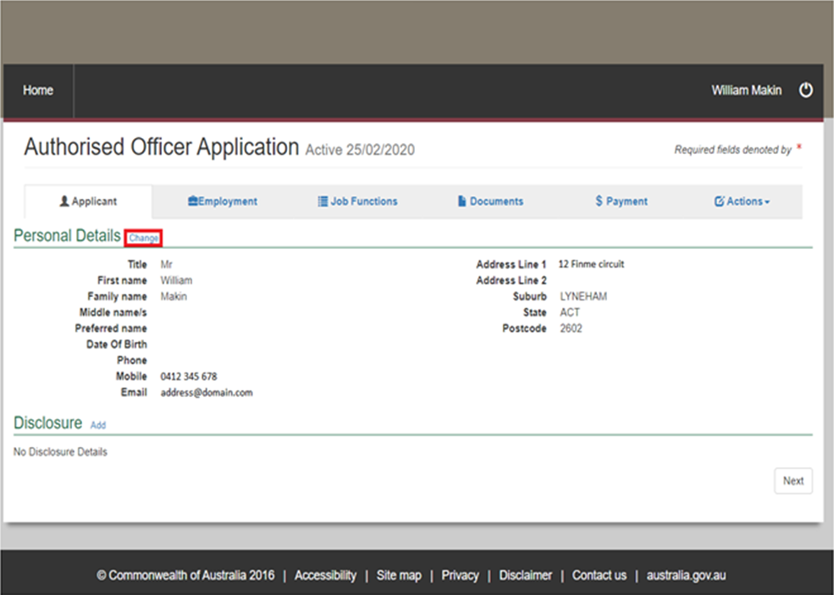
5. | - Update your details.  - Click ‘Save’. | 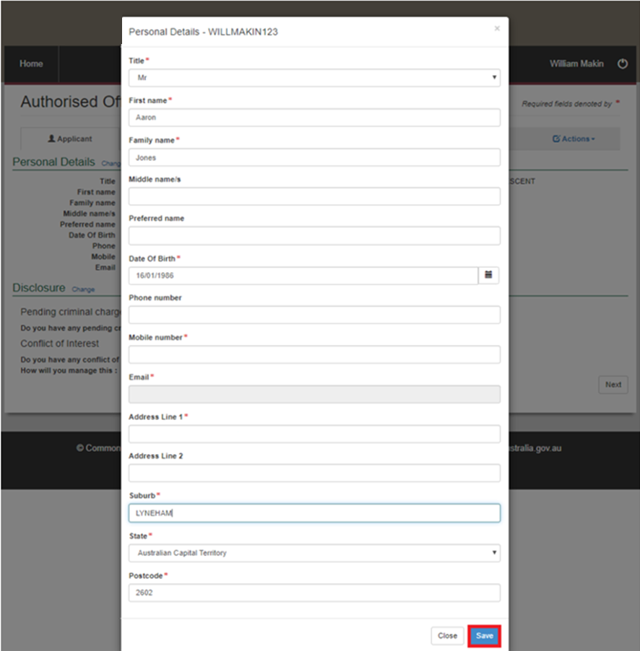
6. | - Note the confirmation that ‘Your personal details have been updated’.  - Add Disclosure details by clicking ‘Add’. | 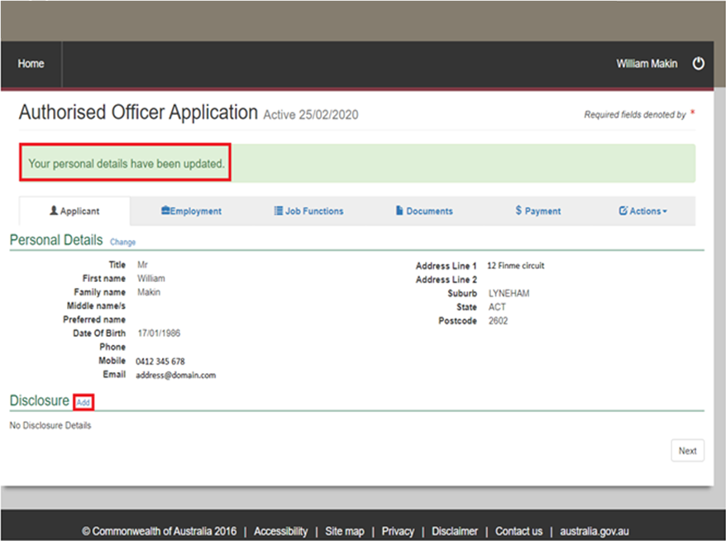
7. | Do you have any pending criminal charges?  If… Then…  yes - click the ‘Yes’ button - continue to Step 8.  no - click the ‘No’ button - go to Step 9.  Note: A pending charge will not automatically exclude you from being appointed as an AO. Nonetheless, the department may be concerned that a particular charge reflects on your fitness to perform the services required or may affect the integrity and reputation of the department. | 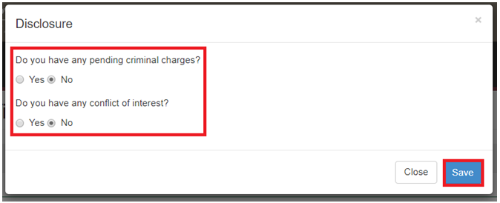
8. | Add details of your pending criminal charges. | 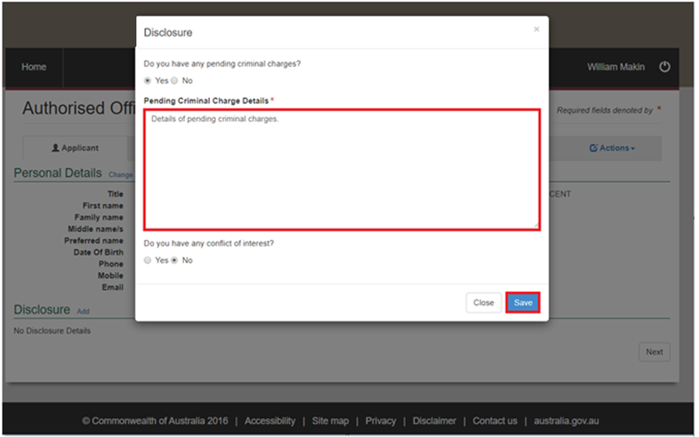
9. | Do you have any conflicts of interest?  If… Then…  yes - click the ‘Yes’ button - continue to Step 10.  no - click the ‘No’ button - click ‘Save’ - go to Step 11. | 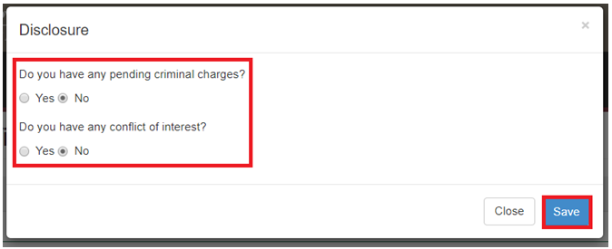
10. | - Select one or more items from the conflict-of-interest list.  - Add details of how you will manage your conflict of interest/s.  - Click ‘Save’. | 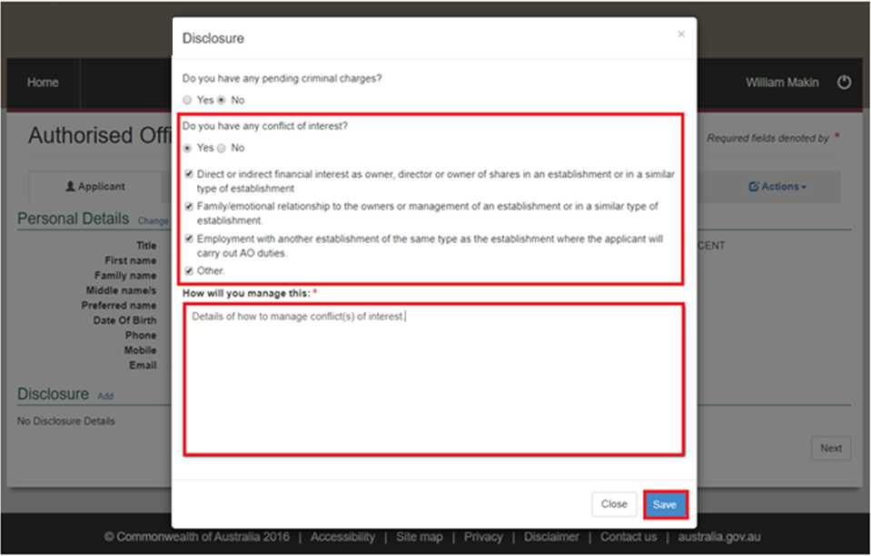
11. | - Note the confirmation that ‘Disclosure details has been added’.  - Review your details.  - Click ‘Next’.  - Go to ‘Employment’. | 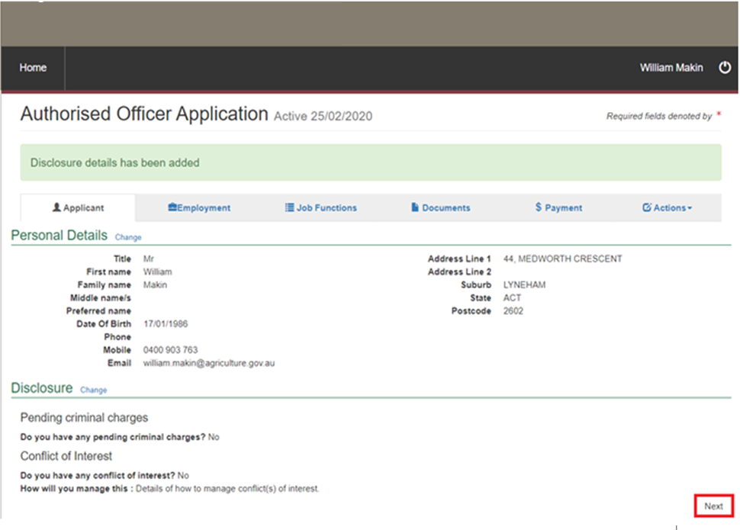

Employment
The following table outlines how to review and complete the employment tab for an AO application.
Step | Action | Graphic
1. | Click ‘Add’. | 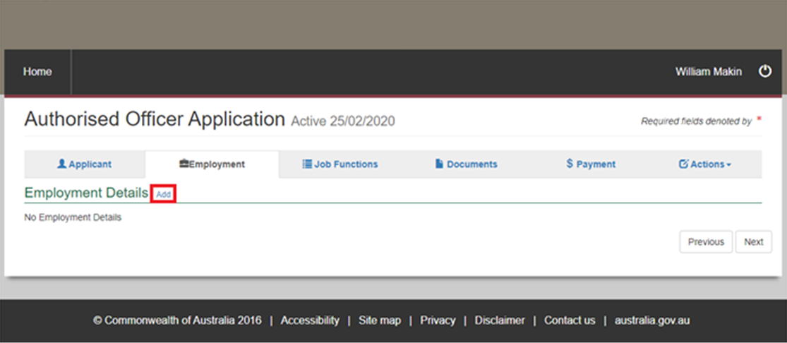
2. | Are you employed by a Registered Establishment?  If you… Then…  are - click the ‘Yes’ button - go to Step 4.  are not - click the ‘No’ button - continue to Step 3. | 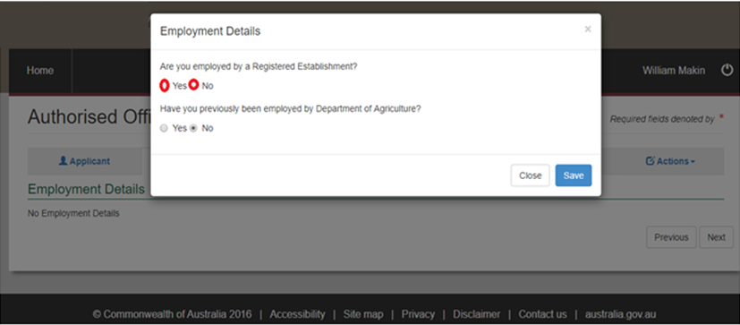
3. | Do you intend to become an independent third party AO?  Important: If you are not currently employed by a Registered Establishment, you must register as an independent third party AO; noting that this can be updated at any time.  If… Then…  yes - click the ‘Yes’ button - enter your Town/ Suburb - enter your postcode - go to Step 5.  no - click the ‘No’ button Note: The answer to ‘Are you employed by a Registered Establishment?’ will default to ‘Yes’ and you will be prompted to enter the details of the Registered Establishment - continue to Step 4. | 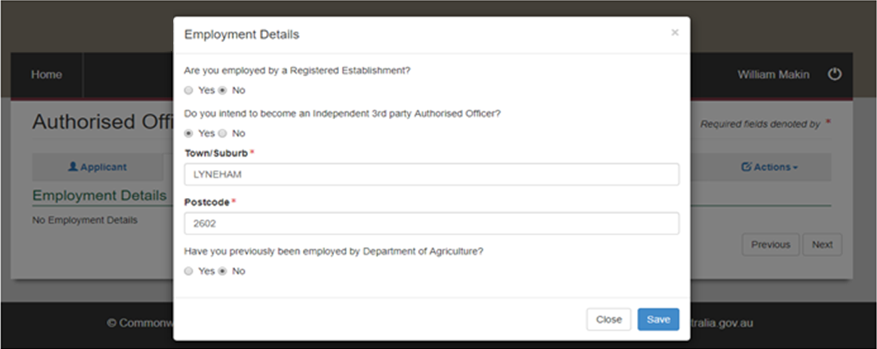
4. | Fill in the details of the Registered Establishment.  Note: If you know your establishment number, enter this within the ‘Establishment Number’ box and select ‘Search’. This will automatically populate the required information into the other mandatory fields. | 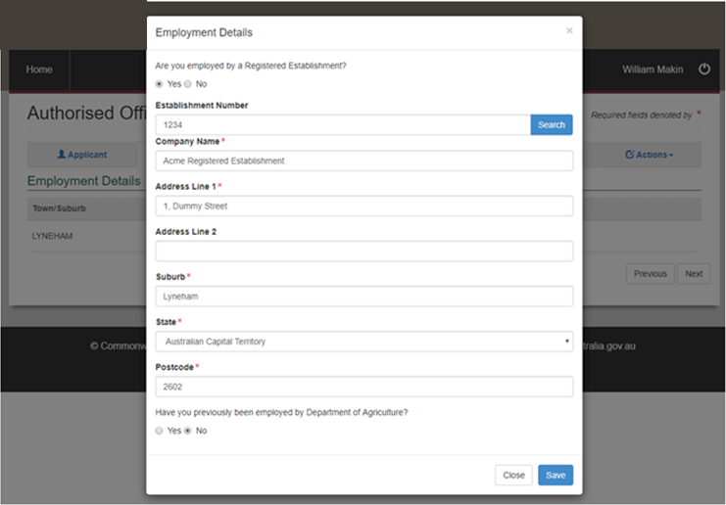
5. | Have you previously been employed by the Department of Agriculture, Fisheries and Forestry?  Note: This includes current and former Commonwealth Department of Agriculture, Fisheries and Forestry names.  If you… Then…  have - click the ‘Yes’ button - continue to Step 6.  have not - click ‘No’ button - click ‘Save’ - go to Step 7. | 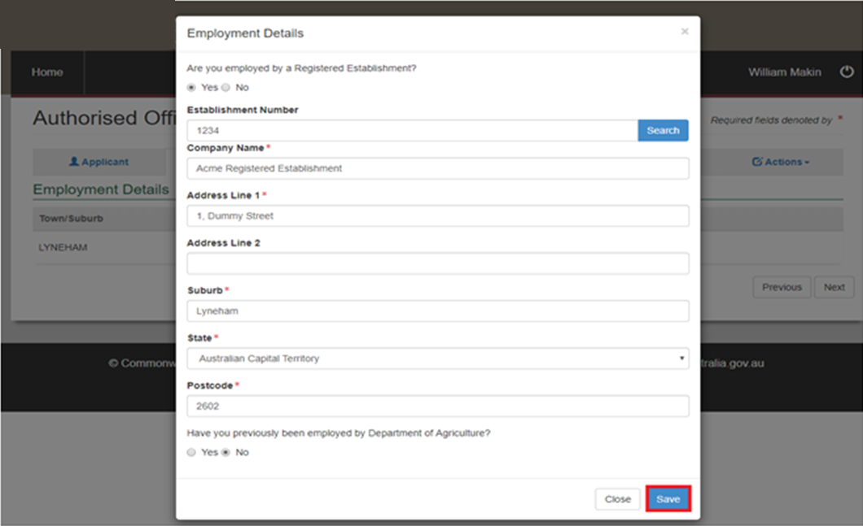
6. | - Enter your position held.  - Enter your separation date (if known).  - Click ‘Save’. | 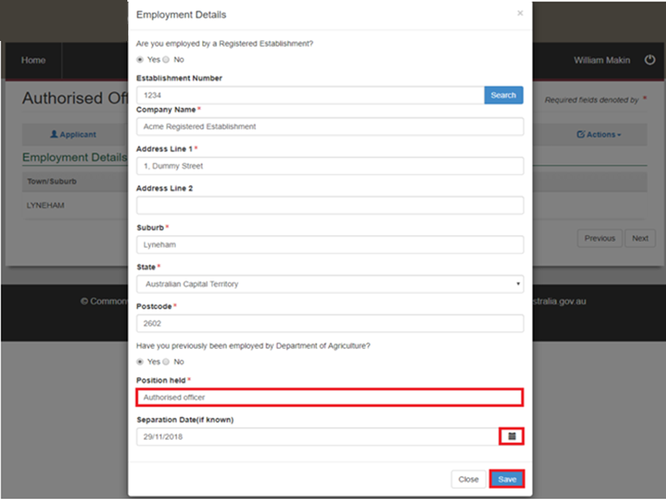
7. | - Click ‘Next’.  - Go to ‘Job Functions’. | 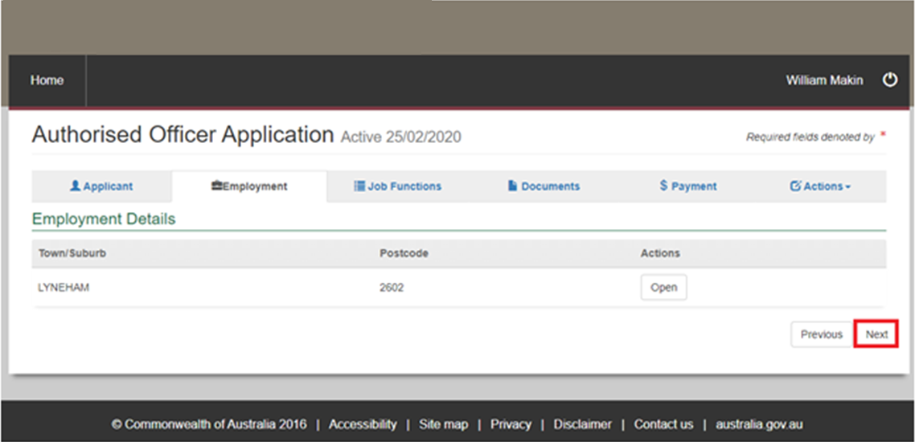

Job functions
The following table outlines how to review and choose job functions for an AO application.
Step | Action | Graphic
1. | Add the job function/s you are applying for by selecting the plus ‘+’ symbol.  Notes:  - If you are unsure of the job function/s you need to apply for, please refer to the Exports reference: Table of authorised officer job functions.  - A learning and assessment fee will be charged at the time you request training for every “package” of up to 5 job functions. For example, if you request 3 job functions as part of your application, you will be charged 1x learning and assessment fee. If you request 6 job functions as part of your application, you will be charged 2x learning and assessment fees. | 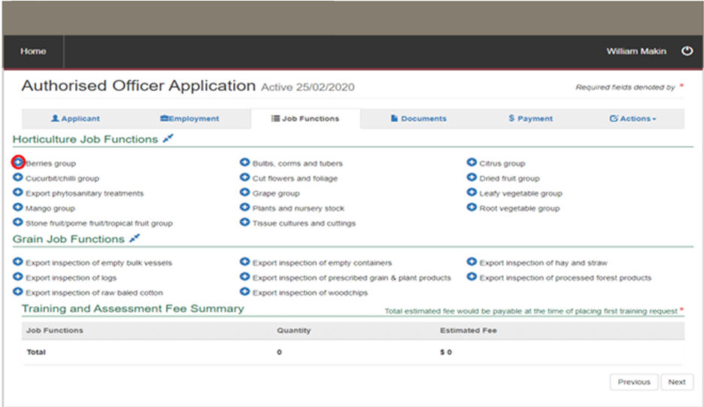
2. | - Choose a job function from the options.  - Click ‘Save’. | 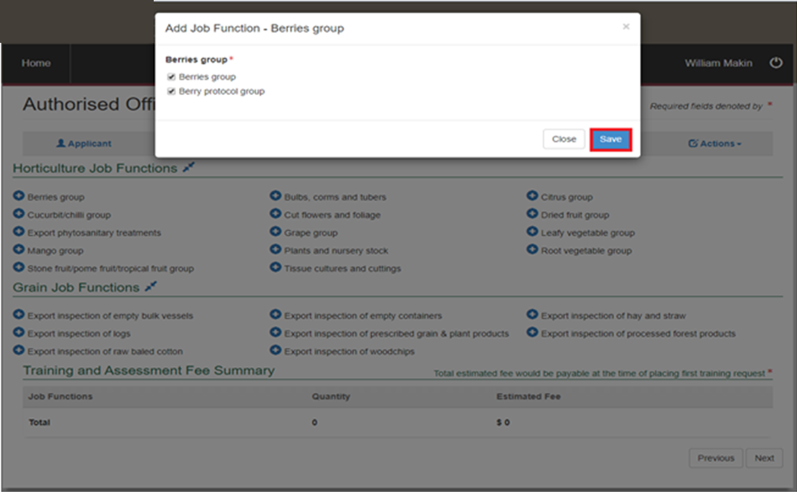
3. | Note the selection and fee now on the screen.  If you… Then…  need to add more job functions return to Step 1.  don’t need to add more job functions go to Step 6.  need to remove a job function continue to Step 4. | 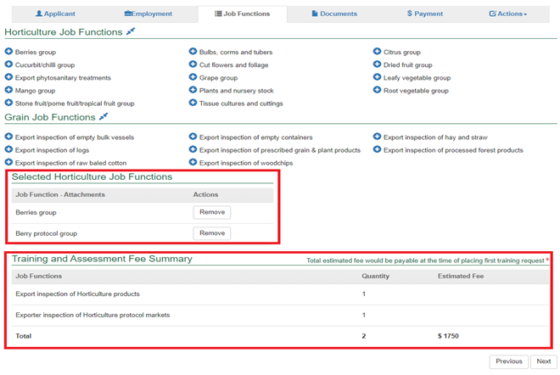
4. | Click on the ‘Remove’ button. | 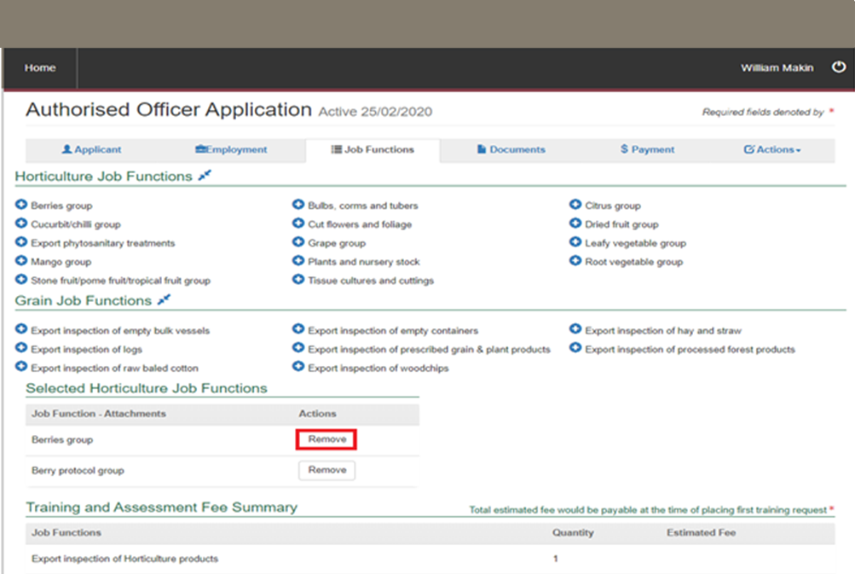
5. | Click ‘OK’. | 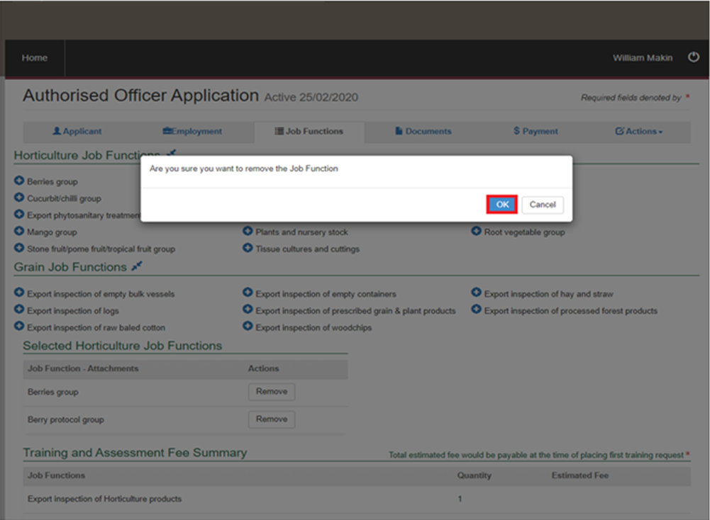
6. | - Click ‘Next’.  - Go to ‘Documents’. | 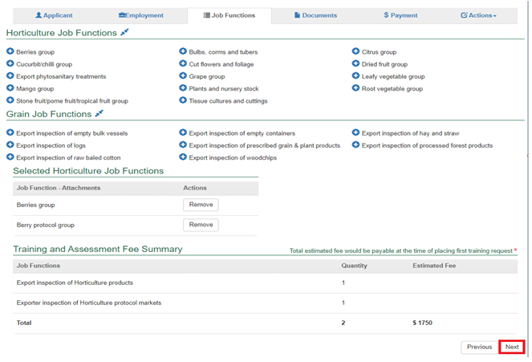

Documents
The following table outlines how to add supporting documents for an AO application.
Step | Action | Graphic
1. | Add the document by selecting the plus ‘+’ symbol. | 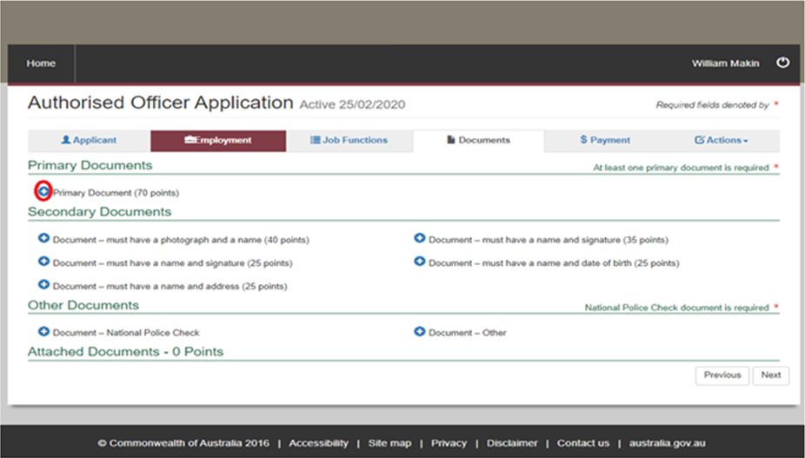
2. | - Attach the document.  - Select which document type it is.  - Add any comments as needed.  - Click ‘Save’. | 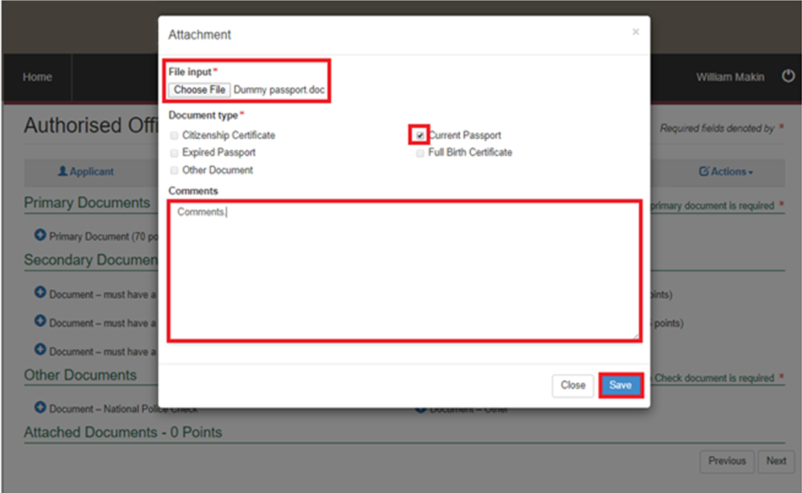
3. | Note the attached document.  If you… Then…  need to attach more documents Important: 100 points of ID are required—at least one primary, and one containing a photograph. You do not need to add more than 100 points of ID. return to Step 1.  don’t need to attach more documents continue to Step 4. | 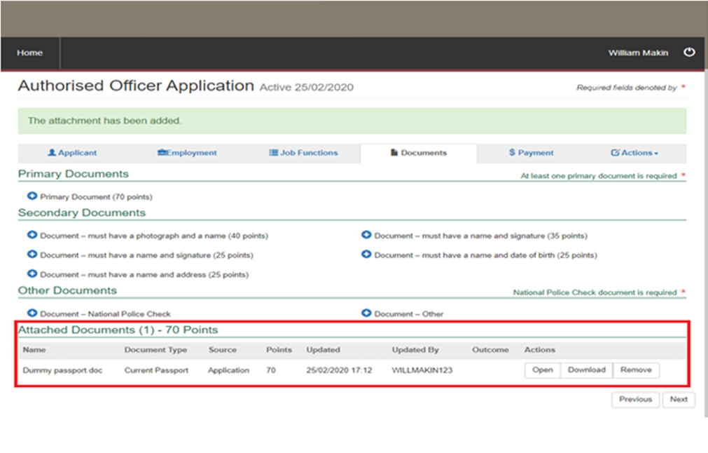
4. | - Add national police check.  - Check ‘National Police Check’ box.  - Add comments as needed.  - Click ‘Save’.  Note: A criminal conviction will not automatically exclude you from being appointed as an AO. Nonetheless, the department may be concerned that a particular conviction reflects on your fitness to perform the services required or may affect the integrity and reputation of the department. | 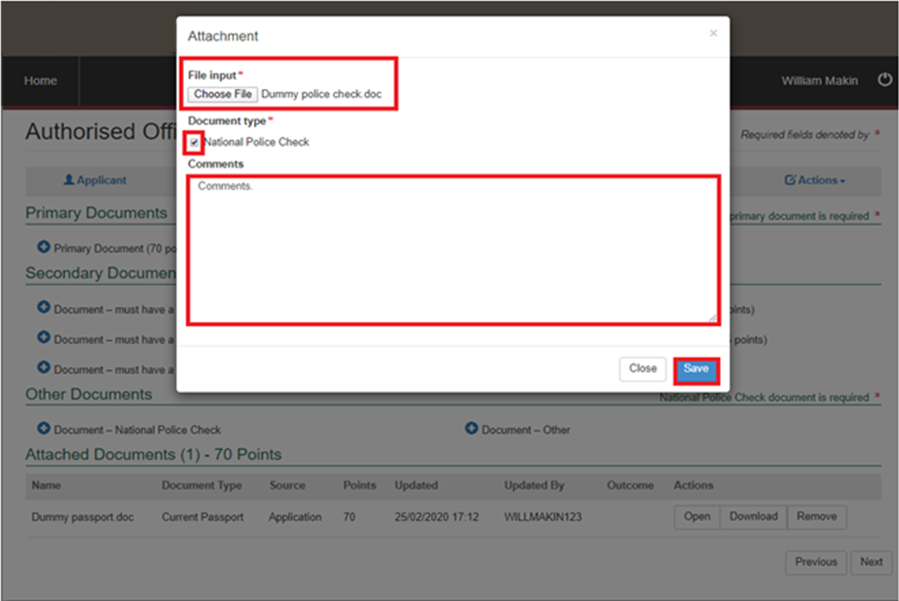
5. | - Click ‘Next’.  - Go to ‘Payment’. | 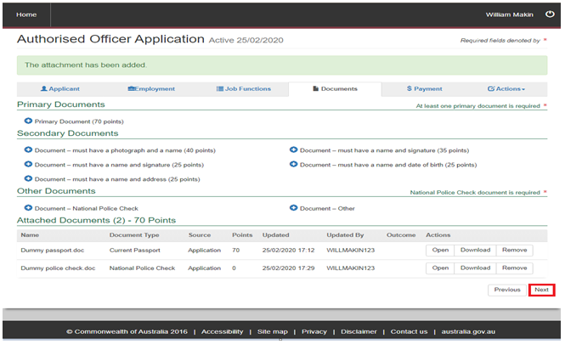

Payment
The following table outlines how to make payment for an AO application.
Step | Action | Graphic
1. | Click on the ‘Make Payment’ link. | 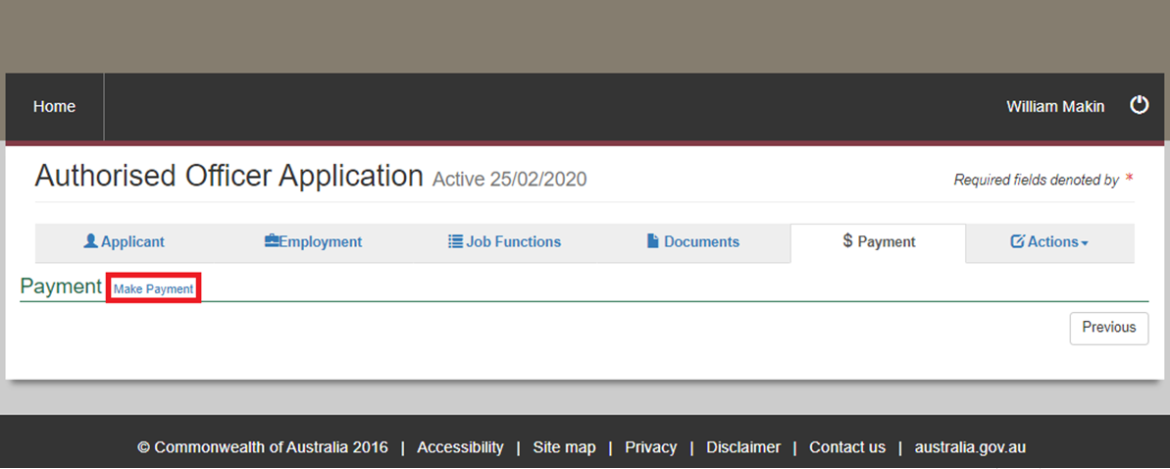
2. | - Read the declaration.  - Check the box ‘I have read and understood the above terms and conditions’.  - Click ‘Accept Declaration’. | 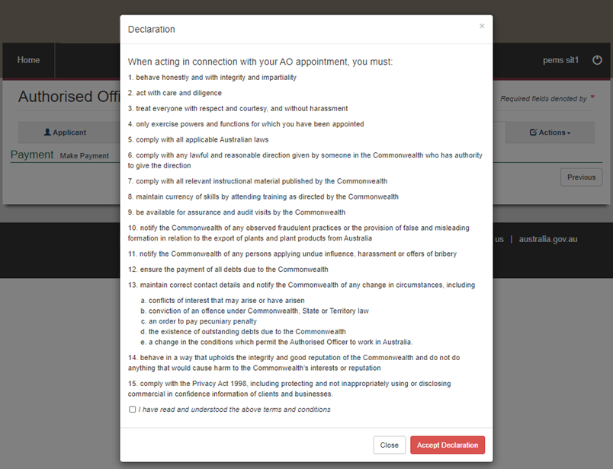
3. | When ready to pay, click the ‘Pay Now’ button. | 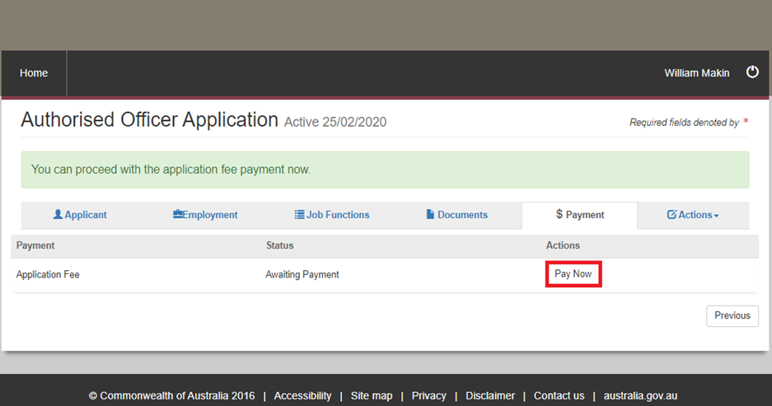
4. | Review and verify the information for the online payment.  If it is… Then…  correct go to Step 6.  incorrect - click ‘Cancel’ - continue to Step 5. | 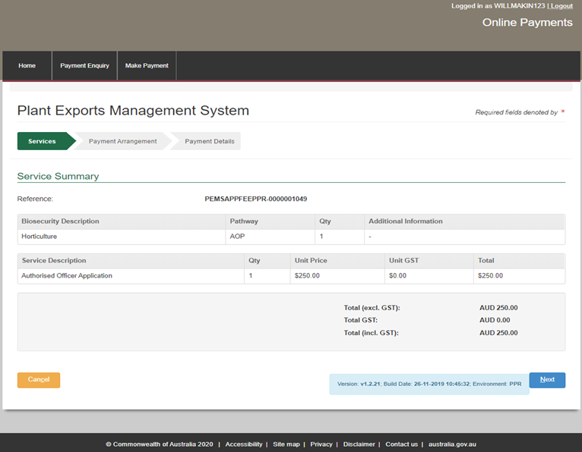
5. | - Confirm cancelation by clicking ‘OK’.  - Go back to ‘Job Functions’ to make changes to the job functions selected. | 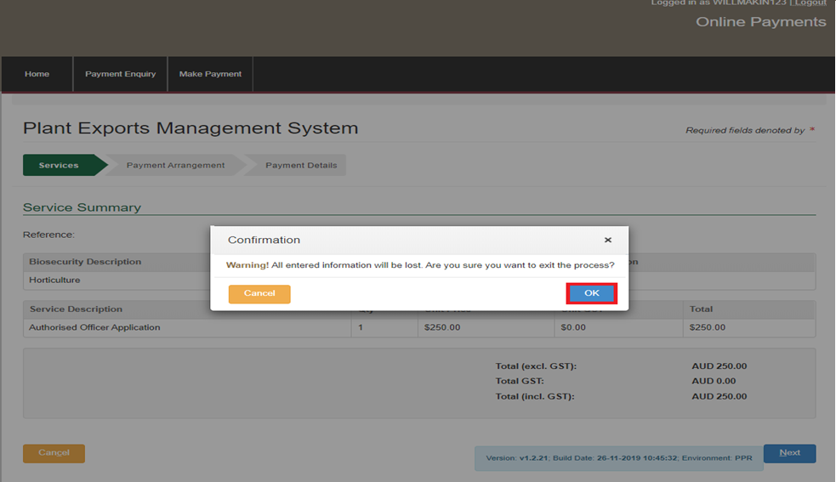
6. | Click ‘Next’. | 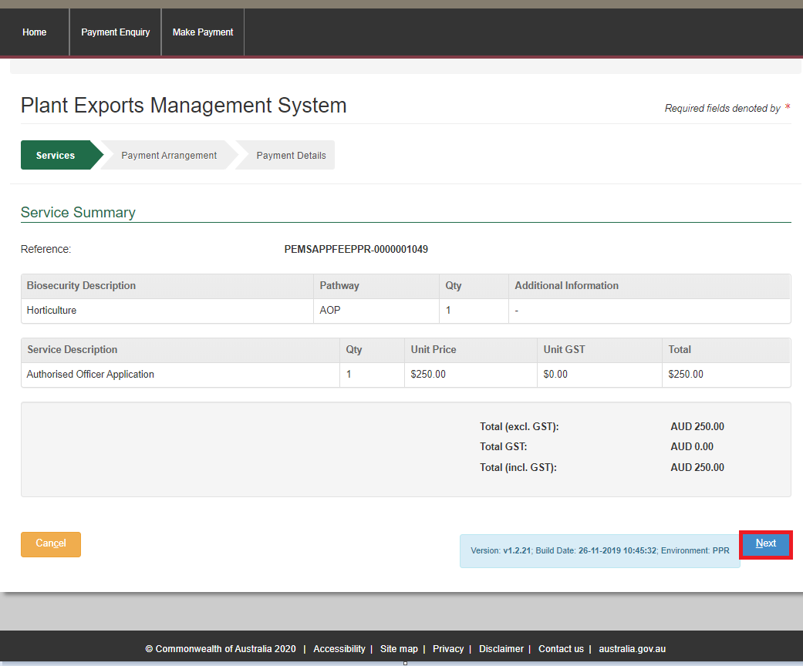
7. | - Select ‘No’ to the question Do you have an Account Number?  - Click ‘Continue to Payment’. | 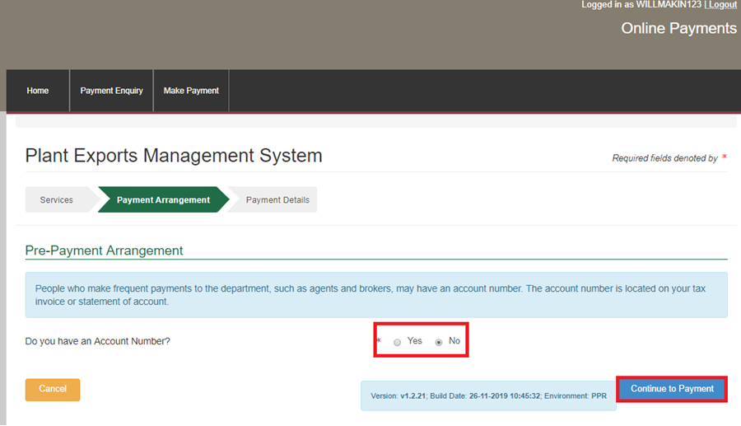
8. | - Enter your credit/debit card details  - Click ‘Pay Now’. | 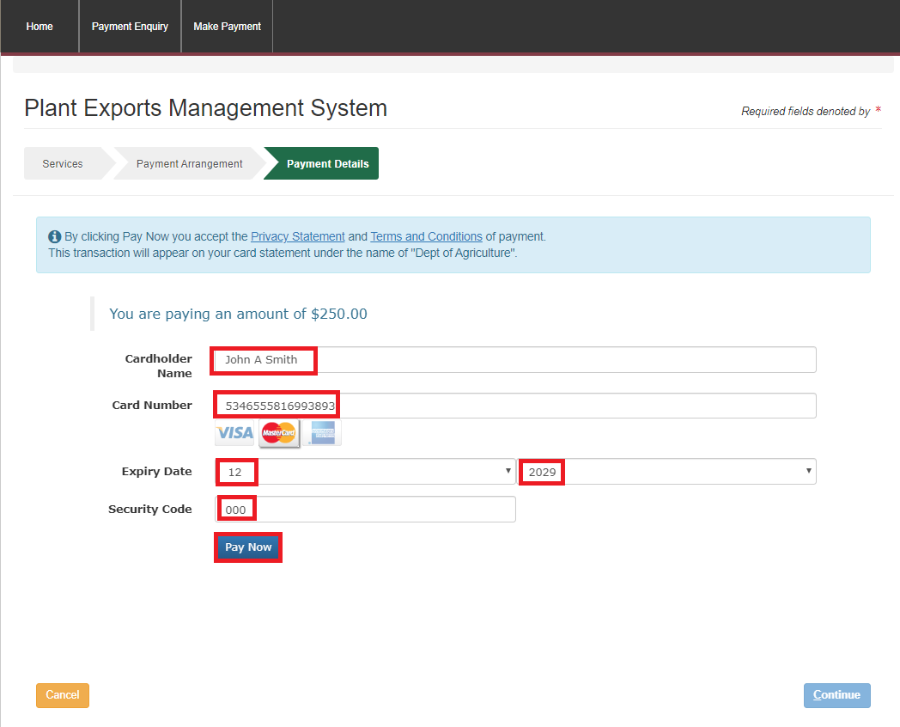
9. | - Note your payment confirmation.  - Click 'Continue’.  Important: Your application has not yet been submitted, you must continue to the next step. | 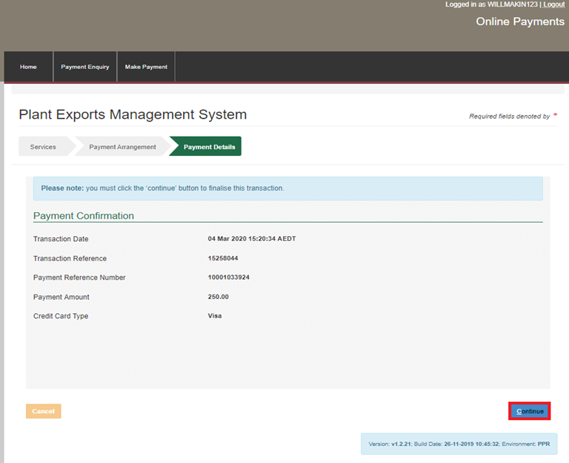
10. | - Select ‘Actions’  - Click ‘Submit’
11. | Review the text in the pop-up box.  If you… Then…  want to add more job functions - click the ‘Cancel’ button - go back to ‘Job Functions’.  don’t want to add more job functions - click the ‘OK’ button - continue to Step 12. | 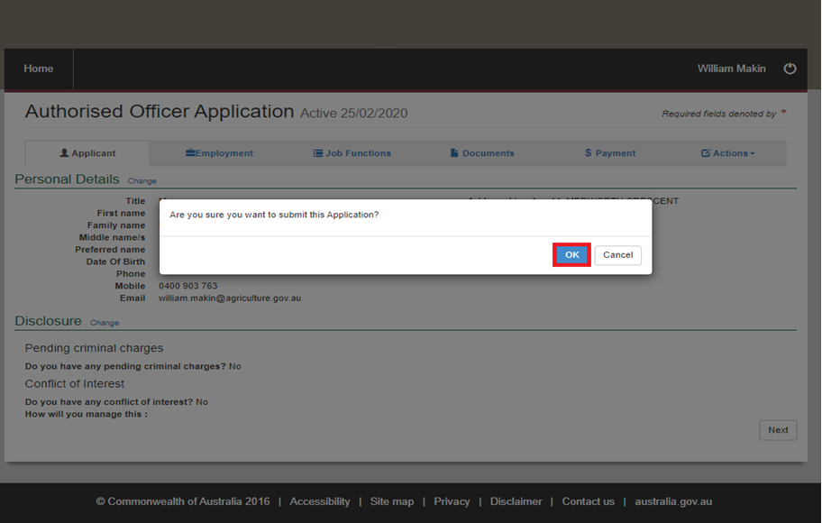
12. | - Note your submitted application.  - End of procedure.  Note: You will now receive an email stating that your application has been received. | 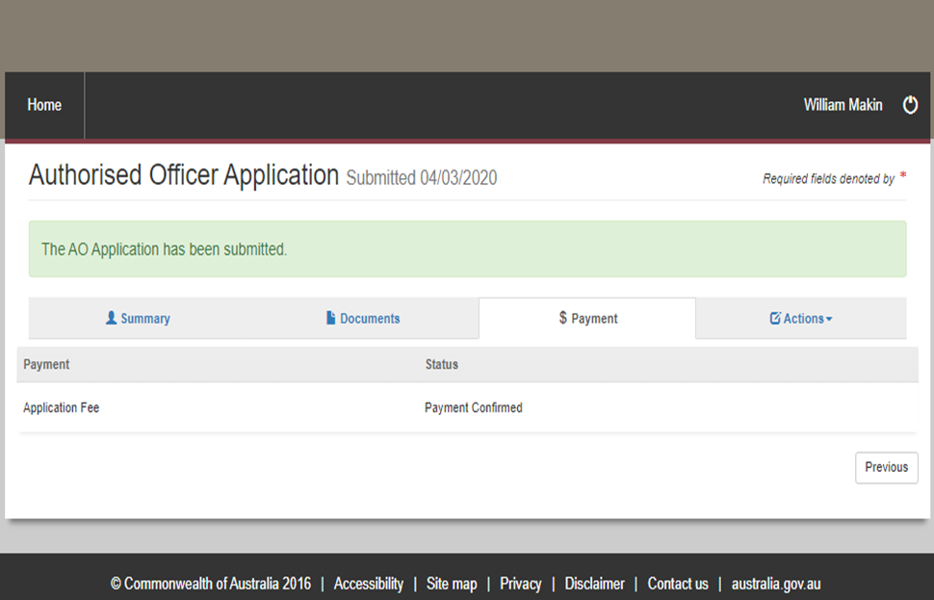

Contact information
- Authorised Officer Program: PlantExportTraining@aff.gov.au
- Authorised Officer Hotline: 1800851305

Related material
The following related material is available online:
- Authorised Officer webpage
- Exports Policy: Management of third party plant exports authorised officers
- Exports work instruction: Requesting Authorised Officer training using the Plant Exports Management System
- Exports work instruction: Requesting Authorised Officer assessment using the Plant Exports Management System
- Exports work instruction: Requesting an Authorised Officer Instrument of Appointment using the Plant Exports Management System
- Exports reference: Requesting additional job functions in the Plant Exports Management System
- Plant Exports Management System
- Plant Export Operations Manual
- Exports reference: Plant Exports Management System Authorised officer user guide
- Exports reference: Table of authorised officer job functions
- Authorised Officer declaration of boarding experience.
- Fees and charges
- Privacy Policy
- Australian Federal Police webpage (police checks)

Document information
The following table contains administrative metadata.
Instructional Material Library document ID | IMLS-9-7543
Instructional material owner | Director, Authorised Officer Program
Risk rating | Low
Review period | Due for review within 4 years of the most recent approved date.

Version history
The following table details the published date and amendment details for this document.
Version | Date published | Date last approved | Review type | Summary of review
1.0 | 06/07/2020 | 06/07/2020 | New document | First publication of this work instruction.
2.0 | 6/08/2020 | 6/08/2020 | Minor change | Re-title of the WI: Requesting Authorised Officer training using the Plant Export Management System.
3.0 | 22/04/2021 | 22/04/2021 | Major change | Updates for the commencement of the Export Control Act 2020 and associated Export Control (Plants and Plant Products) Rules 2021.
4.0 | 31/10/2022 | 31/10/2022 | Minor change | Minor updates to reflect updates to fees and charges and PEMS.
5.0 | 28/02/2024 | 28/02/2024 | Minor change | Minor updates to reflect changes to department name and contact details.
6.0 | 19/04/2024 | 19/04/2024 | Major change | Major updates to screengrabs.
7.0 | 11/10/2024 | 11/10/2024 | Major change | Included information about the learning and assessment fee.

