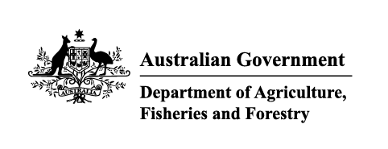

Instrument revoking a holding order under section 15(2) of the Imported Food Control Act 1992
The listed holding orders, having satisfied the circumstances under which the orders will be revoked, are revoked under section 15(2) of the Imported Food Control Act 1992 (the Act).
The circumstances being that the Secretary or delegate is satisfied that the basis for the order no longer applies.

Holding order number | Date revoked
18593 | 02/04/2026
18947 | 02/04/2026
19770 | 02/04/2026
20050 | 02/04/2026
20137 | 02/04/2026
20250 | 07/04/2026
20289 | 10/04/2026
20289 | 10/04/2026
20289 | 10/04/2026
17413 | 15/04/2026
20093 | 15/04/2026
20094 | 15/04/2026
17948 | 16/04/2026
19629 | 16/04/2026
15921 | 21/04/2026
16037 | 21/04/2026
17724 | 21/04/2026
17728 | 21/04/2026
17849 | 21/04/2026
17875 | 21/04/2026
17889 | 21/04/2026
18451 | 21/04/2026
18507 | 21/04/2026
18530 | 21/04/2026
18564 | 21/04/2026
18679 | 21/04/2026
18733 | 21/04/2026
18750 | 21/04/2026
18851 | 21/04/2026
18911 | 21/04/2026
19016 | 21/04/2026
19025 | 21/04/2026
19056 | 21/04/2026
19060 | 21/04/2026
19060 | 21/04/2026
19067 | 21/04/2026
19068 | 21/04/2026
19073 | 21/04/2026
19075 | 21/04/2026
19076 | 21/04/2026
19077 | 21/04/2026
19078 | 21/04/2026
INC23004 | 21/04/2026
INC24007 | 21/04/2026
INC24009 | 21/04/2026
REC23013 | 21/04/2026
20078 | 22/04/2026
20306 | 24/04/2026
19530 | 30/04/2026
19667 | 30/04/2026
19891 | 30/04/2026
20155 | 30/04/2026

Delegate position number | Date
100091 | 19/05/2026
Delegate of the secretary for the purposes of section 15(2) of the Act.

