

Aquatic fauna use of the Warrego River Western Floodplain
Summer 2017
Prepared for
The Commonwealth Environmental Water Office

June 2017

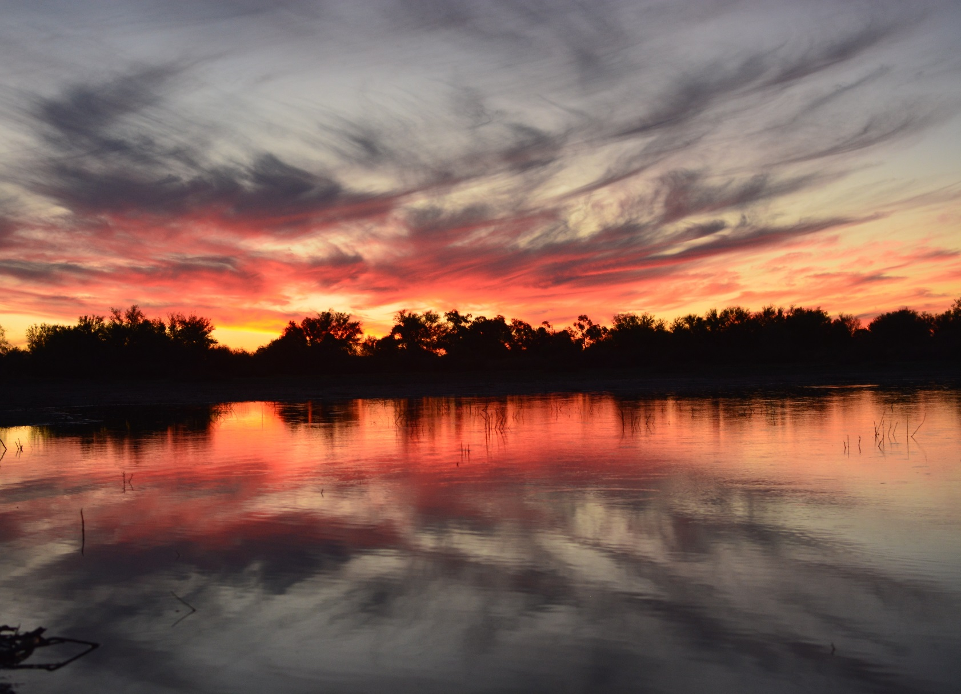

DOCUMENT TRACKING
Item | Detail
Project Name | Aquatic fauna use of the Warrego River Western Floodplain
Project Number | 16ARM-5947
Project Manager | Dr Mark Southwell  02 8081 2688  92 Taylor St, Armidale, 2350
Prepared by | Peter Hancock, Ben Martin
Reviewed by | Mark Southwell
Approved by | Mark Southwell
Status | FINAL
Version Number | 1
Last saved on | 3 August 2017
Cover photo | Dusk at Site 3 before commencing the frog survey. Photo by Peter Hancock

This report should be cited as ‘Eco Logical Australia 2017. Aquatic fauna use of the Warrego River Western Floodplain. Prepared for the Commonwealth Environmental Water Office.’

Disclaimer
This document may only be used for the purpose for which it was commissioned and in accordance with the contract between Eco Logical Australia Pty Ltd and Commonwealth Environmental Water Office. The scope of services was defined in consultation with Commonwealth Environmental Water Office, by time and budgetary constraints imposed by the client, and the availability of reports and other data on the subject area. Changes to available information, legislation and schedules are made on an ongoing basis and readers should obtain up to date information.
Eco Logical Australia Pty Ltd accepts no liability or responsibility whatsoever for or in respect of any use of or reliance upon this report and its supporting material by any third party. Information provided is not intended to be a substitute for site specific assessment or legal advice in relation to any matter. Unauthorised use of this report in any form is prohibited.
Template 29/9/2015

Contents
Executive summary v
1 Background 1
1.1 Introduction 1
1.2 Scope 1
2 Methods 4
2.1 Study sites 4
2.2 Hydrological context 7
2.3 Survey methods 7
2.3.1 Fish and turtles 7
2.3.2 Frogs 9
2.3.3 Macrocrustaceans 9
2.3.4 Birds 9
3 Results 10
3.1 Water Quality 10
3.2 Fish communities 10
3.3 Turtle communities and yabbies 12
3.4 Frog communities 13
3.5 Bird communities 14
3.6 Opportunistic terrestrial fauna 23
4 Discussion 24
4.1 Fish 24
4.2 Frogs 25
4.3 Birds 26
4.4 Faunal response to inundation frequency 26
4.5 Waterhole persistence 27
4.6 Food web dynamics on the Western Floodplain 27
5 Conclusion 29
References 30

List of figures
Figure 1 Location of the Western Floodplain and floodplain structures that influence water flows along it 2
Figure 2 Maximum inundation extent of the flood event in November 2016 3
Figure 3 Survey sites on the Western Floodplain. 5
Figure 4 Western floodplain Sites that were monitored in February 2017 for fauna. 6
Figure 5 Water level in Boera Dam and period of connection to the Western Floodplain 7
Figure 6 Retrieving a fyke net from Site 6 8
Figure 7 Setting a bait trap at Site 5 8
Figure 8 Carp (Cyprinus carpio) collected using a a fyke net in February 2017 11
Figure 9 Hyrtl's catfish (Neosilurus hyrtlii) collected from Site 5 12
Figure 10 Juvenile Murray Turtles (Emydura macquarii) at Site 4. 12
Figure 11 Yabby (Cherax destructor) collected from Site 5 13
Figure 12 Peron's Tree Frogs (Litoria peronii) at Site 2. 14
Figure 13: Dietary preferences of birds at Toorale wetland sites. 15
Figure 14 Waterbirds observed during the February 2017 survey on the Western Floodplain (a) Pink Eared Duck (Malacorhynchus membranaceus) (b) Royal Spoonbill (Platalea regia) and (c) Brolga (Grus rubicunda) 16
Figure 15 Estimated extent of Site 3 on initial disconnection (light blue) and then during the survey (dark blue) 25
Figure 16: Generic food-web for trophic interactions at waterholes on the Western Floodplain during the flow recession period of February 2017. 28

List of tables
Table 1: Brief descriptions of survey sites 4
Table 2. Physico-chemical measurements at sites on the Western Floodplain 10
Table 3: Fish collected from 6 sites on the Western Floodplain 11
Table 4 Turtle and yabby captures at each Western Floodplain site. 13
Table 5. Frogs observed during spotlighting around waterholes of the Western Floodplain. 14
Table 6 Birds observed on the Western Floodplain during the February 2017 survey. * denotes waterbirds 17
Table 7: Terrestrial fauna observed opportunistically on the Western Floodplain * denotes exotic species 23

Executive summary
The existing Warrego-Darling Long term intervention monitoring (LTIM) project includes several sites on the Western Floodplain where vegetation and fauna surveys are undertaken by Eco Logical Australia (ELA). In February 2017, a series of disconnected waterholes were present on the Western Floodplain following a significant inundation event in late 2016. Conditions on the floodplain in February 2017 provided an opportunity to broaden the monitoring being undertaken as part of the existing LTIM project and to better assess links between floodplain inundation and responses in the aquatic fauna community.
Sampling in February 2017 on the Western Floodplain targeted key groups of aquatic fauna, including fish, macrocrustaceans, frogs, birds and turtles, and assessed the influence of inundation frequency on patterns of diversity and abundance. The survey also linked patterns in the faunal communities to the receding water levels in the surveyed wetlands.
Several specific questions were addressed by this study:
- What aquatic animal species are using the Western Floodplains during inundation events, and does the species composition vary with floodplain inundation frequency?
- What are the abundances of key faunal groups on the Western Floodplain and do they vary with floodplain inundation frequency?
For this study, sites were stratified into high (inundated in the two years prior to 2016) and low (not inundated since 2012) inundation frequency groups. Sites also differed in depth and therefore potential duration of inundation.
A total of 2,749 fish from eight species, 21 turtles of two species and 19 yabbies were sampled at the study sites. In addition, 1,194 birds from 76 species and 288 frogs from three species were observed on the Western Floodplain.
Our preliminary results suggest that some fish species, such as Murray Rainbowfish, Carp, and Goldfish, as well as Murray Turtles and Peron’s Tree Frog likely bred during the expansion phase of floodplain inundation, then become concentrated as waterholes shrunk. Similar patterns can be inferred in microcrustacean communities, through examining abundances of some waterbird taxa such as Pink-eared Duck and Royal Spoonbill.
Only three species of frog were observed in our survey. Of these, Perons Tree Frog was the most abundant, present as recent metamorphs. These frogs preferred sites where structure (dead trees, shrubs) was in close proximity to waterholes. Waterholes with high inundation frequency had at least three times as many frogs as those with low inundation frequency.
Two species of turtle were recorded, with the Broad-shelled Turtle being the most abundant. Yabbies were present at most sites in low numbers.
In the drying phase, native fish species seemed to preferentially congregate in deeper waterholes. This is likely to be a strategy to allow them to survive in dry times. Spangled Perch and Bony Bream were most abundant in waterholes where inundation frequency was low.

Background

Introduction
The Western Floodplain is an extensive floodplain system that borders the Warrego River within the Toorale State Conservation Area. The Western Floodplain is inundated by water breaking from the Warrego channel at Boera Dam. The floodplain then runs in a south westerly direction, and during times of high river flows surface water enters the Darling River 15-20 km downstream of the Toorale SCA boundary (Figure 1). In its upper sections, the Western Floodplain is constrained by natural sand hills to the west, and a man-made training embankment and access road to the east, which restricts the return of water from the floodplain back into the Warrego channel. Water flow is also diverted within the southern areas of the floodplain by a western embankment (Figure 1), a man-made embankment that diverts water into the neighbouring Uteara property and into several old stock dams on Toorale (Cox et al. 2012). Using an environmental watering strategy, the Commonwealth Environmental Water Office (CEWO) manages flows entering Boera Dam in accordance with their licence conditions for both the Western Floodplain and lower Warrego River (CEWO 2015a). Providing water to the Western Floodplain is a focus of this strategy and considers; the environmental demands of the floodplain, the demands in the Warrego and Darling rivers and the volume of water available in the Warrego River. The volume of water that can flow onto the Western Floodplain is dependent on the water level in Boera Dam, which is managed by the National Parks and Wildlife Service (NPWS), by operating two gates on the dam wall.
When water breaks out over the downstream end of Boera Dam, it spreads across the Western Floodplain and drives a suite of biological activity. Plants and animals on the floodplain respond to the water, and the nature of response can change with the spatial extent, duration, and frequency of wetting. Biological activity also changes through time, having a continuum of processes that commence upon the initial wetting, progress through inundation, and culminate as water on the floodplain recedes to isolated pools, or dry claypans. The initial flow down the channels of the floodplain carries with it nutrients, aquatic fauna, and plant propagules. It also links up previously isolated waterholes, connecting animal populations within the floodplain, potentially back into the Warrego River, and in large inundation events potentially back into the Darling River. Water stimulates biological activity, such as the emergence of eggs and seeds from dormant phases that have been stalled since the last time water was present.
Understanding how aquatic fauna use the Western Floodplain will provide information to improve Commonwealth environmental water management decisions at Toorale. Linking patterns of fauna abundance and diversity to hydrodynamic information will allow the CEWO to better target environmental water within Toorale.

Scope
Before 2016, the last major inundation event of the Western Floodplain was in 2012, when most of the floodplain was inundated. Several years of dry conditions followed before some minor flooding occurred in 2015, wetting 464 ha of the northern sections of the floodplain. Significant rainfall in the upper Warrego catchment in September 2016 resulted in widespread inundation of the Western Floodplain (maximum of around 3,365 ha) during late 2016 to early 2017 (Figure 2). This provided an opportunity to undertake additional monitoring to the existing Warrego-Darling LTIM project, which surveys several sites on the Western Floodplain for vegetation and one site for fauna (waterbirds, frogs, invertebrates) when water is present. The aim of this additional monitoring was to better assess links between floodplain inundation and responses in the aquatic fauna community. Sampling targeted key groups of aquatic fauna on the Western Floodplain, including fish, macrocrustaceans, frogs, birds and turtles to assess the biotic response (diversity and abundance of biota) to inundation.
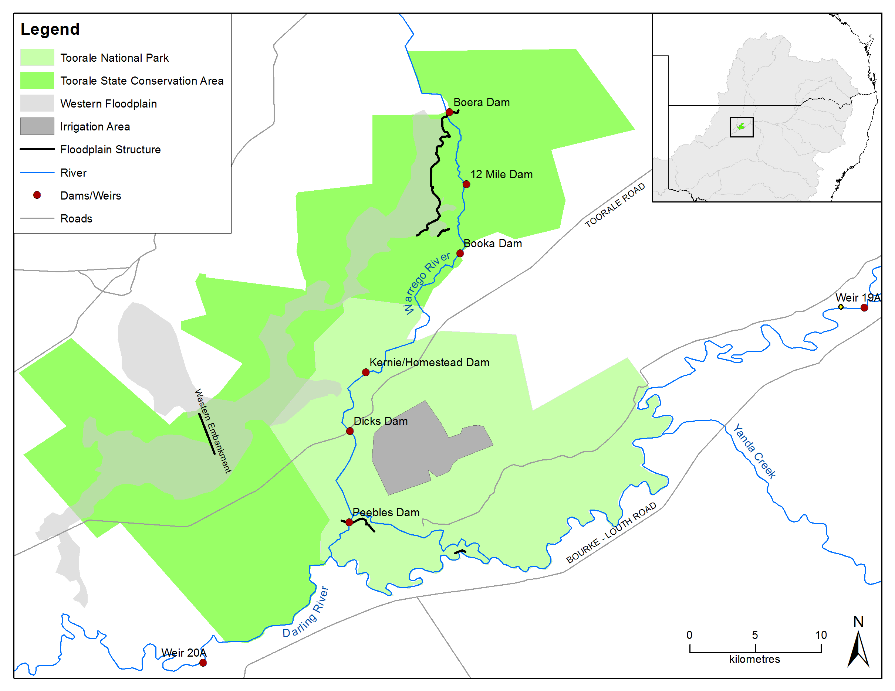
Figure 1 Location of the Western Floodplain and floodplain structures that influence water flows along it

This report focuses on one of two planned survey occasions, being restricted to the disconnection phase of the inundation event.
Several specific questions were addressed by this study:
- What aquatic animal species are using the Western Floodplains during inundation events, and does the species composition vary with floodplain inundation frequency?
- What are the abundances of key faunal groups on the Western Floodplain and do they vary with floodplain inundation frequency?
- How do food-webs change with inundation frequency? This report presents a food web snapshot in time which may be improved with additional surveys.

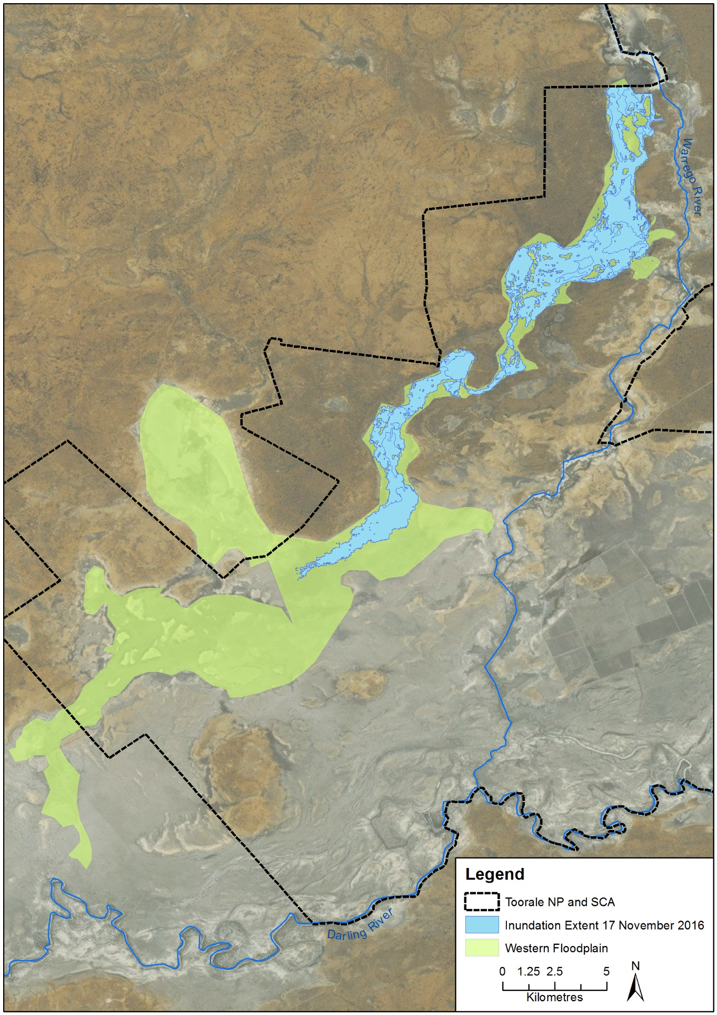
Figure 2 Maximum inundation extent of the flood event in November 2016

Methods

Study sites
The field survey was conducted from 13 to 17 February 2017 by ELA Aquatic Ecologists Dr Peter Hancock and Ben Martin.
Six study sites were sampled on the Western Floodplain of the Warrego River downstream of Boera Dam (Figure 3, Figure 4). At the time of the survey the Western Floodplain was in a drying phase, and waterholes were contracting. Sites were chosen based on their potential inundation frequency, duration of wetting, and location. Three sites were selected as having a ‘high’ inundation frequency as they were inundated in the two years prior to 2016, and three sites were selected as having a ‘low’ inundation frequency (not inundated since 2012). Existing inundation mapping and field observations were used to inform site selection.
Table 1: Brief descriptions of survey sites
Site number | Brief description | Easting | Northing | Nominated inundation duration* | Inundation frequency
Site 1 | This was a dam created by the road embankment and was deeper than 2 m. The dam was surrounded by trees and shrubby vegetation. | 347844 | 6665646 | longer | high
Site 2 | This was a long, skinny waterhole, with a maximum depth of 50 cm, width of 5 m, and length of approximately 120 m. There was one standing dead tree and some fallen branches around its base providing good potential habitat. | 347834 | 6665615 | shorter | high
Site 3 | This site was a shallow wetland approximately 50 cm deep. In December 2016 the water level had fallen to a point where once fringing vegetation (rushes) were isolated from the water by low gradient mudflats up to 50 m wide. | 347418 | 6660803 | shorter | high
Site 4 | This was a large farm dam with steep, bare banks and little shading over the water. | 342348 | 6658922 | longer | low
Site 5 | This was a long dam that had an old truck trailer acting as a bridge. Water was greater than 1.8 m, and there was little fringing vegetation. | 342134 | 6655063 | longer | low
Site 6 | This site was a small agricultural dam that was 90 cm deep. There was a dead pig in the water at one side of the dam. No aquatic vegetation or solid substrata were present, although occasional sticks lay on the bottom of the dam. | 338606 | 6653451 | shorter | low
* duration length is based on the depth of the waterholes, with longer duration sites expected to remain in the landscape for a longer time than shorter duration sites.
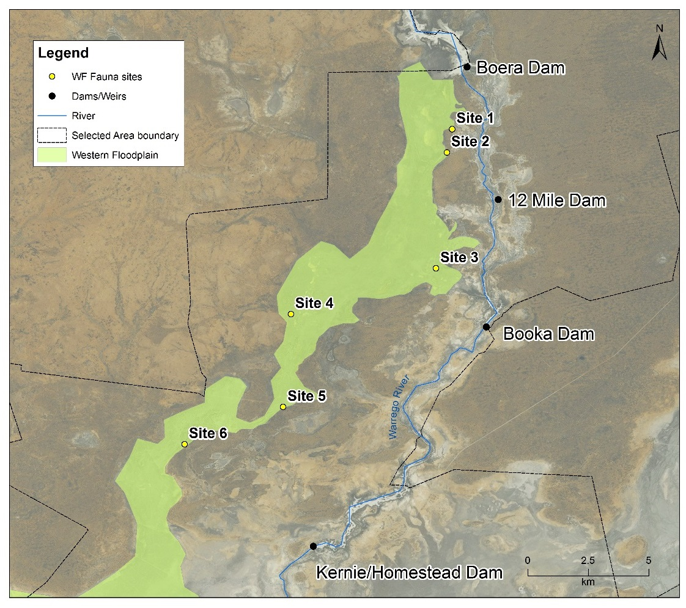
Figure 3 Survey sites on the Western Floodplain.

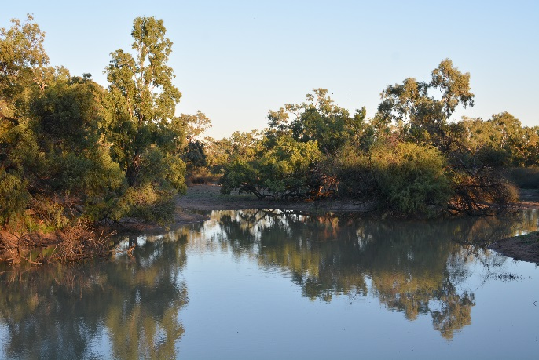
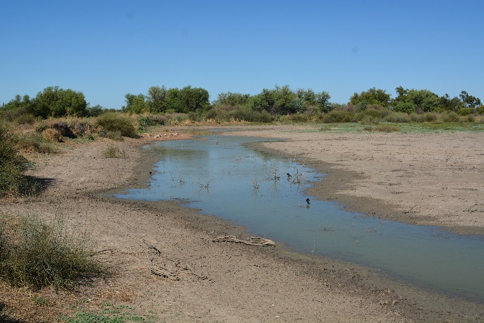
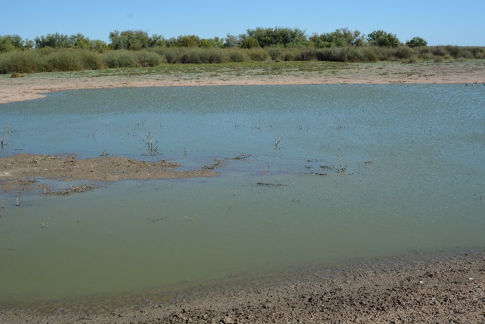
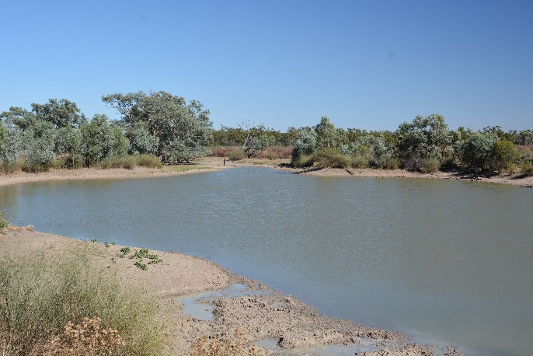
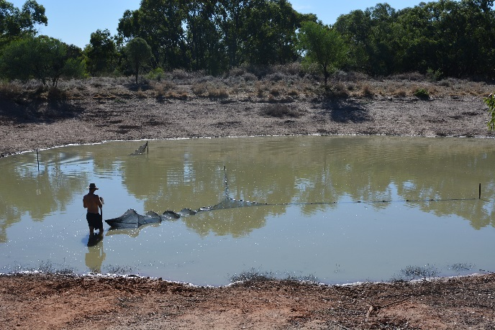
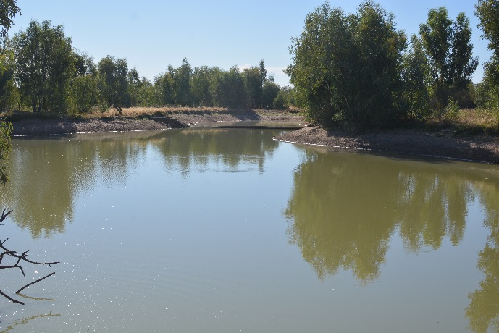
Site 2
Site 1
Site 1

Site 5
Site 6
Site 4
Site 3
Figure 4 Western floodplain Sites that were monitored in February 2017 for fauna.

Hydrological context
Waterholes on the Western Floodplain fill when the Warrego River spills over the western bywash of Boera Dam and moves through a series of shallow, ill-defined channels. The February 2017 survey occurred at a time when water on the floodplain was in recession and waterholes were isolated from the main channel and each other. Connection between Boera Dam and the Floodplain had ceased 2 months prior to sampling (Figure 5). Of the waterholes sampled, three (Site 2, Site 3, Site 6) were small and less than 1 m deep, while three (Site 1, Site 4, Site 5) were deeper and likely to retain water for a longer period.

Survey methods

Fish and turtles
Fish and turtle communities were sampled with fyke nets (Figure 7) and bait traps (Figure 7). Traps were installed late in evening and checked early in the morning. Three fyke nets were installed at five of the sites: two double-wing nets with an opening of 1 m diameter, and one single-winged net with an opening of 60 cm diameter. At Site 3, there was only enough water to install one single-winged net and one double-winged net.
Fish were identified to species and their length measured or estimated (where large numbers were collected). Exotic species (carp and goldfish) were humanely euthanised, while all native species were released after measurement. Turtles were identified, their shell length measured and released unharmed.

Figure 5 Water level in Boera Dam and period of connection to the Western Floodplain
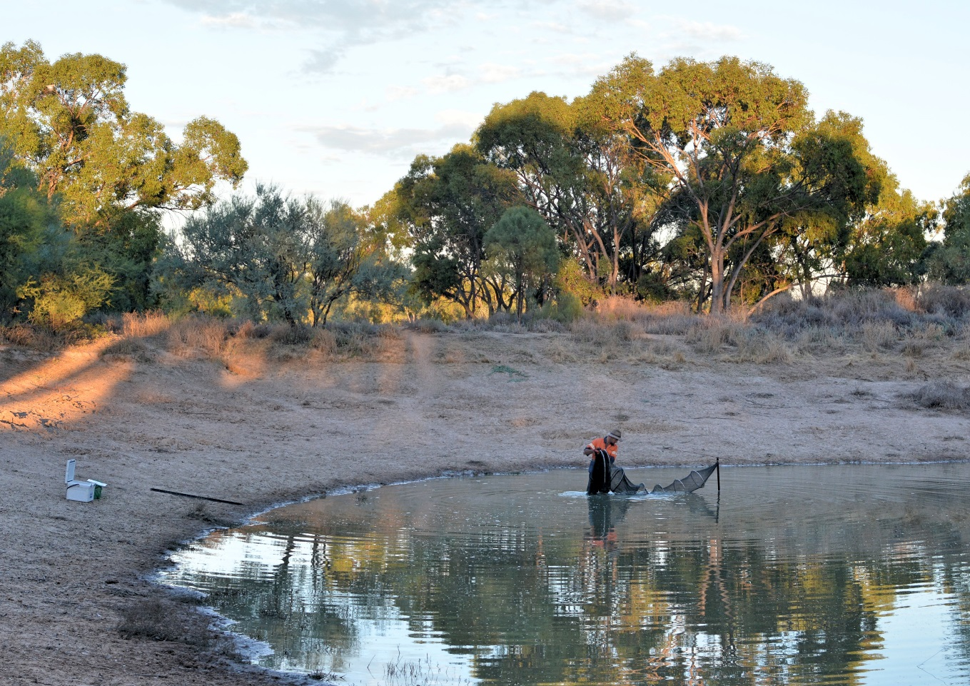
Figure 6 Retrieving a fyke net from Site 6
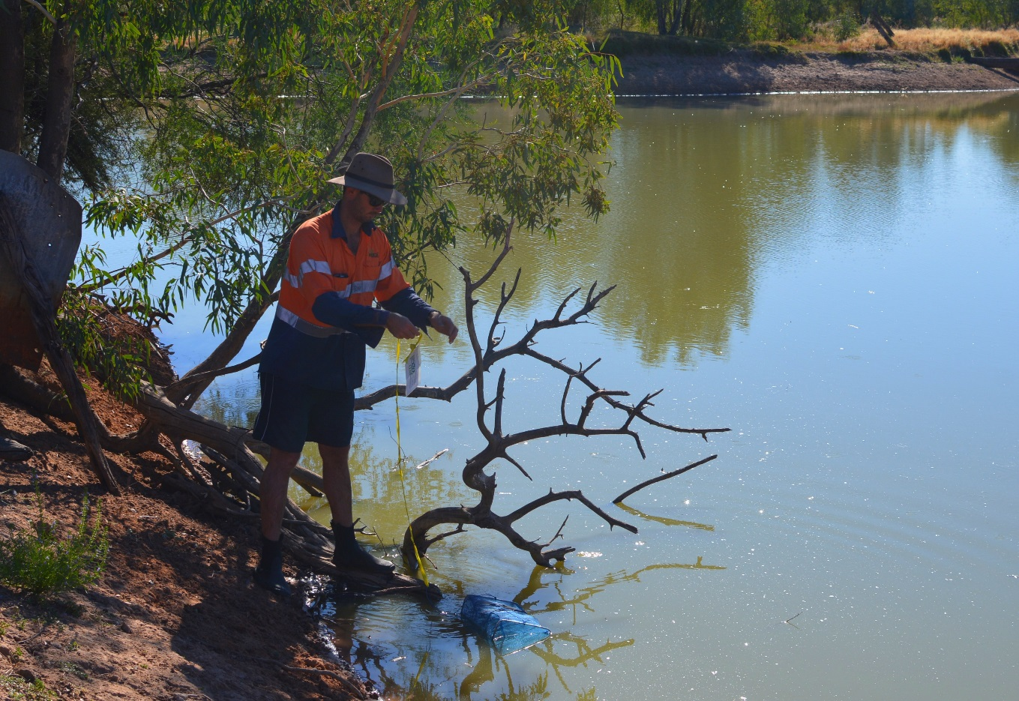
Figure 7 Setting a bait trap at Site 5

Frogs
Frog surveys began about 30 minutes after sunset and continued until 11 pm. Surveys used the same methods as the frog surveys in the Warrego-Darling LTIM project (CEWO 2015b). Two people meandered around the wetted edge of each site for 20 minutes, counting the numbers of each species observed. Habitat features, such as fringing vegetation, fallen timber, and rocks, were given a higher level of scrutiny. Estimates of population size were be made for species heard during the survey using the methods described in Wassens et al. (2011).

Macrocrustaceans
Yabbies and shrimps were sampled using the same techniques as described for fish. In addition, opera house traps were employed to target macrocrustaceans. The carapace length of yabbies, and any evidence of breeding (eggs), was noted as an indicator of growth and recruitment.

Birds
Thirty-minute bird surveys were conducted at each site by two ecologists. Each species seen and heard at and around the designated waterhole, was identified and counted. Species were subsequently classified by how they use aquatic habitats and by their main food type. This information was used to assess how each species responds to inundation.

Results

Water Quality
Physico-chemical parameters varied substantially between sites, presumably a result of each waterhole being in a different stage of drying. Turbidity for most sites was between 177 and 336 NTU, although at Site 4 it was 84.8 and at Site 2 it was 908 NTU. Site 2 had relatively low temperature (18.4ºC) and high EC (737 µS/cm). Dissolved oxygen concentration was low (11.4-26.6% Saturation) at Sites 2, 3, and 6 and moderate (69.5-75.2% Saturation) at the other three sites (Table 2). The pH was between 7.7 and 8.92. All physico-chemical parameters were in the ranges surveyed in the first two years of the LTIM project, and reflect the extreme nature of water quality in intermittent inland freshwater ecosystems (CEWO 2016).
Table 2. Physico-chemical measurements at sites on the Western Floodplain
Parameter | Units | Site 1 | Site 2 | Site 3 | Site 4 | Site 5 | Site 6
Turbidity | NTU | 244 | 908 | 336 | 84.8 | 177 | 232
Temperature | °C | 25.32 | 18.14 | 20.22 | 25.21 | 23.74 | 22.93
EC | µS/cm | 404 | 737 | 568 | 308 | 299 | 304
DO | % Saturation | 69.5 | 21.8 | 11.4 | 73.5 | 75.2 | 26.6
DO mg/l | mg/L | 5.7 | 2.03 | 1.03 | 6.04 | 6.35 | 2.32
pH |  | 8.3 | 7.7 | 8.25 | 8.26 | 8.92 | 8.32
Alkalinity | mg/L as CaCO₃ | 184 | - | 199 | 144 | 123 | -

Fish communities
Five native and three exotic fish species were collected from waterholes of the Western Floodplain (Table 3). Murray Rainbowfish (Melanotaenia fluviatilis) was the most abundant species, with 876 individuals at Site 3, but relatively low numbers at Site 5 and Site 6. Only European Carp were caught at every site, in abundances of 14 to 258 individuals (Figure 8). Goldfish were another abundant exotic species, with 412 animals at Site 1 and 102 at Site 6. Most of the Carp and Goldfish were less than 15 cm long.
Site 4 and Site 5 had the highest diversity, with six species each (Table 3). These were the only sites at which Hyrtl’s Catfish (Neosilurus hyrtlii) were collected (Figure 9). Golden Perch (Macquaria ambigua) was found only at Site 4.

Table 3: Fish collected from 6 sites on the Western Floodplain
Common Name | Scientific name | Site 1 | Site 2 | Site 3 | Site 4 | Site 5 | Site 6
Murray Rainbowfish | Melanotaenia fluvitilis |  |  | 876 |  | 5 | 22
Bony Bream | Nematalosa erebi | 47 |  |  | 97 | 2
Spangled Perch | Leiopotherapon unicolor | 12 |  |  | 6 | 47 | 81
Hyrtl's Catfish | Neosilurus hyrtlii |  |  |  | 3 | 3
Golden perch | Macquaria ambigua |  |  |  | 1
European Carp* | Cyprinus carpio | 258 | 14 | 87 | 209 | 107 | 61
Goldfish* | Carassius auratus | 412 |  |  | 20 | 13 | 102
Mosquitofish* | Gambusia holbrooki |  | 4 | 260
Total |  | 729 | 18 | 1223 | 336 | 177 | 266
Taxa richness |  | 4 | 2 | 3 | 6 | 6 | 4
* Exotic species

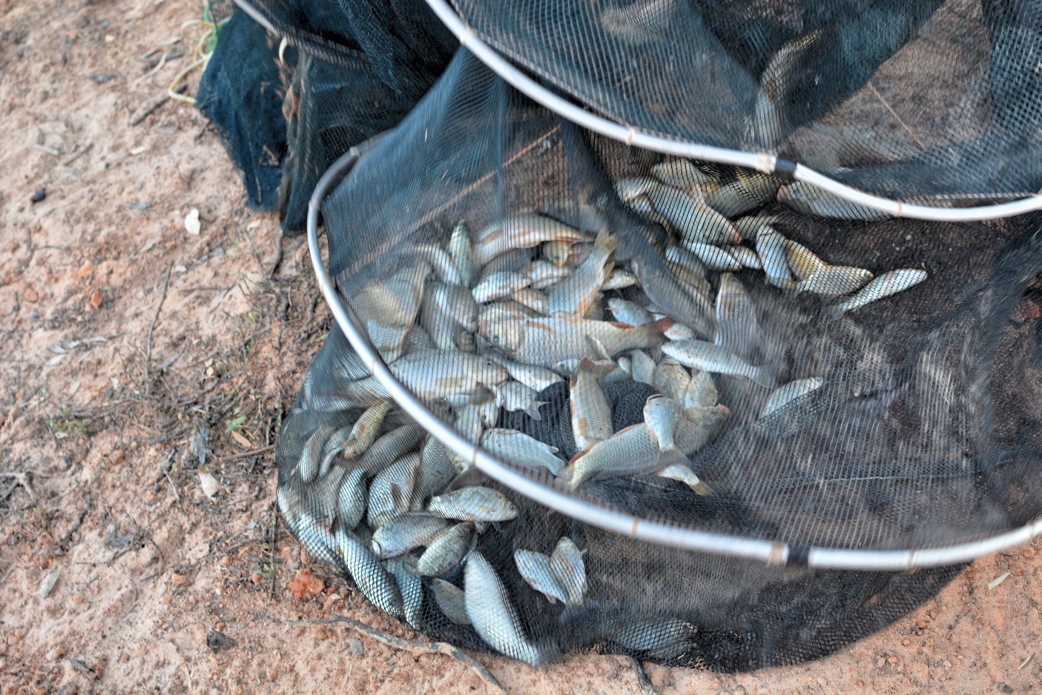
Figure 8 Carp (Cyprinus carpio) collected using a fyke net in February 2017

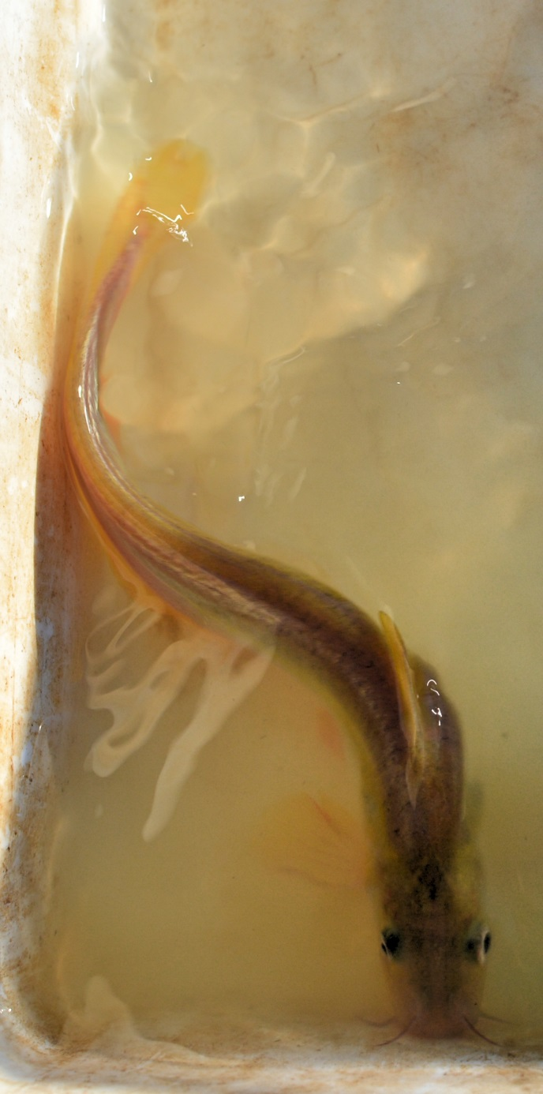
Figure 9 Hyrtl's catfish (Neosilurus hyrtlii) collected from Site 5

Turtle communities and yabbies
Two species of turtle were collected from Site 1, Site 3 and Site 4 (Table 4). Broad-shelled Turtle (Chelodina expansa) was the most abundant species, with the largest individual having a shell length of 46 cm. Juvenile Murray Turtles (Emydura macquarii) with shells between 4 and 6 cm long were collected at Site 1, Site 3 and Site 4 (Figure 10. Site 1 and Site 4 were the only sites where both species co-occurred.
Yabbies occurred at all sites except Site 6 (Figure 11), and were most abundant at Site 1. No shrimp were captured or observed.
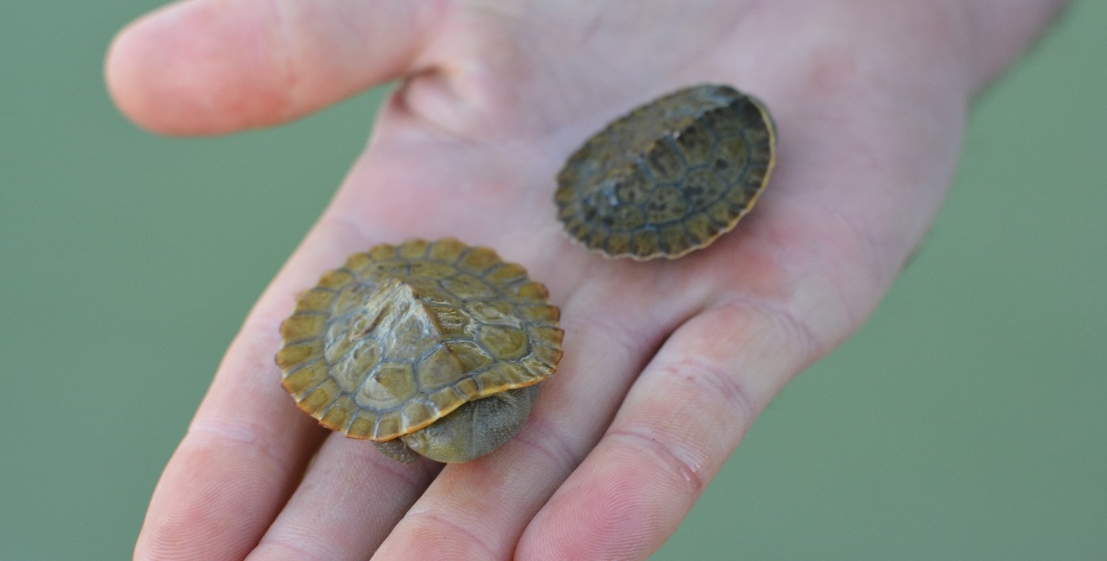
Figure 10 Juvenile Murray Turtles (Emydura macquarii) at Site 4.

Table 4 Turtle and yabby captures at each Western Floodplain site.
Common Name | Scientific name | Site 1 | Site 2 | Site 3 | Site 4 | Site 5 | Site 6
Broad-shelled Turtle | Chelodina expansa | 4 |  |  | 8
Murray Turtle | Emydura macquarii macquarii | 2 |  | 2 | 5
Yabby | Cherax destructor | 11 | 1 | 1 | 5 | 1

Frog communities
Three species of frog occurred at waterholes on the Western Floodplain, with only one species (Barking Marsh Frog, Limnodynastes fletcheri) present at all sites. These were mostly found along the water’s edge, either in the water or on the bank.
Peron’s Tree Frog (Litoria peronii) was present in large numbers at three sites (Figure 12). This species was associated with near-water terrestrial habitat such as fallen logs and standing dead trees (Site 2) and Lignum (Duma florulenta) growing close to the water (Site 1 and Site 4).

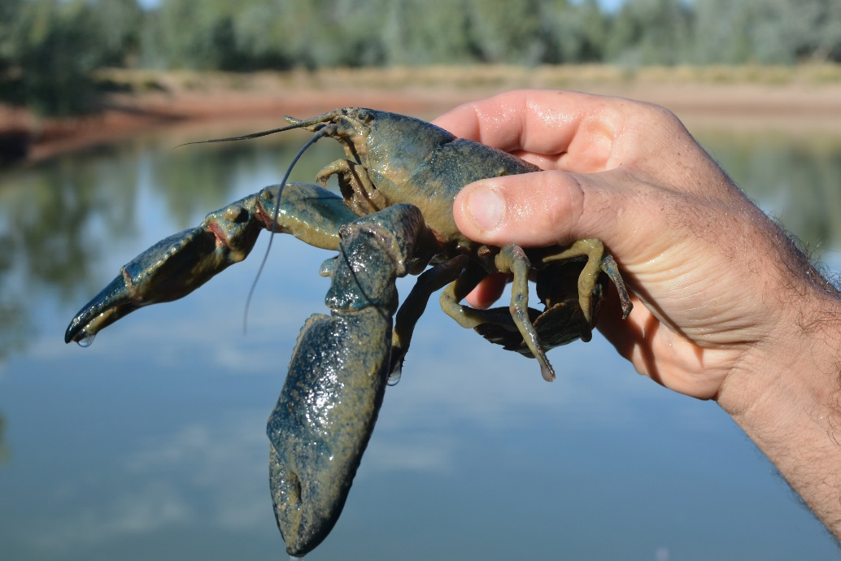
Figure 11 Yabby (Cherax destructor) collected from Site 5

Table 5. Frogs observed during spotlighting around waterholes of the Western Floodplain.
Common Name | Scientific Name | Site 1 | Site 2 | Site 3 | Site 4 | Site 5 | Site 6
Peron’s Tree Frog | Litoria peronii | 56 | 147 | 11 |  | 40
Barking Marsh Frog | Limnodynastes fletcheri | 3 | 17 | 3 | 1 | 4 | 1
Spotted Marsh Frog | Limnodynastes tasmaniensis |  | 4 |  |  | 1
Frog abundance |  | 59 | 168 | 14 | 1 | 45 | 1
Number of species |  | 2 | 3 | 2 | 1 | 3 | 1

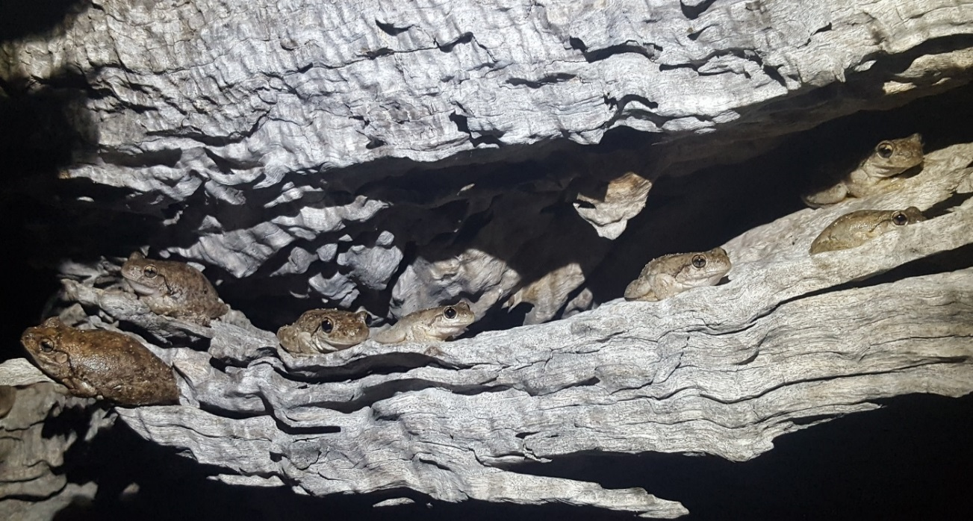
Figure 12 Peron's Tree Frogs (Litoria peronii) at Site 2.

Bird communities
There were 76 bird species observed in our survey, of which 63 were present at the study sites and 13 additional species were observed at other locations on the Western Floodplain (Table 6). There were 29 species at the survey sites that could be considered waterbirds. Insect-eating species, whether obtained through aerial feeding, filtering, or probing, dominated the bird communities at Site 3, making up more than 35% of waterbirds present (Figure 13). Omnivores and invertebrate consumers dominated the bird fauna at Site 2 and Site 5, while Site 1 and Site 6 had no omnivorous species.
Pink-eared Duck (Malacorhynchus membranaceus) was the most abundant aquatic bird species and was present at all sites except Site 6 (Figure 14a). Site 3 had the most Pink-eared Duck, with 46 present in the morning survey and 22 in the afternoon survey. Australian White Ibis (Threskiornis Molucca), Grey Teal (Anas gracilis) and Royal Spoonbill (Platalea regia) (Figure 14b) were also present in high abundances at this site. Brolga (Grus rubicunda) were present at or near all sites in this survey (Figure 14c).

Figure 13: Dietary preferences of birds at Toorale wetland sites.

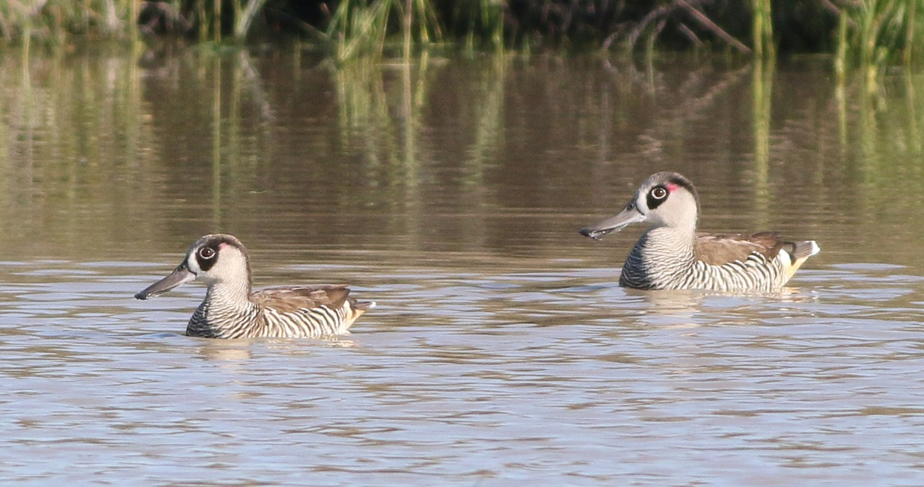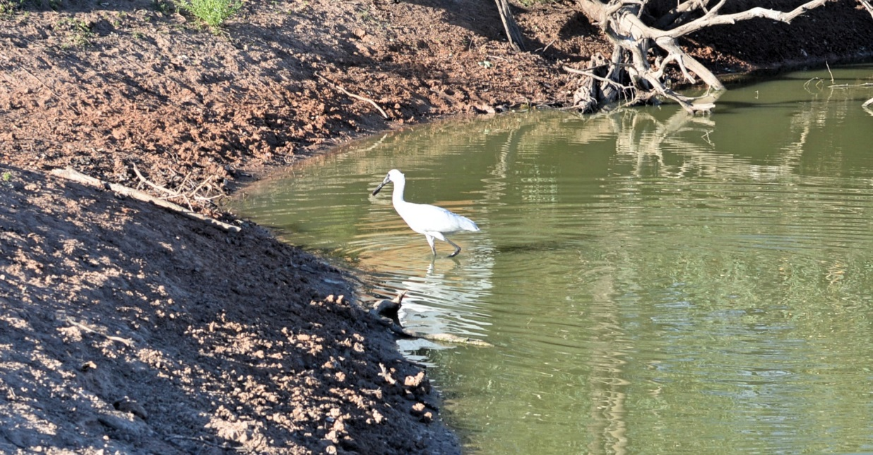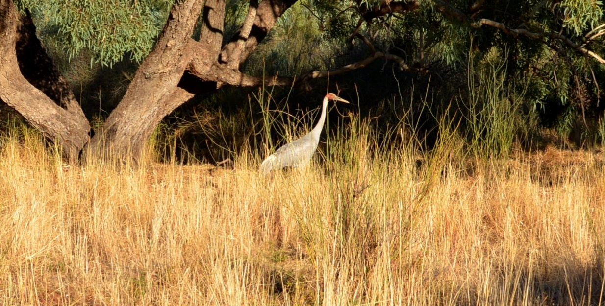
(c)
(b)
(a)
Figure 14 Waterbirds observed during the February 2017 survey on the Western Floodplain (a) Pink Eared Duck (Malacorhynchus membranaceus) (b) Royal Spoonbill (Platalea regia) and (c) Brolga (Grus rubicunda)

Table 6 Birds observed on the Western Floodplain during the February 2017 survey. * denotes waterbirds
Common Name | Scientific Name | Site 1 | Site 2 | Site 3 | Site 4 | Site 5 | Site 6 |  | Other areas | Aquatic habitat use- food type
Apostlebird | Struthidea cinerea |  |  |  | 8 |  | 6 |  | x
Australasian Darter* | Anhinga novaehollandiae | 2 |  |  |  |  |  |  |  | Fish/frogs
Australasian Pipit | Anthus novaeseelandiae |  |  |  |  |  |  |  | x
Australasian Shoveler* | Anas rhynchotis |  |  |  |  |  |  |  | x | Invertebrates
Australian Grebe* | Tachybaptus novaehollandiae |  |  |  | 5 |  |  |  |  | Fish/frogs
Australian Magpie | Cracticus tibicen |  |  |  |  |  | 1 |  | x
Australian Pelican* | Pelecanus conspicillatus |  |  |  |  |  |  |  | x | Fish/frogs
Australian Raven | Corvus coronoides |  |  |  | 1 |  | 2 |  | x
Australian Ringneck | Barnardius zonarius | 20 | 18 | 5 | 10 | 6 | 19 |  | x
Australian White Ibis* | Threskiornis molucca |  |  | 40 |  |  |  |  | x | Invertebrates
Australian Wood Duck | Chenonetta jubata |  |  |  |  |  |  |  | x | Omnivore
Black Kite | Milvus migrans | 1 |  | 1 |  | 1 |  |  | x
Black-faced Cuckoo-shrike | Coracina novaehollandiae | 2 |  |  |  |  |  |  | x
Black-fronted Dotterel* | Elseyornis melanops |  |  | 1 |  |  |  |  |  | Invertebrates
Black-tailed Native-hen* | Tribonyx ventralis |  | 1 | 15 | 1 |  |  |  | x | Omnivore
Black-winged Stilt* | Himantopus himantopus |  | 9 | 8 | 5 |  |  |  |  | Invertebrates
Blue Bonnet | Northiella haematogaster |  |  |  |  | 4
Blue-faced Honeyeater | Entomyzon cyanotis |  |  |  | 1 |  |  |  | x
Brolga* | Grus rubicunda |  |  |  | 2 | 4 |  |  | x | Omnivore
Brown Goshawk | Accipiter fasciatus |  |  |  |  |  |  |  | x
Brown Honeyeater | Lichmera indistincta |  |  |  |  |  |  |  | x
Budgerigar | Melopsittacus undulatus |  |  |  |  | 62
Cockatiel | Nymphicus hollandicus |  |  | 22
Common Bronzewing | Phaps chalcoptera |  |  |  |  |  |  |  | x
Crested Pigeon | Ocyphaps lophotes | 3 | 1 | 3 | 29 | 2 | 1 |  | x
Diamond Dove | Geopelia cuneata |  |  |  |  |  | 2 |  | x
Double-barred Finch | Taeniopygia bichenovii |  | 2
Emu | Dromaius novaehollandiae |  |  | 17 |  |  |  |  | x
Galah | Eolophus roseicapillus | 6 | 21 |  | 8 | 55 | 5 |  | x
Glossy Ibis* | Plegadis falcinellus |  | 3 |  | 1 |  |  |  | x | Invertebrates
Grey Teal* | Anas gracilis |  | 8 | 41 |  | 4 |  |  | x | Omnivore
Hardhead* | Aythya (Nyroca) australis |  | 8 | 12 |  |  |  |  | x | Omnivore
Hoary-headed Grebe* | Poliocephalus poliocephalus |  |  | 5 | 3 |  |  |  |  | Invertebrates
Jacky Winter | Microeca fascinans | 6 | 1
Laughing Kookaburra | Dacelo novaeguineae | 1 |  |  |  |  |  |  | x
Little Black Cormorant* | Phalacrocorax sulcirostris | 6 |  | 1 |  |  | 1 |  |  | Fish/frogs
Little Friarbird | Philemon citreogularis |  | 1 |  | 1 |  |  |  | x
Little Woodswallow | Artamus minor | 22
Magpie-lark | Grallina cyanoleuca | 5 | 1 | 5 | 6 | 3 | 2 |  | x
Major Mitchell's Cockatoo | Lophochroa leadbeateri |  | 2 |  | 6 |  |  |  | x
Masked Lapwing* | Vanellus miles |  |  |  |  | 1 |  |  | x | Invertebrates
Masked Woodswallow | Artamus personatus |  |  |  | 4 |  |  |  | x
Mistletoebird | Dicaeum hirundinaceum |  |  |  |  |  | 1
Mulga Parrot | Psephotus varius |  | 5
Musk Duck* | Biziura lobata |  |  | 7 |  |  |  |  | x | Omnivore
Nankeen Kestrel | Falco cenchroides |  |  |  |  |  |  |  | x
Nankeen Night-heron* | Nycticorax caledonicus | 24 | 1 |  |  | 3 |  |  |  | Fish/frogs
Peaceful Dove | Geopelia striata |  | 1
Pied Butcherbird | Cracticus nigrogularis |  |  |  |  | 1 |  |  | x
Pink-eared Duck* | Malacorhynchus membranaceus | 2 | 11 | 68 | 5 | 8 |  |  |  | Invertebrates
Rainbow Bee-eater* | Merops ornatus | 5 | 10 |  |  | 3 |  |  |  | Invertebrates
Red-kneed Dotterel* | Erythrogonys cinctus |  |  |  |  |  |  |  | x | Invertebrates
Red-rumped Parrot | Psephotus haematonotus |  | 6 |  |  | 8
Red-winged Parrot | Aprosmictus erythropterus |  | 5 |  | 7 | 6 |  |  | x
Restless Flycatcher | Myiagra inquieta |  |  |  |  | 3
Royal Spoonbill* | Platalea regia |  | 2 | 34 |  | 1 |  |  |  | Invertebrates
Sacred Kingfisher* | Todiramphus sanctus |  | 1 |  |  |  |  |  |  | Fish/frogs
Spiny-cheeked Honeyeater | Acanthagenys rufogularis |  | 1 |  | 5 |  | 1
Striped Honeyeater | Plectorhyncha lanceolata |  | 1
Tree Martin* | Petrochelidon nigricans |  | 1 |  | 8 | 5 | 4 |  |  | Invertebrates
Variegated Fairy-wren | Malurus lamberti | 10 | 3 | 3 | 1 |  |  |  | x
Wedge-tailed Eagle | Aquila audax |  |  | 1 |  |  |  |  | x
Welcome Swallow* | Hirundo neoxena |  |  |  |  |  |  |  | x | Invertebrates
Western Gerygone | Gerygone fusca | 7 | 3 |  |  | 1
Whiskered Tern* | Chlidonias hybrida |  |  |  |  |  |  |  | x | Fish/frogs
Whistling Kite | Chlidonias hybrida |  | 1
White-breasted Woodswallow | Artamus leucorynchus |  | 3 |  |  |  |  |  | x
White-faced Heron* | Egretta novaehollandiae |  |  | 1 | 1 | 1 |  |  |  | Fish/frogs
White-necked Heron* | Ardea pacifica | 2 |  | 2 |  | 1 | 1 |  | x | Fish/frogs
White-plumed Honeyeater | Ptilotula penicillata | 19 | 11 |  | 1 | 25 | 3
White-winged Chough | Corcorax melanorhamphos |  |  |  |  |  |  |  | x
Willie Wagtail | Rhipidura leucophrys | 26 | 14 | 2 |  | 2 | 1
Yellow-billed Spoonbill* | Platalea flavipes |  | 2 | 1 |  |  |  |  | x | Invertebrates
Yellow-throated Miner | Manorina flavigula |  |  |  | 1 | 3
Zebra Finch | Taeniopygia guttata |  |  |  | 160 | 26
Grand Total |  | 169 | 158 | 295 | 280 | 239 | 50
No. species/site |  | 19 | 32 | 23 | 25 | 26 | 15

Opportunistic terrestrial fauna
Twelve species of fauna were observed during the survey period (Table 7). Eastern Grey Kangaroos (Macropus giganteus) and Red Kangaroos (Macropus rufus) were the most common native mammals, while feral Pigs (Sus scrofa) and Goats (Capra hircus) were the most widespread pest species.

Table 7: Terrestrial fauna observed opportunistically on the Western Floodplain * denotes exotic species
Common Name | Scientific Name | Notes
Eastern Grey Kangaroo | Macropus giganteus | Widespread, few seen
Red Kangaroo | Macropus rufus | Widespread, abundant
Common Wallaroo | Macropus robustus | One near Boera Dam
Short-beaked Echidna | Tachyglossus aculeatus | One near Toorale Homestead
Bearded Dragon | Pogona barbata | 3 seen
European Hare* | Lepus europaeus | Widespread, few seen
Rabbit* | Oryctolagus cuniculus | Widespread, abundant
Goat* | Capra hircus | Widespread, abundant
Pig* | Sus scrofa | Widespread, abundant
Sheep* | Ovis aries | 4 sheep seen near Site 3
Cat* | Felis catus | 2 seen
Red Fox* | Vulpes vulpes | 5 seen on Western Floodplain

Discussion
During this survey, wetlands on the Western Floodplain were in a phase of drying that commenced approximately three months beforehand. During this phase, the floodplain had gone from a large, interconnected body of shallow water to increasingly fragmented isolated waterholes, many of which subsequently dried up. Sampling during the fully connected phase of this event was not possible due to logistical reasons. Future sampling during the filling or full phases of an inundation event would, along with the data reported here, further our knowledge of the use of the Western Floodplain by aquatic fauna.

Fish
Prior to the inundation event in late 2016, many of the waterholes sampled during this survey were dry. This means that the fish collected would have moved earlier from Boera Dam or other permanent waterholes, or bred on the floodplain. There is evidence from our sampling that some fish species bred during the inundation period. Small specimens of large-bodied fish such as Carp and Goldfish, could indicate breeding stimulated by the spread of water over the floodplain. At most sites there were large numbers of Carp and Goldfish less than 10 cm long. These two species could have bred during the inundation period, and spread out across the floodplain while waterholes were connected. Due to the restricted nature of the connection between the Western Floodplain and the Warrego River, any return of animals bred on the floodplain to the river would be restricted to the time when the floodplain was connected through Boera Dam (Figure 5). Again, further sampling during this period is required to quantify this exchange of animals from the Western Floodplain back into the Warrego River.
Carp and Goldfish were the most abundant species on the Western Floodplain, and preferred the deeper, more permanent waterholes in the survey area. Goldfish were absent from the two shallowest wetlands, Site 2 and Site 3, but carp were in all waterholes. Nearly all carp caught were less than 15 cm long, so were likely less than 1-1.5 years old (Donkers 2003, Vilizzi and Walker 1998). However, they may also have been younger, since the length to age ratio from Donkers (2003) and Vilizzi and Walker (1998) were calculated in southern populations. Carp on the Western Floodplain may have developed more rapidly in the warmer water, and with the abundant food available in the early phases of inundation.
Murray Rainbowfish were abundant only at Site 3, which was a shallow basin wetland with turbid water and little aquatic vegetation. In the months prior to sampling, when the water level was higher, the wetland would have extended to include fringing Lignum. Google Earth imagery suggests that this wetland covers approximately 15.6 Ha when it becomes isolated from nearby wetlands (Figure 15). Murray Rainbowfish lay eggs that adhere to submerged and emergent vegetation (McDowall 1996), and it is likely that they bred when water levels were higher and these habitats were accessible. As water levels fell, these fish likely became concentrated, so that the current densities were reached when surface area of the waterhole was just 0.3 Ha.
Native fish species appeared to prefer deeper waterholes that retained water for long periods. Apart from the high number of Murray Rainbowfish at Site 3, the shallow sites had no native fish. Sites 4 and 5 had more native species (both with 4) than the others, and were the only two sites with Hyrtl’s Catfish. Spangled Perch were the most widespread native species, present at all but Sites 2 and 3. This is a hardy species that colonises waterholes rapidly in the early stages of inundation but retreats to deeper water during the recession.

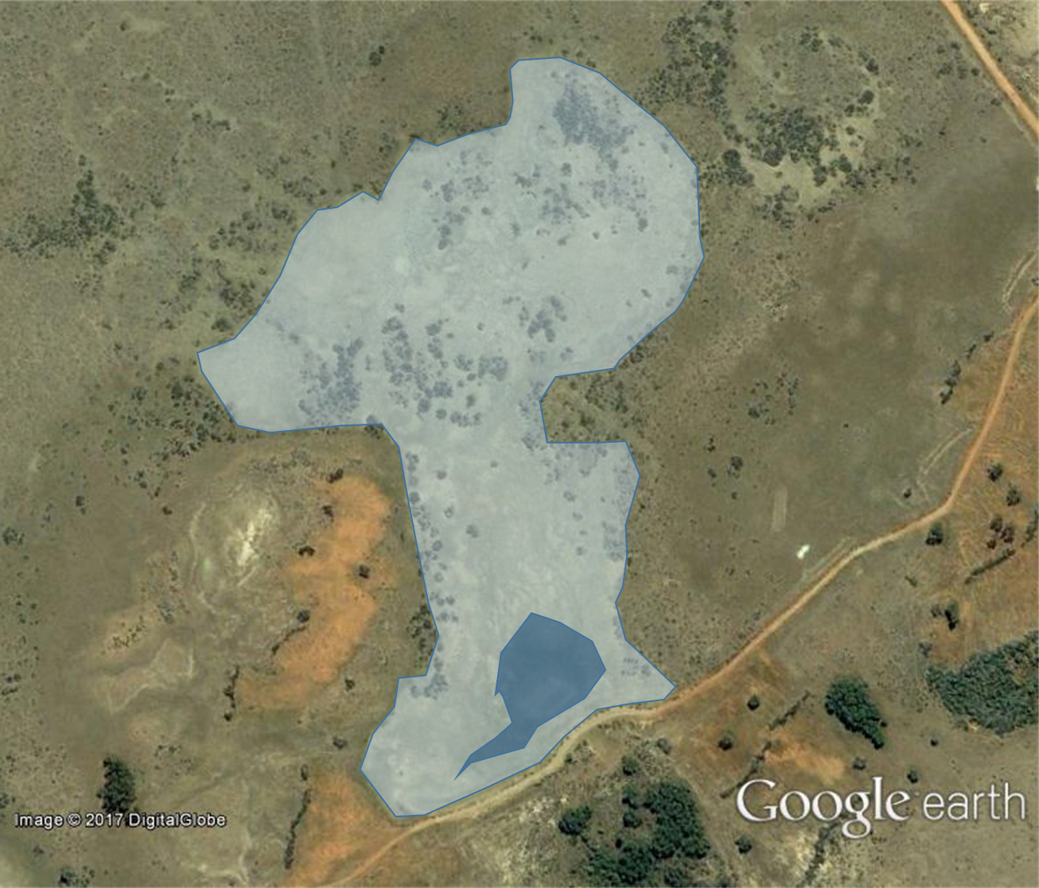
Figure 15 Estimated extent of Site 3 on initial disconnection (light blue) and then during the survey (dark blue)

Frogs
Peron’s Tree Frog was the most abundant species on the Western Floodplain, although was present at only four sites. Most Peron’s Tree Frogs seen during the survey period were small and likely to have recently transformed from their tadpole phase into frogs. Very few individuals of this species were calling, but this may be due to most of them being sub-adults and breeding being completed. Peron’s Tree Frog generally calls in summer, but towards the end of the season it calls less often (Wassens, 2011).
Peron’s Tree Frog were more abundant in locations where structured habitat on the bank occurred close to the waterhole. The most common type of structure was Lignum, which grew around nearly all waterholes. The tree frogs were seldom seen on the bare ground between the water’s edge and the Lignum, but were common in the lower and mid-level branches. In addition, there were 140 Peron’s Tree Frogs in fissures and hollows of a standing dead tree at Site 3, and only 7 other individuals in Lignum. The link between vegetation proximity to water and frog abundance, suggests that habitat access is an important factor for Peron’s Tree Frog on the Western Floodplain.
Given the large numbers of small sized individuals observed, there appears to have been a large breeding event for Peron’s Tree Frog on the Western Floodplain during the recent inundation period. Due to the receding water levels at the time of survey, it appears that frogs are becoming concentrated around remnant waterholes, and potentially crowded into fringing vegetation.

Birds
The most widespread waterbird species was the Pink-eared Duck, which occurred at all sites except Site 6. This species is a filter–feeder that prefers shallow waterholes created by inland flooding (Menkhorst et al. 2017). During the drying phase on the Western Floodplain, waterholes contract and potential food sources, such as microcrustacean communities become concentrated. These conditions favour filter-feeders such as Pink-eared Ducks, and appeared most favourable at Site 3 where the species was most abundant. It is likely that as the Western Floodplain dries further in the coming months, species like these will retreat to the more permanent waterbodies in the system such as Boera and Booka Dams.
Site 3 also had highest numbers of Royal Spoonbill, Grey Teal, and Hardhead, and was the only site with Australian White Ibis and Musk Duck. These species would all have benefitted from the concentration of food (invertebrates, fish) and shallow water depths that occurred at this waterhole during contraction.

Faunal response to inundation frequency
The three waterholes categorised as having a high inundation frequency (Sites 1-3) had higher frog abundances than those that had a low frequency, regardless of inundation duration. This was the case for all three species encountered, with between 3 and 5 times the total abundance of frogs at the high frequency sites. Peron’s Tree Frog occurred at all three of the high frequency waterholes, but only one of the low intensity waterholes.
There were more than twice the number of yabbies in the frequently inundated waterholes than there were in waterholes of low inundation frequency, although yabbies showed a preference for waterholes that retained water for longer periods of time.
Juvenile Murray Turtles were collected at three of the sites. These turtles had shells of 4 to 6 cm diameter, and would likely have hatched in the previous month. The increase in shoreline associated with inundation of the Western Floodplain, along with an abundance of food, provide ideal nursery habitats for Murray Turtles.
Total fish abundance when combined for all species, was higher in frequently inundated waterholes than it was in less frequently wet ones. When considered for each site, there were more fish in the high inundation frequency Sites 1 and 3, but not Site 2. This is likely because Site 2 was shallow when sampled, and the fish may have been heavily predated by birds before sampling.
Spangled Perch and Bony Bream were both more abundant at low inundation frequency waterholes. They were also present at a higher proportion of sites. Neither of these species occurred in the ‘short duration’ waterholes at Sites 2 and 3, preferring those that were deeper and held water for longer periods. Both Spangled Perch and Bony Bream are early colonisers and readily able to disperse through wetland systems soon after inundation (McDowall 1996), which may explain why they were abundant in the less-frequently inundated waterholes found further down the floodplain. Rising water levels are one of the stimuli for spawning in Bony Bream (Ralph et al. 2011). Connection to the floodplain provides access to nursery habitats for larval and juvenile Bony Bream, and allows adults to disburse and feed. They prefer waterholes with greater habitat heterogeneity, and with larger amounts of productive littoral habitat in which to feed (Ralph et al. 2011). Spangled Perch spawn in summer, and connection to the floodplain during this period provides an opportunity for adults to disperse and build up the fat reserves that allow them to survive dry periods in remnant waterholes (Ralph et al. 2011).
Goldfish occurred in all three of the less frequently inundated waterholes, but only one of the high frequency sites. However, abundance at this site was more than four times greater than any of the low frequency sites. Goldfish were absent from Sites 2 and 3, both of which were ‘short duration’ wetlands that were shallow when sampled and likely to have dried out soon after sampling.

Waterhole persistence
Field observations in April 2017 suggested that many of the sampled waterholes had dried since the time of survey. Therefore, the persistence of these waterholes was around 3 months following the floodplain’s disconnection with Boera Dam. This pattern of wetting and drying is typical of semi-arid floodplain systems that experience intermittent flow. While this drying is not ideal for the longevity of aquatic populations such as fish on the floodplain, the increased productivity of these floodplain habitats when water is present provides a boom of resources for other more mobile species such as waterbirds, helping to maintain their condition through later dry periods.

Food web dynamics on the Western Floodplain
Hydrological patterns are likely to play a critical role in food web dynamics on the Western Floodplain. The rewetting, connection, isolation, contraction, then drying of floodplain waterholes each create unique resource and physico-chemical conditions that influence biological interactions. Each of these threshold phases is likely to have a set of unique ecological processes that influence aquatic food webs, either by changing the species in the foodwebs or the strength of interactions. The current round of sampling occurred in the contraction phase, where waterholes were isolated, becoming smaller and the interactions between the remaining biota more frequent.
During this phase, biological and physico-chemical processes are strongly influenced by a decrease in the volume of available water. The key processes occurring in wetlands during the contraction phase include:
- Increased densities of fish as waterholes shrink. This leads to more encounters between predators and prey in the water, and an increase in predation on fish by terrestrial species (e.g. birds, etc)
- A retreat of the waters’ edge from fringing vegetation.
- Greater fluctuations in some physico-chemical parameters such as temperature, dissolved oxygen, and turbidity.
- More rapid changes in water chemistry.
- Mudflats become exposed.
- More vulnerable to disturbance by pigs
A conceptual web is provided below for the aquatic fauna observed on the floodplain during February 2017 when the water was receding from the Western Floodplain (Figure 16). How this changes over time will be informed by successive surveys in other connection phases.
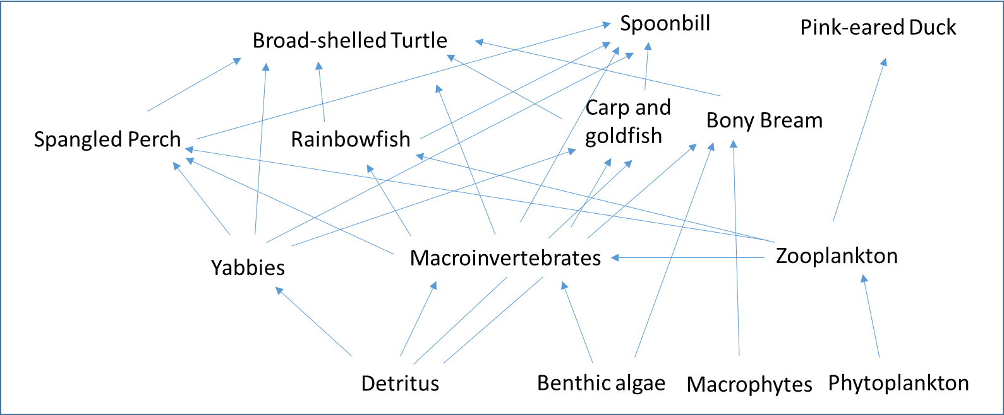
Figure 16: Generic food-web for trophic interactions at waterholes on the Western Floodplain during the flow recession period of February 2017.

Conclusion
The survey conducted in February 2017 provided an inventory of fauna using the waterholes of the Western Floodplain during the drying phase of a flooding event. The size and maturity of some species suggests that they likely bred on the floodplain in response to the recent flooding. There was also an indication that native aquatic species had begun their retreat to deeper waterholes as the floodplain dried out, and that mobile bird species were taking advantage of this concentration of resources to feed.
The later drying of the waterholes after survey would have been detrimental to fauna like fish that were unable to move to other locations. Other animals such as yabbies, turtles and frogs may have been able to move to other waterholes in the adjacent Warrego River, or would have been consumed by higher level predators. This drying is a natural part of intermittent semi-arid floodplain rivers, and while water management activities can aim to maintain inundation on the floodplain, in the end, it is broader weather patterns in the upstream catchment that determines the amounts of water available to provide floodplain inundation. In any case, this study showed a boom in aquatic resources that likely sustained animal population like waterbirds at a broader regional scale.
This study reported on observations made during the drying phase of a significant inundation event, when the floodplain was effectively cut off from the Warrego River system. This provided a snapshot of the abundance and diversity of fauna using the Western Floodplain. We would recommend follow up surveys be undertaken during the filling or connected phases of an inundation event, to further characterise the movement of fauna onto and off the floodplain during these phases.

References
Commonwealth of Australia. 2015a. Commonwealth Water Office Long Term Intervention Monitoring Project Junction of the Warrego and Darling rivers Selected Area – 2014-15 Evaluation Report. Commonwealth of Australia, Canberra.
Commonwealth of Australia. 2015b. Commonwealth Water Office Long Term Intervention Monitoring Project Junction of the Warrego and Darling rivers Selected Area – Monitoring and Evaluation Plan Commonwealth of Australia, Canberra.
Cox, S.J., Thomas, R.F. & Lu, Y. 2012. Flooding patterns of Toorale: the confluence of the Warrego and Darling rivers. Office of Environment and Heritage, Sydney. Unpublished report.
Donkers P. 2003. Age and Growth of Carp (Cyprinus carpio) in Two Tasmanian Lakes, Lake Sorell and Lake Crescent. Inland Fisheries Service Carp Management Program. Technical Report Number 4, Inland Fisheries Service, Hobart.
McDowall, R. 1996. Freshwater Fishes of South-eastern Australia. Reed Publishing, Chatswood.
Menkhorst, P., Rogers, D., Clarke, R., Davies, J., Marsach, P., Franklin, K. 2017. The Australian Bird Book. CSIRO Publishing
Ralph, T.J., Spencer, J.A., and T.S. Rayner. 2011. Fishes, in: Rogers, K and T.J. Ralph (eds) Floodplain Wetland Biota in the Murray-Darling Basin: Water and Habitat Requirements. pp 205-251
Vilizzi, L. and Walker, F,F. 1998. Age and growth of common carp, Cyprinus carpio, in the River Murray, Australia: Validation, consistency of age interpretation, and growth models. Environmental Biology of Fishes, 54 11-106
Wassens, S., Watts, R., Howitt, J., Spencer, J., Zander, A. and Hall, A. 2011. Monitoring of ecosystem responses to the delivery of environmental water in the Murrumbidgee system. Report to DSEWPaC. Albury, Institute of land, Water and Society. Report 1.
Wassens, S. 2011. Frogs, in: Rogers, K and T.J. Ralph (eds) Floodplain Wetland Biota in the Murray-Darling Basin: Water and Habitat Requirements. pp 253-274





Head Office  Suite 2, Level 3  668-672 Old Princes Highway  Sutherland NSW 2232  T 02 8536 8600  F 02 9542 5622 |  | Sydney  Suite 1, Level 1  101 Sussex Street  Sydney NSW 2000  T 02 8536 8650  F 02 9542 5622 |  | Huskisson  Unit 1, 51 Owen Street  Huskisson NSW 2540  T 02 4201 2264  F 02 9542 5622
Canberra  Level 2  11 London Circuit  Canberra ACT 2601  T 02 6103 0145  F 02 9542 5622 |  | NEWCASTLE  Suites 28 & 29, Level 7  19 Bolton Street  Newcastle NSW 2300  T 02 4910 0125  F 02 9542 5622 |  | NAROOMA  5/20 Canty Street  Narooma NSW 2546  T 02 4302 1266  F 02 9542 5622
COFFS HARBOUR  35 Orlando Street  Coffs Harbour Jetty NSW 2450  T 02 6651 5484  F 02 6651 6890 |  | ARMIDALE  92 Taylor Street  Armidale NSW 2350  T 02 8081 2685  F 02 9542 5622 |  | MUDGEE  Unit 1, Level 1  79 Market Street  Mudgee NSW 2850  T 02 4302 1234  F 02 6372 9230
PERTH  Suite 1 & 2  49 Ord Street  West Perth WA 6005  T 08 9227 1070  F 02 9542 5622 |  | WOLLONGONG  Suite 204, Level 2  62 Moore Street  Austinmer NSW 2515  T 02 4201 2200  F 02 9542 5622 |  | GOSFORD  Suite 5, Baker One  1-5 Baker Street  Gosford NSW 2250  T 02 4302 1221  F 02 9542 5622
DARWIN  16/56 Marina Boulevard  Cullen Bay NT 0820  T 08 8989 5601 |  | BRISBANE  Suite 1, Level 3  471 Adelaide Street  Brisbane QLD 4000 |  | 1300 646 131  www.ecoaus.com.au

