# The Nationally Protected Arnhem Plateau Sandstone Shrubland Complex

The Arnhem Plateau Sandstone Shrubland Complex or Arnhem Shrubland Complex is an ecological community of national conservation significance comprised mostly of native shrubs, grasses and animals living in rock country. It is a vital habitat to a big number of plants and animals in Australia’s Top End and is now protected under federal environment law, the *Environment Protection and Biodiversity Conservation Act 1999* (EPBC Act).

It is listed under the EPBC Act as an endangered ecological community because:

* hot fires are burning big areas of the plateau country too often
* weeds such as gamba grass (*Andropogon gayanus*) and mission grass (*Cenchrus polystachion*), and feral animals such as cats and cane toads, which aren’t part of the ecological community, are also making the country unhealthy.

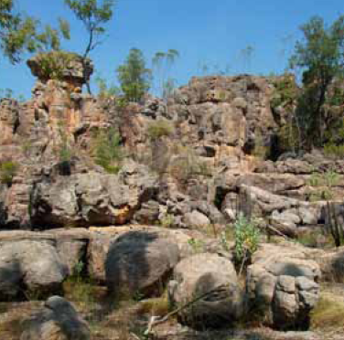

Sandstone Country (Helena Mills)

Not as many Indigenous people live on the plateau to look after the country these days, so the old ways of burning do not happen as much. Big, hot fires burning late in the hot dry season have made the land unhealthy. If these hot fires happen over too much country, and too often, some plants don’t have time to regrow and make seed. Hot fires that burn too often kill the parent plants and the seed. Some animals have nowhere to go to escape hot fires (such as Alyurr[1] or Leichhardt’s grasshopper) and others don’t have food after big, hot fires. Animals from unburnt areas further away don’t have time to move in before the next big fire happens.

The old ways used by Indigenous people living on country, were to mainly start small cooler fires in different parts of the land during the early dry season. This created lots of small patches of burnt and unburnt land. The old ways cleaned and rested different parts of the land so that it had time to regrow before the next big fire at least five years later. These patches helped stop big, hot fires from spreading. With the old ways, many animals could live and move through the land easier and the native plants in the Arnhem Shrubland Complex would regrow and stay healthy. These traditional ways of managing the land helped to retain the areas of the ecological community that are in the best condition. A continuation or return to traditional ways is encouraged.

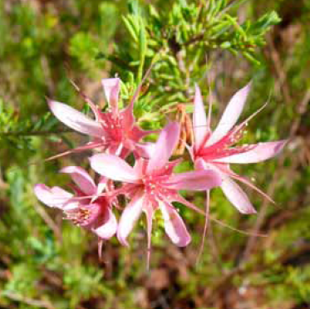

*Calytrix Megaphyllus* (Anthony Hoffman)

Federal environment law protects Australia’s unique native plants and animals, but it does not stop traditional activities such as using bushfood[2].

Australian Government approval may be needed if:

* the protected Arnhem Shrubland Complex (or other protected matters, such as northern quolls) is on your country, and
* an action, such as a major new construction (e.g. building a new mine); making something bigger (e.g. enlarging a road to carry more traffic); or a major change in the way things are done, which could be bad for the Arnhem Shrubland complex (or other protected matters such as nationally listed threatened species).

For more gudiance on what does not need approval and what might need approval see page 5.

## What does national protection achieve?

Federal EPBC Act listing of the Arnhem Shrubland Complex will help to let more Australians know of the importance of the plants, animals and environment on the Arnhem Plateau. The listing of the Arnhem Shrubland Complex will help to make sure the environment is part of future decision‑making, although EPBC Act protection will also consider the social and economic needs and plans of the Arnhem community.

Importantly, federal EPBC Act listing does not change land ownership, and does not affect Native Title. Management of listed ecological communities also remains with the land owner, lease holder or manager.

Current lawful use, for example, existing grazing and finding bushfood is not affected. Also previously approved mining and exploration activities, or recreation activities like tourism, and any activities now permitted under Native Title can continue as they did prior to EPBC Act listing of the ecological community.

## Where is the Arnhem Plateau Sandstone Shrubland Complex

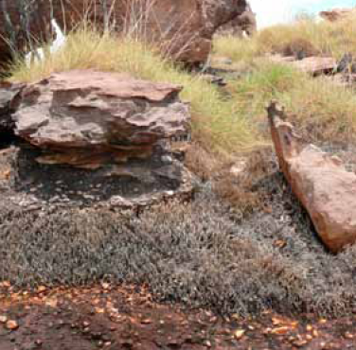

*Micraira* sp. and spinifex (Anthony Hoffman)

The Arnhem Shrubland Complex is on the country (the traditional lands) of the Adjurmarllal, Barwinanga-Djelk, Jawoyn, Mimal and Manwurrk-Warddeken Indigenous ranger groups, including within the Djelk and Warddeken Indigenous Protected Areas, and also in Kakadu and Nitmiluk National Parks.

The Arnhem Shrubland Complex is mainly on the Arnhem Plateau and outliers such as Ubirr, Nawurlandja (Little Nourlangie Rock) and Burrunggui (Nourlangie Rock). It is also on the Marawal Plateau. The national ecological community is mainly found on the sandstone rock pavements. It grows in cracks of rock and also in shallow sandsheets of the wardde wardde (sandstone country). The Arnhem Shrubland Complex can also grow on mudstone on the Marawal Plateau in Nitmiluk National Park.

A detailed map is available at:

[www.environment.gov.au/cgi-bin/sprat/public/publicshowcommunity.pl?id=111&status=Endangered](http://www.environment.gov.au/cgi-bin/sprat/public/publicshowcommunity.pl?id=111&status=Endangered)

## What are the key plants and animals of the Arnhem Plateau Sandstone Shrubland Complex?

Not many trees grow in the Arnhem Shrubland Complex. Where trees, such as cypress pine (*Callitris intratropica*) and rock figs (*Ficus platypoda*) do grow, they don’t grow as high as they would if they were in deeper soil.

A part of the Arnhem Shrubland Complex is made up of resprouter shrubs, like Wij – turkey bush (*Calytrix exstipulata*) – and obligate seeder shrubs like rock myrtle (*Petraeomyrtus punicea*). Resprouters can regrow from their roots, trunks or branches after a fire. An important part of the Arnhem Shrubland Complex is obligate seeders which germinate from seeds protected in woody fruit or from seeds protected in the ground. While these seeds can grow after a fire, the parent plant often dies. Obligate seeders are the plants that are dying out because of repeated hot fires that will kill the new seedlings before they have a chance to produce new seeds. This can take up to five years. When there are not many obligate seeders left, the ecological community is unhealthy.

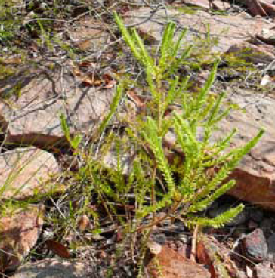

*Pityrodia* sp. (Anthony Hoffman)

During the dry season the most common plants on the ground in the Arnhem Shrubland Complex are grasses such as hummock grasses (*Triodia* species like Jalkwarak *Triodia microstachya*) and mat-forming grasses such as resurrection bush (*Micraira* species). During the wet season, flowering herbs that only live for a year or less (annuals) are generally the most common plants on the ground.

Key animals of the Arnhem Shrubland Complex include: black wallaroo, Leichhardt’s grasshopper, northern quoll, Oenpelli python and white-throated grass-wren.

## How do I know whether the Arnhem Plateau Sandstone Shrubland Complex on my land is protected?

The Arnhem Plateau Sandstone Shrubland Complex is only fully protected under federal environment law where it meets certain condition thresholds that show it is in relatively good condition. A patch (area) of Arnhem Shrubland Complex must be at least five hectares (12.4 acres) in size and have four or more different obligate seeder plants. It is then known and protected as a matter of national environmental significance.

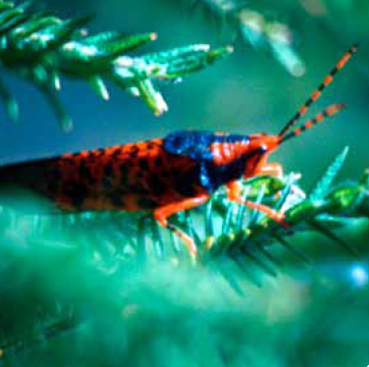

Leichardt's grasshopper (Robert Thorne)

Patches of Arnhem Shrubland Complex that do not meet these criteria are not protected by Federal (national) environment law but they may still be protected under Northern Territory law. Some of the ecological community also receives national protection through Kakadu National Park and its World Heritage listing.

## What routine activities do not need approval?

This ecological community was officially protected under national environment law on 25 November 2011. Lawful activities that began before the EPBC Act came into effect on 16 July 2000 can continue without further Australian Government approval. Any activity since the listing that could harm the Arnhem Shrubland Complex is discouraged but the following activities will not need approval:

* harvesting of bushfood and other traditional activities and use of country, including traditional fire regimes
* maintaining existing fence lines, tracks, roads or fire breaks
* replacing or maintaining existing outstations, sheds, other buildings and yards
* small-scale and existing tourism activities
* controlling pest animals and weeds (with minimal disturbance, or by selective spot spraying)

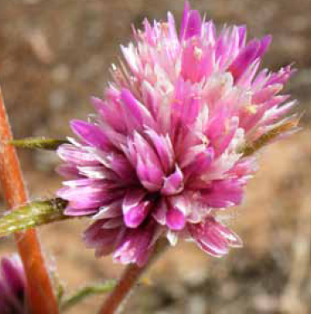

Spermacoce sp. (Helena Mills)

## What activities might need approval?

Things that are likely to be bad (significant, irreversible or have a long-term detrimental impact) for the ecological community may need Australian Government approval. For example:

* large clearing of land/vegetation
* large developments that bring extra vehicles via new roads and lots of people on country.

Developments such as mining activities and new roads can still be approved but more obligations are on the mining companies and construction workers to be more careful to protect the Arnhem Shrubland Complex ecological community.

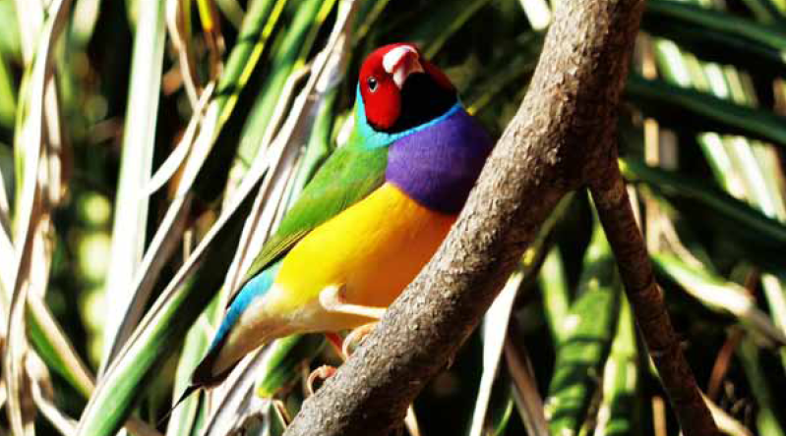

*Erythrura gouldiae* (Gouldian Finch) (Matt White)

## Can I get help to improve or restore Arnhem Plateau Sandstone Shrubland Complex?

There may be natural resource management projects funded by the Australian Government’s Caring for our Country initiative that can help you manage the protected Arnhem Shrubland Complex.

For more information go to [www.nrm.gov.au](http://www.nrm.gov.au) or contact your local NRM regional body: [www.territorynrm.org.au](http://www.territorynrm.org.au)

Northern Territory regional and Indigenous land management coordinators: [www.territorynrm.org.au/contacts/regionalcoordinators](http://www.territorynrm.org.au/contacts/regionalcoordinators)

## Where can I get more information?

More information on this ecological community, its condition thresholds for national protection, threats and priority conservation actions is contained in the comprehensive listing advice and the conservation advice for this ecological community at: [www.environment.gov.au/cgi-bin/sprat/public/publicshowcommunity.pl?id=111&status=Endangered](http://www.environment.gov.au/cgi-bin/sprat/public/publicshowcommunity.pl?id=111&status=Endangered)

For advice on whether or not an activity may need federal approval, contact the Department of Sustainability, Environment, Water, Population and Communities.

Free call: 1800 803 772

Email: [ciu@environment.gov.au](mailto:ciu@environment.gov.au)

## Disclaimer

The views and opinions expressed in this publication are those of the authors and do not necessarily reflect those of the Australian Government or the Minister for Sustainability, Environment, Water, Population and Communities. While reasonable efforts have been made to ensure that the contents of this publication are factually correct, the Commonwealth does not accept responsibility for the accuracy or completeness of the contents, and shall not be liable for any loss or damage that may be occasioned directly or indirectly through the use of, or reliance on, the contents of this publication.

## © Commonwealth of Australia 2011

This work is copyright. You may download, display, print and reproduce this material in unaltered form only (retaining this notice) for your personal, non-commercial use or use within your organisation. Apart from any use as permitted under the Copyright Act 1968, all other rights are reserved. Requests and enquiries concerning reproduction and rights should be addressed to Department of Sustainability, Environment, Water, Populations and Communities, Public Affairs, GPO Box 787 Canberra ACT 2601 or email public.affairs@environment.gov.au

1. Jaowyn and Gundjeibmi language for children

   of the lightening man Namarragon.
2. Bushfood can be plants or animals.