Bananas from the Philippines assessment

  - Final engagement report—appendices
Department of Agriculture, Fisheries and Forestry

This document contains the transcripts of the butcher paper notes captured during the public sessions with banana growers in Queensland, New South Wales and Western Australia.

Appendix A—Innisfail, Qld

Discussion topics today
- What’s changed? Historical contention and long-term engagement
- Change of scope
- Perspective of assessment (Federal/local, DAFF or Australian grower interests)
- Which technical representatives are conducting field assessments:
  - Knowledge base + qualifications – knowledge of bananas/propagation/common pathogens (Moko, Black Sigatoka, Banana Freckle, TR4)
  - Industry perspective is critical – know-how (technical + local context)
  - Formosana introduction requires practical grower POV to be melded against scientific research – safety of introduction (capacity to host vs. visibility of disease)
- Will growers have access to new industry regulations and scientific modelling?
  - Local industry-based review
  - Adequate time horizon + genuine and meaningful opportunity
- Political landscape:
  - Competing interests
  - Varied industry standards
- Will transparency be assured?
  - No ‘smoke and mirrors’
  - Engagement throughout project duration (no last-minute approval/loss of industry engagement)
- Will the social and economic impacts on the sector be considered?
  - Who addresses these concerns
  - Broader impacts beyond biosecurity – vitality of industry
- Will there be compensation for incursion?

Review process
- Regional engagement (in person + webinars)
- Late November provincial trip to the Philippines (baseline activity)
  - Assessment of commercial practices + risk mitigations
- Issues paper – considerations to date
- Draft report for further consultation (late 2026-2027)
  - Formal consultation period – interim between draft/finalisation
  - Further regional engagement – in-person, in depth
- Regulated (additional safeguards) vs. unregulated process – TBD:
  - Recommendation to be made post Issues Paper draft

Sectoral involvement
- Recommendations on industry representative to participate in field assessment
- Inviting industry input regarding places to visit + specific experts to send

Reason for review/what changed?
- 1995 inception, risk assessment 2000-09
- Further conversation required to outline specifies to ensure practical application of criteria
- Dormant dispute issued with the WTO:
  - #1 market access priority w/Australia
  - “Assessment of alternative measures” to provide same level of biosecurity protection
  - Posed by Philippines
  - Risk assessment according to IAPP standards
- Ensuring that any response is an Australian decision, as opposed to one made by an international body
- NZ-apples risk assessment elevated to WTO – ruled Australian response invalid and mandated further review (external decision-makers)
- Is there an opportunity to reject WTO involvement?
  - Commitment to international trade agreements
  - Required to export 70% of agricultural product
- “Why are we importing bananas when we have bananas here?”
- Additional pest/disease have emerged (including blood disease)
- Additional locations/grower provinces

Field assessment (baseline activity)
- Robust decision-making requires confidence – experts in their field
- “People we all take confidence in”
- Entomologist, pathologist, farming practice experts (commercial/technical knowledge)
- Knowledge that best practice will be showcased – visiting variety of farms in several provinces
- Must seek permission of government and individual producers
- Local farmers with technical knowledge
  - Difficult to distinguish between several diseases
  - TR4 resembles Black Sigatoka/Moko or even fertilizer impacts

Additional export province (Davao, region 11)
- Major banana growth region – why was this not assessed originally?
  - Well known, existing province
- Steve visited 3x central locations and 5x sites
  - All host endemic disease – visible evidence
  - Empty and abandoned plantations, industry workers unemployed
- Davao not previously included in risk assessment in ‘08 – requested addition

Export conditions
- Multiple product sources exported out of same ports:
  - Mixed together
  - Only takes “a little bit of dirt” cross-contamination to transmit disease
- Cost of freight – 400 trucks headed south, cost of product into the area:
  - One way with bananas + return with white goods
- Potential incursions may impact other crops and wildlife
  - Pathogens/insects – “hitchhikers”

Biosecurity
- “No new science” to necessitate/support change
- “Australia is an island nation” – practical to have more stringent biosecurity measures
  - “Once a pathogen is in, you can’t get it out”
- Alternatives posed by the Philippines are minimal – assess production practices

Alternative varieties
- No plant propagation rights originally – since secured (“improved”), Dr Chao
- Promoted and secured 218 – not resistant to TRQ
- Marketed by Taiwan through China – to be offloaded to Australia in a similar fashion
- T4R resistance is stifled by presence of other disease – difficult to assess + verify
- Tissue culture assessment unveiled varied diseases – can be difficult to distinguish
- Formosana not previously included in risk assessment in 2008 – requested addition

Steve – insights
- Extensive exposure to pest/disease + knowledge of international practice
- Engagement of local guides, tertiary institutions, pathologist – on-ground experience
  - Papaya Fruit Fly
  - Black Sigatoka (10x worse than yellow) – incredibly serious, endemic
  - Panama TR4 – worst banana disease, confined to Tully Valley, enormous effort to contain, present in NT
  - Banana Freckle – loss of crop (100,000 lost/off the market), present in NT
  - Bunchy Top – extensive containment efforts in QLD, present in SEQ
- “Impact is worn by farmers”
- 25% reduction in industry size in the Philippines due to disease
- “Nothing has changed over 50 years in the Philippines” – no improvement in practice

Grower impacts
- “Banana’s is a family brand”
- ‘Young persons’ game – lower average age of growers
- Extensive investment in building the industry over decades (machinery/resource + marketing industry)
- Well supplied, structured market – impact of social and economic damage (imports + disease)
- Compensation for incursion
- Declined investment in industry – expansion stalled from 2000-08
  - Machinery (100K for bagging machine, to be replaced each decade – impact on manufacturing sector/supply chain)
  - Relocation
  - Disaster resilience
- Reduction in investment in industry – current issue
- “What do you do”? Lack of certainty
- 21.5% employed in industry, 96% small growers – Cassowary Coast region
- Small and multi-generational, family farms – invested into the community
- Mental health – significant in the community due to TR4 and other issues, likely to be exacerbated
- “Are we going to get sacrificed for someone else’s benefit?

Other content/anything major missed?
- What company is behind this application?
- Will the bananas from the small local producers be included in this application
- Hitchhikers – other than banana:
  - Papaya – exotic Fruit Flies, viral strains
  - Mango – Mango Pulp Weevil
  - Citrus – Asian Citrus Psyllid, Citrus Canker (different strains), boring insects
  - Melons/Lychee – Liriomyza SPP
  - Avocado – exotic fungal and bacterial strains
- Weeds carried in as hitchhikers:
  - Manchurian Wild Rice
  - Mikania
  - Mouse-ear Hawkweed
  - Spiked Peppers
- Broad acre crops:
  - Wheat Stem Rust (Ug99 Strain)
  - Karnal Bunt
- Native tree and timber:
  - Xylella Bacteria, vector insects
  - Myrtle Rust
  - Sudden Oak Death
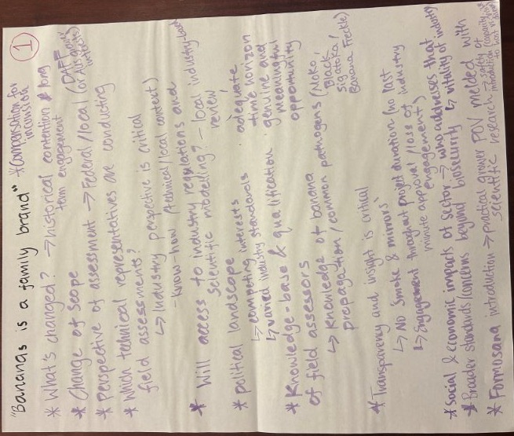
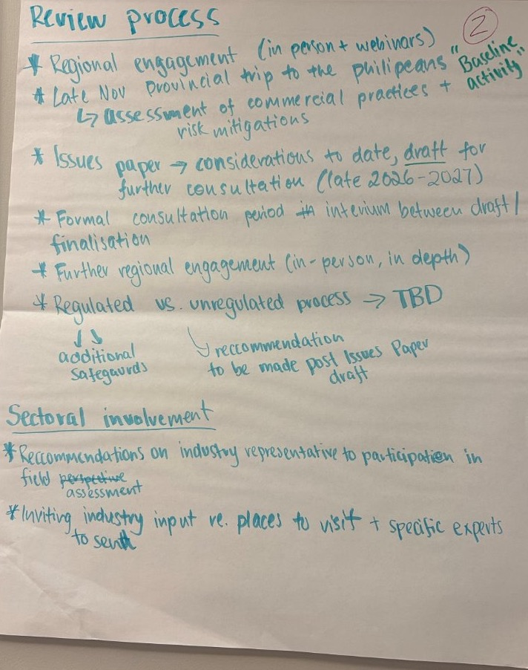
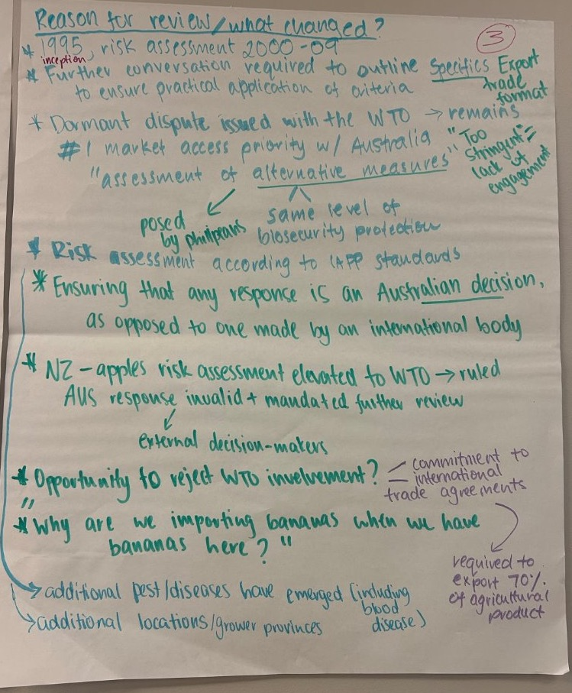
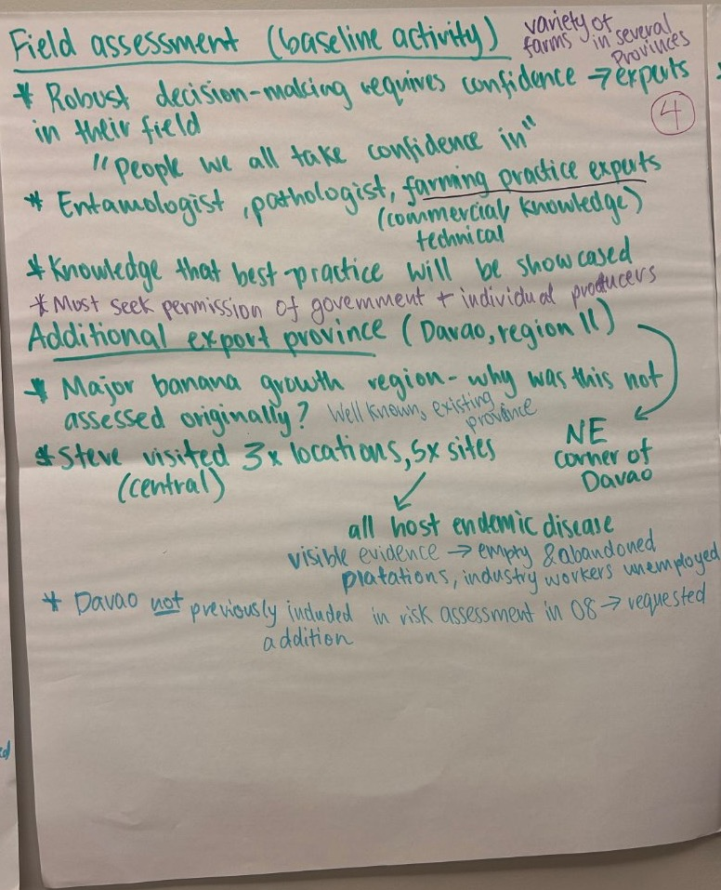
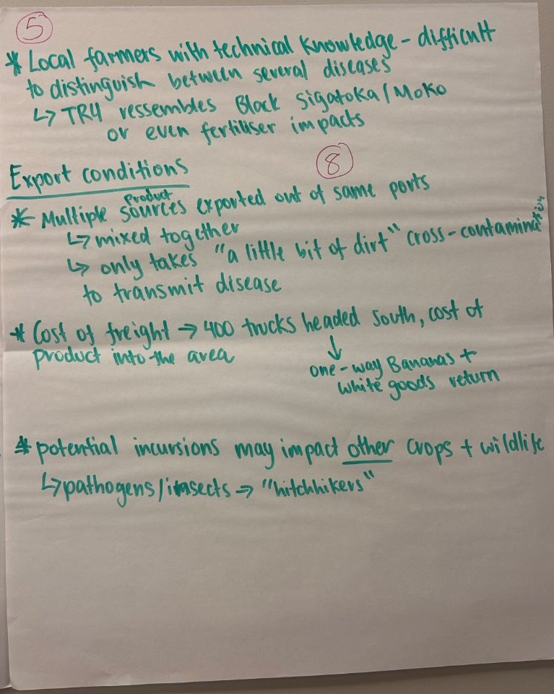
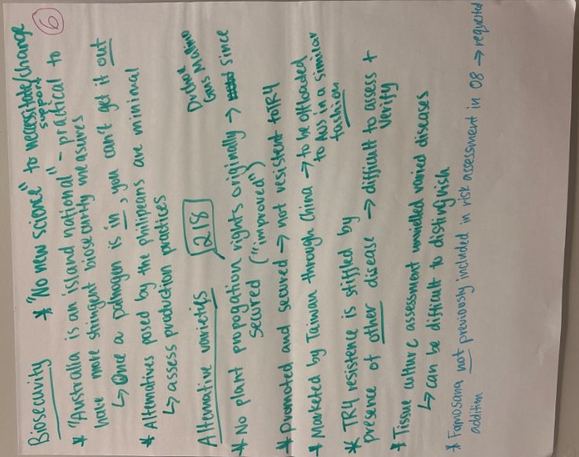
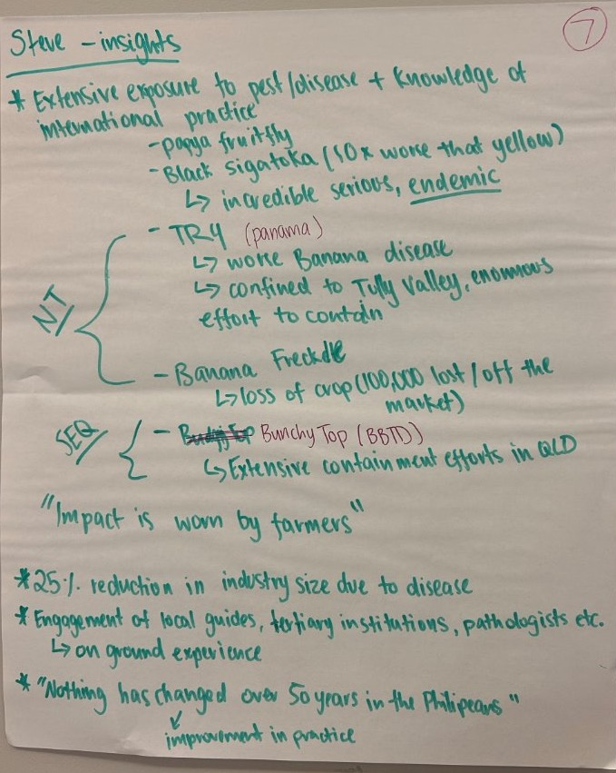
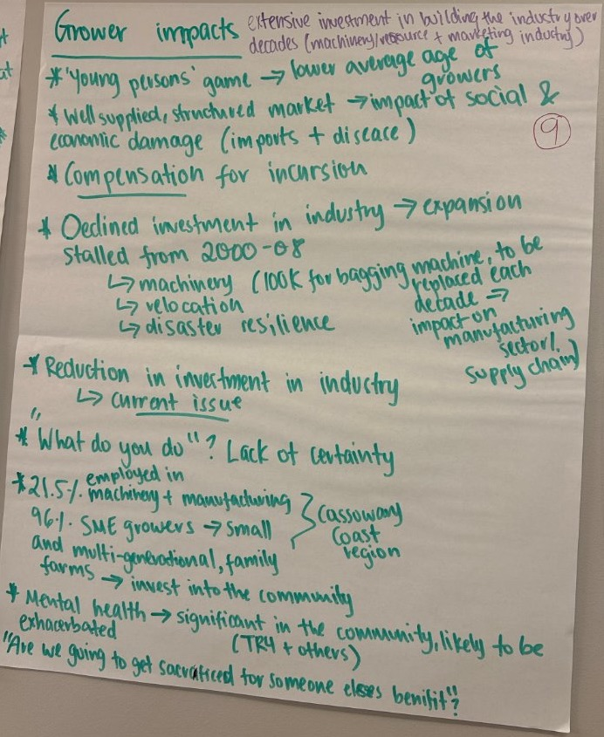
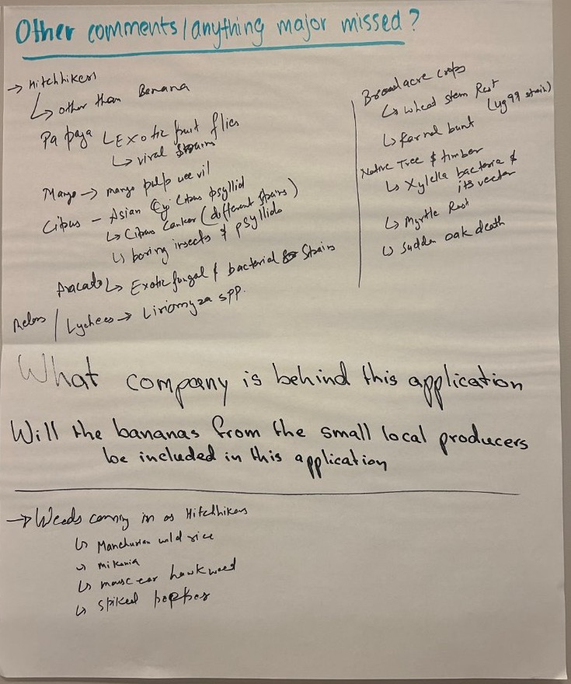

Appendix B—Mareeba, Qld

Discussion topics today
- Are prior experiences/research outcomes considered in drafting of framework?
  - Actions to protect industry/maintain disease free status
  - Australian industry knowledge + history
- Technical expertise – trusted by industry (farming practice experts)
- Contingency for incursion – cost, where does cost sit?
- Why are we entering into this process?
  - Driving force + end result
  - Imports entering local markets (large retailers)
  - Supply consumer market
- Historical management of pathogen entry by federal government
- How to rebuild if industry knowledge/skill is lost?
- Impact of TR4 in Philippines + potential desperation to enter new market
- Did you consult with industry during the TR4 outbreak?
- Why do we need to wait for pathogens to be present/risked before we’re consulted?
- Referrals of information out scope – alternative decision-makers
- Is there someone driving or lobbying for this?
- Where are the products going?

Review process
- Visit to Philippines – baseline picture of production practice
  - Non-specific re assessment – practice + attentional measures to achieve appropriate level of protection
- Issue Paper – first half 2026
  - Key consideration for review – open to feedback from industry
  - Director of biosecurity makes determination, not minister
  - Minister decides whether process is regulated vs. unregulated
- Draft report release (End 2026, early 2027)
  - Public consultation period
  - Further opportunity to provide input prior to finalisation
- Scientific Advisory Group + Inspector General of biosecurity may have involvement – review functions
- Published report, ‘Have Your Say’ survey, additional in-person visits
- Review opportunity – advise on key groups + industry individuals
- All states + territories (DPI’s working collaboration)
  - Email available for specific feedback – relevant information elevated to the right person
  - AGD + DFAT connection point can be established
- Stakeholder engagement not yet determined, “at least 60 days” is standard practice
  - Will be framing around time phrase, but additional time can be provided
  - Prior experience w/ discussion with peak bodies

What has changed + review process
- Inception in 1995, import risk analysis process 2000-08
- 2009 – formal determination allowing access provided biosecurity measures are achieved
  - No pathogen area, arthropods/insects not present
- Perceived as “overly trade restrictive” – lack of specificity
- Initiated WTO dispute resolution process – triggered interest of additional countries
  - Dormant dispute – now a bilateral 1v1 negotiation w/ Philippines
  - Yet to re-trigger process through WTO
  - WTO agreement + international framework agreements for trade dispute
- 2018, March 2025 (more formal) request to evaluate alternative
  - #1 highest priority trade request, raised at all level of government
  - Prior work on dragon fruit underpins new request for assessment
- 4x varieties + 8 provinces considered originally – expanded options for consideration (including 1x new province)
- Preferrable for decision to be made domestically, controlled by Australia
- Changing environment with new considerations – additional pathogens, pests (including blood diseases)
- Apples – NZ
  - Dispute resolution process through WTO
  - Saw Australian measures determined as unjust – overly trade restrictive + don’t meet international standards
  - Reconsidered alternative measures enabled trade
- $100B AFF revenue in 2025, 70% exported
  - Need to engage in dispute process with trading partners both ways
  - WTO can rule to align with any decision, provided it is rigorous + robust
  - Methodology no longer meets international standards – risk of losing control and having review surrendered to WTO

Philippines context/expanded scope
- Original risk assessment review 3x Davao regions, additional regions requested for review
  - 4x cultivares
  - 1x province, 1x new crop
- Require strong verification + trust
  - Third party auditors?
  - Frequency of field visits?
- Meticulous about documentation – can afford to pay for this to be produced, facilities to be immaculate etc.
- May achieve higher accreditation – not through practice but through paperwork
- Knowledge of green loads/current trade activity – “who is driving/willing to accept this?”
- DFAT Level 3 – “Reconsider your need to travel”
  - Personal responsibility for safety of staff
  - Philippines officials ensuring safety to visitor
- Risk management – can be assured in multiple ways – mechanisms

Paul – Insights (ABGC)
- “Bananas are a family brand” – civil and respectful discussion
- Articulate concern on behalf of the growing community re unpopular trade agreement

Biosecurity
- Prior efforts, long-term to eliminate risks
- Alternative industry experience of incursion – prawns etc.
  - White spot, considered low risk
  - Lacking accountability of federal government
- Eradication of Black Sigatoka – point of pride
- “Why do farmers bear the cost?”
- Substantial crop loss – replanting Bananas from scratch, estimated 15 year set back
- TR4 presence in Philippines – lacking viable land
- Formosana may be tolerant but not resistant
- Loss of business + industry knowledge – held long-term, passed through generations
- “When all our businesses are out of business, who is going to pick up the pieces and grow again?”
- Farmers carry the industry on their back – report symptomatic crop, sacrifice for the betterment of the industry
- Only country on earth who have constrained TR4 outbreak to 9-10 properties
  - How are we rewarded for that?
  - Instead threatened with negative impacts
- Lack of mobility opportunity compared to Philippines – cutting down additional jungle etc.

Market stability – broader economic impacts
- Fluctuation of Australian market price – introduction impacts price by $2-3
  - Evaluations on importing bananas at minimal cost shows potential for negative economic impact
  - Revenue loss
  - Unemployment – some growers may struggle to reskill elsewhere
- History of industry of collapse/reduction (i.e. Tabaco) – understood and recognised in the region
- Reduced investment in industry
  - Family farm with assurances to banks to maintain cash inflow – long-term decisions (10-year investment)
- Period of uncertainty – “Not just competing with the people in this room”

Broader social impacts
- Base economy providing year-round guaranteed employment + business (52 weeks)
- Flow on effect to other shops/business
  - Allied business – irrigation suppliers, accommodation, hospitality
- Alternative crops are grown in other nearby areas – pivoting to new industries will increase competition
- Boom/bust of seasonal crop (e.g. Avocados)
- “What about the commitment to Australian growers and their communities?” – should be the #1 priority

Why entertain requests/what enables it?
- 2x drivers of review – direct request either way – access to products or market expansion
- #1 export, seeking increase exports, ‘tick’ from Australia enables expansion into other international markets
- Trade-off – Is there a direct trade of produce occurring (i.e. Banana for passionfruit/blueberry example with Vietnam)
- Strong access into Philippines market – looking for ROI
- “You buy a lot of our products, will you consider buying ours?”

Culpability (Govt/WTO) for negative ramification
- Removed entity like WTO – easier to defend and make decisions
- Prior example very different (i.e. Apples out of NZ)
- Direction of concerns to broader Australian government
- Issues outside of scope are relayed
  - DFAT (trade aspects)
  - Attorney General + Modern Slavery Commissioner (worker/labour impacts)
- Capacity to manage additional pathogens + pest – testing/identification on-site:
  - Requires experienced technical experts/scientists on site
  - Competent Authority Assessment – rely on BPI
  - How reliable is their disease identification monitoring/protocols? Need for 2-way confidence
  - Evaluation in intergovernmental systems – need to determine whether trust can be assured

Field assessment
- Representation of growers – “people with skin in the game”
- Technical experts with Australian industry-knowledge + farming practice
- Knowledge of real-time commercial practice
- QDPI + industry knowledge required
- Subjective, invested people showcasing industry – “Why are we playing to their rules?”
- Food safety + biosecurity standard still apply (+ additional requirements)
- Last minute inclusion of industry presence may risk process – conversation w/ Philippines still ongoing
- Field assessors sceptical
  - Competent in trade negotiation
  - Showcased facilities will be “schmick”
  - Open to receive recommendation + intelligence where to go, inclusion of Banana Republic knowledge holders, trusted experts to be involved in process
  - Suggestion expert – letter to Minister, under very serious consideration
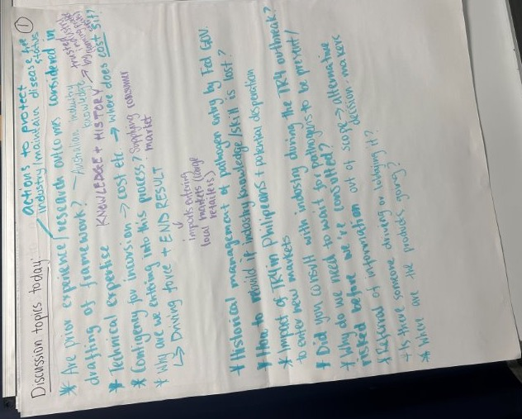
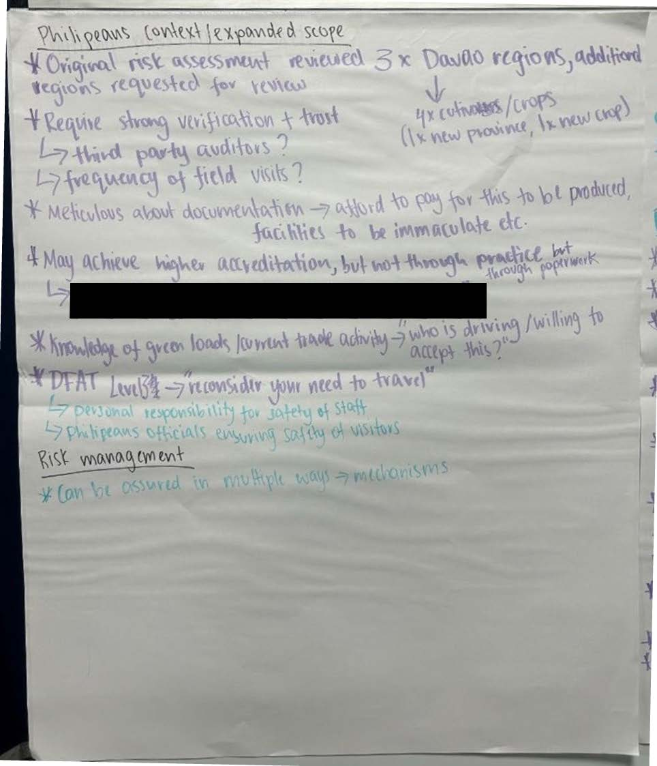
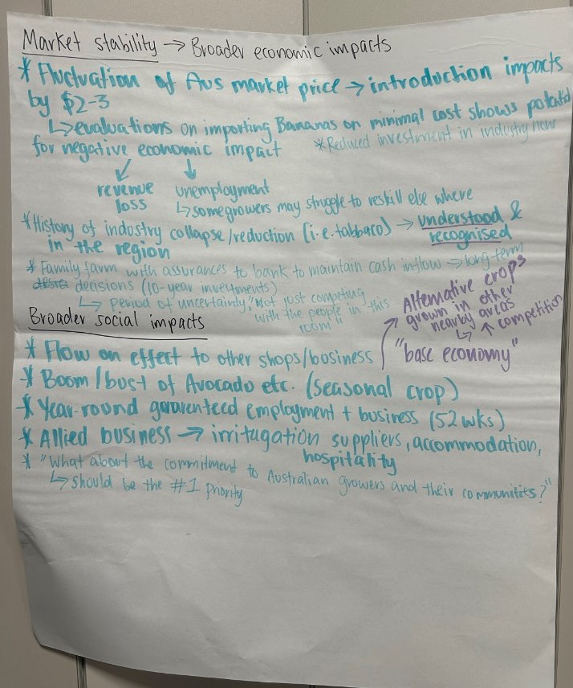
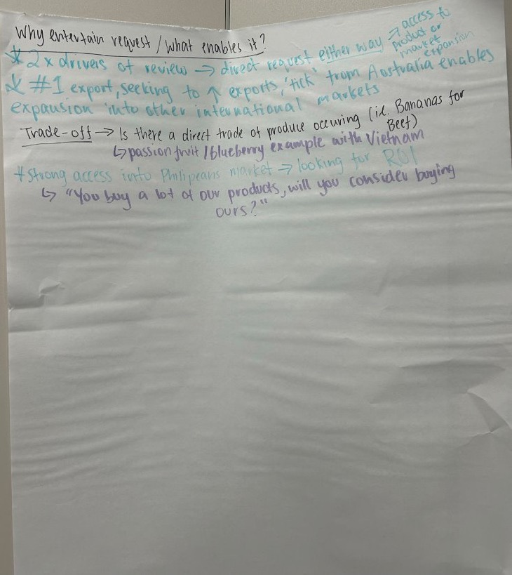
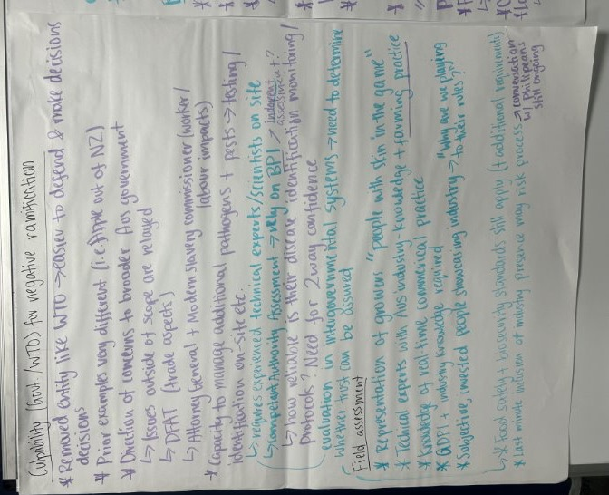
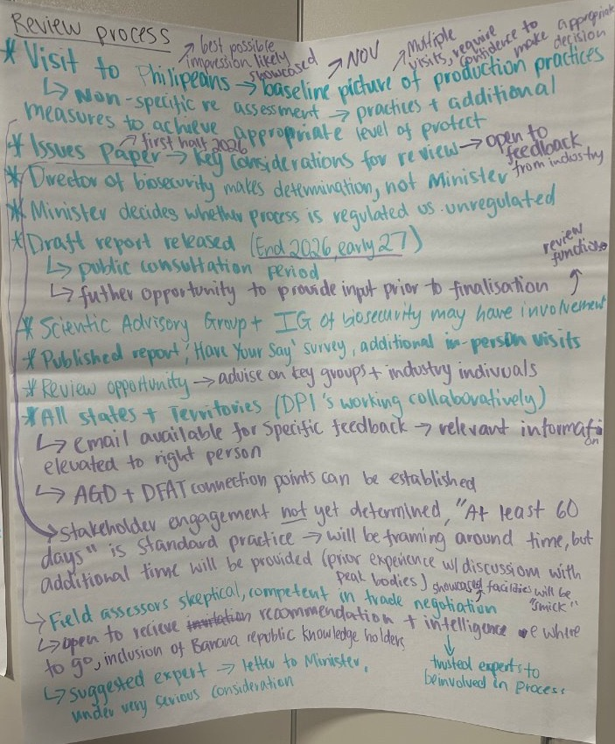
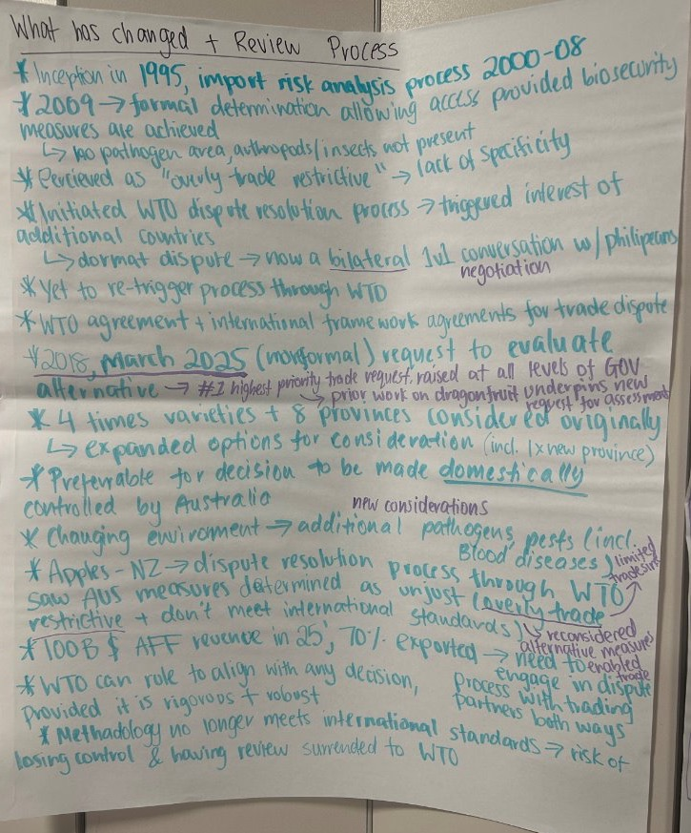
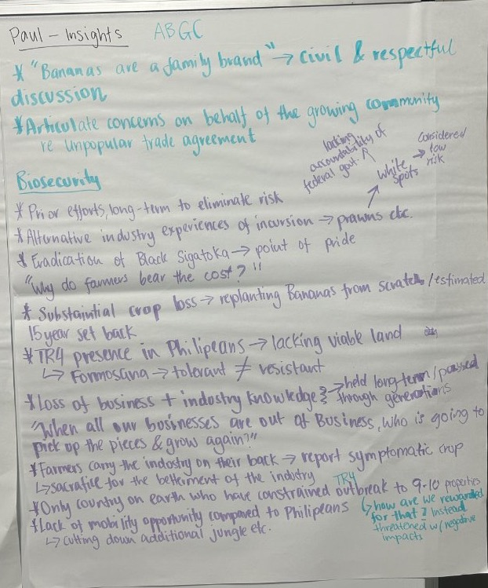

Appendix C—Coffs Harbour, NSW

Concerns
- I had optimism coming here. We have a different standard, and rules and culture. The Philippines’ motivations are financial… which means they are motivated.
- There is great frustration in our industry. We invest in R&D to protect our industry.”
- They don’t have a culture of biosecurity. It’s not just bananas, it’s across all agriculture sectors. I don’t have faith in the systems.
- Are Australian biosecurity officers going to monitor the Philippines 24/7?
- Previous biosecurity fails—we don’t see the Australian Government learning from the consequences.
- There is no point to this, we don’t need it. It’s not coal, it’s not something we need. It’s bananas.
- The bananas they produce are cheap. Our livelihoods are at risk.
- Importing bananas is going to ruin our farms for our children. We are fourth generation farmers. What will there be for our kids?
- Would like testing to be done on Philippines bananas. We would feel better. You can’t see germs.
- Panama is deceiving. It looks good, but the inside is rotten. How do we protect against that risk?
- Every incursion that happens, we pay the cost. If we have another incursion we can’t survive. One more extra thing and we are done.
- The option of going to the WTO is not transparent. We feel this is a gun pointed at our industry to force us into a situation.
- We produce enough bananas for Australia. We don’t need their bananas.
- We have a fight on our hands. We won’t back down. It’s our livelihoods, it’s for our children.
- With reference to beef imports from the USA it looked like there was political pressure.
- Will there be a defined line in the sand? What is low biosecurity risk?
- How clean do the farms need to be?
- Can we have a blanket ban?
- We are an industry that employs migrants, First Nations and regional people. There’s not much resilience left.
- We don’t want any weakening of what we currently have.
- What is going to happen to the industry once the biosecurity box is ticked?
- We don’t feel we get heard.
- Somebody from industry needs to go with the Australian delegation to the Philippines.
- Should we draw up a submission to review Philippines practice?
- Request for information regarding state and territory consumer legislation regarding country of origin.
- The talks started in September, the trip is planned for November. Should we delay the trip? We don’t know who’s going. It feels rushed.
- The flow-on impact because of this announcement extends beyond bananas. It’s impacting investment and innovation. Industry stagnates and then dies.
- We don’t make decisions on tomorrow, we make decisions for our kids. I don’t want my children to have this future.

Questions
- What does consultation look like after the report is published?
- What happens to the final report? What is the timeline?
- What assurances will be provided?
- Have they provided information on what measures will be implemented?
- Why isn’t there a committee/advisory group appointed yet?
- Who are we engaging with in the Philippines? Is it government or farmers?
- If they tick the biosecurity box then why are we here?
- How many ports in the Philippines are exporting fruit? How many Australian ports are receiving imported fruit?
- How can we say “it can’t get in to our country” but we have illegal tobacco coming in?
- How can we manage hitchhiking pests?
- Will the risk assessment only look at pathways for bananas or all risks from the Philippines?
- If approved, what does our industry look like?
- Will there be an economic assessment showing the impact of this decision?
- Does the Philippines have credible biosecurity measures? Can we trust them?
- Is there political pressure within the department to make a decision?
- Will Australian banana farmers be coming with DAFF to the Philippines? Are Australian banana farmers front of mind?
- Does the tax invoice for the trip go to the Philippines?
- Are we lax in certain parts of the industry to create a pathway for this situation?
- If approved how are they going to market? Is country of origin going to be known?
- Is the methodology around the risk assessment going to be published? How transparent is it?
- When you’re testing bananas in the Philippines whose lab are we using?
- What happens to produce exported to WA?
- When we reject produce what happens?
- Who takes responsibility for the consequences of biosecurity? Farmers are facing financial consequences from government failures.
- What is the plan for known biohazards? Does it go to the tip? What is a safe means of disposal?
- How are we planning to manage the risk? Who pays for the additional work?
- What is the journey for bananas from the Philippines and then to market?
- At what point are the parameters for safety determined?
- Will the tropical plant expert be a part of the Australian Government or will they be independent?
- What are the three diseases that the Philippines have that have asked to be reviewed?
- DAFF previously talked about appropriate levels of protection. Why has it changed from protection to risk?
- What’s the pressure on our government to accept this?
- Does the WTO tell us we need to sacrifice an industry to protect someone else? What is there role?
- What happened when bananas ended up at the WTO? How did we get there last time?
- Do they (WTO) look at anything other than the Australian standards? What is the role of the WTO?
- What is DAFF taking away from today? What have you heard?

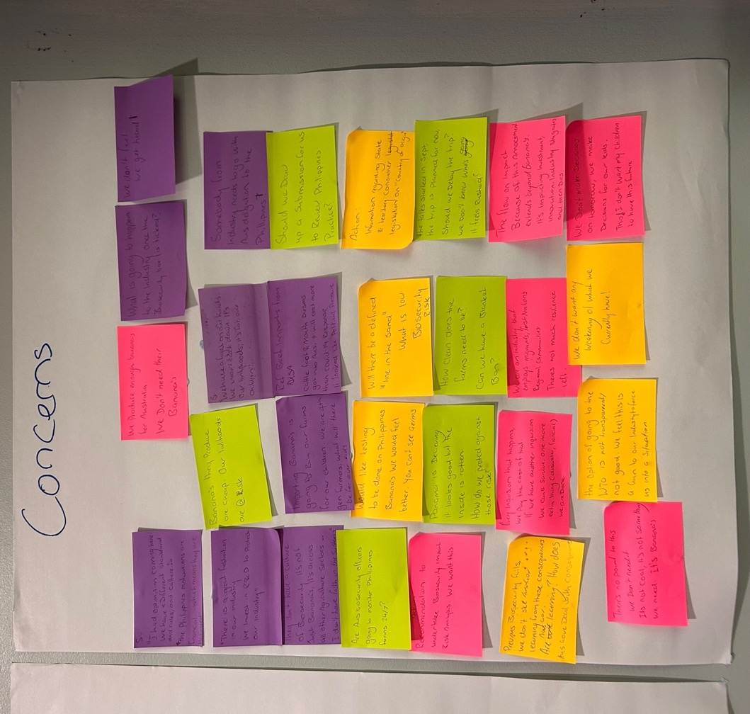

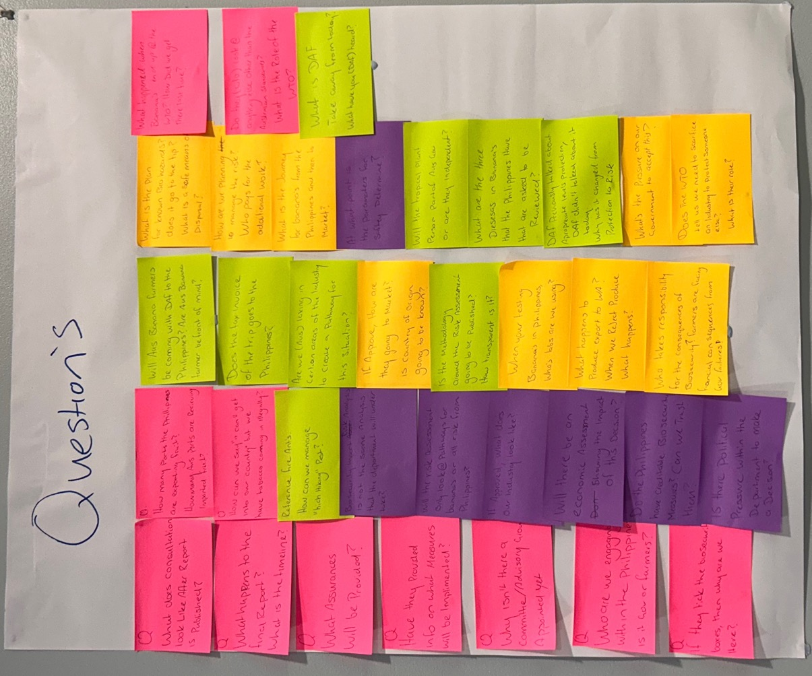

Appendix D—Carnarvon, WA
- Can we ensure confidence that the Philippines follow through with risk mitigations?
- Competent authority approval
- If something goes wrong? Money refunded from ROT?
- EPRD and government (national) and industry will split percentage/share cost
- Overall solved by proper risk assessment
- Representation of the growers at parliamentary level?
  - Industry engagement
  - Regular meetings
  - Draft feedback
- Practices – effectiveness as a concern (burning risk husks onto soil – evidence to stay for 30+ years)
- How will costs be split between Australian and Philippines? National costs will be us, Philippines will pay for everything on their end. If outcome is no – we will not fund continually.
- Industry turnover domestically vs number of growers and where?
- Where does Philippines trade now? – Why do they want Australia?

Questions
- Filipino visit – organised by both parties
- 2008 request was using existing New Zealand risk assessment- new risk assessment framework will solve insufficiencies
- Competition between legislation? Working with industry and state to consolidate all import issues/regulations
- How risk level assessed and who decides what level is acceptable? Director of biosecurity supported by evidence based. Australia does – high level designed to decrease biosecurity risks to low but not 0 (impossible)
- Risk incursion likelihood-based risk assessment?
  - Likelihood of entry, distribution, establishment
- And consequences (at each level) e.g. state, environment
- What steps can producers take?

Concerns
- Actual practices in the Philippines
- Money government has spent on engagement for this publicised and made back to industry
- Self-investment in domestic industry
- Tariffs on trade
- Process will take how long? 2-3 years
- In milestones:
  - Philippines visit Feb 2026
  - Issues paper 2026
  - Draft report on findings 2027
  - Final report?
- Question of unreasonable
- Regular updates and reports publicly published
- Working conditions, environmental concerns incorporated into risk assessment (Philippines is different environment). Environment is considered, involvement of government represented ties e.g. modern slavery and biosecurity act
- Asbestos example – what’s the testing regime? Requirement of food tested at boarder at cost of importer.
- Geo-politics – USA tariffs example
- Trade is essential but we need to consider biosecurity risks. Pathways of entry: do we assess every step of the import process? E.g. soil on shipping containers, hitchhiking into country, many check in points along journey to Australia.
