ASEL 3.2 Errata 17 December 2021
The following standards have been amended in the online version of ASEL 3.2.

Deleted text is struck through and coloured red (example), new text is coloured blue and underlined (example).
1.2.5 | Female buffalo sourced for export as feeder or slaughter animals must:  - be accompanied by a spay declaration from the owner or manager of the premises where the procedure was performed including name, contact information and signature, that certifies that the animal has been spayed not less than 30 days prior to export using the Willis dropped ovary technique and includes the animal’s individual NLIS identification number and date of the procedure; or  - be accompanied by a spay declaration from the owner or manager of the premises where the procedure was performed including name, contact information and signature, that certifies that the animal has been spayed not less than 280 days prior to export and includes the animal’s individual NLIS identification number and date of the procedure; or  - be pregnancy tested within 30 days prior to export, by a registered veterinarian or competent pregnancy tester who must certify in writing that the animal is not detectably pregnant and include with the certification their name, registration or accreditation number (or other authorisation) and signature, and the animal’s individual NLIS identification number and the date of the procedure; and  - undergo the above pregnancy testing by manual palpation, ultrasound or an approved blood test (as accreditation/authorisation permits). Registered veterinarians may use ultrasound if the animal is too small to be manually palpated.
1.2.6 | Female buffalo sourced for export as breeder animals must be no more than 220 days pregnant at the scheduled date of discharge in the importing country, and must be pregnancy tested within 30 days prior to export:  - by a registered veterinarian using an approved blood test; and  - if the test result is negative, be certified in writing as not detectably pregnant; or  - if the test result is positive, undergo testing as per b) or c) below; or  - if the voyage is less than 10 voyage days, by a registered veterinarian that attests to current experience and competency in buffalo pregnancy diagnosis, using manual palpation and only if the voyage is less than 10 voyage days, or by a registered veterinarian that is accredited under the PREgCHECK (NCPD) Scheme if the animal is too small to be manually palpated safely, using ultrasound; and  - if the test result is negative, be certified in writing as not detectably pregnant; or  - if the test result is positive, be certified in writing as pregnant with number of days pregnant stated; or  - if the voyage is 10 voyage days or more, by a registered veterinarian that is accredited under the PREgCHECK (NCPD) Scheme, using manual palpation or if the animal is too small to be manually palpated safely, using ultrasound; and  - if the test result is negative, be certified in writing as not detectably pregnant; or  - if the test result is positive, be certified in writing as pregnant with number of days pregnant stated; and  - with the certification stating the animal’s individual NLIS identification number and date of the procedure, the veterinarians name, registration number and signature, their attestation to experience and competency, or for voyages 10 days or more or animals tested by ultrasound, their PREgCHECK accreditation number and a statement of their accreditation, and the animal’s individual NLIS identification number.
1.4.5 | Female cattle sourced for export as feeder or slaughter animals must:  - be accompanied by a spay declaration from the owner or manager of the premises where the procedure was performed including name, contact information and signature, that certifies that the animal has been spayed not less than 30 days prior to export using the Willis dropped ovary technique and includes the animal’s individual NLIS identification number and date of the procedure; or  - be accompanied by a spay declaration from the owner or manager of the premises where the procedure was performed including name, contact information and signature, that certifies that the animal has been spayed not less than 280 days prior to export and includes the animal’s individual NLIS identification number and date of the procedure; or  - be pregnancy tested within 30 days prior to export, by a registered veterinarian or competent pregnancy tester who must certify in writing that the animal is not detectably pregnant and include with the certification their name, registration or accreditation number (or other authorisation) and signature, and the animal’s individual NLIS identification number and the date of the procedure; and  - undergo the above pregnancy testing by manual palpation, ultrasound or an approved blood test (as accreditation/authorisation permits). Registered veterinarians may use ultrasound if the animal is too small to be manually palpated.
1.4.6 | Female cattle sourced for export as breeder animals must be no more than 190 days pregnant at the scheduled date of discharge in the importing country, and must be pregnancy tested:  - by a registered veterinarian using an approved blood test; and  - if the test result is negative, be certified in writing as not detectably pregnant; or  - if the test result is positive, undergo testing as per b) or c) below; or  - if the voyage is less than 10 voyage days, by a registered veterinarian that attests to current experience and competency in cattle pregnancy diagnosis, using manual palpation and only if the voyage is less than 10 voyage days or by a registered veterinarian that is accredited under the PREgCHECK (NCPD) Scheme if the animal is too small to be manually palpated safely, using ultrasound; and  - if the test result is negative, be certified in writing as not detectably pregnant; or  - if the test result is positive, be certified in writing as pregnant with number of days pregnant stated; or  - if the voyage is 10 voyage days or more, by a registered veterinarian that is accredited under the PREgCHECK (NCPD) Scheme, using manual palpation or if the animal is too small to be manually palpated safely, using ultrasound; and  - if the test result is negative, be certified in writing as not detectably pregnant; or  - if the test result is positive, be certified in writing as pregnant with number of days pregnant stated; and  - with the certification stating the animal’s individual NLIS identification number and date of the procedure, the veterinarians name, registration number and signature, their attestation to experience and competency, or for voyages 10 voyage days or more or animals tested by ultrasound, their PREgCHECK accreditation number and a statement of their accreditation, and the animal’s individual NLIS identification number.
3.1.16 | Livestock must be penned so that:  - animals of different species are not mixed in a single pen; and  - different classes of animals are not mixed in a single pen; and  - animals of different sexes, pregnancy status, or physical characteristics (such as those covered under any applicable management plans and entire vs castrated male livestock) are not mixed in a single pen. This excludes differences in the following categories where animals may be penned together:  - ewe and wether lambs;  - entire and spayed female livestock;  - ≤500kg and >500kg cattle and buffalo (provided the weight of each animal in the pen does not vary from the pen average weight by more than 50 kg, and that all animals in the pen are managed in accordance with ASEL and an approved heavy management plan); and  - immature bulls and castrated steers which have been socialised in the source mob.  - animals of different health status are kept separated; and  - immature animals are separated from mature animals; and  - animals of a dissimilar size and/or weight are separated.
3.1.20 | Daily monitoring of livestock health, welfare and mortality must include:  - inspection of all livestock by a competent stock handler; and  - rejection of any livestock and their management as per Standard 3.1.145; and  - investigation by a registered veterinarian if mortalities in any 1 paddock or shed exceed 0.1% or 3 deaths, whichever is the greater, on any 1 day for cattle and buffalo, or 0.25% or 3 deaths, whichever is greater, on any 1 day for any other species of livestock; and  - removal of dead livestock on a daily basis. Carcases must be disposed of in compliance with all relevant and applicable legislation.
5.1.2 | Before loading of livestock for transport to the port of embarkation, a loading plan for the  vessel on which the livestock are to be transported must be prepared in writing by the exporter. The loading plan must be compliant with relevant vessel safety standards and include details of:  - the net available pen area on the vessel (excluding the area of the hospital pens) according  to the vessel's record of equipment for the carriage of livestock; and  - pen layout, available pen area for the particular consignment, hospital pens, ventilation,  vessel characteristics and stability requirements, port rotation, and discharge sequence; and  - the total number of livestock that are to be loaded on the vessel and number of livestock to  be placed in each pen, based on the minimum pen area per head required for the relevant  livestock species, weight, class, sex, reproductive status and physical characteristics as  specified in Standard 05. Basis for calculations must be included.
5.2.3 | Feed loaded and provided to buffalo exported on voyages of:  - short and long-haul voyages, must include at least 1% of the required feed as chaff and/or hay; or  - extended long-haul voyages where an exporter has approval under Standard 5.1.17 to export buffalo on extended long-haul voyages, must include at least 2% of the required feed as chaff and/or hay.
5.2.5 (and 5.2.6) | The minimum veterinary medicines and equipment to be carried on the vessel are in Table 7. Additional veterinary medicines and equipment to be carried on voyages with pregnant buffalo are in 1 Refer to veterinary advice and the Australian veterinary antimicrobial prescribing guidelines  5.2.6 Table 8. Additional veterinary medicines and equipment may be necessary if there are other classes of buffalo on the vessel.  *This error impacted subsequent standard 5 numbering. Please refer to the current ASEL 3.2 version online for correct numbering.
5.3.3 | Standard 5.3.2 applies unless an exporter is approved in writing under their approved arrangement to use alternative pen space for cattle loaded at a port north of latitude 26°S to a particular destination. The alternative pen space allocation is contained in Table 10a for near markets. Table 10b contains the alternative pen space allocation for far markets. For weights between those shown in Table 10a or those shown in Table 10b, the minimum pen area per head must be calculated by linear interpolation. Daily reports must be provided as set out in Standard 5.6.6.
5.3.7 | Feed loaded and provided to cattle exported on voyages of:  - short and long-haul voyages, must include at least 1% of the required feed as chaff and/or hay; and  - extended long-haul voyages where an exporter has approval under Standard 5.1.17 to export cattle on extended long-haul voyages, must include at least 2% of the required feed as chaff and/or hay.
5.3.8 | In addition to standard 5.1.18, cattle exported on long and extended long haul voyages must be provided with additional sawdust, rice hulls or similar bedding material to be used exclusively for bedding at a rate of at least 7 tonnes or 25m³ for every 1,000m² of cattle pen space. This additional bedding requirement does not apply to cattle loaded from a port north of latitude 26°S and exported to South-East Asia.
5.3.9 (and 5.3.10) | The minimum veterinary medicines and equipment to be carried on the vessel are in Table 14. Additional veterinary medicines and equipment to be carried on voyages with pregnant cattle are in 1 Refer to veterinary advice and the Australian veterinary antimicrobial prescribing guidelines  5.3.10 Table 15. Additional veterinary medicines and equipment may be necessary if there are other classes of cattle in the consignment.
6.3.5 | Female buffalo sourced for export as feeder or slaughter animals must be:  - be accompanied by a spay declaration from the owner or manager of the premises where the procedure was performed including name, contact information and signature, that certifies that the animal has been spayed not less than 30 days prior to export using the Willis dropped ovary technique and includes the animal’s individual NLIS identification number and date of the procedure; or  - be accompanied by a spay declaration from the owner or manager of the premises where the procedure was performed including name, contact information and signature, that certifies that the animal has been spayed not less than 280 days prior to export and includes the animal’s individual NLIS identification number and date of the procedure; or  - be pregnancy tested using manual palpation, ultrasound or approved blood test, or if the animal is too small to be manually palpated safely, ultrasound, within 30 days prior to export, by a registered veterinarian who must certify in writing that the animal is not detectably pregnant. The certification must include the certifier’s name, registration number and signature, and the animal’s individual NLIS identification number and the date of the procedure.; and  - undergo the above pregnancy testing by a registered veterinarian if the animal is too small to be manually palpated, who must base the certification on assessment of the animal by a method other than manual palpation manual palpation, ultrasound or an approved blood test (as accreditation/authorisation permits).
6.5.3 | Cattle must not be sourced for export or exported unless they have been assessed by a competent stock handler against the non-dairy breed cattle body condition scoring in Table 29 or dairy breed cattle body condition scoring in Figure 5 and have a body condition score of:  - for non-dairy breed cattle, 2 or more but less than 5 (on a scale of 0 to 5); and  - b) for dairy breed cattle, 3.5 or more but less than 5.5 (on a scale of 1 to 8).
6.5.4 | Female cattle sourced for export as feeder or slaughter animals must:  - be accompanied by a vendor spay declaration from the owner or manager of the premises where the procedure was performed including name, contact information and signature, that certifies that the animal has been spayed not less than 30 days prior to export using the Willis dropped ovary technique and includes the animal’s individual NLIS identification number and date of the procedure; or  - be accompanied by a vendor spay declaration from the owner or manager of the premises where the procedure was performed including name, contact information and signature, that certifies that the animal has been spayed not less than 280 days prior to export and includes the animal’s individual NLIS identification number and date of the procedure; or  - be pregnancy tested using manual palpation, ultrasound or approved blood test, or if the animal is too small to be manually palpated safely, ultrasound, within 30 days prior to export, by a registered veterinarian who must certify in writing that the animal is not detectably pregnant. The certification must include the certifier’s name, registration number and signature, and the animal’s individual NLIS identification number and the date of the procedure.; and  - undergo the above pregnancy testing by a registered veterinarian if the animal is too small to be manually palpated, who must base the certification on assessment of the animal by a method other than manual palpation manual palpation, ultrasound or an approved blood test (as accreditation/authorisation permits).
6.9.6 | Sheep with horns must only be sourced for export or exported if the horns:  - would not cause damage to the head or eyes of the animal or other animals; and  - would not endanger other animals during transport; and  - would not restrict access to feed or water during transport; and  - are no longer than 1 full curl, unless otherwise provided in a long-horned livestock management plan approved in writing by the department.
Appendix C b) | The PLUs must:  - be placed and secured in accordance with Marine Order 43; and  - have non-slip and non-abrasive surfaces. This may be achieved through the use of bedding material suitable for the class and species of livestock to be transported; and  - allow space in accordance with Standard 05, with an additional 15% space allocation to account for:  - species and class; and  - size and body condition; and  - wool or hair length; and  - horn status; and  - predicted climatic conditions; and  - design and capacity of the PLU.  - be supplied with feed and water that:  - has adequate storage space  - is sufficiently protected from weather  - is managed in accordance with Standard 05, and Marine Order 43.
Figure 6 | Figure 36 Visual aid for assisting with body condition scoring of goats
Table 2 | Table 2 [deleted]
Table 26 | Score 1 to 5 for export purposes Description P8 fat mm thickness (1 to 5), [1 to 9] Loin surface Illustration of vertical section of the loin region between spinous and traverse processes  1 Emaciated; very weak – extreme muscle wastage. All bones highly visible. Skin 'draped' over skeleton. Unsteady gait. 0 Severely concave 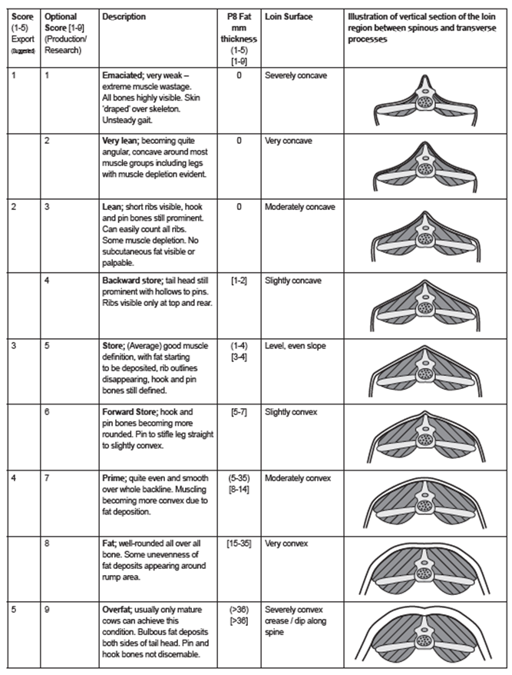  2 Lean; short ribs visible, hook and pin bones still prominent. Can easily count all ribs. Some muscle depletion. No subcutaneous fat visible or palpable. 0 Moderately concave  3 Store; (average) good muscle definition, with fat starting to be deposited, rib outlines disappearing, hook and pin bones still defined. (1 to 4), [3 to 4] Level, even slope  4 Prime; quite even and smooth over whole backline. Muscling becoming more convex due to fat deposition. (5 to 35), [8 to 14] Moderately convex  5 Overfat; usually only mature cows can achieve this condition. Bulbous fat deposits both sides of tail head. Pin and hook bones not discernible. (>36), (>36) Severely convex, crease/dip along spine  Source: NT Buffalo Industry Council Inc.

