Assessment of Murray cod recruitment to the lower Darling River in response to environmental flows throughout 2016–18.

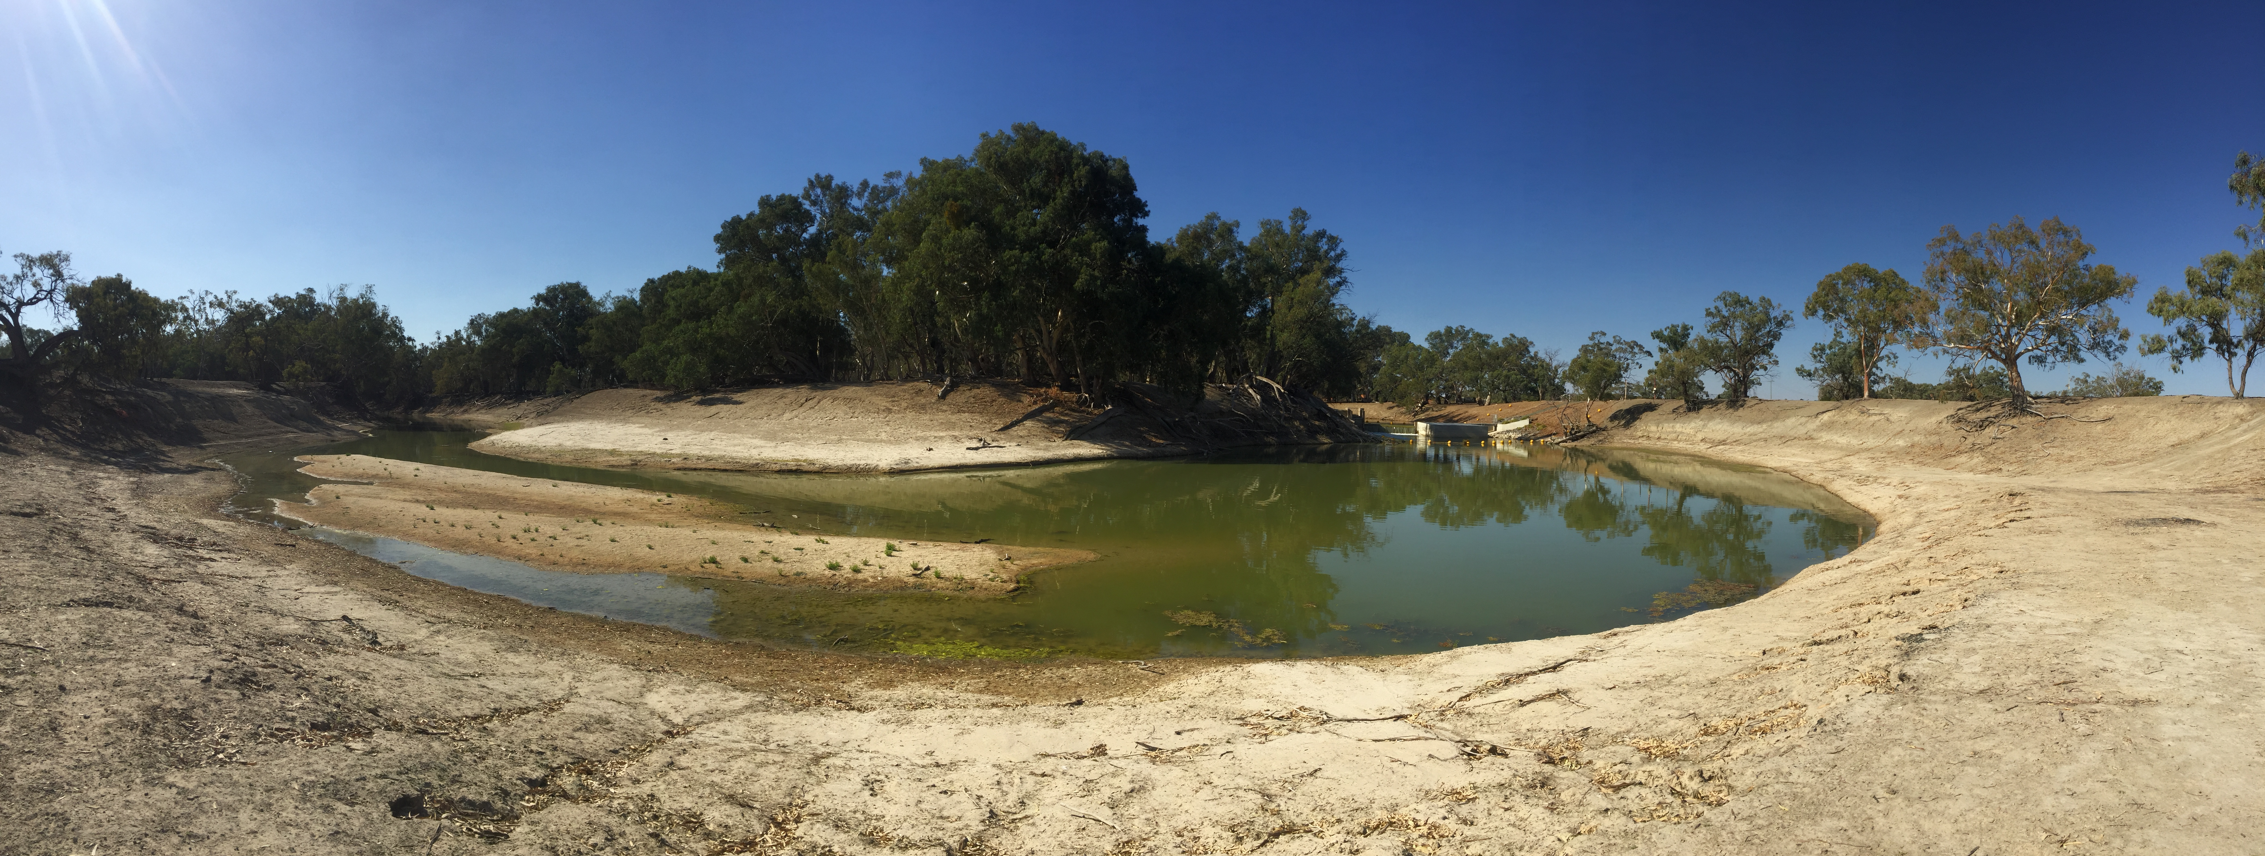


Citation:
Sharpe, C. and Stuart, I. (2018). Assessment of Murray cod recruitment in the lower Darling River in response to environmental flows 2016–18. CPS Enviro technical report to The Commonwealth Environmental Water Office.

Acknowledgements:
This project was funded by the Commonwealth Environmental Water Office, the New South Wales Office of Environment and Heritage (NSW OEH) and Murray–Darling Basin Authority’s (MDBA) The Living Murray Program (TLM). The Living Murray is a joint initiative funded by the New South Wales, Victorian, South Australian, Australian Capital Territory and Commonwealth Governments, coordinated by the Murray–Darling Basin Authority. Thanks to Irene Wegener, Alana Wilkes, Hilton Taylor, Hilary Johnson and Sean Kelly from CEWO for managing the project and environmental water. From NSW OEH Paula D’Santos, Sascha Healy and Paul Childs and NSW DPI Fisheries Iain Ellis who provided leadership in flow planning and delivery to promote the maintenance and recovery of fish populations in the Darling River and Southern-Connected Basin. From the Murray–Darling Basin Authority, Adam Sluggett, Adam McLean, Kerry Greenwood, John Waterworth and Tristan Skinner provided operational guidelines for hydrograph development. From CPS Enviro, Sheridan Stephens for expert project administration and staff scheduling, Eden Sharpe and Jason Healy for technical support in field sampling of the Darling River. We also acknowledge and thank landholders along the Darling River for access through their properties. This work was conducted under NSW Fisheries Permit P12/0004 following Griffith University ACEC ENV0417AEC.

Disclaimer:
The results and comments contained in this report have been provided on the basis that the recipient assumes the sole responsibility for the interpretation and application of them. The author gives no warranty, express or implied, or assumes any legal liability or responsibility for the accuracy, completeness or use of the results and comments contained in this report by the recipient or any third party.

© CPS Enviro P/L
With the exception of the Commonwealth Coat of Arms, photographs and logos, all material presented in this document is provided under a Creative Commons Attribution 4.0 International licence. (https://creativecommons.org/licenses/by/4.0/) .
For the avoidance of any doubt, this licence only applies to the material set out in this document.


The details of the licence are available on the Creative Commons website (accessible using the links provided) as is the full legal code for the CC BY 4.0 licence (https://creativecommons.org/licenses/by/4.0/legalcode ).

Cover Image: The lower Darling River downstream of Pooncarie Weir, June 2018 (C. Sharpe).

Contact Details:
Commonwealth Environmental Water Office
John Gorton Building
King Edward Terrace
Parkes ACT 2600
Australia
P: +61 2 6274 1111
E: ewater@environment.gov.au

Executive summary

In 2017/18, river managers aimed to build upon the outcomes achieved from the 2016/17 lower Darling River (LDR) environmental flow by optimising flow delivery to again support spawning and recruitment opportunities for Murray cod (Maccullochella peelii peelii). This report evaluates the influence of the 2016/17 and 2017/18 environmental flow schedules by examining recruitment of age 0+ and 1+ year Murray cod in the LDR, spawned in spring 2017 and 2016, respectively. The second aim of this report is to describe the population structure of other native fish in the LDR, in particular for golden perch (Macquaria ambigua), with regard to the 2016/7 and 2017/18 LDR environmental flows.

Key findings: Murray cod recruitment in the LDR supported by environmental flows
Fish sampling of the LDR was undertaken across thirteen sites during winter 2018. Published size-at age data were used to assign fish spawned in 2016 and 2017 to age 1+ and age 0+ year classes respectively. Data analyses from the 2018 survey indicated that Murray cod spawned in spring 2016 accounted for 14 per cent of the population structure indicating that the 2017/18 environmental flow had continued to support recruitment of the 2016 spawned fish into the population. Murray cod spawned in 2017 also contributed to 14 per cent of the overall population structure. Cumulatively, Murray cod spawned in spring 2016 and 2017, in conjunction with environmental flows, comprised nearly one-third (28 per cent) of the overall population structure.

The LDR Murray cod population structure consisted of fish from 88 mm- 1024 mm long and a complete range of size classes (thus potentially age classes) within were represented, indicating a robust population structure. However, fish within the slot size for take by anglers (550-750 mm) appeared somewhat reduced in abundance compared to smaller (<550 mm) and larger (>750 mm) fish, potentially indicating that angling pressure may be influencing population structure in the LDR.

The 2016/17 and 2017/18 environmental flow schedule delivered to the LDR was successful in meeting its primary aim of supporting recruitment and importantly, resilience for the LDR’s Murray cod population. For future management of Murray cod in the LDR, continuing to support annual spawning and recruitment with annual implementation of the Murray cod hydrograph is key to long-term resilience.

We also recommend that all future regulated flow management deliver as a minimum similar flow schedules to maintain annual recruitment. In summary;
- Deliver a moderate increase in discharge above base entitlement levels during spring/summer (from 1 September-1 December) from 400 ML/d to 800 ML/d at Weir 32 and maintain stable water levels and high hydrodynamic complexity to support the ecology of Murray cod spawning; evidenced by the strong spawning success observed in 2016 (Sharpe and Stuart 2018) and again in 2017 (Sharpe 2018).
- From 1 December- 28 February, when spawning is complete (as observed in 2014 by Ellis et al.; 2016 and 2017 by Sharpe and Stuart 2018), provide a moderate increase in discharge (from ~800 – 1200 ML/d at Weir 32) to increase water levels and inundate low-lying benches along the LDR corridor to support early juvenile recruitment by promoting habitat, food availability and shelter from predation (as observed by Stuart and Sharpe (2018)).
- From 28 February- 1 April, deliver a slow recession in discharge and water levels from 1200- 400 ML/d at Weir 32 and maintain this baseflow over autumn and winter, providing higher than winter base entitlement flows (i.e. increase base entitlement flow from 180 ML/d to 400 ML/d) to provide over-wintering YOY (age 0+ juveniles spawned during the previous spring and age 1+ spawned in 2016) with increased access to littoral habitats, continuing to provide shelter from predation and greater feeding opportunities, thus enhancing recruitment success.

Thus, a perennial hydrograph should be planned for in the LDR to support its iconic and nationally significant Murray cod population. For river managers, we recommend developing a 10-year flow delivery schedule for the LDR in consultation with CEWO, New South Wales (NSW) Office of Environment and Heritage (OEH), TLM (The Living Murray), Murray–Darling Basin Authority (MDBA) Environmental Water Coordination (EWC) (formally TLM), MDBA River Operations, and WaterNSW. The flow delivery plan should consider wet, average and dry year scenarios.

Embedding a Murray cod conceptual life history model into the LDR flow delivery schedule enabled environmental managers to meet the overarching aim of supporting Murray cod reproduction and recruitment and thus improve population resilience. This is a major outcome for Murray cod in the LDR and is a framework that can be applied to other reaches of the Darling River system (e.g. Louth-Bourke) or other rivers where Murray cod population enhancement or maintenance is required.

Golden perch recruitment in the LDR supported by environmental flows
The environmental flow plan for golden perch in the LDR in 2016/17 was based on the principals of providing connectivity in population function over thousands of kilometres of the river system, aligning with a Southern Connected plan for native fish management in the MDB (Stuart and Sharpe 2017). In December 2016, Sharpe and Stuart (2018) confirmed that golden perch spawning occurred in response to the October 2016 flow-event in the Darlings’ northern tributaries upstream of Brewarrina, with larvae transitioning into early juveniles during a drift over many hundreds of kilometres before settling into the productive nursery grounds of the Menindee Lakes.

Downstream dispersal of young golden perch from Menindee Lakes was then initiated by releasing environmental water into the LDR and Great Darling Anabranch, providing vital dispersal pathways for golden perch recruitment into the LDR and Murray River populations. Monitoring of the LDR population in winter 2017 demonstrated that new recruits (age 0+ years) comprised over 30 per cent of the golden perch population structure.

Monitoring of the LDR golden perch population undertaken herein (winter 2018) confirmed the survival of the spring 2016 year-class, within the LDR population, where they dominated (36 per cent) the populations structure. This is a remarkably high contribution of new recruits and similar to Murray cod, demonstrates the value of embedding a conceptual understanding of the life history ecology of golden perch into the environmental flow delivery schedule for the LDR.

List of acronyms
CEWO Commonwealth Environmental Water Office
EWC Environmental Water Coordination (formerly the MDBA TLM team)
GDA Great Darling Anabranch
LDR lower Darling River
MDBA Murray–Darling Basing Authority
MDB Murray–Darling Basin
NSW New South Wales
TLM The Living Murray
YOY Young of Year

Introduction

Since completion of the Menindee Lakes Scheme in 1968, flow to the ~500 km of the Darling River downstream of Menindee, the lower Darling River (LDR) to its confluence with the Murray River at Wentworth has been regulated except during large floods, which have occurred approximately one year in 10 (Thoms and Sheldon 2000). The impacts of river regulation and low inflows to the Darlings’ northern rivers throughout 2014–15 resulted in the longest cease to flow period for the LDR in recorded history, exceeding 500 days at Burtundy (https://realtimedata.waternsw.com.au).

Inflows to the Menindee Lakes re-occurred in August 2016, and the first environmental flow specifically targeting ecological outcomes for the LDR was delivered by State and Commonwealth environmental water holders. From September 2016 to December 2017, environmental flows were embedded into the delivery schedule for the LDR to support Murray cod (Maccullochella peelii peelii) spawning and recruitment and the dispersal and recruitment of golden perch (Macquaria ambigua) early juveniles from nursery grounds in the Menindee Lakes to LDR, Great Darling Anabranch (GDA) and Murray River populations (Sharpe and Stuart 2018).

Sharpe and Stuart (2018) undertook an ecological evaluation of the 2016/17 environmental flow and demonstrated that Murray cod in the LDR successfully spawned in spring 2016 and recruited to young of the year (YOY) juveniles. In addition, juvenile golden perch (age 0+, less than 1 year old) dispersed from Menindee Lakes throughout the length of the LDR and GDA. These data demonstrate that the 2016/17 environmental flow was successful in meeting its ecological objectives of supporting the recruitment of those two species to the LDR system (Sharpe and Stuart 2018).

In 2017/18, environmental managers aimed to build upon the outcomes from the 2016/17 environmental flow by optimising flow in the LDR to support spawning and recruitment opportunities for Murray cod. The 2017/18 flow was also designed to enhance survival of juvenile Murray cod spawned in spring 2016. This report evaluates the influence of the 2016/17 and 2017/18 environmental flow schedules in achieving Murray cod recruitment to age 0+ and 1+ years in the LDR, spawned in spring 2016 and 2017, respectively. The second aim was to describe the structure of other fish populations in the LDR, in particular for golden perch, in consideration of the influence of the 2016/17 and 2017/18 LDR environmental flow delivery schedules.

Environmental flow delivery schedules for 2016/17 and 2017/18 water years

In September 2016, Commonwealth environmental water holders (CEWO, TLM) delivered ~119 GL to support the objectives identified above for Murray cod and golden perch population recovery in the Lower Darling River (CEWO ~70 GL, TLM ~50 GL). The environmental flow plan was developed as per the conceptual framework provided by Sharpe and Stuart (2018), outlined in Appendix 1 and summarised in Table 1. The flow plan was operationalised to a delivery schedule, or hydrograph, for river operators to implement (Figure 1). Briefly, flow delivery from September to December 2016 aimed to accommodate Murray cod breeding ecology, supporting courtship, nest selection, spawning and nest retention by providing higher than base-flow water levels (LDR base entitlement flow spring/summer 400 ML/d, optimised to 800 ML/d), and avoiding rapid drops and rises in river levels throughout the breeding period. Upon completion of spawning (which was determined as early December 2016 by Sharpe and Stuart 2018), flows delivered to the LDR from Menindee Lakes were increased to inundate low-lying benches along the river corridor, to increase the availability of littoral habitats for recently spawned Murray cod to shelter and to promote productivity processes and thus food availability (micro- and macro-invertebrates) for young fish, in turn promoting survival and early recruitment to the population (Figure 1).

Sharpe and Stuart (2018) then conducted a census of the LDR Murray cod population during winter 2017 at six sites, from ~50 km downstream of Menindee and throughout ~500 km of the LDR, to 5 km upstream of the Wentworth (Lock 10) weir pool. Their assessment reported that 14.2 per cent of the LDR Murray cod population were aged 0+ juveniles, spawned in spring 2017, and concluded that the 2016/17 environmental flow plan was successful in meeting its aim of supporting recruitment to the population (Sharpe and Stuart 2018).

A similar environmental flow plan was repeated in 2017/18 (Figure 1), when 25 810 ML was delivered to the LDR from July-December 2017 (TLM: 23 072 ML, CEWO: 2 738 ML) (Figure 1). In 2017/18, this environmental water was again embedded into the water delivery schedule for the LDR so as to meet the overarching aim of supporting Murray cod spawning and early recruitment ecology, including for fish spawned in 2016, as per that outlined above (see Appendix 1). The flow plan also continued to support golden perch recruits in the LDR that were spawned in 2016. The TLM water was delivered 1 July- 29 September and 28 November- 15 December 2017 and CEWO water 21-28 November 2017.

Table 1. Key elements of the 2016–18 LDR environmental flow plan, based on conceptual models of population function for Murray cod and golden perch in the LDR.
Temporal scale (season) | Spatial scale for LDR objectives | Water level | Mean channel velocity | Ecological objectives  Murray cod
Early spring  (early Sep) 2016 and again in spring 2017 | ~500 km  LDR from Weir 32 – Wentworth | Slowly rising (e.g. 0.15 m per day) to ¾ to full channel  No major reductions in water level (e.g. net drop < 0.3 m)  450 ML/d | > 0.4 m/s | - Enable adult fish to move to breeding habitats  - Initiate egg maturation  - Inundate spawning sites including snags, undercut banks, benches and establish littoral macrophytes and food resources for larvae  - Minimise sudden drops to avoid nest abandonment
Mid-spring to late summer (Oct-Feb) |  | Smooth slowly rising (e.g. 0.15 m per day) to ¾ to full channel  Minimise hydraulic disturbance  No major reductions in water level (e.g. net drop < 0.3m)  600-800 ML/d | > 0.4 m/s | - Nest construction, courtship, mating, egg laying, males to guard nest  - Minimise sudden drops to avoid nest abandonment  - Enhance egg hatching and maintain larval drift and nursery areas
Late spring – early summer (Nov-end Dec) | ~600 km  LDR from Weir 32 – Wentworth and Murray River | Increase 800-1200 ML/d, avoid water level reductions | > 0.4 m/s | - Inundate low-lying benches, promote primary and secondary productivity and food for larvae  - Enable YOY to inhabit littoral zone and snag habitats
Late summer and autumn  (Jan-April) |  | Slow recession to ¼ full channel  800-6000 ML/d flow pulse | > 0.4 m/s | - Increase littoral habitats for YOY dispersal  - Increase snag habitats for sub-adults and adults  - Inundate low lying benches food resources for YOY
Winter  (April to August) |  | ¼ to full channel  Slow recession to winter base flow (e.g. fall of <0.15 m/24 h)  400 ML/d | > 0.4 m/s | - Enable native fish to move to permanent winter habitats (i.e. deep refuge pools)  - Maintain base flow for survival of YOY juveniles, sub-adults and adults

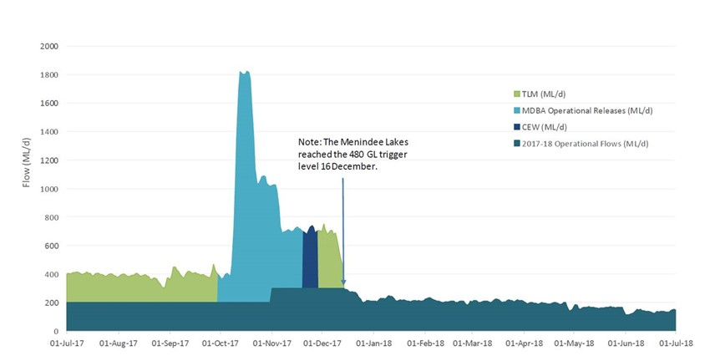
Figure 1. Flow (ML/d) at Weir 32 delivered to the lower Darling River throughout 2016–18. In 2016/17, the total volume of environmental water delivered was 119.3 GL. In 2017/18, the volume of environmental water delivered was 25.8 GL. The dark green represents WaterNSW operational flow for LDR. The light green represents TLM, light blue MDBA Operational Releases, dark blue CEW. The main elements of the environmental flow plan were to (a) increase discharge and water levels above the WaterNSW operational flows to promote inundation of potential spawning sites (snags), (b) increase flows to inundate low-lying benches, promote nursery habitat and food availability for early juveniles, (c) provide higher winter flows to promote habitat availability, shelter from predation and food availability for YOY juveniles, (d) avoid rapid drops and rises in water level so as to support nesting success (per (a)).

In 2017/18, 3 230 ML of CEW Murray resource was used to alter the delivery pattern of MBDA operational releases in the Lower Darling, in order to achieve ecological outcomes relating to the spawning of Murray cod. In early November, MDBA River Operations planned to increase operational releases from 1 000 ML/d at Weir 32 to 1 800 ML/d. Following advice from the LDR Technical Advisory Group, the CEWO and MDBA worked together to submit a proposal to Water Liaison Working Group to reduce the rate of operational releases to 700 ML/d. This rate of flow represented the best balance between providing sufficient habitat for Murray cod spawning and recruitment and, maintaining flows of sufficient height and duration for as long as possible until the 480 GL trigger was met. Changing the delivery pattern of these operational releases incurred a ‘cost’ to the Murray resource because more operational water was required to be maintained in Menindee Lakes for a longer period of time, thereby incurring increased evaporation. In order to offset these additional losses to Murray resource, the CEWH provided the equivalent volume of lost resource into Lake Victoria from environmental water in the Murray system. Shortly after the operation was agreed and flows at Weir 32 had been reduced to 700 ML/d, there was a rain event on the Murray, meaning that the operational transfers were now only required at minimum flow rates. At this point, the accounting method switched, and the desired flow of 700 ML/d was maintained by water holders delivering Lower Darling environmental water allocations from Menindee Lakes on top of the operational releases.

Methods

Aims
The primary aim of this study was to evaluate recruitment success to age 1+ (spawned in 2016) and age 0+ years (spawned in 2017) Murray cod in the LDR population. The second aim was to evaluate the population structure for other fish species encountered, with particular focus on the structure of the LDR golden perch population.

Field evaluation methods
Study sites were situated approximately 50 km apart downstream of Menindee to the Murray–Darling junction at Wentworth (Figure 2) by capturing fish using boat mounted electrofishing and fyke netting, from May 23- 12 July 2018. Specific sampling locations were selected based upon boat access at each site (Figure 2). The electrofishing boat was equipped with on-board 6.0 Kva Smith–Root Model GPP 5.0 H/L electrofishing system. The electrofisher was usually operated at 1000 V DC, 7.5 amps pulsed at 120 Hz and 35% duty cycle. Boat electrofishing followed Sustainable Rivers Audit (SRA) protocols whereby 12 x 90 sec machine time shots were undertaken at each survey site.

Four pairs of large and small fyke nets were also set at each survey site. Nets were set in the afternoon and retrieved the following morning with set and retrieval time recorded. Large fyke nets had a central wing (8 m x 0.65 m) attached to the first supporting hoop (= 0.55 m) with a mesh entry (0.32 m, stretched) and a stretched mesh size of 28 mm (Figure 3.3). Small fyke nets had a stretched mesh size of 2 mm, dual wings (each 2.5 m x 1.2 m), with a first supporting hoop (= 0.4 m) fitted with a square entry (0.15 m x 0.15 m) covered by a plastic grid with rigid square openings (0.05 m x 0.05 m).

All large bodied fish captured were identified according to published keys (Lintermans 2007), measured for length and returned to the water at their point of capture with exception of bony herring, for which the first 30 individuals were measured at each sampling site and the remainder counted. Small bodied species were counted only, so as to minimise handling stress. All data from each site were pooled.

Determination of young of the year (YOY) age 0+ years size classes were inferred by corresponding size to min-max length ranges for age 0+ (i.e. <1 year old) from published size/age relationships for Murray cod (max. 115 mm) and golden perch (max. 118 mm) (Anderson et al. 1992a, b; Sharpe and Villizi 2014; Robinson 2014). This enabled determination of which fish within the sample were likely spawned during the 2016/17 environmental flow year, or in the 2017/18 year.
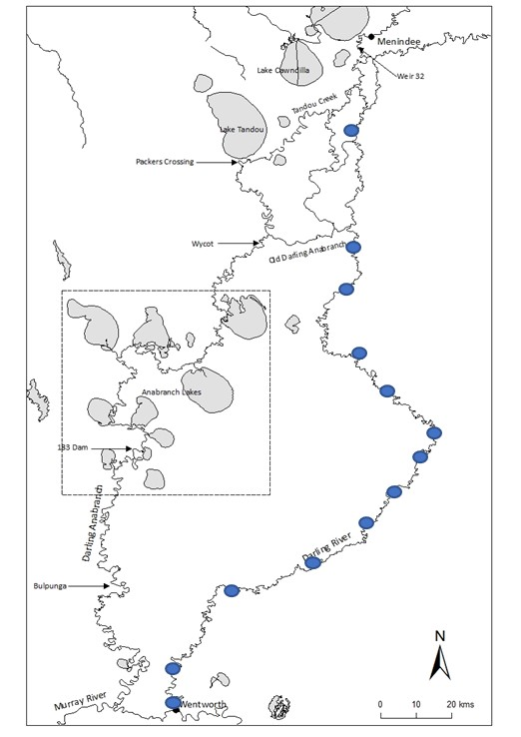
Figure 2. Locations of the thirteen sites (blue icons) sampled by boat electrofishing on the lower Darling River during June and July 2018. Sites are in chronological order starting at Site 1, 50 km downstream of Weir 32 to Site 13 at Wentworth.

Results and Discussion

Population census to evaluate Murray cod recruitment responses to environmental flows.

A total of 3413 fish, representing 9 species were collected (6 native and 3 introduced) (Table 5.). Native species dominated the catch (Table 2). The most abundant was bony herring (53.3 per cent) followed by Australian smelt (18.1 per cent), and carp gudgeon (12.6 per cent). Amongst the large bodied species, golden perch was the most abundant (6.1 per cent overall) followed by carp (4.5 per cent) and Murray cod (2.2 per cent) (Table 2).

Table 2. Total number and percentage (%) contribution to overall community structure for fish in the LDR at 13 sites sampled by boat electrofishing and fyke netting during May- June 2018.
Site # | Australian smelt | Bony herring | Carp gudgeon | Golden perch | Murray cod | Silver perch | Common carp | Eastern gambusia | Goldfish | Grand Total
1 | 94 | 44 | 39 | 23 | 7 | 1 | 14 | 3 | 0 | 225
2 | 23 | 86 | 11 | 31 | 10 | 0 | 15 | 9 | 0 | 185
3 | 56 | 149 | 36 | 39 | 9 | 0 | 11 | 0 | 0 | 300
4 | 19 | 114 | 59 | 9 | 6 | 0 | 5 | 11 | 0 | 223
5 | 47 | 136 | 41 | 13 | 4 | 3 | 7 | 7 | 0 | 258
6 | 36 | 188 | 14 | 2 | 3 | 0 | 9 | 11 | 0 | 263
7 | 15 | 171 | 53 | 5 | 9 | 0 | 3 | 0 | 0 | 256
8 | 27 | 216 | 29 | 3 | 12 | 0 | 13 | 0 | 0 | 300
9 | 94 | 196 | 61 | 3 | 8 | 0 | 11 | 5 | 2 | 380
10 | 69 | 203 | 33 | 29 | 6 | 2 | 28 | 15 | 0 | 385
11 | 41 | 186 | 32 | 19 | 1 | 0 | 30 | 12 | 0 | 321
12 | 69 | 119 | 12 | 29 | 1 | 2 | 1 | 19 | 0 | 252
13 | 27 | 11 | 9 | 2 | 0 | 0 | 7 | 9 | 0 | 65
Grand Total | 617 | 1819 | 429 | 207 | 76 | 8 | 154 | 7 | 2 | 3413
% | 18.1 | 53.3 | 12.6 | 6.1 | 2.2 | 0.2 | 4.5 | 0.2 | 0.1 | 100.0

Murray cod in the lower Darling River in 2018
A total of 76 Murray cod were sampled across all sites (Table 2). The highest number of Murray cod (n=12) was recorded at Site 8, ~90 km downstream of Pooncarie (~385 km downstream of Weir 32 at Menindee). The number of Murray cod was similar among the remaining sites but was lowest at sites 10- 13, all downstream of Burtundy Weir (Table 2; Figure 2).

Of the 76 Murray cod collected, n=11 (14.4 per cent) were YOY (age 0+) sized fish (< 115 mm TL; Figure 3) that were likely spawned during the previous (2017) year (October-December 2017). YOY sized fish were captured at five sites and these were all downstream of Pooncarie (Table 3). Based on the length at age relationship for Murray cod from the Murray–Darling Basin (Anderson et al. 1992a), Murray cod from 115-230 mm long were considered age 1+ years old; hence in the context of this study, were spawned in spring 2016. Fish within that size range (n=11) represented 14.4 per cent of the overall population structure (Figure 3). These were distributed across half of the sampling sites, from Site 1 ~50 km downstream of Menindee, to ~20 km downstream of Burtundy Weir (Table 3). The percent contribution of the age 1+ cohort captured in winter 2018 was similar to that recorded for age 0+ fish captured from sampling the LDR in winter 2017 (Sharpe and Stuart 2018). The 2018 survey findings indicate strong survivorship of the 2016 spawned Murray cod cohort in the LDR and that the objective of supporting Murray cod spawning and recruitment with environmental water throughout 2016/17– 2017/18 was met.

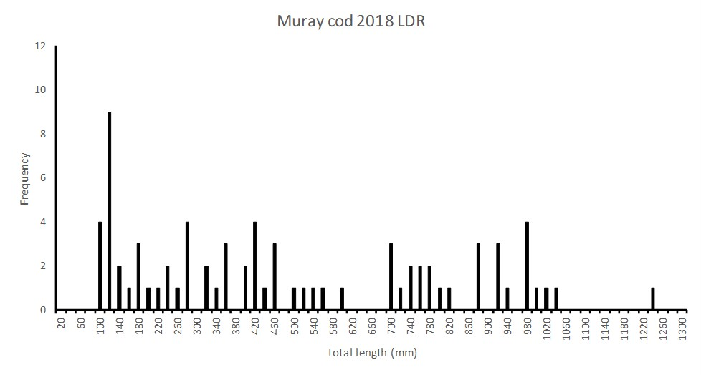
Figure 3. The population structure for Murray cod sampled across thirteen sites and 500 km of the LDR downstream of Menindee during May-July 2018. Young of year (YOY) sized fish spawned during the previous breeding season (October-December 2017) are represented by fish less than 115 mm in total length. Fish from size at age 1+ years were assigned to the 115 mmm – 230 mm length range.

Table 3. Age 0+ (YOY) and age 1+ years sized Murray cod encountered from each LDR site sampled during May-July 2018.
SITE | Age 0+ (spawned 2017) | Age 1+ (spawned 2016)
1 |  | 3
2 |  | 1
3 |  | 2
4 |  | 1
5 | 2
6 |  | 1
7 | 5
8 | 2 | 3
9 | 1
10 |  | 1
11
12 | 1
13
Grand Total | 11 | 11

The Murray cod population structure overall was represented by fish across a broad range of size (thus age) classes (Figure 3). Fish ranged in size from YOY size (88 mm long) to large adults (1240 mm long). Across all of the survey sites, each size class (thus potentially each age class) was represented (Figure 3). However, fish within the slot size for take by anglers (550-750 mm) appeared somewhat reduced in abundance compared to smaller (<550 mm long) and larger (>750 mm long) categories, potentially indicating that angling pressure may influence population structure (Figure 3).

The recruitment of new juveniles to the LDR Murray cod population from spawning and early recruitment in spring 2016 and again in spring 2017 was evident; whereby nearly one-third of the overall population sample (29 per cent overall) was represented by age 0+ and age 1+ sized fish (Table 2, Figure 3). Recruitment to the LDR Murray cod population is key to its long-term viability and resilience, especially in the context of reduced water availability and drought. In the regulated lower Darling River, applying environmental water to ensure that recruitment events are maximised within operational constraints supports native fish population resilience. Maximising population resilience should be recognised as a priority for long-term management for one of the last strongholds of Murray cod in the southern connected Murray–Darling Basin.

Optimising the flow regime in the LDR to enhance spawning and recruitment opportunities for Murray cod was the primary aim of the environmental flow plan delivered to the river throughout 2016–17 and similar, strong age 0+ years recruitment responses were observed from both of those flow years. The schedule of the 2016–17 environmental flow delivered to the LDR was therefore successful; meeting the primary management aim of supporting the LDR Murray cod populations recruitment and future resilience. We recommend that future flow delivery to the LDR repeat the designed hydrograph to promote annual recruitment and long-term resilience of the LDR Murray cod population.

Golden perch in the LDR in 2018
A total of 207 golden perch were recorded in the 2018 LDR fish community survey. YOY sized fish, or new recruits estimated to have been spawned in 2017, were assigned to < 118 mm TL and accounted for n= 9 or 4.3 per cent of the total number of golden perch sampled (Figure 4). Golden perch estimated to have been spawned in 2016, potentially the same cohort collected by Sharpe and Stuart (2018) in the Menindee Lakes and LDR for which the time of spawning was confirmed by ageing (as October 2016), were assigned to >118- 200 mm TL size class and accounted for more than one-third (n= 76, 36.7 per cent) of the total number of golden perch recorded (Figure 4).

In the absence of otolith ageing, assigning this larger size class (118-200 mm long) to the 2016 spawning reported by Sharpe and Stuart (2018) should be treated with some caution, and we recommend that the age structure of that cohort be confirmed so as to increase confidence in determining the contribution of 2016 spawned fish to the LDR population. Regardless, the collection of the first (and smaller) cohort is evidence that golden perch successfully recruited to early juvenile size in the LDR during 2017/18 and that overall, more than 40 per cent of the population is comprised of juvenile sized fish < 200 mm (which is smaller than the average age at maturity for male and female golden perch in the southern Murray–Darling Basin (Anderson et al. 1992b)) that have recruited to the LDR population in association with the 2016/17 and 2017/18 environmental flow schedule.

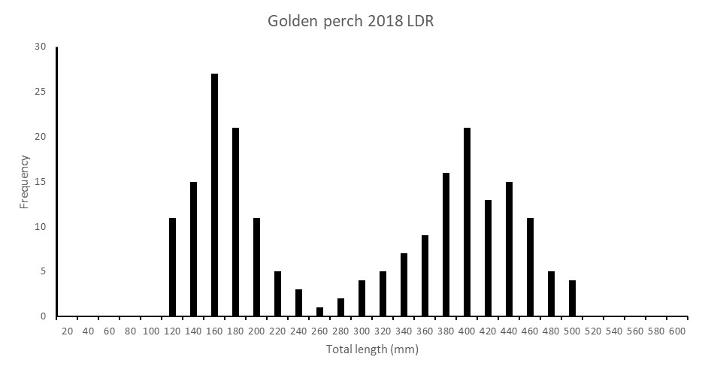
Figure 4. The population structure for golden perch sampled across thirteen sites and 500 km of the LDR downstream of Menindee during May-July 2018. Young of year (YOY) sized fish are represented by fish less than 118 mm long. Fish from size at age 1+ years were assigned to the 118 mm – 200 mm length range.

Carp in the LDR in 2018
A total of 154 carp were recorded in the 2018 LDR fish community census. YOY sized fish, or new recruits estimated to have been spawned in 2017, were assigned to < 150 mm Fork Length (FL) and accounted for n= 5 or 3.2 per cent of the total number of carp sampled (Figure 5). Those fish estimated to have been spawned in 2016, which were assigned to the >150- 300 mm FL size class, represented 33.1 per cent (n= 51) of the population (Figure 5). Overall, the population was represented by the complete range of size classes expected including YOY, juveniles and adult sized fish (after Brown et al. 2005) ranging in size from 114 mm- 890 mm FL (Figure 5).
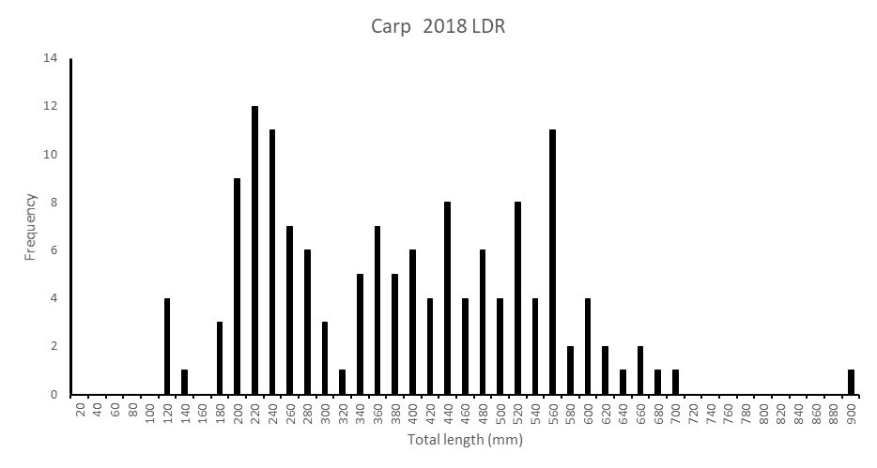
Figure 5. The population structure for carp sampled across thirteen sites and 500 km of the LDR downstream of Menindee during May-July 2018. Young of year (YOY) sized fish spawned during the previous breeding season (spring-autumn 2017/18) are represented by fish less than 118 mm long (FL). Fish from size at age 1+ years were assigned to the 150 mmm – 300 mm length range.

Synthesis of findings and recommendations
The delivery of environmental water to the LDR and GDA throughout 2016–17 was aimed at supporting two highly valuable fish populations; supporting spawning and recruitment for Murray cod and supporting golden perch recruitment. The hydrograph that was delivered from September 2016–December 2017 was designed on a contemporary understanding of the ecological life history of those two species, which have broad differences in their reproductive biology, but were accommodated for by various elements in the environmental flow delivery schedule design (Sharpe and Stuart 2018; Appendix 1).

Murray cod recruitment
The 2016/17 and 2017/18 LDR environmental flow schedules aimed to match a variety of biological and behavioural ecology traits exhibited by Murray cod including for adults (courtship, nesting site selection, spawning and nesting retention) through to the hatching of eggs, accommodating larval drift and promoting riverine productivity and food resources to support post- larval growth, survival and transition to juvenile recruitment. These aspects of Murray cod biology and ecology are well recognised (Rowland 1998; 2005; Lintermans and Phillips 2005; Koehn and Harrington 2005; National Murray cod Recovery Team 2010) and formed the foundation of the conceptual life history model for Murray cod that was embedded into the 2016/7 and 2017/18 environmental flow delivery schedule for the lower Darling River.

For Murray cod in the LDR, providing a moderate increase in discharge above base entitlement levels for the LDR during spring/summer from 400 ML/d to 800 ML/d and maintaining stable water levels and high hydrodynamic complexity during the breeding period (spring) supported the ecology of spawning; evidenced by the strong recruitment success observed in 2016 (Sharpe and Stuart 2018) and again in 2017 (Sharpe and Sharpe 2018). Upon the completion of spawning, a small increase in discharge (from ~800 – 1200 ML/d at Weir 32) and water level inundated low-lying benches along the LDR corridor, with the aim of supporting early juveniles by promoting habitat availability, shelter from predation and food resources (Sharpe and Stuart 2018). Finally, providing higher than base winter entitlement flows (i.e. increase from 180– 400 ML/d) aimed to provide over-wintering YOY (age 0+ juveniles spawned during the previous spring) with increased access to littoral habitats, continuing to provide increased shelter from predation and enhanced feeding opportunities.

The 2016/17 and 2017/18 environmental flow schedule delivered to the LDR was successful in meeting its primary aim of promoting recruitment and importantly, resilience for the LDR’s Murray cod population. For future management of Murray cod in the LDR, continuing to support annual spawning and recruitment to the population is key to maintaining its current demographic structure and long-term resilience. We recommend that annual flow management follow the flow delivery schedules applied in 2016/17 and 2017/18 to maintain annual recruitment of the LDR Murray cod population. This framework can be applied to other reaches of the Darling River system (e.g. Louth-Bourke) or other rivers where Murray cod population enhancement or maintenance is required.

In summary;
- Deliver a moderate increase in discharge above base entitlement levels during spring/summer (from 1 September- 1 December) from 400 ML/d to 800 ML/d at Weir 32 and maintain stable water levels and high hydrodynamic complexity to support the ecology of Murray cod spawning; evidenced by the strong spawning success observed in 2016 (Sharpe and Stuart 2018) and again in 2017 (Sharpe 2018).
- From 1 December- 28 February, when spawning has been completed (as observed in 2014 by Ellis et al.; 2016 and 2017 by Sharpe and Stuart 2018) provide a moderate increase in discharge (from ~800 – 1200 ML/d at Weir 32) to increase water levels and inundate low-lying benches along the LDR corridor, to support early juvenile recruitment by promoting habitat and food availability and shelter from predation (as observed by Stuart and Sharpe (2018).
- From 28 February- 1 April, deliver a slow recession in discharge and water levels from 1200- 400 ML/d at Weir 32 and maintain over autumn and winter, providing higher than winter base entitlement flows (increase baseflow from 180 ML/d to 400 ML/d) to provide over-wintering YOY (age 0+ juveniles spawned during the previous spring and age 1+ spawned in 2016) with increased access to littoral habitats, continuing to provide shelter from predation and greater feeding opportunities, thus enhancing recruitment success.

Thus, a perennial hydrograph should be planned for in the LDR to support its iconic and nationally significant Murray cod population. Accordingly, we recommend developing a 10-year flow delivery schedule for the LDR to meet annual fish population management objectives in consultation with NSW OEH, MDBA EWC, MDBA River Ops, and WaterNSW. The flow delivery plan should consider wet, average and dry year scenarios.

Golden perch recruitment in the LDR supported by environmental flows
The environmental flow plan for golden perch in the LDR in 2016/17 was based on the principals of providing connectivity in population function over thousands of kilometres of the river system, aligning with a southern connected plan for native fish management in the MDB (Stuart and Sharpe 2017). In December 2016 Sharpe and Stuart (2018) confirmed that golden perch spawning occurred in response to the October 2016 flow event in the Darlings’ northern tributaries upstream of Brewarrina, with larvae transitioning into early juveniles during a drift over many hundreds of kilometres with the flow pulse before settling into the productive nursery grounds of the Menindee Lakes. Dispersal of young fish from Menindee Lakes was then initiated by releasing environmental water into the LDR and Great Darling Anabranch, providing pathways for golden perch recruitment into the LDR and Murray River populations. Monitoring of the LDR population in winter 2017 demonstrated that new recruits (age 0+ years) comprised over 30 per cent of the populations structure.

Monitoring of the LDR golden perch population undertaken by this study (winter 2018) confirmed the survival of the 2016 cohort within the LDR population, whereby they continued to account for more than one-third of the population structure (36 per cent). This is a high contribution of new recruits and similar to Murray cod, demonstrates the value of embedding a conceptual understanding of the life history ecology of golden perch into the environmental flow delivery schedule for the LDR.

References
Anderson, J.R., Morison, A.K., and Ray, D.J. (1992a). Age and growth of Murray cod, Maccullochella peelii (Perciformes: Percichthyidae), in the lower Murray-Darling Basin, Australia, from thin-sectioned otoliths. Marine and Freshwater Research 43(5), 983-1013.
Anderson, J.R., Morison, A.K. and Ray, D.J. (1992b). Validation of the use of thin-sectioned otoliths for determining the age and growth of golden perch, Macquaria ambigua, in the lower MDB. Marine and Freshwater Research 43, 1103-1128.
Baumgartner, L. J. (2007). Diet and feeding habits of predatory fishes upstream and downstream of a low‐level weir. Journal of Fish Biology 70(3), 879-894.

Baumgartner, L., Reynoldson, N., and Gilligan, D. (2006). Mortality of larval Murray cod (Maccullochella peelii peelii) and golden perch (Macquaria ambigua) associated with passage through two types of low-head weirs. Marine and Freshwater Research 57(2), 187-191
Ebner, B. (2006). Murray cod an apex predator in the Murray River, Australia. Ecology Freshwater Fish 15, 510–520.

Forbes, J., Watts, R.J., Robinson, W.A., Baumgartner, L.J., McGuffie, P., Cameron, L.M. and Crook, D.A. (2015). Assessment of stocking effectiveness for Murray cod (Maccullochella peelii) and golden perch (Macquaria ambigua) in rivers and impoundments of south-eastern Australia. Marine and Freshwater Research 67, 1410-1419

Henderson, M., Campbell C., Johns, C., Sharpe, S., Kattel, G. and Wallace T. (2009). The Living Murray Condition Monitoring at Lindsay, Mulcra and Wallpolla Islands 2008/09. Report prepared for the Department of Sustainability and Environment by The Murray-Darling Freshwater Research Centre, July, 261pp.

Jones, M.J. and Stuart, I. G. (2008). Regulated floodplains – a trap for unwary fish. Fisheries Management and Ecology 15, 71–79.

King, A., Z. Tonkin, et al. (2009). "Environmental flow enhances native fish spawning and recruitment in the Murray River, Australia." River Research and Applications 25(10): 1205-1218.

Koehn, J. D. (2009). Multi‐scale habitat selection by Murray cod Maccullochella peelii peelii in two lowland rivers. Journal of Fish Biology, 75(1), 113-129.

Koehn, J.D. and Harrington, D.J. (2005). Collection and distribution of the early life stages of the Murray cod (Maccullochella peelii peelii) in a regulated river. Australian Journal of Zoology 53, 137-144.

Koehn, J., McKenzie, J., O'Mahony, D., Nicol, S., O'Connor, J., and O'Connor, W. (2009). Movements of Murray cod (Maccullochella peelii peelii) in a large Australian lowland river. Ecology of Freshwater Fish 18(4), 594-602.

Leigh, S.J. and Zampatti, B.P. (2011). Movement and spawning of Murray cod, Maccullochella peelii and golden perch Macquaria ambigua in response to a small-scale flow manipulation in the Chowilla anabranch system. SARDI report.
Leigh, S.J. and Zampatti, B.P. (2013). Movement and mortality of Murray cod, Maccullochella peelii, during overbank flows in the lower Murray River, Australia. Australian Journal of Zoology 6, 160-169.
Lintermans, M. and Phillips B.(eds) 2005. Management of Murray Cod in the Murray-Darling Basin: Statement, recommendations and supporting papers. Proceedings of a workshop held in Canberra ACT, 3–4 June 2004. Murray-Darling Basin Commission, Canberra
Lintermans, M (2007). Fishes of the Murray-Darling Basin: An Introductory Guide. Murray-Darling Basin Commission, Canberra. 157pp
Mallen-Cooper, M. and I. Stuart (2003). "Age, growth and non flood recruitment of two potamodromous fishes in a large semi arid/temperate river system. River Research and Applications 19 (7): 697-719.
Mallen‐Cooper, M. and Zampatti, B.P. (2017). History, hydrology and hydraulics: rethinking the ecological management of large rivers. Ecohydrology.
Mallen-Cooper M, and Zampatti, B. (2015b). Background Paper: Use of life history conceptual models in flow management in the Murray-Darling Basin. Report prepared for the Murray-Darling Basin Authority. 31 p
National Murray Cod Recovery Team (2010). Background and Implementation Information for the National Recovery Plan for the Murray Cod Maccullochella peelii peelii. Department of Sustainability and Environment, Melbourne.
Rowland, S.J. (1996). Development of techniques for the large-scale rearing of the larvae of the Australian freshwater fish golden perch, Macquaria ambigua (Richardson, 1845). Marine and Freshwater Research, 47(2), 233-242.
Rowland, S. (1998) Aspects of the reproductive biology of Murray cod, Maccullochella peelii peelii. Proceedings of the Linnean Society of New South Wales, 147-162.
Rowland, S. (2005). Overview of the history, fishery, biology and aquaculture of Murray cod (Maccullochella peelii peelii). In: Management of Murray cod in the Murray-Darling Basin, Canberra. Eds M. Lintermans and B. Phillips. Murray-Darling Basin Commission Workshop. Pp 38-61.
Sharpe, C. and Stuart, I. (2015). Optimising flow in Gunbower Creek to enhance spawning opportunities for Murray cod. Final Report to North Central Catchment Management Authority by CPS Enviro and Kingfisher Research P/L
Sharpe, C. and Sharpe, E. (2018). Patterns of fish spawning in the lower Darling River in response to environmental flows. CPS Enviro report to the Commonwealth Environmental Water Office.
Stuart, I. and Sharpe, C. (2017). Towards a Southern Connected Basin Plan: connecting rivers to recover native fish communities. Kingfisher Research and CPS Enviro report to the Murray-Darling Basin Authority.
Thoms, M. and F. Sheldon (2000). "Water resource development and hydrological change in a large dryland river: the Barwon-Darling River, Australia." Journal of Hydrology 228(1-2): 10-21.
Tonkin, Z., Stuart, I., Kitchingman, A., Jones, M., Thiem, J., Zampatti, B., Hackett, G., Koster, W. and Koehn, J. (2017). A review of the effects of flow on silver perch population dynamics in the Murray River. Unpublished Client Report for the Murray Darling Basin Authority March 2017. Arthur Rylah Institute for Environmental Research, Department of Environment, Land, Water and Planning, Heidelberg, Victoria.

Ye, Q., Cheshire, K. and Fleer, D. (2008). Recruitment of golden perch and selected large-bodied fish species following the weir pool manipulation in the Murray River, South Australia. SARDI Aquatic Sciences report.

Zampatti, B, and Leigh, S. (2013) Effects of flooding on recruitment and abundance of Golden Perch (Macquaria ambigua ambigua) in the lower River Murray. Ecological Management & Restoration 14.2 (2013): 135-143.

Zampatti, B.P., Wilson, P.J., Baumgartner, L., Koster, W., Livore, J.P., McCasker, N., Thiem, J., Tonkin, Z. And Ye, Q. (2015). Reproduction and recruitment of golden perch (Macquaria ambigua ambigua) in the southern Murray-Darling basin in 2013-14: an exploration of river-scale response, connectivity and population dynamics. SARDI Research Report Series No. 820. 61 pp

Appendix 1. Conceptual life history model for Murray cod
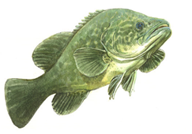
Murray cod occasionally grow to 1.5 m long and 50 kg and can live for up to 50 years. Murray cod inhabit many of the waterways of the Murray–Darling Basin (MDB) (ACT, SA, NSW, Qld and Vic) and live in a wide range of aquatic habitats that range from clear, rocky streams to slow flowing turbid rivers and billabongs (Lintermans, 2007).
Conceptual model Murray cod
Habitat use
- Prefer permanent flowing river reaches and creeks with hydraulic complexity/diversity.
- Require woody debris (snags), debris piles and bank side vegetation (Koehn and Harrington 2005).
- In the southern reaches of the MDB, the status of Murray cod populations is influenced by habitat availability, flow regime, hydrodynamic diversity (water velocity, depth and turbulence) and connectivity (Henderson et al. 2010a,b; Mallen-Cooper et al., 2013; Mallen-Cooper and Zampatti, 2015a; Mallen-Cooper and Zampatti 2017).
- Recruitment potential may be increased when additional habitat resources such as food and shelter are created as river benches, snags and rocks and riparian zones are inundated by rising flows.
- Eggs and larvae require a steady flow increase and very little daily variations in water level (e.g. 0.1 m) to maximise spawning success.
Diet
- Diet changes with age with the typical adult diet consisting of spiny crayfish, yabbies and shrimps (National Murray Cod Recovery Team 2010)
- Predominantly piscivorous and feed on native and exotic fish species e.g. [native species - other cod (Maccullochella spp.), golden perch, bony bream (Nematalosa erebi), freshwater catfish, western carp gudgeon (Hypseleotris klunzingeri)], [exotic species - redfin perch (Perca fluviatilis), carp (Cyprinus carpio) and goldfish (Carassius auratus auratus)].
- Less common animals found in the diet include ducks, cormorants, grebes, tortoises, water dragons, snakes, mice, frogs and mussels (Rowland, 1996).
- Upon hatching, larvae are 5–8 mm long and within 8–10 days can feed on zooplankton. After reaching a length of 15–20 mm, they begin to feed on aquatic insects (King, 2005).
Spawning
- Occurs annually during October, November and December each year (Humphries, 2005; Koehn and Harrington, 2005), occurs during base flows and during river rises (King et al., 2009a; Ye et al., 2008).
- Display complex pre-spawning courtship behaviour (during winter and spring) and females may spawn with more than one male.
- Females lay their eggs into nests. The male guards the nest for up to two weeks while the eggs hatch. Juveniles leave the nest and move into littoral or snag habitats.
- Despite often being classified as a ‘flow independent spawner’ Murray cod do require permanent flowing water for optimal recruitment (Sharpe and Stuart 2015).
- Can spawn and recruit during low stable flows, rising flows and floods.
- Floods are not necessary for spawning but in some cases, appear to enhance subsequent recruitment (King et al., 2009a).
Recruitment
- There is high mortality of young fish but those that survive their first summer and winter and grow to 90-140 mm long tend to have a good chance of recruiting into the sub-adult population (250-600 mm long) (Baumgartner et al., 2006).
- Mature late (3-5 years) and at a reasonably large size (>600 mm long) but females have relatively low egg numbers (fecundity).
- Long-lived (>40 years) and can grow to a large size (e.g. 1.4 m and 45 kg) where they become the apex aquatic predator (Anderson et al., 1992a; Ebner, 2006).
- Where riverine stocking occurs there can be significant augmentation of natural populations (Forbes et al., 2016).
Movement and migration
- May move large distances (e.g. up to 120 km) but are usually only a few kilometres (e.g. commonly up to 30 km), (Leigh and Zampatti, 2011; 2013).
- Move from their home snag to spawning areas in July/August/September on rising water temperature in winter and early spring (Jones and Stuart, 2007; Saddlier et al. 2008).
- Both adult and juvenile fish are strongly associated with snags with a ‘home’ snag with adult fish often returning to the same snag (Koehn, 2009).
- In recent years, the need to provide fish passage for Murray cod to escape anoxic black water events has been demonstrated in the lower Murray, most recently in late 2016, when large numbers of fish were killed in the lower and mid-Murray River, Edward-Wakool system, Frenchman’s Creek, Rufus River and Mullaroo Creek (Tonkin et al., 2017).
Implications for Victorian environmental flows
- A specific Murray cod hydrograph should be implemented where population recovery is required (Sharpe et al. 2015; Sharpe and Stuart 2018)
- Flowing riverine sites can be considered ecological priorities for Murray cod recovery
- Application of the Murray cod hydrograph, especially high winter base-flows, is required on an annual basis (Sharpe and Stuart 2015; Sharpe and Stuart 2018)
Implications for flow monitoring
- Flow-event monitoring is crucial to identify the specific components of the hydrograph (shape, timing, frequency, duration, height, discharge, velocity) that influence population dynamics.
Threats
- Lack of flowing water habitats with a high density of snags because of past de-snagging, regulation transforming the hydrodynamic nature of many rivers from flowing rivers to weir pools and cold water discharge from high dams (Mallen-Cooper and Zampatti 2017.
- Loss of permanent flows when rivers and anabranches are de-watered during winter.
- In many regulated rivers and anabranches (e.g. Gunbower Creek, Gulpa Creek, Edward River, Mullaroo Creek) there are two major hydrological constraints on Murray cod population recovery
- intense fluctuation in river discharge causing rapid decreases in river level and interruption of spawning/recruitment processes,
- low or zero winter flows that appear to be population ‘bottlenecks’ because this forces all fish into the deeper refuge pools for up to 3 months each year (Sharpe and Stuart, 2015).
Knowledge and data limitations
- Wide-scale implementation, refinement and evaluation of the Murray cod hydrograph

