Assessment of the Code of Practice for Plantation Forestry in Tasmania
© Commonwealth of Australia 2024
Ownership of intellectual property rights
Unless otherwise noted, copyright (and any other intellectual property rights) in this publication is owned by the Commonwealth of Australia (referred to as the Commonwealth).
Creative Commons licence
All material in this publication is licensed under a Creative Commons Attribution 4.0 International Licence except content supplied by third parties, logos and the Commonwealth Coat of Arms.

Cataloguing data
This publication (and any material sourced from it) should be attributed as: Phelan, T, Roscoe, J and Groenhout, P 2024, Assessment of the Code of Practice for Plantation Forestry in Tasmania Report prepared by Greenwood Strategy Solutions Pty Ltd for Department of Agriculture, Fisheries and Forestry, Canberra, December. CC BY 4.0.
This publication is available at agriculture.gov.au/publications.
Department of Agriculture, Fisheries and Forestry
GPO Box 858 Canberra ACT 2601
Telephone 1800 900 090
Web agriculture.gov.au
Disclaimer
The Australian Government acting through the Department of Agriculture, Fisheries and Forestry has exercised due care and skill in preparing and compiling the information and data in this publication. Notwithstanding, the Department of Agriculture, Fisheries and Forestry, its employees and advisers disclaim all liability, including liability for negligence and for any loss, damage, injury, expense or cost incurred by any person as a result of accessing, using or relying on any of the information or data in this publication to the maximum extent permitted by law.
Acknowledgements
The authors acknowledge the significant assistance provided by a number of stakeholders that assisted through the provision of logistics support, access to plantations and in-depth industry knowledge and expertise. Specifically, we acknowledge the support of Reliance Forest Products, Timberlands Pacific, Pentarch Forestry, Forico, Sustainable Timbers Tasmania, Midway Tasmania, Melythina Tiakana Warana Aboriginal Corporation, AWT Forest Management, Tasmanian Department of State Growth, Forest Practices Authority, Cradle Coast Authority, Private Forests Tasmania and the Tasmanian Forest Products Association.
Acknowledgement of Country
We acknowledge the Traditional Custodians of Australia and their continuing connection to land and sea, waters, environment and community. We pay our respects to the Traditional Custodians of the lands we live and work on, their culture, and their Elders past and present.

Contents
Summary 6
Introduction 7
Context 7
Purpose and scope 7
Assessment methodology 8
Plantation forestry in Tasmania 9
Assessment overview 12
The role of codes of practice in wood exports 12
Assessment against the National Principles 12
Australia’s sustainable forest management framework 13
Export requirements for codes of practice 14
Assessment method 14
Criterion 1: Compliance of plantation management with relevant planning schemes and legislation 16
1.1 Context 16
1.2 Changes to the Code 16
1.3 Implementation of the revised code 16
1.4 Effectiveness of the revised code 17
1.5 Scope for improvement 17
Criterion 2: Protection of native vegetation and animal communities and natural landscape values 18
2.1 Context 18
2.2 Changes to the code 19
2.3 Implementation of the revised code 19
2.4 Effectiveness of the revised code 20
2.5 Scope for Improvement 20
Criterion 3: Protection of water quality and, where required, management of water yield 21
3.1 Context 21
3.2 Changes to the Code 22
3.3 Implementation of the revised Code 22
3.4 Effectiveness of the revised code 22
3.5 Scope for Improvement 23
Criterion 4: Protection of soil resources 24
4.1 Context 24
4.2 Changes to the code 24
4.3 Implementation of the revised code 24
4.4 Effectiveness of the revised code 24
4.5 Scope for Improvement 24
Criterion 5: Protection of cultural heritage values 25
5.1 Context 25
5.2 Changes to the code 25
5.3 Implementation of the revised code 25
5.4 Effectiveness of the revised code 26
5.5 Scope for Improvement 26
Criterion 6: Protection from fire, pests and diseases 27
6.1 Context 27
6.2 Changes to the code 27
6.3 Implementation of the revised code 28
6.4 Effectiveness of the revised code 28
6.5 Scope for Improvement 28
Criterion 7: Training for environmental care 29
7.1 Context 29
7.2 Changes to the code 29
7.3 Implementation of the revised code 29
7.4 Effectiveness of the revised code 30
7.5 Scope for Improvement 30
Other National Principles 31
National Principle 2 – Safety 31
National Principle 3 – Planning 31
National Principle 4 - Access 31
National Principle 5 - Establishment and maintenance 33
National Principle 6 - Timber harvesting 33
National Principle 7 - Forest protection 33
National Principle 8 - Monitoring and review 33
Appendix A: Relevant legislation 34
References 35

Tables
Table 1: Four desktop review steps for the scientific assessment 8
Table 2: An overview of Australia’s sustainable forest management framework 13

Figures
Figure 1: Tasmania's Forest Practices System 11
Figure 2: Clearfell of softwood plantation areas in northern Tasmania 17
Figure 3: Well maintained unsealed access road in hardwood plantation, northern Tasmania 22
Figure 4: Hardwood plantation harvesting, log loading and hauling in northern Tasmania 32

Summary
The Export Control Act (2020) provides the legislative basis for regulating exports from Australia, including agricultural exports. Under the Export Control (Wood and Woodchips) Rules 2021, wood and woodchips are prescribed for the purposes of the Act. That means they require a licence to be exported, unless they are derived from trees sourced from a plantation in a State for which there is an approved code of practice, in which case they are taken to not be prescribed. If wood or woodchips do not meet this requirement, their export is prohibited unless the exporter holds a wood export licence which is in force at the time when the wood or woodchips are exported.
In order for a code of practice to be approved for the purposes of the Wood Rules, it must be scientifically assessed against the National Principles for Forest Practices Related to Wood Production in Plantations. In Tasmania, that assessment was previously undertaken by the CSIRO in 2012 for the Forest Practices Code (2000). Subsequently, the code has been reviewed twice leading to the current version. The code of practice is therefore considered to have been reviewed and requires re-assessment against the National Principles and approval by the Minister for Agriculture, Fisheries and Forestry, so that wood and woodchips continue to be non-prescribed for export purposes.
This report presents the findings from the assessment of the Forest practices Code (2020) Tasmania against the National Principles. The assessment has determined that the code continues to evolve and develop and strongly supports the delivery of sustainable management of plantations in Tasmania. The revised code adequately meets the requirements of the National Principles for Forest Practices Related to Wood Production in Plantations.
The assessment has focused on National Principle 1: Principles of Environmental Care but has also addressed the remaining seven National Principles, which overlap considerably with Principle 1. The CSIRO review in 2012 applied seven criteria to the assessment process. For continuity, the same seven criteria have been applied to this assessment in considering changes to the code.
Potential areas for improvement in future reviews of the code have been identified throughout the report. These are quite minor and reflect areas of continuous improvement that have already been identified or flagged for consideration within the Forest Practices System. The Tasmanian Code is very structured and prescriptive. There are instances where the highly prescribed approach is potentially limiting to innovation and may also result in poorer on-ground outcomes because the prescriptions are not a suitable solution to the specific on-ground outcomes. In this context it is useful that the most recent version of the Code has incorporated outcome statements that specify what each part of the Code aims to achieve in practice. As the Code continues to evolve, it is important that it allows for a sensible, outcomes focussed approach which allows for reasonable interpretation in situations where the on-ground circumstances demand an alternative or nuanced approach.
Based on these observations, we conclude that the Code and its implementation in Tasmania are satisfactory for achieving the national principles of environmental care.

Introduction

Context
Codes of practice are an important element of the overall sustainable forest management framework in Australia. The regulation of land management and land use decision-making is a state responsibility. Therefore, codes of practice for sustainable forest management operate at the state and territory level of government.
Typically, forestry codes of practice are focussed on environmental outcomes and, as such, form a nexus between operational planning and delivery and the broader regulatory and legislative framework that operates in each state and territory. That framework varies considerably between jurisdictions. Therefore, while forestry codes of practice are generally consistent with respect to the higher order environmental issues being addressed, there is a great degree of variation around the specific detail in those codes, and the approach to and responsibility for code compliance.
One of the ways in which forestry codes of practice are used is to demonstrate that forest management and harvesting activities on plantations operate consistently with the National Principles for Forest Practices Related to Wood Production in Plantations (the National Principles), which provides for plantation wood products (e.g., woodchips and round logs) to be eligible for export without the requirement for an export licence. Any changes to codes of practice must be scientifically assessed against the National Principles for those conditions to be met.

Purpose and scope
The purpose of the assessment is to evaluate the effectiveness of the Forest Practices Code (2020) Tasmania in meeting the National Principles. It compares changes in the Tasmanian Code against the previous version of the Code, reviews those changes in the context of the findings from a scientific assessment undertaken by the CSIRO in 2012 (Raison et. al., 2012), and assesses the Code against the National Principles. Delivery of the assessment has involved:
- A comprehensive review of the Code itself, analysis of changes since the previous assessment, its implementation on the ground, and related guidelines, policies, and regulations.
- Stakeholder engagement, including interviews with industry representatives, government officials, and other stakeholders.
- Field inspections to assess the practical application of the Code in plantation forestry operations.
For continuity, findings are presented in the same structure as the 2012 assessment. Particular focus is placed on Principle 1 (Principles of Environmental Care), which assesses performance against seven criteria:
- Compliance
- Ecology and biodiversity
- Water
- Soil
- Cultural heritage
- Forest health and protection
- Training for environmental care
Principles 2 to 8 are also addressed, where the assessment of Principle 1 does not cover them. For each criterion, the assessment addresses changes to the Code, how these are being implemented, how effective the Code is in meeting the requirements of the National Principles, and scope for improvement.

Assessment methodology

Desktop review
The desktop aimed to provide background information to inform stakeholder consultation and field observation of code implementation. It included four steps, summarised in Table 1.
Table 1: Four desktop review steps for the scientific assessment
Assessment step | Description
Identification of relevant documentation | Additional reference material such as management guidelines, policy, legislation and regulation was identified and described.
Change analysis | Variations to the Guidelines and related documents that have occurred since 2012 and the findings of the 2012 CSIRO assessments were reviewed and documented to provide additional change context.
Comparison with National Principles | The Guidelines and related documents were subject to a high-level desktop assessment against the National Principles, aimed at identifying any obvious questions with respect to potential non-compliance.  To allow for consistency and comparison, the CSIRO structure for presenting assessment against the National Principles was adopted (i.e., seven criteria for environmental care and cultural heritage, plus commentary on the remaining National Principles).
Identification of focus areas | Results were collated and analysed to determine focus areas for additional desktop review and for the stakeholder consultation and field assessment.

Change analysis
The 2020 and 2000 versions of the Code follow the same basic structure. The 2020 version includes a greater amount of explanatory prose in the preamble and introduction sections. That includes a focus on the international and national context for sustainable forestry regulation, as well as introducing concepts of forest carbon and climate change and newer policy. There is also a new section about the scope of the Code and more explanation about how the system works. Through the document, while the main headings remain the same, there is more detail included (some of which is native forestry specific). Each section now also includes a defined outcome which compliance is aiming to achieve. Overall, the focus and intent of the Code has not changed materially but incremental improvements and response to emerging trends and knowledge have been incorporated.

Stakeholder consultation
There was a strong response from stakeholders in Tasmania, representing a wide range of interested parties. A total of 14 stakeholders from 11 organisations were consulted for the assessment. They included plantation growers, State Government agencies, industry representative organisations, Traditional Owner stakeholders and natural resource management stakeholders.

Field assessment
Field assessment was undertaken in northern Tasmania, looking at a range of forest management activities in both softwood and hardwood plantations.

Plantation forestry in Tasmania

Industry overview
The forest and wood products sector is a significant contributor to Tasmania’s economy, with the plantation sector playing a major role. Tasmania is home to 276,000 ha of plantation of which 196,000 is hardwood (predominantly Eucalyptus nitens managed for short rotation export woodchip production) and 78,000 ha of softwood (Pinus radiata managed on long rotations for solid wood production). Plantations are distributed through the south-east, east and north of the state, although there is a strong concentration of plantations in norther Tasmania. Total plantation log production was 4.12 million m³ in 2022/23, comprising 2.53 million m³ of hardwood and 1.59 million m³ of softwood (ABARES, 2024).

Background to the Tasmanian Forest Practices Code
The Tasmanian Forest Practices Code provides a comprehensive suite of rules and guidelines covering most forestry activities within the State. The current Code (Forest Practices Code 2020) is the second revision undertaken since the 2012 CSIRO assessment of the 2000 code. A 2017 review was undertaken on the 2015 version of the Code, which had superseded the 2000 version.
The Code scope excludes forest management activities that do not require a Forest Practices Plan. This may include fire management, forest health and other non-timber related forest management activities, particularly those conducted between the major phases of establishment and timber harvesting. The Code does not address safety. However, this is addressed through the Tasmanian Forest Safety Code 2022.
The Code is detailed, industry specific and prescriptive, providing a high degree of clarity about the expected standards for operations. Some stakeholders within the industry seek a more outcomes focussed regulatory approach, arguing that highly prescriptive regulations can stifle innovation and sometimes lead to perverse environmental outcomes. The 2020 Code introduced outcome statements to complement the prescriptions and guidance.

The Forest Practices Framework
The FPA oversees the forest practices framework, providing training, authorisation, tools, resources and advice to FPOs and forest managers; conducting audit, enforcement, engagement and reporting activities; and coordinating research and review of the system.

The Forest Practices Authority website states that:
“According to section 31 of the Forest Practices Act 1985 (the Act) the purpose of the Forest Practices Code (the Code) is to prescribe the manner in which forest practices shall be conducted so as to provide reasonable protection to the environment.
The Tasmanian Forest Practices Code was the first in Australia and is central to the forest practices system. It is the only forest code in Australia, and one of a very few world-wide, to apply equally to public and private land. The code is legally enforceable under the Forest Practices Act 1985. The code is applied in accordance with a guiding policy that explains the contribution to be made by the code towards sustainable forest management in Tasmania. The guidelines and standards in the Forest Practices Code cover:
- planning
- building access into the forest (roads, bridges, quarries etc.)
- harvesting of timber
- conservation of natural and cultural values (soil and water, geomorphology, visual landscape, botany, zoology and cultural heritage)
- establishing and maintaining forests.
The FPA developed the code through extensive consultation and public comment. It is reviewed periodically, incorporating suggestions from scientists, government, the forestry industry and the public.”
In addition to the Code, key elements of the Tasmanian framework include:
Forest Practices System: The Forest Practices Code is part of Tasmania’s Forest Practices System (refer to Figure 1) which is an independent regulatory framework applied to all forestry activities on both public and private land. The forest practices system comprises a documented and systematic approach to planning, approval, supervision, monitoring and enforcement for forestry activities. It provides access to a large amount of additional documentation and tools covering all aspects of sustainable forest management. Section H of the Code includes 35 supporting documents relevant to Code implementation. Section I of the Code references 29 pieces of relevant legislation and policy (State and Commonwealth) that apply. The Code and supporting documentation and tools are subject to ongoing refinement supported through active monitoring and research programs.
Forest Practices Officers: Forest Practices Officers (FPOs), accredited by the FPA, are responsible for overseeing and enforcing the Forest Practices Code and Forest Practices System. FPO functions include conducting field inspections of forestry operations, assessing and approving Forest Practices Plans, and providing guidance to forest managers.
Forest Practices Plans: Forest managers are required to prepare detailed Forest Practices Plans (FPPs) for each timber harvesting operation and a wide range of other forest management activities. These plans outline the proposed activities, including harvesting methods, road construction, and environmental protection measures. FPOs review, certify, monitor and verify compliance reports in relation to Forest Practices Plans to ensure compliance with the Code.

Figure 1: Tasmania's Forest Practices System
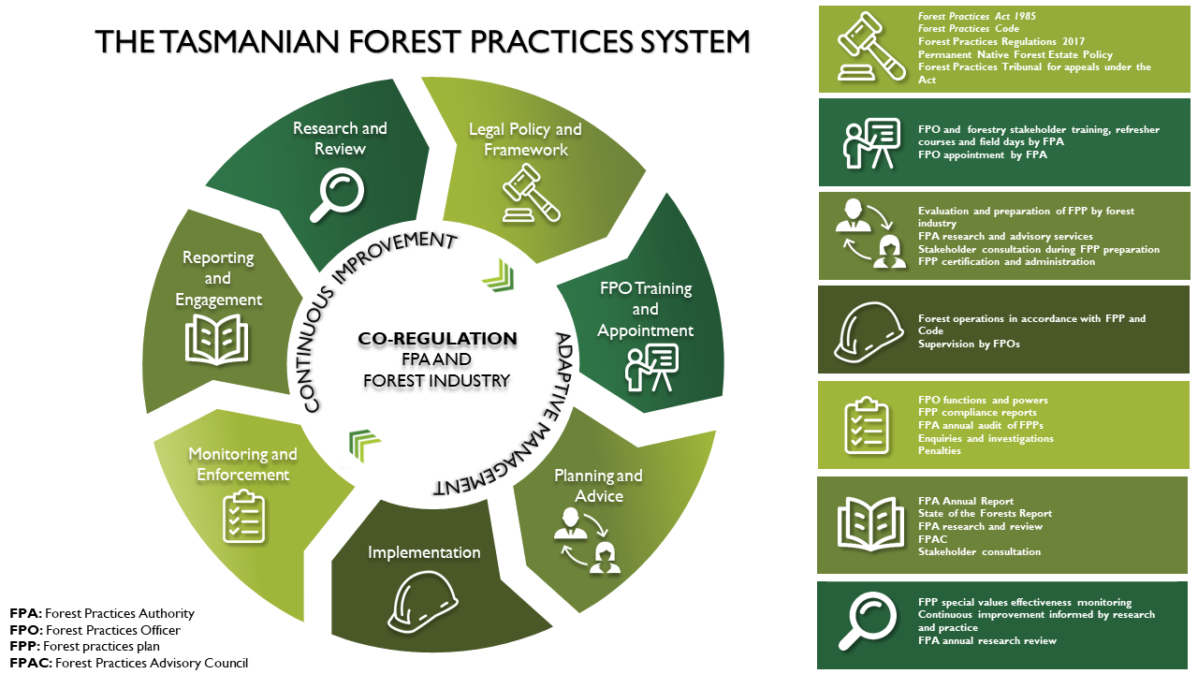
Compliance Program: The FPA compliance program consists of a comprehensive suite of activities in addition to those implemented by FPOs. The annual FPP assessment program involves a systematic, risk-based assessment of the performance of a sample of FPPs against the requirements of the Act and Code. All complaints about alleged breaches of the Forest Practices Act and the Code are assessed. Investigations proceed in situations where there is sufficient evidence indicating an offence may have occurred. The FPA undertake legal and administrative enforcement actions where applicable. The most major breaches tend to occur outside the forestry sector as a result of unauthorised clearing and conversion on private land.

Assessment overview

The role of codes of practice in wood exports

General sustainability framework for forest products
Australia has a strong framework for legal and sustainable timber production from commercial plantations and native forests and for the sale of those products to domestic and international (export) markets. The framework includes national and state level legislation and policies, regional forest agreements, a framework for criteria and indicators to measure sustainability and independent voluntary certification.

Legislated export controls
An important piece of Commonwealth legislation is the Export Control Act (2020) (the Act), supported by the Export Control (Wood and Woodchips) Rules (2021) (the Rules). The Act provides the legislative basis for regulating exports from Australia, including agricultural exports. Under that framework, specific kinds of goods can be prohibited from export or required to be licensed by the Australian Government for export. Both these instruments form an important part of Australia’s sustainable forest management framework. The Rules specify requirements which must be met for prescribed and non-prescribed wood and woodchips, so that products are eligible for export.
Wood and woodchips are prescribed for the purposes of the Act, unless they are derived from trees sourced from a plantation in a State for which there is an approved code of practice, in which case they are taken to not be prescribed. If wood or woodchips do not meet this requirement, their export is prohibited unless the exporter holds a wood export licence which is in force at the time when the wood or woodchips are exported.

Practical meaning
In practical terms, the effect of the Act and the Rules is to provide a regulatory framework that limits the export of wood and woodchips unless management of those forests meets certain requirements, while allowing more ready access to export markets for wood and woodchips produced from plantations, so long as the jurisdiction where the plantations are grown has in place an approved code of practice for forest management and timber production which has been assessed against the National Principles. In this context, State and Territory based codes of practice are essential regulatory instruments which allow the plantation sector to access important commodity export markets.

Assessment against the National Principles

Regulatory logic
Under the Rules, a State may request approval of a code of practice. The Commonwealth (specifically the Minister) can approve a code for the purposes of the Rules if satisfied that the code would substantially protect environmental and heritage values in the State and the State enters an agreement with the Commonwealth to undertake any required amendments and to advise when they have been made. The Minister must give regard to the findings of a scientific assessment of the code of practice based on the National Principles. The Minister may require the State to amend the approved code. The State may also make minor amendments to an approved code. However, by implication, a significant amendment to a code requires the code to be reviewed and the Minister can revoke approval of the code.
The Rules specify the kinds of wood and woodchips that are prescribed and non-prescribed goods. Prescribed goods require an export license and non-prescribed goods do not. Under sub-section 2-1(2) of the Rules, wood and woodchips that are sourced from plantations are taken to be non-prescribed goods, if an approved code of practice is in place for the relevant State or Territory. An approved code of practice is one which has been scientifically assessed as meeting the requirements of the National Principles and approved by the Minister based on that assessment.

Role of the National Principles
The framework for assessing whether a code of practice meets the requirements for approval is the National Principles, which provide specific guidance about what a code of practice must address to be successful in achieving and maintaining approval for the purposes of the Act. They are categorised into Environmental Care, Safety, Planning, Access, Establishment and Maintenance, Timber Harvesting, Forest Protection and Monitoring and Review. The National Principles are intended to provide a basis for a consistent and scientifically sound approach to plantation management for application in all States and Territories.

Australia’s sustainable forest management framework
The framework which guides sustainable management of forests for timber production in Australia is well established. It includes national and state level policies and regulatory instruments, regional forest agreements, a framework for criteria and indicators to measure sustainability and independent third-party forest management and chain of custody certification (Greenwood Strategy, 2024).
Table 2: An overview of Australia’s sustainable forest management framework
Framework element | Framework instruments | Examples/explanation
National framework | Legislation and regulation | Various Commonwealth legislation including the Environment Protection and Biodiversity Conservation Act (1999), Regional Forest Agreements Act (2002), Illegal Logging Prohibition Act (2012), Export Control Act (2020) and Export Control (Wood and Woodchips) Rules (2021).
 | National Forest Policy Statement (1992) | Promotes the conservation and sustainable management of forests.
 | Forest practices related to wood production in plantations: National Principles | Set of eight nationally agreed principles guiding sustainable wood production from timber plantations in Australia.
 | Regional Forestry Hubs | Eleven Regional Forestry Hubs in strategic locations funded by the Australian Government to support the ‘Growing a better Australia’ policy.
 | Australian Forest and Wood Innovations | Established in partnership with the University of Tasmania to support research, development and innovation for Australia’s timber industry, while also supporting the training and development of forest industries researchers.
 | Regional Forest Agreements | Long-term agreements between the federal and state government to support regional approaches to balancing conservation and timber production needs from native forests.
 | Australia’s Sustainable Forest Management Framework of Criteria and Indicators (2008) | An internationally recognised framework for monitoring, measuring and reporting on Australia's sustainable forest management.
State and Territory frameworks | Policy, legislation, regulation | Each state and territory has policies, legislation and regulation (such as Codes of Practice) in place to ensure sustainable forest management practices.
Certification | Independent, standards-based verification of sustainable management of forests and supply chains | Independent, third-party certification of sustainable forest management and timber manufacturing to internationally recognised standards, which applies to most of Australia’s production forests.
Source: Groenhout et. al. (2024) Private Forestry Guidance Materials: An introduction to the business of small-scale forestry

Export requirements for codes of practice

Previous reviews and approval
In 2012, the codes of practice for all Australian State and Territory jurisdictions were assessed by the CSIRO on behalf of the Australian Government. The findings of the assessment relevant to this report are documented in Raison et.al. (2012).

Changes to codes of practice
Since the CSIRO completed its 2012 assessments, codes of practice in the Northern Territory (2021), Tasmania (2015 and 2020) and Victoria (2014 and 2022) have undergone revision and changes. Consequently, the Department of Agriculture, Fisheries and Forestry has determined that the codes of practice for all three jurisdictions require an updated scientific assessment to determine whether they still meet the requirements of the Rules and the National Principles.

Assessment method

Overall approach
The assessment approach developed for this project was consistent with the approach used in previous assessments, and across all three jurisdictions assessed. The broad scope for the assessment included:
- Desktop review and change analysis, focused on:
  - Review of the scientific validity of the goals and guidelines contained in each individual code, the way the code is implemented, and how environmental performance and other aspects of compliance are monitored.
  - Effectiveness in complying with the National Principles.
  - Assessment of interactions of each individual code with the relevant regulations (e.g. planning) and guidelines applicable to the regional and local contexts that affect risk to environmental values.
  - Developing priority focus areas for the assessment.
- Stakeholder engagement by way of interviews.
- Regional field visits to assess in-field practical application of the Code in plantation forestry operations.
- Assessment of the suitability of the Code to meet the requirements of the Export Control Act (2020), Export Control (Wood and Woodchips) Rules (2021) and the Forest practices related to wood production in plantations: National principles.

Specific considerations for Tasmania
Tasmania’s plantation forestry sector is large, diverse and evolving. For example, there is an active program of moving short rotation hardwood plantations to long rotation (either changing species to pine or changing the management intent for the hardwood species to solid wood production). There is also a considerable area of small independently owned plantations which have different regulatory challenges to larger corporately owned estates. The large and diverse sector is supported by an independent regulator (the Forest Practices Authority) and a dedicated private forestry agency (Private Forests Tasmania).
There is broad and strong support for the Code in Tasmania. It has a relatively high profile, due to the role of forestry in the State. The Code is very robust and operates within a sound and comprehensive regulatory and legislative framework. There is strong support for the Code as a critical element in providing a social license to operate plantation forestry. Industry stakeholders were actively involved in the 2020 revision of the Code.
Priority focus areas were identified to guide field visits and stakeholder interviews. Interviews were based around the content of the code, the National Principles and the results of the 2012 assessment. The process aimed to gauge the level of familiarity with and understanding of the requirements and how they have been and continue to be implemented in the local context. This approach facilitated a collaborative dialogue, allowing stakeholders to share knowledge and voice concerns. Specific focus areas included:
- Accessibility of the system for smaller growers.
- Native vegetation clearing and new plantations.
- On-ground compliance with water quality, water yield and soil protection requirements.
- Adequacy of multi-organisation approach to fire management and its suitability for plantation protection.
- Training.

Criterion 1: Compliance of plantation management with relevant planning schemes and legislation
Relevant National Principle
National Principle 1.3 - Plantation management should comply with State and regional conservation and catchment management objectives, relevant planning schemes and legislation.
Questions addressed
How well does the Code support operational compliance with State and regional legislation, regulation and policy for sustainable management of plantations?
Are the processes adequate to meet this criterion?

Context
Where a private timber reserve (PTR) is gazetted (through Private Forests Tasmania) local government and planning provision requirements are entirely superseded by the Forest Practices System. In the absence of a PTR, proponents need to consider local government planning requirements as well as subsequently complying with the Forest Practices System. Compliance with the Forest Practices System, including the planning process, will typically ensure compliance with all other legislated and regulatory requirements for sustainable forestry operations.

Changes to the Code
A range of refinements were made to the Code for the 2020 revision. However, there are no material changes to the code in relation to compliance.
The 2012 Review identified three topics with scope for improvement under Criteria One, which have been addressed to some degree. The 2020 Code revision provided opportunity to subject new additional conditions that had been applied through FPP approval processes to consultation, with the result that these are now included in the Code. FPP costs are standardised and based on the scale and type of operation, thus a small or lower intensity operation will cost less than a large intensive operation. It is important to note that the cost structure for FPP preparation and approval is still problematic for small growers.

Implementation of the revised code
Compliance audit results published in the FPA Annual Report 2023-24 indicate very high levels of compliance with the Code. Only one percent of activities assessed had unacceptable practices, and an average of 94% were deemed sound. These results reflect the average result across all tenures and forest types. However, industrial operations performed slightly better than non-industrial operations. The FPA identified a handful of areas for improvement, largely related to FPP preparation. There are no material changes for which discussion about implementation is relevant.
Figure 2: Clearfell of softwood plantation areas in northern Tasmania
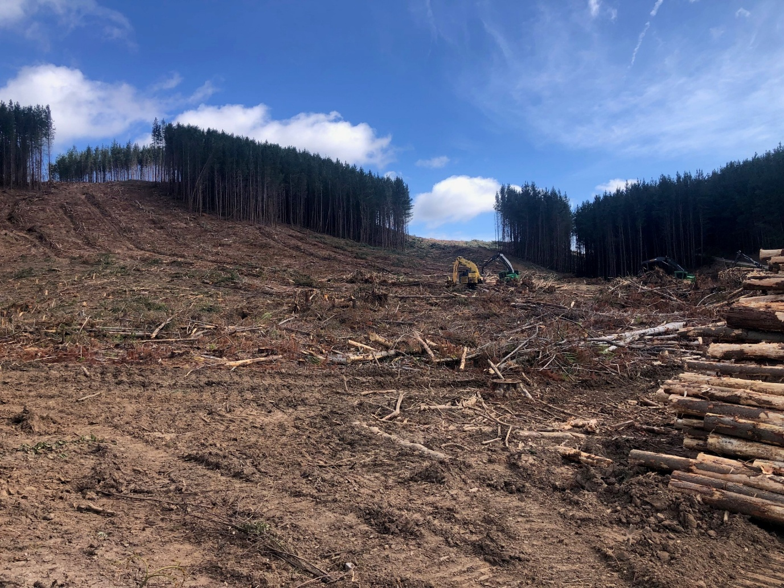

Effectiveness of the revised code
The Forest Practices System and Code provides a comprehensive framework for compliant forestry operations in Tasmania. The system effectively identifies and mitigates environmental risks, ensuring that forestry activities align with environmental values. The robust planning processes, detailed guidance, and independent regulatory oversight by the Forest Practices Authority contribute to the system's effectiveness in achieving positive environmental outcomes. While there is limited scope for significant changes to the Tasmanian code at this time, the current system demonstrates a strong foundation for sustainable forestry practices and aligns with National Principle 1.3.

Scope for improvement
There are no specific areas identified for improvement.

Criterion 2: Protection of native vegetation and animal communities and natural landscape values
Relevant National Principles
National Principle 1.1 - Native forest should not be cleared for plantation establishment where this would compromise regional conservation and catchment management objectives. In some circumstances it may be appropriate to clear forests that have been severely degraded by impacts such as disease, weed invasion, wind and fire so as to enable rehabilitation through replanting.
National Principle 1.2 - Values such as intensive recreation, high scenic quality, significant geomorphic, biological, or cultural heritage sites, should be recognised in the planning of plantation forest operations.
National Principle 1.8 - Fauna, floristic, and landscape values should be protected by the careful planning of plantation layout establishment operations and the reservation and protection of appropriate areas of native vegetation; such values should be recognised in subsequent plantation management. (Note cultural heritage values are considered in Criterion 5).
Questions addressed
If it is applied as written, how effective is the Code in delivering environmental management outcomes in and around plantations?
How well does the Code support the protection of site specific significant values such as native vegetation, social (recreation and visual values), and fauna, flora and landscape values?
Are the processes for managing the clearing of native vegetation adequate to meet the objectives of the National Forest Policy Statement (including the objective of not clearing for plantation establishment where this would compromise regional conservation and catchment management objectives)?
Do these processes take into account the need to achieve adequate conservation of important natural heritage values?
Are there measures and processes in place for the identification of these values in assessing proposed plantation sites and adjacent areas for natural values?
Where values are identified are protection measures taken into account in the planning and future management of plantations?

Context

Vegetation clearing
Clearing of native vegetation is permitted in Tasmania and is regulated by the Forest Practices Authority. Clearing of land is generally considered to be a forestry practice under the Code. There are clear processes in place to manage potential clearing of native vegetation. The forest practices system provides considerable guidance about the steps that landholders must take to be compliant and states that:
“Clearance and conversion of threatened native vegetation communities is not permitted unless the FPA is satisfied of one or more of the following (as outlined in section 19(1AA) of the Forest Practices Act (1985):
- the clearance and conversion is justified by exceptional circumstances Information on land clearing controls in Tasmania
- the activities authorised by the forest practices plan are likely to have an overall environmental benefit
- the clearance and conversion is unlikely to detract substantially from the conservation of the threatened native vegetation community
- the clearance and conversion is unlikely to detract substantially from the conservation values in the vicinity of the threatened native vegetation community.”
Approved clearing is authorised under a vegetation management agreement and the FPA is required to report annually on the number and nature of these agreements active during the year. In 2023-24 (Forest Practices Authority, 2024) there were no new vegetation management agreements issued, and existing current agreements relate to clearing of native vegetation for purposes other than new plantations. Practically all of the plantation timber produced in Tasmania is either directly certified or enters certified supply chains through the controlled supply programs that operate under both certification schemes. That presents a market barrier for plantation wood on land cleared of native vegetation because both of the certification schemes operating in Australia prohibit clearing of native vegetation to establish new plantations. Similarly, participation the Australian Carbon Credit Unit (ACCU) Scheme prohibits clearing of native vegetation.

Protection of other values
The Forest Practices System explicitly requires assessment and protection of a wide range of environmental and social values, including visual landscape values, geomorphological values and other natural heritage values.

Changes to the code
There are no material changes to the code in relation to protection of native vegetation and animal communities and landscape values.

Implementation of the revised code
As discussed under Criterion 1, there is a high degree of compliance with the Code and the results of the audit program indicate no areas of improvement in relation to implementation for Criterion 2. Through discussions with stakeholders during the field visit to north-east Tasmania, it was apparent that several values relevant to Criterion 2 are placing increasing pressure on the Tasmanian plantation industry in this region: recreational activities and eagle nests.
The volume of recreational activity, particularly mountain biking, has increased significantly in some localities around the Tasmanian plantation estate since the 2012 Review. This has significant implications for haulage activities in high usage areas. User groups have also challenged plantation managers about the impacts of harvesting on recreational values around particular locations such as Derby. Plantation managers are addressing the safety and social risks associated with growing recreational pressures through their management systems and implementing management actions where applicable. Recreation values are currently dealt with in the Code under the banner of scenic amenity, however given the increasing pressures associated with recreation, there could be benefit in addressing this topic separately in the Code.
Fauna Technical Note No. 1 Eagle nest searching, activity checking and nest management sets out the requirements to identify and protect nesting eagles from disturbance during the sensitive breeding period. Plantation managers must ensure that nest searches are done prior to harvesting. When new nests are found, these are recorded and a nest reserve established. Activity permitted within the nest reserves is very limited. Intensive plantation management activities must not occur within a 500m to 1km distance of the eagle nest during the breeding season, which lasts from July to February each year. Over time the amount of plantation area subject to eagle constraint period has increased as the number of new eagle nests found outstrips lost and derelict nests. In some locations eagle nest constraints are having severe commercial impacts on plantation operations. The industry and FPA are continuing to research and work together to refine the eagle nest prescriptions to ensure the best outcomes for both eagles and the forest industry.

Effectiveness of the revised code
The code continues to be effective in relation to this criterion.

Scope for Improvement
Consideration should be given to addressing the topic of recreational values separately within the Code.

Criterion 3: Protection of water quality and, where required, management of water yield
Relevant National Principles
National Principle 1.4 - Water quality (physical, chemical, or biological) should be protected by measures controlling change resulting from plantation activities
National Principle 1.5 - Water yield should be managed as required by careful planning of operations.
Questions addressed
How well does the Code support protection of water quality and water yield in plantation operations?
Do measures that protect water quality include streams, springs, soaks, swampy ground and bodies of standing water, and minimise sediment and other contaminant input to streams from plantation areas including roads?
What environmentally sound guidance regarding plantation management strategies for the use of nutrients and biocides do the codes of practice provide especially to ensure that changes to water quality are within acceptable limits?
Where the water resource is required to be managed (for example, controlled catchments), do the codes of practice provide effective strategies for managing water yield?

Context
The Code and the Forest Practices System more broadly are heavily focused on water quality. As with Victoria, water yield is not as much of a focus. In relation to water quality, there is considerable attention applied to road design, construction and maintenance (including crossings), timber harvesting and watercourse management. It is supported by mandatory actions and considerable guidance. There are also specific sections of the Code dealing with chemical use (section E2) and with fuel, oil, rubbish and emissions (section F).
An emerging issue for plantation forestry is movement of harvesting slash during major flooding events. Forestry debris caused significant damage to infrastructure in New Zealand in recent years, and infrastructure was impacted by debris in Tasmania during the 2016 floods. Section C7.2 of the Code includes an operational approach for managing this increasing risk.
In relation to water yield, section D2.2 of the Code addresses operations within town and domestic water supply catchments. The operational approach is to restrict clearfelling in a town water supply catchment area to 5% of the catchment area in any one year, as well as applying additional watercourse protections upstream and within 2km of a town water supply intake. These protections are in line with research that indicates that catchment level effects on water yield are evident when vegetation cover change exceeds 20% of the catchment area.
Figure 3: Well maintained unsealed access road in hardwood plantation, northern Tasmania
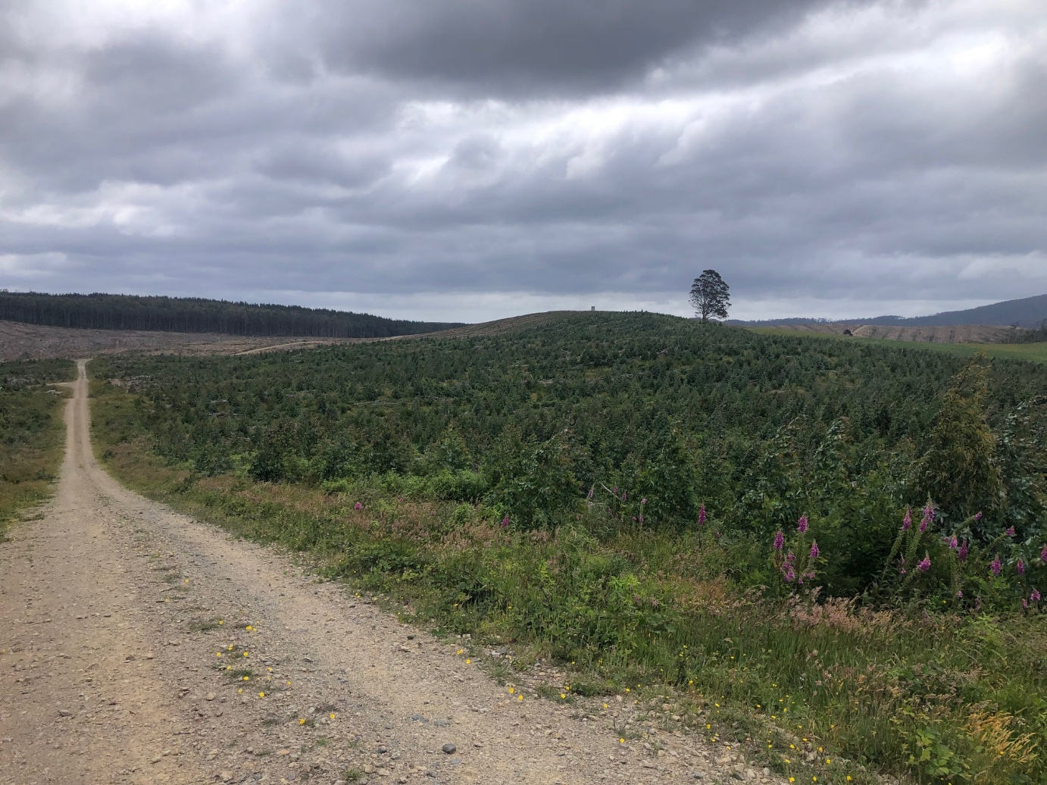

Changes to the Code
There are no material changes to the code in relation to protection of water quality and yield.

Implementation of the revised Code
There are no material changes for which discussion about implementation is relevant. Code audit results and observations during the field visits indicate that watercourse protections are rigorously applied.
An example of why greater focus should be placed on outcomes rather than prescriptions was observed at one harvesting site. To avoid extracting logs along a drainage depression, the operation had reinstated an old side cut track several meters uphill from the base of the depression. A windrow of loose soil was created on the edge of the track, which had potential to move into the drainage depression in the next rain. The conditions were dry, and a better outcome may have been achieved by extracting along the base of the drainage depression. The Code does allow for extraction along drainage depressions with FPO authorisation, however this option was not pursued in this instance.

Effectiveness of the revised code
The code continues to be effective in protecting water quality and water yield, although future focus towards water yield and hydrology has been flagged as important.

Scope for Improvement
Stakeholders indicated that future focus is likely to be directed towards the relationship between plantation establishment, growth and management and catchment hydrology.
With the introduction of outcomes statements, there is opportunity to encourage plantation managers to base decisions on outcomes.

Criterion 4: Protection of soil resources
Relevant National Principles
National Principle 1.6 - Soil stability should be protected by measures, which regulate site disturbance.
National Principle 1.7 - Soil, water catchment, cultural and landscape values should be protected by the careful location, construction, and maintenance of roads and tracks, and regulation of their use. (Note: cultural heritage values are considered in Criterion 5).
Questions addressed
How well does the Code support protection of soil resources in plantation operations?
Are there measures and processes in place to assess the risks to soil resources? How are differences in soil type, topography and climatic conditions taken into account?
Do the codes of practice provide guidelines for roading, harvesting and site preparation that minimise soil loss or adverse change to soil properties?

Context
As with water quality, soil resources are a heavy focus for the Code and the Forest Practices System. Section D1 of the Code deals with soils and section D3 deals with geomorphology. These sections are supported by a considerable amount of background documentation, research and mapping. Appendices 3, 4, 5 and 6 all provide detailed guidance around identification, assessment and management of risks to soil protection.

Changes to the code

There are no material changes to the code in relation to protection of soil resources.

Implementation of the revised code
There are no material changes for which discussion about implementation is relevant. The FPA annual report and field inspections confirmed the Code is being implemented appropriately in respect to soils.

Effectiveness of the revised code
The code continues to be effective in protecting soil resources.

Scope for Improvement
There are no specific areas identified for improvement.

Criterion 5: Protection of cultural heritage values
Relevant National Principles
National Principle 1.7 - Soil, water catchment, cultural and landscape values should be protected by the careful location, construction, and maintenance of roads and tracks, and regulation of their use
National Principle 1.8 - Values such as intensive recreation, high scenic quality, significant geomorphic, biological, or cultural heritage sites, should be recognised in the planning of plantation forest operations. (Note: cultural heritage aspects only).
Questions addressed
If it is applied as written, how effective is the Code in delivering protection of cultural heritage values?
In the planning of plantation layout, establishment and maintenance operations, are there measures and processes for managing cultural heritage values?

Context
Protection of cultural heritage values is well covered in the Code and the Forest practices System. Tasmania’s is the only Code being considered in this review which addresses geomorphology and visual landscape conservation directly and specifically.
Section D of the Code covers all aspects of Criterion 5, including National principles 1.7 and 1.8. Section D incorporates subsections which deal specifically with: D1 Soils; D2 Water quality and flows; D3 Geomorphology; D4 Biodiversity; D5 Visual landscape; and D6 Cultural heritage. Each of the subsections is supported by considerable background documentation and guidance.

Changes to the code
The cultural heritage section of the Code has been modified to now refer to the 2018 Procedures for managing Aboriginal cultural heritage when preparing FPPs (PACH). These guidelines, developed by the FTA and Aboriginal Heritage Tasmania (AHT) and endorsed by the Aboriginal Heritage Council, are a significant modernisation of the management of Aboriginal cultural heritage in forestry operations. The PACH strongly encourages forest managers to work with the Aboriginal community, provides examples of types of archaeology found in Tasmania and establishes standards for identifying and managing Aboriginal cultural heritage sites (both tangible and intangible). The PACH now advises local Aboriginal communities be consulted, particularly in areas known to have rich Aboriginal heritage or not previously subject to forest operations. The Code also includes procedures for managing new cultural sites identified during forest practices, which was a gap identified in the 2012 Review.

Implementation of the revised code
Training sessions conducted by the FPA include members of the Aboriginal community providing training to operational staff on cultural heritage awareness and management practices. As a result of this training there are now more people qualified to conduct cultural heritage surveys, which addresses an implementation issue raised through the 2012 Review.
During the field visit it was confirmed that cultural heritage, both Aboriginal and historic is managed by plantation managers in accordance with the Code. Interview with a FPA endorsed Aboriginal Heritage Forest Practices Officer indicated that additional support may be required to confirm some types of cultural artefacts and that this can be difficult to obtain in a timely manner. This is particularly the case with older records which lack precise locations and details about the site.
Several certified plantation managers in Tasmania have developed Reconciliation Action Plans with local Aboriginal communities. These processes are providing a basis for relationship building and knowledge sharing that will ultimately benefit protection of cultural heritage.

Effectiveness of the revised code
The Code and PACH provide a more robust approach to cultural heritage management than other similar instruments in Australia and the effectiveness of the Code has improved since the 2012 Review. However, there is a view among stakeholders that cultural heritage management should consider the role of plantations in the cultural landscape, rather than just focusing on artefacts and sites. The PACH scope includes intangible cultural heritage, however unless these sites have been recorded in government databases, they may not be identified through routine planning processes if the plantation manager elects not to consult with local Aboriginal communities.
Although the FPA has trained and endorsed Aboriginal Heritage Forest Practices Officers to implement the PACH, it is still the case that specialist advice is required to confirm some cultural artefacts.

Scope for Improvement
There are no specific improvements identified. However, it is important that there is ongoing access to cultural heritage specialists and engagement with local Aboriginal communities to drive continuous improvement in the protection of cultural heritage values.

Criterion 6: Protection from fire, pests and diseases
Relevant National Principle
National Principle 1.9 - Plantations and adjacent native forests should be protected from the adverse effects of fire and from the introduction and spread of plant, insect and animal pests and plant diseases.
Questions addressed
Is the Code effective in guiding protection pf plantations and adjacent native forests from fire, pests and diseases?
Do the codes of practice provide for fire management plans for plantations including containment from adjacent native forest?
Do the codes of practice provide guidelines to deal with outbreaks of pests and diseases?

Context
Like many other jurisdictions, fire management and biosecurity are addressed in Tasmania as whole of landscape issues through specific legislation and management frameworks. The Code and associated documents provide forest operation specific prescriptions for fire and biosecurity, however these form only part of the regulatory and management framework governing these topics. Section C2 of the Code addresses fire management planning and section E deals with fire and forest health associated with establishing and maintaining forests, covering insect pests, weeds, diseases, browsing, grazing, burning and firebreak maintenance.
In Tasmania, fire management is regulated under the Fire Services Act 1979. Additional provisions for forests on Crown Land are specified in the Forest Management Act 2013. Tasmania’s State Fire Management Council, brings together key agencies and major landowners or landowner groups (including the Tasmanian Forest Products Association) to coordinate bushfire management activities across the State. The industry has collaborated to develop fire prevention and prescribed silvicultural burning standards. Large plantation owners have collaborated to enter a memorandum of understanding with the Tasmanian Fire Service deliver fire response services. Although these arrangements have been in place for a long period, they are constantly evolving to manage bushfire risk.
Biosecurity is a major focus of the Tasmanian Government and of the State’s natural resource management agencies, with new legislation in place since 2019.

Changes to the code
The fire management provisions within the Code have been restructured and updated. The Code no longer recommends the preparation of fire management plans, but instead provides an operational approach for fire management planning in whatever form it takes. More detail has been introduced for different burning objectives and higher risk situations such as steep country, peat soils, button grass and alpine grasslands. There has been no substantive change to firebreak and fire dam requirements which focus primarily on protection of environmental values. Stakeholders have indicated that there is scope to develop minimum standards for plantation fire protection infrastructure covering aspects such as firebreak design, setbacks, water points and access and operational protocols for burning. The industry has developed a draft standard, however it had not been ratified at the time of this review.
Only minor changes were made to the Forest Health section of the Code. The most substantive change is reference to the FPA’s Flora Technical Note 8: Management of Phytophthora cinnamomi in production forest, which provides a comprehensive guide to recognising affected areas and applying hygiene measures.

Implementation of the revised code
Code audit results and stakeholder consultation indicates that plantation managers are implementing the fire, burning and forest health prescriptions effectively. Large plantation owners continue to have processes, people and equipment in place to address fire management requirements. The existing collaborative approach to fire response is becoming more comprehensive, with some private plantation managers contributing to the fire detection network and contributing aerial suppression capability. It was observed that firebreaks are not always maintained in a state that allows for effective access.
Minimising risk of spread of pathogens is a strong focus. The fungal pathogen Phytopthera is a recognised forest health risk which is managed by updated machinery washdown guidelines, consistent with national level requirements. The Chytrid fungus which affects frogs is another area of focus, particularly for ex-farmland sites and where frogs are present in fire-fighting dams.
Declared weeds are managed less actively on site but spread is addressed with washdown practices. Insect pests are a major challenge for hardwood plantations and are dealt with through active seasonal monitoring and response.
There is evidence of hybridisation of Eucalyptus nitens with several endemic eucalypt species in Tasmania. In most cases resulting hybrids lack vigour and do not regenerate. However, they have an impact by replacing viable regeneration of the endemic species. This issue is understood and is managed to some extent through buffers of softwood species, among other solutions. There are varying views among stakeholders about the full potential impact of hybridisation.

Effectiveness of the revised code
The code continues to be effective in forest protection, however there is scope for stronger standards of fire protection infrastructure and its management.

Scope for Improvement
Minimum standards for fire protection infrastructure should be finalised, published and implemented.
Consideration should be given to undertaking further research and investigation to fully understand the impacts of hybridisation on native species and vegetation communities.

Criterion 7: Training for environmental care
Relevant National Principle
National Principle 1.10 - Operators will be trained in the principles of environmental care.
Questions addressed
What requirements does the Code have in place for ensuring that operators are adequately trained in the principles of environmental care?
Are the processes adequate to meet this criterion?

Context
As with other jurisdictions, the issue of operator training in the principles of environmental care is challenging, largely because of the lack of accredited training providers and the relatively small market for education provision. The Code does not specifically address the issue of training. However, the broader Forest Practices System actively recognises training requirements and is involved in the delivery of training.
Previously ForestWorks provided training and recorded accreditation for a wide range of operator skills, including environmental care, through the Forest Operator Licensing System (FOLS). However, that system has ceased to operate. The Arbre Forest Industries Training and Careers Hub provides industry training, which includes environmental awareness.
Feedback in this area is that adequate training has been raised previously as an area of improvement. The FPA has implemented measures to improve adequate operator training in environmental care principles. These include contractor training programs and the introduction of interpretive booklets for specific practices, such as roading. However, the focus of training in the Forest Practices System is for Forest Practices Officers.
Individual companies provide training and familiarisation programs for employees and contractors, which is generally required by their certification systems. Some contracting companies support their operators to complete Certificate III in Forest Operations, which includes modules covering application of environmental protection procedures. In the absence of a standard environmental care competency for all operators, application of Code requirements relies on adequate operational supervision by FPOs.

Changes to the code
There are no material changes to the code.

Implementation of the revised code
There are no material changes for which discussion about implementation is relevant.

Effectiveness of the revised code
While larger industrial plantation owners are seen to demonstrate strong supervision and training practices, smaller private growers may lack the same level of rigor. To address these gaps, there is a growing focus on improving training and supervision for non-industrial private landowners.
While the FPA provides training opportunities, it is unclear to what extent individual operators engage with these programs and how consistently they apply the acquired knowledge in their practices. Further investigation is needed to assess the long-term impact of training initiatives and to identify strategies for maintaining and reinforcing knowledge and skills among forest operators.
The broader regulatory system, including the broad reach of forest management certification, means that operators are typically required to be trained or familiarised with the principles of environmental care. These programs are relatively informal but appear to be effective.

Scope for Improvement
There are no specific areas identified for improvement.

Other National Principles
There are a further seven National Principles covering 23 objectives, many of which overlap extensively with the Principles of Environmental Care dealt with above.
Questions addressed
What are your perspectives on the effect of the Code on the economic viability of timber production activities in plantations?
Are there any particular factors that you think influence how well and consistently the Code is applied?
Are there any particular areas of the Code you consider need updating or reform? eg. Topics that are missing, out of date, inappropriate, conflicting with other regulations, unclear, impractical. What and Why?

National Principle 2 – Safety
The Forest Safety Code (Tasmania) 2021 provides the framework for safety management in forestry operations. WorkSafe Tasmania states that:
“The Forestry Safety Code (Tasmania):
- is a Tasmania-only code of practice
- provides practical guidance on how to manage health and safety risks associated with forestry work; and how to achieve the standards required under the work health and safety laws
- applies to all workplaces where forestry work is carried out and anyone involved in these activities
- covers general safety principals for working alone, road access restrictions, operator competency, personal protective clothing, forest operations signage, onsite amenities, first aid, emergencies procedures, tools, work vehicles, tools, fire equipment and more
- covers chainsaws and brush cutters, manual tree felling, higher risk tree felling, mechanised felling, firewood cutting, log extraction. machinery, log landings, transportation, road construction and maintenance, silviculture, forest fire fighting
- cover human factors such as fatigue, dehydration, fitness for work, UV exposure, noise and more.”
Larger growers have safety management systems in place which meet the requirements of the Code, forest management certification and, in many cases, ISO 45001: Occupational health and safety management systems.

National Principle 3 – Planning
The Code and Forest Practices System provides complete coverage of the planning requirements (Section A3).

National Principle 4 - Access
The Code fully addresses access (Section B).
Figure 4: Hardwood plantation harvesting, log loading and hauling in northern Tasmania
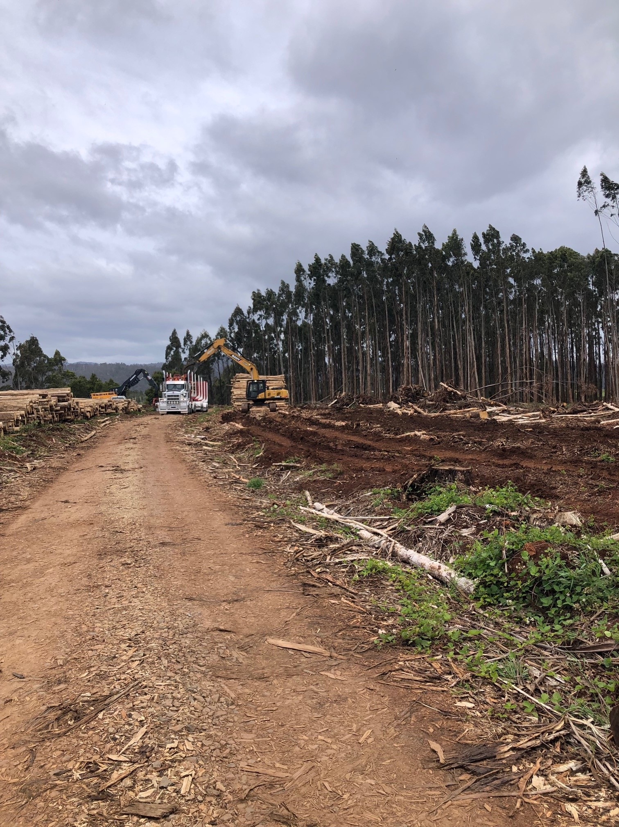

National Principle 5 - Establishment and maintenance
The Code fully addresses establishment and maintenance (Section E)

National Principle 6 - Timber harvesting
The Code fully addresses harvesting (Section C).

National Principle 7 - Forest protection
The Code addresses non-fire aspects of forest protection (Sections E1 and E3) and some aspects of fire protection (Section E1). Fire management is also addressed at the whole of landscape level through multi-organisation arrangements overseen by Tasmanian Government agencies.

National Principle 8 - Monitoring and review
A key element of the Forest Practices System is monitoring and review, along with enforcement. Of the Codes assessed in this program, the Tasmanian system is the only code regulatory system that overtly addresses monitoring and review.

Appendix A: Relevant legislation
Jurisdiction | Instrument
Tasmania | Forest Practices Act 1985
 | Forest Practices Regulations 2017
 | Forest Management Act 2013
 | Nature Conservation Act 2002
 | Fire Service Act 1979 (RL)
 | Fire Service (Miscellaneous) Regulations 2017
 | Water Management Act 1999
 | Threatened Species Protection Act 1995
 | Aboriginal Heritage Act 1975
 | Historic Cultural Heritage Act 1995
 | Agricultural and Veterinary Chemicals (Control of Use) Act 1995
 | Weed Management Act 1999
 | Weed Management Regulations 2017
 | Environmental Management and Pollution Control Act 1994
 | Environmental Management and Pollution Control (Noise) Regulations 2016
 | Nature Conservation Act 2002
 | Land Use Planning and Approvals Act 1993
 | Crown Lands Act 1976
 | Forestry (Rebuilding the Forest Industry) Act 2014
 | Forestry Rights Registration Act 1990
 | National Parks and Reserves Management Act 2002
 | Resource Planning and Development Commission Act 1997
 | Inland Fisheries Act 1995
 | Work Health and Safety Act 2012
Commonwealth | Environment Protection and Biodiversity Conservation Act 1999
 | Aboriginal and Torres Strait Islander Heritage Protection Act 1984
 | Export Control Act 2020

References
ABARES (2024) Australian Forest and Wood Products Statistics Sep-Dec 2023, Australian Government
Forest Practices Authority (2020) Forest Practices Code Forest Practices Authority, Hobart Tasmania
Forest Practices Authority (2024) Annual Report 2023/24, Forest Practices Board
Forest Practices Board (2000) Forest Practices Code, Forest Practices Board, Hobart, Tasmania
Nambiar, E.K.S, Smethurst, P.J, Raison R.J, House, A.P.N, & Moggridge, B (2012) Assessment of the Code of Practice for Plantation Forestry: Tasmania, Prepared for the Australian Department of Agriculture, Fisheries and Forestry
WorkSafe Tasmania (2021) FOREST SAFETY CODE (Tasmania)
Websites
https://fpa.tas.gov.au/landowners/clearing_land (Accessed November 2024)
https://fpa.tas.gov.au/__data/assets/pdf_file/0014/524102/Fauna_Tech_Note_1_-_Eagle_nest_management.pdf (Accessed November 2024)
https://www.sfmc.tas.gov.au/about-us (Accessed December 2024)
https://www.arbre.net.au/ (Accessed December 2024)
https://worksafe.tas.gov.au/topics/laws-and-compliance/codes-of-practice/cop-folder/forest-safety-code-tasmania (Accessed December 2024)

