Assessment of Code of Practice for Plantation Forestry in the Northern Territory
© Commonwealth of Australia 2024
Ownership of intellectual property rights
Unless otherwise noted, copyright (and any other intellectual property rights) in this publication is owned by the Commonwealth of Australia (referred to as the Commonwealth).
Creative Commons licence
All material in this publication is licensed under a Creative Commons Attribution 4.0 International Licence except content supplied by third parties, logos and the Commonwealth Coat of Arms.

Cataloguing data
This publication (and any material sourced from it) should be attributed as: Phelan, T, Roscoe, R and Groenhout, P 2024, Assessment of the Sustainable Forestry Practices – Guidelines for the Northern Territory Report prepared by Greenwood Strategy Solutions Pty Ltd for Department of Agriculture, Fisheries and Forestry, Canberra, December. CC BY 4.0.
This publication is available at agriculture.gov.au/publications.
Department of Agriculture, Fisheries and Forestry
GPO Box 858 Canberra ACT 2601
Telephone 1800 900 090
Web agriculture.gov.au
Disclaimer
The Australian Government acting through the Department of Agriculture, Fisheries and Forestry has exercised due care and skill in preparing and compiling the information and data in this publication. Notwithstanding, the Department of Agriculture, Fisheries and Forestry, its employees and advisers disclaim all liability, including liability for negligence and for any loss, damage, injury, expense or cost incurred by any person as a result of accessing, using or relying on any of the information or data in this publication to the maximum extent permitted by law.
Acknowledgements
The authors acknowledge the significant assistance provided by a number of stakeholders that assisted through the provision of logistics support, access to plantations and in-depth industry knowledge and expertise. Specifically, we acknowledge the support of the Forest Industries Association of the Northern Territory (FIANT), Northern Territory and Ord Valley Forestry Hub, Plantation Management Partners, Tiwi Plantation Corporation, Tiwi Land Council, Great Northern Plantations, Apical Forest Management, African Mahogany Australia and the Northern Territory Government.
Acknowledgement of Country
We acknowledge the Traditional Custodians of Australia and their continuing connection to land and sea, waters, environment and community. We pay our respects to the Traditional Custodians of the lands we live and work on, their culture, and their Elders past and present.

Contents
Summary vi
Introduction 8
Context 8
Purpose and scope 8
Assessment methodology 9
Plantation forestry in the Northern Territory 10
Assessment overview 13
The role of codes of practice in wood exports 13
Assessment against the National Principles 13
Australia’s sustainable forest management framework 14
Export requirements for codes of practice 15
Assessment method 15
Criterion 1: Compliance of plantation management with relevant planning schemes and legislation 17
1.1 Context 17
1.2 Changes to the code 18
1.3 Implementation of the revised Code 20
1.4 Code effectiveness 21
1.5 Scope for Improvement 21
Criterion 2: Protection of native vegetation and animal communities and natural landscape values 22
2.1 Context 22
2.2 Changes to the code 23
2.3 Implementation of the revised code 24
2.4 Code effectiveness 25
2.5 Scope for Improvement 25
Criterion 3: Protection of water quality and, where required, management of water yield 27
3.1 Context 27
3.2 Changes to the code 28
3.3 Implementation of the revised Code 29
3.4 Code effectiveness 29
3.5 Scope for Improvement 30
Criterion 4: Protection of soil resources 31
4.1 Context 31
4.2 Changes to the code 31
4.3 Implementation of the revised code 32
4.4 Code effectiveness 33
4.5 Scope for Improvement 33
Criterion 5: Protection of cultural heritage values 34
5.1 Context 34
5.2 Changes to the code 34
5.3 Implementation of the revised code 35
5.4 Code effectiveness 36
5.5 Scope for Improvement 36
Criterion 6: Protection from fire, pests and diseases 37
6.1 Context 37
6.2 Changes to the code 38
6.3 Implementation of the revised Code 39
6.4 Code effectiveness 40
6.5 Scope for Improvement 40
Criterion 7: Training for environmental care 41
7.1 Context 41
7.2 Changes to the code 41
7.3 Implementation of the revised code 41
7.4 Code effectiveness 41
7.5 Scope for Improvement 42
Other National Principles 43
National Principle 2: Safety 43
National Principle 3: Planning 43
National Principle 4: Access 43
National Principle 5: Establishment and Maintenance 43
National Principle 6: Timber Harvesting 43
National Principle 7: Forest Protection 44
National Principle 8: Monitoring and Review 44
Appendix A: Relevant legislation 45
References 47

Tables
Table 1: Four desktop review steps for the scientific assessment 9
Table 2: An overview of Australia’s sustainable forest management framework 14

Figures
Figure 1: African mahogany plantation, Douglas-Daly region 11
Figure 2: Approval pathways for new plantations on cleared and uncleared land 19
Figure 3: Monitored raptor nest, Melville Island 24
Figure 4: Post-harvest rollover drainage structure, Melville Island 30
Figure 5: Cattle and goats are used to manage fuel levels and weeds in the Douglas-Daly region 38
Figure 6: Indian sandalwood and host trees, Douglas-Daly region 42

Summary
The Export Control Act (2020) provides the legislative basis for regulating exports from Australia, including agricultural exports. Under the Export Control (Wood and Woodchips) Rules 2021, wood and woodchips are prescribed for the purposes of the Act. That means they require a licence to be exported, unless they are derived from trees sourced from a plantation in a State for which there is an approved code of practice, in which case they are taken to not be prescribed. If wood or woodchips do not meet this requirement, their export is prohibited unless the exporter holds a wood export licence which is in force at the time when the wood or woodchips are exported.
In order for a code of practice to be approved for the purposes of the Wood Rules, it must be scientifically assessed against the National Principles for Forest Practices Related to Wood Production in Plantations. In the Northern Territory, that assessment was previously undertaken by the CSIRO in 2012 for the Northern Territory Codes of Practice for Forestry Plantations (2004). Subsequently, the Codes of Practice have been incorporated into the Sustainable Forestry Practices – Guidelines for the Northern Territory (2021). The code of practice is therefore considered to have been reviewed and requires re-assessment against the National Principles and approval by the Minister for Agriculture, Fisheries and Forestry, so that wood and woodchips continue to be non-prescribed for export purposes.
This report presents the findings from the assessment of the Sustainable Forestry Practices – Guidelines for the Northern Territory against the National Principles. The assessment has determined that the Guidelines, constituting the revised code, represent a significant and positive evolution of the framework for delivering sustainable management of plantations in the Northern Territory. The revised code is a modern, fit-for-purpose document that adequately meets the requirements of the National Principles for Forest Practices Related to Wood Production in Plantations.
The assessment has focused on National Principle 1: Principles of Environmental Care but has also addressed the remaining seven National Principles, which overlap considerably with Principle 1. The CSIRO review in 2012 applied seven criteria to the assessment process. For continuity, the same seven criteria have been applied to this assessment in considering changes to the code.
The Guidelines represent a significant and positive evolution of the code framework for the Northern Territory. The key areas for improvement identified in the 2012 CSIRO review have largely been addressed. Potential areas for improvement in future reviews of the code have been identified throughout the report. Focus areas for future improvement include:
- Improved awareness of the Guidelines: current industry awareness is low, probably because there is little establishment or harvesting activity currently underway. However, it is imperative that industry awareness is improved, especially with a significant re-establishment program foreshadowed for Melville Island. Linked with this, the Guidelines and associated Field Guide could be effectively applied to a simple and effective training program related to the principles of environmental care.
- Alignment with the broader regulatory framework: Effectiveness in facilitating forest managers to identify and manage local conservation management priorities would be improved by more explicitly aligning the Guidelines with the broader regulatory environment. That includes regional conservation objectives (as outlined in the Territory NRM management plans), regulatory compliance beyond only land-clearing, and processes to deal with cultural heritage discovery.
- Codification of buffers: Broadly the Guidelines strike an appropriate balance between guidance and prescription. However, codification in the form of prescriptions (specific to the plantation forestry types), for example in relation to prescribed buffers for streamside and native vegetation protection, would contribute to ensuring desired outcomes are achieved for protection of water, streamside habitat and remnant vegetation management and conservation.
Based on these observations, we conclude that the Code and its implementation in the Northern Territory are satisfactory for achieving the national principles of environmental care.

Introduction

Context
Codes of practice are an important element of the overall sustainable forest management framework in Australia. The regulation of land management and land use decision-making is a state responsibility. Therefore, codes of practice for sustainable forest management operate at the state and territory level of government.
Typically, forestry codes of practice are focussed on environmental outcomes and, as such, form a nexus between operational planning and delivery and the broader regulatory and legislative framework that operates in each state and territory. That framework varies considerably between jurisdictions. Therefore, while forestry codes of practice are generally consistent with respect to the higher order environmental issues being addressed, there is a great degree of variation around the specific detail in those codes, and the approach to and responsibility for code compliance.
One of the ways in which forestry codes of practice are used is to demonstrate that forest management and harvesting activities on plantations operate consistently with the National Principles for Forest Practices Related to Wood Production in Plantations (the National Principles), which provides for plantation wood products (e.g., woodchips and round logs) to be eligible for export without the requirement for an export licence. Any changes to codes of practice must be scientifically assessed against the National Principles for those conditions to be met.

Purpose and scope
The purpose of the assessment is to evaluate the effectiveness of the Sustainable Forestry Practices – Guidelines for the Northern Territory (the Guidelines) in meeting the National Principles. It compares changes in the Guidelines against the previous version of the Code, reviews those changes in the context of the findings from a scientific assessment undertaken by the CSIRO in 2012 (Raison et. al., 2012), and assesses the Guidelines against the National Principles. Delivery of the assessment has involved:
- A comprehensive review of the Guidelines itself, analysis of changes since the previous assessment, its implementation on the ground, and related guidelines, policies, and regulations.
- Stakeholder engagement, including interviews with industry representatives, government officials, and other stakeholders.
- Field inspections to assess the practical application of the Guidelines in plantation forestry operations.
For continuity, findings are presented in the same structure as the 2012 assessment. Particular focus is placed on Principle 1 (Principles of Environmental Care), which assesses performance against seven criteria:
- Compliance
- Ecology and biodiversity
- Water
- Soil
- Cultural heritage
- Forest health and protection
- Training for environmental care
Principles 2 to 8 are also addressed, where the assessment of Principle 1 does not cover them. For each criterion, the assessment addresses changes to the Guidelines, how these are being implemented, how effective the Guidelines are in meeting the requirements of the National Principles, and scope for improvement.

Assessment methodology

Desktop review
The desktop review aimed to provide background information to inform stakeholder consultation and field observation of implementation of the Guidelines. It included four steps, summarised in Table 1.
Table 1: Four desktop review steps for the scientific assessment
Assessment step | Description
Identification of relevant documentation | Additional reference material such as management guidelines, policy, legislation and regulation was identified and described.
Change analysis | Variations to the Guidelines and related documents that have occurred since 2012 and the findings of the 2012 CSIRO assessments were reviewed and documented to provide additional change context.
Comparison with National Principles | The Guidelines and related documents were subject to a high-level desktop assessment against the National Principles, aimed at identifying any obvious questions with respect to potential non-compliance.  To allow for consistency and comparison, the CSIRO structure for presenting assessment against the National Principles was adopted (i.e., seven criteria for environmental care and cultural heritage, plus commentary on the remaining National Principles).
Identification of focus areas | Results were collated and analysed to determine focus areas for additional desktop review and for the stakeholder consultation and field assessment.

Stakeholder consultation
The plantation-based forest and wood products sector in the Northern Territory is quite small, with four estates under management, representing three quite different types of plantation forestry. In recent years there has been considerable effort to consolidate the sector and improve engagement with Government, which has been advanced with the establishment of a dedicated Forestry Division within the Department of Industry, Tourism and Trade. Consultation was undertaken with 10 stakeholders representing nine separate organisations. This represents a significant proportion of a small stakeholder base. Consultation was undertaken through interviews, either face-to-face or by telephone or video meetings. The interviews were a semi-structured format, with pre-prepared questions forming the basis of the consultation but scope allowed for the consultation to explore issues and concepts that may not have been anticipated during planning.

Field assessment
Field assessment was undertaken for three of the four plantation forestry projects in the Northern Territory, and covered all species grown there. Prior to undertaking field assessment, priority focus areas were identified. As there are currently no establishment or harvesting operations underway in the Northern Territory plantation estate, primary focus was on forest maintenance issues, with efforts made to retrospectively determine the impacts of historic establishment and harvesting activities.

Plantation forestry in the Northern Territory

Industry overview
The Northern Territory plantation sector is unique in Australia, in terms of the species grown, the remote tropical environment and social and economic setting. The industry is still relatively young, and active research is underway to establish best practice silviculture and markets for each of the three distinct types of plantation forestry. The Northern Territory Government supports the plantation industry, providing technical and policy support where required. There is currently no established timber processing industry in the Northern Territory and movement of raw materials to other mainland Australian locations is challenging. Therefore, the presence of a favourable trade environment for forest exports, in terms of infrastructure, market access, policy and regulation, is particularly important.
All three plantation projects in the Northern Territory have experienced considerable change since the 2012 assessment. A brief outline of each project is provided below, including an update on developments occurring since the 2012 assessment. All plantation projects were either mid-rotation or between crops at the time of the assessment. That has limited the extent to which implementation of the Guidelines can be fully assessed against the full range of forest management practices (establishment through to harvesting). Consequently, the review of implementation focusses on tending, post-harvest and maintenance practices. Where feasible, indirect assessment of establishment and harvesting practices has been undertaken through the desktop review and consultation components of the assessment.
Acacia mangium: On Melville Island approximately 30,000 ha of Acacia mangium plantations were established between 2001 and 2008 as short rotation pulp crop. Tiwi Plantations Corporation, an indigenous-owned business, commissioned the harvesting of a significant proportion of these plantations between 2015 and 2023 for export as woodchip from Port Melville to Asian markets. The remainder of the crop is now considered unsuitable for pulp production. Current operational focus is on forest protection and infrastructure maintenance, along with strategic planning for the next rotation which is likely to involve a shift to a new plantation species. Plantation management activities on Melville Island are certified to AS/NZ4708:2021 (Responsible Wood).
African mahogany: Approximately 13,000 ha of Khaya senegalensis (African mahogany) plantations were established between 2006 and 2014 in the Douglas-Daly region with the aim to produce sawlogs. Thinning and maintenance operations are currently the key activities. Clearfell harvest is expected to occur between ages 25 to 30 years. The first harvest is anticipated to occur around 2030. The African mahogany plantations are not currently certified. However, the plantation manager is developing a system which will be compliant with certification requirements, and certification will be sought ahead of harvesting activity.
Indian sandalwood: Approximately 5,000 ha of Santalum album (Indian sandalwood) is grown in irrigated plantations to produce oil and specialty timber products in the regions between Mataranka and the Douglas-Daly. Establishment occurred between 2010 and 2017, and the plantations are currently in mid-rotation phase. Irrigation, biomass control and plantation maintenance are the key activities currently. This estate was being rationalised at the time of the review, following liquidation of the previous management company. New management arrangements have been implemented. Some areas are in the process of reversion to agriculture and the future of the remaining estate is unknown. These plantations achieved both FSC and Responsible Wood certification in 2022, which has now been terminated.
Figure 1: African mahogany plantation, Douglas-Daly region
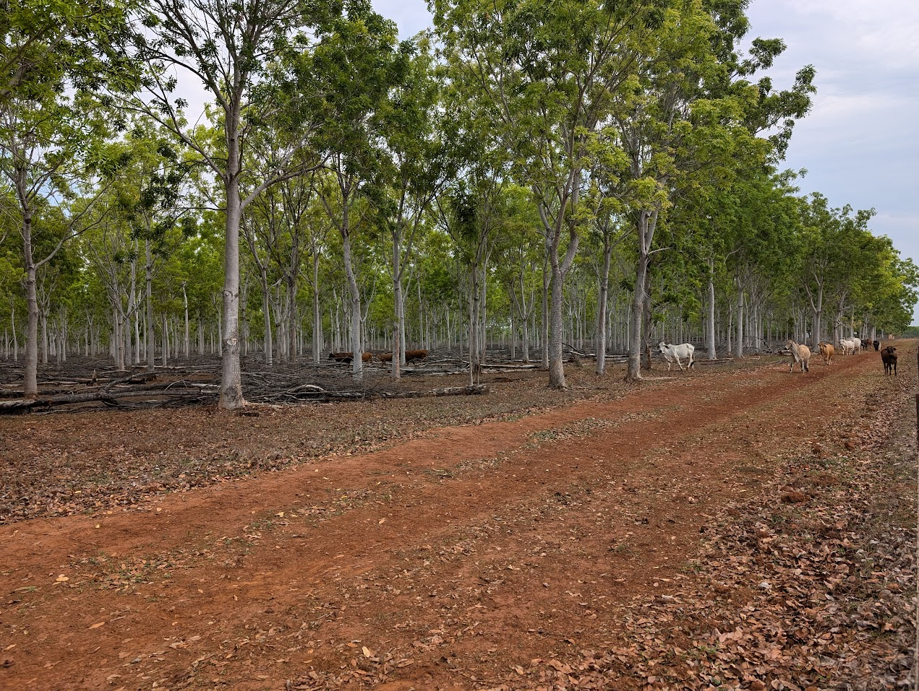

Background to the Northern Territory Code
In 2021, Territory Natural Resource Management published Sustainable Forestry Practices: Guidelines for the Northern Territory (the Guidelines) which functions as the Northern Territory Code. These Guidelines incorporate and replace the 2004 Northern Territory Codes of Practice for Forestry Plantations (the 2004 Code). The 2004 Code was a brief document covering the main requirements for sustainable plantation management in a series of 26 goal statements. The 2012 assessment found that the 2004 Code was broadly consistent with the National Principles. However, it identified areas for improvement which included:
- Establishment of clearer links to legislation and the broader regulatory environment
- Provision of guidance about how to implement the goals effectively
- Focus on compliance and oversight.
The development of the Guidelines in 2021 recognises and seeks to address the framework provided by the National Principles and the conclusions of the 2012 assessment.
The Guidelines incorporate goals and recommend practices to support sustainable and economically competitive forest management in the Northern Territory environment and industry context. All stages of the plantation lifecycle are addressed, from development and land clearing (where necessary) through to post-harvest activities. Key natural and cultural values are addressed in dedicated sections. The Guidelines reference relevant legislation and regulations, and key supporting information available through the Northern Territory Government.
The Guidelines have no formal regulatory function. The document was developed in consultation and collaboration with representatives from across the Northern Territory plantation industry and Government. Nevertheless, it is a fit-for-purpose code of practice that comprehensively addresses the National Principles at a level of detail appropriate to the current stage of evolution of the industry. This approach accommodates the scale, variety and emerging nature of forestry enterprises in the Northern Territory as well as the environmental, social and economic conditions of the jurisdiction. Information available from the Northern Territory Government provides detailed guidance on interpretation and implementation of the practices outlined in the Guidelines for key risk areas. This assessment has identified there is still scope for development and incorporation of more detailed guidance on some aspects of the National Principles that are not covered through existing materials.
There is no specific law or compliance function in the Northern Territory for regulation of plantation forestry, and the Guidelines are not recognised as a regulatory tool by any law. Plantations are therefore subject to broader Territory and Commonwealth laws and compliance frameworks and relevant enforcement, which may or may not consider the Guidelines.
Forest certification is a sector specific mechanism for assessing the implementation of sustainable practices. Forest Stewardship Council (FSC) and Responsible Wood (PEFC) certification systems involve annual audit of certified forest estates to ensure operations conform with the respective standards. Both schemes require compliance with all relevant laws and regulations. They also specify comprehensive sustainability focussed forest management practices which are compatible with the National Principles and the Guidelines. Certification is voluntary, so reliance on these systems to perform a compliance mechanism consistently across all Northern Territory plantations is not possible. However, for estates that are certified, the process provides a useful indication of legal compliance and effective implementation of the Guidelines.

Assessment overview

The role of codes of practice in wood exports

General sustainability framework for forest products
Australia has a strong framework for legal and sustainable timber production from commercial plantations and native forests and for the sale of those products to domestic and international (export) markets. The framework includes national and state level legislation and policies, regional forest agreements, a framework for criteria and indicators to measure sustainability and independent voluntary certification.

Legislated export controls
An important piece of Commonwealth legislation is the Export Control Act (2020) (the Act), supported by the Export Control (Wood and Woodchips) Rules (2021) (the Rules). The Act provides the legislative basis for regulating exports from Australia, including agricultural exports. Under that framework, specific kinds of goods can be prohibited from export or required to be licensed by the Australian Government for export. Both these instruments form an important part of Australia’s sustainable forest management framework. The Rules specify requirements which must be met for prescribed and non-prescribed wood and woodchips, so that products are eligible for export.
Wood and woodchips are prescribed for the purposes of the Act, unless they are derived from trees sourced from a plantation in a State for which there is an approved code of practice, in which case they are taken to not be prescribed. If wood or woodchips do not meet this requirement, their export is prohibited unless the exporter holds a wood export licence which is in force at the time when the wood or woodchips are exported.

Practical meaning
In practical terms, the effect of the Act and the Rules is to provide a regulatory framework that limits the export of wood and woodchips unless management of those forests meets certain requirements, while allowing more ready access to export markets for wood and woodchips produced from plantations, so long as the jurisdiction where the plantations are grown has in place an approved code of practice for forest management and timber production which has been assessed against the National Principles. In this context, State and Territory based codes of practice are essential regulatory instruments which allow the plantation sector to access important commodity export markets.

Assessment against the National Principles

Regulatory logic
Under the Rules, a State may request approval of a code of practice. The Commonwealth (specifically the Minister) can approve a code for the purposes of the Rules if satisfied that the code would substantially protect environmental and heritage values in the State and the State enters an agreement with the Commonwealth to undertake any required amendments and to advise when they have been made. The Minister must give regard to the findings of a scientific assessment of the code of practice based on the National Principles. The Minister may require the State to amend the approved code. The State may also make minor amendments to an approved code. However, by implication, a significant amendment to a code requires the code to be reviewed and the Minister can revoke approval of the code.
The Rules specify the kinds of wood and woodchips that are prescribed and non-prescribed goods. Prescribed goods require an export license and non-prescribed goods do not. Under sub-section 2-1(2) of the Rules, wood and woodchips that are sourced from plantations are taken to be non-prescribed goods, if an approved code of practice is in place for the relevant State or Territory. An approved code of practice is one which has been scientifically assessed as meeting the requirements of the National Principles and approved by the Minister based on that assessment.

Role of the National Principles
The framework for assessing whether a code of practice meets the requirements for approval is the National Principles, which provide specific guidance about what a code of practice must address to be successful in achieving and maintaining approval for the purposes of the Act. They are categorised into Environmental Care, Safety, Planning, Access, Establishment and Maintenance, Timber Harvesting, Forest Protection and Monitoring and Review. The National Principles are intended to provide a basis for a consistent and scientifically sound approach to plantation management for application in all States and Territories.

Australia’s sustainable forest management framework
The framework which guides sustainable management of forests for timber production in Australia is well established. It includes national and state level policies and regulatory instruments, regional forest agreements, a framework for criteria and indicators to measure sustainability and independent third-party forest management and chain of custody certification (Greenwood Strategy, 2024).
Table 2: An overview of Australia’s sustainable forest management framework
Framework element | Framework instruments | Examples/explanation
National framework | Legislation and regulation | Various Commonwealth legislation including the Environment Protection and Biodiversity Conservation Act (1999), Regional Forest Agreements Act (2002), Illegal Logging Prohibition Act (2012), Export Control Act (2020) and Export Control (Wood and Woodchips) Rules (2021).
 | National Forest Policy Statement (1992) | Promotes the conservation and sustainable management of forests.
 | Forest practices related to wood production in plantations: National Principles | Set of eight nationally agreed principles guiding sustainable wood production from timber plantations in Australia.
 | Regional Forestry Hubs | Eleven Regional Forestry Hubs in strategic locations funded by the Australian Government to support the ‘Growing a better Australia’ policy.
 | Australian Forest and Wood Innovations | Established in partnership with the University of Tasmania to support research, development and innovation for Australia’s timber industry, while also supporting the training and development of forest industries researchers.
 | Regional Forest Agreements | Long-term agreements between the federal and state governments to support regional approaches to balancing conservation and timber production needs from native forests.
 | Australia’s Sustainable Forest Management Framework of Criteria and Indicators (2008) | An internationally recognised framework for monitoring, measuring and reporting on Australia's sustainable forest management.
State and Territory frameworks | Policy, legislation, regulation | Each state and territory has policies, legislation and regulation (such as Codes of Practice) in place to ensure sustainable forest management practices.
Certification | Independent, standards-based verification of sustainable management of forests and supply chains | Independent, third-party certification of sustainable forest management and timber manufacturing to internationally recognised standards, which applies to most of Australia’s production forests.
Source: Groenhout et. al. (2024) Private Forestry Guidance Materials: An introduction to the business of small-scale forestry

Export requirements for codes of practice

Previous reviews and approval
In 2012, the codes of practice for all Australian State and Territory jurisdictions were assessed by the CSIRO on behalf of the Australian Government. The findings of the assessment relevant to this report are documented in Raison et.al. (2012).

Changes to codes of practice
Since the CSIRO completed its 2012 assessments, codes of practice in the Northern Territory (2021), Tasmania (2015 and 2020) and Victoria (2014 and 2022) have undergone revision and changes. Consequently, the Department of Agriculture, Fisheries and Forestry has determined that the codes of practice for all three jurisdictions require an updated scientific assessment to determine whether they still meet the requirements of the Rules and the National Principles.

Assessment method

Overall approach
The assessment approach developed for this project was consistent with the approach used in previous assessments, and across all three jurisdictions assessed. The broad scope for the assessment included:
- Desktop review and change analysis, focused on:
  - Review of the scientific validity of the goals and guidelines contained in each individual code, the way the code is implemented, and how environmental performance and other aspects of compliance are monitored.
  - Effectiveness in complying with the National Principles.
  - Assessment of interactions of each individual code with the relevant regulations (e.g. planning) and guidelines applicable to the regional and local contexts that affect risk to environmental values.
  - Developing priority focus areas for the assessment.
- Stakeholder engagement by way of interviews.
- Regional field visits to assess in-field practical application of the Code in plantation forestry operations.
- Assessment of the suitability of the Code to meet the requirements of the Export Control Act (2020), Export Control (Wood and Woodchips) Rules (2021) and the Forest practices related to wood production in plantations: National principles.

Specific considerations for the Northern Territory
Due to the small scale of the plantation industry in the Northern Territory, its remoteness and its unique characteristics, the stakeholder consultation stage of the project was combined with the field visits. Visits were made to enable field observations at each of the plantation projects. This allowed the assessment team to gather perspectives on the Guidelines and observe implementation of practices. Interviews were also conducted with representatives of the Forestry Industry Association Northern Territory (FIANT), the Department of Industry, Tourism and Trade, Plant Industries Group and an Indigenous land council.
Priority focus areas were identified to guide field visits and stakeholder interviews. Interviews were based around the content of the code, the National Principles and the results of the 2012 assessment. The process aimed to gauge the level of familiarity with and understanding of the requirements and how they have been and continue to be implemented in the local context. This approach facilitated a collaborative dialogue, allowing stakeholders to share knowledge and voice concerns. Field observations focussed on the general condition of the plantations (there were no establishment or harvesting operations occurring at the time of the visit). Through this process the project team was able to gain a sound understanding of contemporary plantation management in the Northern Territory, as well as perspectives on the content of the Guidelines, their practical application, and current challenges and priorities for the sector.

Criterion 1: Compliance of plantation management with relevant planning schemes and legislation
Relevant National Principle
National Principle 1.3 - Plantation management should comply with State and regional conservation and catchment management objectives, relevant planning schemes and legislation.
Questions addressed
How well does the Code support operational compliance with State and regional legislation, regulation and policy for sustainable management of plantations?
Are the processes adequate to meet this criterion?

Context
Relevant legislation is detailed in Appendix A. Land use planning and development is regulated by the Planning Act (1999) and Planning Regulations (2000) which set out how land in the Territory can be developed and used. The Northern Territory Planning Scheme (2020) divides some land into zones and specifies how land within those zones can be used and developed. Unzoned land attracts some forms of land use controls, especially removal of native vegetation >1 ha. Development permits and exceptional development permits authorise the use and development of land. Development has legislated meanings, including the establishment of a use, or a change in the use of land (Environmental Defenders Office, 2021).
Land tenure in the Territory is mostly pastoral lease, Aboriginal freehold or vacant Crown land. There are smaller areas of other lease types and non-Aboriginal freehold. Each of these tenures has a different legislative and regulatory framework that applies to developments.
Developments on Aboriginal freehold require approval by the Northern Land Council or Tiwi Land Council and traditional owners, via a Section 19 application process and submission of a Land Use Agreement expression of interest and consultation with traditional owners.
For pastoral leases, plantation forestry is one of a number of diversified non-pastoral agricultural activities that can be permitted under the Pastoral Land Act (1992) following the passing of an Amendment bill in 2017. Permits are subject to approval from the Pastoral Land Board, following assessment by the Department of Environment, Parks and Water Security. An application must detail the intended non-pastoral use and its purpose, details of the applicant and lease, and must address environmental and cultural heritage issues including water requirements, sacred sites, sites of conservation significance, duration of intended use (up to 30 years) and costs.
Freehold land that has previously been cleared does not require formal assessment under the Planning Act or Environmental Protection Act (2019) if it was cleared prior to other controls being introduced and have been maintained in a cleared condition. However, if regrowth has re-established, consent will be required to clear again. For uncleared land, a clearing permit is required under the Planning Act, regardless of tenure. Figure 2 summarises the approval pathways for new plantations on different tenures.

Changes to the code

Previous code
The 2004 Code identified key Territory and Commonwealth legislation relevant to plantation development and management. It provided a brief explanation of how laws are considered and applied in goals 1-4, 8 and 26. It specifically addresses regulatory processes associated with clearing vegetation for plantation development on the various Territory land tenures, the development and implementation of a plan of management, and laws and regulations relevant to enforcement activities.
The 2012 assessment identified that the 2004 Code lacked detailed guidance on the content of plans of management, how they would be assessed, how ongoing compliance and effectiveness issues would be dealt with and the management of operational processes. It highlighted the fact that there is no specific reference in legislation to plantation forestry and no explicit recognition by the Territory Government and industry stakeholders of the Code’s function as a voluntary policy instrument and code.

Revised code
The Guidelines were developed in consultation with representatives from across the Northern Territory plantation industry and the Territory Government. The Guidelines acknowledge the issues raised in the 2012 assessment and address these to the extent possible within a guidance document. Key changes introduced by the Guidelines in relation to compliance include:
- Specific reference to relevant legislation, regulation and other management guidelines for each of the 14 operational themes covered within the document.
- An overview of all relevant Territory and Commonwealth environmental legislation for the plantation industry, covering both development and ongoing management, in Appendix One.
- Comprehensive documentation of the approval pathways for new plantation establishment in the Legislative Framework for Establishing Plantations section.
- Guidance to prepare a costed Plantation Operation Plan for at least one full crop cycle with 21 specific planning practices to be considered in the Plantation Planning section.
Although the Guidelines do not reference health and safety legislation, the importance of health and safety in plantation management is articulated within the document. Regional conservation and catchment management objectives are only directly referenced in the Weeds and Pests and Irrigation sections. However regional conservation and water regulation objectives are considered through the Northern Territory Government’s Land Clearing Guidelines (Department of Environment, Parks and Water Security, 2021). These provide detailed guidance on matters to be considered in plantation development applications involving land clearing on freehold, Crown land and Pastoral Lease tenures.

Figure 2: Approval pathways for new plantations on cleared and uncleared land
The Guidelines are voluntary and are designed to support forest managers to understand how to undertake forestry operations in a sustainable and legally compliant manner. The Guidelines are not referenced within the regulatory environment and there is no associated compliance program. Instead, the Guidelines identify relevant laws and regulations, for which compliance enforcement is undertaken outside the jurisdiction of the Guidelines.

Implementation of the revised Code

General implementation considerations
Plantation managers interviewed for the assessment process demonstrated varying awareness of the Guidelines. This ranged from detailed knowledge of the document to being unaware of its existence. Despite this, evidence from interviews, review of documents and field observations indicates that plantation management is generally compliant with laws and regulations. It is also aligned with regional natural resource management (NRM) plans and objectives. Plantation managers were familiar with and appeared to be operating to legal requirements of relevance to their operations. These requirements vary considerably between forest owners/managers due to different land tenure and forest type. Much of the legislation and regulation of relevance to plantation management does not appear to be actively regulated. However, generally the plantation industry in the Northern Territory appears to be acting in a compliant manner.

Acacia mangium
Operations on Melville Island are subject to a Land Use Agreement with the Tiwi Land Council, and approval conditions for Acacia mangium plantation development imposed under the Environment Protection and Biodiversity Conservation Act (Cth, 1999) (EPBC Act). Compliance activities that are regularly conducted around the plantations include monitoring focused on: species listed under the EPBC Act; water quality and groundwater; weed control; fire prevention; and preparing an annual erosion report. Land Use Application Requests are submitted to Tiwi Land Council for a range of operational activities. Mission grass and Spider flower, which are declared weeds, are actively controlled. The Acacia mangium plantations are subject to annual certification audits which include assessment of compliance with applicable regulations. Previous breaches of permit conditions on Melville Island which were noted in the 2012 assessment have been rectified and closed. However, Acacia mangium wilding spread from the plantations is contrary to the NRM objective of preventing and responding in a timely and appropriate manner to new weed incursions.

African mahogany and Indian sandalwood
African mahogany and Indian sandalwood plantations were established on freehold or leased land. Plantation developments for mahogany and some sandalwood plantations were subject to clearing regulations which consider a broad range of environmental, cultural and economic factors. New managers (following recent changes in management and ownership) of the sandalwood plantations did not receive detailed information about values identified through planning processes from the former manager. However, where they are already, or become, aware of these values they are managed sensitively. Plantation managers have ongoing programs to address regulated matters including bushfire prevention and control, control of declared weeds such as Gamba grass, erosion control and compliance with water extraction licence conditions and chemical use regulations.

Code effectiveness
The new Guidelines have substantially addressed the shortfalls identified in the 2012 code assessment. There is now a clear link between the legislative and regulatory framework and the Guidelines. Developments in legislation (particularly the Pastoral Land Legislation Amendment Bill, 2017) provide for a much clearer pathway to approving new plantations. Plantation managers are demonstrably aware of applicable legal requirements and are implementing these. That is despite the minimal active regulation and compliance monitoring being undertaken (apart from clearing and water extraction requirements).

Scope for Improvement
The Guidelines document is a substantial step forward when compared against the 2004 Codes of Practice. It is a fit-for-purpose code, suited to the Northern Territory’s variable plantation forestry sector and relatively early stage of development. The Guidelines have addressed the issues raised at the 2012 assessment. The areas for improvement which are identified below reflect the developing nature of the sector and opportunities for future iterations of the Guidelines to develop accordingly. Specific opportunities for improvement in relation to compliance include:
- Alignment with regional conservation objectives: Effectiveness in facilitating forest managers to identify and manage local conservation management priorities could be improved by providing overt links to regional conservation objectives in the Guidelines. Territory NRM oversaw the development of the Guidelines and hosts them. Territory NRM has four regional management plans (Top End, Gulf Savannah, Tablelands and Arid Lands) The Top End management plan is the most relevant for the Northern Territory's plantation timber industry. It incorporates ten natural resource management goals which could be readily linked with the Guidelines.
- Regulatory awareness: Awareness of the Guidelines (and in fact, of the previous endorsed Code) is very limited. Only one of the operational stakeholders that was consulted was aware of the Guidelines and their application. That is probably because the Guidelines were developed during a period when most plantation establishment and recent harvesting had been completed. With changes in management and the likelihood of a wave of second rotation establishment to occur, there is a need to improve industry awareness of the Guidelines and their application to forest management activities.

Criterion 2: Protection of native vegetation and animal communities and natural landscape values
Relevant National Principles
National Principle 1.1 - Native forest should not be cleared for plantation establishment where this would compromise regional conservation and catchment management objectives. In some circumstances it may be appropriate to clear forests that have been severely degraded by impacts such as disease, weed invasion, wind and fire so as to enable rehabilitation through replanting.
National Principle 1.2 - Values such as intensive recreation, high scenic quality, significant geomorphic, biological, or cultural heritage sites, should be recognised in the planning of plantation forest operations (Note cultural heritage values are considered in Criterion 5).
National Principle 1.8 - Fauna, floristic, and landscape values should be protected by the careful planning of plantation layout establishment operations and the reservation and protection of appropriate areas of native vegetation; such values should be recognised in subsequent plantation management.
Questions addressed
If it is applied as written, how effective is the Code in delivering environmental management outcomes in and around plantations?
How well does the Code support the protection of site specific significant values such as native vegetation, social (recreation and visual values), and fauna, flora and landscape values?
Are the processes for managing the clearing of native vegetation adequate to meet the objectives of the National Forest Policy Statement (including the objective of not clearing for plantation establishment where this would compromise regional conservation and catchment management objectives)?
Do these processes take into account the need to achieve adequate conservation of important natural heritage values?
Are there measures and processes in place for the identification of these values in assessing proposed plantation sites and adjacent areas for natural values?
Where values are identified are protection measures taken into account in the planning and future management of plantations?

Context
The protection of native vegetation, animals and natural landscape values in the Northern Territory is primarily exercised through clearing and development regulations, which vary according to land tenure and zoning.
Native vegetation clearing requirements are detailed in the discussion under Criterion 1. Ongoing management of natural vegetation, fauna and landscape values is addressed primarily through the EPBC Act, Northern Territory Parks and Wildlife Conservation Act (1976) and the Environmental Protection Act.
Management of plantations is typically subject to internal management plans which specify how each plantation manager addresses the ongoing requirements for managing these values.
The Northern Territory Government provides access to a considerable amount of extension material related to land clearing and the processes required for approving and undertaking removal of native vegetation. There is a strong Government focus on sustainable land management and ensuring that good land management principles result in protection of soil, water and biodiversity values.
The Northern Territory does not have comprehensive mapping and conservation status information for native vegetation and has patchy information about native flora and fauna and for some tenures cultural heritage. Biodiversity and cultural assessments are conducted at a project level triggered by clearing regulations. This does not apply to plantation planning for cleared land or ongoing operations.
Territory NRM oversees four regional management plans, including the Top End natural resource management plan (Territory NRM 2021b). The plan includes ten natural resource management goals, of which six relate directly to management and conservation of landscape, vegetation and animal values.

Changes to the code

Previous code
The 2004 Code included several goals directly related to Criterion 2. Two goals related to native forest clearing and one specifically addressed the concept of no net loss of biodiversity values. Environmental protection requirements were also included in some operational goals.
The 2012 assessment found the 2004 Code to be lacking clear links to legislation and detailed industry specific processes for clearing and protection of environmental values, compliance and outcome assessment. In 2012, the Northern Territory was in the process of drafting new legislation for clearing and guidelines, which the review considered favourably.

Revised code
The Guidelines broadly address most of the 2012 assessment findings for Criteria 2. The Legislative Framework for Establishing Plantations Section provides detailed coverage of Northern Territory land clearing requirements and links to legislation and guidance material. It is noted that the Land Clearing Guidelines referenced in the Guidelines now provide for more consistent regulation of clearing activities across land tenures. However, the legislative reform highlighted positively in the 2012 assessment did not proceed.
Standalone Biodiversity and Cultural Heritage sections provide industry specific goals and practices to support the protection of these values across all plantation management activities per National Principle 1.8. Prescriptions to support the implementation of practices have not been codified, which leaves implementation subject to the interpretation and skills of the plantation manager. The Monitoring Sustainability section lists a range of physical, biological and social attributes that could be monitored to support outcome reporting, however there are no clear performance measures. As discussed in section 4.1, the Guidelines do not address compliance.
Figure 3: Monitored raptor nest, Melville Island
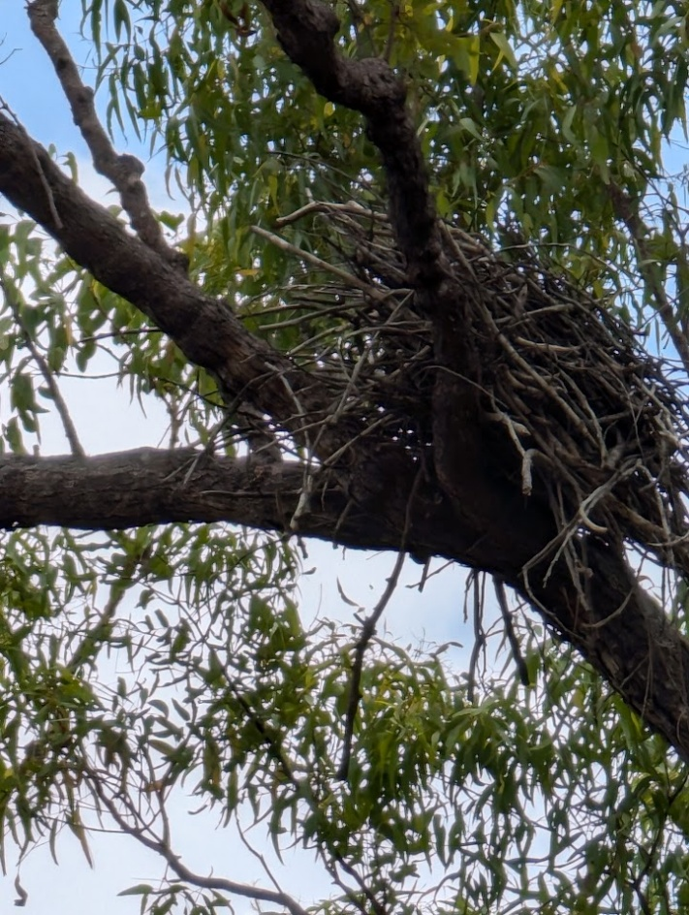
With respect to National Principle 1.1, the Guidelines encourage plantations to be established on already cleared land, although they provide for clearing, where necessary, subject to relevant laws. It is noted that there is very little cleared land in the Northern Territory and little opportunity for plantation estate development without clearing. It is also worth noting that clearing for new plantation establishment is a barrier for certification and also effectively limits participation in the Australian Carbon Credit Unit (ACCU) Scheme.
The major potential impact of ongoing plantation management operations for vegetation, animal and landscape values relates specifically to the spread of wildings, which is a noted issue for Acacia mangium on Melville Island and a likely issue for African mahogany in the Douglas-Daly.
Several planning values listed under National Principle 1.2 are not specifically addressed in the Guidelines. These include recreation, high scenic quality and significant geomorphic sites. However, where significant values are present, they are addressed within the Northern Territory Planning scheme or through land use applications.

Implementation of the revised code
The plantation industry is compliant with national principle 1.1. in avoiding native vegetation clearing for plantation establishment. Native forest was cleared to establish a considerable proportion of the current plantation estate in the Northern Territory, particularly on Melville Island and parts of the Indian sandalwood plantation estate. African mahogany establishment involved some regrowth clearing. All clearing was undertaken subject to relevant Northern Territory and Commonwealth laws applicable to the relevant land tenure. Plantation expansion has currently stalled in the Northern Territory to establish new plantations. A major barrier is the unwillingness of proponents to clear land for new plantations and the regulatory and market barriers for doing so.
Planning processes for a large proportion of the existing plantation estate involved biodiversity assessments triggered by clearing of native forest or regrowth. Known cultural heritage sites and sites on the Northern Territory Heritage Register were considered. Known significant values were excluded from the plantation area at the time of establishment and continue to be factored into plantation management. As discussed in section 4.1, poor transfer of planning information during transition between Indian sandalwood plantation managers means some values could be overlooked during plantation operation planning. However, there were no issues specifically raised during stakeholder consultation or field visits. It is noted that lack of comprehensive values information may potentially limit the effectiveness of the practices described in the Guidelines.
Two implementation issues of relevance to Criterion Two came to light through stakeholder consultation and field inspections:
- Since the 2012 assessment Acacia mangium has continued to spread from the Melville Island plantations throughout the Tiwi Islands, including into rainforest ecosystems where it is very difficult to control. There may also be a future challenge with spread of African mahogany wildings in the Douglas-Daly.
- Intense and regular prescribed burning in some parts of the Douglas-Daly has the potential to contribute to degrading the quality of native vegetation and habitat features.

Code effectiveness
The Guidelines provide a clear link between the broad concepts of sustainable plantation management and regulations. The Guidelines have addressed most of the issues identified in the 2012 assessment and are far more effective in addressing the requirements of Criterion 2 than the 2004 code. The Guidelines have several gaps in relation to Criterion 2 (recreation, high scenic quality and significant geomorphic site values) and could provide more detailed guidance to support consistent application, particularly for social and geomorphic values.
The operating legal and regulatory framework for control of land clearing in the Northern Territory is strong. Although the protection of environmental values is generally regulated under the Environmental Protection Act, the compliance framework for these values post-clearing is only triggered where significant impacts occur.

Scope for Improvement
Consideration of the following matters could further improve the Guidelines and their implementation in respect to the national principles for Criterion 2:
- Non-biological values: Inclusion of practices to recognise recreation, high scenic quality and significant geomorphic site values
- Codification of some prescriptions: Introduction of sensible recommended prescriptions and performance measures to guide consistent implementation of practices, such as buffer widths or other management methods suitable for particular values or management of environmental issues such as wildings and fire intensity.
- Wilding management: Explicit recognition of the potential environmental damage associated with wildings, and guidelines for managing this.
- Management of post-clearing regrowth: Clearly defining regrowth triggers for clearing permits consistent with the Land Clearing Guidelines
- Broadening the regulatory focus beyond clearing: more effective compliance frameworks for biodiversity and landscape values outside of the clearing.

Criterion 3: Protection of water quality and, where required, management of water yield
Relevant National Principles
National Principle 1.4 - Water quality (physical, chemical, or biological) should be protected by measures controlling change resulting from plantation activities
National Principle 1.5 - Water yield should be managed as required by careful planning of operations.
Questions addressed
How well does the Code support protection of water quality and water yield in plantation operations?
Do measures that protect water quality include streams, springs, soaks, swampy ground and bodies of standing water, and minimise sediment and other contaminant input to streams from plantation areas including roads?
What environmentally sound guidance regarding plantation management strategies for the use of nutrients and biocides do the codes of practice provide especially to ensure that changes to water quality are within acceptable limits?
Where the water resource is required to be managed (for example, controlled catchments), do the codes of practice provide effective strategies for managing water yield?

Context
Water quality and, to a lesser extent water yield, are typically a key focus for forestry codes of practice and the broader regulatory framework. That is also the case in the Northern Territory. Management for water quality and yield is a core component of sustainable forest management. In the Northern Territory, where both quality and yield are affected by intense seasonal rainfall events, this is a particularly important focus.
Legislative cover is provided under the Water Act (1992), Waste Management and Pollution Control Act (1998) and the Soil Conservation and Land Utilisation Act (1969). Sections of the Guidelines including Water Management, Soil Conservation, Weeds and Pests and Irrigation address the theme of water quality. Practices covered include protection of waterways and water bodies, minimising of disturbance, understanding impacts of physical changes (e.g. drainage and mounding) on soil chemistry, hydrology and sediment movement, management of fertiliser, monitoring of runoff and the use of erosion and sediment control measures, including in relation to road location. Water yield and hydrology are addressed in relation to physical works (e.g., mounding) and irrigation, which requires a permit/license and is recognise as having potential impacts on groundwater availability. The section on Irrigation also requires monitoring of groundwater depth and quality.

Changes to the code

Previous code
The 2004 Code included numerous goals of relevance to protection of water quality dispersed through the document but no guidance or reference to supporting documentation.

Revised code
The Guidelines include a consolidated section on water protection (section F Water Management) and several other sections provide guidance on particular aspects of water management. Section F includes goals that align with both national principles 1.4 and 1.5. Practices described in the Guidelines are focussed primarily on protection of water quality and cover specific issues such as hydrological impacts of structures, erosion and sediment control, methods of irrigation management to support sustainable water use and track design and management.
The issue of water yield is not overtly addressed in the Guidelines. However, the Environment section provides a useful description of Khaya senegalensis water use dynamics in relation to groundwater and seasonal changes, explaining why these plantations have minimal impact on groundwater. Bore and stream monitoring around Acacia mangium plantations on Melville Island indicates there is minimal difference between plantation and native vegetation water use. Section J Irrigation references a number of information sources on water allocation, which are relevant to Sandalwood plantations.
The water management section of the Guidelines is pitched at a broad level, covering similar material to the 2004 Code. More detail is provided on some matters such as hydrological flow and less in others such as watercourse crossings. NT Government information referenced from the Guidelines include the Soil management, erosion and sediment control information page which contains links to a variety of technical notes of relevance to water quality. This largely addresses the issue raised by the 2012 review that the 2004 Code provides no guidance or reference to supporting documentation on how to mitigate risks, although it is noted that some of the links and references provided are out of date.
Key planning protections for water quality and quantity such as application of buffers, consideration of aquifer recharge and runoff and soil erosion and sediment control plans are regulated through the mechanisms outlined in the Legislative Framework for Establishing Plantations section. The Land Clearing Guidelines provide detailed guidance on water related topics to be addressed in clearing applications for freehold and Pastoral Lease. Plantation developments on non-irrigated cleared freehold land are not subject to these planning controls.
For ongoing management of plantations, relevant legislation referenced in the Guidelines include the Water Act (1992) and the Soil Conservation and Land Utilisation Act (1969) both of which are administered by the Department of Environment, Parks and Water Security (DEPWS). Permits are required for works around waterways. Plantations reliant on irrigation water are subject to allocations per the relevant regional water allocation plan, which are rigorously controlled by the Water Resources Division. The Rangelands Division has published a series of technical notes to assist with managing soil erosion and sediment control, and enforcement provisions are made in the Soil Conservation and Land Utilisation Act 1969 although they are not actively enforced outside the planning frameworks. Water is of critical importance to traditional owners and water protection conditions may be applied to plantation developments on Aboriginal lands by the relevant land council.

Implementation of the revised Code
Acacia mangium plantations on Melville Island and African mahogany plantations in the Douglas-Daly region were subject to development approval conditions at the time of establishment, including application of extensive buffers around water features (watercourses, drainage areas and wetlands). Water features are also excluded from Indian sandalwood plantations visited for this assessment. However, as clearing permits were not always applicable to these plantations buffering may be less extensive. Buffers applied during plantation development have resulted in reducing potential impacts such as the number of crossings, disturbance to waterways, sedimentation and interruptions to hydrological flows. The selection of low relief terrain for plantation developments also reduces water quality risks associated with erosion and sedimentation from plantation areas and track networks.
Plantation areas inspected during site visits no longer have obvious mounding from site establishment processes, and hence disruption to waterflows through the plantations is minimal.
Plantation managers noted that they have in place routine road maintenance regimes which include regular inspection and maintenance programs for plantation track networks. It was also evident through interviews and field observation that managers take erosion control seriously. Roads and tracks inspected during site visits to Melville Island and the Douglas-Daly were generally in good condition with functioning drainage. Most forest managers interviewed reported having repairs scheduled for erosion damage on internal tracks and drainage structures caused by tropical rain events and cattle grazing. On Melville Island, cross drains were observed in place on plantation roads that are not in regular use. Some minor erosion was evident in table drains associated with recent heavy rain. The forest manager is required to prepare an annual erosion report as part of the original development approval conditions.
The Australian Forestry Standard (AS/NZS 4708:2021) includes criteria to protect and maintain water values including water quality, hydrological flows (both surface water and groundwater recharge). The Acacia mangium plantations on Melville Island have been certified to this standard for at least a decade and can therefore be assumed to comply with those criteria. It was reported that the bore and stream monitoring network established around the plantations is regularly measured and first rotation records show that the plantations have negligible impact on water yield.
Indian sandalwood plantations are entirely irrigated and subject to water extraction licence conditions and allocations issued and actively monitored by DEPWS.

Code effectiveness
The Guidelines and their implementation are generally consistent with the national principles for water quality management. There is a high awareness among forest managers of risks to water quality and availability, as reflected in the regulatory framework, the Guidelines and interviews with forest managers. Although the Guidelines specify practices at a principle level only, reference to detailed Northern Territory government publications on water related matters has significantly addressed the concerns from the 2012 assessment about lack of guidance for implementation. Formal regulation of water management practices identified in the Guidelines is minimal aside from development conditions and water extraction licences, which apply to some but not all plantation estates in the Northern Territory.
Figure 4: Post-harvest rollover drainage structure, Melville Island
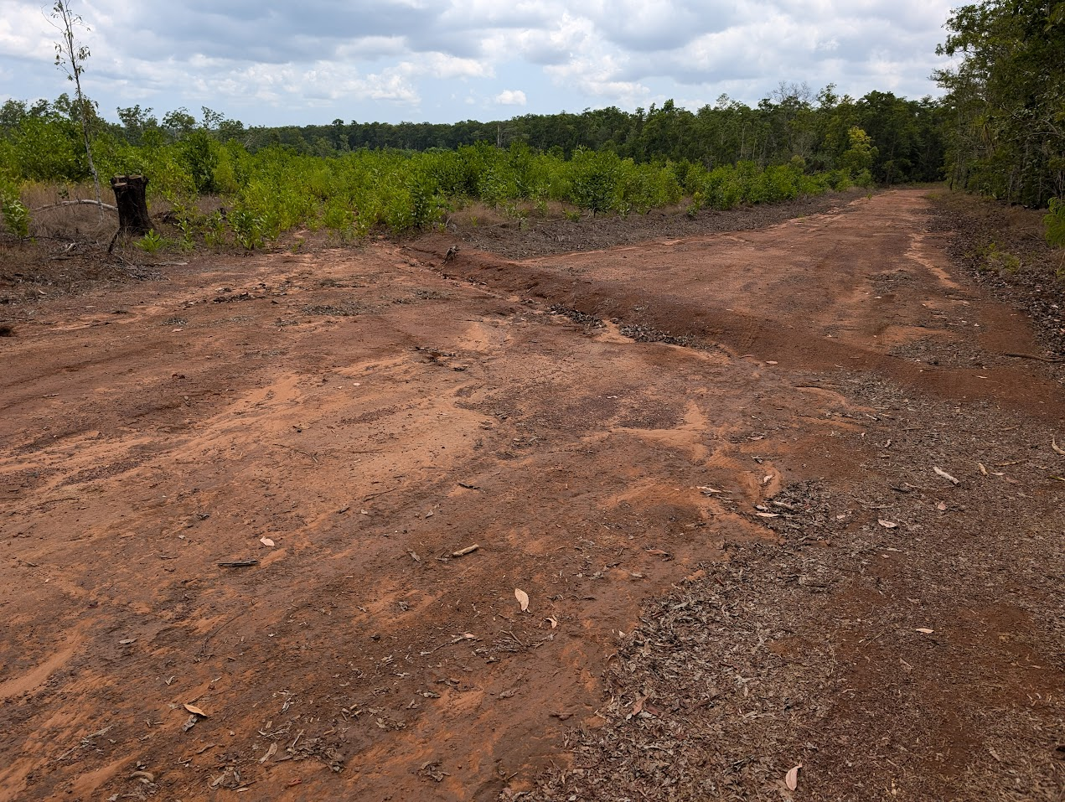

Scope for Improvement
Several opportunities for improvement were identified.
- Codification of recommended buffers: Practices for plantation establishment such as buffering are embedded in clearing regulations, which are not always triggered for new plantation developments on freehold land or subsequent rotations. The Guidelines could specify application of buffers in the Water Management section, to ensure these are considered by forest managers during operations and subsequent rotations.
- Referencing: References within the Guidelines to the Land Clearing Guidelines and Soil management, erosion and sediment control web page are out of date and should be amended at the next review.
- Hydrology: The Guidelines should address water yield (aquifer recharge and runoff to rivers) and crossings more overtly.

Criterion 4: Protection of soil resources
Relevant National Principles
National Principle 1.6 - Soil stability should be protected by measures, which regulate site disturbance.
National Principle 1.7 - Soil, water catchment, cultural and landscape values should be protected by the careful location, construction, and maintenance of roads and tracks, and regulation of their use. (Note: cultural heritage values are considered in Criterion 5).
Question asked
How well does the Code support protection of soil resources in plantation operations?
Are there measures and processes in place to assess the risks to soil resources? How are differences in soil type, topography and climatic conditions taken into account?
Do the codes of practice provide guidelines for roading, harvesting and site preparation that minimise soil loss or adverse change to soil properties?

Context

Effective and appropriate soil management is critical to the success of plantation enterprises and other land uses in the Northern Territory. Soils have low fertility and limited water holding capacity. They are highly variable in depth and extremely vulnerable to erosion during high intensity rainfall events. The importance of soil management is recognised in its own legislation: the Soil Conservation and Land Utilisation Act (1969). Although the Act makes no specific reference to plantation forestry, it provides adequate powers to the Northern Territory Government for monitoring and control of risks to soil resources.

Changes to the code

Previous code
The 2004 Code included an overarching goal (Goal 6) to protect soil quality by preventing erosion and mitigating processes that lead to chemical and structural change. Several other operation specific goals also included reference to protection of soil values in relation to roading (goal 11), site preparation (Goal 13), buffers (Goal 14), harvesting (Goal 22) and reserves (Goal 25).
The 2012 assessment found that the 2004 Code included relevant goals but lacked guidance or reference to supporting documentation on how the goals could be achieved. It observed an issue of drainage outflows into adjacent road reserve causing serious erosion. It also noted that lessons from plantations across the Northern Territory should be gathered to inform guidelines for soil management during the establishment and harvesting phases.

Revised code
The 2021 Guidelines largely address the issues raised in the 2012 assessment. It includes dedicated sections on Soil Conservation practices, Site Tracks, Harvesting and Haulage and Post-harvest which cover operationally specific practices and address soil management in a way which is relevant to the National Principes at a broad level. The Guidelines also specifically address prevention of off site impacts from sedimentation. The Guidelines lack detailed industry specific operational guidance about how to achieve and measure sustainable outcomes in relation to soil protection. Examples might include recommended drainage spacings, mounding techniques, methods to minimise soil damage.
The Guidelines were developed through a whole of industry consultation process which provided opportunity for a range of perspectives on effective soil management practices for plantation management in the Northern Territory. References to relevant legislation and sources of information such as the Northern Territory Government soil management, erosion and sediment control fact sheets and the Land Clearing Guidelines, provide detailed and relevant information to support good general soil management practices.
The primary compliance instrument for protection of soil resources is a Soil Conservation Order issued under the Soil Conservation and Land Utilisation Act. Soil Conservation Orders can be issued to any landholder in the Northern Territory to prevent soil erosion due to vegetation removal, soil disturbance, a land management method or land use, or excessive numbers of livestock. Soil Conservation Orders can direct particular infrastructure planning, land use, and remediation practices. Development permit conditions in the Northern Territory often include a requirement to develop an Erosion and Sediment Control Plan. These have a standardised format and detailed requirements which are described in a fact sheet. It is understood that aside from new developments, these laws are not heavily enforced.

Implementation of the revised code
Management of soil stability within Northern Territory plantations and associated roads, tracks and infrastructure is a priority for plantation managers. Evidence of soil management practices consistent with the Guidelines was collected in all four plantation projects, demonstrating alignment throughout the plantation lifecycle. Application of good practices is in part driven by regulatory and certification requirements. However, more importantly, soil conservation is of critical importance to plantation productivity in the Northern Territory due to the vulnerability of soils to degradation.
Site selection has been fundamental to reducing the potential for erosion and sedimentation. All the Northern Territory plantations have been established on relatively flat land, away from watercourses and with native vegetation buffers retained where these exist. The African mahogany estate was established on properties with active soil scours. These are monitored and managed where necessary. Roads and firebreaks were constructed at the time of plantation establishment and brief field visits indicate these were well situated to minimise run-off and erosion. Most of the plantation projects were subject to some degree to development approvals, which control proximity to waterways, native vegetation retention and in the case of Melville Island an ongoing erosion monitoring and reporting program.
Intense rainfall events are common during the wet season in the Northern Territory, and erosion is not uncommon where there is loss of vegetation cover. Soil conservation practices, such as contour mounding and planting, and installation of control structures on roads, tracks and firebreaks were implemented at establishment and continue to be actively monitored and maintained. As noted under Criterion 3, most planting mounds in older plantations are no longer evident.
Grazing is used within in some plantations on the mainland as a more soil friendly alternative to herbicide to manage weeds while maintaining low vegetative cover. While this is effective, it was observed by one plantation manager that tracks created by stock on firebreaks can result in erosion, which requires monitoring and active management.
Minor erosion was observed and reported on plantation roads and firebreaks. Erosion mitigations include regular maintenance of roads and tracks and rollover drains, use of geotextiles in erosion prone areas, installation of sediment traps and maintenance of vegetation cover to protect soil and capture sediment. Some plantation managers use slashing and grazing to maintain firebreaks to regulated standards while retaining cover, rather than grading to mineral earth. Rollover drains were reinstated on tracks following harvesting on Melville Island. All plantation managers interviewed indicated that operations cease during the wet season. This assists to protect soil and roads from damage.
Fertiliser is used in all plantation projects other than Acacia mangium, which is a nitrogen fixing species. Fertiliser application methods are generally well targeted to minimise the potential for off-site nutrient movement. Targeted techniques include underground tablet fertiliser at planting and application through dripper tape in irrigated plantations throughout the rotation. Some fertiliser is applied aerially for mid-rotation, non-irrigated plantations.

Code effectiveness
The Soil Conservation section of the Guidelines provides more comprehensive coverage of soil protection than the 2004 Code in respect to the National Principles. It includes measures to regulate site disturbance and protect soil through appropriate design, construction and maintenance of roads and tracks. Sources of information highlighted in the Guidelines provide very detailed guidance on a range of generally applicable soil protection methods. Interviews and brief field visits indicate that plantations and associated infrastructure are maintained in accordance with the Guidelines and Principles of Environmental Care and erosion is monitored and addressed in a timely manner. There is some inconsistency in the regulation of this Criterion, depending on the need for development approval. However, the intrinsic requirement to protect soil and maintain productivity is an effective driver of practices consistent with the National Principles.

Scope for Improvement
It is still the case the Guidelines lack guidance about how to achieve and measure sustainable outcomes in a plantation specific context. In part this is because silvicultural systems and industry specific approaches to soil protection are still evolving.
- Improved soil management knowledge: As the knowledge base improves and the full suite of plantation management practices is applied across the estate, it would be useful to develop plantation specific soil protection guidelines based on industry experiences as to accompany the Guidelines.

Criterion 5: Protection of cultural heritage values
Relevant National Principles
National Principle 1.7 - Soil, water catchment, cultural and landscape values should be protected by the careful location, construction, and maintenance of roads and tracks, and regulation of their use
National Principle 1.8 - Values such as intensive recreation, high scenic quality, significant geomorphic, biological, or cultural heritage sites, should be recognised in the planning of plantation forest operations. (Note: cultural heritage aspects only).
Questions addressed
If it is applied as written, how effective is the Code in delivering protection of cultural heritage values?
In the planning of plantation layout, establishment and maintenance operations, are there measures and processes for managing cultural heritage values?

Context
Cultural heritage values in the Northern Territory are covered under Territory legislation including the Heritage Act (2011) the Northern Territory Aboriginal Sacred Sites Act (1989), Aboriginal Land Act (1978), and Commonwealth legislation which includes the Aboriginal Land Rights (Northern Territory) Act (1976), the Aboriginal and Torres Strait Islander Heritage Protection Act (1984) and the Environment Protection and Biodiversity Conservation Act 1999. The Heritage Act includes obligations to protect Indigenous and post-colonial archaeology and significant heritage, including reporting of discovery of Aboriginal and Macassan places and objects. The 2012 assessment provides a comprehensive overview of the function of each of the Northern Territory laws of relevance to this Criterion. The Land Clearing Guidelines referenced from the Plantation Planning section of the Guidelines include guidance on assessing and protecting cultural heritage when preparing clearing applications.

Changes to the code

Previous code
The 2004 Code included one goal of relevance to Criterion 5. Goal 19 simply stated the requirement to protect significant heritage and archaeological sites from disturbance by plantation activities. Although the 2012 assessment found the 2004 Code was inadequate in respect to protection of cultural heritage values in the plantation estate, it recognised that the industry is effectively protecting these values through other information and processes. Issues identified included lack of reference to the applicable legislative framework and lack of guidance about identifying and protecting Aboriginal places in a plantation context. The need to consult with the local Aboriginal community to inform appropriate management of culturally significant sites was particularly highlighted.

Revised code
The Cultural Heritage section of the Guidelines provides guidance on aspects of cultural heritage regulations and consultation with relevant indigenous stakeholders that are generally applicable to plantation developments and ongoing management. The Plantation Planning section identifies the need to plan for protection of cultural heritage at the plantation proposal stage and avoid plantation development on sites with significant cultural heritage. Relevant legislation and several key sources of information are provided. While the practices in the Guidelines focus on Indigenous cultural heritage, the requirement to identify post-colonial heritage is also addressed.
The practices documented in the Guidelines cover the processes for identifying known Indigenous and post-colonial sites of cultural significance that may be impacted by plantation activities. They include requirements to obtain an Authority Certificate and broad guidance to conduct indigenous consultation with the correct parties. These practices are generally aligned with the National Principles.
The Guidelines are not clear about when these processes should be applied beyond initial plantation planning. They lack guidance on several aspects including: practices to protect post-colonial heritage; when it is recommended to conduct new cultural assessments; and how to manage new heritage discoveries. These aspects are covered for Indigenous cultural heritage by guidance material provided by the Northern Territory Government on its Aboriginal heritage information website and through the Heritage Act.
The certified plantation estate is subject to comprehensive standards in respect to Indigenous peoples and cultural heritage, which are compatible with the Guidelines and the National Principles.

Implementation of the revised code
Cultural heritage management as practiced by plantation managers is generally consistent with the Guidelines. Like other values, cultural assessments were formally triggered through clearing regulations or in the case of Aboriginal Freehold, through Land Use Approval processes at the time of initial plantation development. Cultural heritage sites were identified through review of known information, and in some cases cultural heritage surveys. Known cultural heritage sites were excluded from the plantation footprint. In the case of Melville Island, traditional owners were involved in determining the approach to protection of cultural sites in relation to the plantations. However, this was not the case for plantation development in the Douglas-Daly.
Stakeholders indicated that the extent of knowledge about cultural heritage within the freehold properties may be limited. Although the Northern Territory Aboriginal Heritage Information website advises proponents to contact the Heritage Branch for advice on requirements for any activity that could affect Aboriginal and Macassan archaeological places, it is unknown whether this occurred for Indian sandalwood plantations that did not require clearing permits.
Plantation management activities regularly involve conducting operations in areas outside the plantation footprint for access and forest protection purposes. Examples include road work, prescribed burning and pest control. To protect heritage and sacred sites effectively, it is necessary for plantation managers to know the location and management requirements for each site to ensure protection measures are planned and implemented. At one Indian sandalwood plantation, the new manager was aware of an important cultural site on the property but did not have access to information about management requirements so had adopted a precautionary approach. The new manager had not consulted with the Traditional Owner custodians of the site at the time of the visit.

Code effectiveness
There is strong legislation in place for dealing with cultural heritage values in the Northern Territory. The Guidelines reflect the importance of cultural heritage values and recognise the potential impact of forestry operations, particularly within the plantation footprint. Attention is focused most heavily on planning for plantations rather than conduct of operations. Management of cultural heritage values is addressed generically by reference to existing legislation and processes and recognition of the primary role that Traditional Owners have in determining the most suitable approach.
The Guidelines provide coverage of the topics related to cultural heritage in the National Principles and address the key findings of the 2012 assessment. However, some aspects of cultural heritage management are not addressed in the Guidelines and the implementation of effective assessment processes and consultation is inconsistent, particularly on freehold tenure.

Scope for Improvement
Specific areas identified for future improvements include:
- Processes to manage new discovery: The Guidelines could be clearer about when cultural heritage practices should be applied beyond initial plantation planning. Practices should be added to address protection of post-colonial heritage, specify triggers for conducting new cultural assessments and guidance for management of new heritage discoveries.
- Traditional Owner engagement: There is opportunity for plantation managers to engage with Traditional Owners to improve knowledge of cultural heritage values around plantations on freehold land on the mainland. This would be of most value where it is uncertain whether the planning processes occurred at the time of plantation development addressed Traditional Owner engagement, or where the plantation manager does not currently have an established ongoing relationship with the relevant Traditional Owners.

Criterion 6: Protection from fire, pests and diseases
Relevant National Principle
National Principle 1.9 - Plantations and adjacent native forests should be protected from the adverse effects of fire and from the introduction and spread of plant, insect and animal pests and plant diseases.
Questions addressed
Is the Code effective in guiding protection pf plantations and adjacent native forests from fire, pests and diseases?
Do the codes of practice provide for fire management plans for plantations including containment from adjacent native forest?
Do the codes of practice provide guidelines to deal with outbreaks of pests and diseases?

Context
Fire and weed management are major and related considerations in the tropical savannah climate of the Northern Territory. Weeds, insect pests and diseases thrive during the wet season. Weeds, in particular, rapidly build to significant levels of biomass and impact plantation growth. Tropical grasses such as Gamba and Mission grass can build to extreme fuel loads over a very short period and must be effectively controlled in a timely manner to reduce fire risk. Vertebrate pests such as buffalo, feral horses, cattle and rats also impact plantation operations, posing a safety risk to workers and impacting trees and infrastructure.
The Weeds Management Act (2001), Plant Health Act (2008) and Bushfires Act (2106) all provide coverage for various aspects of Criterion 6, and the Northern Territory government actively enforces these laws.
The Weed Management Branch of the Department of Environment, Parks and Water Security administer the Weed Management Act 2001. The Act allows for the declaration and classification of weeds, the preparation of statutory management plans and prescribed actions for high priority weeds. The Department monitors high priority weed infestations and landowners are obliged to implement prescribed control actions. A structured compliance framework has been established to support implementation of the management plans, which is actively enforced.
The Bushfires Management Act 2016 is administered by Bushfires NT. The Act provides a framework for bushfire governance and management and establishes controls and obligations in relation to fire prevention, preparedness and response. Of specific relevance to the plantation industry are the requirements for property fire management plans, maintenance of firebreaks, ignition controls, obligations to control fires, burn permit requirements. Regional Bushfire Management Plans relevant to mainland plantations highlight extreme fuel risks related to Gamba and Mission grass.

Changes to the code

Previous code
The 2004 Code included two goal statements of relevance to Criterion 6. The first was Goal 18 to minimise fire risk through precautionary measure. The second was Goal 20 to minimise harmful pest outbreaks and prevent spread of weeds, pests and diseases. The 2012 assessment found that plantation fire protection and plantation health management were effective. However, more specific guidance was required in a revised Code. Progress towards eradicating Acacia mangium wildings from rainforest on Melville Island was reported and the need for a long-term maintenance program identified. The 2012 assessment anticipated that future plantation expansion would require greater coordination around weed, pest and disease issues.
Figure 5: Cattle and goats are used to manage fuel levels and weeds in the Douglas-Daly region
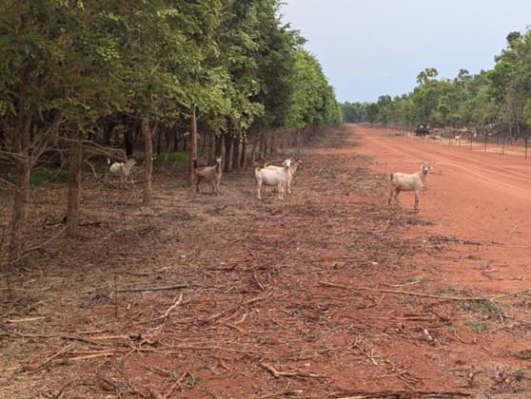
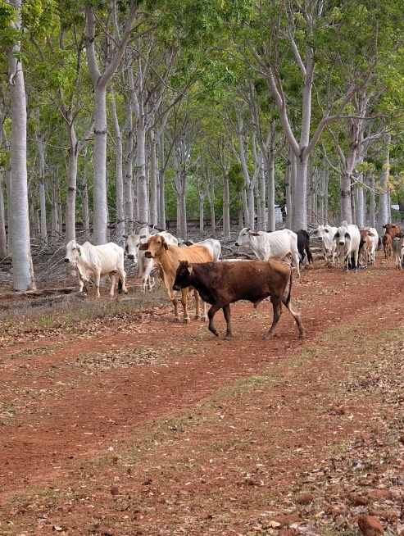

Revised code
The Fire Management and Weeds and Pests sections of the Guidelines deal specifically with fire, plant, insect and animal pests and plant diseases. The Stock Management section identifies the role of cattle grazing in weed control and reducing fuels. The Site Tracks, Silviculture, Harvest and Haulage and Post-harvest sections all include reference to actions to manage or prevent incursions of weeds and pathogens.
Fire Management practices broadly cover regulatory requirements such as preparation of a Fire Management Plan, coordinated fire protection planning, firebreaks and their maintenance and controlled burning and provide some forestry specific guidance. The Guidelines do not address some key bushfire management aspects such as: minimising ignition risk associated with operations; control of extreme fuel risks such as Gamba and Mission grass; methods of fuel management both within plantation and outside other than controlled burning (e.g. grazing, slash management); minimising impacts of fire management on natural and cultural values; establishment and maintenance of water points; or anything concerning fire suppression. These aspects are largely addressed through the regulatory framework for bushfire management referenced from the Guidelines.
The Weeds and Pests section of the Guidelines covers issues relevant to the Northern Territory plantation sector and common approaches to preventing, monitoring and controlling these in accordance with government guidance. An extensive list of sources of information is provided, including forestry specific information where this is available.
These topics clearly cover the National Principles and provide links to laws and guidance relevant to forestry activities. The Guidelines cover broadly applicable practices, particularly in relation to control of declared weed, but lacks links to specific guidance for control of silvicultural weeds and pests.

Implementation of the revised Code
Protection of plantations and adjacent native forests from threats (including fire, pests, diseases and pathogens) is a clear focus for plantation managers in the Northern Territory, where there are considerable operational challenges for forest protection. Local conditions mean that any reduction in attention can result in the rapid development of weed, pest and fire problems. Because of the small size of the plantation estate, changes in ownership and lumpy revenue profile, the availability of funds to support management of threats can also be challenging.
Plantation control programs target declared weeds, silviculturally problematic weeds such as vines, termites. and to some extent vertebrate pests. Weed and pest monitoring and treatment is carried out regularly at the plantations visited for this assessment. Integrated methods involving a combination of chemical, fire and in some instances mechanical systems or grazing are used for weed control. Chemicals are applied by trained and licenced personnel. Plantation companies actively work with the Northern Territory Government to develop and implement effective controls for significant pest outbreaks such as termites. Termites are controlled using trapping techniques where required, or in the case of Indian sandalwood targeted chemical application delivered via the irrigation system. A cooperative approach is taken to control of vertebrate pests, which are ubiquitous in the Northern Territory. Before machines arrive on Melville Island they are subject to inspection to prevent entry of new pests and weeds.
On Melville Island Acacia mangium wildings have become a widespread issue which is proving difficult to manage, particularly with lower current levels of activity within the 30,000 ha estate. The wildings are causing challenges for broader ecosystem health, resulting in ecosystem changes, hybridisation and changed fire regimes. The plantations have largely been harvested but regrowth is aggressive, vigorous and flammable. There is at least the possibility that African mahogany plantations in the Douglas-Daly could also present a wilding threat in the future, although the potential for landscape level problems seems considerably less.
Bushfire management is also a major focus of for the plantation projects. All plantation managers have Fire Management Plans in place and actively implement fire protection and coordinated response programs. Fuel management, firebreak and track maintenance activities are the main fire protection activities and implementation was evident at all field visits. Plantation managers in the Douglas-Daly are increasingly using stock to very effectively reduce weed and fuel levels within plantations and maintain firebreaks. All plantation managers interviewed participate in coordinated burning of native vegetation in strategic locations and fire response programs with adjacent land managers and the local bushfire brigade where applicable. Burn permits are obtained as required.
Two issues relating to bushfire management were identified during the visit to Melville Island. Areas within the plantation footprint are increasingly being affected by community burns. The reduction in the extent of the prescribed burn program facilitates those burns to enter the plantation footprint, burning the unharvested Acacia mangium plantations and regrowth. Large volumes of slash left around landings present increased fire risk as these heaps are difficult to extinguish and smoulder for a long time. However, as the Acacia mangium resource has no identified value and is causing environmental problems, this issue is of low concern currently. The Guidelines require that fire regimes be maintained following harvest but do not include specific practices for post-harvest slash management.

Code effectiveness
Overall, the Guidelines address the National Principles and relevant legislative requirements in respect to fire, weed and pest management. However, as with the other criteria, they lack specific guidance for plantation forestry, particularly in relation to silvicultural weeds and pests. Forest protection activities are actively implemented by all plantation projects visited for this assessment, although It is evident that uncertainty about the future of some plantations impacts the extent of control programs. The spread of Acacia mangium wildings on the Tiwi Islands is an ongoing issue which does not appear to have a viable solution at present.

Scope for Improvement
The Guidelines could be improved by providing more industry specific guidance on plantation forestry issues. Specific potential improvements include:
- Wilding management: To avoid future repeat of the issues associated with Acacia mangium, increased focus is needed on selection of species that do not impact the surrounding environment through proliferation of wildings or hybridisation. The Northern Territory Government has developed the Weed Risk Management Assessment Tool, which is used to assess clearing applications. Reference to this should be included in the Guidelines.
- Slash management: The Guidelines could be improved by overtly codifying prescriptions for the removal of slash concentrations around landings to reduce fire hazard.
- Improved weed and pest knowledge: As knowledge of silvicultural practices improves, plantation specific guidance should be developed for best practice silvicultural weed and pest control and linked to from the Guidelines.

Criterion 7: Training for environmental care
Relevant National Principle
National Principle 1.10 - Operators will be trained in the principles of environmental care.
Questions addressed
What requirements does the Code have in place for ensuring that operators are adequately trained in the principles of environmental care?
Are the processes adequate to meet this criterion?

Context
Operator training around the principles of environmental care is important to ensure delivery of sustainable plantation operations and management. This is a challenging issue in all jurisdictions because of shortages in appropriately qualified educators for such a small ‘market’. For the Northern Territory, it is more challenging because of the very small size of the industry, limited amount of activity and seasonal nature of work.

Changes to the code
Neither the 2004 Code or the revised Guidelines deal directly with the issue of training in the principles of environmental care. However, the revised code (Guidelines) is accompanied by a field guide which is a useful tool for operators, if they are aware of it.

Implementation of the revised code
Despite the fact the Guidelines do not deal with training directly, each of the plantation managers interviewed has in place formal processes for inducting and training new staff. Examples were observed of training and induction materials.

Code effectiveness
All the plantation managers consulted for this assessment demonstrated a clear focus on implementing the principles of environmental care. Particular focus around the other criteria discussed in this report was evident. Training to deliver these outcomes is currently provided internally by plantation management companies. Given the small scale of the sector, variable nature of the species and the environments in which they are being managed, that is appropriate and is also consistent with other Australian jurisdictions. All growers are either certified or looking to become certified, which has firm requirements in relation to training.

Scope for Improvement
- Education materials: The Guidelines and the accompanying field guide are well suited to build a simple and consistent education tool around. There is value in considering the development of a slide-based, or similar, environmental training presentation with multiple choice question and answer capability, that all plantation managers could apply as part of their induction and training processes.
Figure 6: Indian sandalwood and host trees, Douglas-Daly region
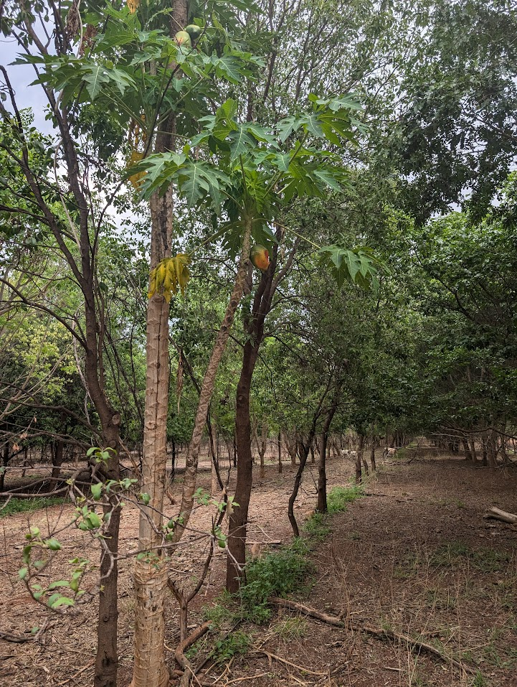

Other National Principles
There are a further seven National Principles covering 23 objectives, many of which overlap extensively with the Principles of Environmental Care dealt with above.
Questions addressed
What are your perspectives on the effect of the Code on the economic viability of timber production activities in plantations?
Are there any particular factors that you think influence how well and consistently the Code is applied?
Are there any particular areas of the Code you consider need updating or reform? eg. Topics that are missing, out of date, inappropriate, conflicting with other regulations, unclear, impractical. What and Why?

National Principle 2: Safety
The Work Health and Safety (National Uniform Legislation) Act (2011) is the primary piece of legislation. NTWorkSafe is the regulator and oversees a series of safety Codes of Practice. There is no specific safety code of practice for forestry or forestry related activities.
The Guidelines state that:
Safety is important in all phases of forestry, through establishment and during all aspects of operations. It is a general consideration that must be taken into account in all sections of the Guidelines, although specific reference is made to safety in some sections only. Training and induction of staff in occupational health and safety is paramount.
Safety is explicitly mentioned in three of the sections of the Guidelines: B. Plantation Establishment, L. Silviculture and M. Harvesting and Haulage. It is likely that plantation owners and managers have in place comprehensive safety management systems. This will be assessed during the field visits and consultation.

National Principle 3: Planning
Planning is addressed in the Guidelines generally and in section A. Planning and M. Harvesting and Haulage specifically.

National Principle 4: Access
Access is dealt with specifically in section K. Site Tracks.

National Principle 5: Establishment and Maintenance
Establishment is dealt with in Section B. Plantation Establishment. Maintenance is dealt with through a number of sections and, specifically, L. Silviculture.

National Principle 6: Timber Harvesting
Timber harvesting is dealt with in Sections M. Harvesting and Haulage and N. Post-harvesting.

National Principle 7: Forest Protection
Forest protection is addressed in Section E. Fire Management, Section H. Weeds and Pests, Section I. Stock Management and Section L. Silviculture.

National Principle 8: Monitoring and Review
The Guidelines identify practices across several sections where monitoring is recommended. The Guidelines also include a specific chapter dedicated to Monitoring Sustainability, which provides guidance about physical, biological, social and economic parameters that can usefully be monitored by plantation owners and managers. The Guidelines do not specify what should be monitored but state that:
In order to assess the effectiveness of sustainable measures in plantation forestry, criteria need to be established to determine whether the sustainability of the system is being maintained. The implementation and effectiveness of sustainable forestry practices should be assessed and reported. Following on from these Guidelines, further consideration should be given to the form of measures and indicators that can be used to track performance.
Currently the major focus for compliance relates to land clearing. The Northern Territory has a complex land tenure system and rules around land clearing for different tenures follow specific compliance pathways. These have been addressed elsewhere in the assessment report.
Some plantation areas (Melville Island) were established on Aboriginal freehold which was cleared for the purpose. That area is subject to monitoring and compliance requirements under the Environmental Protection and Biodiversity Act 1999 (Cth). Other areas were established on freehold land (the Douglas-Daly region) on notionally cleared land, although some areas of regrowth were cleared. There appears to be some confusion about the eligibility of some regrowth clearing and lack of clarity about what defines a forest for the purposes of clearing. The overarching regulatory framework would benefit from improved clarity. Growers are highly attuned to the issue.
Other focus areas for monitoring and compliance appear to have a very loose framework for enforcement. For example, detailed information about environmental values and ecological systems is usually only collected in response to an application to develop. However, most of the growers consulted take an active approach to monitoring and compliance, with excellent examples provided of internal approaches to this issue. Most growers are either certified or interested in becoming certified, and have systems in place to meet the requirements of certification. There is also a broad intent within the industry to work closely with Government and ‘get ahead of the curve’ on compliance and monitoring issues.

Appendix A: Relevant legislation
Jurisdiction | Instrument | Summary of application
Northern Territory | Bushfires Management Act 2016 | Includes the legal framework and responsibilities for bushfire management. The fundamental principle established by the Act is that the responsibility for bushfire management rests with the landholder.
 | Environmental Protection Act 2019 | Assessment for environmental approval is required under this Act, which commenced on 29 June 2020. The requirement for an approval will be triggered if a proposed action or strategic proposal is likely to have potential for significant impact on the environment; or meets a referral trigger.
 | Heritage Act 2011 | The principal object of this Act is to provide a system for the identification, assessment, recording, conservation and protection of heritage places and objects.
 | Aboriginal Land Act 1978 | This Act relates to entry onto Aboriginal land and the issue of permits.
 | Northern Territory Aboriginal Sacred Sites Act 1989 | Established the Aboriginal Areas Protection Authority (AAPA) which is responsible for overseeing the protection of sacred sites across the whole of the NT.
 | Pastoral Land Act 1992 | Controls the clearing of native vegetation on pastoral land. Pastoral Land Legislation Amendment Bill 2017 – allows those operating under the Pastoral Land Act to diversify their agricultural activities.
 | Planning Act 1999 | This Act provides for the planning and control of the use and development of land across the Territory, establishes the NT Planning Scheme and Development Consent Authority and provides for a development approval process. This Act controls the clearing of native vegetation (section 75)
 | Plant Health Act 2008 | Details obligations about plants and plant-related materials that are affected by a pest, i.e. an organism that feeds on a plant or that causes an abnormal or unhealthy condition in a plant. This includes prevention of infestation and spread, and treatment or disposal.
 | Soil Conservation and Land Utilisation Act 1969 | An Act to make provision for the prevention of soil erosion and for the conservation and reclamation of soil. Establishes a Commissioner for soil conservation and a Soil Conservation Advisory Council.
 | Territory Parks and Wildlife Conservation Act 1976 | Provides for the establishment of parks and reserves and the study, protection, conservation and sustainable utilisation of wildlife. Under this act development proposals are assessed in terms of flora and fauna harvest and utilisation, the import and use of non-native wildlife, and the impact of development on the environment and threatened species.
 | Waste Management and Pollution Control Act 1998 | Regulatory Act to provide for effective waste management and pollution control.
 | Water Act 1992 | The Water Act provides for investigation, allocation, use, control, protection, management and administration of water resources, including water extraction and waste discharge licenses. Section 90 details factors to be considered by the Controller in deciding whether to grant a licence.
 | Weeds Management Act 2001 | Owners and occupiers of land are required to take all reasonable measures to prevent their land being infested with a declared weed.  Declared weeds in the NT (Class A - to be eradicated; Class B - growth and spread to be controlled) have been identified under the Act. If a proponent wishes to grow a plant declared under the Weeds Management Act as a crop, then a ‘Permit to Use a Declared Weed’ is required.
 | Work Health and Safety (National Uniform Legislation) Act (2011) | Primary workplace health and safety legislation for the Northern Territory.
Commonwealth | Environment Protection and Biodiversity Conservation Act 1999 | The EPBC Act is the Australian Government’s primary environmental legislation. Under the environmental assessment process, the EPBC Act may be triggered where there is likelihood of a proposed project having a significant impact on a matter or matters of national environmental significance. The EPBC Act aims to conserve biodiversity, provide for the protection of the environment and promote ecologically sustainable development.
 | Aboriginal Land Rights (Northern Territory) Act 1976 | Provides the basis for Aboriginal Australian people in the Northern Territory to claim rights to land based on traditional occupation. Aboriginal land is granted as freehold title to Aboriginal Land Trusts. The Act also mandated the establishment of land councils. Applications must be made to the appropriate land council to conduct activities on an Aboriginal Land Trust.
 | Aboriginal and Torres Strait Islander Heritage Protection Act 1984 | The purposes of this Act are the preservation and protection from injury or desecration of areas and objects in Australia that are of particular significance to Aboriginals in accordance with Aboriginal tradition. Heritage places are listed under the National Heritage List. Information about listed places is provided in the Australian Heritage Database.
 | Export Control Act 2020  (NB: the Guidelines require updating as they reference the 1982 Act and 1986 regulations) | The Export Control (Wood and Woodchips) Rules 2021under the Export Control Act 2020 allow plantation-sourced timber to be exported without a licence if the minister finds that the relevant state or territory’s plantation forestry code of practice satisfactorily protects environmental and heritage values.

References
Andrews, P (pers comm), Plantation Management Partners, 15 October 2024.
Department of Environment, Parks and Water Security (2021) Land clearing guidelines, TRM number: LRM2021/0077~0002, Northern Territory Government.
Environmental Defenders Office (2021) Factsheet: Planning and development laws in the NT (Accessed 13 September 2024).
Groenhout, P, Roscoe, J, Phelan, T, Jenkin, B, Annandale, M, Annandale, C & Schraenkler, T (2024) Private Forestry Guidance Materials: An introduction to the business of small-scale forestry, Prepared for Forest & Wood Products Australia and funded by the Australian Government, Department of Agriculture, Fisheries and Forestry.
Ministerial Council on Forestry, Fisheries and Aquaculture (1995) Forest Practices Related to Wood Production from Plantations: National Principles.
Northern Territory Government (2020) Northern Territory Planning Scheme (accessed 12 December 2024).
Raison, r. J, Smethurst, P. J, Moggridge, B & E.K. Sadanandan Nambiar, E.K (2012) Assessment of Code of Practice for Plantation Forestry: Northern Territory, Report prepared for the Australian Government Department of Agriculture, Fisheries and Forestry.
Territory Natural Resource Management (2021a) Sustainable Forestry Practices: Guidelines for the Northern Territory, Funded from the National Landcare Program: Smart Farms Small Grants – an Australian Government initiative.
Territory Natural Resource Management (2021b) Top End Region: Northern Territory Natural Resource Management Plan 2021-2025, Funded by the Australian Government National Landcare Program.
Websites
https://nt.gov.au/property/land-clearing (Accessed November 2024).

