Assessment of the Code of Practice for Plantation Forestry in Victoria
© Commonwealth of Australia 2024
Ownership of intellectual property rights
Unless otherwise noted, copyright (and any other intellectual property rights) in this publication is owned by the Commonwealth of Australia (referred to as the Commonwealth).
Creative Commons licence
All material in this publication is licensed under a Creative Commons Attribution 4.0 International Licence except content supplied by third parties, logos and the Commonwealth Coat of Arms.

Cataloguing data
This publication (and any material sourced from it) should be attributed as: Phelan, T., Roscoe, J and Groenhout, P 2024, Assessment of the Code of Practice for Plantation Forestry in Victoria Report prepared by Greenwood Strategy Solutions Pty Ltd for Department of Agriculture, Fisheries and Forestry, Canberra, December. CC BY 4.0.
This publication is available at agriculture.gov.au/publications.
Department of Agriculture, Fisheries and Forestry
GPO Box 858 Canberra ACT 2601
Telephone 1800 900 090
Web agriculture.gov.au
Disclaimer
The Australian Government acting through the Department of Agriculture, Fisheries and Forestry has exercised due care and skill in preparing and compiling the information and data in this publication. Notwithstanding, the Department of Agriculture, Fisheries and Forestry, its employees and advisers disclaim all liability, including liability for negligence and for any loss, damage, injury, expense or cost incurred by any person as a result of accessing, using or relying on any of the information or data in this publication to the maximum extent permitted by law.
Acknowledgements
The authors acknowledge the significant assistance provided by a number of stakeholders that assisted through the provision of logistics support, access to plantations and in-depth industry knowledge and expertise. Specifically, we acknowledge the support and input of Djaara, Barengi Gadjin Land Council, Midway Ltd, Hancock Victoria Plantations, Australian Bluegum Plantations, DevTree, PF Olsen Australia, the Victorian Forest Products Association, Corangamite Catchment Management Authority, and the Victorian Department of Energy, Environment and Climate Action.
Acknowledgement of Country
We acknowledge the Traditional Custodians of Australia and their continuing connection to land and sea, waters, environment and community. We pay our respects to the Traditional Custodians of the lands we live and work on, their culture, and their Elders past and present.

Contents
Summary 6
Introduction 8
Context 8
Plantation forestry in Victoria 10
Assessment overview 13
The role of codes of practice in wood exports 13
Assessment against the National Principles 13
Australia’s sustainable forest management framework 14
Export requirements for codes of practice 15
Assessment method 15
Criterion 1: Compliance of plantation management with relevant planning schemes and legislation 17
1.1 Context 17
1.2 Changes to the code 18
1.3 Implementation of the revised code 18
1.4 Effectiveness of the revised code 18
1.5 Scope for improvement 18
Criterion 2: Protection of native vegetation and animal communities and natural landscape values 19
2.1 Context 19
2.2 Changes to the code 21
2.3 Implementation of the revised code 21
2.4 Effectiveness of the revised code 22
2.5 Scope for improvement 22
Criterion 3: Protection of water quality and, where required, management of water yield 23
3.1 Context 23
3.2 Changes to the code 23
3.3 Implementation of the revised code 24
3.4 Effectiveness of the revised code 24
3.5 Scope for improvement 25
Criterion 4: Protection of soil resources 26
4.1 Context 26
4.2 Changes to the code 26
4.3 Implementation of the revised code 26
4.4 Effectiveness of the revised code 27
4.5 Scope for improvement 28
Criterion 5: Protection of cultural heritage values 29
5.1 Context 29
5.2 Changes to the code 29
5.3 Implementation of the revised code 29
5.4 Effectiveness of the revised code 30
5.5 Scope for improvement 30
Criterion 6: Protection from fire, pests and diseases 31
6.1 Context 31
6.2 Changes to the code 31
6.3 Implementation of the revised code 32
6.4 Effectiveness of the revised code 32
6.5 Scope for improvement 32
Criterion 7: Training for environmental care 33
7.1 Context 33
7.2 Changes to the code 33
7.3 Implementation of the revised code 33
7.4 Effectiveness of the revised code 33
7.5 Scope for improvement 33
8 Other National Principles 34
National Principle 2: Safety 34
National Principle 3: Planning 34
National Principle 4: Access 34
National Principle 5: Establishment and Maintenance 34
National Principle 6: Timber Harvesting 34
National Principle 7: Forest Protection 34
National Principle 9: Monitoring and Review 35
Appendix A: Relevant legislation 36
References 38

Tables
Table 1: Four desktop review steps for the scientific assessment 9
Table 2: Code principles, operational goals and sections relevant to plantation operations 10
Table 3: An overview of Australia’s sustainable forest management framework 14

Figures
Figure 1: Protected remnant vegetation in mixed hardwood plantation, Bendigo 20
Figure 2: Effective plantation road drainage 24
Figure 3: Plantation harvesting in Gippsland, with slash protection of soils 27
Figure 4: Retention of koala browsing trees in blue gum plantation, south west Victoria 30
Figure 5: Sugar gum plantation central Victoria 35

Summary
The Export Control Act (2020) provides the legislative basis for regulating exports from Australia, including agricultural exports. Under the Export Control (Wood and Woodchips) Rules 2021, wood and woodchips are prescribed for the purposes of the Act. That means they require a licence to be exported, unless they are derived from trees sourced from a plantation in a State for which there is an approved Code of practice, in which case they are taken to not be prescribed. If wood or woodchips do not meet this requirement, their export is prohibited unless the exporter holds a wood export licence which is in force at the time when the wood or woodchips are exported.
In order for a Code of practice to be approved for the purposes of the Wood Rules, it must be scientifically assessed against the National Principles for Forest Practices Related to Wood Production in Plantations. In Victoria, that assessment was previously undertaken by the CSIRO in 2012 for the Code of Practice for timber production (2007). The Code of Practice was subsequently amended in 2014 and again in 2022. The Code of practice is therefore considered to have been reviewed and requires re-assessment against the National Principles and approval by the Minister for Agriculture, Fisheries and Forestry, so that wood and woodchips continue to be non-prescribed for export purposes.
This report presents the findings from the assessment of the Code of Practice for Timber Production 2014 (as amended in 2022) against the National Principles. The assessment has determined that the revised Code, has had minimal substantive change with respect to plantations. The introduction of supporting management guidelines provides a useful and easily maintained reference to applicable Victorian legislation and supporting interpretation for the Code. There have been major reforms to relevant Victorian legislation since the CSIRO assessment including some specific applications for timber plantations. The plantation industry in Victoria is almost entirely certified under the Responsible Wood and Forest Stewardship Council standards, which reflect best practice sustainable forest management. The combination of the revised Code, legislation, management guidelines and broad certification coverage provides a framework that adequately meets the requirements of the National Principles for Forest Practices Related to Wood Production in Plantations.
The assessment has focused on National Principle 1: Principles of Environmental Care but has also addressed the remaining seven National Principles, which overlap considerably with Principle 1. The CSIRO assessment in 2012 applied seven criteria to the assessment process. For continuity, the same seven criteria have been applied to this assessment in considering changes to the Code.
Potential areas for improvement in future reviews of the Code have been identified throughout the report. Many of these improvements are relatively administrative and are likely to be captured in any future review, particularly as the Code becomes more focused on plantation operations.
The most significant and important area for improvement is the need for a functioning and objective mechanism to assess and monitor compliance with the regulatory framework. The development of a statewide audit mechanism and monitoring framework which can be delivered consistently should be a focus for future reviews of the Code.
Aligned with this, there is scope to develop a more comprehensive framework for providing technical guidance and specialist support in relation to potentially challenging areas for Code compliance, such as soil and water management in steep country operations.
Based on these observations, we conclude that the Code and its implementation in Victoria are satisfactory for achieving the national principles of environmental care.

Introduction

Context
Codes of practice are an important element of the overall sustainable forest management framework in Australia. The regulation of land management and land use decision-making is a state responsibility. Therefore, codes of practice for sustainable forest management operate at the state and territory level of government.
Typically, forestry codes of practice are focussed on environmental outcomes and, as such, form a nexus between operational planning and delivery and the broader regulatory and legislative framework that operates in each state and territory. That framework varies considerably between jurisdictions. Therefore, while forestry codes of practice are generally consistent with respect to the higher order environmental issues being addressed, there is a great degree of variation around the specific detail in those codes, and the approach to and responsibility for code compliance.
One of the ways in which forestry codes of practice are used is to demonstrate that forest management and harvesting activities on plantations operate consistently with the National Principles for Forest Practices Related to Wood Production in Plantations (the National Principles), which provides for plantation wood products (e.g., woodchips and round logs) to be eligible for export without the requirement for an export licence. Any changes to codes of practice must be scientifically assessed against the National Principles for those conditions to be met.

Purpose and scope
The purpose of the assessment is to evaluate the effectiveness of the Victorian Code of Practice for Timber Production 2014 (as amended 2022) (the Code) in meeting the National Principles. It compares changes to the Victorian Code against the previous version of the Code, reviews those changes in the context of the findings from a scientific assessment undertaken by the CSIRO in 2012 (Smethurst et. al., 2012) (the 2012 assessment), and assesses the Code against the National Principles. Delivery of the assessment has involved:
- A comprehensive review of the Code itself, analysis of changes since the previous assessment, its implementation on the ground, and related guidelines, policies, and regulations.
- Stakeholder engagement, including interviews with industry representatives, government officials, and other stakeholders.
- Field inspections to assess the practical application of the Code in plantation forestry operations.
For continuity, findings are presented in the same structure as the 2012 assessment. Particular focus is placed on Principle 1 (Principles of Environmental Care), which assesses performance against seven criteria:
- Compliance
- Ecology and biodiversity
- Water
- Soil
- Cultural heritage
- Forest health and protection
- Training for environmental care
Principles 2 to 8 are also addressed, where the assessment of Principle 1 does not cover them. For each criterion, the assessment addresses changes to the Code, how these are being implemented, how effective the Code is in meeting the requirements of the National Principles, and scope for improvement.

Assessment methodology

Desktop review
The desktop review aimed to provide background information to inform stakeholder consultation and field observation of code implementation. It included four steps to be applied for each jurisdiction, summarised in Table 1.
Table 1: Four desktop review steps for the scientific assessment
Assessment step | Description
Identification of relevant documentation | Additional reference material such as the Management Guidelines, policy, legislation and regulation was identified and described.
Change analysis | Variations to the Code and related documents that have occurred since 2012 and the findings of the 2012 CSIRO assessments were reviewed and documented to provide additional change context.
Comparison with National Principles | The Code and related documents were subject to a high-level desktop assessment against the National Principles, aimed at identifying any obvious questions with respect to potential non-compliance.  To allow for consistency and comparison, the CSIRO structure for presenting assessment against the National Principles was adopted (i.e., seven criteria for environmental care and cultural heritage, plus commentary on the remaining National Principles).
Identification of focus areas | Results were collated and analysed to determine focus areas for additional desktop review and for the stakeholder consultation and field assessment.

Change analysis
The 2007 and 2014 (as amended in 2022) versions of the code were reviewed to determine what, if any, changes were incorporated from the perspective of plantation management. The later version of the Code includes modifications to the scope, substantial changes in relation to management of public native forests and removal of guidance within the document. However, with respect to plantations the changes are generally cosmetic.
Scope changes of relevance include the deliberate removal of clauses duplicating requirements in legislation and topics that are not relevant to environmental performance. As an example, most references to cultural heritage and safety matters have been removed as these are covered by detailed frameworks elsewhere. It also removes guidance provided within the 2007 Code, instead referencing separate documents for assistance in interpreting the Code. Guidance for private land operations is now provided in the Management Guidelines for private native forests and plantations – Code of Practice for Timber Production 2014 (the Management Guidelines).

Stakeholder consultation

Nine stakeholders were consulted, reflecting a broad cross-section of interested parties including major growers, smaller growers, Traditional Owner representative groups, State Government and a catchment management authority. Unfortunately, no local government authorities responded to the request for consultation (plantation operational compliance is a local government responsibility in Victoria).

Field assessment
Field assessment was undertaken for softwood plantations in north-east and central Victoria and in Gippsland. Assessment of hardwood plantations was undertaken in central and south-west Victoria. The assessment team is based in Victoria and has detailed knowledge of the plantation sector within the State.

Plantation forestry in Victoria

Industry overview
Victoria has the largest area of plantation (381,000 ha) and largest plantation log production (5.9 million m³ annually) of any Australian jurisdiction. Plantations are hardwood (160,000 ha) which are predominantly short rotation Tasmanian blue gum for export woodchip production (2.32 million m³/yr), and softwood (221,000 ha) which is almost exclusively radiata pine, grown on long rotations for domestic consumption (3.54 million m³/yr). Plantation area has reduced from a peak of 434,000 ha in 2010, due primarily to the return of ex-Managed Investment Scheme hardwood plantations to agricultural land uses. Plantations are concentrated in Gippsland, north-east Victoria, central Victoria and south-west Victoria. Practically all of Victoria’s plantations are owned privately, with institutional investors the major ownership group. At the time of this review, new investments in plantation development were occurring in south-west Victoria and Gippsland.

Background to the Victorian Code
The current code is the Code of Practice for Timber Production 2014 (as amended in 2022). The code was reviewed and republished in 2014. Subsequent changes resulted from a 2021 review and a 2022 review which were focused almost entirely on the application of the code to public native forests.
The Code operates around six principles (refer to Table 2). It documents 35 operational goals which are covered in the various sections of the Code. Most of these are specific to public and private native forests and only 12 of the operational goals relate to plantation forests.
Table 2: Code principles, operational goals and sections relevant to plantation operations
Code principle | Operational goal | Code section
Biological diversity and ecological characteristics of native flora and fauna within forests is maintained. | Fertiliser and chemicals are only used where appropriate to the site conditions and circumstances and with care for the maintenance and protection of water quality, biodiversity, soil values and neighbouring land uses. | 4.3.2 Chemical Usage
 | Planning and implementation of timber harvesting operations in plantations address the conservation of biodiversity, including rainforest, in accordance with relevant laws. | 4.2.2 Conservation of Biodiversity
The ecologically sustainable long-term timber production capacity of forests managed for timber harvesting operations is maintained or enhanced. | The management of all roads that are part of timber harvesting operations takes account of environmental and cultural values, the safety of road users and the intended use of the road. | 4.4 Plantation Roading
 | Timber harvesting is conducted in a manner appropriate to the site, to manage the impact on soil, water and other values, including biodiversity, historic places and Aboriginal cultural heritage. | 4.5.2 Timber Harvesting
Forest ecosystem health and vitality is monitored and managed to reduce pest and weed impacts. | Forest [plantation] health is monitored and maintained by employing appropriate preventative, protective and remedial measures. | 4.3.3 Plantation Health
Soil and water assets within forests are conserved. River health is maintained or improved. | Water quality and river health are maintained or improved in plantations by protecting waterways from disturbance.  Soil erosion and water pollution are minimised by avoiding timber harvesting operations in plantations in inappropriate areas or slopes and undertaking necessary preventative measures. | 4.2.1 Water Quality, River Health and Soil Protection
 | Chemicals are only used where appropriate to the site conditions and is conducted with due care for the maintenance of forest health, water quality, biodiversity and soil values.  Fertiliser and chemicals are only used where appropriate to the site conditions and circumstances and with care for the maintenance and protection of water quality, biodiversity, soil values and neighbouring land uses. | 4.2.1 Water Quality, River Health and Soil Protection  4.3.2 Chemical Usage
 | During or following wet weather conditions, timber harvesting operations are modified or where necessary suspended to minimise risks to soil and water quality values. | 4.2.1 Water Quality, River Health and Soil Protection  4.5.4 Timber Harvesting
 | Site preparation is appropriate to the characteristics of the particular site, and take into account the maintenance of soil and water values as well as site productivity. | 4.3.1 Site Preparation
Historic places and Aboriginal cultural heritage values within forests are protected and respected. | Timber harvesting operations are conducted in a manner appropriate to the site, and manages impacts on soil, water and other values including biodiversity, historic places and Aboriginal cultural heritage. | 4.5.2 Timber Harvesting
Planning is conducted in a way that meets all legal obligations and operational requirements. | Plantations on private land are designed, managed and operated in accordance with this Code.  Local government is appropriately informed of new plantation development on private land by the lodgement of either a Plantation Development Notice or a planning permit, in accordance with this Code. | 4.1.1 Plantation planning and design
 | A Timber Harvesting Plan is prepared in accordance with the requirements of this Code and submitted to the relevant local government prior to the commencement of timber harvesting. | 4.5.1 Timber Harvesting Plan
The code is supported by the Management Guidelines for Private Native Forests and Plantations: Code of Practice for Timber Production 2014 (the Management Guidelines). The guidelines more detailed guidance for growers in these two categories.
The code deals with legislation and regulation by exception – that is, if the issue to be addressed is addressed by an existing piece of legislation or regulation, then the code assumes it is dealt with and does not address it. Therefore, the code operates within a broader legal and regulatory framework and provides reference to 96 pieces of Commonwealth and State legislation, State regulations and Commonwealth and State policy which are relevant to plantation management operations.

Assessment overview

The role of codes of practice in wood exports

General sustainability framework for forest products
Australia has a strong framework for legal and sustainable timber production from commercial plantations and native forests and for the sale of those products to domestic and international (export) markets. The framework includes national and state level legislation and policies, regional forest agreements, a framework for criteria and indicators to measure sustainability and independent voluntary certification.

Legislated export controls
An important piece of Commonwealth legislation is the Export Control Act (2020) (the Act), supported by the Export Control (Wood and Woodchips) Rules (2021) (the Rules). The Act provides the legislative basis for regulating exports from Australia, including agricultural exports. Under that framework, specific kinds of goods can be prohibited from export or required to be licensed by the Australian Government for export. Both these instruments form an important part of Australia’s sustainable forest management framework. The Rules specify requirements which must be met for prescribed and non-prescribed wood and woodchips, so that products are eligible for export.
Wood and woodchips are prescribed for the purposes of the Act, unless they are derived from trees sourced from a plantation in a State for which there is an approved code of practice, in which case they are taken to not be prescribed. If wood or woodchips do not meet this requirement, their export is prohibited unless the exporter holds a wood export licence which is in force at the time when the wood or woodchips are exported.

Practical meaning
In practical terms, the effect of the Act and the Rules is to provide a regulatory framework that limits the export of wood and woodchips unless management of those forests meets certain requirements, while allowing more ready access to export markets for wood and woodchips produced from plantations, so long as the jurisdiction where the plantations are grown has in place an approved code of practice for forest management and timber production which has been assessed against the National Principles. In this context, State and Territory based codes of practice are essential regulatory instruments which allow the plantation sector to access important commodity export markets.

Assessment against the National Principles

Regulatory logic
Under the Rules, a State may request approval of a code of practice. The Commonwealth (specifically the Minister) can approve a code for the purposes of the Rules if satisfied that the code would substantially protect environmental and heritage values in the State and the State enters an agreement with the Commonwealth to undertake any required amendments and to advise when they have been made. The Minister must give regard to the findings of a scientific assessment of the code of practice based on the National Principles. The Minister may require the State to amend the approved code. The State may also make minor amendments to an approved code. However, by implication, a significant amendment to a code requires the code to be reviewed and the Minister can revoke approval of the code.
The Rules specify the kinds of wood and woodchips that are prescribed and non-prescribed goods. Prescribed goods require an export license and non-prescribed goods do not. Under sub-section 2-1(2) of the Rules, wood and woodchips that are sourced from plantations are taken to be non-prescribed goods, if an approved code of practice is in place for the relevant State or Territory. An approved code of practice is one which has been scientifically assessed as meeting the requirements of the National Principles and approved by the Minister based on that assessment.

Role of the National Principles
The framework for assessing whether a code of practice meets the requirements for approval is the National Principles, which provide specific guidance about what a code of practice must address to be successful in achieving and maintaining approval for the purposes of the Act. They are categorised into Environmental Care, Safety, Planning, Access, Establishment and Maintenance, Timber Harvesting, Forest Protection and Monitoring and Review. The National Principles are intended to provide a basis for a consistent and scientifically sound approach to plantation management for application in all States and Territories.

Australia’s sustainable forest management framework
The framework which guides sustainable management of forests for timber production in Australia is well established. It includes national and state level policies and regulatory instruments, regional forest agreements, a framework for criteria and indicators to measure sustainability and independent third-party forest management and chain of custody certification (Greenwood Strategy, 2024).
Table 3: An overview of Australia’s sustainable forest management framework
Framework element | Framework instruments | Examples/explanation
National framework | Legislation and regulation | Various Commonwealth legislation including the Environment Protection and Biodiversity Conservation Act (1999), Regional Forest Agreements Act (2002), Illegal Logging Prohibition Act (2012), Export Control Act (2020) and Export Control (Wood and Woodchips) Rules (2021).
 | National Forest Policy Statement (1992) | Promotes the conservation and sustainable management of forests.
 | Forest practices related to wood production in plantations: National Principles | Set of eight nationally agreed principles guiding sustainable wood production from timber plantations in Australia.
 | Regional Forestry Hubs | Eleven Regional Forestry Hubs in strategic locations funded by the Australian Government to support the ‘Growing a better Australia’ policy.
 | Australian Forest and Wood Innovations | Established in partnership with the University of Tasmania to support research development and innovation for Australia’s timber industry, while also supporting the training and development of forest industries researchers.
 | Regional Forest Agreements | Long-term agreements between the federal and state governments to support regional approaches to balancing conservation and timber production needs from native forests.
 | Australia’s Sustainable Forest Management Framework of Criteria and Indicators (2008) | An internationally recognised framework for monitoring, measuring and reporting on Australia's sustainable forest management.
State and Territory frameworks | Policy, legislation, regulation | Each state and territory has policies, legislation and regulation (such as Codes of Practice) in place to ensure sustainable forest management practices.
Certification | Independent, standards-based verification of sustainable management of forests and supply chains | Independent, third-party certification of sustainable forest management and timber manufacturing to internationally recognised standards, which applies to most of Australia’s production forests.
Source: Groenhout et. al. (2024) Private Forestry Guidance Materials: An introduction to the business of small-scale forestry

Export requirements for codes of practice

Previous reviews and approval
In 2012, the codes of practice for all Australian State and Territory jurisdictions were assessed by the CSIRO on behalf of the Australian Government. The findings of the assessment relevant to this report are documented in Raison et.al. (2012).

Changes to codes of practice
Since the CSIRO completed its 2012 assessments, codes of practice in the Northern Territory (2021), Tasmania (2015 and 2020) and Victoria (2014 and 2022) have undergone revision and changes. Consequently, the Department of Agriculture, Fisheries and Forestry has determined that the codes of practice for all three jurisdictions require an updated scientific assessment to determine whether they still meet the requirements of the Rules and the National Principles.

Assessment method

Overall approach
The assessment approach developed for this project was consistent with the approach used in previous assessments, and across all three jurisdictions assessed. The broad scope for the assessment included:
- Desktop review and change analysis, focused on:
  - Review of the scientific validity of the goals and guidelines contained in each individual code, the way the code is implemented, and how environmental performance and other aspects of compliance are monitored.
  - Effectiveness in complying with the National Principles.
  - Assessment of interactions of each individual code with the relevant regulations (e.g. planning) and guidelines applicable to the regional and local contexts that affect risk to environmental values.
  - Developing priority focus areas for the assessment.
- Stakeholder engagement by way of interviews.
- Regional field visits to assess in-field practical application of the Code in plantation forestry operations.
- Assessment of the suitability of the Code to meet the requirements of the Export Control Act (2020), Export Control (Wood and Woodchips) Rules (2021) and the Forest practices related to wood production in plantations: National principles.

Specific considerations for Victoria
The general view among stakeholders consulted is that the code is suitable for the purpose of providing the underpinning regulatory framework for sustainable plantation management. In Victoria, responsibility for code development resides with the State Government but responsibility for regulating compliance of plantation management activities with the code sits with local government, which creates potential challenges with continuity of direct compliance activity. However, the vast majority of Victoria’s plantation estate is subject to forest management certification, the requirements for which generally exceed the requirements to achieve compliance with the code. Wood from plantations that are not certified enters certified supply chains through controlled supply processes that operate under both the major certification schemes.
The priority focus areas for the assessment included:
      - Identification and management of sites of significance.
      - Management and protection of cultural heritage.
      - Compliance with water quality, water yield and soil protection requirements.
      - Training
      - General compliance and monitoring.

Criterion 1: Compliance of plantation management with relevant planning schemes and legislation
Relevant National Principle
National Principle 1.3 - Plantation management should comply with State and regional conservation and catchment management objectives, relevant planning schemes and legislation.
Questions addressed
How well does the Code support operational compliance with State and regional legislation, regulation and policy for sustainable management of plantations?
Are the processes adequate to meet this criterion?

Context
Timber production on private land in Victoria is regulated by the Victorian Planning Provisions (VPP), which are administered by local government under the Planning and Environment Act (1987). Section 53.11 of the VPP addresses timber production and specifies the Code as the minimum regulatory standard for compliance. Road repairs and decision guidelines for new timber production developments are also covered in this section of the VPP.
Part 4 of the Code deals with plantations on private land, covering all phases of management from new plantation developments through to harvesting and re-establishment. Plantations on public land, of which there are very little, are managed in accordance to Part 2 of the Code. Regulatory touch points with local government include at the time of new plantation development and timber harvesting. Compliance audits may be conducted at any time by individual local governments, however in practice these rarely occur.
Under section 4.1 of the Code, new plantation proponents are required to appropriately inform the relevant local government authority of a proposed new plantation development by lodgement of either a Plantation Development Notice (PDN) or a planning permit (if it is required). A planning permit is generally not required but proponents must check with the relevant local government planning scheme to make certain. Mandatory actions in the Code for PDNs include
- The proponent is required to ensure that plantation design accounts for environmental values and is consistent with relevant fire protection requirements.
- The PDN must be lodged at least 28 days prior to the commencement of site preparation (unless the local government authority agrees to waive the notice period).
- The minimum content of the PDN is specified in the Code.
The Management Guidelines provide a template for the PDN.
Plantation managers are also required to submit a timber harvesting plan to local government prior to commencement of operations. Section 4.5 of the Code lists a range of environmental, cultural and operational matters to be addressed during timber harvest planning.
Section 4.2 of the Code addresses environmental values in plantations, including:
- Water quality, river health and soil protection
- Conservation of biodiversity
Sections 4.3 (Establishment and management of plantations), 4.4 (Plantation roading) and 4.5 (Timber harvesting) all provide coverage of environmental management recommendations or requirements. The management guidelines provide further detail and guidance, including specifying operational goals.
The Code provides an extensive inventory of relevant Commonwealth and State legislation, State regulations and Commonwealth and State policy relevant to timber harvesting on private land, which it is the plantation manager’s responsibility to address. The Code itself does not consider regional conservation and catchment management objectives, however where there are significant environmental considerations identified through regional strategies, these are generally incorporated into the planning scheme. The Management Guidelines provide a solid overview of legislation applicable to private plantations.

Changes to the code
There are no material changes to the code with respect to Criterion 1.

Implementation of the revised code
There are no material changes to the implementation of the code.

Effectiveness of the revised code
The role of local government in code implementation and compliance is a potential challenge for the plantation sector in Victoria. This issue was identified in the 2012 review and appears to remain unresolved. A key issue is the lack of relevant skills and capability among most of the local government authorities. The Code and the instruments it refers to address the requirements of Criterion 1. However, the Code does not provide a comprehensive framework for compliance. It is incumbent on proponents to make sure they are compliant with legal and regulatory requirements not addressed through the code. However, practically all of Victoria’s plantation timber supply, and certainly all wood supplied for export, is certified or subject to controlled supply assessment processes, the risk of non-compliance is very low because certification requirements exceed the requirements for compliance with the code.

Scope for improvement
With the cessation of public native forest harvesting, future reviews of the code will, by necessity, be strongly focused on plantation timber production. Any future review should consider what mechanisms can be developed to improve the regulatory compliance framework.

Criterion 2: Protection of native vegetation and animal communities and natural landscape values
Relevant National Principles
National Principle 1.1 - Native forest should not be cleared for plantation establishment where this would compromise regional conservation and catchment management objectives. In some circumstances it may be appropriate to clear forests that have been severely degraded by impacts such as disease, weed invasion, wind and fire so as to enable rehabilitation through replanting.
National Principle 1.2 - Values such as intensive recreation, high scenic quality, significant geomorphic, biological, or cultural heritage sites, should be recognised in the planning of plantation forest operations (Note cultural heritage values are considered in Criterion 5).
National Principle 1.8 - Fauna, floristic, and landscape values should be protected by the careful planning of plantation layout establishment operations and the reservation and protection of appropriate areas of native vegetation; such values should be recognised in subsequent plantation management.
Questions addressed
If it is applied as written, how effective is the Code in delivering environmental management outcomes in and around plantations?
How well does the Code support the protection of site specific significant values such as native vegetation, social (recreation and visual values), and fauna, flora and landscape values?
Are the processes for managing the clearing of native vegetation adequate to meet the objectives of the National Forest Policy Statement (including the objective of not clearing for plantation establishment where this would compromise regional conservation and catchment management objectives)?
Do these processes take into account the need to achieve adequate conservation of important natural heritage values?
Are there measures and processes in place for the identification of these values in assessing proposed plantation sites and adjacent areas for natural values?
Where values are identified are protection measures taken into account in the planning and future management of plantations?

Context
As a general rule, clearing of native vegetation for new plantations (National Principle 1.1 and National Principle 1.8) is not legal and protection and enhancement of remnant vegetation is a strong focus of the State Government. The Guidelines for the removal, destruction or lopping of native vegetation provides the regulatory framework and is supported by a large body of guidance material for proponents and assessors which is readily available online as well as reference to relevant legislation and supporting regulation. The Code itself also discusses the need to retain and protect remnant native vegetation within plantations. Additionally, native forest conversion to plantation is considered unacceptable by both forest certification schemes operating in Australia. As most plantations in Victoria are certified, this effectively enforces implementation of National Principle 1.1.
The Code only partially addresses values as described in relation to National Principle 1.2. Operational planning requirements are specified for timber harvesting and roading but not for other forest operations. These address protection of biodiversity at a very broad level, but do not address recreation, scenic qualities and geomorphic sites. The Management Guidelines provide more detailed guidance about laws applicable to management of these values, and the visual landscape, and how they relate to different stages of a plantation lifecycle, however this is incomplete and does not reflect changes since 2022, in particular Koala management. Important natural heritage values are also regulated through municipal planning schemes.
There is no clear mechanism to ensure identification of and compliance with the Code in respect to Criterion 2, although in some instances these values are regulated through other compliance frameworks as discussed in section 2.2. There is no clear guidance about sites of high recreation value, or significant geomorphic value. If these issues are addressed, it is likely through the efforts of individual growers. Up to 90% of Victoria’s plantations are certified to either PEFC or FSC, both of which have expectations about these matters which have to be addressed. It is therefore most likely that certification provides adequate coverage in the absence of clear Government coverage.
Figure 1: Protected remnant vegetation in mixed hardwood plantation, Bendigo
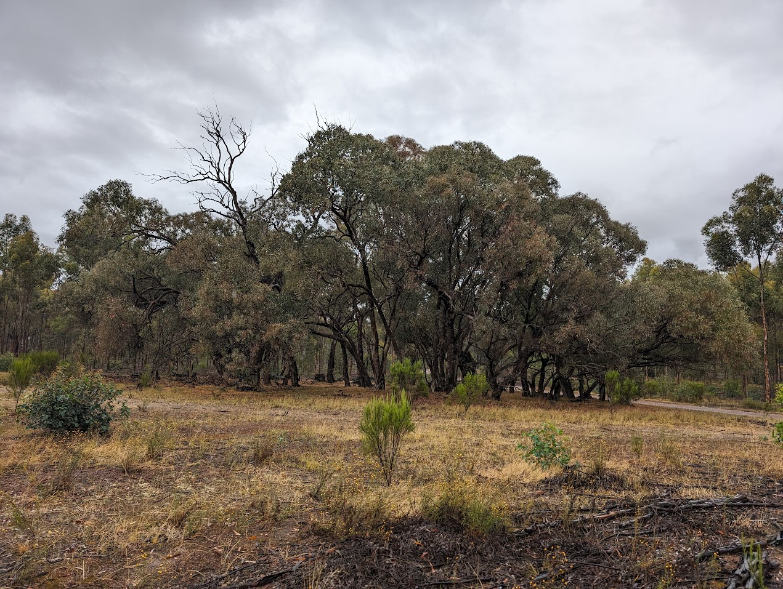

The protection of animal communities is covered in section 4.2 of the code (conservation of biodiversity) and the management guidelines. The Flora and Fauna Guarantee Act 1988 and Wildlife Act 1975 also provide considerable coverage. An example of this working relates to koala populations in blue gum plantations in south-west Victoria, which are protected through actions developed by industry and the State Government (Minimising impacts to Koalas in blue gum plantations: Regulatory guide) under the Wildlife Act which seeks to prevent harm to native animals.

Changes to the code
There are no material changes to the code with respect to Criterion 2. However, there have been significant amendments to some laws of relevance and the Management Guidelines were introduced in 2014.
The Flora and Fauna Guarantee Act (1988) was reformed in 2019 to better align the Victorian legislation to the Environment Protection and Biodiversity Conservation Act (1999) and strengthen its enforceability. In effect, the amendment resulted in changed conservation status and management requirements for a range of species, new risk assessment processes and stronger penalties for non-compliance.
A new Victorian Koala Management Strategy was released in 2023, introducing a range of additional requirements for blue gum plantation managers including preparing a Koala Management Plan, obtaining an authorisation to disturb koalas and monitoring and mitigating impacts of plantation operations on Koalas. This is not recognised in the management guidance.

Implementation of the revised code
The main changes in respect to the implementation of the revised Code relate to associated regulatory change and increased recreational pressures. Regulatory powers and activity have been strengthened significantly for biological values through the regulatory reforms discussed in section 2.2. Field visits and interviews indicate that plantation managers are working to protect natural heritage values per the Code and other relevant laws.
In the absence of published compliance reports, online searches show there are occasional incidents impacting values of relevance to Criterion 2 in Victorian plantations. High profile examples include impacts to Koalas associated with Blue Gum harvesting and spray drift, which were prosecuted by Victorian government agencies under relevant legislation.
Recreational activities, in particular mountain biking, have continued to grow in popularity and there have been a number of trail networks (both legal and illegal) developed within plantations in some areas since the 2012 Assessment. Certification standards require forest managers to consult with and consider stakeholder interests within their estate, particularly in relation to operational impacts. Victorian plantation managers are working with user groups to accommodate recreational interests within the context of the plantation enterprise where appropriate.

Effectiveness of the revised code
It is difficult to objectively assess the effectiveness of the Code in relation to any criteria as there is no state-level mechanism for monitoring Code compliance and outcomes in Victoria’s plantation estate.
Broadly, the Code provides sufficient attention to the issue of managing native vegetation and fauna, flora and landscape values. Planning requirements are specified for timber harvesting and roading operations. Planning for other types of operations is not addressed; however plantation managers generally have operational planning protocols that consider impacts on natural heritage values regardless of operation type.
Intensive recreation and geomorphic sites are not specifically addressed by the Code. Biological values are strongly regulated through specific legislation. Gaps in the Code and legislation are addressed but it is also well supported by forest management certification standards which apply to most of Victoria’s plantation estate.

Scope for improvement
The Code could be improved in the following respects for National Principles considered under Criterion 2 by:
- Addressing planning for plantation operations other than timber harvesting and roading.
- Including recreation and geomorphic sites as values to be recognised in planning and providing guidance on planning for these.
- Including guidance for planning for historic places and koalas.
Two suggested improvements from the 2012 Assessment have not been adopted and are still relevant improvements for Criterion 2. These include:
- Developing a continuous improvement process for the Code and Management Guidelines based on assessment of outcomes and research.
- Including in the PDN template an acknowledgement by proponents that natural heritage values have been considered.

Criterion 3: Protection of water quality and, where required, management of water yield
Relevant National Principles
National Principle 1.4 - Water quality (physical, chemical, or biological) should be protected by measures controlling change resulting from plantation activities
National Principle 1.5 - Water yield should be managed as required by careful planning of operations.
Question asked
How well does the Code support protection of water quality and water yield in plantation operations?
Do measures that protect water quality include streams, springs, soaks, swampy ground and bodies of standing water, and minimise sediment and other contaminant input to streams from plantation areas including roads?
What environmentally sound guidance regarding plantation management strategies for the use of nutrients and biocides do the codes of practice provide especially to ensure that changes to water quality are within acceptable limits?
Where the water resource is required to be managed (for example, controlled catchments), do the codes of practice provide effective strategies for managing water yield?

Context
The Code specifically addresses water quality, river health in section 4.2. It does not directly address water yield. The Management Guidelines provide reference to the Catchment and Land Protection Act 1994 and the Water Act 1989, both of which prescribe specific actions related to water supply offtake points, special area plans and design of stream crossings on designated waterways. The Management Guidelines also provide detailed guidance in relation to mandatory operational actions for plantation operations. Other areas of the Code also address water quality indirectly in relation to harvesting and road maintenance and construction activities.

Changes to the code
There are no changes to the code with respect to Criterion 3. However, the Management Guidelines introduced in 2014 provide reference to key regulatory mechanisms such as works on waterways permits and the requirements for declared water supply catchments. They also provide considerable guidance interpreting the requirements of the Code in respect to waterway protection, including recommended maximum distances between run-offs, cross drains and culverts on plantation roads, guidance on how to apply wet weather restrictions and useful references for responsible application of fertiliser and herbicide around water and other values. These guidelines address the suggested improvements from the 2012 Assessment.

Implementation of the revised code
There are no material changes to the implementation of the code. Field observations and stakeholder consultation indicate that waterway protections are well understood by plantation managers and operators and are generally adhered to during operations. Water quality issues occasionally arise as a result of storm activity, particularly following bushfires when surface water flow is exacerbated by lower soil porosity and reduced rates of evapotranspiration by trees. There are recent examples of situations where plantation managers have undertaken major bushfire recovery activities to stabilise soils and protect waterways from potential storm impacts.
Implementation of waterway protections can vary because Victoria does not have a definitive map of waterways and distinguishing some types of watercourses can be challenging. Since the 2012 Assessment, LiDAR technology has been increasingly used by larger plantation managers for a variety of purposes, including locating and classifying watercourses with greater precision.
Figure 2: Effective plantation road drainage
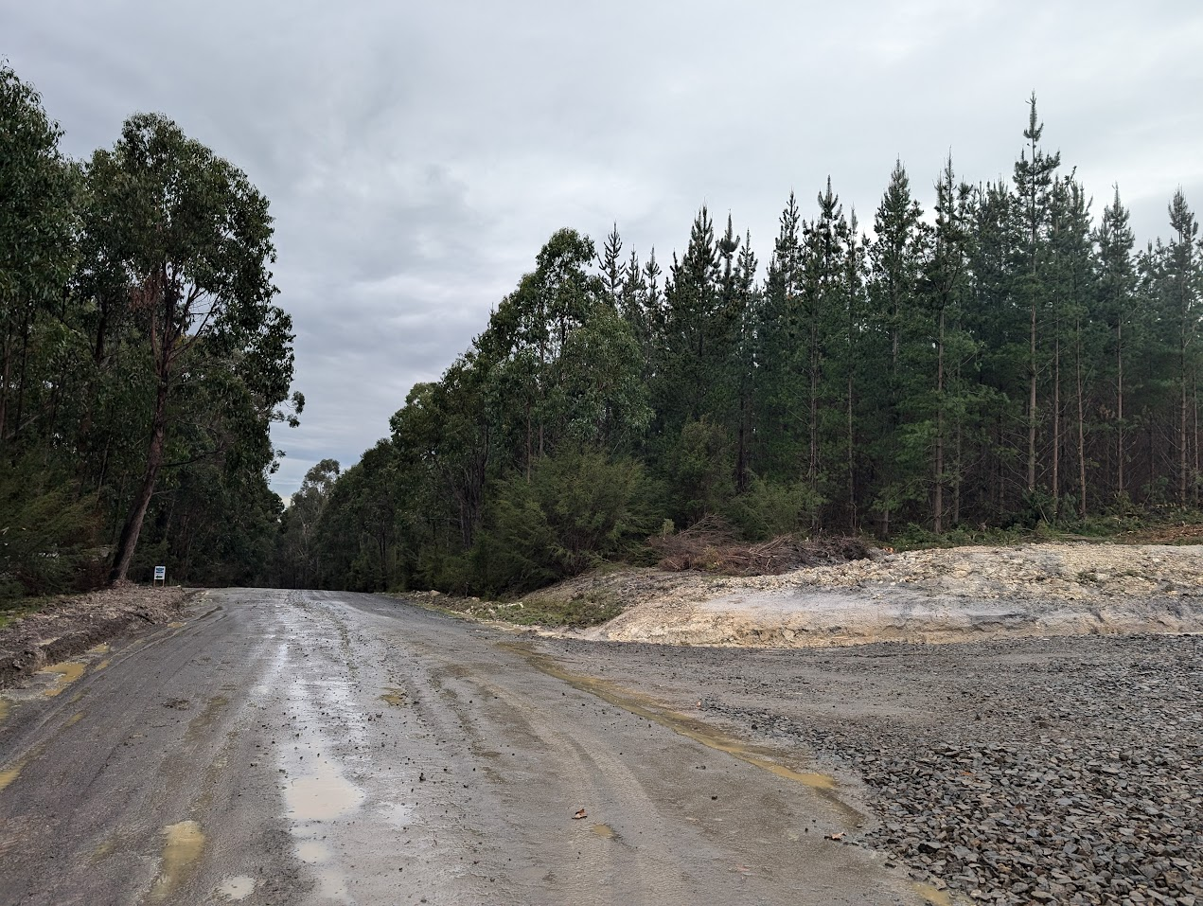

Effectiveness of the revised code
Similar to 2.4 there is no mechanism for objective assessment of the effectiveness of the revised Code. However, there are some indications of the effectiveness of the Code on water quality outcomes. A study conducted in the Latrobe catchment in 2013 investigated the impacts of intensive agriculture and plantation forestry on water quality. The study focussed on pesticide and sedimentation and found that there were few water quality issues associated with plantation operations. Forest certification standards require certified plantation managers to avoid negative impacts on water quality and quantity and conduct monitoring to assess the effectiveness of management measures. The long-term certification of the majority of the Victorian plantation estate would suggest water quality values are being appropriately managed.
The Code and management guidelines provide good coverage on water quality but are silent on water yield. There is limited Australian research on the effects of plantations on water yield, however what has been done shows that afforestation of previously cleared land can reduce stream flows and ground water recharge, particularly in locations with high evapotranspiration and where plantations have access to groundwater (UNESCO, 2017). These impacts are thought to be localised and dynamic. Although there is some legislative cover related to water yield, this is an area that could benefit from further research and coverage in the Code.

Scope for improvement
Future reviews of the code should consider its role in relation to managing catchment hydrology, particularly in the context of climate change and potential changes in rainfall levels and seasonal distribution.
A statewide mechanism for auditing the Code and monitoring its effectiveness in achieving goals associated with water values.

Criterion 4: Protection of soil resources
Relevant National Principles
National Principle 1.6 - Soil stability should be protected by measures, which regulate site disturbance.
National Principle 1.7 - Soil, water catchment, cultural and landscape values should be protected by the careful location, construction, and maintenance of roads and tracks, and regulation of their use. (Note: cultural heritage values are considered in Criterion 5).
Questions addressed
How well does the Code support protection of soil resources in plantation operations?
Are there measures and processes in place to assess the risks to soil resources? How are differences in soil type, topography and climatic conditions taken into account?
Do the codes of practice provide guidelines for roading, harvesting and site preparation that minimise soil loss or adverse change to soil properties?

Context
Soils are one of the most important values for the ongoing sustainability of the plantation industry. They are also particularly vulnerable to damage associated with poorly managed operations and natural disasters. Risk factors include site characteristics (soil and slope), weather conditions, operation intensity, equipment choice, harvesting infrastructure layout, site establishment techniques, changes in soil conditions associated with fire and operational control.
The Code specifically addresses soil protection in section 4.2. The Management Guidelines also provide detailed guidance in relation to mandatory operational actions for plantation operations. Other areas of the Code also address soil protection in relation to harvesting and road maintenance and construction activities. The relationship between soil protection and water quality is also clearly articulated.

Changes to the code
There are no material changes to the code with respect to Criterion 4. The introduction of the Management Guidelines represents the main change since the 2012 Assessment. The Management Guidelines provide guidance in relation to mandatory operational actions for plantation operations and include Part A Assessment & classification procedure – soil erosion hazard & soil permeability. The management of slash in harvesting and site preparation is covered within the Management Guidelines, addressing the area identified as having scope for improvement in the 2012 Assessment.

Implementation of the revised code

Since the 2012 Assessment, the main implementation changes for soils relate to the equipment and operational techniques available to plantation managers. The introduction of tethered systems for steep country harvesting is reducing soil rutting and the need for side cut extraction tracks. Plantation managers are also increasingly using harvesting and site establishment techniques that maintain nutrients and cover across the site. The recent introduction of mechanical planting systems also has potential to improve soil outcomes by maintaining slash and reducing extensive soil disturbance requirements.
Figure 3: Plantation harvesting in Gippsland, with slash protection of soils
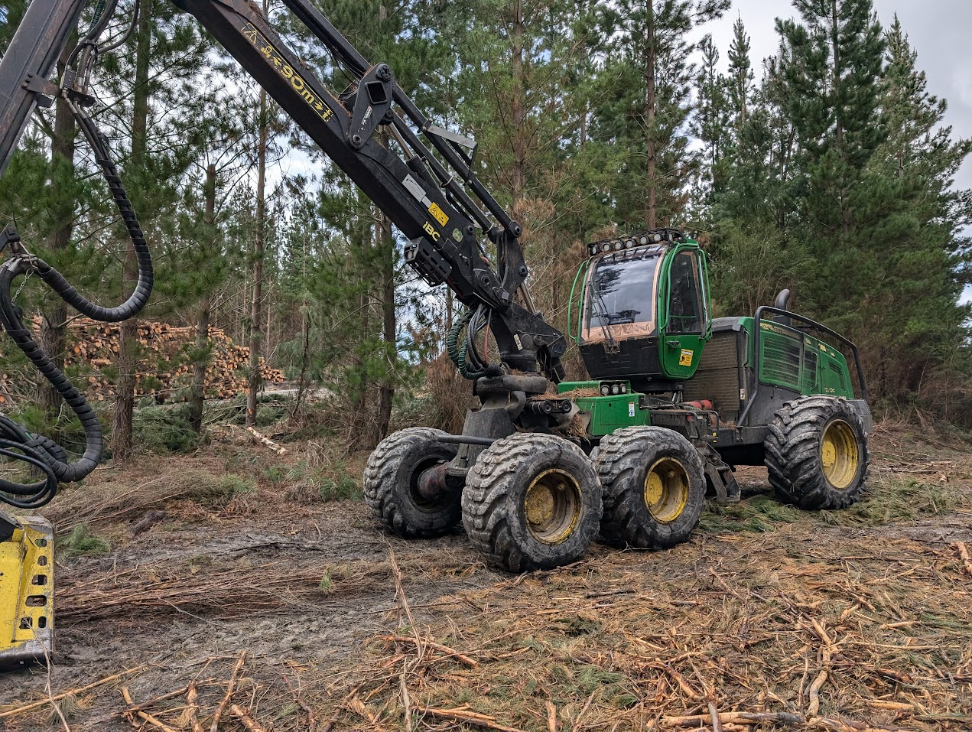

Effectiveness of the revised code
Similar to 2.4 there is no mechanism for objective assessment of the effectiveness of the revised Code.
Protection of soil resources, particularly in steep erodible terrain is one of the most challenging aspects of the Code to implement, requiring good decisions at all stages from scheduling, planning, equipment configuration, operational management and maintenance and rehabilitation of infrastructure. Field observations and interviews suggest that soil management practices are generally appropriate and improvements in equipment are supporting better outcomes where they are used. However, it was identified that lack of Code enforcement and expert input for challenging situations is problematic.
The Code and management guidelines provide good coverage on soil protection. However, guidance on management of common soil risks associated with plantation management is relatively limited in comparison to some other Codes.

Scope for improvement
The Code and its system of application could be improved in the following respects for National Principles considered under Criterion 4:
- Developing and implementing a statewide system of audit and effectiveness monitoring
- Providing improved technical guidance or specialist support for challenging situations.
- Updating guidance to recognise evolving improvements in equipment and techniques to support soil protection.

Criterion 5: Protection of cultural heritage values
Relevant National Principles
National Principle 1.7 - Soil, water catchment, cultural and landscape values should be protected by the careful location, construction, and maintenance of roads and tracks, and regulation of their use
National Principle 1.8 - Values such as intensive recreation, high scenic quality, significant geomorphic, biological, or cultural heritage sites, should be recognised in the planning of plantation forest operations. (Note: cultural heritage aspects only).
Question addressed
If it is applied as written, how effective is the Code in delivering protection of cultural heritage values?
In the planning of plantation layout, establishment and maintenance operations, are there measures and processes for managing cultural heritage values?

Context
Aboriginal Cultural Heritage is addressed through the Aboriginal Heritage Act 2006 and non-Aboriginal Heritage through the Heritage Act 2017. First Nations State Relations and Heritage Victoria provide considerable material and advice about the legislative framework and compliance with requirements. Local government planning schemes also address heritage values. The Code is silent on these matters and simply references the Acts. Certification processes require these issues to be addressed, including consultation with Traditional Owners. The Code requires that timber harvesting operations are “…appropriate to the site and manage the impacts on…historic places and Aboriginal cultural heritage”.

Changes to the code
The code changes remove most references to cultural heritage, which is dealt with directly through the broader legal and regulatory framework. Guidance on the regulatory framework for Aboriginal heritage is provided in the Management Guidelines. This has been updated to reflect 2016 amendments to the Aboriginal Heritage Act (2006), which introduced protection for Aboriginal intangible heritage and new powers for Aboriginal Heritage Officers to issue stop work orders.

Implementation of the revised code
The main changes in respect to the implementation of the revised Code for cultural heritage relate to regulatory changes. Regulatory powers and activity have been strengthened significantly for Aboriginal Heritage values through the regulatory reforms discussed in section 5.2. Field visits and interviews indicate that plantation managers are working to protect cultural heritage values per the Code and other relevant laws.

Effectiveness of the revised code
The Code does not directly address requirements for cultural heritage management. However, suitable guidance is provided for Aboriginal cultural heritage (but not other heritage) in the Management Guidelines. Cultural heritage values are strongly regulated through specific legislation, and local government planning schemes also apply in some situations.
Traditional Owner groups and forest managers consulted for this assessment noted a desire to move from a cultural heritage artefacts focus to an engagement focus which considers the whole landscape and the role of plantations (and other land uses) within that. Because cultural heritage management is the responsibility of other areas in the State Government, the Code is quiet on these issues.
It is not clear how compliance is achieved through any State Government processes. However, for certified forests, there are processes in place to ensure that consultation occurs and that sites are identified and managed.

Scope for improvement
The Code could be improved in the following respects for National Principles considered under Criterion 5 by:
- Addressing planning for plantation operations other than timber harvesting and roading, and
- Including guidance for planning for historic places.
Figure 4: Retention of koala browsing trees in blue gum plantation, south west Victoria
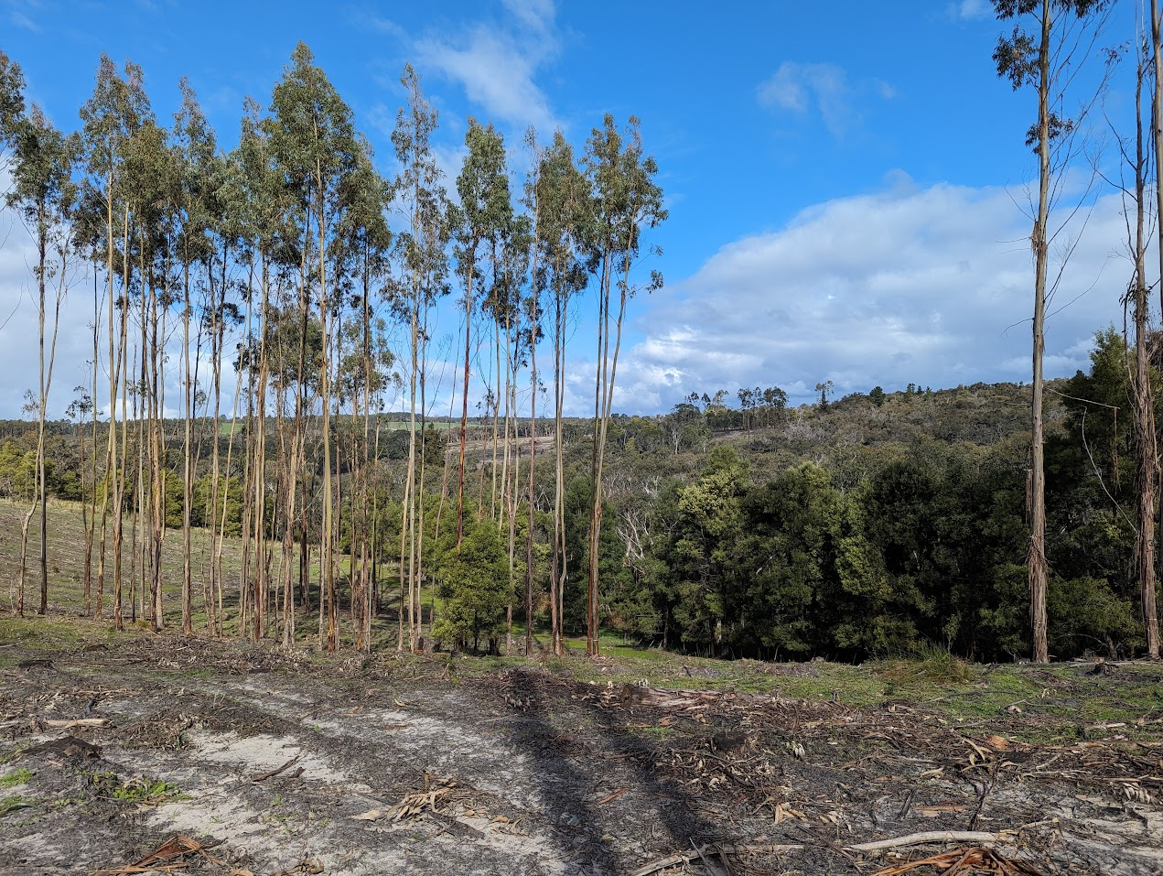

Criterion 6: Protection from fire, pests and diseases
Relevant National Principle
National Principle 1.9 - Plantations and adjacent native forests should be protected from the adverse effects of fire and from the introduction and spread of plant, insect and animal pests and plant diseases.
Questions addressed
Is the Code effective in guiding protection pf plantations and adjacent native forests from fire, pests and diseases?
In the planning of plantation layout, establishment and maintenance operations, are there measures and processes for managing cultural heritage values?
Does the code of practice provide guidelines to deal with outbreaks of pests and diseases?

Context
Fire, invasive species and disease are an increasing issue for plantations in Victoria. Although the Code provides minimal and very high-level regulation on these topics, they are dealt with via other legislation in Victoria and are a major focus for plantation managers.
The code requires that plantation design be consistent with relevant fire protection requirements timber harvesting plans include fire protection measures and native vegetation and powerlines be protected during burning operations. Bushfire management in Victorian plantations is regulated by the Country Fire Authority Act 1958 and the Victorian Planning Provisions. The Country Fire Authority (CFA) provides considerable guidance around fire management in plantations, including legislated requirements and guidance for fire management planning, equipment and so forth. Where a plantation estate is large enough, the manager must have in place a Forest Industry Brigade which operates under the control of the CFA. The Victorian Planning Provisions also provide some coverage around bushfire planning and setbacks related to buildings.
The code recommends that plantation health is monitored and maintained through appropriate preventative, protective and remedial measures. It requires the State’s Biosecurity section to be informed of the introduction of an exotic agent and requires risk management where the potential introduction of pests and pathogens through equipment could occur. Other legislation such as the Catchments and Land Protection Act require landowners to actively manage pests, weeds and feral animals.

Changes to the code
There are no material changes to the code with respect to Criterion 6. The Management Guidelines provide clear explanations of relevant sections of the Country Fire Authority Act (1958), the Catchment and Land Protection Act (1994) and requirements of local government authorities. These laws are continuously evolving to meet increasing fire and biosecurity risks. Victorian biosecurity laws were being overhauled at the time of this review.

Implementation of the revised code
Since the 2012 Assessment there have been more major plantation losses as a result of bushfire, pests, diseases and wind in south-eastern Australia. Plantation managers are increasingly focussed on activities that improve plantation health and fire suppression and many are involved in collaborative research programs. Large plantation estates have regular forest health monitoring programs and engage specialist advice to manage disease and pest outbreaks. A good example of the effectiveness of these processes is the industry’s strong response to the detection of Giant Pine Scale. Thinning is an increasing focus for long rotation plantations, and one of the key aims of these programs is maintaining plantation health. The plantation industry is leading the adoption of remote AI assisted fire detection systems in the Green Triangle.
The 2012 Assessment identified scope for greater control and protection of weeds and pine wildings. Although these long established problems still persist, forest certification standards compel the major plantation managers to control any new invasive species introduced as a result of their activities and cooperate with other parties to control the spread of invasive species in general.

Effectiveness of the revised code
Although the Code provides only minimal attention to fire protection it references the requirements across other parts of the legal and regulatory framework. The relationship between the CFA and industry is well established and legislated. Similarly, with pests and diseases the code provides minimal coverage. However, there are recent examples where the industry has worked with State and Commonwealth agencies to manage the potential spread of newly discovered pathogens, such as the giant pine scale. These aspects are well covered by existing processes and there is strong motivation for forest owners to manage them.

Scope for improvement
There are no improvements identified with respect to Criterion 6.

Criterion 7: Training for environmental care
Relevant National Principle
National Principle 1.10 - Operators will be trained in the principles of environmental care.
Questions addressed
What requirements does the Code have in place for ensuring that operators are adequately trained in the principles of environmental care?
Are the processes adequate to meet this criterion?

Context
As with other jurisdictions, the issue of operator training in the principles of environmental care is challenging, largely because of the lack of accredited training providers and the relatively small market for education provision. There is no mention in the Code or in any relevant instruments about requirements for training.

Changes to the code
There are no material changes to the code with respect to Criterion 7.

Implementation of the revised code
There are no material changes to the implementation of the code.

Effectiveness of the revised code
Most of the large plantation owners and managers have in place strong processes for training and development, which are also often required by the certification schemes. For example, one large grower consulted for the project recently completed an extensive internal training program for silvicultural management, which included a dedicated session on environmental management. This same company is now developing their own system for ensuring operators have appropriate training, including environmental care.

Scope for improvement
Future code reviews should consider and consult with industry about the potential benefits of providing code specific training materials and tools around the principles of environmental care.

Other National Principles
There are a further seven National Principles covering 23 objectives, many of which overlap extensively with the Principles of Environmental Care dealt with above.
Questions addressed
What are your perspectives on the effect of the Code on the economic viability of timber production activities in plantations?
Are there any particular factors that you think influence how well and consistently the Code is applied?
Are there any particular areas of the Code you consider need updating or reform? eg. Topics that are missing, out of date, inappropriate, conflicting with other regulations, unclear, impractical. What and Why?

National Principle 2: Safety
The Code does not address safety. Worksafe Victoria published the Industry Standard: Safety in Forestry Operations – Harvesting and haulage in 2007. The preface to the online version now reads:
“On 18 June 2017, the Occupational Health and Safety Regulations 2017 (OHS Regulations 2017) replaced the Occupational Health and Safety Regulations 2007 (OHS Regulations 2007), which expired on this date. This publication has not yet been updated to reflect the changes introduced by the OHS Regulations 2017 and should not be relied upon as a substitute for legal advice.”
Broadly, the State Government’s exposure to safety in forestry has declined considerably. Individual companies have progressed significantly and there are whole of industry groups that are actively involved in this space.

National Principle 3: Planning
Planning is well addressed in the Code.

National Principle 4: Access
Sections 4.4 Plantation Roading and 4.5 Timber Harvesting address access in detail.

National Principle 5: Establishment and Maintenance
Section 4.3 Establishment and Management of Plantations addresses establishment and maintenance in detail.

National Principle 6: Timber Harvesting
Section 4.5 Timber Harvesting addresses timber harvesting.

National Principle 7: Forest Protection
Section 4.3 address Plantation Health. Fire protection and other plantation protection matters are not addressed. The Victorian Country Fire Authority provides comprehensive coverage in relation to fire. The plantation sector in Victoria contributes financially and with firefighting resources through mandated Forest Industry Brigades (FIBs). FIBs operate under the direction of the CFA and are required to be established once plantations owned or managed by one entity exceed 500 ha within a 25 km radius.

National Principle 9: Monitoring and Review
The code does not deal specifically with monitoring and review. However, the majority of Victoria’s plantation estate is subject to forest management certification which imposes stringent requirements for monitoring and review.
Figure 5: Sugar gum plantation central Victoria
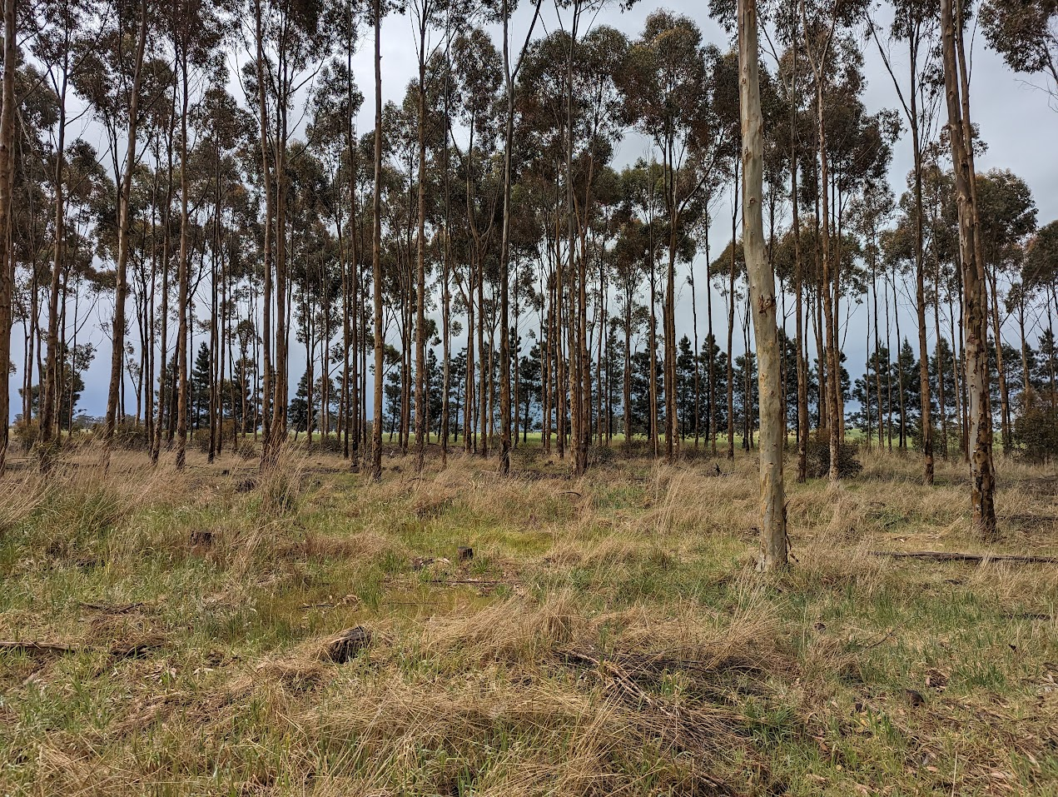

Appendix A: Relevant legislation
Jurisdiction | Instrument
Victoria | Aboriginal Heritage Act 2006
 | Accident Compensation Act 1985
 | Agricultural and Veterinary Chemicals (Control of Use) Act 1992
 | Building Act 1993
 | Catchment and Land Protection Act 1994
 | Charter of Human Rights and Responsibilities Act 2006
 | Climate Change Act 2017
 | Conservation, Forests and Lands Act 1987
 | Country Fire Authority Act 1958
 | Dangerous Goods Act 1985
 | Electricity Safety Act 1998
 | Emergency Management Act 2013
 | Environment Protection Amendment Act 2018
 | Environment Protection Act 2017
 | Environmental Protection Act 1970
 | Fences Act 1968
 | Firearms Act 1996
 | Fisheries Act 1995
 | Flora and Fauna Guarantee Act 1988
 | Heritage Act 2017
 | Heritage Rivers Act 1992
 | Land Act 1958
 | Inland Fisheries Act 1995
 | Local Government Act 1989
 | Marine and Coastal Act 2018
 | Occupational Health and Safety Act 2004
 | Planning and Environment Act 1987
 | Planning and Environment (Planning Schemes) Act 1996
 | Plant Biosecurity Act 2010
 | Prevention of Cruelty to Animals Act 1986
 | Road Management Act 2004
 | Subordinate Legislation Act 1994
 | Victorian Plantations Corporation Act 1993
 | Water Act 1989
 | Wildlife Act 1975
 | Workplace Injury Rehabilitation and Compensation Act 2013
 | Aboriginal Heritage Regulations 2018
 | Agricultural and Veterinary Chemicals (Control of Use) Regulations 2017
 | Conservation, Forests and Lands (Infringement Notice) Regulations 2017
 | Country Fire Authority Regulations 2014
 | Dangerous Goods (Explosives) Regulations 2011
 | Dangerous Goods (HCGD) Regulations 2016
 | Dangerous Goods (Storage and Handling) Regulations 2012
 | Electricity Safety (Electric Line Clearance) Regulations 2020
 | Electricity Safety (Installations) Regulations 2009
 | Fences Regulations 2014
 | Heritage Regulations 2017
 | Occupational Health and Safety Regulations 2017
 | Planning and Environment Regulations 2015
 | Subordinate Legislation (Legislative Instruments) Regulations 2011
 | Subordinate Legislation (Prevention of Cruelty to Animals Regulations 2008) Extension Regulations 2018
 | Victorian Plantations Corporation (Register of Plantation Licences) Regulations 2018
 | Wildlife Regulations 2013
 | Workplace Injury Rehabilitation and Compensation Regulations 2014
Commonwealth | Export Control Act 2020
 | Aboriginal and Torres Strait Islander Heritage Protection Act 1984
 | Agricultural and Veterinary Chemicals Act 1994
 | Australian Heritage Council Act 2003
 | Biosecurity Act 2015
 | Environment Protection and Biodiversity Conservation Act 1999
 | National Environment Protection Measures (Implementation) Act 1998
 | National Environment Protection Measures (Implementation) Act 1998
 | Native Title Act 1993
 | Regional Forests Agreement Act 2002

References
Department of Environment, Land, Water and Planning (2022) Code of Practice for Timber Production 2014 (as emended 2022), Victorian Government.
Department of Environment and Primary Industries (2014) Management guidelines for private native forests and plantations: Code of Practice for Timber Production 2007, Victorian Government.
Department of Sustainability and Environment (2007) Code of Practice for Timber Production 2007, Victorian Government.
Smethurst, P.J, Raison, J.R, Nambiar, E.K.S, House, A.P.N & Moggridge, B (2012) Assessment of Code of Practice for Plantation Forestry: Victoria, Prepared for Australian Government Department of Agriculture, Fisheries and Forestry.
UNESCO (2017) Forest management and the impact on water resources: a review of 13 countries.
Websites
https://www.environment.vic.gov.au/native-vegetation/native-vegetation-removal-regulations (Accessed December 2024).
https://www.vic.gov.au/koalas-blue-gum-plantations (Accessed December 2024).

