#### Final Report

Assessment of the voluntary phase out of microbeads

May 2018

Contents

[Background 3](#_Toc513732732)

[Findings 2](#_Toc513732733)

[Commitments by companies: BeadRecede campaign led by Accord 3](#_Toc513732734)

[Independent assessment of the sale of microbeads and other non-soluble plastic polymers 5](#_Toc513732735)

[Ongoing compliance with the voluntary phase out 6](#_Toc513732736)

[Further information 6](#_Toc513732737)

**ASSESSMENT OF THE VOLUNTARY PHASE OUT OF MICROBEADS**

This assessment of the effectiveness of the industry-led, voluntary phase out of microbeads from rinse-off cosmetic, personal care and cleaning products was undertaken by officials from the Commonwealth, in consultation with NSW and Accord.

# Background

* The Meeting of Environment Ministers in February 2015 expressed concern about the impact of microbeads on the marine environment. In particular, concern was raised about microbeads used in consumer products that enter our waterways with potential long-term risks to marine organisms and human health.
* To address this concern, Ministers asked officials to work with industry to secure a voluntary agreement to phase-out of microbeads in personal care, cosmetic and cleaning products by no later than 1 July 2018.
* Ministers stated that if the voluntary phase-out was not effective, they would move to implement a ban.
* Work to progress the phase-out was led by Accord, the national industry association representing manufacturers and suppliers of hygiene, cosmetic and specialty products, their raw material suppliers and service providers.
* Ministers agreed that NSW and the Australian Government would lead the Government involvement in progressing the phase-out.
* Consistent with the intention of protecting the marine environment, the voluntary phase-out has focused on microbeads in rinse-off products, which would be reasonably capable of entering the aquatic environment through normal use of the product. It does not extend to:
  1. cosmetic products that are generally wiped-off, such as make up and lipsticks, as those products are not designed to be rinsed off so the risk of them entering the aquatic environment through normal use is reduced.
  2. Non-solid plastic ingredients (e.g. liquids or polyethylene waxes, which may be used for purposes such as a film former, softening or aesthetic film in hair fixatives, conditioners and thickeners)
  3. Plastic microbeads contained in industrial cleaning products used in closed systems (e.g. air blasting media used in manufacturing process cleaning);
  4. Plastic microbeads in medicines;
  5. Plastic fibres from washing clothes; and
  6. Pre-production plastic pellets used to manufacture plastic products.

These types of microplastics may cause harm when they enter the environment. However, there is limited scientific research on these impacts. The NSW EPA is conducting further work to better establish whether plastics from these sources are reaching the marine environment in NSW.

# Findings

* While there remain some gaps in the evidence available, and some areas still to be addressed, officials have concluded that, on balance, industry’s efforts to deliver a voluntary phase-out of microbeads in rinse-off, personal care, cosmetic and cleaning products will be effective as at 1 July 2018 and that regulation is not needed at this stage.
* Companies are aware of the expectation that they phase out microbeads and in the majority of cases have either phased them out already or committed to doing so by 1 July 2018.
* Companies’ actions and commitments were reported in writing by the companies to Accord in December 2016 and December 2017, and show an increasing level of commitment over time.
* Commonwealth officials viewed the written representations by companies to Accord and are satisfied that the commitments support an effective voluntary phase-out of microbeads in products within scope by 1 July 2018.
* An independent assessment of the sale of products that could potentially contain microbeads was undertaken between November 2017 and February 2018. While this assessment showed that there remained some products with microbeads and other non- soluble plastic polymers on the market at that time, the low proportion of in-scope products containing microbeads more than four months before the phase-out was to be complete appeared consistent with the statements made by companies about actions taken or planned to remove microbeads from their rinse-off products.
* The independent assessment showed that, between November 2017 and February 2018:
* 94 per cent of all products surveyed did not contain microbeads or other non-soluble plastic polymers
* some categories of rinse-off products, such as body washes, did not contain any microbeads or other non-soluble polymers
* the majority of the products still containing microbeads or other non-soluble plastic polymers were not rinse-off products, would not reach the marine environment under normal use and therefore fall outside the scope of the phase-out.
* Some of the non-soluble plastic polymers identified through the survey are non-solid plastic ingredients and would therefore fall outside the scope of the phase-out.
* Accord has agreed to work with officials to finalise and implement a compliance and monitoring protocol by June 2018, which will include actions to ensure the phase-out continues to be effective on an ongoing basis
* Based on the information available, the following areas will be prioritised for follow-up with the industry, including in the lead-up to July 2018 and through the monitoring and compliance protocol.
* Residual microbeads in rinse-off products: Immediate effort will be focused on the in- scope products that still contained microbeads between November 2017 and February 2018 (including facial scrubs) and products which do not list full ingredients on their

ingredients list (such as toothpaste and business to business cosmetic and cleaning products).

* Companies that are not members of Accord: While good progress has been made by Accord in securing wide commitment to the phase out among the companies identified, there are likely to be non-member companies that Accord have not been able to identify.
* Clarification of out-of-scope non-soluble plastic polymers: Accord have indicated that two non-soluble plastic polymers identified in the independent assessment, Polymethyl methacrylate and Methyl methacrylate cross polymer, are film-forming synthetic non- soluble plastic polymers rather than microbeads.
* Engagement with pharmacies: Accord has contacted 10 of the major pharmacies, but the response rate has been low. This may be a lower order concern, as results of the independent assessment and research undertaken by Accord suggest that pharmacies do not sell in-scope, own-label products, and therefore products sold in pharmacies are already captured by their suppliers’ engagement with the phase out.
* Further detail on the information on which the assessment was based is provided below.

## Commitments by companies: BeadRecede campaign led by Accord

* The BeadRecede campaign has been implemented by Accord as a focus for its industry outreach.
* As part of the campaign, Accord wrote to 146 companies that were identified as supplying products in sectors that could *potentially* contain microbeads. The sectors were: personal care and cosmetic (71), homecare/consumer cleaning (7), commercial business to business cleaning (40), raw material business to business (9), retailers (9) and pharmacies (10).
* The data presented in the tables below are drawn from Accord’s reports to officials on the BeadRecede campaign, and deal only with the 53 companies (out of the original list of 146 companies) that were identified as having at some point supplied products that contained microbeads.
* The data show an increased commitment by industry to phase out microbeads from December 2016 to December 2017.
* Table 1 below shows that by December 2016, 80 per cent of companies identified as supplying products containing plastic microbeads (or 42 of the 53 companies) had phased out or committed to phasing out microbeads.

*Table 1: Results of Accord's December 2016 survey of companies that were identified as having supplied products containing microbeads*

|  |  |  |  |  |  |  |
| --- | --- | --- | --- | --- | --- | --- |
| **Accord’s survey results - Dec 2016** | **Personal care and cosmetic** | **Homecare**  **/ consumer cleaning** | **Commercial B2B**  **cleaning** | **Retail** | **Non members** | **Total** |
| Already phased out by Dec 2016 | 16 | 1 | 4 | 1 | 1 | 23 |
| Committed to phasing out by mid-2018 | 9 | 2 | 3 | 3 | 2 | 19 |
| Subtotal – phased out or committed to phase out | 25 | 3 | 7 | 4 | 3 | **42** |
| Not committed to phasing out as at Dec 2016 | 0 | 0 | 1 | 7 | 3 | 11 |
| Total | 25 | 3 | 8 | 11 | 6 | **53** |

* Table 2 below shows that by December 2017, 94 per cent of companies (or 50 of the 53 companies) identified as supplying products containing plastic microbeads had already phased out or committed to phase out microbeads.

*Table 2: Results of Accord's December 2017 survey of companies that were identified as having supplied products containing microbeads*

|  |  |  |  |  |  |
| --- | --- | --- | --- | --- | --- |
| **Accord’s survey results - Dec 2017** | **Personal care and cosmetic** | **Homecare/ consumer cleaning** | **Commercial B2B**  **cleaning** | **Retail** | **Total** |
| Already phased out by Dec 2017 | 28 | 2 | 8 | 0 | 38 |
| Committed to phasing out by mid-2018 | 4 | 0 | 4 | 4 | 12 |
| Subtotal – phased out or committed to phase out | 32 | 2 | 12 | 4 | **50** |
| Not committed to phasing out as at Dec 2017 | 1 | 0 | 1 | 1 | 3 |
| Total | 33 | 2 | 13 | 5 | **53** |

* Accord survey data shows that there has been an 81 per cent reduction in the volume of microbeads contained in products on the Australian market since late 2014.
* In the retail category, no household cleaning products were found to contain microbeads.

The four major supermarkets, comprising 66 per cent of the Australian facial cleanser product market have committed to remove microbeads in their branded products. In terms of product volumes, this is likely to be more significant than other retailers supplying personal care products.

* In January 2017, Commonwealth Department of Environment and Energy reviewed the written responses that companies provided to Accord, in which they outlined actions they have taken, or are committed to taking, to phase out microbeads by mid-2018. Companies are replacing microbeads with natural biological materials such as cellulose, jojoba wax, bamboo beads, polenta and fruit/nut kernels. Commonwealth officials were satisfied that the responses reviewed supported a conclusion that the voluntary phase-out would be effective by mid-2018.

## Independent assessment of the sale of microbeads and other non-soluble plastic polymers

* In late 2017, the Commonwealth Department of the Environment and Energy commissioned an independent assessment of the sale of microbeads and other non- soluble plastic polymers from supermarkets and pharmacies. The scope of the independent assessment included all personal care, cosmetic and cleaning products that the assessor identified as potentially containing microbeads or other non-soluble plastic polymers. This is broader than the scope of the industry-led phase out of microbeads in ‘rinse off’ products.
* The assessment showed that 94 per cent of products surveyed between November 2017 and February 2018 did not contain microbeads or other non-soluble plastic polymers.
* Approximately 4,400 products which could potentially have contained microbeads were inspected during the retail outlet surveys, with 267 (6 per cent) of the products found to contain microbeads or other non-soluble plastic polymers.
* The 6 per cent of products containing microbeads or other non-soluble plastic polymers were sold in 53 retail outlets and distributed by 55 companies. Of these products an aggregated total of 94 per cent were in; foundations/blushes (38.2 per cent), eye make-ups (14.2 per cent), lip make-ups (12.0 per cent), skin creams/moisturisers (19.1 per cent), and facial scrubs (10.5 per cent).
* No shampoos/conditioners, body washes and hand cleaners contained microbeads or other non-soluble plastic polymers, demonstrating that the phase-out of microbeads in these products may be complete.
* While the independent assessment was carried out subject to some limitations, such as having restricted access to some retail outlets and online sales platforms, the results support Accord’s findings that few rinse-off personal care products containing microbeads are still available in the Australian market.

## Ongoing compliance with the voluntary phase out

* Australian Government and NSW officials are working with Accord to finalise a monitoring and compliance protocol that will detail actions to be taken between July 2018 and

June 2020, to support the continued success of the phase-out.

* While the details will be concluded over the coming weeks, it is expected that the protocol will include:
* Market scans undertaken by Accord in 2018-19 and 2019-20 to identify any entrants to the market that supply products which may contain microbeads, and follow-up by Accord to ensure any new entrants are aware that they are expected to exclude microbeads from their products.
* Ongoing communication between Accord and NSW and Commonwealth officials, and support from officials to persuade any companies that are found to be supplying product containing microbeads, to stop doing so.
* Maintenance by Accord of the BeadRecede webpage, to communicate the phase-out to the public.
* Drawing on funds available in the National Environment Protection Council special account to support work on plastics, the Commonwealth will commission a follow-up independent assessment the presence of microbeads in rinse-off personal care, cosmetic and cleaning products in 2018-19.
* Continued work by Accord to ensure that cosmetic, personal-care and cleaning products regulated as therapeutic goods (other than medicines) under the *Therapeutic Goods Act 1989 (Cth)*, are effectively phased out by 1 July 2019. These products require a longer lead time to obtain regulatory approval for changes to product formulations.
* In addition, the NSW EPA has commissioned CSIRO to undertake an extensive research project that will identify and quantify microplastics that enter waste water treatment plants and are released into the marine environment via effluent. This research will also provide data to inform assessment of whether the voluntary industry phase out of microbeads continues to work effectively.

# Further information

Visit our website to learn more about microbeads or download the independent assessment of the sale of microbeads and other non-soluable plstic polymers in personal care and cosmetic products in Australia:

[www.environment.gov.au/microbeads](http://www.environment.gov.au/microbeads)

***Contact us***

Email: [wastepolicy@environment.gov.au](mailto:wastepolicy@environment.gov.au)  
Phone: 1800 423 135  
Mail: Stewardship and Waste Section  
 GPO Box 787, Canberra ACT 2601 AUSTRALIA

**environment.**gov.au

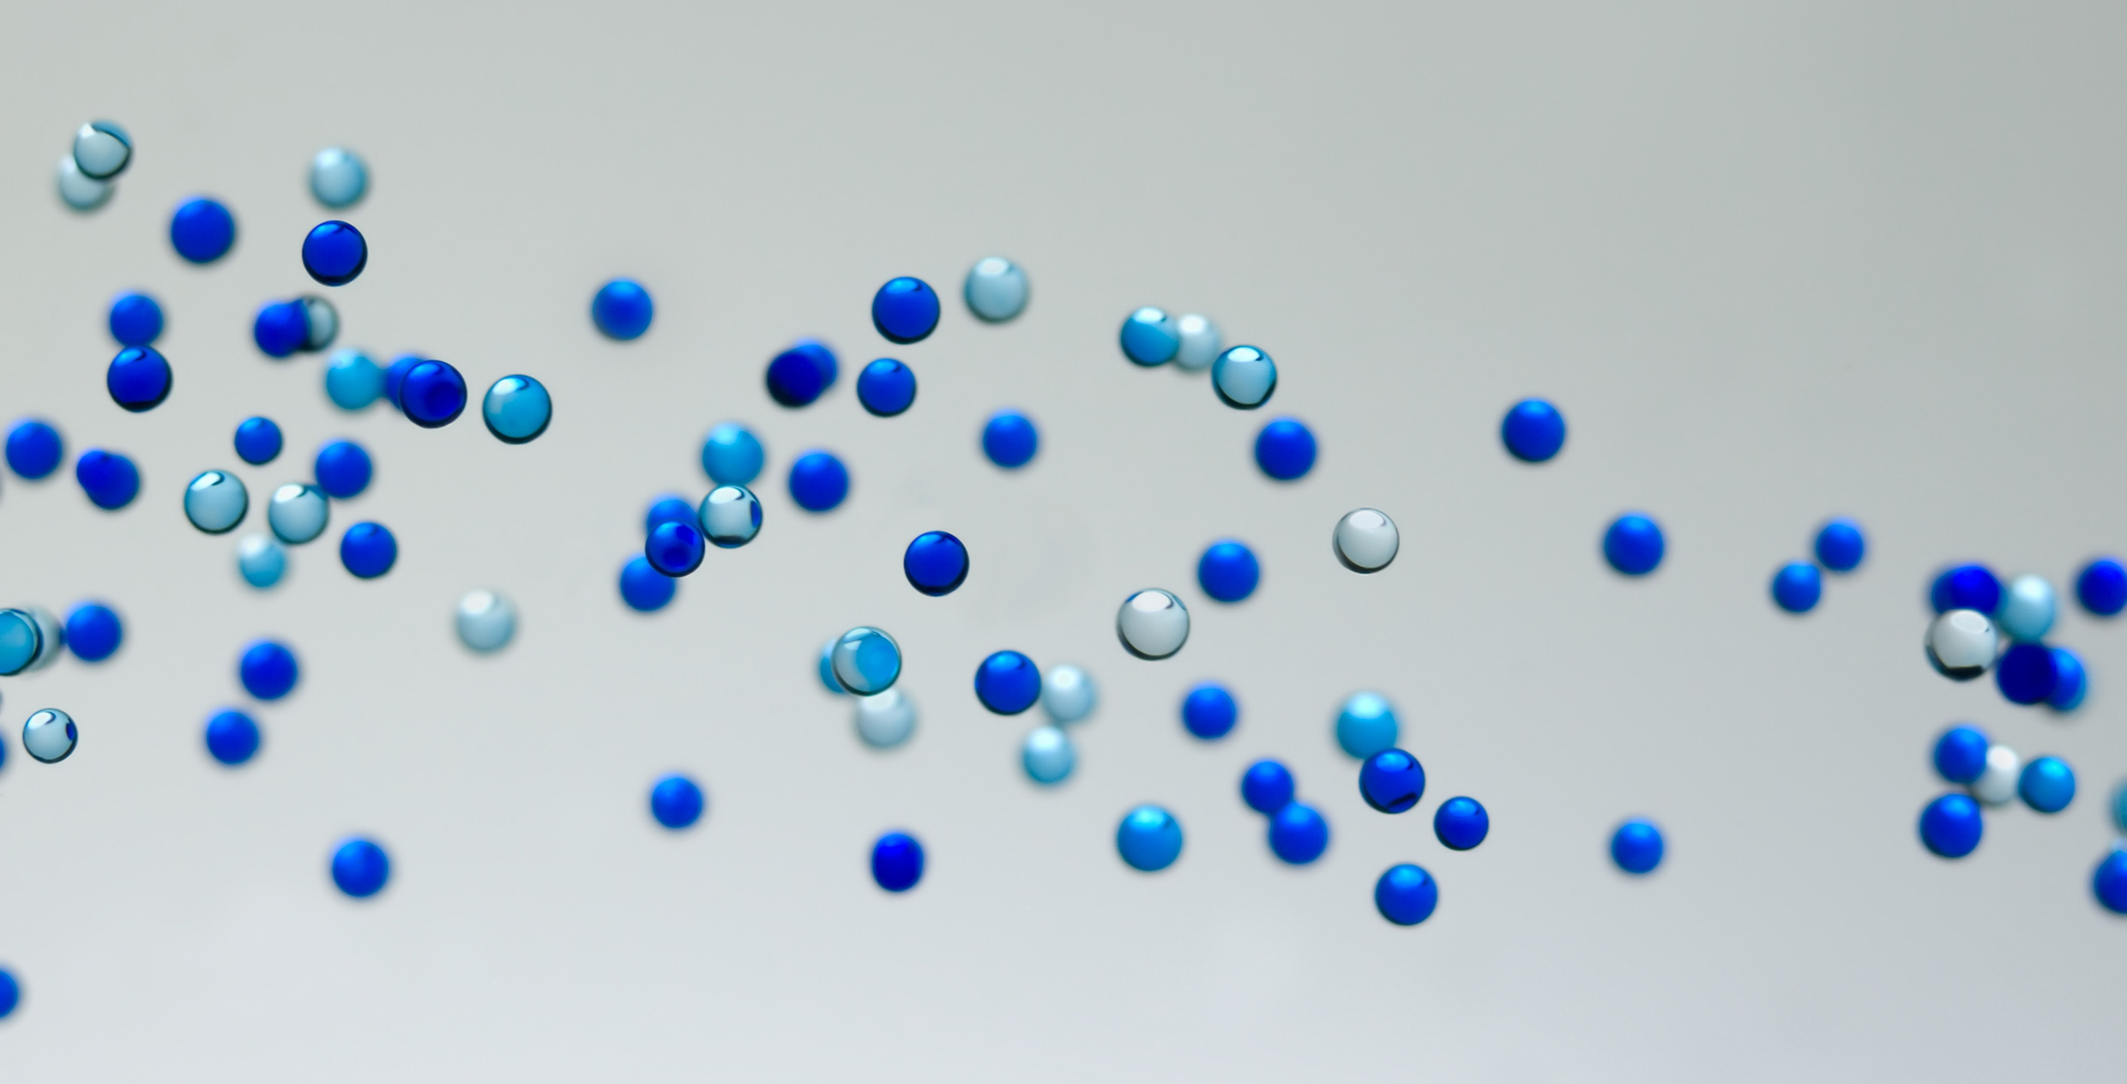C:\Users\a11944\AppData\Local\Microsoft\Windows\Temporary Internet Files\Content.Outlook\DEX22WEH\HR_dotted_line_darkerblue.png