Attachment 2– Maps of 2024 and 2025 HPAI outbreaks
Region | Date Outbreak Resolved | Key | Map
Terang, VIC | 4 Nov 2024 | Map as at 25 June 2024.  Red shade: Restricted areas  Purple shade: Control areas  Red diamonds: Infected premises | 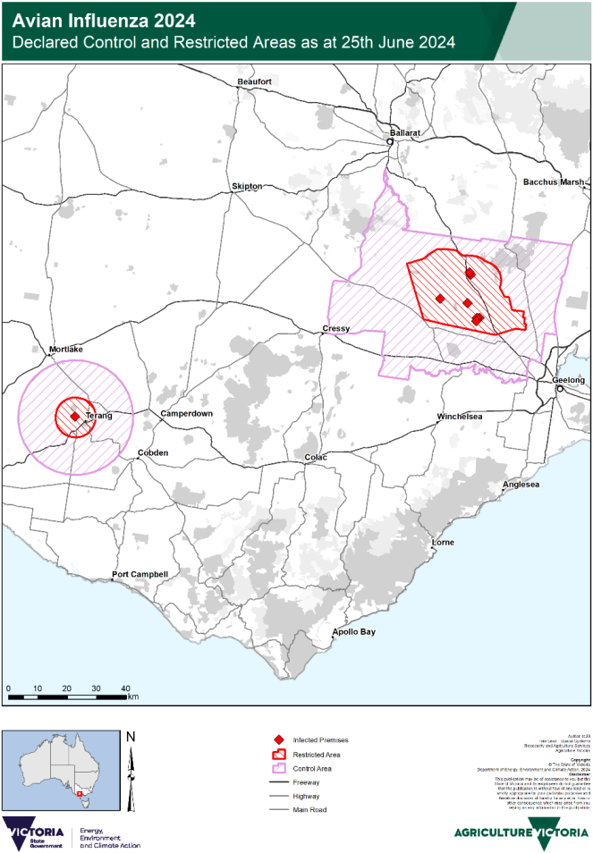
Meredith & Lethbridge, VIC | 30 Dec 2024

Region | Date Outbreak Resolved | Key | Map
Freemans Reach, Glossodia, North Richmond, & Cornwallis, NSW | 23 Jan 2025 | Map as at 12 July 2024.  Red shade: Restricted areas  Orange shade: Control areas  Red diamonds: Infected premises | 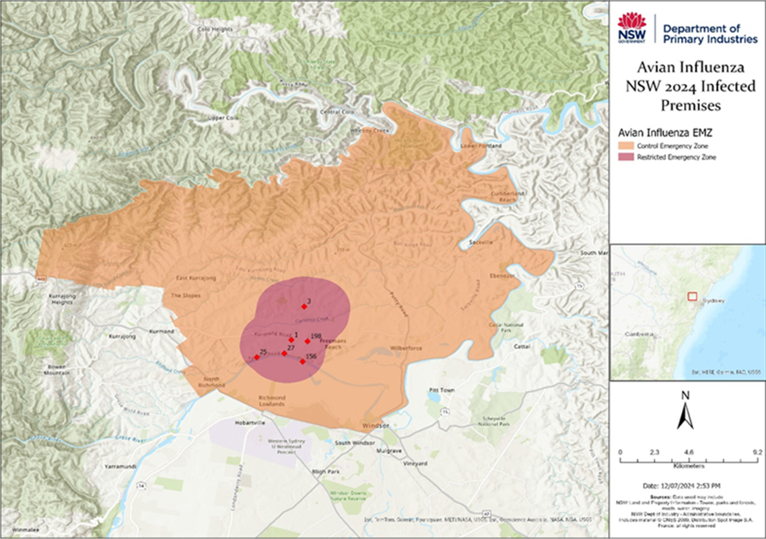

Region | Date Outbreak Resolved | Key | Map
NSW Bordering Belconnen | 31 Oct 2024 | Map as at 27 June 2024.  Red shade: Restricted areas  Orange shade: Control areas  Note: There are no infected premises in this area, as it was established given the proximity to the infected premises in the ACT in the below image. | 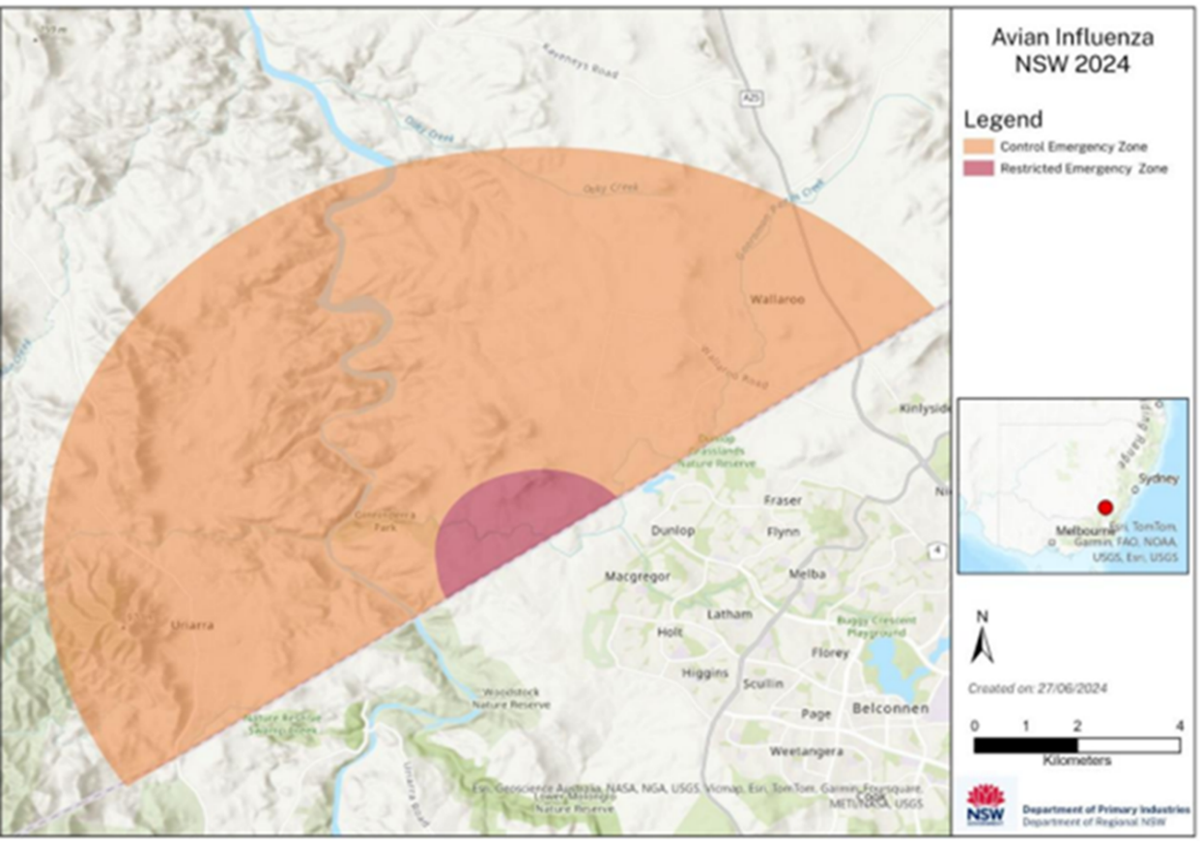

Region | Date Outbreak Resolved | Key | Map
Belconnen, ACT | 31 Oct 2024 | Map as at 28 June 2024.  Red shade: Restricted areas  Orange shade: Control areas  Note: There are no infected premises in this area, as it was established given the proximity to the infected premises in the ACT in the below image. | 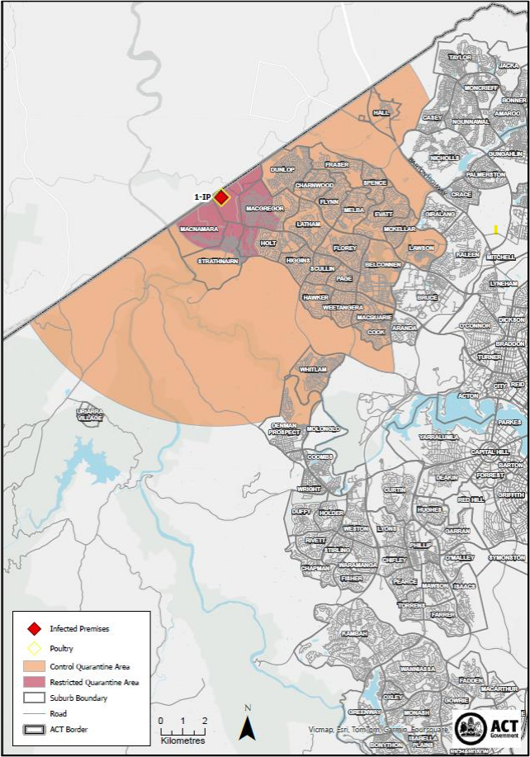

Region | Date Outbreak Resolved | Key | Map
Euroa, VIC | 13 June 2025 | Map as at 28 April 2025.  Red shade: Restricted area  Yellow shade: Control area | 