**Exporter registration and searching for identifiers in TRACES-NT**

Once registered in TRACES-NT, it is possible to search for Consignee and Place of Destination Identifiers.

**Advice to exporters on registering in TRACES-NT**

1. Go to <https://webgate.ec.europa.eu/tracesnt/login> .
2. Click on ‘Request an access’ on the right hand side.

1. Fill out the form and follow all instructions until you are successfully logged in to the EU Login website.
2. Click on <https://webgate.ec.europa.eu/tracesnt/login>.
3. Click on ‘Log in’ and use the same password you just created.

1. Once in TRACES, Select “Actors” and then “Operators” from the dropdown.  
     
   Graphical user interface, text, website

   Description automatically generated
2. Add the ‘activity’ ’ of ‘exporter’ to your company profile (you can follow the instructions in [Create a new Operator in TRACES.NT (europa.eu)](https://webgate.ec.europa.eu/tracesnt-help/Content/D_User%20Management/create-a-new-operator-in-TRACES.NT.htm)).
3. Once you have successfully created your new profile, email [exdoc.helpdesk@awe.gov.au](mailto:exdoc.helpdesk@awe.gov.au). The EXDOC Helpdesk will check the registration, validate it, and add the TRACES-NT ID (the Activity identifier) to your EXDOC exporter profile.

**Locating the correct ID for an exporter, importer or place of destination  
EU TRACES-NT**

For an eCert to be accepted by EU TRACES-NT, the EU TRACES-NT valid Activity Identifiers must be supplied for the exporter, importer, place of destination and establishments. Once you have access, you can locate all these by searching in EU TRACES-NT.

1. Search for the company’s EU TRACES-NT details by either searching on their name or using the Advanced search to filter by country.
2. The Activity Identifier number is found on the search results page in the unlabelled column, shown in the snip below with the large red arrow. Please note that identifiers located in the Identifiers column, are the wrong identifiers and will not work. A red cross has been used to highlight an incorrect identifier in the snip below.

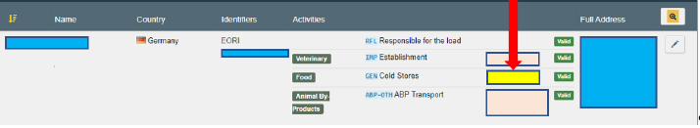

1. The Activity Identifier ID is also visible in the full record and is labelled as “identifier”.

