This document is an attachment to the Goulburn Monitoring Evaluation and Research (MER) Plan and describes additional project services to be undertaken. Please visit <http://www.environment.gov.au/water/cewo/publications/mer-plan-goulburn-2019> to read the entire Goulburn MER Plan.

Information about the Commonwealth Environmental Water Office Monitoring, Evaluation and Research Program (Flow-MER) is found at <http://www.environment.gov.au/water/cewo/monitoring/mer-program>

*Note that all projects will comply with Covid-19 pandemic restrictions and may require changes to activity and timelines.*

Schedule 6 –Work Order

|  |
| --- |
| **Order** |
| The parties have agreed in accordance with clause 7 the Agreement that the Provider will provide the Additional Project Services specified in this Work Order. |

**Goulburn MER Collaborative Research Project**

| **Item** | **Description** | **Clause** | **Details** |
| --- | --- | --- | --- |
|  | **Agreement description** | N/A | Agreement for Additional Project Services in respect of Long-form Services Agreement Commonwealth Environmental Water Office: Monitoring, Evaluation and Research Services for the Goulburn River Selected Area – 18 March 2019 |
|  | **Names of Parties to the Agreement** | N/A | The Commonwealth of Australia as represented by the Department of Agriculture, Water and the Environment  ABN 34 190 894 983  University of Melbourne  ABN: 84 002 705 224 |
|  | **Additional Project Start Date** | 1.1 | From the date of approval by CEWO of the Work Order |
|  | **Additional Project Timeframe** | 1.1 | From the date of approval by CEWO of the Work Order to 30 December 2022 |
|  | **Category of Services** | 7 | Research |
|  | **Additional Project Services** | 7 | **Project Planning**  Team members prepare for and attend a 0.5 day workshop at which they will agree on the focal area for the research project. Both preparatory activities and the workshop will build upon the substantial development work done during the preparation of the MER Plan in 2019.  Workshop outcomes will be developed into a detailed research plan to be completed in final form by September 30, 2020. The plan will include full budgeting of activities through to December 2022, including full methods, personnel, equipment and budget  **Project Delivery**  It is expected that different disciplines will conduct fine-scale research activities at a common set of sites, with field work coordinated where possible to achieve efficiencies in sampling.  Data collection is expected to be largely field-based, potentially with some laboratory work required for processing field-collected samples. Discipline leads will undertake data pre-processing, with inferential analyses undertaken at the University of Melbourne using a model analogous to the Core Monitoring Program.  Disciplines will contribute to a section for the Goulburn MER Annual Report. Time required for preparation of journal papers is not included in the budget, with staff contributing this as an in-kind contribution. Continual communication among discipline leads will be required to adequately interpret project findings.  During project delivery, the Research Plan will be reviewed and revised as knowledge accumulates. This will be done through meetings and other communications of the research team.  See Attachment A for more details |
|  | **Subcontractors** | 6.5 | Arthur Rylah Institute for Environmental Research ABN: 90 719 052 204  Goulburn Broken Catchment Management Authority: ABN89 184 039 725  Jacobs Pty. Ltd. ABN: 37 001 024 095  Monash University ABN: 12 377 614 012  RMIT University ABN: 49 781 030 034  Streamology Pty. Ltd. ABN 34 336 739 136 |
|  | **Progress meetings and reports** | 11 | **Meetings**   * The workshop meeting described at Item 6 * Meetings of the research team as necessary for ongoing review of research plans during the term of the project * Provide updates to each Working Group meeting * Provide verbal updates to CEWO when required   **Reports**   * Provide brief written content describing this activity to incorporate into the Core Program quarterly outcomes newsletter * Report research activities and outcomes as part of the Goulburn MER Annual Report |

|  |  |  |  |
| --- | --- | --- | --- |
|  | **Performance Criteria** | 12 | The following Performance Criteria will apply to the Additional Project Services specified in the Work Order:   * Must be undertaken in accordance with the Work Order. * Must be completed to a professional standard. * Must address relevant feedback provided by the CEWO. * Must be undertaken in accordance with the dates and timeframes specified in the Work Order * Outcomes must be included in the annual Goulburn MER report in accordance with the agreed standard format and template |

Attachment A

Goulburn MER collaborative research project

# Introduction

The Goulburn MER Program provides an opportunity to fund collaborative research projects that:

* Build on what we’ve learnt and improve understanding of the processes that drive ecological response to flow
* Address knowledge gaps in our understanding of flow responses, including identification of factors other than flow that may limit responses
* Improve ability to respond to emerging issues / trends / threats / adaptively manage flows for the best outcomes
* Contribute to integration across the basin.

# Research questions

Through the development of the Goulburn MER Plan a range of research questions were identified to help better understand the relationships between in-channel flow, hydraulic habitat conditions and ecological response. We’ve now expanded on those themes a little to consider off-channel habitats and a consideration of interactions between different biotic groups.

1. What are the in-channel or off-channel habitat types (e.g. slack waters, backwaters, benches, flood-runners, etc. with different hydraulic characteristics) that are particularly important for ecological processes, specific organisms, or life history stages in the Goulburn River, including the interaction among organisms?
2. Does the distribution and quality of these habitat types change with different flow rates?
3. Can flow rates be manipulated to optimise the availability of habitat types that are shown to be important, or to minimise impacts on these habitats during river operations (e.g. IVT flows)?
4. Can we quantify or demonstrate interactions between the different groups of organisms that we monitor in the MER Program?

Efforts to develop these questions will build upon the substantial preparatory work done during development of the MER Plan in 2019, but we will not necessarily be restricted to specific questions developed during that process.

# Why is it important to answer these questions for the Goulburn River?

Evidence in the literature suggests that certain habitat types are important for various ecological processes, life history stages, species interactions, etc. (e.g. as areas for organic carbon retention and processing, low-flow refuges for larval and juvenile fish, sites of sediment and seed deposition, etc.). EWKR research has identified the importance of anabranches and floodplain wetlands as sources of carbon and zooplankton for fish food, and that these habitats generate more ‘food’ than main channel habitats.

In this context, the proposed research program aims to identify which habitats in the Goulburn River are particularly critical to the river’s ecological function including both direct responses of organisms to the habitats and indirect responses through interactions with other organisms. Can such habitats be optimised through flow manipulation?

# How will we answer these questions?

We propose a collaborative project with a focus on first, understanding which particular habitats / characteristics are important for biota, ecological processes, and species interactions occurring in the Goulburn River; and second, determining the distribution of important habitat types and identifying flows required to optimise these habitat types.

The following outlines a suggested process for the project (this is based on some feedback on an earlier project summary prepared during the MER Plan development):

1. **Question refinement / hypotheses development.** Convene a project team workshop to elicit the hydraulic conditions / physical characteristics that are expected to be important for plants, fish, macroinvertebrates, ecosystem processes, and the interactions among these. We can use our conceptual model (below) to reflect on our current understanding / beliefs of important linkages and identify where there are still gaps (i.e. the question marks in the conceptual model), or where there is an apparent link but there is an opportunity to quantify or demonstrate that link more explicitly (i.e. a tick that needs more evidence to demonstrate with high confidence). At this workshop we would refine our research questions and develop hypotheses for testing. Inputs for the workshop will be i) the potential questions and rankings developed during the MER Plan process in 2019, ii) independent inputs from each discipline lead prior to the workshop re-eliciting priority research questions in the context of the conceptual model below.

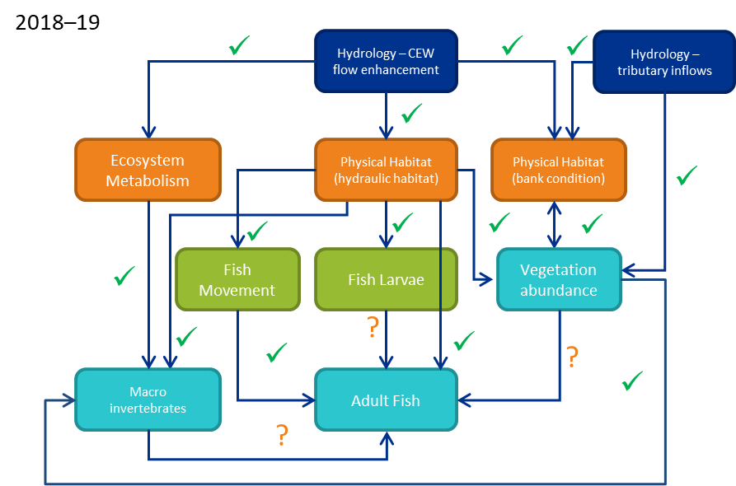

**2018-19 updated conceptual model of the linkages among the different monitoring matters in the lower Goulburn River Long-Term Intervention Monitoring Project (modified from Webb et al. 2018). The blue ‘hydrology’ box is the ultimate cause – flow enhancement with Commonwealth environmental water, plus with the addition now of unregulated tributary inflows as an additional major hydrologic driver; orange boxes are physical effects of this, with flow on effects to intermediate (green) and ultimate (aqua) environmental variables. Arrows are hypothesized causal linkages posed at the start of the LTIM Project (with several added since as well). Ticks are linkages that we believe have been demonstrated by the monitoring data, or at least strongly suggested. Question marks are linkages that are yet to be demonstrated. No linkages have been disproved throughout the program.**

1. **Map habitats**. Use existing hydraulic models to map hydraulic habitats identified in the workshop as important for each taxa or ecological process (at selected reaches).
2. **Field investigations.** Use maps to target investigations at sites that span a range of hydraulic conditions ranging from optimal to sub-optimal for each taxa or ecological process to validate relationships. This does not necessarily mean that all investigations would take place at the same locations.
3. **Data mining.** Look for opportunities within existing data sets to reanalyse data in light of the above hypotheses.
4. **Analysis and reporting**. Asses against hypotheses, validate relationships, update conceptual model, identify flow bands for optimising habitats / hydraulic conditions, incorporate outcomes into refinement of water delivery (both for environmental flows and water supply delivery).

The above steps are open for discussion, but the first task is to run a workshop (booked for 12 June 2020) to refine the questions / hypotheses and establish the basis for field investigations.

# Workshop outputs

By the end of the workshop, we will commit to have:

* Agreement on the priority hypotheses / questions that we want to address in the collaborative research project.
* Allocated roles to team members to develop research plans for the priority hypotheses and a timeline for their development (for implementation over spring / summer 2020-21).
* Discussed capacity to deliver the research program in terms of fieldwork, data analysis, write-up of results.

# Proposal development

The first major milestone for the project will be a detailed project proposal to be delivered to CEWO by 30 September 2020 (we expect some research activities to be under way by then). The proposal will describe proposed research activities through to December 2022, including:

* Specific hypotheses to be tested in different disciplines
* Field and associated laboratory methods needed to collect data
* Schedule of field sampling including timing and frequency
* Data preparation and analysis required
* Detailed budget required for each activity, costed using the same rates as during development of the Core monitoring program

# Project delivery

Research is expected to begin in Spring 2020, following the detail of the final proposal. We envisage up to 2 years of data collection, with the final phase of the project focusing on reporting and other communications of findings.

While research will be driven by this program for the duration of the project, we will periodically review and revise the plan in light of emerging knowledge and preliminary findings. There may be variations in detailed research questions, methods or balance of activities.

# Reporting

Project progress and outcomes will be primarily reported through the Goulburn MER Annual Report and through the Quarterly Outcomes Newsletter. We intend to write one or more journal papers from the findings, with the additional time to develop these being an in-kind contribution of the Goulburn MER Program team. We will present findings of the research at community forums developed through the Communications and Engagement program, the MER Annual Forum and other community events. We will also present findings at local and international conferences.