Comparing the 2021-22 agricultural season to previous years - August 2022
Australia exported a record $65 billion in agricultural products in 2021-22. While 2021-22 was an unusual year, domestic and international conditions mean we could be in for another year of high production and high prices in 2022-23.

Consecutive La Niña events and high commodity prices
- The value of agricultural exports is largely determined by production conditions at home and commodity prices abroad.
- Above average rainfall and strong prices are good news for the agriculture sector.
- Rising input costs and storm damage have offset the benefits in some regions.

How do Australian grain exports in 2021-22 compare to previous years?
- High production and high prices led to record grain exports in 2021-22.
- Figure 1 shows the volume and value of grain exports for every year since
2000-01 and the forecast for 2022-23.
  - Data points further to the right indicate higher export volumes, while data points towards the top indicate higher export values.
- Price changes the relationship between the total volume and total value of exports.
  - For example, high prices in 2012-13 meant the value of exports was higher than in 2016-17, despite lower export volumes.
- 2021-22 (orange dot) had both the highest volume and value of trade over the last two decades by a substantial margin.
- The forecast for 2022-23 (red dot) indicates that another unusual season could be on the way

Figure 1 - The value and volume of Australian grain exports 2000-01 to 2022-23f
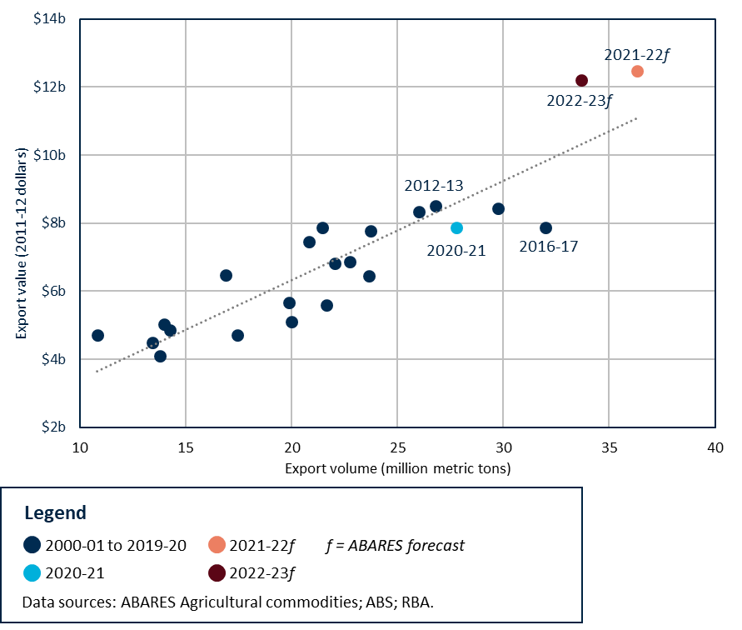

How do Australian meat exports in 2021-22 compare to previous years?
- Beef and sheepmeat producers are rebuilding their herds after years of drought. This has reduced Australian meat production and export volumes.
  - Competition between farmers to purchase stock and strong global demand for meat have pushed average Australian saleyard prices higher since 2018-19.
- Figure 2 shows the impact of high prices on the total value of Australian meat exports.
- The volume of Australian meat exports in 2021-22 (orange dot) was slightly below the 2000-2021 average.
- Despite lower than average export volumes, the value of meat exports in 2021-22 were the third highest since 2000-01.
  - This shows that high prices offset the impact of reduced export volumes in terms of overall export value.
Figure 2 - The value and volume of Australian beef and sheepmeat exports 2000-01 to 2022-23f
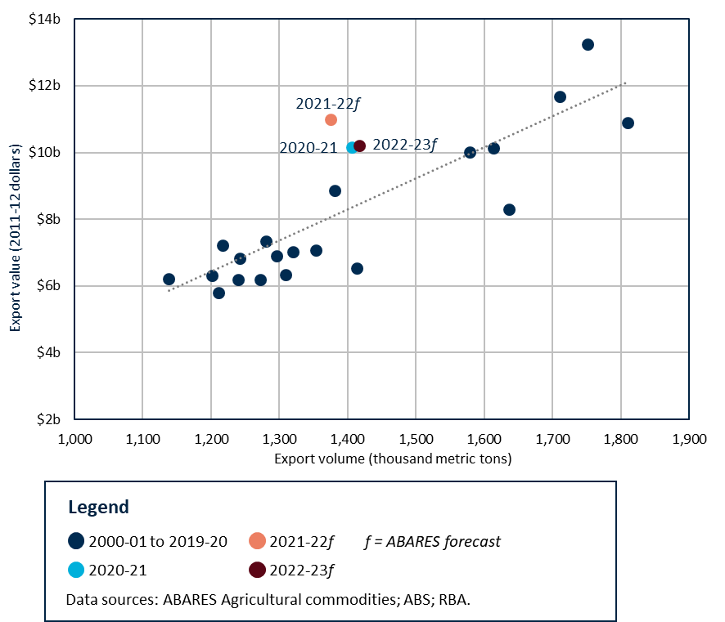

Will we see another year like 2021-22?
- Forecasts for 2022-23 (maroon dot) indicate that another ‘unusual’ year could be on the way.
- There is a 50% chance of a third consecutive La Nina developing later in 2022.
- Wet conditions and high international food prices increase the likelihood of a similar season in 2022-23.

