Australian hazardous waste data and reporting standard

2017 revision

prepared for

The Department of the Environment

for distribution to the Australian states and territories

by



in association with:



June 2017

Australian hazardous waste data and reporting standard

2017 revision: P726

June 2017

Disclaimer

This report has been prepared for Department of the Environment in accordance with the terms and conditions of appointment dated 30 May 2016, and is based on the assumptions and exclusions set out in our scope of work. Information in this document is current as of May 2017. This report has been compiled based on secondary information and data provided by other parties; as such it relies on the accuracy of the provided material. Although the data has been reviewed, the information provided was assumed to be correct unless otherwise stated.

While all professional care has been undertaken in preparing this report, Blue Environment Pty Ltd cannot accept any responsibility for any use of or reliance on the contents of this report by any third party.

© Department of the Environment and Blue Environment Pty Ltd

Blue Environment Pty Ltd

ABN 78 118 663 997

Suite 208, 838 Collins Street, Docklands Vic 3008

email: [blue@blueenvironment.com.au](mailto:blue@blueenvironment.com.au)

web: [www.blueenvironment.com.au](http://www.blueenvironment.com.au)

Phone +61 3 9081 0440

+61 3 5426 3536

Blue Environment prints on 100% recycled content paper

Author

Joe Pickin

Reviewers

Geoff Latimer, Paul Randell

CONTENTS

1. Introduction 2

2. Key terms and definitions 4

3. Hazardous waste classification 8

4. Hazardous waste tonnage data 11

5. Hazardous waste source sectors 15

6. Hazardous waste management (pathways, fates and receiving infrastructure) 16

7. Hazardous waste data management and reporting 20

Appendices

A How this standard was developed 24

B Waste codes maps 26

C Principles for codifying hazardous waste 29

D Gaps in waste tracking systems 37

E Unit conversion factors 39

F Hazardous waste management types map 41

G Hazardous waste management typology (long-term) 43

H Hazardous waste infrastructure typology 45

I National reporting of hazardous waste 48

Tables

Table 1: Assumptions about source stream, where not known 15

Table 2: Responsibilities in relation to hazardous waste data management and reporting 22

Table 3: Consultees in developing this document 24

Table 4: Descriptively coded wastes 29

Table 5: Example wastes for selected NEPM codes 30

Table 6: National reporting of hazardous waste data 48

Figures

Figure 1: Illustration of the typology and process for classifying hazardous waste 8

Figure 2: Considerations in determining whether hazardous waste data from the states and territories should be supplemented or adjusted using alternative data sources 12

Figure 3: A simplified schematic of annual flows of hazardous waste 14

Figure 4: Hierarchy of terminology for hazardous waste management 19

Abbreviations

|  |  |
| --- | --- |
| ANZSIC | Australian and New Zealand Standard Industrial Classification |
| Basel Convention | Basel Convention on the Control of Transboundary Movements of Hazardous Wastes and Their Disposal |
| NEPM | *National Environment Protection (Movement of Controlled Waste between States and Territories) Measure* |

# Introduction

National Australian data on hazardous waste is required for several purposes, including annual reporting under the Basel Convention and periodic domestic reporting*.* Intrastate movements of hazardous waste are substantial, and there is a need for an Australian-wide understanding of the sources, types, fates of hazardous wastes and of the availability of infrastructure to deal with them. The Basel Convention also contains obligations regarding domestic management of hazardous waste, as well as data and reporting.

For national reporting purposes, the Australian Government relies on data collected and submitted by the states and territories, which have legislative responsibilities for wastes generated in their jurisdiction. However, compiling a national data set is not straightforward due to gaps and disparities in state and territory systems for collecting, collating and reporting hazardous waste data. These gaps and disparities reflect the differing development of jurisdictional legislation, policy, regulation and licences for controlling hazardous waste.

This national standard for hazardous waste data and reporting is intended to help alleviate some of the data collation difficulties and also diminish the differences between regulatory systems, reducing costs and providing more certainty for regulators and businesses. The standard guides data management systems and processes and, where the guidance differs from the current system in a state and territory, represents a reference for opportunistic and voluntary adoption where convenient.

The standard seeks to:

* clarify key terms and definitions
* establish principles and processes for classifying hazardous waste
* set out methods for obtaining, adjusting and collating national waste tonnage data
* institute standardised approaches for classifying and reporting hazardous waste source sectors and hazardous waste pathways, fates and receiving infrastructure
* confirm methods for managing hazardous waste data
* be consistent with relevant standards and guidance[1].

Adoption and implementation of this standard would also oblige various governments to take various actions. For example, it would require minor changes to the *National Environment Protection (Movement of Controlled Waste between States and Territories) Measure* (the NEPM). It should therefore be reviewed with care by the Australian, state and territory governments.

The Australian Government has an ongoing reform program in the area of hazardous waste. It involves working with the states and territories in multiple ways to improve the quality and efficiency of hazardous waste management, tracking and data in Australia. This standard is not the last word in the area of waste data, and is likely to require revision on an ongoing basis. Any such revisions will occur in consultation with the states and territories.

The *Hazardous waste data and reporting standard* was developed by a consortium of consultants led by Blue Environment and supported by Randell Environmental Consulting and Ascend Waste and Environment. The project process is summarised in Appendix A.

This version of the standard was produced for testing during preparation of Australia’s 2015 report to the Basel Convention and *Hazardous waste in Australia* covering financial year 2014-15. These two projects are being undertaken by the consortium of consultants that developed the standard, and are due for completion in early 2017. In undertaking the two project, the consultants will follow, and test the applicability of, relevant aspects of the guidance in this document. On completion, this test version of the standard may be amended and/or supplemented accordingly.

### Document structure

Section 2 defines and explain key terms used in this document. This is followed by five sections covering different aspects of hazardous waste data and reporting: classification; tonnage data; source sectors; management; and data management and reporting. In each case, a brief introduction is followed by a series of brief ‘items’ specifying a standard approach, some of which refer to detail in appendices.

# Key terms and definitions

The following list is intended to provide clear and consistent terminology for national conversations on hazardous waste, and to clarify terms used in this document. The terminology is consistent with other authoritative Australian documents[2] but terms are listed here only when they are relevant to the purpose of this document. Terms are listed in alphabetical order. References to terms listed here are shown in red.

### Arising (of hazardous waste)

The term ‘arise’ is used in relation to hazardous waste data derived from tracking systems. Waste ‘arises’ when it is delivered to hazardous waste infrastructure. This is distinct from ‘generation’, a term commonly used in waste reporting, in that if a given mass of hazardous waste is transported to more than one site during a data period, the it may ‘arise’ more than once in the tracking system data.

### Basel Convention

The *Basel Convention on the Control of Transboundary Movements of Hazardous Wastes and their Disposal*; an international agreement signed by Australia.

### Characterisation and categorisation (of the hazard)

In the classification process for a hazardous waste, when designation does not unambiguously show the material is a hazardous waste, then an understanding of its hazardous characteristics is required through characterisation and categorisation.

* Characterisation is the determination of whether the waste exhibits one or more *hazard characteristics* such as flammability, reactivity, infectiousness or toxicity. The latter involves determining whether the waste contains any of a selection of constituents – typically *chemical contaminants* – at levels above those prescribed as acceptable.
* Categorisation is the process of placing the waste into a ‘category’ of relative hazard, based on comparison of the level of the constituent in the waste against its prescribed upper limit for each category.

Characterisation and categorisation may involve laboratory testing using methods usually prescribed or recommended in guidance. Such guidance will include the hazard categories developed to direct the management of the waste down different paths depending on the level of hazard. Concentration and solubility may both be significant in the characterisation process. The combination of designation and characterisation/ categorisation answers the question of whether the waste is hazardous or not; definitively, clearly and transparently.

### Classification (of hazardous waste)

The regulatory process of determining if a waste should be considered hazardous, and if so how it should be described with reference to a list of waste codes. This process can be understood via a three level typology[3]: (1) designation; (2) characterisation and categorisation of the hazard; and (3) codification. See Section 3 for more detail.

### Codification (of a hazardous waste)

In the classification process, when the process of designation and/or characterisation and categorisation have determined that a waste is, in fact, hazardous, then it must be codified. This is giving the waste a name, code and/or description as part of some system. Two examples of codification systems are:

* the alphanumeric codes and descriptions in the NEPM, with 75 codes listed in Schedule A List 1 of the NEPM grouped into 15 broader categories for reporting purposes
* the Y-codes used for reporting under the Basel Convention.

### Controlled waste

Waste as defined in the NEPM. The NEPM’s list of controlled wastes is the primary reference for codification of hazardous waste in a national reporting context in Australia.

### D and R codes

A set of 28 codes (D1 to D15, and R1 to R13) established under Annex IV of the Basel Convention that represent different types of fates for hazardous waste within the broad groups of disposal and recovery/recycling/reuse.

### Designation (of a waste as hazardous)

An element of the hazardous waste classification process involving the high-level determination, usually via regulation, of whether a waste is hazardous. Designation is based on ‘in or out’ questions such as:

* Does the waste meet a broad regulatory definition for hazardous waste?
* Does it unambiguously appear on an *inclusionary* list?
* Does it unambiguously appear on an *exclusionary* list?

An *inclusionary list* is a specific list that nominates a waste as hazardous based on: inherent chemical or physical characteristics (e.g. ‘highly odorous organic chemicals’); a description of the process/ industry from which it arises (e.g. ‘tannery wastes’); or the article or product from which it derives (e.g. ‘waste pharmaceuticals, drugs and medicines’). An *exclusionary list* may form part of a hazardous waste definition of specify exemptions to a category (e.g. intact or partly disassembled televisions in Queensland).

In some cases, the answer to the ‘is it in, is it out’ question is obvious. In others, a waste is not conclusively designated as hazardous, and classification must be informed by characterisation and categorisation of the waste.

### Fate (of hazardous waste)

Waste fate refers to the ultimate destination of the waste within the management system. Types of fate may include recycling, energy recovery, long-term storage and disposal, each of which categories can be divided into more specific fates. Treatment, transfer and short-term storage are not fates, but are rather part of the pathway leading to a fate. See Section 6 for more detail.

### Generation (of hazardous waste)

The process of creating a waste. For data purposes, generation of non-hazardous waste is normally taken as the sum of waste disposed of, recycled or sent for energy recovery. Generation of hazardous waste is more difficult to estimate because data on the tonnages to each of these fate types is not always readily available, and additional pathways, such as storage or treatment, may be taken by hazardous waste on route to its final fate.

Typically, in Australia, waste is not considered generated until it leaves a site, but this is not the case under the Basel Convention. Within this standard, waste that has hazardous characteristics and has been stored on a site for more than one year should be considered hazardous waste (see the definition of hazardous waste storage). For national reporting purposes, any additions of similar hazardous wastes to such stores will be regarded as generated in the year of addition.

### Hazardous waste

Waste that, by its characteristics, poses a threat or risk to public health, safety or to the environment[4]. In national reporting this term is taken to correspond with:

* wastes that cannot be imported or exported from Australia without a permit under the Hazardous Waste (Regulation of Exports and Imports) Act 1989
* wastes that any jurisdiction regulates as requiring particularly high levels of management and control, namely: regulated waste (Queensland); trackable waste (New South Wales); prescribed waste (Victoria); listed waste (South Australia and NT); or controlled waste (ACT, Tasmania and Western Australia)
* additional wastes nominated as hazardous by the Australian Government[5].

In addition, waste that has hazardous characteristics and has been stored on a site for more than one year should be considered hazardous waste.

NSW (along with the ACT[6], due to their adoption of NSW classification procedures) uses the term ‘hazardous waste’ in a specific regulatory sense. The NSW *Protection of the Environment Operations (Waste) Regulation 2005* and associated guidance defines ‘hazardous waste’ as one of six classes of waste – and it typically cannot be disposed at landfill without hazard reduction treatment such as immobilisation. ‘Hazardous waste’ in this strict NSW (ACT) regulatory interpretation is equivalent only to those *hazardous wastes* (in national reporting terminology) that would be categorised at the higher hazard end of the range.

### Infrastructure groups (for managing hazardous waste)

A typology applied to infrastructure that accepts and managed hazardous wastes, as applied in a database maintained by the Australian Government. See Section 6 for more detail.

### Management / management type (of hazardous waste)

For the purposes of this document, management of hazardous waste comprises the activities through which it is dealt with in infrastructure approved to receive it. The types of management are recycling, energy recovery, long-term storage, disposal, treatment and short-term storage. The first four of these are a type of fate; the last two are a type of pathway.

### NEPM

The *National Environment Protection (Movement of Controlled Waste between States and Territories) Measure*, an agreement between the Australian Government and the states and territories on the regulation of hazardous (controlled) waste movements between Australian states and territories.

### Pathway (of hazardous waste)

The various steps in the route between hazardous waste generation and fate, potentially including transfer, storage and/or treatment.

### Source (of hazardous waste)

Where a waste is generated. This may be applied to a location (e.g. state or territory) or to a company or industry sector.

### Storage (of hazardous waste)

Accumulation in approved infrastructure, typically while awaiting the development of appropriate and cost effective infrastructure or processes, or while building economically viable quantities for transfer and management. Storage can be considered ‘short-term’ only when there is a plan and reasonable expectation that the term of storage will be less than 10 years.

Waste that has hazardous characteristics and has been stored on a site for more than one year should be considered hazardous waste.

### Stream (of waste)

The main source types, namely: municipal solid waste; commercial and industrial waste; and construction and demolition waste.

### Tracking (of hazardous waste)

Most states[7] operate systems for ‘cradle to grave’ tracking of the movement of each consignment of hazardous waste from point of generation to treatment or disposal. The purpose of these systems is to provide a safeguard against inappropriate or illegal management. Tracking certificates must be created when a waste leaves a facility and when it reaches the receiving facility. They state the type and quantity of waste, the dates, and the producer, transporter and details of the receiving facility. Copies are sent to the government. Certificates may be electronic or paper based, depending on the jurisdictional system.

### Treatment (of hazardous waste)

The removal, reduction or immobilisation of hazardous characteristics to enable the waste to be sent to its final fate or further treatment.

### Typology

A system used for putting things into groups according to how they are similar.

# Hazardous waste classification

The differences in jurisdictional systems for hazardous waste classification are deeply embedded in legislation, regulation and licensing, and cannot be easily harmonised in the short-term. These differences add a layer of uncertainty in national reporting and increase complexity and cost for businesses operating nationally. The elements of this standard are intended to help resolve the discrepancies over time.

Most jurisdictions have developed and regulated their own codification systems, which generally mirror NEPM codes. However, some wastes could potentially be included in more than one code. Examples: a waste may be contaminated with multiple chemicals and therefore validly placed in multiple codes; soils contaminated with asbestos could potentially be coded (in some states) as *N120 Soils contaminated with a controlled waste* or *N220 asbestos contaminated material*. Discrepancies in coding methods undermine the quality of hazardous waste data, including examination of trends.

1. Classification method

Wastes should be classified using an approach similar to the three level step-by-step process[8] shown in Figure 1 and with terms explained in Section 2. The process is:

1. *Designation*, which involves checking the waste against pre-defined regulatory definitions and lists.
2. *Characterisation and categorisation*, which may involve laboratory testing, and is necessary if designation is inconclusive. Steps 1 and 2 will always determine if a waste is hazardous.
3. *Codification*, which involves giving the waste a name, code and/or description as part of some system.

Figure 1: Illustration of the typology and process for classifying hazardous waste

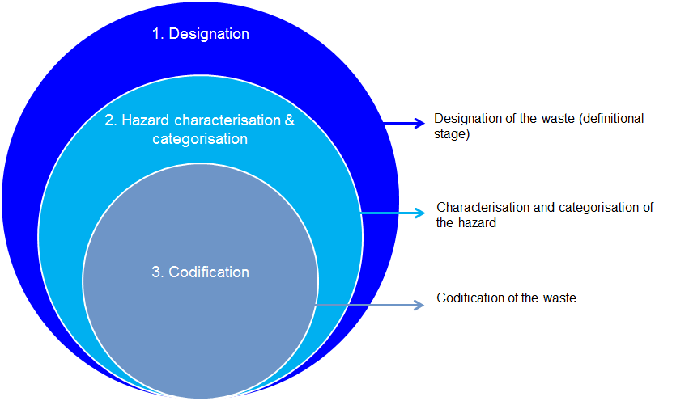

EPA Victoria’s *Solid industrial waste hazard categorisation and management guideline*[9] explains the Victorian system, a good example of the categorisation and characterisation approach.

1. Guidance for classifying hazardous waste

The Australian Government may produce or endorse guidance under this standard on:

* principles and methods for classifying hazardous wastes
* hazardous waste classifications, including risk-based contaminant thresholds, that specify whether a waste should be deemed hazardous.

Wastes should be classified in accordance with that guidance. (See also Item 8.)

1. Classifying new hazardous wastes

Periodically, ‘new’[10] hazardous wastes may come to the attention of regulators in any jurisdiction. When this occurs, the jurisdiction should liaise with other states and territories and the Australian Government concerning classification. On agreement, one government may take the lead in running the classification process on behalf of all, including laboratory-based characterisation of hazards and categorisation of contaminant levels. The Australian Government will update the NEPM codes to ensure they encompass any new wastes.

1. Classifying problematic hazardous wastes

Periodically, a government may receive intelligence that inconsistencies in jurisdictional classifications of a hazardous waste are particularly problematic for industry. Inconsistencies may, for example, cause difficulties in complying with transport requirements or tracking certification processes. When this occurs, the jurisdiction should liaise with other states and territories and the Australian Government in relation to the problem. On agreement, one government may take the lead in running the re-classification process on behalf of all, including laboratory-based characterisation of hazard and categorisation of hazards and categorisation of contaminant levels.

1. Classifying hazardous waste treatment outputs

Waste outputs from hazardous waste infrastructure should be designated hazardous unless they have been classified otherwise using the process set out in this standard.

1. Hazardous waste codes for national reporting

NEPM codes will be used for most national reporting. Jurisdictional waste codes will be converted to NEPM codes using the mapping process illustrated in Appendix B[11]. The national data set encompasses current Qld regulated waste; NSW trackable waste; Vic prescribed waste; SA and NT listed waste; and ACT, Tas and WA controlled waste with the following exceptions, which are excluded:

* NSW, Qld, SA and WA code K130 *Sewage sludge and residues including nightsoil and septic tank sludge*
* WA code K210 *Septage wastes*
* Vic and WA codes L100 *Car and truck washwaters*
* Vic and WA codes L150 *Industrial washwaters from cleaning, rinsing or washing operations, NOS*.

Where it considers it appropriate, the Australian Government may:

* include additional hazardous wastes[12]
* collate NEPM codes into other groups for convenient reporting[13].

The Australian Government, in concert with the states and territories, will review the list of wastes under the NEPM for relevance, including the potential for new waste codes. In order of priority, those most relevant for review include:

* N220 to be augmented with the addition of N221, for wastes contaminated with asbestos contaminated material.
* N205 biosolids (as N205a, N206 or K400).
* CSG wastes (currently reported against C100, D300 and N205). CSG wastes should be examined more closely through a follow-up study, which focuses on classifying the range of wastes, relative volumes and the identification of specific hazards of each.

States should verify the historical record of their hazardous waste arisings reported in the *National Hazwaste Data Collation*, including mapping of historical and spurious state waste codes to modern state waste codes where possible.

Basel reporting needs to occur using a different codification system: Y-codes. NEPM codes have been mapped to Basel Y-codes[14].

1. Principles for codifying hazardous waste

Users of waste transport certificates should codify wastes based on the guidance given in Appendix C.

1. Guidance for codifying hazardous waste

Through consultation with industry, the Australian Government and the states and territories should develop guidance on how industry users should code wastes. The principles and examples in Appendix C should form the basis of such guidance. Existing jurisdictional approaches and insights, such as those published by NSW[15] and WA[16] (note the latter’s Appendix B and *Guide to classification of category G wastes* in particular), should be utilised.

1. Gradual conversion to NEPM codes

As opportunities arise, states and territories should convert their codification systems to match that of the ‘NEPM 75’ list.

# Hazardous waste tonnage data

Standard approaches are needed for obtaining and reporting hazardous waste tonnage data. These must address several issues.

First, collated tracking system data does not provide a comprehensive and best possible data set. This is because:

* three jurisdictions do not track hazardous waste
* tracking systems do not all collect data on all hazardous wastes – a list showing which jurisdictions do not track particular codes is given in Appendix D
* alternative sources of data may be available that provide nationally consistent figures[17].

Item 10 addresses this issue.

Second, the representation in the data of hazardous waste that arises in one jurisdiction but is managed in another is variable. It is usually included in the data of the receiving jurisdiction, sometimes included in the data of the source jurisdiction, and sometimes both. This needs to be carefully handled. Item 11 addresses this issue.

Third, unwanted materials are generally recorded as ‘waste’ only when they move offsite. Materials stored on the site where they are generated are not recognised as waste. The Basel Convention, on the other hand, considers a waste hazardous due to its inherent characteristics rather than when those characteristics have the potential to cause harm off-site. Item 12 addresses this issue.

Fourth, tracking system data need adjusting to take into account that information may be collected in varied units: namely, numbers of items (e.g. drums and tyres); volume (e.g. many liquids); or mass. Item 13 addresses this issue.

Fifth, annual tonnage data is needed in different contexts. In some cases – for example in assessing the adequacy of infrastructure – waste ‘arisings’ data[18] is required in which a given mass of waste may be counted more than once if it passes through more than one type of infrastructure (e.g. a treatment plant then a landfill). In other cases – for example in compiling overall national waste accounts – waste ‘generation’ data is required in which a given mass of waste should be counted only once even if it passes through more than one type of infrastructure. The data obtained from tracking systems is waste arisings. To produce generation data from arisings data, adjustments are needed to correct for multiple counting of units of waste that is transported to more than one facility. Item 14Item 13 addresses this issue.

Finally, the quality of trend data is undermined if reports over time differ in relation to data availability, sources, assumptions and adjustments. Ideally, when these change then historical data should be reviewed and updated for consistency. Item 32 addresses this issue.

1. Sources of hazardous waste tonnage data for the national data set

Where available, tracking system data will be used as the primary source of national data on hazardous waste tonnages (with appropriate adjustments – see below). Gaps in the primary data set will be filled using additional data that the jurisdiction is able to provide from NEPM, facility or survey data. The tracking system and other data from jurisdictions may be supplemented or adjusted using other sources of data, such as from industry bodies, based on the considerations illustrated in Figure 2.

Figure 2: Considerations in determining whether hazardous waste data from the states and territories should be supplemented or adjusted using alternative data sources

a) *Where there is a gap in the hazardous waste tonnage data provided by a state or territory*

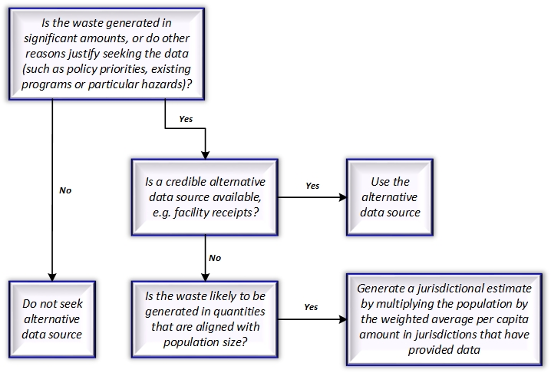

b) *Where there is no gap, but an alternative source is available that provides data for all or most jurisdictions, or a national figure*

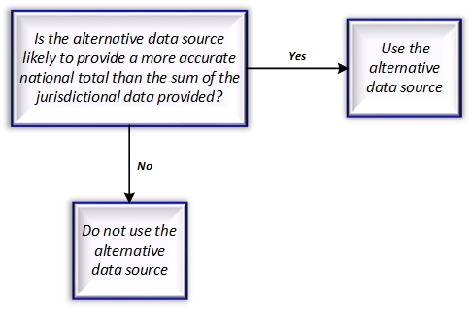

1. Scope of hazardous waste tonnage data for the national data set

The Australian Government will ask states and territories to confirm how their data represents hazardous waste that was transported to, or received from, interstate. Appropriate adjustments will be made. The adjustment methods will be transparent to enable state and territory review.

1. Onsite wastes in the national data set

The Australian Government will consult with the states and territories to attempt to identify and seek data on significant on-site stockpiles of hazardous waste, including through workplace health and safety regulators. Significant and quantifiable additions to such stockpiles during the reference year may be included in national hazardous waste data.

1. Unit conversion factors

A set of waste type-specific factors for converting volume measures and numbers of items to tonnes in included in Appendix E of this standard. These factors should be used by all states and territories and the Australian Government for converting hazardous waste data to a consistent tonnage basis.

1. Converting waste arisings data to waste generation data – multiple count adjustments

Hazardous waste arisings are the sum of waste tonnages sent to all types of hazardous waste infrastructure. In using arisings data to estimate hazardous waste generated, the Australian Government will exclude (to the extent the relevant tonnes can be identified):

1. hazardous waste sent to facilities for short-term storage or transfer
2. hazardous waste outputs of hazardous waste infrastructure – only inputs will be counted.

This is consistent with the definition of hazardous waste ‘generation’ given in Section 2[19].

As an example, consider the flow diagram in Figure 3 overleaf (the diagram is simplified – only ‘treatment’ is shown as producing hazardous waste outputs). Hazardous waste arisings would be the sum of the hazardous waste received by all infrastructure types = 2,400 kilotonnes. Hazardous waste generation would be arisings less the quantity of waste sent to short-term storage or transfer (300 kilotonnes) less the hazardous waste outputs of hazardous waste infrastructure (200 kilotonnes) = 1,900 kilotonnes.

The following techniques can be used for identifying the tonnages for subtraction (assuming Item 21 and Item 22 of this standard are adopted and implemented):

1. Waste sent to facilities for short-term storage or transfer is equal to the tonnes sent to management codes D13, D14, D15 and R13 (see Appendix G for descriptions).
2. Hazardous waste outputs from facilities that receive hazardous waste for recycling, energy recovery, treatment or long-term storage can be identified when these infrastructure groups are the source of the hazardous waste (see Item 22 and Appendix H). Alternatively, where this information is not available, NEPM code N160 *Encapsulated, chemically-fixed, solidified or polymerised wastes referred to in this list* provides an estimate of the hazardous waste outputs of treatment, which is likely to represent the bulk of the outputs from hazardous waste infrastructure.

Figure 3: A simplified schematic of annual flows of hazardous waste

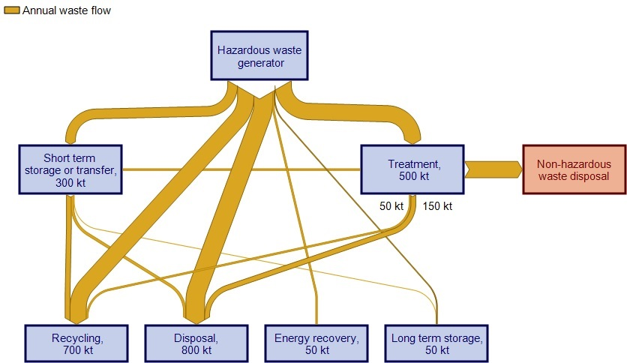

# Hazardous waste source sectors

Meaningful analysis of hazardous waste flows requires an understanding of industry source sectors. It is a requirement of the NEPM that source industry sectors are reported by Australian and New Zealand Standard Industrial Classification (ANZSIC) codes. However, current tracking systems do not all manage this well. In particular:

* usage rates by reporters are, in some cases, low
* hazardous waste tracking systems generally provide for recording source in codes that are adapted from ANZSIC codes, rather than in actual modern ANZSIC codes – and these adaptations differ
* particular waste loads may comprise material from more than one source
* some material is recorded as sourced from the waste sector when it was not transported from a waste industry premises, suggesting that the definition of ‘source’ is not always clear.

1. Recording source sector

States and territories should take measures to maximise the identification of source sectors in tracking system data.

1. States and territories to use ANZSIC codes

As opportunities arise, tracking systems should be converted to use only modern ANZSIC codes to record source sectors. Best practice is to use four digit ANZSIC classes only, because two-digit sub-divisions and three-digit groups are generally not definitive enough to describe a source clearly and, from a practical perspective, jurisdictional database structures housing ANZSIC codes usually require four digits.

ANZSIC codes can be analysed to determine the primary source stream from which a waste derives (i.e. municipal; commercial and industrial; or construction and demolition). Where this information is not available, the assumptions[20] specified in Table 1 will be applied.

Table 1: Assumptions about source stream, where not known

|  |  |  |  |
| --- | --- | --- | --- |
| Hazardous waste type | MSW | C&I | C&D |
| Contaminated soils | 0% | 28% | 72% |
| Asbestos | 0% | 46% | 54% |
| All other types of hazardous waste | 0% | 100% | 0% |

1. Recording of source sector where there are multiple sources

In tracking systems, where a waste load derives from more than one source, the recorded source should be the one that provides the greatest proportion.

1. Recording of source sector where waste passes through a chain of handlers

A waste may pass down a chain of handlers. For example, it could be picked up by an agent and taken to a licensed storage premises, then subsequently delivered to a treatment facility that sends treated material and residuals to various other premises. In all cases, the recorded source sector should be the ANZSIC code of the facility or facilities from which the transport vehicle collected the material.

# Hazardous waste management (pathways, fates and receiving infrastructure)

Meaningful analysis of hazardous waste flows requires an understanding of the facilities to which waste is delivered, including pathways as well as fates, and what happens to it there. This detailed knowledge of various steps in the route between generation and fate provides the transparency and evidence for environmentally sound management of a waste to be assessed.

At the time of writing, state tracking systems include a category called ‘treatment’, ‘treatment type’ or ‘treatment method’. The current arrangements for recording information under this data category are inadequate for national data needs in several ways:

1. Use of the word ‘treatment’ in this context is confusing. It refers to the fate or pathway of hazardous waste, but the term is also used to represent a particular pathway and infrastructure type in which hazardous waste is processed to reduce the hazard. The term ‘management method’ would be better (see the definitions for ‘treatment’ and ‘management’ set out in Section 2).
2. The typologies under these ‘treatment’ headings vary from state to state, making it difficult to compile a national data set. In Qld and Vic, some users continue to report historical treatment types that are no longer officially in use.
3. The various types of hazardous waste ‘treatment’ cannot always be readily linked to the analogous fate types used for reporting non-hazardous wastes (disposal, recycling, energy recovery). This isolates the reporting of hazardous waste from non-hazardous waste. This is not ideal given that hazardous and non-hazardous wastes are often generated and managed by the same companies and end up in similar infrastructure.
4. The Australian Government has developed a database of hazardous waste infrastructure. This is intended to improve infrastructure planning by allowing the correlation of capacity data with waste quantity data and projections. A typology of infrastructure types is required that can be readily mapped to waste fates and pathways. Current state systems to not readily facilitate this mapping.

To fix these four areas of inadequacy is not straightforward – amendments would be needed to data systems within all five state tracking systems, which would take considerable time under the most optimistic scenarios. Therefore, in relation to this issue, this standard establishes different approaches for the short-term and long-term:

* *Approach for the short-term* – establish a system for mapping state categories of ‘treatment type’ to a common national typology (see Item 20).
* *Approach for the long-term* – establish three data categories
  1. hazardous waste management
  2. hazardous waste management type
  3. hazardous waste infrastructure group.

The three data categories for the long-term are discussed below.

*a) Hazardous waste management*

The current ‘treatment type’ categories are better considered as management within the receival infrastructure (see Item 19). The most suitable basis for a standard typology of management is Annex IV of the Basel Convention. This establishes a set of 28 D and R fate codes comprising 15 disposal classes (D1-D15) and 13 “processes that may lead to resource recovery, recycling, reclamation, direct reuse or alternative uses” (R1-R13). Qld and Vic both use D and R codes, but have each adapted them in slightly different ways.

Not all D and R codes are relevant to Australia – for example, D6 *Release into a water body except seas/oceans* is not needed. Similarly, some codes need amendment, aggregation or disaggregation to make them relevant. For example, *D10 incineration on land* and *D11 incineration at sea* could be merged and amended to a single code *Thermal treatment without energy recovery.* In addition, corresponding with the definitions of fate and pathway in Section 2, there is a need for disaggregation of the D and R codes to provide for treatments (T codes) that are neither disposal nor recovery.

Item 21 addresses these issues.

*b) Hazardous waste management type*

The various processes undertaken within receival infrastructure need to be classified according to whether they are a type of disposal, recycling, energy recovery, consistent with the classification of non-hazardous waste fates. Some management types for hazardous waste infrastructure do not fit the classification applied to non-hazardous waste:

* Long-term storage is an additional fate applicable to hazardous waste. This is defined in this standard to refer to an intended period of at least 10 years.
* Several management activities can be considered ‘pathways’, or steps in the route between hazardous waste generation and fate. These would include short-term storage and various types of treatment (as defined in this standard).

Item 21 addresses this issue.

*c) Hazardous waste infrastructure group*

The recent *Hazardous waste infrastructure and data project*[21] established 17 infrastructure groups under the broad headings: ‘recovery’, ‘treatment’, ‘storage’ and ‘disposal’. The groups were based on the main wastes received and the primary function of the facility, providing a more detailed understanding of their main activities so as to be suitable for infrastructure planning. Industry feedback indicated that these infrastructure groups were reasonable and acceptable. The groups provide a suitable foundation for a standard infrastructure typology, with some amendment to incorporate, for example, cement kilns and to describe more specifically the group ‘chemical and physical treatment’.

To provide a complete set of fate data, waste generation needs to be mapped not only to management type but also to the infrastructure group receiving the waste. For example, the tonnages sent to chemical and physical treatment facilities need to be quantified and then the proportions of the outputs of these facilities sent to recycling, energy recovery, and disposal would need to be estimated.

Items 24-26 address this issue.

1. Hazardous waste management terminology

Application of the term ‘treatment’ to refer generally to management of hazardous waste should be phased out. The definition of ‘management’ given in this standard should be applied. ‘Treatment’ should be considered a type of hazardous waste management.

Figure 4 (on page 19) illustrates how this revised terminology fits with the overall system of describing and coding the activities that occur in hazardous waste infrastructure.

1. National reporting of hazardous waste management (short-term)

National reporting of hazardous waste management will apply the following typology, which is similar to that used by NSW and SA:

* recycling
* chemical/physical treatment
* landfill
* biodegradation
* thermal destruction
* storage or transfer
* other.

The different typologies for ‘treatment type’ will be mapped to the national set of hazardous waste management types as shown in Appendix F[22], [23].

1. Hazardous waste management codes (long-term)

A typology for hazardous waste management is set out Appendix G, and is proposed for use over the long-term. It is based on Basel D and R codes and the Vic and Qld amendments of these, but is further adapted so as to be more suitable to use in Australia. Specifically:

* a T code category is created to cover hazardous waste treatments, which are neither disposal nor recycling, and represent a pathway rather than a fate
  + T1-T3 replace the Basel code D9, which is split by Vic into D9A, D9B and D9C and by Qld into D9A and D9B (the definitions of T1-T3 would need to be worked out with Vic and Qld)
  + T4 replaces Vic code R15 and is amended to *Treatment of contaminated soils*
  + T5 replaces Basel code D8 *Biological treatment resulting in final compounds or mixtures that are discarded ...*
* three disposal codes are excluded[24]
* three codes added by Vic and/or Qld are included
  + R14 Recycling, reconditioning or laundering of steel drums or plastic containers
  + R16 Organic waste processing (e.g. composting or anaerobic digestion without methane recovery and use)
  + T4 (see above).

Inclusion of a T code category enables accurate mapping to infrastructure groups (see Item 22) and correction for multiple-counting in collating hazardous waste tonnage data (see Item 13). As indicated in Appendix G, issues in relation to codes D2 and T1-T3 require resolution. After this proposed management typology is completed and confirmed then, as opportunities arise, tracking systems should be converted to use it.

Figure 4 (overleaf) illustrates the overall system of describing and coding hazardous waste management.

Figure 4: Hierarchy of terminology for hazardous waste management

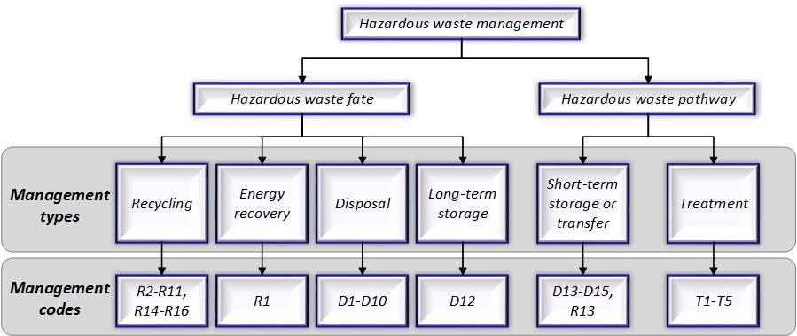

1. Hazardous waste infrastructure groups

The Australian Government will maintain a database of hazardous waste infrastructure and its capacity for use in assessing the adequacy of national infrastructure. Infrastructure is classified into groups for assessing capacities. The typology that will be applied for this purpose is shown in Appendix H.

1. Adoption of the national hazardous waste infrastructure typology

As opportunities arise, states and territories should adopt the national infrastructure typology shown in Appendix H in licensing and tracking systems. Tracking systems will need to make provision to record hazardous waste flows into and out of infrastructure groups to help prevent multiple counting in estimating waste generation (see Item 13).

1. Populating the national database of hazardous waste infrastructure

The Australian Government will consult with the states and territories with a view to populating the national database of hazardous waste infrastructure using data obtained through licences, tracking systems and annual performance statements. This will include characterisation of the outputs of different infrastructure groups in order to map hazardous waste flows to the broad categories of disposal, energy recovery, recycling and etc. Consultation with industry will also be undertaken.

The Australian Government will coordinate with GeoScience Australia with a view to ensuring that the national database of hazardous waste infrastructure is integrated with the GeoScience Australia database of waste infrastructure through the use of their site identification number. The states and territories will be encouraged to adopt use of the GeoScience Australia site identification number in their own databases.

# Hazardous waste data management and reporting

With more than one level of government (and representatives) needing access to data, it is important that roles and responsibilities are well understood by all parties.

Tracking systems should comprehensively record and report waste type, source, tonnes and management as set out in this standard. In addition, inclusion of data on the contaminants of contaminated soil improves tracking and can generate useful data. It should not be difficult for waste generators to report since an assessment must have been made to characterise the specific nature and extent of contamination. Some states already provide text fields to record this information. Victoria provides for reporting the four most significant contaminants in order of significance using a contaminant coding system[25]. This issue is addressed in Item 25.

A baseline level of data quality management is needed to limit the probability of major misinterpretations due to readily identifiable errors. This issue is addressed in Item 26.

The difficulty in managing data quality is exacerbated where paper-based systems are in use, which are prone to errors, gaps and ambiguities. Electronic systems are used partly in Qld, SA, Vic and WA and fully only in NSW. Full adoption of electronic reporting would significantly improve data quality. This issue is addressed in Item 27.

Jurisdictions have a responsibility to appropriately protect the commercial confidentiality of data provided by industry waste generators or receivers. This responsibility may be established through legislation or other means. Waste data could potentially reveal to commercial rivals a business’s customers, waste types, quantities and processes. The critical issue in protecting commercial confidentiality is hiding identities. For a given waste type, appropriate protection of commercial confidentiality depends on the number of generators or receivers within a reporting boundary (state, territory or national). This issue is addressed in Item 28.

National reporting of hazardous waste data currently occurs for a variety of purposes. It is important that the Australian Government informs the states and territories about its needs for their data, including the form and timing, and that its requests are not duplicative. This issue is addressed in Item 29 and Item 30.

National reporting may involve manipulation of the data submitted by states and territories. Section 4 describes some circumstances in which this might occur. Data manipulations, adjustments and substitutions should be transparent so that states and territories are able to understand how their data has been changed. This issue is addressed in Item 31.

A summary of roles and responsibilities under this standard is tabulated at the foot of this section.

1. Recording soil contaminants

In tracking contaminated soil quantities, states and territories should collect and record data on the contaminants that characterise the soil as contaminated. The Australian Government may produce or endorse an approach to doing so under this standard.

1. Data validation

Prior to provision to the Australian Government, states and territories should ensure hazardous waste data is validated through data quality checks and cleaning. The checks should consider completeness, accuracy, consistency and reasonableness. In particular, checks should be made to look for:

* unit errors (such as mistaking kilograms for tonnes)
* inconsistent coding of wastes from the same company or of the same type
* major gaps (for example, hazardous wastes that are not included in tracking systems)
* major differences from previous years (e.g. in the quantity of a particular waste type
* use of historical reporting codes (these should be converted to modern codes).

Significant errors should be identified and removed, and significant gaps should be filled to the extent practicable. Suspect data should be identified in the submission.

1. Electronic tracking systems

As opportunities arise and mobile coverage allows, hazardous waste tracking systems should be converted to require only electronic systems for reporting waste movements.

1. Data confidentiality

The Australian Government will negotiate a memorandum of understanding with the states and territories in relation to the confidentiality of hazardous waste data. The types of confidentiality covered will include:

* commercial-in-confidence information
* regulator-in-confidence information.

The Australian Government may consider hazardous waste data commercial-in-confidence if either:

* a state or territory specifically advises the Australian Government to that effect and provides supporting information, or
* each of the following apply[26]
  + public release of that data could reasonably be expected to have significant adverse impacts on the commercial interests of one or more of the original providers of that information
  + the damage to those commercial interests outweighs the public interest in publication of that information
  + the information is not available elsewhere in the public domain
* collated data is attributable to less than three facilities or companies.

Hazardous waste data may be considered regulator-in-confidence if a state or territory specifically advises the Australian Government to that effect and provides supporting information.

Notwithstanding the above, state and territory data collated by NEPM or Basel Y-code is not considered confidential.

The proposed memorandum of understanding will specify, for each state and territory, the data fields that the Australian Government is allowed to access without further negotiation.

1. Information on national reporting to be kept up-to-date in this standard

The Australian Government will ensure that the states and territories are kept informed of the requirements and schedule for national reporting of hazardous waste. This will occur through this standard by ensuring that Table 6 in Appendix I is kept up-to-date. Note that the methods by which the Australian Government obtains hazardous waste data may change as a result of investigations and plans under development and in consultation with the states and territories.

1. Quantity data to be provided in six-monthly blocks

The Australian Government will provide for the states and territories to submit annual hazardous waste quantity data (for the Basel report) in collated six-monthly blocks by waste type. This will ensure the same data set can be used for other purposes, for example national waste reports.

1. Transparency in national reporting

The Australian Government will ensure that manipulations, adjustments and substitutions applied to state and territory data are transparent, so that states and territories can follow the logic, assumptions and calculations linking their data to the corresponding national data.

1. Recording data methods and backdating changes

The Australian Government will record the sources, methods and assumptions it applies in compiling hazardous waste data. To the extent practical, where changes occur, it will retrospectively apply those changes to previously reported data in order to maintain an accurate record of trends.

Table 2: Responsibilities in relation to hazardous waste data management and reporting

|  |  |  |
| --- | --- | --- |
| Responsibility | Task | Reference item |
| States and territories | Validate data prior to provision to the Australian Government | Item 26 |
| As opportunities arise, convert tracking systems to electronic only | Item 27 |
| Report tonnage data in six-monthly blocks | Item 30 |
| Australian Government | Develop an MoU in relation to data confidentiality | Item 28 |
| Maintain up-to-date information on national reporting needs | Item 29 & Appendix H |
| Ensure that data manipulations are transparent | Item 31 |



How this document was developed

A How this standard was developed

In November 2015 the Department of the Environment commissioned a consultant team led by Blue Environment and supported by Ascend Waste and Environment and Randell Environmental Consulting to develop this *Hazardous waste data and reporting standard.* The consultant team had first-hand experience of many of the problems and issues that the standard is intended to alleviate through previous work for the Department. This work included developing data collations for annual reports to the secretariat of the Basel Convention, preparing a *Hazardous waste data infrastructure needs and capacity assessment*, and authoring *Hazardous waste in Australia 2015*.

Consultation with the states and territories was a core element of the project.

The consultant team firstly prepared an options paper that discussed a range of issues and canvassed potential approaches for addressing them in the standard. The options paper was distributed in mid-January 2015 to each state and territory, selected major industry operators, academics and an environmental group, as tabulated below.

Table 3: Consultees in developing this document

|  |  |
| --- | --- |
| Category | Name |
| States and territories | ACT, NSW, NT, Qld, SA, Tas, Vic, WA |
| Industry | GeoCycle, JJ Richards, SteriHealth, Suez Environnement, Toxfree Australia, Transpacific Industries, Veolia Environmental Services |
| Researchers | Academics at the universities of Melbourne, Monash and Griffith, plus CSIRO |
| Environmental groups | National Toxics Network |

Presentations on the standard were prepared and delivered to representatives of state and territory governments in Sydney, Melbourne, Brisbane, Adelaide, Hobart and Darwin in early February 2016. Various comments on the options paper were obtained during these presentations. Further written responses were obtained from NSW, SA, WA and GeoCycle.

A preliminary draft standard was developed and sent to the Department for comment. Changes were made in response to those comments, resulting in an amended draft that was sent to the consultees listed in Table 3. Comments were received from the ACT, NSW, NT, SA, Vic, WA and researchers from the University of Melbourne, Monash University and CSIRO. The draft standard was amended based on those comments to create a test version.

The test version was applied in developing *Hazardous Waste in Australia 2017*. Subsequently, a report titled ‘testing the standard’ was prepared for the Department describing a few difficulties in applying the test version of the standard, and proposing some amendments. Those amendments were made to derive this 2017 version of the standard.



Waste codes maps

B Waste codes maps

Jurisdictional waste codes will be converted to NEPM codes using the mapping process illustrated below (s*ee the explanation under Item 6*)*.*

|  |  |  |  |  |
| --- | --- | --- | --- | --- |
| **Key** | Code | Data for this NEPM code is not collected | **Code** | Data for this NEPM code is collected from landfill data (data for other codes is from tracking system data) |

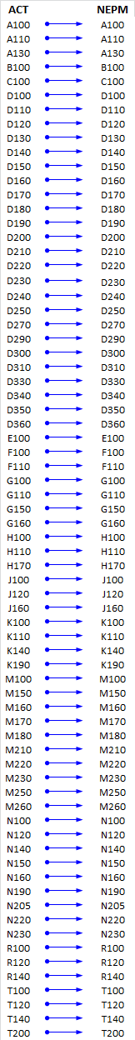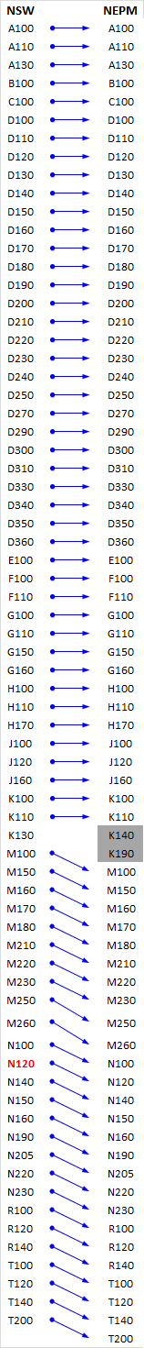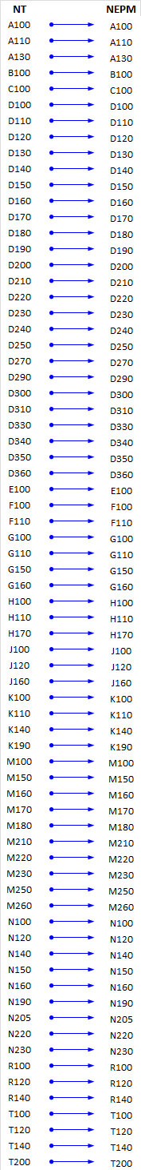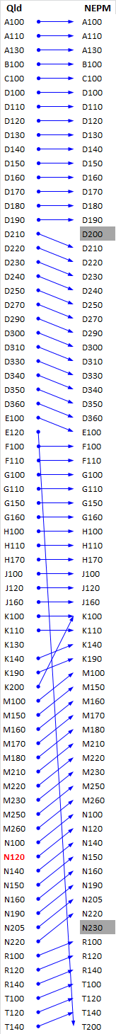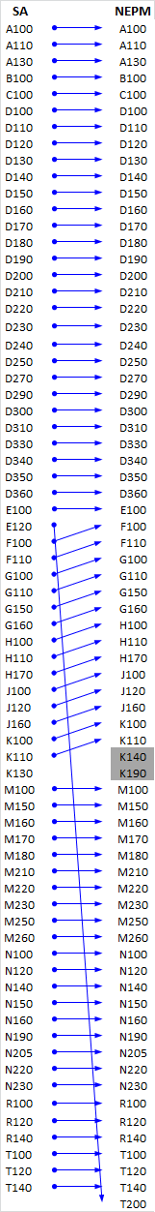

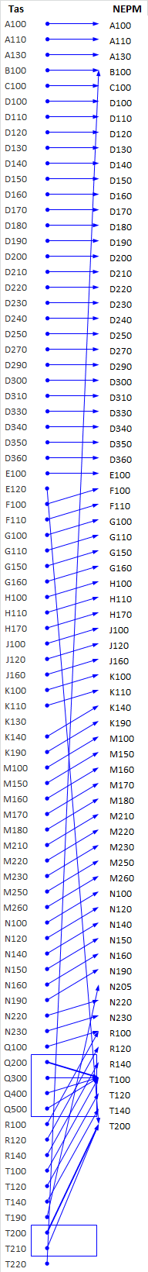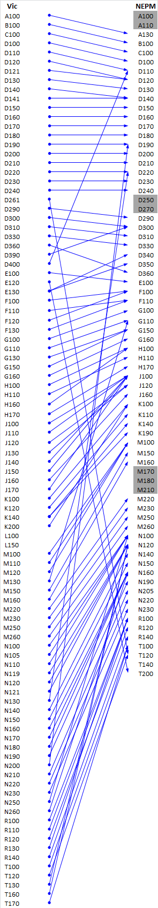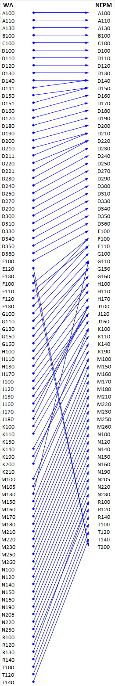



Principles for codifying hazardous waste

C Principles for codifying hazardous waste

*See the explanation under Item 7.*

Users of waste transport certificates and others who need to codify wastes should apply the following hierarchical principles for waste codification:

1. If the waste can be neatly described by either the process/ industry from which it arises, the article or product from which they derive, or inherent physical or chemical characteristics (obvious without any testing), as listed in Table 4, use that waste code.
2. Understand the major hazardous characteristics of the waste. This may be apparent from historical knowledge of company or industry processes and/or may involve testing for a range of chemical contaminants and assessment against jurisdictional contaminant threshold lists[27].
3. If the waste can be described by a single hazardous characteristic that matches a NEPM code (for example *D120 Mercury; mercury compounds*), use that waste code.
4. If testing indicates that more than one contaminant or characteristic is present, use the code that describes the contaminant of highest potential hazard. This can be determined as follows:
   1. Firstly, compare the test results for each against contaminant thresholds (used by your jurisdiction or another’s, in the event your jurisdiction does not have them) and codify the waste according to the contaminant in the highest hazard category. Note that this may not be the contaminant that is present at the highest concentration because threshold values vary.
   2. If there is more than one contaminant in the highest hazard category, then prioritise the hazard by reference to the contaminant with the highest ratio of waste concentration to category contaminant threshold (or upper limit). The waste code corresponding to the contaminant with the highest ratio should be used.
5. Consult the list of example wastes by NEPM code given below in Table 5. Codification based on this table should be confirmed through consultation with the relevant jurisdictional regulator.

Table 4: Descriptively coded wastes

| **NEPM code** | **Waste description (NEPM Schedule A, List 1)** |
| --- | --- |
| *Process/ Industry described wastes* | |
| A100 | Waste resulting from surface treatment of metals and plastics |
| A110 | Waste from heat treatment and tempering operations containing cyanides |
| F100 | Waste from the production, formulation and use of inks, dyes, pigments, paints, lacquers and varnish |
| F110 | Waste from the production, formulation and use of resins, latex, plasticisers, glues and adhesives |
| G160 | Waste from the production, formulation and use of organic solvents |
| H100 | Waste from the production, formulation and use of biocides and phytopharmaceuticals |
| H170 | Waste from manufacture, formulation and use of wood-preserving chemicals |
| J160 | Waste tarry residues arising from refining, distillation, and any pyrolytic treatment |
| K100 | Animal effluent and residues (abattoir effluent, poultry and fish processing wastes) |
| K110 | Grease trap waste |
| K140 | Tannery wastes (including leather dust, ash, sludges and flours) |
| K190 | Wool scouring wastes |
| N140 | Fire debris and fire wash waters |
| N160 | Encapsulated, chemically-fixed, solidified or polymerised wastes referred to in this list |
| N190 | Filter cake contaminated with residues of substances referred to in this list |
| N205 | Residues from industrial waste treatment/disposal operations |
| R100 | Clinical and related wastes |
| R140 | Waste from the production and preparation of pharmaceutical products |
| T100 | Waste chemical substances arising from research and development or teaching activities, including those which are not identified and/or are new and whose effects on human health and/or the environment are not known |
| T120 | Waste from the production, formulation and use of photographic chemicals and processing materials |
| *Article/ product described wastes* | |
| M230 | Triethylamine catalysts for setting foundry sands |
| N100 | Containers and drums that are contaminated with residues of substances referred to in this list |
| N150 | Fly ash, excluding fly ash generated from Australian coal fired power stations |
| R120 | Waste pharmaceuticals, drugs and medicines |
| T140 | Tyres |
| *Inherent characteristics* | |
| J100 | Waste mineral oils unfit for their original intended use |
| M260 | Highly odorous organic chemicals (including mercaptans and acrylates) |
| T200 | Waste of an explosive nature not subject to other legislation |

Table 5: Example wastes for selected NEPM codes

|  |  |  |  |  |
| --- | --- | --- | --- | --- |
| **NEPM waste type** | | **NEPM code** | **Waste description** | **Waste examples** |
| A | Plating and heat treatment | A100 | Waste resulting from surface treatment of metals and plastics | * Liquid phosphates or chromates from metal coating (e.g. commercial product Alodine 1200S) * Liquids or sludges from polyurethane-based plastics treatment * Wastes from cleaning, sandblasting and surface protection of ship hulls and vehicle bodies |
| A110 | Waste from heat treatment and tempering operations containing cyanides | * Case hardening residues such as potassium cyanide/ potassium carbonate mixtures |
| B | Acids | B100 | Acidic solutions or acids in solid form | * Wastes with pH <2 * Acids including sulfuric, hydrochloric, nitric, phosphoric, chromic, hydrofluoric, acetic, other organic acids * Pickle liquors * Mixtures of the above |
| C | Alkalis | C100 | Basic solutions or bases in solid form | * Wastes with pH >10 * Alkaline cleaners * Ammonia * Hydroxides such as ammonium, sodium (caustic soda), calcium (lime), potassium * Caustic neutralised waste * potash |

| **NEPM waste type** | | **NEPM code** | **Waste description** | **Waste examples** |
| --- | --- | --- | --- | --- |
| D | Inorganic chemicals | D110 | Inorganic fluorine compounds excluding calcium fluoride | * Spent pot liner waste from aluminium smelting * Simple fluoride salts such as sodium fluoride and potassium fluoride |
| D120 | Mercury; mercury compounds | * Fluorescent lamps * Dental amalgam waste * Spent catalysts * Articles containing mercury (such as old thermometers) |
| D130 | Arsenic; arsenic compounds | * Arsenic containing wastes from glass manufacturing, metal smelting & mine processing |
| D140 | Chromium compounds (hexavalent and trivalent) | * Casting/ foundry wastes * Chrome plating wastes * Brick linings and dyes |
| D150 | Cadmium; cadmium compounds | * Electroplating wastes * Industrial paint pigments * Nickel cadmium (NiCad) batteries * Semi-conductors such has cadmium telluride in solar panels * Spent catalysts |
| D160 | Beryllium; beryllium compounds | * Machining wastes from copper beryllium alloys (aircraft and electronics industries) |
| D170 | Antimony; antimony compounds | * Antimony mine tailings * Other metal mine tailings |
| D190 | Copper compounds | * Refinery slags and flue dusts * Water treatment sludges * Shipyard barnacle removal washings * Spent catalysts * Blue dyes and spent liquors |
| D200 | Cobalt compounds | * Pigment and paint wastes * Spent catalysts |
| D210 | Nickel compounds | * Spent catalysts |
| D220 | Lead; lead compounds | * Lead acid batteries * Leaded glass (CRT glass) * Grit blast waste * Used fire assay cupels * Mine tailings * Refinery and smelter wastes |
| D230 | Zinc compounds | * Zinc smelting and refining slags, fines and other wastes * Zinc ash/dust * Galvaniser's ash * Smelting slag * Spent filter cartridges (from electroplating/ galvanising) |
| D250 | Tellurium; tellurium compounds | * Anode sludges from refining of blister copper * Blast furnace dusts (likely to contain more hazardous metals, such as lead) |
| D270 | Vanadium compounds | Spent catalysts |
| D300 | Non-toxic salts | * Coal seam gas industry brine and salt wastes * Aluminium dross * Salt cake, salt slag * Furnace slags from lead acid battery recycling * Desalination plant salt/brine wastes * Simple inorganic chlorides |

| **NEPM waste type** | | **NEPM code** | **Waste description** | **Waste examples** |
| --- | --- | --- | --- | --- |
| F | Paints, resins, inks, organic sludges | F100 | Waste from the production, formulation and use of inks, dyes, pigments, paints, lacquers and varnish | Waste paint and other surface coatings |
| F110 | Waste from the production, formulation and use of resins, latex, plasticisers, glues and adhesives | Fibreglass resin wastes |
| G | Organic solvents | G100 | Ethers | Family of ether compounds including ‘ether’ itself (diethyl ether) |
| G110 | Organic solvents excluding halogenated solvents | * Naphtha solvents, benzene and xylenes, alcohols, glycols, epoxides, ketones and aldehydes * Methylated spirits, mineral turpentine, kerosene * Cyclohexane * Klenasol (non-chlorinated) |
| G150 | Halogenated organic solvents | * Any solvent with a halogen element in its structure (chloro, fluoro, bromo, iodo in the chemical or product name) * Carbon tetrachloride * Genklene * Methylene chloride (dichlormethane) * paint stripper * Tetrachloroethylene (perchloroehtylene/ perc) * Trichloroethane * Trichloroethylene * Klenasol 75/25 * Dry cleaning sludge (containing perchloroethylene) |
| G160 | Waste from the production, formulation and use of organic solvents | Solvent recovery residues |
| H | Pesticides | H100 | Waste from the production, formulation and use of biocides and phytopharmaceuticals | * Inorganic & organo-metallic pesticides * Nitrogen containing pesticides * Organochlorine pesticides * Sulfur containing pesticides * Biological pesticides * Mixed pesticide residue * Phytopharmaceutical wastes such as from alkaloid production in Tasmania |
| H110 | Organic phosphorous compounds | * Organo phosphorus pesticide such as Diazinon, Azinphos-methyl, Chlorpyrifos and Dichlorvos * Triphenyl and tricresyl phosphates (as flame retardants) |
| H170 | Waste from manufacture, formulation and use of wood-preserving chemicals | * Copper chrome arsenic (CCA) solutions and solids * Other inorganic wood preserving compounds * Organic wood preserving compounds (such as creosote) |

| **NEPM waste type** | | **NEPM code** | **Waste description** | **Waste examples** |
| --- | --- | --- | --- | --- |
| J | Oils | J100 | Waste mineral oils unfit for their original intended use | * Waste oils/ hydrocarbons * Used oil filters * Transformer fluids (excluding PCB's) |
| J120 | Waste oil/water, hydrocarbons/water mixtures or emulsions | * Vehicle washwaters * Boiler blowdown sludge * Cooling tower washwaters * Textile effluent & residues * Industrial plant washwaters * Ethylene glycol-water (antifreeze) * Oil/hydrocarbon (<50%) mixed with water * Oil/hydrocarbon (>50%) mixed with water |
| K | Putrescible/ organic waste | K100 | Animal effluent and residues (abattoir effluent, poultry and fish processing wastes) | Includes Animal oils & derivatives (e.g. tallow) |
| K110 | Grease trap waste | Separated grease and oil based wastes from grease interceptor traps used in cooking establishments. |
| M | Organic chemicals | M100 | Waste substances and articles containing or contaminated with polychlorinated biphenyls, polychlorinated napthalenes, polychlorinated terphenyls and/or polybrominated biphenyls | * Oil, solvents & materials contaminated with PCBs, PCTs and PBBs * Equipment containing PCBs, PCTs and PBBs * PCNs, PCTs and PBBs |
| M160 | Organo halogen compounds—other than substances referred to in this Table or Table 2 | * Waste containing these organohalogen chemicals above jurisdiction-specific acceptance criteria * Organohalogen chemicals are organic chemicals that contain fluorine, chlorine, bromine or iodine atoms, generally providing specific properties to the chemical (for example flame retardancy) * Chemicals listed on the Stockholm Convention (not otherwise specified in this list) are relevant to this category. * Hexachlorobenzene (HCB) * PFOS and other PFAS-containing wastes * Halogenated refrigerants |
| M170 | Polychlorinated dibenzo-furan (any congener) | Waste containing these chemicals above jurisdiction-specific acceptance criteria |
| M180 | Polychlorinated dibenzo-p-dioxin (any congener) | Waste containing these chemicals above jurisdiction-specific acceptance criteria |
| M210 | Cyanides (organic) | * More correctly known as nitriles such as acetonitrile and acrylonitrile solvents used in polymer industry * Cyanogen (ethanedinitrile) fumigant |
| M220 | Isocyanate compounds | Toluene diisocyanate (TDI) and methylene bisphenyl isocyanate (MDI) used in polymer production and polyurethane foam blowing |
| M230 | Triethylamine catalysts for setting foundry sands | Catalysts for phenolic urethane cold box binders in the foundry industry |

| **NEPM waste type** | | **NEPM code** | **Waste description** | **Waste examples** |
| --- | --- | --- | --- | --- |
| N | Soil/ sludge | N100 | Containers and drums that are contaminated with residues of substances referred to in this list | Drums, bags or other containers (such as aerosol cans) containing waste which must be tracked |
| N120 | Soils contaminated with a controlled waste | Soils contaminated with residues of substances contained in this list at a concentration which exceeds jurisdiction-specific landfill acceptance criteria. |
| N205 | Residues from industrial waste treatment/disposal operations | * Scrubber sludge * Ion-exchange column residues * Industrial waste treatment sludges and residues * Residues from pollution control operations * May include sewerage sludge & residues (including biosolids, where contaminated with substances contained in this list above guideline levels) |
| N220 | Asbestos | Defined on a state by state basis. Generally, if a material (including soil) contains asbestos fibres it is classified as asbestos (or asbestos containing material, ACM). |
| N230 | Ceramic-based fibres with physico-chemical characteristics similar to those of asbestos | Aluminium silicate fibre products used mainly for fire protection and insulation purposes |
| R | Clinical and pharmaceutical | R100 | Clinical and related wastes | * Sharps such as syringes, needles, lancets, scalpels * No-sharps clinical waste such as * human blood or body fluids; * human tissue; * a clinical specimen (other than urine or faeces); * a laboratory culture; * tissue, carcasses or other waste arising from animals used for laboratory investigation or for medical or veterinary research; * materials or equipment contaminated with any of the above; * waste from patients known to have, or suspected of having a communicable disease * NOTE: Sanitary napkins, incontinence pads, nappies, emptied colostomy/ urine bags and dressings which are not saturated in blood, are NOT controlled waste. |
| R120 | Waste pharmaceuticals, drugs and medicines | * RUM (Return Unwanted Medicines) project wastes such as out of date, unsold and unwanted pharmaceutical products and subsequent residues in packaging. * Includes cytotoxic drugs such as azathioprine, chlorambucil, chlornaphazine, ciclosporin, cyclophosphamide, melphalan, semustine, tamoxifen, thiotepa and treosulfan * Includes sharps contaminated with cytotoxins |
| R140 | Waste from the production and preparation of pharmaceutical products | Similar to R120 but waste may be related to raw materials of manufacture and preparation of similar drugs and medicines. |

| **NEPM waste type** | | **NEPM code** | **Waste description** | **Waste examples** |
| --- | --- | --- | --- | --- |
| T | Miscellaneous | T100 | Waste chemical substances arising from research and development or teaching activities, including those which are not identified and/or are new and whose effects on human health and/or the environment are not known | * Waste chemicals from R&D or teaching * Waste from domestic chemical collections |
| T120 | Waste from the production, formulation and use of photographic chemicals and processing materials | * Waste from production or formulation of photographic chemicals * Wastes from film processing materials such as fixer or developer (may or may not contain silver) |
| T140 | Tyres | Used truck and passenger tyres |
| T200 | Waste of an explosive nature not subject to other legislation | Highly reactive chemicals |



Gaps in waste tracking systems

D Gaps in waste tracking systems

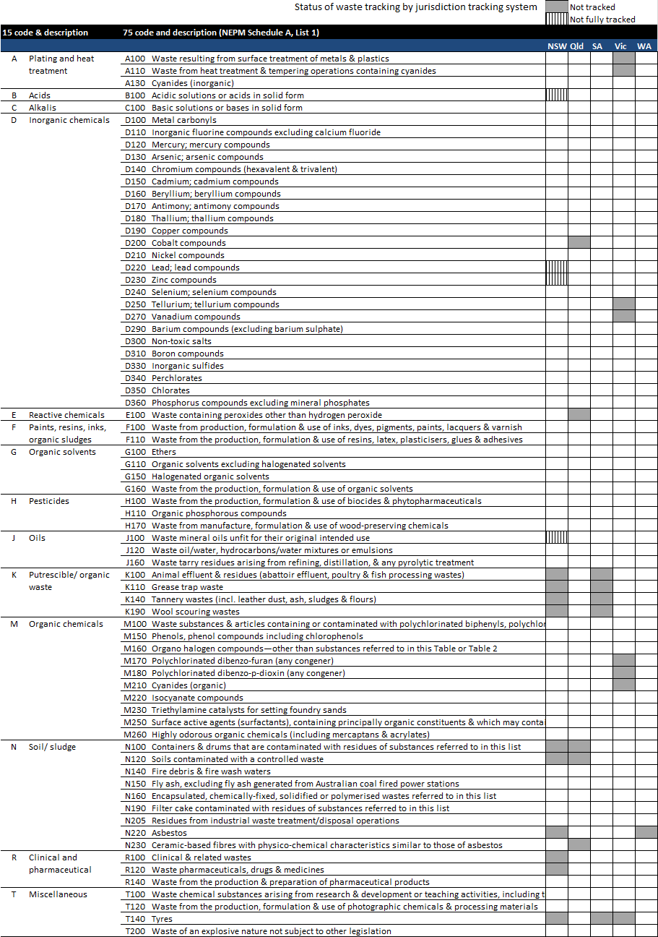The following diagram shows wastes that are not tracked in intra-state tracking systems by states that run such systems (*see the discussion in the introduction to Section 4*).



Unit conversion factors

E Unit conversion factors

The following density and unit conversion factors are for use in translating waste quantities to tonnes when data is received in numbers of items or volumetric units (*see the explanation under Item 13*)*.*

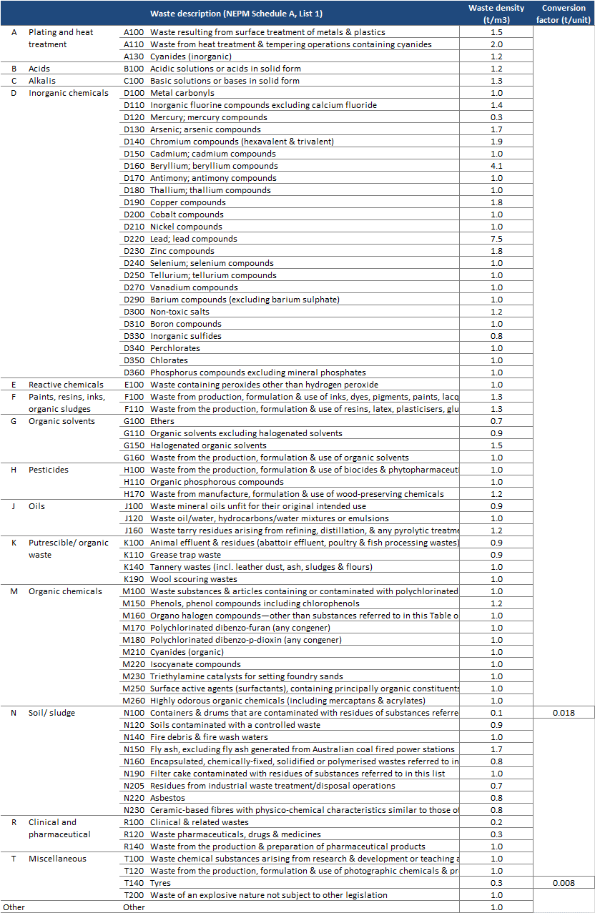



Hazardous waste management types map (short-term)

F Hazardous waste management types map

Jurisdictional ‘treatment type’ (or fate/pathway) codes are to be mapped to a national set of hazardous waste management types using the mapping process illustrated below (*see the explanation under Item 20*)*.*





Hazardous waste management typology (long-term)

G Hazardous waste management typology (long-term)

A proposed management typology is illustrated below (*see the explanation under Item 21*)*.*

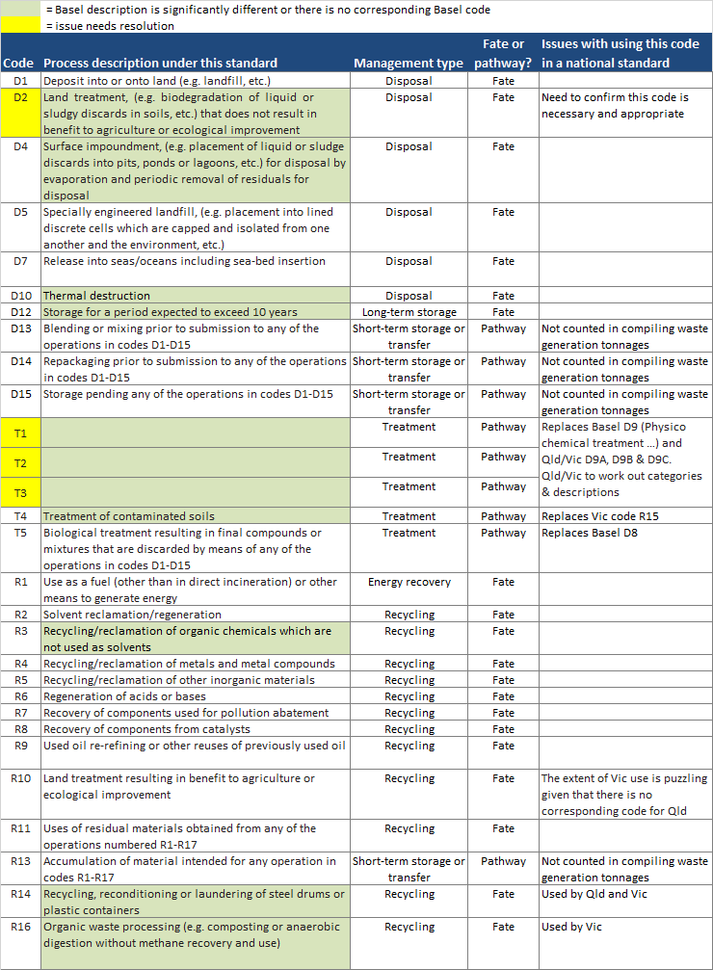



Hazardous waste infrastructure typology

H Hazardous waste infrastructure typology

The Australian Government will maintain a database of hazardous waste infrastructure and its capacity for use in assessing the adequacy of national infrastructure. Infrastructure will be classified into groups for assessing capacities based on the typology illustrated below *(see explanation in Item 22*).

| **Hazardous waste management type** | **Hazardous waste infrastructure group** | **Description** | **Management code** |
| --- | --- | --- | --- |
| **Recycling** | Hazardous waste packaging facility | Facilities that recycle industrial packing that contains residual hazardous wastes. Containers are typically refurbished and reused or materials are recycled. | R14 |
| E-waste facility | Major e-waste physical/chemical and manual disassembly processing facilities. Facilities receive inorganic hazardous wastes, such as copper, cobalt, and lead. | R4 |
| Oil re-refining facility | Facilities that re-refine (recycle) waste oil. (Facilities that only dewater and filter waste oil should be considered primarily ‘transfer facilities’) | R9 |
| Lead facility | Facilities that recycle lead. Typically, the lead is from used lead acid batteries. | R4 |
| Mercury facility | Facilities that recycle mercury. Used fluorescent light fittings are usually a key waste. | R4 |
| Solvents/paints/organic chemicals facility | Facilities that recycle paints, resins, inks, organic sludges and/or organic solvents, but not for energy recovery. | R2, R3 |
| Organics processing facility | Facilities that recycle a range of low hazard organic wastes such as grease trap waste, cooking oil, animal effluents, etc. through composting or similar | R16 |
| Spent potlining facility | Facilities that recycle spent potlining waste from the aluminium industry. | R5 |
| **Energy recovery** | Energy recovery | Facilities that recover or use solvents, paints or other hazardous wastes with calorific value for energy recovery on-site or elsewhere (e.g. a cement facility). | R1 |
| **Treatment** | Chemical physical treatment (CPT) plant | Sophisticated facilities developed with significant capital to apply chemical and physical treatments to a broad range of wastes. Often licensed to receive almost all NEPM 15 waste codes. Processes can include many chemical treatments (e.g. oxidation, reduction, precipitation, neutralisation, etc.) and physical treatments (e.g. sedimentation, filtration, adsorption, immobilisation, etc.) | D13, D14, R6, T1 |
| Clinical waste treatment facility | Facilities that treat clinical waste typically using an autoclave. | T2 |
| Bioremediation facility | Temporary or permanent facilities that treat hazardous waste by land-farming or bioremediation. May be co-located with an organics processing facility, but does not generate a useful product. | D2, T5 |
| Soils treatment facility | Facilities that treat contaminated soils. Treatment processes include biodegradation and thermal destruction of contaminants. | T4 |
| **Disposal** | Hazardous waste landfill facility | A small number of landfill facilities that are licensed to dispose of a wide range of hazardous wastes many of which can only be landfilled at these sites. | D1, D5 |
| Landfill facility (NEPM codes N, T) | Landfill facilities licensed to dispose of low-risk hazardous wastes such as low level contaminated soils, asbestos, and tyres (NEPM 15 codes N and T). These landfills also generally dispose of non-hazardous wastes, which typically represent the majority of their inputs. | D1 |
| Persistent organic pollutants thermal destruction facility | Facilities able to destroy persistent organic compounds by thermal destruction. | D10 |
| Clinical waste facility thermal destruction | Facilities that dispose of medical waste by thermal destruction. | D10 |
| **Short-term storage**  **or transfer** | Transfer facility | Facilities that transfer of hazardous wastes. Some of these facilities receive a wide range of wastes, others only specific wastes. | D15, R13 |
| Temporary storage facility | Facilities that temporarily store of hazardous wastes. Some of these facilities receive a wide range of wastes, others only specific wastes. | D15, R13 |
| **Long-term storage** | Long term storage facility | Facilities licensed to store hazardous wastes for long periods (≥10 years), typically until an economically viable treatment or disposal solution is developed. | D12 |



National reporting of hazardous waste

I National reporting of hazardous waste

National hazardous waste reporting requirements are set out in Table 6 below (*see explanation in Item 29*).

Table 6: National reporting of hazardous waste data

|  |  |  |  |  |  |
| --- | --- | --- | --- | --- | --- |
| Report | Rationale | Period | Frequency | State & territory data needed by | Content |
| Report to the Basel Secretariat | Requirement of the Basel Convention | Calendar year | Annually | By end of previous calendar year | Quantities generated nationally by waste type |
| *Hazardous Waste in Australia* | Government commitment | Financial year | Every two years | Not yet fixed | Quantities, trends in quantities, sources, pathways and fates, potentially with sub-analyses by jurisdiction |
| National waste reports | Government commitment | Financial year | Not yet fixed | Not yet fixed | Quantities, pathways and fates by jurisdiction |
| OECD reports | Requirement of OECD membership | Calendar year | Various | Varied | Various |
| NEPM reports | Requirement of under the NEPM and its implementation agreement | Financial year | Annual | Not fixed | Collated summary information on the:  (i) movement of controlled waste into each jurisdiction, indicating jurisdiction of origin, waste code and quantity of waste;  (ii) level of discrepancies (e.g. non‑arrival of a consignment) as a percentage of total authorised controlled waste movements; and  (iii) benefits arising from the implementation of the Measure.  *NEPM 13(i)* |

1. Including the *Methodological guide for the undertaking of national inventories of hazardous wastes within the framework of the Basel Convention*, available from: <https://www.google.com.au/url?sa=t&rct=j&q=&esrc=s&source=web&cd=1&cad=rja&uact=8&ved=0ahUKEwim6IPqi4jMAhUi2KYKHa6wDhwQFggbMAA&url=http%3A%2F%2Farchive.basel.int%2Fpub%2Fmetologicalguidee.pdf&usg=AFQjCNHaJ44ysB6i4X2NGF4OwhQZIvauMA&bvm=bv.119408272,d.dGY>
2. Two Australian standards focus on waste terminology: AS/NZS 3831:1998 *Waste Management – Glossary of Terms*; *and* AS4082:1992 *Recycled Paper – Glossary of Terms*. More recently, a number of relevant definitions, including for ‘waste’, ‘reuse’, ‘recycling’ and ‘energy recovery’, are given in *Waste Generation and Resource Recovery in Australia, Reporting Period 2010-11*, (prepared by Blue Environment and Randell Environmental Consulting for the Department of the Environment, and available from: <https://www.environment.gov.au/resource/waste-generation-and-resource-recovery-australia-report-and-data-workbooks>. The ABS waste accounts also include definitions – see <http://www.abs.gov.au/AUSSTATS/abs@.nsf/Lookup/4628.0.55.001main+features80May+2012>
3. This builds on work by: Moore S and Shin-Yu T (1997) *Designation & Classification of Hazardous Wastes. Version 2,* UNSW, available from: <http://awd.csiro.au/awdwebsite2003/Awd%20pubn%20PDFiles/Hazw_.PDF>; and White R and Heckenberg D (2011) *What is hazardous waste and what makes it hazardous? Briefing Paper No.2,* University of Tasmania, available from: <http://www.utas.edu.au/__data/assets/pdf_file/0003/193413/Briefing_Paper_2_What_is_hazardous_waste.pdf>
4. From AS/NZS 3831:1998 *Waste Management – Glossary of Terms.*
5. For example, the Australian Government has considered waste lithium ion batteries as hazardous in assessing the adequacy of hazardous waste infrastructure.
6. Environment ACT (2000) *ACT Environmental Standards: Assessment and Classification of Liquid & Non-liquid Wastes,* June, available from: <http://www.environment.act.gov.au/__data/assets/pdf_file/0005/585500/wastestandards.pdf>
7. At the time of writing: NSW, Qld, SA, Vic and WA operate intrastate tracking systems.
8. This builds on work by: Moore S and Shin-Yu T (1997) *Designation & Classification of Hazardous Wastes. Version 2,* School of Civil & Environmental Engineering, UNSW, available from: <http://awd.csiro.au/awdwebsite2003/Awd%20pubn%20PDFiles/Hazw_.PDF>; and White R and Heckenberg D (2011) *What is hazardous waste and what makes it hazardous? Briefing Paper No.2,* School of Sociology and Social Work, University of Tasmania, available from: <http://www.utas.edu.au/__data/assets/pdf_file/0003/193413/Briefing_Paper_2_What_is_hazardous_waste.pdf>
9. EPA Victoria (2009) *Solid industrial waste hazard categorisation and management*, available from: <http://www.epa.vic.gov.au/our-work/publications/publication/2009/july/iwrg631>
10. ‘New’ hazardous wastes could be declared if, for example, Australia ratifies new persistent organic pollutants under the Stockholm Convention, or if discarded lithium ion batteries develop into a significant risk for the general waste sector.
11. This mapping process was established in 2014 in consultation with the jurisdictions to improve reporting under the Basel Convention.
12. For example, recent reporting has included waste lithium ion batteries, biosolids and some persistent organic pollutants that have been added to the Stockholm Convention but have not yet been ratified by Australia.
13. The last version of *Hazardous waste in Australia* used 29 groups, based on the NEPM 15 system with some disaggregation and additions.
14. A number of NEPM codes do not readily map to Basel Y-codes, so eight new descriptions were created that are referred to as Y+1 through to Y+8.
15. EPA NSW (2013) *Waste codes & descriptions,* available from: <https://www.epa.nsw.gov.au/owt/wclist.htm>
16. WA Department of Environment Regulation (2014) *Guideline: Driver information package for transportation of bulk controlled waste,* available from: <https://www.der.wa.gov.au/images/documents/your-environment/controlled-waste/driver-information-package.pdf>
17. In recent years, alternative sources have been used in reporting tyres and biosolids, for example in Basel Convention reports.
18. Arisings and generation of hazardous waste are defined in section 1.
19. Some hazardous wastes are fundamentally transformed by their management. For example, incineration of hazardous clinical waste produces ash that is also hazardous but is fundamentally different from the input material in form, mass and hazard type. It could reasonably be argued that such outputs are ‘generated’ separately from the original waste and should be counted as additional generation. For simplicity and consistency, however, under this standard the material is counted only once.
20. Based on 2012-13 data from Vic and SA
21. Blue Environment, Ascend Waste and Environment & Randell Environmental Consulting (2015). *Hazardous Waste Infrastructure and Data Project,* prepared for the Australian Government Department of the Environment,incorporating the[*Hazardous Waste Infrastructure Needs and Capacity Assessment*](http://www.environment.gov.au/protection/publications/hazardous-waste-infrastructure-needs-capacity-assessment) and[*Hazardous Waste in Australia*](http://www.environment.gov.au/protection/publications/hazardous-waste-australia)*.*
22. The map is similar to that employed in the recent *Hazardous waste infrastructure and data project* – see footnote 21.
23. Vic should note that this mapping is from the D and R codes in its ‘treatment type’, not the descriptions in its ‘disposal type’.
24. D3 *Deep injection, (e.g., injection of pumpable discards into wells, salt domes of naturally occurring repositories, etc.)*; D6 *Release into a water body except seas/oceans*; D11 *Incineration at sea*.
25. See list 3 (pp.13-14) of EPA Victoria (2016) *Waste codes*, publication IWRG822.3, available at: <http://www.epa.vic.gov.au/~/media/Publications/IWRG822%203.pdf>
26. This is adapted from the Department of Environmental Regulation of Western Australia (2014) *National Pollutant Inventory WA – commercial in confidence guideline*, available from: <https://www.der.wa.gov.au/images/documents/our-work/programs/NPI_Guideline_for_Claims_of_Commercial_in_Confidence.pdf>
27. See, for example, Table 2 of EPA Victoria (2009) *IWRG 631: Solid industrial waste hazard categorisation and management*, available from: <http://www.epa.vic.gov.au/~/media/Publications/IWRG631.pdf>