Publication details

Title:

Land Tenure of Australia 2010–11 to 2015–16, 250 m

Alternative title:
AUSTEN_250m

Date published:
29 September 2021

Date prepared:
13 September 2021

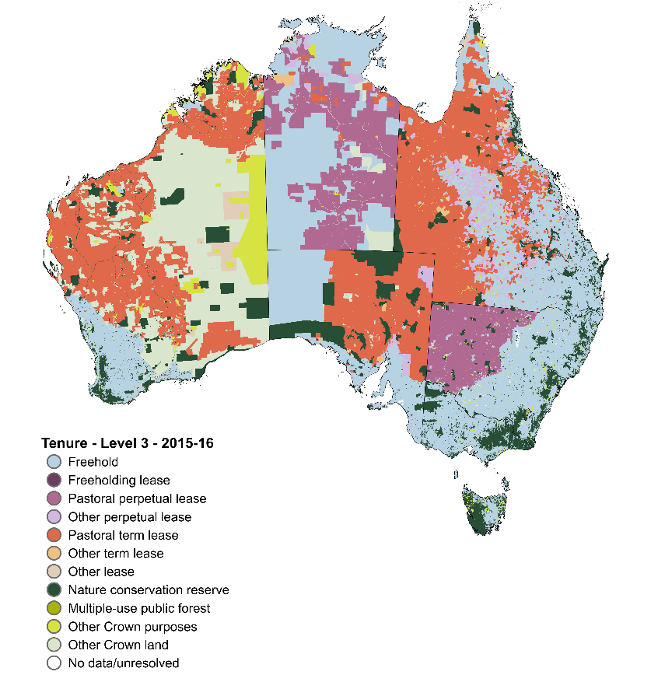
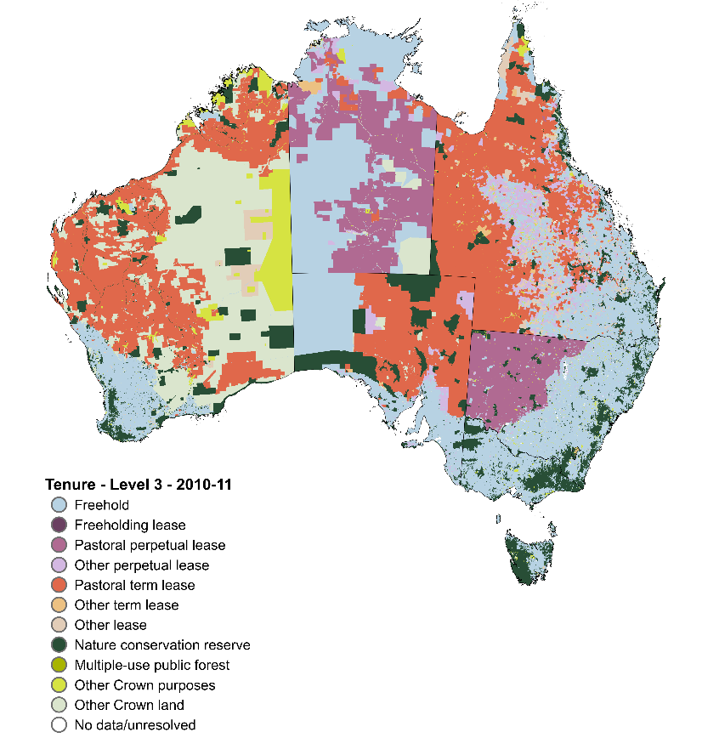
Preview:

Abstract:
The Land tenure of Australia 2010–11 to 2015–16 is a data package of seamless continental rasters combining tenure information from state, territory, and Australian government agencies at a resolution of 250 by 250 metres. The data package contains an independent raster for each target period, a combined change raster at the most detailed classification level and a data caveat raster of known uncertainties in the product.
Land tenure is classified according to a four-tiered hierarchical structure, ordered in increasing level of detail. Level 1 distinguishes between the basic land title types of freehold and Crown land. Level 2 splits Crown land into leasehold, dedicated or reserved for Crown purposes and other Crown land. Level 3 further distinguishes Crown land, defining leasehold type or Crown purposes type based on term and purpose. Leasehold types are split into freeholding lease, pastoral perpetual lease, other perpetual lease, pastoral term lease, other term lease, and other lease. Crown purposes are split into nature conservation reserve, multiple-use public forest and other Crown purposes. Level 4 distinguishes land with an Indigenous land grant, either Crown land held on behalf of, or freehold land owned by, traditional owner groups. Level 4 does not include native title which applies alongside tenure.
The Land tenure of Australia 2010–11 to 2015–16 data package is a product of the Australian Collaborative Land Use and Management Program.

Descriptive information

Authors:
Australian Bureau of Agricultural and Resource Economics and Sciences (ABARES)

Acknowledgements:
This data package was produced by the Australian Bureau of Agricultural and Resource Economics and Sciences (ABARES) within the Australian Government Department of Agriculture, Water and the Environment as part of the Australian Collaborative Land Use and Management Program (ACLUMP). ACLUMP, of which ABARES is a partner, is a consortium of Australian Government, and state and territory government partners that promotes the development of nationally consistent land use, land cover and land management practice information for Australia.
Spatial data sourced from and used with permission of: ACT Office of the Surveyor-General and Land Information, NSW Department of Customer Service, NSW Department of Finance, Services and Innovation – Spatial Services, NSW Department of Planning, Industry and Environment – Crown Lands and Water, NT Department of Infrastructure, Planning and Logistics, PSMA Australia Limited, Queensland Department of Resources, SA Department for Infrastructure and Transport, SA Department for Environment and Water, Tasmanian Department of Primary Industries, Water and Environment, Victorian Department of Environment, Land, Water and Planning, Victoria Department of Jobs, Precincts and Regions, WA Department of Planning, Lands and Heritage, WA Department of Biodiversity, Conservation and Attractions, and WA Department of Primary Industries and Regional Development.

Constraints

LEGAL CONSTRAINTS ASSOCIATED WITH THE MATERIAL

Limitation on the use of the material:
The Australian Government acting through the Department of Agriculture, Water and the Environment, represented by the Australian Bureau of Agricultural and Resource Economics and Sciences, has exercised due care and skill in preparing and compiling the information and data in this publication. Notwithstanding, the Department of Agriculture, Water and the Environment, ABARES, its employees and advisers disclaim all liability, including liability for negligence and for any loss, damage, injury, expense or cost incurred by any person as a result of accessing, using or relying on any of the information or data in this publication to the maximum extent permitted by law.

Constraints on using the material:
Copyright

Other constraints:
Licence type: Copyright
© Commonwealth of Australia 2021
All material in this publication is licensed under a Creative Commons Attribution 4.0 Australia Licence, save for content supplied by third parties, logos and the Commonwealth Coat of Arms.
This publication (and any material sourced from it) should be attributed as: ABARES 2021, Land tenure of Australia 2010–11 to 2015–16, 250 m, Australian Bureau of Agricultural and Resource Economics and Sciences, Canberra, September, CC BY 4.0. DOI: 10.25814/txp0-vs96

Additional information about this material

Purpose for which the material was obtained:
The land tenure datasets provide the spatial representation of the legal regime in which land is owned, leased, reserved or unallocated to a defined purpose in Australia. Land tenure at its simplest is either freehold (private) or non-freehold Crown (public) land. These datasets allow change in Australia’s land tenure to be explored between 2010–11 and 2015–16 for various tenure types. These land tenure datasets are also input layers to the Land use of Australia 2010–11 to 2015–16, 250 m data package.

How to use this data:
1. These datasets have been made for change analysis. With the nature of archived datasets, change may reflect improved data quality. The data caveat raster should be used to track possible data issues with the data.
2. The equal area projection (Australian Albers EPSG:3577) is provided for area calculations. The accuracy of the raw area estimates is affected by the 250 by 250 m resolution of the tenure datasets and the input datasets used in their construction.
3. These datasets do not provide a comprehensive assessment of Australia’s nature conservation reserve system. Only the tenure type of Crown land nature conservation reserve is captured. Nature conservation reserves can occur on freehold land.
4. Freehold land owned by government and government entities, where declared, are included in other Crown purposes, as they are not consistently defined across state and territories as public or private land.
5. These datasets do not consider Indigenous peoples’ rights and interests in all lands, only for land granted under Indigenous land grant instruments.
6. No data/unresolved tenure captures areas where there is no tenure data or conflicting data sources. This category includes water features that have unallocated tenure categories in state and territory registers.

Progress status of this material:
Final

Maintenance and update frequency:
As needed

KEYWORD(S)

ANZLIC search words:
AGRICULTURE
BOUNDARIES
BOUNDARIES Administrative
FORESTS
FORESTS Natural
FORESTS Plantation
LAND
LAND Ownership
LAND Conservation
LAND Conservation Reserve
LAND Use

General keywords:
Tenure
Land tenure
Ownership
Ownership Indigenous
Crown land
Public land
Reserve
Leasehold
Pastoral lease
Freehold
Private land
Land use
Australian Collaborative Land Use and Management Program (ACLUMP)

TOPICS

ABARES topic categories:
Agriculture
Land Use
Environment and Natural Resource Management
Models, Risk, Spatial Data and Datasets

ISO topic categories:
PlanningCadastre
Boundaries
Farming
Environment

SPATIAL EXTENT(S)

Description of spatial extent:
Australian Land

Spatial bounding box included in:
North: -9.995 degrees; South: -44.004 degrees; East: 154.004 degrees; West: 112.505 degrees.

Spatial area included in:
Australian Mainland. Australia excluding external territories.

Projection:
The datasets are available in equal area EPSG:3577 projections.

Coordinate reference details in Well-Known Text for equal area projection EPSG:3577:
PROJCS["GDA94 / Australian Albers",
GEOGCS["GDA94",
DATUM["Geocentric_Datum_of_Australia_1994",
SPHEROID["GRS 1980",6378137,298.257222101,
AUTHORITY["EPSG","7019"]],
TOWGS84[0,0,0,0,0,0,0],
AUTHORITY["EPSG","6283"]],PRIMEM["Greenwich",0,
AUTHORITY["EPSG","8901"]],
UNIT["degree",0.0174532925199433,
AUTHORITY["EPSG","9122"]],
AUTHORITY["EPSG","4283"]],
PROJECTION["Albers_Conic_Equal_Area"],PARAMETER["standard_parallel_1",-18],
PARAMETER["standard_parallel_2",-36],
PARAMETER["latitude_of_center",0],
PARAMETER["longitude_of_center",132],
PARAMETER["false_easting",0],PARAMETER["false_northing",0],
UNIT["metre",1,
AUTHORITY["EPSG","9001"]],
AXIS["Easting",EAST],
AXIS["Northing",NORTH],
AUTHORITY["EPSG","3577"]]

Data Package Contents
Table 1 Description of the Land tenure of Australia 2010–11 to 2015–16, 250 m data package
Folder or file name | Description
AUSTEN_250m_2010_11_alb.zip | AUSTEN raster dataset providing 2010–11 tenure. GeoTIFF, 16-bit integer; coordinate system GDA94/Australian Albers (EPSG: 3577); resolution 250 by 250 metres. Assigned the colour ramp used for the Level 4 land tenure classes. For attribute table description, see Table 2.
AUSTEN_250m_2015_16_alb.zip | AUSTEN raster dataset providing 2016–15 tenure. GeoTIFF, 16-bit integer; coordinate system GDA94/Australian Albers (EPSG: 3577); resolution 250 by 250 metres Assigned the colour ramp used for the Level 4 land tenure classes. For attribute table description, see Table 2.
AUSTEN_250m_CHANGE_2010_11_2015_16_alb.zip | AUSTEN observed change raster dataset providing 2010–11 tenure, 2015–16 tenure, 2010–11 to 2015–16 tenure change and change attributes. GeoTIFF, 16-bit integer; coordinate system GDA94/Australian Albers (EPSG: 3577); resolution 250 by 250 metres. For attribute table description, see Table 3.
AUSTEN_250m_DC_2010_11_to_2015_16_alb.zip | AUSTEN data caveat raster dataset showing known data limitations at a pixel level. GeoTIFF, 16-bit integer; coordinate system GDA94/Australian Albers (EPSG: 3577); resolution 250 by 250 metres. For attribute table description, see Table 4.
Maps.zip
- Tenure-L1_20YY_YY.png; .pdf | Map showing the AUSTEN dataset tenure classes in Level 1; either 2010–11 or 2015–16.
- Tenure-L2_20YY_YY.png; .pdf | Map showing the AUSTEN dataset tenure classes in Level 2; either 2010–11 or 2015–16.
- Tenure-L3_20YY_YY.png; .pdf | Map showing the AUSTEN dataset tenure classes in Level 3; either 2010–11 or 2015–16.
- Tenure-L4_20YY_YY.png; .pdf | Map showing the AUSTEN dataset tenure classes in Level 4; either 2010–11 or 2015–16.
- TenureCaveat_2010_11_to_2015_16.png; .pdf | Map showing the AUSTEN dataset data caveats for change reporting.
- TenureChange-L[classification level]_2010_11_to_2015_16.png; .pdf | Map showing for the AUSTEN dataset where tenure change occurred between 2010-11 and 2015-16, at Level 3 and Level 4.
Symbology.zip | Folder containing files to visualise rasters in ESRI ArcMap. The .clr files are ESRI colour map files and the .lyr files are ESRI raster symbology files.
Note: Each .tif raster dataset contains a .tif.aux.xml auxiliary file storing information including raster statistics, histogram, and attributes. ‘YY’ denotes the year; ‘_11’ for 2010–11 and ‘_16’ for 2015–16. [classification level]: 1, 2 ,3 or 4. [jurisdiction]: AUST = Australia; ACT = Australian Capital Territory; NSW = New South Wales; NT = Northern Territory; OT = Other Territories (Jervis Bay); SA = South Australia; Tas = Tasmania; Vic = Victoria; WA = Western Australia.

Data Dictionary
Table 2 Attributes of each tenure target period raster (AUSTEN_250m_20YY_YY_alb.zip)
Field name | Field description | Data type
Value | Tenure code in the target year. First digit represents Level 1, second digit Level 2, third digit Level 3 and the fourth digit Level 4 of the land tenure hierarchical classification. Refer to Table A1.5. a | Integer, range: 1001 to 2302
Count | Count of the number of raster cells in each class of Value | Integer count
L1N | Level 1 tenure classification code. Refer to Table A1.2. a | Integer, range: 1 to 2
L1_DESC | Description of the Level 1 land tenure classes in the target period. Refer to Table A1.2. | String, width 150
L2N | Level 2 tenure classification code. Refer to Table A1.3. a | Integer, range: 10 to 23
L2_DESC | Description of the Level 2 land tenure classes in the target period. Refer to Table A1.3. | String, width 150
L3N | Level 3 tenure classification code. Refer to Table A1.4. a | Integer, range: 100 to 230
L3_DESC | Description of the Level 3 land tenure classes in the target period. Refer to Table A1.4. | String, width 150
L4N | Level 4 tenure classification code. Refer to Table A1.5. a | Integer, range: 1001 to 2302
L4_DESC | Description of the Level 4 land tenure classes in the target period. Refer to Table A1.5. | String, width 150
a The first two integers are -1 for Offshore and 0 for No data/unresolved tenure.
Table 3 Attributes of the change raster dataset (AUSTEN_250m_CHANGE_2010_11_to_2015_16_alb.zip)
Field name | Field description | Data type
Value | Unique number of all possible combinations given to each land tenure change combination. | Integer, range: 0 to 182
Count | Count of the number of raster cells in each class of Value | Integer count
TEN11 | Tenure code in the year 2010–11. First digit represents Level 1, second digit Level 2, third digit Level 3 and the fourth digit Level 4 of the land tenure hierarchical classification. Refer to Table A1.5. a | Integer, range: 1001 to 2302
TEN11_DESC | Description of the Level 4 land tenure classes in the year 2010–11. Refer to Table A1.5 | String, width 150
TEN16 | Tenure code in the year 2015–16. First digit represents Level 1, second digit Level 2, third digit Level 3 and the fourth digit Level 4 of the land tenure hierarchical classification. Refer to Table A1.5. a | Integer, range: 1001 to 2302
TEN16_DESC | Description of the Level 4 land tenure classes in the year 2015–16. Refer to Table A1.5 | String, width 150
TCH | Observed tenure change code. Refer to Table A2.1. a | Integer, range: -1 to 2
TCH_DESC | Description of observed tenure change code. Refer to Table A2.1. | String, width 150
T11_16 | Change in tenure code from the year 2010–11 to 2015–16. | String, width 150
T11_16DESC | Change in tenure class description from the year 2010–11 to 2015–16. | String, width 150
a The first two integers are -1 for Offshore and 0 for No data/unresolved tenure.
Table 4 Attributes of the data caveat raster (AUSTEN_250m_DC_2010_11_to_2015_16_alb.zip)
Field name | Field description | Object ID
Value | Data caveat code. The code describes the data caveat related to using the cell for change detection. Refer to Table A2.2. | Integer, range: -1 to 7
Count | Count of the number of raster cells in each class of Value | Integer count
DC_DESC | Description of data caveat code. Describes the data caveat related to using the cell for change detection. Refer to Table A2.2. | String, width 150

RESPONSIBILITY FOR THIS MATERIAL

Custodian:
Department of Agriculture, Water and the Environment: Australian Bureau of Agricultural and Resource Economics and Sciences
Data Manager
GPO Box 858
CANBERRA CITY
Australian Capital Territory 2601 AUSTRALIA
Voice: +61 2 6272 3933
dataman@awe.gov.au

Publisher:
Department of Agriculture, Water and the Environment: Australian Bureau of Agricultural and Resource Economics and Sciences
GPO Box 858
CANBERRA CITY
Australian Capital Territory 2601 AUSTRALIA
Voice: +61 2 6272 3933
dataman@awe.gov.au

CONTACT(S) WHEN INQUIRING ABOUT THIS MATERIAL

Point of contact:
Department of Agriculture, Water and the Environment: Australian Bureau of Agricultural and Resource Economics and Sciences
Data Manager
GPO Box 858
CANBERRA CITY
Australian Capital Territory 2601 AUSTRALIA
Voice: +61 2 6272 3933
dataman@awe.gov.au

Process used to generate this material

Lineage Statement
Lineage:
ABARES has produced these raster datasets from vector datasets provided by state, territory and Australian government agencies and other entities. The date of mapping reflects the best available data sources for both time periods (2009 to 2012 for 2010–11, and 2014 to 2016 for 2015–16). The datasets were constructed by combining jurisdictional land title information from digital cadastre databases or their equivalents with Indigenous land grant instruments areas. All vector data was rasterised by cell centre to a resolution of 50 by 50 metres, then resampled by mode to 250 by 250 metres. This corresponded to a simple majority rasterisation. All data processing used the Python spatial libraries Geospatial Data Abstraction Library (GDAL) (v2.4.1), Rasterio (v1.1.2) and GeoPandas (v0.6.2). All geo-processing occurred in Australian Geographic GDA 1994 (EPSG:4283) with the raster datasets provided in Australian Albers 1994 (EPSG:3577).
All input datasets were reclassified into nationally consistent tenure classes using a four-tiered hierarchy (Appendix 1). Level 1 describes the land title type, distinguishing between freehold or non-freehold and held by the Crown as the state, territory, or the Commonwealth of Australia. Level 2 splits Crown land into leasehold, Crown purposes or other Crown land. Level 3 describes leasehold and Crown purposes types. Level 4 distinguishes whether land is granted to Indigenous peoples under Indigenous land grant instruments. Each level of the hierarchy is maintained within a 4-digit code.
Digital Cadastre Databases (DCDB) or relevant derived layers were obtained from New South Wales, the Northern Territory, Queensland, South Australia, Tasmania and Victoria. For Western Australia, the respective departments provided properties of agricultural significance, of environmental interest, or properties maintained by the WA Department of Biodiversity, Conservation and Attractions. The Australian Capital Territory (ACT) supplied a territory plan overlay dataset which provided reserve locations. This was supplemented by a dataset from the ACT specifying multiple-use public forest which have not changed extent since 2008. PSMA CadLite and Land Tenure datasets (PSMA Australia 2012ab, 2017ab) were used for Jervis Bay, parts of the ACT and parts of Western Australia to supplement the tenure information provided. No data patches were filled with Stock routes – Queensland (Department of Natural Resources 2007) or a digitised version of Stock routes in Western Australia (Department of Lands and Surveys 2019; PSMA 2017ab) or Tenure of Australia’s forests (2018) (ABARES 2018). These were combined with jurisdictional registers which capture land granted to traditional owner groups (National Native Title Tribunal 2020). Spatial locations of the Indigenous land grant arrangements were provided by all jurisdictions except for Victoria, Jervis Bay and the ACT. Data received for New South Wales was incomplete and supplemented by the Indigenous owned category from Australia’s Indigenous forest estate (2020) (ABARES 2020). For Victoria’s Indigenous land grant arrangements, parcels corresponding to the Aboriginal Lands Act 1970 (Vic) and Aboriginal Land (Lake Condah and Framlingham Forest) Act 1987 (Vic.) were extracted from Victoria’s Vicmap Property Parcel database (Department of Environment, Land, Water & Planning 2019). The boundaries of the Booderee National Park and Booderee Botanic Gardens were extracted from the Collaborative Australian Protected Areas Database 2018 (Department of the Environment and Energy 2019) for those areas granted to the Wreck Bay Aboriginal Community Council under the Aboriginal Land Grant (Jervis Bay Territory) Act 1986 (Cth). At the date of construction, the ACT has not implemented any Aboriginal land rights legislation, although the Namadgi National Park is jointly managed and interim arrangements are in place to obtain a 99-year lease on behalf of the Ngunnawal People, no evidence of a final agreement could be found. Appendix 4 lists the datasets used from each jurisdiction.
Where a jurisdiction had multiple datasets for title information, datasets were preferentially overlayed according to the title register data structure of each jurisdiction and the data quality of each layer. Digital cadastre databases were prioritised, followed by registers kept within administrating departments and then other data providers. Data governance such as collection mandate, maintenance status and inclusiveness are given higher preference. If no difference between the quality of the datasets could be established, the dataset with the largest average parcel size was preferenced, to minimise loss of those features in the rasterisation process. For overlaps, where more detail could be derived from a lower preferenced dataset, these were constrained to the previous level of the tenure hierarchy, identified in the higher preferenced layer. For example, where Crown land type (Level 2) could be derived from a lower preferenced dataset, it was constrained to Crown land (Level 1). Where leasehold and Crown purposes type (Level 3) could be derived from a lower preferenced dataset these were constrained to the appropriate Level 2 class. Where any unallocated pixels occurred these were added to the other Crown land at Level 2 or other reserve and other lease at Level 3. Where Indigenous land grant registers did not allocate tenure these were derived by overlaying with other title register data. For NSW, under the Aboriginal Land Rights Act 1983 (NSW) section 9 transfer to Aboriginal Land Councils (ALC) is only in the form of freehold or perpetual lease, where the DCDB indicated other lease types, these were interpreted to be leased on behalf of the ALC and allocated to freehold.
Tenure was constructed at a jurisdictional level then mosaicked into a national raster dataset by allocating the jurisdiction’s pixel value to the equivalent pixel in a 250 m rasterised version of the Statistical Area Level 2 (SA2) Australian Statistical Geography Standard shapefile (Australian Bureau of Statistics 2016). No data voids in one year were filled with the other year’s values, where possible. Where undefined leases were defined in one year but not the other, the defined lease types were assigned. This applies particularly to Queensland where the lease type in 2015–16 was assigned to undefined leases in 2010–11. No data voids smaller than 0.0002 degrees squared (~41 pixels, ~2.5km²) were filled with the most frequent value within a radius equivalent to 5 pixels around each no data void. No data voids larger than 0.0002 degrees squared were filled with Stock routes – Queensland (Department of Natural Resources 2007) or a digitised version of Stock routes in Western Australia (Department of Lands and Surveys 2019; PSMA 2017ab) and finally Tenure of Australia’s forests (2018) (ABARES 2018) where these features had unresolved tenure. The auxiliary data caveat raster includes which technique was used to fill a no data pixel.
Victoria has restructured its public land management (PLM) dataset from 1:100,000 (PLM100) to 1:25,000 (PLM25). Between 2010 and 2012 dataset attribution in the PLM is inconsistent and incomplete. To address this a hybrid PLM layer was created for 2010–11. The PLM25 datasets from 2011, 2012 and 2016 and the PLM100 dataset from 2011 were analysed and tenure allocated manually for 2010–11 based on the most consistent evidence between the datasets.
Crown land held in fee simple is not consistently defined in state or territory legislation or consistently recorded in registers. To achieve the most nationally consistent capture of Crown land held in fee simple, lands either purchased on the open market, acquired, or vested in a government entity were allocated to other Crown purposes. As these lands are acquired (by purchase or by legislation) or vested for the purpose of the government entity they fit the other Crown purposes definition.
Data structure changes in source datasets for Western Australia introduced an inconsistency in how Crown land held in fee simple was captured for the two time periods. Crown land held in fee simple is freehold land owned by the Crown. The PSMA Land Tenure had allocated these areas to Crown land in 2010–11 and private freehold in 2015–16. Where other Crown land and other Crown purposes in 2010–11 changed to freehold in 2015–16 these were reassigned to their 2010–11 tenure types.
Figure 1 provides the process flow diagram for the construction of the tenure data package with further details in Gramenz and Stewart (forthcoming)
Figure 1 Process flow to generate the Land tenure of Australia rasters
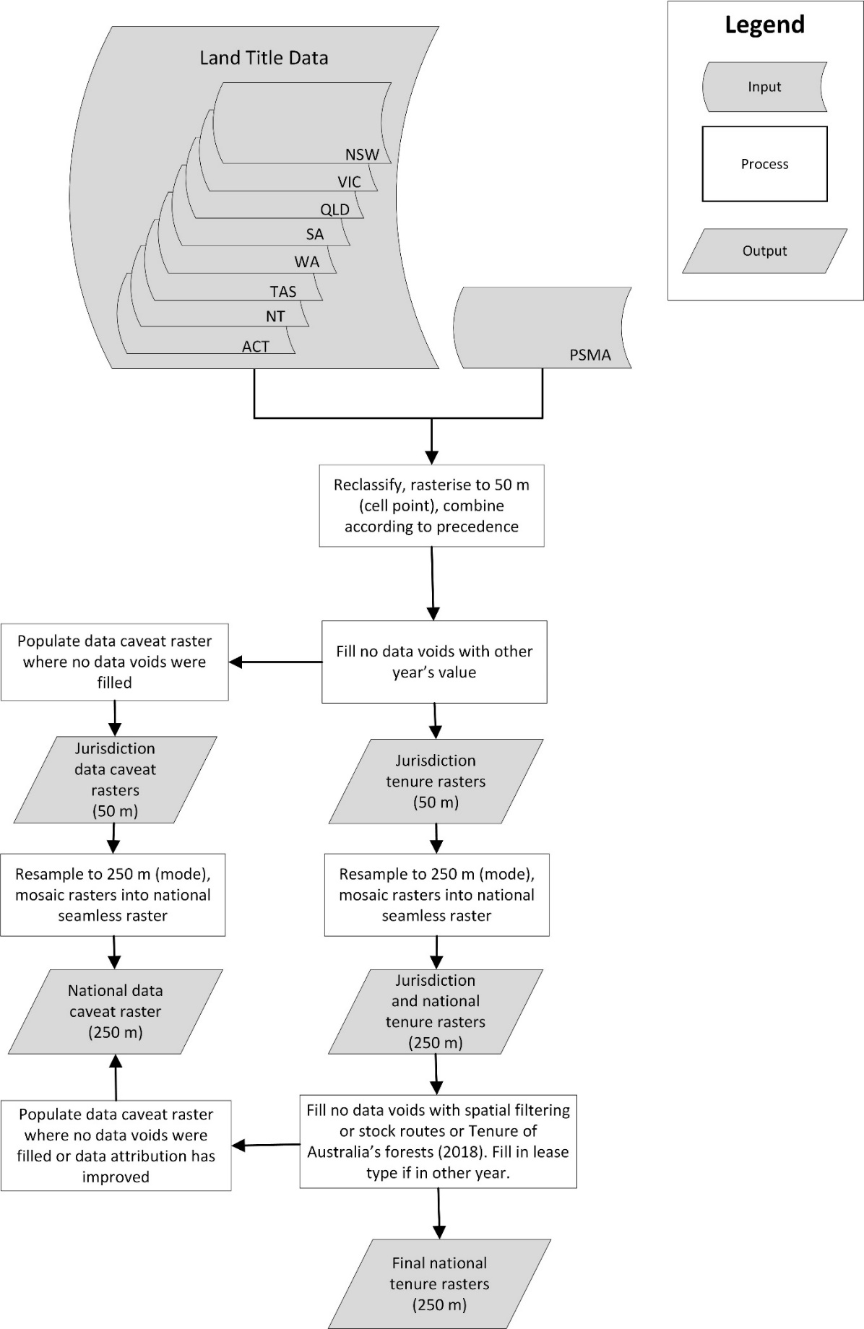

Positional accuracy:
Horizontal: ±250 metres
Vertical: not applicable

Attribute accuracy:
Attributes are compiled exercising due care and skill. However, attribute accuracy depends in part on the accuracy of input datasets and therefore cannot be guaranteed. The methods for mapping and classifying tenure depended on jurisdictional input data available. These are available as spreadsheets for each jurisdiction.

Logical consistency:
Data was used from authoritative sources and are reliant on the logical consistency of input datasets.

Completeness:
Dataset provides coverage for Australian mainland. Tenure attribution is present for 99.98% of Australia. Residual no data voids is 0.12% of mainland Australia which includes some water features.

Information about the product description

Parties responsible for description

Description custodian:
Department of Agriculture, Water and the Environment: Australian Bureau of Agricultural and Resource Economics and Sciences
Data Manager
GPO Box 858
CANBERRA CITY
Australian Capital Territory 2601 AUSTRALIA
Voice: +61 2 6272 3933
dataman@awe.gov.au

Description publisher:
Department of Agriculture, Water and the Environment: Australian Bureau of Agricultural and Resource Economics and Sciences
GPO Box 858
CANBERRA CITY
Australian Capital Territory 2601 AUSTRALIA
Voice: +61 2 6272 3933
dataman@awe.gov.au

Description originator:
Department of Agriculture, Water and the Environment: Australian Bureau of Agricultural and Resource Economics and Sciences: Forest and Land Sciences
GPO Box 858
CANBERRA CITY
Australian Capital Territory 2601 AUSTRALIA
Voice: +61 2 6272 3933
dataman@awe.gov.au

Additional metadata

References
ABARES 2018, Tenure of Australia’s forests (2018), Australian Bureau of Agricultural and Resource Economics and Sciences, Canberra, CC BY 4.0, DOI: doi.org/10.25814/5c592792c780e
ABARES 2020, Australia’s Indigenous forest estate (2020), Australian Bureau of Agricultural and Resource Economics and Sciences, Canberra, CC BY 4.0, DOI: doi.org/10.25814/bqr0-4m20
Australian Bureau of Statistics 2016, 1270.0.55.001 - Australian Statistical Geography Standard (ASGS): Volume 1 - Main Structure and Greater Capital City Statistical Areas, July 2016, Australian Bureau of Statistics, Canberra.
Department of the Environment and Energy 2019, Collaborative Australian Protected Areas Database (CAPAD) 2018 - Terrestrial , Commonwealth of Australia, Canberra.
Department of Environment, Land, Water & Planning 2019, Vicmap Property – Parcel Map Polygons, Victoria State Government, Melbourne.
Department of Lands and Surveys 2019, Stock routes in Western Australia, Western Australia Government.
Department of Natural Resources 2007, Stock routes – Queensland, Queensland State Government.
Gramenz L & Stewart JB (forthcoming), Land tenure of Australia 2010-11 to 2015-16: Land account methodology, Australian Bureau of Agricultural and Resource Economics and Sciences, Canberra.
Jacobsen R, Mutendeudzi M, Howell CL & Read SM 2019, Development of a national tenure dataset for reporting the tenure of Australia’s forests, ABARES technical report 19.4, Australian Bureau of Agricultural and Resource Economics and Sciences, Canberra, DOI: doi.org 10.25814/5d5e34e2d3dcc
National Native Title Tribunal 2020, Indigenous Estates: Land granted under specified Indigenous land granted instruments, National Native Title Tribunal, Perth.
PSMA 2012a, CadLite February 2012, Public Sector Mapping Agency Australia Limited, Canberra.
PSMA 2012b, Land Tenure February 2012, Public Sector Mapping Agency Australia Limited, Canberra.
PSMA 2017a, CadLite February 2017, Public Sector Mapping Agency Australia Limited, Canberra.
PSMA 2017b, Land Tenure February 2017, Public Sector Mapping Agency Australia Limited, Canberra.

Appendix 1 – Tenure descriptions

Table A1.1 Land tenure of Australia hierarchical classification
L1N | Level 1 | L2N | Level 2 | L3N | Level 3 | L4N | Level 4
1 | Freehold | 10 | Freehold | 100 | Freehold | 1001 | Freehold
 |  |  |  |  |  | 1002 | Freehold - Indigenous
2 | Crown land | 21 | Leasehold | 211 | Freeholding lease | 2111 | Freeholding lease
 |  |  |  |  |  | 2112 | Freeholding lease – Indigenous a
 |  |  |  | 212 | Pastoral perpetual lease | 2121 | Pastoral perpetual lease
 |  |  |  |  |  | 2122 | Pastoral perpetual lease – Indigenous
 |  |  |  | 213 | Other perpetual lease | 2131 | Other perpetual lease
 |  |  |  |  |  | 2132 | Other perpetual lease - Indigenous
 |  |  |  | 214 | Pastoral term lease | 2141 | Pastoral term lease
 |  |  |  |  |  | 2142 | Pastoral term lease - Indigenous
 |  |  |  | 215 | Other term lease | 2151 | Other term lease
 |  |  |  |  |  | 2152 | Other term lease - Indigenous
 |  |  |  | 216 | Other lease | 2161 | Other lease b
 |  |  |  |  |  | 2162 | Other lease - Indigenous
 |  | 22 | Crown purposes c | 221 | Nature conservation reserve d | 2211 | Nature conservation reserve
 |  |  |  |  |  | 2212 | Nature conservation reserve - Indigenous
 |  |  |  | 222 | Multiple-use public forest e | 2221 | Multiple-use public forest
 |  |  |  |  |  | 2222 | Multiple-use public forest – Indigenous a
 |  |  |  | 223 | Other Crown purposes | 2231 | Other Crown purposes
 |  |  |  |  |  | 2232 | Other Crown purposes - Indigenous
 |  | 23 | Other Crown land | 230 | Other Crown land f | 2301 | Other Crown land
 |  |  |  |  |  | 2302 | Other Crown land - Indigenous
a These classes are included for completeness but are not present in the datasets. b For Tasmania, other lease contains licences in 2010-11 as they are not differentiated in the source data. c This class is equivalent to the PSMA Level 2 class Reserve. d This class is equivalent to the definition of nature conservation reserve used by the National Forest Inventory (Appendix A in Jacobsen et al. 2019). e This class is equivalent to the definition of multiple-use public forest used by the National Forest Inventory (Appendix A in Jacobsen et al. 2019). As states differ in their classification of state forests and timber reserves they are included in multiple-use public forest. f This class aligns with PSMA definition of vacant, unallocated, unreserved or other Crown land. This is not equivalent to the tenure class other Crown land used by the National Forest Inventory which also includes other reserves (Appendix A in Jacobsen et al. 2019).

Table A1.2 Land tenure of Australia Level 1 tenure descriptions and meanings
Code | Description | Meaning
1 | Freehold | The highest form of land ownership. Land title is held in perpetuity. Includes land held by Aboriginal land trusts.
2 | Crown land | Land owned by the Crown; non-freehold land.
Note: Code = L1N; Description = L1_DESC

Table A1.3 Land tenure of Australia Level 2 tenure descriptions and meanings
Code | Description | Meaning
10 | Freehold | The highest form of land ownership. Land title is held in perpetuity. Includes land held by Aboriginal land trusts.
21 | Leasehold | The exclusive use of Crown land leased to an entity for a specified term and purpose.
22 | Crown purposes | Land reserved, dedicated, vested to, acquired, or purchased by the Crown or its authorised entities.
23 | Other Crown land | Crown land unallocated to a purpose or purposes.
Note: Code = L2N; Description = L2_DESC

Table A1.4 Land tenure of Australia Level 3 tenure descriptions and meanings
Code | Description | Meaning
100 | Freehold | The highest form of land ownership. Land title is held in perpetuity. Includes land held by Aboriginal land trusts.
211 | Freeholding lease | Crown leasehold land where a lessee is in the process of transferring lease to freehold with instalments.
212 | Pastoral perpetual lease | Crown leasehold land granted in perpetuity to an entity for primarily pastoral purposes.
213 | Other perpetual lease | Crown leasehold land granted in perpetuity to an entity for non-pastoral or non-specified purposes.
214 | Pastoral term lease | Crown leasehold land granted for a specified term of years to an entity for primarily pastoral purposes.
215 | Other term lease | Crown leasehold land granted to an entity for a specified term of years for non-pastoral or non-specified purposes.
216 | Other lease | Crown leasehold land where the purpose is specified as other or undefined.
221 | Nature conservation reserve | Crown land set aside for conservation purposes. Includes heritage reserves where specified.
222 | Multiple-use public forest | Crown land set aside for multiple-use forest values such as wood harvesting, recreation, and environmental protection, includes state forests and timber reserves.
223 | Other Crown purposes | Crown land set aside for all other purposes including water, infrastructure, institutional, defence and other undefined reserves; or lands vested to, acquired, or purchased by the Crown or its authorised entities to deliver essential services.
230 | Other Crown land | Crown land unallocated to a purpose or purposes.
Note: Code = L3N; Description = L3_DESC

Table A1.5 Land tenure of Australia Level 4 tenure descriptions and meanings
Code | Description | Meaning
1001 | Freehold | Land title holder has the power to sell, lease, licence and mortgage the land. Minerals and petroleum remain property of the Crown. All dealings are subject to compliance to planning and environmental laws, including the protection of heritage and sacred sites. May include freehold land purchased by Aboriginal land trusts through the open market.
1002 | Freehold - Indigenous | Land granted to an Aboriginal land trust as freehold. The power to sell, lease and licence the land varies with jurisdiction legislation. Minerals and petroleum rights and acquisition powers of the Crown varies between jurisdictions.
2111 | Freeholding lease | Crown leasehold land where a lessee is in the process of transferring lease to freehold with instalments.
2121 | Pastoral perpetual lease | Crown leasehold land granted in perpetuity to an entity for primarily pastoral purposes.
2131 | Other perpetual lease | Crown leasehold land granted in perpetuity to an entity for non-pastoral or non-specified purposes.
2132 | Other perpetual lease - Indigenous | Crown leasehold land granted in perpetuity to an Indigenous land trust for non-pastoral or non-specified purposes.
2141 | Pastoral term lease | Crown leasehold land granted for a specified term of years to an entity for primarily pastoral purposes.
2142 | Pastoral term lease - Indigenous | Crown leasehold land granted for a specified term of years to an Indigenous land trust for primarily pastoral purposes.
2151 | Other term lease | Crown leasehold land granted to an entity for a specified term of years for non-pastoral or non-specified purposes.
2152 | Other term lease - Indigenous | Crown leasehold land granted to an Indigenous land trust for a specified term of years for non-pastoral or non-specified purposes.
2161 | Other lease | Crown leasehold land where the purpose is specified as other or undefined.
2162 | Other lease - Indigenous | Crown leasehold land where the purpose is specified as other or undefined and held by an Indigenous land trust.
2211 | Nature conservation reserve | Crown land set aside for conservation purposes. Includes heritage reserves where specified.
2212 | Nature conservation reserve - Indigenous | Crown land vested or reserved to an Indigenous lands trust and set aside for conservation purposes. Includes heritage reserves where specified.
2221 | Multiple-use public forest | Crown land set aside for multiple-use forest values such as wood harvesting, recreation, and environmental protection, includes state forests and timber reserves.
2231 | Other Crown purposes | Crown land set aside for all other purposes including, water, infrastructure, institutional, defence and other undefined reserves; or lands vested to, acquired, or purchased by the Crown or its authorised entities to deliver essential services
2232 | Other Crown purposes - Indigenous | Crown land vested or reserved to an Indigenous land trust for the benefit of the Indigenous.
2301 | Other Crown land | Crown land unallocated to a purpose or purposes.
2302 | Other Crown land - Indigenous | Unallocated Crown land held by an Indigenous land trust.
Note: Code = VALUE or L4N; Description = L4_DESC

Appendix 2 – Change and data caveat descriptions

Table A2.1 Values, description, and meanings of the tenure observed change (TCH) attribute
TCH | TCH_DESC | Meaning
-1 | Offshore | Offshore
0 | No data/unresolved | No data/unresolved tenure. Captures areas where there is no tenure data or conflicting data sources; includes water features with unallocated tenure.
1 | Observed difference/change | Change has been observed between 2010–11 and 2015–16, at Level 4.
2 | No observed difference/change | No change has been observed between 2010–11 and 2015–16, at Level 4.

Table A2.2 Values, description, and meanings of the data caveat (DC) attribute
DC | DC_DESC | Meaning
-1 | Offshore | Offshore
0 | No data/unresolved | No data/unresolved tenure for this pixel. Captures where there is no tenure data or conflicting data sources; includes water features with unallocated tenure.
1 | No known data caveats | No known data caveats for this pixel
2 | Data attribution improved | The attribution for the pixel was improved from 2010-11 to 2015-16. This applies to the separation of leases and licences in Tasmania. Minor impact to change detection.
3 | No data in 2011, filled with data from 2016 | The pixel was populated with the same dataset for 2015–16 as no data was available for 2010–11. This includes leasehold pixels from 2010–11 data where lease type was defined by 2015–16 data. Change detection may be limited due to data availability issues.
4 | No data in 2016, filled with data from 2011 | The pixel was populated with the same dataset for 2010–11 as no data was available for 2015–16. This includes leasehold pixels from 2015–16 data where lease type was defined by 2010–11 data. Change detection may be limited due to data availability issues.
5 | No data in both years, filled with despeckling process | No data was available for both target periods, so a modelled approach was used to fill no data voids. Only no data voids <0.0002 degrees squared were filled using this method. Change detection may be limited due to data availability and modelling issues.
6 | No data in both years, filled with Stock routes a | No data was available for both target periods but identified as a stock route and filled. This applies to Western Australia and Queensland. Change detection may be limited due to data availability and modelling issues.
7 | No data in both years, filled with Tenure of Australia’s forests (2018) b | No data was available for both target periods and filled from ABARES' Tenure of Australia’s forests (2018) dataset. Latest date of information/currency is 30 June 2016. This was not applied to Inland water bodies in Tasmania which remain no data. Change detection may be limited due to data availability and modelling issues.
a Stock routes assigned to other Crown purposes. b Tenure of Australia’s forests (2018) provides tenure for forests and land. LEASE is assigned to other leases, with the other classes transferring to the equivalent class name if used to fill; freehold, nature conservation reserve, multiple-use public forest or other Crown land.

Appendix 3 – Colour tables

Table A3.1 Level 1 tenure classification symbology (RGB and hexadecimal colour values)
Level 4 code | Tenure classification - Level 1 | Red | Green | Blue | Hex | Colour
1001, 1002 | Freehold | 183 | 210 | 227 | #B7D2E3
2111, 2112, 2121, 2122, 2131, 2132, 2141, 2142, 2151, 2152, 2161, 2162, 2211, 2212, 2221, 2222, 2231, 2232, 2301, 2302 | Crown land | 236 | 193 | 130 | #ECC182

Table A3.2 Level 2 tenure classification symbology (RGB and hexadecimal colour values)
Level 4 code | Tenure classification - Level 2 | Red | Green | Blue | Hex | Colour
1001, 1002 | Freehold | 183 | 210 | 227 | #B7D2E3
2111, 2112, 2121, 2122, 2131, 2132, 2141, 2142, 2151, 2152, 2161, 2162 | Leasehold | 242 | 175 | 0 | #F2AF00
2211, 2212, 2221, 2222, 2231, 2232 | Crown purposes | 106 | 127 | 16 | #6A7F10
2301, 2302 | Other Crown land | 218 | 229 | 205 | #DAE5CD

Table A3.3 Level 3 tenure classification symbology (RGB and hexadecimal colour values)
Level 4 code | Tenure classification - Level 3 | Red | Green | Blue | Hex | Colour
1001, 1002 | Freehold | 183 | 210 | 227 | #B7D2E3
2111, 2112 | Freeholding lease | 106 | 64 | 97 | #6A4061
2121, 2122 | Pastoral perpetual lease | 176 | 106 | 146 | #B06A92
2131, 2132 | Other perpetual lease | 211 | 184 | 226 | #D3B8E2
2141, 2142 | Pastoral term lease | 224 | 104 | 75 | #E0684B
2151, 2152 | Other term lease | 236 | 193 | 130 | #ECC182
2161, 2162 | Other lease | 226 | 205 | 184 | #E2CDB8
2211, 2212 | Nature conservation reserve | 40 | 78 | 54 | #284E36
2221, 2222 | Multiple-use public forest | 168 | 180 | 0 | #A8B400
2231, 2232 | Other Crown purposes | 214 | 227 | 66 | #D6E342
2301, 2302 | Other Crown land | 218 | 229 | 205 | #DAE5CD

Table A3.4 Level 4 tenure classification symbology (RGB and hexadecimal colour values)
Level 4 code | Tenure classification - Level 4 | Red | Green | Blue | Hex | Colour
1001 | Freehold | 183 | 210 | 227 | #B7D2E3
1002 | Freehold - Indigenous | 84 | 130 | 171 | #5482AB
2111 | Freeholding lease | 106 | 64 | 97 | #6A4061
2112 | Freeholding lease – Indigenous a | 223 | 212 | 215 | #DFD4D7
2121 | Pastoral perpetual lease | 176 | 106 | 146 | #B06A92
2122 | Pastoral perpetual lease - Indigenous | 195 | 173 | 195 | #AFADC3
2131 | Other perpetual lease | 211 | 184 | 226 | #D3B8E2
2132 | Other perpetual lease - Indigenous | 131 | 141 | 203 | #8F8DCB
2141 | Pastoral term lease | 224 | 104 | 75 | #E0684B
2142 | Pastoral term lease - Indigenous | 213 | 43 | 30 | #D52B1E
2151 | Other term lease | 236 | 193 | 130 | #ECC182
2152 | Other term lease - Indigenous | 200 | 143 | 66 | #C88F42
2161 | Other lease | 226 | 205 | 184 | #E2CDB8
2162 | Other lease - Indigenous | 81 | 43 | 27 | #512B1B
2211 | Nature conservation reserve | 40 | 78 | 54 | #284E36
2212 | Nature conservation reserve - Indigenous | 32 | 108 | 73 | #206C49
2221 | Multiple-use public forest | 168 | 180 | 0 | #A8B400
2222 | Multiple-use public forest – Indigenous a | 106 | 127 | 16 | #6A7F10
2231 | Other Crown purposes | 214 | 227 | 66 | #D6E342
2232 | Other Crown purposes - Indigenous | 122 | 184 | 0 | #7AB800
2301 | Other Crown land | 218 | 229 | 205 | #DAE5CD
2302 | Other Crown land - Indigenous | 232 | 227 | 190 | #E8E3BE
a These classes are included for completeness but are not present in the datasets.

Appendix 4 – Data sources

Table A4.1 Land tenure of Australia, data sources obtained for each jurisdiction
 |  |  | Dataset date used for
Jurisdiction | Dataset | Data custodian | 2010-11 |  | 2015-16
ACT | Cadlite and Land Tenure | PSMA Australia | February 2012 (date range 2010 to 2011) |  | February 2017 (date range 2014 to 2016)
ACT | Territory Plan Overlay Zones | Office of the Surveyor-General and Land Information | May 2011 |  | May 2016
NSW | Digital Cadastral Database (DCDB) | NSW Department of Finance, Services and Innovation – Spatial Services | May 2011 |  | May 2016
NSW | Crown Reserve Tenure | NSW Department of Planning, Industry and Environment – Crown Lands and Water | 2011 |  | 2016
NSW | Aboriginal Land Council (ALC) – Aboriginal land trusts | NSW Department of Planning, Industry and Environment - Crown Lands and Water | 2011 |  | 2016
NSW | Australia’s Indigenous forest estate (2020) | Australian Bureau of Agricultural and Resource Economics and Sciences | June 2016 |  | June 2016
NT | Digital Cadastral Database of the Northern Territory | NT Department of Infrastructure, Planning and Logistics | May 2010 |  | May 2016
NT | Aboriginal Land Trusts | NT Department of Infrastructure, Planning and Logistics | 2011 |  | 2016
Qld | Digital Cadastral Database | Queensland Department of Resources | December 2010 |  | May 2016
Qld | Digital Cadastral Database – Lease aspatial table February 2020 | Queensland Department of Resources | sort a |  | sort
Qld | Stock routes - Queensland | Queensland Department of Resources | 2007 |  | 2007
Qld | Indigenous Interests | Queensland Department of Resources – Land and Native Title Service | sort a |  | sort
SA | Parcel Cadastre | SA Department for Infrastructure and Transport | 2009 |  | 2015
SA | Conservation Reserve Parcels | SA Department for Environment and Water | sort a |  | sort
Tas. | LIST Land Tenure | Tasmania Department of Primary Industries, Water and Environment | November 2011 |  | April 2016
Tas | LIST Authority Land b | Tasmania Department of Primary Industries, Water and Environment | sort a |  | sort
Vic. | Public Land Management (PLM100) | Victoria Department of Environment, Land, Water and Planning | 2011 |  | NA
Vic. | Public Land Management (PLM25) | Victoria Department of Environment, Land, Water and Planning | December 2012, July 2011, July 2016 |  | July 2016
Vic. | Vicmap Crown Land Tenure | Victoria Department of Environment, Land, Water and Planning | May 2011 |  | May 2016
Vic. | Victorian Land Use Information System | Victoria Department of Jobs, Precincts and Regions | 2010–11 |  | 2016–2017
Vic | Vicmap Property – Parcel Map Polygons c | Victoria Department of Environment, Land, Water and Planning | May 2019 | May 2019
WA | DBCA - Lands of Interest (DBCA-012) | WA Department of Biodiversity, Conservation and Attractions | June 2011 | June 2016
WA | DBCA - Legislated Lands and Waters (DBCA-011) | WA Department of Biodiversity, Conservation and Attractions | June 2011 | June 2016
WA | Client Property Event System - Properties (DPIRD-018) | WA Department of Primary Industries and Regional Development | March 2011 | August 2016
WA | CadLite and Land Tenure | PSMA Australia | February 2012 (2012) | February 2017 (date range 2015 to 2016)
WA | Aboriginal Land Trust (ALT) Estate | WA Department of Planning , Lands and Heritage | May 2011 | May 2016
Jervis Bay | Collaborative Australian Protected Areas Database (CAPAD) 2018 d | Australian Government Department of Agriculture, Water and the Environment | sort a | sort
Jervis Bay | CadLite and Land Tenure | PSMA Australia | February 2012 (2012) | February 2017 (date range 2014 to 2016)
Australia | Tenure of Australia’s forests | ABARES National Forest Inventory | 2018 (up to June 2016) | 2018 (up to June 2016)
a Recent dataset that can be sorted to find relevant dates. b Only those parcels where the GOVERN_ACT is Aboriginal Lands Act are selected. c Extracted manually those areas identified in the Aboriginal Lands Act 1970 and Aboriginal Land (Lake Condah and Framlingham Forest) Act 1987. d Booderee National Park and Booderee Botanic Gardens extracted. NA represents where datasets are not applicable for a target period.

