**Australian AFF exports by states and territories – June 2022**

Australian agricultural, fisheries and forestry (AFF) exports reached a record value of $62.8 billion in 2021. This was a result high international prices and favourable seasonal conditions that led to record crop production. Victoria, New South Wales, Queensland and Western Australia experienced record AFF exports. South Australia had their second highest AFF exports on record. Tasmania and the North Territory recorded declines in exports.

Western Australia, South Australia and Northern Territory AFF exports (2021)

Western Australia

* Western Australia’s AFF exports increased +30.7% from $7.5b in 2020 to a record $9.7b in 2021.
* Favourable seasonal conditions led to a +52.6% increase in grain, oilseed and pulse exports from $4.2b in 2020 to $6.4b in 2021.
* In 2021, the top 5 AFF exports from Western Australia were wheat ($3.3b), canola ($1.5b), barley ($1.2b), wool ($628.4m) and sheep meat ($573.8m).

**South Australia**

* South Australia’s AFF exports increased +9.4% from $5.7b in 2020 to the $6.2b in 2021. This is the second highest value on record, behind 2017.
* A rise in grain, oilseed and pulse exports by +68.1% from $1.6b in 2020 to $2.8b in 2021 offset a $641.1m decline in wine exports.
* In 2021, the top 5 AFF exports from South Australia were wheat ($1.4b), wine ($1.3b), barley ($635.7m), sheep meat ($551.6m) and lentils ($384.8m).

**Northern Territory**

* The Northern Territory’s AFF exports fell -22.2% from $647m in 2020 to $503.3m in 2021.
* AFF exports declined due to live cattle export volumes declining by -19.6% from 366,200 cattle in 2020 to 294,300 cattle in 2021.
* Between 2017 and 2021, live cattle exports accounted for 87.2% of the value of the Northern Territory's AFF exports.

Figure 1: Western Australia, South Australia and Northern Territory AFF exports (2021)

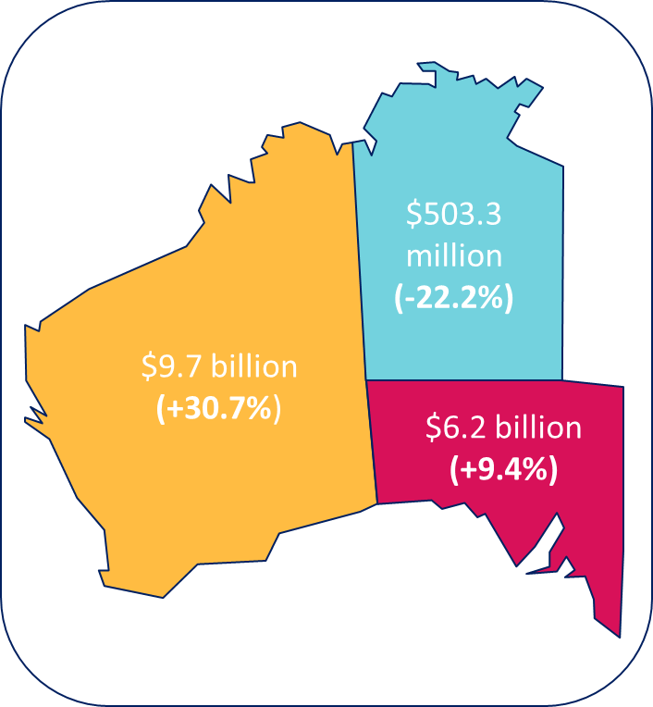

Victoria, New South Wales, Queensland and Tasmania AFF exports (2021)

Victoria

* Victoria’s AFF exports increased +18.8% from $13.6b in 2020 to a record $16.2b in 2021.
* Favourable seasonal conditions led to a +283.8% increase in grain and oilseed exports from $765.9m in 2020 to $2.9b in 2021.
* In 2021, the top 5 AFF exports from Victoria were sheep meat ($1.7b), wool ($1.5b), wheat ($1.5b), beef ($1.5b) and food preparations ($1.2b).

**New South Wales**

* New South Wales’ AFF exports increased +44.5% from $8.3b in 2020 to a record $12b in 2021.
* Favourable seasonal conditions led to a substantial increase of +878.5% in grain, oilseed and pulse exports from $404.2m in 2020 to $3.9b in 2021.
* In 2021, the top 5 AFF exports from New South Wales were wheat ($2.6b), beef ($1.6b), sheep meat ($1.2b), food preparations ($938m) and wool ($642.9m).

**Queensland**

* Queensland’s AFF exports increased +15.8% from $8.7b in 2020 to a record $10.1b in 2021.
* Favourable seasonal conditions led to a +207.7% increase in grain, oilseed and pulse exports from $522.4m in 2020 to $1.6b in 2021.
* In 2021, the top 5 AFF exports from Queensland were beef ($5.3b), wheat ($622.4m), grain sorghum ($424.4m), animal oils and fats ($392.9m) and chickpeas ($302.8m).

**Tasmania**

* Tasmanian AFF exports declined -8.5% from $1.2b in 2020 to $1.1b in 2021.
* Exports declined due to beef exports falling from $277m in 2020 to $187.6m in 2021 and forestry exports falling from $152.3m in 2020 to $99.6m in 2021.
* In 2021, the top 5 AFF exports were salmon ($214.7m), beef ($187.6m), cheese ($86.6m), food preps. ($63.9m) and skim milk powder ($50.4m).

Figure 2: Victoria, New South Wales, Queensland and Tasmania AFF exports (2021)

