Australian Ballast Water Management Requirements

Version 8



© Commonwealth of Australia 2020

**Ownership of intellectual property rights**

Unless otherwise noted, copyright in this publication (and any other intellectual property rights, if any) is owned by the Commonwealth of Australia.

**Creative Commons licence**

All material in this publication is licensed under a [Creative Commons Attribution (CC BY) 3.0 Australia](http://creativecommons.org/licenses/by/3.0/au/deed.en) licence, with the exception of content supplied by third parties, logos and the Commonwealth Coat of Arms.

C:\Documents and Settings\west merryn\Local Settings\Temporary Internet Files\Content.Word\by.png

The Creative Commons Attribution 3.0 Australia Licence is a standard form licence agreement that allows you to copy, distribute, transmit and adapt this publication provided you attribute the work. A summary of the licence terms is available from [creativecommons.org/licenses/by/3.0/au/deed.en](http://creativecommons.org/licenses/by/3.0/au/deed.en). The full licence terms are available from [creativecommons.org/licenses/by/3.0/au/legalcode](http://creativecommons.org/licenses/by/3.0/au/legalcode).

Inquiries about the licence and any use of this document should be sent to [copyright@awe.gov.au](mailto:copyright@awe.gov.au).

Any material sourced from this document should be attributed to the Department of Agriculture, Water and the Environment, *Australian Ballast Water Management Requirements Version 7.*

Department of Agriculture, Water and the Environment  
Postal address GPO Box 858 Canberra ACT 2601  
Switchboard +61 2 6272 2000  
Facsimile +61 2 6272 2001  
Web [awe.gov.au](http://daff.gov.au)

The Australian Government acting through the Department of Agriculture, Water and the Environment has exercised due care and skill in preparing and compiling the information and data in this publication. Notwithstanding, the Department of Agriculture, Water and the Environment, its employees and its advisers disclaim all liability, including liability for negligence, and for any loss, damage, injury, expense or cost incurred by any person as a result of accessing, using or relying upon any of the information or data in this publication to the maximum extent permitted by law.

Material in this publication is made available on the understanding that the Commonwealth is not providing professional advice and should not be taken to indicate the Commonwealth’s commitment to a particular course of action. Different solutions and outcomes may apply in individual circumstances. Before relying on any material contained in this publication, readers should obtain appropriate professional advice suitable to their particular circumstances.

Contents

1 Introduction 4

2 Documents Required 5

3 Ballast Water Reporting 8

4 Ballast Water Management Options 10

5 Acceptable Areas for Ballast Water Exchange 17

6 Ballast Water Management For Vessels servicing offshore installations 23

7 Exemptions 24

8 Disposal of Ballast Tank Sediment 27

9 Practical Considerations 28

10 Further Advice and Information 32

Attachment A: Ballast Water Management Plan and Certificate Requirements 33

Attachment B: Example Ballast Water Management Certificate 35

Attachment C: Ballast water pump test 36

Attachment D: Maps of Ballast Water Exchange Exclusion Areas 37

Attachment E: Ballast Water Management System Commissioning Circular 41

11 Glossary 43

### **Version history**

The Australian Ballast Water Management Requirements are updated periodically. You can check that this version is still current at [awe.gov.au/abwmr](http://www.agriculture.gov.au/abwmr)

The following table describes recent changes to the requirements.

|  |  |  |
| --- | --- | --- |
| Version | Date | Reason for issue |
| 5.3 | 1 August 2011 | Review and update of document to reflect new ballast water management requirements. |
| 6 | 6 June 2016 | Review and update of document to reflect new ballast water management requirements under the *Biosecurity Act 2015*. |
| 7 | 07 July 2017 | Review and update of document to reflect the *Biosecurity (Ballast Water and Other Measures) Amendment Act 2017* and the *Biosecurity (Ballast Water & Sediment) Determination 2017*. |
| 8 | 13 October 2019 | Review and update of document to reflect the *Biosecurity (Ballast Water and Sediment) Amendment (Ballast Water Management Methods) Determination 2019*; and the *Biosecurity (Ballast Water Same Risk Area) Amendment (Great Barrier Reef and Northern Territory) Instrument 2019.* |

## Introduction

The Australian Ballast Water Management Requirements set out the obligations on vessel operators with regards to the management of ballast water and ballast tank sediment when operating within Australian seas. These requirements include legislative obligations under the:

* [*Biosecurity Act 2015* (Biosecurity Act)](http://agriculture.gov.au/biosecurity/legislation/biosecurity-legislation), and
* International Convention for the Control and Management of Ships’ Ballast Water and Sediments (Ballast Water Convention).

The requirements provide guidance for vessel operators on best practice policies and apply to all vessels operating internationally and domestically in Australia.

The legislative obligations on vessels to manage ballast water are contained in the Commonwealth Biosecurity Act 2015 and associated legislation. Vessels following these requirements will be complying with these obligations.

Ballast water can contain a range of invasive marine species, which, if unmanaged, can lead to an unacceptable economic and environmental impact on Australia’s unique maritime environment.

This version of the requirements reflects the implementation of the Ballast Water Convention and other changes associated with the introduction of new national domestic ballast water requirements to reduce the risk of spreading marine pests that have already established in Australian seas.

Contact details for more information on these requirements is included in [Section 10](#_Toc433622012).

### Checklist for Masters

This checklist is to assist masters in complying with these requirements and includes page references for more information.

🞏 Ensure the vessel has a valid Ballast Water Management Plan (BWMP, management plan) and a valid Ballast Water Management Certificate (BWMC, management certificate) as set out in [Section 2](#_Documents_required).

🞏 Ensure all operations are recorded in the Ballast Water Record System, as described in [Section 2](#_Documents_required).

🞏 Ensure the vessel has met the reporting obligations set out in [Section 3](#_Ballast_water_reporting).

🞏 Ensure all ballast water is managed in accordance with [Section 4](#_Ballast_water_management).

## Documents Required

### Key points

* All vessels must carry a valid ballast water management plan
* All vessels must carry a valid International Ballast Water management certificate
* Vessels with a ballast water management system (BWMS) must carry a Type Approval Certificate specific to the type of Ballast Water Management System (BWMS) installed
* All vessels must maintain a complete and accurate record of all ballast water movements

For clarification of requirements for different vessel types please refer to [Attachment A](#_Attachment_A:_Ballast)

### Ballast Water Management Plans

All vessels designed to carry ballast water are required to carry a valid Ballast Water Management Plan (BWMP). A valid BWMP must be approved by either a survey authority, classification society, or the Administration of the vessel. For Australian flagged vessels, a management plan must be approved by the Director of Biosecurity, or an approved survey authority.

BWMPs should be consistent with the Ballast Water Convention’s *Guidelines for Ballast Water Management and Development of Ballast Water Management Plans* (G4 Guidelines).

The department strongly recommends Responsible Officers include a copy of the Australian Ballast Water Management Requirements with the vessels Ballast Water Management Plan. All crew responsible for ballast water management must familiarise themselves with the requirements within the document.

The BWMP must

* be vessel specific (vessel name and International Maritime Organization (IMO) number),
* be approved by a survey authority, recognised organisation, or the vessel’s flag administration,
* nominate the rank(s) of the responsible officer and crew, and
* contain the ballast water management method and pumping rates.

Non-commercial vessels that are less than 400 gross tonnes are exempt from carrying Ballast Water Management Plans and International Ballast Water certificates.

Refer to [Section 7](#_Exemptions) for details on seeking an exemption.

### Ballast Water Management Certificates

A Ballast Water Management Certificate (BWMC) is required for all vessels to which the Ballast Water Convention applies. The majority of Australian domestic vessels designed to carry ballast water will also need to obtain a ballast water management certificate. [Attachment A](#_Attachment_A:_Ballast) lists the certification requirements for different classes of vessel.

A BWMC verifies the vessel has been surveyed to a standard compliant with the Ballast Water Convention, and must be consistent with the format described in Appendix I of the Ballast Water Convention. A statement of fact, or a certificate of compliance, is also accepted for vessels flagged to an administration that is not party to the Ballast Water Convention.

A valid BWMC must be issued by either a survey authority, classification society, or the administration of the vessel, and be in accordance with Regulation E-1 of the Ballast Water Convention. For Australian flagged vessels, a management certificate must be issued by the Director of Biosecurity, or an approved survey authority.

The certificate should

* be vessel specific (vessel name and IMO number),
* be approved by survey authority, administration or recognised organisation,
* state the principal ballast water method(s) used (Regulation D-1 (Exchange Standard) or Regulation D-2 (Treatment Discharge Standard or Potable water) or Regulation D-4 (Prototype System)),
* certify Regulation E-1 in fine print (survey schedule), and
* have an end date up to five years from time of issue.
* need only state the principal method of ballast water management (D-2) if the keel lay date is on or after 8th September 2017. Contingency methods must be included with the vessels BWMP and need not be included on the vessels certificate.

Regulation D-1 on a BWMC is for vessels that utilise ballast water exchange as their primary method of ballast water management. Regulation D-2 on the certificate is for vessels that utilise an IMO Type Approved Ballast Water Management System (BWMS); or meet the D-2 standard of the Convention through use of another method. If Regulation D‑2 has been selected, the management certificate should clearly state the name of the system installed on the vessel.

Floating platforms, Floating Storage Units (FSUs) and Floating Production, Storage and Offloading Units (FPSOs) are required to obtain a BWMP and BWMC. The survey schedule required for these vessels is not required to follow the schedule specified in Regulation E.1.1. Certification for floating platforms, FSUs and FPSOs may remain valid for a maximum of five years in-between surveys.

An example of valid certificates is provided in [Attachment B](#_Attachment_B:_Example).

### Type Approval Certificate

For vessels with a BWMS, also known as a ballast water treatment system, a Type Approval Certificate must be retained on board. A Type Approval Certificate relates specifically to the ballast water management system, and is not vessel specific.

### Ballast Water Record System

All vessels that utilise ballast water management, must maintain a complete and accurate Ballast Water Record System (Record System). The system may be electronic or in hard copy and should comply with Regulation B‑2 of the Annex to the Ballast Water Convention.

The Record System should contain a complete and current record of all ballast water movements. Records that should be kept in the vessel’s ballast water recording system when conducting a ballast water exchange are:

* start and finish coordinates of uptake and discharge of ballast water
* start and finish times for pumping water during an exchange
* actual pumping times (these should not be affected by the crossing of time zones)
* residual volume remaining in the tank at the end the empty cycle prior to refill (empty refill method only)
* signature of the officer in charge of the operation.

A manual ballast water handling log is recommended for vessels that use an electronic record keeping system as a backup for verification purposes. A vessel must maintain a minimum of two years of records on board from 8 September 2017.

If you require further advice and information, please contact us using the details available in [Section 10](#_Toc433622012).

## Ballast Water Reporting

### Key points

* It is highly recommended that all vessels submit a Ballast Water Report. Vessels arriving from an international location and intending to discharge ballast are obligated to submit a report.
* International vessels can submit a Ballast Water Report through the [Maritime Arrivals Reporting System (MARS)](http://www.agriculture.gov.au/biosecurity/avm/vessels/mars)
* Domestic trading vessels can request a low risk exemption through a Domestic Risk Assessment. All applications must be submitted through MARS.

Reporting obligations differ depending on whether a vessel is trading domestically in Australia, or making international voyages. This is distinct from the flag of the vessel and is based on whether the vessel has been released from biosecurity control by the department.

If there are exceptional circumstances that prevent the vessel from managing the ballast, the department should be notified as soon as practicable. In the event of a BWMS failure the operator must notify the [Maritime National Coordination Centre (MNCC)](#_Toc433622012) as soon as they are aware of the failure, to seek the department’s advice on possible contingency measures.

### Reporting obligations for international vessels

Vessels that are intending to discharge internationally sourced ballast water must submit a Ballast Water Report through MARS at least 12 hours prior to arrival.

However to prevent the discharge of high risk ballast, even vessels not intending to discharge ballast water are strongly encouraged to manage their ballast water, and submit a Ballast Water Report. This action may assist in avoiding delays should the vessel have an itinerary change.

The Ballast Water Report will be assessed by the department through MARS and a response will be issued through the Biosecurity Status Document. The Ballast Water Report should be updated if the ballast water situation changes on board. This should be completed as soon as practicable.

Following the first point of arrival, international vessels may uptake Australian sourced ballast water for discharge later in Australia or overseas. The movement of Australian sourced ballast water between Australian ports is prohibited unless it has been managed, or a low risk exemption has been provided by the department.

Vessels can report the status of Australian sourced ballast water by resubmitting their Ballast Water Report with an updated status about their ballast water tanks. This is not compulsory however may be used to check the vessels compliance prior to arrival at the subsequent Australian port.

More information about Ballast Water Reports and Biosecurity Status Documents is available on our website at [a.gov.au/biosecurity/avm/vessels](http://www.agriculture.gov.au/biosecurity/avm/vessels)

### Reporting obligations for domestic vessels

Vessels that have been released from biosecurity control are still required to manage the movement of Australian sourced ballast water. All ballast water must be managed or receive a low risk exemption from the department prior to discharge.

Vessels can seek a low risk exemption through a Domestic Risk Assessment submitted through [MARS](http://www.agriculture.gov.au/biosecurity/avm/vessels/mars/vessel-compliance). Exemptions will be granted for ballast water which is determined to be low risk based on the date and port of uptake and the date and port of discharge. Once submitted, a Domestic Risk Assessment Outcome document will be issued advising the vessel of the status of the exemption.

Vessel operators should be aware that seasonal changes will affect the outcome of risk based exemptions within Australian ports. Risk based exemptions for Australian sourced ballast water are only issued for a single voyage on the specified dates.

Vessel operators must retain evidence of the exemption notice on board, and may be required to present this on request during an inspection. If a risk based exemption is issued, the vessel is not required to manage the relevant ballast water prior to discharge at the port specified in the exemption.

### Ballast Water Verification Inspections

The department may conduct on-board ballast water verification inspections to assess the ballast water information on board, including plans, certificates, and ballast water records.

In addition to the above records, a responsible officer that is listed in the BWMP must be available to assist with the inspection.

Fees apply to verification inspections, as per the Department’s charging guidelines.

## Ballast Water Management Options

### Key points

* Australia is phasing out ballast water exchange in line with the agreed schedule set out under the Ballast Water Convention.
* All ballast water should be managed using one of the approved ballast water management options.
* Carrying high risk ballast water is strongly discouraged, as a vessel’s itinerary may change or discharge may be necessary to ensure the safety of the vessel or prevent pollution

### Phase out of ballast water exchange

Australia is implementing the agreed implementation schedule for the Ballast Water Convention that requires vessels to phase out ballast water exchange in favour of a method that is compliant with the D-2 discharge standard. In order to achieve this, vessels will be required to install an IMO approved BWMS, or use one of the other approved methods of management.

#### Vessels constructed on or after 8 September 2017

New vessels constructed on or after 8 September 2017, will be required to meet the Regulation D-2 discharge standard from the date they are put into service.

#### Vessels constructed before 8 September 2017

Vessels constructed before 8 September 2017 will need to comply with the Regulation D-2 standard by either the first or second five-year renewal survey of the vessel associated with the International Oil Pollution Prevention Certificate (IOPP) under the International Convention for the Prevention of Pollution from Ships (MARPOL) Annex I.

Vessels must comply with the Regulation D-2 standard by their first renewal survey date, when the first renewal survey takes place on or after 8 September 2019

#### Vessels that are not subject to IOPP renewal surveys

An existing vessel to which the IOPP renewal survey under MARPOL Annex I does not apply must meet the Regulation D-2 standard from 8 September 2024.

[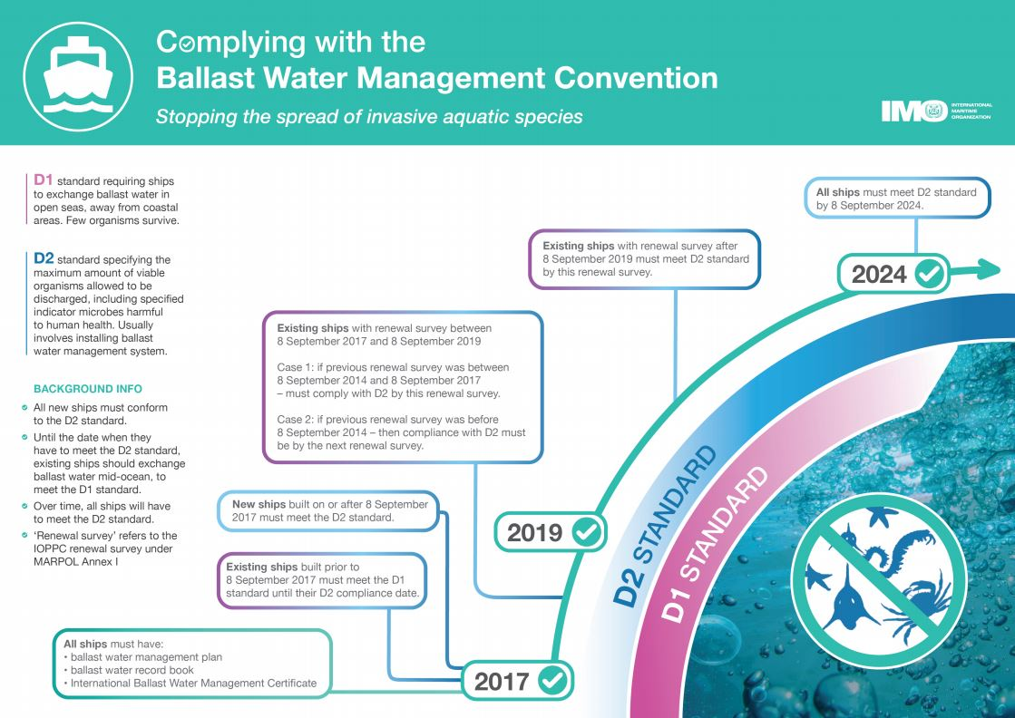](http://www.google.com/url?sa=i&rct=j&q=&esrc=s&source=images&cd=&ved=2ahUKEwjz2t20gLbkAhWPXisKHaRKDxMQjRx6BAgBEAQ&url=http://www.imo.org/en/MediaCentre/HotTopics/Pages/Implementing-the-BWM-Convention.aspx&psig=AOvVaw1m28pIwEJA46OIv7Fp9RKq&ust=1567646491609181)

[Source: International Maritime Organization (IMO)](http://www.imo.org/en/MediaCentre/HotTopics/Pages/Implementing-the-BWM-Convention.aspx)

### Approved methods of ballast water management

The approved methods of ballast water management are:

* use of a BWMS
* ballast water exchange conducted in an acceptable area
* use of low risk ballast water (such as fresh potable water, high seas water or fresh water from an on-board fresh water production facility)
* retention of high-risk ballast water on board the vessel
* discharge to an approved ballast water reception facility.

### Use of a Ballast Water Management System

The department accepts any IMO Type Approved BWMS, and prototype systems being tested for approval. The list of Type Approved and Prototype Approved systems is available at [imo.org](http://www.imo.org/).

All Type Approved systems have been included in the department’s reporting documents. If your vessel’s particular system does not appear on this form, contact the [MNCC.](#_Toc433622012)

BWMS must be used in accordance with the manufacturer’s instructions as described in the BWMP.

### Ballast Water Management System Commissioning

The Australian Government expects Australian flagged ships to which the Ballast Water Management Convention applies to adhere to BWM.2/Circ.70 on **“Guidance for the commissioning testing of ballast water management systems”**. A circular to inform the industry on the application of this guidance was released on 18 October 2019 and is available at [Attachment E](#_Attachment_E:_BWMS).

The purpose of the commissioning test is to verify that the mechanical, physical, chemical and biological processes of the installed BWMS are working properly on installation.

### Contingency Measures for BWMS

A contingency measure means a process undertaken on a case-by-case basis after a determination that ballast water to be discharged from a ship is not compliant.

Vessels installed with BWMS and wishing to utilise a contingency measure should incorporate ship-specific contingency measures into the BWMP. The contingency measures and BWMP should subsequently be approved by a Registered Organisation (RO).

The ship-specific contingency measures incorporated in the BWMP does not permit a vessel to discharge unmanaged ballast water in Australian Waters. The department must be informed of the defective BWMS as soon as practical.

### Ballast Water Exchange

Ballast water exchange is an approved method only for those vessels that are not yet required to meet the Convention’s Regulation D-2 discharge standard as described in the phase out schedule above.

Ballast water exchange must be conducted to the equivalent of a 95 per cent (or greater) volumetric exchange, using one of the acceptable methods of ballast water exchange provided below. Ballast water exchanges must be conducted as far from the nearest land as possible, and in all cases within an acceptable area (see acceptable areas for ballast water exchange).

The safety of the vessel and crew are paramount, all safety considerations must be taken into account when conducting ballasting operations. The Master of the vessel must ensure that the ballast water exchange is conducted in accordance with the vessel’s BWMP to ensure the method is appropriate to manage the risk of transferring pests whilst also ensuring the safety of the vessel and crew.

#### Acceptable methods for ballast water exchange

Australia’s acceptable ballast water exchange methods are consistent with the Ballast Water Convention. A vessel should only use ballast water exchange methods that are described in the vessel’s BWMP. Under the requirements of the Ballast Water Convention, three management methods are considered suitable to meet a 95 per cent (or greater) volumetric exchange:

* sequential exchange (empty/refill)
* flow-through
* dilution.

#### Sequential exchange (empty/refill)

Sequential exchange is emptying of at least 95 per cent of the total tank volume prior to refilling it with water sourced from an area considered acceptable for ballast water exchange. Vessels conducting a sequential exchange must ensure that the residual volume is less than 5 per cent of the total tank volume prior to refilling the tank. This residual volume quantity must be recorded in the vessel's ballast water records.

When verifying an empty/refill operation, a biosecurity officer will compare the residual volume of the tank recorded at the end of the empty cycle to the final volume on arrival, to ensure that at least 95 per cent of high-risk water was exchanged.

#### Flow-through method

A total of three times the total ballast capacity of the tank (300 per cent) must be pumped through, as a minimum, when conducting exchange using the flow-through method.

This is calculated from the time when the tank is full and/or water begins to overflow from the tank, not from when the pumps start. This is the case regardless of whether the tank was partially or completely full at the beginning of the flow-through process.

Tanks must be flushed one at a time or in similar port and starboard pairs. If co-joined ballast tanks are flushed, a biosecurity officer may request documentary evidence of the ballast tank layouts to ensure compliance with these requirements (e.g. the vessel’s ballast water management plan). Flushing dissimilar tanks together does not meet Australian requirements and may result in the ballast water not being managed for discharge in accordance with the Biosecurity Act.

A biosecurity officer can verify if a sufficient volume of water has been exchanged by using the current verified pumping capacity and pump time to determine if at least 300 per cent of the total tank capacity has passed through the tank. Pumping times must be calculated from the time each tank starts to overflow, not from when the pumping operation has begun.

For further advice on conducting flow-through exchanges, please refer to [Section 9](#_Practical_considerations).

#### Dilution method

At least three times the tank’s maximum capacity must be pumped through when conducting an exchange using the dilution method.

Tanks must be flushed one at a time or in similar port and starboard pairs. If co-joined ballast tanks are flushed, a biosecurity officer may request documentary evidence of the ballast tank layouts (which could be included in the BWMP) to ensure compliance with these requirements. Flushing tanks inconsistent with the vessels BWMP will result in the ballast water not being managed for discharge in accordance with the Biosecurity Act.

For further advice on conducting flow-through exchanges, please refer to [Section 9](#_Practical_considerations).

### Low-risk ballast water

A tank is considered to contain low-risk ballast water if at least 95 per cent of the ballast water in that tank is from a low-risk source. Tanks containing less than 95 per cent low-risk water will be considered high risk, and will need to be managed consistent with the methods outlined in this document.

#### Fresh potable water

Fresh potable water can be sourced from a municipal water supply or from an on-board desalination system. Documentation will be required to confirm the source of any potable water.

Documentation may include:

* a bill of sale or receipt, or
* a signed letter on company letterhead verifying the origin of the water, or
* a surveyor’s report, or
* records of operating a desalination system detailing the volume of fresh water generated, or
* a test report verifying compliance of the fresh water with the D-2 discharge standard

If these conditions cannot be met, the ballast water will be considered high-risk, and must be managed by an acceptable method outlined in this document prior to discharge in Australian seas.

#### Water taken up on the high seas

Water that has been taken up on the high seas, or international waters, is considered to be low risk. This includes water that is greater than 200 nautical miles from any land mass and in water that is greater than 200 metres deep. See section 5 for alternate areas.

#### Water taken up and discharged within the same place

Ballast water taken up and discharged in the same place is considered low risk, provided that the water comprises 95 per cent or greater of the volume of water in the tank. The same place is considered to be within the port limits of the same port, or within one nautical mile of the point of uptake.

### Retention of high-risk ballast water

Operators may choose to retain high-risk water within a ballast water tank if there is no intention to discharge the water in Australian seas. However, carrying high-risk ballast water into Australian seas is strongly discouraged, as a vessel’s itinerary may change, or discharge may be necessary in the case of safety or pollution considerations.

#### Tank-to-tank transfers

Ballast water may be transferred between ballast tanks to control the trim and draft of the vessel. Tank-to-tank transfers of high-risk ballast water complicate ballast water management and may result in accidental discharge. Operators must be vigilant to ensure the risk of high-risk ballast discharging during the transfer operations is minimised.

Mixing low-risk water with high-risk water through tank-to-tank transfers may result in ballast water being considered high risk and unsuitable for discharge. Vessel operators must update their ballast water records for each transfer operation.

#### Empty tanks

Tanks are considered to be empty when the pumps lose suction, and the remaining volume cannot be removed.

It is recommended that soundings of empty tanks be conducted, and recorded separately in the vessels ballast water recording system at the end of the pump out cycle of ballast operations. These soundings must demonstrate that the volume remaining is less than 5 per cent of the total volume of the ballast water tank.

If the residual volumes exceed 5 per cent of the final volume, the tank is considered to be unmanaged and any water introduced to that tank would result in a mixed tank. A biosecurity officer may ask vessel operators to conduct soundings on a selection of empty tanks to ensure the residual volumes are recorded accurately. If tanks cannot achieve 5 percent or less as a minimum, [contact the MNCC for advice](#_Toc433622012)

#### Mixed tanks

Where water from more than one source is added to a ballast water tank, it is considered to be a mixed tank. The mixing of ballast water from multiple sources in one tank is not recommended by the department as it increases the complexity in managing the tank and increases the likelihood of discharge of high risk water.

Mixed tanks may be eligible for discharge if all water is from low risk sources.

If you are concerned about your vessel’s eligibility for a mixed tank for discharge, [contact the MNCC for advice](#_Toc433622012).

### Discharge to a ballast water reception facility

Ballast water may be discharged to a ballast water reception facility that has been approved by the Director of Biosecurity in accordance with the G5 Guidelines of the Ballast Water Convention. The ballast water must be treated or disposed of at the facility in accordance with the approval requirements.

If there is an intention to discharge to a ballast water reception facility, [contact the MNCC](#_Toc433622012) to ensure the facility intended for discharge is an approved facility.

### Discharge relating to safety, accident or pollution

A vessel is able to discharge high risk ballast water when:

* it is necessary for ensuring the safety of a vessel in emergency situations or saving a life at sea
* the discharge is accidental and results from damage to the vessel or its equipment, or
* it is necessary for the purposes of minimising or avoiding pollution.

All reasonable precautions must be taken to prevent or minimise the discharge. Vessel masters must report the discharge to the department as soon as possible after the incident. Under no circumstances should this information be sent to the department any later than the submission of the pre-arrival report.

For enquiries, or to report discharges relating to safety, accident or pollution, [contact the MNCC](#_Toc433622012).

### Alternative methods

Vessels wishing to use alternative methods for ballast water management that are not specified in this document must receive approval from the department prior to discharge. Vessels that cannot comply with the requirements, [contact the MNCC](#_Toc433622012) as soon as practicable to avoid possible delays in operations.

## Acceptable Areas for Ballast Water Exchange

### Key points

* Vessels must not exchange ballast water within the Great Barrier Reef or Ningaloo Reef, as described in this section and in [Attachment D](#_Attachment_D_–).
* Vessels taking up and discharging ballast water within the [Same Risk Areas](#_Same_Risk_Areas) described in this section are not required to exchange ballast water. However if the vessel is fitted with a type approved ballast water management system this system will be required to be used.

Ballast water exchange should be conducted in at least 200nm from nearest land and in waters 200m deep. For voyages that cannot practically meet these requirements ballast water exchange must occur at least 12 nautical miles from the nearest land and in water at least 50 metres deep.

Ballast water must not be exchanged within 12 nautical miles of the Great Barrier Reef ([Map 1](#_Map_1_-).), or within the Ningaloo Reef ballast water exchange exclusion area ([Map 2](#_Map_2:_Ningaloo).)

### Same Risk Areas

The waters within the following areas are considered [Same Risk Areas](#_Same_Risk_Areas) (SRA) and water may be taken up and discharged within these areas without undertaking ballast water exchange. For vessels that have been required to phase out the use of ballast water exchange, ballast water must be managed utilising an alternative method within these areas:

* Queensland - The Great Barrier Reef Marine Park SRA
* South Australia- Gulf St Vincent and the Spencer Gulf SRA
* Victoria - Port Phillip Bay SRA
* Northern Territory – Northern Territory SRA - excluding international ports of Darwin, Gove and Milner Bay.

**The operation of the same risk area only applies only to vessels utilising ballast water exchange as their primary method of ballast water management.** When a vessel is required to meet the discharge standard under Regulation D-2 of the BWM Convention and Australia’s ballast water requirements (see [Section 4](#_Ballast_water_management)) the vessels’ ballast water must be managed in accordance with the BWMP.

#### Discharging ballast water sourced inside the SRA

Vessel operators are not required to exchange ballast water sourced within the SRA if:

* their vessel uses ballast water exchange as their primary method of ballast water management, and
* the ballast water was taken up in the SRA, and
* ballast water exchange is the only practicable ballast water management method available.

#### Discharging ballast water sourced outside the SRA

Ballast water management operations must occur prior to entering an SRA, if you plan to discharge ballast water sourced from a port outside an SRA.

### Great Barrier Reef Marine Park SRA

The ports within the Great Barrier Reef Marine Park, and part of the Torres Strait and Gulf of Carpentaria, are known as the Great Barrier Reef Marine Park Same Risk Area. This area includes:

* all ports located within the boundaries of the Great Barrier Reef World Heritage Area
* the ports of Weipa and Amrun
* all ports located within the boundaries of the Torres Strait Islands; and
* Bundaberg.

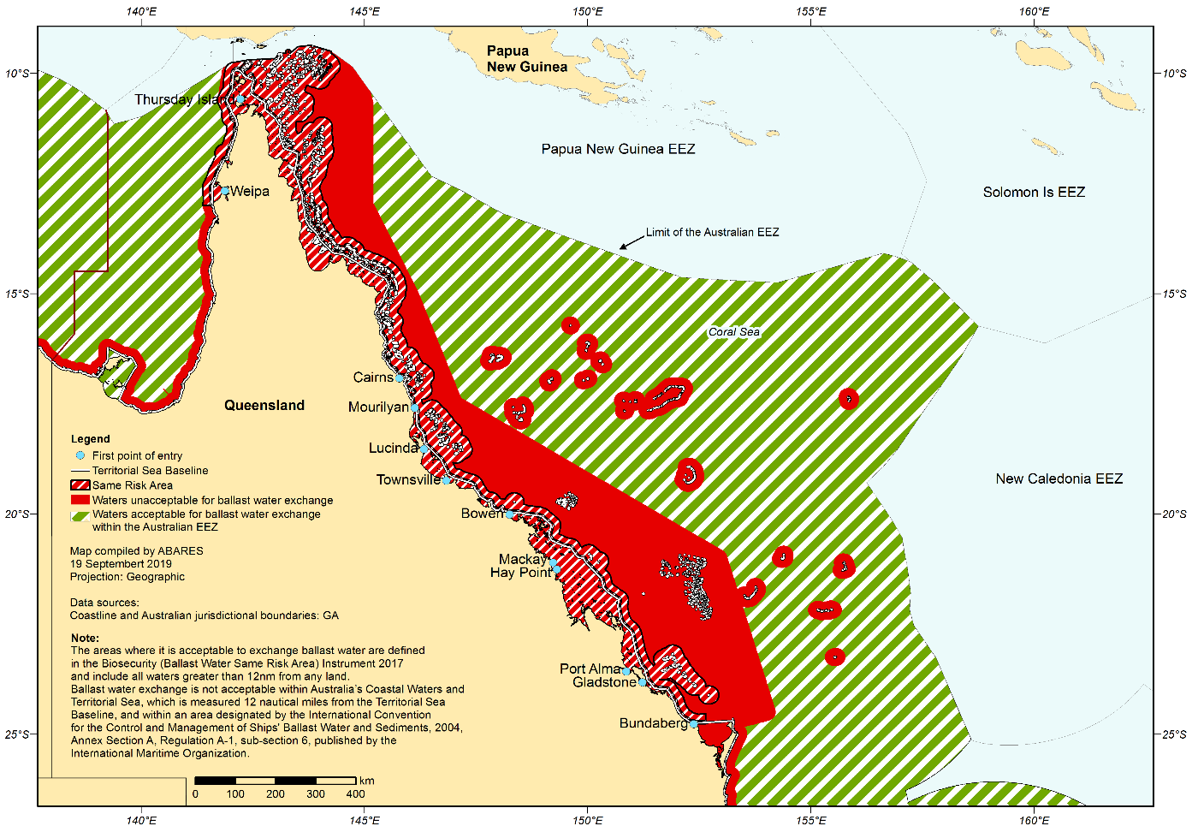

The area bounded by the line starting at the point described in item 1 of the following table and running sequentially as described in the table is specified.

| **Queensland—Great Barrier Reef** | |
| --- | --- |
| **Item** | **Description** |
| 1 | The westernmost intersection of the mean low water line of the mainland of Australia around Thud Point, Queensland, by the parallel of latitude 13°00′00″S |
| 2 | West along that parallel to its intersection by the outer limit of the territorial sea of Australia |
| 3 | Generally northerly along that outer limit to its intersection by the parallel of latitude 10°00’00”S |
| 4 | East along that parallel to its intersection by the outer limit of the territorial sea of Australia |
| 5 | Generally southerly and south‑easterly along that outer limit to its intersection 12 nautical miles north of the territorial sea baseline across Hervey Bay by the meridian of longitude 152°39’00”E |
| 6 | South along that meridian to its intersection by the parallel of latitude 24°46’00”S |
| 7 | West along that parallel to its intersection by the mean low water line of the mainland of Australia around South Head, Bundaberg, Queensland |
| 8 | Generally north‑westerly, northerly, north‑westerly and southerly along that mean low water line to the starting point |

Note: Geographic coordinates in this instrument are expressed in terms of the Geocentric Datum of Australia 1994 (commonly known as GDA94).

#### South Australia- Gulf St Vincent and Spencer Gulf

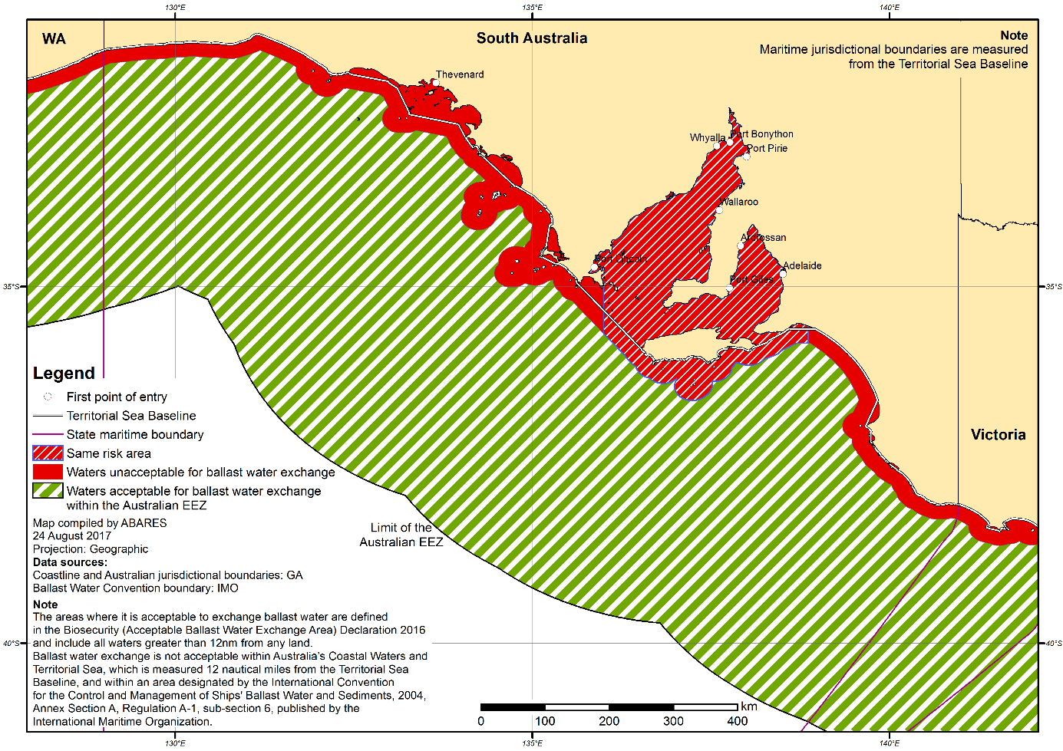

**Eastern boundary**

River Murray mouth (west bank): 138° 52’ 28.325”E. 35° 33’ 26.697”S

Intersection with edge of waters acceptable for BW exchange: 138° 52’ 30.469”E. 35° 47’ 44.164”S

**Southern boundary (east to west)**

Intersection with edge of waters acceptable for BW exchange (east): 138° 33’ 51.748”E. 35° 50’ 32.605”S

Eastern end of Kangaroo Island: 138° 8’ 6.428”E. 35° 50’ 29.078”S

Western end of Kangaroo Island: 136° 32’ 1.042”E. 35° 52’ 29.632”S

Intersection with edge of waters acceptable for BW exchange (west): 136 12 29.499”E. 35° 52’ 31.625”S

**Western boundary**

Cape Catastrophe: 136° 0’ 8.018”E. 34° 59’ 8.712”S

Intersection with edge of waters acceptable for BW exchange: 136° 0’ 2.63”E. 35° 39” 47.805”S

### Victoria- Port Philip Bay

This area is inclusive of all waters north of the heads (coordinates below) of Port Philip Bay.

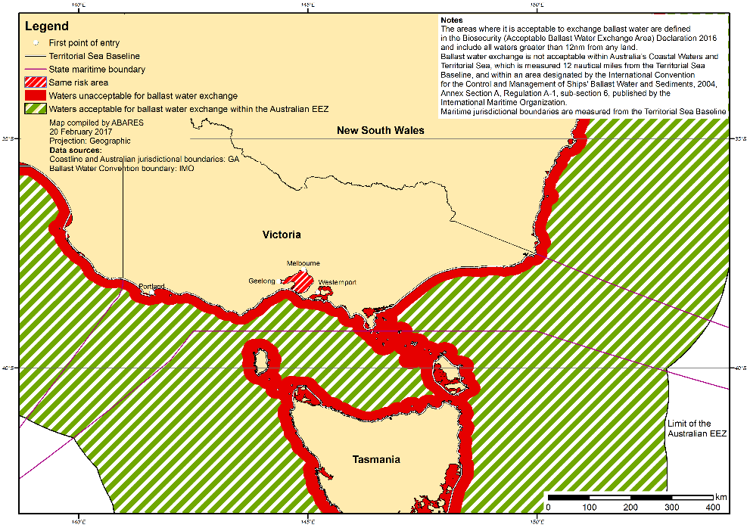

**Western boundary** 144° 36’ 54.272” E 38° 17’ 29.988” S

**Eastern boundary** 144° 39’ 2.7” E 38° 18’ 6.737” S

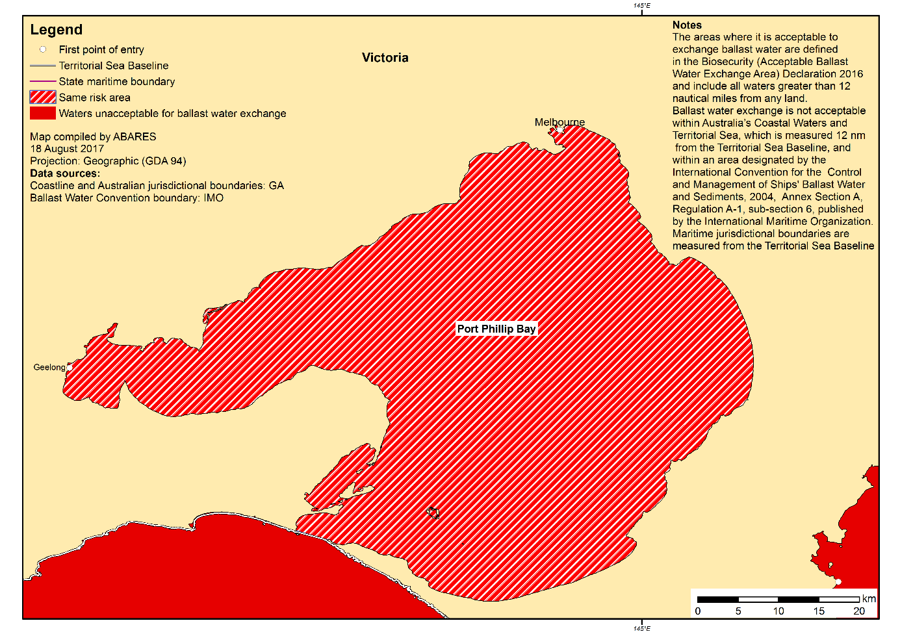

### Northern Territory Excluding Ports of Darwin, Gove & Milner Bay

This area excludes the uptake of ballast water in the ports of Darwin, Gove and Milner Bay

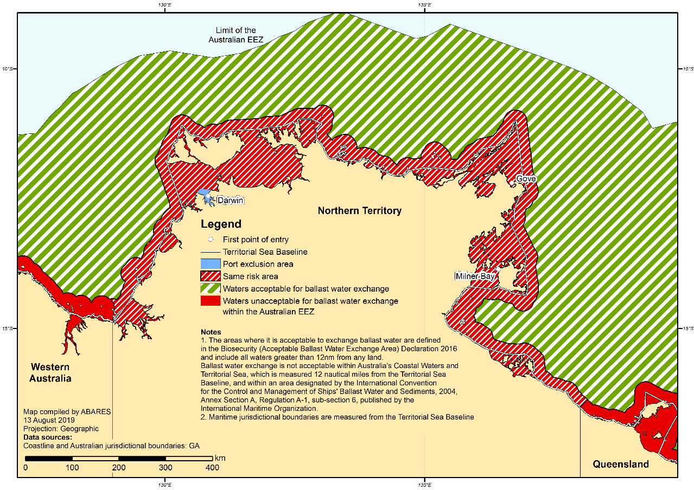

**Western boundary:** Longitude 129°00′01.659560″E

**Eastern Boundary:** Longitude 138°07′33.574000″E

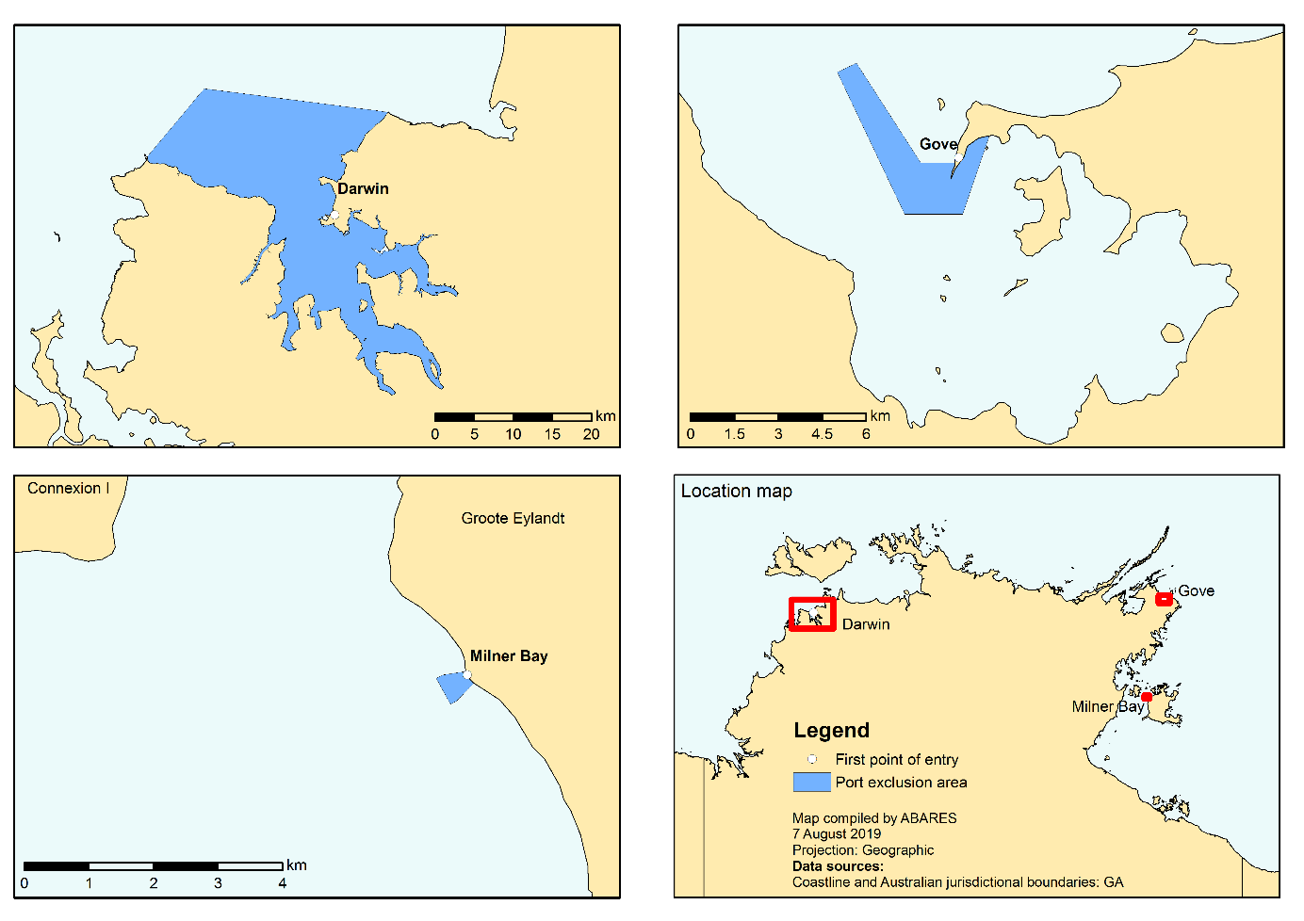

## Ballast Water Management For Vessels servicing offshore installations

Vessels arriving at an offshore oil and gas installation within Australia’s Exclusive Economic Zone (EEZ) must manage their ballast water in accordance with one of the acceptable methods of ballast water management, prior to arrival.

Vessels using ballast water exchange that are arriving in Australia’s EEZ from a port outside of Australia, the ballast water exchange must be conducted consistent with the requirements of [Section 4](#_Ballast_water_management) of this document.

Vessels that operate between offshore oil and gas installations and Australian ports are also required to manage their ballast water before arrival at the installation and Australian port. The acceptable area for a ballast water exchange between an installation and an Australian port is in sea areas that are no closer than 500 metres from the offshore installation, and no closer than 12 nautical miles from the nearest land.

If any vessels are unable to achieve these ballast water requirements, they must [contact the MNCC](#_Toc433622012) for further advice.

## Exemptions

### Key points

* Exemptions apply to some vessels when meeting the D-2 discharge standard of the Ballast Water Management Convention. If your vessel fits the eligibility criteria, the exemption applies automatically.
* Other exemptions are available on application, including risk based exemptions and time limited extension for the use of ballast water exchange.
* Application and/or assessment fees may apply to exemptions.
* The department does not regulate ballast water management for military vessels and those that fall under Article 3.2(e) of the ballast water convention and the *Biosecurity Act 2015 -* Sect 263(a)

Exemptions from the Ballast Water Convention’s Regulation D-2 discharge standard

A number of vessel types and operations are exempt from meeting the Regulation D-2 discharge standard of the Ballast Water Convention. Vessels meeting these conditions **do not** need to seek an exemption from the obligations specified in brackets:

* vessels that do not use ballast water to control trim, stability or list (exempt from all requirements)
* vessels with sealed tanks, and only discharge for the purpose of scheduled maintenance, dry-docking or emergency (exempt from ballast water management requirements except keeping ballast water records)
* vessels using only potable water, and operating solely in Australian waters (are not required to meet the Regulation D-2 discharge standard, and therefore are not required to install an (IMO) approved BWMS)
* vessels that only uptake and discharge ballast water in the same place (within the port limits of the same port, or within 1 nautical mile of the point of uptake) are not required to meet the Regulation D-2 discharge standard, and therefore are not required to install an (IMO) approved BWMS)
* dumb barges with no power source, that do not uptake and discharge ballast water (are not required to meet the Regulation D-2 discharge standard, and therefore are not required to install an (IMO) approved BWMS)
* recreational, or search and rescue vessels, less than 50 metres in length, with less than 8 cubic metres of ballast (do not need a BWMC, and because they are not required to meet the Regulation D-2 discharge standard, do not need to install an (IMO) approved BWMS).

Case by case exemptions are available upon application for vessels operating only in Australian waters. Applications will considered for:

* floating platforms, FSUs and FPSOs operating exclusively in Australian waters
* fishing vessels that only source ballast water outside 12 nautical miles from the nearest land.

Exemption from the requirement to obtain a Ballast Water Management Certificate and Ballast Water Management Plan

While all vessels must keep records of ballast operations, case by case exemptions from having a BWMP and BWMC are available upon application for vessels operating only in Australian waters. [Attachment A](#_Attachment_A:_Ballast) explains the requirements for different vessel types in detail.

Vessels may apply for an exemption where equivalent measures to address biosecurity and safety concerns can be demonstrated. Applications will be considered for vessels that:

* are less than 400 gross tonnes
* use potable water as ballast, and only discharge for the purpose of scheduled maintenance, dry-docking or emergency
* are dumb barges with no power source, and that do not uptake and discharge ballast water on a regular basis

### Risk based exemptions

A risk based exemption from ballast water management may be granted upon application to the Director of Biosecurity. Applications must include a risk assessment based on the Convention guidelines for risk assessments (G7), which demonstrates the level of biosecurity risk associated with the ballast water is acceptable.

How to apply for an exemption

To apply for an exemption email awe[pestsmarine@awe.gov.au](mailto:pestsmarine@awe.gov.au). The application will be assessed within 28 days of receipt of a valid application. Assessment fees may apply.

An application for an exemption must include:

* a completed and signed application form
* proof of legal entity showing the business or organization name that is the owner of the vessel
* vessel particulars or an attachment showing vessel particulars and ballast capacity
* operational profile of the vessel, demonstrating operation solely in Australian waters or the high seas
* an approved BWMP detailing ballast operations and methods
* an approved BWMC.

Further information may be required in order to assess the application.

It is strongly encouraged you contact the department at [pestsmarine@awe.gov.au](mailto:pestsmarine@awe.gov.au) prior to submitting an application to ensure an exemption is required for your vessel. If you have questions about applying for an exemption, please email [pestsmarine@awe.gov.au](mailto:pestsmarine@awe.gov.au).

### 

### Military Vessels

The Department has an expectation of all visiting international and domestic military vessels, or vessels that fall under Article 3.2(e) of the ballast water convention and the *Biosecurity Act 2015 -* Sect 263(a) to undertake measures to manage any biosecurity risk that may be related to the vessel’s ballast water management.

The department will provide further information, including guidelines on sovereign immunity if required. [Contact the MNCC](#_Toc433622012) for further advice.

## Disposal of Ballast Tank Sediment

### Key points

* Disposal of tank sediment is prohibited in Australia’s EEZ
* A vessel may discharge ballast tank sediment outside 200 nautical miles from the nearest land, and in at least a depth of 200 metres or at an approved land-based reception facility

Sediment must be disposed of in an area outside 200 nautical miles from the nearest land, and in at least a depth of 200 metres, or at an approved land-based reception facility. Australian state and territory legislation may apply to land-based sediment reception facilities.

Stripping of ballast tank sediment in Australian seas is not permitted, unless a vessel seeks permission to discharge sediment to a reception facility.

The discharge of sediment is permitted if:

* it is necessary for ensuring the safety of the vessel in an emergency or saving life at sea
* if the discharge is accidental and results from damage to the vessel or its equipment
* where all reasonable precautions have been taken to prevent or minimise the discharge
* for the purposes of minimising pollution.

The department must be contacted with details of the disposal as soon as is practicable of the vessels crew becoming aware of the disposal.

For more information, [contact the MNCC](#_Toc433622012).

## Practical Considerations

Masters must apply the requirements in this section if applicable to their vessel type.

### Ballasting under pilotage

A vessel that is under pilotage may manage ballast water to adjust trim for safety considerations and/or to allow for draft restrictions. This may occur after the responsible ballast water officer has submitted the ballast water report to the department demonstrating the ballast water on-board has been acceptably managed for discharge. The vessel’s responsible ballast water officer is required to record all ballast water management in the vessel’s ballast water records. These records must be presented to a biosecurity officer on request.

### Estimating pump rates

The definition of a single pressure source includes using two or more pumps simultaneously into common lines.

Estimating the quantity of water flushed through each tank involves estimating the delivery rate of ballast pumps, and timing the hours of running of those pumps.

The actual pump rates will differ from their rated capacity due to:

* wear on pumps, pipes etc.
* depth underwater of sea inlet (vessel’s draft)
* horizontal and vertical distance of each tank from the pump (friction/gravity)
* vessel trim (trim by the stern will pump the water uphill and force the pump to overcome gravity)
* variations in ballast main diameter.

To ensure that sufficient water has been flushed through a tank to satisfy Australian requirements, we strongly recommend that ballast water management equipment such as pumps be regularly surveyed, and tested to verify actual delivery rates.

Pumping rates should be recorded in the BWMP or the ballast water record book and verified through annual surveys.

### Test to estimate pumping rates:

Pump tests should be conducted against the fore peak tank or similarly situated tanks forward of the vessel and should be the furthest tank/s from the ballast pumps. Most vessels have a portion above the waterline, and most ballast mains (pipes) will incorporate a series of reductions in diameter and changes in direction between the pump and the tank. The combination of all of these factors leads to the fore peak tank receiving less water per hour than any other on the vessel.

The pump test should therefore comprise filling the fore peak from empty or waterline (as proven by a manual sounding) until the tank is full or overflows and timing the operation. A template for documenting ballast pump tests is available in [Attachment C](#_Attachment_C:_Ballast).

If more than one ballast pump is fitted, each pump should be tested separately. If two pumps are intended to be used together in flow-through operations, a separate test using both pumps together should be conducted. The quantity being delivered by two pumps operating together into a common line would usually be less than the sum of each pump’s individual delivery rate.

As it would be unusual to use two pumps to fill the fore peak tank, a test of the combined delivery rate of two pumps should be conducted against forward upper wing tanks, ideally above the waterline. For example, Top Side Tanks 1 Port and Starboard.

The department recommends pump tests only be conducted when it is safe to do so and in accordance with the vessels ballast water management plan.

### Exchange calculation examples

#### Sequential exchange

**Calculation example 1**

A vessel has a fore peak ballast tank with full capacity 2,000 m³. The vessel’s master wishes to arrive in an Australian port with the fore peak tank only half full (1,000 m³). Regardless of how much high-risk water is in the tank before the exchange, the water in the tank must be exchanged so that, after refilling, not more than 5 per cent of the resulting mixture in the tank is high-risk water. After pumping out (when suction on the pump is lost), a sounding of the tank is taken and this shows that only 5 m³ remains.

In this situation, provided at least 95 m³ of deep ocean water is added to the fore peak tank, the resultant mixture will be acceptable for discharge in Australian seas. The master may fill the tank only to his desired volume of 1,000 m³ and the ballast water in the tank requires no further management.

**Calculation example 2**

A vessel has a centre line, double bottom tank beneath No. 1 Cargo Hold (DB1C) with full capacity 6,000 m³. The vessel’s master wishes to arrive in an Australian port with DB1C only filled to one-third of its capacity (2,000 m³).

After pumping out (when suction on the pump is lost), a sounding of the tank is taken and this shows that 250 m³ remains in the tank.

To achieve a 95 per cent volumetric exchange in this tank, the master has two options:

1. Fill the tank up to 5,000 m³ and then pump out water until his desired level of 2,000 m³ is reached
2. Strip the tank until only 100 m³ remains before refilling the tank to 2,000 m³.

#### Flow-through/dilution

A cape-sized vessel (100,000 DWT) with nine cargo holds, has the following dedicated ballast tanks:

| **Tank/hold** | **Capacity** | **Contents** |
| --- | --- | --- |
| WBT 1P | 3 000 m3 | Full |
| WBT 1S | 3 000 m3 | Full |
| WBT 2P | 4 200 m3 | Full |
| WBT 2S | 4 200 m3 | Full |
| WBT 3P | 3 000 m3 | 1200 m3 |
| WBT 3S | 3 000 m3 | Full |
| WBT 4P | 4 200 m3 | Full |
| WBT 4S | 4 200 m3 | Full |
| After peak | 1 200 m3 | 800 m3 |

The 10-year-old vessel is fitted with two main ballast pumps each with a rated capacity of 2,500 m3/hr when the vessel was new. From pump tests, the chief officer is aware that each of these pumps now delivers about 2,000 m3/hr when used by itself, or a total of 3 700 m3/hr when the pumps are used together.

**Calculation example 1**

Fore peak tank (capacity 2,000 m³) initially contains 1,000 m³ of high-risk ballast water. The Master wants to exchange the tank’s contents in mid-ocean using the flow-through method.

300 per cent of the tank’s full capacity (i.e. 3 x 2,000 m³) = 6,000 m³.

Using only one pump, the master must pump clean seawater into the tank for three hours. Using two pumps together, the required pumping time would be 6,000 ÷ 3,700 = 1.62 hours (1 hour 37 minutes).

One pump delivers 2,000 m³/hr = 6,000 m³ in 3 hours = 300% of tank’s FULL capacity.

Two pumps deliver 3,700 m³/hr = 6,000 m³ in 1.62 hours = 300% of tank’s FULL capacity.

**Calculation example 2**

The Master wants to use flow-through method on WBT 1P, WBT 1S, WBT 2P and WBT 2S.

**Acceptable**

Using both ballast pumps together, the master simultaneously flushes WBT 1P and 1S for at least 4.86 hours (combined capacity of 1P&S = 6,000 m³, 4.86 hours pumping @ 3,700 m³/hr = 18,000 m³ = 300% of each tank’s full capacity).

After the ballast exchange in WBT 1P and S, those tanks are closed off and a new exchange begins on WBT 2P and S simultaneously. No. 2s, with combined capacity of 8,400 m³, require a further 6.81 hours of flushing with both pumps simultaneously.

**Unacceptable**

Master uses both pumps to flush WBT 1P&S and WBT 2P&S (combined capacity = 14,400) simultaneously for 11.68 hours. The pumps deliver the same quantity of water in total but it is impossible to say how much water each tank received if this procedure is used. It is clear though that No. 1s, being further from the pumps, will receive less than No. 2s.

## Further Advice and Information

#### General advice and support

Further information can be obtained by contacting the department or visiting the department’s [website](http://www.agriculture.gov.au/biosecurity/avm/vessels). For further information on the process to manage ballast water in Australian waters, please contact the Maritime National Coordination Centre or the department’s nearest [regional office](http://www.agriculture.gov.au/about/contactus/phone/vessel).

**Maritime National Coordination Centre**

Email: [maritimeNCC@awe.gov.au](mailto:maritimeNCC@awe.gov.au)

Phone: 1300 004 605

Fax: 1300 005 882

#### Exemptions

For further information on exemptions please contact the department’s Marine Biosecurity Unit.

**Marine Biosecurity Unit**

Email: [pestsmarine@awe.gov.au](mailto:pestsmarine@awe.gov.au)

Website: [awe.gov.au/ballast](http://www.agriculture.gov.au/ballast)

## Attachment A: Ballast Water Management Plan and Certificate Requirements

This table shows the requirements for ship types/classes designed to carry ballast water, to obtain a ballast water management plan and ballast water management certificate.

Ballast Water Management Plan and Certificate requirements

| Scenario number | Ship type/class | Sub-category | Ballast Water Management Plan & Certificate required? | Exemption Policy |
| --- | --- | --- | --- | --- |
| 1 | Ships which use an IMO Type Approved BWMS | Any size | Yes—approved by a survey authority or a Flag State Administration | Not eligible for an exemption |
| 2 | Commercial and non-commercial ships (that don’t meet table items 1, 3, 4 or 7) | Greater than 400 gross tonnes | Yes—approved by a survey authority or a Flag State Administration | Exemption may be available on a case-by-case basis. Vessel must manage ballast water |
| 3 | Ships using potable water,  Vessels with no power source | Any size | Yes—approved by a survey authority, registered surveyor or Flag State Administration. | Exemption may be available on a case-by-case basis.  Vessel must manage ballast water. |
| 4 | Ships that are covered by Equivalent Compliance | (Regulation A-5) of the Ballast Water Convention[[1]](#footnote-2) | Yes—approved by a survey authority, registered surveyor or Flag State Administration. | Exemption may be available on a case-by-case basis.  Vessel must manage ballast water |
| 5 | Commercial ships | Less than 400 gross tonnes | Yes—approved by a survey authority, registered surveyor or Flag State Administration. | Exemption may be available on a case-by-case basis.  Vessel must manage ballast water. |
| 6 | Non-commercial ships | Less than 400 gross tonnes | No (application for exemption not required) | Exempt from this requirement. Vessel must manage ballast water. |
| 7 | Ships considered to have sealed tanks[[2]](#footnote-3) | Any size | No (application for exemption not required) | Exempt from this requirement. Must still manage ballast water. |
| 8 | Government and defence vessels | Used only for non-commercial purposes | No (application for exemption not required) | Exempt from this requirement |

## Attachment B: Example Ballast Water Management Certificate

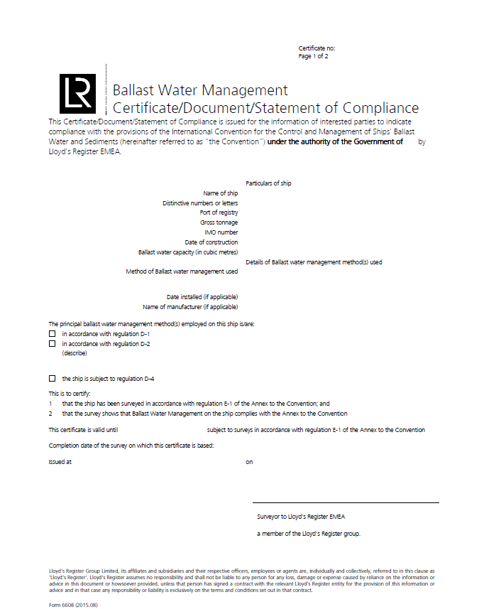

## Attachment C: Ballast water pump test

Vessel name:………………………………………………………………………..

IMO number: ………………………………………………………………

Port of registry: ………………………………………………………………

Date launched: ………………………………………………………………

ID of ballast pump(s) tested:………………………………………………………………………………………………..

Original rated capacity of pump(s) tested: ………………………………………………………………

Details of tank(s) used in test: ……………………………………………………………………………………………

(Fore peak tank preferred for single pump tests, forward upper wing tanks preferred for testing combined pumps)

a) Maximum tank capacity (m3): …………………………………………

b) Initial contents (m3): ………………………………………………………..

c) Time start pumping: ………………………………………………………….

d) Time tank overflowed: e) Hours Pumping (d – c): f) Volume pumped (a – b):

e) Pump’s delivery rate: (f ÷ e) per hour …………………………………………………………………..

f) Date of Pump Test …………/…………/…………

Master’s signature: ………………………………………………………………………….

Chief officer’s signature: …………………………………………………………………

Vessel’s stamp:

|  |
| --- |
|  |

The safety of the vessel and crew are paramount. We strongly recommend pump tests are only to be conducted if safe to do so, and that pumps are tested at least every 12 months.

## Attachment D: Maps of Ballast Water Exchange Exclusion Areas

#### Great Barrier Reef ballast water exchange exclusion area

From the nearest land off the north-eastern coast of Australian means from a line drawn from a point on the coast of Australia in:

latitude 11°00´ S, longitude 142°08´ E   
to a point in latitude 10°35´ S, longitude 141°55´ E   
thence to a point latitude 10°00´ S, longitude 142°00´ E   
thence to a point latitude 9°10´ S, longitude 143°52´ E   
thence to a point latitude 9°00´ S, longitude 144°30´ E   
thence to a point latitude 10°41´ S, longitude 145°00´ E   
thence to a point latitude 13°00´ S, longitude 145°00´ E   
thence to a point latitude 15°00´ S, longitude 146°00´ E   
thence to a point latitude 17°30´ S, longitude 147°00´ E   
thence to a point latitude 21°00´ S, longitude 152°55´ E   
thence to a point latitude 24°30´ S, longitude 154°00´ E   
thence to a point on the coast of Australia in latitude 24°42´ S, longitude 153°15´ E

If the requirements to conduct a ballast water exchange outside 12 nautical miles of the Great Barrier Reef Marine Park (see Map 1) are unachievable, the master should contact the MNCC for advice as soon as possible.

**Map 1 - North-eastern Australian areas that are acceptable for ballast water exchange within the Australian EEZ**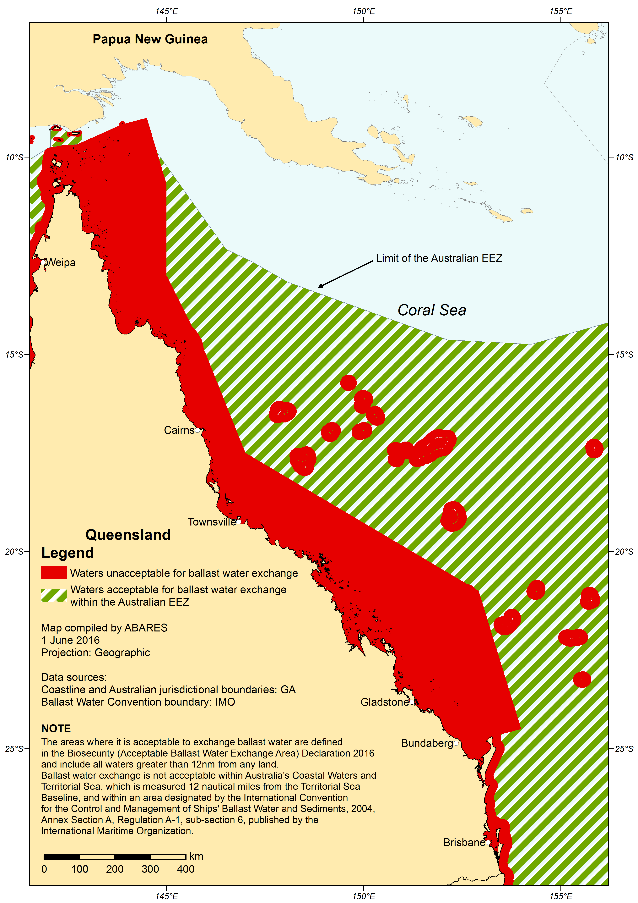

#### Ningaloo ballast water exchange exclusion area

Ballast water exchange is not permitted in the Ningaloo ballast water exchange exclusion area.

The Ningaloo ballast water exchange exclusion area is the area bounded by the line starting at the point described in Item 1 of the following table and running sequentially as described in the table below.

|  |  |
| --- | --- |
| Item | Description |
| 1 | The point of intersection of the outer limit of the territorial sea, north of North West Cape Western Australia, by the meridian of longitude 114°14’21” East |
| 2 | North along that meridian to its intersection by the outer limit of the line every point of which is 20 nautical miles from the territorial sea baseline |
| 3 | Generally south-westerly along that outer limit to its intersection by the parallel of latitude 24°01’53” South |
| 4 | East along that parallel to its intersection by the outer limit of the territorial sea |
| 5 | Generally north-easterly along that outer limit to the starting point |

#### Map 2: Ningaloo Reef Marine Park Exclusion Zone

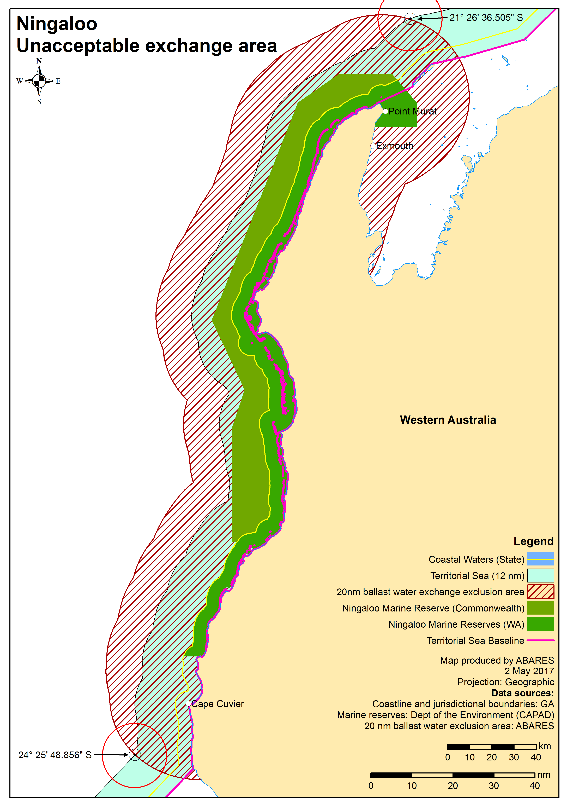

## Attachment Z:\Animal\Marine Pests\Ballast Water\Biosecurity Act_Ballast Water Project Phase 2\Circulars to RO's\Circular for BWMS commissioning_Nov19_Page_01.jpgE: Ballast Water Management System Commissioning Circular

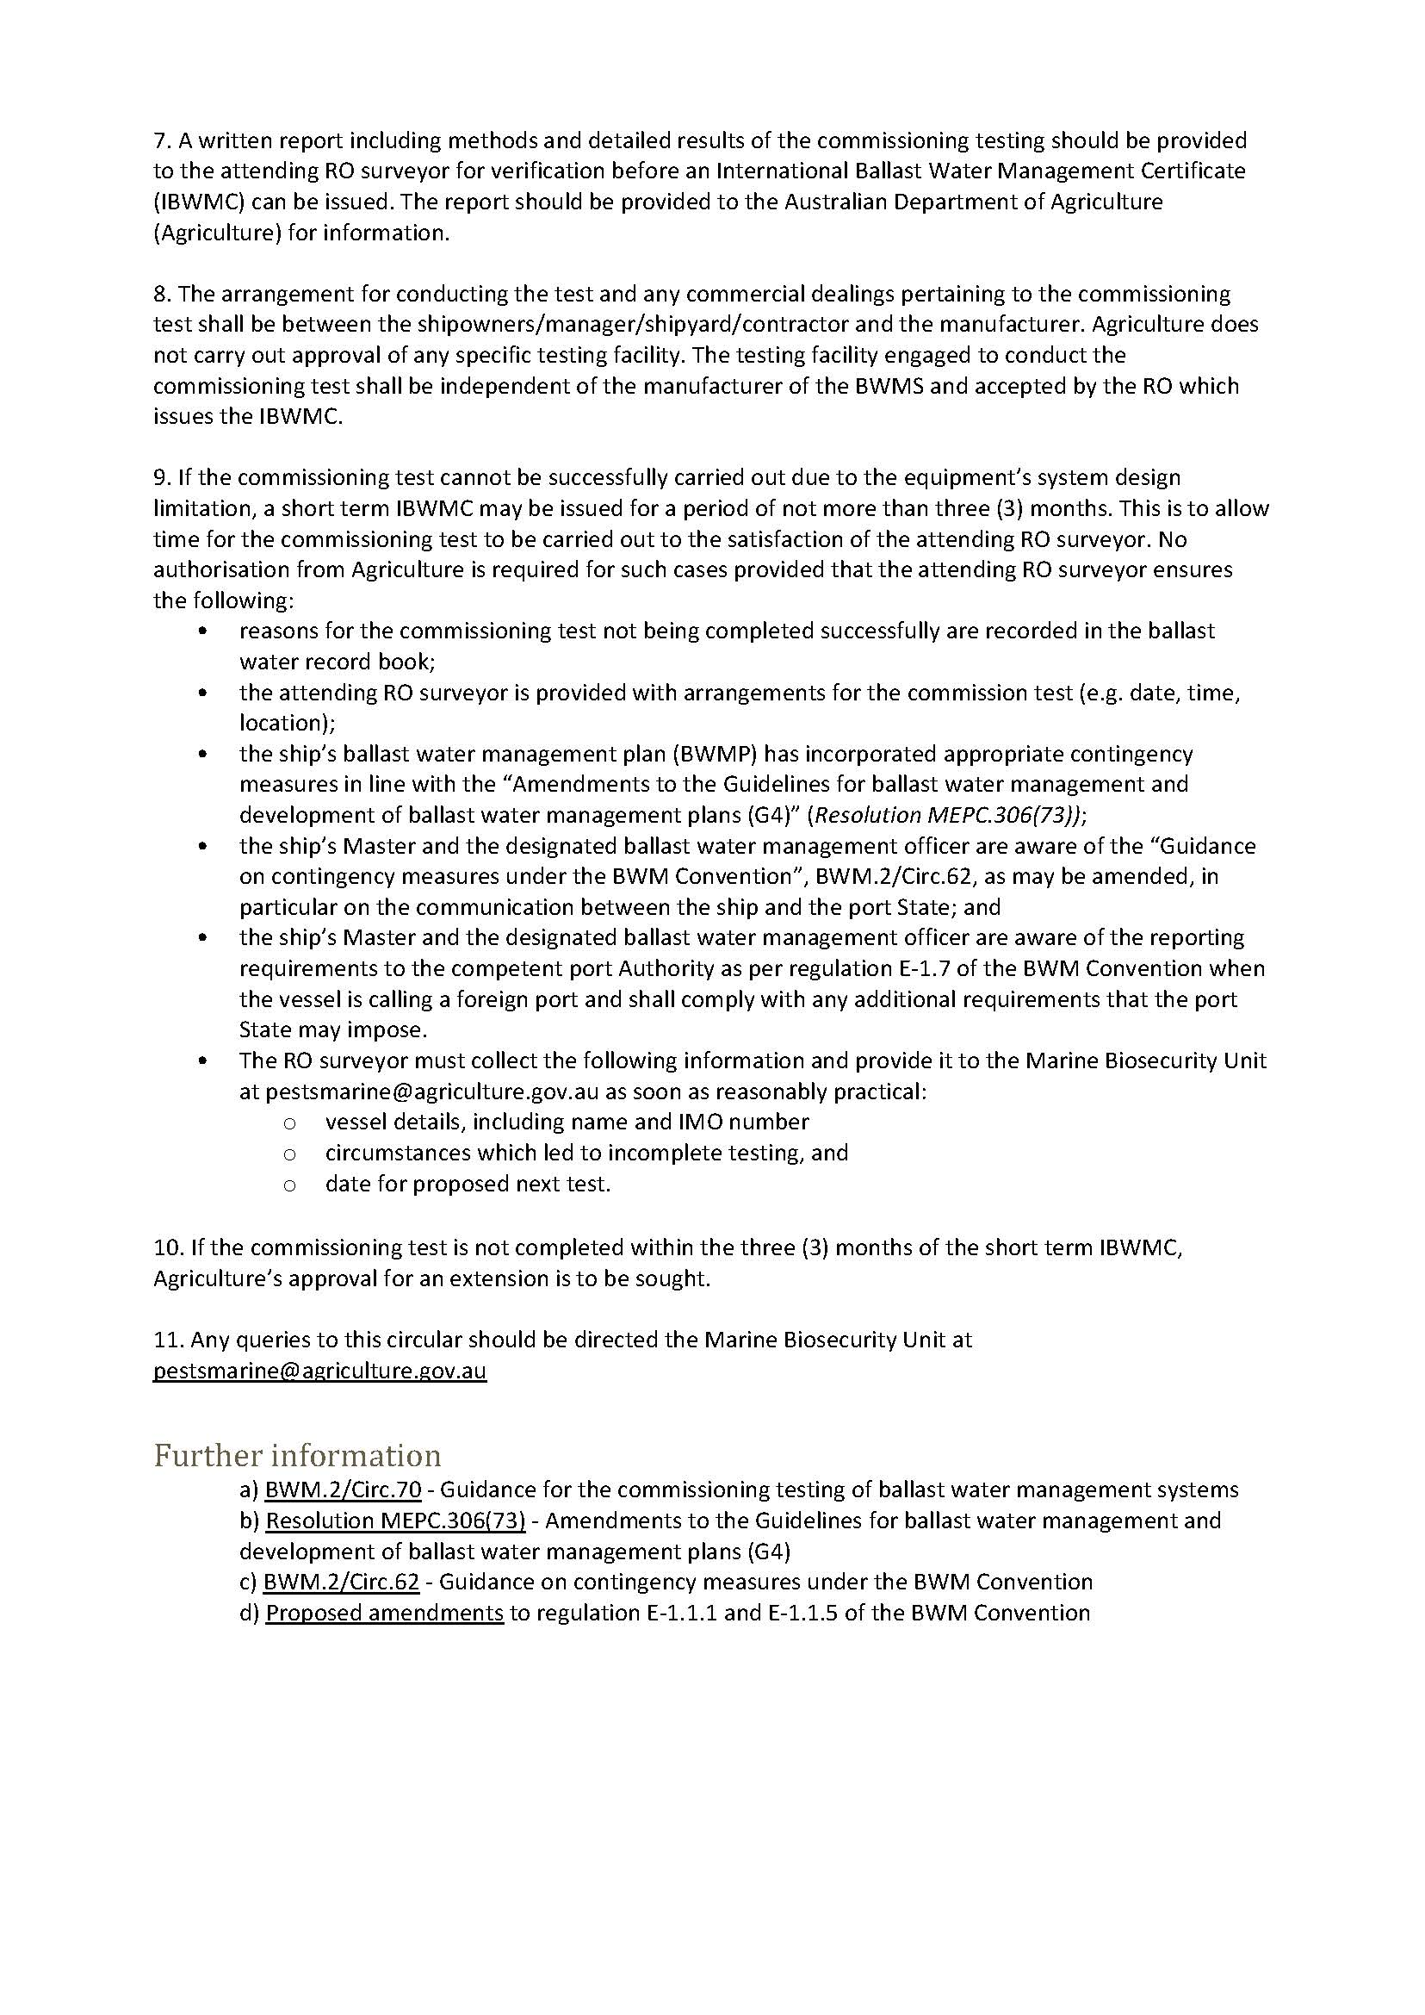

## Glossary

**Australian ballast water**

Water that has been sourced within the Australian exclusive economic zone (within 200Nm of Australia). Also referred to as domestic ballast water.

**Ballast Water Convention**

The International Convention for the Control and Management of Ship’ Ballast Water and Sediments which came into force on 8 September 2017 and has been ratified by Australia.

**BWMP**

A Ballast Water Management Plan (also referred to as a management plan) is specific to the vessel and provides the appropriate procedures for the safe management of ballast water on that vessel.

**BWMC**

A Ballast Water Management Certificate verifies the vessel has been surveyed to a standard compliant with the Convention and states the principle management methods used.

**BWMS**

A Ballast Water Management System, also known as a treatment system, is a system designed to remove and destroy/inactivate biological organisms (zooplankton, algae, and bacteria) from ballast water. These systems must be approved by the International Maritime Organization.

**Department**

Australian Department of Agriculture, Water and the Environment

**Domestic ballast water**

Water that has been sourced within the Australian exclusive economic zone (within 200Nm of Australia). Also referred to as Australian ballast water.

**Empty tank**

Ballast tanks that contain less than, or equal to, 5 per cent high risk water based on the total tank capacity.

**High-risk ballast water**

Ballast water that is considered to represent an unacceptable biosecurity risk to Australia. This includes, but not limited to, any ballast water that has not been managed in accordance with these requirements and has been taken up:

* within 12 nautical miles of any land mass or in water less than 50 metres deep
* within 500 metres of an offshore installation, or
* in an Australian port and intended for discharge in the Australian territorial seas.

Vessels without records to demonstrate the management or source of the ballast water will be considered to have high risk ballast water.

**Low-risk ballast water**

Water that has:

* been managed using one of the approved methods listed in [Section 4](#_Ballast_water_management), or
* an approved low risk exemption and is sourced in Australia.

**MARS**

The Maritime Arrivals and Reporting System, used to submit the Ballast Water Report and Domestic Risk Assessment.

**Record System**

A Ballast Water Record System which is a complete and accurate record of all ballast water operations.

**Responsible officer**

The officer or crew member identified in the ballast water management plan to conduct the ballasting operations.

**Sealed Tanks**

Ballast tanks that are permanently sealed and unable to receive or discharge ballast water from the environment. Vessels that have been fitted with spectacle blinds or similar, and do not intend to discharge or uptake ballast water during normal operations, are considered to have sealed tanks.

**Sloshing**

The official term for the movement of water in a slack tank. Such movement can be so violent that it causes damage to structural steelwork inside a vessel’s tank.

1. The *Guidelines for Ballast Water Management Equivalent Compliance (G3)* apply to pleasure craft used solely for recreation or competition or craft used primarily for search and rescue less than 50 metres in overall length and with a maximum ballast water capacity of eight cubic metres. Overall length means the length of the hull excluding bowsprits, booms, bumpkins, pulpits. [↑](#footnote-ref-2)
2. Sealed Tanks - Ballast tanks that are permanently sealed and unable to receive or discharge ballast water from the environment. Vessels that have been fitted with spectacle blinds or similar, and do not intend to discharge or uptake ballast water during normal operations, are considered to have sealed tanks. [↑](#footnote-ref-3)